E
wo/cc/67/2
ORIGINAL: English
DATE: July 22, 2013

WIPO Coordination Committee

Sixty-Seventh (44th Ordinary) Session
Geneva, September 23 to October 2, 2013

Annual report on human resources

prepared by the Director General

TABLE OF CONTENTS

I. WIPO Staff

II. Human Resources (HR) Strategy 2013-2015 – An Executive Summary

III. Recent Progress in HR
- Contract Reform
- Regularization/Recruitment of Long-Serving Temporary Employees (LSTEs)
- Revision of Staff Regulations and Rules (SRR) and the HR Policy Framework
- Internal Justice
- Internal Justice Reform
- Organizational Design (OD) Implementation and Alignment
- Performance Management
- Occupational Health and Safety
- Recruitment
- Training and Development
- Gender
- Geographic Diversity
- Staff-Management Relations
- Implementation of the HR Management Systems under the Enterprise Resource Planning (ERP) Portfolio of Projects
- Policy Development
- Classification
- Ethics Office
- Risk Management
- Audit Recommendations

IV. Staff Matters for the Attention of the WIPO Coordination Committee

(a) Termination of Employment Contracts - Agreed Terminations
(b) WIPO Staff Pension Committee
(c) Honor Awarded to Director General
(d) Other Staff Matters

V. Outlook for 2014
- Implementation of the HR Strategy
- Internal Justice Reform – Chapters X and XI of SRR
- Occupational Health and Safety
- ERP: Next Steps
- Challenges and Risks

Annexes
- HR Statistics
- HR Strategy
- Annual Report of the Ethics Office 2012

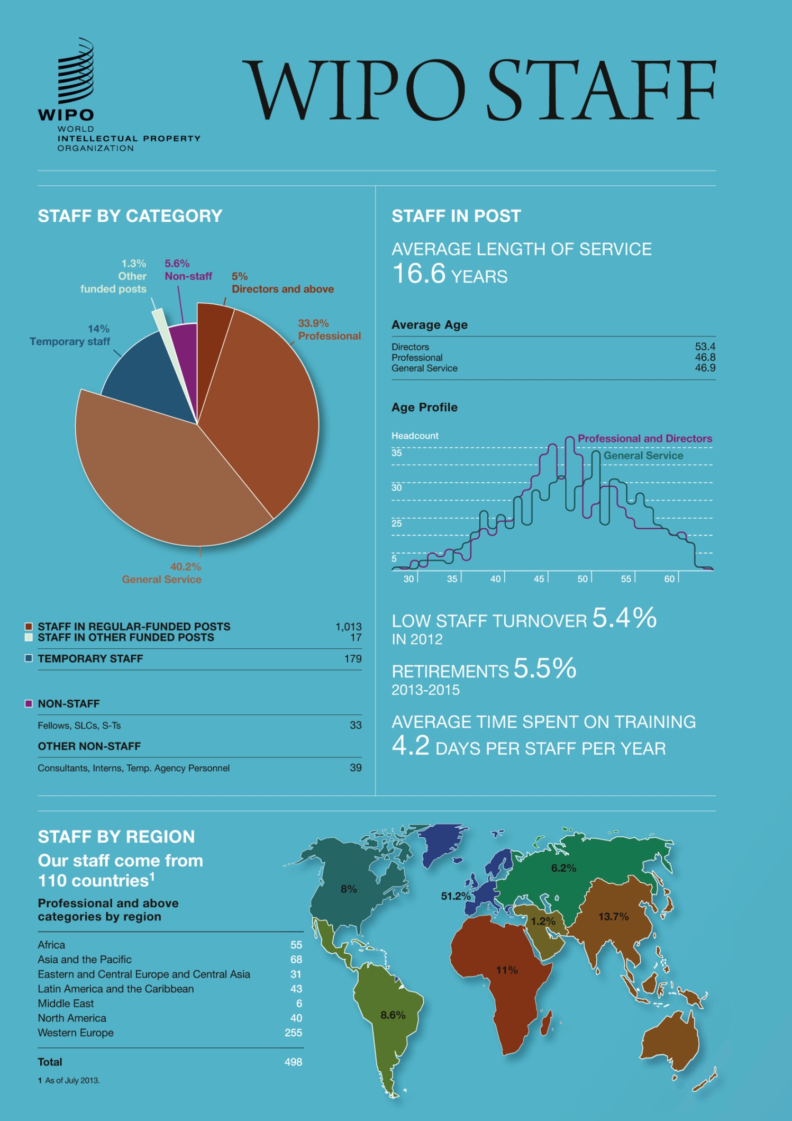

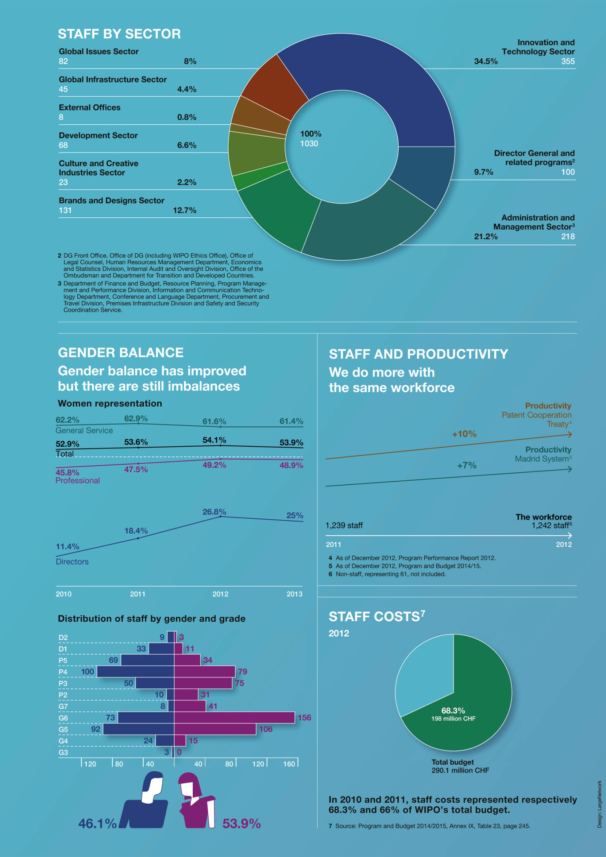
II. HUMAN RESOURCES (HR) STRATEGY 2013-2015 – AN EXECUTIVE SUMMARY

Enabling Globally Integrated Intellectual Property (IP) Services

The HR Strategy 2013-2015 is designed to position the World Intellectual Property Organization (WIPO) as a premier provider of global IP services, and to ensure it is responsive to a rapidly-evolving global IP environment. It further aims to confirm WIPO as an employer of choice for international IP experts and professionals from a wide range of backgrounds, and to its support staff, all of whom bring a wealth of knowledge, experience and commitment to the Organization. An additional objective of the strategy is to further improve organizational efficiency.

Staff are key to WIPO’s success as a provider of global IP services. WIPO generates 95 per cent of its income from the fees collected for services provided by the international registration systems. This business model is unique in the United Nations (UN) system. While it creates opportunities, it also leads to a number of challenges.

The evolving global IP environment is highly dynamic, and demand for global IP services continues to increase. There has been a significant geographical shift in the use of IP with growth rates in Asia far outpacing those of the rest of the world.

WIPO is not the sole provider of IP services. Global stakeholders evaluate their options based on criteria such as overall quality and relevance of services, speed of response, cost and sustainability. WIPO must therefore continue to innovate and improve its quality of service delivery in order to remain competitive.

The nature of the demand for development for cooperation, capacity building and technical assistance has become more sophisticated as growth rates have increased consistently in the developing world over the past two decades, and countries seek to encourage value addition in economic production. This change needs to be mirrored in the skill sets of the staff serving in this sector of the Organization.

The Organization has successfully navigated an economic crisis and return to growth, ensuring that results are delivered with tightly managed resources. This has been achieved through a number of strategies, including productivity enhancement in core service areas, review and redesign of organizational structures and redeployment of resources where necessary. Transformation of the Organization’s successful delivery must, however, continue. Further realignment of the workforce is needed, in terms of structure, skills and contracts.

WIPO has a solid financial basis and encouraging income forecasts for the coming biennium. However, it faces cost pressures that must be managed robustly. More than two-thirds of expenditure relate to staff costs. Structural adjustments and recalibration of the workforce are necessary to ensure that WIPO not only can meet the demands on it as a global service provider, but also has the agility to adjust to changes rapidly. New program needs must be financed through realignment of current resources.

WIPO seeks to offer competitive conditions of employment to its staff, together with a conducive working environment, opportunities for professional growth, work-life balance and family-friendly support systems. WIPO is committed to further improving its geographic diversity, gender balance and internal mobility.

The present HR Strategy does not require additional financial resources. It calls for a plan of action, integrating tailored sub-strategies of WIPO’s key operations, to be implemented and monitored from 2013 onwards.

III. RECENT PROGRESS IN HR

- Contract Reform

In 2012, the Staff Regulations and Rules (SRR) were amended to introduce two new appointment types, namely, temporary appointments and continuing appointments, in line with the contractual framework recommended by the International Civil Service Commission (ICSC). Since November 2012, 195 short-term contracts (including consultancies, Special Labor Contracts (SLCs) and temporary translator contracts) have been converted to temporary appointments, giving contract holders the status of “staff” and providing enhanced benefits. Contract reform has been implemented in a phased manner. Benefits were offered with effect from July 1, 2012. The allowances and benefits for temporary appointments were announced in Office Instructions. Some 28 Office Instructions had to be brought in line with the contract reform. The estimated cost of the contract reform is three million Swiss francs for 2012/13.

- Regularization/Recruitment of Long-Serving Temporary Employees (LSTEs)

As mandated by Member States in the Sixty-Third (41st Ordinary) Session of WIPO Coordination Committee in September 2010 (document WO/CC/63/5), 60 posts were authorized for the regularization of LSTEs performing continuing functions. These posts were authorized for use within the 2012/13 Program and Budget, and constitute the first phase of use of the 156 posts approved by Member States. Where functions were not assessed to be continuing, they have not been regularized, consistent with the eligibility requirements approved by the WIPO Coordination Committee in the LSTE regularization strategy (document WO/CC/63/5). In some cases, the functions were assessed as non-continuing due to technological advances and changing business needs. The regularization has progressed rapidly over this biennium as a result of both these posts being advertised as well as LSTEs being selected on other advertised posts. As of July 1, 2013, there are only 43 LSTEs left to be regularized in the Organization.

In the draft Program and Budget for 2014/15, it is proposed that the remaining 96 of the 156 regularization posts approved by Member States be authorized for the regularization of: (i) the remaining LSTEs performing continuing functions (approximately 30); and (ii) functions (currently performed by temporary staff) assessed to be continuing through the Organizational Design (OD) exercise. As indicated in the draft Program and Budget, the regularization of both of these categories will mitigate the risk of a recurring LSTE problem.

- Revision of the Staff Regulations and Rules (SRR) and the HR Policy Framework

The revised SRR entered into force in January 2013. The Human Resources Management Department (HRMD) conducted a review of the HR-related Office Instructions framework to align this with the revised SRR. HRMD updated and consolidated Office Instructions concerning working hours, sick leave, medical appointments, annual leave and overtime, and included new policies linked to the revised SRR. The result is a clearer framework in which HR information is more easily accessible to staff.

Following the WIPO Coordination Committee’s approval of the SRR in September 2012, a quality control was conducted to correct some editorial (non-substantive) discrepancies in the document, in consultation with the Chair of the WIPO Coordination Committee. The updated version was published in December 2012, shortly before the entry into force of the revised SRR.

- Internal Justice

Awards rendered in the judgments of the Administrative Tribunal of the International Labour Organization (ILOAT) in complaints against WIPO during the period January 2012 to June 2013 amounted to 395,034 Swiss francs, and internal appeals before the WIPO Appeal Board (WAB) to 2,500 Swiss francs. These awards also include damages against WIPO in the amount of 74,500 Swiss francs from the ILOAT and 2,500 Swiss francs recommended by the WAB.

In the same period, the total administrative fixed cost for cases examined by the ILOAT and the WAB, which varied depending on the number of judgments rendered or appeals concluded, was 379,217 Swiss francs, i.e., 224,217 Swiss francs and 155,000 Swiss francs for the ILOAT and the WAB, respectively. The fixed cost for each appeal concluded by the WAB is 5,000 Swiss francs. For the ILOAT, it is approximately 21,000 Swiss francs.

- Internal Justice Reform

A comprehensive review of WIPO’s internal justice system was undertaken and called on extensive external and internal expertise and consultation. Three broad discussion sessions were held in November 2012, February and April 2013, with the participation of all key internal justice actors. An expert consultant with wide international experience was engaged and, with his support, best practices in other international organizations and tailored solutions that meet WIPO’s needs were considered. The Director General constituted a Consultative Group composed of equal representation from the staff and the Administration, with the mandate to propose recommendations for an improved internal justice system and revisions to the SRR. This has resulted in a proposal for an improved and accessible system that enhances the promotion of justice, meeting the needs of staff and the Organization. The Consultative Group’s work represented a significant collaborative and productive effort between the staff and the Administration. The amendments to the SRR proposed by the Director General, having taken into consideration the recommendations of the Consultative Group, and further to consultation with the Staff Council and other relevant stakeholders, are provided in the document entitled “Revision of Staff Regulations and Rules” (WO/CC/67/3).

- Organizational Design (OD) Implementation and Alignment

A major initiative in 2012 was the introduction of OD as a key business activity in WIPO. By securing the effective use of human resources through proactive HR planning – supported by organizational structures that include robust job design, clearly defined reporting relationships and workload distribution – WIPO aims to provide an enabling environment to ensure organizational strategic objectives are met.

The OD review consisted of a series of sessions in which all programs were systematically analyzed. More than 20 sessions were held, led by the Director General and Program Managers. Programmatic overlaps and areas of potential staff shortages were identified and addressed; opportunities for synergies were considered; grade realignment proposals were made leading to 15 vacant posts being downgraded, eight upgrades and five conversions from senior General Service to the Professional level; underutilized resources were redirected towards new programmatic and support areas according to WIPO’s strategic priorities. The review also found ways to standardize, simplify and improve the system. The information collected has informed Program and Budget planning for 2014/15 with a view to achieving optimal use of resources.

- Performance Management

WIPO’s Performance Management and Staff Development System (PMSDS) has matured since its inception in 2009. It is increasingly accepted and used as a managerial tool and, as assessed through WIPO’s core value surveys, is progressively used for managing staff performance, work planning and objective setting. Furthermore, the PMSDS is used for identifying and addressing underperformance constructively, for identifying staff training needs and for recognizing and rewarding the highest performers.

The PMSDS enables individual staff objectives to be aligned with the Organization’s strategic goals. A large majority of staff (89 per cent in 2012) believe their individual objectives directly relate to the strategic goals. It also fosters staff development through better identification of learning priorities and the provision of cost-effective, cross-sector training. The system encourages continuous dialogue, as seen in the increase in the number of staff who receive regular performance feedback from their supervisors (72 per cent in 2012).

In 2013, HRMD updated its Handbook for Managers to address underperformance, with new templates for performance improvement management. Managers faced with underperforming staff were given coaching so that performance issues could be addressed promptly and consistently. Administrative measures were implemented for cases of underperformance identified in PMSDS.

A rewards and recognition pilot has been developed in consultation with managers and will be implemented in 2013. This program aims to acknowledge and reward excellent performance by individual staff members and by teams through a combination of monetary and non-monetary incentives. The program, developed in line with ICSC guidelines, is built around WIPO’s core values and considers innovation as well as efficiency. Managers play a key role in leading the debate with staff on what constitutes outstanding performance. Lessons learned at the end of the pilot period will serve to inform a future WIPO policy on rewards and recognition.

- Occupational Health and Safety

An external expert consultant was engaged in April 2013 to review medical and occupational health services and safety at WIPO. The mandate is threefold: (i) a review of the current medical services provided by the United Nations Office at Geneva (UNOG) Medical Services Section and the costs incurred, with a view to ensuring cost efficiency while offering an adequate level of service to WIPO staff and delegates; (ii) an analysis of absenteeism, with a view to enabling WIPO to identify opportunities to reduce absence levels through effective sick leave management; (iii) a policy proposal on occupational health and safety management for WIPO. A report with recommendations was provided in June 2013, for implementation in 2013 and 2014.

- Recruitment

Amendments to the SRR introduced in January 2012 have provided a basis for improved policies and procedures for recruitment. New guidelines for Appointment Boards have contributed to improved efficiency. Recruitment activity has increased in 2012, with 77 competitions for fixed-term posts and 24 for temporary positions. Of the 77 fixed-term posts advertised, 36 were in the Professional and higher category and 41 in the General Service category. Approximately 5,850 applications were received and evaluated. At the Professional and higher levels, 50 per cent of recruitment cases were filled externally, and 50 per cent internally. Of the externally-filled vacancies, 10 were filled by candidates from other international organizations. Of the internally-filled vacancies, five staff members received promotions and 37 posts were filled by LSTEs. The average vacancy rate in respect of approved posts was 7.8 per cent in 2012, which is in line with the costing assumptions described in Appendix C of the approved Program and Budget for the 2012/13 Biennium (Publication No. 360E/PB1213). Average recruitment time has been further reduced to 17 weeks.

Recruitment has focused not on only time needed to recruit but steps have been taken to improve the quality of recruitment. Proactive planning, the review and development of up-to-date, business-focused job descriptions and the use of external assessors for senior posts have all contributed to ensuring the best candidate for the job is hired.

Going forward, the focus will be on improving gender and geographic balance through appropriate recruitment strategies, including diversifying advertising and outreach.

- Training and Development

In 2012, more than 90 per cent of staff participated in at least one formal WIPO training activity. The total number of training days was 5,234, which reflects about 4.2 days of training per year per staff member. An amount of 1.4 million Swiss francs which amounts to 0.74 per cent of staff costs has been invested in training. These figures comprise regular WIPO training programs (e.g., people management, conflict resolution), the WIPO Language Training Program (e.g., regular classes, preparation for proficiency), special training programs under the Strategic Realignment Program (SRP) initiatives (e.g., ethics, PMSDS, customer orientation), IT-related training (e.g., IT project management, new IT software), internal training programs (e.g., induction program for new staff, Learning@WIPO), as well as other training activities (e.g., individual external training, contributions to studies undertaken by staff). In addition, a substantial amount of internal training is conducted by staff trainers and at no cost in the Patent Cooperation Treaty (PCT) and Madrid operations sectors (for more than 950 participants). Furthermore, training in IP areas is also provided through the WIPO Academy and it at no cost for staff members.

Training needs in WIPO are assessed through a top-down as well as a bottom-up approach. Program Managers identified critical collective training needs for the Program and Budget 2014/15. The PMSDS enables supervisors, together with staff members, to identify individual training needs required to meet work objectives. The process of defining WIPO’s learning priorities and related training activities has been fully integrated into WIPO’s Results-Based Management (RBM) Framework.

- Gender

WIPO is committed to achieving gender balance at all levels by 2020 and further progress has been made in 2012 towards reaching this goal. Women currently represent 53.9 per cent of the workforce. Imbalances exist at senior levels with regard to gender representation. At Director level, only about 25 per cent of staff are women. The Organization also aims to ensure that gender considerations are part of its programming and project work. A gender policy and action plan will be available for implementation towards the end of 2013. A Gender and Diversity Specialist has been recruited recently.

- Geographic Diversity

WIPO is committed to recruiting staff from as wide a geographical basis as possible. The WIPO policy on geographic distribution, which applies to regular Professional and higher level posts excluding language posts, requires consideration by Member States. Meanwhile, certain imbalances need to be addressed, including further reducing the number of unrepresented Member States. Currently the staff of WIPO comes from 110 countries.

- Staff-Management Relations

Regular meetings have been held with the WIPO Staff Council on matters of policy and on general issues of staff welfare. The Staff Council has also been consulted on vacancy announcements and on proposed Office Instructions. Furthermore, staff representatives nominated by Staff Council participate in WIPO committees and on interview boards.

WIPO has held regular Town Hall and briefing meetings for all staff. A number of staff surveys have been conducted on a range of matters affecting the staff.

- Implementation of HR Management Systems under the Enterprise Resource Planning (ERP) Portfolio of Projects

The initial project phase, implementing core HR and payroll processing, has continued to make steady progress. Detailed design activities have helped identify the required solutions for WIPO’s business processes. Several staff members took part in cross-functional design activities, giving them early exposure to new system capabilities and functions.

WIPO’s HR and payroll solution, based on PeopleSoft software, is currently being developed with the objective of deployment for production on October 1, 2013. Comprehensive and rigorous testing and training activities are currently under way to ensure a smooth, successful transition.

The first phase will strengthen the integration of data and processes, both within HRMD and in relation to other WIPO administration and management functions. It lays the foundation that will enable access to improved and more comprehensive management information.

The second phase, starting in early 2014, will include replacement of the current eRecruitment system, and activation of self-service functions for staff and managers. Phase II will build upon the foundation data and processes from the first phase.

- Policy Development

WIPO has delivered a modernized staff regulatory and policy framework in line with best practices and ICSC standards. The streamlined contractual framework provides enhanced clarity and transparency in the contractual status of staff. The Organization has also begun developing a clearly-defined legal framework for non-staff resources, including interns and fellows as well as delivery and skills-based experts. This will ensure the appropriate and transparent engagement of non-staff services to meet the Organization’s needs.

In addition to contract reform, 14 new HR policies have been developed on the following subjects: part-time working arrangements, rewards and recognition, maternity, paternity, adoption leave and post-maternity benefits, family leave, internships and fellowships, medical appointments during office hours, language allowance, classification and reclassification, mobility and hardship allowance, continuing and temporary appointments, salary advances, internal mobility as well as guidelines on succession planning. These new policies aim to provide greater guidance to staff on HR issues and to enhance work-life balance.

- Classification

Two sessions of the Classification Committee were held in 2012 to address all reclassification requests received prior to October 2011. A total of 44 posts were reviewed, 66 per cent of which were upgraded and the remaining cases confirmed at current grade level. All requests submitted after October 2011 were considered within the 2012 OD review and workforce planning exercise. The cost of reclassification of encumbered posts amounted to 1.1 million Swiss francs for the current biennium.

One of the Organization’s important improvements in HR processes over the last 12 months is the development of a policy on classification and reclassification of posts. This policy ensures that reclassification of posts is an integral part of workforce planning and budgeting. Dispensing with the practice of continuous and ad hoc reclassifications, this new approach enables WIPO to proactively manage and cost all changes in work requirements.

- Ethics Office

Considerable progress was made in establishing a comprehensive ethics and integrity system at WIPO in 2012. The WIPO Code of Ethics was issued following consultation with the staff, including the WIPO Staff Council. A Whistleblower Protection Policy was also published, following a similar process of consultation. This policy articulates the duty of all staff to report suspected misconduct and provides straightforward mechanisms for doing so. It also provides protection for staff members who have made such reports or who participate in enumerated oversight activities.

A program of mandatory training and awareness-raising for all staff at all levels was launched in 2012, comprised of half-day face-to-face training sessions. By late April 2013, over 96 per cent of all staff had completed the training, including staff of the external offices via video conference.

Details of the activities of the Ethics Office is available in the Annual Report of the Ethics Office 2012, which is attached as Annex III.

- Risk Management

During the past 12 months, a careful risk analysis has been conducted by HRMD and a number of high-impact risks have been identified. WIPO’s main strategic risk in the area of HR is the limited capacity to respond to a rapidly-evolving global IP environment. Increasing WIPO’s capacity in this regard and ensuring the necessary agility is the central focus of the new HR Strategy.

Closing skills gaps and reducing overcapacity are also necessary to mitigate risks. Rightsizing requires accurately capturing and specifying job requirements, training and retraining, internal reassignment, external hiring are among the measures which have to be contemplated.

Another considerable risk to WIPO is the loss of knowledge and capacity with the departure of renowned IP specialists. Measures to mitigate such risks include succession planning, training and appropriate career development incentives for highly specialized experts.

- Audit Recommendations

Of the 52 audit recommendations on HR recorded in July 2012, 39 have been closed. The remaining recommendations are at an advanced stage of implementation and concern mainly the implementation of the ERP system and internal justice reform. It is anticipated that the remaining audit recommendations will have been implemented by the end of 2013.

IV. STAFF MATTERS FOR THE ATTENTION OF THE WIPO COORDINATION COMMITTEE

- Termination of Employment Contracts - Agreed Terminations

Pursuant to the provisions of WIPO Staff Regulation 9.1(e), which requires the Director General to report all cases of termination of employment contracts to the WIPO Coordination Committee, the WIPO Coordination Committee is informed that 17 termination agreements were signed by WIPO staff members between January 2012 until end of June 2013, in the interest of the good administration of the Organization and with the consent of the staff members concerned, in accordance with WIPO Staff Regulation 9.1(a)(4). Indemnities were paid in accordance with the provisions in the WIPO SRR.

The WIPO Coordination Committee is invited to note the information provided in the preceding paragraph.

- WIPO Staff Pension Committee

The WIPO Coordination Committee decided, at its ordinary session in 1977 that the WIPO Staff Pension Committee would consist of three members and three alternate members, with one member and one alternate to be elected by the WIPO Coordination Committee. The members elected by the WIPO Coordination Committee serve a four-year term of office.

At its 59th session in 2008, the WIPO Coordination Committee elected Mr. Vladimir Yossifov as alternate member of the WIPO Staff Pension Committee until the ordinary session of the WIPO Coordination Committee in 2011. Thereafter, however, as the term of office of one member expired in 2009 due to retirement, it was proposed that Mr. Yossifov be elected as the new member of the WIPO Staff Pension Committee for a four-year term until 2013. The WIPO Coordination Committee accepted this proposal and elected Mr. Yossifov until 2013.

The Director General has received from the Delegation of Bulgaria the proposal that Mr. Yossifov be elected by the WIPO Coordination Committee as member of the WIPO Staff Pension Committee until the ordinary session in 2017 of the WIPO Coordination Committee.

Mr. Yossifov, a national of Bulgaria (born on February 7, 1946), has an advanced degree in civil engineering from the High Institute for Mining and Geology in Sofia (1968), followed by a degree in patent engineering from the High Institute for Mechanical and Electrical Engineering in Sofia (1974). In 1979, Mr. Yossifov obtained a degree in international economy at the All Union Academy of Foreign Trade in Moscow.

Mr. Yossifov is a member of the Bulgarian group of the Association for the Protection of Intellectual Property (AIPPI) and the Licensing Executives Society (LES), and was employed by a State Foreign Trade enterprise in Bulgaria until he joined the Bulgarian Foreign Ministry in August 1979. In November 1981, Mr. Yossifov was recruited to WIPO on a post at grade P-3 and held important posts within different sectors of the International Bureau until he retired from WIPO on February 28, 2007, from the post as Director of the Division for Certain Countries in Europe and Asia. During the period with WIPO, Mr. Yossifov also held important functions in the Staff Council and as member of the WIPO Staff Pension Committee as representative of the participants, and was elected Chairman of the UN Joint Staff Pension Board (UNJSPB) for the 2006 and the 2010 sessions.

The WIPO Coordination Committee is invited to note the information contained in paragraphs 51 to 55, above, and to elect Mr. Vladimir Yossifov as member of the WIPO Staff Pension Committee for the period until the ordinary session in 2017 of the WIPO Coordination Committee.

- Honor Awarded to Director General

Staff Regulation 1.8 provides, in its material part:

“(a) No staff member shall accept any honor, decoration, favor, gift or remuneration from any source external to the International Bureau, without first obtaining the approval of the Director General. Approval shall be granted only where such honor, decoration, favor, gift or remuneration is not incompatible with the staff member's status as an international civil servant. The Director General shall prescribe guidelines for the interpretation of the present Regulation through an Office Instruction.

“(b) Where the Director General is involved, the approval shall be granted by the Coordination Committee.”

In June 2013 in Marrakesh, on the occasion of the Diplomatic Conference to Conclude a Treaty to Facilitate Access to Published Work by Visually Impaired Persons and Persons with Print Disabilities, the Director General was informed that His Majesty King Mohammed VI had decided to confer upon the Director General the decoration of the Alawite Commander Wissam. The Director General informed the Chair of the Coordination Committee, Ambassador Kwok Fook Seng, of the intention of His Majesty the King and sought the latter’s advice on procedure. The Chair suggested reporting the conferring of the decoration to the Coordination Committee at its next meeting in September as it would be logistically impossible to convene the Coordination Committee before then. The decoration was conferred on the Director General by the Minister for Communications of the Kingdom of Morocco, the Honorable Mustapha Khalfi on June 28, 2013.

The WIPO Coordination Committee is invited to note the decoration mentioned in paragraph 58, and to approve its acceptance by the Director General.

- Other Staff Matters

By its resolution 67/257, the UN General Assembly approved the recommendations of the ICSC to:

- raise the mandatory age of separation to age 65 years for new staff of member of organizations of the UN Staff Joint Pension Fund (UNSJPF), effective no later than January 1, 2014;
- adopt the revised Standards of Conduct for the International Civil Service, effective January 1, 2013; and
- amend the education grant amounts, effective as of the school year in progress on January 1, 2013.

Accordingly, the WIPO Coordination Committee is invited to:

- approve the amendments to Staff Regulation 9.10 “Retirement Age” effective January 1, 2014;

- adopt the new “Standards of Conduct for the International Civil Service”, effective January 1, 2014, and approve the corresponding amendment to Staff Regulation 1.5 “Conduct”; and

(iii) note the amendments to Annex II of the SRR, Article I(f), with the amounts applicable for the education grant, effective as of the school year in progress on January 1, 2013.

Pensionable Remuneration

The ICSC changed the post adjustment multiplier in New York, resulting in an increase of 1.9 per cent in the net remuneration of New York staff in the Professional and higher categories. In accordance with Article 54(b) of the Regulations of the UNJSPF, the pensionable remuneration for staff in the Professional and higher categories has been adjusted by the same percentage. The salary scales in Annex II, Article I(a), (b) and (c) of the SRR have been amended accordingly, effective February 1, 2013.

Amendments to the SRR

Some further amendments to the SRR are presented to the WIPO Coordination Committee. All the proposed amendments including those detailed above, are contained in the document entitled “Revision of Staff Regulations and Rules” (WO/CC/67/3).

ICSC Report

In accordance with Article 17 of the ICSC statute, the attention of Member States is drawn to report of the ICSC, submitted to the 67th session of the UN General Assembly in 2013 (UN document A/67/30). The document may be consulted on the ICSC Internet site: www.icsc.un.org.

United Nations Joint Staff Pension Board (UNJSPB)

Under Article 14(a) of its Regulations, the UNJSPB shall present a report to the General Assembly of the United Nations and to member organizations, at least once every two years. The 2012 report was presented by the Board of the UNJSPF to the General Assembly of the United Nations at its 67th session in 2012 (UN document (A/66/267)). Since the report was included in the documentation of the said session of the General Assembly of the United Nations, it is not reproduced by the International Bureau. The report may be consulted at http://www.un.org/en/documents.

The WIPO Coordination Committee is invited to note the information contained in paragraphs 62 to 65, above.

V. OUTLOOK FOR 2014

(a) Implementation of the HR Strategy

One of the key areas of focus of HRMD in 2014 will be the implementation of the HR Strategy. Staff are the most important asset of WIPO. Their contribution, commitment, creativity and innovation capacity are among the determining factors of WIPO’s success.

Workforce adjustments will be made in line with progress in the automation of patent filing processes and the expansion of the Madrid and Hague areas. Adjustments are needed with regard to language capacity. ICT capacity needs to be strengthened.

The proportion of flexible contracts should be gradually increased. More use will be made of flexible agency personnel to meet short-term staffing needs without recreating long-term short-term concerns.

The training strategy will reflect the need for skills alignment.

Workforce planning and integration with RBM is under way and will be available in 2014.

Performance management, including a policy on rewards and recognition, will continue to receive special attention.

Opportunities for career development are a major aspiration of staff. Both lateral movement for broader skills development and learning, as well as upward career progression will be facilitated. With regard to the latter, opportunities will be available through internal recruitment and to a lesser extent through reclassification of posts.

(b) Internal Justice Reform – Chapters X and XI of SRR

Amendments to the SRR chapters relating to the internal justice system, if approved by the WIPO Coordination Committee in September 2013, will enter into force in January 2014. The SRR is a high-level document, and its provisions will be complemented by more detailed rules and guidelines to be issued in the form of new Office Instructions or amendments to existing ones. Any structural changes in internal justice mechanisms resulting from the new legal framework that require budgetary support must be incorporated into the Program and Budget. The Consultative Group has also been mandated to provide for transitory measures, where deemed necessary such that any new procedures for the advisory bodies that will make up the enhanced system may be implemented retroactively where they favor the staff member concerned.

(c) Occupational Health and Safety

As a follow-up to the expert consultant’s report review and recommendations in June 2013, it is expected that the recommendations made will be implemented in 2013 and 2014. The report includes recommendations regarding the prevention of accidents and illness and should contribute to reducing the level of absenteeism.

The medical services provided to WIPO staff will be focusing on occupational health and prevention. A health and safety policy will be implemented by a Health and Safety Committee which will be created during the second part of 2013. Staff members performing functions implying health risks will be monitored on a more regular basis. The management of sick leave will be reinforced resulting in a better analysis. Staff will also benefit from more information and communications as regards to health and safety.

(d) ERP: Next Steps

The initial project phase of the ERP will become operational on October 1, 2013. In addition to project delivery activities, related change management will continue. Staff members will be supported through knowledge transfer activities and training, and the HR structure will be assessed in line with new system capabilities and the automation of procedures.

HRMD will play a key role in the launch of the second project phase, in which WIPO will implement self-service functions for staff and management. This phase will also include a complete review of the Organization’s recruitment tools and related processes. As a result of the integrated nature of the new HR and payroll system, reporting capabilities will be enhanced. Dashboards will be developed and deployed for business use in a phased approach during 2013-2014.

Subsequent project phases will be implemented in accordance with WIPO project management standards. The governance structure put in place will continue to supervise project activities and actively manage risks.

Further integration of WIPO’s HR systems with the Enterprise Performance Management systems and PeopleSoft HR will ensure that RBM is applied at all stages of planning, including workforce planning, in order to improve effectiveness, efficiency and accountability in WIPO’s management of human resources. The Organization will build up workforce planning as a systematic, fully-integrated organizational process that involves forward planning to ensure the required skills are available so that RBM can deliver on strategic objectives.

(e) Challenges and Risks

Structural adjustments and recalibration of the workforce are necessary to ensure that WIPO can meet the demands on it as a global service provider in a fast-evolving external environment. WIPO must increase its capacity to be responsive and agile with more flexible structures, faster processes and surge capacity.

Although WIPO has a solid financial basis, it faces cost pressures that must be managed robustly. The Organization must do more with less. Currently it can do so without resorting to drastic measures. However, if action is not taken in a timely manner, more far-reaching corrective steps might become necessary in the future.

[Annexes follow]

By June 30, 2013.

