WIPO |  | E  PCT/CTC/24/2  ORIGINAL: English  DATE: August 4, 2009
WORLD INTELLECTUAL PROPERTY ORGANIZATION
GENEVA
INTERNATIONAL PATENT COOPERATION UNION
(PCT UNION)
PCT COMMITTEE FOR TECHNICAL COOPERATION
Twenty-Fourth Session
Geneva, September 22 to October 1, 2009
Appointment of the Egyptian Patent Office as an International Searching and Preliminary Examining Authority under the PCT
Document prepared by the International Bureau

Introduction

The Committee is invited to give advice to the PCT Assembly on the proposed appointment of the Egyptian Patent Office as an International Searching and Preliminary Examining Authority under the PCT.

Background

In a letter dated July 13, 2009, the text of which appears in Appendix I, accompanied by further details set out in Appendix II, the President of the Egyptian Academy of Scientific Research and Technology requested that the Egyptian Patent Office be appointed as an International Searching Authority (ISA) and International Preliminary Examining Authority (IPEA) under the PCT.

The appointment of ISAs and IPEAs under the PCT is a matter for the Assembly of the PCT Union and is governed by Articles 16 and 32(3) of the PCT.

Articles 16(3)(e) and 32(3) of the PCT require that, before the Assembly makes a decision on such an appointment, it shall seek the advice of the PCT Committee for Technical Cooperation. The Committee’s advice, which is sought by the present document, will be submitted to the Assembly during its 40th session, which is being held during the same period as the session of the Committee.

REQUIREMENTS TO BE SATISFIED

The minimum requirements for an Office to act as an International Searching Authority are set out in PCT Rule 36.1 as follows:

“The minimum requirements referred to in Article 16(3)(c) shall be the following:

“(i) the national Office or intergovernmental organization must have at least 100 full-time employees with sufficient technical qualifications to carry out searches;

“(ii) that Office or organization must have in its possession, or have access to, at least the minimum documentation referred to in Rule 34, properly arranged for search purposes, on paper, in microform or stored on electronic media;

“(iii) that Office or organization must have a staff which is capable of searching the required technical fields and which has the language facilities to understand at least those languages in which the minimum documentation referred to in Rule 34 is written or is translated;

“(iv) that Office or organization must have in place a quality management system and internal review arrangements in accordance with the common rules of international search;

“(v) that Office or organization must hold an appointment as an International Preliminary Examining Authority.”

PCT Rule 63.1 sets out equivalent minimum requirements for acting as an International Preliminary Examining Authority, except that item (v) requires the Office to hold an appointment as an International Searching Authority, so that, in order to meet the requirements, it is essential to be appointed as both types of Authority.

The Committee is invited to give its advice on this matter.

[Appendices follow]

Cairo, July 13, 2009

Re.: Appointment of the Egyptian Patent Office as International Authority under
the PCT rules

Dear Mr. Gurry,

Noting that the Egyptian Patent Office (EGPO) will be the first office in the Arab region to be appointed as International Searching Authority (ISA) and International Preliminary Examination Authority (IPEA), services will hereafter be introduced to approximately four hundred and half million Arab-speaking clients.

Considering that EGPO has managed to handle the escalating numbers of filed applications pursuant to Paris Convention and PCT maintaining the international patent pendency rates.

Egyptian Government kindly requests to enroll the attached document¹ within the agenda of the PCT Committee for Technical Cooperation. We are so keen to receive your respective feedback and recommendations. Thereupon, we will introduce a presentation to the PCT Assembly as referred to in Articles 16(3) and 32(3) of the PCT.

Yours sincerely,

[signed by Prof. Mohamed Tarek Hussein,
President, Academy of Scientific Research & Technology]

Annexes:
I. Minimum Documentation.
II. Egyptian Patent Office (EGPO) Technical Infrastructure.
III. Automation of Egyptian Patent Office.
IV. Automation Enhancements Roadmap.
V. EPOscan system.
VI. Workflow for E-Filing, E-Payment System, Workflow for Registration System, Workflow for Update Existing Application and Workflow for New Application System.
VII. Quality Sampling Review Committee (QSR) Flow Chart.

[Appendix II follows]

¹ The document attached to the letter, together with the Annexes thereto, is set out in Appendix II of the present document.

І. Overview of the Egyptian Patent Office

1. Background of the Egyptian Patent Office

Egypt was one of the first countries in the Arab Region to enact laws on Industrial Property Rights such as Law no. 57 of year 1939 on the protection of Trademarks and Law no. 132 of year 1949 on the protection of Patents, Drawings and Industrial Models.

The Egyptian Patent Office (hereinafter referred to as EGPO) was established in 1950. In 1951, EGPO started to receive applications. The Presidential Decree no. 543 of year 1969 stipulated that the Ministry of Scientific Research was the competent authority to apply the provisions of Law no. 132 of year 1949. The enactment of the said Decree stressed the importance of patenting on developing industries and increasing productivity, consequently improving the national economy.

The Academy of Scientific Research and Technology (hereinafter referred to as ASRT) was established by the Presidential Decree no. 2617 of year 1971. By virtue of that Decree, ASRT became the Authority responsible for implementing the provisions of Law no. 132 of year 1949.

EGPO is an agency of ASRT and its president is an undersecretary of a president of ASRT, who is on a ministerial level. In 2002, the Law on Intellectual Property Rights was amended by Law no. 82 of year 2002 and as a result EGPO not only provides protection to patents, but also utility models, integrated circuits as well as undisclosed information.

EGPO budget is financed from ASRT, in addition to the fees collected for services delivered to clients. Therefore, it focuses on presenting high quality services taking into consideration clients’ needs and market. EGPO has a very restricted system for optimal utilization of human resources and financial resources.

2. Organization

As mentioned above, the Egyptian Patent Office affiliates to the Academy of Scientific Research and Technology. The Office president reports directly to the president of the ASRT.

ІІ. Looking to the future

The current situation

1. Cooperation with other Egyptian Government Agencies

EGPO believes that a major part of its role is to help put the inventions into practice in order to advance development and achieve welfare to the society. Being desirous to activate this role, EGPO has established the project of Focal Points network (FPs net.) to connect universities and research centers to industrial entities, so the latter can benefit from researches and patents. The project has started in March, 2003 with 23 FPs in 11 governorates. Through FPs applicants can pre-register their applications via the EGPO website. Aiming at achieving the ultimate benefit of granted patents, EGPO tries to connect inventors to corresponding industries to meet the latter needs. EGPO holds also workshops to spread awareness among scientists and searchers in universities and research institutes regarding the importance of patenting their work.

2. Cooperation with the International Community

EGPO provides training courses to technical and legal examiners from other Arab and African patent offices as part of WIPO activities. These courses have covered trainees from Sudan, Libya, Syria, Algeria, Palestine, Jordan, Djibouti, Qatar, Kuwait, Bahrain, and ARIPO in fields like, for example, legal and technical procedures for granting patents, procedures of filing patent applications and methods for utilizing thereof, and automation and archiving systems (EPO-scan). Additionally, EGPO legal experts provided assistance to the Syrian Patent Office on amending and reviewing its Law and regulations before consideration by the parliament for approval.

3. Co-operation work plan between WIPO & EGPO

– Data validation of patents database project.
– Automation of Reception project.
– Monitoring System Deployment project.
– EGPO Focal Points network Automation project.
– PCT-ROAD project.
– PCT Applications Download project.
– Electronic submission of granted patents project.

The Future Vision

1. Electronic Filing and Processing

EGPO is to apply PCT-ROAD to electronically communicate documents from and to The World Intellectual Property Organization (WIPO). EGPO is working on activating e-services which allows applicants to electronically file applications and pay fees. It is worth mention that the first stage of the project is already completed.

2. Video Conference

EGPO is considering setting up a video conference network with the Focal Points network to facilitate holding regular training courses to update the officers with latest technical and legal issues and to assist in exchange of information.

3. Disaster Recovery Unit

A disaster recovery unit is being set up, which aims to provide protection to patent documents and databases, in addition to other stored data and information against all types of disasters.

4. ISO 9001/2000

EGPO is currently planning to be ISO certified.

ІІІ. Patent Examination Resources

1. Introduction

The patent examination resources of EGPO have expanded considerably in recent years keeping pace with growing number of patent application filings of the ever-expanding new technologies. More Examiners are being hired and trained to the internationally accepted standards using state-of-the-art equipment to access to patent and non-patent literature. These resources are needed to effectively search and examine patent applications filed by Egyptians and international community.

2. Human resources

EGPO started with 16 technical examiners and has expanded to reach now 115 technical examiners. They cover all required technical fields divided into, engineering (communication, power, mechanical, textiles, agricultural, and medical), science (chemistry, physics, microbiology, biochemistry, and entomology), physics (biophysics), pharmacy, and medicine (human, and dentist).

EGPO has an advisory board from all reputable universities and research centers in all fields of science. The said advisory board is acting to clarify prior art whenever it is necessary.

3. Competence of Examiners

All technical examiners are competent to do search and examination on applications in both the Arabic and English languages. Some of them are proficient in other languages such as French, German and Swedish.

All technical examiners are bachelor degree holders. About 30% of them hold postgraduate qualifications and 17 out of the 115 are M.A. holders.

4. Processing of Patent Applications and Other Work

In addition to modern IP law and executive regulations enforced since 2002, technical examiners in the EGPO use the “Examination Procedures Manual”, which is based on “The PCT International Search and Preliminary Examination Guidelines” but customized to Egyptian Law. For implementing the procedures of this Manual, EGPO applies a series of electronic forms which are used for recording the actions of the examiners and transmitting information to patent application. In addition, a procedural manual details workflow inside EGPO, and “filing guidelines for applicants” contain all the information an applicant may need to know about procedures for filing patent applications.

5. Examination Methods and Tools

In the late 1990s, EGPO started a process of infrastructure development covering, for example, equipment; networks; security systems for networks and information; updating patents databases; and automation and archiving systems.

Dynamic search is currently available through Egyptian database. In that respect, Technical examiners are allowed to conduct search on both patents and patent applications by bibliographic data and abstract. External users are allowed to conduct Dynamic search service only on granted patents via the EGPO website. Search processes have reached about 35,000.

In 2007, security systems were renewed to achieve the highest degree of security to protect the secrecy of data and information when officials of EGPO access the internet. In order to ensure continuity of work under any circumstance, backup systems have been set up.

IV. Human Resources Development

In this information age, every day brings new information and new sources of information. EGPO makes every effort to update the examiners on all levels with state-of-the art technologies in order to keep pace with developments. It organizes trainings such as, language courses (English & French), computer skills, training of trainers, customer services, supervision skills, archiving systems, modern documentation systems, administrative system development, auditing, and development of governmental affairs. Specialized on-the-job training courses are held to technical and legal examiners by the seniors to update them with information related to their work.

Training courses are held not only inside the office, but also outside in reputable organizations including The World Intellectual Property Organization (WIPO), The European Patent Office (EPO), and the Swedish Patent and Registration Office (SPRO). Those courses cover, for example, search & examination procedures, databases search, negotiating agreements, intellectual property & technology transfer, information systems, PCT, administrative procedures for granting patents and R&D. EGPO staff also attend many international conferences and meetings such as, meetings of WIPO’s Standing Committee on the Law of Patents (SCP), WIPO’s Program and Budget Committee, the PCT Working Group, WIPO’s Committee on Development of Intellectual Property, and the PCT Assembly.

EGPO being one of the largest and most advanced offices in the Arab region, has signed a MOU with WIPO to be a training centre for officers from other Arab Offices. Training has started since 2002. The number of Arab trainees is about 67 coming from Sudan, Libya, Algeria, Palestine, Jordan, Djibouti, Qatar, Kuwait, and Bahrain. As it is noticed from the countries, EGPO also focuses on African countries. It hopes to offer further services of this type in the future.

V. PCT Minimum Documentation

1. Available search documents

EGPO possesses more than 28 million patent documents from 8 countries, which go back to 1790. These documents are available in paper form, microfilm, CDs, and DVDs.

The technical examiners have access to a variety of patent information services, including those from WIPO, EPOline, USPTO, JPO, SIPO, KIPRIS, SurfIP, Thompson Patent Store, Patentscope® and Free Patents online. To assist with IPC classification, examiners have access to TACSY and IPCCAT.

EGPO currently has access to EPOQUE as one-year test access term, has started in September, 2008. It is worth mention that The European Patent has extended the test access term for further one year ended in September 2010. After completion of such test term, EGPO is planning to grant full access to EPOQUE

Regarding the non-patent literature, in addition to EPOQUE, technical examiners have access to wide variety of scientific periodicals and journals that includes the non-patent literature as part of the PCT minimum documentation NCBI, Scirus, Pubmed, CAB Abstract, refworks, Inter Science, PNAS, highwirepress, and Elseveir journals.

Furthermore, EGPO has access to the Egyptian Universities Library (EUL) databases, which is provided by the Academy of Scientific Research and Technology. EUL covers the major scientific periodicals and journals including: ASME & API, IEEE, EPSCO, Science Direct, Springer link, Ovid MEDLINE, Ovid CAB, etc. (see Annex I).

2. Information Technology

EGPO started modernization and development of IT infrastructure since 1998 (see annex II). EGPO applies effectively the Automated IP Management Software (AIPMS) supported by WIPO. AIPMS is a fully automated system that includes the following steps: registering patent applications, sustentative examination, technical and legal examinations, granting patents, issuing formal gazettes, inquiries, statistics, and annual fees. All applications documents in paper form are scanned on the automatic archive system. Then the documents forms are adjusted according to WIPO standers, and connected to the bibliographic database. AIPMS has been enhanced to keep up with the latest development. EGPO is to apply (XML) to facilitate document transfer to other international patent offices (see annex III).

All PCT applications entering the national phase are downloaded directly from WIPO website via AIPMS. Technical examiners benefiting from the International Searching Reports in their work (see annex IV).

Patent applications that are received on paper form are scanned by use EPOscan. After scanning step, the application contents are indexed and transformed to WIPO standard form, and then the application is connected to the bibliographic database through AIPMS by its number. All bibliographic data and attached documents are available to EGPO officers to carry on the necessary procedures via AIPMS, and search is conducted by patent number, title of invention, name of applicant, and abstract. External users can access to granted patents only via EGPO website. (see annex V).

Technical examiners have access to all to up-to-date PC sets with high internet speed to enable them to do their work with high quality.

By 2010, EGPO is to fully activate e-government services, which include e-registration, e-payment, and e-signature. By applying such services, it is expectedly that number of applications will increase. Once the e-services law is enacted, EGPO will set a computerized program for safely e-filing procedures. Currently, pre-registration is allowed through EGPO website to patent attorneys and focal points. (see annex VI).

EGPO is in experimental phase for using PCT-ROAD This is expected to significantly increase the efficiency of electronic communication with WIPO when fully deployed.

VI. Quality Management

Believing that quality management is an essential for monitoring work follow procedures, EGPO has established the Quality Management System (QMS. It is based on the Quality Management System set forth in the PCT Search and Preliminary Examination Guidelines. Further illustration on the QMS can be found later in this document.

The Egyptian Patent Office has implemented a major portion of the Quality Management System which is part of the Offices’ Examination Procedures Manual. The Quality Sampling and Review has started its work since November 2007, and a High Committee has been convened to complete the final stages of the implementation.

The current status of the Quality Management System is set forth in Annex VII.

[Annexes to Appendix II follow]
Annex I
Minimum Documentation

Table 1
Available Paper Document & Micro Form/Film or CD/DVD in EGPO

CD/DVD | MicroForm/Film | Paper | Country
 | 14407-31174 (1973-2008) | 1-24056 (1951-2008) PAT  1-14406(1951-1972)APP | EG
29495-21608  (1997-2004) | 97000-29494  (1987-1996) |  | AU
2970910-2348385  2348385-2430340  (1991-2004) |  | 700000-1101749  1101749-1595073  2000001-2279217  (1952-1991) | GB
 |  | 1-297000 | EPO
2662501-2737075  (1990-2006) | 2185251-2662500  (1973-1990) | 1-1509200  1509201-2185250  (1905-1973) | FR
3902299-5544667  (1990-2007) |  | 90901-3902298  (1960-1990) | DE
1-7.373.672  (1790-2007) |  |  | US
1980-2003 |  |  | JP abstract
2002-2008 |  |  | RU abstract

Table 2
Available Document from esp@cenet in EGPO

BIBLOGRAPHIC | Abstracts from | Facsimiles | esp@cenet
 | 1970 | 1888, from CH1 onwards | CH
 | 1970 | 1877, from DE1 onwards | DE
 | 1978 | 1978 | EP
 | 1970 | 1920 | FR
 | 1918 | 1920 | GB
 | 1970 | 1836, from US1 onwards | US
 | 1978 | 1978 | WO
1975 | . | 1920 | AT
1973 |  | 1980 | JP
1972 |  |  | RU-SU
1966 |  |  | OA
all |  | From begin | AP

Table 3
Selection of Available Documents from EPOQUE in EGPO

[The EPOQUE database contains the complete patent literature part of the PCT minimum documentation, as it applies to Offices whose official languages do not include Japanese, Korean, Russian or Spanish, and much more: the patent collection is greater in both range of dates covered, as shown below, and in terms of countries covered.]

EPODOC | EPOQUE Full-text | BNS | COUNTRY
All documents from: CH1 (A 18881101) | French, German and Italian since1900 | All documents from: CH1 (A 18881101) | CH
Documents from:  DE1 (C 18770702)  DE1427159U (U 19330203) | German full-text since 1920. oldest document DE318791 (C 19200207) | Documents from:  DE1 (C 18770702)  DE1427159U (U 19330203) | DE
Documents From: FR1983E (E 19000101) | French full-text since 1900. oldest document FR1983E (E 19000101) | Documents from: FR1983E (E 19000101) FR2000029 (A1 19690829) (Utility Model) | FR
Documents From:  GB189300739 (A 18931011) | English full-text since:  GB189503951 (A 18960330) | Documents From:  GB189503951 (A 18960330)  GB20000136 (B 1979) | GB
Documents From:  JP40000046Y1 (Y1 19650106 | - | JP documents from 1970 | JP
SU documents from: SU115325 (A1 19721207) | - | SU documents from 1972 | RU-SU
All documents from: US1 (A 18360713) | All documents from: US1 (A 18360713) | All documents from: USX000001 (A 17900731) | US

Non-Patent Literature

As noted above, EGPO has access to complete collection to non-patent literature agreed by the International Searching Authorities under Rule 34.1(b)(iii) through a variety of different services. When EPOQUE is deployed for EGPO examiners, it will allow a convenient single point of access to the majority of this literature and the existing systems will continue to be available to provide access to the remainder.

[Annex II follows]
Annex II
Egyptian Patent Office (EGPO)
Technical Infrastructure

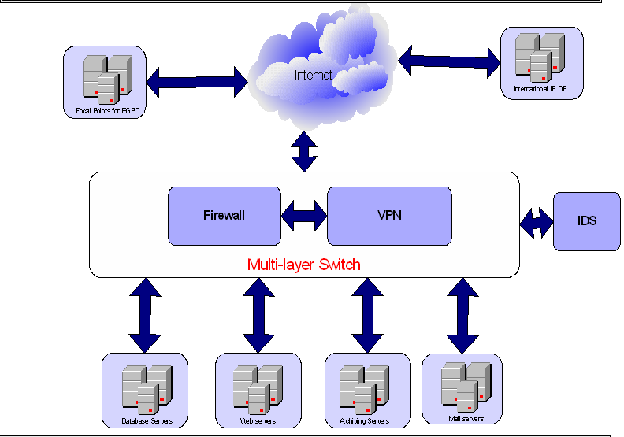

I. Network Infrastructure

Network infrastructure consists of catalyst 6500 that contains IDS, VPN, super Engine and FW service Modules that make network more secure

Catalyst 6500 Description

VPN | IP Sec VPN acceleration services Module (Sw-SVC-IPSec-1)
IDS | Intrusion Detection Module (Sw-SVC-IDSM2)
SW | WS-X6548v-GE-TX
Engine | (WS-Sup720-3B) Supervisor 720 with integrated switch Fabric/PFc3B
FW | Firewall Services Module (WS-SVC-FWM-1)

II. Security System

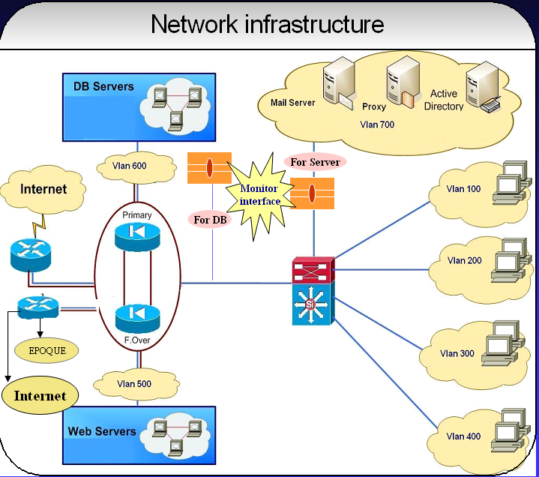

A. Polices of catalyst 6500

1. Divided catalyst into vlans
– Vlan for client.
– Vlan for examiners.
– Vlan for IT
– Vlan for Lower.
– Vlan for (HR – Information – receiving Dep.).
– Vlan for servers (domain & additional – ISA & additional – Exchange Servers).
– Vlan for Database Server.
– Vlan for website server.
2. Security policies applied on firewall service (primary)
3. Firewall failover (Secondary) .
4. IDS Monitor for any IP try to connect to Servers
5. another IDS Monitor for any IP try to connect to Database servers.
6. router for pass only allowed IP to connect to EPOQUENET Database server.
7. Backup for security system.

B. Servers on Network

1. Domain Active Directory server that manages,
– Manage all users and computer during it
– Divided user & computers to groups and manage all group
– Put polices on each group according to needed for finished work Domain Controllers GP
– Put policies on each computer
2. Additional domain controller secondary
– Make replications with primary domain
– Update services on all servers & client during WSUS.
– Generate report for all update &synchronization.
3. Symantec AntiVirus Server
– Symantec AntiVirus client for server
– Symantec System Center Console to mange all Symantec on all server & client
– Update all AntiVirus for servers & client
– Generate report for all computers that installed update and others that failed.
4. ISA Server 2004 primary
– Manage all users wanted to access internet to permit and deny according to rules put on ISA distributed according to needed of department.
– Block specific sites.
– Generate report for user
– Generate report for unwanted user trying to access servers.
5. Additional ISA Server 2004 secondary
– Make replication with primary ISA for data
– Divided users on two ISA to obtain high speed.
6. Exchange Server
– Make mail for each user on office
– Mange all mails for user
– Sent a copy for any mail sent by any user
– Filters message receive or sent by user
– Limit The Quota For Sender
– User deal with mail inside & outside office
7. Archiving servers
– Archiving servers contain all applications & patents in the following electronic formats using EPOSAN system version 4:
1- tiff compressed G4 format.
2- pdf format.
3- wipo st33 format.
– Weekly Backup for Archive system
– Exchange patent issued (.bac) format between EGPO and EPO
8. Database servers
– AIPMS Patent database using oracle9i, Traips and PCT
– PCT-ROAD and Core
– EDI
– Exchange patent issued bibliographic data (XML) format between EGPO and EPO.
– Weekly Backup for database
9. Web Server
– Web site server (www.egypo.gov.eg)
– Backup Web server (Linux and JSP)
10. syslog server
– Generate report for unwanted server access attempts blocked by intrusion detection system.
– Generate report for IP users and site want to access statistics.
11. EPOQUE Server
– Allow certain IP access to EPOQUE Database to authorized users and deny other one try to access

[Annex III follows]
Annex III
Automation of Egyptian Patent office

Objectives

– Automate office business processes (from filing to granting)
– Build office electronic registry
– Generate letters, correspondences, certificates and journal
– Establish basic electronic services for local and internal community (website and basic search)

A. Automation Platform

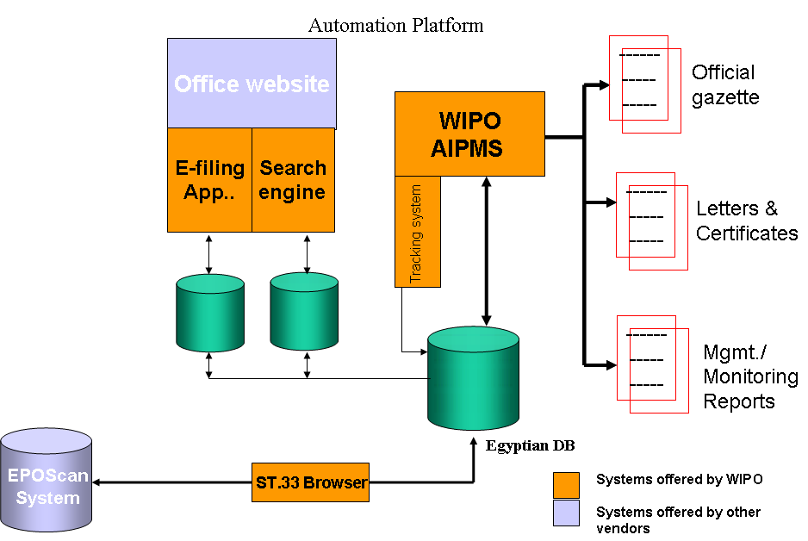

B. Automation of file workflow

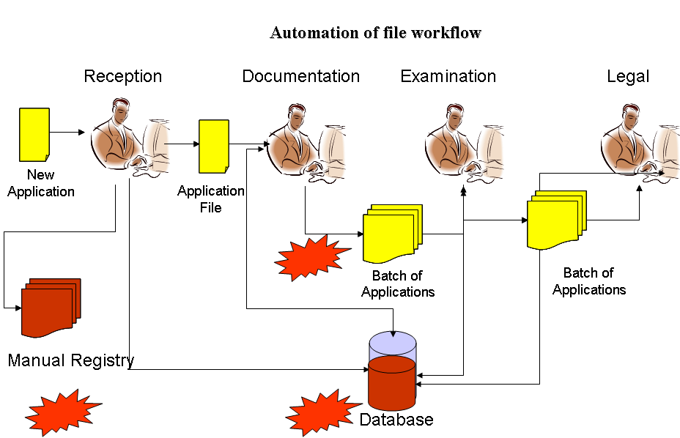

1. Incomplete database (old files)
– Inaccurate search reports
– Inaccurate corresponding (use manual letters in parallel)
– Lower utilization of system features (e.g. annuities)
– Obstacle facing e-services deployment
2. Parallel Manual registry
– Double work (manual and electronic registry)
– Source of errors and inconsistency
– More resources to maintain both registries
3. Physical file movement
– Slowing processing of applications
– Possible file loss between departments
– Additional resources required for tracking and monitoring
4. Applications volume:
– Increased number of national applications
– Increased number of International applications under PCT treaty
– Big application volume for examination and legal
– Limited increase of office staff

[Annex IV follows]
Annex IV
Automation Enhancements Roadmap

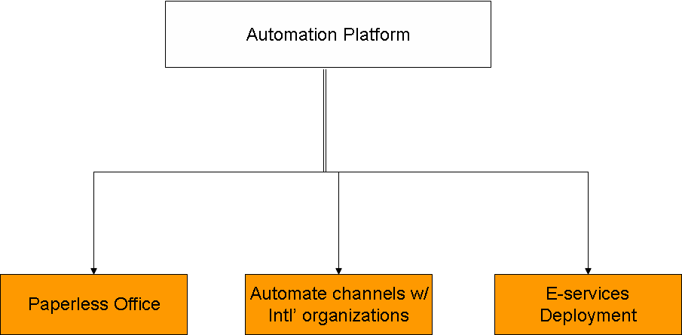

A. System Enhancements

1. Data validation (completion)
– Build project team for: data capture, validation and monitoring/management
– Implement project in two phases;
– Phase I: active patents
– Phase II: Lapsed patents
– Initial project outlook:
– 20 data entry staff
– 5 revisers and quality control
– 1 Project management
– 6*2 months period

2. Automation of Reception (Serial Number)
– Auto generate of application number from system
– Possible generation of receipt from system
– Reduce (eliminate) dependency on manual registry
– Speedup application reception
– Key pre-requisite for e-filing

3. Workflow-enabled System
– Enable monitoring on each application file
– Move from monthly monitoring to daily monitoring
– Monitor processing delay on the level of department and on the level of employee
– Create uniform and streamlined processing across all applications
– Speedup overall application processing and efficiency
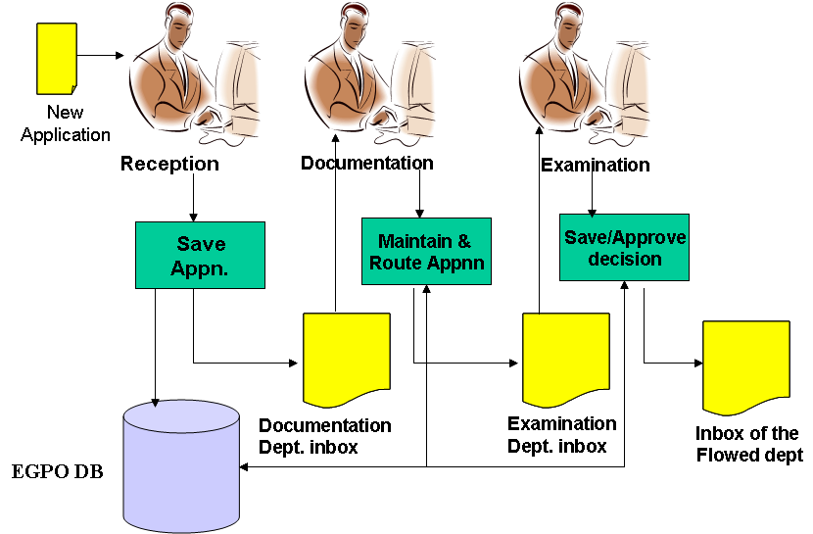

4. Output from the system

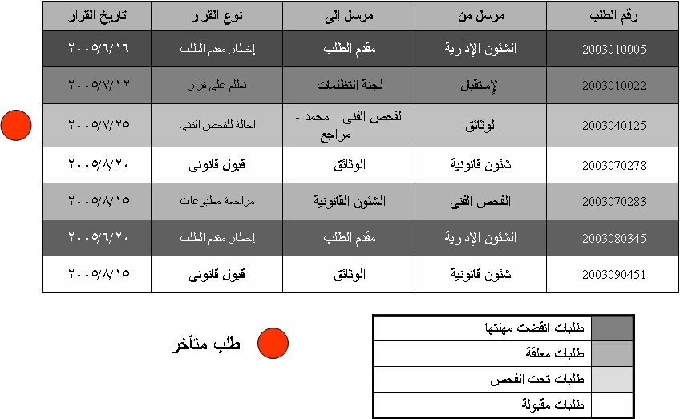

B. E-channels with WIPO

– Egyptian office member of PCT since 2003
– Accepts applications as receiving office since 2003
– Process applications entered into national phase since 2005

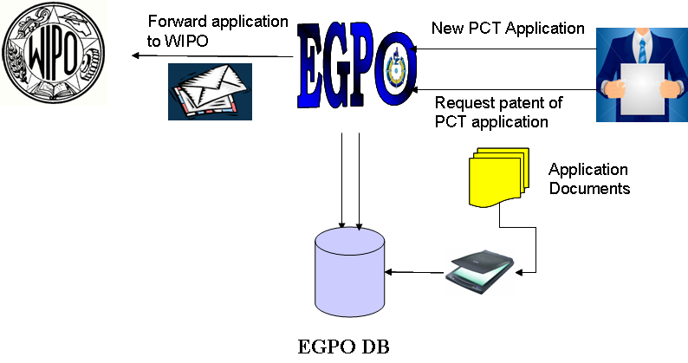
PCT channels with WIPO

C. Use of e-channels

– Office gain
– Speed up application reception
– Speedup application communication
– Simplify and speedup processing
– Reduce bottleneck at reception
– Develop office image with international organizations

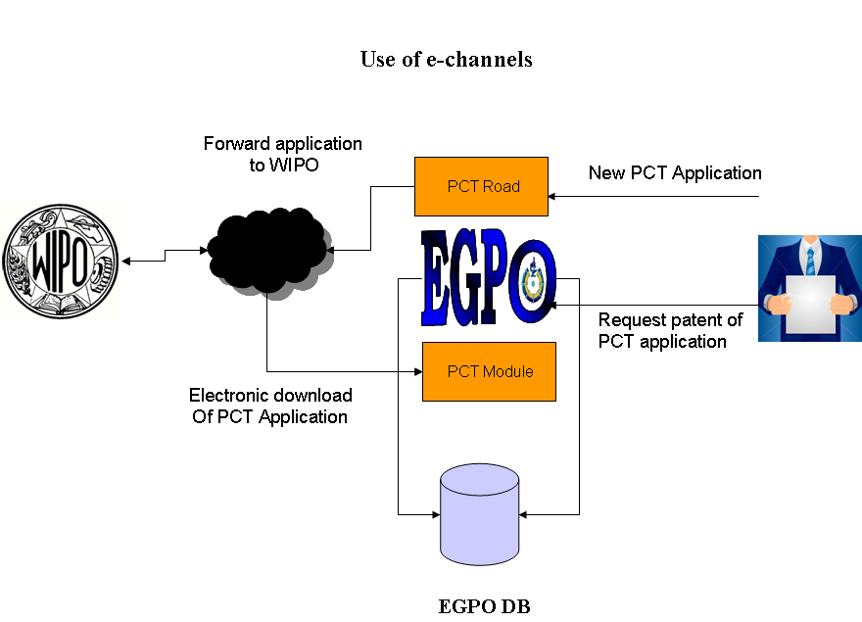

[Annex V follows]
Annex V
Eposcan system

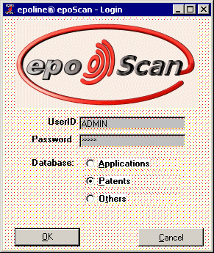

Index

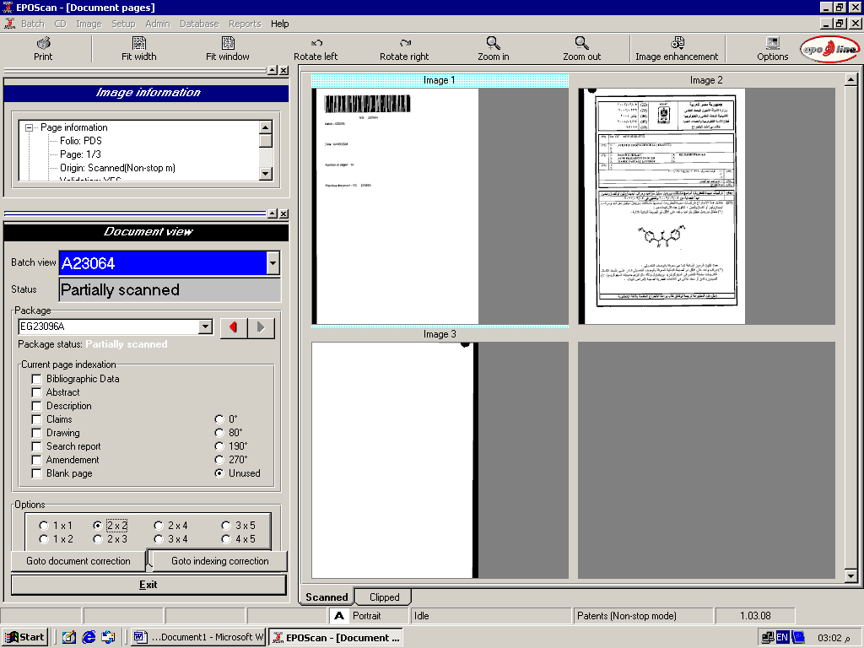

[Annex VI follows]
Annex VI
Workflow for E-Filing, E-Payment System;
Workflow for Registration System;
Workflow for Update Existing Application; and
Workflow for New Application System

1. Workflow for e-filing, e-payment system

Registration

User Name + Password
Digital Signature

Web e-filing (VPN)

Update existing Application
e-payment fee system
New Application
Searching

Application Status
Authorization (Smart card verification, Signature, Date, Checked)

Attached DOC as TIF 300 DPI
Bibliographic Data

2. Workflow for Registration system

New User
Fill out
Form
ID Generator
Submit

Front Office
Contact Information
New ID has been generated to be received by mail

Package Certificate

User

On
Disk + installations instructions
Send by mail for user

3. Workflow for Update Existing Application
OK
OK
1
User
Log on Screen

Validate
Certificate
Enter Application #
Verify Application with ID

No
No
Illegal Access
Illegal Access

Link to Registration
Grant access to Application

1
List of Services
Service details attachment
Bank form in case of Payment
Previous of Action
(Submit)

Process Payment
Generate office Receipt for Transaction

No Payment

4. Workflow for New Application system

ok
Login Screen
(Client)

User
Fill Bibliographic Data (Client)
Check list of Document attached (Client)

No
Validate Certificate (Server)

Illegal Access (Registration)

Application Form
Abstract A/E
Full Text A/E
Agency
Priority

Preview bibliographic Check list (client)

Calculation of Payment + Submit
(Server)

Response from Bank

Payment processing (Bank)
Payment form from Bank (Client)

Accept

Generate Application No. & Date (Server)

App. #
Date #
Ref # Bank +
App. Details

Generate Receipt (Server)

[Annex VII follows]
Annex VII
Quality Sampling Review committee (QSR) flow chart
President of QSR
(QSR)

Technical Committee
Legal Committee
Technical examination review
Legal examination review

Establishing evaluation report
Completed file/uncompleted file
Referring files to competent Dep. to complete examination procedures
Legal Department

Monthly workflow plan in Egyptian Patent office
Technical
Department

Electronic selection of random Sample

[End of Annex VII, of Appendix II
and of document]

