WIPO |  | E  PCT/A/XIX/1  ORIGINAL: English  DATE: June 28, 1991
WORLD INTELLECTUAL PROPERTY ORGANIZATION
GENEVA
international patent cooperation union
(pct union)
assembly
Nineteenth Session (8th Ordinary)∗
Geneva, September 23 to October 2, 1991
finances of the pct union

Memorandum by the Director General

Introduction

1. The draft program and budget for the 1992-93 biennium contains the following matters particularly relevant to the finances of the PCT Union:

- the participation of the Fee-financed Unions (including the PCT Union) in the financing of certain activities in which they had not previously participated, whereby the amount of the contributions of the Member States to the Contribution-financed Unions would remain at the same level as for the current (1990-91) biennium (see document AB/XXII/2,·paragraphs 2.23 to 2.32);

- the Alternative Financing Arrangement whereby part of the surpluses of the Fee-financed Unions (including the PCT Union) accumulated before the current (1990-91) biennium would be used to reduce the amount of the contributions of the Member States to the Contribution-financed Unions to 50% of the level for the current biennium (see document AB/XXII/2, paragraphs 2.48 to 2.56);

- the assumption that the fees paid by applicants to the International Bureau as concerns the P~T system would be increased by 10% effective January 1, 1992 (see document AB/XXII/2, paragraph 2.33(i)); and

- the special provision of 4,000,000 francs to continue the 2,000,000 francs per year reimbursement to States of the contributions that they paid before the PCT system became self-supporting (“PCT deficit-covering contributions”; see document AB/XXII/2, Item 11(6)).

2. At its April 1991 meeting, the· WIPO Budget Committee examined the above-mentioned matters and:

- “… decided to recommend to the Governing Bodies that the draft program for the 1992-93 biennium be approved, that the amount of the contributions payable in that biennium by the Member States of the Contribution-financed Unions be the same as the total amount of their contributions in the 1990-91 biennium, and that the proposal to have the Fee-financed Unions participate, with an amount of 4.3 million francs, in the financing of certain activities in which they had not previously participated be approved by the Assemblies of the PCT, Madrid and Hague Unions” (document AB/XXII/3, paragraph 16);

- did not make a recommendation concerning the Alternative Financing Arrangement, as some members of the Budget Committee agreed with it while others considered that it would be premature to make recommendations (see document AB/XXII/3, paragraphs 19 to 23);

- “ … decided to recommend that the International Bureau furnish additional documentation to the Governing Bodies concerning the finances of the PCT Madrid and Hague Unions including options for their reserves for the use of those for any fee increases and for any distribution of surpluses to Member States lf (document AB/XXII/3, paragraph 17); and

- “ … decided to recommend to the Assembly of the PCT Union that the reimbursement of the PCT deficit-covering contributions be at the amount of 6,580,819 francs during the 1992-93 biennium, in order to complete that reimbursement” (document AB/XXII/3, paragraph 29).

3. The present document provides the said additional documentation requested in respect of the PCT Union; documents MM/A/XXIII/1 and H/A/XII/1 (issued together with this document) provide the corresponding additional documentation in respect of the Madrid and Hague Unions, respectively.

Participation of the PCT Union in the Financing of Certain Activities in Which
It Had Not Previously Participated

4. The draft budget foe the 1992-93 biennium (see document AB/XXII/2, paragraphs 2.23 to 2.32) proposes that the contributions payable in that biennium by the Member States of the Contribution-financed Unions be the same as the total amount of their contributions in the current biennium. That result would be achieved through the participation of the PCT, Madrid and Hague Unions in the financing of certain activities in which they had not previously participated, in the amount of 4,300,000 francs. The participation of the PCT Union would amount to 2,666,000 francs (whereas the participation of the Madrid and Hague Unions would amount to 1,375,000 francs and 259,000 francs, respectively). Most of the said amounts would be used to cover the costs of development cooperation activities and other activities of interest to developing countries, whereas the balance would be for activities directly relevant to applicants using the PCT Madrid and Hague systems, whether such applicants are from industrialized or developing countries.

5. The following activities in the field of development cooperation are of specific interest to the PCT Union: encouraging adherence to the Patent Cooperation Treaty (see document AB/XXII/2, Item 02(3); developing human resources; facilitating the creation or improvement of legislation; institution-building; encouraging local inventive activity; developing the teaching of intellectual property law; developing the profession of intellectual property lawyer and agent; facilitating the acquisition of foreign, locally protected technology; facilitating the access to and use of technological information contained in patent documents, and facilitating the participation of representatives of developing countries in certain WIPO meetings (see document AB/XXII/2, Item 02(1), (2), (4), (5), (6), (7), (8), (9) and (11), along with the associated staff resources in the Development Cooperation and External Relations Bureaux (see document AB/XXII/2, Item 17). The participation of the PCT Union in these activities leads to the PCT Union having a correspondingly greater share in the relevant common expenses.

6. Since the proposal is feasible, since it is in the interest of each Member State (since it would reduce the cost of being a member of WIPO and the WIPO-administered Contribution-financed Unions) and since it hurts nobody, it would seem logical for the Assembly of the PCT Union to favor the participation of that Union in the financing of certain activities in which it had not previously participated.

Lowering of the Amount of Contributions to the Contribution-financed Unions

7. The draft budget for the 1992-93 biennium (see document AB/XXII/2, paragraphs 2.48 to 2.56) includes a proposal for an “Alternative Financing Arrangement” which would reduce the contributions to WIPO (by’ countries not members of either the Paris or the Berne Unions) and to the Contribution-financed Unions (that is, the Paris, Berne, IPC, Nice, Locarno and Vienna Unions) to one half of their present (1990-91) amounts. Consequently, the total amount of contributions would, instead of 47,748,000 francs, be 23,874,000 francs.

8. The other half (that is, equally 23,874,000 francs) would be covered by a transfer from the surpluses that the PCT, Madrid and. Hague Unions accumulated before 1990. The amount of those accumulated surpluses as of December 31, 1989, totaled 43,484,000 francs: 21,020,000 francs in respect of the PCT Union, 21,345,000 francs in respect of the Madrid Union, and 1,119,000 francs in respect of the Hague Union. Thus, the amount of the accumulated surpluses exceeds by 19,610,000 francs the amount that would be needed for the proposed transfer. It is to be noted that, since the proposed transfer would be covered from surpluses existing at the end of 1989 (when the 1988-89 biennium ended), such transfer could be carried out irrespective of the question of whether the current (1990-91) or the forthcoming (1992-93) biennium will end with a surplus. The amount that would be transferred from the said accumulated surpluses in respect of the PCT Union would be 11,541,000 francs.

9. It is to be noted also that the proposal to reduce contributions by 50% concerns only the 1992-93 biennium. But as matters stand today, it is highly probable that a similar reduction of the contributions would be possible also for the 1994-95 biennium from the surpluses remaining and the expected surpluses of the 1990-91 biennium. The same is true in respect to the bienniums beyond 1995, provided the level of the fees continues to be set adequately.

10. Since the proposal is feasible (the money is there), since it is in the interest of each Member State (since it would substantially reduce the cost of being a member of WIPO and the WIPO-administered Contribution-financed Unions) and since it hurts nobody it would seem to be logical for the Assembly of the PCT Union to favor the Alternative Financing Arrangement for the 1992-93 biennium.

New premises

11. As already noted in the 1989 session of the Governing Bodies (see documents AB/XX/2, Annex A, item GSS.27, and document AB/XX/11), the office and other space available in the WIPO and BIRPI Buildings will be sufficient only until the end of the 1990-91 biennium. Additional premises will be needed at the very beginning of 1992, especially for the additional staff and equipment required to handle the expected, continuing and substantive growth in the activities under the PCT, Madrid and Hague systems.

12. At the time of the writing of this document, it is not yet known where the required new building could be built and by what date its construction could be completed. It is hoped that that a new building will be completed in 2000. In the meantime, either temporary premises will have to be constructed (costing at least 10,000,000 francs) or premises will have to be rented (at a yearly cost from between 1,000,000 francs at the beginning and 4,000,000 francs towards the end, totaling until 2000 around 20,000,000 francs (not counting the maintenance costs which would be covered in the budgets)). In any case, since the need for the temporary and/or rented premises is attributable to the increasing activities under the PCT, Madrid and Hague systems, the costs will have to be financed from the special reserve fund for additional premises and computerization (see· documents AB/XX/2, paragraph 29, and AB/XX/20, paragraph 199(i) constituted from surpluses of the PCT, Madrid and Hague Unions earned in the bienniums subsequent to 1989.

13. The cost of the construction of a definitive building was very tentatively estimated two years ago at 130 million francs, on the assumption that the construction would be completed by the year 1995 and would cover the needs until 2000 (see document AB/XX/11, paragraph 30). In view of the delay of some five years, the eventual cost will doubtless ·be much higher, not only because the costs of construction (on account of inflation) will be higher, but also because the building should be bigger so as to cover the needs not only of 2000 but also for a few years beyond 2000. The said eventual cost could be of the order of 200 million francs.

14. It is recalled that the cost of the construction of the WIPO Building (completed in 1978) and the cost of the transformation (completed in 1990) of the BIRPI Building were mainly covered through loans given by the “Fondation des immeubles pour les organisations internationales” (FIPOI).

15. The giving of loans by FIPOI--the funds being voted for each loan separately by the Swiss federal parliament is a practice, and a generous one of Switzerland. It is generous because the typical loan carries a yearly interest rate of 3% or 3.5% only and is repayable (capital plus interest) in 40 equal yearly installments. Those generous loans (by which several organizations other than WIPO have also benefitted and continue to benefit) considerably alleviate the burden of the Member States: instead of having to pay the cost out of the budgets of the years in which the construction is effected, that is, three or four years (which would mean a very drastic increase of the yearly ‘amount of the contributions of the Member States), the loan allows payment out of the budgets of, 40 years (which means a relatively small increase of the yearly amount of the contributions). But since WIPO’s new building is needed not because of the Contribution-financed Unions but because of the Fee-financed Unions, the generosity of the Swiss government would-not be a generosity vis-a-vis the other governments. It is believed that WIPO should ask for a FIPOI loan only to the extent (if any) that the earnings of the Fee-financed Unions are insufficient to finance the construction. Such earnings should, attain a level that would allow the putting aside, between now and the time the construction of the new building is expected to be finished, that is, 2000, of a substantial amount of the construction cost. It will probably not be possible so to put aside all of the 200,000,000 francs indicated above from the surpluses of t he present and the next four (1992-93, 1994-95, 1996-97 and 1998-99) bienniums (which would require a surplus of some 20,000,000 francs per year from 1990 to 1999) but the maximum effort should be made out of correctness vis-a-vis the Swiss government (which finances FIPOI) that the FIPOI loan should be of the smallest possible amount.

16. What will in actual reality be possible depends on how much the surplus of the Fee-financed Unions will be. And what will be the surplus depends on the amount of the fees: higher fees will mean higher surpluses. It should, therefore, be a deliberate policy to try to obtain surpluses in order to finance at least a major part of the construction cost of the new building.

17. In addition to the construction cost of the new premises, a certain initial investment will’ be required for equipping the said new premises with furniture and office equipment such as word-processing, stations. The share of the PCT, Madrid and Hague Unions in that investment was estimated two years ago to be about 10 million francs. For the same reasons that the eventual cost of the new premises can be expected to be higher than was estimated two years ago (see paragraph 13,above), a higher cost perhaps around 15,000,000 francs can also be expected for equipping those new premises.

Computerization and Advanced Technologies

18. In order to handle, in the most cost-effective manner, the expected growth in numbers of international patent applications, significant investments will undoubtedly be needed after the 1992-93 biennium for computerization. Those investments will probably be of such magnitude as to requite; recourse to the above-mentioned special reserve fund for additional premises and computerization.

19. This, too, is a reason for putting aside all; that is possible and, certainly, for not distributing part of the surpluses to Member States. The idea of such a distribution was raised in the Budget Committee, but there is no basis--neither legal nor moral for it.

Reserve Fund of the PCT Union and Expected Surpluses

20. The need for reserves to provide for the above-mentioned investments which shows both why a fee increase is needed and why funds should not be distributed to Member States is expected to continue for the next few bienniums, but would not continue indefinitely. In particular, the situation will change once the new premises have been constructed and equipped, and once significant investments have been made in computerization and other advanced technologies.

21. As of December 31, 1989 (that is, at the end of the last (1988-89) biennium), the reserve fund of the PCT Union amounted to 21,020,000 francs.

22. At its September-October 1989 session, the Assembly of the PCT Union decided that the reimbursement of the PCT deficit-covering contributions (that had been paid by States for the six years 1978 to 1983) be at the level of 2,000,000 francs for each of the years 1990 and 1991, and that those yearly installments be covered from the reserve fund of the PCT Union. (See documents PCT/A/XVI/l, paragraph 43, and PCT/A/XVI/3, paragraph 18(ii)). Those reimbursements have therefore reduced the amount of the reserve fund of the PCT Union by (2,000,000 + 2,000,000 =) 4,000,000 francs, to the level of (21,020,000 - 4,000,000 =) 17,020,000 francs.

23. The surplus budgeted for the PCT Union for the current (1990-91) biennium is 10,849,000 francs. (See document AB/XX/2, paragraph 55, amended according to documents PCT/A/XVI/2, paragraphs 7 and 8, and PCT/A/XVI/3, paragraph 18(i) and (iii).) The said surplus will go into the special reserve fund, whose constitution was decided in 1989 by the Governing Bodies (see documents AB/XX/2, paragraph 29, and AB/XX/20, paragraph 199) for covering part of the costs of the additional premises needed to accommodate the increased number of staff and additional equipment required to handle the ever-increasing activity of the PCT, Madrid and Hague systems, and for covering part of the investments needed in connection with a fuller computerization of those systems.

24. The level of use of the PCT system is expected to be higher during the 1990-91 biennium than was budgeted two years ago, which will result in an income higher than budgeted. At the same time, the cost of handling more international applications and demands for international preliminary examination will result in expenditure being higher than budgeted. The higher than budgeted rate of inflation encountered during the 1990-91 biennium will further increase expenditure. In the light of those factors and recognizing that about one-third of the 1990-91 biennium remains at the time of writing the present document, it seems reasonable to assume that the surplus that will result for the PCT Union for the 1990-91 biennium, and which will go into the above-mentioned special reserve fund, will be approximately as budgeted, that is 10,849,000 francs.

25. Based on the assumption of a 10% increase in PCT fees, the draft budget for the 1992-93 biennium forecasts a surplus of 19,666,000 francs for the PCT Union (see document AB/XXII/2, table on page 67). As is the case for the current biennium, it is proposed in the draft budget (document AB/XXII/2, paragraph 2.14) that that surplus also go into the above-mentioned special reserve fund.

PCT Deficit-Covering Contributions

26. The draft budget for the 1992-93 biennium includes the special provision of 4,000,000 francs in order to continue the 2,000,000 francs per year reimbursement of the PCT deficit-covering contributions which had started in 1990 (see paragraph 29, above, and document AB/XXII/2, Item 11(6)). Following that reimbursement, the unpaid balance of the PCT deficit-covering contributions would be 2,580,819 francs.

27. In this context, it is recalled that, at its April 1991 meeting, the Budget Committee “… decided to recommend to the Assembly of the PCT Union that the reimbursement of the PCT deficit-covering contributions be at the amount of 6,580,819 francs during the 1992-93 biennium, in order to complete that reimbursement” (document AB/XXII/3, paragraph 29).

28. The implications of that higher rate of reimbursement of the PCT deficit-covering contributions would be that the expected surplus of the PCT Union for the 1992-93 biennium would be 2,580,819 francs lower than the figure given in paragraph 25, above, and therefore that the level of the special reserve fund referred to in paragraph 23, above, would also be lower by the same amount.

29. Nevertheless, the Director General would not oppose the said recommendation of the Budget Committee if the PCT fees will, as proposed, be increased by 10% from the beginning of the 1992-93 biennium.

Higher Costs

30. As the most recent PCT fee increase (of 8%) became effective on January 1, 1986, there will have been a period of six years until the next fee increase, namely, the proposed 10% increase which would become effective January 1, 1992. That 10% increase would therefore corresp6nd to an average increase of only 1.6% per year compounded over that period. The overall increase of inflation in Geneva during that period will have been about 23%, that is, more than double the prop6sed 10% increase in fees.

31. It is recalled that a proposal was made to the Assembly of the PCT Union, at its September-October 1989 ordinary session, to increase the PCT fees by 10%, but that proposal was not adopted (see documents PCT/A/XVI/l, paragraphs 46 to 53, and peT/A/XVI/3, paragraph 18(iii)). With a rate of inflation in Geneva having reached a rate of over 6% per year in recent months, costs will have increased by more than 11% over the two-year period since the said September-October 1989 session of the PCT Assembly.

32. As concerns higher costs in the future, it is recalled that the draft budget for the 1992-93 biennium is predicated on an overall rate of inflation in Geneva of 5% per annum for 1991, 1992 and 1993 (see document AB/XXII/2, paragraph 2.34(i). Certain expenditures could increase well beyond the forecast levels if inflation continues at higher rates, or if there are unanticipated cost increases.

33. Faced by the cost increases applicable to their own operations, various national and regional Patent Offices have recently announced significant increases in the levels of their fees in respect of patents. In the period since January 1, 1986, there have been increases in fees in most of the countries from which international applications under the PCT originate, with those increases ranging from 8% to 200%. As concerns the countries whose applicants are the major users of the PCT system, Japan increased its national filing fee by 47% effective August 1, 1987 (having previously increased its fees effective August 1, 1984); the United States Patent and Trademark Office increased its fees by an average of 69% effective November 5, 1990 (having previously increased its fees effective October 5, 1985), and the European Patent Office increased its fees by an average of 20% effective January 3, 1991 (having previously increased its fees effective January 3, 1985).

34. It is to be noted that, in 1990, the average amount of the fees for an international application under the PCT system was 1,496 francs. That amount is very reasonable in view of the numerous advantages of the PCT system for applicants.

35. Moreover, the above-mentioned average PCT fees are very low in comparison to the full costs entailed in securing patent protection. And the above-mentioned average PCT fees are minimal when compared to the overall costs of developing an invention and of bringing the associated goods to market, which overall costs can involve hundreds of thousands or even millions of francs in respect of a given invention. Thus the impact of the proposed 10% fee increase (increasing the average cost of the applicant by the very modest amount of 150 francs) has to be recognized as creating only a miniscule additional cost for those persons and companies which use the PCT system.

Fee Increase

36. In conclusion, the proposed increase in the PCT fees is needed not only to cover the higher costs due to inflation of handling international applications and demands for international preliminary examination (see paragraphs 30 to 32, above), but also

- to provide sufficient funds to enable the contributions to the Contribution-financed Unions to be maintained at their present level or even to be lowered (see paragraphs 4 to 10, above);

- to provide reserves needed for the necessary investments for new premises for both the short term and the long term (see paragraphs 11 to 17, above), and

- to provide reserves needed for extraordinary investments for further computerization and other advanced technologies to be used in the PCT system (see paragraphs 18 and 19, above).

37. It is therefore proposed that the PCT fees due to the International Bureau be increased by 10% effective January 1, 1992. The amended Schedule of Fees for the PCT system, resulting from the said 10% increase, is reproduced in the Annex.

38. A table of equivalent amounts in other currencies (“prescribed currencies”) of the fees for 1992 will be submitted to the Assembly on September 23, 1991, on the basis of the then-prevailing exchange rates and in order to accomplish the consultation with each interested receiving Office and International Preliminary Examining Authority which is provided for in Rules 15.2(b) and 57.2(c) of the PCT Regulations.

39. The Assembly of the PCT Union is invited to note the information contained in this document and to approve the proposal contained in paragraph 37, above.

[The Annex follows]

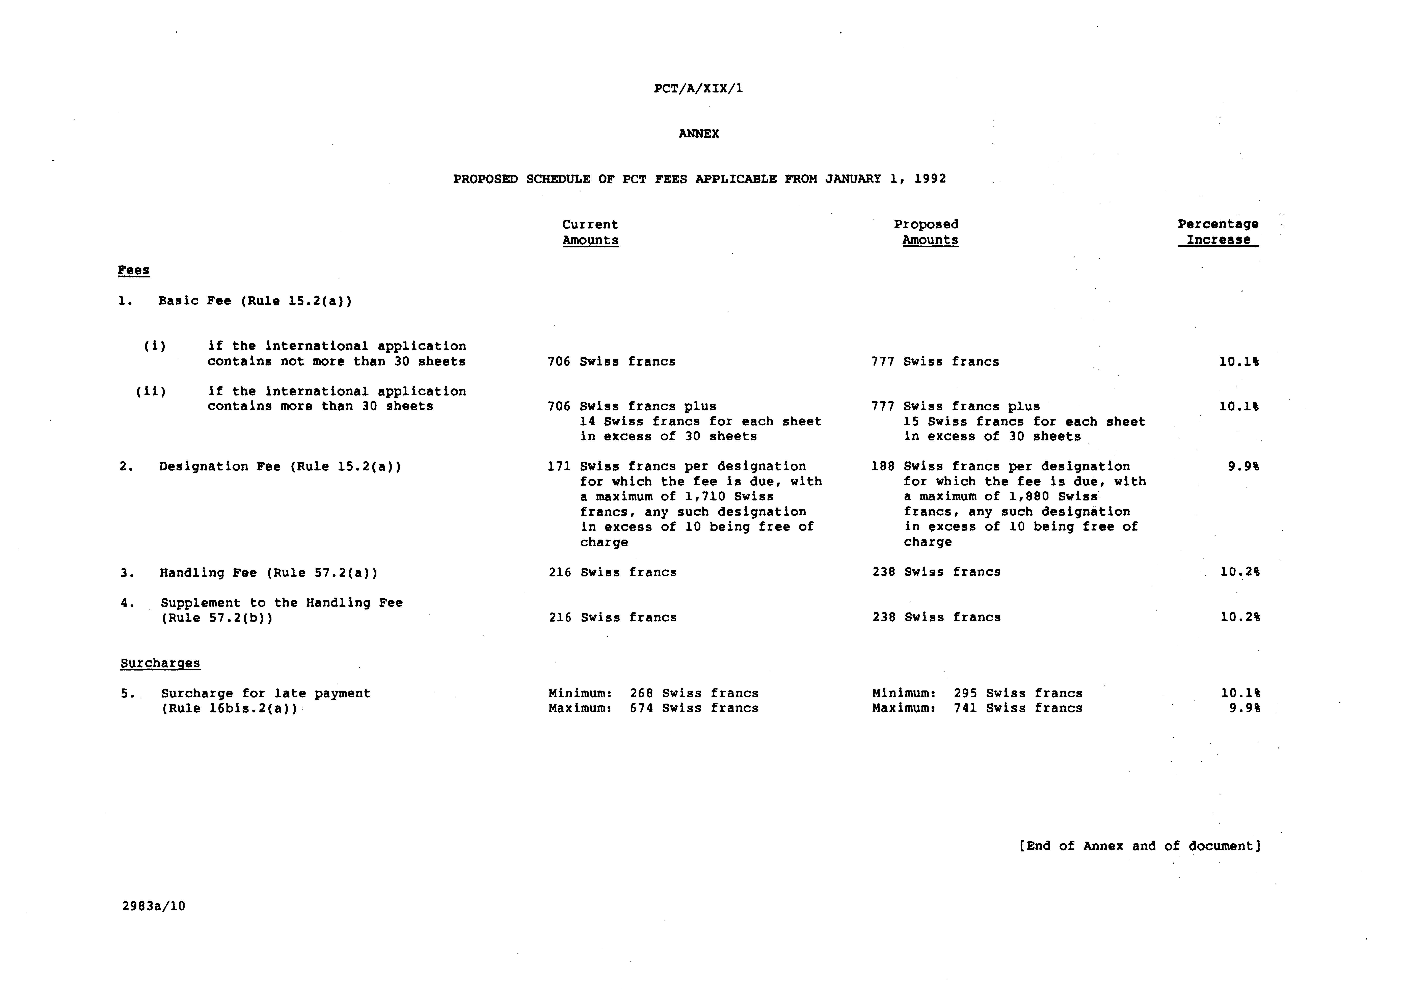

 Editor’s Note: This electronic document has been created from the paper original and may contain errors. Please bring any such errors to the attention of the PCT Legal Division by e-mail at pct.legal@wipo.int

