WIPO |  | E  PCT/A/XI/8  ORIGINAL: English  DATE: January 31, 1984
WORLD INTELLECTUAL PROPERTY ORGANIZATION
GENEVA
international patent cooperation union
(pct union)
assembly
Eleventh Session (7th Extraordinary)∗
Geneva, January 30 to February 3, 1984
proposed amendment to rules 70.16 and 74
of the regulations under the pct
(Chapter 18 of document PCT/A/XI/4 and Chapter 37 of document PCT/A/XI/5)
Proposal by the Delegation of the United Kingdom

1. The United Kingdom delegation approves the intention behind the proposals to amend Rule 70.16 to clarify the content of the annex to the International Preliminary Examination Report which will ensure that only letters which cancel entire sheets of the application are attached as annex (in addition to replacement sheets). This will reduce the amount of translation required. However, the problem which arises is that letters written to the International Preliminary Examining Authority in response to a written opinion may contain several matters, e.g. a statement cancelling entire sheets, an explanation of the differences between replaced sheets and the replacement sheets (when other amendments are made - see Rule 66.8) and perhaps several pages of argument against citations made in the written opinion. The present proposal only provides for the entire letter to be annexed. This may still involve the applicant in wasteful translation of a good deal of matter, which is not only irrelevant but could be confusing since the reader of the annex will not have before him a copy of the written opinion to which the letter is directed. Accordingly, the United Kingdom delegation would like to propose two possible ways of avoiding this.

2. The first is to further amend rules 66.8, 70.16 and 74.1 to indicate that the cancellation of entire sheets should be communicated on a separate sheet of a letter and that only this sheet be annexed to the report. This would correspond somewhat to the treatment of the statement under Art 19 (see rules 46.4). Suggested proposals for these amendments are attached (Version 1). The second method would be to require the IPEA to indicate the cancellation of entire sheets on the front page of the IPE Report. This would correspond to what the IB does (presumably) when entire sheets of claims are cancelled under rule 46.5 - see publication rule 48.2(f). This could be effected either by producing an amended form of PCT/IPEA/409 or by using the present form and in the section headed “Basis of Report” where it says “description (or claim(s), or drawings, Sheet/fig….) as originally filed adding in the space provided “are cancelled in your letter of …” as illustrated on the attached copy of Form PCT/IPEA/409. No amendment of rule 66.8 would then be needed and rules 70.16 and 74.1 could be amended as indicated in Version 2. An additional Administrative Instruction could make this procedure clear if necessary.

3. The United Kingdom delegation’s preference is for the second version.

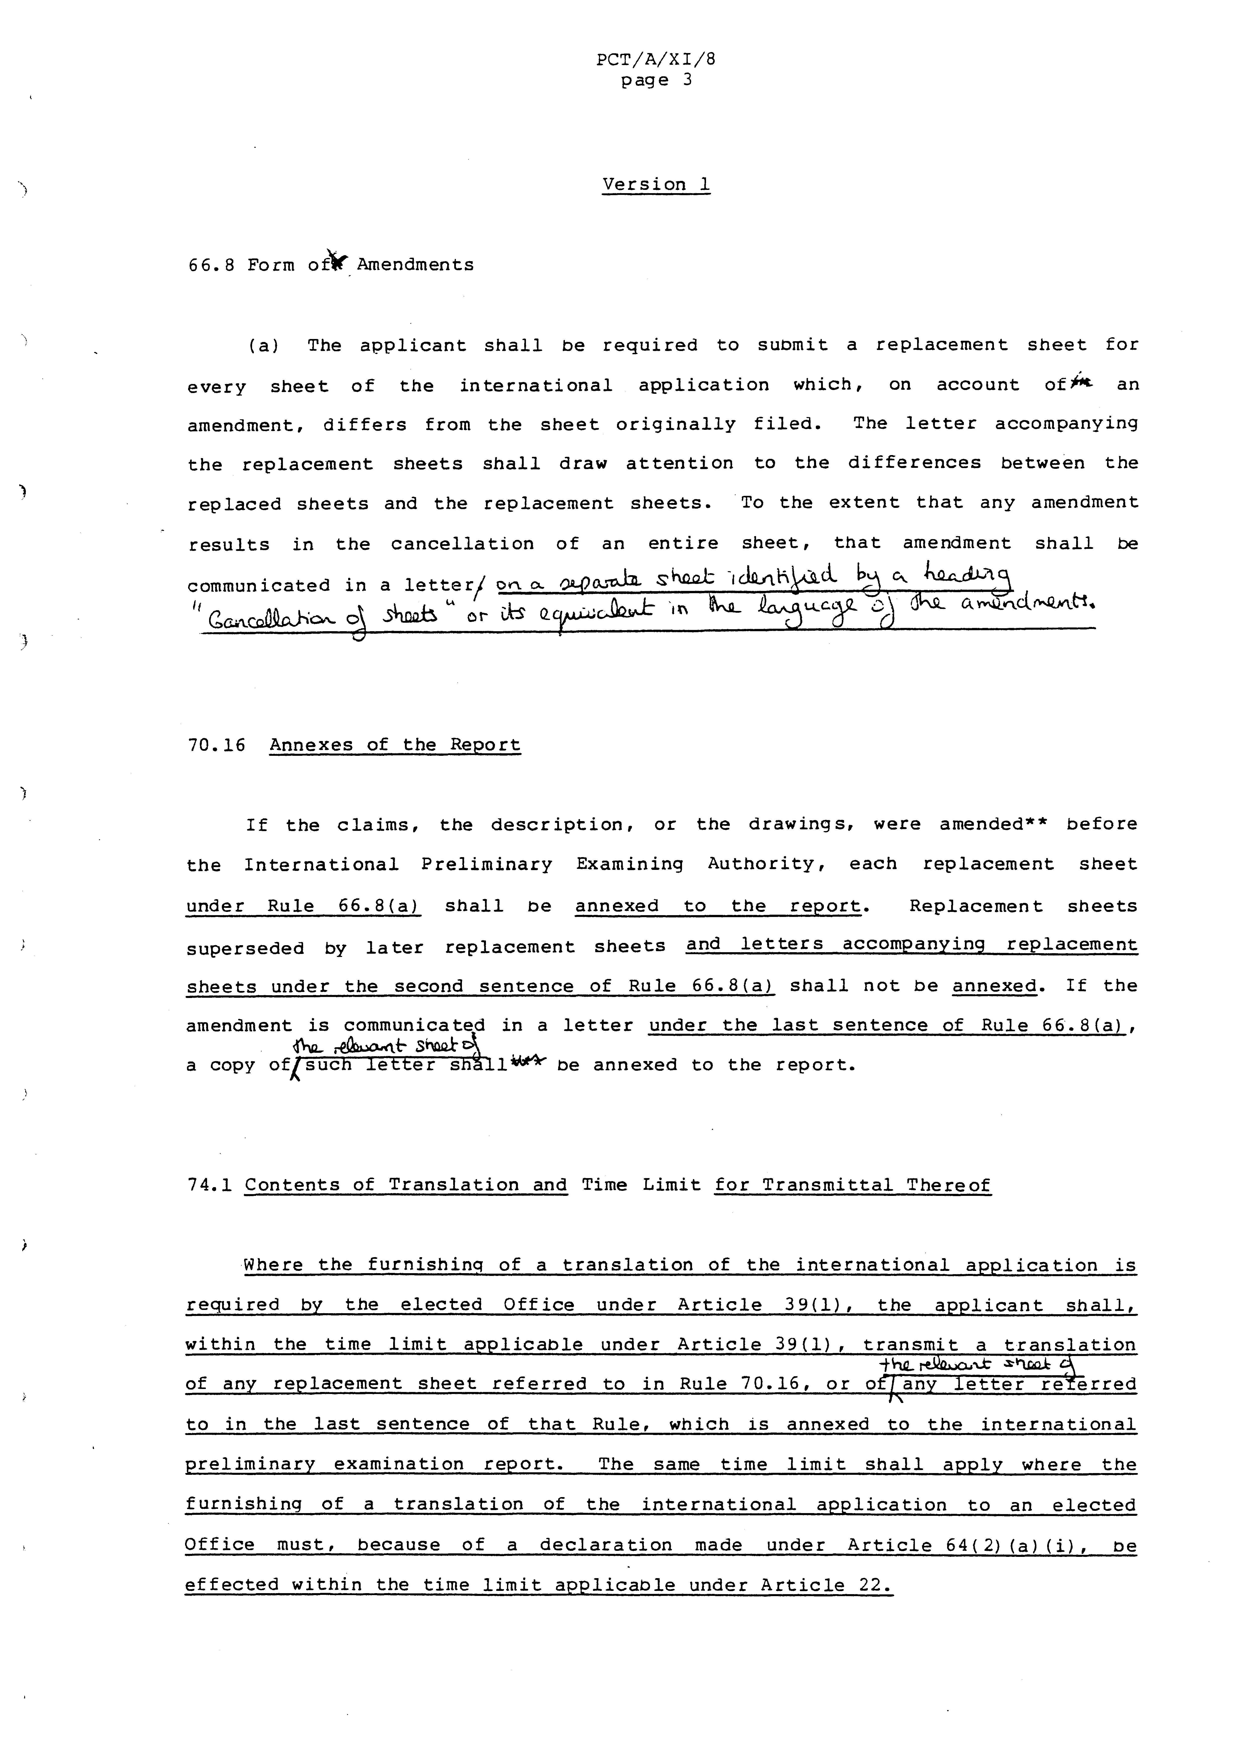
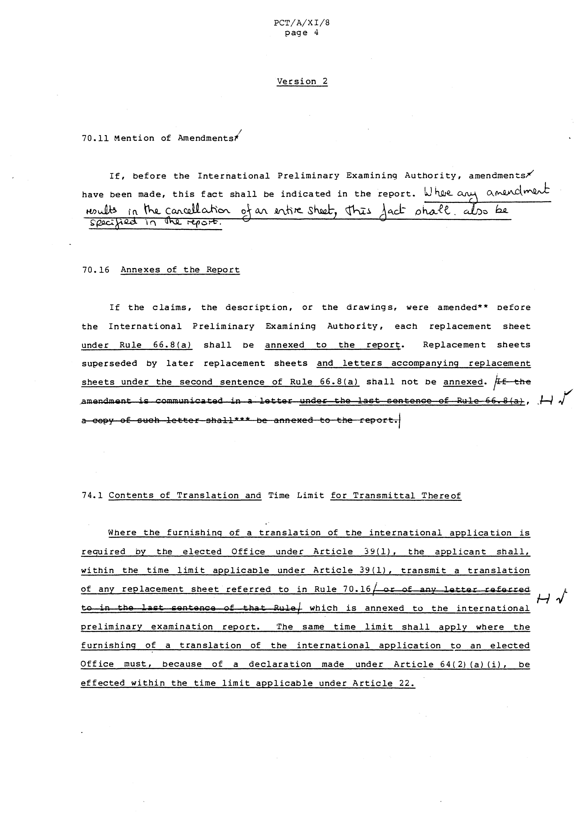
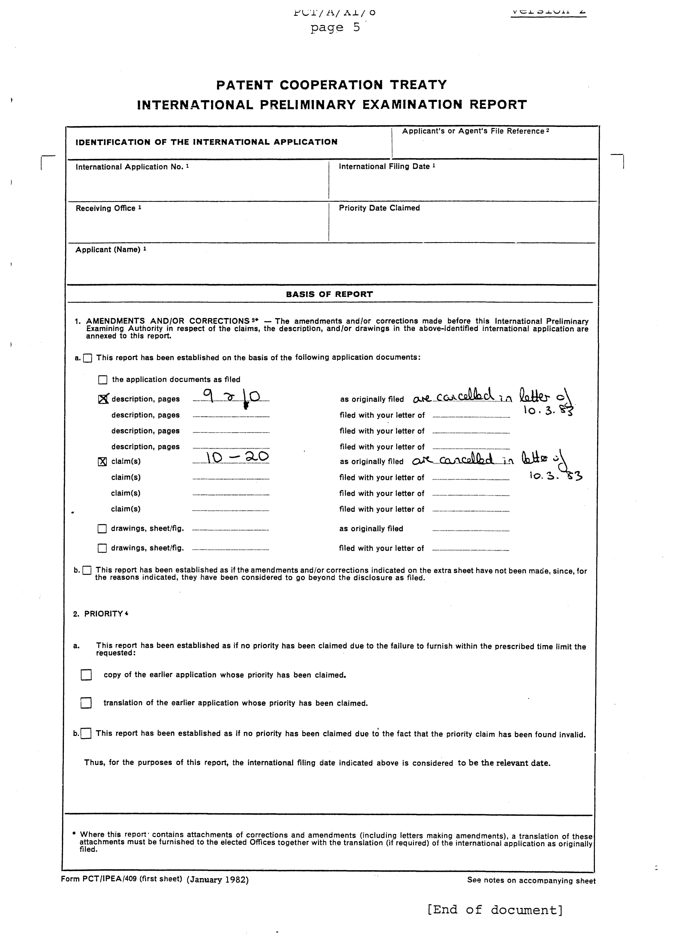

 Editor’s Note: This electronic document has been created from the paper original and may contain errors. Please bring any such errors to the attention of the PCT Legal Division by e-mail at pct.legal@wipo.int

