WIPO |  | E  PCT/A/X/2  ORIGINAL: English  DATE: June 24, 1983
WORLD INTELLECTUAL PROPERTY ORGANIZATION
GENEVA
international patent cooperation union
(pct union)
assembly
Tenth Session (4th Ordinary)∗
Geneva, September 26 to October 4, 1983
amendment of the schedule of fees
annexed to the pct regulations
Memorandum of the Director General

1. The Assembly of the PCT Union adopted the biennal budget of the PCT Union for 1982-1983 (at its eighth session, held in Geneva from November 16 to 24, 1981) on the assumption that the basic and the designation fees would be raised by 22% for each of the years 1982 and 1983 (see paragraph 66 of document AB/XII/21 and paragraphs 29 and 66(iv) of document AB/XII/2). Indeed, the 22% increase took place in 1982. During its ninth session, however, which was held in Geneva on September 10, 1982, the Assembly decided that the increase for 1983 should be of 7.5% instead of 22% (see paragraphs 10 to 12 and 17 of document PCT/A/IX/3). That decision was based on the fact that it was possible to have, at that time (September 1982), more precise estimations as to the number of international applications and of designations expected in 1983 than when the biennal budget for 1982-1983 was drafted (July 1981) and when it was adopted (November 1881).

2. When it took the decision to increase the fees by 7.5% for 1983, the Assembly of the PCT Union noted a statement made by the Director General to the effect that no deficit-covering contributions would be asked for in addition to those already decided upon for 1983 provided certain assumptions were confirmed by facts, including the assumption that the fees would be increased by 10% for 1984 and by another 10% for 1985 (see paragraph 11 of document PCT/A/IX/3).

3. The draft bienna1 budget of the PCT Union for 1984-1985 does not provide for deficit-covering contributions for 1984 and 1985 and has been established on the basis of assumptions contained in paragraph 49 of document AB/XIV/2 which include the assumption that the basic and the designation fees would be raised by 10% for 1984, so that they would be 623 francs and 150 francs, respectively, from January 1, 1984. (As to the assumption that the fees would be raised by a further 10% for 1985, the Assembly of the PCT Union will have to take a decision thereupon in 1984.)

4. It is proposed to amend the Schedule of Fees annexed to the PCT Regulations accordingly. Since the Schedule of Fees also contains other fees, it is proposed to apply a 10% increase to those fees too. The resulting new Schedule of Fees is reproduced in Annex I to this document.

5. Equivalent amounts in other currencies (“prescribed currencies”), as provided for under Rules 15.2 and 57.2 of the PCT Regulations, have been provisionally calculated on the basis of the exchange rates of June 1, 1983, as indicated in Annex II to this document. The calculation will be reviewed on September 1, 1983, Annex II will be updated if necessary and the updated version, if any, will be submitted to the Assembly on September 26, 1983. That procedure will constitute the consultation with each interested receiving Office and International Preliminary Examining Authority’ which is provided for in Rules 15.2(b) and 57.2(c) of the PCT Regulations.

6. The Assembly of the PCT Union is invited

(i) to amend, with effect as of
January 1, 1984, the Schedule of Fees annexed to the PCT Regulations as set out in Annex I;

(ii) to note the Table of Equivalent Amounts, reproduced in Annex II, or its updated version, if any.

[Annex I follows]

Schedule of fees

Fees Amounts

1. Basic Fee:
(Rule 15.2(a))

if the international application contains
not more than 30 sheets 623 Swiss francs

if the international application contains
more than 30 sheets 623 Swiss francs plus
13 Swiss francs for each sheet in excess of 30 sheets

2. Designation Fee:
(Rule 15.2(a)) 150 Swiss francs

3. Handling Fee:
(Rule 57.2(a)) 191 Swiss francs

4. Supplement to the Handling Fee:
(Rule 57.2(b)) 191 Swiss francs

Surcharges

5. Surcharge for late payment: Minimum: 236 Swiss francs
(Rule 16bis.2(a)) Maximum: 594 Swiss francs

[Annex II follows]

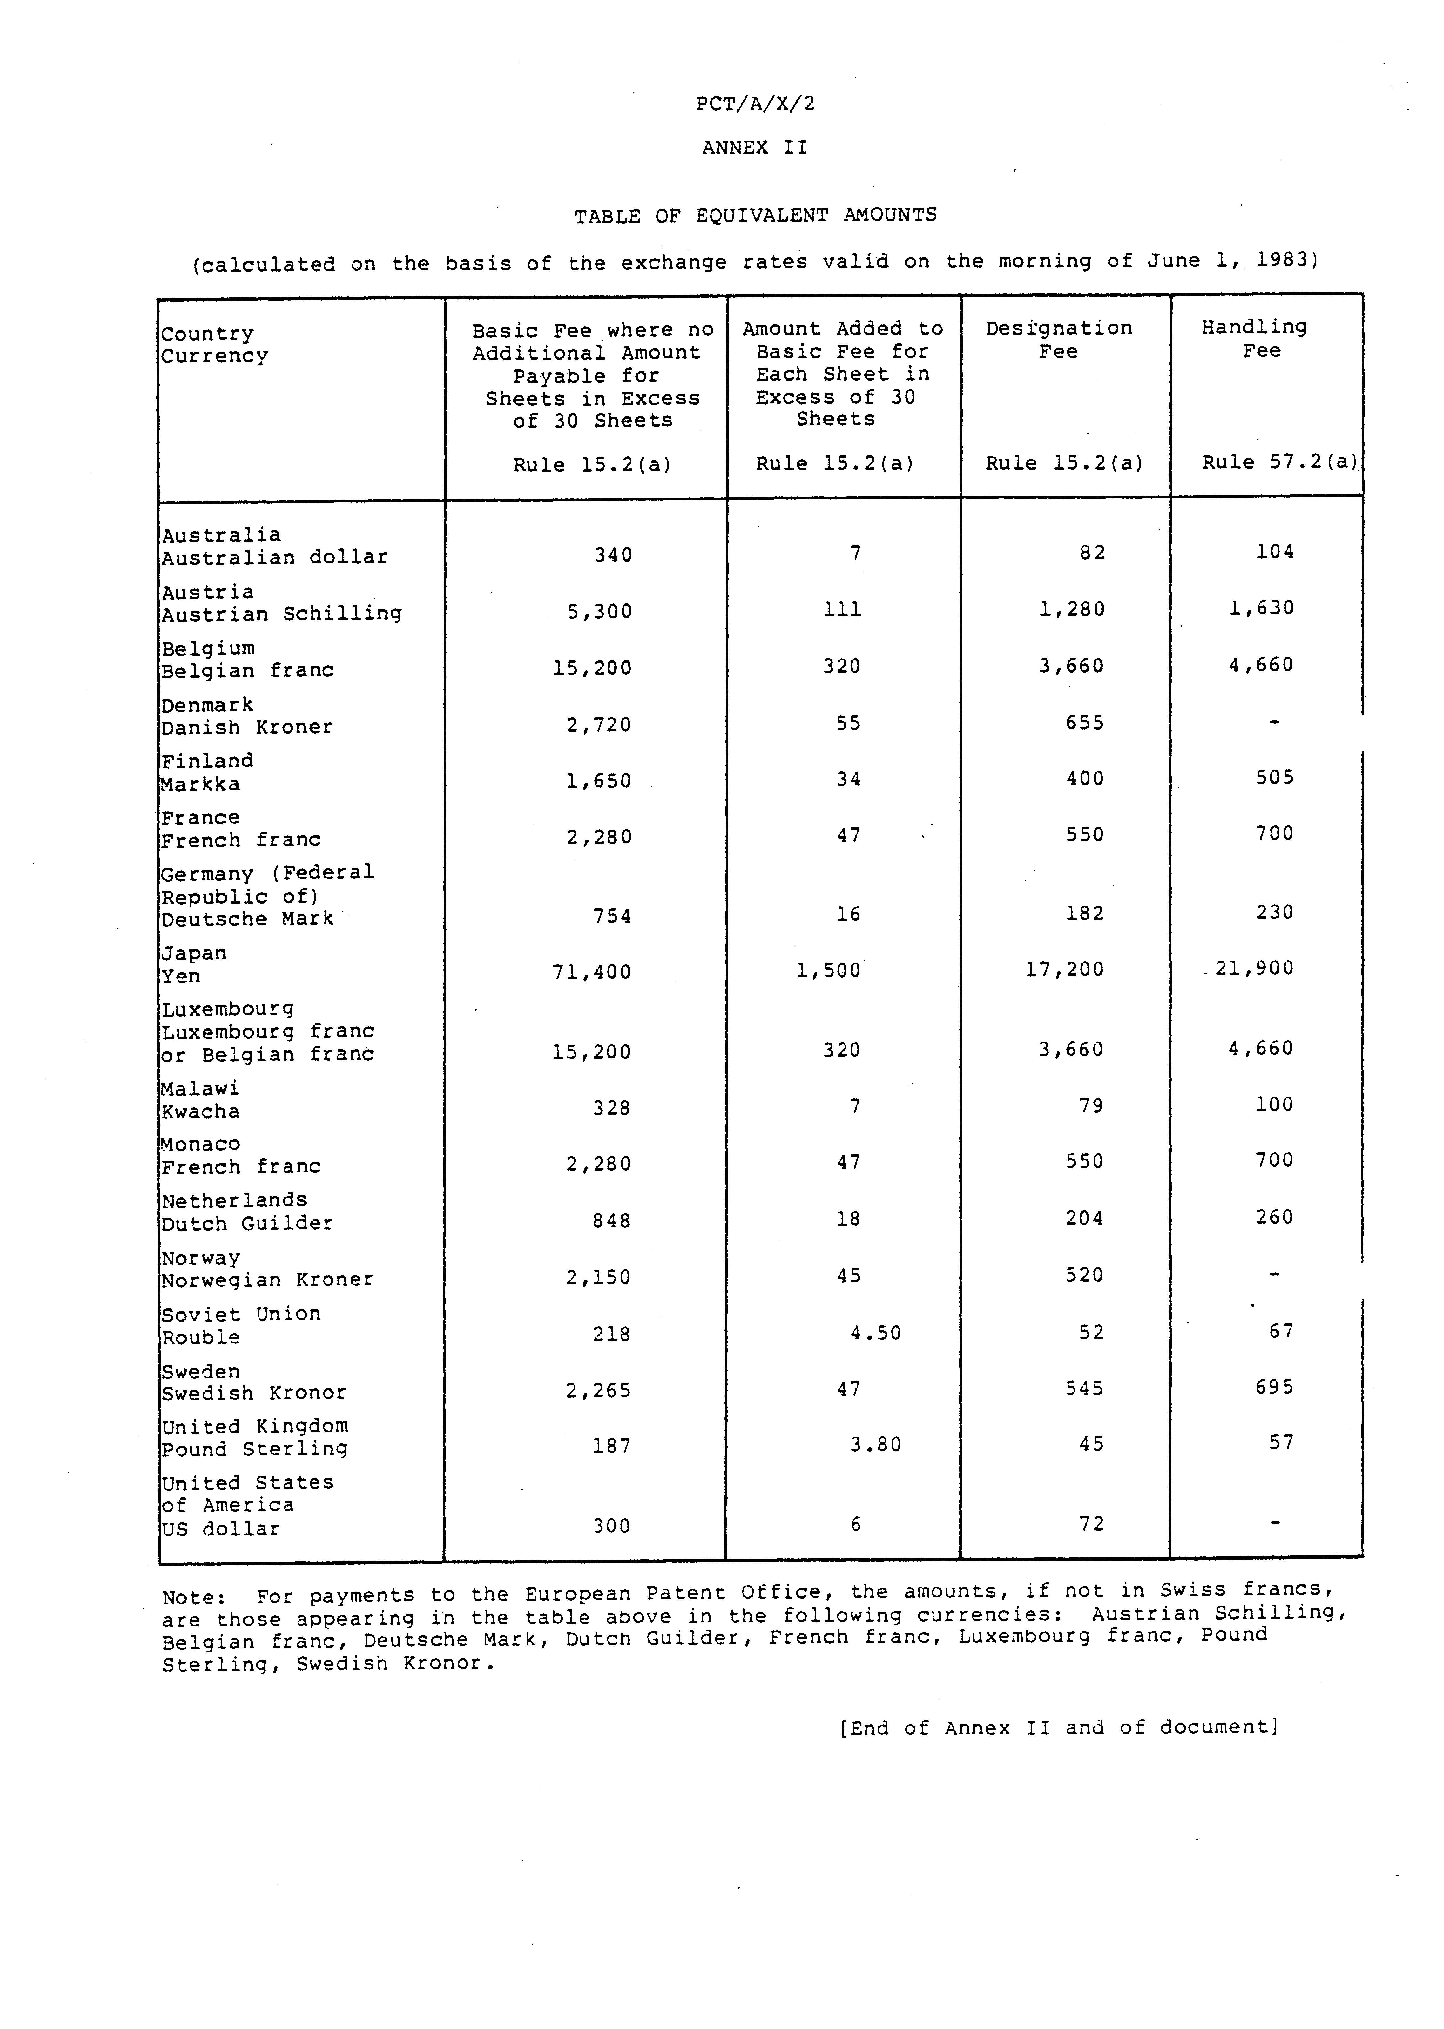

 Editor’s Note: This electronic document has been created from the paper original and may contain errors. Please bring any such errors to the attention of the PCT Legal Division by e-mail at pct.legal@wipo.int

