WIPO |  | E  PCT/A/VII/2  ORIGINAL: English  DATE: April 6, 1981
WORLD INTELLECTUAL PROPERTY ORGANIZATION
GENEVA
international patent cooperation union
(pct union)
assembly
Seventh Session (5th Extraordinary)∗
Geneva, June 29 to July 3, 1981
proposed revision of the request form
Memorandum prepared by the International Bureau

Background

1. Certain proposals for the revision of the “request” form (form PCT/RO/101), made by one of the organizations representing users of the PCT system were brought to the attention of the Assembly at its fifth session (third extraordinary) held in Geneva from June 9 to 16, 1980, but, due to the need for further study, no proposal for the revision of the form was made at that session by the International Bureau. The International Bureau said (in document PCT/A/V/4 Corr.Add., page 2), however, that it agreed “that a change of the request form should be considered having particular regard to the mistakes made by applicants when filling in that form (see document PCT/A/V/6 Add.2).”

2. Furthermore, it was noted in the report of the said fifth session that, due to a lack of time, a discussion was not possible of the desirability of revising the request form during the consultations (relating to the Administrative Instructions as provided in Rule 89.2(a)) which were held on the occasion of the said fifth session with the receiving Offices and the International Searching and Preliminary Examining Authorities but that the question would be studied by the International Bureau (see document PCT/A/V/17, paragraph 59).
3. The present document contains in its Annex A, a draft of a revised version of the request form (“the proposed request form”) and of the Notes thereto which is the result of a study carried out by the International Bureau.

4. In preparing the proposed request form, the International Bureau had regard to:

- the improvements requested by the organization representing users of the PCT system (see paragraph 1, above);

- the most frequent mistakes it had noticed as having been made by applicants in completing the present version of the request form (“the current request form”), including those mentioned in document PCT/A/V/6 Add.2;

- the desirability of omitting certain items dealt with in the current request form since, in practice, the matters provided therein arise only infrequently and either lead to confusion and error or occupy space which could be utilized more effectively for the purposes of other items included in the request form; and

- changes effected in the last sessions of the PCT Assembly in the PCT Regulations which require consequential changes in the current request form.

Improvements Requested by PCT Users

5. The changes requested by the users of the PCT system (paragraph 4 (i), above) were:

- that particulars of the inventor need be given only once;

- that, where one of the applicants has already, prior to the filing of the international application, given a genera1 power of attorney for the agent named, the agent should be entitled to sign the international application for that applicant (the other applicants will still have to sign);

- that more space should be provided in the appropriate boxes for Applicant, Designation of States and Priority Claim so that the cases in which the Supplemental Box is needed should become less frequent.

Mistakes Noticed by International Bureau

6. Some of the mistakes mentioned below (but not all) are probably due to the weaknesses of the current request form. They consist of:

(a) The following mistakes noticed by PCT users (see document PCT/A/V/6 Add.2):

- failure to complete Boxes Nos. II and IX of the current request form correctly (the applicant for the United States of America being indicated in Box No. IX but not also in Box No. II);

- omission of indications of applicants’ nationality and residence when indications concerning applicants are given in the Supplemental Box;
- failure to indicate names of natural person in the manner prescribed in Rule 4.4(a) (which requires that the person’s family name be indicated before the person’s given name(s));

- designating the “OAPI States” incorrectly;

- failure to indicate in the priority claim the country where the earlier application was filed;

- indication of irrelevant matter in Box No. VII of the current request form due to apparent lack of understanding of its purpose; (indication of a priority application instead of a parent application);

- failure, when there are different applicants for different designated States, to include in Box IX of the current request form indications regarding all of the applicants;

- failure of persons signing specifically in a representative capacity (e.g., as representative of a legal entity) to also sign in a personal capacity when the person signing is also an applicant in his own right; and

(b) The following additional mistakes noticed by the International Bureau:

- the applicant’s nationality is not completed correctly (because an adjective describing the nationality has been used and not the name of the country, e.g., “Austrian” rather than “Austria”);

- the applicant’s residence (indicated by the name of the country) is left blank since it is the same country as that shown in the address;

- inappropriate short titles are used for the designation of States;

- failure to indicate that a regional (European) rather than a national patent was desired.

Recent Amendments to the regulations

7. The following amendments to the PCT Regulations have been taken into account:

- with regard to indications concerning the agent (Box No. IV of the current request form), the possibilities now provided for in Rule 90.3(a) that, where there are several applicants, the agent may be appointed- by one or more applicants signing the request and by others signing a separate power of attorney and in Rule 90.3(d) that a general power of attorney may be utilized provided that a copy is supplied;

- with regard to the priority claim (Box No. Vl of the current request form), the possibility provided for in Rule 17.1(b) of asking the receiving Office to transmit the priority document to the International Bureau where that Office is the Office with which the earlier document was filed;

- with regard to a reference to an earlier international or international-type search, (Box No. VIII of the current request form), the inclusion, as provided in Rules 4.11 and 41.1, of reference to “other search.”

The Proposed Request Form

8. The paragraphs below comment on each of the boxes of the proposed request form.

Box No. I

9. Apart from the size of the box being slightly reduced, this box is the same as in the current request form. Such reduction should invite applicants to use titles of the recommended length.

Boxes Nos. II and III

10. These Boxes permit indications to be given concerning three persons who are applicants and/or inventors provided that one person at least is an applicant. The latter (who mayor may not also be inventor) must be indicated in Box No. II. Each of the additional persons may be in any of the following categories: applicant and inventor, applicant only, inventor only. The category must be shown by completion of the appropriate check box. The new arrangement not only meets the desire mentioned in paragraph 5(i), above, to avoid any need to repeat the name of a person who is both applicant and inventor (as is necessary with the current request form when there are several applicants not all of whom are inventors and there are different applicants for different designated States) but also makes provision for indications concerning possibly two (but always at least one) additional person(s) without restriction due to the category to which the person may belong before recourse must be had to the Supplemental Box. It is considered that the number of cases in which recourse to the Supplemental Box will be necessary (see paragraph 5(iii), above) will be reduced to reasonable proportions (less than 5% of the cases).

11. Since applicants may be indicated in Box No. III, provision has been made therein for all of the indications (name, address, nationality, residence) which must be given regarding an applicant. The text makes it clear that the indications as to nationality and residence are not to be given if the person indicated is inventor only.

12. The confusion which sometimes occurs as to how to complete Boxes Nos. II and IX of the current request form (see paragraphs 6(a) (i) and (vii), above) is avoided by the providing of indications (explained in the next paragraph) which allowed the deletion of Box No. IX of the current request form.

13. In practice, all except a small percentage of applicants fall into one of the following three categories;

- applicant for all designated States (including the case of a single designated State) (i.e., there are no different applicants for different designated States);

- applicant for all designated States except the United States of America
(i.e., the United States of America and other States are designated and there are applicants who are not inventors);

(iii) applicant for the United States of America only (i.e., the United States of America and other States are designated and the inventors, who have assigned the invention, are the applicants for the purposes of the designation of the United States of America only).

Check boxes corresponding to these categories and an additional box for the (very few) cases, where none of these three categories is applicable (to be completed in such cases by precise indications in the Supplemental Box as to the particular States for, which the person in question is applicant) have been provided (and must be completed).

14. With a view to avoiding mistakes in the manner of indicating names (see paragraph 6(a) (iii), above), a footnote specifies the correct manner; likewise, an indication that it is the country of nationality or residence which must be given should limit the mistakes made in completing these indications (see paragraph 6(b) (i), above). A further footnote makes it unnecessary, in fact, to indicate the country of residence where that country is the same as that indicated in the address, thus avoiding any need to correct the omission of the indication of the country of residence (see paragraph 6(b) (ii), above).

15. The other footnote to Boxes Nos. II and III requires the indication in the Supplemental
Box of the designated State for, which a person is inventor if there are different inventors for different designated States. Experience to date has shown that it is extremely rare for different inventors to be indicated for different designated States. The allocation of space in the request form for a Box for these indications does not seem justified and accordingly Box No. X of the current request form has been deleted from the proposed request form (see in this regard paragraph 4(iii), above).

Box No. IV

16. The box provides for the indication of the name and address of the agent (or, in the case of several agents having the same address, their names and addresses) or where, instead of an agent, one of the applicants is appointed common representative, the name of such common representative. Provision is also made for the indication of the telephone number, telegraphic address and teleprinter address of the agent(s) named in the box. The box has three check boxes one of which must always be checked. Starting with the left hand check box, the checking of the first check-box indicates that the appointment of the agent (or common representative) is effected by signature of the request; the checking of the second check-box indicates that the appointment was effected by a separate power of attorney signed by all of the applicants or at least those not signing the request; the checking of the third check-box indicates that the appointment was effected by a general power of attorney signed by all of the applicants or at least by those not signing the request. The box provides for much more space than the current request form does.

17. The new text and format take into account the amendments to Rule 90.3(a) and (d) adopted at the fifth session of the Assembly (see paragraph 7(i), above).

Box No. V

18. The primary purpose of this box is the designation of the States in which protection is desired. Where a European patent as well as national patent is available, the applicant must indicate whether he wants a national patent or a European patent or both. The subsidiary purpose of the box is to allow indications regarding possible kinds of protection other than a patent or special kinds of treatment. By other kinds of protection is meant petty patents, utility models, inventors’ certificates, whereas by other kinds of treatment is meant titles (e.g., patents, inventors’ certificates) of addition and, in the United States of America, continuation or continuation-in-part.

19. The general purpose of Box No. V and the indications it may contain are not changed significantly in the proposed request form. But, whereas in the current request form a blank space is provided in which the applicant must write the names of the States in which he wishes the international application to have effect and any desired indications of the choice of a European patent and/or certain kinas of protection or treatment (but not of a continuation or continuation-in-part in the United States of America), this is changed in the proposed request form to the extent that the names of the PCT Contracting States are preprinted together with check boxes to be used for the indication of designations and the choice of a national and/or European patent. The indication as to kinds of protection and kinds of treatment (including continuation or continuation-in-part in the United States of America) would be simply written in by the applicant where desired in a space reserved for that effect after the check box relating to the national patent. A footnote (relating to certain check boxes) draws attention to the existence of instructions in the Notes to the proposed request form on how the indications are to be made. The check boxes have been arranged so as to provide space for the indications to be inserted in those cases where the applicant has a choice.

20. The names of the countries (and of the EPO and of OAPI) appear in the alphabetical order of the two-letter codes with the result that, whatever the language of the request form is, the order of the countries remains the same.

21. Possible objections to the proposed pre-printing of the names of Contracting States may be that a mistake could be made in checking a box, or that the pre-printed names will have to be added to from time to time as more countries join the PCT, or that the order in which States are listed could have implications if some designation fees are unpaid.

22. The avoidance of mistake cannot, however, be ruled out with the current request form with which there may be a tendency to fail to list countries which it was intended to designate or to fail to indicate clearly whether a European or a national patent is sought. The only solution finally is to permit the correction of what can be demonstrated to be errors. It is not considered that the need to add new member countries is a major objection and, in the period from entry into force of the PCT for new States and their inclusion in the list printed in the form, the space at the bottom of Box No. V should be sufficient for the listing of such countries by the applicant.
23. The need existing under the current request form for users of the PCT system to frequently list countries in the Supplemental Box has been criticized (see paragraph 5(iii), above). The proposed request form ensures that recourse will never be needed to the Supplemental Box for the designation of States. Moreover, the printing of the correct names of the Contracting States in the form itself will not only avoid mistakes due to the use of incorrect names but serve as a guide to the names to be shown elsewhere in request.

24. As far as failure to pay designation fees is concerned, it must be agreed that the listing in the alphabetical order of country codes may lead to an unintended result flowing from the application of provisions such as Rule 16bis.2(c) (ii). However, at present many applicants probably act in ignorance of such provisions. Those who do not will have two possible safeguards. First of all, Rule 16bis is a safeguard since it requires a notification to be given to the applicant. Then the possibility of indicating preferences in the Supplemental Box is expressly invited in the note to that Box.

Box No. VI

25. This box has been changed in order to satisfy the demand for a revision of the form which would allow several priority claims to be indicated (see paragraph 5(iii), above) and to take into account the amendment of Rule 17.1(b) accepted at the fifth session of the Assembly (see paragraph 7(ii), above).

26. While certain changes to the text and layout have been made, the only substantive change is in the extreme left-hand column which now suggests the indication of only one country in the case of all kinds of earlier application (i.e., international and regional as well as national).

Box No. VII

27. Textual changes mainly reflect the amendment to Rules 4.11 and 41 adopted at the fifth session of the Assembly (see paragraph 7(iii), above).

Box No. VIII

28. This box has been enlarged to allow more signatures and, if so desired, the typing in of the name of the person signing and, where appropriate, the capacity in which the person is signing. Reference to signature by the agent as well as by the applicant has been included in the title.

Box No. IX

29. The changes take into account the documents which may, under the present practice, accompany the international application when it is filed.

Supplemental Box

30. This box has been changed in two main respects. First, it has a whole sheet devoted ‘to it so that, when not used, it may be discarded and thereby ease the reproduction work. In fact, it is not expected that the sheet will be used often. This is so because the reason for the use of the box at present (insufficient space in certain boxes) should largely disappear with the other changes made in the proposed request form.

31. Secondly, certain items for which special boxes are provided in the current request form but for which no special box is included in the proposed request form are, as has been noted, envisaged to be indicated in the Supplemental Box. These items are listed in the heading of the Supplemental Box, and specific instructions are given as to the text matter which should be used when those items are to be included in the request. Furthermore, due to the pre-printing of the names of States for the purposes of indicating designations, the applicant may, if he wishes, indicate an order of designations which, however, will only be of relevance where not all designation fees are paid.

32. The possibility of using the Supplemental Box, as at present, in cases where there is insufficient space in a box to include the indications required will continue unchanged.

Consequential Amendments to Rules 3 and 4 of the PCT Regulations

33. Rule 3.3(a) (ii) containing the list of documents which make up the check list of the documents that may accompany the international application will need to be amended mainly to include a reference to the power of attorney or the copy of a general power of attorney referred to in paragraph 16, above.

34. Certain of the provisions of Rule 4 will also need to be amended mainly in view of the amendments referred to in paragraph 7(i) and (ii). Annex B contains (on its right hand side pages) the texts of proposed amendments and (on its left hand side pages) the explanations of the International Bureau of the reasons for the amendments.

35. It is to be noted that none of the proposed amendments affects in any way the rights and obligations of the receiving Offices, a fact that should facilitate their approval.

36. The Assembly is invited to consider and, if it agrees,

(i) to adopt the amendments to the PCT regulations contained in Annex B;

(ii) to fix September 1, 1981, as the day on which the said amendments shall enter into force.

Consequential Amendments to the Administrative Instructions

37. Certain Sections of the Administrative Instructions will need to be amended mainly having regard to the inclusion of preprinted indications with associated check boxes in the proposed request form.

38. Annex C contains (on its right hand side pages) the texts of proposed amendments to certain Sections and (on its left hand side pages) the explanations of the International Bureau.

[Annex A follows]

Contents of Annex A

Request Form

(1) First sheet (recto only)

(2) Second sheet (recto only)

(3) Supplemental sheet (recto only)

(4) Last sheet (recto only)

Notes to Request Form

(5) 1 sheet (recto-verso)

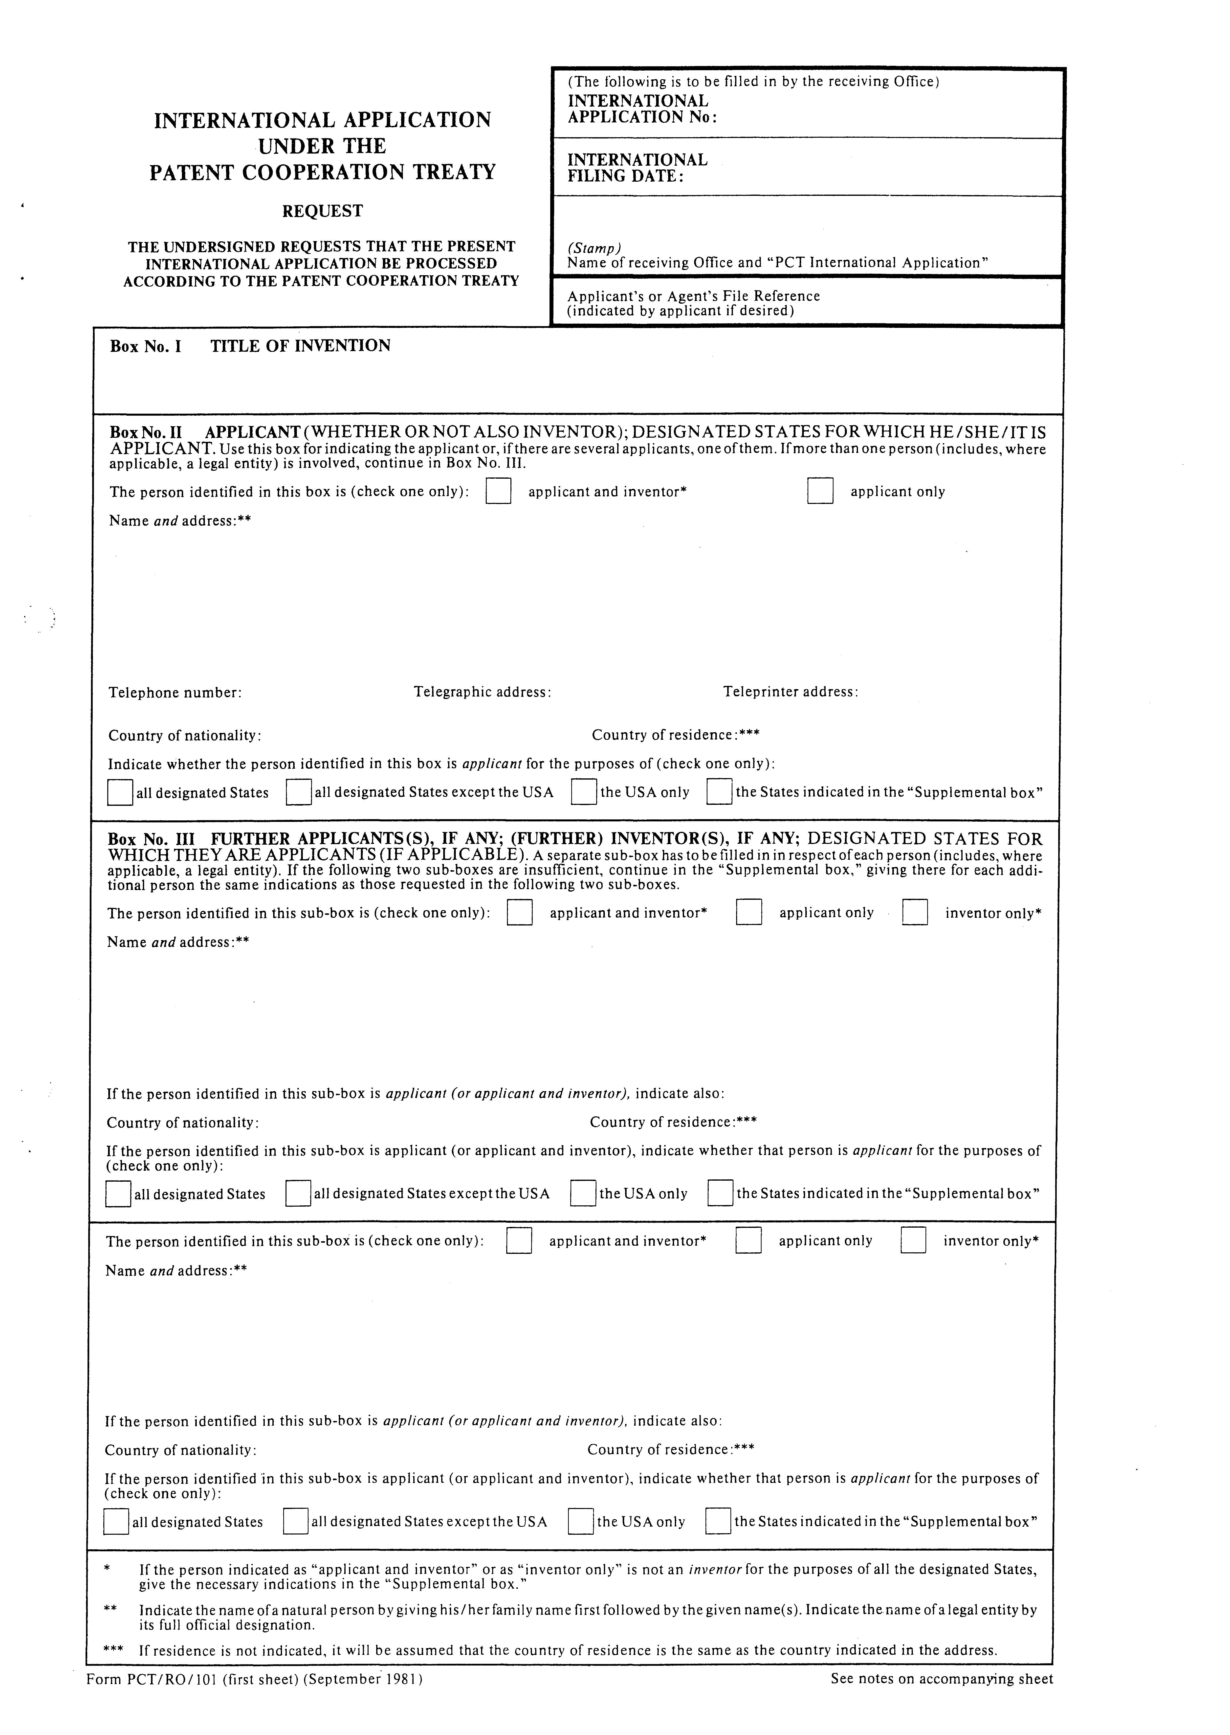
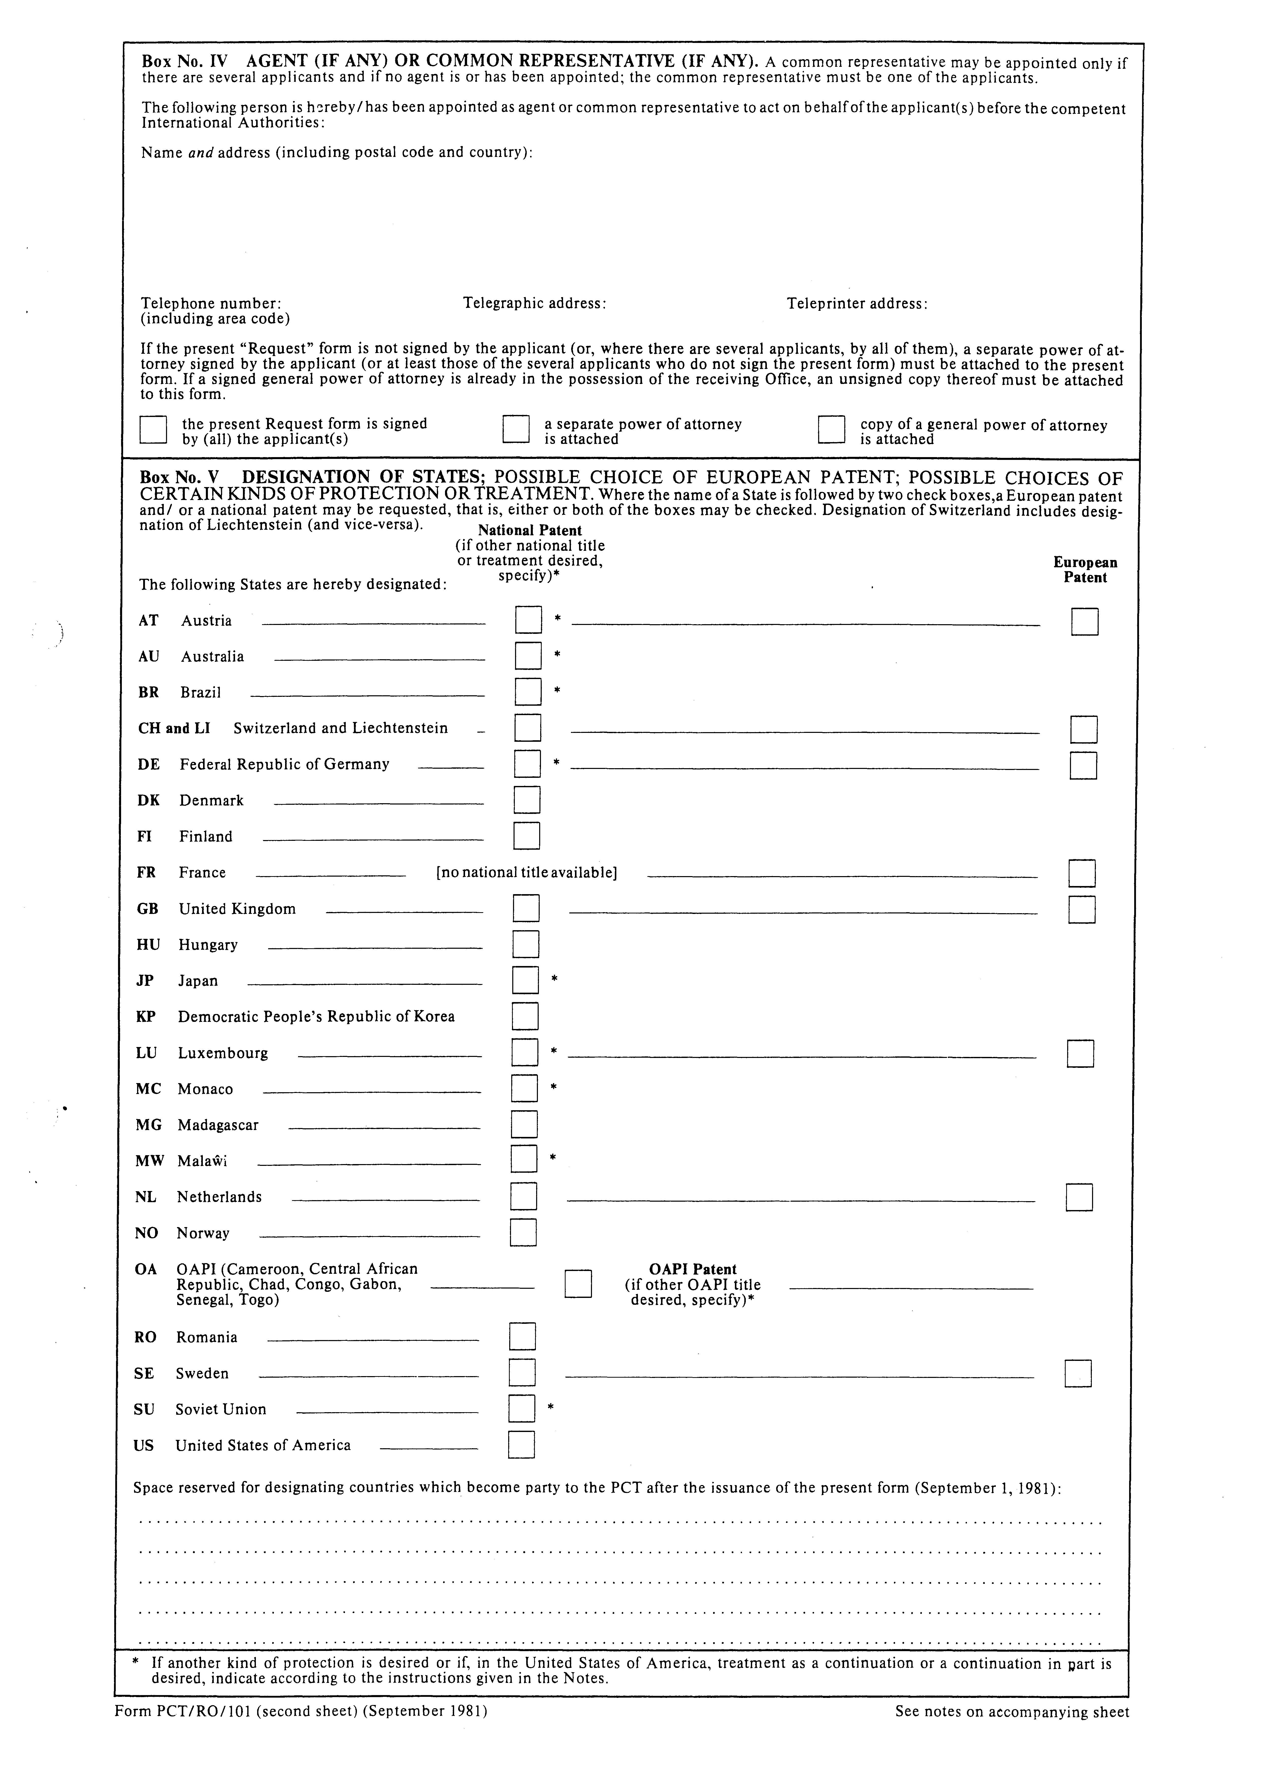
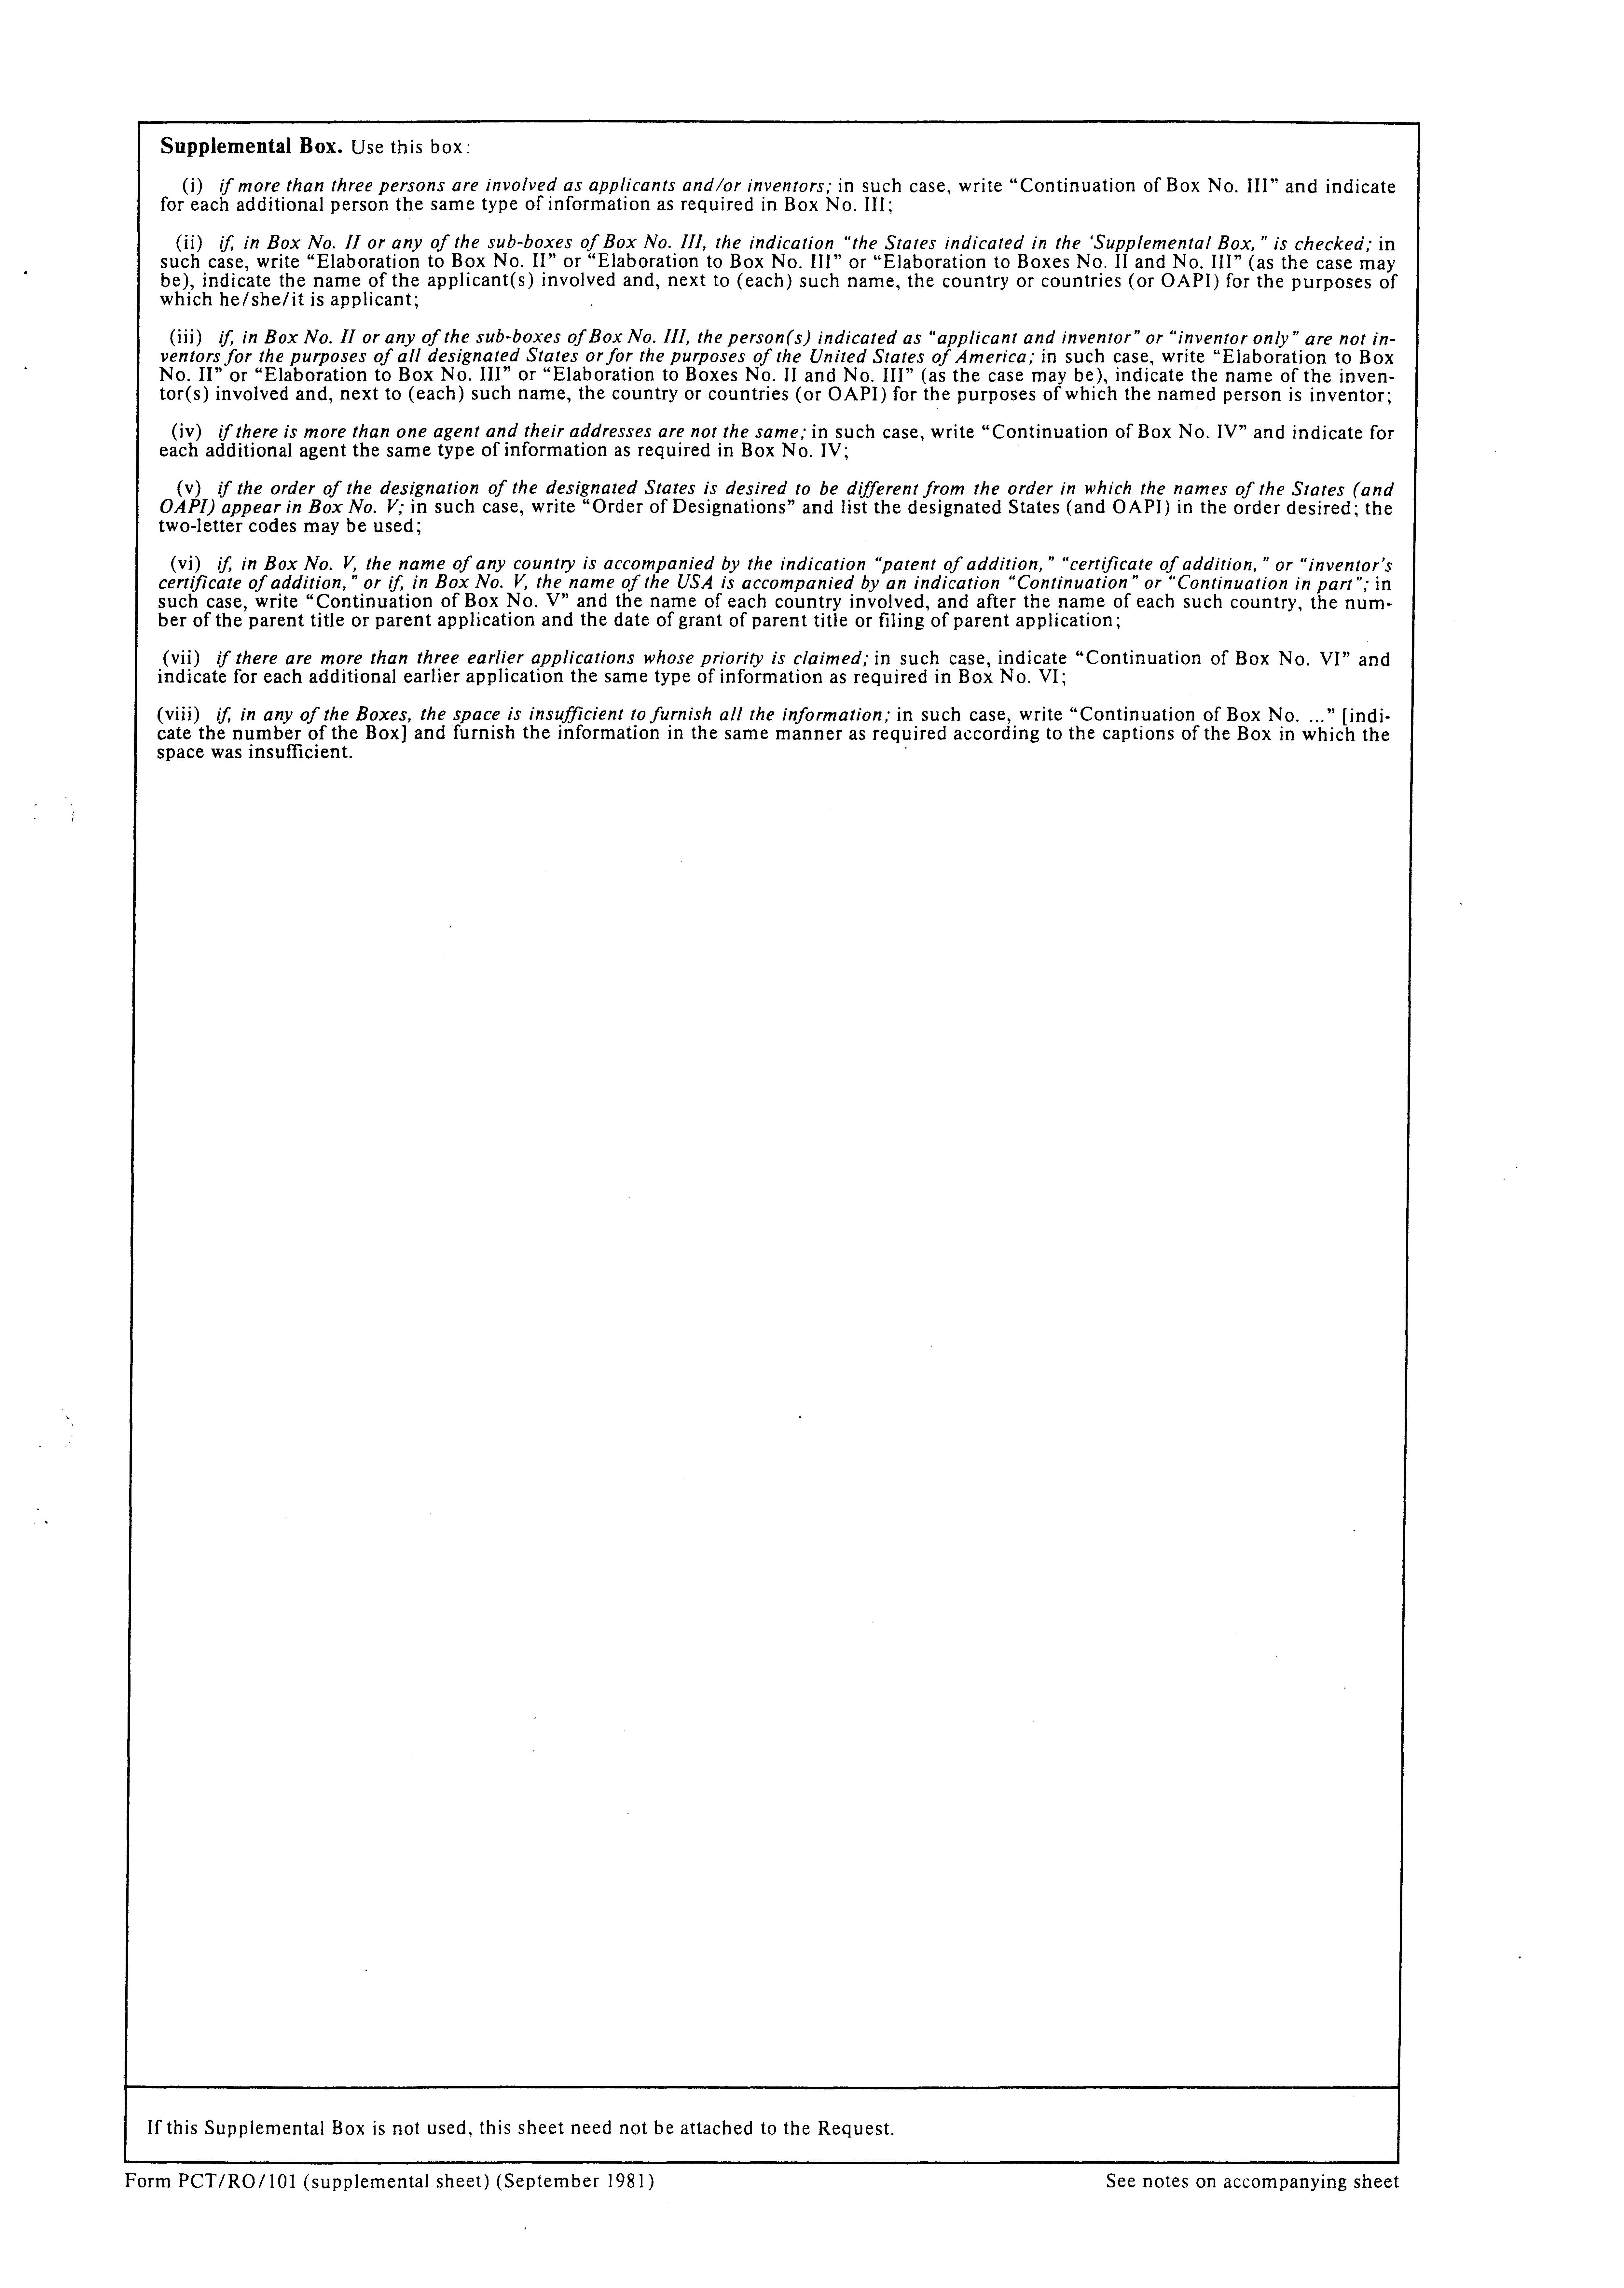
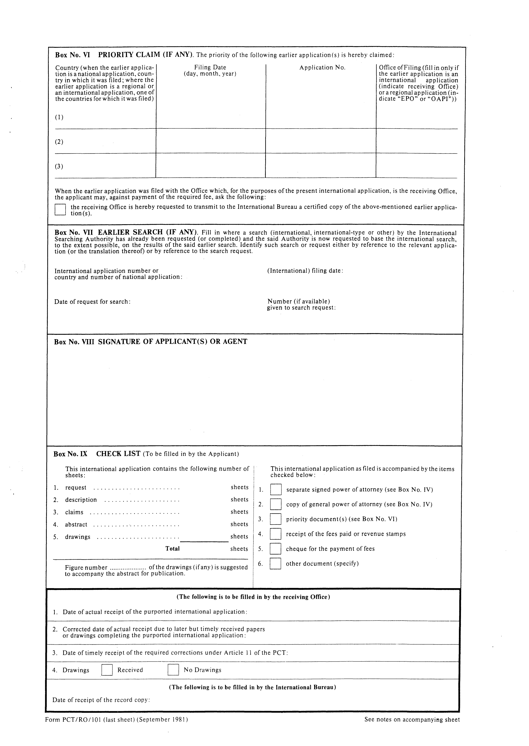
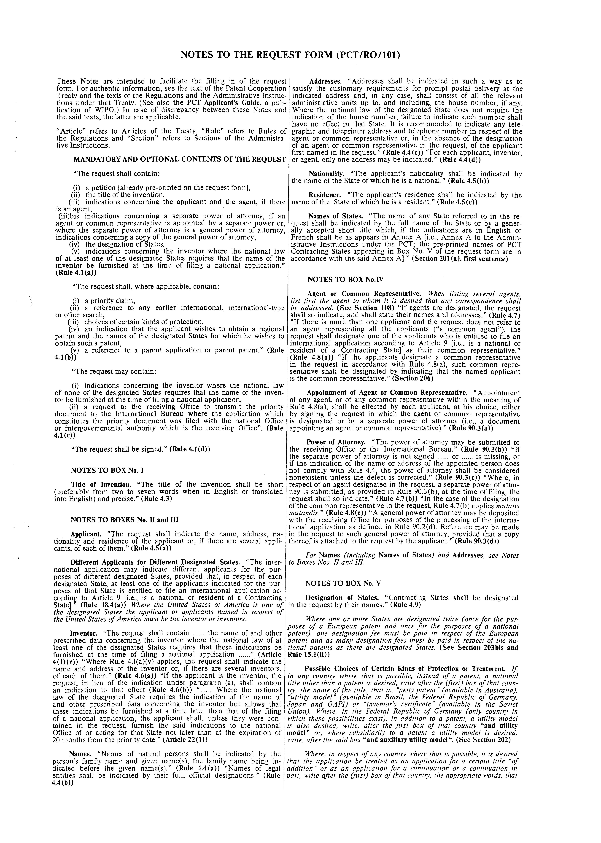
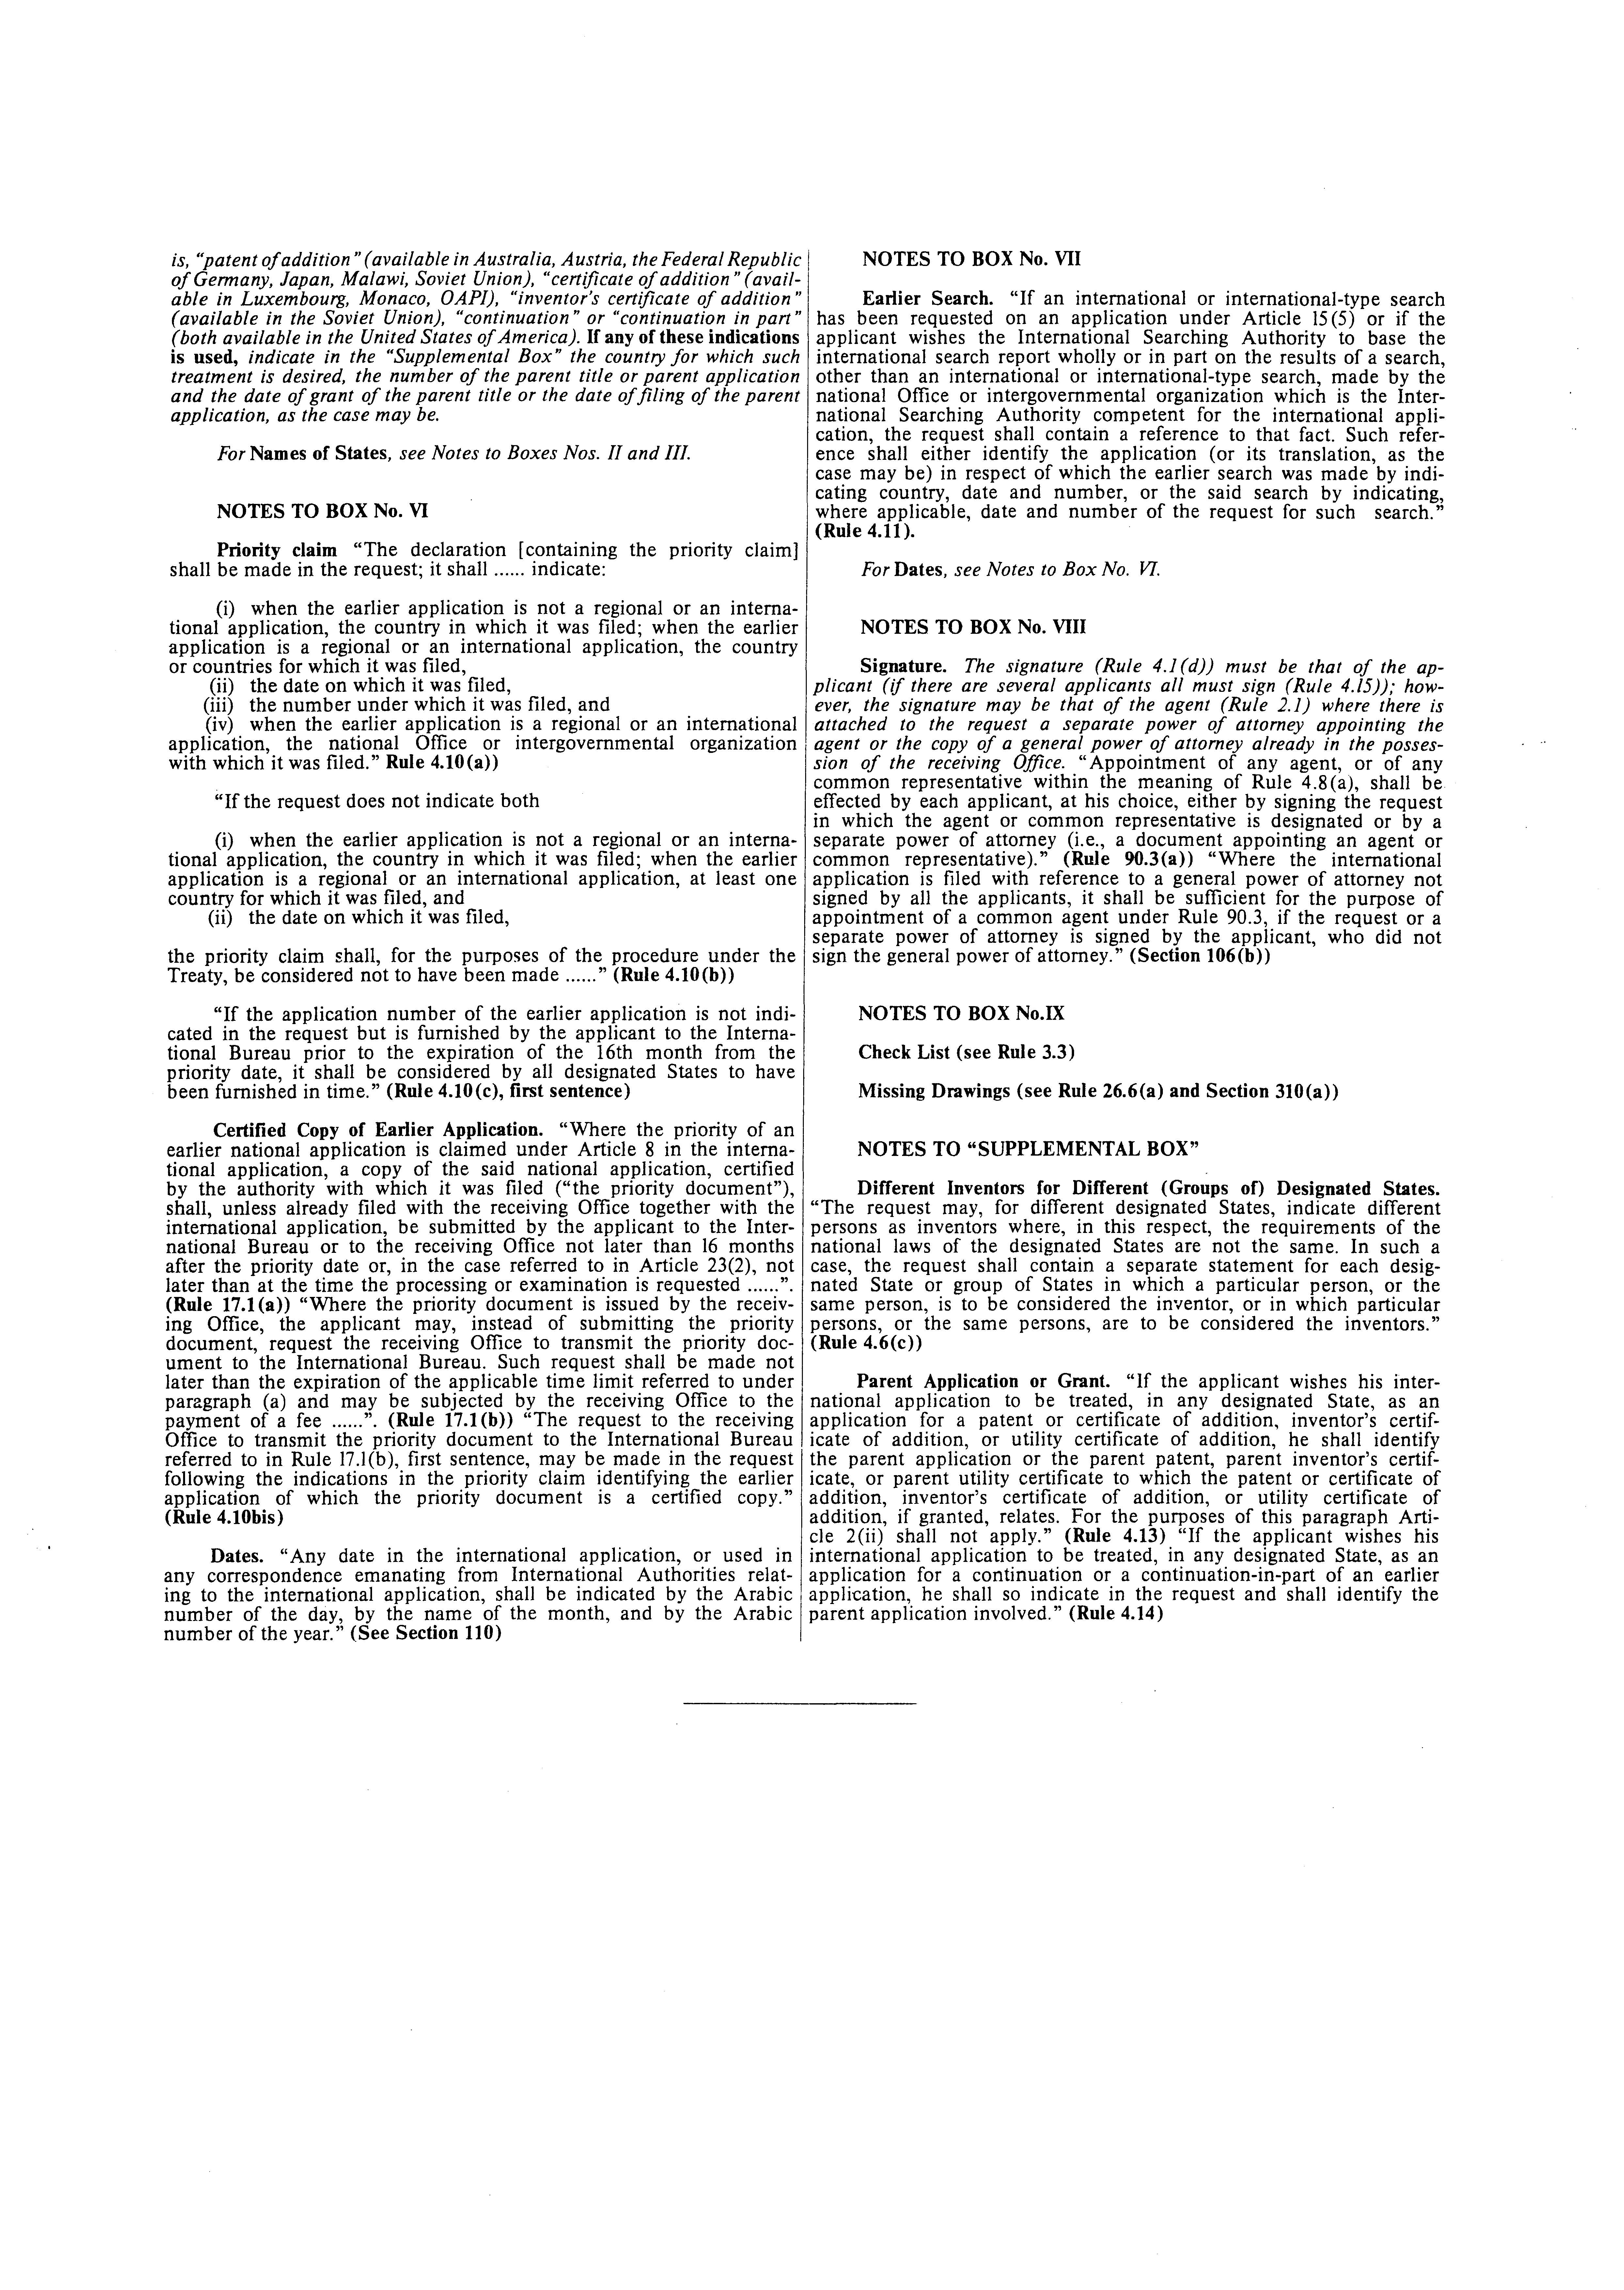

Proposed Amendments to the Regulations

under the PCT

Ad rule 3.3(a) (ii)

This provision needs to be amended to include in the check list of documents accompanying the international application as filed a reference to a copy of the general power of attorney required to be attached to the request (Rule 90.3(d), second sentence).

References to an international or an international-type search report and a document in evidence of the fact that the applicant is the successor in title of the inventor should be deleted. Such documents are, in practice, never filed with the international application but their inclusion in the check list creates the impression they may have to be furnished, which, however, is not the case.

Rule 3.3

  - Check List

(a) The printed form shall contain a list which, when filled in, will show.

- [No change]

- Whether or not the international application as filed is accompanied by a power of attorney (i.e., a document appointing an agent or a common representative), a copy of a general power of attorney, a priority document, a receipt for the fees paid or a check for the payment of fees and any other required document (to be specified in the check list);

- [No change]

- [No change]

Ad Rule 4.1(a) (iii) bis and (c)

The mandatory and optional contents of the request have been amended to take into account the additional indications therein for which provision is made in the proposed amendments to Rules 4.7(b), 4.8(c) and 4.10bis set out below

Rule 4.1

  - Mandatory and Optional Contents; Signature

(a) The request shall contain;

- [No change]

- [No change]

- [No change]

(iii) bis indications concerning a separate power of attorney, if an agent or common representative is appointed by a separate power of attorney or, where the separate power of attorney is a general power of attorney, indications concerning a copy of the general power of attorney;

- [No change]

- [No change]

- [No change]

- The request may contain

  - indications concerning the inventor where the national law of none of the designated States requires that the name of the inventor be furnished at the time of filing a national application; and

  - a request to the receiving Office to transmit the priority document to the International Bureau where the application which constitutes the priority document was filed with the national Office or intergovernmental authority which is the receiving Office.

- [No change]

Ad Rule 4.4(c)

In practice, if there is an agent or common representative, it is only useful to have the telegraphic and teleprinter address and the telephone number of the agent or common representative.

In the absence of the designation of an agent or common representative in the request, it would be useful to have the telegraphic and teleprinter address and the telephone number of at least the applicant first named in the request who will usually be the common representative by virtue of Rule 4.8(b).

Rule 4.4

  - Name and Addresses

  - [No change]

(b) [No change]

(c) Addresses shall be indicated in such a way as to satisfy the customary requirements for prompt postal delivery at the indicated address and, in any case, shall consist of all the relevant administrative units up to, and including, the house number, if any. Where the national law of the designated State does not require the indication of the house number, failure to indicate such number shall have no effect in that State. It is recommended to indicate any telegraphic and teleprinter address and telephone number in respect of the agent or common representative or, in the absence of the designation of an agent or common representative in the request, of the applicant first named in the request.

(d) [No change]

Ad Rule 4.6(b)

Under the flexible system adopted for Boxes Nos. II and III of the proposed request form, preprinted indications with associated check boxes allow in every case an indication to be given that the person indicated is inventor as well as applicant. The same applies when an applicant who is also inventor is indicated in the Supplemental Box. Consequently, the reference in the Rule at present to the repetition of the applicant’s name in the space reserved for indicating the inventor should be deleted.

Rule 4.6

4.6 The Inventor

(a) [No change]

(b) If the applicant is the inventor, the request, in lieu of the indication under paragraph (a), shall contain a statement to that effect.

(c) [No change]

Ad Rule 4.7

It is desirable that reference be made in the request to the signing of a separate power of attorney in respect of any agent designated in the request. According to Rule 90.3(b), such a separate power of attorney may be submitted either to the receiving Office or to the International Bureau. The making of a reference to a general power of attorney is already provided for in Rule 90.3(d).

Rule 4.7

  - The Agent

(a) The existing text of Rule 4.7

(b) Where, in respect of an agent designated in the request, a separate power of attorney is submitted, as provided in Rule 90.3(b), at the time of filing, the request shall so indicate.

Ad Rule 4.8(c)

The situation with regard to a separate power of attorney relating to the common representative is the same as that explained above with regard to a separate power of attorney relating to an agent (see pages 10 and 11, above, relating to Rule 4.7(b)).

Rule 48

4.8 Representation of several applicants not having a Common Agent

(a) [No change]

(b) [No change]

(c) In the case of the designation of the common representative in the request, Rule 4.7(b) applies mutatis mutandis.

Ad Rule 4.10bis

It was discussed at the fifth session of the Assembly that the applicant should be able to give an indication in the request which has the effect of a request to the receiving Office to prepare and transmit the priority document to the International Bureau (see document PCT/A/V/17, paragraph 22). Having regard to Rule 4.17, it is desirable that specific provisions be made in Rule 4 to allow the request to contain such an indication.

Rule 4.10bis

4.10bis Request to transmit the priority document to the International Bureau

The request to the receiving Office to transmit the priority document to the International Bureau referred to in Rule 17.1(b), first sentence, may be made in the request following the indications in the priority claim identifying the earlier application or which the priority document is a certified copy.

[Annex C follows]

ANNEX C

Proposed Modification of the Administrative Instructions
under the PCT

Ad Section 201

Since the names of States are preprinted in the part of the request in which designations are made together with the corresponding two-letter country codes, the Section has to be amended so as not to apply to such names. Likewise, the indication of a sample for the indication of the two-letter country code seems to be no longer necessary and has therefore been deleted.

Section 201

Names of States: Cancellation of Designations

(a) The name of any State referred to in the request shall be indicated either by the full name of the State or by a generally accepted short title which, if the indications are in English or French, shall be as appears in Annex A. If the name is inserted in the request by the applicant for the purpose of designating that State, the receiving Office, or the International Bureau where the receiving Office fails to do so, shall insert, preferably before the name of the State, the two-letter country code indentifying the State, as appears in Annex B.

(b) [No change]

Ad Section 202

Having regard to the fact that in practice the law of only one Contracting State (the Federal Republic of Germany) permits an application for two kinds of protection, it appears appropriate to amend Section 202 by indicating the existing options and using the terms which are commonly used, particularly since the wording of Rule 4.12(b) and the former Section 202 has rarely been correctly understood and applied by applicants. For the situation where the applicant seeks protection by way of utility model only in the event that a patent is refused, it is usual to say that the applicant seeks an “auxiliary utility model”. Instead of the indication that primarily a patent is sought and subsidiarily a utility model is sought as at present, it is proposed to introduce the term “auxiliary utility model” which has the same meaning.

Section 202

Kind of Protection

(a) [No change]

(b) Where, in respect of the designation of the Federal Republic of Germany, the applicant is seeking two kinds of protection under Article 44, he shall make the indication referred to in Rule 4.12(b) by inserting, immediately after the indication of the Federal Republic of Germany and in the language of the international application, one of the two following indications:

- “and utility model”;

- “and auxiliary utility model”.

Ad Section 203 (a)

The provision in the request form of a preprinted list matches perfectly with the provisions of Rule 4.1(b) (iv) and does not require any further elaboration in the Administrative Instructions for the indication that the applicant wishes to obtain a regional patent. Section 203 is therefore only required to give instructions for the said indication where a country newly adhering to the PCT for which a European patent is desired is not included in the preprinted list. The amendment makes this situation clear but leaves the Section otherwise unchanged.

Section 203

Regional Patents

(a) If the applicant wishes to obtain a regional patent in respect of any designated State and the request form does not contain preprinted indications permitting the application to make the indication in the request referred to in Rule 4.1(b) (iv), the applicant shall make the said indication by inserting the words “regional patent”, or their equivalent in the language of the international application, immediately after the indication of the said State or, where an indication has been made under Section 202, after that indication, provided that;

- [No change]

- [No change]

(b) [No change]

(c) [No change]

Ad Section 206

The requirement of the present Section that the designation of the common representative be indicated on the front page of the request is no longer applicable once the proposed request form is adopted. Section 206 is therefore redrafted in order to be compatible with Box No. IV of the proposed request form.

Section 206

Common representative designated in the request

If the applicants designate a common representative in the request in accordance with Rule 4.8(a), such common representative shall be designated by indicating that the named applicant is the common representative.

[End of Annex
and of document]

 Editor’s Note: This electronic document has been created from the paper original and may contain errors. Please bring any such errors to the attention of the PCT Legal Division by e-mail at pct.legal@wipo.int

