WIPO |  | E  PCT/A/VII/15  ORIGINAL: English  DATE: July 3, 1981
WORLD INTELLECTUAL PROPERTY ORGANIZATION
GENEVA

international patent cooperation union
(pct union)
ASSEMBLY
Seventh Session (5th Extraordinary)
Geneva, June 29 to July 3, 1981
report
Adopted by the Assembly
INTRODUCTION

1. The Assembly of the International Patent Cooperation (PCT) Union (hereinafter referred to as “the Assembly”) held its seventh session (5th extraordinary) in Geneva from June 29 to July 3, 1981.

2. The following 20 Contracting States were represented at the session: Australia, Austria, Brazil, Congo, Denmark, Finland, France, Germany (Federal Republic of), Hungary, Japan, Liechtenstein, Luxembourg, Netherlands, Norway, Romania, Soviet Union, Sweden, Switzerland, United Kingdom, United States of America.

3. The following five States participated in the session as observers: Iraq, Italy, Niger, Spain and Zaire.

4. Two intergovernmental organizations, the African Intellectual Property Organization (OAPI) and the European Patent Organisation (EPO), and the following eight international non-governmental organizations, were represented by observers: Asian Patent Attorneys Association (APAA), Committee of National Institutes of Patent Agents (CNIPA), European Federation of Agents of Industry in Industrial Property (FEMIPI), Inter-American Association of Industrial Property (ASIPI), International Association for the Protection of Industrial Property (IAPIP), International Federation of Inventors’ Associations (IFIA), International Federation of Patent Agents (FICPI) and Union of Industries of the European Community (UNICE).

5. The number of participants was about 60. The list of participants is contained in Annex I to this Report.

OFFICERS OF THE SESSION

6. The Assembly appointed Mr. J. Dekker (Netherlands) as acting Chairman in the absence of Mr. H. J. Winter (United States of America), Chairman, and Mr. I. Nayashkov (Soviet Union), Vice-Chairman.

7. Mr. E. M. Haddrick, Director, PCT Division, WIPO, acted as Secretary of the Assembly.

OPENING OF SESSION; ADOPTION OF THE AGENDA

8. The session was opened, on behalf of the Director General, by Mr. K. Pfanner, Deputy Director General of WIPO.

9. The Assembly adopted its agenda as contained in document PCT/A/VII/1.Rev. with the addition, under item 3(c) thereof, of a reference to document PCT/A/VII/13.

AMENDMENTS TO THE PCT REGULATIONS

Amendments Other Than to the Schedule of Fees

10. Discussions were based on documents PCT/A/VII/2, 3, 6, 11 and 13.

11. Following the discussion of the proposals contained in document PCT/A/VII/2, and 11 and consequential upon the results of the consultations which had taken place on the modification of the “Request” form (see paragraphs 73 to 76, below), the Assembly adopted, with effect on and from October 1, 1981, amendments to Rules 3.3(a), 4.1(c), 4.4(c) and (d) and 4.6(b). The text of the amendments is set out in Annex II to this Report.

12. In the course of the discussions concerning the proposed amendment of Rule 91.1, there was general sympathy with the underlying principle of the proposal of the International Bureau to permit the rectification of errors occurring in the request according to a less stringent test than in the case of errors occurring in the description, claims and drawings. A number of Delegations of States and intergovernmental organizations (hereinafter referred to as “Delegations”) and the Representatives of the international non-governmental organizations (hereinafter referred to as “NGO Representatives”) expressed also agreement with the proposal of the International Bureau as drafted in a modified version prepared by the International Bureau in the light of the discussions, while views were divided on the question of whether a special provision, excluding the omission of designations from rectification, was required.

13. A number of Delegations and NGO Representatives supported furthermore the intention underlying the drafts prepared by the International Bureau to align the provisions of Rule 91 with Rule 88 of the Implementing Regulations to the European Patent Convention. In this context, the International Bureau drew attention to the fact that already the provisions on certain non-rectifiable omissions in the present text (Rule 91.1(c)), and even more so an amendment excluding omission of designations from rectification, had no counterpart in the Implementing Regulations to the European Patent Convention, so that the PCT would continue to be, or would become, more stringent than the European system on that question.

14. The Delegations expressing concern about the admission of corrections in certain cases of erroneous omission of designations, resulting from the original draft amendment submitted by the International Bureau, stated that in their opinion this would lead to recognition of “later designations” in certain cases. Later designations, however, should not be allowed in any circumstances. Consequently, they were in favor of amending Rule 91.1 in a way that would exclude rectification of omissions of designations from rectification. Those Delegations added, however, that they were not opposed to the rectification of designations made which were erroneously defective. Other Delegations expressed the opinion that the amendment proposed by the International Bureau in its original version would not lead to allowing later designations as one of the conditions for the rectification was that a designation, which was demonstrably intended at the time of filing, was erroneously omitted from the request. Consequently, those Delegations were not in favor of the amendment referred to above tending to exclude all omissions of designations from rectification. Several Delegations were also concerned, on the other hand, about possible e contrario arguments as regards the question of rectification of other kinds of omissions if omitted designations per se were expressed to be not rectifiable. The NGO Representatives declared that already the present text of Rule 91.1(c), excluding rectification in all cases of omission of elements or sheets of the international application, was objectionable from the point of view of the users of the PCT system. This objection applied even more to the proposed extension of that Rule to the exclusion of omissions of designations from rectification.

15. In view of prevailing differences of opinion, a majority of Delegations was in favor of deferring a decision to a later session of the Assembly. The Chairman concluded that a deferment of the decision to the next session of the Assembly was inevitable in view of the fact that time did not permit at this session to resolve the remaining differences of opinion.

16. In the course of the adoption of the amendment to Rule 3.3(a), the proposal to delete this Rule and to transfer its contents to the Administrative Instructions, as contained in document PCT/A/VII/11, was withdrawn by the Delegation of Switzerland upon the understanding that the proposal would be included in the study by the International Bureau referred to in paragraphs 54 to 63, below.

17. The amendment of Rule 4.4(d) was adopted to allow the applicant or the common representative to indicate a second address (in Box No. IV of the “Request” form) which would be used for the sending of notices. It was envisaged that advantage could be taken of this possibility, in particular, by corporations wishing to have correspondence addressed to their patent departments while wishing to retain their headquarters address for other purposes.

18. The proposals for amendment of Rules 4.7 and 4.8 and a new Rule 4.10bis, contained in document PCT/A/VII/2, Annex B, were withdrawn by the International Bureau.

19. The Assembly decided that the matter raised by the proposed amendment of Rule 34 contained in document PCT/A/VII/6 should be studied first by the Committee for Technical Cooperation. A large majority of Delegations found the proposal useful and expressed general sympathy with its aim. The Assembly noted in this context a declaration by the Delegation of the United States of America that it could not accept the proposed amendment with the consequence that the amendment could not be adopted since the requirement of Rule 88.3 would not be fulfilled.

20. The Assembly considered the correction of the French text of Rule 92.4(b), as contained in document PCT/A/VII/13, and adopted the proposed French text as set out in Annex II to the French version of this Report.

Amendment of the Schedule of Fees

21. Discussions were based on document PCT/A/VII/8.

22. The Assembly fixed the amounts of the fees as proposed in document PCT/A/VII/8 with effect on and from January 1, 1982, and accordingly amended with effect on and from that date, the Schedule of Fees annexed to the PCT Regulations. The Assembly also decided that, for the purpose of fixing new amounts in currencies other than Swiss francs, the rates of exchange between such currencies and Swiss francs on October 1, 1981, shall be used. The amended Schedule of Fees is set out in Annex II to this Report.

23. The Delegations of Brazil and Romania declared that, while not objecting to the Schedule of Fees as now agreed upon, they were in general in favor of lower fees for nationals of developing countries. The application of this principle to the PCT would promote accession to PCT by developing countries and its use by such countries. That question should be studied with a view to taking a decision at a later stage on the occasion of a reconsideration of PCT fees. The Delegation of the United States of America said that its established position was that reductions of amounts of fees could only be considered on the basis of the individual economic situation of applicants but not on the basis of nationality. The Assembly noted a statement by the International Bureau, that the said question would be studied in the framework of the general study referred to in paragraphs 54 to 63, below.

24. The Assembly noted, furthermore, a proposal by the Delegation of the EPO to study the desirability of allowing, for a transitory period following the entry into force of new amounts of fees, supplementary payments by applicants who erroneously made their payment on the basis of the old amounts of fees, thus preserving their rights. The question of the possible adoption of such transitory provisions should be included into the study referred to in paragraphs 54 to 63, below.

Mailing Costs of the International Bureau

25. In the course of the discussions concerning the fixing of new amounts of the PCT fees, the International Bureau said that the report of the PCT Management and Budget Consultants Group, which had met recently to consider the PCT budget, had expressed concern about the PCT mailing costs (see document PCT/MBCG/II/5).

26. The PCT Management and Budget Consultants Group had expressed the view that savings could be achieved if some national Offices which received several copies of the pamphlet by air mail would agree to accept one copy by airmail and the rest by surface mail. The Group had also suggested that savings could be achieved if Offices were not to place blanket requests for copies of priority documents.

27. The International Bureau said that even if the national Offices which at present had blanket requests would wait until it was certain that the application had entered the national phase before requesting a copy of the priority document, considerable savings could be achieved. Another way of achieving savings would be if Offices would agree to receive the Article 20 communication copy of the international application by a lower category of mailing, such as printed matter. In effect, this would mean that the Offices would agree to accept the risk that the communication copy might take longer to reach them than at present.

28. The Assembly noted that the International Bureau would communicate with the Offices whose cooperation would be necessary if savings were to be achieved as suggested by the PCT Management and Budget Consultants Group.

INTERPRETATION OF ARTICLE 9 OF THE PCT

29. The discussion was based on document PCT/A/VII/3.

30. The Assembly adopted the interpretation that Article 9 is not concerned with the capacity in which a person who as applicant files an international application is acting when filing the application. In other words, even if, in fact, the applicant is acting in a representative capacity (e.g., the applicant is a person who is administering the estate of a deceased person or is a person in whom the law vests property and/or rights of another person in a particular situation, such as in the case of the insanity of the person properly entitled) it is not for the receiving Office to attempt to go behind the person who is the applicant and to treat some other person as being the applicant when it is determining the right to file the international application (Article 9 and Rules 4.8 and 18.4) or the competent receiving Office (Articles 10 and 11(1)(i) and Rule 19.l(a)) by reference to the nationality or residence of the applicant.

31. The Assembly noted a statement by the Delegation of Japan that it could not associate itself with the decision of the Assembly since, under the Japanese legal system, a person acting in a representative capacity would not be entitled to be the applicant (i.e., would not be entitled to exercise in his own name the rights of the represented person). In this context, the attention of the Delegation of Japan was drawn to the fact, that in view of this situation, it would seem that Japan was not concerned by the interpretation referred to above.

32. The Assembly also noted a statement by the Delegation of the United States of America that, in accordance with its national law, a person who was not the actual inventor could be accepted as the applicant by the United States of America as a designated State only in cases where that person was legally entitled to act on behalf of a deceased or mentally incapacitated inventor.

THE PCT INTERNATIONAL MEETING (TOKYO)

33. Discussions were based on document PCT/A/VII/9.

34. The Assembly took note of the Report of the PCT International Meeting (document PCT/TIM/I/13) held in Tokyo from May 25 to 29, 1981, and of the intention of the International Bureau to follow up in due course all matters discussed during the said meeting which required further action and were not specifically referred to in document PCT/A/VII/9.

Translation of Documents Cited in the International Search Report

35. The Assembly endorsed the views expressed in the Report (document PCT/TIM/I/13, paragraphs 21 to 23) as to the importance of including in international search reports as much patent family information as is feasible under the circumstances and avoiding in the national phase the requiring of translations of references cited in the international search report. Placing the applicant who follows the PCT route in a less favorable position than applicants who do not follow that route should in particular be avoided. The action proposed by the International Bureau to make appropriate recommendations to the designated and elected Offices as well as to the International Searching Authorities was endorsed.

The Usefulness of International Search Reports in the National Phase

36. The Assembly noted the conclusions reached by the PCT International Meeting (document PCT/TIM/I/13 paragraphs 32 and 33) as to the usefulness of the international search report and endorsed the intention of the International Bureau to bring the conclusions to the attention of all designated and elected Offices. This would include, in particular, stressing the importance of the international search report for the avoidance of duplication of search effort by the designated Offices and the need to reflect, as far as possible, economies made in the national procedure in certain benefits for the applicant, e.g., reduction of national fees or acceleration of the procedure for the grant of the patent.

37. In this context, the Delegation of the EPO stated that continued efforts would be required towards further harmonization of search methods and quality of search and indicated the readiness of the EPO to participate in such efforts in both multilateral and bilateral cooperation.

Announcing of Certain Facts in the Gazette

38. The Assembly endorsed the interpretation of Rule 48.6 and of Rules 29.2 and 51.4 according to which it would suffice if the information required under Rules 29.2 and 51.4 would be supplied by the designated and elected Offices on an annual basis in the form of statistical data. The Assembly noted the intention of the International Bureau to send a circular to all Offices concerned outlining the manner in which, the period for which and the date by which such data will be required to be given. The combined data would then be published in the PCT Gazette.

Usefulness of International Preliminary Examination Reports for the National Phase

39. The Assembly noted the conclusions reached in the Report (document PCT/TIM/I/13, paragraph 43) as to the usefulness of the international preliminary examination report and endorsed the action proposed by the International Bureau. This action will consist of bringing the conclusions reached by the PCT International Meeting to the attention of all elected Offices and of stressing the importance of the international preliminary examination report for the avoidance of duplication of examination effort by the elected Offices and also the need to reflect, as far as possible, economies made in the national procedure in certain benefits to the applicant, for instance, through an appropriate reduction of national fees or the acceleration of the procedure for the grant of the patent.

Extension of Time Limit for Establishment of International Preliminary Examination Report and Change of the Provision of Rule 70.6

40. The Assembly considered the views expressed in paragraphs 45 to 49 of the Report (document PCT/TIM/I/13).

41. The Assembly adopted the view expressed in the Report that no extension of the time limit for a reply to a written opinion (Rule 66.2(d)) was required since the present text of the said Rule was flexible enough to give the applicant sufficient time for a reply.

42. After considering whether the time limit for the establishment of the international preliminary examination report (Rule 69.1(a)) should be extended in special cases (upon express request by the applicant and provided that the International Preliminary Examining Authority thinks fit, on the basis put forward by the applicant, to allow an extension) the Assembly invited the International Bureau to study further the question of an amendment to Rule 69.1(a) and to prepare a proposal for its consideration at a subsequent session.

43. The Assembly agreed that Rule 70.6 dealing with the statement under Article 35(2) contained in the international preliminary examination report would not require to be amended in such a way as to allow the possibility of explanations to be given in cases where a positive statement under Article 35(2) could only be made if the claim were to be amended. A modified international preliminary examination report form (form PCT/IPEA/409) which the Director General intended to promulgate (see paragraph 45, below) would provide sufficient possibilities for giving explanations of such a nature that, where a claim was patentable only in an amended version, the applicant or the elected Office could easily identify the required amendment, without the need for the Authority to propose a revised version of the claim, which was considered not to be desirable.

Amendments to Sections 503, 505 and 507 of the Administrative Instructions

44. The Assembly noted the intention of the Director General to modify Sections 503, 505 and 507 of the Administrative Instructions as set out in Annex II to the Report (document PCT/TIM/I/13).

Modifications of Certain Forms Related to International Search and Preliminary Examination

45. The Assembly noted that amended Forms (referred to in paragraphs 36 to 41 and 56 of the Report (document PCT/TIM/I/13)) would be promulgated in due course.

46. The Assembly noted a statement by the Delegation of Romania that, since it had had no time to consider the document before the Assembly, it would reserve its position.

APPLICATIONS OF NATIONAL REMEDIES FOR PRESERVING THE RIGHTS OF APPLICANTS

47. Discussions were based upon document PCT/A/VII/5, containing a proposal submitted by the Royal Patent and Registration Office of Sweden which had been before the Assembly at its 5th session (document PCT/A/V/10) but had been deferred due to a lack of time. The proposal concerned the application, in favor of PCT applicants, of provisions which can be availed of by national applicants to preserve their rights which might otherwise be jeopardized in the case of error and the treatment, in the application by national Offices of measures available in the case of official mistakes, of a mistake by any of the PCT Authorities as if it were a mistake of the national Office.

48. A majority of the Delegations as well as the NGO Representatives and the International Bureau made statements expressing their firm interest in and support for the general objective to which the proposal was directed.

49. Several Delegations indicated that their PCT implementing laws fully satisfied the objectives of the proposal. Some Delegations, while supporting the objectives in principle, felt that there was a need for further study to identify the particular cases in which the proposal would apply.

50. The NGO Representatives and the International Bureau underlined the importance of consideration being given to implementing in national laws the possibility, provided under Article 24(2), for the designated Offices to continue international applications in effect even where this was not required under the provisions of Article 25. This was of importance in relation to the possible late transmission of the record copy to the International Bureau which was one of the reasons frequently cited against the use of the PCT system (although among the roughly 9,500 international applications filed so far, there was no such case).

51. The International Bureau also underlined the importance of the application of national provisions which could preserve the rights of applicants in the case of a failure to meet the time limit for entry into the national phase. There were instances where Contracting States only applied their national remedies once the applicant had successfully entered the national phase. This was contrary to Article 48(2)(a) which required that Contracting States shall excuse, for reasons admitted under the national laws, any delay in meeting a time limit and this included the case of the performance of the acts necessary to enter the national phase since the national remedies must be available as from the international filing date.

52. Some Delegations referred specifically to the importance of the proposal that, in applying national remedies which cover “official mistakes,” a mistake by any PCT authority should be taken into account. The Delegation of Japan said, however, that it doubted whether it could accept such a proposal since it would seem to be based upon the principle of joint responsibility amongst PCT Authorities which that Delegation found it difficult to accept.

53. In conclusion, the Assembly noted with approval the objectives of the proposal submitted by the Royal Patent and Registration Office of Sweden, urged all PCT Offices and authorities to seek to achieve them and invited the International Bureau to include the question in its study of the PCT (see paragraphs 54 to 63, below).

STUDY OF THE PCT BY THE INTERNATIONAL BUREAU

54. Discussions were based on document PCT/A/VII/4, containing a memorandum setting out a proposal of the Government of Sweden, document PCT/A/VII/11, containing a proposal submitted by the Delegation of Switzerland, and document PCT/A/VII/11.Add., containing a communication by the Delegation of France supporting the proposal made by the Delegation of Switzerland. Following the Introduction of the proposals by the Delegations of Sweden and Switzerland, the Assembly discussed them together.

55. The Delegation of Sweden, stating its continued full support for the PCT and its objectives and its recognition of the fact that the PCT had proven its practical value in the past years, explained that its proposal for a study of the PCT by the International Bureau was not directed towards a basic revision of the system; its intention was to facilitate the achievement of the objectives of the PCT in order to promote the wide use which the PCT deserved. It recalled that the objectives of the PCT included simplifying and making more economical the obtaining of protection for inventions and also assisting the developing countries. The study should seek to simplify further the obtaining of protection for inventions through the use of the PCT with a view to increasing its use. The study should find out what the problems were at present that gave rise to suggestions that the procedure was too complex and suggest solutions to them.

56. A great number of Delegations supported the Swedish proposal. All agreed that it was not intended to question either the purposes of the PCT or the proven usefulness and adequacy of the general principles on which the PCT was based or of the principle of distribution of functions over various Offices and Authorities through which the PCT system operates. This was important to bear in mind since the PCT, during the first three years of its operations, had proven to be a very useful and effective means of cooperation in the patent field, and since one should not create the impression that it needed basic substantive changes. It was also agreed that the study should aim at achieving a simplification of the system for both users and Offices as well as the PCT Authorities, having regard to practical problems revealed by experience in its operation, and at increasing the attractiveness of the system for the users. Several Delegations said that the situation of the developing countries should be taken into account in the study in order to allow those countries to derive full benefit from participating in the PCT system and thus promote accession by those developing countries not yet party to the Treaty. Some Delegations said that the study should be limited to reviewing the Regulations and Administrative Instructions and should not extend to the Articles of the Treaty, since this could lead to a revision of the Treaty and imply the convening of a Diplomatic Conference to revise the Treaty, which was considered premature so soon after its entry into force. Moreover, a revision of the Treaty at this stage could affect the credibility of the system with the users and States wishing to adhere. Other Delegations and NGO Representatives said that the study could not be carried out properly if any such limitations were imposed in advance and that, in particular, the consideration of Articles of the Treaty should not be excluded, the more so as certain of the repeatedly stated problems could probably only be solved by an appropriate revision of some of those Articles. It was also stated that there was a need to include in the study the implementation of the PCT system in the Contracting States of the PCT and, in particular, potential pitfalls and difficulties for the user when entering the national phase, and that ways and means should be found to ensure direct application by all countries of the amendments made to the Regulations by the Assembly. In this context, attention was drawn to the usefulness of assistance by the Contracting States and the users of the system in providing material relevant for purposes of the study.

57. The Delegation of Switzerland introduced its proposal by explaining that provisions in the PCT Regulations which it was not necessary to retain therein and which could be transferred to the Administrative Instructions should, after a study by the International Bureau to identify them, be transferred to the Administrative Instructions. The proposal was intended to enable changes to be made affecting the PCT procedure without burdening national authorities, particularly in those countries where amendments to the PCT Regulations had to be reproduced in the official journal containing national legislation. This would not only ease the burden on the national authorities, but should allow greater flexibility in making changes to the PCT procedure.

58. A number of Delegations, in addition to the Delegation of France which had previously expressed its support in writing, expressed strong support for the proposal of the Delegation of Switzerland.

59. The Chairman suggested that the study of the proposal of the Delegation of Switzerland should be carried out in combination with the study proposed by the Government of Sweden. In studying the implications of the proposal of the Delegation of Switzerland, one should apply care and prudence and not only examine what could be transferred to the Administrative Instructions, but also what the implications of such transfer in terms of advantages or disadvantages for the users could be. In general, one should not overestimate the benefit for the users of a transfer of otherwise unchanged provisions from the Regulations to the Administrative Instructions.

60. In conclusion, the Assembly decided to entrust to the International Bureau the study proposed by the Government of Sweden, together with the study necessary to implement the proposal of the Delegation of Switzerland. For the carrying out of the combined study, the following conclusions were reached:

A. As to the proposal of the Government of Sweden:

(i) it was understood that the study would be based on experience to date of applicants who have filed applications under the PCT and of the Offices and the PCT Authorities, including the International Bureau, in processing such applications;

(ii) the study should establish the needs of the users and the Offices and Authorities implementing the PCT with respect to simplifying and improving its practical implementation, identify any complexities and pitfalls in the procedure and propose solutions which would make the system more attractive and less onerous for the users and the Offices;

(iii) the study should be directed primarily to a review of the PCT Regulations and Administrative Instructions but should not exclude, where necessary, consideration of relevant Articles of the Treaty while avoiding proposals for a basic revision of the Treaty changing its fundamental structure. Proposals requiring revision of the Treaty should be clearly identified as such and, where various solutions could be found to a problem, the solution not requiring revision should be given preference;

(iv) it was understood in that context that the Assembly would, in any event, consider the results of the study, so that the decision not to exclude the Treaty from the study did not prejudge the eventual decision as to whether changes in the Treaty as well as in the Regulations and Administrative Instructions should be undertaken to achieve the benefits expected to be derived as a result of the study;

(v) the study should also deal with problems concerning the national phase of the PCT procedure;

(vi) specific problems of the developing countries with respect to the implementation of the Treaty should be taken into account in the general context of the study;

(vii) the proposals made, or to be made, by the users of the system, including those contained in documents PCT/A/VII/12 and 12.Add., should be taken into account for the preparation of the study.

B. As to the proposal of the Delegation of Switzerland:

(i) proposals for the transfer of provisions from the Regulations to the Administrative Instructions should only be made with respect to provisions not affecting the applicant or national law and should therefore be limited to provisions such as those dealing with the communications among Offices and PCT Authorities;

(ii) proposals for transfer should take into account the need for completeness and easy comprehension of the provisions in both texts;

(iii) the implications of a transfer in terms of advantages and disadvantages for the users should be considered before making proposals, keeping the overall objective of the combined study in mind.

61. The Delegation of France felt, for its part, that the study referred to in paragraph 60A(iii) should, as a general rule, avoid any proposal for revision of the Treaty and not only its basic revision.

62. The International Bureau stated its preparedness to undertake the combined study entrusted to it by the Assembly. As far as that part of the study deriving from the proposal of the Swedish Government was concerned, the International Bureau intended to draw on the experience of the Offices and authorities involved in the operation of the PCT system as well as that of the PCT applicants, especially through the organizations representing the interested circles. The study should be done as quickly as possible but would necessarily take some time to be carried out and probably the Committee for Administrative and Legal Matters would be convened to consider and advise upon the preliminary conclusions of the International Bureau before the results of the study would be presented to the Assembly.

63. The Assembly expressed the desire that, as far as possible, further changes of the Regulations should now await the outcome of the study. It agreed, however, that, in view of the fact that the study would be wide-ranging with a view to finding a comprehensive solution to problems affecting the PCT procedure, and that a certain degree of delay would occur before changes resulting from it would be made, necessary changes in the PCT Regulations, which might come to notice during the time occupied by the study and could not await its results, would nevertheless have to be considered and decided upon.

Proposals from Organizations Representing PCT Users for Further Improvements in the PCT System

64. The Assembly, having noted documents PCT/A/VII/12 and 12.Add., containing proposals from organizations representing PCT users, decided that the proposals should be considered within the framework of the study to be undertaken by the International Bureau, referred to in paragraphs 54 to 63, above).

OPERATION OF RULE 16BIS

65. The Assembly noted an oral report given by the International Bureau that the charging to it of amounts required to cover fees not paid to receiving Offices by applicants within the prescribed time limit had occurred only in a few cases (less than 20) and that, in many cases, the procedure under Rule 16bis was, in any event, not complete. The International Bureau was therefore not in a position to give a substantive report on the operation of the system established by Rule 16bis at the present session. The Assembly noted the statement of the International Bureau.

DEVELOPMENT OF THE PCT UNION

66. Discussions were based on document PCT/A/VII/10.

Promotion of Acceptance of the PCT

67. The Assembly noted an intervention by the Delegation of Spain expressing the continued interest of its country in the consideration, in close contact with the International Bureau, of certain questions, in particular relating to the use of the Spanish language, bearing upon its possible accession to the PCT. The International Bureau, referring to the ongoing discussions with Spain in cooperation with the European Patent Office, expressed its continued willingness to assist in resolving those problems. The Chairman, noting the urgency and importance of that matter in view of its bearing on the participation of Spain and the Latin American countries of Spanish language in the PCT system, said that these considerations should be pursued with priority and outside the study referred to in paragraphs 54 to 63, above.

68. The Assembly, noting the report of the International Bureau on the present state of membership of the Treaty, confirmed unanimously the resolution previously adopted by it at its 5th session and reproduced in Annex III.

Regional Treaties

69. The Assembly, on the basis of the report of the International Bureau, reaffirmed its position, taken at its said 5th session, at which it “took note of the situation which resulted from the fact that not all member States of certain regional patent treaties were also members of the PCT Union and, in this regard, noted, furthermore, the disadvantages resulting therefrom for the applicant since the latter could not fully benefit from the advantages to be obtained by using the PCT system and the regional system by filing a single application, disadvantages which make it desirable for the users of the PCT system that the said States adhered as soon as possible to the Treaty.”

Chapter II of the PCT

70. The Assembly, on the basis of a report by the International Bureau, noted that, following the withdrawal by France of its reservation excluding the application of Chapter II, only six of the 30 Contracting States party to the PCT continued to maintain such reservations, and renewed the expression of its interest, formulated at its said 5th session, in the acceptance of Chapter II by all Contracting States.

COMPOSITION OF THE COMMITTEE FOR TECHNICAL COOPERATION (PCT/CTC) AND THE COMMITTEE FOR TECHNICAL ASSISTANCE (PCT/CTA)

71. Discussions were based on document PCT/A/VII/7.

72. The Assembly decided that:

(1) with regard to the PCT Committee for Technical Cooperation,

(a) all Contracting States, in addition to the ex officio members according to PCT Article 56(2)(b), shall, until the ordinary session of the Assembly in 1985, be members of the said Committee, provided that the said Committee continues, until that time, to meet in joint sessions with the WIPO Permanent Committee on Patent Information and the membership of the latter remains unrestricted,

(b) the Assembly will, in the event that the said Committee ceases, before that time, to meet in joint sessions with the WIPO Permanent Committee on Patent Information or the membership of the latter Committee ceases to be unrestricted, reconsider, at its next session following such event, the question of the composition of the said Committee;

(2) with regard to the PCT Committee for Technical Assistance,

(a) all Contracting States shall, until the ordinary session of the Assembly in 1985, be members of the said Committee, provided that the said Committee continues, until that time, to meet in joint sessions with the WIPO Permanent Committee on Development Cooperation Related to Industrial Property and the membership of the latter remains unrestricted,

(b) the Assembly will, in the event that the said Committee ceases, before that time, to meet in joint sessions with the WIPO Permanent Committee on Development Cooperation Related to Industrial Property or the membership of the latter Committee ceases to be unrestricted, reconsider, at its next session, the question of the composition of the said Committee.

CONSULTATIONS RELATING TO THE ADMINISTRATIVE INSTRUCTIONS

73. On the occasion of the present session of the Assembly, consultations were held with the Offices which are the PCT receiving Offices concerning the “Request” form (Annex F of the Administrative Instructions) and related Sections of the Administrative Instructions, as provided in PCT Rule 89.2(a). The results of such consultations, as reflected in the following paragraphs, were noted by the Assembly on the basis of a report by the International Bureau.

74. The consultations were based on the proposed modifications set out in document PCT/A/VII/2. The Assembly was informed that the said consultations had resulted in the approval of a revised “Request” form (form PCT/RO/101), amendments of Sections 201, 202 and 203 and the deletion of Section 206 of the Administrative Instructions. The revised “Request” form is set out in Annex IV of this Report and the modifications to the Sections of the Administrative Instructions are set out in Annex V of this Report.

75. At the suggestion of the USSR State Committee for Inventions and Discoveries, and with the support of other Offices and the NGO Representatives, the revised “Request” form would include, in addition to the four sheets originally proposed by the Director General of WIPO, a “continuation sheet” containing four sub-boxes for the indication of additional persons in Box III. This would allow an easy and uniform indication of the required data in case of more than three applicants and/or inventors. The inclusion of this sheet as part of the “Request” form would be optional for the receiving Offices (who could, if they wished, not provide such a sheet to applicants) and for the applicants who could, even where the sheet was provided, choose instead to use the Supplemental Box.

76. The Assembly noted that the modified “Request” form and the modified Administrative Instruction would be promulgated by the Director General with October 1, 1981, as the date of their entry into force. An updated version of the second sheet of the “Request” form (containing the listing of the PCT Contracting States for the purpose of the designations being indicated) would be issued from time to time depending on changes in the PCT Contracting States.

77. The Assembly decided that, for a transitory period expiring on March 31, 1982, the present version of the “Request” form could still be used by applicants. The use of the present “Request” form after that date would have no effect on the international filing date but would result in the invitation by the receiving Office to the applicant to furnish the request on the new form as set out in Annex IV.

78. The Assembly also noted that the consultations resulted in the approval of providing for the possibility of indicating on the Fee Calculation Sheet a request to deduct the fees from a deposit account (if the receiving Office concerned provided for such accounts to be established) and that the International Bureau would study the possibility of including on the bottom of the Fee Calculation Sheet a box for the indication of an amount due for the preparation of a copy of a priority document by the receiving Office. The International Bureau stated that the new Fee Calculation Sheet would be prepared and promulgated as soon as possible.

CLOSING STATEMENTS

79. At the close of the session, Deputy Director General Mr. R. Pfanner informed the Assembly that the Director of the PCT Division, Mr. E. M. Haddrick, had resigned from his post with effect from October 31, 1981. He underlined the important contribution made by Mr. Haddrlck in connection with the development of the PCT system and extolled his merits during the preparatory period prior to the entry into force of the Treaty and during the first years of practical operations under the PCT. It was with regret that the International Bureau saw the departure of Mr. Haddrick.

80. The Chairman, speaking on behalf of the Assembly, thanked Mr. Haddrick for the outstanding work which, thanks to his excellent qualifications and his extensive knowledge, he was able to perform in this important position for the benefit of the PCT system and expressed the Assembly’s best wishes for his personal and professional future.

81. The Assembly adopted this Report unanimously
at its closing meeting on July 3, 1981.

[Annexes follow]
LIST OF PARTICIPANTS/
LISTE DES PARTICIPANTS

(in the English alphabetical order of the names of the States)
(dans l’ordre alphabétique anglais des noms des Etats)

I. MEMBER STATES/ETATS MEMBRES

AUSTRALIA/AUSTRALIE

Mr. C. H. FRIEMANN, Deputy Commissioner of Patents, Australian Patent Office, Canberra

AUSTRIA/AUTRICHE

Dr. J. FICHTE, Vice-President, Austrian Patent Office, Vienna

BRAZIL/BRESIL

M. A. G. BAEADIAN, Conseiller, Mission permanente, Genève

Mrs. M. M. R. MITTELBACH, Vice-Director, Patent Department, National Institute of Industrial Property, Rio de Janeiro

Miss A. R. HOLANDA CAVALCANTI, Assistant to Patent Director for International Affairs, National Institute of Industrial Property, Rio de Janeiro

CONGO

M. E. KOULOUFOUA, Chef du Bureau des Brevets et Marques, Ministere de l’Industrie, Antenne Nationale de propriété Industrielle, Brazzaville

M. D. NKOUNKOU, Chef de Division des Organisations internationales du système des Nations Unies, Ministère de la Coopération, Brazzaville

DENMARK/DANEMARK

Mrs. D. SIMONSEN, Chief of Division, Patent and Trademark Office, Copenhagen

Mr. J. DAM, Head of Section, Patent and Trademark Office, Copenhagen

FINLAND/FINLANDE

Mr. T. KIVI-KOSKINEN, Director General, National Board of Patents and Registration, Helsinki

Mr. V. SORALAETI, Attaché, Permanent Mission, Geneva

FRANCE

M. G. J. VIANES, Directeur de l’Institut national de la propriété industrielle, Paris

M. P. GUERIN, Attaché de direction, Institut national de la propriété industrielle, Paris

M. J. VERONE, Division administrative des brevets, Institut national de la propriété industrielle, Paris

GERMANY (FEDERAL REPUBLIC OF)/ALLEMAGNE (REPUBLIQUE FEDERALE D’)

Mr. U. C. HALLMANN, Leitender Reglerungsdirektor, German Patent Office, Munich

Mr. H. WESENER, Leitender Regierungsdirektor, German Patent Office, Munich

HUNGARY/HONGRIE

Dr. Z. SZILVASSY, Vice-President, National Office of Inventions, Budapest

Mrs. E. PARRAGH, Counsellor, National Office of Inventions, Budapest

JAPAN/JAPON

Mr. I. SHAMOTO, Director General, Department of Appeal, Japanese Patent Office, Tokyo

Mr. 5. UEMURA, First Secretary, Permanent Mission, Geneva

Mr. M. FUJIOKA, Deputy Director, General Administration Division, Japanese Patent office, Tokyo

LIECHTENSTEIN

Comte A. F. de GERLICZY-BURIAN, Chef de l’Office pour les relations internationales, Vaduz

LUXEMBOURG

M. F. SCHLESSER, Inspecteur, Ministère de l’Economie, Service de la propriété industrielle, Luxembourg

NETHERLANDS/PAYS-BAS

Mr. J. DEKKER, President, Netherlands Patent Office, Rijswijk

Mr. S. de VRIES, Deputy Member of the Patents Council, Netherlands Patent Office, Rijswijk

NORWAY/NORVEGE

Mr. P. T. LOSSIUS, Deputy Director General, Norwegian Patent Office, Oslo

Mr. I. LILLEVIK, Head of Section, Patent Department, Norwegian Patent Office, Oslo

ROMANIA/ROUMANIE

Mr. P. GAVRILESCU, Troisième secrétaire, Ministère des Affaires étrangères de la Roumanie, Bucarest

SOVIET UNION/UNION SOVIETIQUE

Mr. L. KOMAROV, First Deputy Chairman, USSR State Committee for Inventions and Discoveries, Moscow

Mr. E. BURYAK, Head, International Patent Cooperation Department, All-Union Research Institute of the State Patent Examination, Moscow

M V. POLIAKOV, Troisième secrétaire, Mission permanente, Genève

SWEDEN/SUEDE

Mr. S. NORBERG, Under-Secretary for Legal Affairs, Ministry of Commerce, Stockholm

Mr. E. TERSMEDEN, Legal Adviser, Ministry of Justice, Stockholm

Mr. L. BJÖRKLUND, Head, Patent Department, Royal Patent and Registration Office,
Stockholm

Mrs. B. SANDBERG, Head, International Section, Royal Patent and Registration Office,
Stockholm

SWITZERLAND/SUISSE

M. R. KAMPF, Chef de Section, Office fédéral de la propriété lntellectuelle, Berne

M. M. LEUTHOLD, Chef de division, Office fédéral de la propriété intellectuelle, Berne

UNITED KINGDOM/ROYAUME-UNI

Mr. D. F. CARTER, Superintending Examiner, Industrial Property and Copyright
Department, Patent Office, London

UNITED STATES OF AMERICA/ETATS-UNIS D’AMERIQUE

Mr. H. D. HOINKES, International and Legislative Patent Specialist, United States
Patent and Trademark Office, Washington, D.C.

Mr. L. O. MAASSEL, Patent Practice and Procedure Specialist, United States Patent
and Trademark Office, Washington, D.C.

II. OBSERVERS/OBSERVATEURS

IRAQ

Mrs. H. WAFOR, Assistant Manager, Planning Board, Central Organization for Standardization and Quality Control, Industrial Property Division, Baghdad

ITALY/ITALIE

Prof. S. SAMPERI, Directeur, Office central des brevets, Rome

NIGER

Mlle H. A. DIALLO, Chargée des questions de la propriété industrielle, Ministère des Mines et Industries, Direction de l’Industrie, Niamey

SPAIN/ESPAGNE

Sr. A. CASADO CERVINO, Jefe, Servicio Relaciones Internacionales, Registro de la Propiedad Industrial, Madrid

Sr. A.-C. ORTEGA LECHUGA, Jefe, Servicio Examen, Clasificacion de Patentes y Modelos, Registro de la Propiedad Industrial, Madrid

ZAIRE

Mme E. ESAKI-KABEYA, Première secrétaire, Mission permanente, Genève

III. INTERGOVERNMENTAL ORGANIZATIONS
ORGANISATIONS INTERGOUVERNEMENTALES

AFRICAN INTELLECTUAL PROPERTY ORGANIZATION/ORGANISATION AFRICAINE DE LA PROPRIETE INTELLECTUELLE (OAPI)

M. D. EKANI, Directeur général, Yaoundé

EUROPEAN PATENT ORGANISATION (EPO)/ORGANISATION EUROPEENNE DES BREVETS (OEB)

M. U. SCHATZ, Directeur principal, Office européen des brevets, Munich

M. G. D. KOLLE, Chef de la Section “Affaires internationales I”, Office européen des brevets, Munich

IV. NON-GOVERNMENTAL ORGANIZATIONS
ORGANISATIONS NON-GOUVERNEMENTALES

ASIAN PATENT ATTORNEYS ASSOCIATION/ASSOCIATION ASIATIQUE D’EXPERTS JURIDIQUES EN BREVETS (APAA)

Mr. T. YAMAGUCHI, Patent Attorney, Member of Japanese Group of AIPPI, Tokyo, Japan

COMMITTEE OF NATIONAL INSTITUTES OF PATENT AGENTS/COMITE DES INSTITUTS NATIONAUX D’AGENTS DE BREVETS (CNIPA)

Mr. R. P. LLOYD, Member of Council, The Chartered Institute of Patent Agents, London, United Kingdom

EUROPEAN FEDERATION OF AGENTS OF INDUSTRY IN INDUSTRIAL PROPERTY/FEDERATION EUROPEENNE DES MANDATAIRES DE L’INDUSTRIE EN PROPRIETE INDUSTRIELLE (FEMIPI)

Dr. F. A. JENNY, Vice-Président, c/o Patent Department, CIBA-GEIGY AG, Basel, Switzerland

INTER-AMERICAN ASSOCIATION OF INDUSTRIAL PROPERTY/ASSOCIATION INTERAMERICAINE DE LA PROPRIETE INDUSTRIELLE (ASIPI)

Dr. F. FERRO, Member, Buenos Aires, Argentina

INTERNATIONAL ASSOCIATION FOR THE PROTECTION OF INDUSTRIAL PROPERTY (IAPIP)/ ASSOCIATION INTERNATIONALE POUR LA PROTECTION DE LA PROPRIETE INDUSTRIELLE (AIPPI)

Mr. G. R. CLARK, Membre d’honneur, Vice-President, Sunbeam Corporation, Chicago, United States of America

INTERNATIONAL FEDERATION OF INVENTORS’ ASSOCIATIONS/FEDERATION INTERNATIONALE DES ASSOCIATIONS DES INVENTEURS (IFIA)

Mr. C. P. FELDMANN, Vice-President, Glattbrugg, Switzerland

INTERNATIONAL FEDERATION OF PATENT AGENTS/FEDERATION INTERNATIONALE DES CONSEILS EN PROPRIETE INDUSTRIELLE (FICPI)

M. H. BARDEHLE, Secrétaire général adjoint, Munich, République féderale d’Allemagne

UNION OF INDUSTRIES OF THE EUROPEAN COMMUNITY/UNION DES INDUSTRIES DE LA COMMUNAUTE EUROPEENNE (UNICE)

Mr. C. G. WICKHAM, Chairman, Industrial Property Panel, Confederation of British Industry, London, United Kingdom
V. OFFICERS/BUREAU

Acting Chairman/Président par interim: Mr. J. L. DEKKER (Netherlands/Pays-Bas)

Secretary/Secrétaire: Mr. E. M. HADDRICK (WIPO/OMPI)

VI. INTERNATIONAL BUREAU OF WIPO
BUREAU INTERNATIONAL DE L’OMPI

Mr. K. PFANNER, Deputy Director General

Mr. E. M. HADDRICK, Director, PCT Division

Mr. M. LAGESSE, Acting Director, Administrative Division

Mr. J. FRANKLIN, Deputy Head, PCT Division

Mr. B. BARTELS, Head, PCT Legal Section

Mr. D. BOUCHEZ, Head, PCT Publications Section

Mr. N. SCHERRER, Head, PCT Fees, Sales and Statistics Section

Mr. V. TROUSSOV, Senior Counsellor, PCT Legal Section

Mr. A. OKAWA, Counsellor, PCT Examination Section

[Annex II follows
L’annexe II suit]
AMENDMENTS TO THE REGULATIONS UNDER THE PCT

Rule 3

The Request (Form)

3.1 [No change]

3.2 [No change]

3.3 Check List

(a) The printed form shall contain a list which, when filled in, will show:

(i) [No change]

(ii) whether or not the international application as filed is accompanied by a power of attorney (i.e., a document appointing an agent or a common representative), a copy of a general power of attorney, a priority document, a document relating to the payment of fees, and any other document (to be specified in the check list);

(iii) [No change]

(b) [No change]

3.4 [No change[

Rule 4

The Request (Contents)

4.1 Mandatory and Optional Contents; Signature

(a) [No change]

(b) [No change]

(c) The request may contain

(i) indications concerning the inventor where the national law of none of the designated States requires that the name of the inventor be furnished at the time of filing a national application,

(ii) a request to the receiving Office to transmit the priority document to the International Bureau where the application whose priority is claimed was filed with the national Office or intergovernmental authority which is the receiving Office.

(d) [No change]

4.2 [No change]

4.3 [No change]

4.4 Names and Addresses

(a) [No change]

(b) [No change]

(c) Addresses shall be indicated in such a way as to satisfy the customary requirements for prompt postal delivery at the indicated address and, in any case, shall consist of all the relevant administrative units up to, and including, the house number, if any. Where the national law of the designated State does not require the indication of the house number, failure to indicate such number shall have no effect in that State. It is recommended to indicate any telegraphic and teleprinter address and telephone number of the agent or common representative or, in the absence of the designation of an agent or common representative in the request, of the applicant first named in the request.

(d) For each applicant, inventor, or agent, only one address may be indicated, except that, if no agent has been appointed to represent the applicant, or all of them if more than one, the applicant or, if there is more than one applicant, the common representative, may indicate, in addition to any other address given in the request, an address to which notifications shall be sent.

4.5 [No change]

4.6 The Inventor

(a) [No change]

(b) If the applicant is the inventor, the request, in lieu of the indication under paragraph (a), shall contain a statement to that effect.

(c) [No change]

4.7 to 4.17 [No change]

SCHEDULE OF FEES

Fees Amounts

1. Basic Fee:
(Rule 15.2(a))

if the international application 527 Swiss francs
contains not more than
30 sheets

if the international application 527 Swiss francs
contains more than 30 plus 11 Swiss francs
sheets for each sheet in excess
of 30 sheets

2. Designation Fee: 127 Swiss francs
(Rule 15.2(a))

3. Handling Fee: 162 Swiss francs
(Rule 57.2(a))

4. Supplement to the Handling Fee 162 Swiss francs
(Rule 57.2(b))

Surcharges

5. Surcharge for late payment: Minimum: 200 Swiss francs
(Rule 16bis.2(a)) Maximum: 500 Swiss francs

[Annex III follows]

Resolution

The Assembly of the International Patent Cooperation Union
(PCT Union)

Noting that the membership in the PCT Union is open to the States which are members of the Paris Union for the Protection of Industrial Property,

Being Convinced that the participation in the PCT Union of as many States as possible of the Paris Union is in the interests of those States and their industries,

Resolves to:

(1) Invite those States members of the Paris Union which are not members of the PCT Union to take, at an early date, the steps necessary to become members of the PCT Union;

(2) Request the International Bureau, on occasions when it appears appropriate to do so, to bring this resolution to the notice of States members of the Paris Union which are not members of the PCT Union.

[Annex IV follows]

Contents

Request Form
(1) First sheet (recto only)
(2) Continuation sheet (recto only)
(3) Second sheet (recto only)
(4) Supplemental sheet (recto only)
(5) Last sheet (recto only)

Notes to Request Form
(6) 1 sheet (recto-verso)

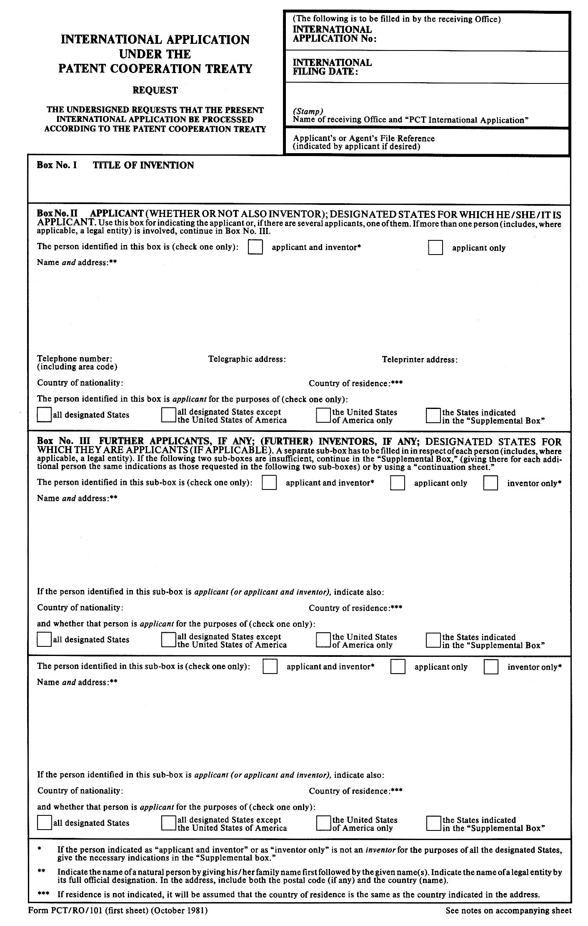
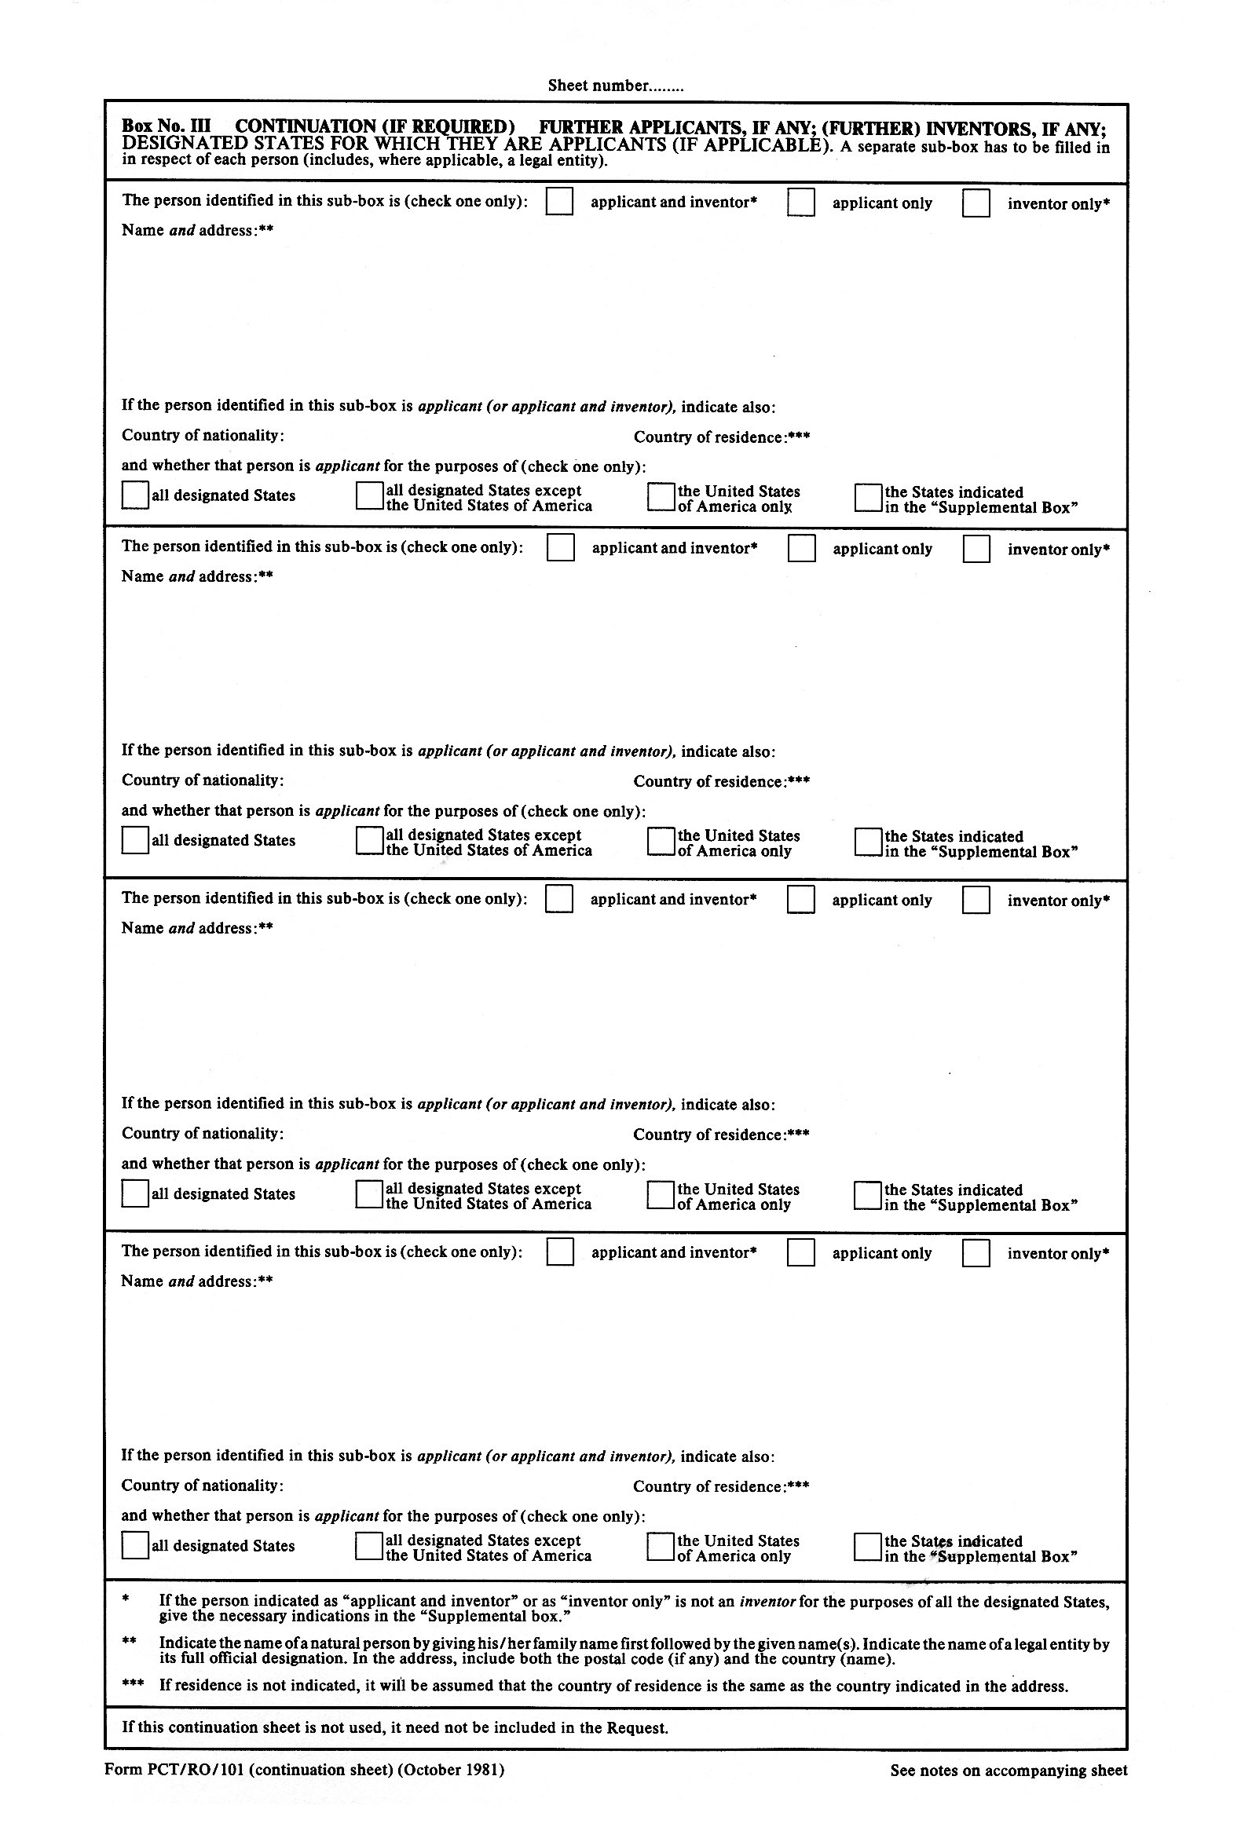
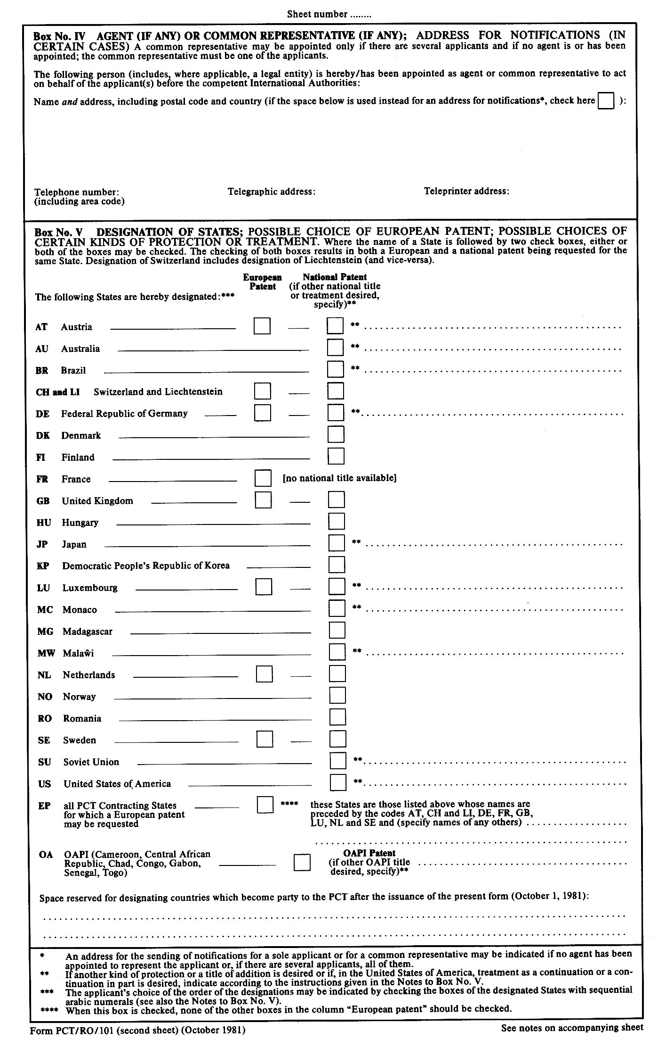
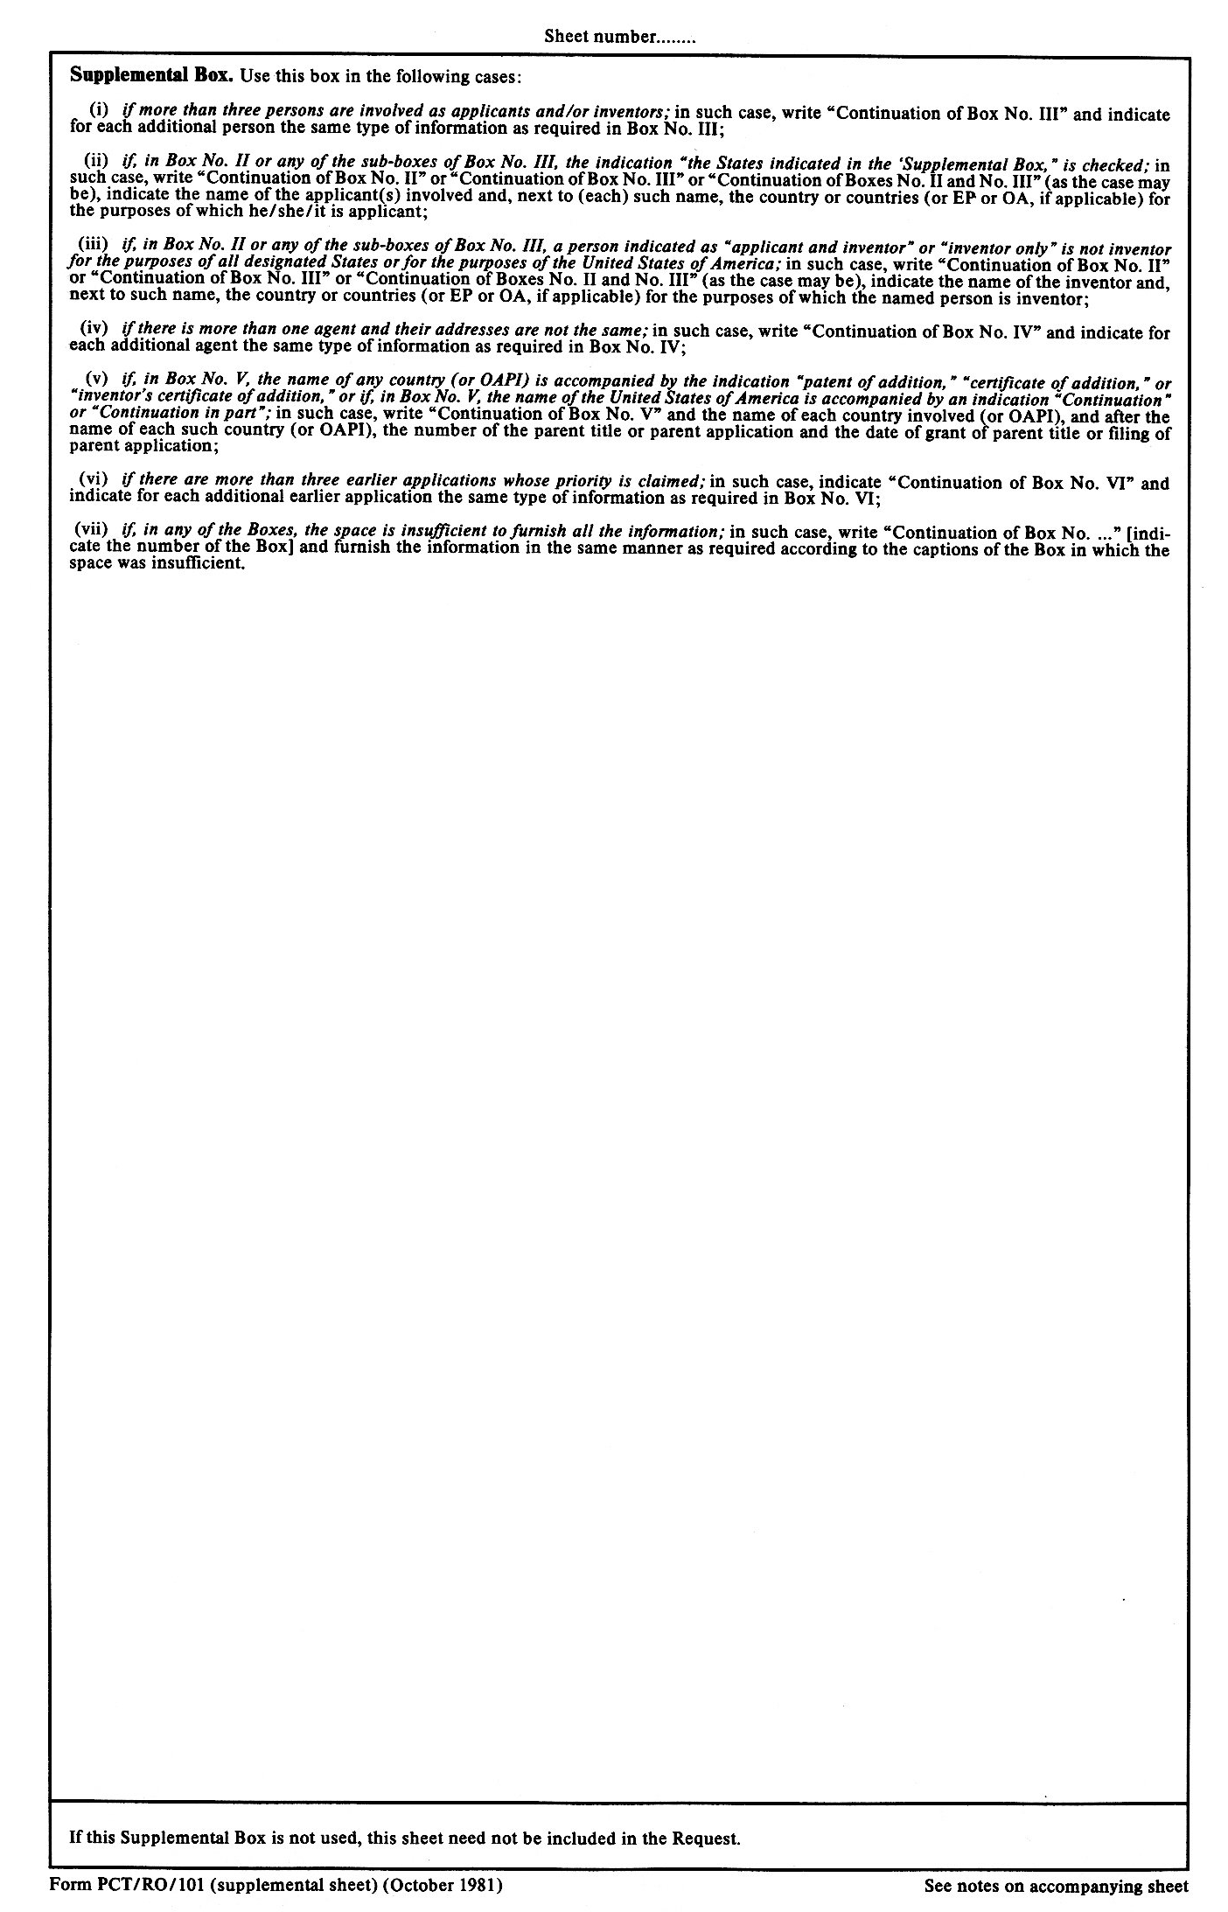
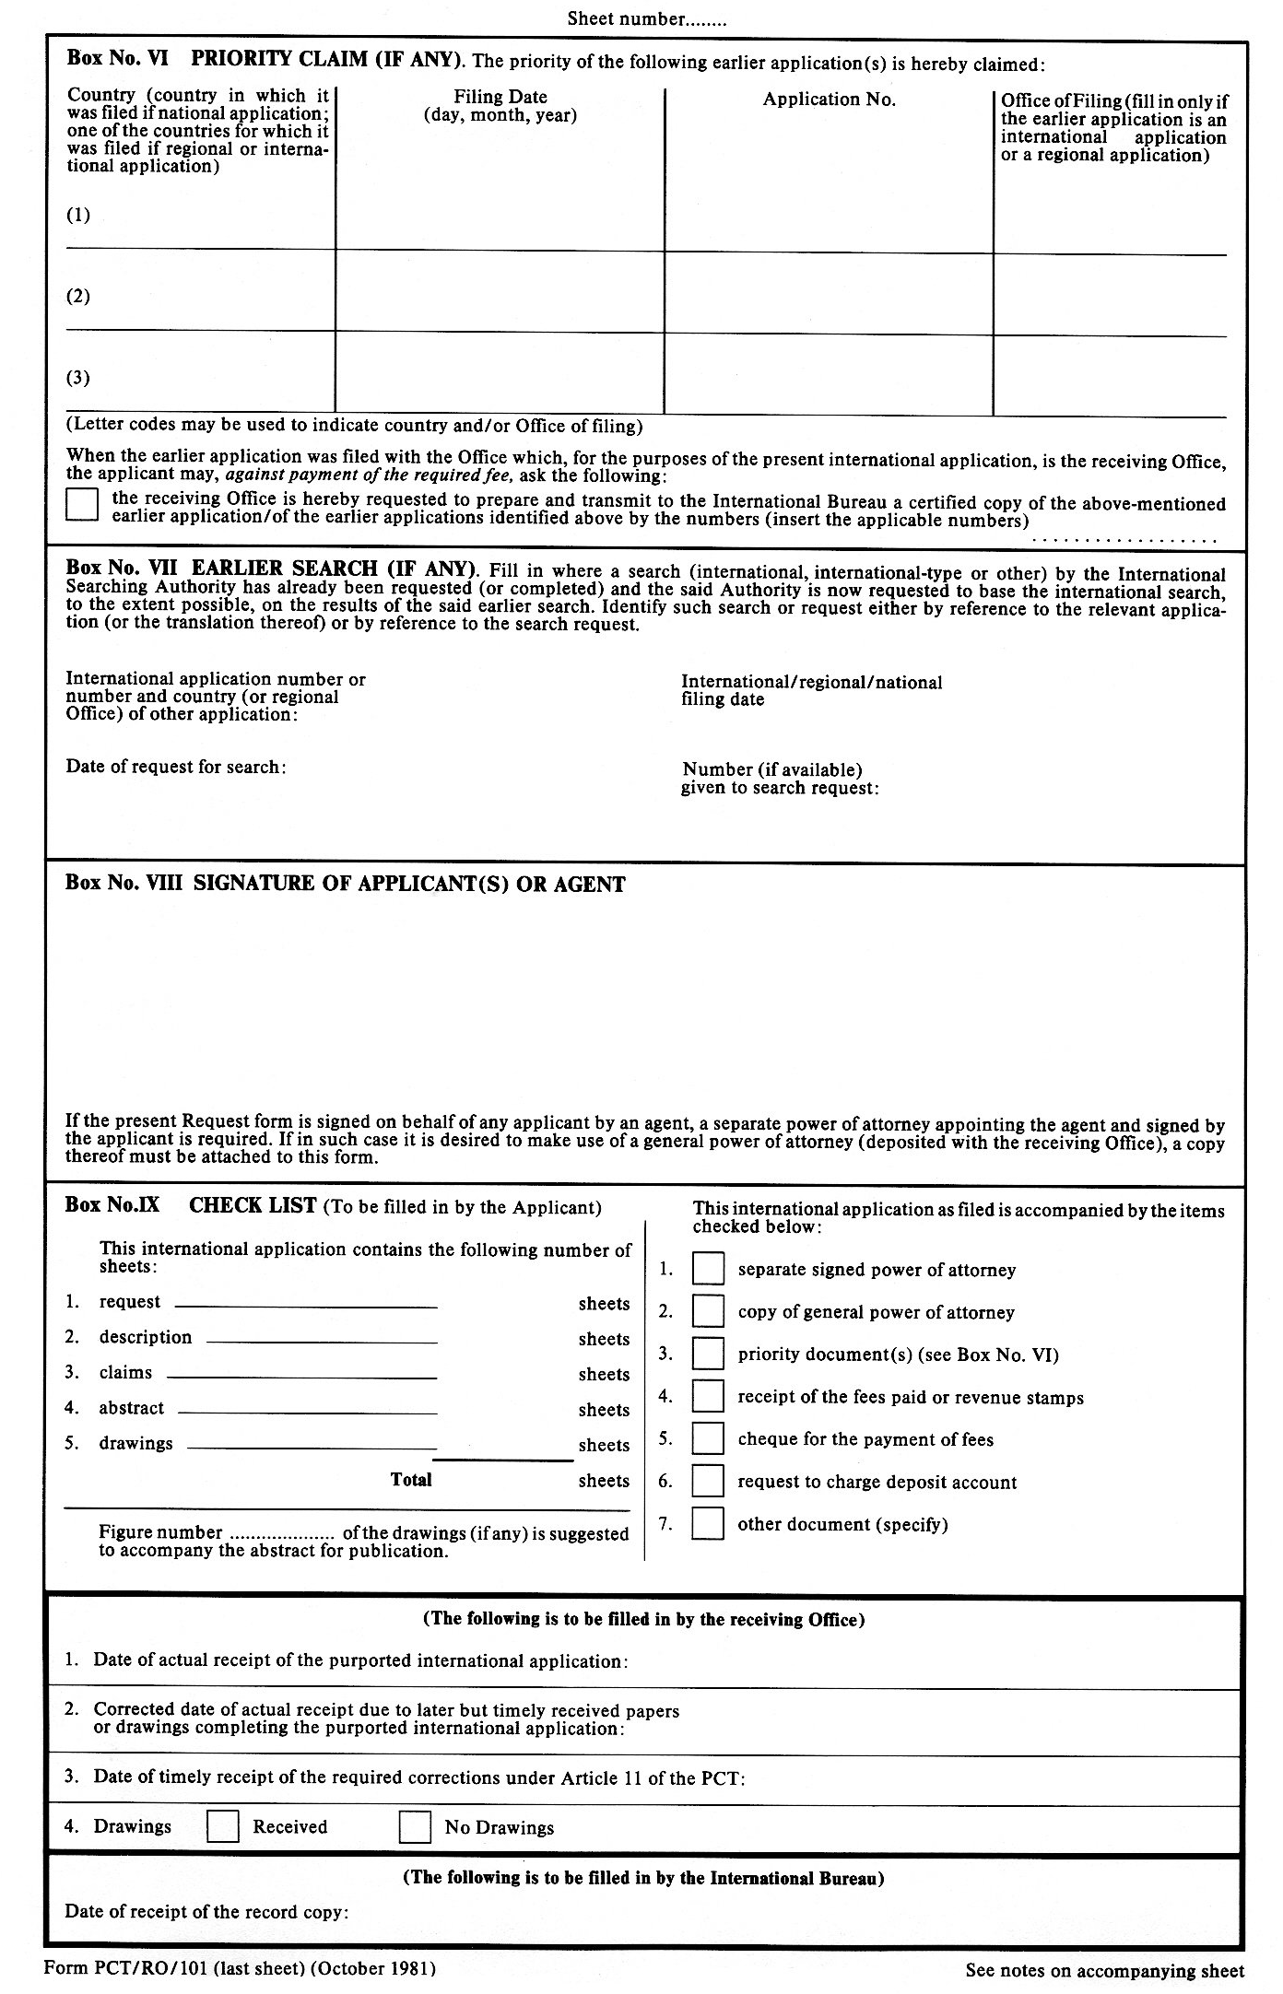
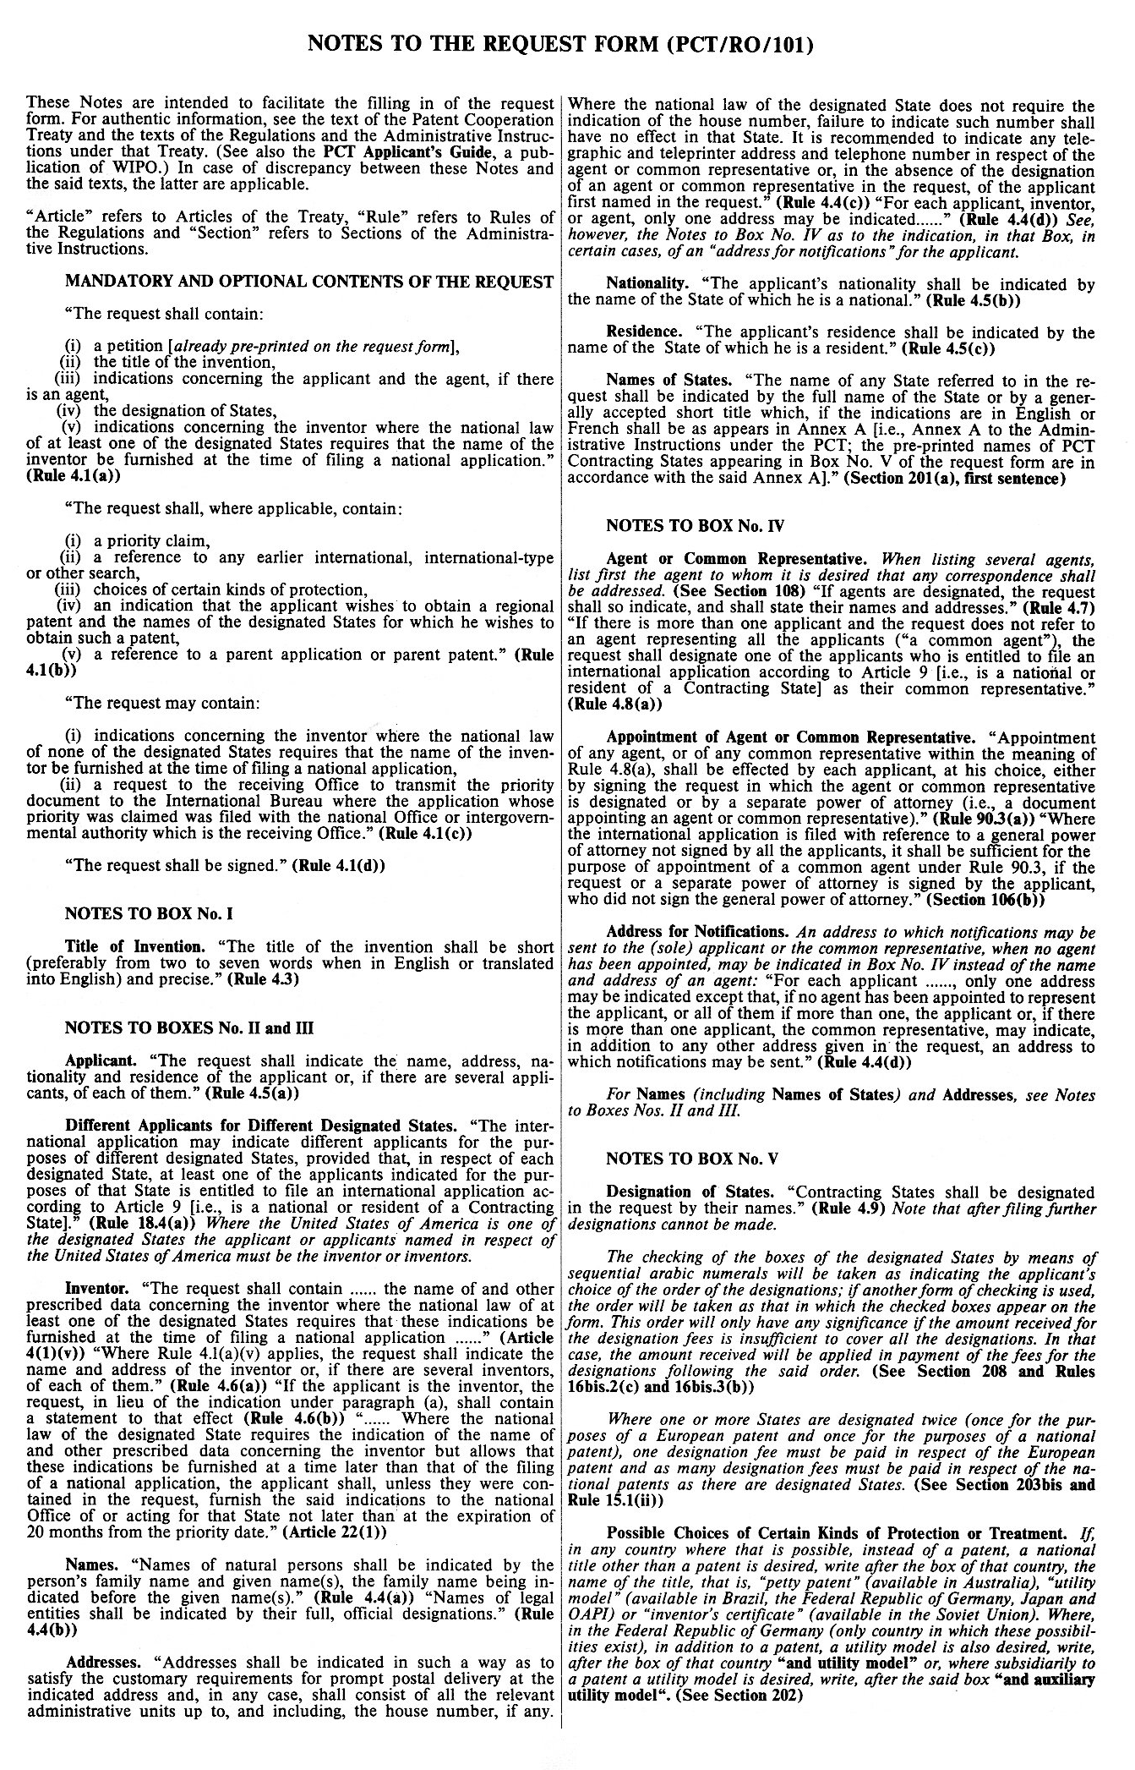
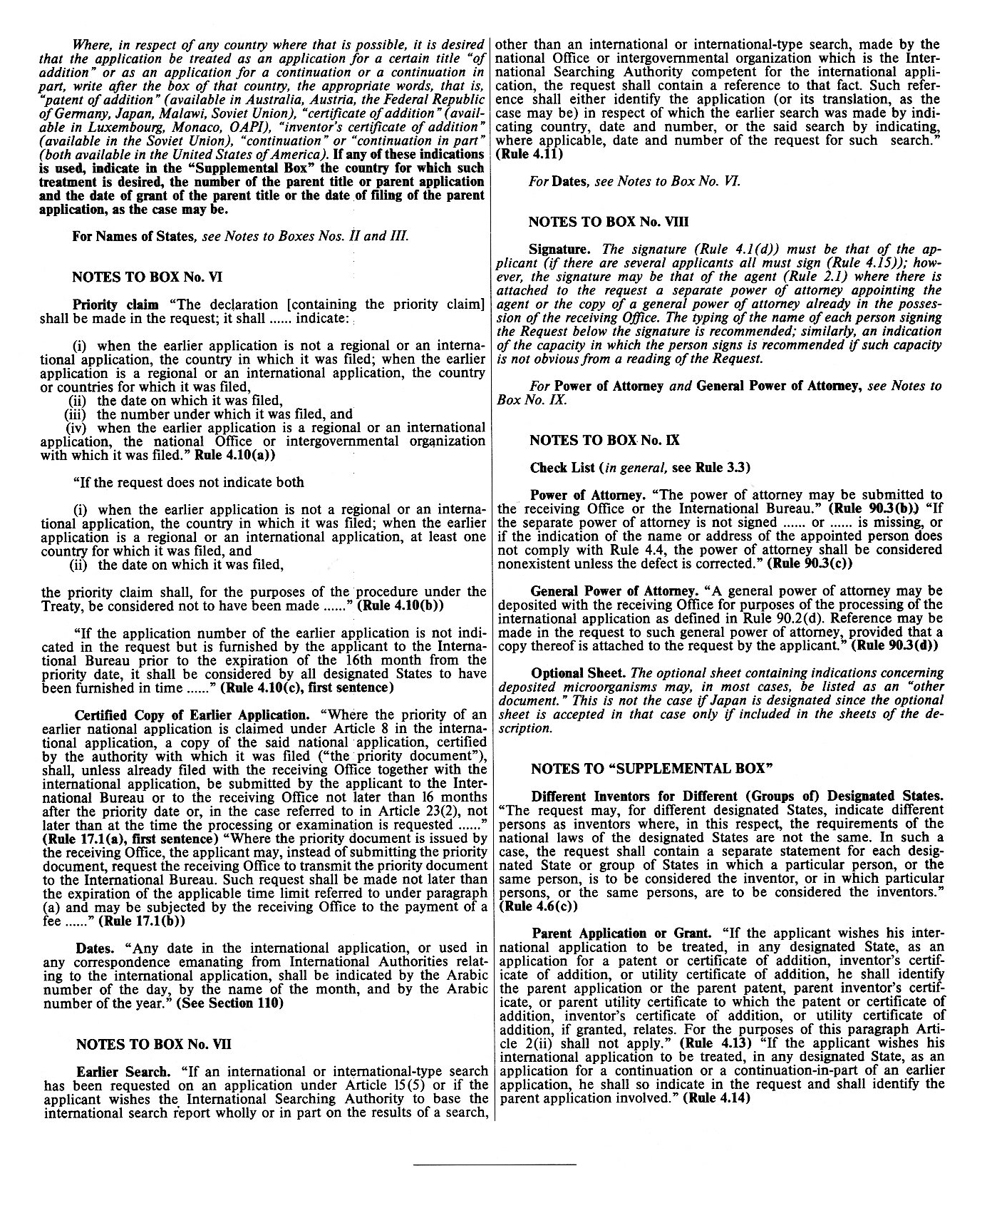

Section 201

Names of States: Cancellation of Designations

(a) The name of any State referred to in the request shall be indicated either by the full name of the State or by a generally accepted short title which, if the indications are in English or French, shall be as appears in Annex A. If the name is inserted in the request by the applicant for the purpose of designating that State, the receiving Office, or the International Bureau where the receiving Office fails to do so, shall insert, preferably before the name of the State, the two-letter country code identifying the State, as appears in Annex B.

(b) [No change]

Section 202

Kind of Protection

(a) Where the applicant wishes his application to be treated in any designated State as an application not for a patent but for the grant of another kind of protection referred to in Article 43, he shall make the indication in the request referred to in Rule 4.12(a) by inserting the words “inventor’s certificate,” “utility certificate,” “utility model” (or “petty patent” for Australia), “patent of addition,” “certificate of addition,” “inventor’s certificate of addition” or “utility certificate of addition,” or their equivalent in the language of the international application, immediately after the indication of the said State.

(b) Where, in respect of the designation of the Federal Republic of Germany, the applicant is seeking two kinds of protection under Article 44, he shall make the indication referred to in Rule 4.12(b) by inserting, immediately after the indication of the Federal Republic of Germany and in the language of the international application, one of the two following indications:

(i) “and utility model”;

(ii) “and auxiliary utility model.”

Section 203

Regional Patents

(a) If the applicant wishes to obtain a regional patent in respect of any designated State and the request form does not contain preprinted indications permitting the applicant to make the indication in the request referred to in Rule 4.1(b)(iv), the applicant shall make the said indication by inserting the words “regional patent,” or their equivalent in the language of the international application, immediately after the indication of the said State or, where an indication has been made under Section 202, after that indication, provided that:

(i) where Article 4(1)(ii), third clause, applies, and not all the States party to the regional treaty have been designated, the international application shall be treated as if all those States had been designated and as if the designations of all such States contained the said words, whether the said designations contained an indication of the wish to obtain a regional patent or, according to Article 4(1)(ii), fourth clause, are to be treated as containing such indication;

(ii) where the national law of any designated State contains a provision as referred to in Article 45(2), the International Bureau shall, according to Article 4(1)(ii), fourth clause, treat the designation as if it contained the said words even where the applicant failed to indicate them.

(b) The applicant may, instead of the words “regional patent” referred to in paragraph (a), use other words to the same effect; such words may include a reference to a patent to be granted by the European Patent Office under the Convention on the Grant of European Patents done at Munich on October 5, 1973 (“European patent”), where the regional patent which the applicant wishes to obtain is a European patent.

(c) An indication, in respect of the designation of Liechtenstein or Switzerland, or both, of the wish to obtain a regional patent shall be taken as indicating a wish to obtain a European patent in respect of those States, whereas the absence of any indication of the wish to obtain a regional patent in respect of such a designation shall be taken as indicating a wish to obtain a patent granted by the Swiss Intellectual Property Office in respect of those States.

Section 206

[Deleted]

[End of document]

