WIPO |  | E  PCT/A/V/4 Corr/Add  ORIGINAL: English  DATE: May 16, 1980
WORLD INTELLECTUAL PROPERTY ORGANIZATION
GENEVA
international patent cooperation union
(pct union)
assembly
Fifth Session (3rd Extraordinary)∗
Geneva, June 9 to 16, 1980
proposals for amendments to the pct regulations and administrative instructions (based on proposals made by organizations representing the users of the pct system) (corrigenda and addendum)
Memorandum prepared by the International Bureau

Corrigenda

1. Ad Rule 41.1. In order to add to the second sentence of the text of the proposed amendment appearing on page 47 of document PCT/A/V/4 a reference to the search other than an international-type search mentioned in the first sentence of the text, the last three words of the second sentence “international-type search” should be replaced by the words “said search.”

2. Ad Rule 69.1. In order to clarify the time limit provided for in the text of the proposed amendment appearing on page 61 of document PCT/A/V/4, the words “such time limit” in the said text should be replaced by the words “such longer time limit as the applicant requests.”

3. Ad Section 205(a) (ii). In order to clarify the claims which shall be renumbered under the text of the proposed modification appearing on page 75 of document PCT/A/V/4, the passage between the word “requires” in the fourth line of the said text and the word “shall” the first time it appears in the seventh line of the said text should be replaced by the following passage: “that a new claim be given a number lower than the highest previously numbered claim, the claims following the new claim.”

Addendum
4. Pages 2 and 3 of this document contain, in the same format as document PCT/A/V/4, an item which is to be added at the end of that document.

Ad Annex F to the Administrative Instructions
Form PCT/RO/101 (Request and Fee Calculation Sheet)

The Chartered Institute of Patent Agents, London

The layout of the request form should be modified so that the particulars of the inventor need be given only once (e.g. in III), whether or not he is a joint applicant (i.e. applicant in respect of U.S.A.). Opportunity could be provided in II and IX for cross-reference to III where necessary.

The form should also provide for the case where one of the applicants has given a general authorization for the agent named, so that the agent may sign for that applicant leaving only the other applicants to add their signature.

The form should be redesigned to reduce frequent use of the Supplemental box, by providing more space in the appropriate boxes for Applicant, Designation of States and Priority Claim.

The Patent Attorneys Association of Japan

Where the same particulars, for example, the same firm name and address for a number of attorneys or agents, are to repeated in the Request form, it should be possible for the repetition to be substituted by a reference (for example, by the expression “ditto”) to the preceding particulars.

The Supplemental box on page 3 of the Request form contains a vertical center line. The line only limits the usage of the box and thus should be deleted.

Comment by the International Bureau

The International Bureau is in agreement that a change of the request form should be considered having particular regard to the mistakes made by applicants filling in that form (see document PCT/A/V/6 Add.2). However, since the changes which should be made require further study, no change other than the removal of the center line from the Supplemental box is proposed at this stage. As far as the further study is concerned, the International Bureau considers that it should be undertaken by a small group consisting of representatives of the receiving Offices, users of the PCT and the International Bureau.

Annex F to the Administrative Instructions
Form PCT/RO/101

No change to pages 1 and 2. Page 3 should be changed as appears in the Annex.

[Annex follows]

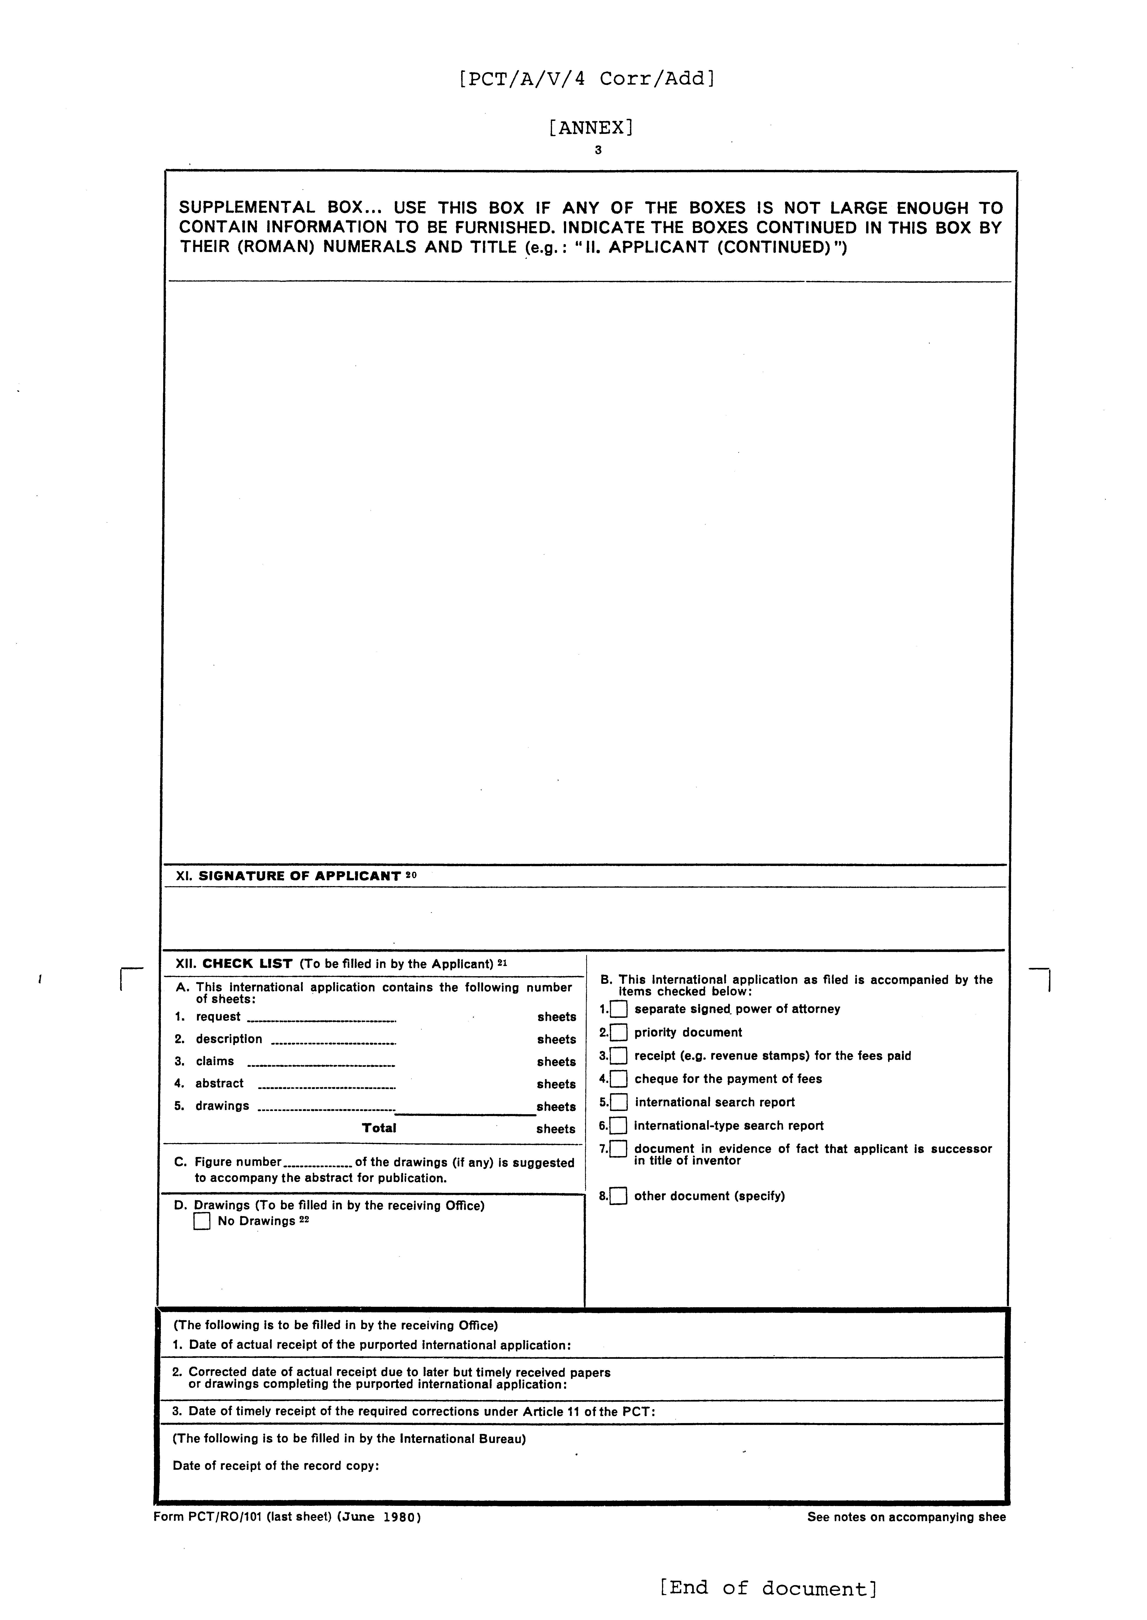

 Editor’s Note: This electronic document has been created from the paper original and may contain errors. Please bring any such errors to the attention of the PCT Legal Division by e-mail at pct.legal@wipo.int

