WIPO |  | E  PCT/A/V/3  ORIGINAL: English  DATE: May 2, 1980
WORLD INTELLECTUAL PROPERTY ORGANIZATION
GENEVA
international patent cooperation union
(pct union)
assembly
Fifth Session (3rd Extraordinary)∗
Geneva, June 9 to 16, 1980
papers submitted by organizations representing users of the pct system indicating their views on necessary changes in the system and its implementation
Memorandum prepared by the International Bureau

1. Various organizations representing users of the PCT system presented papers to the International Bureau before, during or following the PCT Users Meeting held at the headquarters of WIPO on October 5, 1979. The papers dealt with various aspects of the PCT system and its implementation by and/or through the various Offices and Authorities provided for under the PCT.

2. For the information of the PCT Assembly, the papers are set out in full in the Annexes to this document.

3. The Annexes to this document and the papers set out therein are as follows:

Annex A: Paper from the European Federation of Agents of Industry in Industrial Property (FEMIPI) dated January 24, 1980.

Annex B: Paper from the International Federation of Patent Agents (FICPI) dated November 16, 1979.

Annex C: Paper from The Chartered Institute of Patent Agents, London, dated January 18, 1980

Annex D: Paper from The Patent Attorneys Association of Japan (in association with the Japan Institute of Invention and Innovation; the Japanese Group of AIPPI and the Japanese Group of APAA) received September 21, 1979, and referred to during the PCT Users Meeting of October 5, 1979 (together with an extract from a further paper dealing with one point in further detail presented during private discussions in Tokyo on December 12, 1979, the remainder of the latter paper not being reproduced because in substance the same as the paper of September 21, 1979).

Annex E: Paper from the Patent Attorneys Association of Japan dated March 4, 1980.

Annex F: Paper from the Trade Marks, Patents and Designs Federation, London, dated January 21, 1980.

Annex G: Paper from the Trade Marks, Patents and Designs Federation, London, dated February 15, 1980.

4. The PCT Assembly is invited to note the contents of the said papers.

[Annex A follows]

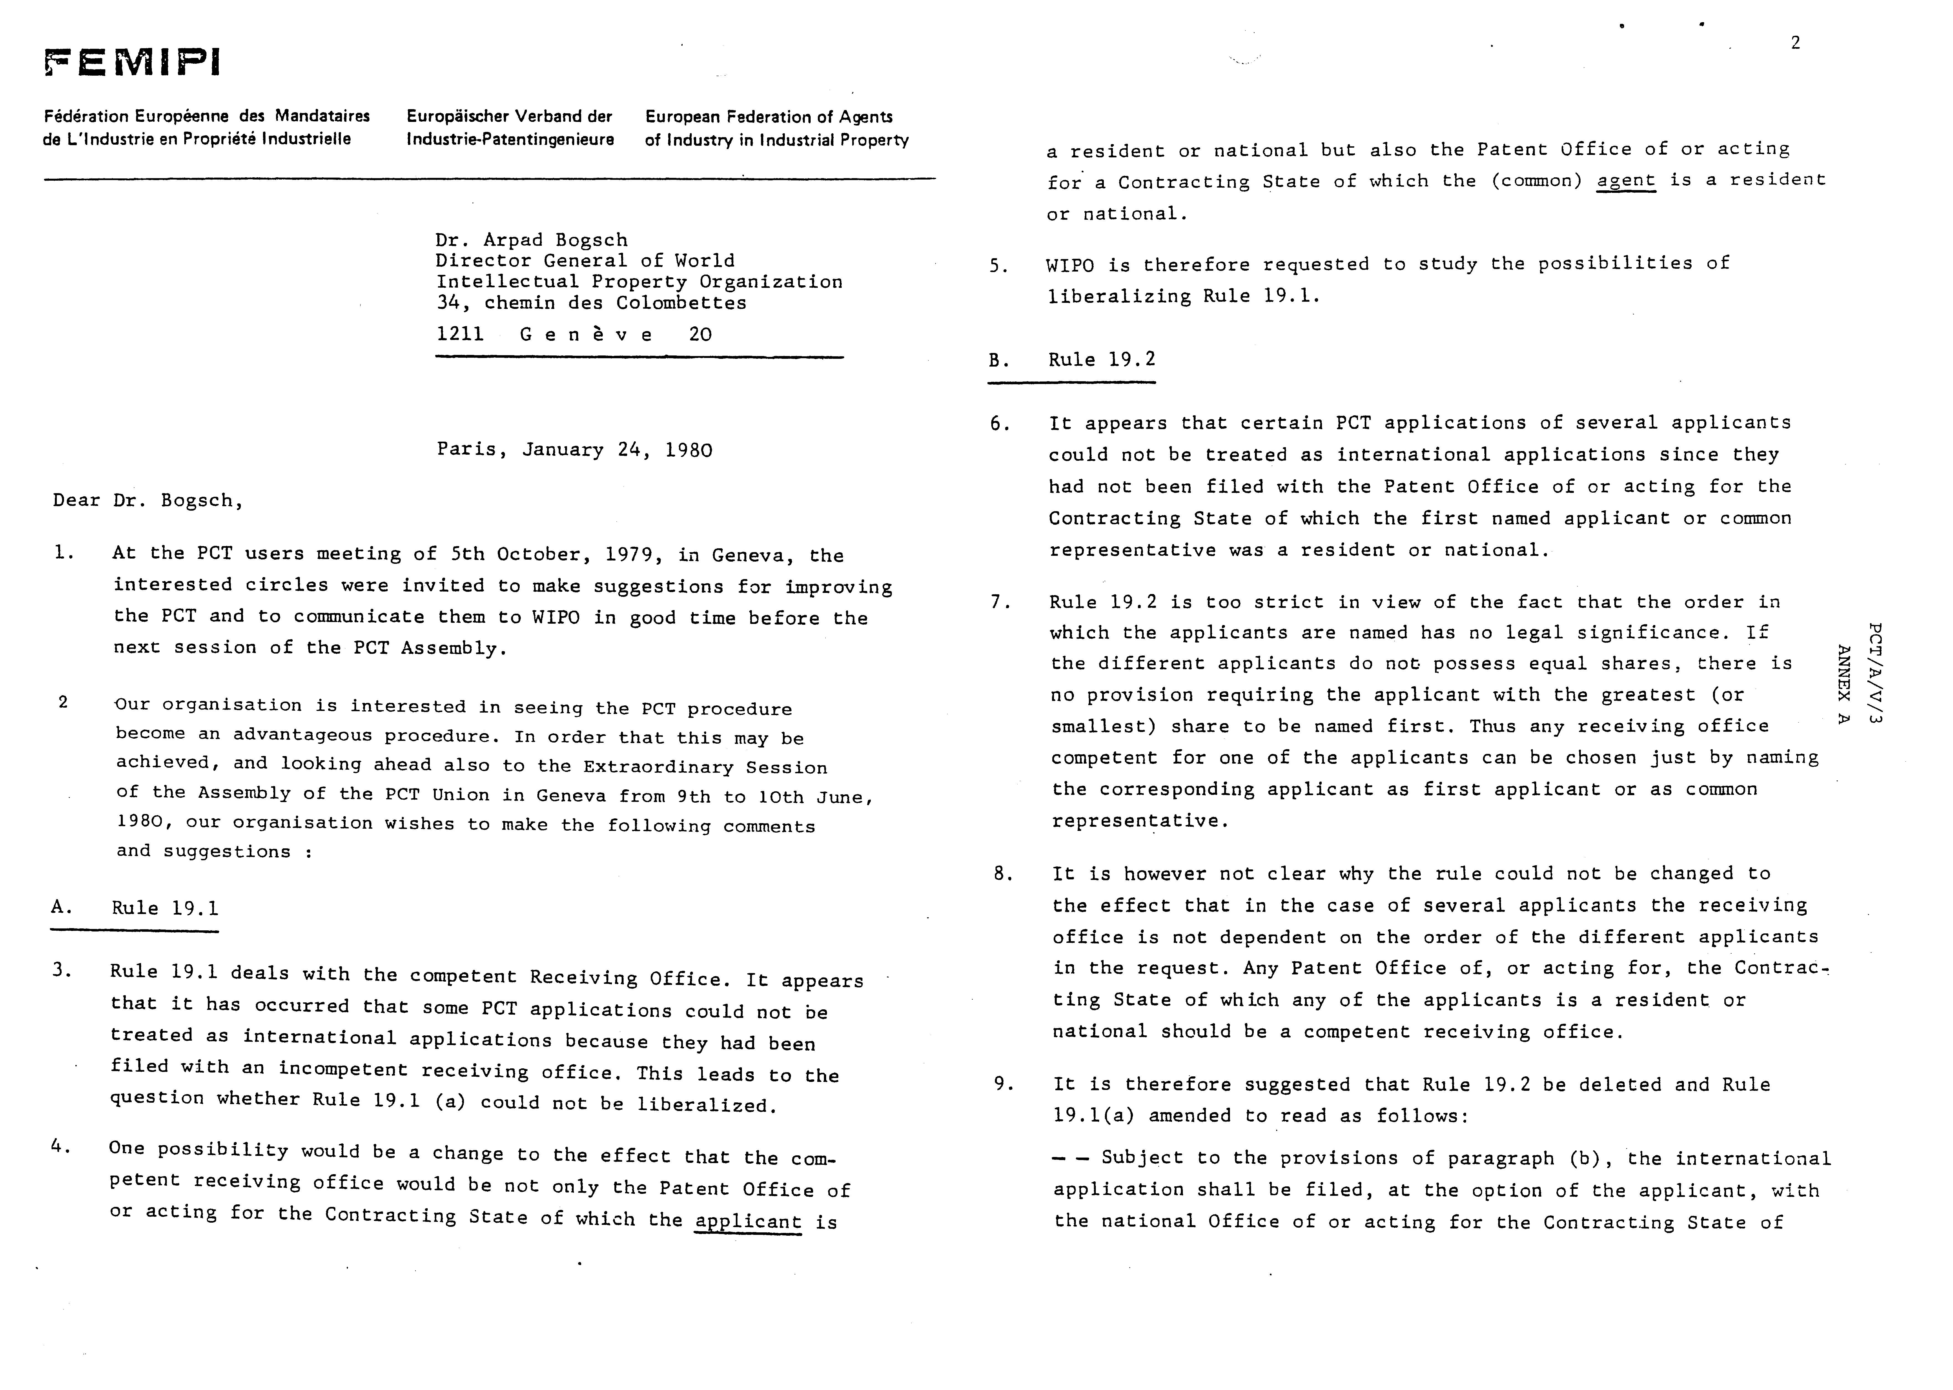
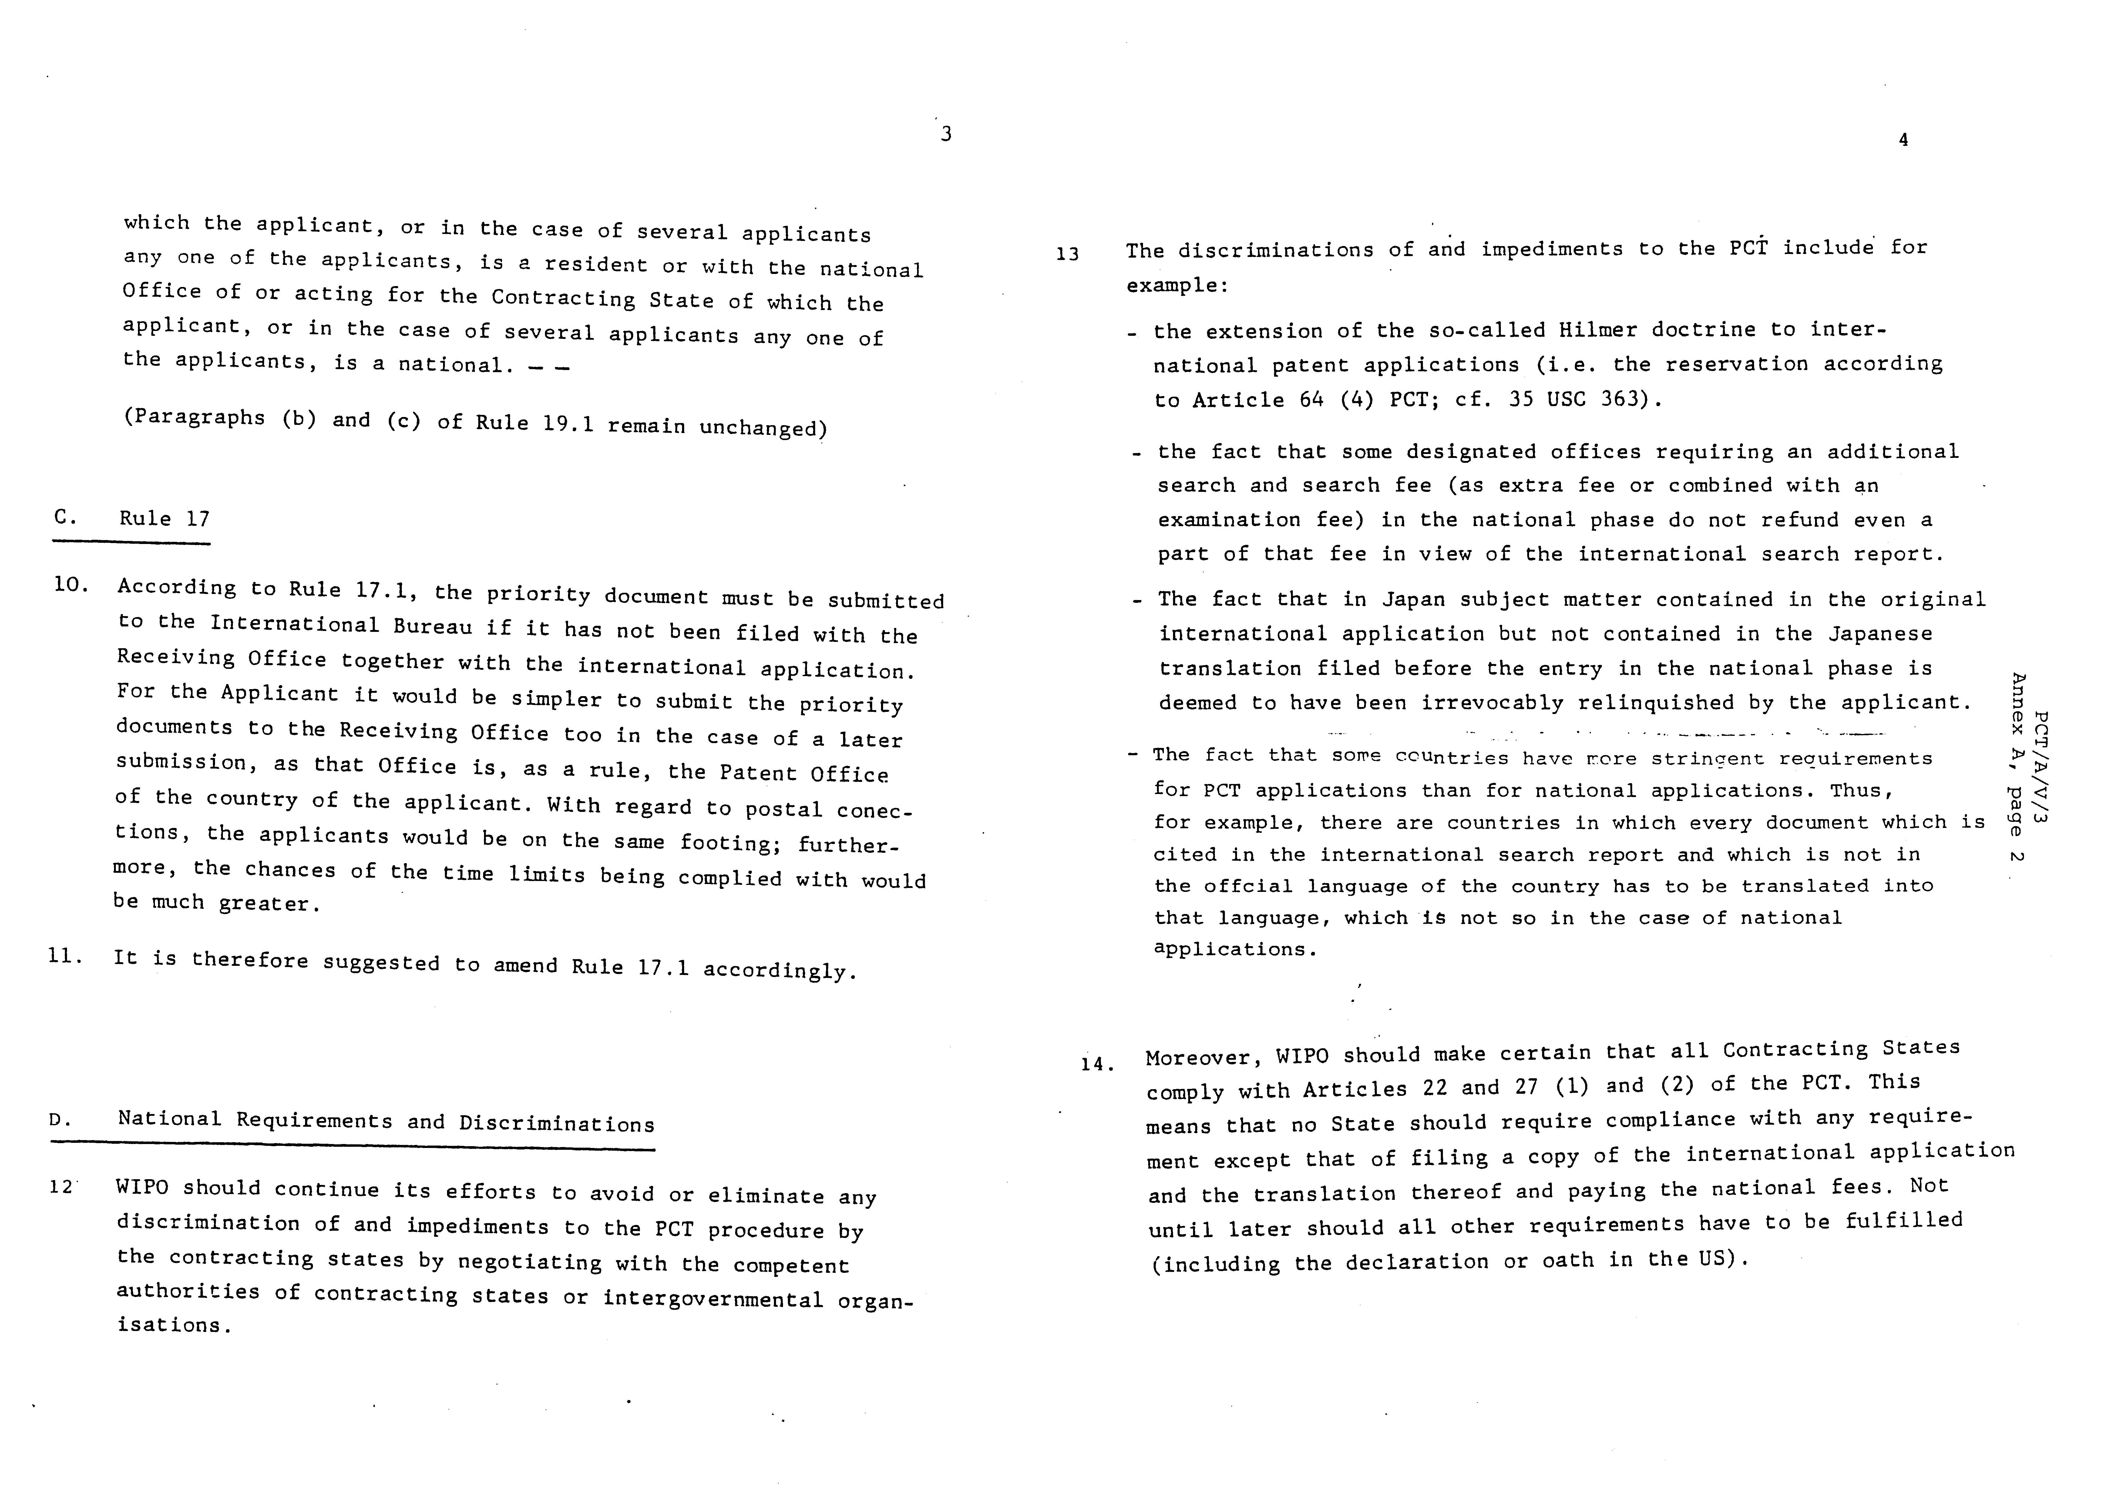
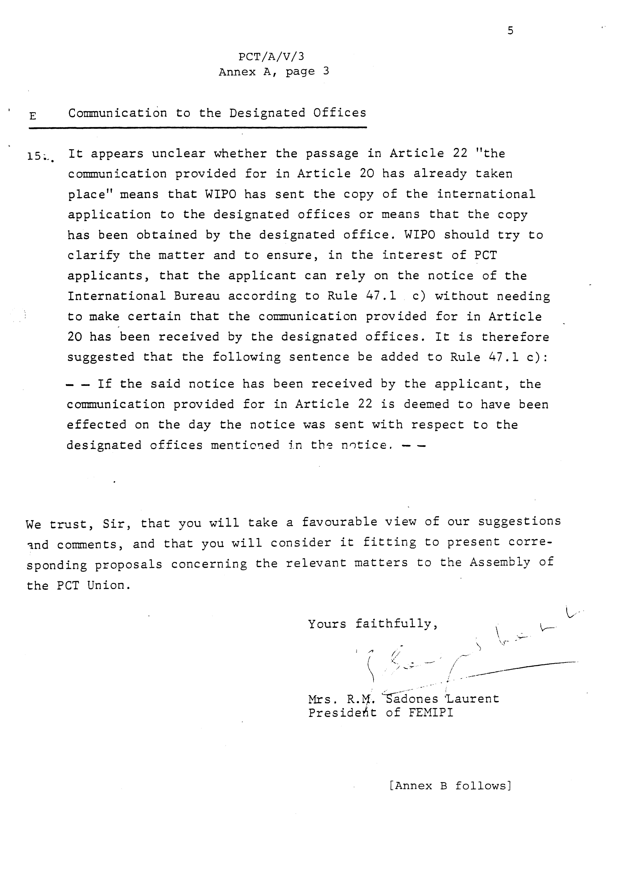
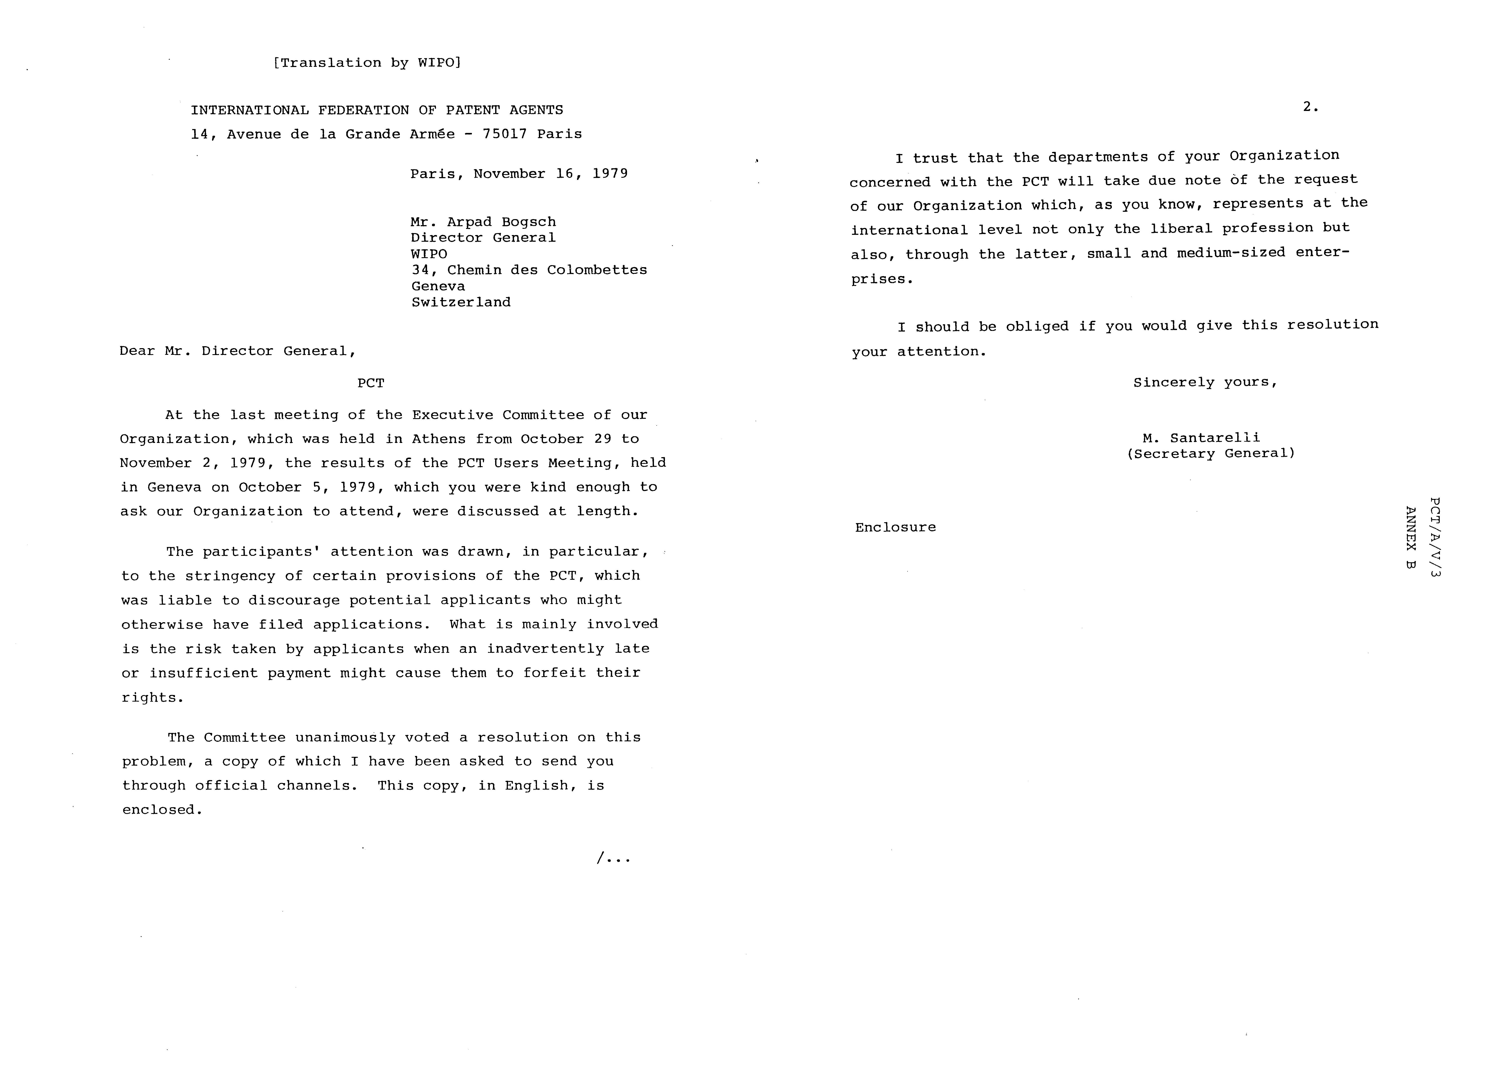

Ficpi – executive committee

Athens

October 29 – November 2, 1979

Resolution

“Members of FICPI, who have now gathered some experience with the filing of PCT application, are concerned with the strictness of the rules regarding the Term of payment of essentially the basis fee, designation fees and search fee. This strictness is liable of discouraging some Applicants from filing PCT applications.

FICPI was satisfied that this matter has been brought up at the PCT user’s meeting in GENEVA on October 5th 1979.

FICPI would welcome and strongly support any remedy to the loss of rights by an Applicant owing to inadvertent late or insufficient payment. Such remedy could e.g. consist of an amendment to the rules which would allow either a grace period for completing the payment or a reinstatement of the application, possible subject to a reasonable penalty payment”.

[Annex C follows]

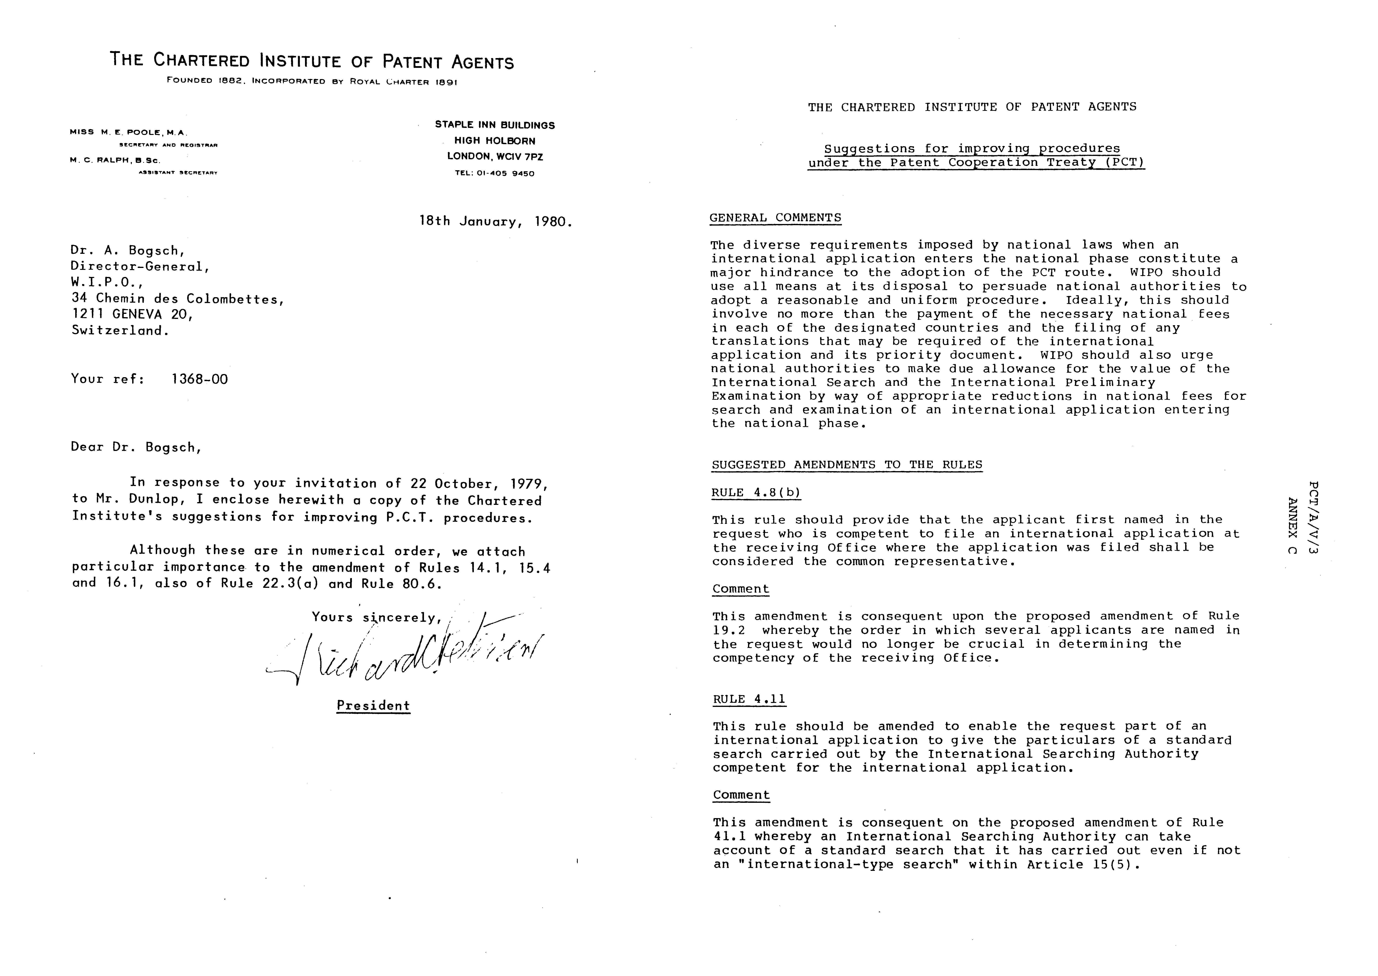

RULE 6.4(a)

In this rule, the second and third sentences should be modified by insertion of the word “preferably” after the word “shall” in each instance. A further sentence should then be added (along the lines of Rule 6.3(c)) saying that, where the law of the designated State does not require the manner of claiming provided for in the foregoing two sentences, failure to use that manner of claiming shall have no effect in that State provided the manner of claiming actually used satisfies the national law of that State.

Comment

This amendment would permit an international application to contain multiple dependent claims dependent on other multiple dependent claims. This form of claiming, which is usual in Europe, tends to result in each subordinate inventive feature being presented in one and only one of the dependent claims. It may therefore be considered to facilitate (rather than to hinder) the searching of the application by the International Searching Authority, and generally to be conducive to conciseness and clarity of claiming. (The corresponding rule under the European Patent Convention (Rule 29(4)) contains nothing equivalent to the second and third sentences of Rule 6.4(a)).

RULE 8.1(d)

In this rule, the word “preferably” should be inserted before the words “placed between parentheses”.

Comment

This amendment would put the abstract on the same footing as the claims, in which reference signs need not necessarily be in parentheses (Rule 6.2(b)).

RULE 10.1(b)

In this rule, the word “Centigrade” should be replaced by “Celsius”

Comment

The term “Celsius” is internationally prescribed, and this amendment would simply reflect the policy expressed in Rule 10.1(d) according to which the rules of international
practice shall be observe for indications of certain physical quantities (including heat). The word “Celsius” is used in the European Patent Convention, Rule 35(12)).

RULE 10.1(c)

This paragraph should be omitted.

Comment

Density is effectively one of the weights and measures dealt with in Rule 10.1(a), and paragraph (c) is therefore redundant. It is also unduly restrictive because it does not include a provision for stating density also in non-metric terms if desired, a facility which exists under paragraph (a).

RULE 11.2

A new paragraph should be added to this rule saying that, notwithstanding paragraph (d), a sheet is permitted to bear a table typed sideways if the information cannot satisfactorily be presented in any other way. It may be desirable to add, either in the Rules or the Administrative Instructions that the top edge of the sheet (with the page number) must then be to the right.

Comment

The circumstances are similar to those for placing drawings sideways on a sheet, which is permitted by Rule 11.13(j).

RULE 13.2

In this rule, the expressions “one independent claim”, “one process, “one use” and “one apparatus or means” wherever occurring under possibilities (i) and (ii) should be replaced respectively by “an independent claim”, “a process”, “a use” and “an apparatus or means”. A further possibility should be added to permit, in addition to an independent claim for a product, the inclusion in the same international application of an independent claim for a process specially adapted for the manufacture of the product, and an independent claim for an apparatus or means specifically designed for carrying out the process.

Comment

This amendment would bring the wording of the rule into line with the corresponding rule under the European Patent Convention (Rule 30) where (so far as is known) no difficulties have arisen. (The European Patent Office Guidelines for Examination, B-III 4.4(c)(ii), refer to this difference in the rules but state that for the search the same practice nevertheless has to be followed for international and European applications.)

RULES 14.1, 15.4, 16.1

These rules should be amended to provide that if the transmittal fee, the basic fee, the designation fees and the search fee are not paid in full as required, the receiving Office shall invite the applicant to pay the fees or the missing parts thereof within one month from the date of the invitation (possibly imposing a surcharge for any such belated payment), and that if the applicant complies with the invitation within the prescribed time limit the respective fees will be considered as if they had been paid on the due date.

Comment

This set of amendments would provide a facility similar to that already given by Rules 57.4(a), 57.5(a) and 58.2(a). It would make PCT procedure materially less hazardous and therefore more attractive to a prospective applicant and his professional advisers. Under the European Patent Convention there is now Rule 85a having a similar effect (Official Journal of the EPO, 10/1979).

RULE 19.2

This rule should be amended to provide that, if there are several applicants, it is necessary only for one of them to be qualified under Rule 19.1 to file an international application at the receiving Office concerned.

Comment

At present, the rule is unduly restrictive because it makes the competency of a given receiving Office depend merely on the order in which several applicants have been named in the request.

RULE 22.3(a)

This rule should be amended to provide that the time limit referred to in Article 12(3) shall in each instance be one month longer than at present.

Comment

For an international application proceeding under Rule 22.1, interaction of the existing Rules 22.1(b) and 22.3(a) (i) results in an unrealistically short period of only 18-21 days for the applicant to take action if he is not in possession of the notification of receipt sent by the International Bureau under Rule 24. 2( a). The interval must be long enough to allow time in the mail for three distinct sequences of correspondence (applicant to receiving Office asking for the record copy or a certified copy of the home copy; receiving Office to applicant sending him the copy requested; applicant to International Bureau transmitting the copy concerned) as well as the time taken by the receiving Office to prepare a certified copy. Even if the application were received by the International Bureau as late as 15 months from the priority date, there would still be sufficient time for it to be prepared for international publication; on the rare occasions when an application was received near the end of this period, Rule 48.2(g) would allow it to be published without the international search report if necessary.

RULE 30.1

This rule should be amended to shorten the time limit referred to in Article 14(4); a period of four months from the international filing date is suggested.

Comment

The public interest, as well as that of the putative applicant, requires that a prompt determination should be made as to whether the requirements listed in items (i) to (iii) of Article 11(1) were complied with at the date of filing of an international application. If an international application is to be considered withdrawn under Article 14(4), the receiving Office should be required so to declare before an international search is carried out and certainly before there is any’ possibility of the application being prepared for international publication. Another reason for shortening the time limit in this rule would be provided by the amendment proposed below in Rule 51.3.

RULE 41.1

This rule should be amended to provide that, when the request part of an international application refers to a standard search carried out by the International Searching Authority competent for the international application, such a search shall be treated as if it were an international-type search.

Comment

There are occasions when the results of a standard search carried out by an International Searching Authority, although not an international-type search within Article 15(5), may be used by the International Searching Authority in establishing the international search report on an international application, and some refund of the search fee may therefore be appropriate.

RULE 46 .1

No amendment is proposed in this rule, in view of the proposed amendment to Rule 80.6.

Comment

As things stand, Rule 46.1 in setting time limits running from the date of transmittal of the international search report appears to be ultra vires Article 19(1) which requires the applicant to have received the international search report at the time when he is entitled to an opportunity to amend the claims of his international application. The proposed amendment to Rule 80.6, by making it possible to link time limits like that prescribed by Rule 46.1 with the applicant’s date of receipt of the document concerned, would appear to overcome this difficulty.

RULE 46.4

This rule should include an additional paragraph permitting an applicant to file comment on the relevance of citations made in the international search report, whether or not he amends his claims. If the aggregate length of the statement (if any) under Article 19(1) and the above-mentioned comment does not exceed 500 words when in English or translated into English, the whole should be regarded as the statement under Article 19(1) for the purposes of Rules 48.2(a)(vi) and 49.3.

Comment

It is believed that the opportunity to provide brief comment on the international search report, going beyond mere explanation of any amendment to the claims, would be welcome to some applicants, and that its publication with the application would be in the public interest too.

RULE 51.3

This rule should be amended to provide that the time limit referred to in Article 25(2)(a); for paying the national fee and furnishing the appropriate translation, shall expire at 20 months from the priority date.

Comment

This amendment would have the desirable effect of making the time limit for taking action in designated offices under Article 25 uniform with that for entry into the national phase under Article 22. Adoption of this amendment would make it desirable to shorten the existing period under Rule 30.1 (as suggested above), because a period of 6 months from the international filing date can be as much as 18 months from the priority date, to which must be added the time taken to issue a notification under Rule 29.1(a) (ii) as well as the 2 months prescribed by Rule 51.1 for asking the International Bureau to send copies of documents to designated offices.

RULE 66.2(d)

No amendment is proposed in this rule, in view of the proposed amendment to Rule 80.6.

Comment

Rule 66.2(d) stands in the same relationship to Article 34(2)(c) as that mentioned above between Rule 46.1 and Article 19(1), and the proposed amendment to Rule 80.6 appears to overcome the difficulty for the same reason.

RULE 69.1

The time limits prescribed for the establishment of the international preliminary examination report in paragraphs (a) and (c) should be capable of extension by a period of up to six months upon request by the applicant.

Comment

The time to establish the report may often be too short, especially when evidence is required in proof of inventive step.

RULE 80.6

This rule should be amended to provide additionally that, when a period starts on the day of the date of a document or letter emanating from a national office or intergovernmental organization, the party to whom the document or letter was addressed may prove that he did not receive it until after 5 days after the date that it bears, in which case the period shall be computed from the date 5 days before the date of actual receipt.

Comment

A similar presumption that a document or letter will arrive within 5 days after the date of mailing is found in Rule 82.1(a). The proposed amendment would be highly desirable in the interests of the applicant, in view of delays currently experienced in the post, and would also serve to introduce a measure of conformity with European practice (cf. European Patent convention, Rule 83(2), together with Rule 78(3». Moreover, in the absence of an amendment of this character, it would apparently be necessary to amend Rules 46.1 and 66.2(d) which prescribe time limits running respectively from the date of transmittal of the international search report and the date of notification of the written opinion of the International Preliminary Examining Authority, because Article 19(1) and 34(2)(c) under which those rules are made require the applicant to have received the document in question before having to respond to it.

RULE 92.1

This rule should be amended to provide that, if an applicant submits a letter from which his signature is missing, a copy of the letter shall be sent to him with an invitation to return it within a prescribed time limit after affixing his signature thereto, and that only if this invitation is not complied with shall the original letter be considered not to have been submitted.

Comment

Circumstances can easily be imagined where an applicant or his agent may inadvertantly fail to sign a paper or covering letter as required by the last sentence of Rule 92.l(a), and Rule 92.l(b) is unduly severe in providing simply that such a paper is considered not to have been submitted. The remedy proposed is along the lines of that adopted by the Administrative Instructions, Section 316, in the case where the request part of an international application has not been signed.

SUGGESTED AMENDMENTS TO THE ADMINISTRATIVE INSTRUCTIONS

SECTION 106

This section should be amended to cater for a situation where one of several applicants has already lodged a general authorization (power of attorney) with the receiving Office, so that only the other applicants (e.g. inventors where U.S.A. is designated) need sign the request form or any separate powers of attorney.

SECTION 204

Heading (v) should be amended to include “Mode for Carrying Out the Invention” by way of alternative.

Comment

Rule 5.1(a) (v) indicates that the law of some designated States does not require the description of the best mode but is satisfied with the description of any mode (whether it is the best contemplated or not). For example, there is no requirement in the European Patent Convention (cf Rule 27(l)(f) for a description of the best mode. Unless a State is designated which requires a description of the best mode, heading (v) as currently set out in Section 204 is inappropriate.

SECTION 205

Greater flexibility should be allowed in the numbering of amended claims. For example, it should be possible to replace a single claim by two claims with consequent renumbering of subsequent claims in the set.

SECTION 406

While no amendment appears to be necessary, a decision is requested from the Director General that the language in which an international application was originally filed shall be identified on the front of the pamphlet in cases where international publication is of a translation under Rule 48.3(b).

FORM PCT/RO/IOI (Request)

The layout of this form should be modified so that the particulars of the inventor need be given only once (e.g. in III), whether or not he is a joint applicant (i.e. applicant in respect of U.S.A.). Opportunity could be provided in II and IX for cross-reference to III where necessary. The form should also provide for the case where one of the applicants has given a general authorization for the agent named, so that the agent may sign for that applicant leaving only the other applicants to add their signatures. The form should be redesigned to reduce frequent use of the Supplemental box, by providing more space in the appropriate boxes for Applicant, Designation of States, and Priority Claim.

[Annex D follows]

Questions, comments and requests concerning

pct applications for the pct users meeting

by

Patent Attorneys Association of Japan
Japan Institute of Invention & Innovation
Japanese Group of AIPPI
Japanese Group of APAA

1. The international application

(1) The checking of formality requirements of the international application at various receiving Offices is not uniform. The receiving Office in Japan is making very rigid checks in this respect in accordance with the PCT Rules, but it does not seem that this is true at receiving Offices in many other countries.

(i) The name of an inventor or applicant (individual) should be written with the family name being indicated before the given name (PCT Rule 4.4(a)), but it has been noted that the given name is often written before the family name (especially in cases from the United States).

(ii) The applicant’s address on the Request form should include “country” according to the note in parentheses on Form PCT/RO/101, Part II. Many applicants do not include the name of their country in their address.

(iii) Together with the name of an individual is sometimes included his title as part of his name, such as, Dr. or Professor. This is often seen in applications deriving from European countries.

At present, when the international application having errors of the above nature is translated and submitted to the Japanese Patent Office as a designated Office, while the Japanese agent indicates the particulars correctly on the paper accompanying the Japanese version of the application, he must submit a statement explaining that there are errors in the original. (This statement is required by the Japanese Patent Office).

For the above reasons, it is hoped that the checking of formality requirements at various receiving Offices be carried out with greater uniformity.

(2) It is desirable that standard sample letters or cover letters to be submitted to the International bureau (for example, for use in submitting the priority documents, amendments under Article 19 of the Treat, withdrawal of the international application or of designations) be prepared and be published in the PCT Gazette.

(3) Where the same particulars, for example, the same firm name and address for a number of attorneys or agents, are to be repeatedly indicated in the Request form, it is hoped that the repletion may be substituted by a reference to the preceding particulars (e.g., by the expression “ditto” or “do”). It has been noted that many receiving Offices have accepted such manner of indication. The propriety of this should be confirmed officially.

(4) The supplemental box on Page 3 of the Request (Form PCT/RO/101 (last sheet)) contains a vertical center line. The line only limits the usage of the box and thus should be deleted.

(5) In the case where a national law of a designated country has a provision for exception to loss of novelty, requiring the applicant to file a relevant statement, proof, copies, etc. simultaneously with the filing of the application or within a short period thereafter, how can the applicant place reliance on this provision when filing the international application?

2. The drafting of the description, claims and abstract of the international application; amendments.

(1) Although it is urged that the title of the invention shall preferably be from two to seven words when in English or translated into English (PCT Rule 4.3), such a limited number of words is unsuitable to meet practical needs. It is desired that the number be increased, if possible, up to 15 words.

(2) Likewise, whereas it is urged that the abstract in English shall preferably be 50 to 150 words if it is in English or when translated into English (PCT Rule 8.1(b)), it is desired that the number be increased somewhat (for example, 50 to 250 words as is the case in MPEP 608.01(b) of the United States Patent and Trademark Office).

(3) According to PCT Regulations, the various parts in the description shall preferably be preceded by appropriate headings as suggested in the Administrative Instructions (PCT Rule 5.1(c)), and thus it has been noted that, in the actual applications filed, some are with headings and some are without any headings. It appears desirable that the minimum requirements be established so that the applications will uniformly include the minimum necessary headings.

(4) The PCT Regulations require that the form of amendments under Article 19 of the Treaty shall be by way of the submission of a replacement sheet for every sheet which differs from the sheet originally filed and the letter accompanying the replacement sheet shall state the differences from the replaced sheet (PCT Rule 46.5(a)). It has been noted that many of the amendments under Article 19 which have been received by Japanese agents from overseas applicants are not in compliance with the above requirements. The agents receiving other forms of amendments are unable to confirm from such papers themselves whether they are in fact Article 19 amendments. A sample letter of the letter accompanying the replacement sheets should be prepared and published in the PCT Gazette.

(5) It is hoped that the applicant (or agent) can be informed of the date on which an amendment under Article 19 of the Treaty was received. Although, upon receipt of such an amendment, the International Bureau informs the applicant (or agent) of the fact that the amendment was received but without the date of receipt thereof. It is desirable for the applicant (or agent) to receive the date since the only method by which this date could be confirmed at present is to check the pamphlet issued by the International Bureau.

(6) Since it is urged that each sheet shall be reasonably free from overwritings and interlineations (PCT Rule 11.12), it is desired that standards be established and made public of the conditions under which such overwritings and interlineations are admitted.

3. Representation

No comments.

4. Official fees; costs; time limits

No comments.

5. International Search

Where the United Kingdom is included as a designated State, the fact that the references marked “x” in a search report must be translated into English renders the prosecution of the PCT originated applications very expensive.

6. International Preliminary Examination

No comments.

7. PCT publications

It is hoped that the “Request” could also be included in the publication of the pamphlet. There are instances where the copy of the Request which an agent in a designated State receives from the applicant and the copy of the Request which the International Bureau communicated to the designated Office under Article 20 of the Treaty have discrepancies due to, for example, corrections made subsequent to the filing. When the designated Office draws the agent’s attention to a deviation in any particulars from the information contained in the copy of the Office, the agent will be able to check this if the pamphlet includes the “Request”.

8. Entering the national phase

(1) Some countries require the submission of a complete set of drawings (especially, formal drawings) and a copy of the priority document. It is desired that the duplication of filing of documents be minimized so that the applicant may be able to save on expenses.

(2) Extent of the documents to be filed with various designated Offices for the national stage processing is not clear.

For example,

- where drawings contain no words to be translated, is it necessary to furnish the drawings for the national stage filing? In the absence of regulations in this respect, the applicant is now furnishing all the drawings to be safe;
- what papers are included in “a copy of the international application” to be submitted to a designated Office? For example, will the application be treated as abandoned if an amendment under Article 19 of the Treaty and
its translation or an amendment of the title of the invention or of an abstract and its translation are not submitted to the designated Office? It is desired that the International Bureau send a questionnaire concerning this question to all contracting countries and publish the information in the PCT Gazette.

(3) It is desired that, upon receipt of a copy of the international application from the International Bureau, the designated Office should inform the applicant of this fact. (It is understood that this is being done by the designated Offices of Federal Republic of Germany and Switzerland. The International Bureau is also informing the applicant when the international application is communicated therefrom to the designated Office concerned).

(4) It is desired that the International Bureau investigates how the various designated Offices are dealing with obvious errors and minor defects in the formalities of an international application which have been accepted or overlooked by the various receiving Offices. It is hoped that measures to cope with such errors and defects be established in an uniform manner. (In Japan, as mentioned above, such errors and defects are relieved by the agent’s statement to the Patent Office).

(5) Eligibility as applicants in contracting countries should be investigated and made known through the PCT Gazette. (In Japan, for example any organization which is not a legal entity and, therefore, cannot obtain a corporation certificate, is ineligible as an applicant).

Extract from a paper from the patent attorneys

association of Japan presented

during discussions in tokyo on December 12, 1979

(6) Article 30 of the Japanese Patent Law provides for exceptions to loss of novelty.

In having Article 30(1) and (3) applied to an International Application in which Japan is designated, there arise the following problems in complying with the procedures set out in Article 30(4).

- Submission of a Written Statement

The international filing date of an international application shall be considered the filing date in Japan and, therefore, the international application is considered to have existed in the Japanese Patent Office from international filing date (Article 184ter (1). According to Article 30(4), the written statement expressing the desire of having Article 30(1) or (3) applied must be filed with the Patent Office simultaneously with the filing of the application. Therefore, it follows that when the international application is filed with any receiving Office, the written statement addressed to the Japanese Patent Office must be attached to and filed with the international application. Thus, a question arises whether such statements, if filed, would in fact properly be received by any receiving Office, be transmitted to the International Bureau and be forwarded to the Japanese Patent Office.

Instead of such a written statement, the desire of having Article 30(1) or (3) applied could be expressed in the request of the patent application (Article 27ter of Japanese Patent Law Enforcement Regulations). However, it is not permitted presently for the request of an international application to include such an expression (Rule 4.17 of PCT).

- Submission of Document Proof

The applicant must submit relevant documentary proof (e.g., a copy of printed reference with date) to the Patent Office (Article 30(4)). When this documentary proof is to be submitted simultaneously with the filing of the international application, the same problem as explained under (a) above occurs. When this proof is to be submitted later but within 30 days of the filing of the application, the organization which is to receive such documents will be the receiving Office and the same problem will also occur. It is considered that such a document cannot be submitted directly to the Japanese Patent Office because it is necessary for the international application to have already proceeded to the Japanese Patent Office and to have had all the stipulated procedures completed there (Article 184 quarter and/or Article 184 quinquies).

- Language and Translation of the Statements and Documents

Where the statements and documents are in Japanese from the outset, there will be no problems in the language as far as the procedure before the Japanese Patent Office is concerned, although this may present problems to the receiving Offices in foreign countries or to the International Bureau in identifying the statements and documents.

If the statements and documents are in a foreign language, they are required to be translated into Japanese (Article 2(2) of Japanese Patent Law Enforcement Regulations). This translation is not covered by the translations referred to in Article 184 quinquies (1) of the Patent Law and the question arises as to by when this translation must be submitted.

In view of the above questions, does the International Bureau intend to make any proposals for revision of the Rules of PCT at the next General Assembly.

[Annex E follows]

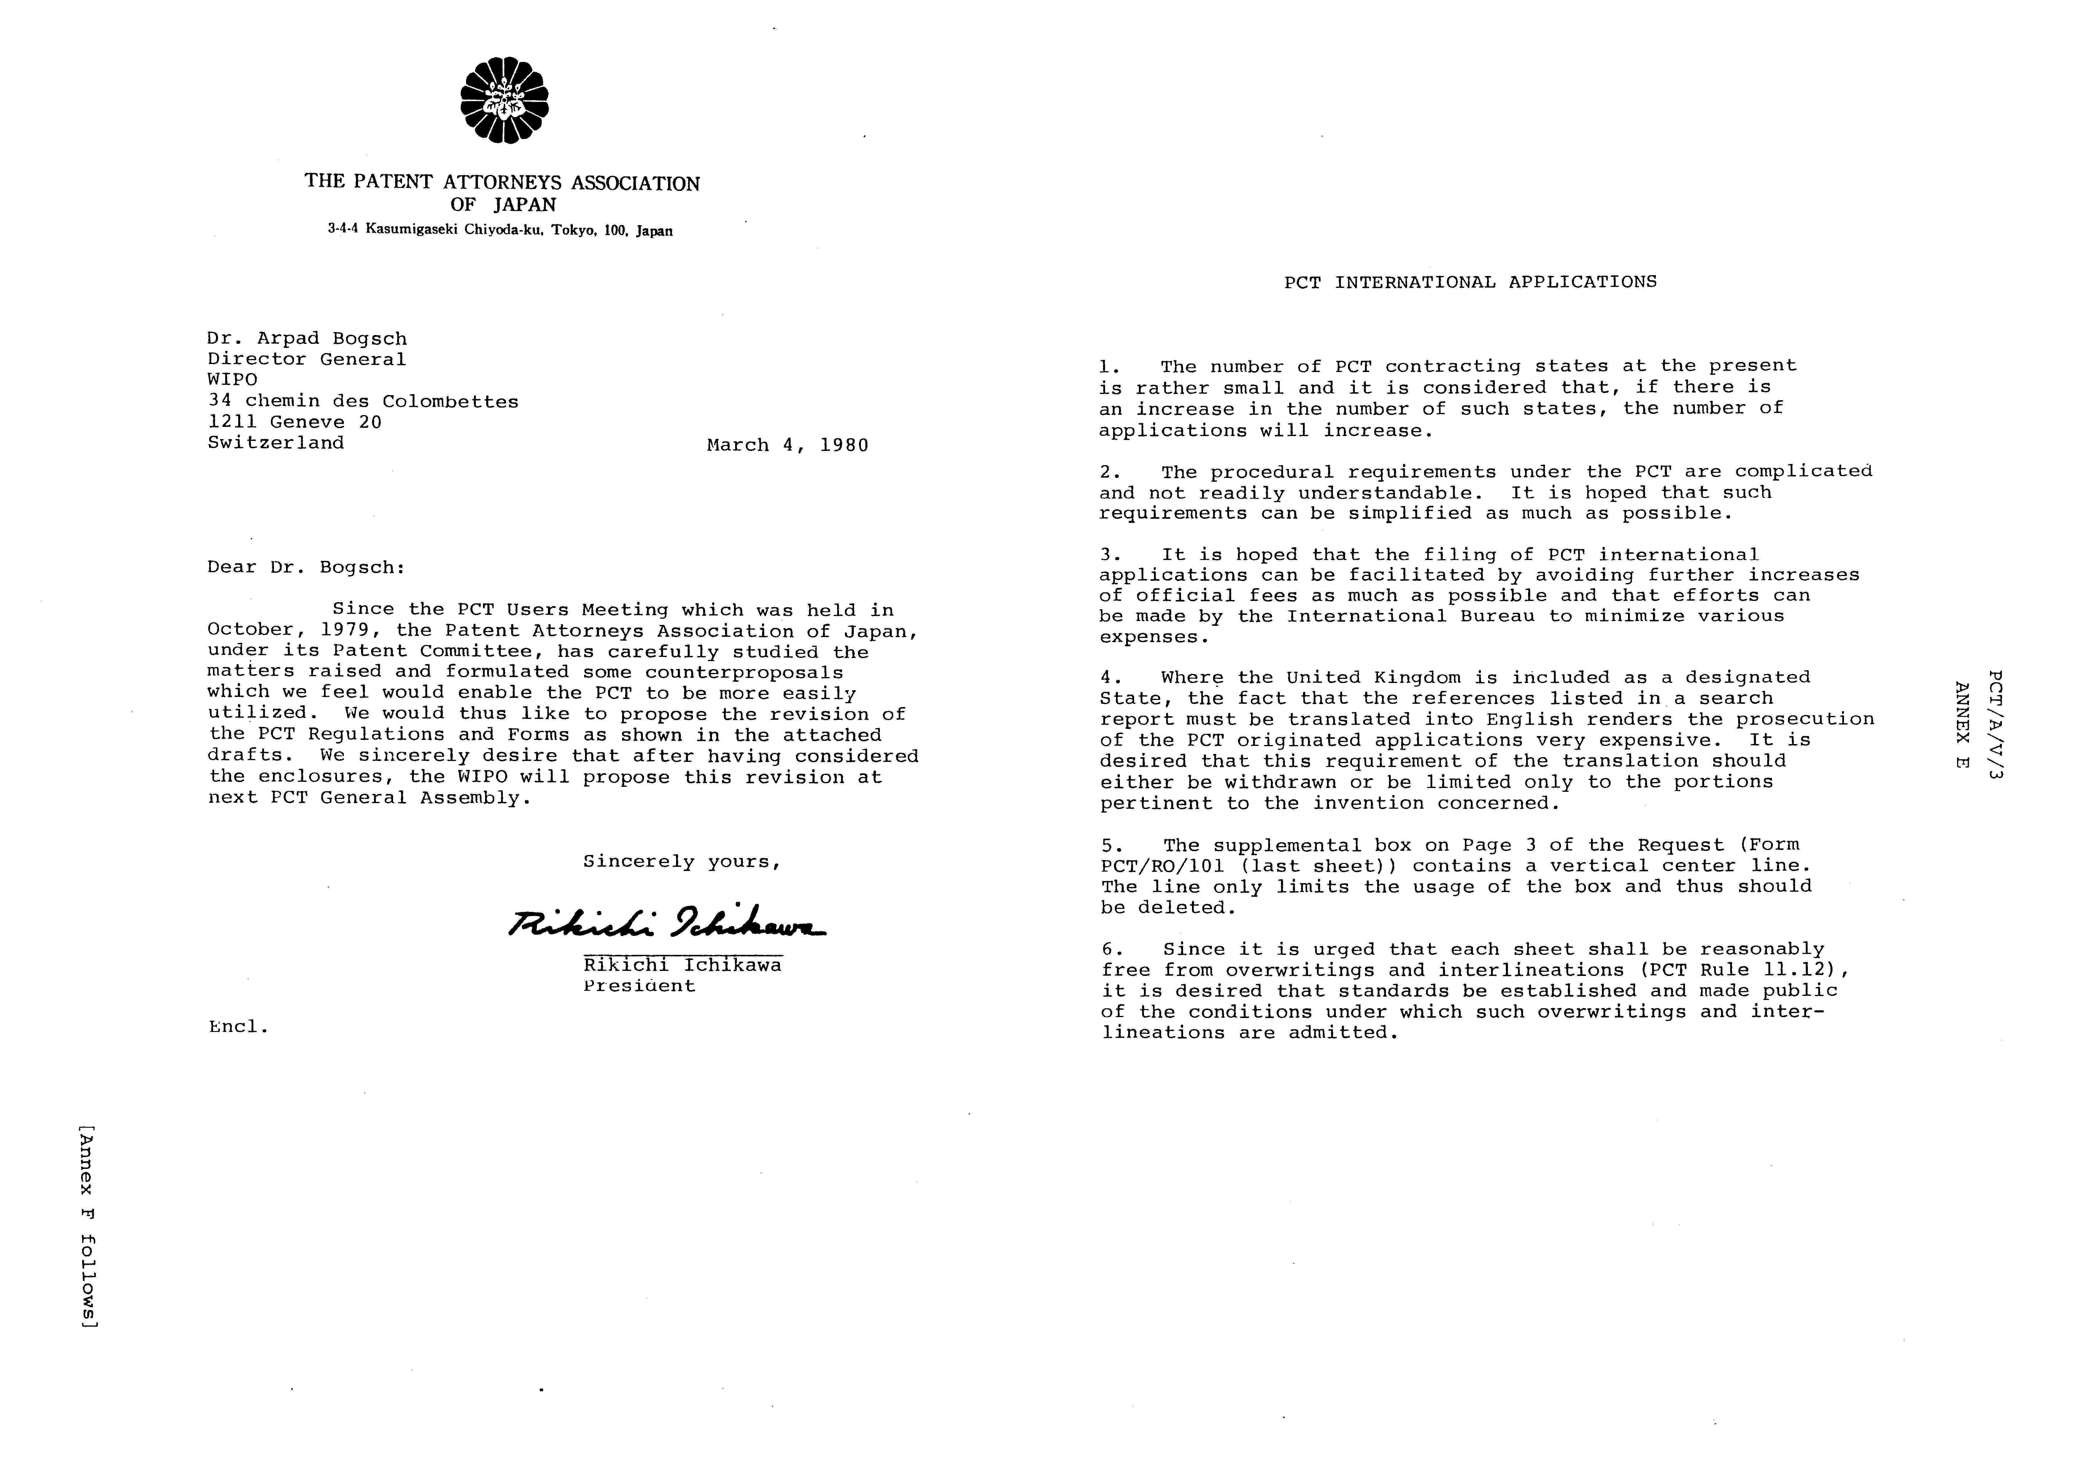
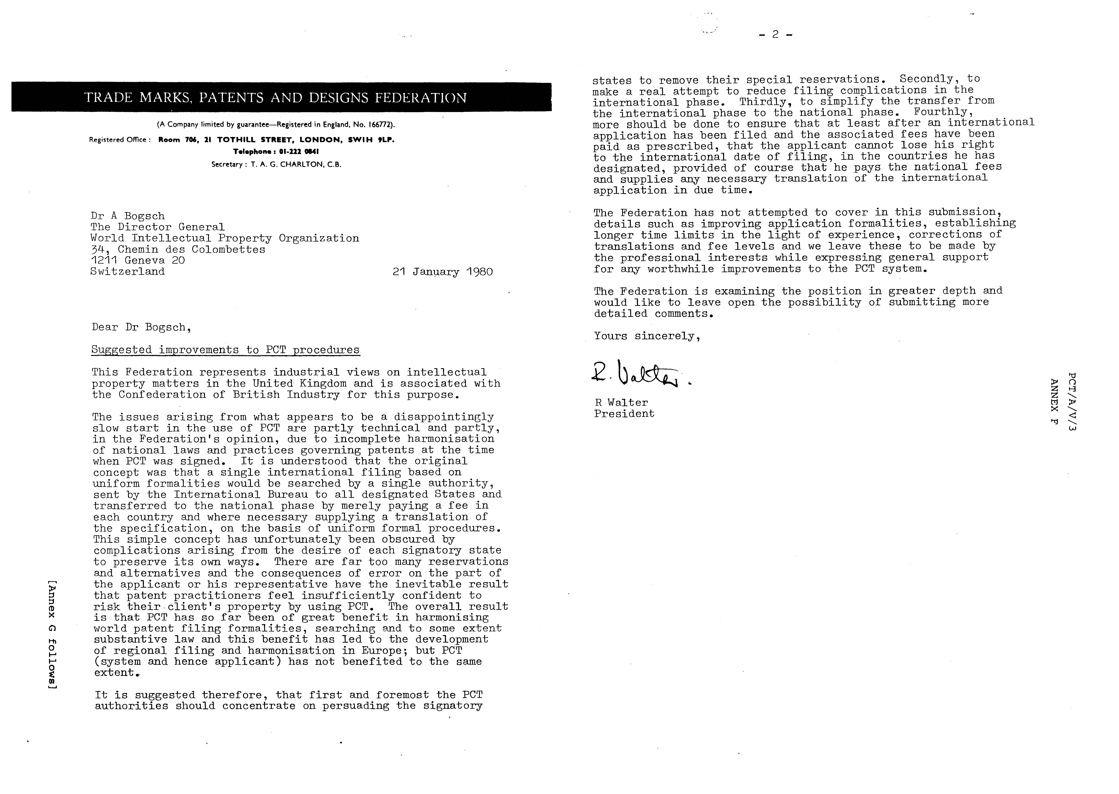
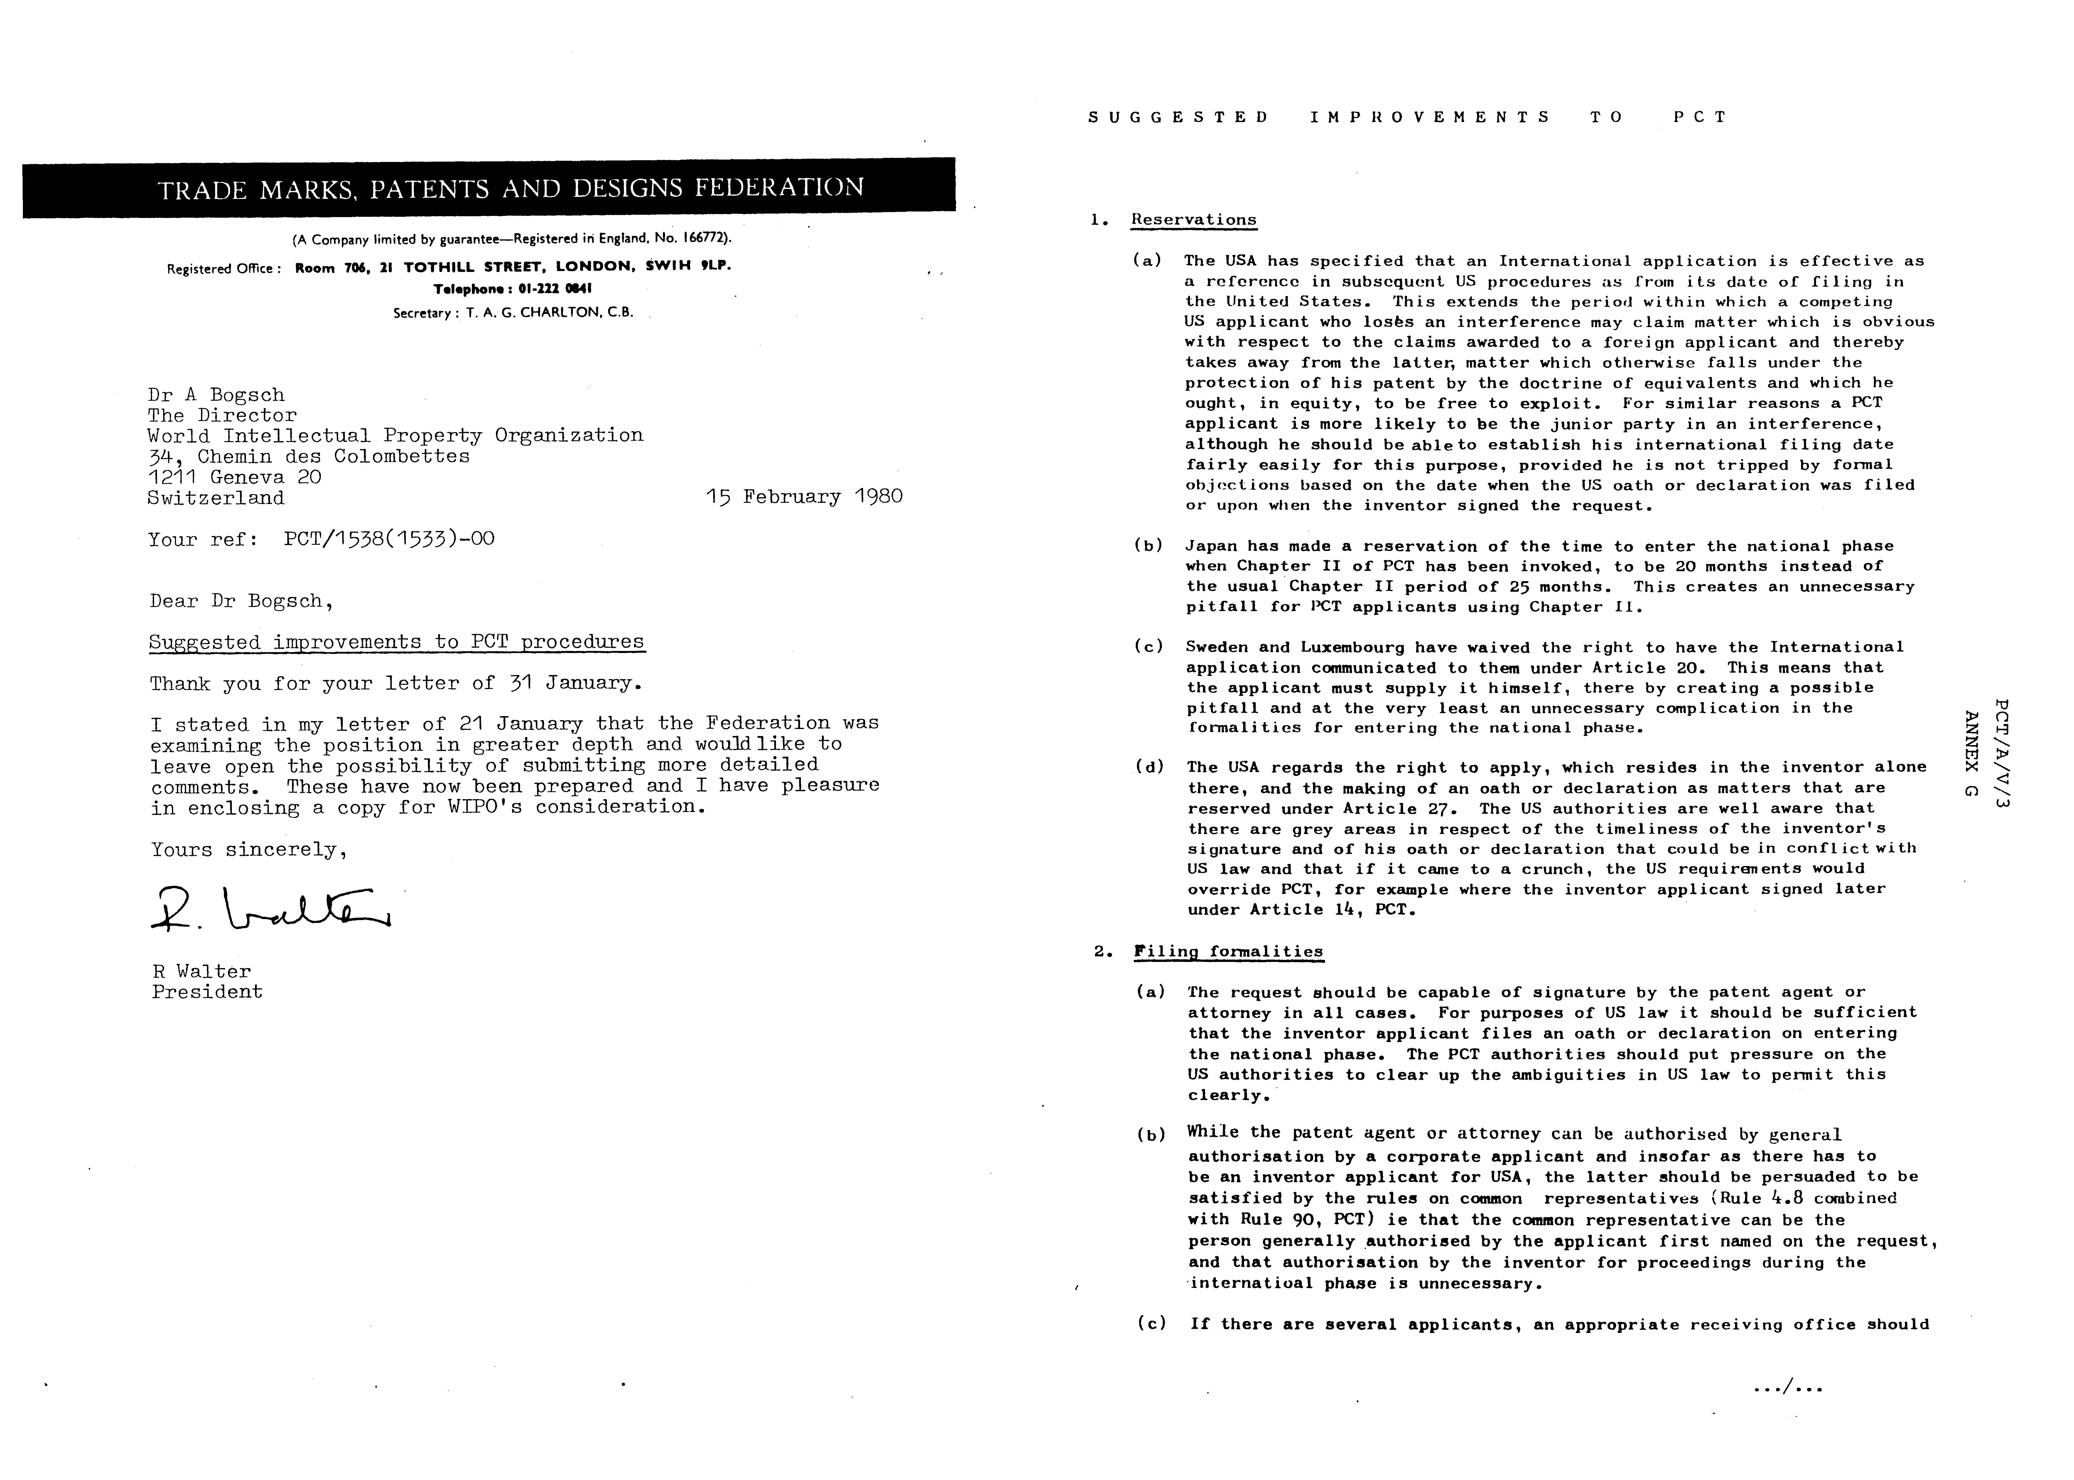
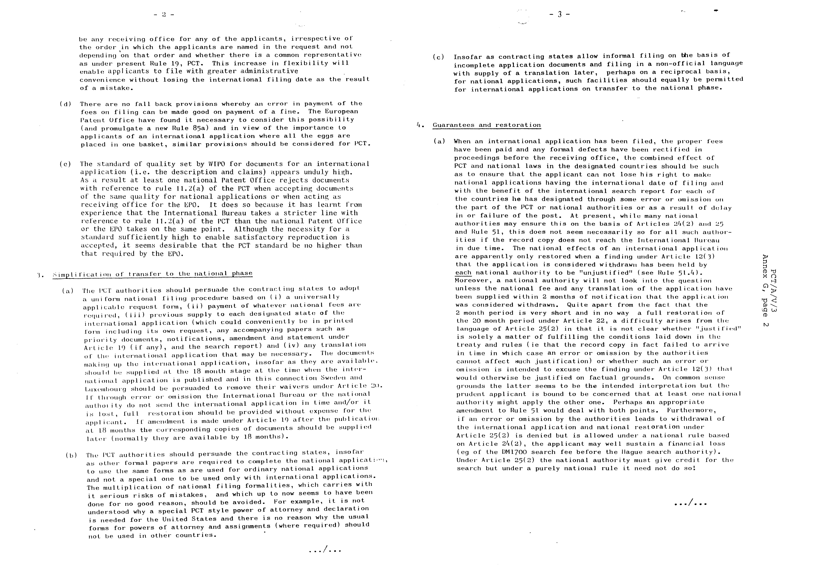

A further problem is that if by the end of 13 months and 10 days the applicant has not been notified by the International Bureau of receipt of the record copy he may transmit a certified copy of it himself (Rule 22.1(b)). Suppose now that there is a delay in the post and it does not arrive within the prescribed 14 month period. According to Articles 25(2)(b) and 48(2) any acts of grace by national authorities then depend solely on their national laws and yet there was an earlier error or omission by the authorities which caused the applicant to seek to rectify it himself Suppose the applicant decides it is wiser to avoid this possibility and not utilize Rule 22.1(b). Is he then guilty of an error or omission by failing to act? Indeed, is the applicant under an obligation to monitor the transmission of the record copy and take action if
there appears to be a failure within the official side of the system. This whole area seems to be a mass of conflicting principles and a goldmine for lawyers. The prudent applicant might indeed think he should keep well clear

(b) There are no provisions for restoration corresponding to Articles 121 and 122, EPC. In view of the importance to the applicant of an international application designating a large number of countries and the possibility of total loss of rights to a competitor if not as a result of intervening publication, serious attention should be given to making corresponding provisions in PCT otherwise applicants will not be prepared to risk such a loss. It will be appreciated, of course, that if the applicant loses his priority over a competing applicant who has a date somewhat later, he loses not merely his right to exclude such a competitor but indeed is excluded himself from marketing the invention he was first to create.

5. International Preliminary Examination

The times to establish an international preliminary examination report tend to be too short when complex matters arise in connection with proof of inventive step, especially when time for experiment a I work is desired by the applicant to provide evidence. It is suggested that when these problems arise the international preliminary examining authority should be able to obtain an extension of the time to establish the report of up to an extra 6 months.

6. Fees

The current level of PCT fees, at least for European applicants is far too high. In particular, if there are 10 designated countries, assuming the specification has less than 30 pages, the transmission and international fees amount to £317 quite apart from the search fee (with more designations of course these fees are correspondingly higher). The applicant is bound, therefore, to think that the facility provided by PCT is bought very dearly and when he bears in mind additionally the disadvantages outlined in Sections 1 to 5 above, then except for special cases in which only PCT allows time to file, there is no incentive to use PCT.

[End of Annex G
and of document]

 Editor’s Note: This electronic document has been created from the paper original and may contain errors. Please bring any such errors to the attention of the PCT Legal Division by e-mail at pct.legal@wipo.int

