WIPO |  | E  PCT/A/III/6  ORIGINAL: English  DATE: April 2, 1979
WORLD INTELLECTUAL PROPERTY ORGANIZATION
GENEVA
international patent cooperation union
(pct union)
assembly
Third Session (2nd Extraordinary)∗
Geneva, April 25 to May 1, 1979
appointment of the australian patent office as international searching and preliminary examining authority and approval of draft agreement between that office and the international bureau
Note prepared by the International Bureau

Background

1. According to Articles 16(3) and 32(3), the International Searching Authorities and the International Preliminary Examining Authorities shall be appointed by the Assembly of the International Patent Cooperation Union (hereinafter referred to as “the Assembly”). Any national Office and any intergovernmental Organization satisfying the minimum requirements, particularly as to manpower and documentation, prescribed by the Regulations (see Rules 36.1 and 63.1) may be appointed as International Searching Authority and/or International Preliminary Examining Authority. Appointment shall be conditional on the consent of the national Office or intergovernmental Organization to be appointed and the conclusion of an agreement, subject to approval by the Assembly, between such Office or Organization and the International Bureau. The appointment shall be for a fixed period of time and may be extended for further periods.

2. The following Offices are, after their appointment by the Assembly in its first session, at present acting as:

(i) International Searching and International Preliminary Examining Authority:

(a) the Patent Office of Japan;

(b) the USSR State Committee for Inventions and Discoveries;

(c) the Royal Patent and Registration Office of Sweden;

(d) the European Patent Office;

(ii) International Searching Authority:

(e) the United States Patent and Trademark Office;

(iii) International Preliminary Examining Authority:

(f) the Patent Office of the United Kingdom.

Request by the Australian Patent Office

3. On January 30, 1979, the Permanent Representative of Australia in Geneva communicated to the International Bureau the decision of the Government of Australia to adhere to the PCT and to seek appointment of the Australian Patent Office as an International Searching and Preliminary Examining Authority at the third session of the PCT Assembly. On February 2, 1979, the said decision was announced publicly in Australia.

4. Australia has not yet deposited its instrument of accession to the PCT. According to the information received, the Government of Australia has taken a decision to become a party to the Treaty, but the deposit of an instrument of accession will only follow the passing of legislation for the implementation of the PCT by the Federal Parliament. Having regard to the time expected to be required for consideration of the said legislation by the Parliament, the Government of Australia expects to deposit the instrument of accession at a time which would cause entry into force of the Treaty for Australia by January 1, 1980. At the same time, the Australian Patent Office intends to take up its function as a PCT Authority. The intention is to have that Office act as an International Searching and Preliminary Examining Authority not only for Australia, but for all developing countries with particular emphasis on the Asian region. The Australian Patent Office fulfills the minimum requirements prescribed in Rule 36 of the PCT.

5. In view of its firm expectation of being in a position to deposit an instrument of accession later this year, the Government of Australia, through its Permanent Representative in Geneva, has suggested to the Director General of WIPO that the Assembly be requested, at its third session, to appoint the Australian Patent Office as an International Searching and Preliminary Examining Authority despite the fact that the parliamentary procedure will not have been completed by the time the decision would be taken. A similar procedure had been applied by the Assembly in its first session, when appointing the Patent Offices of Austria and
Japan as PCT Authorities. The reasons for this request of the Australian Authorities are mainly:

(i) that an early decision would facilitate and accelerate the accession process and the preparation of the implementation of the Treaty on the legislative and administrative level, taking into account the functions which the Australian Patent Office would undertake as a PCT Authority,

(ii) that an early decision would enable the Australian Patent Office without any further lead period to assume its functions as an International Searching and Preliminary Examining Authority immediately upon entry into force of the Treaty and without having to wait for a decision of the Assembly after accession which could not be implemented immediately in view of the further necessary legislative and administrative preparations.

6. In view of this request, the International Bureau has immediately started negotiations with the Australian Patent Office concerning the Agreement to be concluded between that Office and the International Bureau under Articles 26(3) and 32(3) of the PCT. These negotiations have resulted in the texts attached to this document. Annex I to this document contains the draft of the Agreement between the Patent Office of the Government of Australia and the International Bureau of the World Intellectual Property Organization in relation to the establishment and functioning of the Patent Office of the Government of Australia as an International Searching and International Preliminary Examining Authority under the Patent Cooperation Treaty. Annex II to this document contains an Exchange of Notes between the Australian Permanent Mission in Geneva and the Director General of WIPO concerning the Agreement between the Patent Office of the Government of Australia and the International Bureau of the World Intellectual Property Organization in relation to the establishment and functioning of the Patent Office of the Government of Australia as an International Searching and International Preliminary Examining Authority under the Patent Cooperation Treaty. The draft Agreement was initialed by both parties on April 2, 1979.

7. The draft Agreement contained in Annex I is submitted to the Assembly for approval and the Exchange of Notes in Annex II is communicated to the Assembly for information.

8. In view of the situation described above, it is suggested that the Assembly approve the draft Agreement contained in Annex I and appoint the Australian Patent Office as an International Searching and Preliminary Examining Authority under the PCT, it being understood that such appointment will take effect when both of the following conditions are fulfilled:

(i) the draft Agreement contained in Annex I is signed by both parties without modification of the text approved by the Assembly, according to the intention of both parties reflected in the Exchange of Notes contained in Annex II and subject only to the exception referred to in that Exchange of Notes;

(ii) the Government of Australia deposits its instrument of accession to the PCT during this year.

9. The draft Agreement contained in Annex I reflects the consent of the Australian Patent Office to be appointed as International Searching and Preliminary Examining Authority which is one of the conditions of appointment under Articles 16(3) (b) and 32 (3).

10. The Assembly is invited:

(i) to approve the draft Agreement contained in Annex I and to note the Exchange of Notes contained in Annex II;

(ii) to appoint, subject to the conditions referred to in paragraph 8 above, the Australian Patent Office as an International Searching and Preliminary Examining
Authority for a period of ten years from the date of entry into force of the Agreement contained in Annex I.

[Annexes I and II follow]

AGREEMENT BETWEEN THE PATENT OFFICE OF THE GOVERNMENT OF AUSTRALIA AND THE INTERNATIONLA BUREAU OF THE WORLD INTELLECTUAL PROPERTY ORGANIZATION IN RELATION TO THE ESTABLISHMENT AND FUNCTIONING OF THE PATENT OFFICE OF THE GOVERNMENT OF AUSTRALIA AS AN INTERNATIONAL SEARCHING AND INTERNATIONAL PRELIMINARY EXAMINING AUTHORITY UNDER THE PATENT COOPERATION TREATY

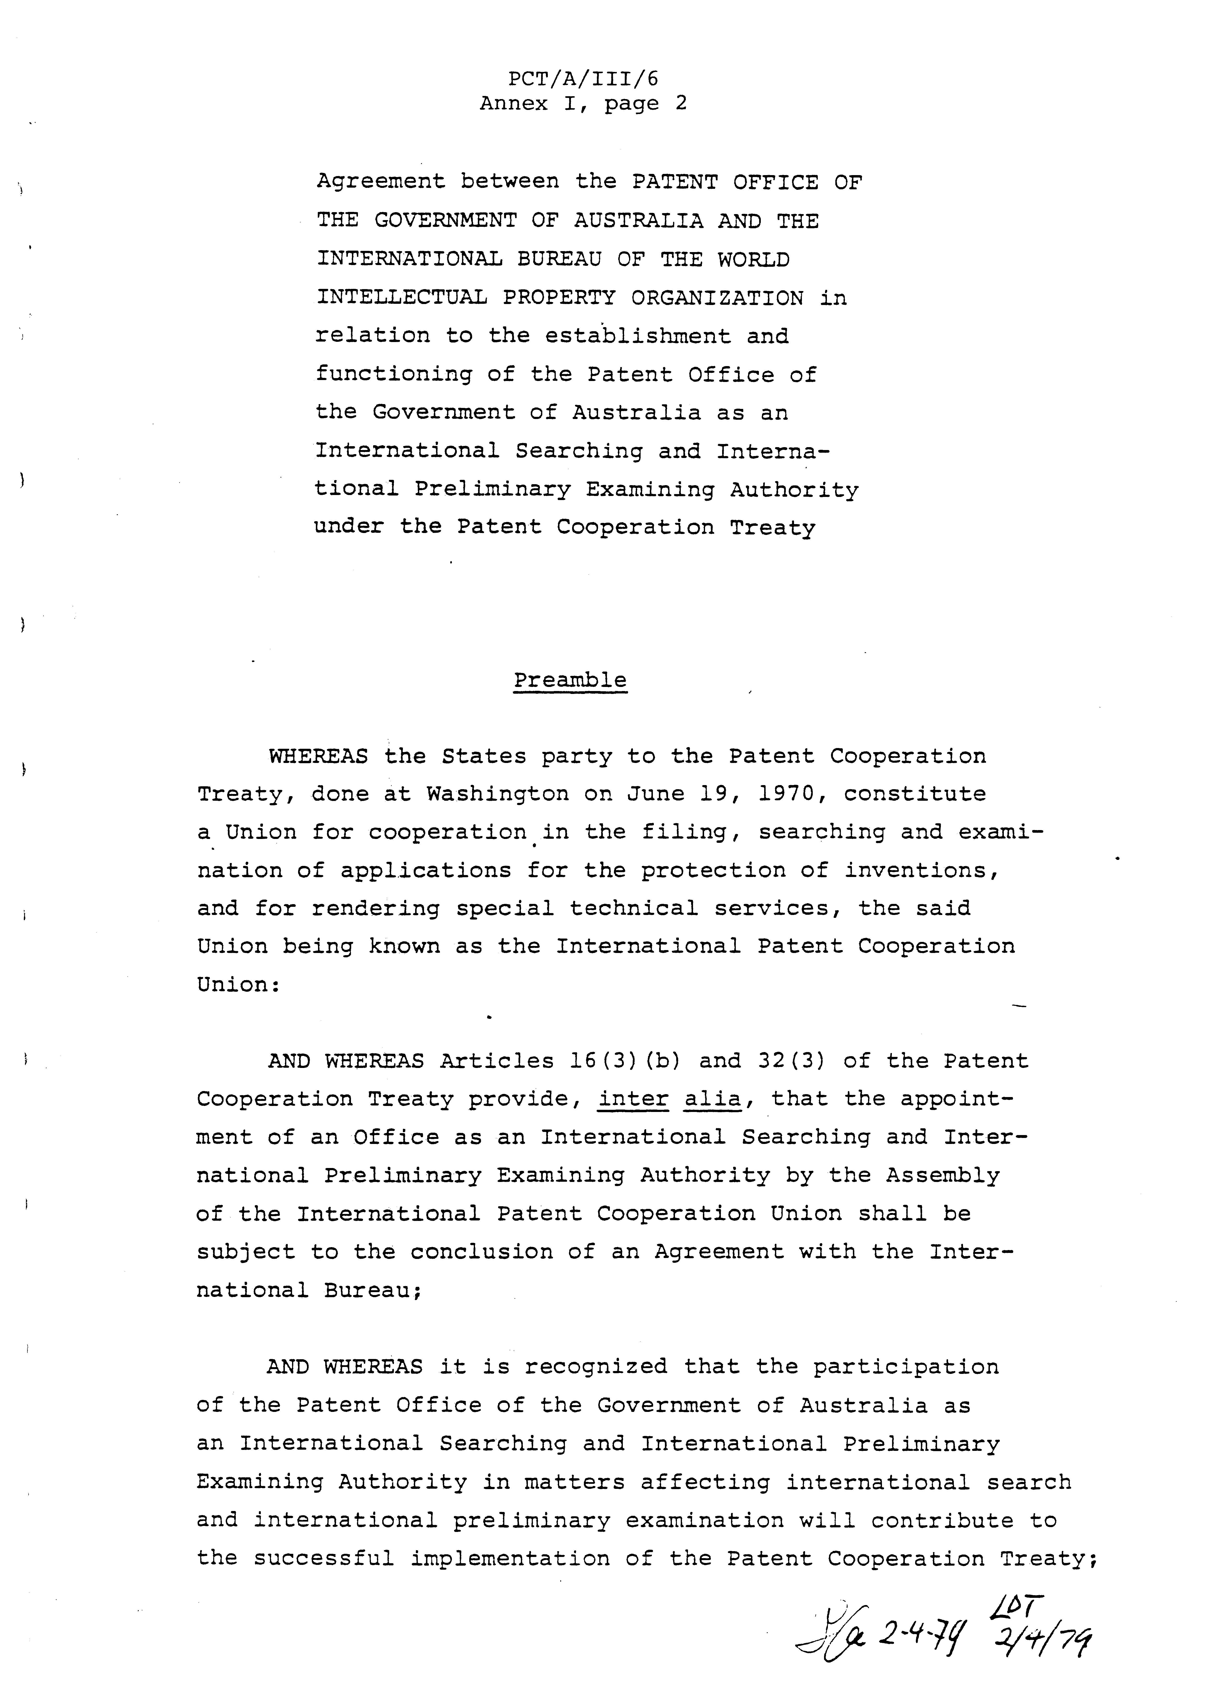
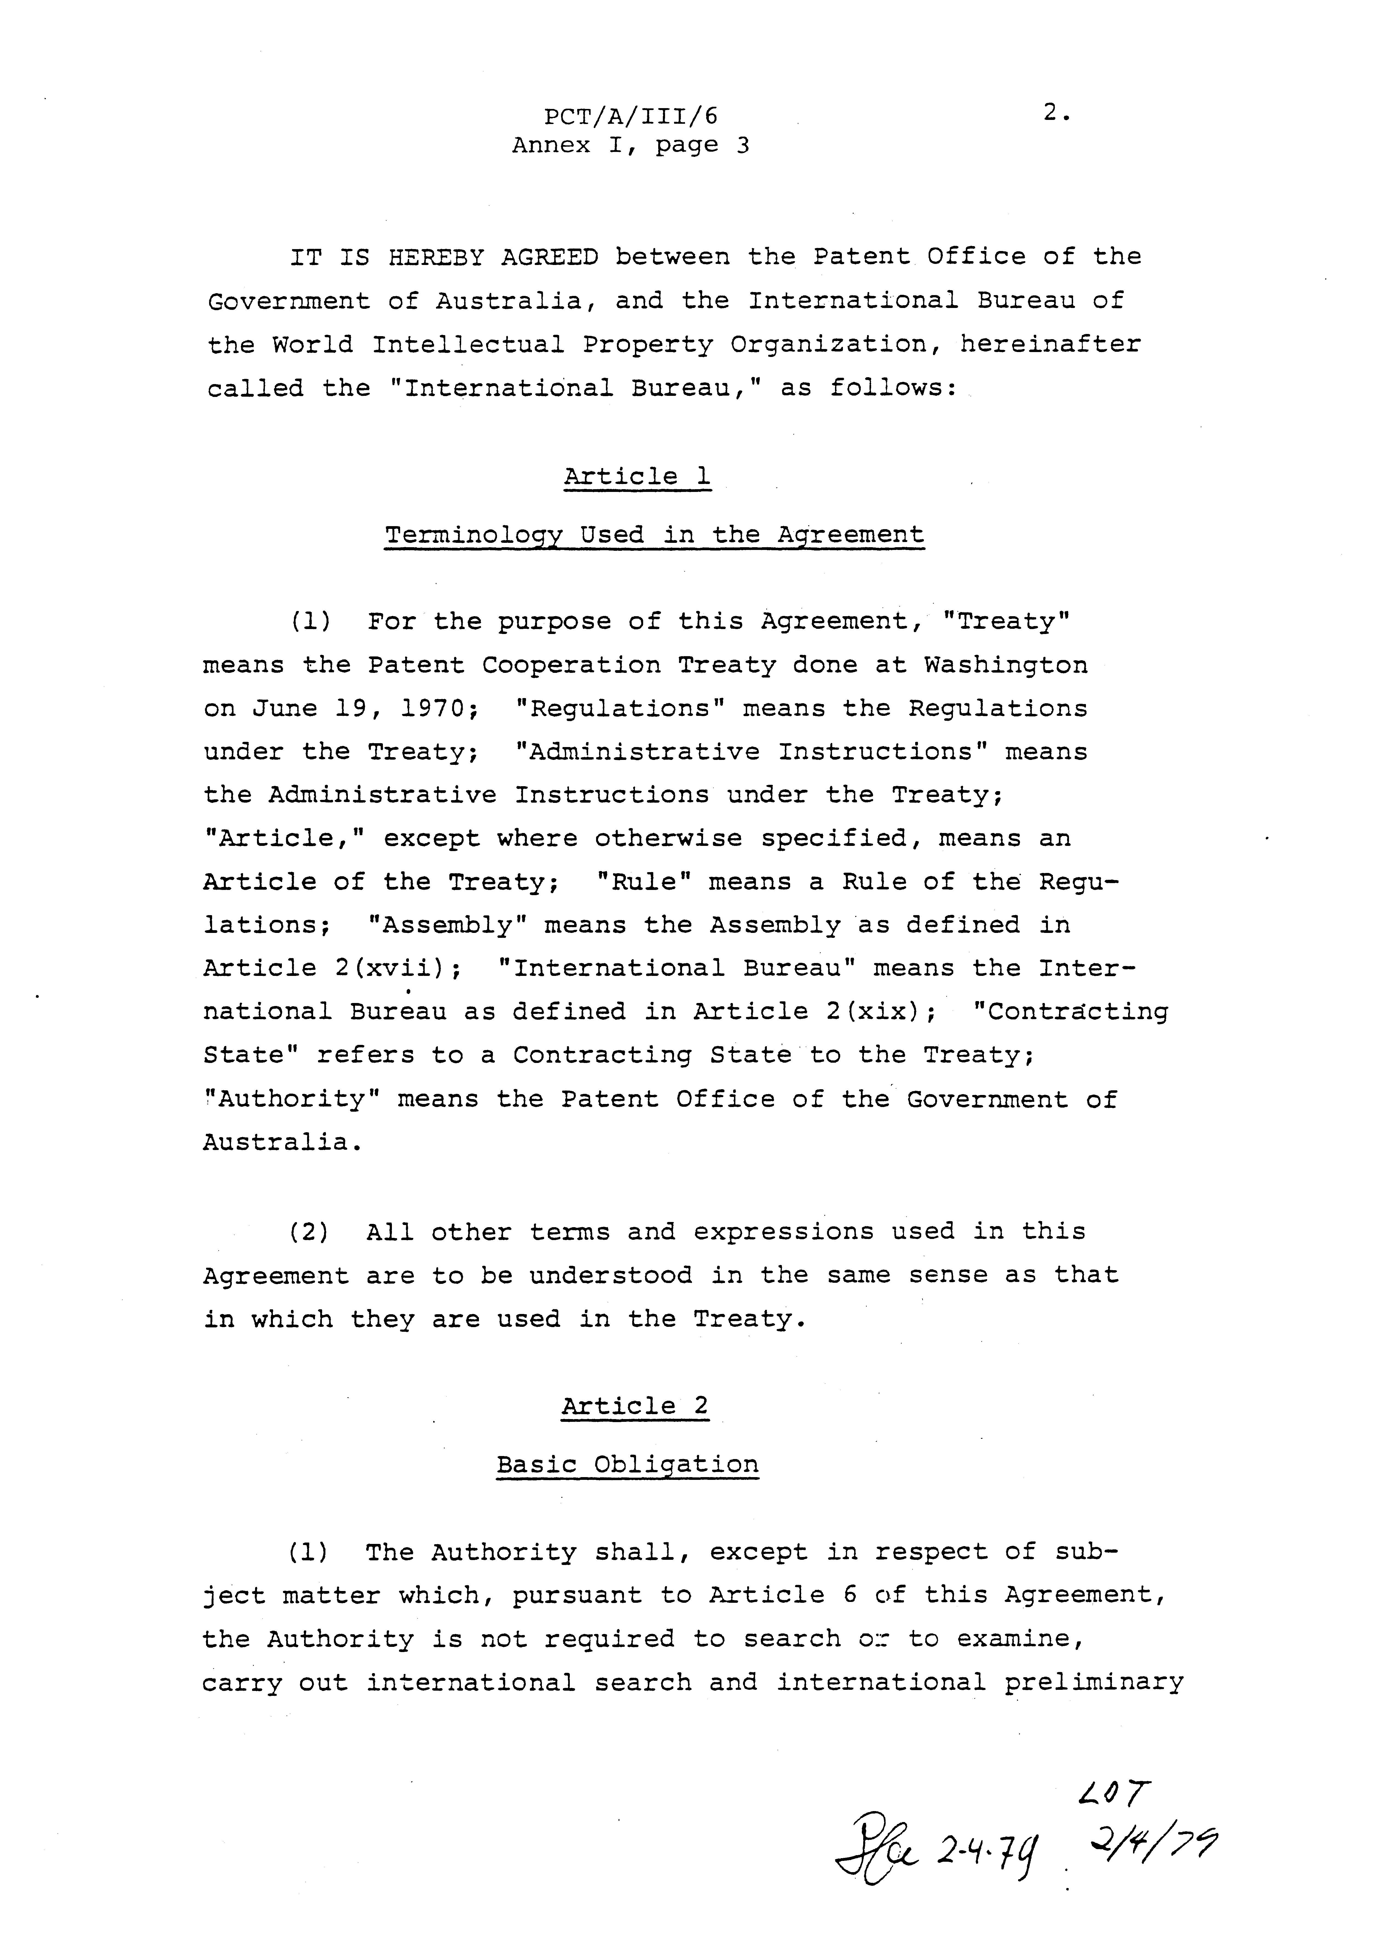

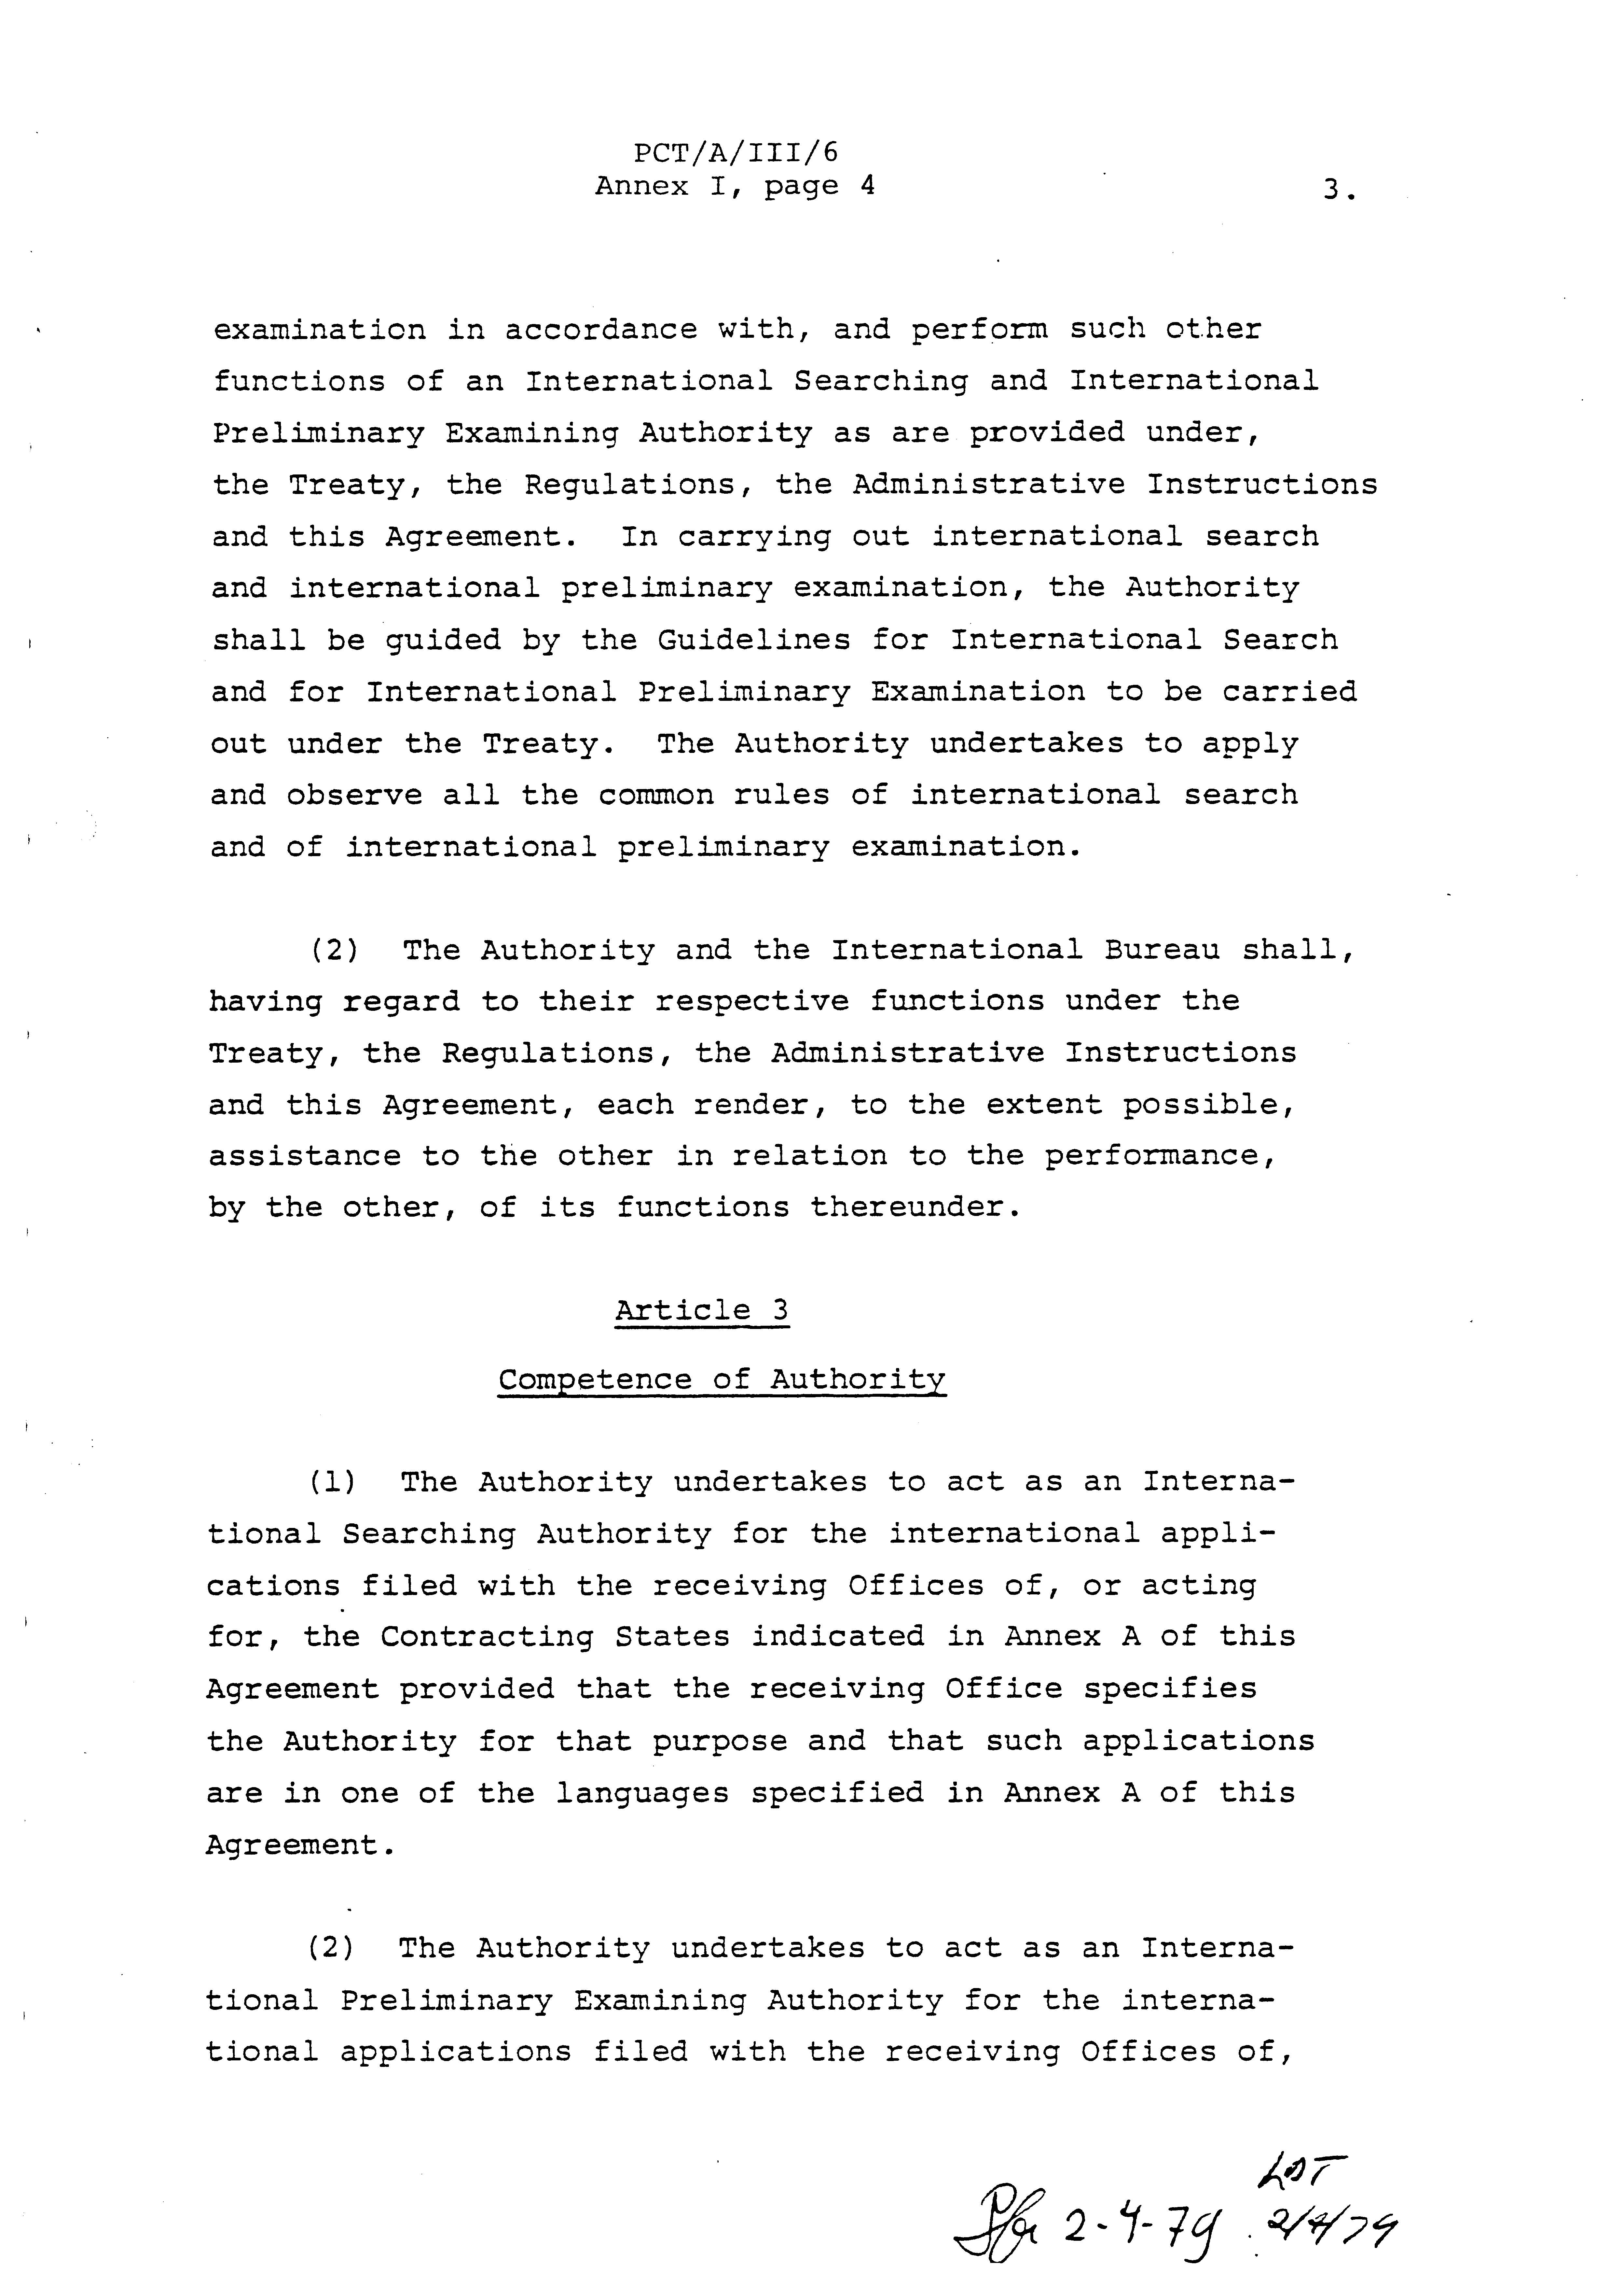

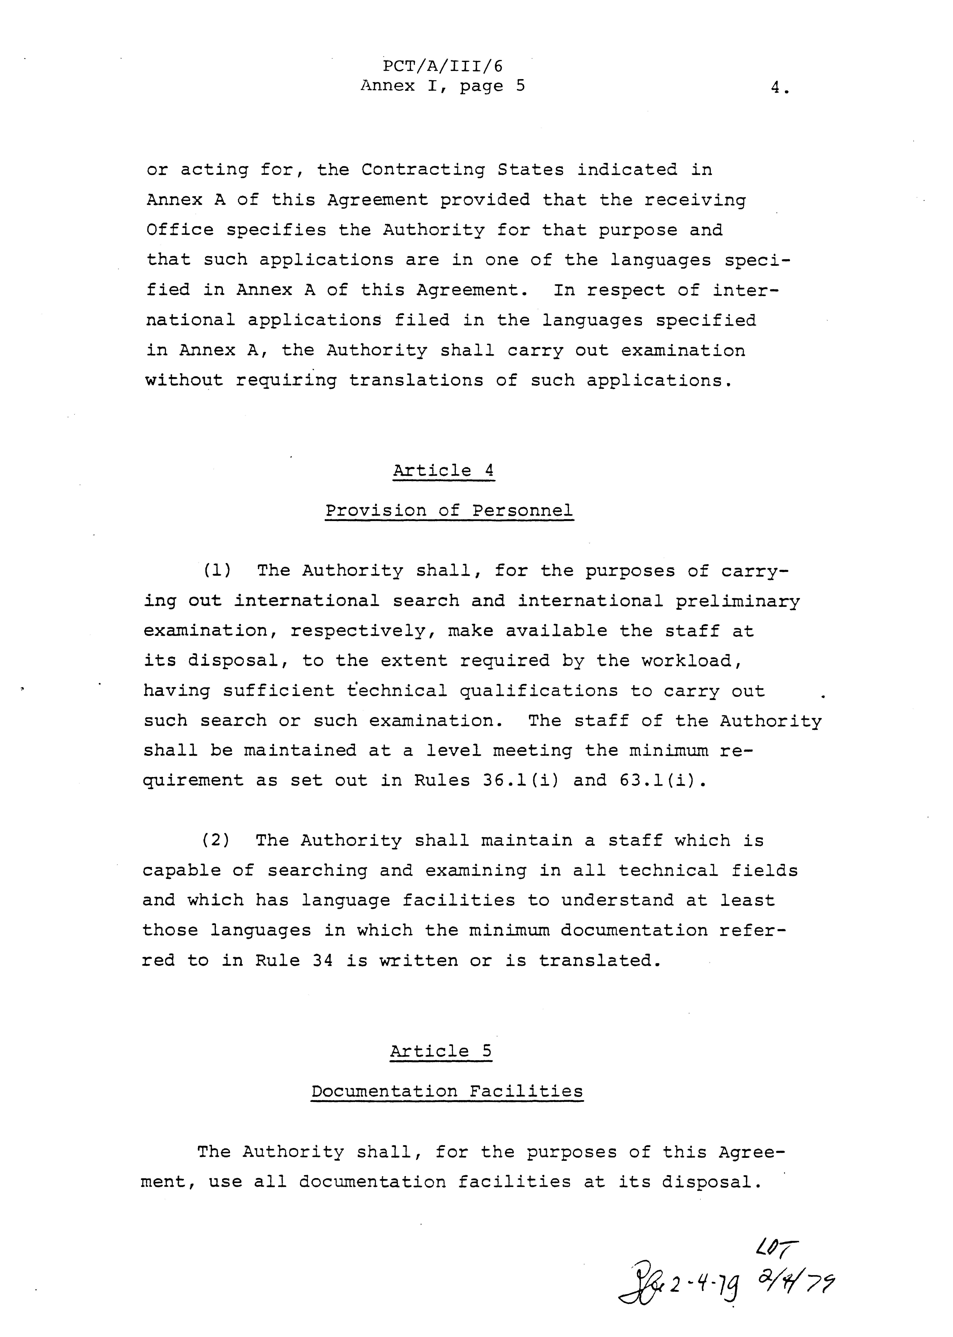

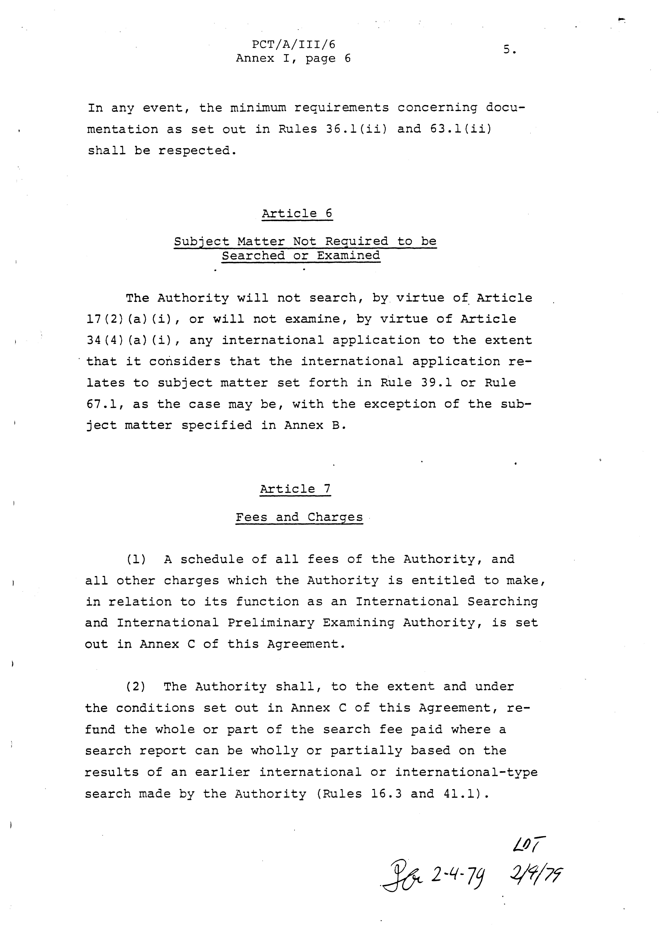

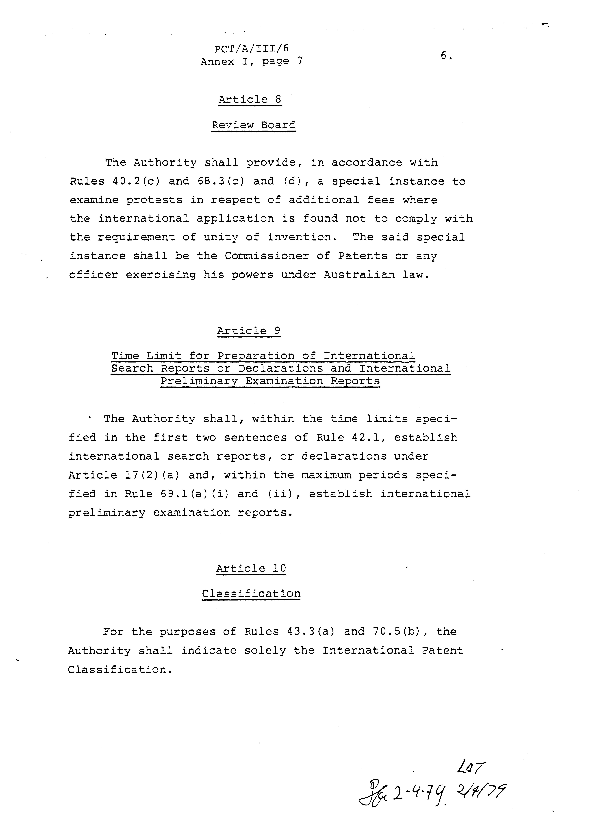

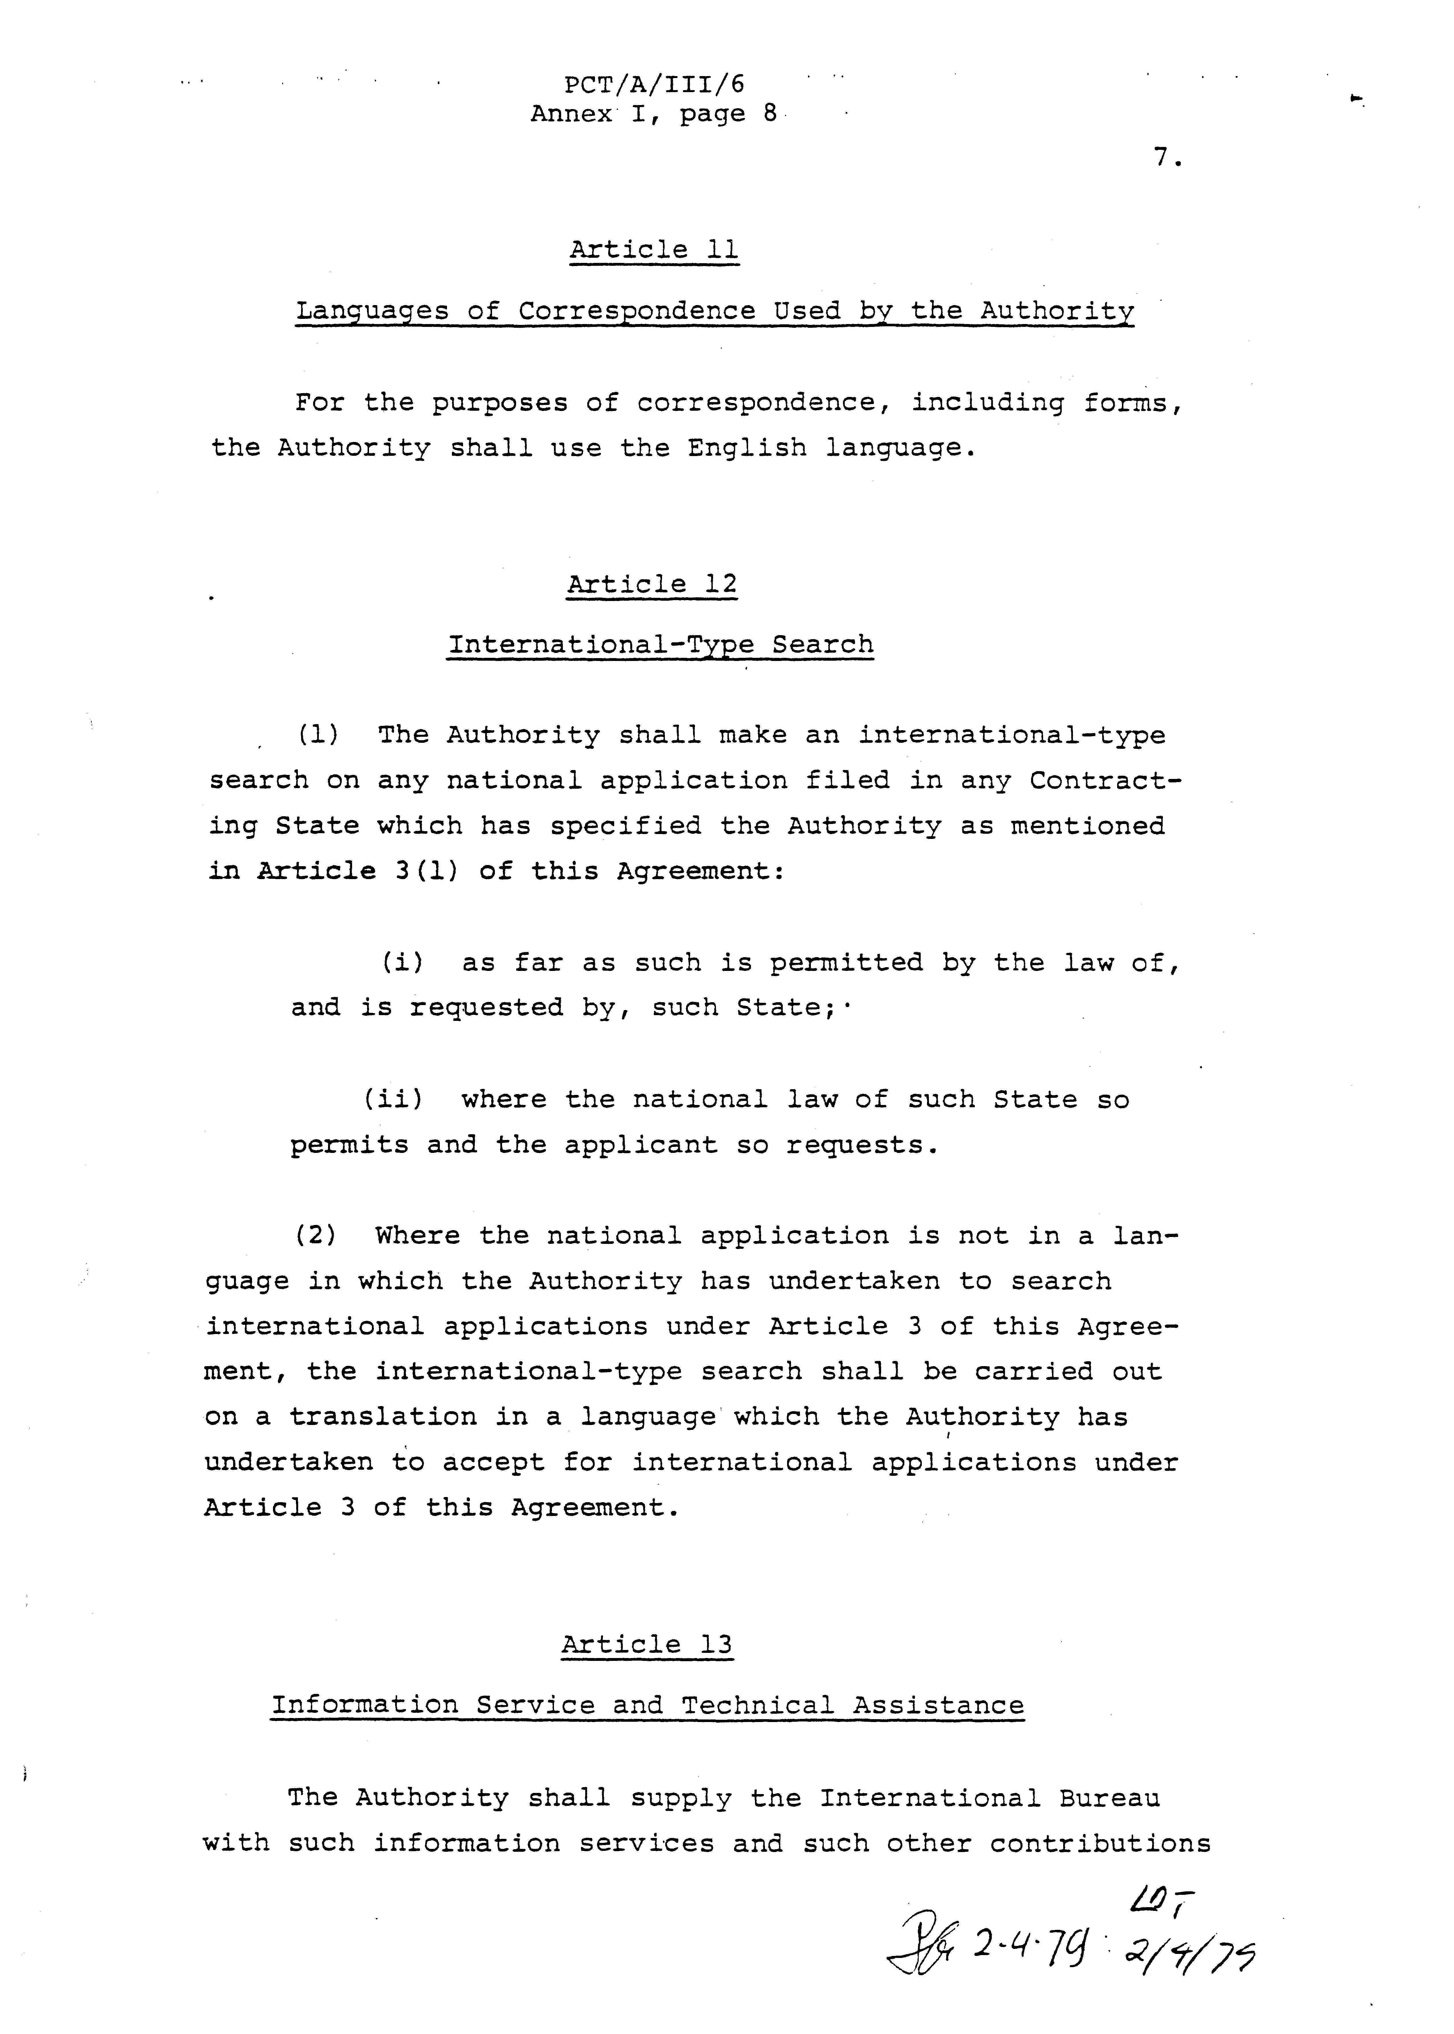

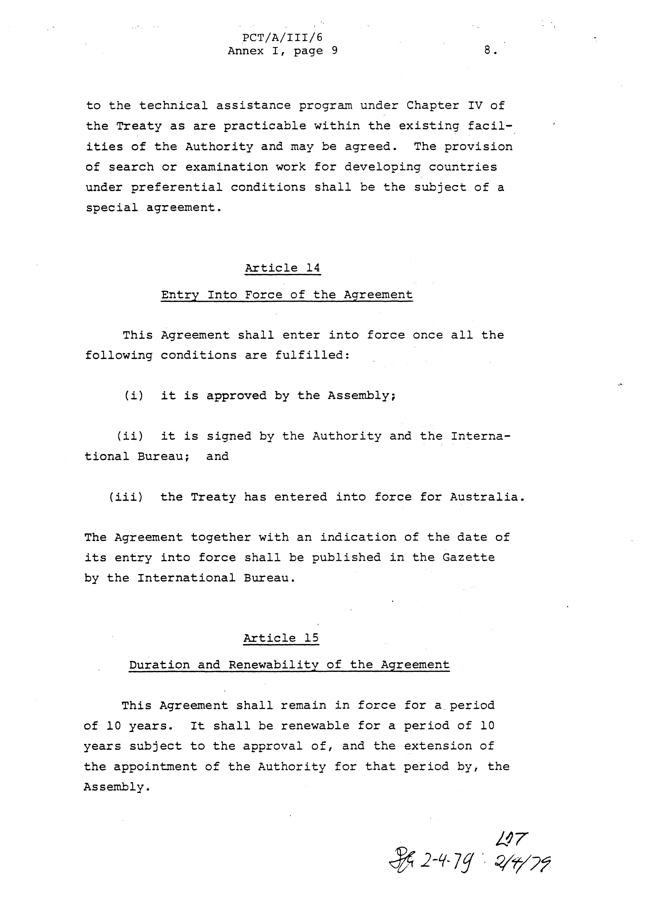

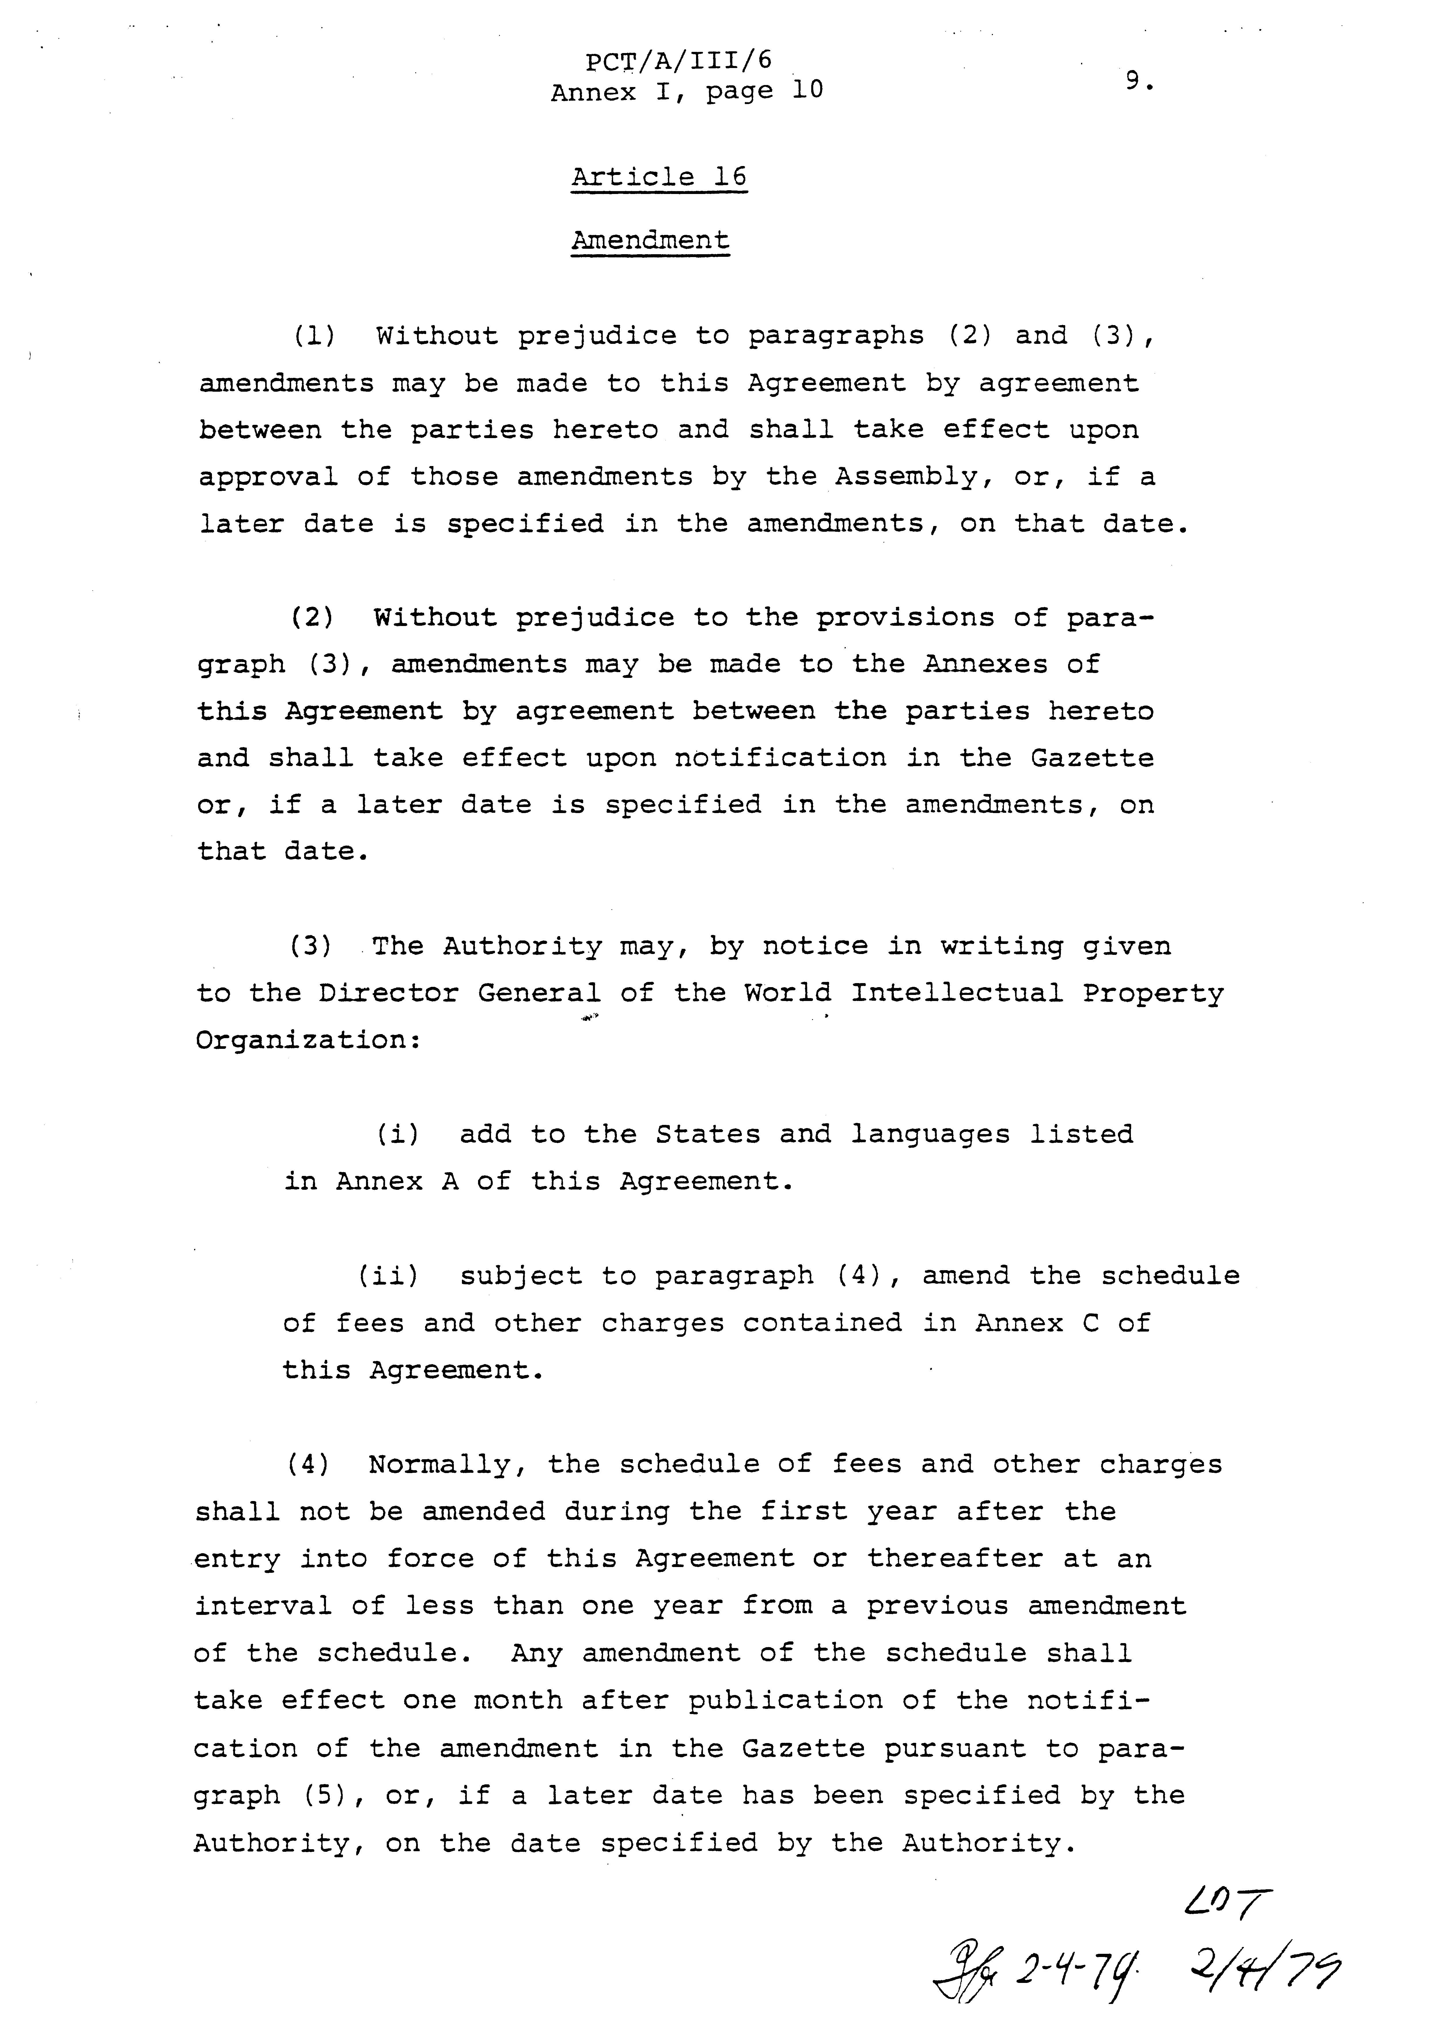

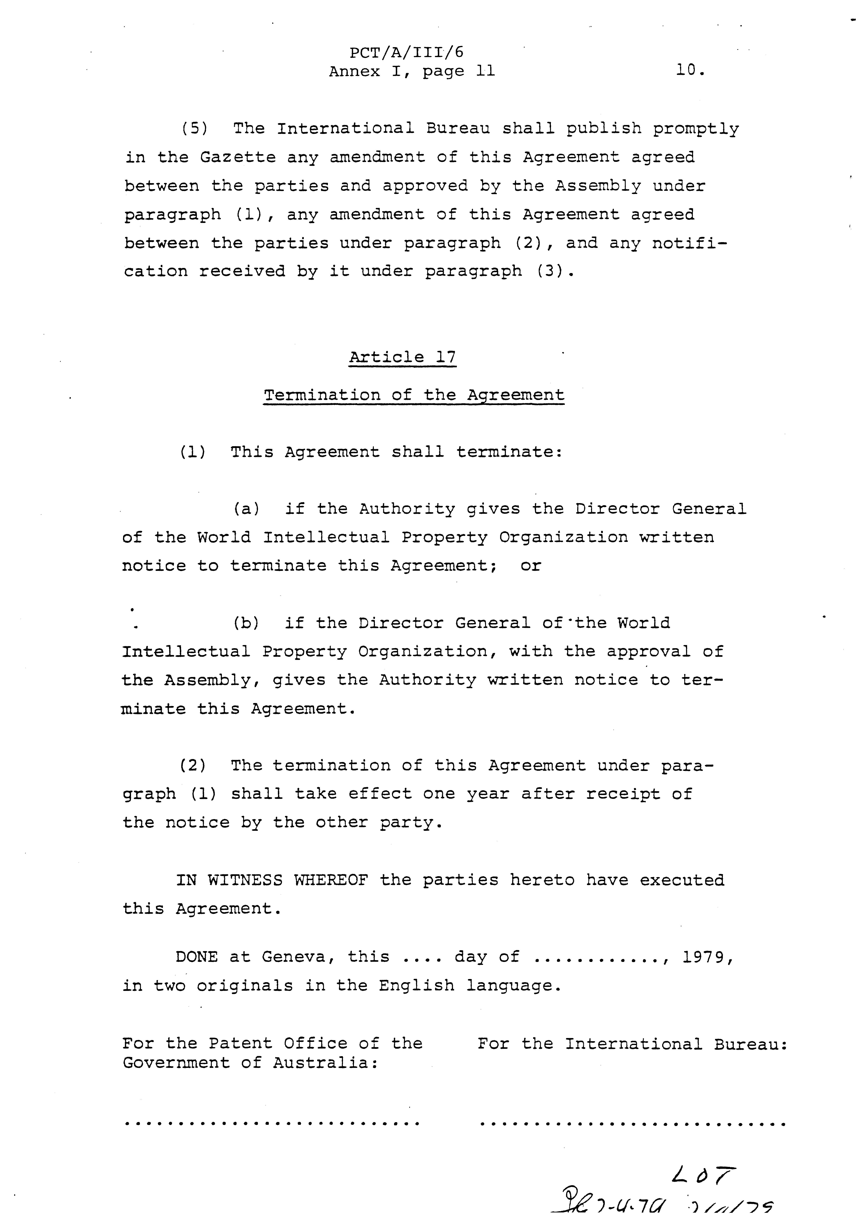

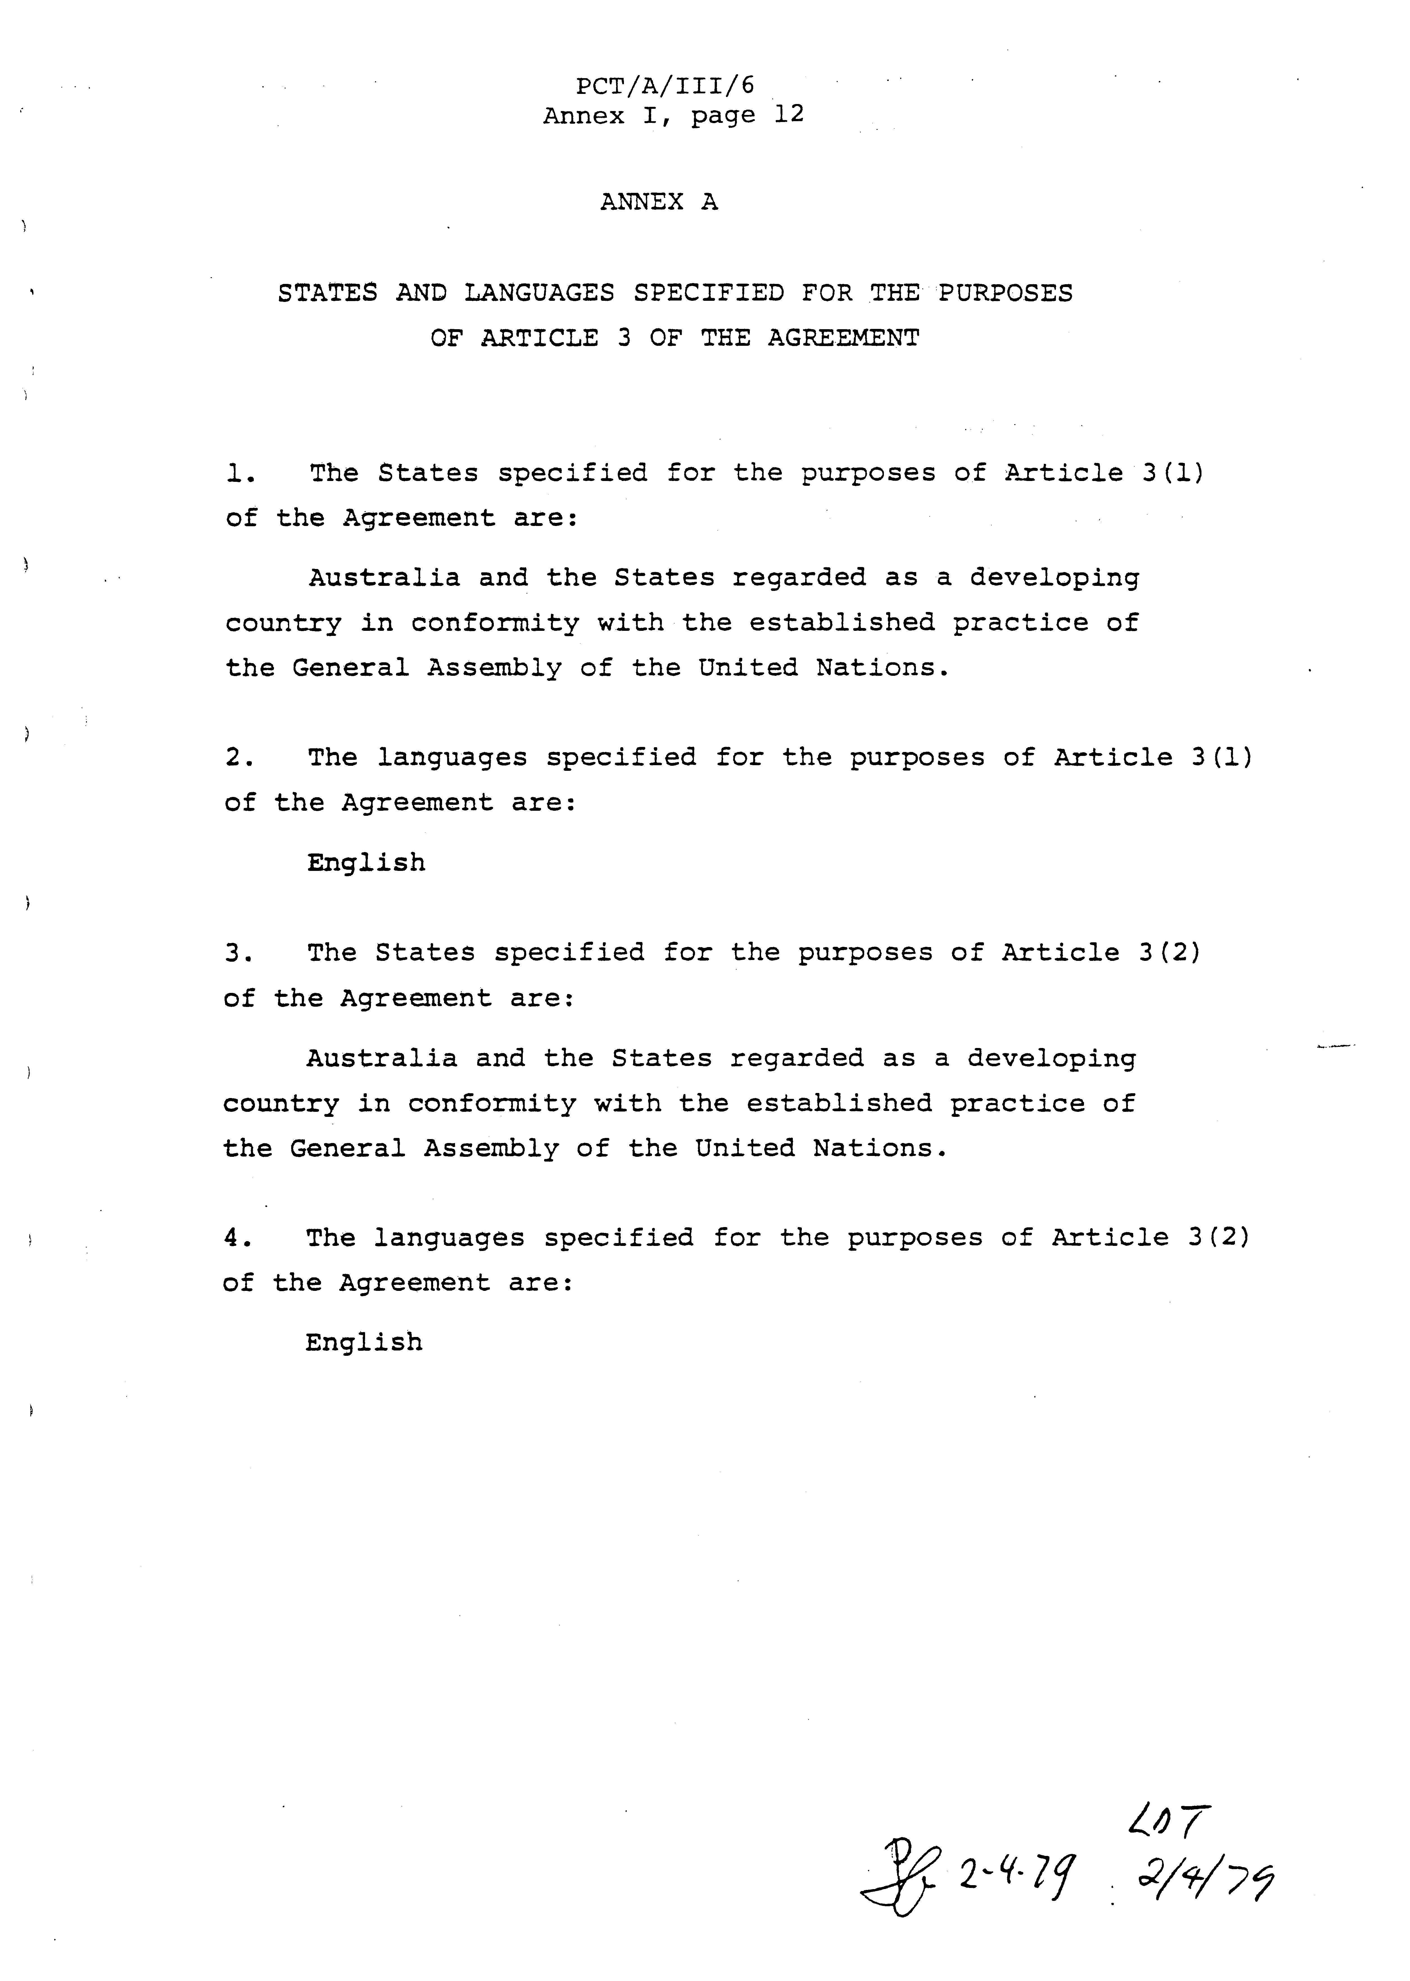

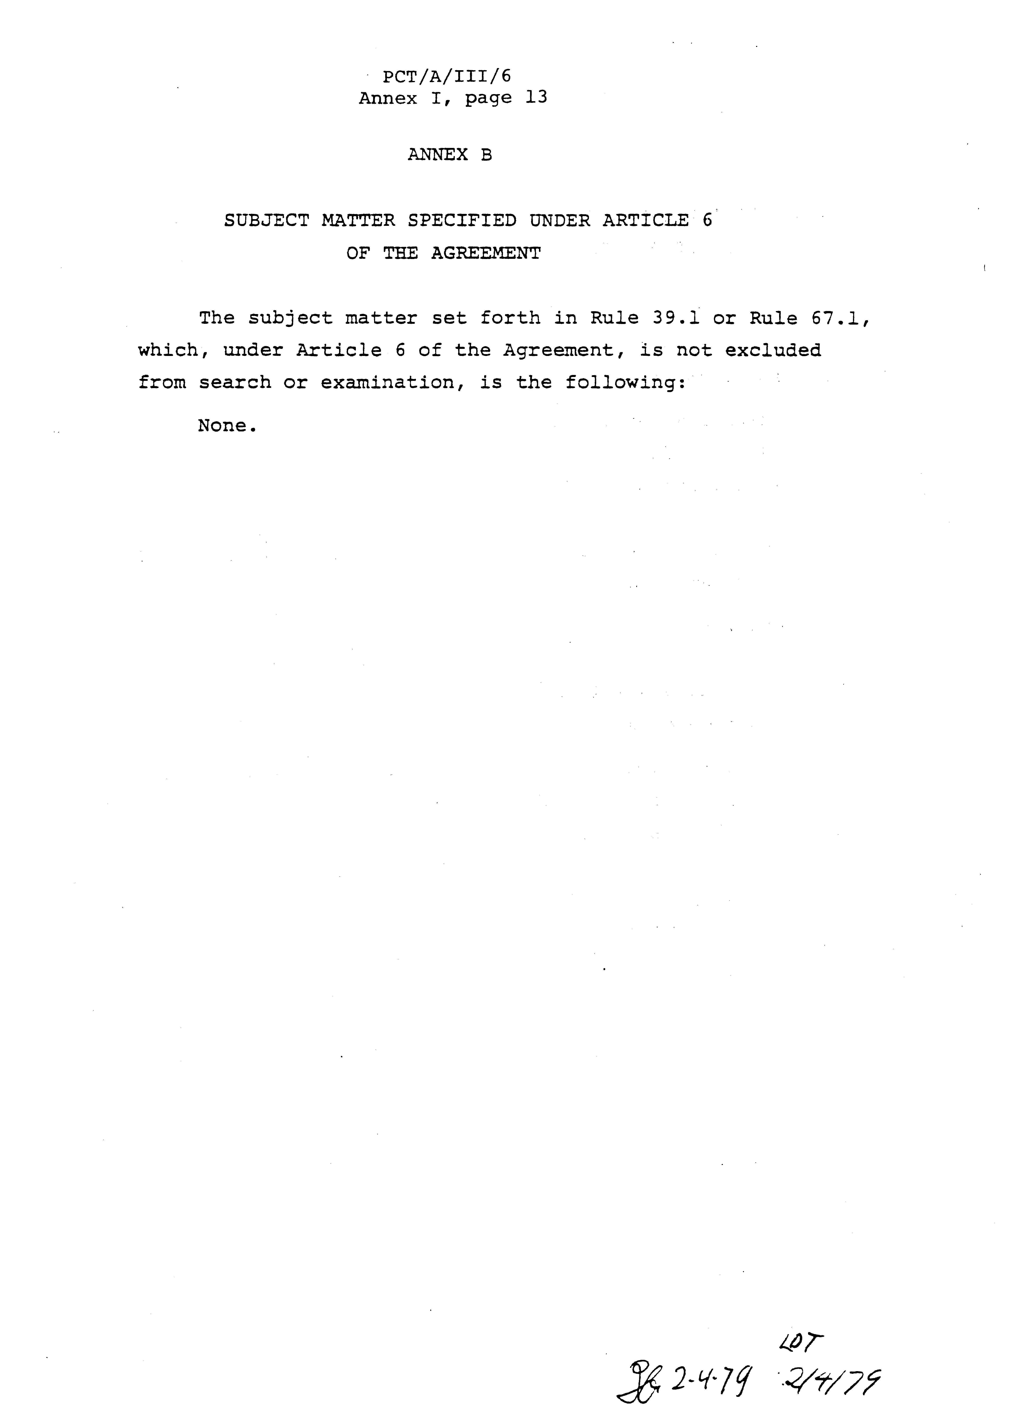

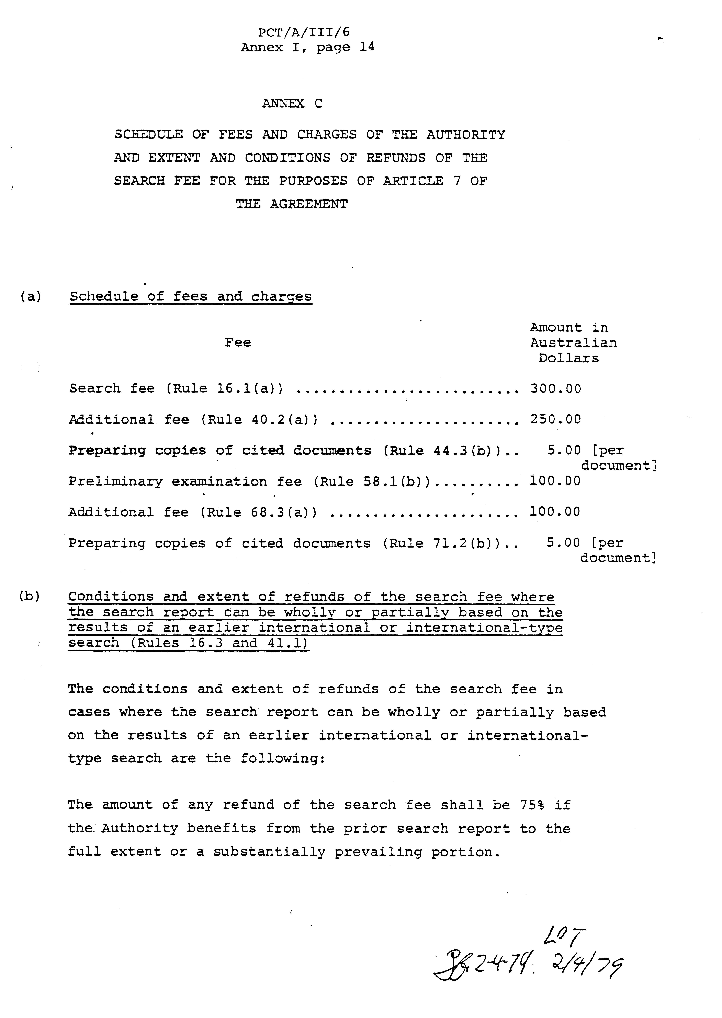

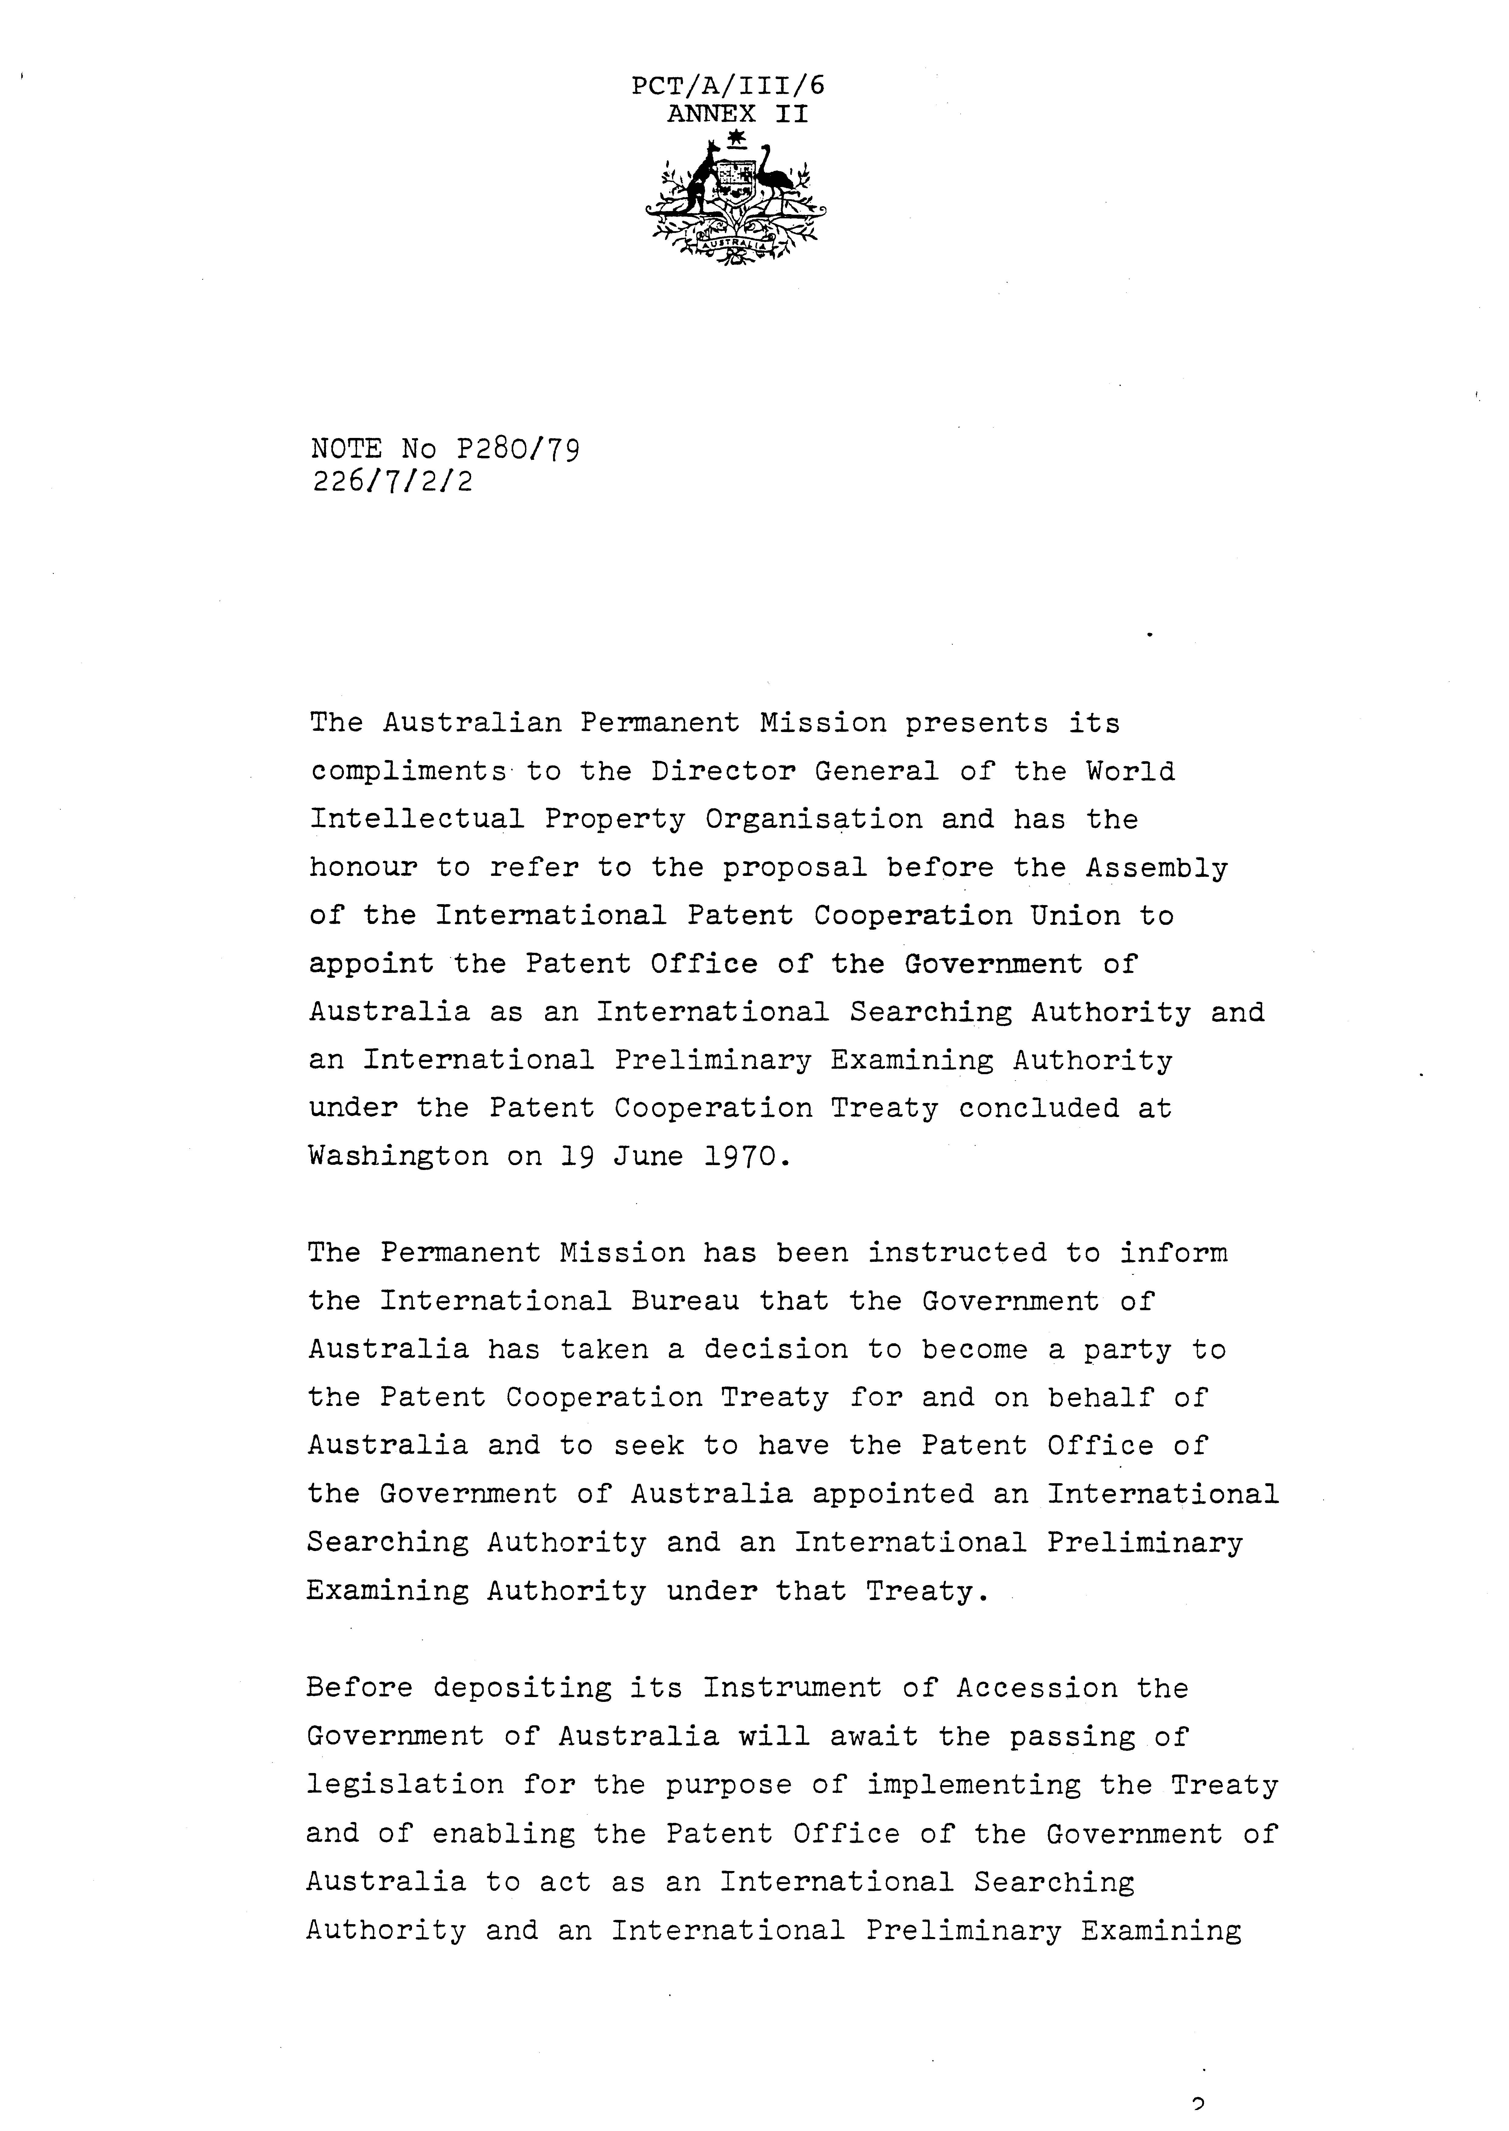

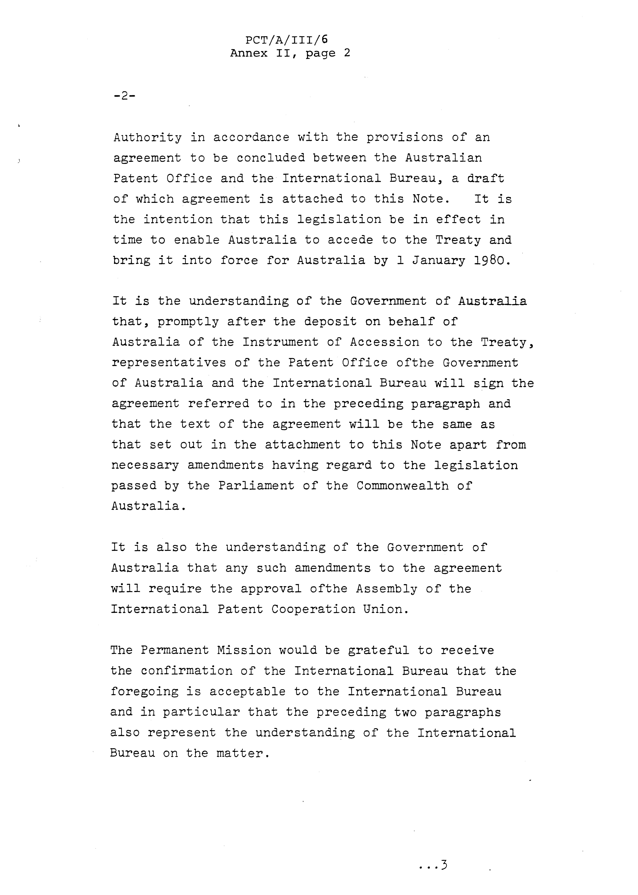

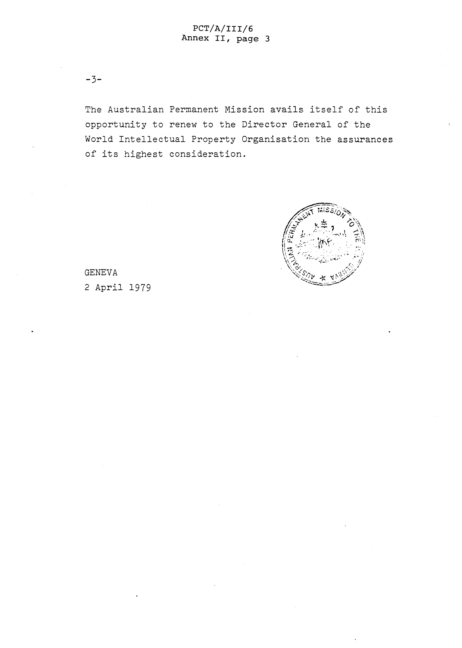

The agreement attached to the Note is not reproduced here since it consists of the draft Agreement reproduced in Annex I.

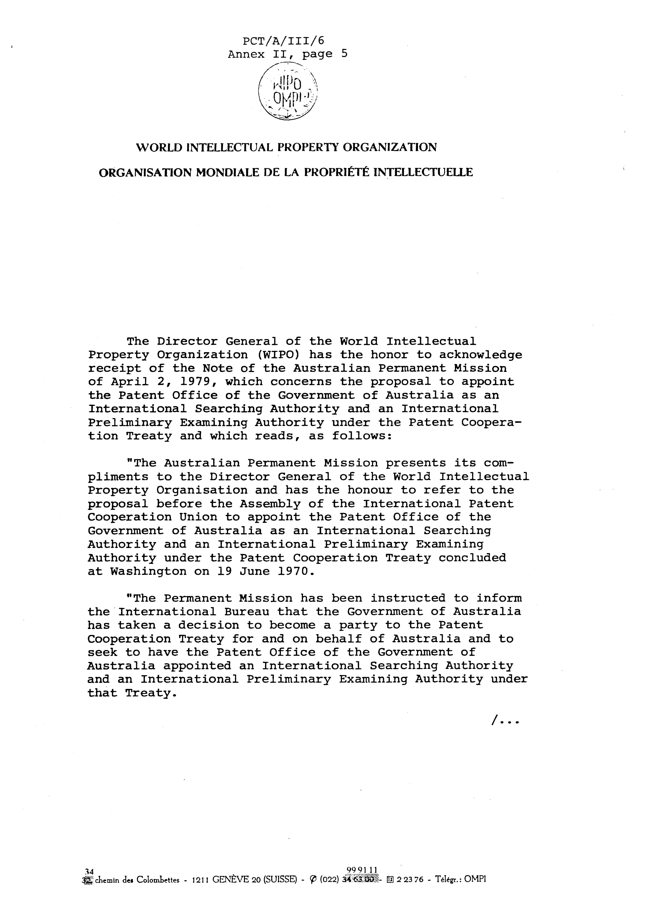

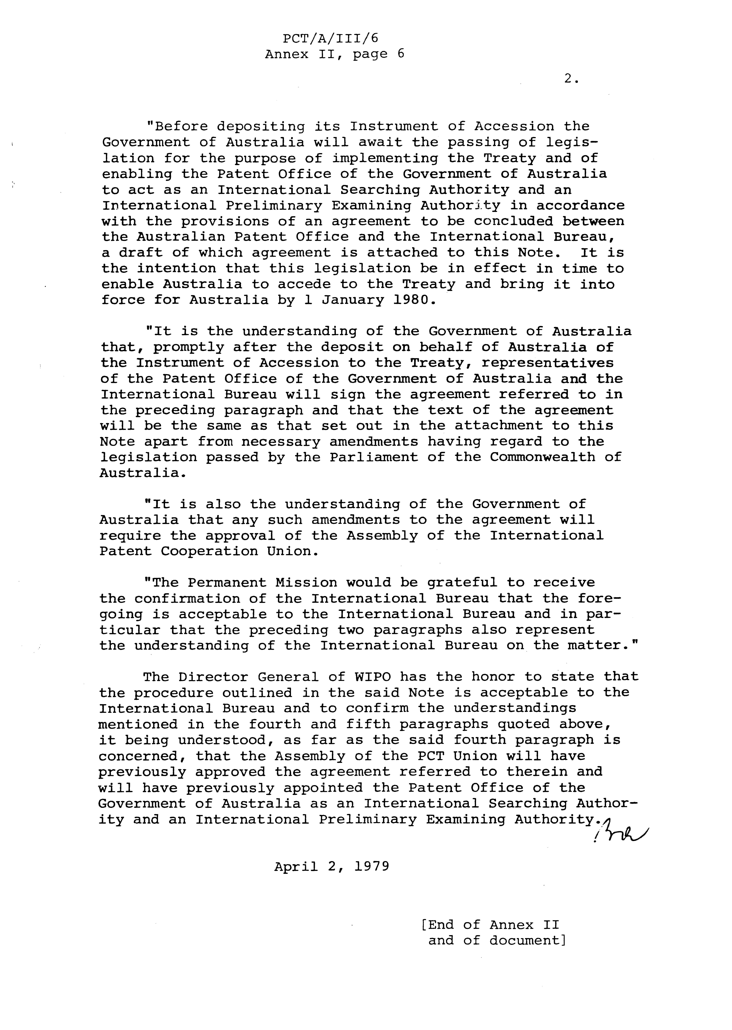

 Editor’s Note: This electronic document has been created from the paper original and may contain errors. Please bring any such errors to the attention of the PCT Legal Division by e-mail at pct.legal@wipo.int

