 |  | E
PCT/A/43/5 REV.
ORIGINAL: English
DATE: August 3, 2012

International Patent Cooperation Union (PCT Union)

Assembly

Forty-Third (25th Extraordinary) Session
Geneva, October 1 to 9, 2012

Appointment of the national institute of industrial property of chile as an international searching and preliminary examining authority under the pct

Document prepared by the International Bureau

- The appointment of International Searching Authorities (ISAs) and International Preliminary Examining Authorities (IPEAs) under the Patent Cooperation Treaty (PCT) is a matter for the Assembly and is governed by Articles 16(3) and 32(3) of the PCT. It follows from Rules 36.1(iv) and 63.1(iv) of the Regulations under the PCT that any appointment will be as both an ISA and an IPEA.
- In a letter dated July 6, 2012, the text of which appears in Annex I, accompanied by further details set out in Annex II, the National Director of the National Institute of Industrial Property of Chile (INAPI), the Minister of Economy, Development and Tourism of Chile, and the Minister of Foreign Affairs of Chile requested that the National Institute of Industrial Property of Chile be appointed as an International Searching Authority and International Preliminary Examining Authority under the PCT.
- Articles 16(3)(e) and 32(3) of the PCT require that, before the Assembly makes a decision on the appointment of an ISA and IPEA, it shall hear the Office or organization concerned and seek the advice of the PCT Committee for Technical Cooperation. The Committee, at its twenty-fifth session to be held in Geneva from October 1 to October 9, 2012, will consider the appointment of the National Institute of Industrial Property of Chile as an ISA and IPEA, and the Committee’s advice will be submitted to the Assembly during its session (which is being held during the same period).
- Under Articles 16(3)(b) and 32(3) of the PCT, the appointment of an ISA and IPEA is conditional on the conclusion of an Agreement, subject to approval by the Assembly, between the Office or organization concerned and the International Bureau. The text of a draft Agreement between the National Institute of Industrial Property of Chile and the International Bureau is set out in Annex III. Its Articles are identical to the corresponding provisions in the Agreements relating to existing Authorities as approved by the Assembly at its fortieth session.
- If the Assembly agrees to the appointment, it would take effect upon the entry into force of the Agreement between the National Institute of Industrial Property of Chile and the International Bureau. Such entry into force would, under Article 9 of the draft Agreement, be a date to be specified by the Office in a notification to the Director General that it is prepared to start functioning as an ISA and IPEA, that date being at least one month from the date of the notification. Under Article 10 of the draft Agreement, it would remain in force until December 31, 2017, that is, until the same time as the Agreements relating to all existing Authorities.
- The Assembly of the PCT Union is invited, in accordance with Articles 16(3) and 32(3) of the PCT:
(i) to hear the Representative of the National Institute of Industrial Property of Chile and take into account the advice of the PCT Committee for Technical Cooperation;
(ii) to approve the text of the draft Agreement between the National Institute of Industrial Property of Chile and the International Bureau as set out in Annex III; and
(iii) to appoint the National Institute of Industrial Property of Chile as an International Searching Authority and an International Preliminary Examining Authority with effect from the entry into force of the Agreement until December 31, 2017.

[Annexes follow]

TEXT OF LETTER FROM THE NATIONAL DIRECTOR OF THE NATIONAL INSTITUTE OF INDUSTRIAL PROPERTY OF CHILE; THE MINISTER OF ECONOMY, DEVELOPMENT AND TOURISM OF CHILE; AND THE MINISTER OF FOREIGN AFFAIRS OF CHILE TO THE DIRECTOR GENERAL OF WIPO

Mr. Francis Gurry
Director General
World Intellectual Property Organization - WIPO
Chemin des Colombettes 34
1211 Geneva
Switzerland

Santiago, 6 July 2012

Dear Mr. Gurry,

We are pleased to submit the documentation regarding the appointment of Chile’s National Institute of Industrial Property (INAPI) as International Searching Authority (ISA) and International Preliminary Examining Authority (IPEA) under the Patent Cooperation Treaty (PCT).

Preparatory work was carried out by INAPI in consultation with the World Intellectual Property Organization (WIPO) and its team of the PCT Business Development Division, which, upon request, undertook a technical mission to Chile on this subject in the past month of April.

The documentation is submitted on behalf of The Chilean Government for consideration by the Committee for Technical Cooperation under the PCT (PCT/CTC) and the 43rd Session of the PCT Union Assembly next October.

We have the firm belief that INAPI will make a substantive contribution to the international patent system, and in particular to Latin American countries, helping to promote and increase the use of PCT in the region. INAPI is in a position to offer high quality, proximate and timely services in Spanish to countries in the region that are members of the PCT, which already amount to 15.

Since its creation in 2009, INAPI has conducted a series of projects to organize and start the operation of the Institute and then to improve its management and service. During 2012, INAPI will finalize the third phase in this process, which encompasses an integral reform to the Chilean IP system. It includes the whole replacement of the Chilean Industrial Property Law, the launching of INAPI’s new web portal, allowing for full online processing of applications, the complete digitization of pending patent and trademark files, the full operation of INAPI’s new facilities and the launch of a complete technology platform for the dissemination of intellectual property and transfer of knowledge.

INAPI is a mature institution that can provide the best technical capabilities to meet the tasks of an International Searching Authority and International Preliminary Examining Authority. You may have the assurance that the sustainability and continuity of this project has the full support not only of the Government of Chile, but also the Academia and the country’s industry and entrepreneurial community.

We take this opportunity to thank you Mr. Gurry and the International Bureau for the assistance provided, and we would very much appreciate your good offices in ensuring the timely and most adequate presentation to the PCT Unions Assembly of INAPI’s candidacy for appointment as International Searching Authority and International Preliminary Examining Authority.

Yours sincerely,

[signed by  Maximiliano Santa Cruz S.  National Director  National Institute of Industrial Property  Of Chile – INAPI] | [signed by  Pablo Longueira Montes  Minister  Ministry of Economy, Development, and Tourism]
[signed by
Alfredo Moreno Charme
Minister
Ministry of Foreign Affairs]

[Annex II follows]

Appointment of the national institute of industrial property of chile as an international searching and preliminary examining authority under the Pct

I. The National Institute of Industrial Property
- The National Institute of Industrial Property of Chile (INAPI) is a decentralized public service, technical and legally responsible for the care and management of all industrial property services in Chile. INAPI is in charge of promoting the protection granted by industrial property and disseminating technological knowledge and information. Among other responsibilities, INAPI is advisor to the President on matters related to industrial property both domestically and internationally, and is also a first instance court in opposition and nullity procedures.
- INAPI started operating in January 2009, replacing the former Department of Industrial Property of the Ministry of Economy. The creation of INAPI was a milestone in Chile’s system of innovation and one of several important measures taken by the Government of Chile that show its clear commitment to the promotion of innovation, competition and entrepreneurship through intellectual property.
- For the performance of its functions, INAPI is organized in three main areas: Trademarks, Patents and Transfer of Knowledge. These areas are supported by a group of professional advisors to the National Director in areas of policy (i.e. Legislative, International and Public Policy Departments).
- In its core business areas, namely patents and trademarks, lawyers, examiners, technical and administrative personnel perform the examination of all applications in order to determine whether or not to grant each right. Through its Transfer of Knowledge Division, INAPI promotes and encourages the use of industrial property and knowledge transfer. Pursuing this same objective, INAPI launched at the beginning of 2012 INAPI-Proyecta, a platform developed in conjunction with the European Union to facilitate access to technological information, provide tools for better use of industrial property rights and to learn about intellectual property through online courses.
- Within its policy areas, INAPI counts intellectual property experts responsible for crafting new legislation on industrial property, including a bill recently submitted to Congress, delivering technical opinions on various international issues and advising other agencies of Government in intellectual property matters.
- Complementing all the above, through its support areas, INAPI has carried forward a series of programs aimed at designing a completely new on-line services platform, stable and dynamic, that allows for a total online processing of industrial property rights.

II. INAPI as ISA/IPEA under the PCT
- Both the creation of INAPI and the work done since its installation have helped to move towards a new stage in the process of transforming the intellectual property system in Chile. In this context, INAPI has become a modern and efficient Office not only able to provide quality services but also to interact effectively with the international intellectual property system as a whole.
- INAPI strongly believes in the importance of the international intellectual property system for the promotion of innovation and entrepreneurship. In this context, the Patent Cooperation Treaty (PCT) plays a key role, so since its entry into force in Chile, its implementation has been a strategic priority for INAPI.
- The Government of Chile sees in the PCT a real and concrete possibility for member countries to interact and effectively contribute to the system, making it more attractive and accessible to all users. By appointing INAPI as an ISA/IPEA, the Government of Chile is of the opinion that it can help further develop the system in the region and encourage the filing of PCT applications in Latin America. This is particularly important if we consider new fillings only grew by 4.8 per cent between 2005 and 2010, well below other regions such as Asia, where the number of PCT filings increased by 10.9 per cent during the same period.
- In addition it is INAPI's belief that its role as a native Spanish speaking language ISA/IPEA may benefit the countries within the Latin-American region that have not yet adhered to the Treaty or may be in the process of considering becoming part of it. The active participation of INAPI in all instances of the PCT system will permit it to share the experience and help those countries that are either implementing or want to be part of the system. Having a Spanish speaking ISA/IPEA within the region that can carry on international searches as well as preliminary examinations will certainly benefit the system as a whole.
- In this sense, and as a strategy to promote the use of the system as a whole, the Government of Chile considers that the existence of a new ISA/IPEA in the Latin American region will be very important to avoid possible delays in the processing of PCT international applications due to work overload in some offices. Furthermore, we believe that searching resources must be allocated in different parts of the world so that they are used more efficiently.
- Considering Chile's interest to promote innovation and entrepreneurship and recognizing the importance that the international patent system has on these objectives, we consider it appropriate to appoint INAPI as an ISA/IPEA. INAPI meets the technical requirements to offer its search and examination services to both its nationals and other members of the PCT, particularly to applicants from Latin American members of the PCT, promoting and increasing the use of the PCT in the region.

III. Human resources

Mixed system of examination
- Within its structure and internal organization, INAPI’s Patent Division has a mixed system for searching and examining patent applications and utility models. External experts and examiners compose this system. This structure has contributed to the achievement of sustained improvement in the quality, effectiveness and efficiency in the processes that INAPI conducts.
- The mixed review system consists of a team of highly qualified professionals, external experts and examiners, who are responsible for performing searches and evaluating whether a patent application for an invention or utility model meets the patentability requirements.

External Experts
- The work of the experts is specifically regulated by the Industrial Property Law (Law No. 19.039) and its Regulations. According to these, INAPI’s National Director has to qualify their suitability for examination and their permanence or removal from the Register of Experts.
- External experts work under the direct supervision of the Management Experts Unit (PMU) of INAPI’s Patent Division, which is in charge of the register and its update. Their work consists on issuing expert reports, analogous to the search and written opinions of the PCT.
- Also, given the nature of the work to be performed, experts are particularly obliged to keep complete confidentiality on all and any information they have access to, either directly or indirectly or in connection with the search reports they carry out. Failure to comply with all confidentiality obligations is ground for immediate removal from the Register of Experts and entitles INAPI as well as any third party concerned to exercise all the appropriate legal actions provided by the law.

Examiners
- The examiners are members of the Patent Examination Department (DEP) of INAPI’s Patent Division, and are responsible for evaluating whether the expert's work meets the criteria and guidelines set by the institution for the analysis of patentability. Examiners are also responsible for delivering a final recommendation on the patentability of applications to the National Director.

Staffing and technical qualifications of Experts
- Currently INAPI has just under 180 staff members and 79 external experts. The team of experts in search and patent examination consists of 102 professionals, qualified to perform searches and patentability reports in all technical areas. They are organized into five technical areas: Pharmacy, Chemistry, Biotechnology, Mechanical and Electrical, allowing INAPI to cover all areas of technology. This number will increase in the near future, as new professionals will be recruited to meet new needs.
- Both examiners and external experts are part of INAPI’s Patent Division. For organizational purposes, the first work under the Patent Examination Coordination Department (DEP), while the latter under the Experts Management Unit (PMU).
- All INAPI professionals dedicated to substantive examination of patent applications for inventions and utility models have the skills and knowledge that enable them to perform searches and meet the demands of a patent examination. In fact, they are required as part of their normal responsibilities to conduct searches of prior art and issue patentability opinions for patent applications based on such background.
- Furthermore, our examiners and experts possess sufficient language skills to understand the minimum documentation that should be reviewed. All of our external experts and examiners have at a minimum an intermediate level of English, and of those, 40 per cent have an advanced level. In addition to the above, a number of external experts and examiners manage French and German, as well as Italian, Japanese and Portuguese. At INAPI, the importance given to language skills is constant and can be reflected in the fact that during the years 2009 to 2011 a significant percentage of INAPI officials were trained in English and French.
- Also, and related to the need for a particular expertise, almost 50 per cent of our experts in search and examination have postgraduate studies, of which the vast majority are masters and PhDs in their respective technical areas.
- It should be noted that with regard to professional experience, about 45 per cent of our team of technical experts have at least 10 years experience in conducting search and examination of patentability reports.

Recruitment and training
- The process of incorporating new professionals, especially external experts, starts by identifying needs in technical areas and building a profile for the post. Then a public application process is conducted which concludes with the selection of candidates. These candidates are subject to a comprehensive training and selection that is divided in two stages: first an "induction", focused on providing general knowledge and expertise with regards to patents and industrial property. For this stage, INAPI normally works in cooperation with other Offices. The second stage corresponds to the training itself. During this period the candidate works under the guidance of experts at INAPI, conducting examination of actual patent applications.
- The entire process takes about four months, and it is overseen by the heads of the technical areas of the Department of Examination who finally evaluate the performance and capacity of the candidates, selecting those which meet the requirements set by INAPI.
- Finally, once candidates are accepted as part of INAPI, each one of them is assigned a tutor that supervises and provides support when preparing their first reports. Tutoring is held for one year with different supervisors within the same technical area. The performance of new professionals is assessed every four months. If after a year (or earlier), the candidate demonstrates the development of skills and abilities necessary to perform search and examination reports, he may start working independently. The purpose of this process is that, within an 18 month period, all new external experts must be prepared for search and examination work of patent without the supervision of a tutor.
- The process of recruitment and training of new experts has been developed and designed so as not to affect the productivity of the Office. This has been reflected in the fast reduction of pending applications over the past years.

Advantages of the mixed review system
- The strategic decision to have a mixed review for the examination of applications has been a helpful tool to increase quality and productivity and to face a constantly increasing demand, without affecting the quality of the granted rights. External experts are paid by each report issued and the applicants are responsible for that expense, according to tariffs set by INAPI.
- The flexibility this system gives is one of its greatest strengths since it allows INAPI to have a group of highly qualified professionals with years of experience in industrial property matters and in continuous contact with both the industry and the academy, as it does not require full dedication to INAPI. This ensures high quality of our search reports and written opinions, since our expert’s knowledge is always updated due to the activities they perform outside INAPI. Moreover, this system makes it easy to react promptly to changes in demand for various areas of technology.
- Making a review of the system, we believe that its success is due, amongst other things, to the following:
– clear definition of the model for examination;
– right mix of examiners and external experts;
– flexible model, rigorous and customer-oriented;
– use of control tools (e.g. expert management module);
– proper management of the process.
- The mixed examination system for analyzing patent and utility model applications can be considered the engine of our institution. Through the years it has been possible to improve it so as to transform it into an effective tool to achieve greater quality and efficiency in the work done. Today, this system will also allow us to easily face the new challenges when INAPI becomes an ISA/IPEA under the PCT.

IV. Minimum Documentation
- Always with the aim of providing high quality service, INAPI has sought ways to enable the execution of effective and efficient searches. According to this, over the past years we have licensed Goldfire Insight, which allows the review of world literature of patents, scientific publications and other technical literature by using keywords, working with the TRIZ methodology, in English, Japanese, German and French. Through that program the following contents can be accessed:
Innovator GoldFire
Patents
Register USA
Hits USA
EPO Register
EPO applications
WIPO PCT Pub
Japan Registry
Hits Japan
Summaries Japan
Registration Britain
British applications
Log France
Hits France
Registration Germany
Hits Germany
MU Germany and Austria
Non-patent databases
Articles IEEE
Summary MEDLINE / PubMed
Deep Web (pre-indexed collection subset of over 5 million documents)
ASABE (American Society of Agricultural and Biological Engineers)
IOP (The Institute of Physics)
OnePetro (Society of Petroleum Engineers)
DSpace (MIT's Institutional Repository)
Science Food and Technology
OSTI.gov (Department of Energy (DOE) Office That Collects)
SPIE (International Society for Optics and Photonics)
Springer (Global Leading scientific publisher)
Tech Briefs (reports of innovations developed by NASA)
IFIS (The International Food Information Service)
- Along with this, according to INAPI’s practice all our technical experts review all major databases such Espacenet, PATENTSCOPE, Latipat, IPDL, the United States Patent and Trademark Office (USPTO) databases and those of the Spanish Patent and Trademark Office (SPTO).
- With regards to non-patent literature, consultations are conducted in public databases that collect specialized scientific publications in various technical areas, such as PubMed, IEEE - The World's Largest Professional Association for the Advancement of Technology - and SCIRUS.
- For national patent documents, INAPI has its own database that can be accessed through our web site (www.inapi.cl), which contains all scanned documents, in addition to the documentation in our paper files and CD and DVD formats, which are deposited or stored as records of patents granted or pending, abandoned or rejected applications. This repository of information is constantly updated since INAPI has an ongoing process of digitization of documents related to patents, utility models and industrial designs.
- Complementing the above, the Government of Chile has committed the resources and infrastructure needed to acquire, implement and provide INAPI with the most advanced search systems available on the market. INAPI is determined to license EPOQUE, a search system developed by the European Patent Office (EPO) that has been widely recognized by the patent Offices as an effective tool for this purpose. Not only EPO but also the Spanish Patent and Trademark Office (SPTO), the Brazilian National Institute of Industrial Property (INPI Br) and the State Intellectual Property Office of the People’s Republic of China (SIPO) use this system. Since the licensing of EPOQUE includes the necessary training, acquisition of this search tool will also ensure that the EPO search strategies are internalized, enabling the adoption of EPO’s best practices by our experts and examiners.
- Notwithstanding the foregoing, INAPI constantly evaluates available new search tools, such as Derwent and Delphion, in order to improve all internal processes and the quality of work being performed. Finally, it should be noted that INAPI is constantly reviewing and incorporating new databases for them to be licensed and used in the processes of analysis and review of national applications in order to increase and further improve the experience and practices of our examiners and therefore the quality of examinations. Particularly, there are negotiations on the hiring of the ASME (American Society of Mechanical Engineers) database, as the majority of the domestic and Latin-American applications that are filed in INAPI pertain to this technical field and it is expected that this trend will be maintained in our role as ISA/IPEA.

V. Quality Management System
- Within INAPI’s permanent policy of providing the highest quality of services, the Institute currently has an organized structure of quality control composed by a Department of Planning and Management Control, an Internal Audit Department and a Department of Development that work in close collaboration with the different areas of the Patent Division.
- INAPI has also begun the implementation of a process to completely certify our quality management systems and internal review by the Chilean Model Management Excellence system, demonstrating the importance INAPI gives to providing quality services to our users (see Appendix).
- This quality model appears to meet the requirements of Chapter 21 of the PCT International Search and Preliminary Examination Guidelines; a more detailed assessment is under way and any deficiencies identified will be addressed before the Office begins operation as an International Searching and Preliminary Examining Authority.

VI. Conclusions
- In light of the above, it is possible to ensure that INAPI has the means to offer its search services and technical analysis to both nationals and other members of the PCT, in particular to Latin American members of the Treaty, therefore contributing to the further development of the system in the region by reducing costs, offering high quality reports, and improving accessibility (by reason of location, culture and language), thus promoting and increasing the filing of PCT applications in the region.
- Also, as we noted at the outset, the existence of a greater number of ISA/IPEA will help avoid any delays in the processing of PCT international applications due to the work overloads suffered by some Offices, which in terms of efficiency is a benefit for the system as a whole.
- Within the PCT, INAPI is a mature institution that is recognized as such by its peers. INAPI counts with the strong support of the Chilean Government and Chile’s intellectual property community, in its commitment to promote innovation, competition and entrepreneurship as a means to promote development. In this context, the designation of INAPI as ISA/IPEA would bring the PCT system closer to the region, would contribute to its development over time and eventually give the international patent system a serious, efficient and effective alternative for the analysis of new inventions and their entry into the PCT.

[Appendix follows]
APPENDIX

QUALITY CONTROL SYSTEM

I. Introduction
- The National Institute of Industrial Property (INAPI) was created in 2009, as a decentralized institution technical and legally responsible for the care and management of industrial property services in Chile.
- INAPI’s mission is to contribute to national economic development by stimulating entrepreneurship, innovation and creativity through the protection of industrial property and knowledge management, based on processes that ensure effectiveness, efficiency, quality, legality, accessibility and certainty of information.
- To achieve the above, INAPI is committed to permanently provide services of the highest quality, which is reflected in the organizational structure of INAPI, as well as in various initiatives aimed at that goal.
- As shown in the chart below, INAPI is headed by the National Director, who is assisted in his work by a group of professional advisors to the National Directorate, mainly in areas of policy. INAPI has two main business areas: the Trademarks and the Patents Divisions. The latter’s structure is composed of the different technical areas of examination and by a group of officials dedicated to provide guidance to users. This internal organization allows addressing analysis and examination without neglecting advice and guidance to users of the system, whether they are inventors, universities, research centers or law firms.
- The Patent Division has also a special PCT Coordination Unit, in charge of organizing within INAPI all work related to the proper use and implementation of the Treaty. This unit will be responsible for processing and managing all applications received as ISA/IPEA.
PATENT DIVISION
TRADEMARKS DIVISION
ADMINISTRATIVE DIVISION
DEPARTMENT OF PLANNING AND MANAGEMENT CONTROL
STUDIES AND PUBLIC POLICY
DEPARTMENT OF INTERNATIONAL AFFAIRS
LEGISLATIVE DEPARTMENT
INTERNAL AUDIT DEPARMENT
EXTERNAL COMUNICATIONS
DEVELOPMENT DIVISION
TRANSFER OF KNOWLEDGE DIVISION
LEGAL DIVISION
LEGAL DEPARTMENT OF PATENTS
UNIT OF GUIDANCE AND SUPPORT FOR PATENTS APPLICANTS

EXTERNAL EXPERTS MANAGEMENT UNIT
TECNOLOGICAL TRANSFER UNIT
UNIT OF DIFUSION AND SUPPORT FOR THE INNOVATORS
INFORMATION TECNOLOGY DEPARTMENT
DEPARTMENT OF CONTINUOUS IMPROVEMENT PROCESS AND MANAGEMENT
USER SERVICE / CUSTOMER SERVICE
CHIEF OF STAFF
INDUSTRIAL PROPERTY FOR THE INNOVATION
PATENT ADMINISTRATIVE PROCESSING UNIT
INSTITUTIONAL
COMUNICATIONS
PCT COORDINATION UNIT
NATIONAL DIRECTOR
PATENT EXAMINATION DIVISION

II. Quality Management at INAPI
- Providing a high quality service is one of the main objectives of INAPI. To achieve this clearly defined institutional goal, the Institute has a number of teams responsible for fulfilling this objective.

Department of Planning and Management Control
- The Department of Planning and Management Control is responsible for defining, designing and continuously improving the management control model applied at INAPI. The model consists in first gathering relevant information on the management and strategic objectives of the Institute, then coordinating the development of strategic planning and finally organizing annual work plans of each of the Divisions and Units of INAPI. This Department contributes to the proper allocation of resources and compliance with the institutional mission, monitors the annual work plans and provides tools for the evaluation of the management. In order to make timely adjustments necessary to ensure proper compliance with the government guidelines, this Department tracks the various actions of the institution through defined management indicators for the fulfillment of strategic objectives and informs the heads of each Division of their progress and results. Finally, the Department of Planning and Management Control collaborates in the construction of all indicators ensuring the existence of means of verification to control the achievement of targets involved in the annual work plan.

Internal Audit Department
- Its main objective is to assist the National Director in the design and implementation of plans aimed at reviewing and examining the administrative and financial management of INAPI. The work performed by this department is essentially preventive. The Internal Audit Department is responsible for proposing policies, programs and control measures for strengthening the institutional management and safeguarding resources that have been assigned to INAPI.

Development Division
- The Development Division is responsible for managing institutional development in order to increase the effectiveness and efficiency of patent and trademark processes. This Department also manages and develops information technology and all communications services for INAPI.

Department of Continuous Improvement of Processes
- The Department of Continuous Improvement of Processes is part of the Development Division and is responsible for evaluating, analyzing, proposing and supporting the implementation process of continuous improvement in the cycles of trademarks and patents. The Department also acts as an advisor to the National Director making recommendations in order to increase the effectiveness, efficiency and quality of all services provided by INAPI.

Quality control measures
- The Departments of Internal Audit and Planning and Management Control have implemented a Risk Management model that examines key business processes and activities, determines the different levels of risk in the different work areas, assesses the risks associated and establishes appropriate controls to mitigate them. This process is led by the Risk Committee, which manages the development and update of the Annual Risk Matrix. The Department of Planning and Management Control in collaboration with the Department of Internal Audit regularly monitors this Matrix. Both Departments work directly under the National Director.
- In addition, and considering the importance of having critical information available in a timely manner for all decision-making, the National Director has established a process for monitoring critical variables of management, both in the business and support units. Through this process, the key performance indicators are monitored and analyzed, identifying gaps in their behavior and their causes, all with the proper feedback from the respective areas. This allows for the introduction of continuous improvements in the different processes.

Management Excellence Model
- The success of an organization is directly related to its ability to meet the needs of its users. Thus, the management of user satisfaction implies a deep understanding of who the users are, what are their needs, how satisfied they are with our services, what is their perception of INAPI, what are their responsibilities and what will their requirements or needs be in the future. These needs have to be identified, understood and used for the development of new tools, creating therefore the value needed to attract and retain those users, not only providing satisfaction, but also, and more importantly an excellent service.
- Strategic planning and development of plans sustained over time are vital to anticipate and prepare for the future. It is therefore important to have coherent planning for development that involve the full participation of the different actors, as well as a continuous monitoring to prevent deviations but also to allow the necessary adjustments to them.
- In this context, INAPI has begun the certification of all processes for quality management systems and internal review by the Chilean Model of Management Excellence. This certification requires a thorough understanding of our users and their behavior. The Chilean Model of Management Excellence is administered by the National Center for Productivity and Quality (Chile Calidad), which operates since 1996 as a Committee within the Corporación de Fomento de la Producción (CORFO) and is part of the Latin American Foundation for Quality Management (Fundibeq), of the Iberoamerican Network of Excellence in Management (Redibex) and, through them, of the Global Excellence Model (GEM). All these organizations provide the opportunity for reflection, discussion and analysis of the evolution of the models, its contents and its evaluation methodologies.
- The Model of Management Excellence is a representation of the various activities or components of the organization’s management necessary for its success. It provides for a framework, which states that every area of management should be approached as a process in order to obtain favorable results. These models are applied worldwide in a similar way. Variations are made in order to adjust to the reality of each organization and their specific internal environment and consist in modifying the emphasis given to the evaluation criteria.
- The Model of Management Excellence Model used in Chile identifies seven areas of management (macro processes), which are linked to results. These areas are: Leadership (1), Customers (Users) and Market (2), People (3), Strategic Planning (4), Process (5), Information and Knowledge (6) and Social Responsibility (7). Each of them and their results (8) are called "criteria".
- The following diagram shows the eight evaluation criteria considered by the Chilean Model of Management excellence adopted by INAPI. Each on of the seven management areas converge generating "Results". The diagram also represents the interrelationship between the criteria previously mentioned.
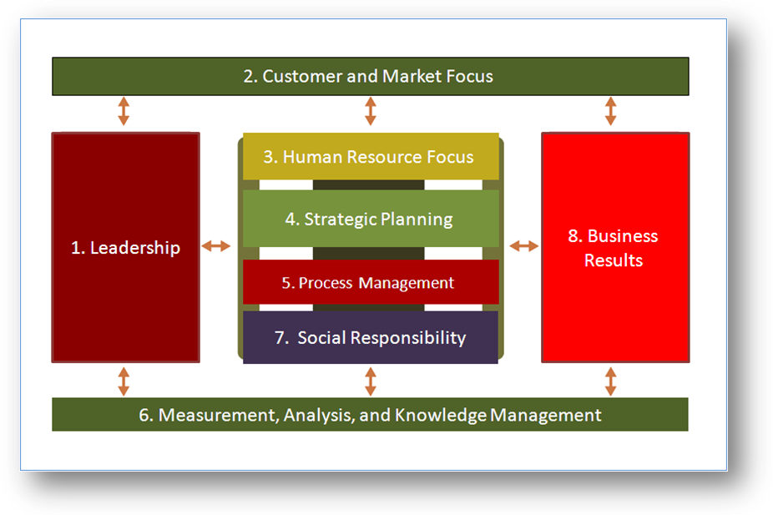

- INAPI is currently finishing the stage of self-diagnosis, where there are three fundamental aspects that comprise the overall performance of the institution. This will allow the development of projects that address the identified gaps.

Customer service users and the integrated citizen service system (SIAC)
- INAPI gives great importance to the opinions of our users and sees in them an opportunity to identify areas for improvement in relation to the service provided. In this sense, and in compliance with paragraph 21.18 of the Guidelines for International Search and Preliminary Examination of the PCT, the Patent Division has a special Unit for Guidance and Support of patent applicants. Highly qualified professionals whose role is to advise users on matters relating to patents, either in the stage prior to the filing and during processing, integrate this unit. Orientation is given personally or through different channels, such as information specially designed for this purpose on INAPI’s website, user guides, frequently asked questions and/or the e-mail account inapi@inapi.cl.
- INAPI’s commitment is to respond to all comments and questions within 48 hours of receipt. All requests for information received are collected electronically, which allows for tracking and reporting as well as for statistical analysis, all useful tools for measuring user satisfaction and perception.

Integrated citizen service system (SIAC)
- INAPI emphasizes quality of service, by focusing and prioritizing attention to citizens, as users of the services provided by the institution.
- To this purpose, INAPI has established a number of methods to manage the quality of its services, including mechanisms for understanding of the public (external users) that allow identifying their characteristics, needs, expectations and satisfaction, measuring relevant aspects of the service areas, and establishing quality standards on the care of the service.
- Earlier this year INAPI put in place a map of "Integrated Citizen Service System" (SIAC), in which all requirements by the public who have contact with INAPI either as users or service providers are channeled and managed in a way that permits satisfying al requirements as well as understanding the perception and degree of satisfaction and dissatisfaction, quality of care and the products delivered.
- The service quality model aims at ensuring high quality customer service, as well as providing products and services of the highest level. In this task INAPI uses INAPI CRM "CUSTOMER RELATIONSHIP MANAGEMENT” (Microsoft Dynamics CRM) which is the system that supports the management of the Integrated Citizen Service System.
- The following figure outlines the mechanisms implemented by INAPI to understand, measure citizen and user behavior and level of satisfaction.
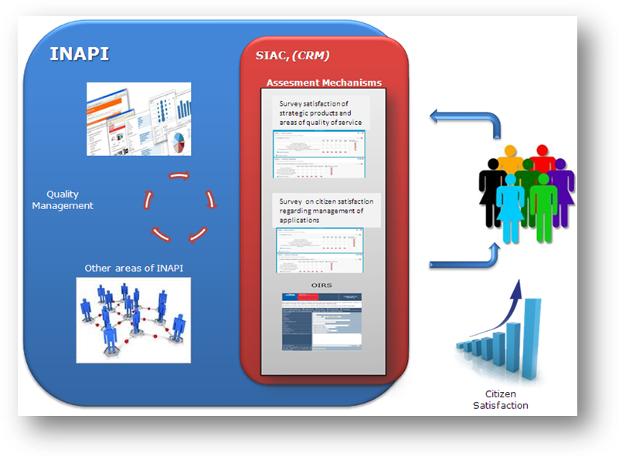

Lean-Six Sigma Methodology
- Starting in 2011, the Patent and Trademark Divisions began to use the Lean-Six Sigma methodology in some of their most critical processes. This methodology is intended to generate improvements making processes much more stable and eliminating defects or failures in the delivery of a product or service to the user.
- The Lean-Six Sigma methodology uses data measurements of the products and services provided to users (users and/or applicants), and a series of indicators that quantify using benefits and user satisfaction. It also creates a culture of quality and allows the organization to develop methodologies to control process variability.
- The implementation of Lean Six Sigma methodology at INAPI has improved processing times in patent and trademark applications and has eliminated unnecessary procedures.

Control Panels and Management Modules
- The Department of Process and Continuous Improvement has designed different tools for live control of applications being processed within INAPI. Among them, the panel control as proven to be the most effective. It provides the Patent and Trademark Divisions with different indicators to facilitate analysis, resource allocation and management, enabling them to improve their performance and make timely adjustments.
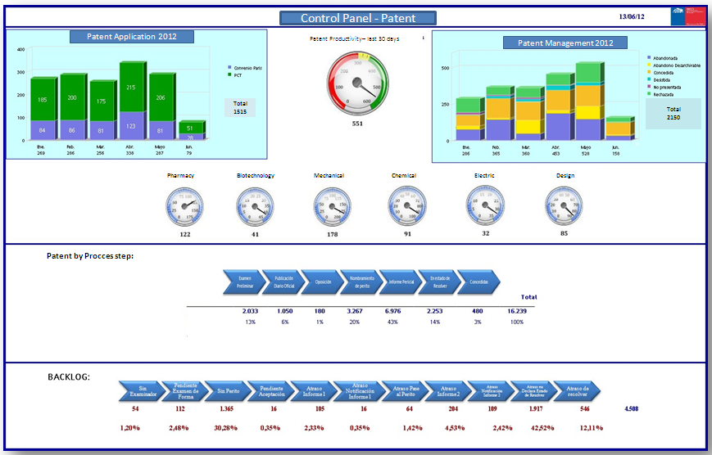

- In addition, the Department of Continuous Improvement Process and Management also developed modules for monitoring and supervision of the various business units allowing adaptation, and facilitating management and planning over time. An example is the Expert Management Module, which is currently used in the Division of Patents, which permits control over the workload of the external experts, optimizing the distribution of applications for examination.
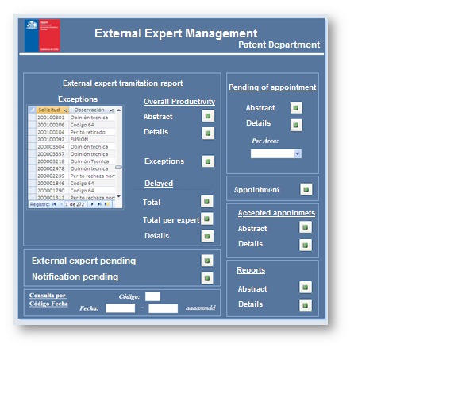

Search and Examination
- As stated before, the work of the external examiners is regularly evaluated and constantly monitored by trained professionals in each technical area.
- In relation to the work of search and examination, the Patent Examination Department (DEP), which groups the examiners of all technical areas, is responsible for the ongoing assessment of performance of our external experts and the identification of possible improvements. In addition, the External Experts Management Unit controls the workload, compliance with statutory deadlines for issuing reports and maintains all information relating to the performance of external experts and examiners.
- In relation to the review and examination process and in compliance with paragraph 21.6 of the Guidelines for International Search and Preliminary Examination under the PCT, the work system at INAPI focuses on achieving quality searches and examinations. The analysis and processing of applications comprises a first stage where external experts perform searches and substantive examination, examiners then verify the quality of the reports and issue a final recommendation on the patentability of applications.
- In addition, the Patent Division has created Examination Guidelines, which are periodically reviewed and updated, addressing among other matters: "Standard Expert Analysis," "Sufficiency of Description", "Novelty", "Inventive Step", " Industrial Application", "Unity of Invention" and" Exclusions from Patentability ". These documents are compiled into a single publication which will be launched during 2012, in order not only to define the technical criteria of INAPI, but also to provide guidance and become a reference material for both our technical professionals and our users, facilitating therefore a high quality standard in the analysis of patentability. These guidelines define a quality framework to be followed and are based on the provisions of the Industrial Property Law and Regulations, and are constantly reviewed by the Examination Department to make changes or updates as needed.
- In general terms, the framework for patentability analysis is consistent with the PCT guidelines, confirming that the searches and examination performed by INAPI meet the highest standards.

III. Conclusions
- As shown in this document INAPI provides an excellent service, which is reflected in the organizational structure and in the many actions and initiatives taken for its continuous improvement. This, as well as the measures taken to ensure high quality in the substantive work performed with regards to patent examination, guarantees that INAPI can act as International Searching Authority and International Preliminary Examining for PCT applications.
- Finally it is important to consider that INAPI:
– has a qualified professional team of examiners and external experts in all areas of technology, which have the required skills in handling languages;
– has a Quality Management framework, based on departments and units that are responsible for designing, implementing and applying plans and methods for quality management that are used in all areas of business; this allows INAPI to meet the strategic objectives of the institution always complying with the laws and regulations that govern it;
– INAPI is an institution that has as primary objectives quality and excellence in the management of all its products and services, along with being strongly oriented to users.

[Annex III follows]

Draft Agreement

Agreement
between the National Institute of Industrial Property of Chile
and the International Bureau of the World Intellectual Property Organization
in relation to the functioning of the National Institute of Industrial Property of Chile
as an International Searching Authority
and International Preliminary Examining Authority
under the Patent Cooperation Treaty

Preamble
The National Institute of Industrial Property of Chile and the International Bureau of the World Intellectual Property Organization,
Considering that the PCT Assembly, having heard the advice of the PCT Committee for Technical Cooperation, has appointed the National Institute of Industrial Property of Chile as an International Searching and Preliminary Examining Authority under the Patent Cooperation Treaty and approved this Agreement in accordance with Articles 16(3) and 32(3),
Hereby agree as follows:
Article 1
Terms and Expressions
(1) For the purposes of this Agreement:
(a) “Treaty” means the Patent Cooperation Treaty;
(b) “Regulations” means the Regulations under the Treaty;
(c) “Administrative Instructions” means the Administrative Instructions under the Treaty;
(d) “Article” (except where a specific reference is made to an Article of this Agreement) means an Article of the Treaty;
(e) “Rule” means a Rule of the Regulations;
(f) “Contracting State” means a State party to the Treaty;
(g) “the Authority” means the National Institute of Industrial Property of Chile;
(h) “the International Bureau” means the International Bureau of the World Intellectual Property Organization.
(2) All other terms and expressions used in this Agreement which are also used in the Treaty, the Regulations or the Administrative Instructions have, for the purposes of this Agreement, the same meaning as in the Treaty, the Regulations and the Administrative Instructions.
Article 2
Basic Obligations
(1) The Authority shall carry out international search and international preliminary examination in accordance with, and perform such other functions of an International Searching Authority and International Preliminary Examining Authority as are provided under, the Treaty, the Regulations, the Administrative Instructions and this Agreement.
(2) In carrying out international search and international preliminary examination, the Authority shall apply and observe all the common rules of international search and of international preliminary examination and, in particular, shall be guided by the PCT International Search and Preliminary Examination Guidelines.
(3) The Authority shall maintain a quality management system in compliance with the requirements set out in the PCT International Search and Preliminary Examination Guidelines.
(4) The Authority and the International Bureau shall, having regard to their respective functions under the Treaty, the Regulations, the Administrative Instructions and this Agreement, render, to the extent considered to be appropriate by both the Authority and the International Bureau, mutual assistance in the performance of their functions thereunder.
Article 3
Competence of Authority
(1) The Authority shall act as International Searching Authority for any international application filed with the receiving Office of, or acting for, any Contracting State specified in Annex A to this Agreement, provided that the receiving Office specifies the Authority for that purpose, that such application, or a translation thereof furnished for the purposes of international search, is in the language or one of the languages specified in Annex A to this Agreement and, where applicable, that the Authority has been chosen by the applicant.
(2) The Authority shall act as International Preliminary Examining Authority for any international application filed with the receiving Office of, or acting for, any Contracting State specified in Annex A to this Agreement, provided that the receiving Office specifies the Authority for that purpose, that such application, or a translation thereof furnished for the purposes of international preliminary examination, is in the language or one of the languages specified in Annex A to this Agreement and, where applicable, that the Authority has been chosen by the applicant and that any other requirements regarding such application as specified in Annex A to this Agreement have been met.
(3) Where an international application is filed with the International Bureau as receiving Office under Rule 19.1(a)(iii), paragraphs (1) and (2) apply as if that application had been filed with a receiving Office which would have been competent under Rule 19.1(a)(i) or (ii), (b) or (c) or Rule 19.2(i).
Article 4
Subject Matter Not Required to Be Searched or Examined
The Authority shall not be obliged to search, by virtue of Article 17(2)(a)(i), or examine, by virtue of Article 34(4)(a)(i), any international application to the extent that it considers that such application relates to subject matter set forth in Rule 39.1 or 67.1, as the case may be, with the exception of the subject matter specified in Annex B to this Agreement.
Article 5
Fees and Charges
(1) A schedule of all fees of the Authority, and all other charges which the Authority is entitled to make, in relation to its functions as an International Searching Authority and International Preliminary Examining Authority, is set out in Annex C to this Agreement.
(2) The Authority shall, under the conditions and to the extent set out in Annex C to this Agreement:
(i) refund the whole or part of the search fee paid, or waive or reduce the search fee, where the international search report can be wholly or partly based on the results of an earlier search (Rules 16.3 and 41.1);
(ii) refund the search fee where the international application is withdrawn or considered withdrawn before the start of the international search.
(3) The Authority shall, under the conditions and to the extent set out in Annex C to this Agreement, refund the whole or part of the preliminary examination fee paid where the demand is considered as if it had not been submitted (Rule 58.3) or where the demand or the international application is withdrawn by the applicant before the start of the international preliminary examination.
Article 6
Classification
For the purposes of Rules 43.3(a) and 70.5(b), the Authority shall indicate solely the International Patent Classification.
Article 7
Languages of Correspondence Used by the Authority
For the purposes of correspondence, including forms, other than with the International Bureau, the Authority shall use the language or one of the languages indicated, having regard to the language or languages indicated in Annex A and to the language or languages whose use is authorized by the Authority under Rule 92.2(b), in Annex D.
Article 8
International-Type Search
The Authority shall carry out international-type searches to the extent decided by it.
Article 9
Entry into Force
This Agreement shall enter into force on a date to be notified to the Director General of the World Intellectual Property Organization by the Authority, that date being at least one month later than the date on which the notification is made.
Article 10
Duration and Renewability
This Agreement shall remain in force until December 31, 2017. The parties to this Agreement shall, no later than July 2016, start negotiations for its renewal.
Article 11
Amendment
(1) Without prejudice to paragraphs (2) and (3), amendments may, subject to approval by the Assembly of the International Patent Cooperation Union, be made to this Agreement by agreement between the parties hereto; they shall take effect on the date agreed upon by them.
(2) Without prejudice to paragraph (3), amendments may be made to the Annexes to this Agreement by agreement between the Director General of the World Intellectual Property Organization and the Authority; and, notwithstanding paragraph (4), they shall take effect on the date agreed upon by them.
(3) The Authority may, by a notification to the Director General of the World Intellectual Property Organization:
(i) add to the indications of States and languages contained in Annex A to this Agreement;
(ii) amend the schedule of fees and charges contained in Annex C to this Agreement;
(iii) amend the indications of languages of correspondence contained in Annex D to this Agreement.
(4) Any amendment notified under paragraph (3) shall take effect on the date specified in the notification, provided that, for any change in the currency or amount of fees or charges contained in Annex C, for any addition of new fees or charges, and for any change in the conditions for and the extent of refunds or reductions of fees contained in Annex C, that date is at least two months later than the date on which the notification is received by the International Bureau.
Article 12
Termination
(1) This Agreement shall terminate before December 31, 2017:
(i) if the National Institute of Industrial Property of Chile gives the Director General of the World Intellectual Property Organization written notice to terminate this Agreement; or
(ii) if the Director General of the World Intellectual Property Organization gives the National Institute of Industrial Property of Chile written notice to terminate this Agreement.
(2) The termination of this Agreement under paragraph (1) shall take effect one year after receipt of the notice by the other party, unless a longer period is specified in such notice or unless both parties agree on a shorter period.
In witness whereof the parties hereto have executed this Agreement.
Done at [city], this [date], in two originals in the English and Spanish languages, each text being equally authentic.
For the National Institute of Industrial Property of Chile by: | For the International Bureau by:
[…] | […]

Annex A
States and Languages
Under Article 3 of the Agreement, the Authority specifies:
(i) the following States for which it will act, so far as Article 3(1) is concerned:
any Contracting State of the Latin American and Caribbean region;
(ii) the following States for which it will act, so far as Article 3(2) is concerned:
where the Authority has prepared the international search report, any Contracting State of the Latin American and Caribbean region;
(iii) the following languages which it will accept:
Spanish.
Annex B
Subject Matter Not Excluded from Search or Examination
The subject matter set forth in Rule 39.1 or 67.1 which, under Article 4 of the Agreement, is not excluded from search or examination is the following:
all subject matter searched or examined in Chilean national applications.
Annex C
Fees and Charges
Part I. Schedule of Fees and Charges
Kind of fee or charge Amount
(Chilean Peso)
Search fee (Rule 16.1(a)) …
Additional fee (Rule 40.2(a)) …
Preliminary examination fee (Rule 58.1(b)) …
Additional fee (Rule 68.3(a)) …
Late payment fee for preliminary
examination [amount as set out in Rule 58bis]
Protest fee (Rules 40.2(e) and 68.3(e)) …
Cost of copies (Rules 44.3(b) and 71.2(b)):
– national documents, per document …
– foreign documents, per document …
Cost of copies (Rule 94.2), per page …
Part II. Conditions for and Extent of Refunds or Reductions of Fees
(1) Any amount paid by mistake, without cause, or in excess of the amount due, for fees indicated in Part I shall be refunded.
(2) Where the international application is withdrawn or considered withdrawn, under Article 14(1), (3) or (4), before the start of the international search, the amount of the search fee paid shall be fully refunded.
(3) Where the Authority benefits from an earlier search, [percentage(s) to be decided] of the search fee paid shall be refunded[, depending upon the extent to which the Authority benefits from that earlier search].
(4) In the cases provided for under Rule 58.3, the amount of the preliminary examination fee paid shall be fully refunded.
(5) When the international application or the demand is withdrawn before the start of the international preliminary examination, the amount of the preliminary examination fee paid shall be fully refunded.
Annex D
Languages of Correspondence
Under Article 7 of the Agreement, the Authority specifies the following languages:
English, Spanish.

[End of Annex III and of document]

Other areas are the Legal and the Administration and Finance Divisions.
See www.inapiproyecta.cl
A third main area is Transfer of Knowledge.
The three aspects are: The global management results, the satisfaction of internal and external users and the quality of life within the organization.

