E
MM/A/51/1
ORIGINAL: ENGLISH
DATE: JULY 3, 2017

Special Union for the International Registration of Marks
(Madrid Union)

Assembly

Fifty-First (22nd Ordinary) Session
Geneva, October 2 to 11, 2017

report on the MADRID SYSTEM GOODS AND SERVICES DATABASE

prepared by the International Bureau

INTRODUCTION

- This document presents progress in the development of the database of acceptable indications of goods and services for the purposes of the Madrid System procedures (hereinafter referred to as the “Madrid System Goods and Services Database” or “MGS Database”).

- In September 2009, the Assembly of the Madrid Union approved a two-year project to develop the MGS Database, as described in document MM/A/42/3, and funding in the amount of 1.2 million Swiss francs from the Madrid Union Reserve Funds for its implementation during the 2010/11 biennium (see document MM/A/42/4, paragraph 28). Eight previous Progress Reports have been presented to the Assembly of the Madrid Union (see documents MM/A/42/3, MM/A/43/2, MM/A/44/3, MM/A/45/2, MM/A/46/2 Rev., MM/A/48/2, MM/A/49/2 and MM/A/50/1).

- On January 1, 2012, the MGS Database project transitioned into operational mode, which meant that ongoing operational support was thereafter funded from the regular budget.

- The present document is a report on the progress of the MGS Database since the previous Progress Report (see document MM/A/50/1), that is, between June 1, 2016, and May 31, 2017.

RESULTS ACHIEVED

- On June 1, 2016, the Madrid Goods and Services Manager (MGS) was available on the public website of the World Intellectual Property Organization (WIPO) with the following features:

- 18 language interfaces, namely Arabic, Chinese, Dutch, English, French, German, Hebrew, Italian, Japanese, Korean, Mongolian, Norwegian, Portuguese, Russian, Serbian, Spanish, Turkish and Ukrainian;

- 27 participating IP national or regional Offices providing acceptance information for display in MGS. At least partial acceptance information was made available to WIPO by the Offices of, namely, Austria, Belarus, Benelux, China, Colombia, Denmark, Estonia, the European Union, Finland, Germany, Israel, Italy, Japan, Mexico, Mongolia, Norway, Portugal, the Republic of Korea, the Russian Federation, Serbia, Singapore, Sweden, Switzerland, Turkey, Ukraine, the United Kingdom and the United States of America.

ALIGNMENT WITH THE 11th EDITION OF THE NICE CLASSIFICATION

- Early January 2017, MGS was published in a version aligned with the 2017 version of the 11th edition of the Nice Classification (NCL11-2017), in the 18 languages then available online.

- The Explanatory Notes of the Nice Classification were aligned with the 11th edition of the Nice Classification in all MGS languages, thus enabling applicants to access up-to-date trademark classification guidance in their national language.

- The content of the MGS Database was aligned with NCL11-2017 in its core language, i.e., English. As a result of this alignment, over 1,000 English terms were added to the database besides the 334 official NCL11-2017 English additions. These 1,000 terms were added to the MGS Database to provide extra guidance to trademark applicants and national IP Offices and to reflect the examination practice of the International Bureau, as set out in the “Examination Guidelines concerning the Classification of Goods and Services in International Applications”, which were published in March 2017.

- In order to provide further guidance to trademark applicants and national IP Offices, a document summarizing the main changes introduced by NCL11-2017 (class transfers, deletions and additions) as well as the class transfers they induced in the MGS Database was published in February 2017 on the WIPO website in a Madrid News Item with the title “NCL11-2017 – Main changes and MGS alignment”.

USE OF THE MGS DATABASE IN THE OPERATIONAL ENVIRONMENT OF THE INTERNATIONAL BUREAU

- In July 2016, the MGS Database replaced the former operational database of goods and services in order to alleviate all differences between the International Bureau acceptance status displayed externally in MGS and the acceptance status displayed to International Bureau examiners in the internal operational environment.

- In March 2017, the MGS contained 90,900 English terms acceptable by the International Bureau displayed as such both externally in MGS and internally in the operational environment.

- The 90,900 English terms comprise a first part including 61,300 terms that are proposed for selection in MGS (results of the Browse and Search functions) to trademark applicants wishing to compile lists of goods and services for filing purposes, and a second part including 29,600 terms that are not proposed for selection but are shown as acceptable by the International Bureau in the function “Check WIPO acceptance” so as to reflect exactly the operational examination practice applied by WIPO examiners.

- Terms not proposed for selection in MGS but accepted operationally if filed in an international application can be terms accepted in several classes in accordance with the examination flexibility explained in the International Bureau’s “Examination Guidelines Concerning the Classification of Goods and Services in International Applications”. For example, “labels” will be accepted by the International Bureau in five different classes under NCL11-2017, namely classes 06, 16, 18, 20 and 24, considering that the class further specifies the term and given that labels are found, specifically worded, in five different classes in the Nice alphabetical list (060465 labels of metal, 160308 labels of paper or cardboard, 180130 labels of leather, 200307 labels of plastic and 240102 labels of textile).

COOPERATION

- WIPO cooperates with a number of national and regional IP Offices that share information on their acceptance of descriptions of goods and services present in the MGS Database.

- Acceptance information provided by MGS-participating countries is used in the WIPO-exclusive function “Check acceptance by designated Contracting Party (dCP)”. This function enables a trademark applicant to know, not only that a term accepted by the International Bureau will be accepted in a designated Contracting Party (dCP) but, most importantly, that some terms can be rejected by certain Contracting Parties and thus may result in a provisional refusal from that Contracting Party.

- Due to the global coverage of the Madrid System, and although the increased use of MGS should facilitate, in time, the harmonization of trademark classification practices among Member States, reasons exist for terms not to be accepted in all possible designated Contracting Parties (dCP) of the Madrid System. Such reasons include e.g. the requirement in some jurisdictions for a high level of specificity in the description of goods and services, or the existence of specific national laws or practices prohibiting the use of certain terms (e.g. practices regarding filing of geographical indications or of registered trademarks).

- Between June 2016 and May 2017, six new countries joined the list of MGS-participating countries, thus bringing the number of Contracting Parties of the Madrid System displaying acceptance information in MGS to a total of 33.

- The six new participating countries, for which acceptance information was made available in the MGS function “Check acceptance by designated Contracting Party (dCP)” are:

- Brunei Darussalam (BN) ‒ March 2017
- Canada (in the process of joining the Madrid System) – January 2017

- Georgia (GE) ‒ March 2017
- Iceland (IS) ‒ February 2017
- New Zealand (NZ) ‒ July 2016
- Viet Nam (VN) ‒ March 2017

- Annex I gives an overview of the relative volume of information provided by the various MGS-participating countries concerning the acceptance status of MGS terms proposed for selection by trademark applicants.

- Two countries, which were not MGS-participating countries before June 2016, namely Brunei Darussalam and New Zealand, indicated that they were in full compliance with the MGS Database and accepted all its terms, except, in the case of New Zealand, for a few terms that are registered as trademarks in this country.

- Finally, with a view to disseminating the MGS classification data, facilities to download the MGS Database monthly updates have been provided to IP Offices of a number of countries, namely Australia, Canada, China, Italy, Mexico, New Zealand, Switzerland, the United States of America as well as to the European Union Intellectual Property Office (EUIPO). Besides, a group of countries from Central America, harmonized in terms of classification and composed of Costa Rica, the Dominican Republic, El Salvador, Guatemala, Honduras, Nicaragua and Panama, also requested access to the MGS monthly updates in Spanish, which they use as the core part of their common database.

GLOBAL HARMONIZATION ON TRADEMARK CLASSIFICATION

- In order to work towards harmonization of classification at global level, the MGS Database is regularly compared to other known databases of goods and services to identify discrepancies in the classification of identical terms.

- In 2016, lists of classification discrepancies were discussed with the EUIPO and with the Japan Patent Office (JPO). As a result, some terms were integrated into the MGS Database in two different classes where the description of goods could allow for a flexible interpretation in operational examination, some terms were modified or deleted from the databases of the EUIPO or the JPO, and some discrepancies were settled through proposals submitted to the next Committee of Experts of the Nice Classification.

- Further comparisons between the MGS Database and the databases from the Australian Office (IP Australia), the EUIPO, the JPO and the United States Patent and Trademark Office (USPTO) were carried out in the first months of 2017. Resulting classification discrepancies will be discussed with each concerned IP Office in the course of 2017.

LINGUISTIC DIVERSITY

- Although no new language interface was introduced since April 2016, cooperation was initiated with several IP Offices with a view to integrating more national languages in MGS in 2017, including the Offices of Georgia and Thailand.

- Early 2017, the gap in French and Spanish translations, which increased over the past few years, was addressed by the International Bureau with specifically dedicated resources so as to align the three Madrid filing languages in the MGS Database. As a result, an additional 12,000 terms both in French and Spanish were added to the MGS Database in May 2017.

- Annex II gives an overview of the relative volume of terms describing goods and services in the various MGS languages at the end of May 2017.

- In May 2017, new batches of MGS concepts were prepared for MGS participating Offices that agree to provide translations for increasing the data available in their national language.

- In some languages, it was possible to provide Offices with automatic translations produced with the “WIPO Translate” tool. Originally designed to translate texts from patent documents, this WIPO tool is recognized as providing industry-leading translations and will soon further benefit from the implementation of a cutting-edge neural translation technology. WIPO Translate has been adapted to translate descriptions of goods and services used for trademark filings, based on the current data content in MGS. The IP Offices that could benefit from receiving automatic translations for review are those of China, Japan, the Republic of Korea and the Russian Federation.

FURTHER ENRICHMENT OF THE MGS DATABASE

INTEGRATION OF NEW INDICATIONS OF GOODS AND SERVICES

- In order to make MGS as relevant as possible to trademark applicants for international as well as national filings, the MGS Database will continue to be populated with indications of goods and services extracted from various sources, such as:

- frequently used terms extracted on a regular basis from international applications received in the International Bureau as well as from the International Trademark Register;

- the harmonized TM5 ID-list (harmonized list elaborated jointly by the EUIPO, JPO, the Korean IP Office (KIPO), the State Administration for Industry and Commerce of the People’s Republic of China (SAIC) and the USPTO;

- the European Harmonized Database;

- national lists of goods and services received from national IP Offices, such as those already made available by the following countries: Australia, China, Japan, the Republic of Korea, Switzerland, Turkey; and

- national trademark registers from countries cooperating with WIPO in the Global Brand Database project, and from which frequently used terms not already present in MGS will be examined for integration. With a view to integrating them in MGS, frequently used terms have so far been extracted from the national registers of Australia, Canada, Israel, Japan, Mexico, New Zealand, the Russian Federation, Singapore, Switzerland and the United States of America.

BUDGET

- In 2016, the Assembly of the Madrid Union approved the use of project funds remaining at the end of 2016 to assist national Offices originally selected in 2009 or with which Memorandum of Understanding (MoU) were signed before 2015. These funds were dedicated to the translation of the MGS Database into national languages (see document MM/A/50/1, paragraph 34).

- Annex III presents a table indicating the breakdown of the initial allocation (232,000 Swiss francs) made available by WIPO for the translation of the MGS Database and the actual payments made up to May 31, 2017, for the translation work carried out by the national Offices mentioned in the preceding paragraph. In particular, the table shows, under “Balance”, the funds still available for each participating Office to continue with the translation of the MGS Database.

- As of May 31, 2017, a total amount of 82,497 Swiss francs remained available for financing the translation of the MGS Database into languages for which an MoU has been signed between WIPO and the corresponding national Office.

- The Assembly of the Madrid Union is invited to:

- take note of the “Report on the Madrid System Goods and Services Database” (document MM/A/51/1), including its paragraph 33 related to the remaining project funds; and

- request the International Bureau to submit to the Assembly in 2018 a new Report on the Madrid System Goods and Services Database, including the use of remaining project funds.

[Annexes follow]

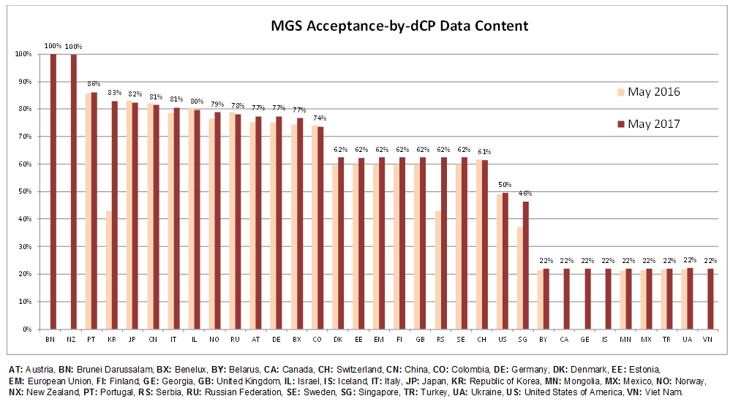

[Annex II follows]

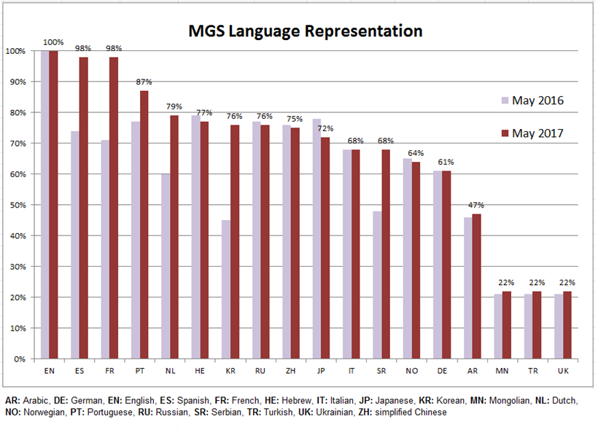

[Annex III follows]

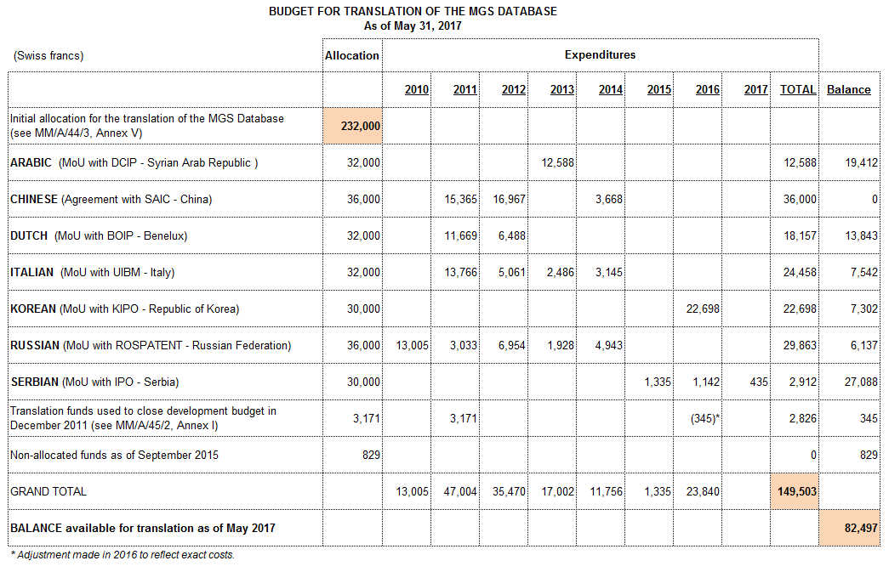

[End of Annex III and of document]

In order to openly display its strict requirement in terms of specificity in the description of goods and services, the Canadian IP Office (CIPO) reviewed the 9,500 English terms from the NCL11-2017 alphabetical list in order to display in MGS, from January 2017, which NCL terms will not be accepted in future international applications designating Canada.

