 |  | E
mm/A/49/2
ORIGINAL: English
DATE: JuLY 7, 2015

Special Union for the International Registration of Marks
(Madrid Union)

Assembly

Forty-Ninth (21st Ordinary) Session
Geneva, October 5 to 14, 2015

progress report on the MADRID SYSTEM GOODS AND SERVICES DATABASE

prepared by the International Bureau

INTRODUCTION

1 The purpose of this document is to present a progress report on the development of the database of acceptable indications of goods and services for the purposes of the Madrid System procedures (hereinafter referred to as the “Madrid System Goods and Services Database” or “MGS Database”).

2 In September 2009, the Assembly of the Madrid Union approved a two-year project aimed at the construction of the MGS Database, as described in document MM/A/42/3, and an amount of 1.2 million Swiss francs funding from the Madrid Union Reserve Funds for its implementation during the 2010-2011 biennium (see document MM/A/42/4, paragraph 28). Six previous Progress Reports have been presented to the Assembly of the Madrid Union (see documents MM/A/42/3, MM/A/43/2, MM/A/44/3, MM/A/45/2, MM/A/46/2 and MM/A/48/2).

3 On January 1, 2012, the MGS Database project transitioned into operational mode which meant that ongoing operational support was thereafter funded from the regular budget.

4 The present document is a report on the progress of the MGS Database since the previous Progress Report (see document MM/A/48/2), that is, between June 1, 2014, and May 30, 2015.

RESULTS ACHIEVED

5 It is recalled that on June 1, 2014, the Madrid Goods and Services Manager (MGS) was available on the public website of the World Intellectual Property Organization (WIPO) with the following features:

- 16 language interfaces, namely Arabic, Chinese, Dutch, English, French, German, Hebrew, Italian, Japanese, Korean, Norwegian, Portuguese, Russian, Serbian, Spanish and Turkish; and

- 19 participating IP national or regional Offices present in the MGS-exclusive function called “Check acceptance by designated Contracting Party (dCP)” with at least partial acceptance information made available to WIPO by the Offices of, namely, Austria, Belarus, Benelux, China, the European Union, Germany, Israel, Italy, Japan, Norway, Portugal, the Republic of Korea, the Republic of Serbia, the Russian Federation, Singapore, Switzerland, Turkey, Ukraine and the United States of America.

6 On January 1, 2015, the MGS Database was brought into line with the 2015 version of the tenth edition of the Nice Classification. Updates were integrated in the 16 languages then available online.

COOPERATION

7 In January 2015, Mexico was added to the list of countries participating in the function “Check acceptance by designated Contracting Party (dCP)” following cooperation established with the Mexican Institute of Industrial Property (IMPI).

8 In February 2015, thanks to the cooperation established with the State Intellectual Property Service of Ukraine (SIPS), the Ukrainian language interface was implemented in MGS as the seventeenth language made available online. For the time being, the Ukrainian interface only gives access to the Ukrainian translation of the Nice Classification alphabetical list, but SIPS indicated its willingness to continue translating the rest of the MGS Database in order to increase its usefulness for Ukrainian applicants.

9 In March 2015, the Intellectual Property Office of the Republic of Serbia (IPO) started to translate and check acceptance of the rest of the MGS Database, following implementation last year of the Serbian language interface in MGS with initially only the Nice Classification Alphabetical List.

10 In April 2015, contacts were made with several European as well as non-European national Offices with a view to increasing the list of available designated Contracting Parties (dCP) in MGS. Integration of related Contracting Parties in the function “Check acceptance by designated Contracting Party (dCP)” is pending and will increase the volume of valuable information made available to trademark applicants in the course of 2015.

11 Since January 2015, the Japan Patent Office (JPO) has provided WIPO with specific codes called "similar group codes" for a major part of the MGS Database. The Korean Intellectual Property Office (KIPO) also started to communicate "similar group codes" used in the Republic of Korea. These Japanese and Korean codes define two different granular taxonomies associated with groups of goods or services that are deemed to be similar to each other in trademark examination. Trademark applicants in Japan and the Republic of Korea are encouraged to refer to these codes before filing a trademark application in order to identify the existence of similar registered trademarks. These codes will be available in MGS in the course of 2015.

CONTENT OF THE MGS DATABASE

12 It is recalled that the enrichment of the MGS Database, with on the one hand translations in the non-Madrid languages and on the other hand acceptance status information, depends on the progress of the translation and/or acceptance checking process carried out by the cooperating national Offices.

13 Annex I presents the content of the MGS Database in terms of data volume per language, as published in May 2015 on the WIPO website.

14 Annex II gives an overview of the relative translation representation in the various MGS languages.

15 Annex III gives an overview of the relative content of the MGS Database in terms of acceptance status by Contracting Parties as displayed in the function “Check acceptance by designated Contracting Party (dCP)”.

WIPO-EXCLUSIVE FUNCTION "CHECK ACCEPTANCE BY DESIGNATED CONTRACTING PARTY"

16 It is recalled that the information on the status of acceptance of terms describing goods or services (hereinafter referred to as "terms") displayed in the WIPO-exclusive function “Check acceptance by designated Contracting Party (dCP)” enables a trademark applicant to know, not only that a term accepted by the International Bureau will be accepted in a designated Contracting Party (dCP) but, most importantly, that some terms are rejected by certain Contracting Parties and would provoke the communication of a provisional refusal from that Contracting Party.

17 It should be noted that, due to the global coverage of the Madrid System, and although the increased use of MGS should facilitate, in time, the harmonization of trademark classification practices among Member States, reasons exist for terms not to be accepted in all possible designated Contracting Parties (dCP) of the Madrid System, such as requirements in terms of wording specificity for describing goods and services in some jurisdictions, or the existence of specific national laws or of bilateral agreements between countries that prevent them from protecting certain goods.

18 The importance of displaying information on rejected terms was illustrated after the harmonization work carried out among European Offices on the acceptability of the "general indications" extracted from the Nice Classification class headings. MGS is the only tool where the rejections of 11 of these "general indications" is displayed to inform applicants that these terms would provoke the issuance of a provisional refusal (due to insufficient specificity) by any European designated Contracting Party (dCP).

19 For a different reason, a term such as "amontillado", which describes a famous Spanish specialty good, could not be integrated into a harmonized database such as the European Harmonized Database because this term cannot be accepted in lists of goods filed in Spain. With MGS, it is possible for applicants to know which countries would accept this term, and which would reject it.

20 Annex IV presents examples of terms that are currently rejected, for diverse reasons, by some of the most designated Contracting Parties (dCP) in classes 7, 33 and 45.

UPDATES OF THE MGS DATABASE

21 It is recalled that the acceptance status available for each of the MGS-participating Contracting Parties is gathered from a variety of sources:

– acceptance information provided directly by national Offices that translate the Database and/or check acceptance or rejection of its English content;

– the harmonized TM5 - ID list of goods and services to which five Offices contribute: the JPO, the KIPO, the Office for Harmonization in the Internal Market (Trade Marks and Designs) (OHIM), the State Administration for Industry and Commerce of the People's Republic of China (SAIC) and the United States Patent and Trademark Office (USPTO);

– the USPTO Manual of Acceptable Identifications of Goods and Services;

– the European Harmonized Database published in the OHIM's classification tool, TMclass; and

– the KIPO’s list of Acceptable Identifications of Goods and Services.

22 MGS features a monthly online update for the benefit of users in order to reflect as accurately as possible:

- changes in translations or acceptance status requested directly by national Offices; and

- changes in acceptance status gathered from databases mentioned in the above paragraph and for which updates can be obtained monthly, such as the harmonized TM5 - ID list and the USPTO Manual of Acceptable Identifications of Goods and Services.

FURTHER ENRICHMENT OF THE MGS DATABASE

ACCEPTANCE CHECKING BY NATIONAL OFFICES

23 Cooperation between the International Bureau and any interested Contracting Party in the Madrid System will continue with a view to increasing the amount of acceptance information available in MGS to provide trademark applicants with useful information for the purpose of international filing, i.e., information that enables them to know in advance whether certain terms in their lists would provoke a provisional refusal from countries they designate.

INTEGRATION OF NEW INDICATIONS OF GOODS AND SERVICES

24 In order to make MGS as relevant as possible to trademark applicants for international as well as national filings, the MGS Database will continue to be enriched with indications of goods and services extracted from various sources, such as:

- frequently used terms extracted on a regular basis from international applications received in the International Bureau as well as from the International Trademark Register;

- the harmonized TM5 ID-list of English indications of goods and services resulting from the cooperation between the JPO, KIPO, OHIM, SAIC and the USPTO;

- national lists of goods and services received from national IP Offices, such as those already made available by the following countries: China, Germany, Japan, Republic of Korea and Switzerland; and

- national trademark registers from countries cooperating with WIPO in the Global Brand Database project, and from which frequently used terms not already present in MGS will be examined for integration. Frequently used terms have so far been extracted from the national registers of Australia, Canada, Israel, the Russian Federation, Singapore, Switzerland and the United States of America.

BUDGET

25 In 2014, the Assembly of the Madrid Union approved the use of project funds remaining at the end of 2014 to assist some national Offices in the translation of the MGS Database into their national languages (see document MM/A/48/2, paragraph 26).

26 Annex V presents a table indicating the breakdown of the initial allocation
(232,000 Swiss francs) made available by WIPO for the translation of the MGS Database and the actual payments made up to May 30, 2015, for the translation work carried out by national Offices originally selected or having requested to receive financial support. In particular, the table shows, under “Roll-over to 2015”, the funds still available for each participating Office to continue with the translation of the MGS Database.

27 As of May 2015, a total amount of 107,763 Swiss francs remained available for financing the translation of the MGS Database into the seven languages for which a Memorandum of Understanding has been signed between WIPO and the corresponding national Office.

28 The Assembly is invited to:

- take note of the “Progress Report on the Madrid System Goods and Services Database” (document MM/A/49/2), including its paragraph 27 related to the remaining project funds; and

- request the International
Bureau to submit to the Assembly in 2016 a new Progress Report on the Madrid System Goods and Services Database, including the use of remaining project funds.

[Annexes follow]

MGS Database

Number of terms acceptable
by the International Bureau

MGS  Database |  |  | May 2014 | May 2015 | Increase
EN | - | English | 51,944 | 67,050 | 29%
ES | - | Spanish | 34,377 | 38,870 | 13%
FR | - | French | 34,512 | 39,073 | 13%
AR | - | Arabic | 24,287 | 24,824 | 2%
DE | - | German | 25,939 | 26,419 | 2%
HE | - | Hebrew | 29,335 | 29,863 | 2%
IT | - | Italian | 29,508 | 31,014 | 5%
JP | - | Japanese | 23,090 | 28,045 | 21%
KR | - | Korean | 11,587 | 13,315 | 15%
NL | - | Dutch | 23,717 | 25,880 | 9%
NO | - | Norwegian | 30,225 | 32,193 | 7%
PT | - | Portuguese | 27,888 | 33,172 | 19%
RU | - | Russian | 26,884 | 32,539 | 21%
SR | - | Serbian | 8,778 | 8,875 | 1%
TR | - | Turkish | 9,498 | 9,695 | 2%
UK | - | Ukrainian | 0 | 8,509 | 100%
ZH | - | Chinese | 19,062 | 33,698 | 77%
TOTAL |  |  | 410,631 | 483,034 | 18%

[Annex II follows]

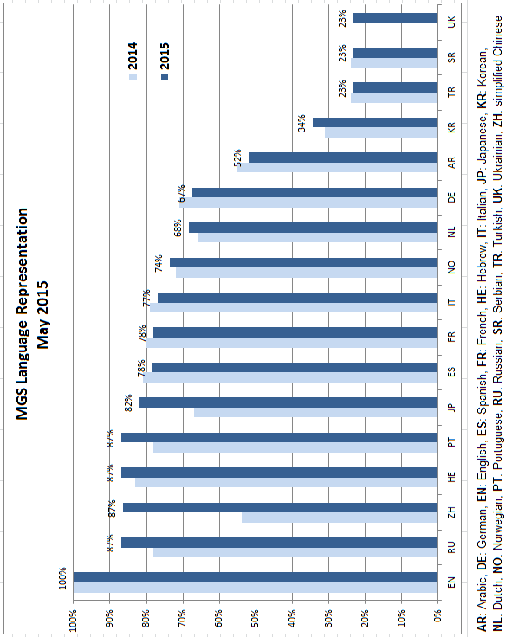

[Annex III follows]

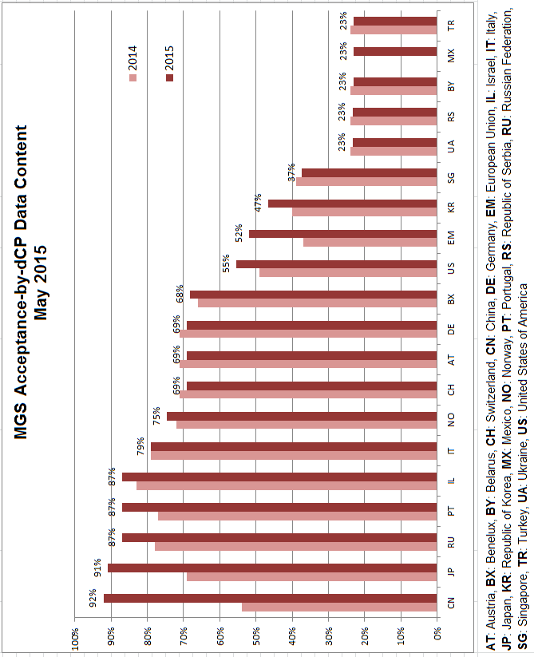

[Annex IV follows]

Examples of terms rejected for diverse reasons
by some of the most designated Contracting Parties (dCP)

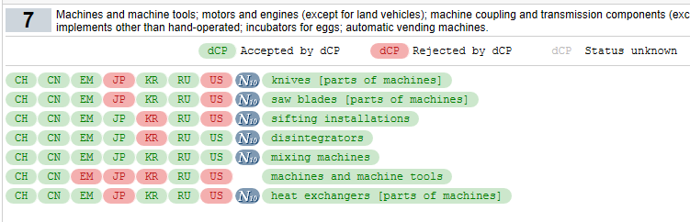

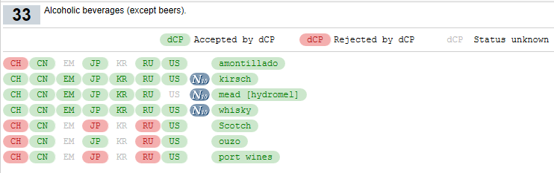

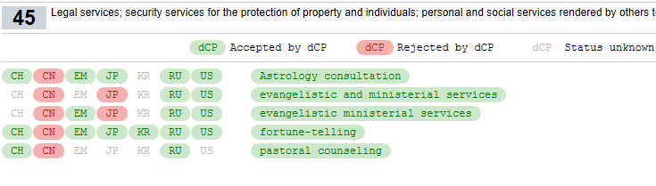
[Annex V follows]

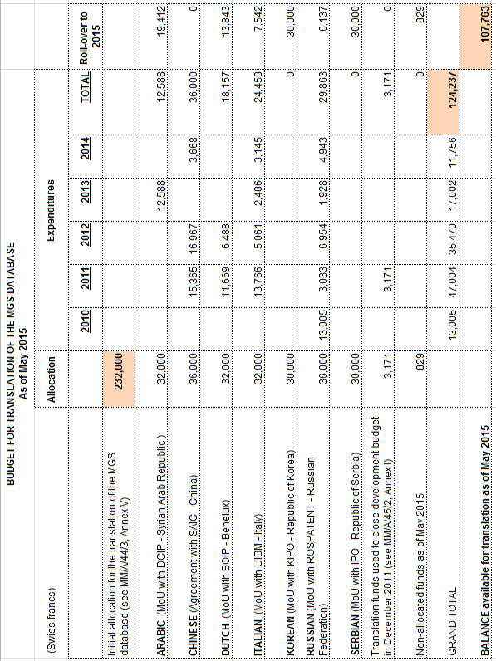

[End of Annex V and of document]

