 |  | E
mm/a/44/3
ORIGINAL: English
DATE: July 26, 2011

Special Union for the International Registration of Marks
(Madrid Union)

Assembly

Forty-Fourth (19th Ordinary) Session
Geneva, September 26 to October 5, 2011

MADRID SYSTEM GOODS AND SERVICES DATABASE: PROGRESS REPORT

prepared by the International Bureau

INTRODUCTION

1 The purpose of this document is to present a progress report on the implementation of the project aimed at accelerating the pace of construction of the database of acceptable indications of goods and services for the purposes of the Madrid system procedures (hereinafter referred to as the “Madrid System Goods and Services Database” or “G&S Database”).

2 It is recalled that this project, as described in document MM/A/42/3, was approved by the Madrid Union Assembly (hereinafter referred to as “the Assembly”) in 2009 and an amount of 1.2 million Swiss francs from the Madrid Union Reserve Fund was allocated for its implementation in the course of the current 2010/11 Biennium (document MM/A/42/4, paragraph 28). It is also recalled that a first progress report on the implementation of the project was presented to the Assembly in 2010 (document MM/A/43/2).

3 The present document reviews the background and original scope of the project, as approved by the Assembly in 2009. It reports on progress made in its implementation since the last report was presented in 2010 and as of June 30, 2011.

4 The present document gives the schedule of work required for project close-out by December 31, 2011. It proposes on the one hand to build a sustainability model to provide users with a G&S Database that can evolve to adapt to future requirements and deliver ever greater benefits over time, and on the other hand to set up adequate monitoring of the utilization and related benefits of the G&S Database.

5 A further purpose of this document is to propose possible future evolutions of the G&S Database through the development of new functionalities that would best meet the needs of all direct beneficiaries of the G&S Database, most notably the inclusion in the database of information relating to the acceptance status of goods or services in the eyes of designated Contracting Parties.

6 In its conclusion, this document addresses the transition of the project infrastructure into an operational environment within the Brands and Design Sector in early 2012 with a view to funding future operation of the G&S Database within WIPO’s regular budget. It also addresses the issue of the gradual enhancement of the linguistic diversity of the database through a request to the Assembly to approve the use, beyond project close-out on December 31, 2011, of the remaining balance from the project budget to complete the various Memoranda of Understanding (MoU) established with Offices of Madrid Union members, thus supporting them in their translation efforts to increase the G&S Database linguistic diversity.

PROJECT BACKGROUND AND ORIGINAL SCOPE

BACKGROUND

The Madrid System Goods and Services Database

7 The project aims at accelerating the construction of the G&S Database, a WIPO administered database of indications of goods and services established for the purposes of the international registration of marks. The indications contained in the database

- have been classified by the International Bureau according to the 9th edition of the International (Nice) Classification; and
- are accepted by the International Bureau under the Madrid system procedures (i.e., they will not be subject to an Irregularity Notice under Rule 12 or Rule 13 of the Common Regulations under the Madrid Agreement and Protocol)*.

8 To the maximum extent possible (i.e., depending on the degree of cooperation that may be established with the Madrid Union members), the G&S Database shall also contain information on the acceptability of those indications by the Offices of Madrid Union members that may be designated in an international application.

9 The G&S Database is being developed in English, French and Spanish. Other language versions may be made available in cooperation with the Offices of interested Madrid Union members. As envisaged in the project document (MM/A/42/3) and approved by the Assembly in 2009, WIPO will be ready to assist interested Offices in the translation of the G&S Database into any of the languages qualifying for participation in Phase I of the pilot project relating to the feasibility of introducing additional languages in the Madrid system, namely Arabic, Chinese, Dutch, German, Italian, Japanese, Portuguese and Russian.

The G&S Database Structure

10 The G&S Database contains indications of goods and services grouped by concepts.
A concept is identified by a unique number.

11 An indication may consist of just one word (e.g., “altimeters”) or several words (e.g., “apparatus for monitoring and recording the performance of machinery”).

12 Indications having the same meaning are grouped under a single concept identification number e.g., “hair bleaching preparations” and “hair decolorants”, are grouped under the same concept number. Both indications are accepted, however, the first one (“hair bleaching preparations”) has been identified as the preferred indication in English. This is important for translation purposes. Whenever an indication is translated into another language in the G&S Manager (the web-based classification tool associated with the G&S Database), the preferred indication in that language will always be automatically selected (e.g., the French indications “produits pour la décoloration des cheveux” and “produits de décoloration capillaire” will always be translated into English as “hair bleaching preparations”).

The G&S Database Sources

13 All indications in the alphabetical list of goods and services of the Nice Classification have been included in the G&S Database. In addition, the database also contains other terms introduced from other sources, including in particular the following sources: lists of frequently used indications extracted from international applications filed under the Madrid system, lists of indications of goods and services made available to the International Bureau by the Offices of some Madrid Union members, as well as other indications added by WIPO as a result of its review of the above-mentioned lists.

The Madrid Goods and Services Manager (G&S Manager)

14 The G&S Manager (formerly known as the Madrid Filing Assistant or MFA) is an electronic search, classification and translation tool developed by the International Bureau and allowing user-friendly access to the G&S Database. It is designed to assist applicants in composing the list of goods and services to be included in an international application. It provides several main functions, including the possibility to:

- select indications of goods and services from a pick-list of validated indications from the G&S Database with the guarantee that no irregularity notice will be issued by the International Bureau in respect of those indications if included in an international application (“Browse” function);

- check the acceptance status by the International Bureau for each indication of an already prepared list of classified goods and services if the applicant is not using the pick list) (“Check acceptance by WIPO” function);

- get classification proposals for unclassified indications through a search facility that will return all acceptable terms from the database, which best match an input description (“Search” function); and

- get an automatic translation of a list of goods and services into the other Madrid working languages for the accepted indications within a list (“Translate” function).

15 An additional function (“Check acceptance by DCP”), enabling applicants to check the acceptance of indications by the Offices of Madrid Union members they intend to designate, has been developed in 2010 in a prototype version of the G&S Manager.

Original scope

Project Objectives

16 The project, as approved by the Assembly in 2009, had the following two objectives:

– to accelerate the pace of construction and (internal and external) deployment of the G&S Database, in cooperation with interested Contracting Parties; and

– to set the ground for and initiate the implementation of Phase I of the pilot project proposed in document MM/A/42/1 relating to the feasibility of introducing additional filing languages in the Madrid system.

Project Deliverables and Tentative Timetable

17 The main deliverables expected from project implementation, as approved by the
2009 Assembly (along with the tentative timetable indicated in the project document), were the following ones:

- 16,300 new indications of goods and services, as validated by the International Bureau in the three working languages (English, French and Spanish) of the Madrid system, added to the G&S Database by October 2010 (thus bringing the contents of the database up to 30,000 such indications);

- full deployment of the G&S Database within the International Bureau for regular use by examiners and translators by the time the number of indications in the database reaches 30,000;

- an e-classification tool made available on the WIPO website for use by interested applicants by the time the number of indications in the G&S Database reaches 30,000;

- a prototype web application for the electronic filing of international trademark applications, that incorporates the functionalities of the e-classification tool and provides access to the G&S Database, made available to the Offices of interested Madrid Union members, along with the necessary advice concerning its exploitation or adaptation;

- 10,000 new indications of goods and services, as validated by the International Bureau in the three working languages of the Madrid system, added to the
G&S Database by spring 2011 (thus bringing the contents of the database up to at least 40,000 indications); and

- translation of the G&S Database (40,000 acceptable indications) into Arabic, Chinese, Dutch, German, Italian, Japanese, Portuguese and Russian, which may be made available to the Offices of interested Madrid Union members, upon request.

Project Inputs and Budget
18 Document MM/A/42/3 identified in detail the inputs required for project implementation. On that basis, the Assembly approved a budget of 1.2 million Swiss francs from the Madrid Union Reserve Fund for the implementation of the project. It further took note that the International Bureau would assign to the project additional resources financed from WIPO’s regular budget, in particular experienced staff in the areas of project management, trademark classification, translation and administrative support.

PROGRESS IN PROJECT IMPLEMENTATION SINCE THE REPORT TO THE 2010 MADRID UNION ASSEMBLY

Deployment of the G&S Database within the International Bureau

19 In July 2010, the G&S Database was deployed within the International Bureau for regular use by examiners and translators through a first version of the G&S Manager that then gave access to some 17,000 concepts including:

- around 25,000 English indications,
- around 21,000 French indications,
- around 21,000 Spanish indications.

Launch of the G&S Manager on the Internet

20 After the volume of 30,000 indications in English was reached, on target, at the end of October 2010, the G&S Manager that gives access to the contents of the G&S Database went live on the Internet on December 20, 2010, with around 20,000 concepts including:

- around 30,000 English indications,
- around 24,000 French indications,
- around 24,000 Spanish indications.

21 In addition to the three Madrid filing languages, the G&S Manager was launched with a Russian user interface giving access to some 16,000 Russian indications. Translations into Russian of more than three quarters of the English concepts had been prepared by the Federal Institute of Industrial Property (FIPS) of the Federal Service for Intellectual Property, Patents and Trademarks of the Russian Federation (ROSPATENT).

G&S Database Contents, as of June 30, 2011

22 On June 30, 2011, the G&S Database contained around 26,500 concepts including:

- around 36,000 English indications,
- around 28,500 French indications,
- around 28,500 Spanish indications.

23 Annex I gives the breakdown of indications and concepts contained in the database, as of June 30, 2011, by language (English, French and Spanish) and by class of the International Classification.

24 Based on the current pace of advancement, it is expected that the International Bureau will have no difficulty in reaching the target of 40,000 indications, in English, included in the G&S Database, by the end of August 2011. By the end of 2011, all concepts containing these 40,000 English indications will have been translated into French and Spanish.

G&S Manager Usage Statistics

25 From mid-January to mid-June 2011, the G&S Manager providing access to the
G&S Database recorded the following results:

- a total of some 22,000 visits;

- approximately 1,000 visits per week, over five working days, with the number of visits being very low at weekends (Annex II shows the pattern of visits during a period covering April and May 2011);

- around 6,000 individual visitors in total;

- visitors were located in 136 different countries (over 50% more than the number of countries in the Madrid Union); and

- the top 10 countries with the highest number of visits were: France, the Russian Federation, Germany, Japan, Italy, Switzerland, Spain, Singapore, Ukraine and Australia.

26 It is very interesting to note that patterns of access to the G&S Manager show a distribution of visits that is widely spread over the whole territory of countries. This indicates that the G&S Manager is of interest not only to Offices of Madrid Union members but also to applicants, in spite of the fact that it is not yet accessible in various national languages and that the volume of available data is still relatively modest.

27 Annex III shows the pattern of distribution of visits to the G&S Manager from the top six countries of the above mentioned list. Over the 24 weeks since January 12, 2011, the visits were as follows:

- in France, there were 3,714 visits from 221 cities,
- in the Russian Federation, there were 2,714 visits from 61 cities,
- in Germany, there were 1,179 visits from 204 cities,
- in Japan, there were 992 visits from 69 cities,
- in Italy, there were 981 visits from 94 cities,
- in Switzerland, there were 893 visits from 94 cities.

Language Statistics

28 As from the first half of 2010, the International Bureau began cooperating with the Offices of interested Madrid Union members for the development of the G&S Database and its user interface, the G&S Manager, in the following language versions (in alphabetical order):

- Arabic (Office of the Syrian Arab Republic),
- Chinese (Office of China),
- Dutch (Office of Benelux),
- German (Offices of Austria, Germany and Switzerland),
- Hebrew (Office of Israel),
- Italian (Office of Italy),
- Japanese (Office of Japan),
- Korean (Office of the Republic of Korea),
- Norwegian (Office of Norway),
- Portuguese (Office of Portugal),
- Russian (Office of the Russian Federation).

29 For all the above-mentioned languages, with the only exception of Dutch, a translation of the Nice Classification alphabetical list has already been prepared and integrated into the G&S Database.

30 As envisaged in the project document (MM/A/42/3), WIPO was committed to assist in the translation of the database into any of the languages that qualified for participation in the pilot project approved by the Assembly in 2009, namely Arabic, Chinese, Dutch, German, Italian, Japanese, Portuguese and Russian, upon request from the office or offices concerned. In this context, the following steps were taken:

- In June 2010, the State Administration for Industry and Commerce of the People’s Republic of China (SAIC) and WIPO signed an exchange of letters establishing the terms of reference for the development of a Chinese version of the G&S Database.

- In September 2010, the Federal Institute of Industrial Property (FIPS) under the Federal Service for Intellectual Property, Patents and Trademarks of the Russian Federation (ROSPATENT) and WIPO signed an MoU to formalize cooperation for the development of a Russian version of the G&S Database.

- In September 2010, the National Institute of Industrial Property (INPI) of Portugal and WIPO signed an MoU to formalize cooperation for the development of a Portuguese version of the G&S Database.

- In February 2011, the Benelux Office for Intellectual Property (BOIP) and WIPO signed an MoU to formalize cooperation for the development of a Dutch version of the G&S Database.

- In June 2011, the text of an MoU on the development of an Italian version of the G&S Database was agreed upon with the Italian Patent and Trademark Office (UIBM) and was about to be signed by the two parties.

- In June 2011, discussions were on-going with the Offices of the Syrian Arab Republic and Japan with a view to finalizing MoUs to formalize cooperation for the development of an Arabic version and a Japanese version of the G&S Database, respectively. Similarly, discussions were ongoing with the Offices of Austria, Germany and Switzerland concerning cooperation in the development of the German version of the G&S Database.
31 The translation of the “non-Nice” indications of the G&S Database (that is, indications other than those contained in the Nice Classification alphabetical list) is already well advanced as far as the following three languages are concerned:

- Russian: By mid-October 2010, ROSPATENT had sent to WIPO the Russian translations of some 9,000 “non-Nice” concepts and had thereby translated more than three quarters of the G&S Database due to be launched on the Internet before the end of 2010. For this reason, the Russian interface of the G&S Manager was launched on the Internet at the same time as the three official Madrid working languages, namely English, French and Spanish.

- Chinese: In March 2011, SAIC provided WIPO with a draft version of the Chinese translations (in both simplified and traditional Chinese) of some 12,000 “non-Nice” concepts. The finalized version of these Chinese translations was due to be made available to WIPO before the end of the first half of 2011. SAIC also provided WIPO with a list of some 2,000 Chinese characteristic indications, in both simplified and traditional Chinese, together with the associated English translations.

- Hebrew: In March 2011, the Israeli Patent Office provided WIPO with the last finalized Hebrew translations of all (Nice and non-Nice) concepts included in the initial volume of the G&S Database. The available Hebrew translations could then be integrated into the database and displayed in a prototype version of the G&S Manager specially developed for languages written from right to left (namely, Arabic and Hebrew) (only available in-house at WIPO, as of June 30, 2011).

32 Annex IV gives a summary of the cooperation status and volume of data available in the 11 languages mentioned in paragraph 28.

Development of Web Services Associated With the G&S Manager

33 In cooperation with the team in charge of the IRPI (International Registration Process Integration) Pilot Project which is part of MAPS Modernization Phase I (document MM/A/44/4), specifications for the development of web services were refined and a prototype of web service integrating functionalities of the G&S Manager was developed within the G&S Database project team.

34 This prototype web service offers the following functionalities:

- extraction of Nice classification headings,

- search of terms in the G&S Database,

- translation of terms into any of the three Madrid working languages from any language handled in the G&S Database.

Budget Implementation

35 Annex V provides details concerning budget allocations, expenditures and commitments projected up to December 31, 2011.

Staff and Missions

36 Staff costs shown as expenditure or commitment in the table for the calculation of the remaining balance relate to staff for whom a contract has been approved as of June 30, 2011. The second IT consultant will need to have his contract extended until December 31, 2011.
All mission costs committed to in June 2011 are included in the project budget. From an initial allocation of 968,000 Swiss francs for the “staff and missions” item, the project budget shows a remaining uncommitted balance of 46,500 Swiss francs. This amount will be used to extend the contract of the second IT consultant up to the end of 2011.

Assistance for the Translation of the G&S Database into Eight Selected Languages
(as approved by the Assembly in 2009, document MM/A/42/3)

37 The initial budget allocation for assisting National Offices in translating the G&S Database was 232,000 Swiss Francs. As of June 2011, only a small part of this allocation has been spent (13,000 Swiss francs) and the remaining uncommited balance is 219,000 Swiss francs. Considering that China, Italy, the Russian Federation, and the Syrian Arab Republic are currently translating all the “non-Nice” indications of the initial volume of the G&S Database, a maximum of 60,000 Swiss francs may be spent before the end of 2011 for the payment of the translation work undertaken by these Offices. This would leave, at project close-out, a remaining minimum uncommitted balance of approximately 159,000 Swiss francs for assistance in translating the G&S Database.

38 To enable other offices to complete translating the G&S Database according to their resource constraints and possibly beyond project close-out, it is proposed that the Madrid Union approve the utilization of the minimum uncommitted balance of approximately 159,000 Swiss francs for this purpose.

SIDE BENEFITS OF PROJECT IMPLEMENTATION

Relationship between the G&S Manager and the Nice Classification

39 The revision of indications from the Nice Classification alphabetical list during the process of populating the G&S Manager Database was far from exhaustive in the first year of the project, but it did generate a long list of proposed error corrections and improvements to English/French term pairs. The list was submitted to the Committee of Experts of the Nice Union in 2010 and led to numerous enhancements which will be included in the 10th edition.

40 A thorough and exhaustive review of the Nice alphabetical list was initiated at the end of 2010 within the G&S Manager project team with a view to correcting inconsistencies between English and French indications (for example, 010351 “petroleum dispersants” / “agents pour détruire le pétrole”), replacing archaic terms (e.g. 010131 “wood alcohol” to be replaced by “methanol”), adding American spelling where appropriate (e.g. 010503: “sulfuric acid” to be added to “sulphuric acid”), and so on. Reports produced in the course of this review will be progressively proposed for the consideration of the Nice Committee of Experts.

41 The creation of the G&S Manager has made it possible to produce a Nice list in “database format” with no inversions of the kind required on a hard copy (such as “Agriculture (Manure for -)”) and no duplications, i.e. no identical indications with two different basic numbers (such as 110062 “Roasters (Coffee-)” and 110066 “Coffee roasters”). The trilingual (English, French, Spanish) list in database format is used as the basis for compiling quadrilingual lists that could be used for the officialization of Nice in various languages (Arabic, Chinese, Hebrew, Japanese, Korean, Norwegian, Russian and others).

42 A compilation of Nice indications that are rejected by a number of offices could be used to identify a set of terms likely to trigger numerous refusals. The Nice Committee of Experts could then examine these terms and optionally delete them from the alphabetical list.

43 A compilation of duplicate entries arising from translation into a range of languages could be used to identify Nice indications that have different basic numbers but cover the same goods or services and do not warrant differentiation (for example, 390031 is “electricity distribution” and 390090 is “distribution of energy”).

44 In future, with the extraction of the most frequently used terms in the G&S Database, new descriptions of goods and services could be proposed for integration into the Nice alphabetical list in order to further develop the Nice Classification in line with applicant behavior.

Areas of Cooperation with the Offices of Contracting Parties

45 Possible areas of cooperation with the Offices of the Madrid Union members were first identified in the 2009 project document (MM/A/42/3, paragraphs 18 to 20) and later included in the report to the 2010 Madrid Assembly (MM/A/43/2 paragraphs 49 to 52). Implementation of the project has confirmed the importance of a continued cooperation between the Offices of Contracting Parties and WIPO after project close-out.

Cooperation in Checking the Acceptance of the Contents of the G&S Database by Designated Contracting Parties

46 For trademark applicants using the Madrid system, it is useful to know whether a given indication will be accepted by the International Bureau. But it is even more important for them to know whether that indication will also be accepted by each of the Contracting Parties designated in the international application, so as to diminish the risk of notifications of refusals. Consequently, in order to ensure that the G&S Database offers maximum benefits for users, it is important to make sure that the G&S Database can also provide as much information as possible on the acceptance of the indications it contains by designated Contracting Parties.

47 Although increased use of the G&S Database will undoubtedly bring about a strong degree of harmonization, it is unlikely to achieve full harmonization of national policies at a global level in the near future. This idea has been formalized in the MoU signed by the Office for Harmonization in the Internal Market (OHIM) (Trade Marks and Designs) and WIPO in December 2009, whereby a long-term goal shared by the two Organizations was that “OHIM supports WIPO piloting a global database initiative among its members to establish a database of classified indications of goods and services that can be accepted by as many offices as possible”.

48 A prototype version of the G&S Manager in which the acceptance status by designated Contracting Parties can be determined for each indication in a list of goods and services selected from the G&S Database has been developed in the course of project implementation.

49 In order to store in the G&S Database relevant data on the status of acceptance by Contracting Parties, WIPO has made it possible for National Offices that agreed to translate the database into their national languages to include their acceptance information alongside their translations. Some Offices (Japan, Republic of Korea) have already provided WIPO with acceptance status information, notably regarding the Nice Classification alphabetical list. In May 2011, the Spanish Office decided to start checking its acceptance of the indications contained in the G&S Database.

Cooperation in the Identification of Indications to be included in the Database

50 In addition to the full list of indications from the Alphabetical List of Goods and Services of the Nice Classification, the G&S Database contains indications drawn from other sources, including lists of indications of goods and services made available to the International Bureau by the Offices of certain Madrid Union members, such as the Acceptable Identification of Goods and Services Manual provided by the United States Patent and Trademark Office (USPTO).

51 During project implementation, other Offices of Madrid Union members have shared or promised to share with the International Bureau their national lists of goods and services for inclusion in the G&S Database, on the basis that these lists are made available together with their translations into one of the three Madrid working languages. In particular:

- the Office of China has provided a list of some 2,000 characteristic Chinese indications;

- the Offices of Germany and Switzerland have provided a list of some 1,200 German indications;

- the Office of Japan could provide a list of some 6,000 characteristic Japanese indications; and

- the Office of the Republic of Korea aims at completing the translation into English of some 7,000 characteristic Korean indications before the end of 2011.

52 Any national list of goods and services made available to the International Bureau will be subject to meticulous scrutiny before being accepted, one term at a time, for inclusion in the G&S Database, either as a new concept or as part of an existing concept. The inclusion of these national lists will make the G&S Manager even more attractive to trademark applicants in the associated Madrid Union members, thus producing ever greater benefits for Offices of Madrid Union members and the International Bureau.

Cooperation in Providing Additional Language Versions of the G&S Database

53 During project implementation, Offices of Madrid Union members whose national languages were not among the eight languages that qualified for participation in Phase I of the pilot project relating to the feasibility of introducing additional languages into the Madrid system, as approved by the Assembly in 2009, have expressed an interest in having the G&S Database and G&S Manager available in their respective national languages.

54 As of June 2011, the additional languages in question are: Hebrew, Hungarian, Korean, Norwegian, Turkish, and Ukrainian.

SCHEDULE OF WORK FOR PROJECT CLOSE-OUT

Achieving the Planned Volume of Data

55 Referring to paragraph 17 of the present document, the following first three deliverables expected from project implementation were entirely met as of June 30, 2011:

- the contents of the G&S Database had reached the target of 30,000 English indications by October 2010;

- the G&S Database was fully deployed within the International Bureau in July 2010; and

- the G&S Manager was made publicly available on the Internet in December 2010 by which time the G&S Database contained over 30,000 English indications.

56 The fifth deliverable (paragraph 17) consisted in reaching a volume of 40,000 English indications in the G&S Database, tentatively by spring 2011.

57 There will be some delay for this fifth deliverable relative to the initial indicative timetable. The reason for this delay is that the validation of English terms (from a classification viewpoint and linguistically) and the concomitant grouping of synonymous terms in the database are time-consuming processes. Simply lining up lists of terms that are acceptable from a classification viewpoint is not enough. Phraseology has to be made as consistent as possible within each class, duplicates and meaningless terms have to be excluded, and any synonyms of existing terms must be entered as part of existing concepts. Also, in early 2011, the classification experts working in the project team were called upon to perform other parallel tasks, such as preparing files for the integration of the 10th edition of the Nice Classification into the G&S Manager on January 1, 2012.

58 On June 30, 2011, the database contained about 36,000 English indications, and by the end of August 2011, the database will contain at least 40,000 English indications, assuming that the pace of review observed since March 2011 is maintained. By the end of December 2011, the database should contain significantly more than 40,000 English indications.

Creating New Language Versions of the G&S Database

59 A language-specific user interface of the G&S Manager has been developed for the eight languages mentioned in the project document (MM/A/42/3) as qualifying for participation in Phase I of the pilot project relating to the feasibility of introducing additional languages into the Madrid system, as approved by the Assembly in 2009, namely Arabic, Chinese, Dutch, German, Italian, Japanese, Portuguese and Russian. An additional “mirror-interface” of the G&S Manager for languages written right-to-left has also been developed for both the Arabic language and the Hebrew language.

60 Depending on the pace of translation of the G&S Database by cooperating National Offices, the International Bureau will endeavor to make available on the Internet, through the G&S Manager, all the language versions for which the volume of data has reached a sufficiently high level.

61 It is reasonable to expect that, in addition to English, French, Spanish and Russian, other language versions of the G&S Database will be made available online before project close-out at the end of 2011. As of June 30, 2011:

  - A Chinese version of the G&S Database in both simplified and traditional Chinese was on the verge of being finalized so that a full translation of the initial G&S Database could be made available online in the public interface of the G&S Manager in the second half of 2011.

  - An Arabic version of the G&S Database was being prepared by the Syrian Office with a team of translators set up for that purpose. A finalized version of Arabic translations of the whole G&S Database was expected to be delivered by the end of September 2011.

  - The Hebrew version of the G&S Database was ready for online implementation with a full translation of the initial G&S Database volume. However, given the difficulty of testing the Hebrew version of the G&S Manager within WIPO, it was decided to make this Hebrew version available only to the Israeli Office for testing purposes during an interim period.

  - An Italian version of the G&S Database was being prepared by the Office of Italy, which had outsourced this task to a translation agency, and would be ready for online implementation during the second half of 2011.

  - German, Dutch and Portuguese versions of the G&S Database were dependent on the progress of the validation of translations in the fill-up process of the Euroclass project by OHIM. A comparison between the G&S Database and the OHIM harmonized database showed that translations in these three languages from the Euroclass fill–up process could be re-used for half of the initial G&S Database volume (excluding the Nice alphabetical list that had already been made available to the International Bureau). A modus operandi for the translation work covering the other half of the initial G&S Database volume, not initially present in the OHIM database, had to be negotiated with the concerned Offices and OHIM.

Adapting the G&S Database to the 10th edition of the Nice Classification

62 With a view to integrating the forthcoming 10th edition of the Nice Classification into the G&S Manager and adapting the G&S Database to the amendments due to enter into force on January 1, 2012, the following work must be carried out in the course of the second half of 2011:

- full re-examination of the 19 classes affected by moves of indications from one class to another, involving a full review of over 11,000 indications from the G&S Database;

- re-examination of indications from the G&S Database that could be analogous to 234 Nice indications deleted in the tenth edition;

- translation or re-translation into Spanish of about 500 Nice entries containing added or modified indications; and

- adaptation of the G&S Database structure to store both the ninth and tenth versions of indications affected by amendments coming into force on January 1, 2012, therefore enabling the further adaptation of the G&S Manager to display, in advance (before January 1, 2012), warnings to users concerning class changes that will enter into force in the 10th edition.

Developing Further the IT Interface of the G&S Database and G&S Manager

63 The back-office application designed for the internal management of the G&S Database will require finalization before project close-out.

64 Apart from minor improvements to the G&S Manager interface, the main added feature to be integrated is the possibility for applicants to export their lists of goods and services directly to an MM form for the international registration of a mark.

65 Finalization of the web service that integrates functionalities of the G&S Manager and gives access to the G&S Database will also be required to enable further development of the electronic filing application developed within the IRPI (International Registration Process Integration) Pilot Project, which is part of MAPS Modernization Phase I.

NEXT STEPS

Project Close-Out Activities

66 From the preceding text of this document, it is clear that there are four remaining areas of main activity in order to ensure the project close-out by the end of 2011. The four domains of activity are:

- the completion of the 40,000 indications in English, French and Spanish;

- the introduction of as many new language translations as possible and as complete as possible, according to the existing cooperation plans already established with offices, so as to appropriately undertake the pilot project relating to the introduction of additional languages in the Madrid system;

- preparations for the introduction of Nice version 10 on January 1, 2012; and

- IT developments, namely establishment and support of web service accessibility and an export capability to the international application form.

67 All such activities have been planned and resourced, and with the exception of the introduction of some new translations, all the activity should be completed by the end of 2011. It is to be noted that some new translations in the eight languages selected for the pilot project on the introduction of additional filing languages in the Madrid system may not be delivered before project close-out due to constraints beyond the control of the International Bureau, and therefore some payments to offices may necessarily be made during 2012 from the approved project budget.

Entering operational mode

68 After project close-out, project staff on short-term contracts will be released and WIPO staff from the Madrid Registry will return to their previous roles, leaving a reduced human resource allocation for the purposes of the day-to-day administration of the G&S Database.

69 In addition to a management capability, the following human resources, financed from the regular budget, will be required to administer the G&S Database for sustainability purposes after project close-out: a classification expert, an IT consultant and a translator-reviser. Should it be required, additional classification and translation expertise may be required temporarily from the Madrid Registry, as work volumes dictate.

70 The principal aim of entering the operational mode is to sustain and consolidate project deliverables and appropriately assess the utilization and suitability of the G&S Database and the G&S Manager.

71 In particular, concerning the possible future evolution mentioned in paragraphs 5, 8 and 46 to 49 and relating to the checking of acceptance by designated Contracting Parties, the International Bureau will assess the need for continued cooperation with offices that might wish to make their status of acceptance of indications from the G&S Database known to international applicants, so as to reduce the volume of refusals following designation of these offices in international applications.

72 At the same time, future monitoring of the utilization of the G&S Database once in operational mode will enable sufficient time to pass for the International Bureau to establish a reliable assessment of the pilot project relating to the feasibility of introducing additional languages in the Madrid system.

73 Staff administering the G&S Database after project close-out will be required to:

- periodically introduce new indications from a variety of sources, as well as translations of new indications in close coordination with concerned Offices;

- assess the evolution of the usage of the system through the establishment of system utilization benchmark data and subsequent monitoring of system usage against those benchmarks;

- in conjunction with Offices concerned with the pilot project relating to the feasibility of introducing additional languages in the Madrid system, monitor the system utilization in the non-Madrid system working languages; and

- based upon the above three activities, develop options and costings of possible functional evolutions of the system.

74 The Assembly is invited to:
(i) take note of the progress made in the implementation of the project of the Madrid System Goods and Services Database, as described in this document, as of June 30, 2011;
(ii) approve the use of the remaining project funds beyond project close-out, in order to finalize the implementation of cooperation agreements established with interested members of the Madrid Union for the purposes of making the G&S Database available in the languages included in the pilot project relating to the feasibility of introducing additional languages in the Madrid system; and
(iii) request the International Bureau to report to the Assembly in 2012 on the operational status of the implementation of the G&S Database.

[Annexes follow]
CONTENTS OF THE MADRID G&S DATABASE
as of June 30, 2011
 | TOTAL English |  | TOTAL French |  | TOTAL Spanish
Class | Concepts | Terms | Concepts | Terms | Concepts | Terms
1 | 1390 | 1633 | 1353 | 1407 | 1351 | 1464
2 | 270 | 356 | 261 | 278 | 261 | 297
3 | 969 | 1444 | 937 | 1134 | 933 | 1085
4 | 228 | 268 | 220 | 237 | 220 | 249
5 | 1258 | 1686 | 1229 | 1386 | 1226 | 1406
6 | 918 | 1232 | 883 | 954 | 879 | 1002
7 | 1523 | 1797 | 1321 | 1398 | 1322 | 1433
8 | 244 | 283 | 244 | 271 | 244 | 311
9 | 2997 | 3956 | 2552 | 2783 | 2618 | 2977
10 | 249 | 288 | 249 | 269 | 249 | 299
11 | 350 | 417 | 350 | 390 | 350 | 424
12 | 266 | 341 | 266 | 309 | 266 | 365
13 | 296 | 351 | 277 | 304 | 277 | 305
14 | 275 | 423 | 264 | 297 | 259 | 295
15 | 161 | 187 | 158 | 171 | 158 | 175
16 | 1360 | 1774 | 1296 | 1448 | 1289 | 1438
17 | 125 | 167 | 125 | 140 | 125 | 167
18 | 340 | 456 | 320 | 386 | 320 | 376
19 | 712 | 963 | 692 | 795 | 689 | 785
20 | 794 | 974 | 742 | 807 | 728 | 825
21 | 387 | 455 | 383 | 431 | 384 | 460
22 | 276 | 359 | 252 | 281 | 251 | 284
23 | 62 | 143 | 61 | 143 | 61 | 137
24 | 277 | 349 | 259 | 286 | 263 | 296
25 | 811 | 1119 | 780 | 930 | 781 | 932
26 | 261 | 306 | 243 | 275 | 223 | 265
27 | 83 | 108 | 81 | 92 | 81 | 101
28 | 228 | 249 | 226 | 239 | 226 | 269
29 | 757 | 1071 | 515 | 546 | 506 | 568
30 | 774 | 996 | 539 | 556 | 530 | 607
31 | 423 | 635 | 333 | 352 | 328 | 369
32 | 171 | 279 | 126 | 135 | 124 | 146
33 | 123 | 179 | 112 | 135 | 114 | 139
34 | 109 | 140 | 76 | 82 | 75 | 109
35 | 502 | 704 | 434 | 527 | 490 | 597
36 | 682 | 1009 | 680 | 1002 | 671 | 831
37 | 1579 | 2374 | 1535 | 2152 | 1474 | 1820
38 | 316 | 492 | 300 | 381 | 301 | 358
39 | 853 | 1435 | 754 | 1160 | 750 | 878
40 | 358 | 500 | 353 | 427 | 355 | 440
41 | 673 | 1025 | 650 | 844 | 641 | 763
42 | 841 | 1275 | 801 | 918 | 797 | 1165
43 | 276 | 432 | 231 | 288 | 227 | 333
44 | 508 | 754 | 458 | 555 | 449 | 539
45 | 402 | 555 | 311 | 404 | 310 | 347
TOTAL | 26,457 | 35,939 | 24,232 | 28,305 | 24,176 | 28,431

[Annex II follows]

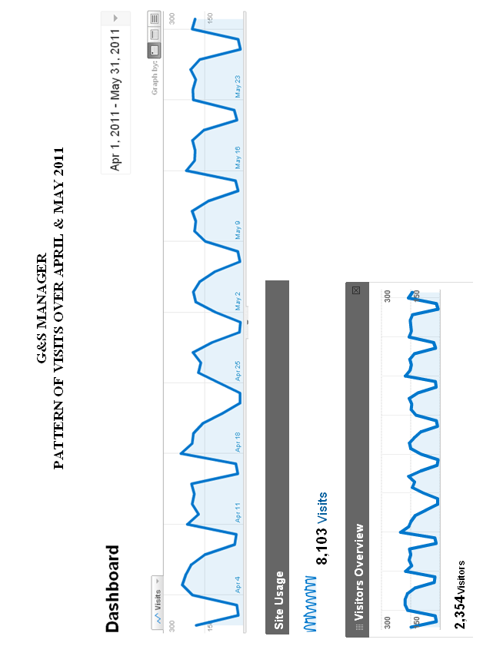

[Annex III follows]

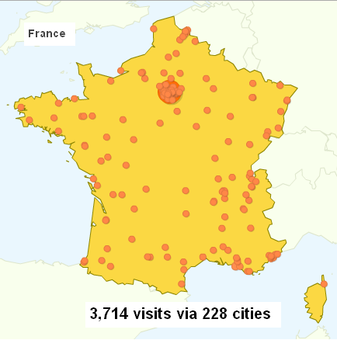

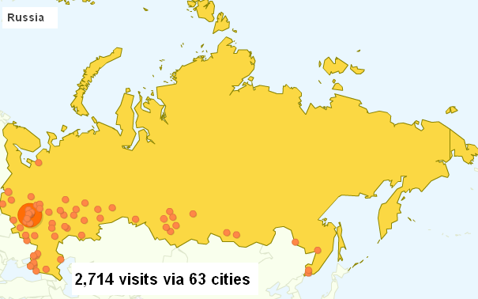

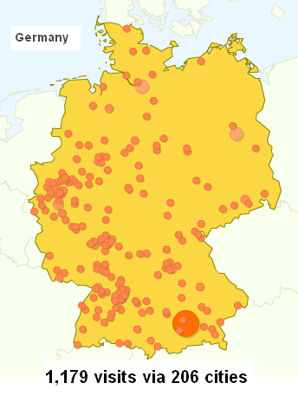
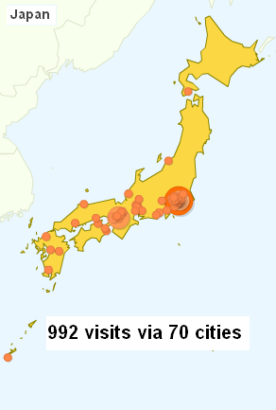
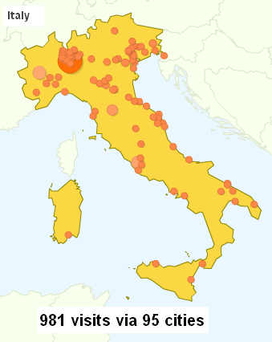
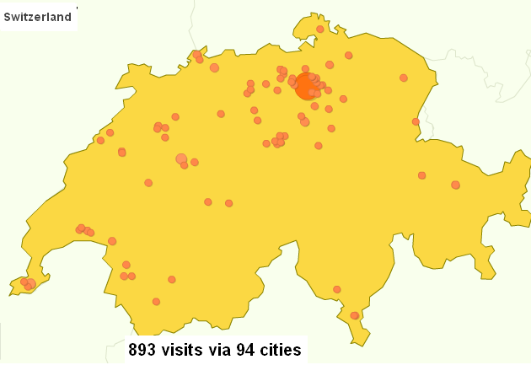

[Annex IV follows]

G&S DATABASE
SUMMARY OF COOPERATION STATUS
as of June 30, 2011
 | NICE Alphabetical List in database format |  | Available TOTAL (NICE + non-NICE) |  |  |  | MoU
 | DRAFT | FINAL | DRAFT  (Terms) | DRAFT  (Concepts) | FINAL  (Terms) | FINAL  (Concepts) | Pending | Signed
English |  | YES |  |  | 30,491 | 19,981
French |  | YES |  |  | 24,149 | 18,996
Spanish |  | YES |  |  | 23,857 | 18,996
Russian * |  | YES |  |  | 16,730 | 16,670 |  | YES
Arabic * | YES |  |  |  |  |  | YES
Chinese Simplified * |  | YES | 20,560 | 18,996 |  |  |  | YES
Chinese Traditional |  | YES | 20,560 | 18,996
Dutch * |  |  |  |  |  |  |  | YES
German * |  | YES
Hebrew |  | YES |  |  | 19,189 | 18,996
Italian * |  | YES |  |  |  |  | YES
Japanese * | YES |  |  |  |  |  | YES
Korean |  | YES
Norwegian |  | YES
Portuguese * |  | YES |  |  |  |  |  | YES
Turkish
Ukrainian
- Eight languages selected in September 2009 for Phase I of the pilot project on introduction of additional filing languages in the Madrid system
[Annex V follows]

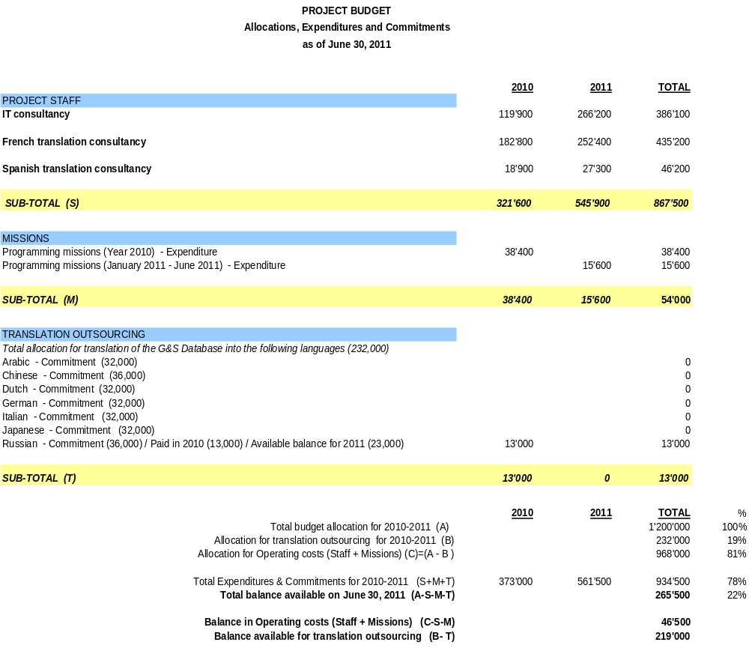

[End of Annex V and of document]

* Under Rule 12 (Irregularities With Respect to the Classification of Goods and Services), the International Bureau shall notify an irregularity whenever it considers that the names of the goods and services for which the international registration is sought are not grouped in the appropriate classes of the International Classification. Under Rule 13 (Irregularities With Respect to the Indication of Goods and Services), the International Bureau shall notify an irregularity whenever it considers that any of the goods or services in an international application is indicated by a term that is too vague for the purposes of classification or is incomprehensible or is linguistically incorrect.

