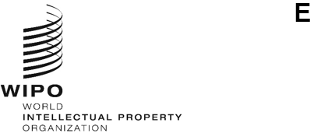
a/68/7
ORIGINAL: English
DATE: June 15, 2026
Assemblies of the Member States of WIPO
Sixty-Eighth Series of Meetings
Geneva, July 7 to 15, 2026
Report on the Assistance and Support for Ukraine’s Innovation and Creativity Sector and Intellectual Property System
prepared by the Secretariat

1. EXECUTIVE SUMMARY 4
1.1. Introduction 4
1.2. SUMMARY 4
2. ASSESSMENT OF IMPACTS OF THE WAR ON UKRAINE’S INNOVATION AND CREATIVITY SECTOR AND ECOSYSTEM 5
2.1. SUMMARY 5
2.2. METHODOLOGY 7
2.3 INNOVATION AND CREATIVE SECTOR AND ECOSYSTEM 8
2.3.1 Policy development 8
2.3.2 Stakeholders responsible for the protection and enforcement of IP 9
2.3.3 Innovation support framework and innovative businesses 11
2.3.4 Educational and research institutions 13
2.3.6 Creative Sector 16
2.4. ANALYSIS OF THE INNOVATION PERFORMANCE OF UKRAINE THROUGH THE GLOBAL INNOVATION INDEX (GII) 17
2.4.1 Overall Ranking and Income Group Placement 17
2.4.2 GII 2026 – Trends by Selected Indicators 19
2.5. INTELLECTUAL PROPERTY FILING TRENDS AND REGISTRATION TRENDS 23
2.5.1 National Filings and Registrations 23
2.5.2 International Filings 25
2.5.2.1 Patent Cooperation Treaty (PCT) 25
2.5.2.2 Madrid System 26
2.5.2.3 Hague System 27
3. WIPO’S ASSISTANCE AND SUPPORT FOR UKRAINE’S INNOVATION AND CREATIVITY SECTOR AND INTELLECTUAL PROPERTY SYSTEM 28
3.1 IMPLEMENTATION OF THE MEMORANDUM OF UNDERSTANDING (MOU) BETWEEN WIPO AND THE MINISTRY OF ECONOMY OF UKRAINE ON COOPERATION IN THE SPHERE OF INTELLECTUAL PROPERTY 28
3.2 SUPPORT FOR THE DEVELOPMENT OF THE NATIONAL IP STRATEGY 29
3.3 GENEVA ACT OF THE LISBON AGREEMENT 29
3.4 SUPPORT FOR INCREASED IP KNOWLEDGE AND SKILLS 29
3.4.1 WIPO Academy – IP Academy of Ukraine 29
3.4.2 Collaboration in other WIPO Academy Programs 30
3.4.3 Support for the Judiciary 30
3.4.4 Other initiatives 31
3.5 SUPPORT TO INNOVATORS, CREATORS, SMES, UNIVERSITIES AND RESEARCH INSTITUTIONS 31
3.5.1 Technology and Innovation Support Centers (TISC) Network 31
3.5.2 Support Tools for SMEs and Startups 32
3.5.3 Provision of Access to Information and Technologies 32
3.5.4 IP Management in Technoparks 32
3.5.5 Copyright Management 33
3.5.6 Accessible Books Consortium (ABC) 33
3.5.7 CDIP Project on “Enhancing the Capacities of National Intellectual Property Offices in Times of Crisis” 33
4. ACCESS TO WIPO’S IP SERVICES AND STEPS UNDERTAKEN TO ENSURE THAT PUBLICATIONS ON WIPO RESOURCES AND PLATFORMS COMPLY WITH THE PRINCIPLES OF SOVEREIGNTY, INDEPENDENCE, AND TERRITORIAL INTEGRITY OF UKRAINE 34
4.1 Patent Cooperation Treaty (PCT) 34
4.2 Madrid System 34
4.3 Hague System 35
4.4 Arbitration and Mediation 35
4.5 Steps Undertaken to Ensure that Publications on WIPO Resources and Platforms comply with the Principles of Sovereignty, Independence, and Territorial Integrity of Ukraine Within its Internationally Recognized Borders 35

1. EXECUTIVE SUMMARY

1.1. Introduction
- During the Sixty-Fifth Series of Meetings of the Assemblies of the Member States of the World Intellectual Property Organization (WIPO) (July 9 to 17, 2024), Member States recalled their “Decisions on the Assistance and Support for Ukraine’s Innovation and Creativity Sector and Intellectual Property System” contained in documents A/63/10 and A/64/14, and took note of the Report contained in document A/65/7, and “the continued negative impacts of the ongoing war on Ukraine’s innovation and creativity sector and IP system”. The Assemblies of WIPO, each in so far as it is concerned, requested the International Bureau:
“(a) to continue its close cooperation with Ukraine to ensure its ongoing support and assistance to the creators, innovators, and members of the IP community, focusing on mitigating the adverse effects of the war and rebuilding an innovative and creative ecosystem in Ukraine that benefits all stakeholders and strengthens the country’s economy; and

“(b) to provide an updated assessment of the medium- and long-term impacts of the war on Ukraine’s innovation and creativity sector and ecosystem; and

“(c) to take steps to ensure that publications on WIPO resources and platforms comply with the principles of sovereignty, independence, and territorial integrity of Ukraine within its internationally recognized borders;

“(d) to report on the implementation of this decision and other relevant activities at the 2025 WIPO Assemblies, and annually thereafter”.

- This document constitutes the report to the Assemblies pursuant to sub-paragraph (d) above, covering the period from July 2025 to June 2026.

1.2. SUMMARY
- Further to the request by Member States, in close cooperation and consultation with Ukraine, the International Bureau continued to provide assistance and support to Ukraine’s innovation and creativity sector and intellectual property (IP) system. The support was guided by the implementation of the Memorandum of Understanding (MoU) between WIPO and the Ministry of Economy of Ukraine on Cooperation in the Sphere of Intellectual Property signed in July 2025.
- Since the last Assemblies, the International Bureau held over 30 online and in-person meetings, which involved relevant governmental and other stakeholders from Ukraine, including the Ministry of Economy, Environment and Agriculture of Ukraine and the Ukrainian National Office for Intellectual Property and Innovations (UANIPIO). These continuous consultations allowed the International Bureau to adapt its support and assistance to the evolving needs of the country and the circumstances on the ground.
- Further to the request by Member States, the International Bureau conducted an assessment on the impacts of the war on Ukraine’s innovation and creativity sector and ecosystem, engaging in targeted consultations with relevant stakeholders at various levels through questionnaires and interviews, as well as desk research and data analysis.
- Based on the outcome of this assessment, the war continues to have a severe and increasingly structural impact on the innovation and creativity sector and ecosystem in Ukraine. Most of the impact observed in reports to the WIPO Assemblies, contained in documents A/64/8, A/65/7 and A/66/8 persist or even intensified and are causing growing damage to the innovation and creative ecosystem. At the same time, Ukrainian institutions and stakeholders have demonstrated remarkable resilience by maintaining core functions and, in some cases, expanding services and adapting operations under extraordinary pressure.
- International reporting by the United Nations Educational, Scientific and Cultural Organization (UNESCO), the International Labour Organization (ILO), the International Telecommunication Union (ITU), the United Nations Economic Commission for Europe (UNECE), the Organisation for Economic Co-operation and Development (OECD), the World Bank and the European Union (EU) and other international organizations during the reporting period indicates that Ukraine’s innovation, scientific, digital and creative ecosystems are gradually transitioning from emergency wartime resilience toward reconstruction-oriented transformation. While structural constraints remain significant, particularly in relation to human capital, infrastructure and financing, the policy direction increasingly emphasizes institutional recovery, EU integration and innovation-led reconstruction as core pillars of Ukraine’s long-term development trajectory.
- National IP filings experienced a declining trend in 2024, while utility model applications demonstrated resilience by sustaining positive growth. In 2025, system resilience was further evidenced by continued growth in international filings. In both cases, filings from applicants domiciled in Ukraine (resident filings) showed greater resilience than non-resident filings.
- The International Bureau continued to ensure adequate financial and human resources within the approved Program of Work and Budget for the implementation of technical and legal assistance, capacity building, and other projects and activities for Ukraine, as appropriate and required, for the restoration and rebuilding of Ukraine’s IP sector and ecosystem.
- The International Bureau also continued to take steps to ensure that publications on WIPO resources and platforms comply with the principles of sovereignty, independence, and territorial integrity of Ukraine within its internationally recognized borders.
- The International Bureau remains committed to continuing its close cooperation with Ukraine to ensure that the ongoing support and assistance provide concrete benefits and impact to the creators, innovators, and members of the IP community, while focusing on mitigating the adverse effects of the war and on rebuilding an innovative and creative ecosystem in Ukraine that benefits all stakeholders and strengthens the country’s economy.

2. ASSESSMENT OF IMPACTS OF THE WAR ON UKRAINE’S INNOVATION AND CREATIVITY SECTOR AND ECOSYSTEM

2.1. SUMMARY
- Four years of war have continued to cause profound social, humanitarian, and economic impacts on Ukraine. The "Ukraine - Fifth Rapid Damage and Needs Assessment" (RDNA5) report published by the World Bank in February 2026 and covering the period from February 2022 to December 2025, provides updated estimates of damage and losses as well as recovery and reconstruction needs. The RDNA5 findings highlight the expanding footprint of destruction in 2025 and the increasing complexity of restoring systems essential for economic recovery and social wellbeing.
- According to RDNA5, socioeconomic losses are estimated at 666.7 billion United States dollars, a 13.2 per cent increase since the “Ukraine - Fourth Rapid Damage and Needs Assessment” (RDNA4) report that reflects the extensive and prolonged disruption to economic activity, public services, and livelihoods nationwide.
- As of December 31, 2025, RDNA5 also estimated the direct damage in Ukraine to have reached approximately 195.1 billion United States dollars, with housing, transport, and energy as the most affected sectors. This represents an increase of about 10.8 per cent compared with the RDNA4. In addition, as of May 13, 2026, UNESCO verified damage to 527 cultural sites since February 24, 2022: 153 religious sites, 276 buildings of historical and/or artistic interest, 39 museums, 33 monuments, 21 libraries, four archaeological sites and one archive.
- According to the Office of the United Nations High Commissioner for Human Rights (OHCHR), as of February 2026, at least 15,172 civilians had been killed and 41,378 injured. The widespread displacement of the population continues to pose a significant challenge. According to the United Nations High Commissioner for Refugees (UNHCR), as of April 30, 2026, a total of 5,762,290 Ukrainian refugees had been recorded globally, and according to the International Organization for Migration (IOM), as of January 2026, an estimated 3.7 million persons were internally displaced within Ukraine.
- All reported figures continue to evolve as the war persists and the outlook remains highly uncertain.
- Against this background and further to the request by Member States, the International Bureau conducted an assessment on the impacts of the war on Ukraine’s innovation and creativity sector and ecosystem by engaging in consultations with relevant stakeholders at various levels through questionnaires and interviews, as well as desk research and data analysis.
- According to this assessment, the innovation and creativity sector and ecosystem in Ukraine continue to experience severe and increasingly structural impacts from the ongoing war. Most of the negative impacts observed in the reports to the WIPO Assemblies, contained in documents A/64/8, A/65/7 and A/66/8 persist or have even intensified, causing cumulative damage to the innovation ecosystem. These include social harm, mental health repercussions, increased infrastructure damage and loss of research equipment, brain drain, and a general lack of human resources, particularly acute in the research and innovation (R&I) sector.
- Additional systemic constraints have deepened during the reporting period, including sustained lack of funding due to continued reallocation of financial resources by the Government to national security and defense priorities and low innovation spending by enterprises. Other impacts include declining student enrollment threatening the long-term sustainability of higher education, mine contamination limiting innovation deployment in agriculture, and market contraction affecting creative industries and IP enforcement capacity.
- The ongoing war continues to pose severe challenges to the creative sector. The industry has been deeply impacted by a drastic reduction in state funding for cultural development, declining production of creative goods and services, acute staff shortages, and the restricted operational capacity of Collective Management Organizations (CMOs). However, certain subsectors showed gradual stabilization where sustained state financial support was maintained, including modest improvements in CMO remuneration collection and payments, as well as recovery in book publishing and film production.
- Alongside these persistent challenges, Ukrainian institutions and stakeholders demonstrated remarkable resilience by maintaining core functions and expanding services under extraordinary pressure. Most notably, international cooperation frameworks expanded significantly, including the establishment of the International Coalition for Science, R&I , UNESCO's Action Plan and strengthened EU research integration. Domestically, resilience was evident in the IP system, defense innovation ecosystem, and creative sectors where State support was sustained, reflecting institutional determination and operational adaptability.
- Analysis of Ukraine's innovation performance through the Global Innovation Index (GII) continues to indicate structural challenges, with Ukraine ranking 66th of 139 economies in GII 2025 (down from 60th in 2024). However, Ukraine retains strong positions in specific areas ranking first globally in utility models, fifth in exports of Information and Communications Technology (ICT) services, and performing above expectations relative to its development level. These findings align with broader assessment trends: declining human capital and constrained research capacity coexist with resilience in specific innovation domains, including venture capital activity reaching new peaks and growth in high-tech manufacturing. However, GII indicators should be interpreted with caution given inherent data lags of one to four years and missing baseline data. The difficulty of attributing trends solely to war-related disruptions rather than pre-existing structural conditions further complicates the assessment.
- The following paragraphs provide an overview and an assessment of the impact of the war on the innovation and creative sector and ecosystem of Ukraine, including the methodology followed, major policy developments, stakeholders responsible for the protection and enforcement of IP, innovation support framework and support businesses, educational and research institutions, Technology Innovation Support Centers (TISCs), the creative sector, as well as an analysis of the innovation performance of Ukraine through the GII, and IP filing trends.

2.2. METHODOLOGY
- Since July 2025, the International Bureau consulted with relevant stakeholders in Ukraine to undertake a further assessment on the impact of the war as requested by Member States. This included preparation, circulation and collection of surveys from key stakeholders, such as government authorities responsible for the protection and enforcement of IP, educational and research institutions, innovation support institutions, IP practitioners, business representatives, representatives of creative industries (artists, performers, musicians, publishers, CMOs, etc.), as well as the TISCs.
- The assessment reviewed the impact of the war on the innovation and creativity sector and ecosystem in Ukraine and was carried out using the following methodology: desk research, interviews and questionnaires, and data analysis. When needed to clarify the information and obtain additional data, supplementary interviews were conducted with relevant institutions and stakeholders.
- Approximately 50 stakeholders participated in this assessment.
- The International Bureau also analyzed Ukraine’s innovation performance as reflected in the GII, and consulted and reviewed publicly available sources, including official reports of international and regional organizations and institutions, such as the United Nations (UN), UNHCR, UNESCO, the United Nations Development Program (UNDP), UNECE, the World Health Organization (WHO), ITU, OECD, the World Bank, EU, national authorities, and official web pages of relevant stakeholders and summaries and reports of research centers.
- The evolving security situation, uncertainty regarding the war's duration and recovery prospects, and limitations in data availability and comparability render impact assessment inherently challenging. These constraints limit the scope and depth of analysis and underscore the importance of continued close engagement with Ukrainian authorities to adapt support to their evolving needs and priorities.

2.3 INNOVATION AND CREATIVE SECTOR AND ECOSYSTEM

2.3.1 Policy development
- Despite ongoing challenges imposed by the war, the Government of Ukraine remained focused in advancing strategic frameworks supporting innovation, industrial recovery, creativity, and IP. Existing strategic frameworks as referenced in document A/66/8 continued to guide recovery-oriented policy direction, long-term institutional planning, with increasing emphasis on digital transformation, human capital resilience, technological modernization, and European integration. At the same time, stakeholders reported that implementation efforts continued to face significant wartime constraints, including staff shortages and relocations, increased workloads, infrastructure damage, disruptions caused by air raid alerts and attacks, interruptions in electricity and heating supply, as well as gaps in statistical datasets and limitations in data collection, particularly in areas affected by active hostilities or temporary occupation.
- During the reporting period, Ukraine also advanced broader labor market and human capital policies aimed at addressing growing shortages of skilled personnel caused by the war. On January 7, 2026 the Government adopted Ukraine’s Employment Strategy until 2030, accompanied by an operational plan for 2026–2028. The Strategy focuses on workforce reintegration, vocational re-skilling, digital skills development, and better alignment between education systems and labor market needs. These measures are particularly relevant for Ukraine’s innovation and creative sectors, which continue to face shortages of researchers, engineers, ICT specialists, and creative professionals due to displacement, migration, and wartime mobilization.
- In parallel, in October 2025, the European Union and the ILO launched the project “Promoting Inclusive Labour Market Governance Reform in Support of Ukraine’s Reconstruction and EU Accession” (2025–2028), which provides technical assistance to strengthen labor market governance, employment services, and institutional capacity. The project is closely aligned with the objectives of Ukraine’s Employment Strategy until 2030 and supports its implementation through capacity-building, analytical inputs, and policy support, particularly in the areas of workforce reintegration and skills development. It also contributes to alignment with EU labor standards and broader reconstruction and recovery priorities.
- Ukraine continued to advance industrial and innovation-oriented reconstruction policies under the “Made in Ukraine” framework, a government framework aimed at supporting Ukrainian producers and entrepreneurs, strengthening domestic production capacity, promoting enterprise modernization and investment, and contributing to economic resilience and reconstruction. In this context, the Ministry of Economy, Environment and Agriculture of Ukraine reported continued implementation of industrial park development policies, including State support for engineering and transport infrastructure on a co-financing basis.
- Ukraine, with the support of the International Bureau, continued the development of the National Strategy for the Development of the IP Sphere until 2030. The development of the Strategy is coordinated by the Ministry of Economy, Environment and Agriculture of Ukraine as the state body responsible for the formulation and implementation of state policy in the field of IP. On November 26, 2025, the draft Strategy was published for public discussion, inviting representatives of the business community, academic institutions, creative industries, authors’ organizations, rights holders, experts and the general public to provide comments. According to information provided by the Ukrainian authorities, following the public consultation, as of mid-May 2026 the draft Strategy and the Operational Plan for its implementation in 2026-2028 had already been formally submitted for inter-agency approval.
- The proposed scope of the draft National IP Strategy includes copyright and related rights, collective management, industrial property, the protection of genetic resources and traditional knowledge, improvements to IP enforcement, commercialization and technology transfer, IP culture, and IP-related aspects of national resilience and security. The draft Strategy is intended to support the development of the national innovation ecosystem and creative economy, strengthen institutional capacity, improve the use of IP by businesses, research institutions and creators, and align Ukraine’s IP system more closely with European standards and recovery needs.
- Ukraine also continued to advance the modernization of its IP legal framework, including in the context of its broader European integration process. During the reporting period, draft laws relating to copyright and related rights, trademarks, patents and utility models, and trade secrets were prepared and underwent broad public consultation, benefiting from international expertise and stakeholder input.

2.3.2 Stakeholders responsible for the protection and enforcement of IP
- To obtain an updated assessment of the impact of the war on the institutions responsible for the protection and enforcement of IP, the International Bureau contacted the following relevant stakeholders: the Ministry of Economy, Environment and Agriculture of Ukraine, the UANIPIO, the Supreme Court of Ukraine, the Office of the Prosecutor General, the National Police, and IP associations.
- The stakeholders that responded to the survey indicated that the challenges remain largely unchanged from the previous reporting period. They continue to report as main operational challenges human resource constraints, mental health strain, brain drain, staff relocation and limited staff support, increased workload for employees, as well as disruptions due to frequent air raid alerts, cyber incidents, bomb threats, power shortages and the need to maintain remote access to services. Despite the persistence of these challenges, they also reported their continued operation, adaptability and resilience.
- Under the challenging circumstances of the war, the Ministry of Economy, Environment and Agriculture of Ukraine continued to coordinate and implement state IP policy. During the reporting period, priorities included the further modernization of the legal framework, support for enforcement-related tools in the digital environment, and measures aimed at improving the collective management system, including its transparency and efficiency. In 2025, a number of legislative and regulatory measures relevant to the IP system were adopted or advanced. These included the restoration of standard time limits for actions to protect IP rights, privileges for veterans’ businesses in relation to the registration of IP rights, rules concerning IP rights in objects created during military service, amendments facilitating access to the market for medicinal products after the expiry of patent protection, measures protecting sensitive information from state IP registers, improvements to the procedure for orphan works, shortened time limits for state copyright registration, and updates to the procedure for examining applications for geographical indications (GIs).
- As a direct IP-related support measure, on May 15, 2026, the Cabinet of Ministers of Ukraine adopted Resolution No. 616, introducing amendments to the grant support framework for the “Vlasna Sprava (Own Business)” program under the “Made in Ukraine” policy framework. “Vlasna Sprava” is a government microgrant program supporting the creation and development of small businesses. The amendments, which are expected to apply from September 1, 2026, include costs related to the registration of IP rights among eligible expenses. They also provide that the grant amount may be increased by 20 per cent for recipients that hold a valid Ukrainian patent for an invention and/or utility model, where the subject matter of the patent is directly related to the business project financed by the grant. This measure is intended to encourage entrepreneurs to integrate IP protection into business planning and to use IP as an intangible asset supporting business development.
- The Ministry of Economy, Environment and Agriculture of Ukraine also continued to support measures against online piracy and digital copyright infringements. Ukraine has been an authorized contributor to the WIPO ALERT platform since September 2020. During the reporting period, the Ministry contributed 16 copyright-infringing domains to WIPO ALERT, bringing the total number of Ukrainian contributions to 21. In addition, as of February 2, 2026, 18 websites were included in the national list of websites raising concerns regarding IP rights compliance, including 15 websites providing access to films and three websites providing access to textbooks.
- Despite the operational challenges outlined above UANIPIO continued operating as the National IP Authority and continued its gradual transformation into a service-oriented institution that combines the functions of IP rights registration, expert review, analytics, awareness raising, innovation support, training and capacity building, mediation, and international cooperation.
- In 2025, for the first time since 2017, the UANIPIO Attestation Commission resumed the certification of IP representatives, certifying 76 patent attorneys specializing in trademarks, industrial designs, inventions and utility models, semiconductor products, GIs and legal services. This helped to replenish and strengthen the professional capacity of Ukraine’s IP ecosystem, thereby expanding the resources available to users, businesses, creators and innovators seeking specialized support in the protection, management and enforcement of IP rights.
- Alternative dispute resolution capacities are also increasing. In 2025 UANIPIO Mediation Center also added six new IP mediators to the relevant register, bringing the total number of registered IP mediators to 21. UANIPIO continued to maintain its international partnerships through initiatives with WIPO, the European Union Intellectual Property Office (EUIPO) and the European Patent Office (EPO) and other IP offices. These ongoing collaborations continue to support Ukraine's alignment with International and European IP standards and its broader EU accession goals.
- UANIPIO continued to lead or co-implemented a series of targeted support programs, including “Lab2Market UA”, an initiative designed to assist researchers and scientists in commercializing academic discoveries into viable deep-tech enterprises. Complementary sectoral variants such as “Veterano” and “Medtech” continued to offer inclusive avenues for post-war recovery and job creation driven by innovation.
- UANIPIO continued to prioritize its educational and outreach activities. In 2025, it organized 55 educational events, training sessions, webinars, and workshops involving over 2500 participants. UANIPIO also developed new informational and analytical materials, such as the Open Innovation Playbook, a Guide to Creating Academic, Graduate, and Student Startups, and an Assessment of Gaps in Awareness Regarding Patent and Licensing Activities. The Office of the Prosecutor General reported sustained operational capacity in the detection and investigation of IP rights violations. The number of criminal proceedings for IP rights violations remained at levels comparable to 2024, continuing the pattern of reduced but stable enforcement activity observed since 2022.
- The Supreme Court of Ukraine maintained operational capacity under enhanced security protocols. However, IP-related cases in commercial courts continued their sharp decline, falling by approximately 40 per cent in 2025 compared to 2024 and reaching only 22 per cent of pre-war volumes - the steepest year-on-year decline since 2022. IP professionals attribute this accelerating contraction to the compounding effects of economic crisis, market contraction, and wartime-specific challenges, including communication difficulties with parties in conflict-affected or occupied territories and evidentiary issues resulting from document loss due to shelling, territorial occupation, and business relocation.
- At the same time, a notable shift in dispute resolution patterns has emerged: rights holders increasingly use out-of-court mechanisms, including notice-and-takedown procedures in the digital environment, negotiations, and mediation. IP professionals consider these procedures not only less expensive than litigation but also more effective, especially for digital infringements, suggesting an adaptive response to judicial system constraints and broader changes in enforcement strategies under wartime conditions.

Innovation support framework and innovative businesses
- To obtain an updated assessment of the impact of the war on the innovation support framework and innovative businesses the International Bureau surveyed, interviewed and analyzed official data of the Ministry of Economy, Environment and Agriculture and the Ministry of Digital Transformation of Ukraine and consulted and reviewed official reports of relevant international and regional organizations and institutions and national authorities.
- According to the UNDP Ukraine Annual Report 2025, micro, small, and medium-sized enterprises (MSMEs) remain the backbone of Ukraine's economy, comprising 99.98 per cent of all business entities. Despite the devastating and prolonged impact of the war, MSMEs demonstrated remarkable resilience: through inclusive initiatives, reskilling programs and business support mechanisms, 223,684 people expanded their economic opportunities, and 17,980 private entities improved their competitiveness and export readiness via Made in Ukraine offices, Resilient Business Hubs, and training programs. In January 2026, the Ministry of Economy, Environment and Agriculture of Ukraine and UNDP approved an action plan to further strengthen small and medium-sized businesses. At the regional level, the Kyiv Regional Administration and Lviv City Council launched initiatives to provide partial reimbursement of expenses for state registration of trademarks, inventions, utility models and industrial designs, supporting SME access to IP protection.
- International assessments confirm a continued structural shift of Ukraine's innovation ecosystem toward dual-use technologies, digitalization and reconstruction-oriented innovation. Analyses and initiatives by the OECD and by the European Commission highlight growing prioritization of artificial intelligence (AI), cybersecurity, defense-related technologies, digital public infrastructure and deep-tech startups as strategic sectors of economic transformation and resilience-building. The World Bank's RDNA5 assessment underscores that reconstruction efforts increasingly rely on innovation-driven economic recovery models, while noting persistent constraints related to labor shortages, capital access and infrastructure destruction.
- Ukraine's defense and dual-use innovation ecosystem achieved significant scale in 2025. The Ministry of Digital Transformation launched the Brave1 Market, a marketplace for defense technologies that presented over 3,000 products by year-end. According to the Innovation Development Fund, State support prioritized unmanned aerial vehicles (the market expanded from a few manufacturers in 2022 to over 500, across more than 30 technological sub-sectors), communications and navigation systems (personnel grew from dozens to thousands), ground-based robotic systems for logistics and evacuation, electronic systems, unmanned watercraft, and rehabilitation technologies. These developments reflect the transformation of fragmented innovation activity into a comprehensive defense-industrial ecosystem with indigenous technological capacity.
- International support for Ukrainian technology companies expanded in 2025-2026. In April 2026, the European Commission announced that the European Innovation Council awarded €20 million in funding to 41 Ukrainian deep-tech startups and SMEs, with grants between €300,000 and €500,000 per company and accelerated access to the EIC Accelerator program. This support is intended to help Ukrainian innovators advance technologies toward market deployment and deepen integration into European innovation ecosystems.
- Innovation in prosthetics and rehabilitation technologies emerged as a significant growth area, addressing urgent needs arising from the war. Ukrainian startups developed AI-powered and robotics-based prosthetic solutions, exemplified by SYLA, an AI-powered bionic knee prosthesis that adapts to individual movement patterns, which was recognized as an Impact Startup at Web Summit 2025. This reflects the broader emergence of health, rehabilitation and assistive technologies as innovation priorities linked to Ukraine's recovery needs.
- The agro-food and medtech sectors, both designated as national priorities under the Strategy for Digital Development of Ukraine's Innovation Activities for the Period up to 2030, faced contrasting trajectories. The agrotech sector confronted multiple compounding constraints: by 2025, Ukraine's total cultivated area had declined by 23.5 per cent compared to pre-war levels, with 18 per cent of crop producers nationwide and 38 per cent in frontline areas reporting land affected by mines and unexploded ordnance. Contamination of approximately 137,000 to 139,000 square kilometers (25 per cent of Ukraine's territory, consisting mainly of agricultural land) has severely constrained investment, field operations, labor availability, irrigation recovery, and the scaling of autonomous and precision-farming technologies.
- Nevertheless, since mid-2025, Ukraine's agro-food sector has entered a more structured phase of recovery. Agriculture has shifted from crisis containment toward system-level restoration, supported by FAO- and UN-backed early recovery programs, integration of mine action into agricultural land rehabilitation, partial stabilization of export logistics, and strengthened integration into reconstruction and EU accession financing frameworks. Implementation of the 2030 Agriculture and Rural Development Strategy accelerated during 2025–2026 through operationalization of the 2025–2027 Action Plan (amended in August 2025 and January 2026), with current priorities including agricultural demining, irrigation restoration, digital agricultural governance, and alignment with EU Common Agricultural Policy standards. These developments reflect a transition where agricultural rehabilitation, demining, digitalization and EU integration are becoming mutually reinforcing drivers of sectoral resilience.
- In contrast, the medtech sector demonstrated dynamism throughout the reporting period, with companies such as UTAS, Helsi, and GlobalLogic Ukraine pioneering smart diagnostics, telehealth platforms, biosensors, and rehabilitation tools, supported by active volunteer networks and international partnerships.
- Digitalization remained a cornerstone of Ukraine's institutional and economic resilience. The ITU Ukraine Digital Development Country Profile 2025 noted that Ukraine's digital transformation continued to advance despite ongoing hostilities, with priorities including deeper alignment with the European digital market, expansion of communication services and investment in resilient infrastructure. A significant new development in 2025 was commencement of work on a national large language model (LLM) for public services and business, with UANIPIO participating alongside the Ministry of Digital Transformation and WINWIN AI Center of Excellence. This initiative signals strategic commitment to digital sovereignty and indigenous AI capacity despite wartime resource constraints. Ukraine's information technology (IT) sector, featuring unicorns such as GitLab, Grammarly, and People.ai, continues to serve as a premier exporter of services in AI, data analytics, blockchain and other emerging technologies

2.3.4 Educational and research institutions
- To update the assessment of the impact of the war on educational and research institutions, the International Bureau surveyed, interviewed and analyzed official data of the Ministry of Education and Science, the National Academy of Sciences, the National Research Foundation, over 50 higher educational and research institutions, as well as relevant international organizations. The key findings are presented in the following paragraphs.
- The cumulative impact of the war on educational and research infrastructure continued to increase. According to the Ministry of Education and Science of Ukraine, as of April 2026, 4,505 educational institutions had been damaged by shelling, of which 412 had been destroyed completely. According to UNICEF, in 2025 alone, more than 340 educational facilities were damaged or destroyed, further disrupting access to education. The World Bank's RDNA5 estimated total damage to the education and science sector at US$13.9 billion between February 2022 and December 31, 2025, with recovery and reconstruction needs of US$33.5 billion over 2026–2035, including costs for restoring in-person education and providing pedagogical and psychosocial support
- Human capital constraints in science and research remained acute. UNESCO reported in July 2025 that between 10 per cent and 20 per cent of Ukraine's scientific researchers had been compelled to relocate within Ukraine or abroad, and that 54.3 per cent of scientists reported being unable to conduct research at pre-war levels. According to the Ministry of Education and Science, between 15 per cent and 20 per cent of Ukrainian researchers had left the scientific workforce since the war began (approximately eight per cent migrating abroad, with others changing careers). The National Academy of Sciences continued to report annual personnel losses, a trend that existed before the war but has significantly accelerated. The respondents noted that this loss, combined with pre-existing declines in young researchers, poses severe risks to the long-term sustainability of Ukraine's scientific system.
- Higher education institutions continued operating in remote or hybrid formats to ensure safety, with measures taken to relocate displaced universities and preserve academic programs even in regions near front lines. However, a particularly alarming trend emerged: according to the Ministry of Education and Science, in 2025, 33.2 per cent fewer students enrolled in higher education institutions than in 2023, and 9.2 per cent fewer than in 2024. This decline, driven primarily by youth emigration abroad since 2022, threatens long-term contraction of the higher education network. The respondents from technical universities also highlighted shortages in engineering and technical fields critical for innovation, industrial recovery and IP-related processes. In response, the Ministry of Education and Science has been aligning higher education priorities with recovery needs, including training specialists in engineering, technology and IT, strengthening universities' innovative roles, and expanding cooperation with business and international partners.
- Persistent and severe funding deficits kept academic salaries uncompetitive, making it difficult for universities to attract young professionals to academia and posing a threat to long-term sustainability. The European Commission's Report "Support to Ukraine on research infrastructures policy" confirmed that Ukraine's R&I ecosystem was already fragile due to chronically low investment before 2022, a situation the war has exacerbated. Research institutions continued to face shortages of infrastructure and personnel, with support for young researchers remaining uneven across institutions.
- Technology transfer within higher education and research institutions remained significantly below pre-war levels, at approximately 30 per cent of 2021 volumes, with 2024 and 2025 figures stagnant and comparable to 2023. The respondents attributed this not only to wartime disruptions but to systemic barriers including limited IP management skills, weak communication networks, insufficient commercial incentives, limited understanding of market trends, damage to laboratories and enterprises, disruption of logistics and supply chains, and increased investment risks. Data from the National Academy of Sciences indicate that patent filing activity, while marginally improving to 391 applications in 2025 (from 227 in 2022), remained at approximately half of pre-war levels, with budget constraints, fee payment difficulties and destroyed laboratory equipment continuing to affect inventive activity.
- In recognition of these escalating challenges, the international community established a dedicated coordination mechanism in July 2025. The International Coalition for Science, Research, and Innovation in Ukraine was launched at the 2025 Ukraine Recovery Conference in Rome as a joint initiative by the Italian Ministry of University and Research, the Ukrainian Ministry of Education and Science, UNESCO, and the European Commission. The Rome Declaration of Intent for Science, R&I in Ukraine, signed by founding members, formally established a structured framework to coordinate international efforts, set shared cooperation priorities, and facilitate sustained dialogue between Ukraine and its global partners. By the end of 2025, membership expanded to include Austria, Bulgaria, Croatia, Denmark, Germany, Poland, Portugal, Slovakia, Spain, Sweden, the United Kingdom, and UNDP. The Coalition aims to address both immediate needs, supporting displaced scientists and maintaining research continuity, and structural objectives, including reconstruction and modernization of research infrastructure and integration of R&I into Ukraine's recovery strategy.
- In June 2025, UNESCO published its Action Plan for Sciences, "Building a Robust Science Ecosystem in Ukraine," developed following consultations with Ukrainian science and research actors and aligned with Ukraine's strategic priorities and the United Nations Decade of Action for Science for Sustainable Development. The Action Plan identifies damage to scientific infrastructure, displacement of scientists, brain drain and funding shortages as key challenges, and proposes short-, medium- and long-term measures including: remote access to scientific equipment, science grants, support for Science, Technology, Engineering, and Mathematics (STEM) education, mental health and psychosocial support for researchers, improved data collection, policy and legal support, and stronger links between scientists, Small and Medium Enterprises (SMEs) and reconstruction-related sectors. OECD assessments similarly highlight that innovation policy is increasingly embedded in broader governance, investment and EU accession reforms, with particular focus on regulatory alignment, institutional resilience and private-sector mobilization.
- At the EU level, the Ukraine Facility and related investment frameworks have reinforced the shift toward reconstruction-oriented innovation governance, supporting integration of Ukraine into European research, digital and industrial ecosystems. Ukraine continued to benefit from its full association with Horizon Europe and Euratom research and training programs (since 2016, with financial contribution waivers for 2021-2022), which allow Ukrainian R&I actors to participate on equal terms with entities from participating European countries. Ukraine has further benefited from the establishment of the Horizon Europe Office in Ukraine, the EIT RIS Community Hub, and dedicated support through Marie Skłodowska-Curie Actions and the European Innovation Council. These international coordination frameworks collectively address the US$33.5 billion reconstruction needs identified in the World Bank's RDNA5.
- Despite these positive international developments, domestic constraints persist. Ukrainian research institutions continue to face severe budget restrictions, uncompetitive salaries that deter young talent, and operational disruptions. The Coalition's and broader international frameworks' effectiveness will depend on their ability to mobilize sustained financial commitments and translate declarations into tangible institutional capacity-building and infrastructure reconstruction. Nevertheless, cooperation between Ukrainian universities and foreign higher educational institutions has developed, with the respondents from Ivan Franko National University of Lviv, Kharkiv National University of Radio Electronics, National Technical University of Ukraine "Igor Sikorsky Kyiv Polytechnic Institute", and Ukrainian State University of Science and Technologies noting improvements in mobility for teachers, undergraduate and graduate students.
2.3.5 Technology Innovation Support Centers (TISCs)
- By the end of 2025, Ukraine’s TISC network expanded to 48 centers, including the TISC Focal Point at the UANIPIO. Two of TISCs were opened at the Regional Chambers of Commerce and Industry in Chernihiv and Lviv. The demand for TISC services has been consistently increasing, demonstrated by 977 user requests to regional TISCs in 2025, 80 patent searches through the Access to Specialized Patent Information (ASPI) and the Access to Research for Development and Innovation (ARDI) programs and consultations on IP rights protection, commercialization, and technology transfer.
- During 2025, regional TISCs organized or participated in 49 events, while the TISC Focal Point led or participated in 50 events, including major national forums such as the IP LET FORUM and the All-Ukrainian Innovation Festival. These initiatives attracted a broad audience of inventors, businesses, and academia, maintaining the network's role as a key platform for IP education and innovation support.
- The network also continued to promote education and awareness through digital learning tools and interactive formats. In 2025, the educational event “Collaborate to Innovate: Startups speak the language of innovation, investors speak the language of solutions” was organized in six sessions, with 15 speakers and more than 500 participants, creating a platform for dialogue among startups, businesses, investors and innovation support institutions. In addition, representatives of the TISC network prepared 33 analytical and informational publications in social networks and media on the activities of the TISC network in Ukraine, the protection and enforcement of IP rights, and the development of innovation activities.
- The TISC network continued the strategic reorientation initiated in 2024, maintaining focus on international patenting support, accessible educational frameworks, and structured engagement with Ukrainian innovators to address ongoing security, humanitarian and technological challenges.

2.3.6 Creative Sector
- To update the 2024 assessment, in addition to publicly available national and international sources consultations were held with stakeholders from across the creative industries, including book publishers, film producers, CMOs, stage actors, and individual artists, photographers, authors and performers of musical works.
- The cultural and creative sectors remained heavily affected by the war throughout the reporting period. In addition to the data reported by UNESCO according to the data published by the Ministry of Culture of Ukraine on May 13, 2026, 4323 different cultural sites were damaged or destroyed. UNESCO estimates point to 4.5 billion United States dollars in damages to cultural assets over the four-year period, with recovery and reconstruction needs for education, media and culture estimated at 52.13 billion United States dollars over the next decade.
- Stakeholder consultations confirmed that fundamental challenges identified in previous assessments persist: falling production rates, depleted revenues, diminished export capacity, emigration of professional talent, team disbandment, workforce displacement, and a shrinking domestic market for cultural events. At the same time, compared with earlier stages of the conflict, international attention increasingly shifted toward recovery, preservation and internationalization rather than solely documenting losses. Certain subsectors also demonstrated signs of gradual stabilization where sustained state financial support was maintained.
- Ukraine's book publishing industry continued to face substantial disruption, with publishers struggling with employee safety, rising production costs, and logistics disruptions. According to the Ministry of Culture, the main challenges include complete destruction of infrastructure and disruption of logistics due to destruction or suspension of operations at companies, including raw material suppliers and distributors. Since the outbreak of the war, 22 entities in the publishing industry sustained damage. However, supported by state funding that in 2024 and 2025 exceeded pre-war levels by more than 50 per cent, the sector showed modest recovery: in 2025, the number of books published increased by 3.92 per cent compared to 2024, and total circulation rose by 5.55 per cent, though both metrics remained substantially below pre-war levels.
- Film production faced similar constraints, with many filmmakers joining the armed forces or relocating abroad, and production facilities affected by destruction, power shortages and shelling in areas where film production offices and facilities are located. The State Film Agency of Ukraine reported that lack of state funding, destruction and damage to production facilities, power shortages, and shelling resulted in the halt or suspension of filming for extended periods. However, state financial support contributed to a notable narrowing of the production gap: while during 2022-2024 the average number of films (including TV series and animated films and series) produced with State support was 70.5 per cent lower than in 2021, in 2025 the gap narrowed to 32.35 per cent below 2021 levels, indicating gradual sector recovery.
- The legal and operational framework for collective management organizations remained unchanged from previous reporting periods. CMOs continue to operate only through voluntary agreements with right holders, without mandate to carry out extended or mandatory collective rights management, as accreditation procedures remain suspended during martial law (and for at least 12 months following its termination, pursuant to the December 2022 Law on Copyright and Related Rights). According to the Ministry of Economy, Environment and Agriculture of Ukraine, only 10 of 18 registered CMOs are functioning stably. Despite these structural constraints, economic indicators showed improvement: total remuneration collected in 2025 increased by 17 per cent compared to 2024, allocated remuneration rose by 37 per cent, and remuneration paid increased by 46 per cent.
- International cooperation in cultural preservation and recovery advanced significantly during the reporting period. UNESCO mobilized over 75 million United States dollars in targeted support, strengthened institutional capacities by training over 2,500 cultural professionals and university students, and provided digital transformation capacity building for 100 museum professionals from 77 institutions. Ukrainian cultural actors increasingly integrated into international markets, exhibitions and digital platforms.
- In March 2026, the 2nd Ukraine Culture Conference "Cooperation for Resilience" showcased the Lviv Culture Hub as a practical model for cultural recovery. Since its opening in 2025, the Hub has hosted over 170 events reaching over 4,500 participants, ensuring continuity of cultural life during the war and providing a platform for dialogue between public authorities, cultural institutions and international partners.

2.4. ANALYSIS OF THE INNOVATION PERFORMANCE OF UKRAINE THROUGH
THE GLOBAL INNOVATION INDEX (GII)

2.4.1 Overall Ranking and Income Group Placement

- Ukraine's positioning in the GII continues to be influenced by a combination of the longstanding systemic constraints, post-2022 disruptions and the data lags and gaps in Ukrainian innovation statistics.
- In the GII 2025, Ukraine ranks 66th out of 139 economies, marking a six-place drop from its 60th position in 2024 and a continuation of the declining trend of its innovation ranking.
- Following Ukraine’s 2024 reclassification from lower-middle to upper-middle-income status, in the GII 2025, Ukraine ranks 15th among the 36 upper-middle-income economies compared with the fourth-place rank among lower-middle-income economies reported in the 2024 edition. While the ranking reflects the change in benchmarking, Ukraine performs above expectations relative to its level of development and produces more innovation outputs relative to its level of innovation investments, indicating that it leverages its limited resources efficiently.
- In particular, Ukraine performs above the upper-middle-income group average in Human Capital and Research, Business Sophistication, Knowledge and Technology Outputs and Creative Outputs, but below the European regional average across all pillars. Ukraine ranks 35th within European economies, with a decrease of one place compared to 2024.
- Looking across the GII 2025 results, Ukraine’s strongest innovation performance remains in Knowledge and Technology Outputs, Business Sophistication and Human Capital and Research. At the same time, challenges and innovation weaknesses remain present in several pillars, such as Institutions, followed by Market Sophistication and Infrastructure.
- Over the recent five-year window, Ukraine’s innovation input decline has shown higher resilience than the output decline, with the innovation outputs showing stabilization over the past two years. Specifically, in the GII 2025, the Ukrainian innovation input ranking is 80th (down from 76th in 2021), and the output ranking is 54th (down from 37th in 2021 and unchanged from 2024).
- At the indicator level, Ukraine retains several strong global positions in GII 2025. The country ranks first globally in utility models by origin and shows resilience in the other IP-intensive indicators. Ukraine also preserved its strength in relation to digital services, remaining the fifth place globally in exports of ICT services, fifth place in Government’s online service and eighteenth in mobile app creation per Gross Domestic Product (GDP). As an exclusion, software spending presented a significant case of a sharp reverse, with a drop of 21 places (down from rank four in 2024 to rank 25 in 2025).
- In relation to human capital, investment in education remains a structural strength and Ukraine ranks fourth in females employed with advanced degrees. However, but an erosion is observed in Ukraine’s talent-stock, with researchers per million population falling 24 per cent in a single year and graduates in science and engineering dropping 1.6 per cent. Certain declines, such as scientific output and researcher numbers have been accelerated by the disruptions since February 2022.
- It must be kept in mind that, as for the GII 2024, the GII 2025 data still only partially reflect post-2022 developments due to inherent data lags of one to four years, missing data for three indicators and outdated data for eleven indicators, which are older than 2022. The outdated indicators cluster heavily in Human Capital and Research and Business Sophistication pillars, which are also the most likely pillars to register post-2022 shocks to talent, research and development (R&D) financing and the knowledge workforce.
- In sum, the GII 2025 ranking should be interpreted as information on the pre-2022 starting position and the immediate inflection, and not for post-2022 performance assessment and causal attribution to particular events, such as the war.

2.4.2 GII 2026 – Trends by Selected Indicators
- While the GII 2026 will only be published on September 29, 2026, the section below provides an overview of the most recent innovation trends and selected indicators.
Gross expenditure on R&D, percentage of GDP
- Until 2023, Ukraine's gross expenditure on R&D as a share of GDP followed a long-term downward trajectory, with a negative compound annual rate of −4.2 per cent and final drop to 0.32 per cent of GDP in 2023, before rebounding to 0.37 per cent in 2024 and noting the first significant increase after 2018.
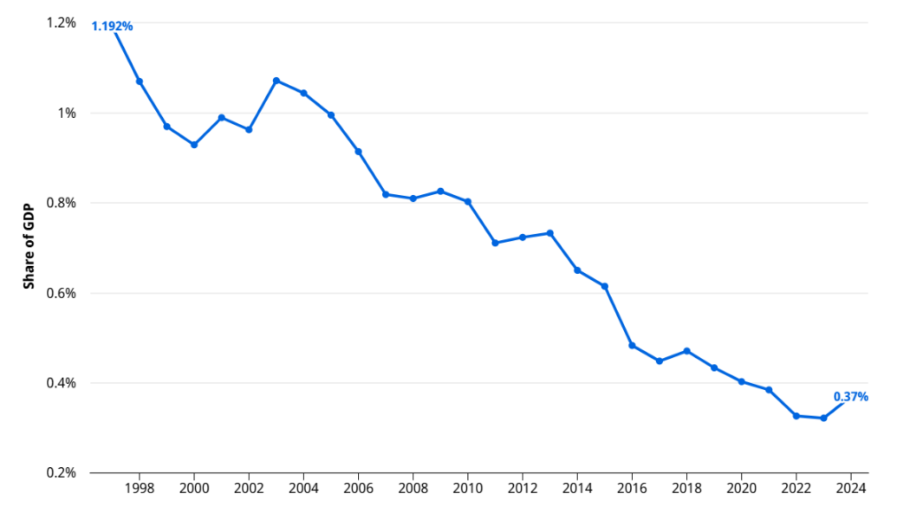
Share of tertiary graduates in science and engineering
- The share of tertiary-level graduates in science and engineering peaked at 26.7 per cent in 2015 and has trended downward since. The numbers contracted at a compound annual rate of −1.2 per cent over the 2015–2024 period, with fluctuations and a temporary recovery to 25.7 per cent in 2021, followed by a decline to 23.9 per cent in 2024.
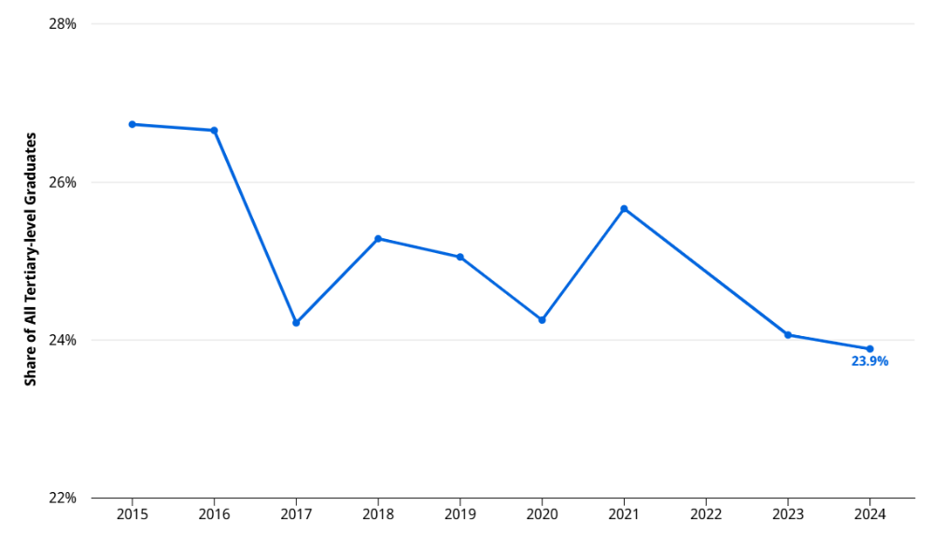
Scientific and technical articles
- Ukraine's scientific output grew steadily from 7,015 articles in 2015 to a peak of 8,942 in 2021, before entering a four-year decline to 8,689 in 2022, 8,352 in 2023 and a post-peak low of 8,204 in 2024. In 2025, the scientific output partially recovered to 8,466 articles, noting a 3.2 per cent year-on-year increase, but remaining 5.3 per cent below the 2021 peak.
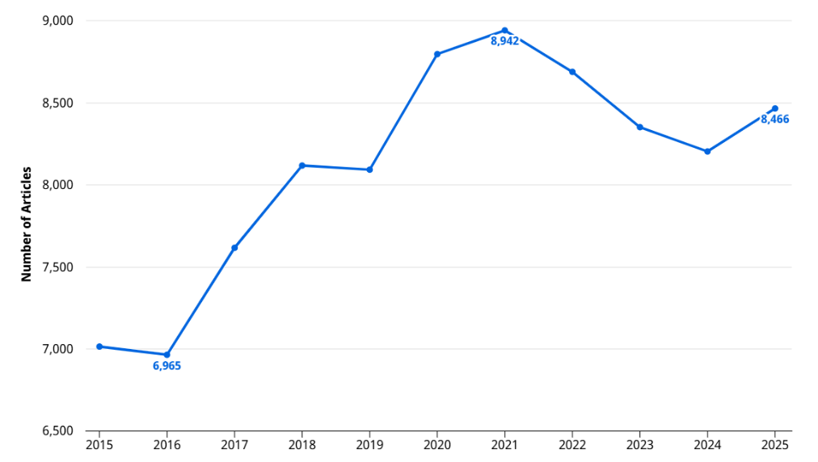
Venture capital (VC) received
- The number of VC deals received in Ukraine reached a new peak in 2025, confirming a renewed acceleration of investor engagement. With a total of 32 VC deals were received in 2025, Ukraine marked an increase of 39.1 per cent compared to 2024, surpassing the previous peak of 30 VC deals received in 2023.
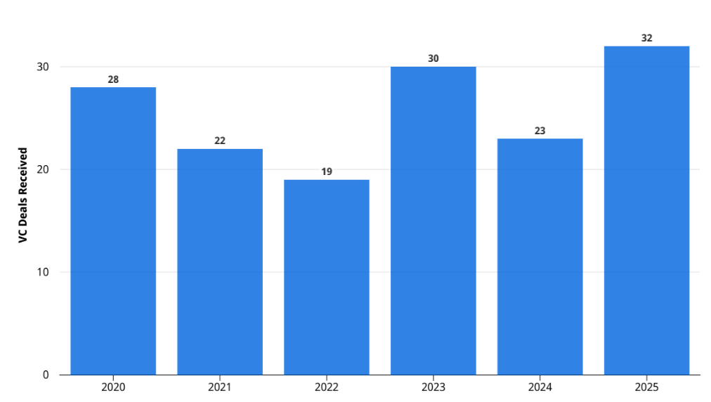
High-tech manufacturing as a share of total manufacturing
- High-tech manufacturing as a share of total manufacturing output rebounded to 21.6 per cent in 2023, the highest share since 2013. This represents a 17.5 per cent increase from the 18.3 per cent recorded in 2022 and a marked recovery from the 16.3 per cent low in 2021, pointing to an increased share of high-tech activity within Ukraine's manufacturing base.
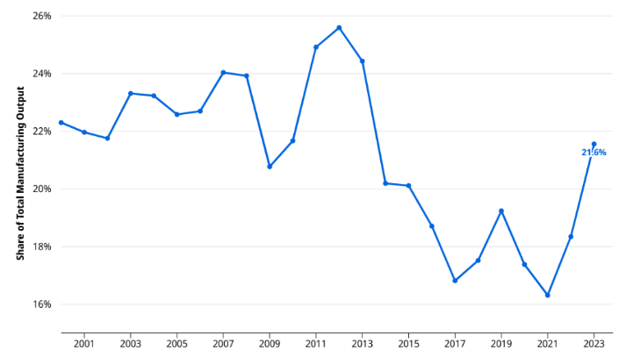
Software spending, million United States dollars
- Further positive change was observed for Ukraine's spending on computer software, which reached a new peak of 976.2 million United States dollars in 2025, surpassing the previous peak of 945.2 million recorded in 2022 and noting a 22.2 per cent year-on-year increase from the 799 million United States dollars in 2024.
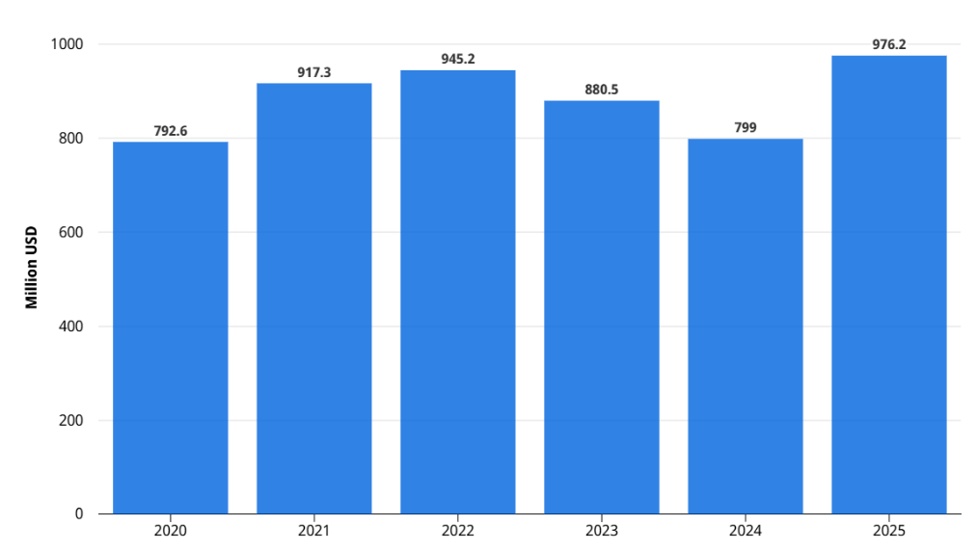
Mobile app creation
- While Ukraine’s mobile app creation has peaked in 2021, reaching 1.20 billion apps, a continuous decline has been observed since 2022, with a final drop to 0.90 billion mobile apps recorded in 2025.
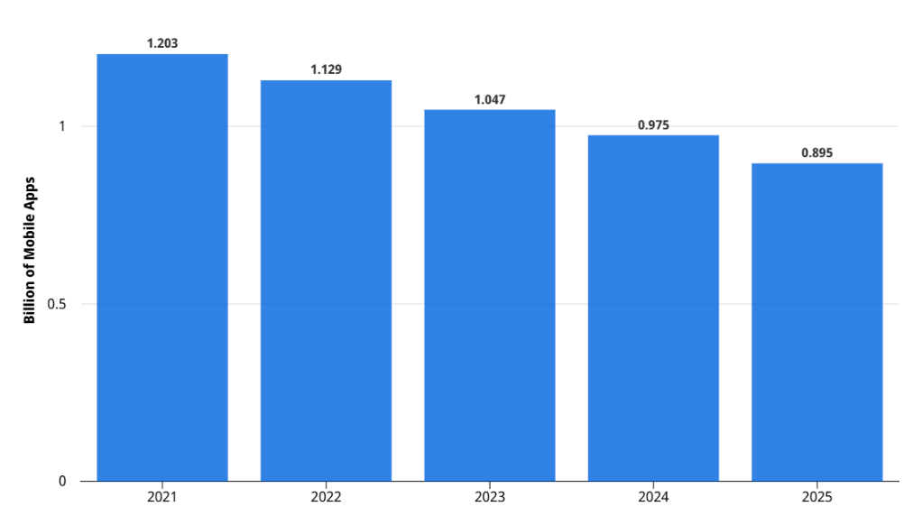
High-tech exports, percentage of total trade
- In 2024, Ukraine's high-tech exports, measured as a percentage of total trade, partially recovered to 0.88 billion United States dollars, noting an 11.2 per cent year-on-year increase after the two-year decline. Despite the increase, high-tech exports remained 40 per cent below the 2021 peak of 1.46 billion United States dollars.
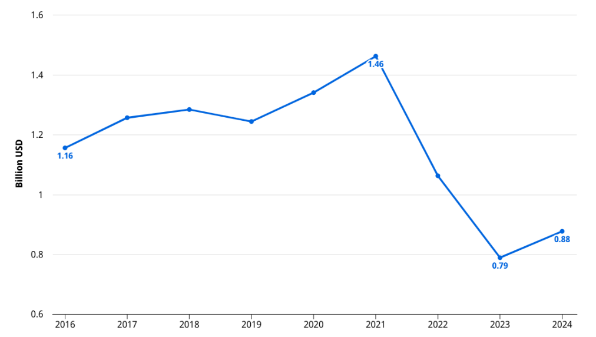
High-tech imports, percentage of total trade
- A significant positive trend was observed for Ukraine's high-tech imports, which reached a peak of 9.50 billion United States dollars in 2024, with a 36.5 per cent increase compared to 2023 and surpassing the previous peak of 8.27 billion United States dollars recorded in 2021. With this increase, Ukraine sharply rebounded from the 5.63 billion United States dollars contraction recorded in 2022.
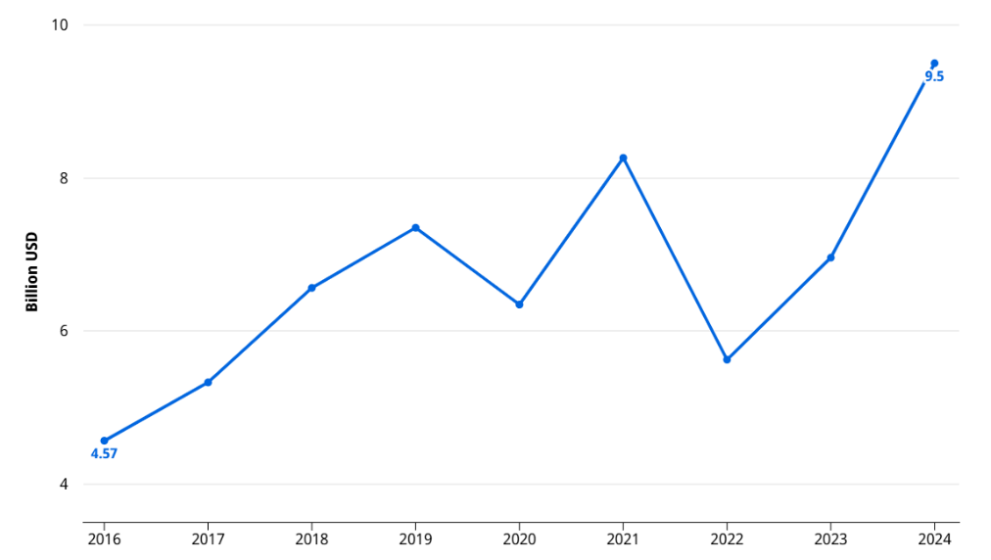
ICT services exports, percentage of total trade
- In contrast to the increase of high-tech exports, Ukraine's exports of ICT services have continued to follow the trend of decline and fell to 6.61 billion United States dollars in 2024, with a four per cent year-on-year decrease.

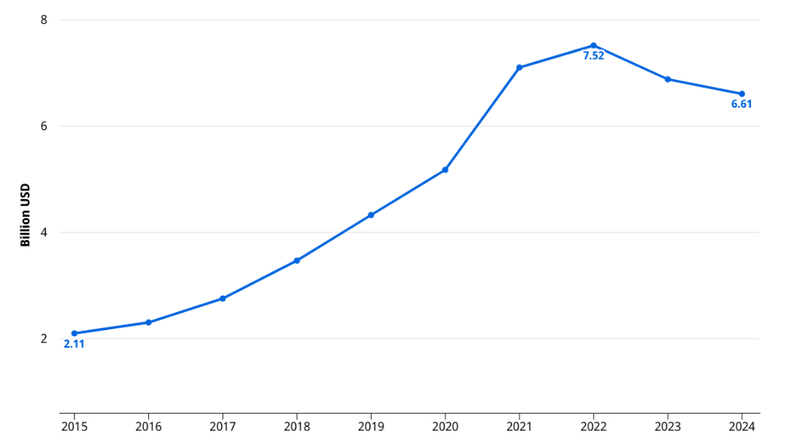
2.5. INTELLECTUAL PROPERTY FILING TRENDS AND REGISTRATION TRENDS

National Filings and Registrations
- In contrast to the observed growth in national filings reported in document A/66/8, in 2024 UANIPIO experienced a pattern of decline in patent, trademark and industrial design filings. Along the three IP rights, the trend was affected both by filings from applicants domiciled in Ukraine (residents) and applicants located abroad (non-residents), with a less pronounced decline in the resident filings. At the same time, utility model applications demonstrated resilience and sustained the positive growth, driven by the increase of resident filings. The following table demonstrates the trend in annual growth rates in national IP filings across the four IP rights, in percentages, wherein the positive values depict growth, and the negative values depict decline in filings:

FILINGS (GROWTH) | RESIDENT |  | NON-RESIDENT |  |  | TOTAL
FILINGS (GROWTH) | 2023 | 2024 |  | 2023 | 2024 |  | 2023 | 2024
Patent applications | 27.2% | -4.1% |  | -3.3% | -16.4% |  | 5.5% | -12.1%
Utility model applications | 47.7% | 7.5% |  | 32.8% | -15.6% |  | 47.4% | 7.0%
Trademark filing  (application class counts) | 64.3% | -1.2% |  | -12.9% | -2.6% |  | 29.1% | -1.6%
Industrial design filing  (application design counts) | 55.5% | -9.4% |  | -2.0% | -14.9% |  | 25.0% | -11.7%
Source: WIPO Statistics
- Utility model filings increased for a second consecutive year. Following a sharp 47.4 per cent rise in 2023, filings grew by a further seven per cent in 2024. The latest increase was driven by resident filings, which increased by 7.5 per cent, while at the same time, non-resident filings dropped by 15.6 per cent.
- On the other hand, patent application filings dropped by 12.1 per cent bringing the total to 2,559 patent applications after a growth of 5.5 per cent in 2023. The decrease in 2024 largely reflected the decline of the filing activity of non-resident applicants, with 16.4 per cent fewer patent applications filed in comparison with 2023. In parallel, resident filings decreased by 4.1 per cent in 2024 after an increase of 27.2 per cent in 2023. Overall, patent filings remained below the 2021 level by about 834 applications.
- As previously reported in document A/66/8, UANIPIO experienced significant fluctuations in trademark filings over the 2021–2023 period. In 2023, the total trademark fillings increased by 29.1 per cent, after a 39.5 per cent decline in 2022. The filings in 2024 demonstrated a more stable pattern compared to 2023, with a comparatively small decline of 1.6 per cent reaching an application class count of 54,742. The decrease was observed in both resident and non-resident filings, which declined by 1.2 per cent and 2.6 per cent respectively.
- Industrial design filings in Ukraine also receded in 2024 following robust growth in the prior year. The filings declined by 11.7 per cent, with 4,222 designs in applications filed in 2024. This decrease reflected contractions in both resident filings and non-resident filings, with decline by 9.4 per cent and 14.9 per cent respectively.
- While filing activity showed an overall decline in 2024, the registration figures point to a more positive trend. In 2024, registrations increased for all IP rights, except for trademarks. The most prominent growth in registrations was observed for utility model grants, with an overall increase of 17 per cent. The positive trend was driven by the surge of registrations related to non-resident applications, which increased 102.7 per cent compared to 2023. The table below presents the trend in annual growth rates for IP registrations at the UANIPIO, with respect to the four IP rights, in percentages, wherein the positive values depict growth, and the negative values depict decline in registrations:
REGISTRATIONS (GROWTH) | RESIDENT |  | NON-RESIDENT |  | TOTAL
REGISTRATIONS (GROWTH) | 2023 | 2024 | 2023 | 2024 | 2023 | 2024
Patent grants | -31.9% | -10.0% | -22.1% | 20.2% | -26.1% | 9.0%
Utility model grants | 31.7% | 15.9% | -14.0% | 102.7% | 30.8% | 17.0%
Trademark registrations  (application class counts) | -9.1% | 4.9% | -23.9% | -9.0% | -16.9% | -1.8%
Industrial design registrations  (application design counts) | 33.7% | 15.3% | -3.4% | -12.3% | 12.3% | 1.6%
Source: WIPO Statistics
- In addition, GIs in force in Ukraine reached 3,133 in 2024, following the trend of modest increase since 2018. While in general, the vast majority of GIs in force in Ukraine are protected through international agreements, since 2019, the observed growth in GI registrations is fully due to increase of the use of sui generis systems.
Source: WIPO Statistics (May 2026)
- By origin, the majority of the GIs in force in Ukraine in 2024 are foreign GIs. National GIs have shown steady growth since 2020, increasing from 20 to 29 over the four-year period. At the same time, foreign GIs have remained largely stable, fluctuating only slightly between 3,101 and 3,104 during this timeframe.
 | GIs in force by origin |  |  | GIs in force by legal means
 | Total GI in force | National GIs | Foreign GIs | International Agreements | Sui Generis
2020 | 3,121 | 20 | 3,101 | 3,091 | 30
2021 | 3,124 | n.a. | n.a. | 3,091 | 33
2022 | 3,124 | 20 | 3,104 | 3,091 | 33
2023 | 3,128 | 24 | 3,104 | 3,091 | 37
2024 | 3,133 | 29 | 3,104 | 3,091 | 42
Source: WIPO Statistics (n.a. equals not available)

2.5.2 International Filings

2.5.2.1 Patent Cooperation Treaty (PCT)
- In 2025, PCT filings by Ukrainian applicants remained almost consistent compared to 2024, with a slight decline by only two applications.
Source: WIPO statistics database (May 2026)

2.5.2.2 Madrid System
- International trademark applications of Ukrainian origin under WIPO's Madrid System increased by 10 per cent in 2025 compared to 2024, surpassing the number of applications filed in the pre-war 2021 by the same margin.

- Moreover, the number of designations of Ukraine in international trademark filings received by the International Bureau increased by around 3.3 per cent, from 5,361 in 2024 to 5,537 in 2025.

2.5.2.3 Hague System
- In 2025, the number of Hague applications filed by applicants residing in Ukraine reached its highest level since 2006, with a notable increase from 33 to 55 applications, or 67 per cent compared to the previous year.

- At the same time, in 2025 the number of designs contained in applications of Ukrainian origin under the Hague System decreased to 94 contained in 55 applications, compared to 111 designs contained in 33 applications in 2024.

- The number of designs contained in international applications with the designation of Ukraine also decreased from 1,572 designs contained in 523 applications in 2024 to 1,510 designs contained in 516 applications in 2025.

3. WIPO’S ASSISTANCE AND SUPPORT FOR UKRAINE’S INNOVATION AND CREATIVITY SECTOR AND INTELLECTUAL PROPERTY SYSTEM
- Throughout the reporting period, the International Bureau continued its close cooperation with Ukraine and ensured ongoing support and assistance to the creators, innovators, and members of the IP community, focusing on mitigating the adverse effects of the war and rebuilding an innovative and creative ecosystem in Ukraine that benefits all stakeholders and strengthens the country’s economy.
- To ensure regular dialogue, coordination, and responsiveness in the delivery of assistance, since the last Assemblies and by the end of May 2026, more than 30 consultation meetings, both virtual and in-person, were held with key national and external stakeholders in Ukraine.
- In July 2025 during the WIPO Assemblies, as well as in October on the margins of the Tallinn Digital Summit , the WIPO Director General met with Mr. Oleksandr Tsybort, Deputy Minister of Economy, Environment and Agriculture of Ukraine, responsible for Digital Development, Digital Transformations, and Digitalization, to discuss the priorities as well as the advancement of the bilateral cooperation agenda.
- The International Bureau continued to ensure adequate financial and human resources within the approved Program of Work and Budget for the implementation of technical and legal assistance, capacity building, and other projects and activities for Ukraine, as appropriate and required, for the restoration and rebuilding of Ukraine’s IP sector and ecosystem.
- The following sections of the Report provide a comprehensive overview of the assistance and support for Ukraine’s innovation and creativity sector and IP system, provided by the International Bureau from July 2025 to May 2026.

IMPLEMENTATION OF THE MEMORANDUM OF UNDERSTANDING (MOU) BETWEEN WIPO AND THE MINISTRY OF ECONOMY OF UKRAINE ON COOPERATION IN THE SPHERE OF INTELLECTUAL PROPERTY
- In July 2025, WIPO and the Ministry of Economy of Ukraine signed a new MoU on Cooperation in the Sphere of Intellectual Property, reflecting the new cooperation priorities of Ukraine and driving the efficient implementation of the support to Ukraine in response to the significant disruptions caused by the war, in line with the decisions adopted by the WIPO Assemblies.
- Serving as a key framework for collaboration, the MoU guided multiple technical assistance, legal advisory, and capacity-building activities carried out between the International Bureau and Ukrainian institutions over the past year. Notable progress has been achieved under this cooperation, as further detailed below.

SUPPORT FOR THE DEVELOPMENT OF THE NATIONAL IP STRATEGY
- During the reporting period, the International Bureau continued to support the development of the National Strategy for the Development of the IP Sphere of Ukraine, coordinated by the Ministry of Economy, Environment and Agriculture of Ukraine.
- Following the completion of public consultations in early 2026, the Ministry of Economy, Environment and Agriculture of Ukraine updated and finalized the draft NIPS and the Operational Plan for its implementation in 2026-2028.
- Subsequently, the International Bureau continued consultations with the Ministry of Economy, Environment and Agriculture of Ukraine with a view to reviewing the Operational Plan and identifying areas where WIPO tools, expertise and technical assistance could support its practical implementation upon adoption. In this context, in May 2026 the International Bureau shared with the Ministry an overview of WIPO programs, tools and technical assistance that could be relevant to the implementation of the Strategy and its Operational Plan.
- The overview identified possible new areas of cooperation, including digital transformation and IP infrastructure, AI and emerging technologies, IP analytics, technology transfer, creative economy measurement, IP valuation and financing.

GENEVA ACT OF THE LISBON AGREEMENT
- Following interest expressed by Ukraine in 2025 in joining the Geneva Act of the Lisbon Agreement on Appellations of Origin and Geographical Indications, in 2026, the International Bureau continued consultations on the accession process with UANIPIO. Further preparation for accession would include organization of online Workshops for national stakeholders planned for June 2026 and review of Ukraine’s legislation to secure its alignment with the Geneva Act.

SUPPORT FOR INCREASED IP KNOWLEDGE AND SKILLS

WIPO Academy – IP Academy of Ukraine
- Since its establishment, the IP Academy of Ukraine (IPA) delivered 211 activities, reaching more than 24,571 participants, of whom approximately 60.5 per cent were women and over 59 per cent were from the private sector. In 2025 alone, IPA organized 96 events for 3,046 participants, of whom 70 per cent were women.
- Since July 2025, as part of the support provided by WIPO Academy to the IPA, the following projects have been carried out:
  - Digital Presence Project. The Project aimed to improve IPA’s online visibility, enhance the presentation of its training offerings and reach a wider audience. During the reporting period, the IPA website was launched, and a comprehensive digital marketing strategy was developed, including branding, a digital content library of audio-visual materials and a structured implementation plan.
  - IP eLearning Customization and Capacity-Building. Ukraine continued to make strong progress in expanding national IP education and EdTech capacity-building, aiming to reach learners across the country through phased customization of WIPO Academy eLearning courses for Ukrainian national IP context, delivered as a joint initiative between the WIPO Academy and the IPA, at the request of the IPA. The Primer on Intellectual Property (DL-001) has been successfully customized and launched in early 2026. The course recorded strong early uptake, with around 300 participants in the first quarter of 2026. Customization of additional courses and Ed Tech capacity-building will proceed with the DL-201 on Copyright and Related Rights, planned to be finalized in 2026.
  - WIPO Academy’s IPTI Program. In 2026, the Program will maintain the engagement of the IPTIs Network, with the aim to foster horizontal cooperation with other IPTIs, promote knowledge and experience sharing among members.
  - Empowerment of women entrepreneurs. In June 2025, the WIPO Academy launched the Women Innovation and Startup Empowerment (WISE) Project under the FIT-Korea IP Education initiative, in collaboration with the IPA. Aiming to strengthen the capacity of women entrepreneurs and innovators in Ukraine, the initiative successfully delivered a four-week online training course to 385 participants, enhancing their understanding of IP and its application to business development. In addition, from November 2025 to February 2026, four women entrepreneurs received tailored mentorship in IP commercialization, branding, and fundraising. The program concluded in March 2026.

Collaboration in other WIPO Academy Programs
- In 2025, 585 Ukrainian nationals have benefited from the hybrid and IP eLearning courses offered by the WIPO Academy. The participants included representatives of academia, the private sector, as well as IP practitioners. Women accounted for around 66 per cent of the participants, and youth for more than 65 per cent.
- Furthermore, two Ukrainian participants enrolled in WIPO Joint Master’s programs in the 2025–2026 academic year. One participant, funded by WIPO, enrolled in the WIPO-UNITO Master of Laws in IP, jointly offered by the University of Turin and WIPO. The second participant enrolled in the Master’s Degree Program in IP and New Technologies, jointly offered by the Jagiellonian University in Krakow, WIPO, and the Patent Office of the Republic of Poland, as self-financed participant.

Support for the Judiciary
- The International Bureau continued to provide support to the Judiciary of Ukraine under the MoU concluded with the Supreme Court of Ukraine in November 2023, with the aim to develop cooperation and joint activities with a view to strengthening the judicial system and services for IP protection in Ukraine.
- The provided support reflects the International Bureau's multi-year approach to continuing judicial education in Ukraine, including a framework of successive and complementary deliverables developed in close cooperation with the national judicial authority and building on its sustained engagement, with a view to durably strengthening the capacity of judges in the adjudication of IP disputes.
- During the reporting period, support to the judiciary included facilitating the participation of Ukrainian judges in two international judicial events. Nine Ukrainian judges attended the 2025 WIPO IP Judges Forum, held in hybrid format and two Ukrainian judges participated in the Regional Seminar for Judges on Current Issues in IP Rights, held in Latvia in September 2025. Both events provided Ukrainian judges with valuable opportunities to engage with their international and regional counterparts, exchange experiences and perspectives, and deepen their understanding of current developments in IP law and adjudication.
- Since July 2025, the International Bureau has continued to support the development of an Intellectual Property Benchbook for Ukraine. It was agreed with the Supreme Court of Ukraine that the Ukraine Benchbook would take the form of a comprehensive revision of A Handbook on Intellectual Property for Judges, published in Ukraine in 2018, commencing with the copyright and related rights chapter.
- The Benchbook is expected to be released in fall 2026. In advance of its release, a closed online workshop will be organized on June 10, 2026, to present the draft copyright chapter to judges and representatives of the IP Office of Ukraine. The workshop would serve the dual purpose of gathering feedback from participants on the draft content and providing an educational opportunity on the substantive issues addressed therein.
- Ukraine also continued to participate in WIPO Lex-Judgments since 2024, enabling the dissemination of leading IP judgments among stakeholders in Ukraine and to the broader international community, thereby contributing to greater transparency and accessibility of Ukrainian IP jurisprudence.

Other initiatives
- During the reporting period, the International Bureau has also participated in and contributed to national activities organized by relevant local stakeholders. In November 2025, it delivered a Keynote address at the fourth edition of the IP LET Forum – Intellectual Property: Law, Economy and Technology, Ukraine's main annual IP event which brought together representatives of government, business, academia, civil society, and international partners to explore how IP fosters development, resilience, and competitiveness.

3.5 SUPPORT TO INNOVATORS, CREATORS, SMES, UNIVERSITIES AND RESEARCH INSTITUTIONS

3.5.1 Technology and Innovation Support Centers (TISC) Network
- As reported at paragraphs 68 and 69, the TISC Network continued its positive development and delivery of a growing range of IP services.
- During the reporting period, the International Bureau continued to support the establishment and development of TISCs in Ukraine by contributing to capacity development, providing technical assistance and offering a range of specialized resources, including project management and knowledge sharing platforms.
- A structured project framework has been developed and formally adopted for the further development of the national TISC network in Ukraine in 2026, in cooperation with the International Bureau. The framework focuses on: (i) increasing the capacity of TISCs to raise awareness and provide trainings on IP for researchers and educators, as well as to support IP protection; and (ii) increased use of patent, scientific, and technical literature in research and education in the country.
- The International Bureau, in coordination with UANIPIO as national TISC focal point, has established the project framework within the TISC Project and Performance Management Platform (TPPM), including structured project design and clearly defined performance indicators to support effective management and monitoring of the TISC project.

Support Tools for SMEs and Startups
- Within the framework of the MoU between WIPO and the Ministry of Economy of Ukraine, the translation and adaptation of the WIPO Diagnostic Tool and the guidebook Enterprising Ideas: A Guide to IP for Startups were completed in August 2025. UANIPIO validated the tools in May 2026, with their official launch and online publication of the tools planned for June 2026.
- Between October and December 2025, 11 Ukrainian ventures and innovators participated in the online WIPO Scale Up Your IP Program for Deep-Tech Ventures, designed to support early-stage innovators, researchers, university spin-offs and deep-tech ventures develop their approach to IP commercialization and integrate IP into their commercialization strategies.
- One Ukrainian participated in the 2025 edition of the WIPO International Patent Drafting Training Program, implemented during eight months and through in three phases including tutor-led online modules, a week-long workshop held at the WIPO Headquarters in Geneva and tailored, online mentoring.
- Additionally, in December 2025, WIPO concluded the Regional Patent Drafting Workshop for Central European and Baltic States and Mediterranean Countries (CEBSMC), held in Belgrade, Serbia in December 2025. The Program enhanced the capacities of 46 participants from 19 CEBSMC countries, including three participants from Ukraine.
- One Ukrainian SME successfully completed the EUIPO-WIPO IP Management Clinic for Fashion Entrepreneurs, implemented in November 2025 in cooperation with the EUIPO and partner organizations from the fashion sector.

3.5.3 Provision of Access to Information and Technologies
- The International Bureau continued to facilitate access to patent and non-patent databases and literature for UANIPIO and other Ukrainian institutions through two key public-private programs: the Access to Research for Development and Innovation (ARDI) program, which provides access to up to 250,000 scientific and technical books, journals and reference works, and the Access to Specialized Patent Information (ASPI) program, which provides access to advanced commercial patent search and analytics databases.
- The free access to ASPI, ARDI and other Research4Life programs for eligible national institutions of Ukraine, including the TISCs network, has been extended until the end of 2026. This extension is part of a strategy to ensure that Ukrainian institutions continue to benefit from global knowledge repositories and technology databases amidst ongoing challenges.
- As of December 31, 2025, 266 institutions in Ukraine were registered to benefit from ARDI, and over 30 institutions were registered to benefit from one or more patent database services through ASPI.

IP Management in Technoparks
- From October to November 2025, the Sikorsky Challenge Science Park of Additive Technologies participated in the WIPO cross-regional project on IP Management in Technoparks. The project brought together 24 technoparks from 13 countries and was guided by ISO 56005 standards. With the assistance of the International Bureau, participating technoparks assessed their IP management needs and prepared IP Management Roadmaps addressing six core areas: governance, disclosure, risk management, protection, valuation, and technology transfer.

Copyright Management
- In September 2025, the International Bureau received a request from the Ministry of Economy, Environment and Agriculture of Ukraine for assistance in improving its collective management system and particularly implementing the 2018 Law on Effective Management of Property Rights.
- In November 2025, the International Bureau launched a project to assist the Ministry of Economy, Environment and Agriculture of Ukraine to increase the transparency of CMOs through the creation of an Information System integrating a Unified Registry of CMOs with a publicly accessible Transparency Dashboard of CMO performance reports.
- In response to the additional needs and proposals expressed by the Ministry of Economy, Environment and Agriculture of Ukraine, the project was broadened to include the review of the secondary legislation regarding the CMOs’ reporting obligations. This included the preparation of a non-normative Guideline to support the Ministry in assessing submitted documents and materials.
- The project benefitted from the insights of a national and international expert and is planned to conclude by the end of June 2026.

Accessible Books Consortium (ABC)
- As noted in document A/66/8, the Central Specialized Library of the Ukrainian Association of the Blind (CLBU), which joined the Accessible Books Consortium (ABC) Global Book Service (GBS) in 2019, has full access to the GBS platform, commonly referred to as the Library Application. The platform currently hosts over 1.2 million titles in accessible formats, all available for cross-border exchange under the framework of the Marrakesh Treaty to Facilitate Access to Published Works for Persons Who Are Blind, Visually Impaired or Otherwise Print Disabled. CLBU joined ABC’s Beneficiary Application in May 2025. This enabled CLBU, as an Authorized Entity, to give its patrons access to a catalogue of more than 540,000 accessible books, which they can independently browse and download to their preferred devices.

CDIP Project on “Enhancing the Capacities of National Intellectual Property Offices in Times of Crisis”
- As previously reported in document A/66/8, at its 32nd session, the Committee on Development and Intellectual Property (CDIP) adopted the Development Agenda Project proposed by the United Kingdom and the Czech Republic on "Enhancing the Capacities of National Intellectual Property Offices in Times of Crisis". Ukraine has expressed its interest in participating in this project, which would entail elaborating a case study and developing and adopting materials in collaboration with other Member States.
- As a first step in the implementation of the project, a comprehensive survey was circulated to all 22 participating countries, including Ukraine, with a view to identifying common trends and divergences across IP offices with respect to their national legal frameworks for crisis management, crisis preparedness, emergency response mechanisms, recovery strategies and adherence to recognized international standards. Ukraine duly completed and submitted its responses to the questionnaire in November 2025, thereby ensuring its full inclusion in the comparative analysis and positioning itself to actively contribute to the subsequent phases of the project.
- Drawing on the data collected, participating countries, including Ukraine, were categorized into three tiers: advanced, intermediate, and developing, reflecting the maturity of their respective crisis management systems, organizational resilience, and overall readiness and preparedness for handling crises. This classification enabled the identification of each country's areas of expertise, potential contributions to the project, specific capacity-building needs, and targeted areas for improvement.
- Having completed this foundational assessment, the project will enter a new phase, in which the respective roles and contributions of participating countries, as well as the intended beneficiaries, will be further defined.

4. ACCESS TO WIPO’S IP SERVICES AND STEPS UNDERTAKEN TO ENSURE THAT PUBLICATIONS ON WIPO RESOURCES AND PLATFORMS COMPLY WITH THE PRINCIPLES OF SOVEREIGNTY, INDEPENDENCE, AND TERRITORIAL INTEGRITY OF UKRAINE

4.1 Patent Cooperation Treaty (PCT)
- From May 2025 to October 2025, the International Bureau reviewed Ukraine’s Authority File and offered advice concerning arrangements to supply patent documentation in compliance with the new requirements of PCT Rule 36. The milestones were the publication of a notice concerning the UANIPIO collection in the PCT Gazette on October 23, 2025 and the UANIPIO patent collection becoming part of the PCT minimum documentation with effect from January 1, 2026.
- The International Bureau also offered advice concerning the preparation of UANIPIO’s application for extension of appointment as an International Searching and Preliminary Examining Authority under the PCT. The application was submitted and published in document PCT/CTC/33/23 in December 2025.
- In February 2026, the PCT Committee for Technical Cooperation recommended to the PCT Union Assembly the extension of appointments of all the 25 national Offices and intergovernmental organizations currently acting as International Searching and Preliminary Examining Authorities under the PCT, including UANIPIO.
- In parallel, Ukrainian applicants have continued to use the PCT System during the reporting period. If applicants experience delays in meeting time limits, the PCT System provides appropriate extensions, exceptions, and other remedies, as set out in paragraph 106 of document A/64/8.
- Within the period from May 2025 to end of April 2026, UANIPIO has produced 67 international search reports as an International Searching Authority and International Preliminary Examining Authority.

4.2 Madrid System
- The International Bureau continued facilitating access to relief measures for missed deadlines due to force majeure under Rule 5 of the Regulations under the Madrid Protocol. It waived the evidence requirement and enabled late online payments, upon request, to streamline the process.
- Communication and technical cooperation between the UANIPIO and the International Bureau continued to support smooth operations and service delivery under the Madrid System in the country. In 2025, Ukrainian brand owners obtained 524 international registrations, most of which were filed through Madrid e-Filing. During the same period, Ukraine received 5,313 designations in international registrations and subsequent designations.
- The International Bureau continued its engagement with Ukrainian stakeholders through capacity building and policy discussions. In 2025, nine participants from Ukraine took part in Madrid System’s public webinar program, while four Ukrainian representatives participated in the Madrid System Working Group, reflecting continued active engagement in the development and use of the Madrid System.

4.3 Hague System
- During the reporting period, there has been no request for application of Rule 5 “Excuse of Delay in Meeting Time Limits” of the Regulations Under the Geneva Act (1999) of the Hague Agreement Concerning the International Registration of Industrial Designs.”
- Several participants from Ukraine took part in the Hague System public webinars during the reporting period.

4.4 Arbitration and Mediation
- The WIPO Arbitration and Mediation Center (AMC) continued its cooperation with the Ministry of Economy, Environment and Agriculture of Ukraine to develop and promote IP alternative dispute resolution (ADR) in Ukraine, including through raising awareness, capacity building, training specialized IP mediators and arbitrators and case administration. Stakeholders from Ukraine participated in six webinars organized by the AMC on different topics relating to IP ADR.
- In the area of Internet domain names, the AMC continues to be the dispute resolution provider for the national .UA domains, for which it has administered 14 cases under the .UA Policy since last reported in 2025. Overall, since July 2025, the AMC has administered 117 domain name cases involving parties from Ukraine
- Furthermore, the AMC has been organizing and participating in online events for Ukrainian stakeholders in 2025. An AMC webinar on WIPO Domain Name Dispute Resolution Services covering both the UDRP and .UA Policy was held on October 2025, and an online presentation on sustainability, innovation, and strategic trends determining the future of Ukraine's Internet space was held in December 2025.
- The AMC remains available to provide further support to MEDT and explore IP ADR collaboration with interested stakeholders in Ukraine.

4.5 Steps Undertaken to Ensure that Publications on WIPO Resources and Platforms comply with the Principles of Sovereignty, Independence, and Territorial Integrity of Ukraine Within its Internationally Recognized Borders
- At the 2024 Assemblies of the Member States of WIPO, the International Bureau was requested “to take steps to ensure that publications on WIPO resources and platforms comply with the principles of sovereignty, independence, and territorial integrity of Ukraine within its internationally recognized borders” (see document A/65/10, paragraph 50(c)).
- The International Bureau has taken a number of steps to implement their request. These steps consisted of:
(a) amending existing and/or adding disclaimers in the terms of use of the PATENTSCOPE Database, Global Brand Database, and Global Design Database;
(b) broadening the scope of existing disclaimers applicable to all international registrations through the Madrid System, and where they did not exist already, introducing disclaimers for each record (PCT, Hague and Lisbon Systems); and
(c) inserting similar disclaimers in WIPO publications that report on or draw data from the above-mentioned four IP systems (see document A/66/8, paragraphs 189 to 191).
5. CONCLUSIONS
- According to the assessment undertaken by the International Bureau, the ongoing war continues to have severe and increasingly structural impacts on Ukraine's innovation and creativity sector and ecosystem. While Ukrainian institutions have demonstrated remarkable resilience in maintaining operations and adapting to extraordinary challenges, and international cooperation frameworks have expanded significantly during the reporting period, fundamental constraints persist in human capital, infrastructure, funding, and market contraction. Substantial reconstruction needs have been identified for education and science. At the same time, international reporting indicates that Ukraine's innovation ecosystem is gradually transitioning from emergency wartime adaptation toward reconstruction-oriented transformation. The medium- and long-term outlook remains highly uncertain given the evolving security situation and prospects for peace and recovery.
- The International Bureau, in close cooperation with Ukraine, continued to ensure a comprehensive framework for support and assistance from across various programs and initiatives to the creators, innovators, and members of the IP community, focusing on mitigating the adverse effects of the war and rebuilding an innovative and creative ecosystem in Ukraine that benefits all stakeholders and strengthens the country’s economy. The International Bureau reiterates its commitment to continuing its close cooperation with Ukraine and providing its full support and assistance.
- The International Bureau remains ready to provide any additional information requested by Member States.
[End of document]

The Report presented at the 2025 WIPO Assemblies is contained in document A/66/8.
On July 21, 2025 the Ministry of Economy of Ukraine consolidated with the Ministry of Agrarian Policy and Food and the Ministry of Environmental Protection and Natural Resources, and continued its function as the Ministry of Economy, Environment and Agriculture of Ukraine.
World Bank. Ukraine - Fifth Rapid Damage and Needs Assessment (RDNA5) : February 2022 - December 2025 (English). Washington, D.C.: World Bank Group. https://documents.worldbank.org/en/publication/documents-reports/documentdetail/099022026094036395
World Bank. Ukraine - Fourth Rapid Damage and Needs Assessment (RDNA4) : February 2022 - December 2024 (English). Washington, D.C.: World Bank Group. http://documents.worldbank.org/curated/en/099022025114040022
UNESCO, “Damaged Cultural Sites in Ukraine Verified by UNESCO”, April 2026. https://www.unesco.org/en/ukraine-war/damaged-cultural-sites
OHCHR, “Fact sheet - Four years since the full-scale invasion of Ukraine: Key facts and findings about the impact on human rights 24 February 2022 to February 2026”, February 2026. . https://ukraine.ohchr.org/sites/default/files/2026-02/2026-0216%20HRMMU_Four%20Years%20On_fact%20sheet_2.pdf
UNHCR, “Ukraine Refugee Situation”. https://data.unhcr.org/en/situations/ukraine
International Organization for Migration (IOM), “Ukraine Internal Displacement Report”, January 2026. Test
UNESCO, “Ukraine: International Coalition for Science, Research and Innovation Launched”, July 2025. https://www.unesco.org/en/articles/ukraine-international-coalition-science-research-and-innovation-launched
UNESCO, “Building a Robust Science Ecosystem in Ukraine: UNESCO’s Action Plan for Sciences”, June 2025. https://www.unesco.org/sites/default/files/medias/fichiers/2025/07/UNESCO%E2%80%99s%20Action%20Plan%20For%20Sciences.pdf
International Labour Organization (ILO), “EU and ILO launch project to strengthen Ukraine’s labour market governance”, October 2025. https://www.ilo.org/resource/news/ilo-and-eu-launch-project-strengthen-ukraine%E2%80%99s-labour-market-governance
Made in Ukraine https://madeinukraine.gov.ua/#politics (in Ukrainian).
Resolution of the Cabinet of Ministers of Ukraine of May 15, 2026, No. 616 on the Amendments to the Resolutions of June 21, 2022 No. 738 “Some issues of providing business grants” and of November 26, 2025 No. 1527 “Some issues of submitting business plans to obtain financial state support” https://zakon.rada.gov.ua/laws/show/616-2026-%D0%BF?lang=en (in Ukrainian).
Ministry of Economy, Environment and Agriculture of Ukraine, “Own Business – Updated: More Support for Starting, Developing and Scaling a Business https://me.gov.ua/News/Detail/ec3dcfc0-318d-4c9a-aeec-c817978e7d3b?lang=uk-UA&title=VlasnaSprava (in Ukrainian).
UNDP, “Ukraine Annual Report 2025: Resilient Recovery and Inclusive Development”, April 2026. https://www.undp.org/ukraine/publications/undp-ukraine-annual-report-2025-resilient-recovery-and-inclusive-development
OECD (2025), OECD Economic Surveys: Ukraine 2025, OECD Publishing, Paris, https://doi.org/10.1787/940cee85-en and OECD (2026), “Supporting Ukraine to design and implement more efficient investment incentive policies”, OECD Business and Finance Policy Papers, No. 99, OECD Publishing, Paris. https://doi.org/10.1787/49f00bcb-en.
European Innovation Council and SMEs Executive Agency, “The European Innovation Council expands support for Ukrainian tech SMEs and start-ups through new funding initiative”, July 2025. https://eic.ec.europa.eu/news/european-innovation-council-expands-support-ukrainian-tech-smes-and-start-ups-through-new-funding-2025-07-17_en
European Innovation Council and SMEs Executive Agency, “Commission boosts support to Ukrainian deep tech innovators”, April 2026. https://eic.ec.europa.eu/news/commission-boosts-support-ukrainian-deep-tech-innovators-2026-04-01_en
Ministry of Education and Science of Ukraine, Save Schools. https://saveschools.in.ua/en/
UNICEF, “More than 340 educational facilities damaged or destroyed in Ukraine this year”, Press Release, November 2025. https://www.unicef.org/ukraine/en/press-releases/more-340-educational-facilities-damaged-or-destroyed-ukraine-year
UNESCO, "Resilient Minds: The Unseen Struggles of Scientists in Wartime Ukraine", July 2025. https://www.unesco.org/en/articles/just-published-resilient-minds-unseen-struggles-scientists-wartime-ukraine
The Rome Declaration of Intent for Science, Research and Innovation in Ukraine, July 2025. https://www.mur.gov.it/sites/default/files/2025-07/RI%20Coalition%20for%20Ukraine%20-%20Declaration%2010072025_online%20version.pdf
UNESCO, “Building a Robust Science Ecosystem in Ukraine: UNESCO’s Action Plan for Sciences”, June 2025. https://www.unesco.org/sites/default/files/medias/fichiers/2025/07/UNESCO%E2%80%99s%20Action%20Plan%20For%20Sciences.pdf
Ministry of Culture of Ukraine, Destruction of cultural heritage, May 2026. https://mincult.gov.ua/en/news/russians-have-damaged-1783-cultural-heritage-sites-and-2540-cultural-infrastructure-facilities/
The full GII 2024 briefing on Ukraine is found under https://www.wipo.int/edocs/gii-ranking/2025/ua.pdf.
As the GII 2026 is still under production, the following data sets may not be complete.
On July 21, 2025, the Ministry of Economy of Ukraine consolidated with the Ministry of Agrarian Policy and Food and the Ministry of Environmental Protection and Natural Resources, and continued its function as the Ministry of Economy, Environment and Agriculture of Ukraine
Document PCT/CTC/33/23, 33rd session of the Patent Cooperation Treaty (PCT) Committee for Technical Cooperation, February 2 to 6, 2026. https://www.wipo.int/meetings/en/details.jsp?meeting_id=89830
Summary by the Chair, 33rd session of the PCT Committee for Technical Cooperation, February 2 to 6, 2026. https://www.wipo.int/edocs/mdocs/pct/en/pct_ctc_33/pct_ctc_33_29.pdf

