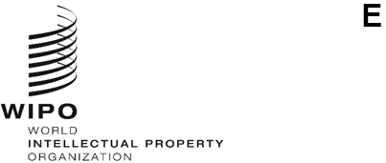
a/67/2
ORIGINAL: ENGLISH
DATE: February 20, 2026
Assemblies of the Member States of WIPO
Sixty-Seventh Series of Meetings
Geneva, April 21, 2026
APPOINTMENT OF THE DIRECTOR GENERAL
Memorandum of the Chair of the WIPO Coordination Committee
Article 6(2)(i) of the Convention Establishing the World Intellectual Property Organization (WIPO Convention) provides that the WIPO General Assembly shall “appoint the Director General upon nomination by the Coordination Committee”.
Article 9(3) of the WIPO Convention provides that the “Director General shall be appointed for a fixed term, which shall be not less than six years. He shall be eligible for reappointment for fixed terms. The periods of the initial appointment and possible subsequent appointments, as well as all other conditions of the appointment, shall be fixed by the WIPO General Assembly”.
In its session held on February 12, 2026, the WIPO Coordination Committee nominated Mr. Daren Tang as the candidate for appointment to the post of Director General of WIPO (document WO/CC/85/4, paragraph 5). The curriculum vitae of the nominee, Mr. Daren Tang, is annexed to the present document.

In accordance with Article 9(3) of the WIPO Convention, it is proposed that Mr. Daren Tang be appointed the Director General of WIPO for a period of six years. The term of appointment of Mr. Daren Tang would commence on October 1, 2026 and would expire on September 30, 2032.
The WIPO General Assembly and the Assemblies of the Paris and Berne Unions, each as far as it is concerned, are invited to:
- consider the nomination of the WIPO Coordination Committee referred to in paragraph 3; and
(ii) appoint Mr. Daren Tang as Director General for a term from October 1, 2026 to September 30, 2032.
[Annex follows]
Curriculum Vitae of Mr Daren Tang
Director General, World Intellectual Property Organization
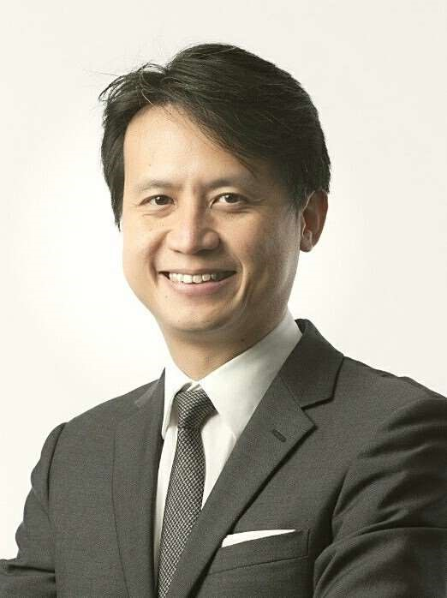
Year of Birth: 1972
Nationality: Singaporean
ACADEMIC QUALIFICATIONS
2013 Advanced Management Program
Harvard Business School, USA
2006 Master of Laws (LL.M) with Distinction
Georgetown University Law Centre, USA
Fellow, Institute of International Economic Law
1997 Bachelor of Laws (LL.B) with Honours
National University of Singapore
PROFESSIONAL EXPERIENCE
2020 – Director General
present World Intellectual Property Organization (WIPO)
Secretary-General
International Union for the Protection of New Varieties of Plants (UPOV)
Board Member
UN System Chief Executives Board for Coordination
2015 – Chief Executive
2020 Intellectual Property Office of Singapore (IPOS)
Ministry of Law, Singapore

2012 – 2015 Deputy Chief Executive and Chief Legal Counsel
Intellectual Property Office of Singapore
Ministry of Law, Singapore
2003 – 2012 Senior State Counsel
International Affairs Division
Attorney-General’s Chambers, Singapore
2001 – 2003 Legal Consultant
Ministry of Trade and Industry, Singapore
1997 – 2001 State Counsel/Deputy Public Prosecutor

PAST APPOINTMENTS
Chairperson, Standing Committee on Copyright and Related Rights (SCCR), WIPO, 2017 – 2020
Member, Singapore-Guangdong Collaboration Council (SGCC)
Member, Manufacturing Sub-Committee of the Future Economy Council, Singapore
Member, Modern Services Sub-Committee of the Future Economy Council, Singapore
Member, Research, Innovation and Enterprise Strategy Committee (RIE SC), Prime Minister’s Office, Singapore
Member, Research, Innovation and Enterprise Executive Committee (RIE Exco), Prime Minister’s Office, Singapore
Co-Chair, National IP Working Group, Prime Minister’s Office, Singapore
Advisory Board Member, Saudi Authority for Intellectual Property (SAIP)
Member, Group of Experts on IP Office of the Future Project, International Trademark Association (INTA)
Board Chairman, IPOS International
Board Member, EW Barker Centre for Law & Business, National University of Singapore
Board Director, Fraunhofer Singapore
Coordinator and Principal Examiner, Intellectual Property Law Course for the Singapore Bar Exam run by the Singapore Institute of Legal Education

HONOURS
2016 Public Administration Medal (Silver)
Prime Minister’s Office, Singapore
2006 Fellow
Institute of International Economic Law, Georgetown University, USA

LANGUAGES
English, Mandarin Chinese, understanding of French, Cantonese

PUBLICATIONS
The Tea Bone Zen Mind Manual of Tea
[End of Annex and of document]

