E

A/66/INF/4
ORIGINAL: ENGLISH
DATE: JuLY 7, 2025

Assemblies of the Member States of WIPO
Sixty-Sixth Series of Meetings
Geneva, July 8 to 17, 2025
STATUS OF THE PAYMENT OF CONTRIBUTIONS AS AT June 30, 2025
Information document prepared by the Secretariat
- The present document contains an update of the information contained in the “Status of the Payment of Contributions as at April 30, 2025” (document WO/PBC/39/INF/1).

Arrears in contributions as AT JUNE 30, 2025

Arrears in Annual Contributions

(Except for Arrears of the Least Developed Countries (LDCs) Placed in a Special (Frozen) Account Concerning the Years Preceding 1990)
- The following table shows the arrears in contributions on June 30, 2025, under the unitary contribution system that has been applicable since January 1, 1994, and under the previously applicable contribution systems of the six Contribution-financed (CF) Unions (Paris, Berne, IPC, Nice, Locarno, Vienna) and of the World Intellectual Property Organization (WIPO) (for States that are members of WIPO but not members of any of the Unions), with the exception of arrears in contributions of the LDCs concerning the years preceding 1990, placed in a special (frozen) account, which are not shown in this table but are shown in the table in paragraph 5 below.

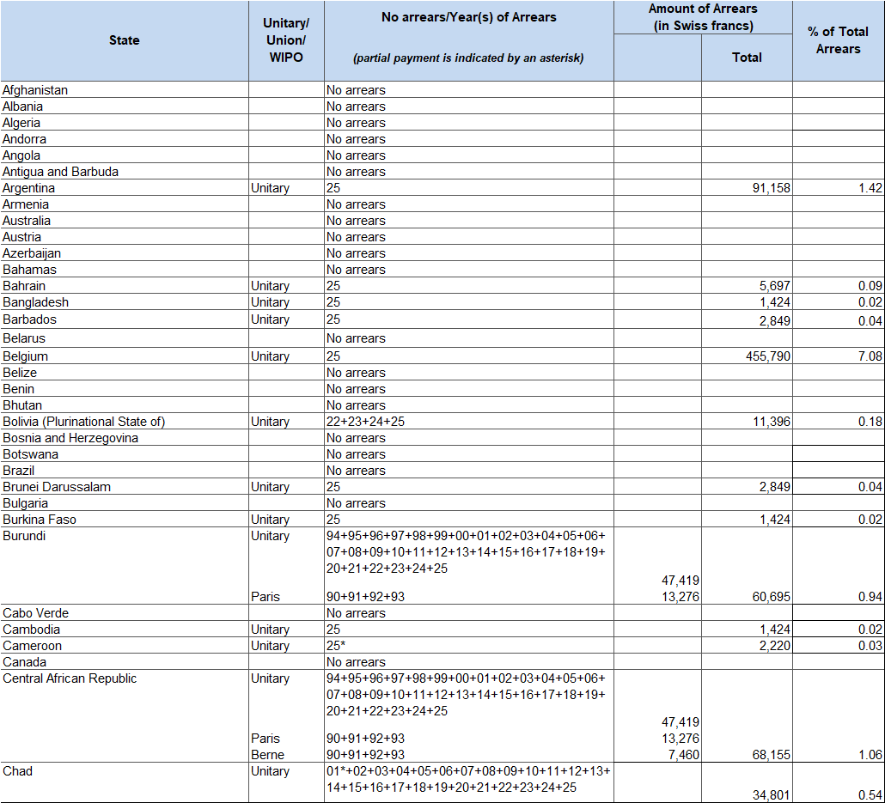

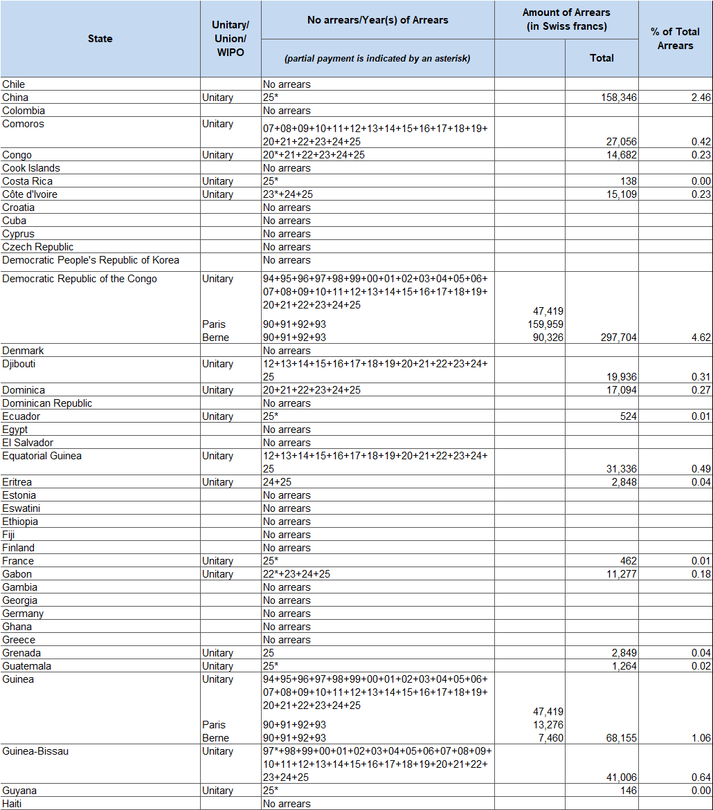

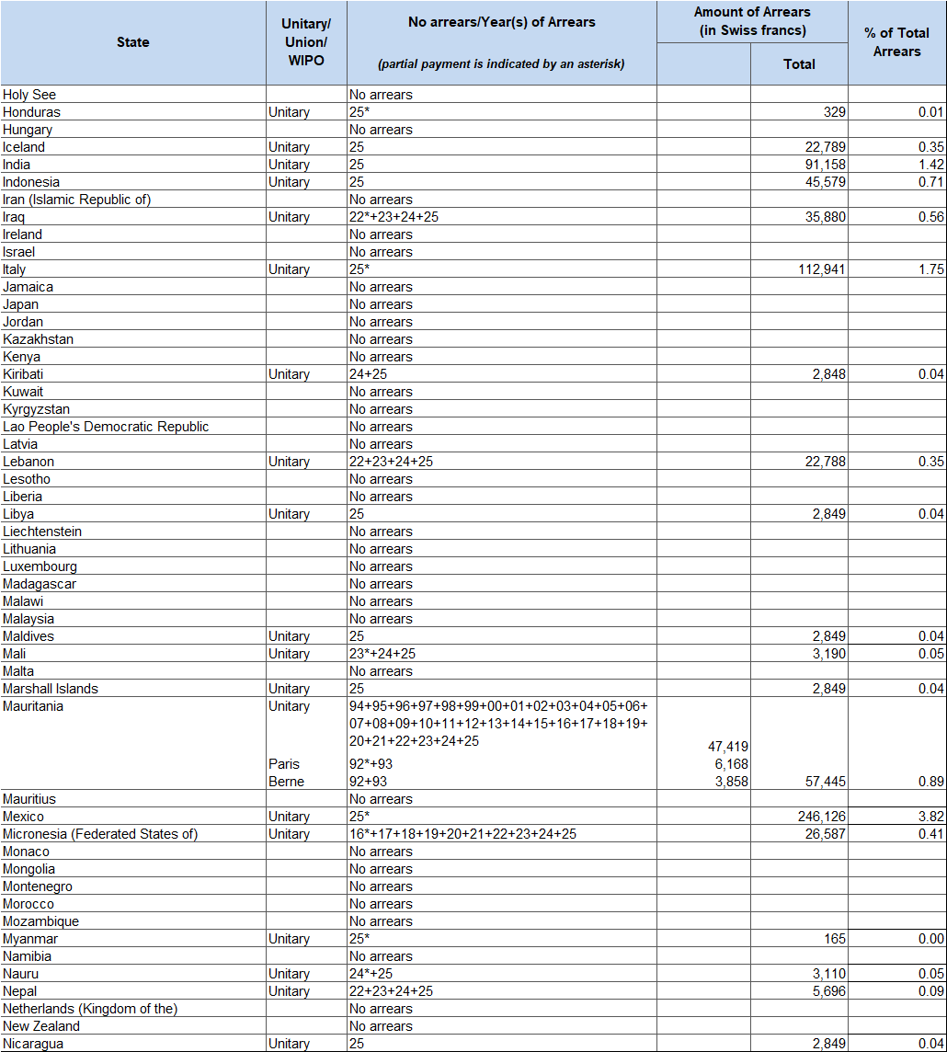

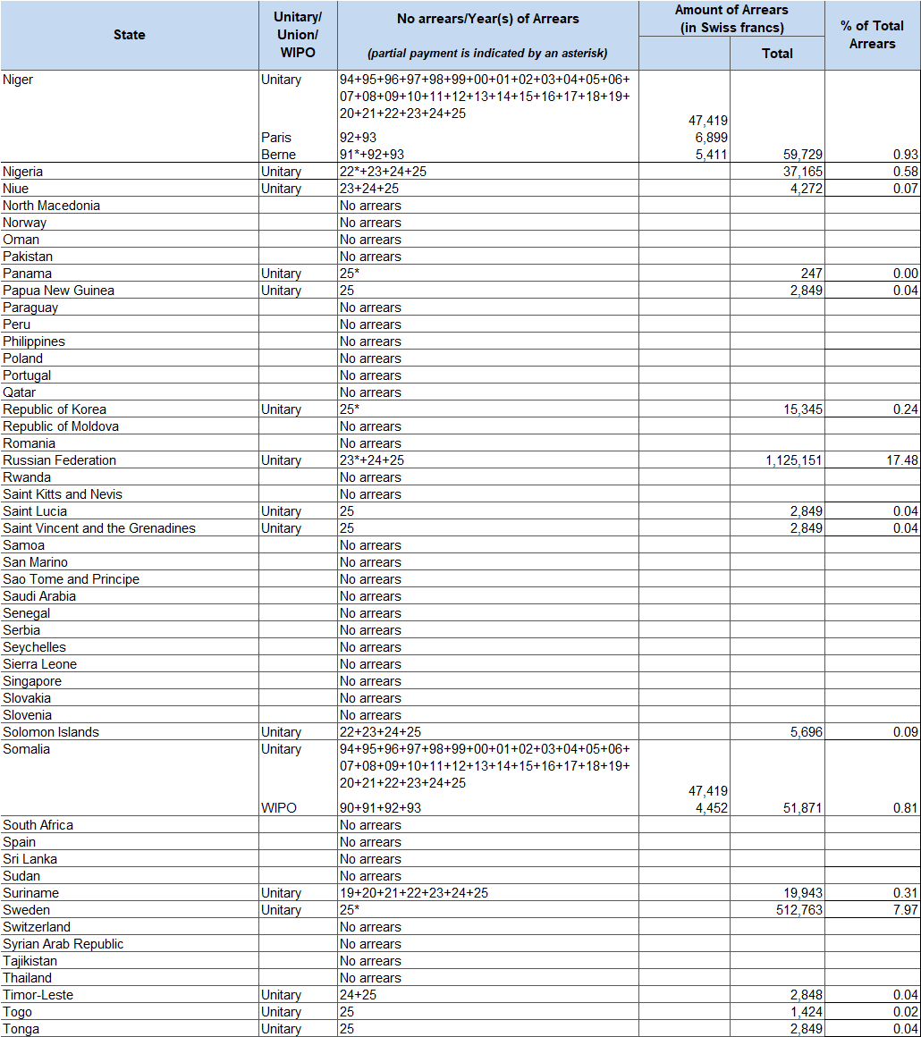

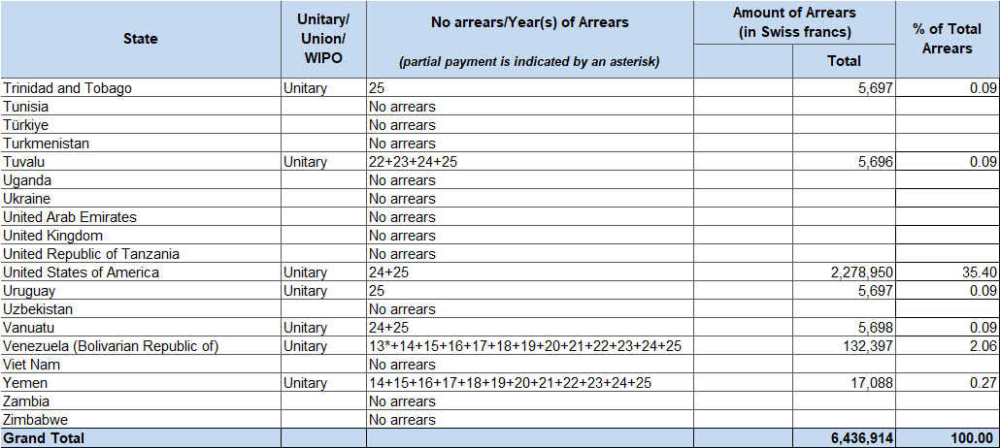

Total amount of arrears (except for arrears of the LDCs placed in a Special (Frozen)
Account concerning the years preceding 1990)
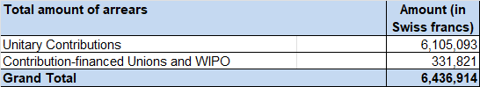

Observations
- The total amount of the overdue contributions on June 30, 2025, was 6.4 million Swiss francs, of which 6.1 million Swiss francs concern the unitary contribution system, whereas 0.3 million Swiss francs concern the pre-1994 contributions in respect of the CF Unions and WIPO. The total amount of arrears, 6.4 million Swiss francs (as shown in the above table), corresponds to 37 per cent of the total amount invoiced for contributions payable for 2025, amounting to 17.6 million Swiss francs.
- Any payment that reaches the International Bureau (IB) between July 1 and July 8, 2025, will be reported to the Assemblies when they consider the present document.

Arrears in Annual Contributions of the LDCs Placed in a Special (Frozen) Account Concerning the Years Preceding 1990
- It is recalled that, in accordance with the decision taken by the WIPO Conference and the Assemblies of the Paris and Berne Unions at their 1991 ordinary sessions, the amount of the arrears in contributions of any least developed country (LDC) relating to years preceding 1990 was placed in a special account, the amount of which was frozen as of December 31, 1989 (documents AB/XXII/20 and AB/XXII/22, paragraph 127). Such arrears in contributions, as at June 30, 2025, concerning the Paris and Berne Unions and concerning WIPO are shown in the following table. Any payment that reaches the IB between July 1 and July 8, 2025, will be reported to the Assemblies when they consider the present document.

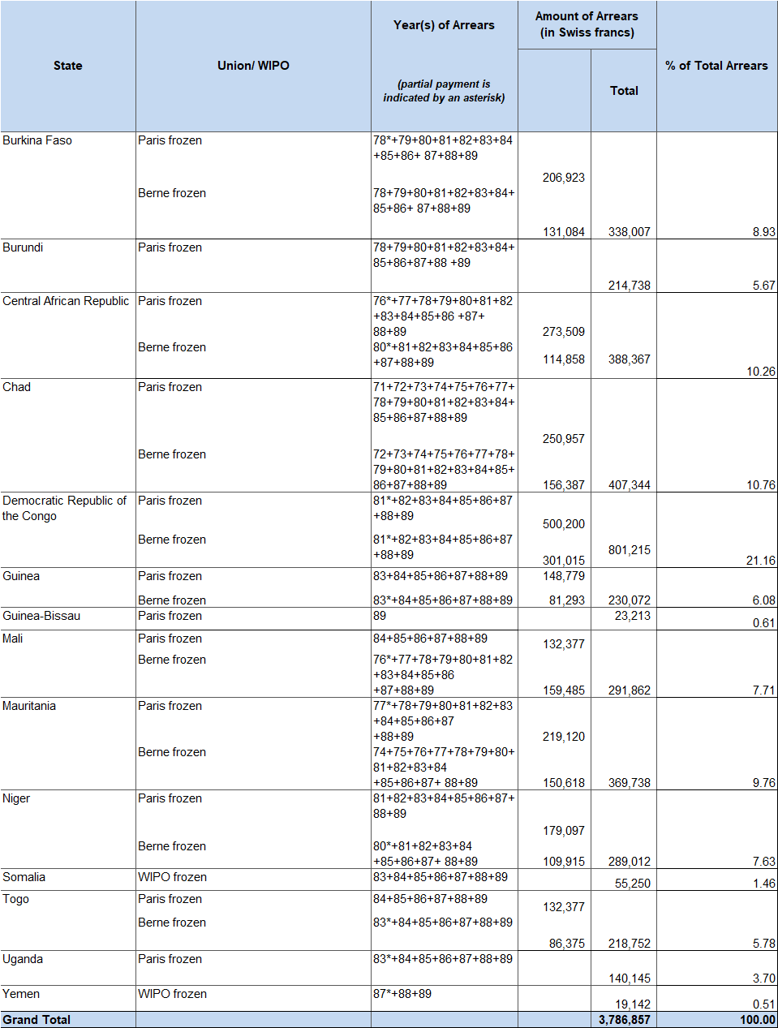

Total amount of arrears of the LDCs placed in a Special (Frozen) Account concerning the years preceding 1990
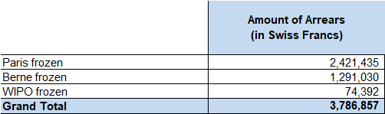

Amounts due towards the Working Capital Funds (WCF)
- The following table shows the amounts due, on June 30, 2025, in the payments by States towards the WCF that have been constituted, namely, those of two Contribution-financed Unions (Paris and Berne). Any payment that reaches the IB between July 1 and July 8, 2025, will be reported to the Assemblies when they consider the present document.
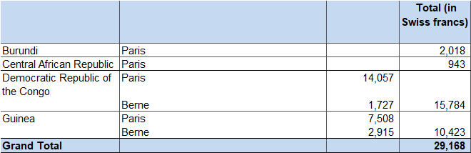

Total amount due towards the WCF

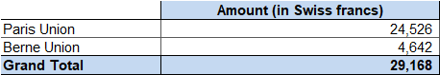

Evolution of Arrears in Contributions and WCF Over the Last Ten Years
- Since the introduction of the unitary contribution system in 1994 and the creation of new, more equitable contribution classes for developing countries, the arrears in contributions and WCF have been reduced significantly. On December 31, 1993, the total arrears in contributions and WCF amounted to 15.12 million Swiss francs and the number of countries having to pay an annual contribution was 140. On December 31, 2024, the total arrears in contributions and WCF amounted to 7.15 million Swiss francs and the number of countries having to pay an annual contribution was 194.
- The following table gives the amounts of arrears in contributions (including the “frozen” arrears of the LDCs) and WCF since 2015.
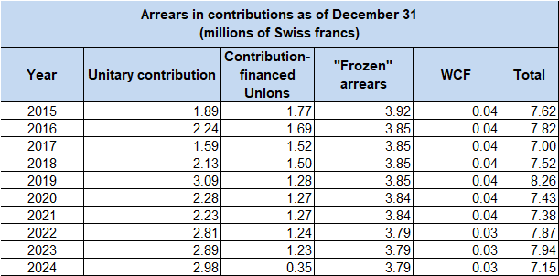
[End of document]

