A/61/INF/3
ORIGINAL: ENGLISH
DATE: august 18, 2020

Assemblies of the Member States of WIPO

Sixty-First Series of Meetings

Geneva, September 21 to 25, 2020

STATUS OF ACCESSIONS TO TREATIES ADMINISTERED BY WIPO, AND CONSTITUTIONAL REFORM MATTERS
Document prepared by the Secretariat
The present document sets out the evolution of membership of treaties administered by the World Intellectual Property Organization (WIPO) from January 1, 1970 to the present date, as well as a status report on constitutional reform matters.
Particular attention is drawn to the WIPO treaties that have been updated, either through the adoption of a new act or instrument (which requires accession), or through an amendment (which requires acceptance), as described in this document (see paragraphs 2, 3, 7, 8 and 25 through 27). Contracting Parties concerned are respectfully invited to consider updating their membership, as applicable.

I. PARTIES TO TREATIES ADMINISTERED BY WIPO

Convention Establishing the World Intellectual Property Organization (1967)
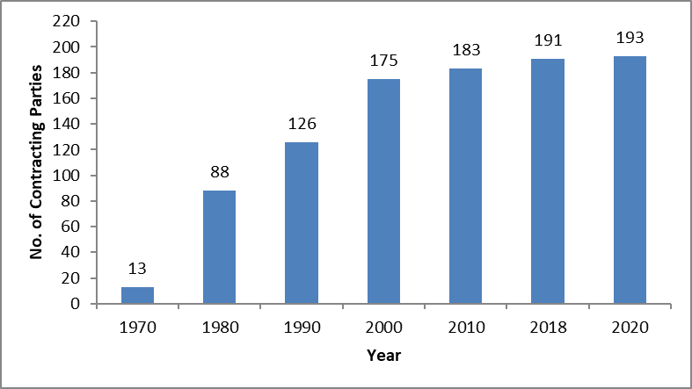

Paris Convention for the Protection of Industrial Property (1883)
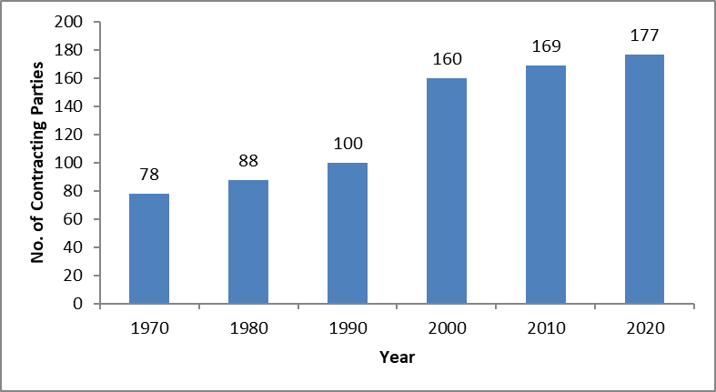
The Paris Convention for the Protection of Industrial Property (the Paris Convention) was revised several times since its conclusion in 1883. It was revised at Brussels (1900), Washington (1911), The Hague (1925), London (1934), Lisbon (1958) and Stockholm (1967), and amended in 1979.
For historical reasons, the Stockholm revision gave Member States the opportunity to accept only one part of the revision (Articles 1 to 12, which constitute the substantive provisions, or Articles 13 to 30, which constitute the final and administrative provisions) or accept one part earlier than the other.
Some Member States that have excluded the substantive provisions from their acceptance of the Stockholm Act, are still, to date, bound by the substantive provisions of an earlier Act, which do not reflect the most up-to-date thinking on matters covered by the Convention. The Member States concerned are Argentina, Bahamas, Lebanon, Malta, Philippines, Sri Lanka, the United Republic of Tanzania and Zambia.
Some other Member States, namely the Dominican Republic and Nigeria, have never acceded to the Stockholm Act, but remain parties to an earlier Act. They are not members of the Assembly of the Paris Union, and thus are not able to participate in the decision-making organ of the Union. The Secretariat has on previous occasions, including by note verbale addressed to the concerned Member States, confirmed its availability to provide information and assistance, in relation thereto.
The Member States concerned are respectfully invited to consider accession to the latest Act of the Convention or to accept all provisions thereof, as applicable.

Berne Convention for the Protection of Literary and Artistic Works (1886)
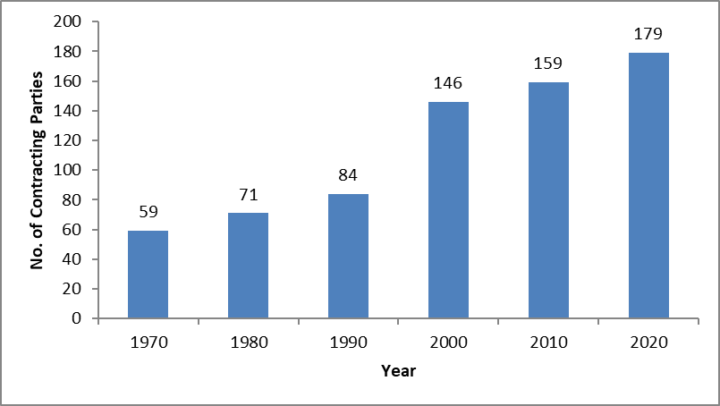
The Berne Convention for the Protection of Literary and Artistic Works (the Berne Convention) was revised several times since its conclusion in 1886. It was completed at Paris (1896), revised at Berlin (1908), completed at Berne (1914), revised at Rome (1928), at Brussels (1948), at Stockholm (1967) and at Paris (1971), and amended in 1979.
For historical reasons, the Stockholm and Paris revisions of the Convention also gave Member States the opportunity to accept only one part of the revision, namely to accept only the final and administrative provisions (Articles 22 to 38). There are still, to date, some States bound by the administrative provisions of the Paris Act only (and in some cases of the Stockholm Act) and not the substantive provisions thereof. The States concerned are Bahamas, Chad, Fiji, Malta, Pakistan, South Africa and Zimbabwe.
Some Member States on the other hand, not being members of either the Stockholm or Paris Acts, are not members of the Assembly of the Berne Union and therefore are not able to participate in the decision-making organ of the Union. Lebanon and Madagascar fall under this category. The same offer for information and assistance, as mentioned above, has been provided to the concerned Member States.
The countries concerned are respectfully invited to accede to, or ratify the latest Act of the Berne Convention or to accept all provisions thereof, as applicable.

Madrid Agreement for the Repression of False or Deceptive Indications of Source on Goods (1891)
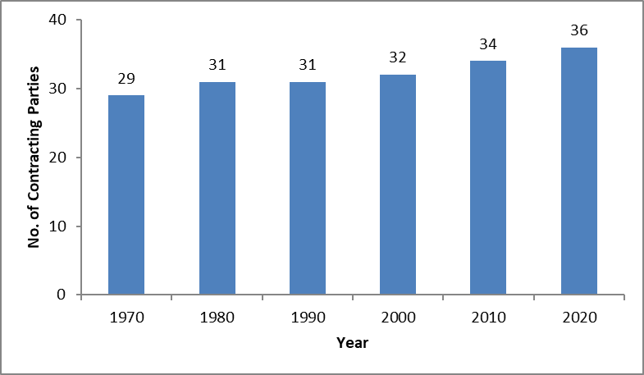

Madrid Agreement Concerning the International Registration of Marks (1891) and Protocol Relating to the Madrid Agreement (1989)
The Madrid System is constituted by two Treaties, namely the Madrid Agreement Concerning the International Registration of Marks and the Protocol Relating to the Madrid Agreement (Protocol). However, the Madrid System is, de facto a one-treaty system with the only applicable Treaty being the Protocol. Since the decision adopted by the Special Union for the International Registration of Marks during its Fiftieth (29th Extraordinary) Session in Geneva, October 3 to 11, 2016, the application of Article 14(1) and (2)(a) of the Madrid Agreement Concerning the International Registration of Marks is frozen, with the effects specified in paragraph 10 of the “Proposal Regarding Accessions to the Madrid Agreement Only” (document MM/A/50/3), as from the date of the decision (see document MM/A/50/5 paragraph 17(ii)).

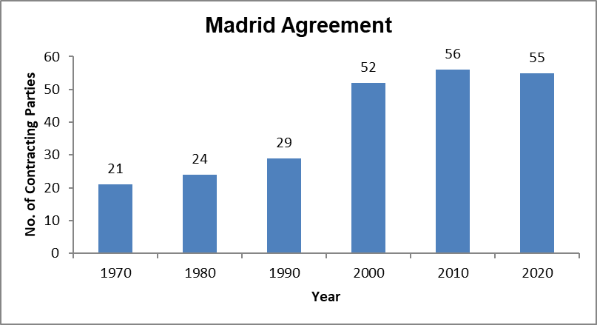
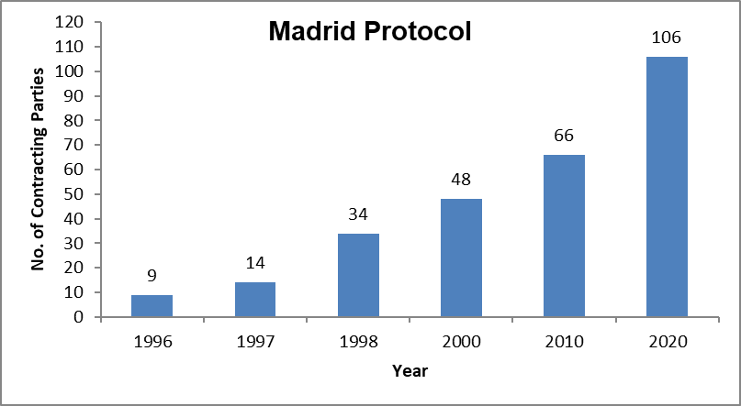

Hague Agreement Concerning the International Registration of Industrial Designs
The Hague Agreement concerning the International Registration of Industrial Designs is constituted by two Acts, namely the Hague Act (1960) and the Geneva Act (1999). It is recalled that the termination of the 1934 London Act became effective on October 18, 2016, which constituted an important first step towards a simplification of the Hague System.
To date, 74 States or intergovernmental organizations are members of the Hague Union, 65 of which are bound by the 1999 Act and 34 of which are bound by the 1960 Act. The two charts below provide information as to the evolution of The Hague Union membership.

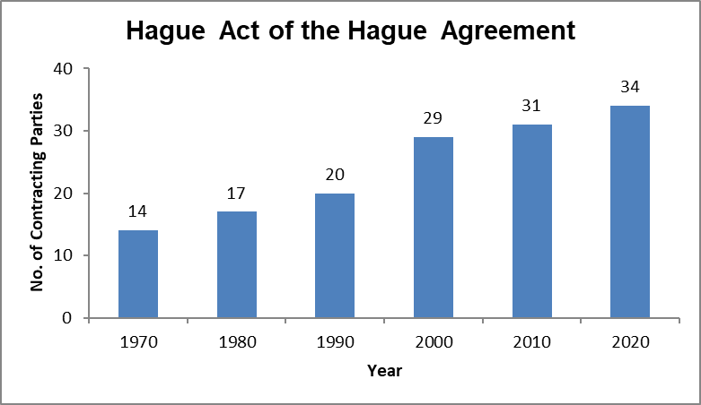
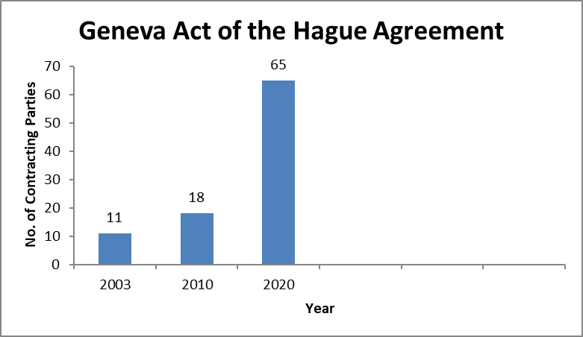

Nice Agreement Concerning the International Classification of Goods and Services for the
Purposes of the Registration of Marks (1957)
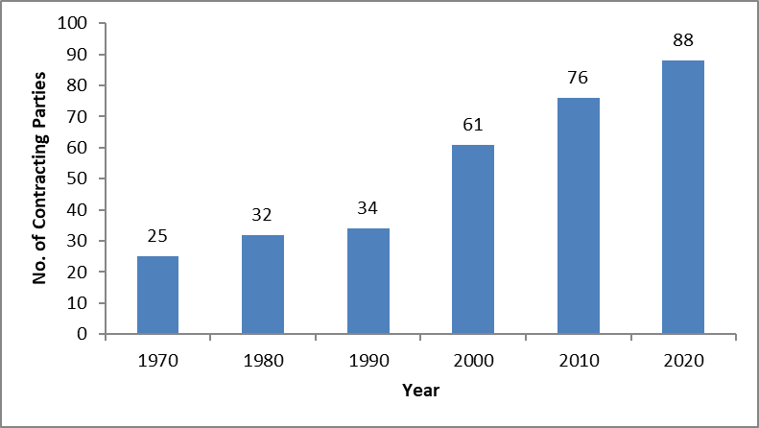
The Nice Agreement was revised twice after its adoption in 1957, namely at Stockholm (1967) and at Geneva (1977). Some Member States remain bound by the Stockholm Act, namely Algeria, Israel and Morocco, and two States by the original Nice Agreement, namely Lebanon and Tunisia (which are therefore not members of the Assembly). These States are respectfully invited to consider acceding to, or ratifying the Geneva Act of the Nice Agreement, and the Secretariat is available for any assistance that may be necessary.

Lisbon Agreement for the Protection of Appellations of Origin and their International
Registration (1958)
The Lisbon Agreement, adopted in 1958, was revised in Stockholm in 1967, and amended
in 1979. The same invitation as applies to the other treaties is extended to Haiti, which is not bound by the Stockholm Act of the Lisbon Agreement and, therefore, is not a member of the Lisbon Assembly.
The Geneva Act of the Lisbon Agreement on Appellations of Origin and Geographical Indications was adopted on May 20, 2015 and entered into force on February 26, 2020. To date, the five contracting parties consist of Albania, Cambodia, the Democratic People’s Republic of Korea, and Samoa, and one intergovernmental organization, namely the European Union.

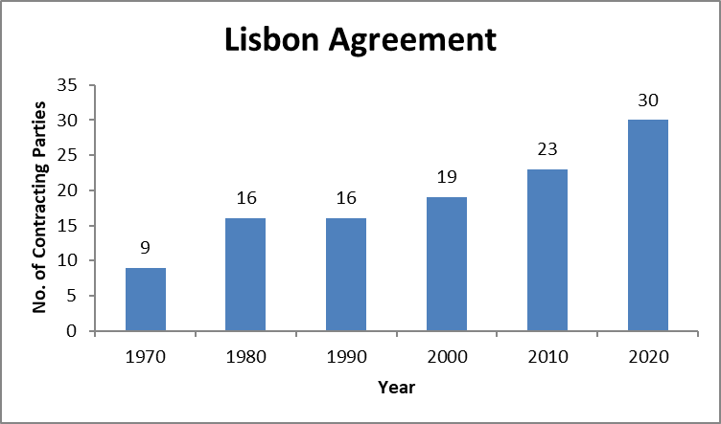
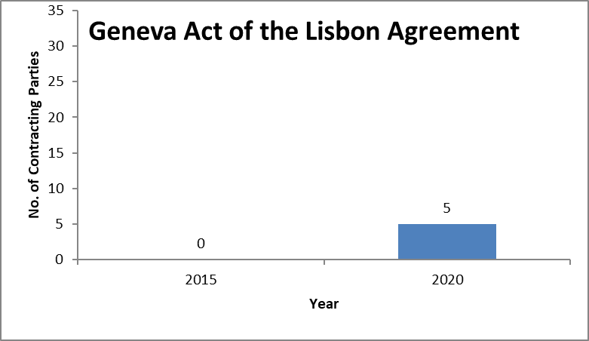

International Convention for the Protection of Producers of Performers, Producers of Phonograms and Broadcasting Organisations (1961)
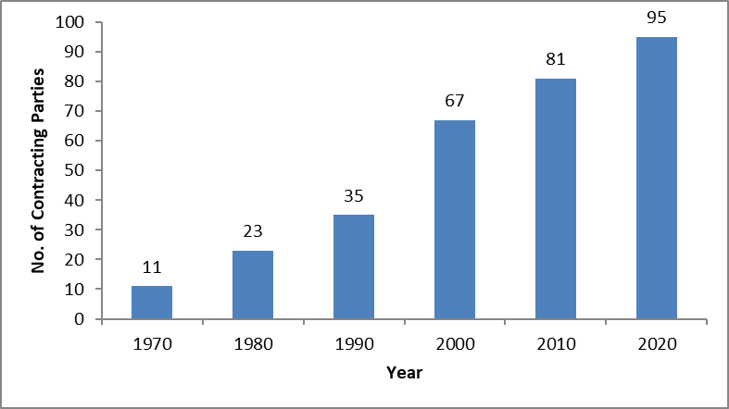

Locarno Agreement Establishing an International Classification for Industrial
Designs (1968)
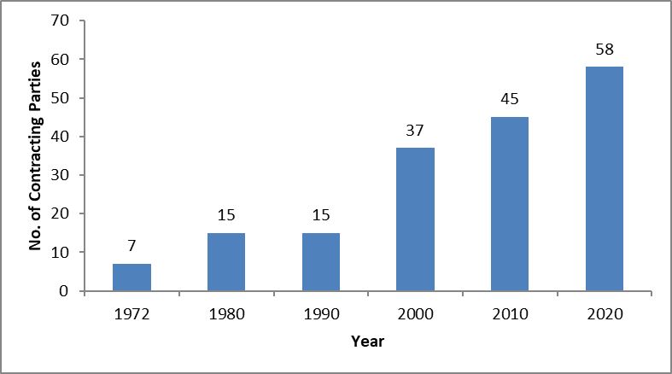

Patent Cooperation Treaty (PCT) (1970)
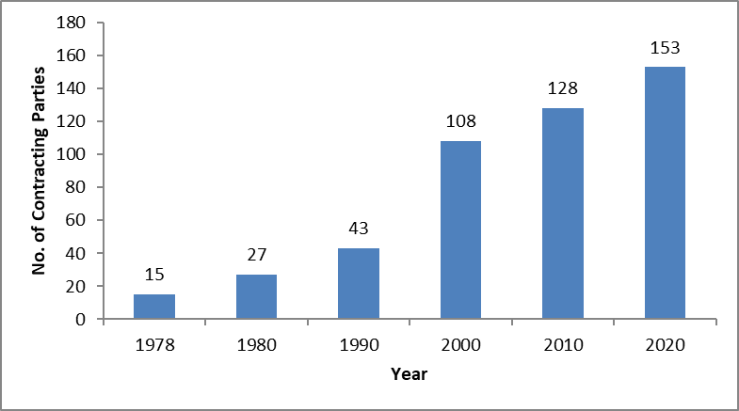

Strasbourg Agreement Concerning the International Patent Classification (1971)
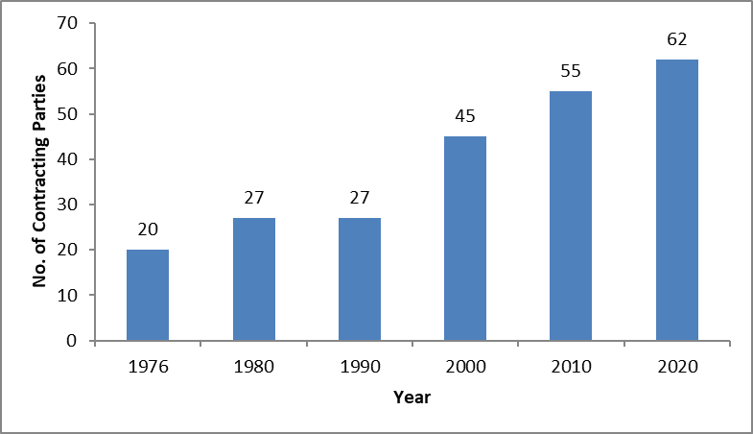

Convention for the Protection of Producers of Phonograms Against Unauthorized Publication of Their Phonograms (1971)
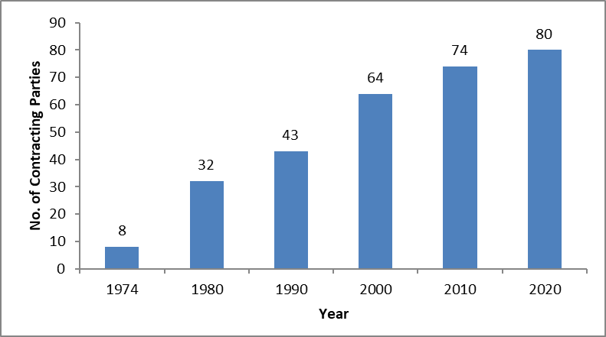

Vienna Agreement Establishing an International Classification of the Figurative Elements of Marks (1973)
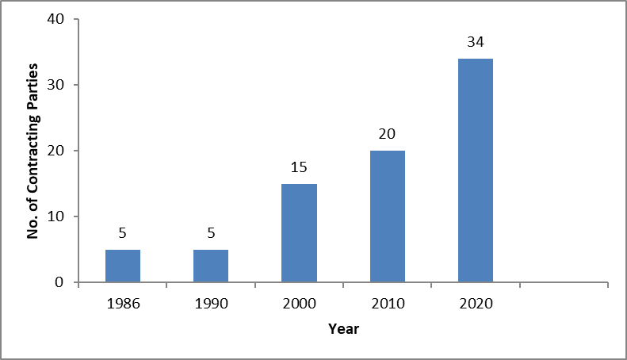

Convention Relating to the Distribution of Programme-Carrying Signals Transmitted by Satellite (1974)
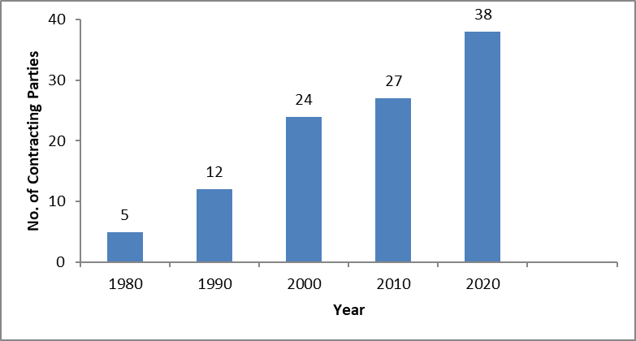

Budapest Treaty on the International Recognition of the Deposit of Microorganisms for the
Purposes of Patent Procedure (1977)
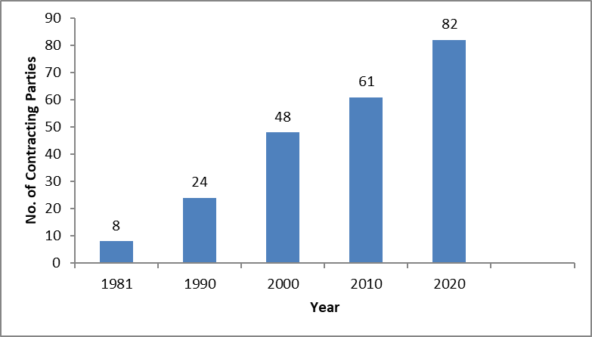

Nairobi Treaty on the Protection of the Olympic Symbol (1981)
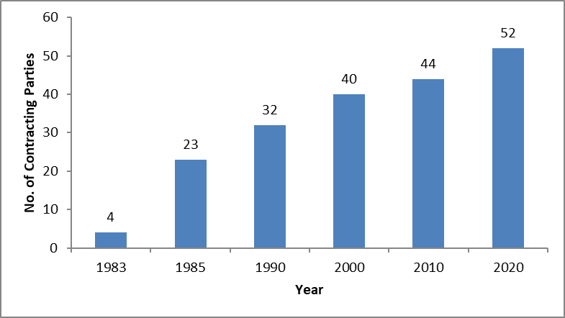

Trademark Law Treaty (TLT) (1994)
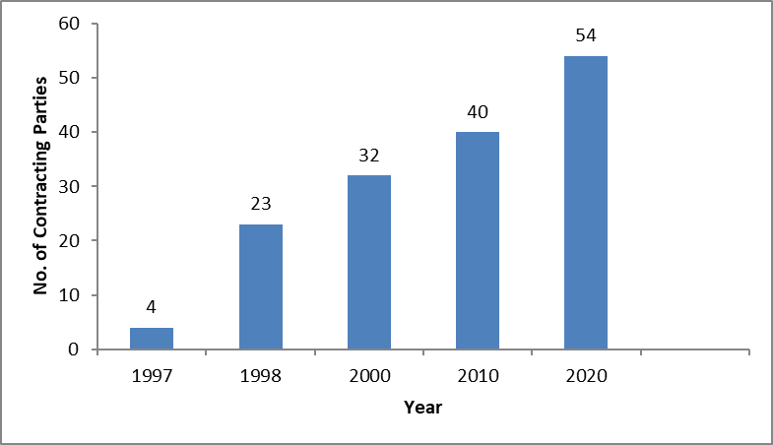

WIPO Copyright Treaty (WCT) (1996)
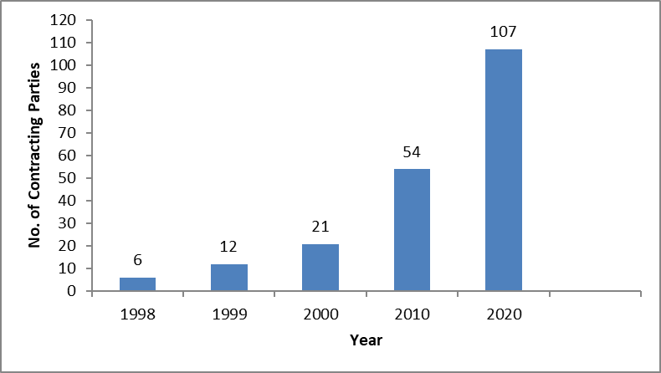

WIPO Performances and Phonograms Treaty (WPPT) (1996)
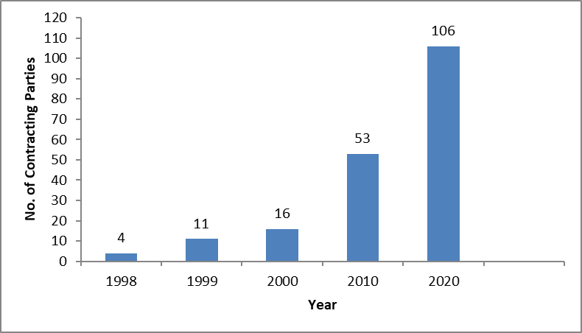

Patent Law Treaty (PLT) (2000)
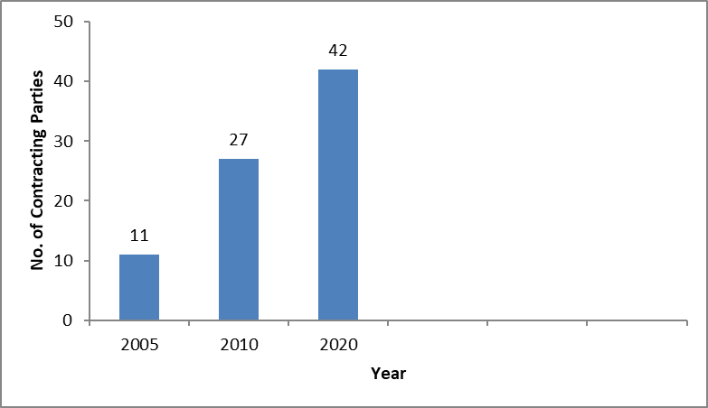

Singapore Treaty on the Law of Trademarks (2006)
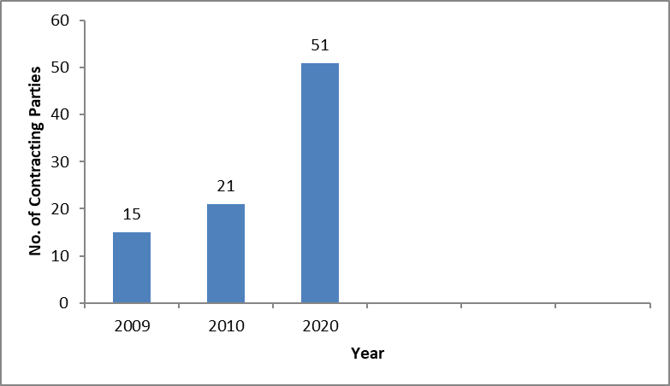

Marrakesh Treaty to Facilitate Access to Published Works for Persons who are Blind, Visually Impaired or Otherwise Print Disabled (2013)
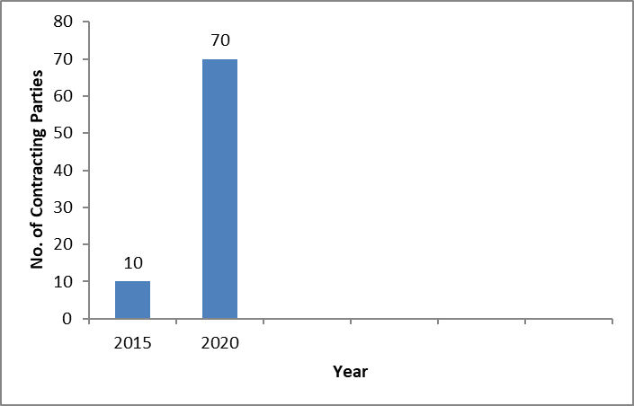

Beijing Treaty on Audiovisual Performances (2012)
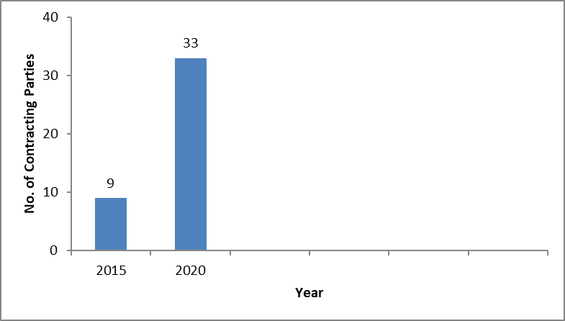

II. Constitutional Reform
25. At the request of the Program and Budget Committee (PBC) in the framework of the discussion on governance issues, the Secretariat made a presentation on the constitutional reform process at the twenty-sixth session of the PBC, held from July 10 to 14, 2017 (see document WO/PBC/26/8).
Following that presentation and at the request of the PBC, the Secretariat reported back to the twenty-eighth, as well as thirtieth, session of the PBC on the status of the implementation of the 1999 and 2003 amendments (see documents WO/PBC/28/12 and WO/PBC/30/13 Rev.).
26. It is recalled that the 1999 amendment to the WIPO Convention would limit the number of mandates of Directors General to two fixed terms of six-years each. The 2003 amendments to the WIPO Convention and to other WIPO-administered treaties would: (i) abolish the WIPO Conference; (ii) formalize the unitary contribution system and the changes in contribution classes that have been practiced since 1994; and (iii) establish annual (rather than biennial) ordinary sessions of the WIPO General Assembly and of the other Assemblies of the Unions administered by WIPO. To date, none of these amendments has entered into force because the Director General has not yet received the requisite number of notifications of acceptance of the amendments from WIPO Member States. As a result, there is a gap between WIPO’s operations and its constitutional structure.
27. Member States are respectfully invited to transmit their instruments of acceptance of the amendments to the WIPO Treaties. By doing so, Member States would close the gap and complete a process of rationalizing the Organization’s governance structure.
[End of document]

For purposes of this update, the relevant treaties are the Paris Convention for the Protection of Industrial Property, the Berne Convention for the Protection of Literary and Artistic Works, the Nice Agreement Concerning the International Classification of Goods and Services for the Purposes of the Registration of Marks and the Lisbon Agreement for the Protection of Appellations of Origin and their International Registration as concerns its Stockholm Act of 1967.
See Part II on constitutional reform.

