|  |  |  |
| --- | --- | --- |
|  | WIPO-E | **E** |
| A/56/5 | | |
| ORIGINAL: ENGLISH | | |
| DATE: AUGUST 2, 2016 | | |

**Assemblies of the Member States of WIPO**

**Fifty-Sixth Series of Meetings**

**Geneva, October 3 to 11, 2016**

PROGRAM PERFORMANCE REPORT FOR 2014/15

*presented by the Director General*

1. The present document contains the Program Performance Report for 2014/15 (document WO/PBC/25/7), which was submitted to the WIPO Program and Budget Committee (PBC) at its twenty-fifth session (August 29 to September 2, 2016).

1. The decisions of the PBC in respect of that document appear in the Decisions Taken by the Program and Budget Committee (document A/56/12).

[Document WO/PBC/25/7 follows]

|  |  |  |
| --- | --- | --- |
|  | WIPO-E | **E** |
| WO/PBC/25/7 | | |
| ORIGINAL: ENGLISH | | |
| DATE: JUNE 27, 2016 | | |

**Program and Budget Committee**

**Twenty-Fifth Session**

**Geneva, August 29 to September 2, 2016**

Program Performance Report FOR 2014/15

*presented by the Director General*

1. The Program Performance Report (PPR) for 2014/15 has been prepared in accordance with WIPO’s results-based management framework. The present report is based on the performance criteria established in the 2014/15 Program and Budget, as approved by the Assemblies of the Member States of WIPO in December 2013 (publication No. 360E/PB14/15).

2. The following decision paragraph is proposed.

*3.* *The Program and Budget Committee (PBC), having reviewed the Program Performance Report (PPR) for 2014/15 (document WO/PBC/25/7), and recognizing its nature as a self‑assessment of the Secretariat, recommended that the Assemblies of the Member States of WIPO acknowledge Programs’ contribution made in 2014/15 to the achievement of the expected results.*

[Program Performance Report for 2014/15 follows]

**PROGRAM PERFORMANCE REPORT FOR 2014/15**

TABLE OF CONTENTS

I. INTRODUCTION 3

II. SUMMARY OF ACHIEVEMENTS IN 2014/15 4

III. CONSOLIDATED BUDGET AND ACTUAL EXPENDITURE 2014/15 21

IV. REPORT ON DEVELOPMENT EXPENDITURES 2014/15 24

V. REPORT ON THE IMPLEMENTATION OF COST EFFICIENCY MEASURES  IN THE 2014/15 BIENNIUM 26

VI. OVERVIEW OF PROGRESS IN 2014/15 BY STRATEGIC GOAL 32

STRATEGIC GOAL I 32

PROGRAM 1 PATENT LAW 34

PROGRAM 2 TRADEMARKS, INDUSTRIAL DESIGNS AND GEOGRAPHICAL INDICATIONS 37

PROGRAM 3 COPYRIGHT AND RELATED RIGHTS 41

PROGRAM 4 TRADITIONAL KNOWLEDGE, TRADITIONAL CULTURAL EXPRESSIONS AND GENETIC RESOURCES 49

STRATEGIC GOAL II 53

PROGRAM 5 THE PCT SYSTEM 56

Program 5 Annex: Indicators of PCT Operations 62

PROGRAM 6 MADRID AND LISBON SYSTEMS 73

Program 6 Annex: Indicators of Madrid Operations 79

PROGRAM 31 THE HAGUE SYSTEM 96

Program 31 Annex: Indicators of the Hague System Operations 100

PROGRAM 7 ARBITRATION, MEDIATION AND DOMAIN NAMES 108

STRATEGIC GOAL III 113

PROGRAM 8 DEVELOPMENT AGENDA COORDINATION 116

PROGRAM 9 AFRICA, ARAB, ASIA AND THE PACIFIC, LATIN AMERICA AND THE CARIBBEAN COUNTRIES, LEAST DEVELOPED COUNTRIES 120

PROGRAM 10 COOPERATIONS WITH CERTAIN COUNTRIES IN EUROPE AND ASIA 130

PROGRAM 11 THE WIPO ACADEMY 136

PROGRAM 30 SMALL AND MEDIUM-SIZED ENTERPRISES (SMES) AND INNOVATION 143

STRATEGIC GOAL IV 149

PROGRAM 12 INTERNATIONAL CLASSIFICATIONS AND STANDARDS 152

PROGRAM 13 GLOBAL DATABASES 155

PROGRAM 14 SERVICES FOR ACCESS TO INFORMATION AND KNOWLEDGE 159

PROGRAM 15 BUSINESS SOLUTIONS FOR IP OFFICES 163

STRATEGIC GOAL V 167

PROGRAM 16 ECONOMICS AND STATISTICS 168

STRATEGIC GOAL VI 172

PROGRAM 17 BUILDING RESPECT FOR IP 173

STRATEGIC GOAL VII 177

PROGRAM 18 IP AND GLOBAL CHALLENGES 178

STRATEGIC GOAL VIII 185

PROGRAM 19 COMMUNICATIONS 187

PROGRAM 20 EXTERNAL RELATIONS, PARTNERSHIPS AND EXTERNAL OFFICES 193

STRATEGIC GOAL IX 208

PROGRAM 21 EXECUTIVE MANAGEMENT 212

PROGRAM 22 PROGRAM AND RESOURCE MANAGEMENT 218

PROGRAM 23 HUMAN RESOURCES MANAGEMENT AND DEVELOPMENT 224

PROGRAM 24 GENERAL SUPPORT SERVICES 231

PROGRAM 25 INFORMATION AND COMMUNICATION TECHNOLOGY 239

PROGRAM 26 INTERNAL OVERSIGHT 245

PROGRAM 27 CONFERENCE AND LANGUAGE SERVICES 249

PROGRAM 28 SAFETY AND SECURITY 254

PROGRAM 29 CONSTRUCTIONS PROJECTS 257

VII. APPENDICES 261

APPENDIX I BREAKDOWN OF THE PERFORMANCE ASSESSMENTS BY PROGRAM 261

APPENDIX II IMPLEMENTATION OF FUNDS-IN-TRUST 2014/15 263

APPENDIX III CAPITAL MASTER PLAN (CMP) PROGRESS REPORT 2014/15 288

PROJECT 1 SECURITY ENHANCEMENT: DATA ENCRYPTION AND USER MANAGEMENT (CMP 1) 289

PROJECT 2 ENTERPRISE CONTENT MANAGEMENT (ECM) IMPLEMENTATION (CMP 2) 292

[PROJECT 3 RENOVATION OF THE FACADES AND COOLING/HEATING INSTALLATION IN PCT BUILDING   
(CMP 3) 298](#_Toc454544510)

PROJECT 4 DEPLOYMENT OF GENEVA LAKE WATER (“GLN”) COOLING SYSTEM TO AB AND PCT BUILDINGS (CMP 4) 302

PROJECT 5 ARPAD BOGSCH BUILDING - PHASE 1 OF BASEMENT RENOVATION (RESIZING OF DATA CENTER AND RENOVATION OF THE PRINTSHOP) (CMP 5) 306

PROJECT 6 ARPAD BOGSCH BUILDING - REPLACEMENT OF CERTAIN WINDOWS (CMP 6) 309

PROJECT 7 SAFETY AND FIREPROTECTION MEASURES (CMP 7) 312

APPENDIX IV ACRONYMS AND ABBREVIATIONS USED IN THE PRESENT DOCUMENT 316

# INTRODUCTION

1. The Program Performance Report (PPR) is the principal accountability tool for reporting on organizational performance to Member States and an integral part of WIPO’s Results Based Management (RBM) framework. The Report also serves as an important learning tool ensuring that lessons from past performance are learned and duly incorporated into the future implementation of WIPO’s activities. The PPR is a self-assessment by Program Managers based on the results framework approved by Member States. As in 2014, the assessment of the implementation of the Development Agenda (DA) was mainstreamed and therefore integrated into the Achievements in the 2014/15 Biennium, as opposed to addressed in a separate section. As part of WIPO’s commitment to strengthening its risk management, the PPR 2014/15 has been enhanced to include, for the first time, a dedicated section on Risk Reporting for the Biennium. To strengthen the validity of the information in the PPR, the Internal Oversight Division (IOD) carries out a validation of the performance data on a biennial basis. The validation of the PPR 2014/15 can be found in document WO/PBC/25/8.
2. The PPR 2014/15 is an end-biennium report, and assesses progress made and/or achievement of the expected results, measured by the Performance Indicators and with the resources approved in the Program and Budget 2014/15[1]. A performance indicator could be measured by more than one target. In such cases, the rating for each target is provided, resulting in multiple ratings. The following assessment criteria have been used for the PPR 2014/15:
3. Key to Traffic Light System (TLS):

* **Fully Achieved** is applied when the 2014/15 performance data suggest 80 per cent or greater achievement of the performance indicator target.
* **Partially Achieved** is applied when the 2014/15 performance data suggest between 30-80 per cent achievement of the performance indicator target.
* **Not Achieved** is applied when the 2014/15 performance data suggest less than 30 per cent achievement of the performance indicator target.
* **Not Assessable[2]** is applied when assessment of the performance is not feasible due to the target not having been adequately defined, when a baseline is not available or when the performance data is insufficient to determine the TLS, and;
* **Discontinued** is applied when a performance indicator is no longer used to measure the performance of the Program.

1. Of a total of 394 performance indicator ratings in the Program and Budget 2014/15, 286 have been assessed as “Fully Achieved”, or 72 per cent. Performance on a total of 19 indicator ratings, or five per cent, were assessed to be “Partially Achieved”, and 46 indicator ratings, or 12 per cent, were assessed to be “Not Achieved”. Some 35 indicator ratings, or nine per cent, were “Not Assessable”, and eight indicator ratings, or two per cent, were “Discontinued”.

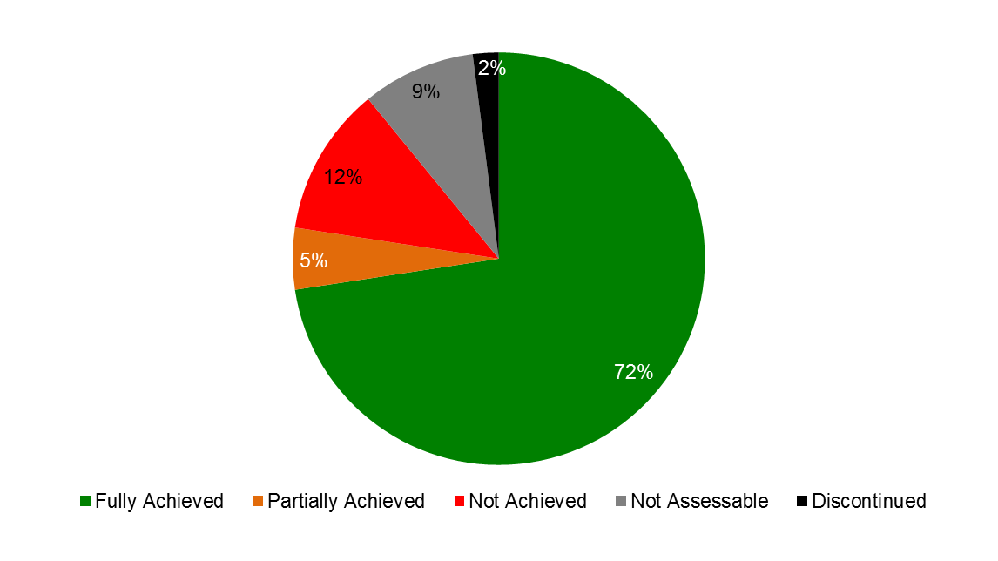

# SUMMARY OF ACHIEVEMENTS IN 2014/15

1. The PPR 2014/15 includes Performance Dashboards for each of the nine Strategic Goals (SGs), providing a graphic summary of the achievements in 2014/15 as measured by the Performance Indicators under the Programs contributing to the respective Goals. In assessing performance, for the first time, an in‑depth analysis of the risks identified in the Program and Budget 2014/15 was performed at the Program level. This included an assessment of the evolution of the risks during the biennium, including whether or not a risk materialized; the implementation of mitigation strategies; and the impact on Program performance towards the delivery of expected results. An overview of WIPO’s strengthened risk management processes can be found under SG IX and Program 22.
2. Highlights of achievements in 2014/15 towards the nine Strategic Goals are summarized below.

**Consolidated view of achievements of the Expected Results in the Biennium 2014/15 by Strategic Goal**

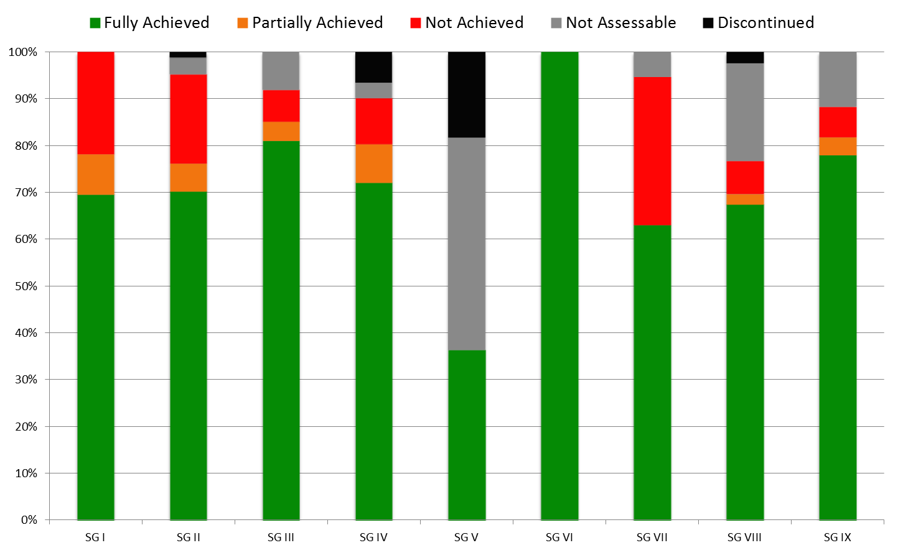

**Strategic Goal I: Balanced Evolution of the International Normative Framework for IP**

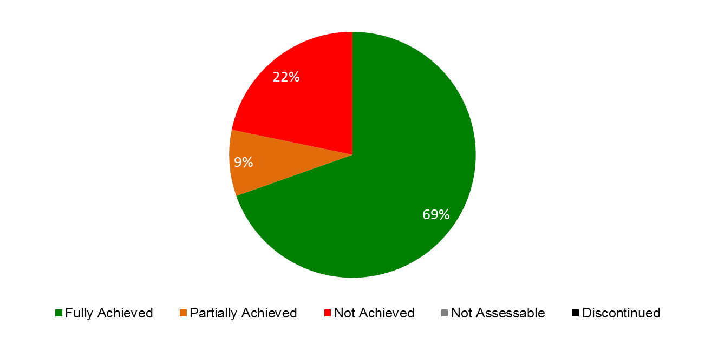

**Summary of Achievements by Expected Results**

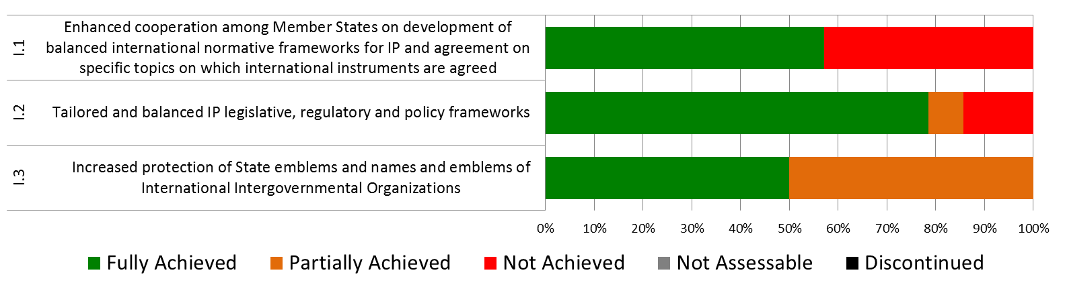

1. Progress continued to be made in 2014/15 under this Strategic Goal, albeit at a slightly slower pace than anticipated. At the end of the biennium, several outstanding issues still remained in the Standing Committees.
2. The progress of the two new copyright treaties toward entry into force continued in 2014 and 2015. The Beijing Treaty on Audiovisual Performances (Beijing Treaty) obtained eight additional ratifications and accessions (Chile, China, Japan, Qatar, Republic of Moldova, Russian Federation, Slovakia and United Arab Emirates) for a total of 10 of the 30 needed to bring it into force. The Marrakesh Treaty to Facilitate Access to Published Works for Persons Who Are Blind, Visually Impaired or Otherwise Print Disabled (Marrakesh VIP Treaty) obtained a total of 80 signatures by the June 2014 deadline. The Marrakesh VIP Treaty obtained 13 ratifications and accessions (Argentina, Australia, Brazil, El Salvador, India, Mali, Mexico, Mongolia, Paraguay, Republic of Korea, Singapore, United Arab Emirates and Uruguay) toward the 20 needed to bring it into force. Although the ratification/accession targets requested for the 2014/15 biennium for these treaties at the twentieth session of the Program and Budget Committee were quite ambitious given the need to hold resource allocations to their proposed levels, the targets were partially achieved by making it a priority to provide assistance to Member States with regard to joining treaties. This approach will be continued in the 2016/17 biennium.
3. Further discussions were held on the topics on the SCCR agenda during the five meetings held in April/May 2014, June/July 2014, December 2014, June/July 2015 and December 2015.   The SCCR discussions addressed a proposed treaty for broadcasting organizations and limitations and exceptions related to libraries and archives, educational and research institutions, and persons with other disabilities (than those covered by the Marrakesh VIP Treaty).   In addition, at the session held in December 2015, the SCCR also received two proposals for new agenda items - one with regard to analysis of copyright related to the digital environment and the other concerning the resale royalty right. The target of having a diplomatic conference and a new treaty was not achieved; Member States requested to remove this target for the 2016/17 biennium.
4. During the biennium, the Standing Committee on the Law of Trademarks, Industrial Designs and Geographical Indications (SCT) continued from its thirty-first through to its thirty-fourth sessions work on a draft Design Law Treaty to be adopted at a Diplomatic Conference. The question of convening such a Diplomatic Conference was dealt with by the WIPO General Assembly at its forty-seventh (22nd ordinary) session in October 2015, where the General Assembly agreed “to convene a diplomatic conference for the adoption of a Design Law Treaty at the end of the first half of 2017, only if the discussions on technical assistance and disclosure have been completed during the thirty-fourth and thirty-fifth sessions of the SCT.” The SCT continued its work on the protection of country names and adopted a Reference Document on the Protection of Country Names against Registration and Use as Trademarks (document WIPO/Strad/INF/7). Furthermore, a number of delegations presented proposals for work by the SCT on geographical indications.
5. The WIPO Intergovernmental Committee on Intellectual Property and Genetic Resources, Traditional Knowledge and Folklore (the IGC) met three times in 2014 (IGCs 26, 27 and 28) in accordance with the renewed mandate of the IGC for the biennium adopted by the WIPO General Assembly in October 2013 and an agreed-upon work program for 2014. IGC 26 included an Ambassadorial/Senior Capital-based officials meeting. By the end of IGC 28, the IGC had further streamlined a consolidated text on genetic resources (GRs) and made further progress on the texts on traditional knowledge (TK) and traditional cultural expressions (TCEs). A Member State-organized inter-sessional meeting held outside Geneva in 2014 gave further impetus to the process. The Secretariat continued to endeavor to play a neutral, professional and efficient facilitatory role in support of the process and to further improve the services provided to IGC participants as a follow up to the evaluation conducted by WIPO’s Internal Oversight Division (IOD) in 2013, which found a high rate (96 per cent) of satisfaction among IGC participants. Although the Secretariat continued to facilitate the participation in the IGC process of indigenous peoples and local communities as far as possible, the WIPO Voluntary Fund for Accredited Indigenous and Local Communities remained depleted. The WIPO General Assembly in October 2014, while considering the texts and the progress made, was not in a position to agree on an IGC work program for 2015. The WIPO General Assembly in October 2015 agreed upon a renewed mandate for the IGC for the 2016/17 biennium.
6. In view of enhancing cooperation among Member States on further developing balanced policy and normative frameworks for the international patent system, the twentieth, twenty-first, twenty-second and twenty-third sessions of the Standing Committee on the Law of Patents (SCP) were held in January and November 2014 and July and December 2015, respectively. The SCP continued to examine five topics on its agenda, namely: (i) exceptions and limitations to patent rights; (ii) quality of patents, including opposition systems; (iii) patents and health; (iv) confidentiality of communication between clients and their patent advisors; and (v) transfer of technology.

**Strategic Goal II: Provision of Premier Global IP Services**

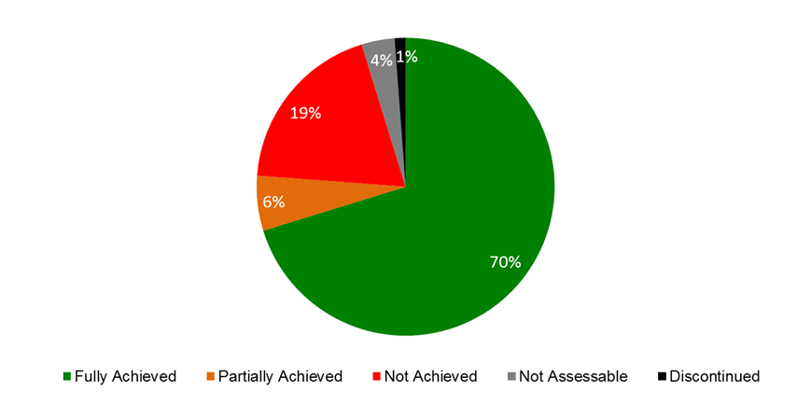

**Summary of Achievements by Expected Results**

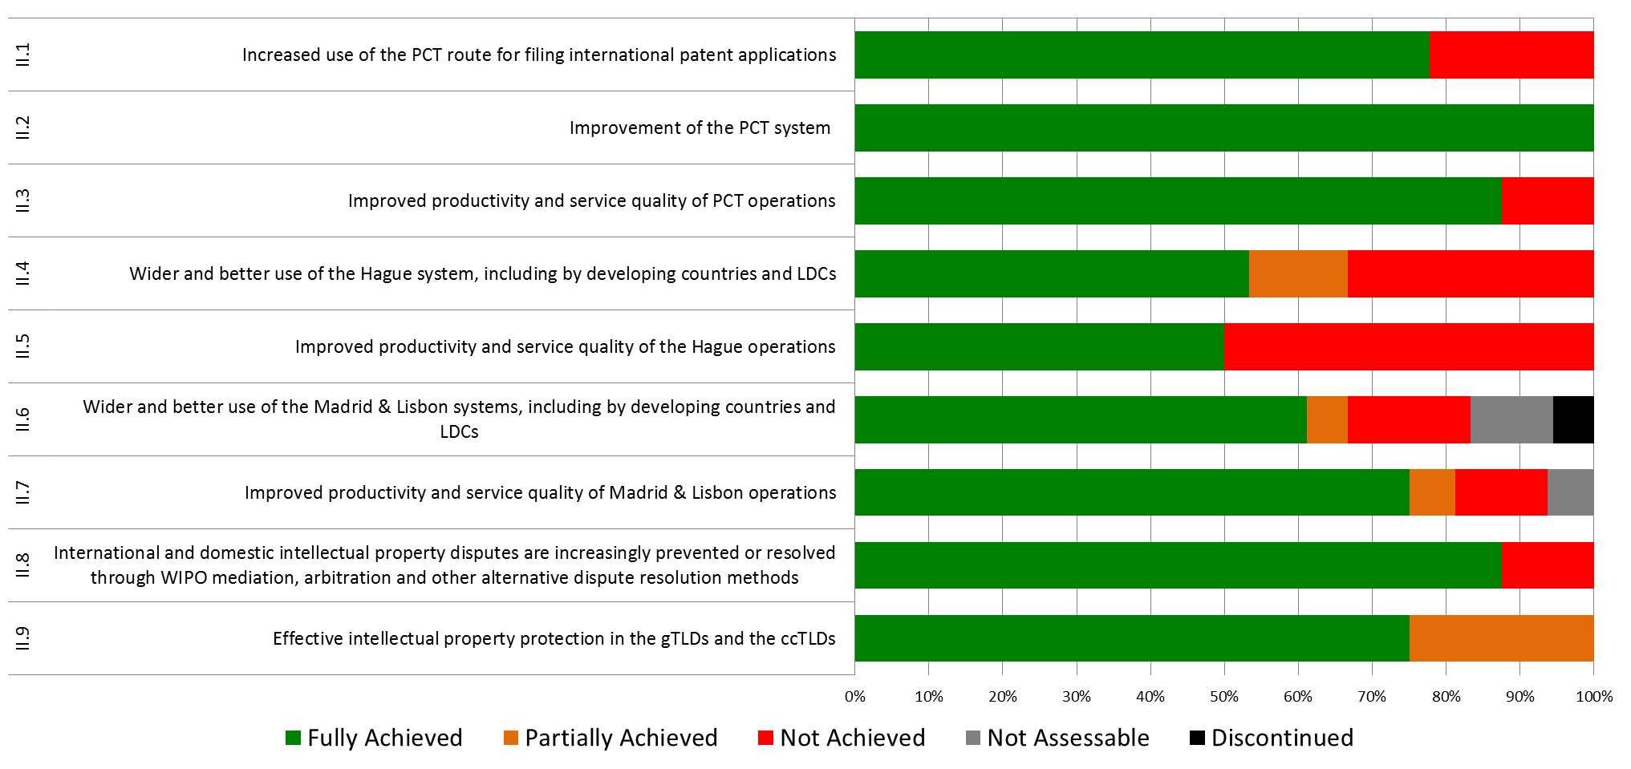

1. The biennium saw considerable growth in the international registration systems for the fifth and sixth consecutive years despite a continuing fragile global economy.
2. Growth in international patent filings under the Patent Cooperation Treaty (PCT) remained strong both in 2014, with a total of 214,500 applications, representing an increase of 4.5 per cent over 2013, and in 2015, with 218,000 applications, representing a 1.7 per cent increase over 2014. The year 2015 marked a new annual record in patent filings. Three telecom giants from China and the United States of America led the international patent filing activity in both years of the biennium.
3. At its seventh and eighth sessions, held in 2014 and 2015, the PCT Working Group continued its discussions on a number of proposals aimed at improving the functioning of the PCT system. Discussions were in line with recommendations endorsed by the Working Group at its third session, which include recommendations as to how the future development of the PCT can be matched with applicable DA Recommendations – notably from Clusters A and C. Particular achievements in 2014 included: (i) agreement on new eligibility criteria for fee reductions for applicants from certain countries, which expanded the number of developing countries and LDCs benefitting from such fee reductions; and (ii) a revised procedure for the appointment of new International Searching and Preliminary Examining Authorities to help ensure that prospective Authorities have the infrastructure and resources to perform this role. Notable achievements in 2015 included: (i) agreement to forward search and classification results from earlier applications to International Searching Authorities to bring about further efficiencies and contribute to raising quality in international search; and (ii) agreement to require designated Offices to send timely information to the IB on applications in the national phase, which will significantly improve information on pending and granted national patent rights. The IB also presented estimations on how responsive PCT filings are to changes in the international filing fee, showing simulations on the effect of possible fee reductions for universities and public research organizations in both developed and developing countries.
4. Use of the Madrid System increased by 2.3 per cent in 2014 as compared to 2013, with a total of 47,885 applications received. In 2014, the United States of America surpassed Germany as the biggest user of the Madrid System, illustrating the geographical transformation of the System. In 2015, a total of 49,273 applications were received representing a 2.9 per cent growth over 2014. This represents healthy growth in the biennium, in particular taking into account that the Madrid System became more expensive for applicants from a number of important filing countries following the sharp appreciation of the Swiss franc in 2015. The geographical expansion of the System saw important positive developments in the biennium. In 2014, Zimbabwe and the *Organisation Africaine de la Propriété Intellectuelle* (OAPI) acceded to the Madrid Protocol. With OAPI being a 17-country intergovernmental organization, these two accessions alone increased the number of countries in which users can protect and manage their trademarks centrally through the Madrid System from 94 to 110 in 2014 alone. In 2015, Algeria, Cambodia, the Gambia and Lao People’s Democratic Republic also acceded to the Protocol, bringing the total number of Contracting Parties at the end of the biennium to 97, covering 113 countries. As Algeria was the last remaining Contracting Party of the Madrid Union to be a member of the Madrid Agreement only, the Madrid System, for practical purposes, now operates as a single treaty system.
5. The Hague System experienced good growth in 2014/15. In 2014, the Republic of Korea, and in 2015, Japan, Turkmenistan and the United States of America became party to the Geneva (1999) Act of the Hague Agreement Concerning the International Registration of Industrial Designs (hereinafter referred to as “the 1999 Act”). Those accessions brought the number of Contracting Parties to that Act to 50. Although this number remained lower than the target, accessions in particular by the Republic of Korea, the United States of America and of Japan, which respectively rank as the third, fourth and fifth jurisdictions worldwide in terms of design filings, significantly raised the attractiveness of the Hague System. Consequently, international applications increased by over 40 per cent in 2015, a figure well above the expected increase on 2014. Also as a result of this expansion, by the end of the biennium, there were already strong indications of interest to join amongst other prospective Contracting Parties, including from countries bound by the older Acts. In that respect, at the end of 2015, only two consents were still required for the termination of the 1934 Act, whilst four Contracting Parties outside the European Union (EU) and *Organisation Africaine de la Propriété Intellectuelle* (OAPI) remained bound only by the 1960 Act.
6. The Assembly of the Lisbon Union mandated the Working Group on the Development of the Lisbon System, in 2009, to engage in a full review of the Lisbon System aimed at making the system more attractive for users and prospective new Members, while preserving its principles and objectives. In view of the progress made by the Working Group, the Lisbon Union Assembly approved in 2013 the convening of a Diplomatic Conference for the Adoption of a Revised Lisbon Agreement on Appellations of Origin and Geographical Indications in 2015. In October 2014, the Working Group finished its preparatory work. From May 11 to 21, 2015, the Diplomatic Conference for the Adoption of a new Act of the Lisbon Agreement took place in Geneva and adopted, on May 20, 2015, the Geneva Act of the Lisbon Agreement on Appellations of Origin and Geographical Indications.
7. Building on the findings of the WIPO Center’s 2013 International Survey on Dispute Resolution in International Technology Transactions, the WIPO Center in 2014/15 worked to optimize the potential of its procedures to meet the needs of IP right holders and users. The year 2014 marked the 15th anniversary of the WIPO-developed UDRP. Since the WIPO Center administered the first UDRP case in 1999, total WIPO case filings have surpassed the 33,000[3] mark, encompassing over 61,000 domain names. Cybersquatting case filings by trademark owners alleging abuse of their mark with WIPO increased in 2014 by 1.9 per cent from the 2013 level, with a further increase of 4.6 per cent in 2015 as compared to 2014. This included the first UDRP cases in relation to registrations in new gTLDs, which represented 6.8 per cent of disputed domain names in 2014/15. WIPO UDRP cases involved parties from 108 countries in 2014 and 113 countries in 2015. Among the top five users in the biennium, the United States of America saw the highest growth in cases filed (14.3 per cent) in 2014 and Germany (43.6 per cent) in 2015. The top three sectors of complainant activity were: retail (13 per cent), banking and finance (11 per cent) and fashion (10 per cent) in 2014; and fashion (10 per cent), banking and finance (nine per cent), and Internet and IT (nine per cent) in 2015.

**Strategic Goal III: Facilitating the Use of IP for Development**

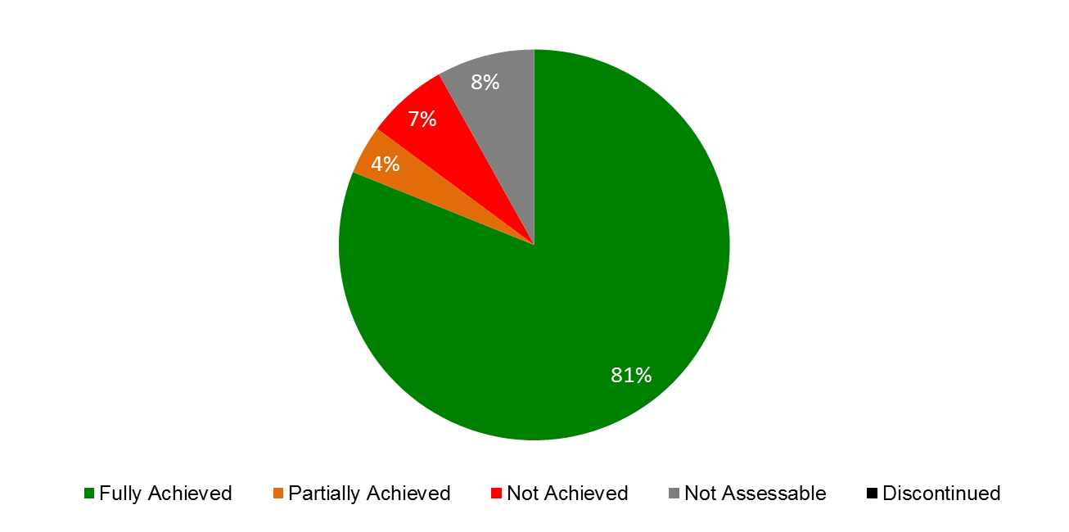

**Summary of Achievements by Expected Results**

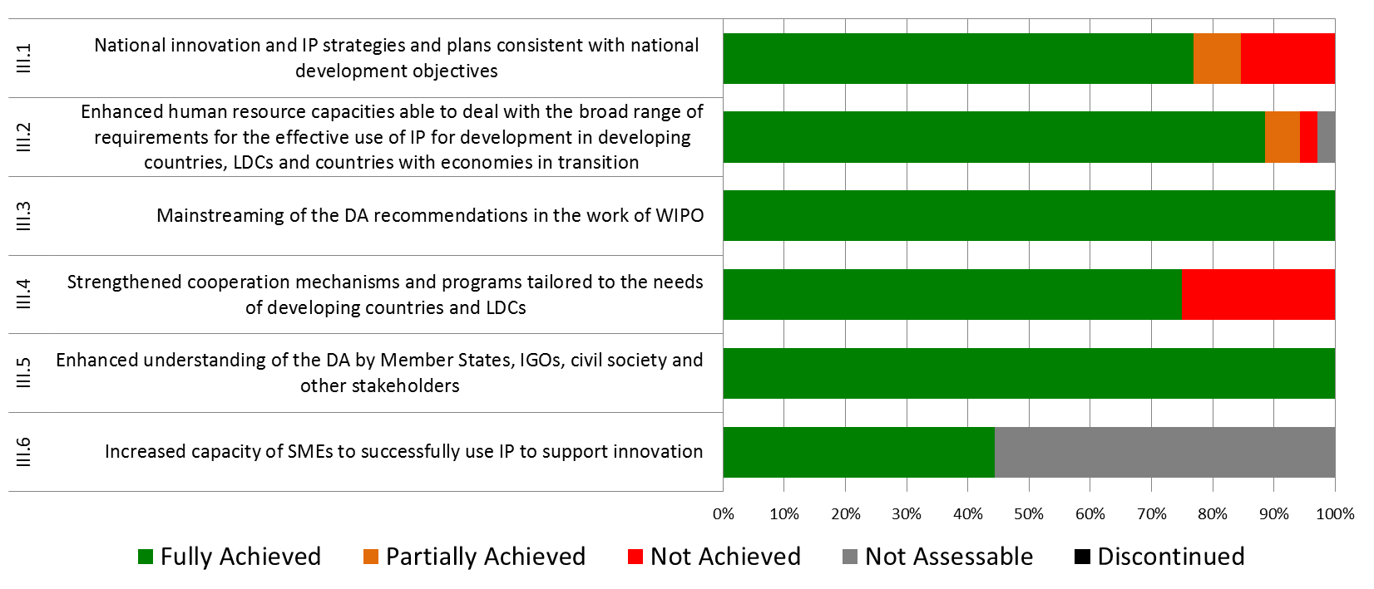

1. Facilitating the use of IP for development and empowering developing countries, LDCs and countries in transition, to harness IP for enhancing national innovation potential and capacities continued to be a priority in the biennium.
2. WIPO continued to assist developing countries and LDCs in the design, development and implementation of national IP strategies that are both consistent with their overall development plans and that have the ability to foster innovation and creativity. The application of the standardized, yet flexible, methodology and set of practical tools for the formulation of national IP strategies and plans, developed as part of the DA project on Improvement of National, Sub-regional and Regional IP Institutional and User Capacity in 2012, continued to guide the process. As a result, 15 countries (six in Africa, five in Asia and the Pacific, and four in Latin America and the Caribbean) initiated the process of formulating national IP strategies/development plans, and 13 countries (four in Africa, two in the Arab region, three in Asia and the Pacific, and four in Latin America and the Caribbean) were still in the process of formulation and/or adoption at the end of 2014. At the end of 2014/15, national IP strategies/development plans had been adopted and/or were under implementation in a total of 44 countries (26 in Africa, two in the Arab region, eight in Asia and the Pacific, and eight in Latin America and the Caribbean), of which 19 in LDCs.
3. In line with the cooperation plans and national IP strategies and, following WIPO assistance, including promotional activities, the following nine countries amended their national IP legislation and/or joined WIPO-administered Treaties: Kazakhstan, Kyrgyzstan, Latvia, Lithuania, Montenegro, the Republic of Moldova, the Russian Federation, Tajikistan and Turkmenistan. Promotion of the importance of and/or assistance in the development and implementation of long‑term and comprehensive national IP strategies to meet the needs of Member States remained a priority in 2014/15. Six countries (Bulgaria, Slovenia, Tajikistan, Turkey, Turkmenistan and Ukraine) adopted IP related national strategies and four countries (Albania, Georgia, Latvia and Poland) initiated the development of a new strategy.
4. In 2014/15, the WIPO Academy initiated the implementation of a reform process and repositioning itself as the core entity in WIPO for providing professional training, education and capacity‑building on IP for government officials and other stakeholders. Throughout this process, the WIPO Academy endeavored to maintain the quantity, quality and frequency of the training programs regularly provided in order to meet the ongoing training obligations with partners; to respond to new and urgent training requests of Member States and other stakeholders; and to preserve the continuum of the training provided. During the biennium, some 80,000 persons benefited from its programs and activities.
5. With regard to the Professional Development Program (PDP), some 35 training courses were offered jointly with 22 partner institutions in Algeria, Austria, Brazil, Cameroon, Canada, Costa Rica, Finland, France, Germany, Indonesia, Israel, Malaysia, Mexico, Morocco, Norway, Paraguay, Peru, Spain, Switzerland, and the United Kingdom, as well as the World Trade Organization (WTO) and the *Centre d’Etudes Internationales de la Propriété Intellectuelle* (CEIPI), in Strasbourg, France. The Distance Learning Program (DL) continued to attract participants from a broad group of stakeholders. In 2014/15, some 78,551 participants from 193 countries (67,809 under its general courses and 10,742 under its advanced courses), a 3.6 per cent decrease from 2012/13, benefited from the enhanced e-learning Centre (WeLC). Of particular note, demand for the advanced courses from IP Offices, other governmental bodies, start-up academies and TISCs, in developing countries and LDCs, increased by 138 per cent[4] to an all-time high of 6,926 as compared to 2,907 in the previous biennium.
6. In 2014, the start-up academies project was mainstreamed into the WIPO Academy’s regular programs following approval by the fourteenth Session of the CDIP of an independent evaluation of the project. Cooperation continued, throughout the biennium with the six start-up academies that were established during the CDIP project phase (Colombia, Dominican Republic, Egypt, Ethiopia, Peru and Tunisia). New agreements to establish national IP Training Centers (start-up academies) were signed with the Governments of Azerbaijan, Cambodia, Costa Rica, Ecuador, El Salvador, Georgia and Turkey. Further requests from Member States seeking assistance to establish national IP Training Centers were received in 2014/15 and will be addressed in 2016/17.
7. Enhancing human resource capabilities to deal with the broad range of requirements for the effective use of IP for development and fostering innovation and creativity remained a priority throughout the biennium. Focused capacity building and skills development programs were delivered to specific target groups such as government officials, policy-makers, IP professionals, enforcement officials, researchers and academics, entrepreneurs and industrialists, as well as SMEs, at the national, sub-regional and regional levels. Some 33 programs on effective IP asset management by SMEs, benefitting over 700 participants, were organized, aiming at creating a critical mass of trainers in specific countries with knowledge, skills and experience to provide basic assistance to SMEs on IP asset management.
8. WIPO also strengthened its cooperation with LDCs for the development of a framework for national policies on innovation; assessing technical skills needs; facilitating access to global scientific and technological information platforms; establishing innovation support infrastructure; supporting inventories and capacity building in traditional knowledge. As part of Phase II of the DA Project on Capacity building in the Use of Appropriate Technology Specific Technical and Scientific Information as a Solution for Identified Development Challenges, MoUs were signed with four LDCs (Ethiopia, Rwanda, United Republic of Tanzania and Uganda, and by the end of 2015, implementation of the project had begun in three LDCs (Ethiopia, Rwanda, and United Republic of Tanzania).
9. In the same vein, WIPO worked closely with the United Nations Office of the High Representative for Least Developed Countries, Landlocked Developing Countries and Small Island Developing States in the context of the implementation of the Istanbul Program of Action. In 2014, on the occasion of the LDCs’ Ministerial Conference held in Benin, WIPO implemented an interregional partnership program in cooperation with the International Telecommunication Union (ITU), the United Nations Capital Development Fund (UNCDF) and the United Nations Industrial Development Organization (UNIDO). In 2015, two additional partnership cooperation fora were established, with the United Nations Economic Commission for Asia and the Pacific (UN ESCAP) and the United Nations Economic Commission for Africa (UNECA). The partnership with UN ESCAP led to a proposal for the signing of a MoU between the two organizations. The focus was on capacity building and strengthening institutions of the LDCs from Africa and Asia.
10. During the biennium, the CDIP considered and discussed various documents and studies. In addition, the Committee approved proposals for second phases of two completed and evaluated projects, three new projects proposals and new activities Related to Using Copyright to Promote Access to Information and Creative content. Furthermore, the Committee approved the Terms of Reference (TORs) for the Independent Review of the Implementation of the Development Agenda Recommendations and took a decision on the convening of the International Conference on Intellectual Property and Development.

**Strategic Goal IV: Coordination and Development of Global IP Infrastructure**

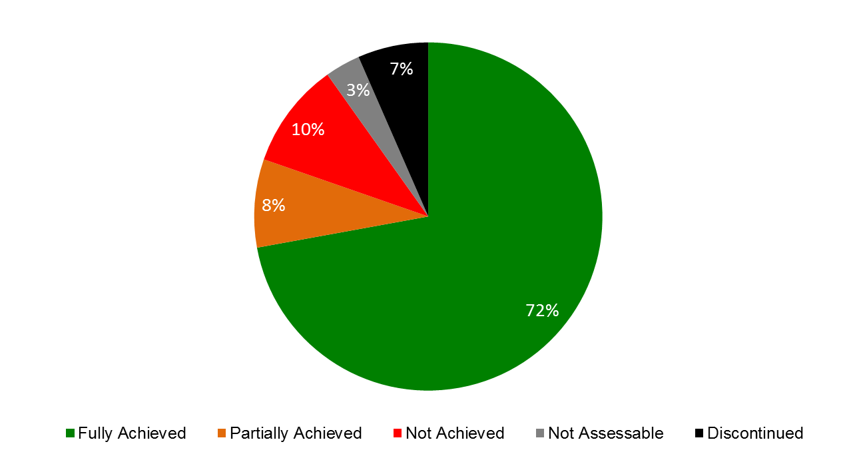

**Summary of Achievements by Expected Results**

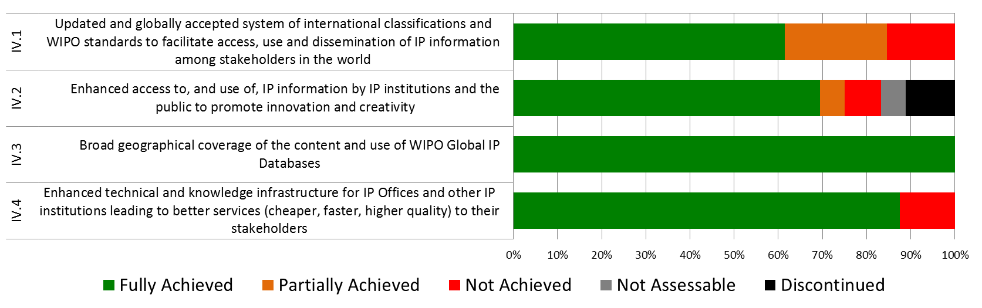

1. With a focus on enhancing the global IP infrastructure to help meet the growing global demand on the IP system and facilitating the participation of developing countries and LDCs in the system, good progress was made in the areas of global IP databases, classifications, IP office modernization, and TISCs in 2014/15.
2. The PATENTSCOPE system was further strengthened in 2014/15 with a significant focus on improving access to the system in regions experiencing poor latency. Demonstrable improvements were also achieved for users in Asia. Two additional languages were developed for inclusion in the Cross Lingual Information Retrieval (CLIR) multilingual searching system, bringing the total number of languages to 14 by the end of the biennium. WIPO Translate[5], a statistical machine translation system developed in-house, was extended to include three additional and difficult language pairs by biennium end: English and Korean, English and Russian, and English and Spanish, bringing the total number to seven, as well as expanding the coverage of English and Chinese to include descriptions and claims.
3. The PATENTSCOPE service continued to show high levels of usage with an average of 500,000 unique page views per day. Use of PATENTSCOPE remained stable with over 221,000 unique visitors per quarter by the end of the biennium, showing that service levels for the PATENTSCOPE search engine are now sufficiently mature to arrive at the point of diminishing returns. The number of collections in PATENTSCOPE also saw a 19 per cent increase from 2013, bringing the total number of national and regional collections to 43 (as compared to 36 at the end of 2013) and the total number of records contained to more than 50 million (as compared to 34 million at the end of 2013), a 47 per cent increase over 2013.
4. With the introduction of a powerful image similarity search function, use of the Global Brand Database exceeded expectations in 2014/15, with a fourfold increase in the number of unique visitors per quarter to more than 80,000 as compared to 23,000 at the end of 2013. The number of national collections more than doubled from 12 at the end of 2013 to 26 at the end of 2015. Likewise, the total number of records contained in the system also more than doubled in 2014/15, from 12 million to over 24 million records.
5. Of particular note in the biennium was the launch in January 2015 of a new service, the Global Design Database for industrial designs. By the end of 2015, just one year after its introduction, the Global Design Database had already reached an impressive 14,000 unique visitors per quarter. In addition, the number of national collections had reached five and contained more than 1.5 million design documents.
6. Despite uneven progress in 2014, the situation as regards International Classifications and WIPO IP Standards improved substantially in 2015, exceeding expectations in certain areas and trailing behind in others. As regards the Nice Classification (NCL), a total of 1,480 new amendments and 25 new information files were introduced in the biennium. The number of amendments represents a 94 per cent increase over 2012/13. In the IPC, the modified publication platform to facilitate the use of the system, including a new search tool and the IPC/CPC/FI parallel viewer, was launched in April 2014. Due to the increase of new revision projects coming from the IP5 Offices and from the IPC community, the number of new subdivisions introduced in 2015 (1,031) exceeded the annual target by 28 per cent, rebounding from 2014 to achieve the target. At its fourth session, the Committee on WIPO Standards (CWS) was unable to adopt an agenda, resulting in informal decisions not being formalized. Despite this set-back, there was one new standard adopted and one standard revised informally in 2014. This standstill continued in 2015, resulting in the lack of formal approval of new Standards. Nonetheless, the informal work continued in the Task Forces, groups consisting of experts nominated by the CWS members and observers to address specific tasks. Several Standards are expected to be adopted when the CWS resumes in 2016. The use of internet tools for accessing classifications and standards publications showed stable growth with visits to the IPC Publications substantially higher (a 107 per cent increase over 2013), due to the inclusion of revised classifications and new tools.
7. The biennium 2014/15 brought the total number of Member States that had established Technology Innovation Support Centers (TISCs) in their countries to 50, with 11 additional networks, a 28 per cent increase over 2012/13. The focus remained on reinforcing the long-term sustainability of the networks, and by the end of 2015, 25 TISC networks were considered sustainable. The eTISC knowledge management platform continued to experience strong growth, more than doubling its membership to nearly 1,500 members from over 115 countries by the end of 2015, as compared to 700 members in the previous biennium. The eTISC platform added 16 training webinars and hosted 10 live question-and-answer sessions with innovation support experts.
8. To respond to the demand, the IB continued to develop the products to support IP Offices’ business processes, in particular the Industrial Property Administration System (IPAS) and supporting modules. Major new features deployed during the biennium included better support for electronic document management and support for bilingual operations, particularly for Offices working in the Arabic language. Two new modules were developed and piloted in several IP Offices:

* WIPO Publish was designed to meet Offices’ needs for online publication of IP data, documents, legal status and dossier information, as well as data exchange needs (including data exchange for WIPO global databases). It was deployed for internal use in more than 10 Offices and for online dissemination of IP information in several other Offices.
* WIPO File was designed to provide an online filing solution for small and medium offices, including the flexibility to be extensively customized for local conditions (e.g. for local payment systems). WIPO File was successfully piloted in one IP Office and is being used for online filing at that Office.

1. The WIPO Copyright Connection (WCC) project (successor to WIPOCOS) was also launched in 2014, with the aim of releasing an interconnected system for the management of author and neighboring rights. The system was in the final development phase at the end of 2014/15 and will be deployed in CMOs in developing countries and LDCs starting in 2016.
2. Based on a specification and review process with participating Offices, a new version of the Digital Access Service (DAS) portal to support the revised framework of DAS 2.0 was launched in December 2014. The number of participating Offices remained steady at 11. In April 2014, the WIPO Centralized Access to Search and Examination (CASE) was linked to the IP5 One Dossier Portal system, allowing full two-way exchange of dossier information between CASE and IP5 Offices. Several new Offices registered to use WIPO CASE during the biennium, bringing the total number of participating Offices to 21, of which 10 have agreed to provide their dossier information to others.
3. In June 2014, a new multi-stakeholder entity, the Accessible Books Consortium (ABC), was established to increase the number of books available in accessible formats to people with print disabilities worldwide. The ABC carried out three main activities: (i) technical assistance in accessible book production (funded by the Governments of Australia and the Republic of Korea); (ii) inclusive publishing, which promotes technologies that allow for “born accessible” publishing so that new books are usable from the start by both sighted people and people with print disabilities; and (iii) the ABC Book Service, also known as TIGAR, an international database of accessible titles in 55 languages. Under the first activity, the ABC produced 1,580 educational books benefiting 23,500 print-disabled students in Bangladesh, India, Nepal, and Sri Lanka. Under the second activity, the ABC sponsored the Charter for Accessible Publishing and the ABC International Excellence Award for Accessible Publishing. As of the end of 2015, there were 4,208 downloads of accessible titles by 15 participating libraries and over 58,000 loans of accessible books to persons who are print-disabled in the reporting period.

**Strategic Goal V: World Reference Source for IP Information and Analysis**

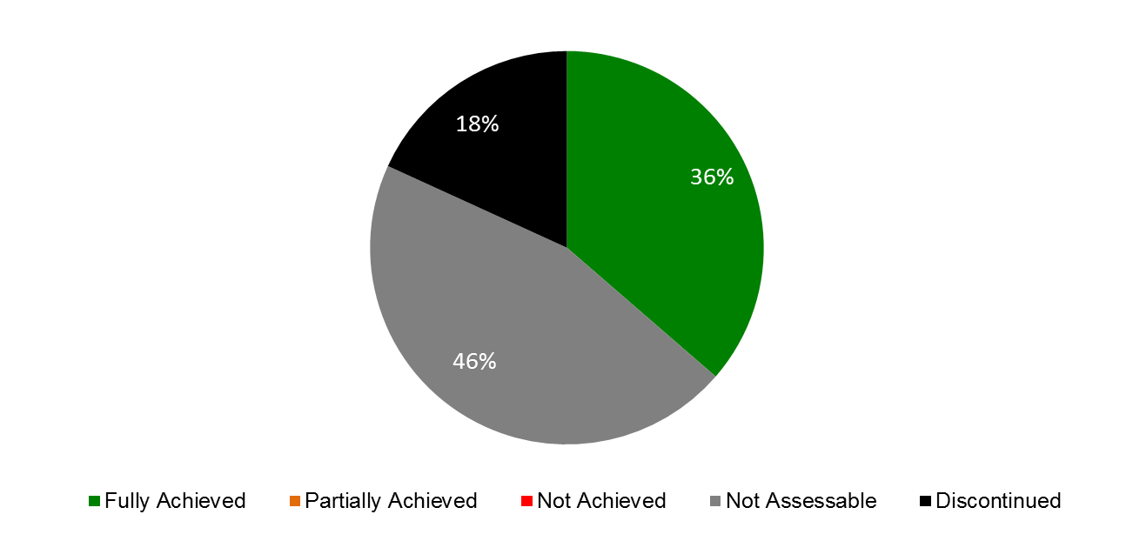

**Summary of Achievements by Expected Results**

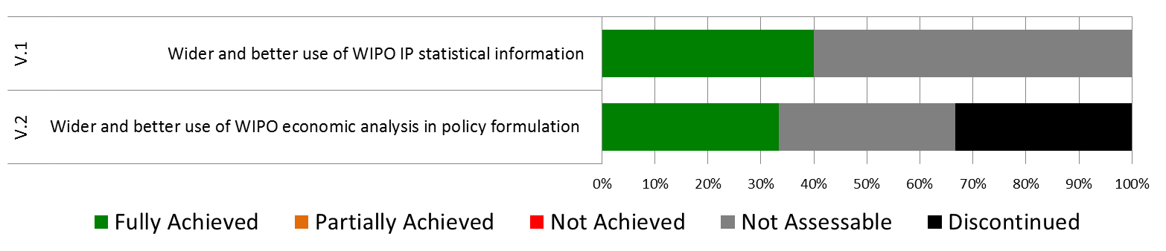

1. In the biennium, WIPO’s economic analysis work made significant progress towards its objective of promoting high quality analysis addressing economic challenges in the international IP system and assessing the economic effects of IP policy choices. One major accomplishment was the publication of the third World Intellectual Property Report on Breakthrough Innovation and Economic Growth, which generated over 200 media articles and interest from policymakers and academia worldwide. In addition, WIPO continued to be a co-publisher of the Global Innovation Index (GII), along with Cornell University and INSEAD. In 2014/15, for the first time, the GII launches took place outside of Geneva, with the launches co-hosted by the Government of Australia in 2014 and the Government of the United Kingdom in 2015. News and social media coverage also reached new highs compared to the previous biennium.
2. Significant achievements in the 2014/15 biennium were also made with regard to targeted economic studies to support the work of WIPO committees. Above all, three Development Agenda (DA) projects were concluded on IP and socioeconomic development, IP and the informal economy, and IP and brain drain. A second phase of the project on IP and socioeconomic development that takes the underlying study work to new developing countries was also launched in 2015.
3. Finally, the statistical work undertaken in the 2014/15 biennium also fulfilled the objective of providing accurate, comprehensive, and timely statistical information on the performance of the IP system worldwide. Most importantly, annual statistical surveys of national and regional IP offices were conducted and saw the average number of responses rise to 127 compared to 112 in the previous biennium

**Strategic Goal VI: International Cooperation on Building Respect for IP**

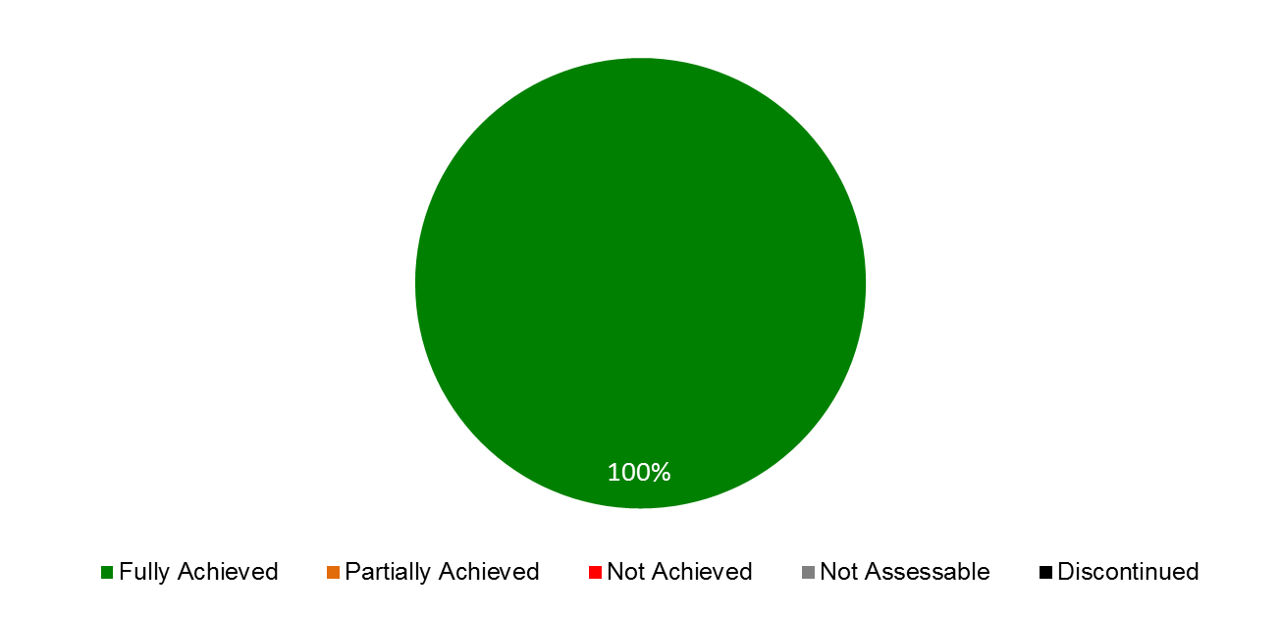

**Summary of Achievements by Expected Results**

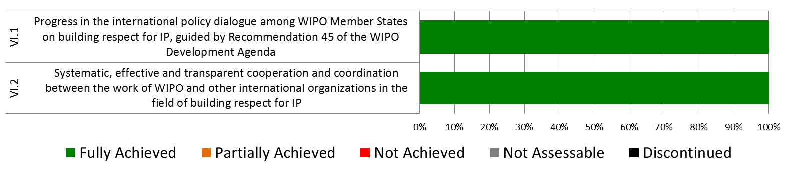

1. With a view to achieving progress in the international policy dialogue among WIPO Member States on building respect for IP, the ninth and tenth sessions of the Advisory Committee on Enforcement (ACE) (March 3 to 5, 2014; and November 23 to 25, 2015) served as a “marketplace of ideas”, allowing for the exchange of national practices and experiences. The three day meetings showed growing interest in effective preventive strategies, ranging from awareness raising, new business models and supply chain security, to alternative mechanisms for resolving IP disputes. The two sessions were accompanied by audiovisual exhibitions, presenting public communication campaigns on respect for IP and awareness tools for young people. Member States agreed to exchange, at its eleventh session, information on national experiences on four topics: (i) awareness building activities and strategic campaigns as a means for building respect for IP among the general public, especially the youth, in accordance with Member States’ educational or any other priorities; (ii) institutional arrangements concerning IP enforcement policies and regimes, including mechanisms to resolve IP disputes in a balanced, holistic and effective manner; (iii) WIPO’s legislative assistance, with a focus on drafting national laws of enforcement that take into account the flexibilities, the level of development, the difference in legal tradition and the possible abuse of enforcement procedures; and (iv) WIPO’s capacity building and support for training activities in line with relevant Development Agenda Recommendations and the ACE mandate.

**Strategic Goal VII: Addressing IP in Relation to Global IP Policy Issues**

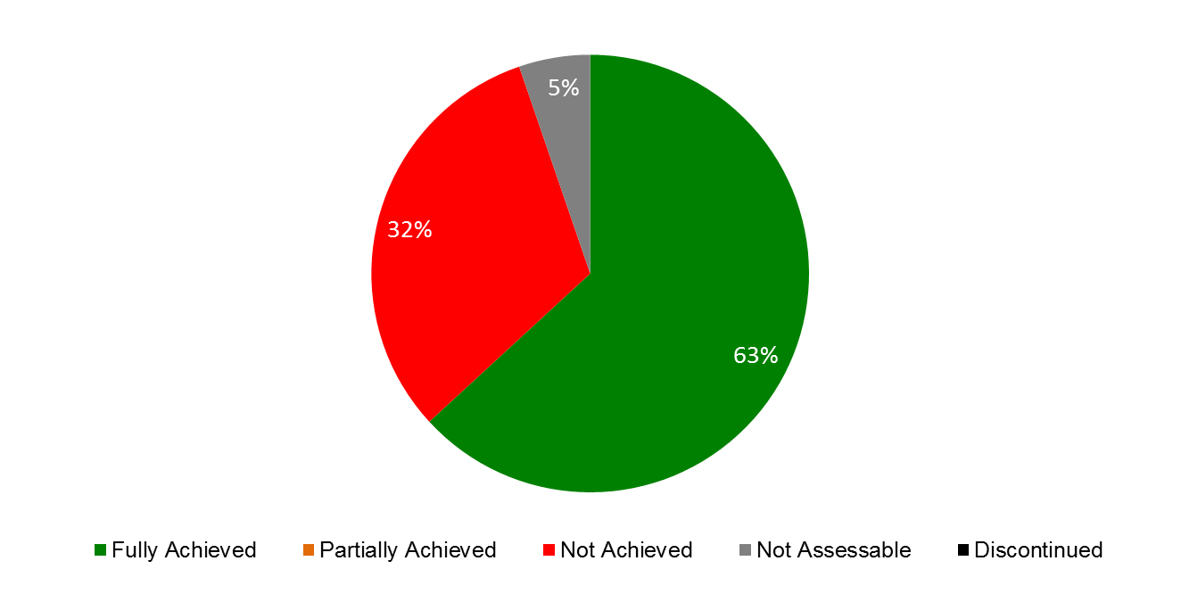

**Summary of Achievements by Expected Results**

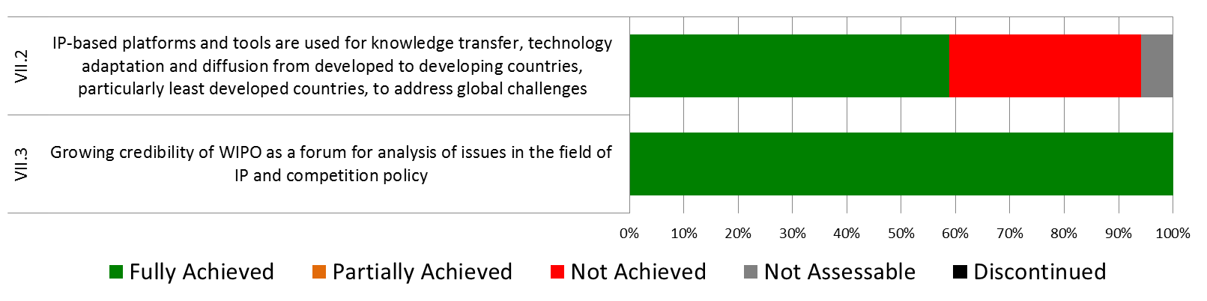

1. At the intersection of pressing global and interconnected issues, in particular global health, climate change and food security, substantive progress was made in supporting an enhanced understanding among policy makers on the interface between global challenges and innovation and IP. In the biennium, WIPO consolidated its position as a credible source of support, collaboration and reference for information on issues related to public policy and IP, resulting in continued requests for WIPO to contribute to and participate in fora by other international and non‑governmental organizations, including WHO, WTO, NGOs, the private sector and universities. Following its launch in November 2013, the year 2014 marked the first full year of WIPO GREEN operations. Through a targeted awareness raising campaign, the profile of WIPO GREEN was raised significantly. The network of partners grew from 36 to 54 in 2014 to 65 in 2015, and the number of registered users tripled from 160 in 2013 to 490 by the end of 2015. The WIPO GREEN database also more than doubled its content, from 830 entries in 2013 to 2,181 in 2015, as a result of database integration agreements and individual uploads.
2. WIPO Re:Search – Sharing Innovation in the Fight Against Neglected Tropical Diseases (NTDs) – gained in recognition as a platform to support innovation, knowledge and technology transfer and capacity building related to research for NTDs, tuberculosis and malaria. The biennium saw 52 additional collaborations between WIPO Re:Search Members and 20 new Members, six of which from developing countries, bringing the totals to 96 collaborations and 100 Members, 22 of which from developing countries. In addition, the platform’s potential for technology transfer from developed to developing countries of IP assets, including know-how and expertise, was further demonstrated by the continued facilitation of research sabbaticals for six African scientists in overseas research institutions. The sabbaticals, which began in the last biennium, were made possible by a Fund-in-Trust from the Government of Australia, four of which were concluded by the end of 2014.
3. Providing fora for participants to share ideas, expertise and information relating to the three core areas, in 2014/15, three WIPO Global Challenges Seminars were organized, four Global Challenges Briefs, and three Global Challenges Reports were published.
4. The trilateral cooperation with WHO and WTO continued to focus on enhanced understanding among policymakers for the interplay between health, IP and trade. In November 2014 and October 2015, the fourth and fifth Trilateral Symposia took place in Geneva, exploring the challenges and opportunities in the health innovation area of middle-income countries, and the public policies necessary to ensure that rapid economic growth contributes to access and universal health coverage.

**Strategic Goal VIII: A Responsive Communications Interface between WIPO, its Member States and All Stakeholders**

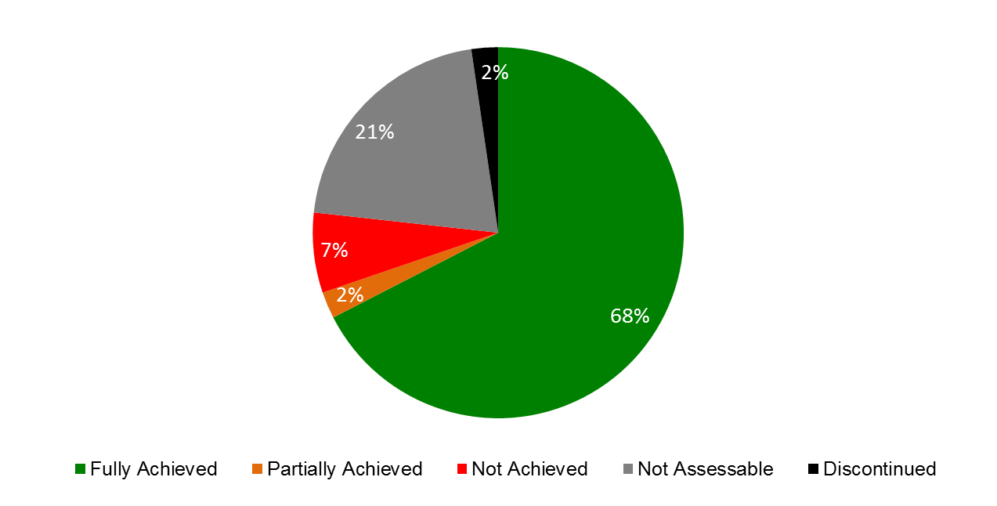

**Summary of Achievements by Expected Results**

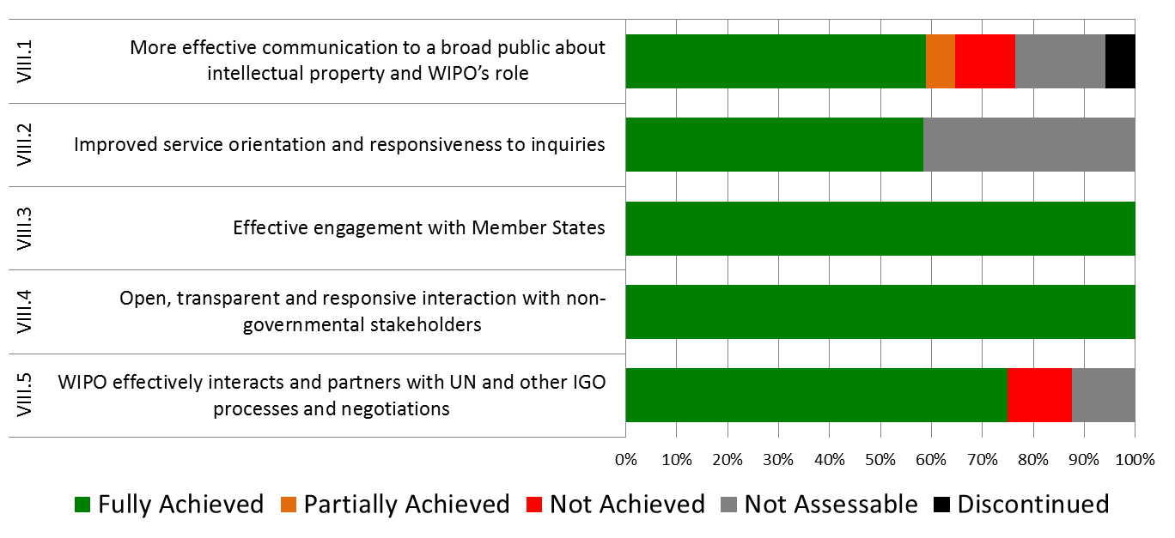

1. Priorities under this goal included a continued focus on creating and delivering relevant, high quality content, on increasing the visibility and public understanding of WIPO’s work, and on strengthening the culture of service within the Organization.
2. A more integrated content and media strategy resulted in greater communications impact for WIPO’s major events and product launches. The Global Innovation Index (GII) achieved Twitter “trending” status in London on the day of its 2015 United Kingdom launch. Coverage in some of the world’s most influential media helped position WIPO’s flagship IP reports (the GII; the World Intellectual Property Report (WIPR); the PCT, Madrid and the Hague Yearly Reviews; and the World Intellectual Property Indicators) as world reference sources for IP and innovation data. Promotion of the WIPR resulted in some 200 press articles in the week following its release. Concerted press and social media outreach to promote the 2014 Dakar Ministerial Conference gained wide coverage on African broadcast and online media, stimulating public interest in IP and development issues. For all major events, webpages were published in all six languages. Advocacy efforts in support of the Accessible Books Consortium (ABC) were strengthened by the production of a compelling video on ABC capacity building in India.
3. Engagement by Member States and the public in the annual World IP Day campaign reached a record level. The theme Movies – A Global Passion was the focus for over 350 events reported in 105 countries (up from 236 events in 93[6] countries in 2013). WIPO’s 2015 #WorldIPDay tweets gained 5.2 million potential impressions (compared to 1.55 million in 2013) and some 900 retweets. Participation was truly global with views of the webpage in Chinese exceeding the English version in 2014; while the highest numbers of ’likes’ of the Facebook page came respectively from India, the United States of America, Mexico, Egypt and Brazil.
4. With regard to External Relations, the United Nations (UN) and its Member States concluded a number of major negotiating processes of relevance to WIPO’s work in 2014/15, including the adoption of the Addis Ababa Action Agenda (AAAA) during the Third International Conference on Financing for Development Conference (FFD3); the adoption of Transforming Our World: the 2030 Agenda for Sustainable Development; and the adoption of the Paris Agreement under the framework of the UN Framework Convention on Climate Change (UNFCCC). As a specialized agency of the UN, and in line with its mandate and with WIPO DA Recommendations 30 and 40, WIPO continued to play its role in supporting these processes through its strategic engagement and the provision of balanced and evidence-based information, as well as in timely responses to specific requests for contributions and cooperation.
5. WIPO’s network of External Offices formed an integral part of the Organization, designed to bring WIPO’s services and cooperation closer to Member States, stakeholders and partners with a view to enhancing efficiency and effectiveness of program delivery, as well as responding to the specific needs and priorities of the countries and/or regions they serve. In 2014, the network of Offices grew to five, with the opening of the WIPO Offices in China (WCO) and in the Russian Federation (WRO). The year 2015 marked the tenth anniversary of the establishment of the WIPO Singapore Office. The results achieved during the 2014/15 biennium continued to underscore the contribution that External Offices bring to the implementation of the Organization’s mandate.

**Strategic Goal IX: Efficient Administrative and Financial Support Structure to Enable WIPO to Deliver its Programs**

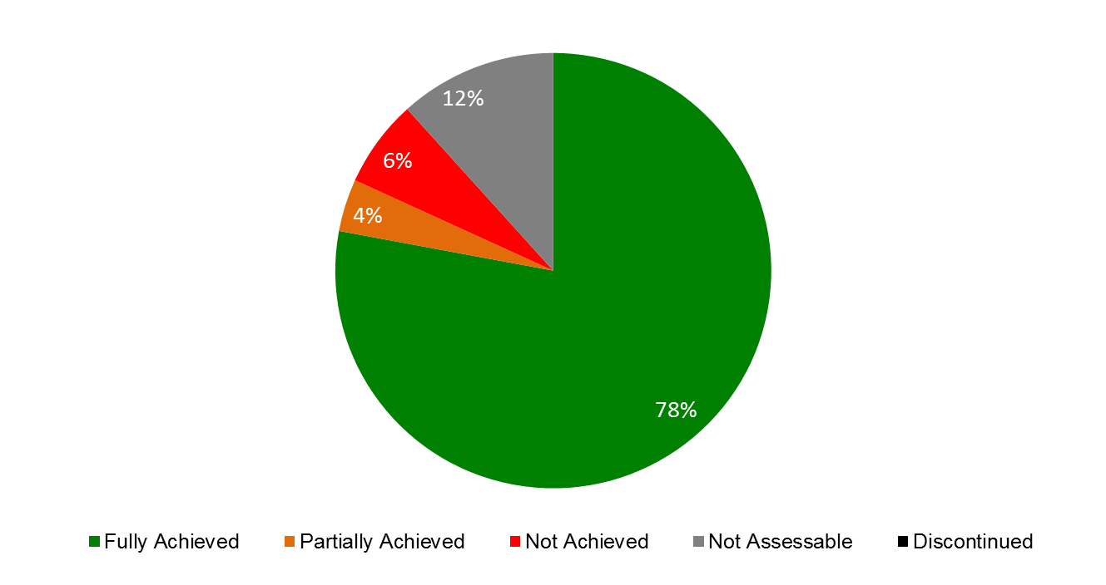

**Summary of Achievements by Expected Results**

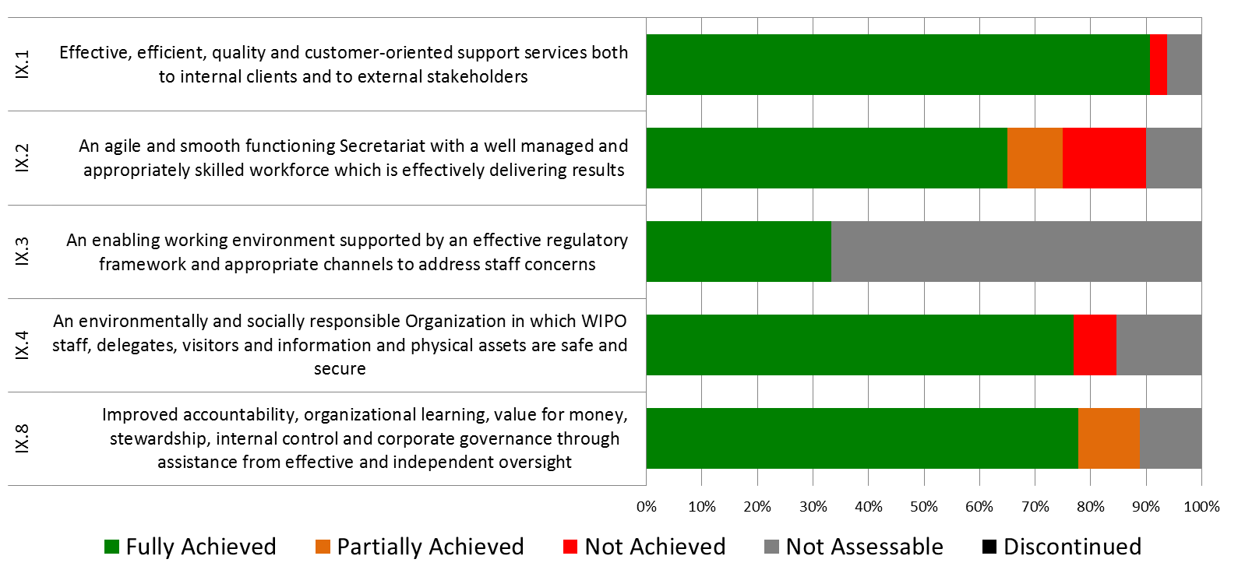

1. WIPO’s program and financial management continued to be strengthened throughout the biennium in order to utilize resources more effectively as well as to establish best practice in an area of administration, which deals with planning, performance management, facilitation and support for various operational activities across the Organization.
2. Despite continuing economic uncertainties, WIPO closed the year with a positive overall result of 70.3 million Swiss francs on an IPSAS basis. Income before IPSAS adjustment in 2014/15 reached 775.7 million Swiss francs, i.e. 62.4 million Swiss francs or 8.8 per cent higher than the 2014/15 budgeted income. The 2014/15 biennial expenditure amounted to 642.6 million Swiss francs, i.e. 31.4 million Swiss francs or 4.7 per cent lower than the 2014/15 approved budget.
3. The comprehensive study of WIPO’s treasury practices and risks, launched in 2013, was completed in spring 2014, resulting in a series of recommendations, including with regard to the practice of hedging as a means to reduce exposure to foreign currency fluctuations in the PCT. A comprehensive review of the proposed hedging strategy was carried out in 2015 with a final decision taken to build a hedging model, which will simulate the effects of hedging on the results of the 2014/15 biennium and those of the year 2016. Following extensive research amongst various banks and financial institutions and a study of the many investment policies in operation throughout the UN system, a new investment policy for the Organization was prepared and approved by Member States in 2015.
4. Good progress was made during the biennium with respect to further embedding a results-based culture and strengthening WIPO’s performance management cycle. The biennial and annual workplanning processes continued to be enhanced. In 2014, position level planning was introduced, driving linkages between the Programs’ expected results and individual staff objectives closer together, leading to increased transparency and accuracy with regard to personnel resource allocation and utilization.
5. Further integration of the ERP components in 2014/15 also enabled improved reporting capabilities and analytical tools. For the first time in 2014, the Administrative Integrated Management System (AIMS) financial and the EPM planning systems were integrated, allowing for improved reporting on budget versus actual expenditure from EPM. In addition, the ERP Human Resources (HR)/Payroll system was brought into operation in January of 2014, and integration with the EPM planning system was completed in April, resulting in significantly enhanced position management capabilities. The Business Intelligence (BI) module evolved during the biennium, with initial management dashboards having been developed and released to core administrative areas (HRMD, Procurement and Travel, and Program Planning and Finance) in 2014 and released organization wide in 2015. A Risk Management dashboard was also developed and released in 2015.
6. In accordance with the Risk Management Roadmap, a formalized and coherent risk management and internal controls framework for the Organization was developed, including WIPO’s Accountability Framework, WIPO’s Risk Appetite Statement, establishment of the Risk Management Group (RMG), issuance of the Risk Management Policy, and the development of a Risk Management and Internal Controls Manual.
7. In order to facilitate real-time access to risk and control information, to support proactive risk and control management, as well as to render efficient responses to audit bodies, an Enterprise Risk Management (ERM) tool was implemented in the second half of 2014 and used to support the 2015 workplanning process as well as the 2016/17 Program and Budget process.
8. The 2014/15 biennium saw the first biennium of implementation of the Human Resource (HR) Strategy, which was approved by Member States in 2013. Progress also continued to be made on mainstreaming organizational design and workforce planning as fully integrated key business activities. Achievements for the biennium included: (i) increased manager engagement in workforce planning through delivery of introductory workshops as well as development of related guidelines; (ii) development of 2014/15 workforce action plans for each organizational unit to capture key HR-related actions to meet business needs; (iii) an organization-wide exercise to update all job descriptions, ensuring that they accurately reflect business priorities; and (iv) a more systematic and closer alignment of job descriptions and annual workplans. As part of the workforce planning exercise mangers were encouraged to consider the optimal mix of resources to efficiently address their business needs.
9. In 2014, WIPO issued its first Gender Equality Policy, with the twin objectives of mainstreaming the gender perspective in WIPO activities, and a time-specific goal for achieving gender balance at all staffing levels. While the percentage of women at the P4 level (46.1 per cent) represented a 2.7 percentage point increase over the 2013 baseline, fully achieving the target, gender balance targets remained challenging at the more senior management levels. New appointments of women at P5 and D1 levels succeeded in avoiding any widening of the gender gap following separations of female staff at these levels, however women at the D2 level saw a decrease of 11.1 percentage points, as compared to 2013. Nevertheless, these percentages represented the highest ever in WIPO’s history.  Accordingly, a network of gender focal points covering all WIPO Programs was established, and WIPO joined the Geneva Champions network in its collective commitment to promote women in the workplace.
10. The regularization process for long-serving temporary employees (LSTEs) was completed in 2014, with 31 LSTEs regularized in 2014 following a competition. In addition, 40 fixed term posts were advertised for the regularization of continuing functions during the biennium (17 in 2014 and 23 in 2015), 30 of which were completed by the end of 2015. The biennium continued to witness a significant level of recruitment activity, which resulted in a slower average recruitment time for the biennium of 19.77 weeks, as compared to 16.03 weeks for 2012/13. For the biennium, there were a total of 255 competitions (183 for fixed-term posts, a 29 per cent increase from 2012/13, and 72 for temporary positions). In total, some 30,320 applications were received. Modernization of HRMD systems and processes also continued. Development of a new integrated recruitment platform (using Taleo) was launched in 2015 and is expected to deliver further efficiencies in recruitment.
11. In 2014/15, procurement and travel made good progress towards achieving targets through a series of measures with a view to optimizing the cost of WIPO procured goods and services and streamlining its processes, resulting in in overall savings of 3.8 million Swiss francs in 2015 and 2.6 million Swiss francs in 2014. As regards travel expenditure, the average ticket cost was reduced by 14 per cent in 2015 to 1,484 Swiss francs from 1,728 Swiss francs in 2013, a significant savings over the biennium. Since the implementation of the new Online Bookng Tool (OBT) in December 2014, the total average transaction fee also decreased by 20 per cent, despite the increase in the agency fee resulting from a change in the supplier. It should also be noted that a substantial effort was made to reduce travel expenditure during the biennium, leading to a decrease in both the number of tickets issued and the number of late travel submissions. Through close monitoring of the administrative process, the average lead time to process purchase requisitions was reduced by half over the last five years, resulting in greater efficiency and more agility in procuring goods and services. It should also be noted that the percentage of locally sourced goods and services for development activities increased to 57 per cent in 2015, a nine per cent increase over 2013 and a 12 per cent increase over 2014.
12. As regards ICT enhancements, specific accomplishments in 2014/15 included: a review of service contracts and operational processes to ensure more cost-effective operations, which resulted in savings of approximately 460,000 Swiss francs as compared to 2013; the successful establishment and testing of a high level ICT disaster recovery capability to support the PCT System; completion of the ICT infrastructure for the new WIPO Conference Hall in time for its opening for the twenty-second session of the PBC and the fifty-fourth series of meetings of the WIPO Assemblies; a new Global Office Architecture (GOA) solution for WIPO’s EOs to provide secure connectivity to all of WIPO’s administrative IT systems hosted at headquarters, together with centralized and consistent IT services; the establishment of Service Delivery Agreements (SDAs) to explicitly capture the ICT needs for the specific business areas and also to enable more systematic tracking and monitoring; and the implementation of an advanced fax system to seamlessly integrate with computer systems for Madrid, as well as internal administrative systems, resulting in greater efficiency and significantly reducing fax error rates.
13. In the field of information assurance, as part of the continuous improvement process promoted by the ISO 27001 Standard, in October 2014, the PCT underwent the second round of external surveillance audits for the ISO 27001 certification, and at the same time migrated the certification from the 2005 version to the latest ISO 27001:2013.  In October 2015, the certification was expanded to include both the Madrid and the Hague operations, in addition to PCT. Simulated phishing campaigns, first launched in 2014, continued to raise user awareness of information security threats, as evidenced by a sharp increase in users reporting phishing (from one per cent in 2014 to 59 per cent in 2015), as well as a 10 per cent decline in users that fell for phishing campaigns (from an average of 17 per cent in 2014 to an average of seven per cent in 2015).
14. The WIPO Language Policy continued to be effectively implemented by extending the six language coverage to Working Groups in a phased and cost-effective approach. According to the timeline set by Member States, coverage was extended in 2014/15 to: (i) the PCT Working Group; (ii) the Working Group on the Legal Development of the Hague System for the International Registration of Industrial Designs; (iii) the Working Group on the Legal Development of the Madrid System for the International Registration of Marks; and (iv) the IPC Revision Working Group.
15. A key achievement in 2014/15 was the inauguration of the new WIPO Conference Hall. The New Conference Hall Project was delivered in several stages, with various technical and system tests carried out in parallel, area by area. The new Access Center was delivered in July 2014; the exterior landscaping between the New Building, the new WIPO Conference Hall and the AB Building was delivered at the end of August 2014; the new WIPO Conference Hall per se was delivered at the end of August and was available for the holding of the PBC session from September 1 to 5, 2014; the entirety of the new and renovated construction was completed in September 2014 in the new WIPO Conference Hall and three floors of the AB Building, and made available for the session of the WIPO Assemblies from September 22 to 30, 2014, which included the inauguration of the new WIPO Conference Hall on the opening day in the presence of WIPO Member States and observers, officials from the Host Country (federal, cantonal and municipal levels), representatives from other UN Agencies, and from the 70-odd companies and firms that had contributed to the construction and completion of the Project. A number of elements of the exterior landscaping were dealt with in the course of 2015. The Project was completed on time for the WIPO Assemblies, even though it was delayed from April 2014 to September 2014, in view of the complexity of the worksite, in particular in the last few months.
16. The biennium 2014/15 also saw the finalization and advancement of a number of important safety and security achievements, notably the opening of the new WIPO Access Center (AB reception) and the Security Coordination Operations Center (SCOC), in time to successfully support the twenty-second session of the PBC and the WIPO Assemblies in 2014 as well as over 200 conferences and events in 2015 attended by staff, delegates, visitors, and the public. In addition, the Headquarters Minimum Operating Security Standards (H-MOSS) project was completed in 2015, resulting in enhancements that significantly strengthened safety and security management throughout the WIPO campus.

# CONSOLIDATED BUDGET AND ACTUAL EXPENDITURE 2014/15

**Table 1: 2014/15 Summary by Program**

*(in thousands of Swiss francs)*



**Table 2: 2014/15 Summary by Expected Result**

*(in thousands of Swiss francs)*



# REPORT ON DEVELOPMENT EXPENDITURES 2014/15

1. The Program and Budget 2014/15 (Table 6) provided an estimate of development expenditure for the biennium 2014/15 by Program (Program and Budget 2014/15 Table 6) and by Expected Result (Results Framework table on page 14 (English version) in the Program and Budget 2014/15). In 2014/15, expenditure is qualified as development expenditure, only where the beneficiary is a developing country and the equivalent expenditure is not available for developed countries. These amounts exclude foregone revenues resulting from the fee reductions accorded under the international registration systems for applicants from developing countries[7]. This Report provides an overview of actual development expenditure in the biennium 2014/15.
2. It is recalled that a comprehensive estimation of development expenditure was introduced for the first time in the revised Program and Budget 2008/09. The 2010/11 methodology was, as in 2008/09, based on high level estimations at the Program level. In 2012/13, the approach was significantly refined using a detailed bottom-up activity-level approach. This revised approach, complemented by the establishment of development expenditure tracking mechanisms through the ERP, has led to more refined reporting on development expenditure. The methodology applied to estimate the development share of the budget for 2014/15 was fully in line and consistent with the methodology adopted in 2012/13. This mechanism was further refined for the biennium 2014/15 with the introduction of a more accurate methodology for allocation of personnel resources at the activity level. The estimated development expenditure in 2014/15 by Program was thus compiled by applying the above development expenditure definition to Program activities in close consultation with Program Managers.
3. Tables 3 and 4 below provide an overview of the estimated development expenditure by Program and by Expected Result, based on the Final Budget after Transfers and actual expenditure in 2014/15. For further information on the development-related results achieved and on budget utilization in the biennium, please refer to the individual Program performance assessments in this report.
4. Explanations of differences between the Approved Budget, the Final Budget after Transfers and actual expenditure in the biennium 2014/15 are contained within the Resource Utilization commentaries under each Program.

**Table 3: 2014/15 Development Expenditure by Program**

*(in thousands of Swiss francs)*



**Table 4: 2014/15 Development Expenditure by Expected Result\***

*(in thousands of Swiss francs)*



# REPORT ON THE IMPLEMENTATION OF COST EFFICIENCY MEASURES  IN THE 2014/15 BIENNIUM

COST EFFICIENCIES REALIZED IN 2014/15

| **Cost efficiency** | **2014**  **Annual Savings**  **(Swiss francs)\*** | **2015**  **Annual Savings**  **(Swiss francs)\*\*** | **Unit cost decrease for 2014\***  **(Swiss francs)** | **Unit cost decrease for 2015**  **(Swiss francs)** | **Notes** |
| --- | --- | --- | --- | --- | --- |
| **A** | **B** | **C** | **D** | **E** | **F** |
| Lower overall costs for the processing of published international PCT applications resulting from enhanced processing of financial commitments for the outsourcing of translation services, and an increase in productivity |  |  | A reduction from 722 CHF in 2013 to 662 CHF in 2014 (i.e. 60 CHF or 8.3% decrease) | An increase from 662 CHF in 2014 to 735 CHF in 2015 (i.e. 73 CHF or 11%) | The unit cost is defined as the average cost of producing one unit of output. The unit cost calculation takes into account the total cost of production which comprises expenditure relating exclusively to the PCT System and expenditure of activities supporting the system. (For more details, please refer to the PPR 2014/15). |
| Lower cost of processing a new/renewed international registration under the Madrid System |  |  |  | A decrease from 837 CHF in 2014 to 743 CHF in 2015 (i.e. 94 CHF or 11%) | Please refer to the PPR 2014/15 for more information on the indicators for the Madrid System operations. |
| Reduction in the cost of home leave travel resulting from the implementation of the new home leave travel policy (OI 22/2014) | n/a | 267,000 |  |  | The implementation of the new home leave travel policy started in 2015. |
| Lower average air ticket price resulting from the implementation of new technology travel tools offering more economical fares (restrictive or non-refundable fares) configured in full compliance with WIPO travel policy and influencing advance ticketing. |  |  | A reduction from 1,728 CHF in 2013 to 1,598 CHF in 2014 (7.5% decrease from 2013) | A further reduction to 1,481 CHF in 2015 (7.3% decrease from 2014) | 2014: A substantial effort was made to reduce travel expenditure leading to a decrease in both the number of tickets issued and the number of late travel submissions.  2015: The implementation of an Online Booking Tool (OBT) and the reporting on late travel authorization submissions (i.e. 16 days prior to departure) have improved early booking rates, resulting in cheaper fares available on the market (the average ticket fare includes tickets issued through the Travel agent, UNDP and self-purchased ones). |
| Lower average transaction fee paid overall to the travel agent, UNDP and Online booking tool. |  |  | 119 | 95 | Enforcing the use of the OBT for all simple trips (one destination) resulted in 69% of the total number of tickets being issued by the Travel Agent and a decrease in the average transaction fee. |
| Cost savings for goods and services procured by WIPO | 2,663,000 | 3,826,361 |  |  | 2014: savings of 1,598,000 CHF have been realized through the Common Procurement Activities Group (CPAG) and 1,064,000 CHF realized from WIPO negotiations after tenders or negotiations with sole suppliers.  2015: savings of 1,316,919 CHF have been realized through the Common Procurement Activities Group (CPAG) and 2,509,442 CHF realized from WIPO negotiations after tenders or negotiations with sole suppliers. |
| Reduction in energy consumption for the Cooling System using Geneva Lake water instead of city water that does not require use of machines to decrease water temperature and thus generates savings in electricity and water consumption for the operation of the Cooling System | 35,000 | 75,000 |  |  | 2014: AB Building: Reduction in electricity and water consumption due to connection of the AB Building to the cooling system. The connection was completed mid-year; hence savings were only realized in the second semester.  2015: AB Building: cost savings for the full year (70,000 CHF).  2015: PCT Building: connection to the Geneva Lake cooling system operational as from November 2015 (hence savings of 5,000 CHF for 2 months) |
| Reduction in electricity consumption in all WIPO buildings resulting from the installation of light presence detectors, energy-efficient light bulbs, light timing service in parking and new more efficient electric closets for the operation of electrical installations in all floors of all buildings. | 15,000 | 45,000 |  |  | Measures implemented during 2014 resulted in savings of 15,000 CHF in 2014 and 30,000 CHF in 2015.  Measures continued to be implemented on other floors and other areas of the buildings on the WIPO Campus and produced additional savings of 15,000 CHF in 2015. |
| Reduction in water consumption resulting, *inter alia*, from the use of lake water instead of city water | 19,500 | 125,500 |  |  |  |
| Reduction in electricity tariff due to new provider contracted after tender with other UN agencies in Geneva | n/a | 164,000 |  |  | The contract with the new provider came into effect on January 1, 2015. |
| Termination of the leases of site storage areas | 12,178  (7,845 CHF for Meyrin IV and  4,333 CHF for La Praille) | 54,150  (31,380 CHF for Meyrin IV,  15,000 CHF for La Praille and  7,770 CHF for Meyrin II) |  |  | Meyrin IV storage terminated on September 30, 2014. La Praille storage terminated in November 2014.  In 2015, advance termination of storage lease for Meyrin II (in advance of contractual date at end January 2016, and due to agreement with subsequent tenant). |
| Termination of 32 abonnements in Parking des Nations in several batches between August and December 2014. | 3,404 | 61,440 |  |  |  |
| Termination of additional 20 abonnements in Parking des Nations in several batches in 2015 | n/a | 62,052 |  |  |  |
| Termination of 5 abonnements in the CAM Building Parking in 2015 | n/a | 8,340 |  |  |  |
| Reduction in the use of office supplies | 8,193 | 9,269 |  |  | The savings made in 2014 were slightly increased in 2015. |
| Implementation of a Mobile Device Management (MDM) system with more integrated services offered at a lower cost. (OI 17/2014) | 112,691 | 277,540 | A reduction in average monthly cost of device from 177 CHF in 2013 to 111 CHF in 2014 by 37% | An increase in average monthly cost of device from 111 in 2014 to 115 in 2015 by 3.6%. The average cost in 2015 is still significantly lower than the cost in 2013. | Total expenditures related to the Swisscom subscription decreased from 799,815 CHF in 2013 (374 devices at end of year) to 520,430 CHF in 2014 (404 devices at end of year). A one-time project cost of 166,784 CHF was incurred in 2014 covering a new device renewal, Swisscom Credit Note for device purchase, MDM licenses and MDM Infrastructure Setup. In 2015, the total expenditures were 522,276 CHF (364 devices at end of year). |
| Implementation of new mailbox management policy as of March, 2015 | n/a | 70,000 |  |  | The new policy resulted in the archiving and progressive clean-up of over 1,480 old mailboxes during the course of 2015. The net reduction amounting to approximately 113,000 CHF per year will continue to be realized in the form of cost avoidance during the 2016/17 biennium. |
| Reduction in translation costs due to renegotiated contracts with external translators, launching of additional international tenders to cover Arabic, Chinese and Russian translations based on the experiences gained in outsourcing translation work of French and Spanish and use of Computer-Assisted Translation and Terminological (CATT) tools. | 306,375 | 601,084 | A reduction in the per word translation cost from 0.63 CHF in 2013 to 0.59 CHF in 2014 (i.e. decrease by 0.04 CHF per word) | Cost per word further reduced to 0.57 CHF in 2015 (i.e. additional decrease of 0.02 CHF) |  |
| Reduction in printing costs following the renegotiation of the base contract for printers. | 243,000*** | 399,000 | A reduction in the cost per page from 0.20 CHF in 2013 to 0.15 CHF in 2014 by 26%*** | The cost per page 0.15 CHF in 2015, the same as in 2014 |  |
| Reduction in mailing costs due to negotiated lower tariffs with external mail service providers and grouping of addresses | 71,662*** | 189,367 |  |  | 2014: Renegotiations of contracts with mail carriers resulted in an overall decrease in mailing costs by 4% from 2013.  2015: Reduction by 11% in 2015 from 2013. |
| Reduction in the number of outsourced Security guards and the number of hours of their work. | 331,882*** | 708,739 |  |  | 2014: An overall reduction of 8.4% (331,882 CHF) from 2013 (3,943,837 CHF) to 2014 (3,611,955 CHF) resulting from reduction in the number of ARNDT security guards in 2014, and a reduction in guard surge capacity requirements by 25%.  2015: An overall reduction of 17.9% (708,739 CHF) from 2013 to 2015 (3,235,098 CHF) resulting from smart re-deployment of ARNDT security guards after the implementation of the access speed gates, and the Security Operations Center as part of the H-MOSS project, thereby reducing the total number of hours worked by security guards; and reduction in the guard surge capacity requirements by 29%. |
| Lower overall costs for the processing of international applications under the Hague System |  |  | A reduction in unit cost per new/renewed design from 420 CHF in 2013 to 366 CHF in 2014 (i.e. 54 CHF or 13% decrease). A reduction in unit cost per recorded document from 1,570 CHF in 2013 to 1,483 CHF in 2014 (i.e. 87 CHF or 5.5% decrease) | A further reduction in unit cost per new/renewed design from 366 CHF in 2014 to 337 CHF in 2015 (i.e. 29 CHF or 7.9% decrease). A further reduction in unit cost per recorded document from 1,483 CHF in 2014 to 1,153 in 2015 (i.e. 330 or 22.3% decrease) | Please refer to PPR 2014/15 for more information on the indicators of the Hague System operations. |
| Lower premiums resulting from renegotiation of the new insurance contract for Professional Accident Insurance (PAI) | n/a | 200,000 |  |  | The renegotiation of the Professional Accident Insurance resulted in an estimated savings of 200,000 Swiss francs in 2015 |

*Numbers may not add up due to rounding*

*\*Information as per document WO/PBC/23/COST EFFICIENCIES REALIZED IN 2014, unless otherwise indicated*

*\*\*Annual savings for 2015 as compared with 2013*

*\*\*\*Revised figures as of April 2016*

COST RECOVERIES IN 2014/15

|  |  |  |  |  |  |  |
| --- | --- | --- | --- | --- | --- | --- |
| **Cost recovery**  **A** | **2014 Annual Savings* (Swiss francs)**  **B** | **2015 Annual Savings (Swiss francs)**  **C** | **Breakdown of costs for 2014* (Swiss francs)**  **D** | **Breakdown of costs for 2015 (Swiss francs)**  **E** | **Notes**  **F** | **Responsible area**  **G** |
| Revenue generated by rental of WIPO spaces to other entities** | 195,000 | 195,000 | 124,766 ICC 17,500 Swisscom Antenna 32,500 Orange antenna 9,504 AMFIE (one standard office CAM) 9,298 UBS bank teller in GBI | 124,766 ICC 17,500 Swisscom Antenna 32,500 Orange antenna 9,504 AMFIE (one standard office CAM) 9,298 UBS bank teller in GBI |  | Premises Infrastructure Division |
| Revenue generated by the reimbursement of the difference paid between 2013 and 2014 by the electricity provider for meeting the annual electricity saving target resulting from the implemented electricity saving measures and as an incentive for further reduced electricity consumption. | 21,300 | n/a | One-off payment made by the electricity provider at the end of the year | n/a | Not applicable in 2015 since a new electricity provider, which was selected through a Geneva-based UN agency tender, does not offer this type of incentive. | Premises Infrastructure Division |

*\*information as per document WO/PBC/23/COST EFFICIENCIES REALIZED IN 2014*

*\*\*Annual revenue figures for ICC are shown as gross figures without offsetting reductions for improvement works implemented during the 2014/15 biennium*

# OVERVIEW OF PROGRESS IN 2014/15 BY STRATEGIC GOAL

STRATEGIC GOAL I

**BALANCED EVOLUTION OF THE INTERNATIONAL NORMATIVE FRAMEWORK FOR IP**

**Biennial Performance Dashboard**

The dashboard below provides a summary of the achievements of the expected results in the biennium 2014/15 as measured by the indicators under the Programs contributing to this Strategic Goal.

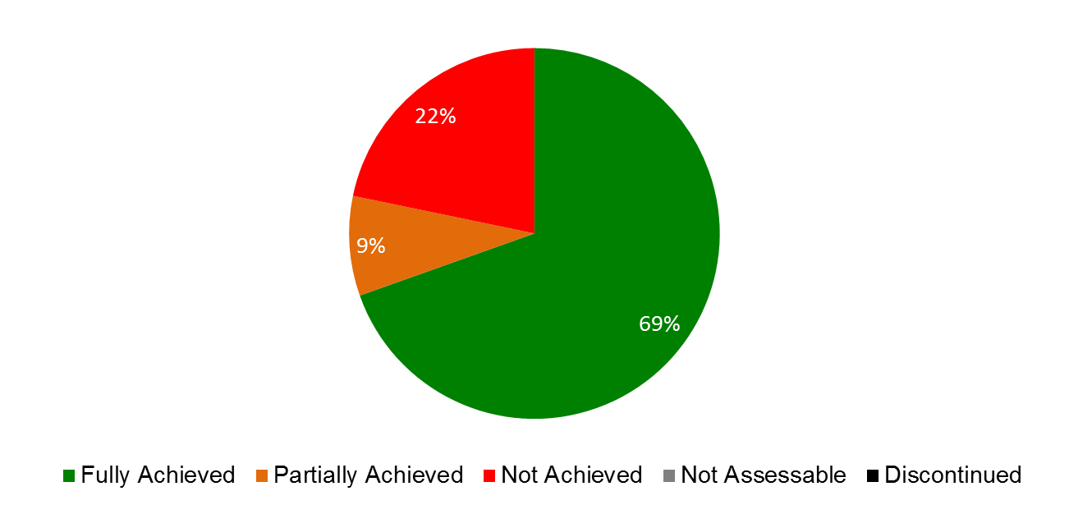

| **Expected Results** | **Performance Indicators** | **Responsible Program(s)** | **TLS** |
| --- | --- | --- | --- |
| I.1 Enhanced cooperation among Member States on development of balanced international normative frameworks for IP and agreement on specific topics on which international instruments are agreed | Progress on the implementation of SCP agreed steps/plans | Program 1 | ⚫ |
| % of satisfied participants in targeted workshops/seminars/conferences held on specific patent-related topics | Program 1 | ⚫ |
|  | Agreement on a normative framework for industrial design registration and maintenance procedures | Program 2 | ⚫ |
|  | Progress towards agreement on current issues on the SCT Agenda | Program 2 | ⚫ |
|  | No. of ratifications/ accessions to the Singapore Treaty | Program 2 | ⚫ |
|  | Progress towards agreement on current issues on the SCCR agenda | Program 3 | ⚫ |
|  | Agreement in the IGC’s negotiations on an international legal instrument(s) on TK, TCEs and GRs | Program 4 | ⚫ |
| I.2 Tailored and balanced IP legislative, regulatory and policy frameworks | No. and % of Member States which found the provided information concerning the legal principles and practices of the patent system, including the flexibilities existing in the system and the challenges it faces, useful | Program 1 | ⚫ |
|  | No. and % of Member States which were satisfied with the quality of legal advice related to patents, utility models, trade secrets and integrated circuits | Program 1 | ⚫ |
| Program 9 | ⚫ |
|  | Subject to approval by Member States, progress on the revision of the Patent Model Law for developing countries and LDCs | Program 1 | ⚫ |
|  | No. and % of Member States/regional organizations providing positive feedback on the legislative advice offered in the area of trademarks, industrial designs and geographical indications | Program 2 | ⚫⚫ |
| Program 9 | ⚫ |
|  | No. of countries that have ratified the Beijing Treaty | Program 3 | ⚫ |
|  | No. and % of countries that have provided positive feedback about WIPO’s legislative advice | Program 3 | ⚫ |
| Program 9 | ⚫ |
|  | No. of ratifications to the WIPO Internet Treaties | Program 3 | ⚫ |
|  | No. of countries that have ratified the Marrakesh Treaty on the VIP | Program 3 | ⚫ |
|  | No. of countries with updated laws and/or regulations | Program 10 | ⚫ |
|  | No. of countries that have adopted or amended relevant frameworks (or are in the process of doing so) further to WIPO assistance | Program 17 | ⚫ |
| I.3 Increased protection of State emblems and names and emblems of International Intergovernmental Organizations | No. of requests for communication under Article *6ter* dealt with | Program 2 | ⚫ |
|  | No. of signs published in Article *6ter* database | Program 2 | ⚫ |

## PROGRAM 1 PATENT LAW

**Program Manager Mr. J. Sandage**

ACHIEVEMENTS IN THE 2014/15 BIENNIUM

1. In view of enhancing cooperation among Member States on further developing balanced policy and normative frameworks for the international patent system, the twentieth, twenty-first, twenty-second and twenty-third sessions of the Standing Committee on the Law of Patents (SCP) were held in January and November 2014 and July and December 2015, respectively. The SCP continued to examine five topics on its agenda, namely: (i) exceptions and limitations to patent rights; (ii) quality of patents, including opposition systems; (iii) patents and health; (iv) confidentiality of communication between clients and their patent advisors; and (v) transfer of technology.
2. The examination of substantive studies allowed the SCP to review the current international patent system in a holistic manner that took into account different needs and interests of Member States and stakeholders. A step-by-step approach broadened the common base from which the Committee could develop its discussions. Furthermore, various methodologies employed by the Committee, including preparation of background studies, seminar and sharing sessions on national implementation of patent law, and exchanging national experiences and challenges, contributed to advancing discussions on issues of common interest at the SCP. During the 2014/15 biennium, a number of proposals were put forward by Member States on the above topics, showing commitments by Member States in the SCP process.
3. With respect to WIPO administered treaties in the field of patents, one State (Kuwait) joined the Paris Convention during the biennium.
4. WIPO’s legislative and policy assistance was consistently based on the multilateral legal framework. Member State legislative activity has grown, particularly due to their participation in regional economic integration processes and preferential trade agreements. Additionally, a number of Member States are revising their patent laws to accommodate local public policies or because of their accession to multilateral treaties on patents – namely, the Patent Cooperation Treaty (PCT), the Budapest Treaty and the Patent Law Treaty (PLT) – or implementing them for the first time through the adoption of regulations. Moreover, the countries joining the World Trade Organization (WTO) systematically revise their legal frameworks. Therefore, requests for legislative advice follow the same trend.
5. Furthermore, during the 2014/15 biennium, the Secretariat continued to contribute to the promotion of a greater awareness of the legal principles and practices of the patent system through the provision of relevant information to intergovernmental organizations, United Nations bodies, non-governmental organizations and other parties on issues covered by this Program.
6. The design, planning and implementation of activities were informed and guided by the relevant DA Recommendations. Discussions on the progressive development of the international patent system within the SCP continued to be inclusive and member-driven, taking into account different levels of development, representing a participatory process and being in line with the principle of neutrality of the WIPO Secretariat (Recommendation 15). The discussions also took into account existing flexibilities in international IP agreements (Recommendation 17). The activities of the SCP were based upon open and balanced consultations (Recommendations 21 and 42), while being supportive of the UN development goals (Recommendation 22). In particular, in line with Recommendation 22, working documents of the SCP addressed issues such as: (i) patent-related transfer of technology; and (ii) potential flexibilities, exceptions and limitations for Member States.
7. The Program’s capacity building and legislative and policy assistance activities were development-oriented, demand-driven and carried out within the timeframe planned (Recommendations 1, 13 and 14). Since March 2015, capacity building activities in the area of patent drafting have been carried out by developing efficient and effective training schemes that create a synergy among various stakeholders.
8. In addition, in accordance with Recommendations 16 and 20, the Program was engaged in a final assessment of the outputs of the DA Project on Patents and the Public Domain, which was presented and discussed at the thirteenth session of the Committee on Development and Intellectual Property (CDIP), which took place in May 2014.
9. The Program also prepared documents CDIP/13/10 and CDIP/15/6, which cover four new patent-related flexibilities and which were discussed respectively in sessions thirteen and fifteen of the CDIP. In addition, activities aimed at raising awareness on the practical implementation of flexibilities at the national level were undertaken, including 14 national and regional seminars or workshops on the patent multilateral legal framework, and public policy issues, including available flexibilities.

PERFORMANCE DATA

|  |  |  |  |  |
| --- | --- | --- | --- | --- |
| **Expected Result:** I.1Enhanced cooperation among Member States on development of balanced international normative frameworks for IP and agreement on specific topics on which international instruments are agreed | | | | |
| **Performance Indicators** | **Baselines** | **Targets** | **Performance Data** | **TLS** |
| Progress on the implementation of SCP agreed steps/plans | *Updated Baseline end 2013:* The SCP concentrated its efforts on progressing the five topics on its agenda, and advanced its discussions through, for example, collecting information through a questionnaire, preparing studies and exchanging national practices and experiences among Member States.  *Original Baseline  P&B 2014/15:* To be determined | Advancement on issues of common interest at the SCP | The SCP concentrated its efforts on the progress of the five topics on its agenda, and advanced its discussions through, for example, preparing studies, collecting information on national laws and practices and exchanging national experiences among Member States. Discussions were based on delegations’ proposals (12) and documents prepared by the Secretariat (27) during the biennium | **Fully Achieved** |
| % of satisfied participants in targeted workshops/ seminars/ conferences held on specific patent-related topics | *Updated Baseline end 2013:* 92.5%, based on 2012/13 survey  *Original Baseline  P&B 2014/15:* Surveys 2012 | 90% | 96.85% based on questionnaires filled out by participants | **Fully Achieved** |
| **Expected Result:** I.2Tailored and balanced IP legislative, regulatory and policy frameworks | | | | |
| **Performance Indicators** | **Baselines** | **Targets** | **Performance Data** | **TLS** |
| No. and % of Member States which found the provided information concerning the legal principles and practices of the patent system, including the flexibilities existing in the system and the challenges it faces, useful | *Updated Baseline end 2013:* 90% based on survey conducted by IOD in 2013 among 47 Member States  *Original Baseline  P&B 2014/15:* To be determined | 90% | 95.24% based on 24 responses to a survey | **Fully Achieved** |
| No and % of Member States which were satisfied with the quality of legal advice related to patents, utility models, trade secrets and integrated circuits | *Updated Baseline end 2013:* 9 respondents (90%), based on survey conducted by IOD in 2013  *Original Baseline  P&B 2014/15:* Surveys 2012 | 90% | In 2014/15, 9 respondents reported on average a 94% satisfaction rate (Africa-3; Arab-1; Asia and the Pacific-2; Certain Countries in Europe and Asia-2; Latin America and the Caribbean-1[8] | **Fully Achieved** |
| Subject to approval by Member States, progress on the revision of the Patent Model Law for developing countries and LDCs | *Updated Baseline end 2013:* One meeting of experts  *Original Baseline  P&B 2014/15:* To be determined | Advancement in the preparatory work for updating the WIPO Patent Model Law | The SCP continued to discuss a proposal by GRULAC. | **Not  Achieved** |

RISK REPORTING FOR THE BIENNIUM

|  |  |  |  |
| --- | --- | --- | --- |
| **Risk(s) to the Program achieving its Results** | **Mitigation plans in place or under implementation** | **Evolution of Risk(s) and Mitigation Strategies Over the Biennium** | **Impact on the Program’s Performance** |
| Reduced relevance of the Standing Committee on the Law of Patents as a multilateral forum. | Provision of impartial and professional guidance.  Provision of an inclusive and neutral environment for dialogue amongst Member States.  Provision of timely, accurate and relevant information needed by Member States. | This is a continuing risk for the Program, which remained present throughout the biennium, and has also been reflected as a key risk to the Program’s Expected Results for the following biennium. | The source of the risk is primarily attributed to differences in Member States’ views on the way forward for the SCP discussions, which has thus resulted in slow progress. |

RESOURCE UTILIZATION

Budget and Actual Expenditure (by result)

*(in thousands of Swiss francs)*



Budget and Actual Expenditure (personnel and non-personnel)

*(in thousands of Swiss francs)*



A. 2014/15 Final Budget after Transfers

1. The overall increase in the 2014/15 Final Budget after Transfers resulted primarily from: (i) the allocation of additional personnel resources to Result I.2 (Legislative advice) in order to more efficiently respond to an increase of requests for legislative advice; and (ii) the transfer of patent drafting activities from Program 30 to Program 1.

B. 2014/15 Budget Utilization

1. Overall budget utilization for the biennium 2014/15 amounted to 97 per cent, however a few activities related to the revision of the Patent Model Law on Inventions for Developing Countries were not undertaken due to the absence of an agreement among Members States at the SCP.

## PROGRAM 2 TRADEMARKS, INDUSTRIAL DESIGNS AND GEOGRAPHICAL INDICATIONS

**Program Manager Ms. B. Wang**

ACHIEVEMENTS IN THE 2014/15 BIENNIUM

2.1. During the biennium, the Standing Committee on the Law of Trademarks, Industrial Designs and Geographical Indications (SCT) continued from its thirty-first through to its thirty-fourth sessions work on a draft Design Law Treaty to be adopted at a Diplomatic Conference. The question of convening such a Diplomatic Conference was dealt with by the WIPO General Assembly at its forty-seventh (22nd ordinary) session in October 2015, where the General Assembly agreed “to convene a diplomatic conference for the adoption of a Design Law Treaty at the end of the first half of 2017, only if the discussions on technical assistance and disclosure have been completed during the thirty-fourth and thirty-fifth sessions of the SCT.” The SCT continued its work on the protection of country names and adopted a Reference Document on the Protection of Country Names against Registration and Use as Trademarks ((document WIPO/Strad/INF/7). Furthermore, a number of delegations presented proposals for work by the SCT on geographical indications. The Program’s norm-setting activities within the SCT continued to be inclusive and member-driven in line with DA Recommendation 15, and the SCT negotiations were based upon open and balanced consultations in line with DA Recommendations 21 and 42.

2.2. The biennium 2014/15 also saw ratification of and/or accession to the Singapore Treaty on the Law of Trademarks by seven new Contracting Parties (Belarus, Belgium, Benelux Organization for Intellectual Property (BOIP), Iraq, Luxembourg, the Netherlands and Tajikistan), bringing the total number of Contracting Parties to 38 at the end of 2015.

2.3. As regards increased protection of State emblems and names and emblems of international intergovernmental organizations under Article 6*ter* Paris Convention, communications and responses to requests were dealt with in a timely and efficient manner during the period under review. The discrepancy between the target for requests to be dealt with and the actual number of requests is due to the fluctuation of requests and the fact that the estimated target was based on a biennial average. At the end of 2015, a total of 3,157 signs were contained in the Article 6*ter* database.

2.4. Concerning the work on tailored and balanced IP legislative, regulatory and policy frameworks, the Program provided advice to 31 Member States/intergovernmental organizations in the area of trademark, industrial design and geographical indications law. The Program’s technical assistance, capacity-building and legislative assistance activities were development-oriented, demand-driven and reported on during the year in line with DA Recommendations 1 and 13.

2.5. In addition, the Program implemented the DA Pilot Project on IP and Design Management for Business Development in Developing and Least Developed Countries (DA_4_10_02) in Argentina and Morocco. Following formal agreement on the project scope, national design protection strategies in 2014, outreach plans and exit strategies were drafted for both Pilot Countries, and a dedicated national program (i.e. *Diseñar* in Argentina and *Nama*dij in Morocco) was set up. Feasibility studies were then carried out in both countries, resulting in the selection of originally 70 beneficiary SMEs, of which 68 were eventually retained (42 in Argentina and 26 in Morocco). To support the beneficiary SMEs in developing tailor-made design protection strategies and to provide them with assistance for IP applications, national project teams consisting of project steering committees, country project coordinators and eight experts (five for Argentina and three for Morocco) were created.

2.6. Progress continued in 2015 with the creation of promotional materials and the development of a set of tools to further support beneficiary SMEs in strategically protecting their designs for their business development on the local and international markets. By November 2015, participating SMEs had filed or were in the process of filing applications for a total of 32 industrial designs and 29 trademarks in Argentina, and for 77 industrial designs in Morocco. Other key deliverables of the Project during the biennium included the establishment of a national steering committee in each country, including ministries, associations, chambers of commerce, schools and universities. To further reinforce institutional partners’ engagement to contribute to each country’s program’s objectives, project charters were signed on April 7, 2015, in Argentina, in presence of the Minister of Industry, and between April 1, 2015, and October 27, 2015 in Morocco by the project’s national key partners. The Secretariat and both countries’ delegations presented the results of the project to Member States at a side event to the thirty-fourth session of the SCT. Surveys to date indicate an overall very high rate of Lead Agencies’ and SMEs’ satisfaction with regards to the technical assistance received and to the value added of the project to local business development of design-intensive SMEs through the strategic use of IP. Exit strategies are being reviewed for implementation in each country in 2016, and a final evaluation of the project will also be conducted.

PERFORMANCE DATA

|  |  |  |  |  |  |  |  |
| --- | --- | --- | --- | --- | --- | --- | --- |
| **Expected Result:** I.1Enhanced cooperation among Member States on development of balanced international normative frameworks for IP and agreement on specific topics on which international instruments are agreed | | | | | | | |
| **Performance Indicators** | **Baselines** | | **Targets** | | **Performance Data** | **TLS** | |
| Agreement on a normative framework for industrial design registration and maintenance procedures | *Updated Baseline end 2013:* No normative framework for industrial design registration procedures  *Original Baseline P&B 2014/15:*  No normative framework for industrial design registration and maintenance procedures | | Adoption of a Design Law Treaty by a possible Diplomatic Conference | | Decision by the WIPO General Assembly to convene a Diplomatic Conference for the adoption of a Design Law Treaty at the end of the first half of 2017, only if the discussions on technical assistance and disclosure have been completed during the thirty-fourth and thirty-fifth sessions of the SCT [9]. | **Not Achieved** | |
| Progress towards agreement on current issues on the SCT Agenda | *Updated Baseline end 2013:* Agreement by the SCT on a substantive number of draft Articles and Rules for a Design Law Treaty.  SCT agreement on the continuation of work on the protection of country names.  *Original Baseline P&B 2014/15:*  Draft Reference Document on the Protection of Country Names Against Registration and Use of Trademarks | | SCT agreed outcomes | | The thirty-fourth session of the SCT adopted a Reference Document on the Protection of Country Names Against Registration and Use as Trademarks (published in document WIPO/Strad/INF/7). | **Fully Achieved** | |
| No. of ratifications/accessions to the Singapore Treaty | *Updated Baseline end 2013:* 31 Contracting Parties (end 2013  *Original Baseline P&B 2014/15:*  29 Contracting Parties (end 2012) | | Eight new ratifications/accessions | | Seven new Contracting Parties during the biennium: Belarus, Belgium, Benelux Organization for Intellectual Property (BOIP), Iraq, Luxembourg, Netherlands and Tajikistan, which brings the total number of Contracting Parties to 38 at the end of 2015. | **Fully Achieved** | |
| **Expected Result:** I.2 Tailored and balanced IP legislative, regulatory and policy frameworks | | | | | | | |
| **Performance Indicators** | **Baselines** | | **Targets** | **Performance Data** | | **TLS** | |
| No. and % of Member States/regional organizations providing positive feedback on the legislative advice offered in the area of trademarks, industrial designs and geographical indications | *Updated Baseline end 2013:*  2013: Advice was provided to 13 Member States on 18 individual pieces of draft legislation  Positive feedback received from nine out of 13 countries. Four countries did not reply.  *Original Baseline P&B 2014/15:*  11 Member States/regional organizations received legislative advice out of which three provided positive feedback on legislative advice received in 2012 | | Legislative advice provided to 10 Member States/regional organizations. 90% of respondents satisfied with the advice offered | Advice was provided to 31 Member States/Regional Organizations (Africa 8; Arab 1; Asia and the Pacific 14; Latin America and the Caribbean 6; Certain Countries in Europe and Asia 1)  Feedback was received from 10 respondents, all of whom (100%) reported satisfaction with the advice offered. | | **Fully Achieved**    **Fully Achieved** | |
| **Expected Result:** I.3Increased protection of State emblems and names and emblems of International Intergovernmental Organizations | | | | | | | |
| **Performance Indicators** | **Baselines** | **Targets** | | **Performance Data** | | | **TLS** |
| No. of requests for communication under Article *6ter* dealt with | *Updated Baseline end 2013:* 126 requests for publication under Article 6*ter* dealt with by the end of 2013  *Original Baseline P&B 2014/15:*  70 requests[10] for communication under Article 6*ter* dealt with in 2012 | 140 requests for communication under Article *6ter* dealt with | | 109 requests for communication received and dealt with, of which 41 resulted in publication. | | | **Partially Achieved** |
| No. of signs published in Article *6ter* database | *Updated Baseline end 2013:* 132 signs published in Article 6*ter* database in 2012/13  *Original Baseline P&B 2014/15:*  75 signs[11] published in Article 6*ter* database in 2012 | 150 signs published in Article *6ter* database[12] | | 149 new signs published.  A total of 3,157 signs contained in the Article 6*ter* database at the end of 2015. | | | **Fully Achieved** |

RISK REPORTING FOR THE BIENNIUM

|  |  |  |  |
| --- | --- | --- | --- |
| **Risk(s) to the Program achieving its Results** | **Mitigation plans in place or under implementation** | **Evolution of Risk(s) and Mitigation Strategies Over the Biennium** | **Impact on the Program’s Performance** |
| Agreements at the multilateral level remain challenging and the successful conclusion of normative activities under Program 2 will depend to a large degree on Member States’ commitment to define mutually agreed outcomes. | This is an inherent risk of every norm developing activity which, by its nature, will have to be retained by the Program. Nevertheless, specific program activities, in particular sessions of the SCT, will allow ongoing dialogue and exchange of views with a view to identifying areas of common understanding and potential agreed outcomes. | The overall risk for the Program as described has not changed materially during the period under consideration and must be considered a constant. The same applies to the mitigation plans in place, which will continue to be relevant for the 2016/17 biennium. | The risks that are inherent to the normative activities in this Program are constantly mitigated through the dialogue and exchange of views facilitated through the sessions of the SCT and the WIPO General Assembly. Thus, while the main target (i.e. the conclusion of a Design Law Treaty) for the normative activity under Program 2 was not reached, important progress was made, in particular at the forty-seventh session of the WIPO General Assembly. |

RESOURCE UTILIZATION

Budget and Actual Expenditure (by result)

*(in thousands of Swiss francs)*



Budget and Actual Expenditure (personnel and non-personnel)

*(in thousands of Swiss francs)*



A. 2014/15 Final Budget after Transfers

2.7 The 2014/15 Final Budget after Transfers reflects a downward adjustment under Result I.1 (Development of balanced international normative frameworks for IP) due to the transfer out of the Program of non-personnel resources initially budgeted for a possible Diplomatic Conference.

2.8 The slight increase in personnel resources in the 2014/15 Final Budget after Transfers is due to the reclassification upwards of one post.

2.9 The adjustments across Results in the Budget after Transfers 2014/15, particularly between Results I.2 (Legislative advice) I.3 (Increased protection of State Emblems) reflects the new and more accurate methodology for allocation of personnel resources resulting from enhancements made to the EPM planning system for the 2014 and 2015 annual work planning exercises.

B. 2014/15 Budget Utilization

2.10 The slight under-utilization of non-personnel resources resulted primarily from:

* the postponement of the Diplomatic Conference under I.1 (Development of balanced international normative frameworks for IP);
* cost savings due to a reduction in the number of staff missions under Result I.2 (Legislative advice); and
* a delay in the recruitment of a project manager for the DA Pilot Project on IP and Design Management for Business Development in Developing and Least Developed Countries, ultimately resulting in a slight delay in the implementation of the project, reflected under III.4 (Strengthened cooperation mechanisms and programs tailored to the needs of developing countries and LDCs). The project is expected to be completed in the first half of 2016.

## PROGRAM 3 COPYRIGHT AND RELATED RIGHTS

**Program Manager Ms. M. Woods (Officer in Charge)**

ACHIEVEMENTS IN THE 2014/15 BIENNIUM

1. The work of the Programin 2014/15 focused on achieving the Expected Results in three broad areas: (i) advancing the normative work through supporting Member States in joining WIPO copyright treaties and in the Standing Committee on Copyright and Related Rights (SCCR), (ii) strengthening the development of copyright infrastructure, and (iii) enhancing institutional and human capacity in developing countries and LDCs, with a view to using the copyright system to exploit the economic potential in their cultures. Significant progress has been made in each of these areas, as demonstrated by the performance indicators discussed below.

Normative and Policy Related Work

1. In accordance with DA recommendations, the Program’s norm-setting activities were inclusive and member-driven (Recommendation 15), duly considering the boundaries, role and contours of the public domain (Recommendations 16 and 20) and taking into account flexibilities in international IP agreements (Recommendation 17). The SCCR negotiations were based upon open and balanced consultations (Recommendations 21 and 42) while being supportive of UN development goals (Recommendation 22). Legislative advice on copyright and related rights issues provided to Member States, at their request, was development-oriented, balanced and tailored to unique Member State situations, in accordance with DA principles (Recommendation 13), and bore in mind the applicable flexibilities relevant to countries at differing levels of development (Recommendations 14 and 17).
2. The progress of the two new copyright treaties toward entry into force continued in 2014 and 2015. The Beijing Treaty on Audiovisual Performances (Beijing Treaty) obtained eight additional ratifications and accessions (Chile, China, Japan, Qatar, Republic of Moldova, Russian Federation, Slovakia and United Arab Emirates) for a total of 10 of the 30 needed to bring it into force. The Marrakesh Treaty to Facilitate Access to Published Works for Persons Who Are Blind, Visually Impaired or Otherwise Print Disabled (Marrakesh VIP Treaty) obtained a total of 80 signatures by the June 2014 deadline. The Marrakesh VIP Treaty obtained 13 ratifications and accessions (Argentina, Australia, Brazil, El Salvador, India, Mali, Mexico, Mongolia, Paraguay, Republic of Korea, Singapore, United Arab Emirates and Uruguay) toward the 20 needed to bring it into force. Although the ratification/accession targets requested for the 2014/15 biennium for these treaties at the twentieth session of the Program and Budget Committee were quite ambitious given the need to hold resource allocations to their proposed levels, the Program partially achieved them by making it a priority to provide assistance to Member States with regard to joining treaties. The Program will continue this approach in the 2016/17 biennium.
3. Further discussions were held on the topics on the SCCR agenda during the five meetings held in April/May 2014, June/July 2014, December 2014, June/July 2015 and December 2015.   The SCCR discussions addressed a proposed treaty for broadcasting organizations and limitations and exceptions related to libraries and archives, educational and research institutions, and persons with other disabilities (than those covered by the Marrakesh VIP Treaty).   In addition, at the session held in December 2015, the SCCR also received two proposals for new agenda items - one with regard to analysis of copyright related to the digital environment and the other concerning the resale royalty right. The target of having a diplomatic conference and a new treaty was not achieved; Member States requested to remove this target for the 2016/17 biennium.
4. In 2014/15, legislative advice was provided to 25 Member States in various regions. Requests for such advice increased in 2014/15, in part due to the interest of Member States in joining the Beijing Treaty and the Marrakesh VIP Treaty. Advice on the new ten-year regime of the Berne Appendix was also provided to developing countries and LDCs upon request. A survey conducted in 2015 indicated that the legislative advice service was viewed positively by the Member States.
5. Positive progress was also made on a variety of projects aimed at enhancing WIPO’s role in copyright in the digital environment. The Program was engaged in a number of activities in different fora, such as the World Summit on the Information Society, the Internet Governance Forum and the World Economic Forum, aimed at raising awareness of relevant copyright-related topics, including user‑generated content, open source, legal protection of video games, and emerging licensing modalities.
6. Important work also continued on several projects related to the Development Agenda: The pilot Project on Strengthening and Development of the Audiovisual Sector in Burkina Faso and Certain African Countries, which also included Kenya and Senegal, was successfully completed and evaluated during the biennium. In addition, based on the discussions held in the twelfth session of the CDIP, a Revised Implementation Proposal on Possible New WIPO Activities Related to Using Copyright to Promote Access to Information and Creative Content was presented and approved by the thirteenth session of the CDIP. As the eighteen-month implementation project was approved relatively late in the biennium, implementation will begin in 2016/17. The Comparative Analysis of National Approaches on Voluntary Copyright Relinquishment (Document CDIP/13/INF/6) was presented and received positively by the CDIP as part of the implementation of Recommendations 1c, 1f and 2a of the Scoping Study on Copyright and Related Rights and the Public Domain.

Copyright Infrastructure

1. Work in this area was in line with DA Recommendations, in particular Recommendations 10 (improving national IP institutions’ capacity through further development of infrastructure and other facilities), 11 (strengthening national capacity for protection of domestic creations) and 35 (undertake studies on the economic, social and cultural impact of the IP system).
2. Progress was made on advancing the *TAG of Excellence* initiative (*TAG*), which promotes excellence in the transparency, accountability and governance of collective management organizations (CMOs). Several international trade associations joined with WIPO to form a Consortium, which agreed on a Compendium of best practices in collective management of copyright and related rights, and consultations were started on the Compendium. *TAG* attracted considerable support from individual CMOs and governments in both the developing and developed world (a total of 14 governments and 63 CMOs have signed an expression of interest in *TAG*).
3. WIPO developed and launched a distance learning course that uses the full range of 21st century communications techniques to create a practical collective management tool for staff of CMOs, policy makers and legal practitioners. The course was piloted in 2014 and positively received by participants. The course, in its finalized version, will be officially launched in 2016. WIPO also signed MoUs and organized a series of capacity-building programs and events with NGOs such as the International Federation of Reproduction Rights Organisations (IFRRO), the International Federation of Phonographic Industries (IFPI), the Norwegian Copyright Development Association (NORCODE), the Societies' Council for the Collective Management of Performers' Rights (SCAPR), the *Insituto de Derecho de Autor* (IA) and *Sociedad Portuguesa de Autores (*SPA), as well as governments, including that of the United States of America. As part of this capacity building work, WIPO’s mentoring program to facilitate knowledge transfer in collective management continued, pairing well-established CMOs with developing CMOs. In addition, six CMO educational modules were made available to Member States in 2014/15.
4. The *2014 Collecting Societies Handbook[13],* an online guide containing key facts and figures on CMOs around the world, was developed in collaboration with the law firm Baker & McKenzie and launched in October 2014. Since its launch, the handbook has seen an average of over 2,300 unique visits per month.
5. In 2014/15, WIPO published four national economic studies on the economic contribution of copyright industries in Argentina, Indonesia, Serbia and Turkey and one study in the Member States of the Organization of the East Caribbean States (OECS) and finalized studies for Ethiopia, France and Republic of Moldova which will be published in early 2016(for a cumulative total of 49 such studies). The studies are based on the *WIPO Guide on Surveying the Economic Contribution of the Copyright Based Industries,* which entered its second edition in 2015. The studies indicate that, on average, the creative industries account for 5.16 per cent of GDP and 5.36 per cent of total employment. WIPO also (i) published (with external partners) two annual surveys on copyright levies; (ii) launched a pilot study on the broader impact of copyright in the creative industries; and (iii) finalized a study on piracy.
6. As for its work with creators, WIPO published two new additional tools in 2014 - Mastering the Game - Business and Legal Issues for Video Game Developers, and Monetization of Copyright Assets by Creative Enterprises. The second edition of the WIPO publication *How to Make a Living from Music* was released in July 2014. These tools were widely used in capacity-building programs and were downloaded over 100,000 times annually in 2014 and 2015.
7. In June 2014, a new multi-stakeholder entity, the Accessible Books Consortium (ABC), was established to increase the number of books available in accessible formats to people with print disabilities worldwide. The ABC carried out three main activities: (i) technical assistance in accessible book production (funded by the Governments of Australia and the Republic of Korea); (ii) inclusive publishing, which promotes technologies that allow for “born accessible” publishing so that new books are usable from the start by both sighted people and people with print disabilities; and (iii) the ABC Book Service, also known as TIGAR, an international database of accessible titles in 55 languages. Under the first activity, the ABC produced 1,580 educational books benefiting 23,500 print-disabled students in Bangladesh, India, Nepal, and Sri Lanka. Under the second activity, the ABC sponsored the *Charter for Accessible Publishing* and the *ABC International Excellence Award for Accessible Publishing.* With respect to the third activity,as of the end of 2015, there were 4,208 downloads of accessible titles by 15 participating libraries and over 58,000 loans of accessible books to persons who are print-disabled.
8. The Program continued successfully to support WIPO’s current copyright data management tool WIPOCOS until September 2015, when responsibility was transferred to Program 15 (Business Solutions for IP Offices). WIPO’s objective is to continue support for WIPOCOS until the WIPO Copyright Connection (WCC), the new data management system to enhance global data and rights flows in beneficiary CMOs, is ready for deployment.

Technical Assistance to Developing Countries and LDCs

1. During the 2014/15 biennium, technical assistance provided to developing countries and LDCs in the field of copyright and related rights continued to be guided by the DA Recommendations and principles, particularly by DA Recommendations 1, 5, 6, 10 and 11. Accordingly, technical assistance programs were demand-based, designed in close consultation with beneficiary countries, and delivered in a tailor-made manner to meet identified national developmental priorities and needs.
2. Efforts were made to respond to the increasing demand from developing countries and LDCs for technical assistance in the field of copyright and related rights. During the period under review, 95 different technical assistance and capacity building programs were implemented at national, regional and inter-regional levels, reaching 116 countries and five regional intergovernmental organizations (the African Regional Industrial Property Organization (ARIPO), *Centro Regional para el Fomento del Libro en América Latina y el Caribe* (CERLALC), *Organisation Africaine de la Propriété Intellectuelle* (OAPI), the League of Arab States, and the Pacific Islands Secretariat (PIFS).
3. These activities encompassed awareness raising and capacity building of copyright and related rights among heads of national copyright offices, decision makers and key stakeholders. The capacity building programs addressed both basic principles of copyright and related rights and emerging issues of particular relevance and importance to developing countries and LDCs, including new developments at the national and international level, and contributed to: (i) the enhancement of capacity to formulate and implement national copyright policies and strategic frameworks for coherent and effective use of IP for sustainable development; (ii) the strengthening of human resources capacity and institutional development to deliver better services to the stakeholders; and (iii) promoting and exploiting their national creativity.
4. Efforts were also made to improve the cost-efficiency and sustainability of these technical assistance activities through, among others, promoting and strengthening cooperation among developing countries through the exchange of knowledge, skills, expertise and resources to meet their development goals. Country specific evaluation processes were also conducted with a view to improving accountability for results. According to these evaluations, more than 80 per cent of the participants considered the content of the capacity building meetings and workshops relevant to their jobs and thought they would be able to use the information and knowledge from the meetings and workshops in their work.

PERFORMANCE DATA

|  |  |  |  |  |  |  |  |  |  |
| --- | --- | --- | --- | --- | --- | --- | --- | --- | --- |
| **Expected Result:** I.1 Enhanced cooperation among Member States on development of balanced international normative frameworks for IP and agreement on specific topics on which international instruments are agreed | | | | | | | | | |
| **Performance Indicators** | **Baselines** | | **Targets** | | **Performance Data** | | | **TLS** | |
| Progress towards agreement on current issues on the SCCR agenda | *Updated Baseline end 2013:* Beijing Treaty text adopted in June 2012. Marrakesh VIP Treaty text adopted in June 2013. Progress consistent with SCCR work plan on all issues on the agenda.  *Original Baseline P&B 2014/15:* Two Treaties adopted in biennium 2012/13 (as to date). Two Diplomatic Conferences convened during the biennium 2012/13. | | One Diplomatic Conference convened and one Treaty adopted in the biennium 2014/15 | | The SCCR and the WIPO General Assembly did not reach agreement on steps toward the convening of a diplomatic conference for a treaty on the protection of broadcasting organizations. | | | **Not Achieved** | |
| **Expected Result:** I.2 Tailored and balanced IP legislative, regulatory and policy frameworks | | | | | | | | | |
| **Performance Indicators** | **Baselines** | | **Targets** | | **Performance Data** | | | **TLS** | |
| No. of countries that have ratified the Beijing Treaty | *Updated Baseline end 2013:* 2 (Botswana, Syrian Arab Republic)  *Original Baseline P&B 2014/15:*  None | | 30 countries cumulative | | Eight additional countries deposited instruments of ratification or accession for the Beijing Treaty (Chile, China, Japan, Qatar, Republic of Moldova, Russian Federation, Slovakia, United Arab Emirates) (10 countries in total) | | | **Not Achieved** | |
| No. and % of countries that have provided positive feedback about WIPO´s legislative advice | Data not available | | 15 countries | | 25 countries received legislative advice in 2014/15. (Africa 9; Arab 3; Asia and the Pacific 5; Latin America and the Caribbean 6; Other 2).  100% of the valid survey responses provided positive feedback (5 or 6 on a scale of 1-6) about WIPO’s copyright legislative advice service. | | | **Fully Achieved** | |
| No. of ratifications to the WIPO Internet Treaties | *Updated Baseline end 2013:* 184  *Original Baseline P&B 2014/15:*  181 (end 2012) | | 190 cumulative | | Four instruments of ratification or accessions were deposited in 2014/15, for a total of 188:   * WIPO Copyright Treaty (Canada, Madagascar) * WIPO Performances and Phonogram treaty (Canada, Madagascar) | | | **Fully Achieved** | |
| No. of countries that have ratified the Marrakesh VIP Treaty | None | | 20 countries cumulative | | 13 instruments of ratification or accession were deposited in 2014/15 (Argentina, Australia, Brazil, El Salvador, India, Mali, Mexico, Mongolia, Paraguay, Republic of Korea, Singapore, United Arab Emirates, Uruguay) | | | **Partially Achieved** | |
| **Expected Result:** III.2 Enhanced human resource capacities able to deal with the broad range of requirements for the effective use of IP for development in developing countries, LDCs and countries with economies in transition | | | | | | | | | |
| **Performance Indicators** | **Baselines** | | **Targets** | | **Performance Data** | | | **TLS** | |
| No. of governments and CMOs signing an agreement with WIPO to develop a new transparency, accountability and governance quality assurance standard | n/a | | Four governments and six CMOs | | 14 national governments (Bangladesh, Cambodia, the Gambia, Indonesia, Jordan, Liberia, Malaysia, Mauritius, Namibia, Nepal, Nigeria, Philippines, Sri Lanka, Trinidad and Tobago)[14], and 63 CMOs signed an expression of interest in the TAG project. | | | **Fully Achieved** | |
| % of creators satisfied with the training provided on using copyright data and information for the efficient management of their copyright | *Updated Baseline end 2013:*  *Original Baseline P&B 2014/15:*  Not yet started | | 60% | | 90% | | | **Fully Achieved** | |
| % of participants’ positive rating of the usefulness of copyright related capacity building meetings and workshops | *Updated Baseline end 2013:* Over 80% of the participants in the copyright and related rights capacity building programs rated the received training as being useful.  *Original Baseline P&B 2014/15:*  70% of satisfactory rate | | 70% agree or strongly agree | | Over 80% of the participants agree or strongly agree | | | **Fully Achieved** | |
| No. of Member States that take initiatives to improve their use of the copyright system to exploit the economic potentials of their cultural works and products | *Updated Baseline end 2013:* 60% of countries received assistance  *Original Baseline P&B 2014/15:*  60% of countries that requested for technical assistance | | 60% of countries that received assistance | | Over 60% | | | **Fully Achieved** | |
| **Expected Result:** IV.2 Enhanced access to, and use of, IP information by IP institutions and the public to promote innovation and creativity | | | | | | | | | |
| **Performance Indicators** | **Baselines** | | **Targets** | | **Performance Data** | | | **TLS** | |
| No. of trusted intermediaries (TIs) and rights holders (RHs) having joined the TIGAR system network, including from developing countries and LDCs | *Updated Baseline end 2013:*  By the end of 2013, 25 TIs and 45 RHs had signed the TIGAR Memorandum of Understanding, including TIs from developing and least developed countries. Eleven TIs had uploaded their accessible format titles to the TIGAR database by the end of 2013.  *Original Baseline P&B 2014/15:*  19 TIs and 40 RHs | 24 TIs and 46 RHs (cumulative) | | The Stakeholders’ Platform has now been moved to the Accessible Books Consortium (ABC). | | | **Dis-continued** | |
| No. of copyright protected works distributed among TIs and made accessible to VIPs across borders through the TIGAR system network | *Updated Baseline end 2013:* By the end of 2013, approximately 600 books in accessible formats had been downloaded from the TIGAR database in various countries.  *Original Baseline P&B 2014/15:*  400 | | 1,000 cumulative | | 4,208 downloaded accessible versions of books by 15 participating libraries by the end of 2015 (cumulative)  Over 58,000 loans of accessible books to persons with print disabilities by the end of 2015 | | | **Fully Achieved** | |
| % of individuals satisfied with the capacity building support on copyright infrastructure | Not yet started | | 60% | | 90% | | | **Fully Achieved** | |
| No. of institutions using GDA | *Updated Baseline end 2013:* 15[15] Copyright Offices using GDA (cumulative)  *Original Baseline P&B 2014/15:* 15 | | 15 | | 16 Copyright Offices using GDA (cumulative)  WIPO’s support of the GDA system was phased out by the end of 2015. | | | **Dis-continued** | |
| Use of the WIPO Collective Management Reference Database | Not yet started | | 100 users | | Since its launch in October 2014, the *Collecting Societies Handbook 2014* received an average of 2,300 unique visits per month. | | | **Fully Achieved** | |
| No. of legal instruments, guidelines, statements of principles other than Treaties agreed to or endorsed by the stakeholders concerned in areas such as IP and Sports and Copyright in the Digital Environment | *Updated Baseline end 2013:*  *Original Baseline P&B 2014/15:* One (WIPO Review of Contractual Considerations in the Audiovisual Sector) | | 1 | | The WIPO Draft Guidelines on Assessing the Economic, Social and Cultural Impact of Copyright on the Economy (ESCIA Guidelines) were finalized in 2014 and entered into a pilot phase of implementation, which will be completed by June 2016. | | | **Fully Achieved** | |
| **Expected Result:** IV.4 Enhanced technical and knowledge infrastructure for IP Offices and other IP institutions leading to better services (cheaper, faster, higher quality) to their stakeholders | | | | | | | | | |
| **Performance Indicators** | **Baselines** | | **Targets** | | **Performance Data** | | | **TLS** | |
| No. of governments and CMOs signing an agreement with WIPO to re-engineer WIPOCOS | Not yet started | | Four governments and Five NGOs | | Seven governments (Chad, Democratic Republic of the Congo, Malaysia, Mali, Nepal, Philippines, Uganda) and 43 CMOs | | | **Fully Achieved** | |
| No. of CMOs in developing countries and LDCs participating in regional and global networks facilitated by WIPO | 0 (zero) | | 10 | | 13 | | | **Fully Achieved** | |
| % of governments that report positively on the improved effectiveness (and governance) of copyright offices and other institutions in the country | *Updated Baseline end 2013:* Over 70% of Governments that received assistance reported positively on the improved effectiveness and governance of related institutions in the country after training.  *Original Baseline P&B 2014/15:* 80% satisfactory rate | | 80% of countries that received technical assistance | | 80% of countries that received technical assistance | | | **Fully Achieved** | |
| **Expected Result:** V.2 Wider and better use of WIPO economic analysis in policy formulation | | | | | | | | | |
| **Performance Indicators** | **Baselines** | | **Targets** | | | **Performance Data** | | **TLS** | |
| Use of WIPO economic studies on copyright by governments and NGOs in decision-making | *Updated Baseline end 2013:*  10 countries in 2012/13: Bulgaria, China, Colombia, Croatia, Jamaica, Kenya, Malaysia, the United Republic of Tanzania, Thailand and Trinidad and Tobago  *Original Baseline P&B 2014/15*: Eight governments or NGOs using WIPO studies | | 12 governments or NGOS using WIPO studies (cumulative) | | | 13 additional countries and NGOs (Finland, Indonesia, Latvia, Lithuania, Malawi, Moldova, Netherlands, Philippines, Republic of Korea, Serbia, United States of America, CERLALC and SERCI) using WIPO studies  23 countries and NGOs (cumulative) | | **Fully Achieved** | |
| National initiatives to develop further statistics on the creative industries based upon WIPO’s work in the field | 10 national initiatives (Bulgaria, China, Colombia, Croatia, Jamaica, Kenya, Malaysia, Thailand, Trinidad and Tobago, the United Republic of Tanzania). | | 15 national initiatives (cumulative) | | | 1 additional national initiative (Finland) in 2014, work in this area was discontinued in 2015  11 national initiatives (cumulative) | | **Dis-continued** | |

RISK REPORTING FOR THE BIENNIUM

|  |  |  |  |
| --- | --- | --- | --- |
| **Risk(s) to the Program achieving its Results** | **Mitigation plans in place or under implementation** | **Evolution of Risk(s) and Mitigation Strategies Over the Biennium** | **Impact on the Program’s Performance** |
| Technology and Innovation: Inability of the copyright system to adapt to rapid technological and media changes threatens to undermine the relevance of the copyright system. | Continuation of awareness-raising activities and initiatives to demonstrate the importance of copyright and to confirm its value and 'fit' in the evolving technological landscape. | The rapid technological evolution continued as technologies evolved and changed; thus the risk and mitigation strategies did not change to any marked extent over the biennium. | The mitigation strategy was successful to the extent that during the biennium, many WIPO Member States requested assistance with demonstrating the importance of the copyright system, especially to national economies. The Program met these requests to the extent possible, given practical resource limitations. There was no material impact on the Program’s performance in the biennium. |

RESOURCE UTILIZATION

Budget and Actual Expenditure (by result)

*(in thousands of Swiss francs)*



Budget and Actual Expenditure (personnel and non-personnel)

*(in thousands of Swiss francs)*



1. 2014/15 Final Budget after Transfers
2. The shift of resources from Expected Result I.1 (Enhanced cooperation among Member States) to Expected Result I.2 (Tailored and balanced IP legislative, regulatory and policy frameworks) in the Final Budget after Transfers 2014/15 was due to the allocation of additional personnel and non-personnel resources to activities related to assistance for the ratification and implementation of the Marrakesh and Beijing Treaties.
3. The increase in resources under Expected Result IV.2 (Enhanced access to, and use of, IP information) was primarily due to the increased emphasis on ABC-related activities.
4. The decrease of resources under Expected Result IV.4 (Wider and better use of WIPO economic analysis) was due to the transfer of certain WIPOCOS-related activities to Program 15 (Business Solutions for IP Offices) to consolidate the data management systems related to CMOs in that Program.

B. 2014/15 Budget Utilization

1. Lower expenditure under Expected Result IV.2 (Enhanced access to, and use of, IP information) was mainly due to the postponement of some activities under the Development Agenda project related to the use of copyright to promote access to information and creative content. Slightly lower expenditure under Expected Result I.2 (Tailored and balanced IP legislative, regulatory and policy frameworks) was due to the postponement of some activities related the promotion of the Marrakesh and Beijing Treaties, specifically in the African and Latin American regions.

## PROGRAM 4 TRADITIONAL KNOWLEDGE, TRADITIONAL CULTURAL EXPRESSIONS AND GENETIC RESOURCES

**Program Manager Mr. M. A. Getahun**

ACHIEVEMENTS IN THE 2014/15 BIENNIUM

1. The WIPO Intergovernmental Committee on Intellectual Property and Genetic Resources, Traditional Knowledge and Folklore (the IGC) met three times in 2014 (IGCs 26, 27 and 28) in accordance with the renewed mandate of the IGC for the biennium adopted by the WIPO General Assembly in October 2013 and an agreed-upon work program for 2014. IGC 26 included an Ambassadorial/Senior Capital-based officials meeting. By the end of IGC 28, the IGC had further streamlined a consolidated text on genetic resources (GRs) and made further progress on the texts on traditional knowledge (TK) and traditional cultural expressions (TCEs). A Member State-organized inter-sessional meeting held outside Geneva in 2014 gave further impetus to the process. The Secretariat continued to endeavor to play a neutral, professional and efficient facilitatory role in support of the process and to further improve the services provided to IGC participants as a follow up to the evaluation conducted by WIPO’s Internal Oversight Division (IOD) in 2013, which found a high rate (96 per cent) of satisfaction among IGC participants. Although the Secretariat continued to facilitate the participation in the IGC process of indigenous peoples and local communities as far as possible, the WIPO Voluntary Fund for Accredited Indigenous and Local Communities remained depleted. The WIPO General Assembly in October 2014, while considering the texts and the progress made, was not in a position to agree on an IGC work program for 2015. The WIPO General Assembly in October 2015 agreed upon a renewed mandate for the IGC for the 2016/17 biennium.
2. The successful conclusion of the IGC’s negotiations is the subject of DA Recommendation 18, which urges the IGC “to accelerate the process on the protection of GRs, TK and folklore, without prejudice to any outcome, including the possible development of an international instrument or instruments”. The Program’s normative activities within the IGC continued to be inclusive, member-driven and based upon open and balanced consultations, involving civil society at large (Recommendations 15, 21 and 42), taking into account the public domain (Recommendations 16 and 20) and flexibilities in international IP agreements (Recommendations 14 and 17). The IGC’s negotiations contributed to the mainstreaming of development considerations and were supportive of the UN development goals (Recommendations 12 and 22).
3. In terms of capacity building and awareness raising, work continued on outreach to indigenous peoples and local communities with a view to enhancing their familiarity with IP and facilitating their effective participation in the IGC process; supporting, upon request, the development of national and regional legislation and policies; and forging practical solutions at all levels through increasing understanding of the issues and options. In 2015, the Secretariat organized two international seminars on IP, GRs, TK and TCEs in Geneva that were open to all Member States and observers. The seminars shared regional, national and local experiences and enabled countries and other stakeholders to discuss policy issues in a less formal setting. During the biennium, the Secretariat responded positively to slightly less than 80 requests from Member States, NGOs, indigenous peoples and local communities, industry associations, and universities for workshops, briefings and other presentations, whether in Geneva or abroad. Six countries received legislative and policy assistance at their request. A series of practical workshops – to share knowledge, build understanding and foster cooperation – was also organized in 2014 and 2015. The series included workshops in Geneva (December 2014), Windhoek, Namibia (August 2015), Panama City, Panama (November 2015) and Apia, Samoa (December 2015). WIPO continued to contribute as a technical partner to regional projects in Africa, Asia and the Pacific, and Latin America and the Caribbean. WIPO also continued to make available a series of short, accessible publications on the key issues, and, in 2014, published a practical guide regarding Intellectual Property and Folks, Arts and Cultural Festivals.[16] In cooperation with the WIPO Academy, a Distance Learning Course on IP, TK and TCEs was launched in April 2015.
4. In fostering cooperation with other relevant intergovernmental organizations and fora, the Secretariat cooperated even more closely with the Secretariat of the Convention on Biological Diversity (CBD) and the Nagoya Protocol on Access to Genetic Resources and the Fair and Equitable Sharing of Benefits Arising from their Utilization, including through co-organizing workshops for officials and indigenous and local communities. The Secretariat worked with the United Nations Permanent Forum on Indigenous Issues (UNPFII) and participated in its 13th and 14th sessions in 2014 and 2015 respectively, as well as in the World Conference on Indigenous Peoples in September 2014, in order to further engage with indigenous and local community organizations and other UN organizations. At the request of the Secretariat of the UNPFII, the WIPO Secretariat provided financial support for the drafting, by an indigenous expert, of a technical review for the UNPFII of the draft IGC texts from a human rights perspective.
5. The Program’s technical assistance, capacity building and legislative assistance activities contributed directly to development and the fulfillment of other DA Recommendations, notably ensuring development-oriented, demand-driven technical assistance (Recommendations 1 and 12), providing legislative and policy advice on national legislation (Recommendations 11, 13 and 14), raising awareness on TK, TCEs and GRs related IP issues (Recommendation 3), and cooperating on IP related issues with UN agencies (Recommendation 40).

PERFORMANCE DATA

|  |  |  |  |  |
| --- | --- | --- | --- | --- |
| **Expected Result:** I.1Enhanced cooperation among Member States on development of balanced international normative frameworks for IP and agreement on specific topics on which international instruments are agreed | | | | |
| **Performance Indicators** | **Baselines** | **Targets** | **Performance Data** | **TLS** |
| Agreement in the IGC’s negotiations on an international legal instrument(s) on TK, TCEs and GRs | *Updated Baseline end 2013:* The WIPO General Assembly in October 2013 agreed on a renewed mandate of the IGC for 2014/15 and a work program for 2014  *Original Baseline P&B 2014/15:*  Negotiations underway under IGC mandate for 2012-2013 and work program for 2013 | Adoption of an international legal instrument(s) by a possible Diplomatic Conference | After three further sessions in 2014, the IGC made progress in its text-based negotiations pursuant to its mandate. The WIPO General Assembly in October 2014 did not agree on a work program for the IGC in 2015. The WIPO General Assembly in October 2015 agreed upon a renewed mandate for the IGC for the 2016/17 biennium. | **Not  achieved** |
| **Expected Result:** III.2Enhanced human resource capacities able to deal with the broad range of requirements for the effective use of IP for development in developing countries, LDCs and countries with economies in transition | | | | |
| **Performance Indicators** | **Baselines** | **Targets** | **Performance Data** | **TLS** |
| % of participants in WIPO activities who report enhanced capacity to understand and use IP principles, systems and tools for the protection of TK and TCEs, and for management of the interface between IP and GRs | *Updated Baseline end 2013:*  95% (79 out of 83) of participants reported positively (feedback questionnaire used in five activities organized by the TK Division in 2012/13)  *Original Baseline P&B 2014/15:*  Not yet available | 80% | 92% (370 out of 398) of participants reported positively (feedback questionnaire used in fifteen activities organized by the TK Division in 2014/15) | **Fully Achieved** |

RISK REPORTING FOR THE BIENNIUM

|  |  |  |  |
| --- | --- | --- | --- |
| **Risk(s) to the Program achieving its Results** | **Mitigation plans in place or under implementation** | **Evolution of Risk(s) and Mitigation Strategies Over the Biennium** | **Impact on the Program’s Performance** |
| The IGC unable to reach agreement on an international legal instrument(s). | The Secretariat is committed, within the scope of its resources, to facilitate and create a conducive environment for the negotiations, for example, through providing clear and objective information about the issues being discussed at the IGC, providing an efficient and neutral Secretariat service and providing efficient and neutral support to the IGC Chair. | Noting the lack of decision by Member States on a workplan for 2015 and despite the renewal of the mandate of the IGC in September 2015, the risk that the Member States will be unable to reach an international legal instrument(s) will remain for the following biennium as well. The mitigation strategy will also remain the same, i.e. to provide an efficient and neutral support to the process and the IGC Chair in particular. | The evolution of this risk had a direct impact on the conclusion by Member States of an international legal instrument(s). |
| Loss of relevance of the IGC if Member States de-prioritize TK, TCEs and GRs as IP issues and/or believe other fora are more likely to deliver desirable outcomes. | The Secretariat raises awareness of the importance for IP policy of TK, TCEs and GRs issues. The Secretariat follows closely the negotiations in other fora, in order to be able to provide neutral information about the IGC to Member States in those other fora, and coordinates with other Secretariats to try to avoid duplication of efforts among Secretariats which can cause confusion among the Member States. | During the 2015 General Assembly, considerable support for the IGC process and Program 4 as a whole was expressed by Member States despite the IGC recess in 2015. Coupled with the renewal of the IGC mandate, such support suggests that the risk of loss of relevance has reduced to some extent. The Secretariat continued to raise awareness of the relevance and importance of GR, TK and TCEs issues for IP policy making. | Program performance was not materially impacted by the evolution of the risk. |

RESOURCE UTILIZATION

Budget and Actual Expenditure (by result)

*(in thousands of Swiss francs)*



Budget and Actual Expenditure (personnel and non-personnel)

*(in thousands of Swiss francs)*



A. 2014/15 Final Budget after Transfers

1. The decrease in the 2014/15 Final Budget after Transfers under Result I.1 (Development of balanced international normative frameworks for IP) reflects a reduction in respect of the initially planned resource allocation for a Diplomatic Conference in the area of IP and Genetic Resources, Traditional Knowledge and Folklore (IGC).
2. Program 4 includes resources allocated to the Department of Traditional Knowledge and Global Challenges relevant to Expected Result VII.2.

B. 2014/15 Budget Utilization

1. The non-personnel budget utilization rate for the Program amounted to 67 per cent of the Final Budget after Transfers. The under-utilization of non-personnel resources resulted primarily from the non-agreement at the WIPO General Assembly in October 2014 on an IGC work program for 2015, resulting in no IGC sessions being held in 2015. Since the IGC accounts for a significant portion of the Program’s budget, the Program utilized a portion of the IGC budget to increase its capacity building and technical assistance activities in 2015.

STRATEGIC GOAL II

**PROVISION OF PREMIER GLOBAL IP SERVICES**

**Biennial Performance Dashboard**

The dashboard below provides a summary of the achievements of the expected results in the biennium 2014/15 as measured by the indicators under the Programs contributing to this Strategic Goal.

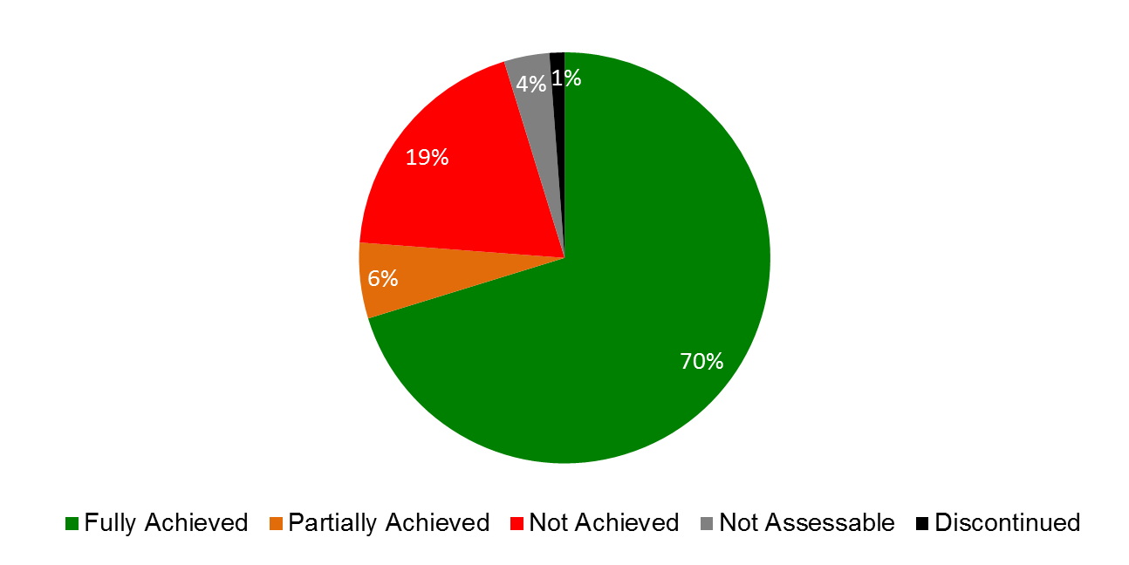

| **Expected Results** | **Performance Indicators** | **Responsible Program(s)** | **TLS** |
| --- | --- | --- | --- |
| II.1 Increased use of the PCT route for filing international patent applications | Level of satisfaction of PCT users with  user-focused information and training services | Program 5 | ⚫ |
|  | Satisfaction of Offices and International Authorities with PCT cooperative activities | Program 5 | ⚫ |
|  | No. of PCT applications originating from transition and developed countries | Program 10 | ⚫ |
|  | % of PCT filings | Program 20 | ⚫⚫⚫ |
|  | % of policy makers, government officials, and IP Practitioners and participants in targeted workshops with enhanced understanding of the PCT and related topics | Program 20 | ⚫⚫⚫ |
| II.2 Improvement of the PCT system | Further development of the PCT system, notably implementation of the PCT roadmap recommendations endorsed by PCT Member States | Program 5 | ⚫ |
|  | Improved electronic services for applicants, third parties, Offices and Authorities | Program 5 | ⚫ |
| II.3 Improved productivity and service quality of PCT operations | Application unit cost  Aggregate quality of formalities examination (including timelines) | Program 5  Program 5 | ⚫⚫⚫  ⚫ |
|  | Quality of translation | Program 5 | ⚫ |
|  | Timelines of report translation | Program 5 | ⚫ |
|  | Quality of software development (QSD) | Program 5 | ⚫ |
|  | Information systems service levels | Program 5 | ⚫ |
| II.4 Wider and better use of the Hague system, including by developing countries and LDCs | No. of Hague system applications originating from transition and developed countries  No. of countries that have formulated and/or are engaged in policies outlining their accession to the Hague Agreement | Program 10  Program 20 | ⚫  ⚫ |
|  | % of policy makers, government officials, and IP Practitioners and participants in targeted workshops with enhanced understanding of the Hague System | Program 20 | ⚫⚫⚫ |
|  | No. of Contracting Parties to the Hague in the Asia and Pacific Region | Program 20 | ⚫⚫ |
|  | Membership of the Geneva (1999) Act | Program 31 | ⚫ |
|  | Share of Offices concerned providing information on the Hague system | Program 31 | ⚫ |
|  | Hague filings and renewals | Program 31 | ⚫⚫⚫  ⚫⚫⚫ |
| II.5 Improved productivity and service quality of the Hague operations | Predominance of the Geneva (1999) Act in the Hague system | Program 31 | ⚫ |
|  | Progress towards the enhancement of the legal framework | Program 31 | ⚫ |
|  | Flexibility of data recorded in the International Register | Program 31 | ⚫ |
|  | No. of automated processes | Program 31 | ⚫ |
| II.6 Wider and better use of the Madrid & Lisbon systems, including by developing countries and LDCs | Expansion of geographical coverage (Madrid) | Program 6 | ⚫ |
| Expansion of geographical coverage (Lisbon) | Program 6 | ⚫ |
|  | Adoption of provisions streamlining or modernizing the Lisbon system legal framework | Program 6 | ⚫ |
|  | No. of International Applications (Madrid) | Program 6 | ⚫ |
|  | Share of Offices concerned providing updated information on the Madrid System | Program 6 | ⚫ |
|  | % of participants in Lisbon system events satisfied and reporting enhanced awareness post an event | Program 6 | ⚫ |
|  | No. and proportion of Lisbon registrations in force from developing countries and LDCs | Program 6 | ⚫ |
|  | Decrease in the number of irregularities (Madrid) | Program 6 | ⚫ |
|  | No. of Madrid & Lisbon system applications originating from transition and developed countries | Program 10 | ⚫⚫ |
|  | No. of countries that have formulated and/or are engaged in policies outlining their accession to the Madrid Protocol | Program 20 | ⚫ |
|  | % of satisfied participants in targeted workshops/seminars held on Madrid related topics | Program 20 | ⚫⚫ |
|  | No. of Contracting Parties to the Madrid Protocol | Program 20 | ⚫ |
|  | No. of new registrations (Madrid System) | Program 20 | ⚫⚫ |
|  | No. of renewals (Madrid System) | Program 20 | ⚫⚫ |
| II.7 Improved productivity and service quality of Madrid & Lisbon operations | Progress towards streamlining and simplification of the Madrid system legal framework | Program 6 | ⚫ |
|  | No. of registrations  No. of renewals processed  No. of modifications, including subsequent designations (Madrid) | Program 6 | ⚫⚫⚫  ⚫⚫ |
|  | Translation of applications in a timely manner (Madrid) | Program 6 | ⚫ |
|  | Decrease in the number of corrections (Madrid) | Program 6 | ⚫ |
|  | Improved client satisfaction (Madrid) | Program 6 | ⚫⚫ |
|  | Increased use of electronic exchange (Madrid) | Program 6 | ⚫⚫⚫⚫ |
|  | Refinement of the electronic International Register of the Lisbon system | Program 6 | ⚫ |
|  | Refinement of the electronic means of communication and publication under the Lisbon procedures | Program 6 | ⚫ |
| II.8 International and domestic intellectual property disputes are increasingly prevented or resolved through WIPO mediation, arbitration and other alternative dispute resolution methods | Increased consideration of the use of alternative dispute resolution services in intellectual property transactions, including through the use of WIPO procedures | Program 7 | ⚫⚫⚫  ⚫⚫ |
| Program 20 | ⚫ |
| Alternative dispute resolution policies to the development and implementation of which policies the Center has contributed | Program 7 | ⚫ |
|  | No. of users in transition and developed countries using the AMC services | Program 10 | ⚫ |
| II.9 Effective intellectual property protection in the gTLDs and the ccTLDs | No. of gTLD UDRP cases administered | Program 7 | ⚫ |
|  | No. of ccTLD UDRP based cases administered | Program 7 | ⚫ |
|  | Dispute resolution policies in the Domain Name System to the development and implementation of which policies the Center has contributed | Program 7 | ⚫ |
|  | No. of ccTLD administrators with WIPO assisted design or administration of intellectual property protection mechanisms in accordance with international standards | Program 7 | ⚫ |

## PROGRAM 5 THE PCT SYSTEM

**Program Manager Mr. J. Sandage**

ACHIEVEMENTS IN THE 2014/15 BIENNIUM

1. The International Bureau (IB) received approximately 217,000 record copies in 2015, representing a decrease of 0.3 per cent compared to 2014. One of the main reasons for the decrease was the spike in filings from the United States of America in March 2014 that was due to the entering into force of the Leahy-Smith America Invents Act one year earlier. A total of approximately 435,000 record copies have been received in the 2014/15 biennium, which represents an increase of nine per cent compared to the 2012/13 biennium, approximately 399,000 record copies in total. The share of fully electronic filings continued to increase in 2015 and now represents 94 per cent of total filings. While English accounted for the largest proportion of filings, with 48.6 per cent in 2014/15, the share of Asian languages has increased over the past decade. The combined share of the PCT applications filed in Japanese, Chinese and Korean has increased from 29.5 per cent in 2009 to 37.6 per cent in 2015.
2. Use of the ePCT system increased significantly in 2014/15, with the interface becoming available in all 10 languages of publication in April 2015, thus offering easier access for applicants and Offices from around the world. The ePCT-filing functionality, which in 2013 was only available to the IB receiving Office B, was made accessible in 2014/15 to all receiving Offices willing to receive and process international applications. By the end of 2015, 29 receiving Offices had, with the assistance of the IB, begun to accept applications filed via ePCT filing, including from developing countries such as Algeria, Azerbaijan, Brazil, Chile, Colombia, India, Malaysia, Mexico, Saudi Arabia and South Africa – which had not previously offered their applicants the possibility of online filing of international applications – in line with DA Recommendations under Cluster A on technical assistance and capacity building. Other countries were in various stages of testing, while 34 receiving Offices and eight International Authorities allowed for submission of post-filing documents via ePCT. Moreover, a new service, eSearchCopy, began as a trial in 2014, where the IB prepares and transmits search copies to the International Searching Authority (ISA) on behalf of the receiving Office to improve timeliness and efficiencies in international search. By the end of 2015, the service was in use between 28 pairs of Offices, including six ISAs and 15 receiving Offices.
3. At its seventh and eighth sessions, held in 2014 and 2015, the PCT Working Group continued its discussions on a number of proposals aimed at improving the functioning of the PCT system. Discussions were in line with recommendations endorsed by the Working Group at its third session, which include recommendations as to how the future development of the PCT can be matched with applicable DA Recommendations – notably from Clusters A and C. Particular achievements in 2014 included: (i) agreement on new eligibility criteria for fee reductions for applicants from certain countries, which expanded the number of developing countries and LDCs benefitting from such fee reductions; and (ii) a revised procedure for the appointment of new International Searching and Preliminary Examining Authorities to help ensure that prospective Authorities have the infrastructure and resources to perform this role. Notable achievements in 2015 included: (i) agreement to forward search and classification results from earlier applications to International Searching Authorities to bring about further efficiencies and contribute to raising quality in international search; and (ii) agreement to require designated Offices to send timely information to the IB on applications in the national phase, which will significantly improve information on pending and granted national patent rights. The IB also presented estimations on how responsive PCT filings are to changes in the international filing fee, showing simulations on the effect of possible fee reductions for universities and public research organizations in both developed and developing countries.
4. The Program continued to devote an important part of its work and resources to technical cooperation and assistance to developing countries and LDCs. Training and capacity building activities were conducted with the goal of assisting both PCT Member States and States considering accession to the PCT to strengthen national capacity for protection of national creativity and innovation, in accordance with DA Recommendation 1. The activities were demand-driven, development-oriented and transparent. They were developed in coordination with the local organizers, taking into account the level of PCT awareness, technical knowledge, and PCT-related skills of the participants and covered a wide range of PCT aspects, including ePCT and examination after entry into the national phase. These activities contributed to strengthening the capacities of PCT Member States and States considering accession to the PCT by enhancing local knowledge of and skills in utilizing the PCT System.
5. Awareness of the PCT among users and potential users was enhanced in 2014/15 through a variety of training and outreach activities, including 111 seminars, 101 presentations, 25 webinars and 67 user visits. In addition, the PCT Information Service responded to 23,618 PCT-related inquiries from PCT users and potential users (an average of 49 inquiries per day), and the PCT Legal Division resolved 2,408 “special handling” cases during the year.
6. The IB continued to improve and expand automation of certain processes relating to formalities examination of PCT international applications. In addition to the applications filed electronically in XML and PDF format, the IB made significant progress in automatically processing the international search reports and written opinions received from China, Japan, the Republic of Korea and the European Patent Office in XML and PDF format. This improved the productivity and the quality of the formalities examination of PCT international applications in the biennium, which enabled the IB to absorb the continued workload increase with fewer staff, while maintaining a high quality of service. Productivity, as measured by the number of PCT publications divided by the number of staff, increased significantly by 22 per cent in the 2014/15 biennium compared to 2012/13. The overall quality, as measured by the aggregate index, improved markedly by 5.8 per cent in the 2014/15 biennium compared to 2012/13.

PERFORMANCE DATA

|  |  |  |  |  |  |  |  |  |
| --- | --- | --- | --- | --- | --- | --- | --- | --- |
| **Expected Result:** II.1Increased use of the PCT route for filing international patent applications | | | | | | | | |
| **Performance Indicators** | | **Baselines** | | **Targets** | | **Performance Data** | **TLS** | |
| Level of satisfaction of PCT users with user-focused information and training services | | 2009 level of user PCT satisfaction with PCT user information and training services | | Maintain or increase 2009 level of PCT user satisfaction | | Overall PCT user satisfaction with WIPO-provided PCT services increased 11% since 2009 to 89%. | **Fully Achieved** | |
| Satisfaction of Offices and International Authorities with PCT cooperative activities | | *Updated Baseline end 2013:* 56 (95 % out of 59 beneficiaries of PCT cooperative activities; 85% out of the 66 survey respondents) (2012 survey)  *Original Baseline P&B 2014/15:* 59 respondents expressed satisfaction with the activities in 2011 (95% out of 62 involved in the activities/ 86% out of all 69 respondents) | | Maintain the 2011 level of satisfaction of Offices and International Authorities | | 58 (96% out of 60 beneficiaries of PCT cooperative activities; 95% out of 61 survey respondents) (2016 survey) | **Fully Achieved** | |
| **Expected Result:** II.2 Improvement of the PCT system | | | | | | | | |
| **Performance Indicators** | | **Baselines** | | **Targets** | | **Performance Data** | **TLS** | |
| Further development of the PCT system, notably implementation of the PCT roadmap recommendations endorsed by PCT Member States | | *Updated Baseline end 2013:* State of the PCT system at the end of 2013  *Original Baseline P&B 2014/15:* Decisions by appropriate PCT bodies up to the end of 2013 | | Progress  towards furthering the aims of the  Treaty, for the benefit of all  stakeholders, in line with the PCT  roadmap recommendations  endorsed by Member States[17] | | In 2014/5, progress towards furthering the aims of the Treaty, for the benefit of all stakeholders, in line with the PCT roadmap recommendations endorsed by Member States, was made in the following respects: (a) Agreement by Member States on eligibility criteria for fee reductions;  (b) Agreement by Member States on a revised procedure for appointment of International Searching and Preliminary Examining Authorities;  (c) Agreement by Member States on sharing of results of search work on earlier applications to improve quality and timeliness of PCT work products; (d) Implementation of a new eSearchCopy service for quicker and more efficient transmission of applications for international search; and  (e) Agreement for Offices to send timely data to the IB on applications in the national phase to improve patent status information. | **Fully Achieved** | |
| Improved electronic services for applicants, third parties, Offices and Authorities | *Updated Baseline end 2013:* No. of transactions carried out using ePCT services at the end of 2013 for:  -- 8,005 public applicants;  -- 4,754 private applicants;  -- 74 third parties;  -- 2,474 Offices; and  -- 2,398 Authorities  (cumulative)  *Original Baseline P&B 2014/15:* No. of transactions carried out using ePCT services at the end of 2013 for:  -- applicants;  -- third parties;  -- Offices; and  -- Authorities | | Increased no. of transactions carried out using ePCT services for:  -- applicants;  -- third parties;  -- Offices; and  -- Authorities | | | At the end of 2015, compared to the end of 2013:  -- 11,242 public applicants (+40%)  -- 29,590 private applicants (+522%)  -- 70 third party observers  (-5%);  -- 9,085 receiving Offices- (+267%); and  -- 2,596 International Authorities (+8%).  (cumulative) | | **Fully**  **achieved** |
| **Expected Result:** II.3 Improved productivity and service quality of PCT operations | | | | | | | | |
| **Performance Indicators** | **Baselines** | | **Targets** | | **Performance Data** | | | **TLS** |
| Application unit cost | *Updated Baseline end 2013:* 722 Swiss francs (2013)  *Original Baseline P&B 2014/15:* Unit cost in 2013 | | Lower unit cost | | 662 Swiss francs (2014)  735 Swiss francs(2015)[18]  Average 698 Swiss francs in the 2014/15 biennium, 2.7% lower than average 717 Swiss francs in the 2012/13 biennium | | | **Fully**  **Achieved**  **Not Achieved**  **Fully**  **Achieved** |
| Aggregate quality of formalities examination (including timeliness) | *Updated Baseline end 2013:* 88.74% (average 2011-13)  *Original Baseline P&B 2014/15:* Average of last three years | | Higher Quality | | 89.60% (2012-2014)  91.13% (2013-2015) | | | **Fully**  **Achieved** |
| Quality of translation | *Updated Baseline end 2013:* 86.23% (2011-2013)  *Original Baseline P&B 2014/15:* Average of last three years | | Higher quality | | 86.77% (2012-2014)  86.90% (2013-2015) | | | **Fully**  **Achieved** |
| Timeliness of report translation | *Updated Baseline end 2013:* 64% on time (2013)  *Original Baseline P&B 2014/15:* Timelines in 2013 | | Improvement | | 82.5% (2014)  90.0% (2015) | | | **Fully**  **Achieved** |
| Quality of software development (QSD) | *Updated Baseline end 2013:* 89.4% (2013)  *Original Baseline P&B 2014/15:* QSD for latest build of  ePCT and eDossier in 2013 | | Higher QSD | | 94.5% (2014)  91.9% (2015) | | | **Fully**  **Achieved** |
| Information systems service levels | *Updated Baseline end 2013:* 93.0% (2013)  *Original Baseline P&B 2014/15:* Information systems  service levels for 2013 | | Higher information systems service levels. | | 95.1%[19] (2014)  96.5% (2015) | | | **Fully**  **Achieved** |

RISK REPORTING FOR THE BIENNIUM

| **Risk(s) to the Program achieving its Results** | **Mitigation plans in place or under implementation** | **Evolution of Risk(s) and Mitigation Strategies Over the Biennium** | **Impact on the Program’s Performance** |
| --- | --- | --- | --- |
| Decrease in PCT filings, in absolute terms or relative to Paris route filings | Continued promotion of the PCT to all users as the most valuable and efficient way to protect innovation in international markets | This is a continuing risk for the Program, but it did not evolve to the detriment of the PCT in 2014/15. Mitigation strategies continued. | No measurable impact |
| Prolonged Breakdown of PCT Operations  If the International Bureau is unable to process documents, even for a short period of time, backlogs grow extremely quickly. A few days of business disruption can lead to many weeks of backlog | Implementation and regular testing of Business Continuity Management (BCM) plan  The objective of the Business Continuity Management plan is to ensure that the International Bureau’s work can proceed sufficiently during periods of disruption so as to avoid unacceptable degradation in quality of service provided to PCT applicants and offices | The risk did not materialize. Preparations were initiated for the design of a resilient and secure platform architecture for PCT information systems as a mitigation measure.  The risk has not materialized. New workload indicators to improve quality control procedures in mitigation measures were created. | This risk and its evolution did not have any material impact on the Program’s performance in 2014/15.  .  Quality of formalities examination improved. |
| Malicious or unintentional disclosure of confidential information | Continued awareness program for staff concerned: continue to implement cutting-edge controls in the physical and electronic environment; continue to improve strategic surveillance; maintain high level of oversight with outsourced translation service providers | The risk did not materialize. Preparations were initiated for the design of a resilient and secure platform architecture for PCT information systems as a mitigation measure. | This risk and its evolution did not have any material impact on the Program’s performance in 2014/15. |

RESOURCE UTILIZATION

Budget and Actual Expenditure (by result)

*(in thousands of Swiss francs)*



Budget and Actual Expenditure (personnel and non-personnel)

*(in thousands of Swiss francs)*



*“NOTE: The resources for the DA projects “IP and Technological Transfer” and “Open Collaborative Projects” (280,000 Swiss francs and 153,000 Swiss francs, respectively) are reflected under Expected Results IV.2 and VII.3. The projects were completed in 2015; a substantive report on both Projects is provided under Program 30.”*

A. 2014/15 Final Budget after Transfers

1. The overall decrease in the Final Budget after Transfers is primarily due to increased productivity in the processing of international applications over the biennium. In addition, the improved workflows and processing of financial commitments for the translation services contributed to a more efficient use of resources.
2. This overall decrease was partially offset by a net increase in the budget allocated to support further enhancements of the PCT information systems.
3. The adjustments in the Final Budget after Transfers between Results are mainly due to reallocation of personnel resources.

B. 2014/15 Budget Utilization

1. Overall budget utilization for the biennium 2014/15 amounted to 95 per cent due to the following:

* the increase in productivity achieved in the processing of international applications over the biennium and lower translation costs that resulted in efficiency gains in PCT Operations; and ongoing implementation of certain PCT information system projects that started and were not completed in 2015, to be continued in the next biennium.

**Program 5 Annex: Indicators of PCT Operations**

PERFORMANCE INDICATORS FOR THE EXPECTED RESULT

“IMPROVED PRODUCTIVITY AND SERVICE QUALITY OF PCT OPERATIONS”

**General**

1. As background for the performance indicators for the expected result “improved productivity and service quality of PCT operations”, the evolution of the following factors need to be considered:

* The PCT workloads;
* The language distribution of those workloads;
* The number of staff assigned to process those workloads; and
* The level of automation.

*Workloads*

1. The workloads are tracked on the basis of the yearly number of record copies received by the International Bureau (IB).[20]

**Evolution of Record Copies by Medium of Filing**

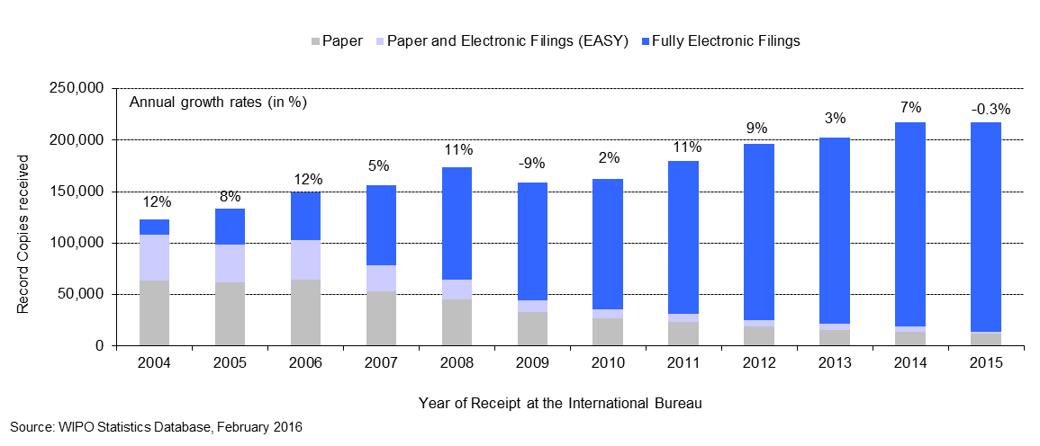

* The IB received approximately 217,000 record copies in 2015, representing a small decrease of 0.3 per cent compared to 2014. One of the main reasons for this decrease is the spike in filings from the United States of America (U.S.) in March 2014 that was due to the entering into force of the Leahy-Smith America Invents Act one year earlier. Nevertheless, the total record copies received in the 2014/15 biennium increased by nine per cent compared to the 2012/13 biennium.
* The share of fully electronic filing methods continued to increase in 2015 and now represents 94 per cent of total filings.

*Language distribution*

1. One fundamental development driving change in the IB is the increasing language diversity of filings, resulting, in particular, from continued increased usage of the PCT System in East Asian countries.

**Languages of Filing** *(all languages)*

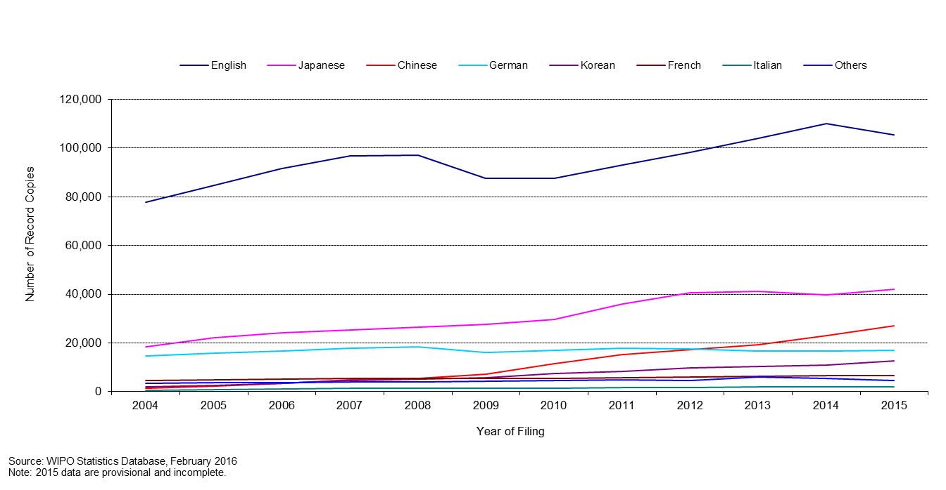

1. As can be observed, while English accounts for the largest proportion of filings, with 48.6 per cent of filings in 2015, the shares of Asian languages have increased over the past decade. The combined share of the PCT applications filed in Japanese, Chinese and Korean increased from 29.5 per cent in 2009 to 37.6 per cent in 2015. Zooming in on languages other than English provides the following picture:

**Languages of Filing** (all languages except English)

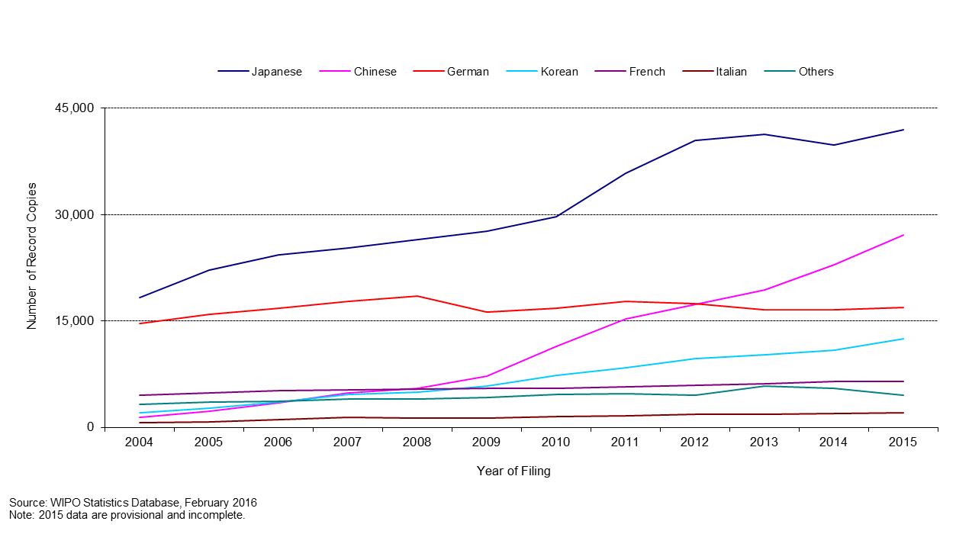

1. The sharp increase of applications filed in Asian languages in the last five years put a considerable strain on the IB due to the limited number of staff resources able to work in these languages. Mitigation for this issue is automation of certain tasks and recruitment of staff able to work in these languages.

*Staff*

1. The chart below shows the number of PCT Operations staff since 2001, in Full Time Staff Equivalent (FTSE ‑ total number of full-time staff plus the full-time equivalent of part-time staff).

**Number of Personnel in PCT Operations**

* The PCT Operations Division’s personnel further decreased in 2015.

*Unit cost of processing an application*

1. The IB’s efficiency in processing PCT applications can be measured by the unit cost, defined as the average cost of producing one unit of output. The total cost of production comprises expenditure relating exclusively to the PCT System and expenditure of activities supporting the System.
2. The expenditure relating exclusively to the PCT System includes those of Program 5 (the PCT System).
3. Expenditure of activities supporting the PCT System comprises the expenditure of the following services: conference and language services, construction, executive management, finance and budget, general support services, human resources management, internal oversight, IT and safety and security. A small proportion of these expenses (cost of server hosting at UNICC, estimated cost of the authentic publication source of PCT applications (PATENTSCOPE) and share of cost of the Income Section in Finance) are directly attributed to the PCT System whereas the remaining of such expenses attributable to the PCT System are calculated based on headcount (including fixed term staff, temporary staff and fellows).
4. The methodology to compute the unit cost was revised in 2013 in order to align it with other WIPO unit/union cost calculations and to better capture a fast changing environment. For example, the old method, which was designed in 2007, included a cost of storage (over 30 years) in warehouses, whereas paper filings (including PCT EASY filings) accounted for less than 10 per cent of filings in 2013. The 2012 PCT unit cost has been calculated using both methods. The 2012 unit cost amounted to 680 Swiss francs using the old method and to 712 Swiss francs using the new method. The 32 Swiss francs difference is due to the new method for allocating indirect costs.
5. Formally, unit cost is defined as:



1. The graphs below depict the evolution of the unit cost of processing from 2004 to 2012 using the old method and from 2012 to 2015 using the new method, including a breakdown of the contribution of direct and indirect costs.

**Unit Cost of Processing a Published PCT Application**

|  |  |
| --- | --- |
| Old method | New method |
|  |  |

* The average cost of processing a published PCT application was 735 Swiss francs in 2015, representing an increase of 11 per cent compared to 2014. This increase was due to higher direct and indirect expenditures, combined with a lower number of applications published in 2015 compared to 2014. This increase in 2015 over 2014 is mainly due to an exceptionally low unit cost and an outstanding efficiency rise in 2014, which were due to: (i) the spike in U.S. filings in March 2014 due to the entering into force of the Leahy-Smith America Invents Act one year earlier; and (ii) the fact that in 2014, as with every five to six year period, the number of weeks of publication was 53 instead of 52, thus increasing the number of publications performed during 2014. Furthermore, expenses are generally higher in the second year of a biennium. In addition, the PCT translation cost increased by 7.3 per cent in 2015 compared to 2014, due to the increase of the shares of Asian languages, as well as the increase of the length of the reports to be translated. In terms of the breakdown of the increase, 44 per cent is attributable to the mentioned decrease in publications, 18.7 per cent to increased translation costs, 4.4 per cent to PCT information services cost, 5.5 per cent to the processing of applications itself, while the rest is attributable to indirect cost. Nevertheless, in comparison to the two last biennia, the average unit cost of processing a published PCT application in 2014/15 (698 Swiss francs) decreased by 2.7 per cent compared to 2012/13 (717 Swiss francs).
* The average cost of processing a published PCT application calculated by the old method decreased by an average of 5 per cent per year from 1,042 Swiss francs in 2004 to 680 Swiss francs in 2012.

*Productivity of formalities examination*

1. The definition of staff productivity is output (i.e. the number of PCT publications) divided by the number of staff for formalities examination.

**Productivity of Formality Examination**

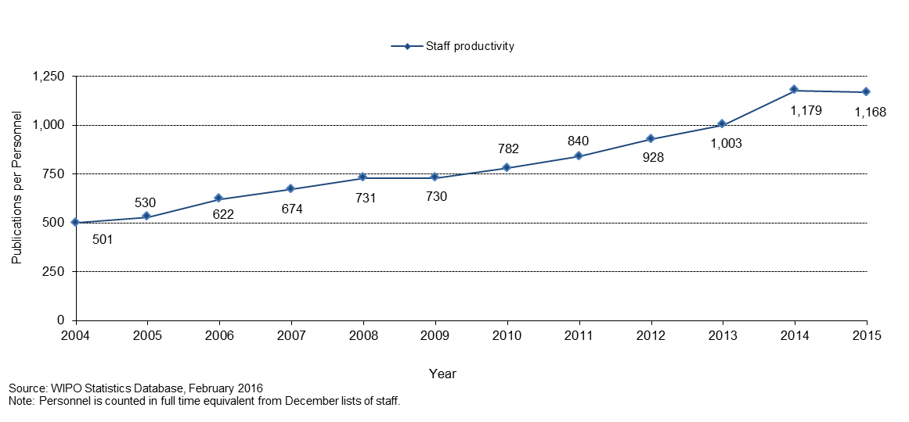

* Historically, productivity of formalities examination has increased, mainly due to automation, which has permitted the processing of much larger workloads with less or equal staff.
* In 2015, despite a decrease of four per cent in the number of staff working in the formalities examination, the productivity of formalities examination dropped by one per cent compared to 2014 due to a decrease of five per cent in the number of PCT applications to be prepared for publication. The main reasons for the decrease were: (i) the spike in U.S. filings in March 2014 that was due to the entering into force of the Leahy-Smith America Invents Act one year earlier; and (ii) the fact that in 2014, as is the case every five to six years, the number of weeks of publication was 53 instead of 52, thus increasing the number of publications performed during that year. Nevertheless, when comparing the two last biennia, the total productivity of formalities examination in 2014/15 increased by 22 per cent compared to 2012/13.

*Aggregate quality of formalities examination*

1. In order to measure the quality of the work performed by the IB in a simple and comprehensive manner, the IB has developed an aggregate quality index, calculated as the average of four lead quality indicators. Three of these indicators are based on the timeliness of key transactions: acknowledgement of receipt of the PCT application, publication and republication. The fourth indicator reflects errors made during the processing of PCT applications.

**Quality Index of Formalities Examination**

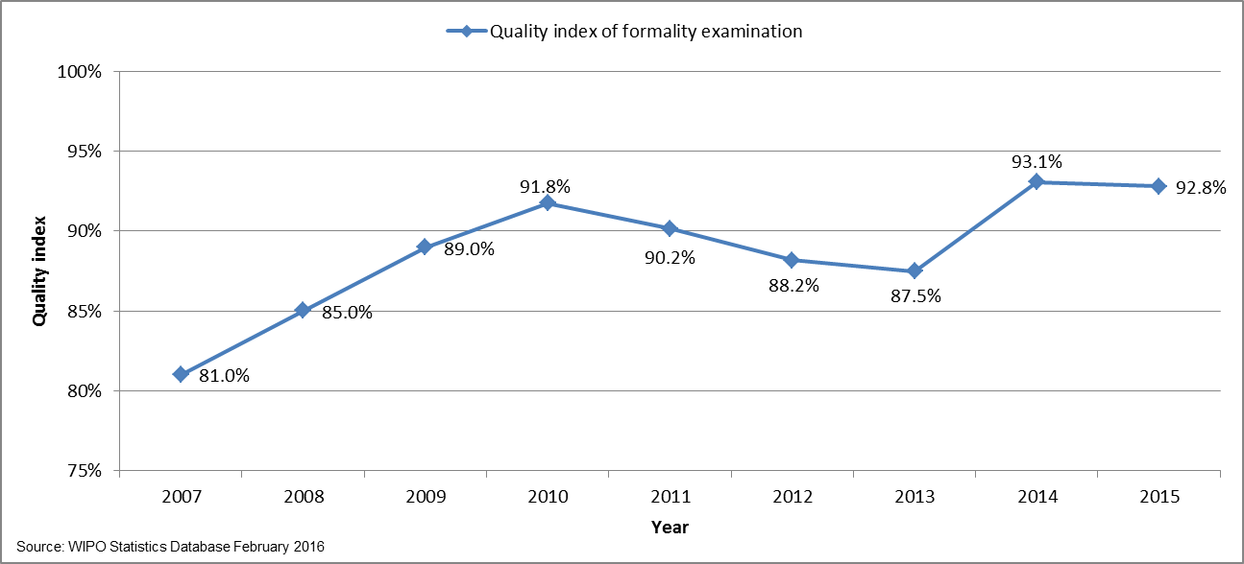

* The overall quality, as measured by the aggregate index, improved markedly from an average of 81 per cent in 2007 to 92.8 per cent in 2015.
* The small decrease in the quality index of 0.3 per cent in 2015, compared to 2014, is due to delays in republishing PCT applications with International Search Reports (ISRs) within two months, which decreased from 77 per cent in 2014 to 74 per cent in 2015. The three other key transactions used to compute this aggregate quality index improved in 2015, as compared to 2014. The quality index in the 2014/15 biennium (93 per cent) improved by nearly five percentage points compared to the 2012/13 biennium (88.1 per cent).

*Timeliness of formalities examination*

1. This indicator reflects in more detail one of the components of the aggregate quality indicator, namely the time required by the IB to issue Form 301. This form is issued after the formality examination of the application has been completed. Applicants appreciate receiving this form as soon as possible because it acknowledges receipt of the application at the IB and allows them to know whether their application has any formal defects.

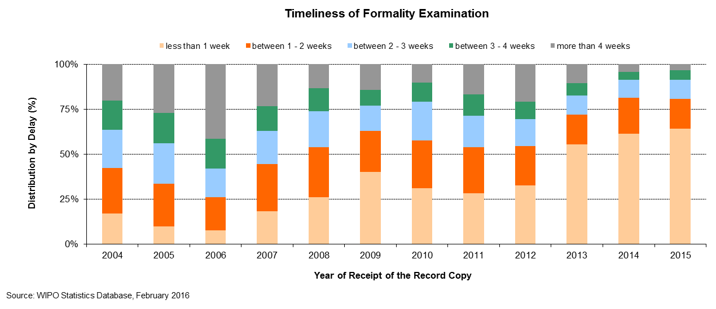

*Timeliness of publication*

1. This indicator reflects in more detail one of the components of the aggregate quality indicator, namely, the time required by the IB to publish the application. Article 21 (2) (a) of the PCT states that the “… international publication of the international application shall be effected promptly after the expiration of 18 months from the priority date of that application.”

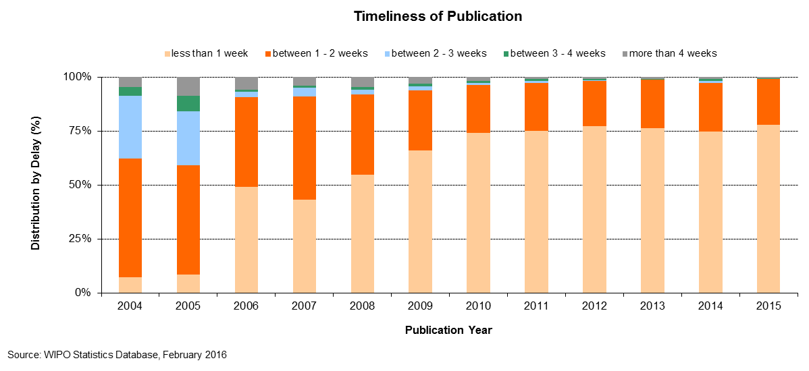

*Timeliness of republication*

1. This indicator reflects in more detail one of the components of the aggregate quality indicator, namely the time required by the IB to republish the application with the ISR. Due to delays in the communication of ISRs by International Searching Authorities (ISAs), a number of international applications are published without the ISR. When the ISR becomes available, the international application needs to be republished with the ISR as soon as possible, so as to complete the international publication.

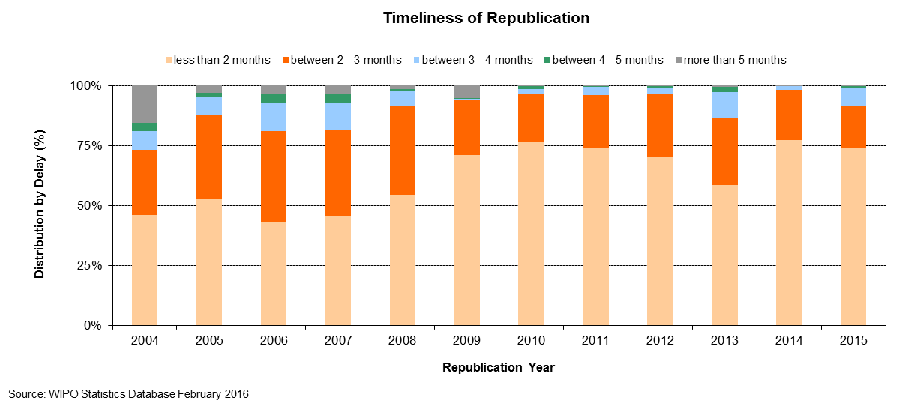

*Quality of translation*

1. Statistically calculated numbers of documents are selected at random from translations of abstracts and patentability reports prepared under the responsibility of the IB for quality control. The evaluation determines whether a translation is “acceptable” or “not acceptable”. This indicator aggregates the results of such quality control performed by the IB across all language combinations and document types. Relationships with any agencies that consistently have less than 80 per cent of their translations deemed “acceptable” are discontinued. The share of 87.6 per cent acceptable obtained in 2015 was the highest that has ever been obtained and was a full 1.6 percentage points higher than the 2014 share.

**Quality of PCT Translation**

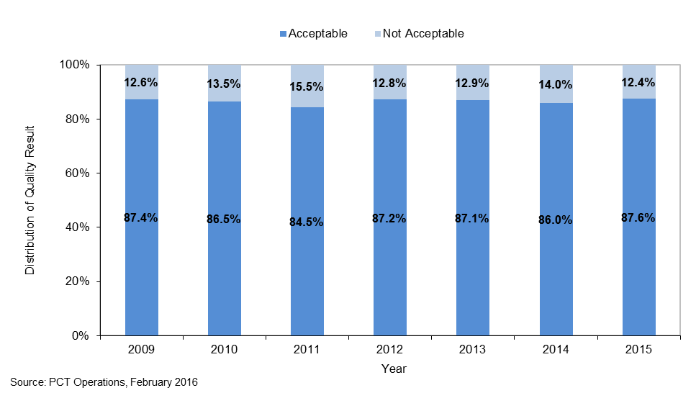

*Timeliness of report translation*

1. This indicator provides information on the timeliness with which patentability report translations are made available by the IB to applicants and Offices. The share of patentability report translations delivered at 30 months from the priority date of the international application has steadily increased since 2010. In 2014, 82.5 per cent of patentability report translations were delivered at 30 months from the priority date. In 2015, this improved to 90 per cent of patentability report translations being delivered at 30 months, with 99 per cent being delivered by 31 months.

**Timeliness of Report Translation**

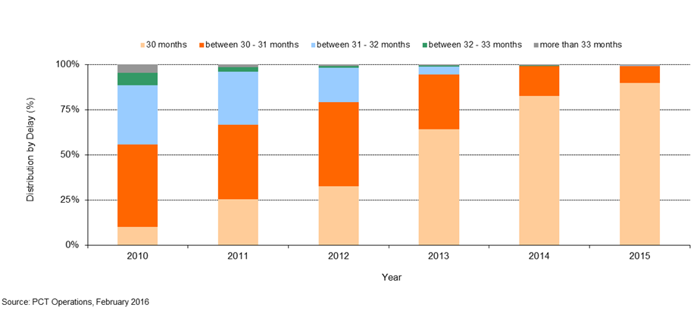

*Quality of software development*

1. The quality of software development (QSD) indicator provides a measure of the quality of major software releases for eDossier and ePCT projects. The QSD reflects the share of the time spent delivering new functionality in the release (i.e. work) out of the total time spent (i.e. work + rework). Rework is the time spent correcting defective work that was detected in the production environment.
2. Under this approach, development outputs that contain low levels of rework are deemed high quality as it reflects the extent of value added to the product through the delivery of new features.
3. The QSD is defined as:



1. In 2014, the quality of major releases, as defined by the QSD, was 94.5 per cent, nearly five percentage points higher than in 2013. The year 2015 saw a slight reduction to 91.9 per cent as compared to 2014. Nevertheless, the performance targets were met in both years, as both improved on the baseline of 89.4 per cent.

**Quality of Software Development**

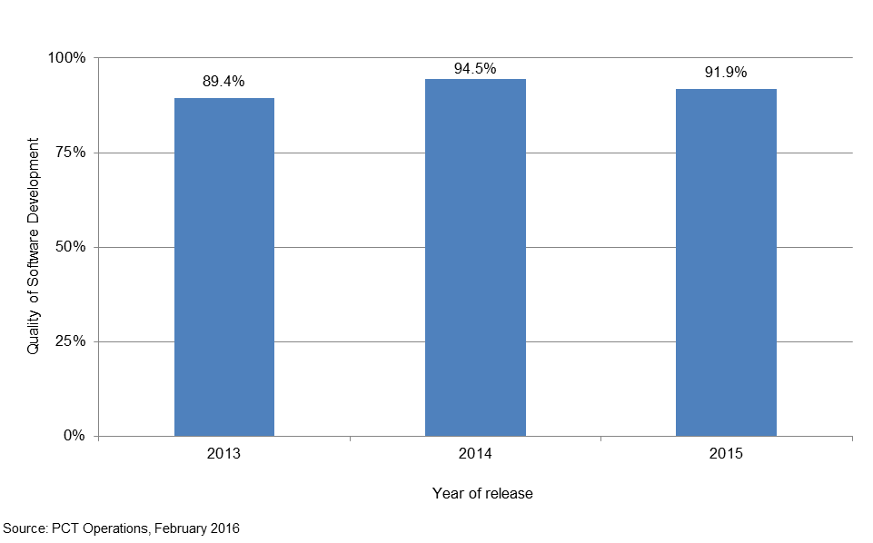

*Information systems service levels*

1. The performance indicator entitled information systems service levels (ISSL) reflects the performance of the service provided by the PCT information systems service to users, based on its ability to meet agreed targets.
2. This composite indicator is calculated using the weighted average of five target-based performance indicators[21]. Each indicator is expressed as the percentage of the target actually attained.

1. In 2014, the overall service level was 95.1 per cent towards meeting the target performance levels. The year 2015 also saw improvement, with the the overall service level reaching 96.5 per cent, resulting in the biennial target of exceeding the 2013 baseline of 93 per cent being met in both years.

**Information Systems Service Levels**

|  |  |  |  |  |  |  |
| --- | --- | --- | --- | --- | --- | --- |
| **Id** | **Performance Indicator** | **Target** | **Conditions** | **Results** | | |
| ***Short description*** | **2013** | **2014** | **2015** |
| 1 | Incident resolution time | Severity 1: 4 hours | Production and Support tickets resolved by the support team | 85.5% | 87.6%[22] | 93.6% |
| *Working time (7am-7pm on WIPO working days) between a ticket being created and resolved.* | Severity 2: 2 days |
| Severity 3: 5 days |
| Severity 4: 10 days |
| 2 | Document load time | 8 hours | Documents loaded by a semi or fully automated process | 80.0% | 88.2% | 89.5% |
| *elapsed time between receipt of document at IB and its availability in eDossier* |
| 3 | Batch job processing success rate | 100% | Batch jobs to be completed successfully by the close of business on the scheduled date | 99.6% | 99.5% | 99.6% |
| 4 | eDossier system availability | 99% | 7am-7pm on working days | 100.0% | 100.0% | 100.0% |
| 5 | ePCT system availability | 99% | 24 hours | 100.0% | 100.0% | 100.0% |
|  | **Information systems service levels (ISSL)** |  |  | **93.0%** | **95.1%[23]** | **96.5%** |
| ***Weighted average of the above indicators: (1) 20% (2) 20% (3) 20% (4) 20% (5) 20%.*** |
| Source: PCT Operations, February 2016 | |  |  |  |  |  |

**Receiving Office at the International Bureau (RO/IB)**

*Filings*

1. This table presents PCT filings by the top 10 receiving Offices over the past five years to 2015. In principle, a PCT application is filed at the national patent office of the applicant’s home country or at a regional patent office acting for the applicant’s home jurisdiction. The IB is a competent receiving Office (RO/IB) for applicants from all PCT contracting States. The evolution of the filings at the RO/IB, its ranking in terms of the number of filings among other receiving Offices, as well as its market share can be observed in this table.



1. In the Program and Budget 2014/15, the following two performance indicators were added for the RO/IB:

*Timeliness of notification of international filing date*

1. This indicator reflects the time required by the RO/IB to issue Form 105. This form is issued after the international filing date has been accorded. Applicants appreciate receiving this form as soon as possible, because an international application has the effect of a regular national application in each designated State as of the international filing date, which date shall be considered to be the actual filing date in each designated State.

**Timeliness of Notification of International Filing Date**

*Timeliness of transmittal of search copy*

1. This indicator reflects the time required by the RO/IB to transmit the search copies to the ISAs. The search copy is to be transmitted promptly after payment of the search fee, so that the ISA can establish the ISR within the deadlines stipulated by the PCT regulatory framework. Delays in paying the fee will delay the transmission of the search copies to the ISAs and therefore negatively impact upon the ability of ISAs to meet these deadlines.

**Timeliness of Transmittal of Search Copy**

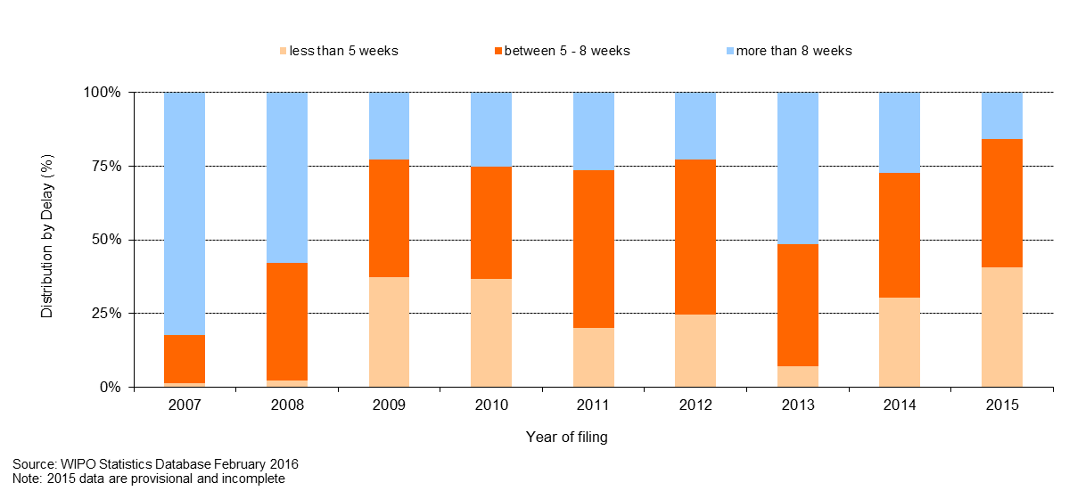

[End of Annex]

## PROGRAM 6 MADRID AND LISBON SYSTEMS

**Program Manager Ms. B. Wang**

ACHIEVEMENTS IN THE 2014/15 BIENNIUM

A. THE MADRID SYSTEM

1. The geographical expansion of the System saw important positive developments in the biennium. In 2014, Zimbabwe and the *Organisation Africaine de la Propriété Intellectuelle* (OAPI) acceded to the Madrid Protocol. With OAPI being a 17-country intergovernmental organization, these two accessions alone increased the number of countries in which users can protect and manage their trademarks centrally through the Madrid System from 94 to 110 in 2014 alone. In 2015, Algeria, Cambodia, the Gambia and Lao People’s Democratic Republic also acceded to the Protocol, bringing the total number of Contracting Parties at the end of the biennium to 97, covering 113 countries. As Algeria was the last remaining Contracting Party of the Madrid Union to be a member of the Madrid Agreement only, the Madrid System, for practical purposes, now operates as a single treaty system.
2. Use of the Madrid System increased by 2.3 per cent in 2014 as compared to 2013, with a total of 47,885 applications received. In 2014, the United States of America surpassed Germany as the biggest user of the Madrid System, illustrating the geographical transformation of the System. In 2015, a total of 49,273 applications were received representing a 2.9 per cent growth over 2014. This represents healthy growth in the biennium, in particular taking into account that the Madrid System became more expensive for applicants from a number of important filing countries following the sharp appreciation of the Swiss franc in 2015.
3. The discussions in the Working Group on the Legal Development of the Madrid System led to the adoption by the Assembly of the Madrid Union of a number of important changes to the Common Regulations, as follows: (i) “continued processing” is now available to applicants or holders who fail to meet given time limits in specific procedures before the International Bureau (IB); (ii) the renewal procedure has been legally simplified through the introduction of an option to renew an international registration only for a reduced list of goods and services, rather than having to request the recording of a limitation prior to the renewal, as was previously the case; (iii) failure to meet a time limit for a communication addressed to the IB that was sent electronically will be excused where the party submits satisfactory evidence showing that this was due to failure in the electronic communication with the IB or a failure that affects the locality of the party due to extraordinary circumstances; (iv) changes to address for correspondence, e-mail address or any other means of communication where the applicant or holder are exempt from fees; (v) applicants will be allowed to provide a voluntary description of the mark, which would be useful to prevent provisional refusals; (vi) the level of examination by the IB of the list of goods and services in subsequent designations has been clarified, and (vii) where the United States of America and other Contracting Parties have been subsequently designated and the declaration of intent for use in the United States of America has not been provided or corrected, this failure will no longer affect the rest of the designated Contracting Parties. Some changes entered into force in January 2015, while others will enter into force on April 1, 2016 and November 1, 2017.
4. In early 2014, a major long-term reform initiative aimed at improving the maturity level of the operational environment was launched. The principal areas covered by this initiative included: (i) work planning and related processes; (ii) IT; (iii) customer support; (iv) examination documentation; (v) fee processing; and (vi) business continuity. These new projects required the diversion of certain resources previously dedicated to examination to other activities. As a result, backlogs accumulated in various examination transactions and other operational delays were incurred in 2014. However, mitigation measures were put in place, including the retention of a number of additional flexible resources, which allowed the IB to reverse the situation in 2015. At the end of the biennium, pendency rates for all examination transactions were either at or better than the five-year historical average. In addition, the high level of registrations achieved in 2015 (as a consequence of the elimination of backlogs) resulted in a biennial income level, which exceeded the budgeted target by six per cent. In parallel with these activities, important foundational progress was made in the other reform areas mentioned above, in particular in customer support, examination quality control and business continuity, the benefits of which are expected to materialize in the coming years. As the operational environment gradually stabilized in 2015, it was also possible to shift some of the management focus to marketing and promotion, as well as the strategic evolution of the Madrid System itself.
5. Following the implementation of recommendations included in the independent review of the preparations necessary for the deployment of the modernized back office ICT systems supporting the Madrid Registry, and in particular, the initiation of appropriate business and ICT transformation programs, the modernized back office systems were scheduled for comprehensive user acceptance testing, and, subject to the successful conclusion of final system and user testing, subsequent deployment in March 2016. As regards the front office ICT systems, work continued as planned.  Progress was noted with the development of an enhanced search system, Madrid Monitor, which is scheduled for deployment in beta test mode in the second quarter of 2016. Progress was also noted in the ongoing evolution of Madrid System online presence, in particular revisions to the functionality of the eRenewal form as a result of new legal framework provisions.

B. THE LISBON SYSTEM

1. The Assembly of the Lisbon Union mandated the Working Group on the Development of the Lisbon System, in 2009, to engage in a full review of the Lisbon System aimed at making the system more attractive for users and prospective new Members, while preserving its principles and objectives. In view of the progress made by the Working Group, the Lisbon Union Assembly approved in 2013 the convening of a Diplomatic Conference for the Adoption of a Revised Lisbon Agreement on Appellations of Origin and Geographical Indications in 2015. In October 2014, the Working Group finished its preparatory work. From May 11 to 21, 2015, the Diplomatic Conference for the Adoption of a new Act of the Lisbon Agreement took place in Geneva and adopted, on May 20, 2015, the Geneva Act of the Lisbon Agreement on Appellations of Origin and Geographical Indications.
2. The Lisbon Registry received 115 new applications for the registration of appellations of origin, 105 statements of grant of protection and 39 refusal declarations, which amounts to an overall total of 267 transactions (including two withdrawals of refusal and six corrections). The total number of registrations in force increased in the biennium to 931 from 816 in 2013. Of these, 95 originate from developing countries or LDCs (14 in the Arab region; 38 in Asia and the Pacific; and 43 in Latin America and the Caribbean).
3. The number of competent authorities that had given their consent to the use of electronic means for communications under the procedures of the Lisbon System increased to 26 by the end of 2015 from 23 in 2013. The electronic interface linking the International Register and the Lisbon Express database on the WIPO website was completed and deployed in 2014. The notifications procedure was further streamlined through the use of the WIPO Inquiry Notification System (WINS). Further development towards an electronic system for the generation of notification letters in 2015 was followed by the initiation of a testing phase.
4. As regards raising awareness of the Lisbon System, the IB organized and/or participated in seven information and promotion events with a specific focus on the Lisbon System, including its planned revision, in all regions.
5. The design, planning and implementation of activities by Program 6 were informed and guided by the relevant DA Recommendations, in particular Recommendations 1 and 6. In addition, the legislative assistance provided to Member States was development-oriented, balanced and tailored to unique Member State requests, in accordance with the DA principles (Recommendation 13), and bearing in mind the applicable flexibilities relevant to countries at differing levels of development (Recommendations 14 and 17).

PERFORMANCE DATA

|  |  |  |  |  |
| --- | --- | --- | --- | --- |
| **Expected Result:** II.6Wider and better use of the Madrid & Lisbon Systems, including by developing countries and LDCs | | | | |
| **Performance Indicators** | **Baselines** | **Targets** | **Performance Data** | **TLS** |
| Expansion of geographical coverage (Madrid) | *Updated Baseline end 2013:*  92 Contracting Parties to the Madrid System(end 2013)  *Original Baseline P&B 2014/15:*  The number of Contracting Parties at the end of 2013 | A total of 100 Contracting Parties by end of 2015 | 97 Contracting Parties by end of 2015 covering 113 countries | **Fully Achieved** |
| Expansion of geographical coverage (Lisbon) | *Updated Baseline end 2013:* 28 (end 2013)  *Original Baseline P&B 2013/14:*  28 (April 2013) | 32 | No new Contracting Parties | **Not  Achieved** |
| Adoption of provisions streamlining or modernizing the Lisbon System legal framework | *Updated Baseline end 2013:* A revision of the Lisbon Agreement and amendments to the Lisbon Regulations are in preparation in the Working Group on the Development of the Lisbon System.  *Original Baseline P&B 2013/14:*  Lisbon Agreement, Regulations and Administrative Instructions in force at the end of 2013 | Revision of the Lisbon Agreement and amendments to the Regulations and Administrative Instructions | Geneva Act of the Lisbon Agreement on Appellations of Origin and Geographical Indications adopted in May 2015 | **Fully Achieved** |
| No. of International Applications (Madrid) | *Updated Baseline end 2013:*  44,018 (2012)  46,829 (2013)  *Original Baseline P&B 2014/15:*  The number of International Applications at the end of 2013 | 8.1% increase by end of 2015 | A total of 97,158 International Applications received in 2014/15:  47,885 (2014)  49,273 (2015  This represents a 6.9% increase compared to the 2012/13 biennium. | **Fully Achieved** |
| Share of Offices concerned providing updated information on the Madrid System | Share of such Offices providing such information | Increased share |  | **Dis-continued** |
| **Expected Result:** II.6 Wider and better use of the Madrid & Lisbon Systems, including by developing countries and LDCs | | | | |
| **Performance Indicators** | **Baselines** | **Targets** | **Performance Data** | **TLS** |
| % of participants in Lisbon System events satisfied and reporting enhanced awareness post an event | *Updated Baseline end 2013:* Evaluation questionnaires showed a satisfaction rate of more than 90%  *Original Baseline P&B 2013/14:*  No. of events and % of satisfied participants in 2013 | At least eight events with 85% of participants satisfied | Seven information and promotion events with a specific focus on the Lisbon System, including its planned revision, in all regions with 84% of participants satisfied | **Fully Achieved** |
| No. and proportion of Lisbon registrations in force from developing countries and LDCs | *Updated Baseline end 2013:* 67 out of 816  *Original Baseline P&B 2013/14:*  67 (out of 809) (April 2013) | 80 (out of 825) | 95 (out of 931):   * Arab (14) * Asia and the Pacific (38)   Latin America and the Caribbean (43) | **Fully Achieved** |
| Decrease in the number of irregularities (Madrid) | *Updated Baseline end 2013:*  2013: 32%[24] (14,985 irregular applications)  *Original Baseline P&B 2014/15:*  Irregular applications 32%[25] (in 2012) | Decrease in the number of irregularities by 10% | * 2014: 34%[26] or 16,281 irregular applications (+9% as compared to 2013) * 2015: 39% or 19,216 irregular applications (+18% as compared to 2014) | **Not  Achieved** |
| **Expected Result:** II.7Improved productivity and service quality of Madrid & Lisbon operations | | | | |
| **Performance Indicators** | **Baselines** | **Targets** | **Performance Data** | **TLS** |
| Progress towards streamlining and simplification of the Madrid System legal framework | Madrid System Common Regulations and Administrative Instructions in force at the end of 2013 | Amendments to the Madrid System Common Regulations and Administrative Instructions | Amendments were adopted by the Madrid Union Assembly (Rules 5, 5bis, 9, 20bis, 24, 27, 30, 31, 36 and Schedule of Fees. Some entered into force (April 1, 2015), others will enter into force in 2016 (April 1) or in 2017 (July 1 and November 1). | **Fully Achieved** |
| No. of registrations  No. of renewals processed  No. of modifications, including subsequent designations (Madrid) | *Updated Baseline end 2013:*  2013: 44,414 registrations;  23,014 renewals;  117,673 modifications including 14,373 subsequent designations  *Original Baseline P&B 2013/14:*  Registrations, renewals (See Annex VII).  97,500 modifications were inscribed in the Registry (2012) | 2014: 6.3% increase in registrations and renewals[27]  2015: 3.3% increase in registrations and renewals  Total registrations 92,500.  Total renewals 49,000  Total modifications 200,000, including 35,000 subsequent designations | 2014: 1.1% increase over 2013 in registrations and renewals   * 42,430 registrations * 25,729 renewals   2015: 12.2% increase over the 2014 target in registrations and renewals[28]   * 51,938 registrations * 28,502 renewals   Total registrations for 2014/15: 94,368.  Total renewals for 2014/15: 54,230.  Total modifications for 2014/15: 220,469, including 35,937 subsequent designations | **Not Achieved**  **Fully Achieved**  **Fully Achieved**  **Fully Achieved**  **Fully Achieved** |
| Translation of applications in a timely manner (Madrid) | data not available | Four weeks | Average processing time is two weeks. | **Fully Achieved** |
| Decrease in the number of corrections (Madrid) | *Updated Baseline end 2013:* 2013: 5,197 corrections received and  4,499 processed  *Original Baseline P&B 2013/14:* Corrections figures in 2012 ( 5,000 requests) | Decrease corrections by 10% | The number of corrections increased in 2014/15.   * 2014: 6,073 corrections received and 5,737 processed (+17% as compared to 2013) * 2015: 6,127 corrections received and 5,294 processed (+31% as compared to the 2014 target)[29] | **Not Achieved** |
| Improved client satisfaction (Madrid) | *Updated Baseline end 2013:*  Service Orientation Index 38  *Original Baseline P&B 2013/14:* Customer Service Orientation Survey 2012. Service Orientation Index 79[30]. | Higher satisfaction rate in the next Survey, focusing on responsiveness and timeliness | 2014: Service Orientation Index 39  2015: No Survey was held covering this year | **Fully Achieved**  **Not Assessable** |
| Increased use of electronic exchange (Madrid) | *Updated Baseline end 2013:*  67% of documents received electronically  158,717 email notifications  714 MPM Clients  16 Offices sending XML  *Original Baseline P&B 2013/14:*  60% of documents received electronically; 85,000 marks notified by email; 200 clients using the MPM; 17 Offices sending applications in XML | 70% of documents received electronically; 110,000 marks notified by email; 1,000 clients using the MPM; 23 Offices sending applications in XML | 79% of documents received electronically in 2015. (70% in 2014)  Emails (RSD) 325,000 email notifications in 2015 (220,000 in 2014)  2,752 clients using the MPM in 2015 (1,800 in 2014)  27 Offices sending applications in XML in 2015 (24 in 2014) | **Fully Achieved**  **Fully Achieved**  **Fully Achieved**  **Fully Achieved** |
| Refinement of the electronic means of communication and publication under the Lisbon procedures | The electronic means in place at the end of 2013 | Electronic filing system and incorporation of the Lisbon Bulletin into the Lisbon Express database | Streamlined procedure for notifications implemented via the WIPO Inquiry Notification System (WINS) | **Partially Achieved** |
| Refinement of the electronic International Register of the Lisbon System | *Updated Baseline end 2013:* IT applications for an electronic International Register in use since the Summer 2013  *Original Baseline P&B 2013/14:*  The electronic International Register (to be) established in  2013 | Electronic system linking International Register and Lisbon Express database on the WIPO website | Electronic interface linking the International Register and Lisbon Express database on the WIPO website was completed and deployed in 2014 | **Fully Achieved** |

RISK REPORTING FOR THE BIENNIUM

| **Risk(s) to the Program achieving its Results** | **Mitigation plans in place or under implementation** | **Evolution of Risk(s) and Mitigation Strategies Over the Biennium** | **Impact on the Program’s Performance** |
| --- | --- | --- | --- |
| The use of the Madrid system decreased in 2009 and since then has increased. However, a second ‘dip’ is a possibility that would result in underutilization of the Madrid system and a lower income for WIPO. Other factors could also contribute to underutilization of the Madrid system, such as political or social instability or lack of the appropriate legal infrastructure. | The risks may be mitigated by intensive promotional activities to maximize the potential use of the Madrid system by users – and thereby reducing the underutilization – to take advantage of the increased efficiency and cost-effectiveness of the system. However, where a change in trademark policy or law at the national, regional or even international level would be required, this may take considerable time to be resolved, if at all. | Over the biennium, mitigation strategies were extended to also include emphasis on improving service and performance for the users of the system, including through the modernization of the IT platform used. An analysis of user filing strategies was also undertaken in close cooperation with the Economics and Statistics Division.  Significant efforts were made to establish good communication with Contracting Parties about how the legal framework of the system should evolve, but it was observed that regardless of the efforts made, there are limits to the changes which certain Contracting Parties are prepared to accept at this stage. | While the number of Contracting Parties was slightly less than projected, the number of countries covered was far above what was anticipated (due to the accession of the OAPI regional system). Filing rates were lower than projected, but nonetheless reasonably healthy considering the state of the economy and the value of the Swiss franc.  Operational performance improved considerably in terms of examination pendency and the number of registrations exceeded the biennial target.  Overall customer satisfaction appears to evolve in the right direction. The number of irregularities and corrections, however, remained above the target.  While most of the changes to the legal framework proposed by the IB were adopted, some of the more fundamental ones ran into political resistance. |
| A number of challenges may hinder the transformation of the Lisbon system into a system that enjoys wide international participation. In particular, doubts may continue to exist among stakeholders on the benefits of the system. | The review takes account of how appellations of origin and geographical indications are protected in various jurisdictions, without losing sight of the principles and objectives of the Lisbon system.  The information and promotion activities have the same focus, while underlining the benefits of the Lisbon system and the available flexibilities to be specified in the Revised Lisbon Agreement. | The risk materialized over the biennium despite the mitigation strategies implemented, which focused on particular attention being paid to continuing to provide the various stakeholders an enabling and neutral international forum where their various interests could be presented and discussed... | The impact on the Program’s Performance was limited. The risk identified for the biennium may, however, continue to be present over the next biennium. |

RESOURCE UTILIZATION

Budget and Actual Expenditure (by result)

*(in thousands of Swiss francs)*



Budget and Actual Expenditure (personnel and non-personnel)

*(in thousands of Swiss francs)*



A. 2014/15 Final Budget after Transfers

1. The Final Budget after Transfers under Result II.6 (Wider and better use of the Madrid and Lisbon Systems) reflects an upward adjustment primarily due to: (i) the transfer of additional funds to support the Madrid Reform Initiative, including the expansion of the Madrid Fellowship Program; (ii) transfer of funds for the convening of a Diplomatic Conference for the Adoption of a Revised Lisbon Agreement on Appellations of Origin and Geographical Indications; and (iii) the transfer of funds from Program 31 to Program 6 for IT‑related work, as well as to cover the cost of additional delegates to the Assemblies of the Madrid, Hague and Lisbon Unions as a result of the growth of the Systems.
2. The net decrease in personnel resources in the 2014/15 Final Budget after Transfers reflects a shift from personnel to non-personnel resources as a means for more flexible and agile resourcing of Madrid Operations as part of the Madrid Reform initiative.

B. 2014/15 Budget Utilization

1. Budget utilization is within the expected range for the biennium.

**Program 6 Annex: Indicators of Madrid Operations**

PERFORMANCE INDICATORS FOR THE EXPECTED RESULT

“IMPROVED PRODUCTIVITY AND SERVICE QUALITY OF MADRID OPERATIONS”

1. When assessing performance indicators to determine the expected result “improved productivity and service quality of Madrid operations”, the following factors should be considered:

* Madrid workload;
* Composition of the workload;
* Number of staff assigned to process the workload;
* Level of automation; and,
* Total cost of production.

1. **Incoming documents**
2. The International Bureau (IB) receives six different categories of documents, namely international applications, renewals, subsequent designations, modifications, decisions and corrections. The latest trend for the number of documents received by the IB in relation to each of these categories is presented below. With respect to international applications, additional information, such as the average number of classes and average length of the application, is also provided. For technical reasons, some indicators show data based on processed documents rather than on incoming documents. Backlogs in processing may therefore affect some indicators. This is particularly true for 2015 as a large part of the backlog was eliminated by the IB in this year.

International applications

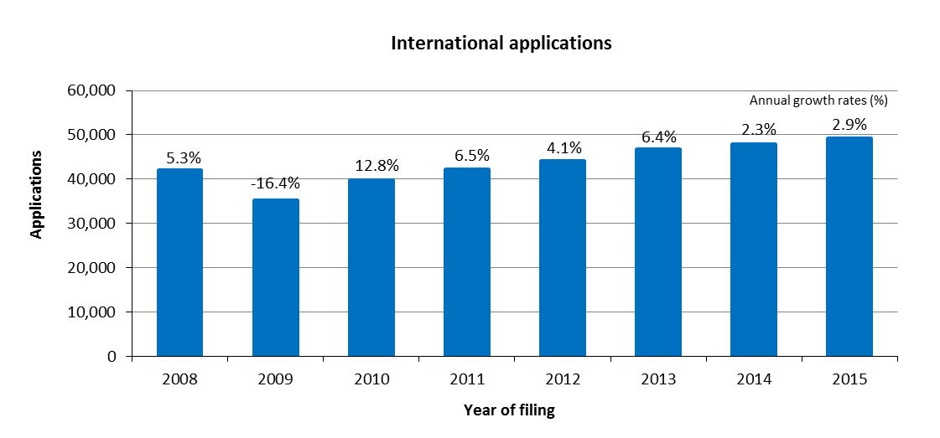

* The IB received 49,273 applications in 2015, representing an increase of 2.9 per cent compared to 2014. The total number of applications received in the 2014/15 biennium increased by sevenper cent compared to the 2012/13 biennium.
* The numbers of applications received have increased continuously since 2010.

*Distribution of applications by language of filing*

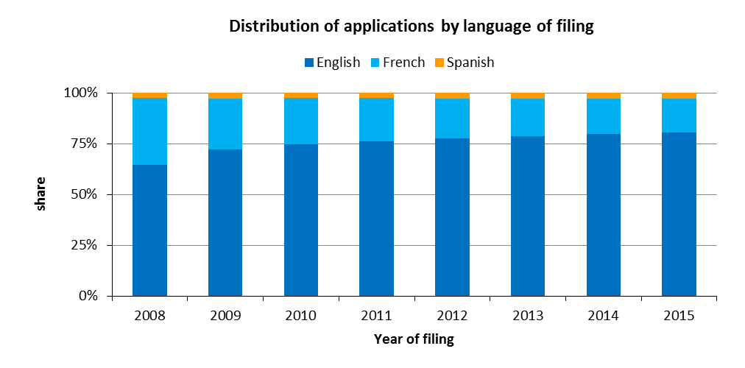

* In 2015, 80 per cent of all applications were filed in English. This share remained unchanged compared to 2014 but grew by 15 percentage points since 2008, when English applications comprised 65 per cent of all applications filed.

*Average* *number of designations per registration*

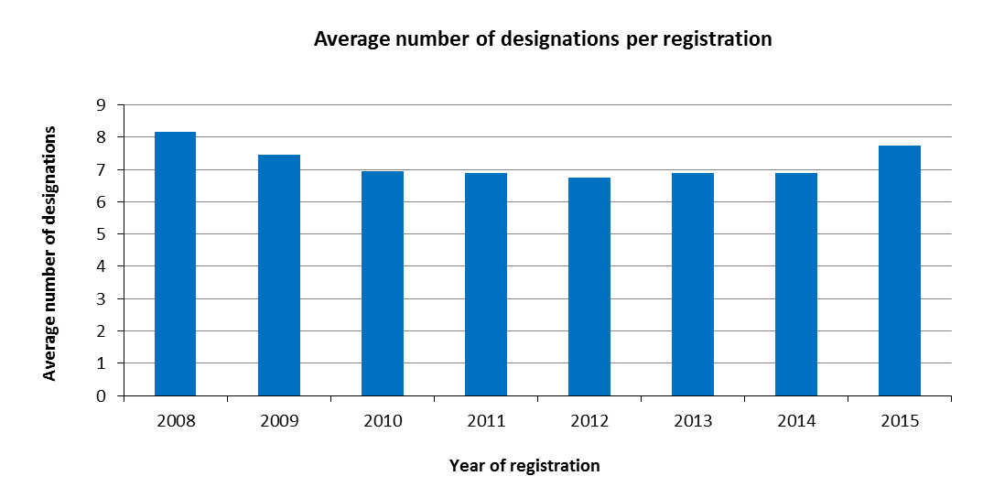

* An average 7.7 designations were made in applications registered in 2015, nearly one more designation than the average for 2014.

*Average number of classes per registration*

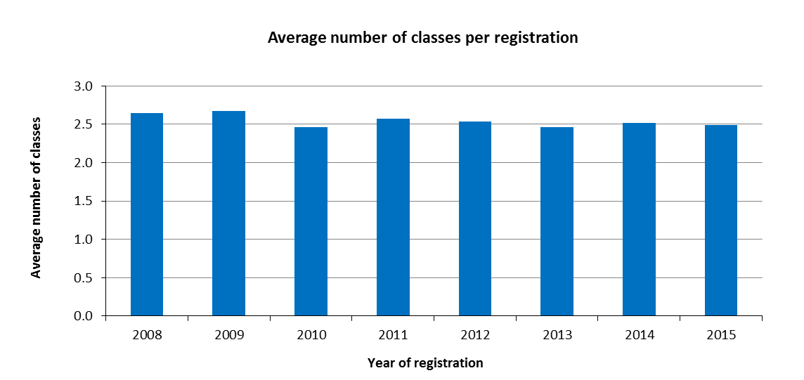

* As was the case in 2014, on average, 2.5 classes were specified in applications registered in 2015.

*Average length of applications*

1. The length of an application is determined by the total number of words used by applicants in (a) the description of the mark, (b) the list of goods and services and (c) any accompanying limitations. To make the application available in all three Madrid System languages, these three elements are translated by the IB into English, French or Spanish, depending on the original language of the application.

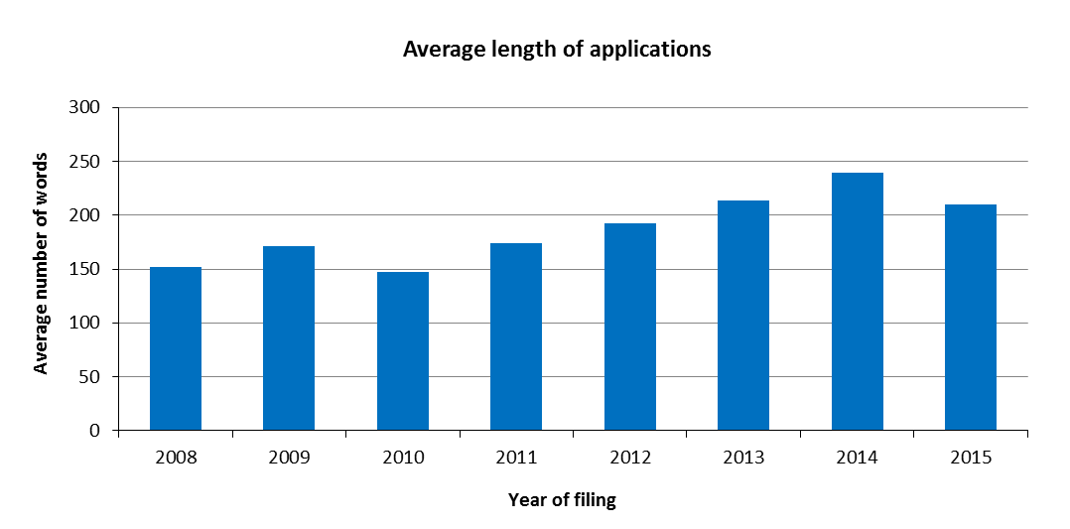

* In 2015, the average length of an application was 209 words, as compared to 239 words in 2014. This represents a decrease of 12.4 per cent compared to 2014.
* While certain aspects of the translation and classification work are automated, increases in the length of applications, such as those observed during the period 2011-2014, had a significant impact on the workload of the IB.

*Distribution of regular and irregular applications*

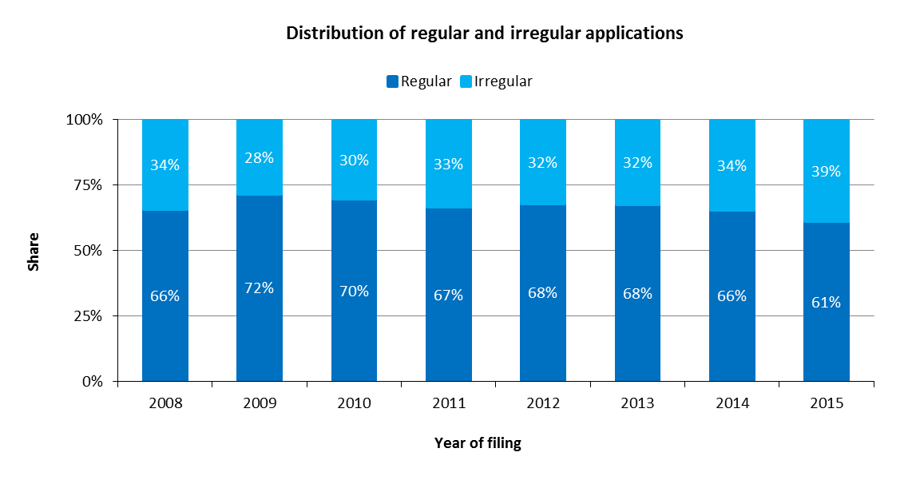

While the share of regular applications remained stable between 2011 and 2014, a decrease of five percentage points was recorded in 2015.

Renewals

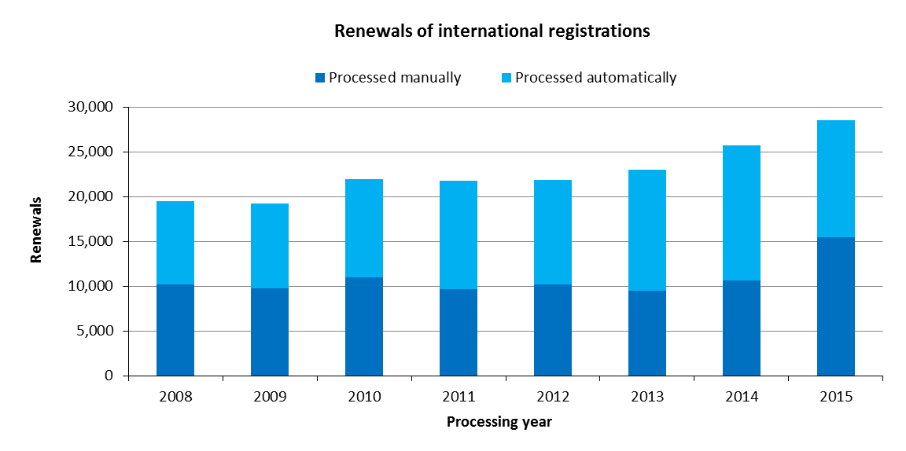

* In 2015, the IB registered 28,502 renewals, up 11 per cent from 2014. The total number of renewals processed during the 2014/15 biennium increased by 21 per cent compared to the 2012/13 biennium.

Subsequent Designations

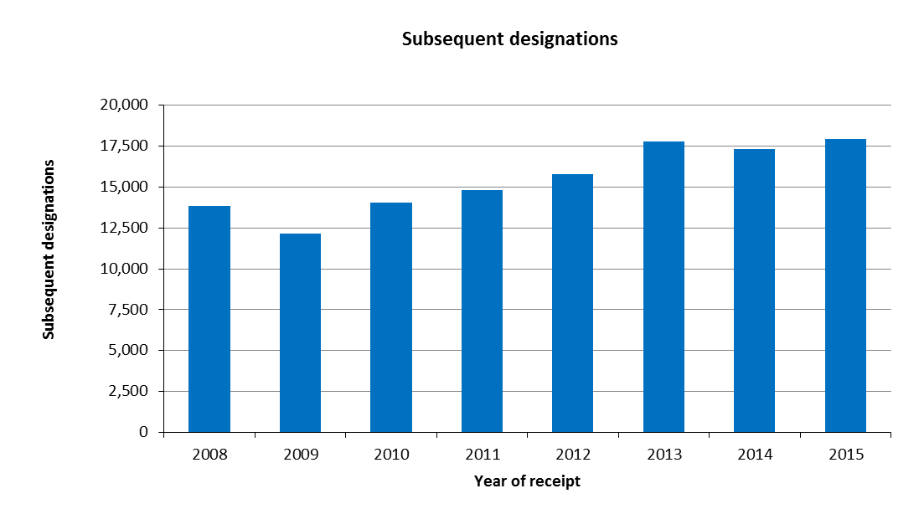

* In 2015, the IB recorded 17,937 subsequent designations, up 3.6 per cent from 2014.

Modifications

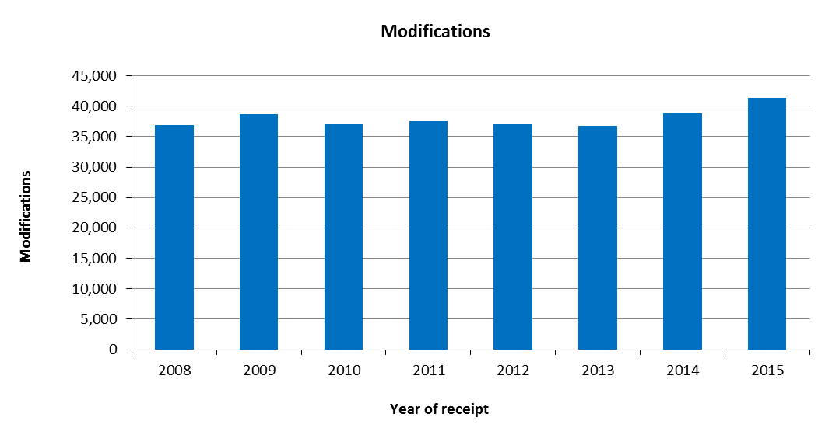

* In 2015, the IB received 41,363 requests for modification, up 6.6 per cent from 2014.

Decisions

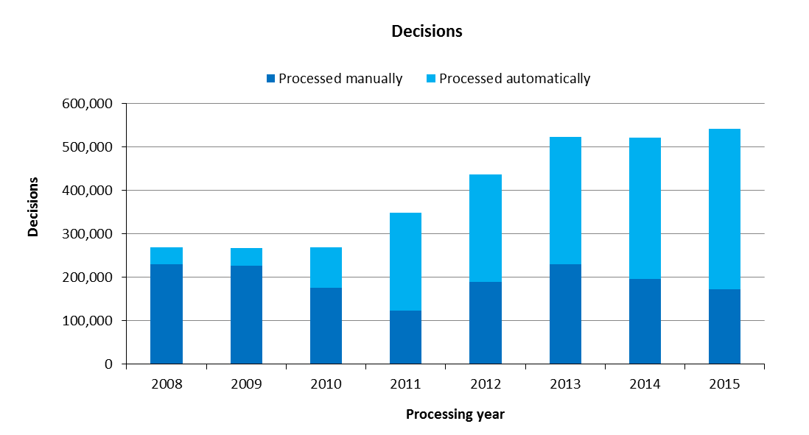

* In 2015, the number of decisions registered increased by four per cent compared to 2014, totaling 541,964. The number of decisions processed has significantly increased since 2010.
* In 2015, 68 per cent of decisions were processed automatically, a proportion which has consistently increased since 2011, when a majority of decisions began being processed automatically.

Corrections

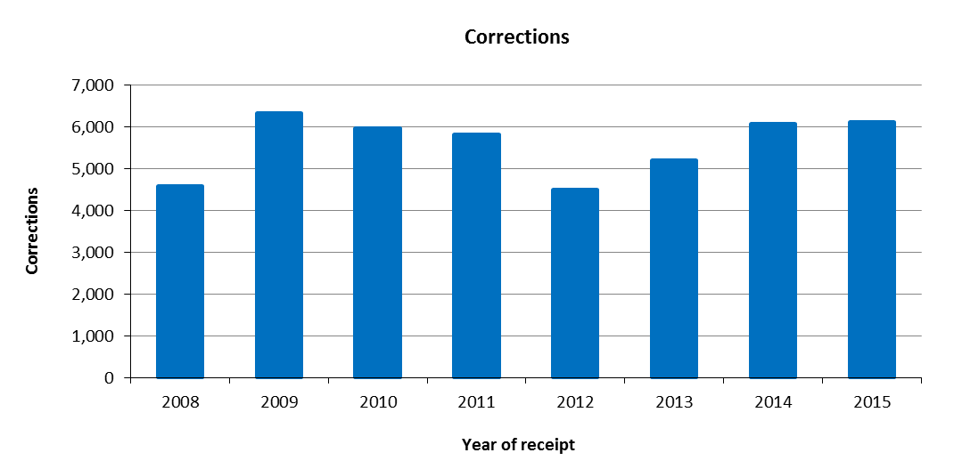

* In 2014, the IB recorded 6,127 corrections. This represents an increase of 0.9 per cent compared to 2014.

1. **Total workload**
2. The total workload represents the weighted total number of documents processed by the IB. All six categories of documents are included (applications, renewals, subsequent designations, modifications, decisions and corrections).
3. As different levels of resources are required to process each document type, they are weighted differently. According to this weighted system, during the time required to process an international application, an examiner is deemed capable of processing 1.6 renewals, 1.8 subsequent designations, 1.8 modifications or 10 decisions. Similarly, during the time required to process an international application, an employee contributing to the automation process is deemed to process 17 documents.

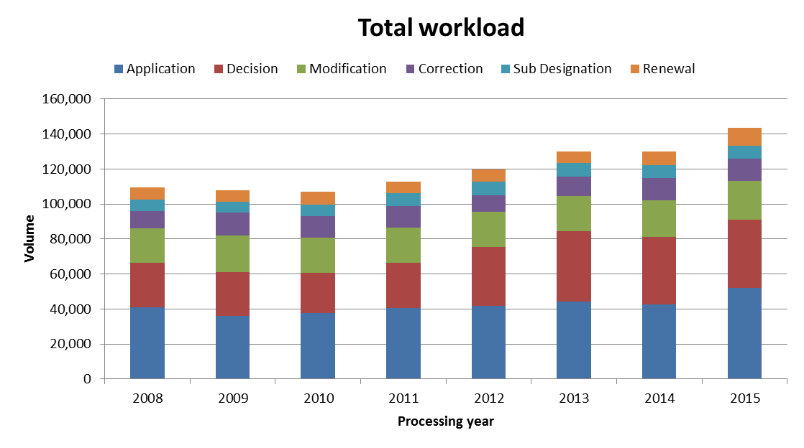

* In 2015, the total workload increased by 11 per cent compared to 2014. Applications, decisions and modifications represented nearly 80 per cent of the total workload. The total workload during the 2014/15 biennium increased by 10 per cent compared to the 2012/13 biennium.
* The growth observed in 2015 was mostly attributable to the increase in the number of applications and renewals, whereas the sharp increase in the workload between 2011 and 2013 was mainly due to the growing number of decisions.

1. **Medium of Transmission of Incoming Documents**

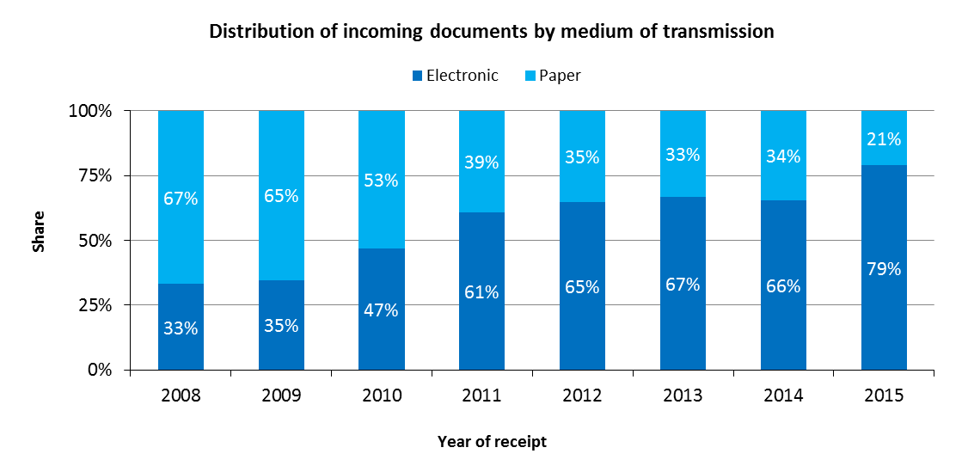

* In 2015, 79 per cent of all incoming documents were transmitted electronically to the IB, which represents a five percentage point increase compared to 2014.

1. **Processing**

Total cost of production

1. The total cost of production comprises expenditure relating exclusively to the Madrid System and expenditure of activities supporting the System.
2. The expenditure relating exclusively to the Madrid System represents about 96 per cent of the expenditures of Program 6 (the Madrid and Lisbon Systems)[31]. The expenditures of the Lisbon Registry in 2015 are excluded from the total cost of production of the Madrid System.[32]
3. Expenditure of activities supporting the Madrid System comprises the expenditure of the following general services: conference and language services, construction, executive management, finance and budget, general support services, human resources management, internal oversight, IT and safety and security. A small proportion of these expenses (cost of server hosting at UNICC and share of cost of the Income Section in Finance) are directly attributed to the Madrid System whereas the remaining such expenses attributable to the Madrid System are calculated based on headcount (including fixed term staff, temporary staff and fellows).

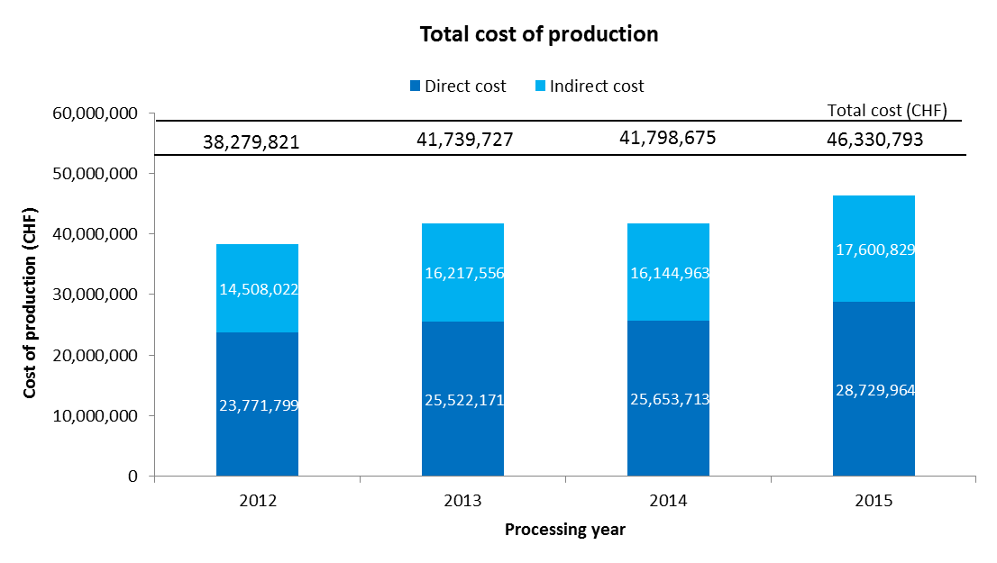

* The total cost of production is estimated at 46.3 million Swiss francs in 2015. This represents an increase of 11 per cent compared to 2014. The total cost of production in the 2014/15 biennium increased by 10 per cent compared to the 2012/13 biennium.
* In 2015, the direct costs accounted for 61 per cent of total costs.

Unit cost

1. The IB’s efficiency in processing transactions can be measured by the unit cost, defined as the average cost of producing one unit of output.
2. As the IB registers new applications and maintains existing registrations, it is relevant to have a unit of output which includes a set of transactions. Two unit cost indicators are presented below using two different units of output.
3. As part of the IB’s efforts to continuously refine its approach to calculating unit costs, the methodology has been revised in the Program and Budget 2016/17 to reflect more accurately the cost of processing Madrid workloads at the IB:

* The methodology for calculating direct and indirect Madrid costs has been aligned with the methodologies for calculating PCT and the Hague unit costs.
* A weighted system has been introduced to better approximate the actual work required to process the six categories of documents, taking into account that some of these documents are more labor-intensive than others.[33]
* The first unit cost has been redefined to include only new international registrations and renewals (the unit cost in the Program and Budget 2014/15 also included subsequent designations). The rationale for removing subsequent designations as a component of this unit cost is a sharper focus on the core Madrid outputs, namely the international registration and its renewal. All other Madrid transactions (subsequent designations, modifications, decisions and corrections) can be considered secondary to these two core transactions. Furthermore, it is difficult to justify including one of these secondary transactions as a component of the first unit cost, while excluding the others.
* The second unit cost is based strictly on the number of documents inscribed in the register, irrespective of the varying levels of resources required to process them.

1. For ease of comparison, the graphs below depict the evolution of the two unit costs from 2008 to 2014 using the old methodology, and from 2012 to 2015 using the new methodology, including a breakdown of the contribution of direct and indirect costs.

*Unit cost per new/renewed international registration*

1. New international registrations consist of applications that are registered within a given year, and renewed international registrations consist of existing registrations that are renewed within a given year. Combined, these two types of transactions reflect the core business of the IB.
2. As processing these two types of transactions do not require equal resources, they are each weighted differently. [34] The unit cost is calculated by dividing the total cost of production by the number of new/renewed international registrations.

|  |  |
| --- | --- |
| Old method | New method |
|  |  |

* The average cost of processing a new/renewed international registration was 743 Swiss francs in 2015. This represents a decrease of 11 per cent compared to 2014. The unit cost per new/renewed international registration in the 2014/15 biennium decreased by one per cent compared to the 2012/2013 biennium.

*Unit cost per document inscribed in the register*

1. The documents inscribed in the register correspond to the total volume of workload (see “Total volume of workload” above).

|  |  |
| --- | --- |
| Old method | New method |
|  |  |

* The average cost of inscribing a document in the register increased slightly from 320 Swiss francs in 2012 to 323 Swiss francs in 2015. The unit cost per document inscribed in the register in the 2014/15 biennium increased by one per cent compared to the 2012/13 biennium.

1. **Productivity of examination**
2. The definition of examination productivity is the number of new/renewed international registrations processed by examiners, divided by the number of personnel involved in examination. The number of personnel includes fellows, interns and external contractors.

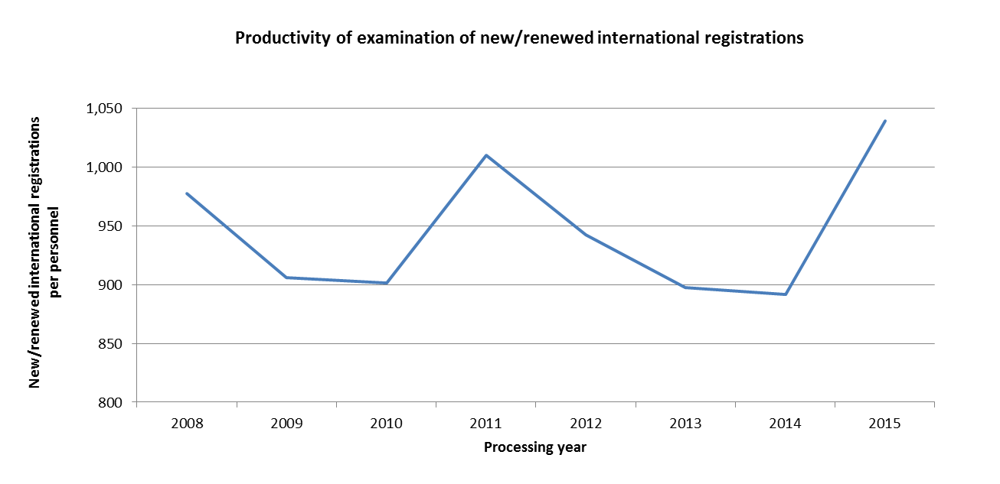

* The productivity of examination increased by 17 per cent compared to the 2014 level. The 2015 level of 1,039 new and renewed international registrations per personnel was the highest for the period 2008 to 2015.

1. **Personnel**

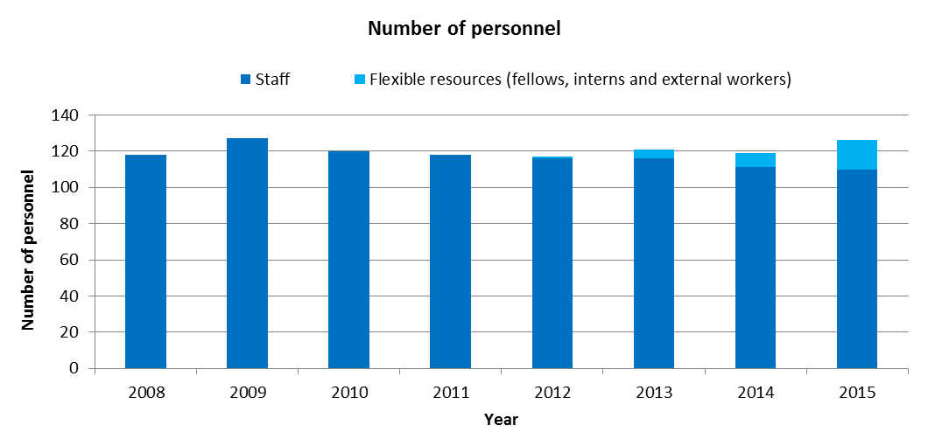

Note: The ability to distinguish the personnel of the Lisbon Registry was only feasible beginning with the 2014/15 biennium. For the years prior to 2014, the personnel of the Lisbon System are included in the overall number of personnel of the Madrid System.

* In 2015, the number of staff remained largely unchanged compared to 2014, while the number of flexible resources doubled, from eight in 2014 to 16 in 2015.
* Agency workers not working on WIPO premises are not included in this indicator.

1. **Pendency**
2. The average pendency for each of the six transactions performed by the IB is shown below. The pendency is calculated from the date a document is received to the date it is inscribed.

|  |  |
| --- | --- |
|  |  |
|  |  |
|  |  |

* Compared to 2014, the average pendency in 2015 decreased for the six transactions performed by the IB. The most significant decreases in average pendency time were recorded for corrections, modifications and subsequent designations.

1. **Quality of examination**
2. The following key indicators on the overall quality of trademark examination produced by the IB are the result of the quality control undertaken following the implementation of the Madrid Registry Quality Management Framework (QMF) in 2015, in compliance with ISO 9001:2008 guidance.[35]
3. Two sources of information on the quality of the examination work produced by the IB are presented:
   1. The results of the internal review of examination transaction samples; and
   2. Errors confirmed to have been made by the IB following the receipt of correction requests under Rule 28 of the Common Regulations.

*Review of examination transaction samples*

1. An Acceptable Quality Level (AQL) is set for each transaction and is the criteria against which quality of trademark examination is measured.

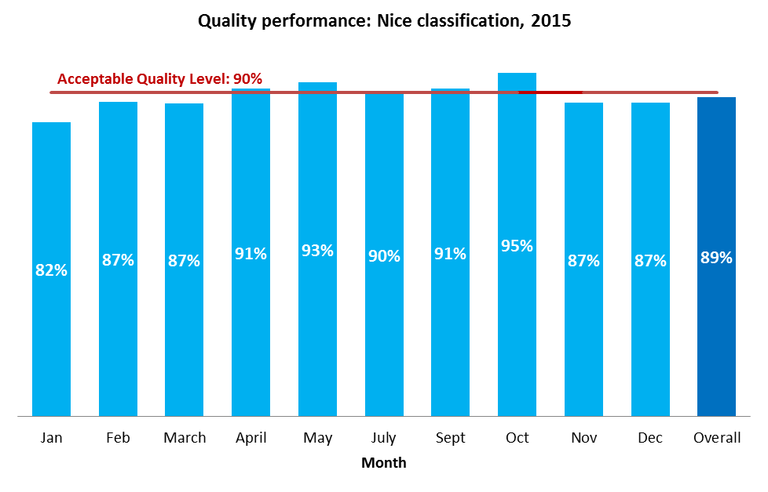

* The overall quality performance in 2015 was one percentage point below the acceptable quality level.

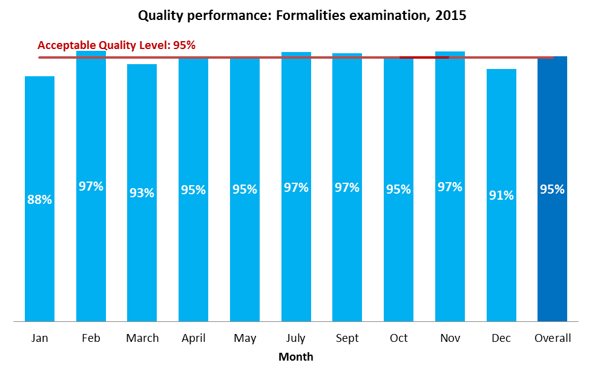

* The overall quality performance met the set quality level for 2015. However, there was a critical issue regarding incorrect recording of applicants’ and representatives’ details.

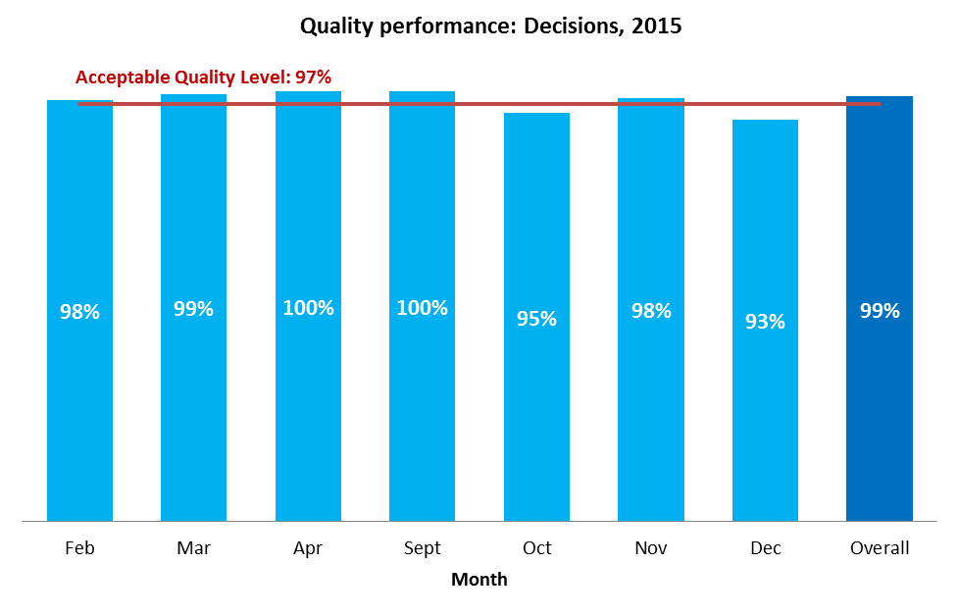

* The overall quality performance for the processing of decisions was two percentage points above the set target in 2015.

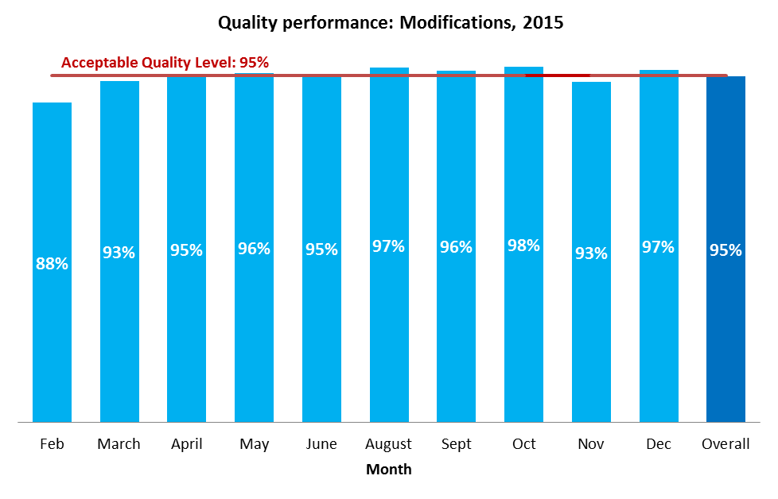

* The overall quality performance met the target quality level of 95 per cent. However, the same issue as for formalities examination was observed.

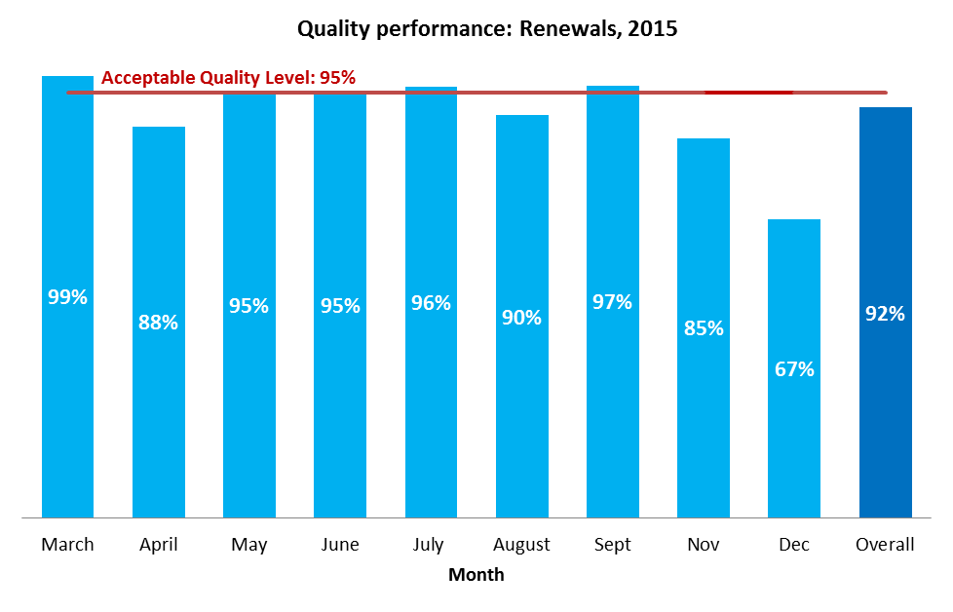

* The overall quality performance for the processing of renewals was three percentage points below the target in 2015. The main issue lay with the fee calculation, owing to the incorrect recording of the number of classes of goods and services.

*Errors made by the IB*

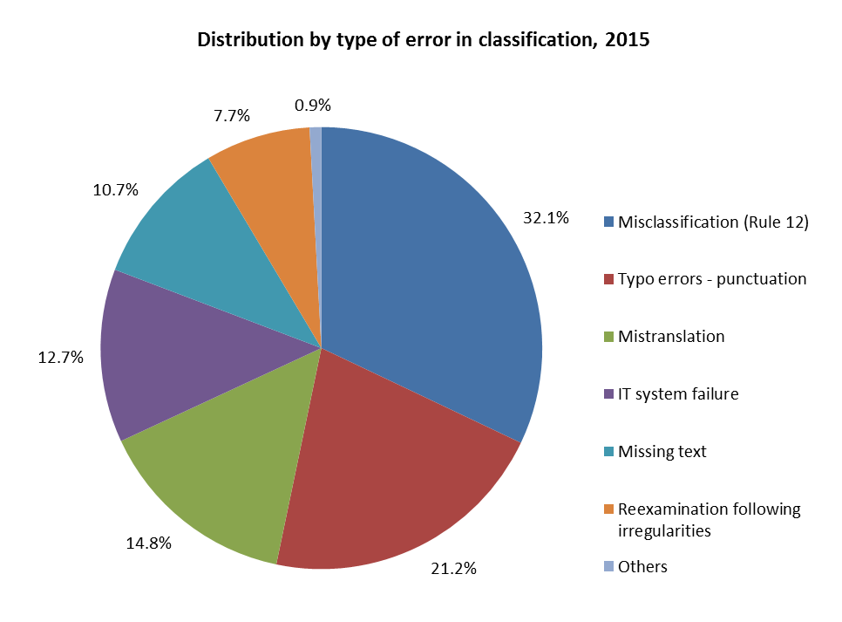

* Misclassification accounted for nearly a third of all errors made in relation to classifications in 2015.

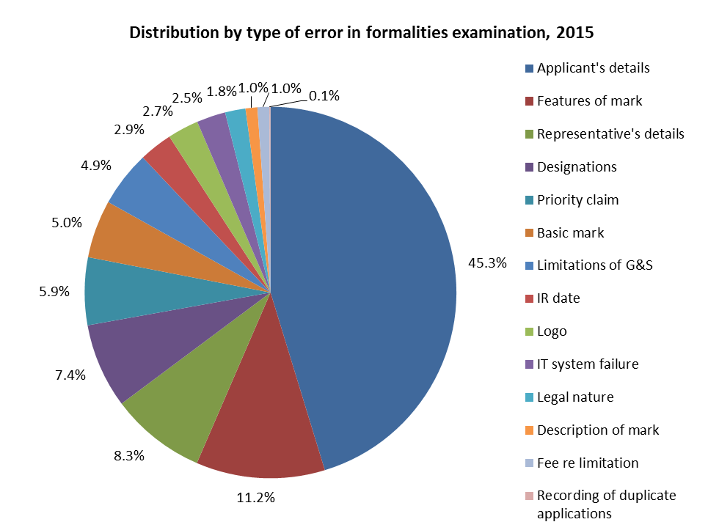

* In 2015, the majority of the corrections in formalities examination were due to errors in inputting the applicants’ (45.3 per cent) and representatives’ (8.3 per cent) details.

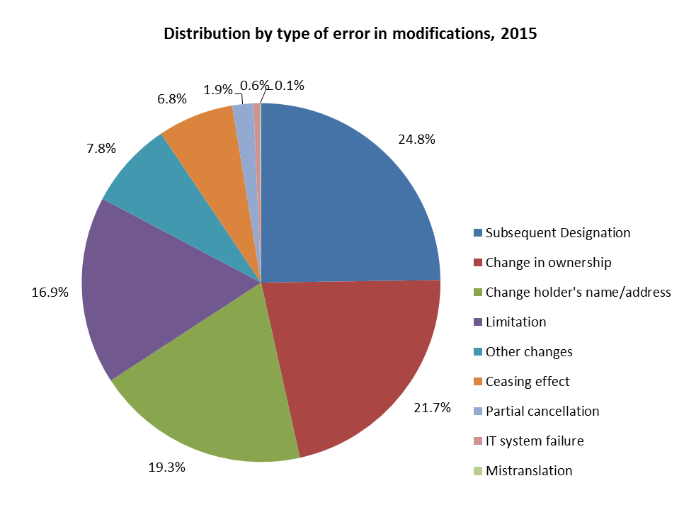

* About 83 per cent of all corrections regarding modifications in 2015 concern four transactions, namely subsequent designations (24.8 per cent), changes in ownership (21.7 per cent), changes of holder’s name and/or address (19.3 per cent) and limitations (16.9 per cent).

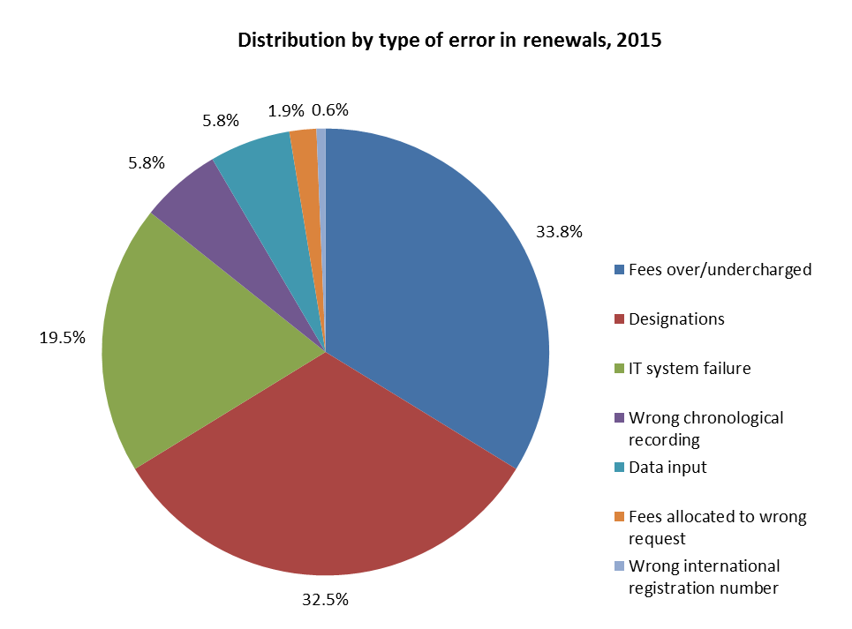

* Incorrect calculation of fees (33.8 per cent) and errors in the recording of designations (32.5 per cent), combined, accounted for two-thirds of corrections made in relation to renewals in 2015.

[End of Annex]

## PROGRAM 31 THE HAGUE SYSTEM

**Program Manager Ms. B. Wang**

ACHIEVEMENTS IN THE 2014/15 BIENNIUM

1. The Hague System experienced good growth in 2014/15. In 2014, the Republic of Korea, and in 2015, Japan, Turkmenistan and the United States of America became party to the Geneva (1999) Act of the Hague Agreement Concerning the International Registration of Industrial Designs (hereinafter referred to as “the 1999 Act”). Those accessions brought the number of Contracting Parties to that Act to 50. Although this number remained lower than the target, accessions in particular by the Republic of Korea, the United States of America and of Japan, which respectively rank as the third, fourth and fifth jurisdictions worldwide in terms of design filings, significantly raised the attractiveness of the Hague System. Consequently, international applications increased by over 40 per cent in 2015, a figure well above the expected increase on 2014. Also as a result of this expansion, by the end of the biennium, there were already strong indications of interest to join amongst other prospective Contracting Parties, including from countries bound by the older Acts. In that respect, at the end of 2015, only two consents were still required for the termination of the 1934 Act, whilst four Contracting Parties outside the European Union (EU) and *Organisation Africaine de la Propriété Intellectuelle* (OAPI) remained bound only by the 1960 Act.
2. Expansion to the aforementioned jurisdictions came at a cost however, as it triggered the application of some of the most complex features of the System, such as those relating to the requirement of an oath of the creator or the payment in two parts of an individual fee, and further necessitated the development of new features, such as those relating to the notion of related designs. To cope with this, the examination system, the electronic filing system and the forms have gone through a succession of updates and additions to accommodate smoothly the new requirements. With regard to information to users, a completely revamped version of Hague Express and integration of Hague data in the Global Designs Database increased the quality of display of information for end-users, Offices and third-parties. The Hague Guide has been fully converted to a web format to allow easier access, including direct access from the electronic filing interface. Despite the sudden growth in applications in 2015 and the increase in complexity, the Hague Operations absorbed the growth and managed to maintain a timeliness level in line with the average of the past five years. This resulted in an eight per cent decrease in the unit cost per design from 2014 to 2015 and a 22 per cent decrease in the unit cost per document from 2014 to 2015. Two new processes have been automated, namely the reception and handling of indirect filings by the Office of the Republic of Korea (KIPO) and the examination of Statements of Grant of Protection sent by the Office for Harmonization in the Internal Market (OHIM) of the European Union, for a total of four automated processes.
3. Significant progress towards the enhancement of the legal framework of the Hague System was achieved in the 2014/15 biennium. Notably, following the fourth session of the Working Group on the Legal Development of the Hague System for the International Registration of Industrial Designs, the Hague Union Assembly adopted provisions, which came into force on January 1, 2015, that introduced a “feedback mechanism”, to ensure the public availability of information on amendments to an industrial design that is the subject of an international registration following a procedure before the Office of a designated Contracting Party. In addition, amendments to the Administrative Instructions were introduced with a view to giving users more flexibility in respect of the disclosure of their industrial designs, which came into force on July 1, 2014. These two developments provided the foundation for moving forward with the long-awaited expansion to jurisdictions where substantive examination is undertaken. Together with the changes made to the e-filing interface, the Hague System became better equipped to cope with the additional complexities and enabled the accessions by Japan, the Republic of Korea, and the United States of America.
4. The design, planning and implementation of activities by Program 31 were informed and guided by the relevant Recommendations, in particular Recommendations 1 and 6.

PERFORMANCE DATA

|  |  |  |  |  |
| --- | --- | --- | --- | --- |
| **Expected Result:** II.4 Wider and better use of the Hague system, including by developing countries and LDCs | | | | |
| **Performance Indicators** | **Baselines** | **Targets** | **Performance Data** | **TLS** |
| Membership of the Geneva (1999) Act | *Updated Baseline end 2013: 46 Contracting Parties (end 2013)*  *Original Baseline P&B 2014/15:* 45 Contracting Parties | 58 Contracting Parties | 50 Contracting Parties to the Geneva Act (end 2015) | **Partially Achieved** |
| Share of Offices concerned providing information on the Hague System | *Updated Baseline end 2013: 42 national or regional Offices were providing adequate information on the Hague System. Nine Offices had no web site.*  *Original Baseline P&B 2014/15: Share of Offices providing such information* | Increased share | 47 national or regional Offices were providing information on the Hague System at the end of 2015. Ten Offices had no website. | **Fully Achieved** |
| Hague filings and renewals | *Updated Baseline end 2013: Applications:*  *2,990*  *Designs contained: 13,172*  *Renewals: 2,859*  *(2013)*  *Original Baseline P&B 2014/15: Applications: 2,604*  *Designs contained: 12,454[36]*  *Renewals: 3,120*  *(2012)* | 2014[37]:  Applications:  33.9% increase  Designs contained: 33% increase  Renewals:  2.9% decrease  2015:  Applications:  23.4% increase  Designs contained: 23.5% increase  Renewals:  5.5% increase | 2014:  Applications:  2.2% decrease (2,924)  Designs contained:  9.6% increase (14,441)  Renewals:  5.5% decrease (2,703)  2015[38]:  Applications:  2.7% increase above the 2014 target (4,111)  Designs contained:  -6.2% decrease below the 2014 target (16,435)  Renewals:  8.57% increase above the 2014 target (3,194) | **Not Achieved**  **Not Achieved**  **Partially Achieved**  **Not Achieved**  **Not Achieved**  **Fully Achieved** |

|  |  |  |  |  |  |  |  |
| --- | --- | --- | --- | --- | --- | --- | --- |
| **Expected Result:**  II.5 Improved productivity and service quality of Hague operations | | | | | | | |
| **Performance Indicators** | **Baselines** | | | **Targets** | | **Performance Data** | **TLS** |
| Predominance of the Geneva (1999) Act in the Hague system | *Updated Baseline end 2013: Three consents were still required for the termination of the 1934 Act, and four Contracting Parties outside the EU and OAPI remained bound by the 1960 Act*  *Original Baseline P&B 2014/15: 15 Hague members still not bound by the Geneva (1999) Act; Five consents to termination of the 1934 Act still outstanding (end 2012)* | | | No (zero) countries bound only by the Hague (1960) Act outside the EU or OAPI; all the remaining consents (five) to termination of the 1934 Act received | | One consent received with two more consents still required for the termination of the 1934 Act, and four Contracting Parties outside the EU and OAPI still bound only by the 1960 Act. | **Not Achieved** |
| Progress towards the enhancement of the legal framework | *Original Baseline P&B 2014/15:* Current legal framework | | | Amendments to the Hague Regulations and Administrative Instructions as well as new features introduced following accessions of some new Contracting Parties. | Amendments to the Common Regulations, among others, introducing a “feedback mechanism”, came into force on January 1, 2015. Amendments to the Administrative Instructions, among others, relaxing certain requirements concerning reproductions and representations, came into force on July 1, 2014. | | **Fully Achieved** |
| Flexibility of data recorded in the International Register | *Original Baseline P&B 2014/15:* Inability to record granular design information | | | Ability to record granular design information | Progress made on the design choices, yet the implementation was scheduled for after the conversion of the main IT system, an event that did not occur during the biennium: DIRIS. | | **Not Achieved** |
| No. of automated processes | | *Updated Baseline end 2013:* Two (e- Filing and e-Renewal)[39]  *Original Baseline P&B 2014/15:* 2 | 4 | | 2 additional automated processes in 2014/15 (Statement of Grant of Protection from OHIM in 2014 and the reception and handling of indirect filings by KIPO) (4 cumulative) | | **Fully Achieved** |

RISK REPORTING FOR THE BIENNIUM

|  |  |  |  |
| --- | --- | --- | --- |
| **Risk(s) to the Program achieving its Results** | **Mitigation plans in place or under implementation** | **Evolution of Risk(s) and Mitigation Strategies Over the Biennium** | **Impact on the Program’s Performance** |
| Decline in the level of customer satisfaction due to difficulties in coping with growth in filings and information requests and to the growing complexity of the system as a result of the implementation of features supporting novelty examination in certain designated Offices | Enhancing efficiency and effectiveness in all aspects of system administration; promotion of best practices and convergence amongst the Offices concerned; development of IT solutions to assist users and examiners of Offices and the International Bureau. | This is a continuing risk for the Program, and mitigation strategies have been enhanced over the course of the biennium with electronic tools and information material, which have allowed the International Bureau to cope with the 40 per cent increase in filings and helped contain user queries and complaints as to the growing complexity of the system to a minimum. | None, as the growth in filings from 2014 to 2015 exceeded expectations, showing that the system’s overall attractiveness was preserved and customer satisfaction was not affected negatively either. |

RESOURCE UTILIZATION

Budget and Actual Expenditure (by result)

*(in thousands of Swiss francs)*



Budget and Actual Expenditure (personnel and non-personnel)

*(in thousands of Swiss francs)*



A. 2014/15 Final Budget after Transfers

1. The 2014/15 Final Budget after Transfers reflects a net increase in personnel resources primarily due to: (i) the temporary transfer of a staff member from Program 10 (Cooperation with Certain Countries in Europe and Asia) to the Program to provide additional support for the Working Group meetings and promotional activities; and (ii) the transfer of additional personnel resources, including two temporary positions from Programs 9 and 19, to support the additional examination demands resulting from the accessions of Japan, the Republic of Korea and the United States of America. This is reflected under Result II.5 (Improved productivity and service quality of the Hague operations).
2. The net decrease in non-personnel resources under Result II.4 (Wider and better use of the Hague System) is primarily due to: (i) the transfer of non-personnel resources for an intern (to Program 23 (HRMD) which centrally manages interns) to support the work on new accessions; and (ii) the transfer of funds to Program 6 (Madrid and Lisbon Systems) for IT-related work, as well as to cover the cost of additional delegates to the Assemblies of the Madrid, Hague and Lisbon Unions as a result of the growth of the Systems.

B. 2014/15 Budget Utilization

1. The non-personnel budget utilization rate for the Program amounted to 81 per cent of the 2014/15 Budget after Transfers. This resulted primarily from a delay in IT-related work due to the postponement of the accessions of certain Contracting Parties under Result II.4 (Wider and better use of the Hague System).

**Program 31 Annex: Indicators of the Hague System Operations**

PERFORMANCE INDICATORS FOR THE EXPECTED RESULT

“IMPROVED PRODUCTIVITY AND SERVICE QUALITY OF THE HAGUE OPERATIONS”

1. As background for the performance indicators for the expected result “improved productivity and service quality of the Hague System Operations”, the evolution of the following factors needs to be considered:

* The Hague System workloads;
* The composition of those workloads;
* The level of automation; and,
* The resources assigned to cope with the workload.

1. The International Bureau (IB) receives four main types of documents, namely international applications, renewals, changes and decisions. The latest trend for each of these documents is presented below. Additional information on the applications received, such as their average number of designs, is also provided. For technical reasons, the indicator on the irregularities issued shows data based on processed rather than incoming documents.

**I. Incoming Documents**

Applications received

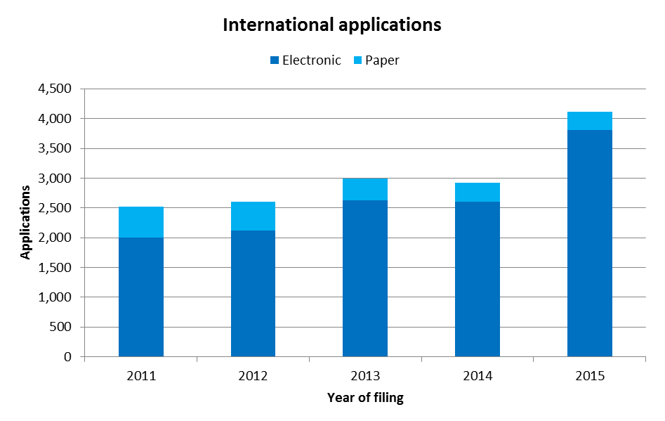

* In 2015, the IB received 4,111 international applications, up 41 per cent from 2014. In addition to applications from the European Union (+352 applications), those from the Republic of Korea (+487 applications), the United States of America (+140 applications) and Japan (+128 applications), all of which joined the Hague System in 2014/15, also contributed to this increase. The total number of applications received in 2014/15 (7,035) increased by 26 per cent compared to 2012/13 (5,594).
* In 2015, 93 per cent of applications were filed electronically, a four per cent increase over 2014. The share of electronic filings increased by 14 percentage points between 2011 and 2015, from 79 per cent in 2011 to 93 per cent in 2015.

*Average number of designs per application*

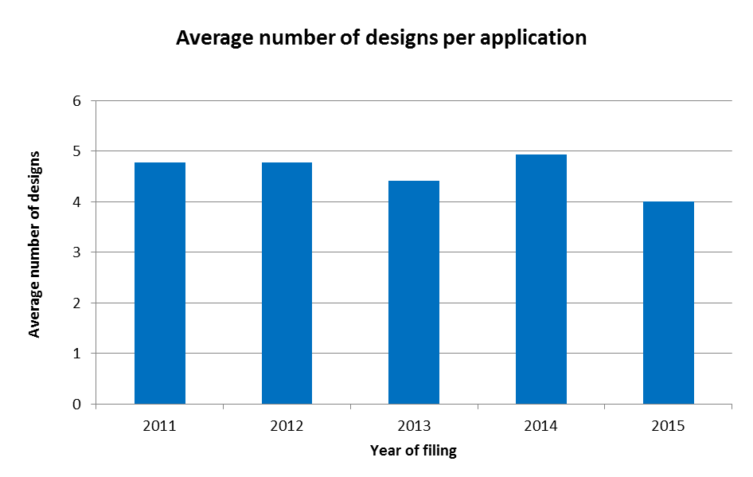

* In 2015, an application contained, on average, four designs, which is almost one design less than the 2014 average. Between 2011 and 2015, the average number of designs per application varied between four and five designs.

*Average number of designations per application*

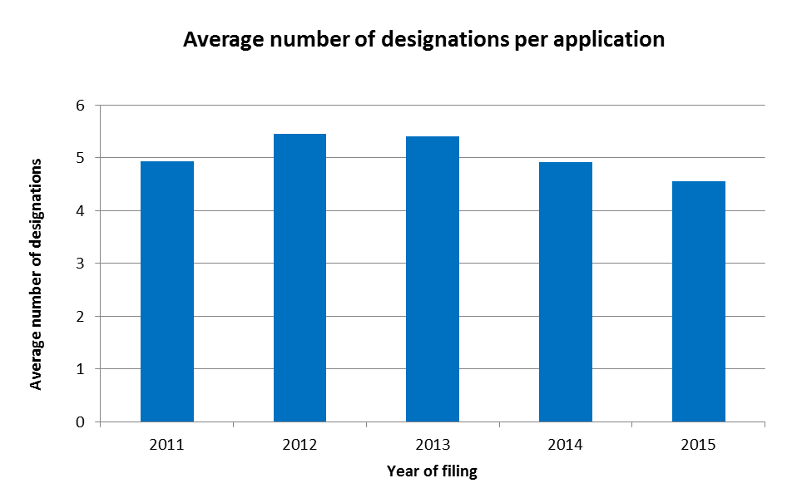

* In 2015, an application contained on average 4.5 designations, as compared to an average of nearly five designations in 2014, representing the lowest average number of designations per application observed since 2011.

*Trend of irregularities in applications*

1. Irregularities in applications are grouped among the ten categories shown below.

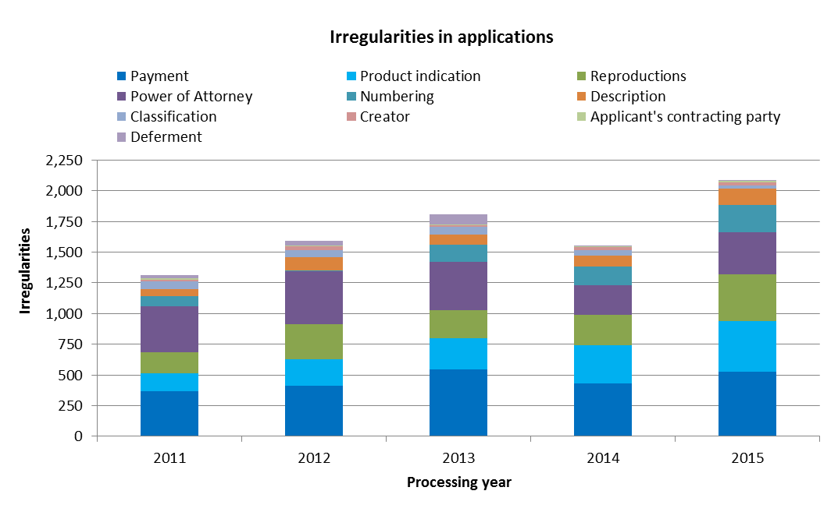

* In 2015, the IB identified 2,118 irregularities in applications, up 36 per cent compared to 2014.
* All types of irregularities increased, except for classification and deferment that, combined, represented only 1.5 per cent of the total number of irregularities in applications. Reproduction (+129 irregularities), product indications (+105 irregularities), power of attorney (+99 irregularities) and payment (+95 irregularities) were the irregularities experiencing the sharpest increase in volume in 2015.

1. The evolution of the share of applications containing irregularities or substantive observations is shown below.

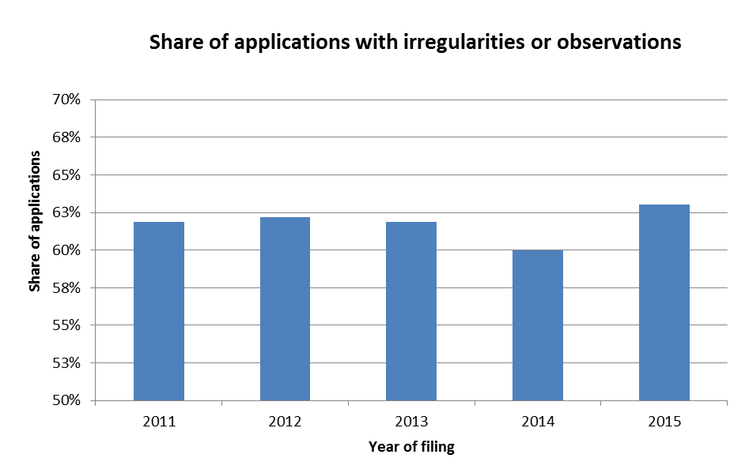

In 2015, some 63 per cent of applications registered contained at least one irregularity or substantive observation. This represented an increase of three per cent compared to 2014.

Renewals

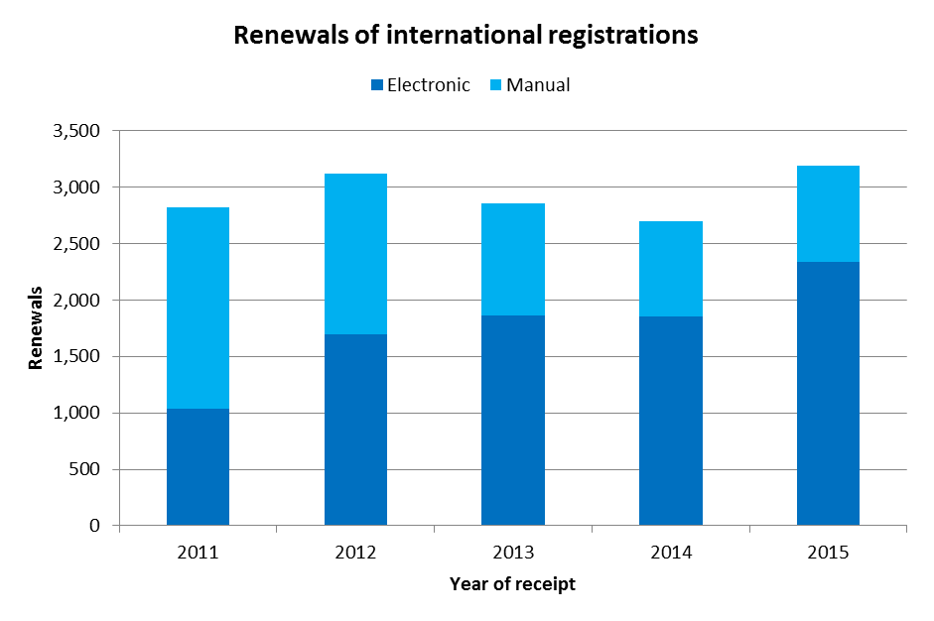

* In 2015, the number of renewals increased by 18 per cent compared to 2014, to a total of 3,194 renewals.
* Since 2012, the majority of renewals have been processed electronically, accounting for 73 per cent of total renewals in 2015 compared to 69 per cent[40] in 2014; an increase of 4 percentage points.

Changes

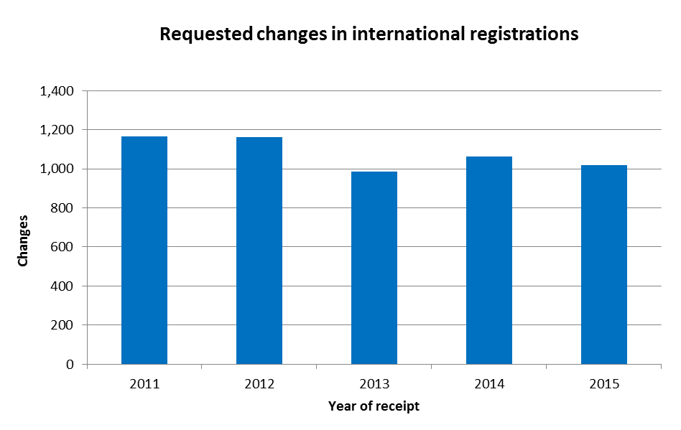

* Applicants requested 1,018 changes in international registrations in 2015, down four per cent from 2014.

Decisions

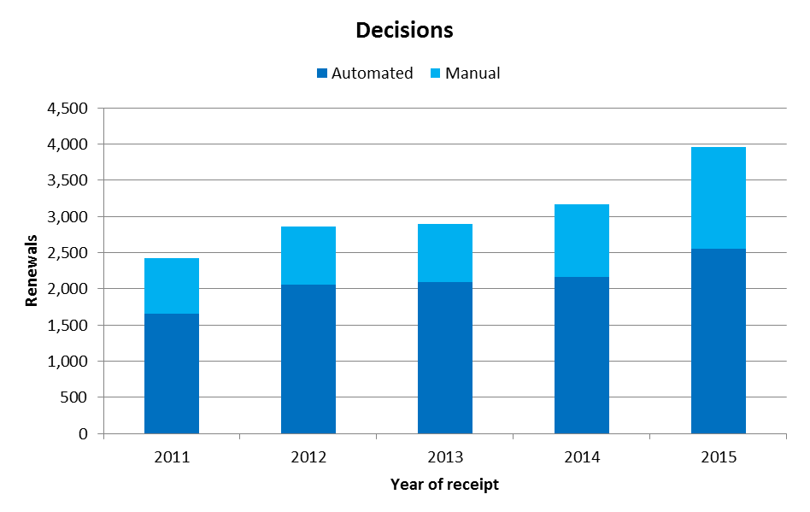

* The number of decisions received in 2015 increased by 25 per cent as compared to 2014, from 3,169 to 3,961 decisions.
* Between 68 per cent and 72 per cent of decisions have been processed automatically since 2011.

**II. Total Workload**

1. The total workload represents the weighted total number of documents received at the IB. All four categories of documents are included (applications, renewals, changes and decisions).
2. As the processing of these types of documents do not require the equal amount of resources, they are each weighted differently. According to the current weighting, during the time required to process one international application, an examiner can process eight renewals, four changes or four decisions (a 1:8:4:4 workload ratio).  In 2014/15, due to an increasing level of complexity of other documents, in particular decisions by Offices, the overall examination of international applications also became more complex.  Nonetheless, the workload ratio remained the same.

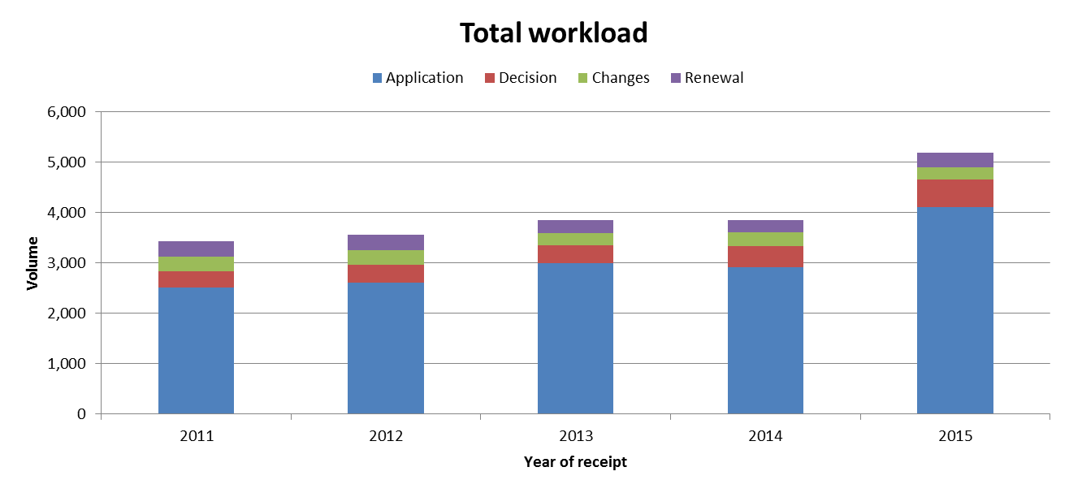

* In 2015, the total workload increased by 35 per cent compared to 2014. The total workload for the biennium increased by 22 per cent compared to 2012/13. Between 2011 and 2015, the increase in workload was mainly due to the increase in the number of applications received.
* In 2015, applications alone represented 79 per cent of the total workload, a three per cent increase as compared to 2014.

**III. Cost of Processing**

Total cost of production

1. The total cost of production comprises expenditure relating exclusively to the Hague System and expenditure of activities supporting the System.[41]
2. The expenditure relating exclusively to the Hague System includes those of Program 31 (the Hague System) and about seven per cent of the expenditure of the Office of the Deputy Director General of the Brands and Designs Sector (Program 6 -Madrid and Lisbon Systems).[42]
3. Expenditure of activities supporting the Hague System comprises the expenditure of the following general services: conference and language services, construction, executive management, finance and budget, general support services, human resources management, internal oversight, IT and safety and security. A small proportion of these expenses (cost of server hosting at UNICC and share of cost of the Income Section in Finance) are directly attributed to the Hague System whereas the remaining of such expenses attributable to the Hague System are calculated based on headcount (including fixed term staff, temporary staff and fellows).

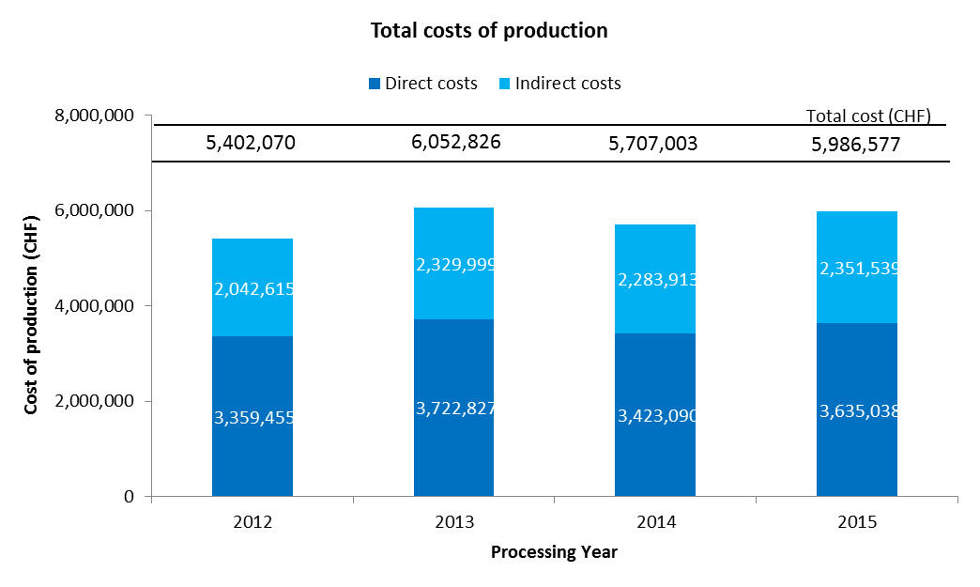

* The total expenditure related to the processing of the Hague System is estimated at nearly six million Swiss francs in 2015. This represents an increase of five per cent on 2014. Direct and indirect costs increased, by respectively six per cent and three per cent on 2014. The total cost of production in 2014/15 increased by three per cent compared to 2012/13.
* In 2015, the direct costs accounted for 61 per cent of total expenditures.

Unit cost

1. The IB’s efficiency in processing transactions can be measured by the unit cost, defined as the average cost of producing one unit of output.
2. As the IB registers new applications and maintains existing registrations, it is relevant to have a unit of output, which includes a set of transactions. Two unit cost indicators are presented below using two different units of output.
3. As part of the IB’s efforts to continuously refine the methodology for calculating unit costs, the methodology has been revised in the Program and Budget for the 2016/17 biennium to reflect more accurately the cost of processing Hague workloads at the IB[43].

*Unit cost per new/renewed design*

1. New designs consist of designs in international applications that are registered within a given year, and renewed designs consist of existing designs in international registrations that are renewed within a given year. Combined, designs contained in these two types of transactions reflect the core business of the IB.
2. As processing designs contained in these two types of documents do not require equal resources, they are each weighted differently[44]. The unit cost is calculated by dividing the total cost of production by the number of new/renewed designs.

|  |  |
| --- | --- |
| Old Method | New method |
|  |  |

* The average cost of processing a new/renewed design was 337 Swiss francs in 2015, down eight per cent from 2014. This decrease was due to a sharp increase of 14 per cent of the number of new/renewed designs processed with the similar amount of resources as in 2014.
* The average unit cost of processing a new/renewed design in the 2014/15 biennium (350 Swiss francs) decreased by 12 per cent compared to the 2012/13 biennium (400 Swiss francs).

*Unit cost per document recorded in the register*

1. The documents recorded in the Register correspond to the total workload (see “Total Workload” above).

|  |  |
| --- | --- |
| Old Method | New method |
|  |  |

* The average cost of recording a document in the Register decreased by 22 per cent from 1,483 Swiss francs in 2014 to 1,153 Swiss francs in 2015. This is due to the sharp increase of 35 per cent in the total workload processed with the same resources as in 2014.
* The average cost of recording a document in the Register in the 2014/15 biennium (1,294 Swiss francs) decreased by 15 per cent compared to the 2012/13 biennium (1,528 Swiss francs).

**III. Timeliness to Process International Applications**

1. This indicator reflects the time required by the IB to process regular applications. The timeliness is calculated between the time elapsed between the date of receipt of an application and the date it was registered.

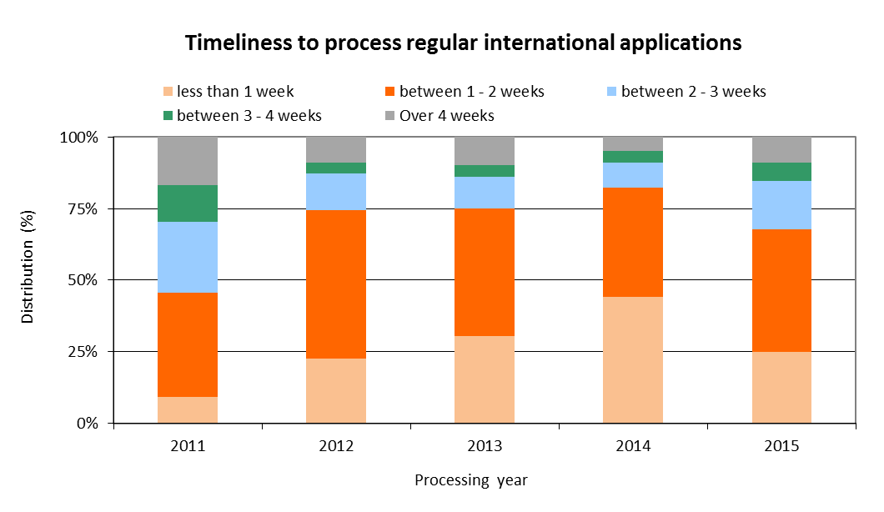

* In 2015, the share of regular applications processed within less than one week decreased to 25 per cent, as compared to 45 per cent in 2014. Between 2011 and 2015, the average share was 27 per cent.
* In 2014, 82 per cent[45] of applications were processed within two weeks from the date of receipt at the IB. In 2015, 85 per cent of applications were processed within three weeks from the date of receipt at the IB.

[End of Annex]

## PROGRAM 7 ARBITRATION, MEDIATION AND DOMAIN NAMES

**Program Manager Mr. J. Sandage**

ACHIEVEMENTS IN THE 2014/15 BIENNIUM

1. The WIPO Arbitration and Mediation Center (WIPO Center) is recognized as a global resource for timely and cost effective alternatives to court litigation of IP and Internet domain name disputes, acting as a provider of legal and organizational expertise and as an administrator of cases. Efficient dispute resolution facilitates the legal protection and productive use of IP internationally.
2. The WIPO Center actively managed WIPO cases in different IP areas using up-to-date case administration infrastructure, in particular the WIPO Electronic Case Facility (ECAF). Following international consultations, the WIPO Center developed revised WIPO Arbitration, Mediation and Expert Determination Rules[46]. These Rules incorporate recent developments in alternative dispute resolution (ADR), enhancing the basis for proceedings that are time and cost efficient. Based on its case administration experience an online WIPO Clause Generator[47] was created and launched in 2015. The WIPO Center furthermore held tailored arbitration and mediation events.
3. National courts and competition authorities in some jurisdictions have been encouraging parties involved in standards-related disputes involving telecom patents in multiple jurisdictions to resolve such disputes through ADR. Following collaboration with a number of Standard-Setting Organizations, in particular the European Telecommunications Standards Institute (ETSI) and the Institute of Electrical and Electronics Engineers (IEEE), the biennium 2014/15 saw an increase in party queries regarding the use of WIPO’s tailored agreements to refer a dispute concerning fair, reasonable and non-discriminatory (FRAND) licensing terms to WIPO Mediation and Arbitration.
4. In the biennium, Memoranda of Understanding (MoUs) were concluded with the National Copyright Directorate of Colombia (DNDA), the Directorate General of Intellectual Property Rights of Indonesia (DGIPR), the Mexican Institute of Industrial Property (IMPI) and the Intellectual Property Office of the Philippines (IPOPHL), adding to existing Member State collaborations. These collaborations concern the development of optional ADR frameworks that provide cost effective and flexible options for parties to resolve their disputes before such Offices in relation to pending applications or granted rights. In 2015, the United States Patent and Trademark Office (USPTO) included the WIPO Center among listed ADR providers available to administer such disputes.
5. The WIPO Center established collaboration with the **Brazilian Franchising Association** (ABF), the Spanish Franchise Association (AEF) and the Swiss Franchise Association (SFA), and assisted in the development of model R&D agreements including ADR clauses by the German Ministry of Economics and Technology and the Spanish Patent and Trademark Office (OEPM). The WIPO Center also developed a fast-track procedure for the resolution of IP disputes arising at trade fairs – first used at the 2015 Geneva International Motor Show.
6. The WIPO Center continued to strive to provide leadership in the development of ADR solutions in relation to the unauthorized use of IP on the Internet. This notably addressed the ongoing introduction by the Internet Corporation for Assigned Names and Numbers (ICANN) of up to 1,400 new generic Top‑Level Domains (gTLDs). In 2014, the WIPO Center implemented the ICANN [Post-Delegation Dispute Resolution Procedure](http://www.wipo.int/amc/en/domains/tmpddrp/), a trademark‑based mechanism adopted in 2013 to encourage responsible registry operator conduct once a domain has become operational. The WIPO Center furthermore contributed to new Uniform Domain Name Dispute Resolution Policy (UDRP) Registrar Lock provisions.
7. The year 2014 marked the 15th anniversary of the WIPO-developed UDRP. Since the WIPO Center administered the first UDRP case in 1999, total WIPO case filings have surpassed the 33,000[48] mark, encompassing over 61,000 domain names. Cybersquatting case filings by trademark owners alleging abuse of their mark with WIPO increased in 2014 by 1.9 per cent from the 2013 level, with a further increase of 4.6 per cent in 2015 as compared to 2014. This included the first UDRP cases in relation to registrations in new gTLDs, which represented 6.8 per cent of disputed domain names in 2014/15.
8. During the biennium, the WIPO Center shared best practices in dispute resolution with the administrators of country code top level domains (ccTLDs) in different regions. The WIPO Center became a provider for the .GQ (Equatorial Guinea) and .VG (Virgin Islands (British) domains, bringing the total of ccTLDs for which WIPO provides such services to 71.[49]
9. The design, planning and implementation of WIPO Center activities were informed and guided by the relevant DA Recommendations, in particular Recommendations 1, 6 and 10. Notably, this concerned the WIPO Center’s organization of tailor‑made arbitration and mediation programs for IP officials and practitioners, assistance to IP Offices in establishing optional ADR frameworks for disputes pending before them, and assistance to ccTLD authorities in the establishment of registry norms and dispute resolution mechanisms, as relevant to developing countries and countries with economies in transition.

PERFORMANCE DATA

|  |  |  |  |  |
| --- | --- | --- | --- | --- |
| **Expected Result:** II.8 International and domestic intellectual property disputes are increasingly prevented or resolved through WIPO mediation, arbitration and other alternative dispute resolution methods | | | | |
| **Performance Indicators** | **Baselines** | **Targets** | **Performance Data** | **TLS** |
| Increased consideration of the use of alternative dispute resolution services in intellectual property transactions, including through the use of WIPO procedures | *Updated Baseline end 2013:* 375 disputes and 95 bons offices (cumulative per end 2013) | 40 additional disputes and bons offices | In 2014/15, 153 additional disputes and bons offices  623 disputes and bons offices  (cumulative per end 2015) | **Fully Achieved** |
| 4,000 incoming queries (2012/13) | 4,000 additional queries | 7,500 additional queries (2014/15) | **Fully Achieved** |
| 3.5 million Web visits (2012/13) | 3.5 million additional visits | 3.1 million additional visits (2014/15) | **Fully Achieved** |
| 408 participants at Center standard events (2012/13) | 250 participants at Center standard events | 262 participants at Center standard events (2014/15) | **Fully Achieved** |
| 4,000 participants at Center external events (2012/13) | 6,000 participants at Center external events | 9,670 participants at Center external events | **Fully Achieved** |
| *Original Baseline P&B 2014/15:* 284 disputes and 79 bons offices (cumulative per end 2012)  4,000 incoming queries (2010/11)  Web visits 30 million (cumulative per end 2012)  276 participants at Center standard events (2010/11);  3,000 participants at Center external events (2010/11) |  |  |  |
|  |  |  |
| Alternative dispute resolution policies to the development and implementation of which policies the Center has contributed | *Updated Baseline end 2013:* 10 schemes adopted (AGICOA, EGEDA, ETSI, Film and Media, ICOM, INPI-BR, IPAG, IPOS(M), IPOS(ED), ITPGRFA, KCC, KOCCA) (cumulative per end 2013)[50]  Original Baseline P&B 2014/15: 6 schemes adopted (AGICOA, EGEDA, Film and Media, ICOM, IPOS, ITPGRFA) (cumulative per end 2012) | 1 to 3 additional schemes | 8 additional schemes in 2014/15 (ABF, AEF, DGIPR, DNDA, IEEE, IMPI, IPOPHL, SFA)  (20 cumulative per end 2015) | **Fully Achieved** |
| **Expected Result:** II.9 Effective intellectual property protection in the gTLDs and the ccTLDs | | | | |
| **Performance Indicators** | **Baselines** | **Targets** | **Performance Data** | **TLS** |
| No. of gTLD UDRP cases administered | *Updated Baseline end 2013:* 24,901 gTLD cases administered by the Center(cumulative per end 2013)  *Original Baseline P&B 2014/15:* 22,644 gTLD cases administered by the Center(cumulative per end 2012) | 3,000 additional cases | 4,666 additional gTLD cases in 2014/15  (29,567 gTLD cases cumulative) | **Fully Achieved** |
| No. of ccTLD UDRP based cases administered | *Updated Baseline end 2013:* 2,798 ccTLD-only cases administered by the Center (cumulative per end 2013)[51]  *Original Baseline P&B 2014/15:* 2,470 ccTLD-only cases administered by the Center (cumulative per end 2012 | 350 additional cases | 722 additional ccTLD cases in 2014/15  (3,520 cumulative) | **Fully Achieved** |
| Dispute resolution policies in the Domain Name System to the development and implementation of which policies the Center has contributed | *Updated Baseline end 2013:* UDRP, Pre-Delegation Dispute Resolution Policy, Trademark Post-Delegation Dispute Resolution Procedure (cumulative per end 2013)  *Original Baseline P&B 2014/15:* UDRP, Pre-Delegation Dispute Resolution Policy (cumulative per end 2012) | Implementation in the Domain Name System of WIPO policy and process recommendations | Updated UDRP Rules for new Registrar Lock provisions (2015)  UDRP, ICANN Pre-Delegation Dispute Resolution Policy, ICANN Trademark Post-Delegation Dispute Resolution Procedure (cumulative per end 2015); no additional policies or recommendations to be implemented. | **Fully Achieved** |
| No. of ccTLD administrators with WIPO assisted design or administration of intellectual property protection mechanisms in accordance with international standards | *Updated Baseline end 2013:* 70 ccTLD administrators (cumulative per end 2013)  *Original Baseline P&B 2014/15:* 67 ccTLD administrators (cumulative per end 2012) | Four new administrators | In 2014/15, two new ccTLD administrators (.GC, .VG) (71 cumulative following one discontinuation) | **Partially Achieved** |

RISK REPORTING FOR THE BIENNIUM

|  |  |  |  |
| --- | --- | --- | --- |
| **Risk(s) to the Program achieving its Results** | **Mitigation plans in place or under implementation** | **Evolution of Risk(s) and Mitigation Strategies Over the Biennium** | **Impact on the Program’s Performance** |
| Shifting resource comparison with other ADR providers affects market recognition of WIPO arbitration and mediation services. | WIPO will continue leveraging the AMC position as the IP ADR specialist through greater collaboration, such as more regular partnering with IP and related associations, maximizing use of Center presence in Singapore for increased regional activity and through intensified collaboration with other WIPO departments. In addition, the risk can be mitigated through participation in events through WIPO neutrals and through working off new research on emerging user practices and expectations. | The emergence of new ADR providers internationally, including specifically in the area of IP, has added to market recognition concerns.  In 2014/15, WIPO actively pursued its mitigation plans through a range of legal and promotional initiatives, and also leveraged the presence of WIPO External Offices regarding IP ADR. | Connecting the legal areas of IP and ADR continues to pose challenges, both in terms of stakeholders and of litigation practices. However, WIPO’s initiatives and mitigation actions have contributed to ensuring the achievement of the Expected Results for the biennium. |
| Fragmentation of and competition within DNS, and ICANN policy development processes, pressuring centralized norms (including UDRP) and Center primacy; DNS expansion and increased ADR use in DNS challenging Center case administration and policy development roles. | Prioritizing case administration and policy development resources to strike balance between “staying in the market” and adding specific WIPO value. | This risk has expanded and its likelihood increased over the biennium, with ICANN’s continuing accreditation of further UDRP providers and approval of DNS expansion, which are impacting the centralized provision of ADR. ICANN also has launched a review of DNS Rights Protection Mechanisms, including UDRP. WIPO closely follows these processes from its DNS ADR position and has been actively pursuing its mitigation strategy. The latter was also helped by delays in the current ICANN review process, as well as the time taken by new domain operators to consider introducing rights protection mechanisms of their own. | The biennium’s Expected Results were not impacted adversely by the evolution of the risk, and as a result of the mitigation strategy in place, WIPO’s UDRP caseload resumed growth over the biennium. |

RESOURCE UTILIZATION

Budget and Actual Expenditure (by result)

*(in thousands of Swiss francs)*



Budget and Actual Expenditure (personnel and non-personnel)

*(in thousands of Swiss francs)*



A. 2014/15 Final Budget after Transfers

1. The increase in resources under ER II.8 (International and domestic IP disputes) reflects a shift in personnel resources to better manage the demand for WIPO’s ADR Services, in particular in response to Member States’ requests.

B. 2014/15 Budget Utilization

1. Budget utilization in the biennium amounted to 81 percent. This is primarily due to: (i) cost savings under the regular budget for staff missions and third party travel under II.8 (International and domestic IP disputes) as a result of additional funding from the Korean Funds-in-Trust; (ii) recruitment-related vacancies under the fellowship program during the biennium; and (iii) a reduction in the need for external consultants and contractors due to a restructuring of certain IT functions.

STRATEGIC GOAL III

**FACILITATING THE USE OF IP FOR DEVELOPMENT**

**Biennial Performance Dashboard**

The dashboard below provides a summary of the achievements of the expected results in the biennium 2014/15 as measured by the indicators under the Programs contributing to this Strategic Goal.

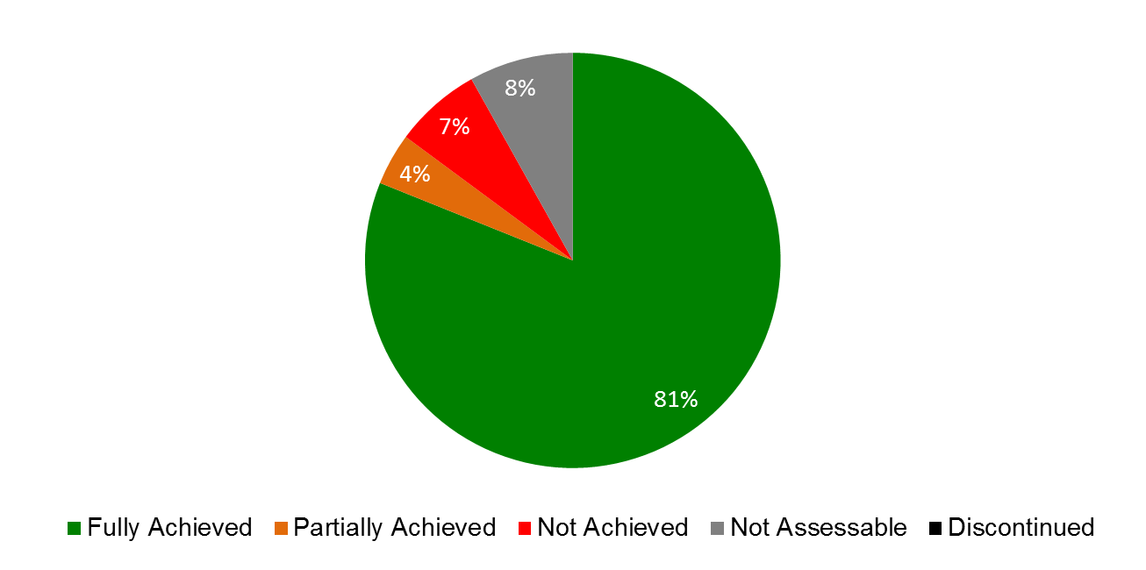

| **Expected Results** | **Performance Indicators** | **Responsible Program(s)** | **TLS** |
| --- | --- | --- | --- |
| III.1 National innovation and IP strategies and plans consistent with national development objectives | No. of countries which are in the process of formulating/adopting national IP strategies and/or development plans | Program 9 | ⚫⚫⚫⚫⚫ |
|  | No. of countries which have adopted and are implementing national IP strategies and/or development plans | Program 9 | ⚫⚫⚫⚫⚫ |
|  | No. of Universities having developed IP policies | Program10 | ⚫ |
|  | No. of countries having developed national IP strategies/plans | Program 10 | ⚫ |
| No. of countries with national innovation policies initiated, in progress or adopted | Program 30 | ⚫ |
| III.2 Enhanced human resource capacities able to deal with the broad range of requirements for the effective use of IP for development in developing countries, LDCs and countries with economies in transition | No. of governments and CMOs signing an agreement with WIPO to develop a new transparency, accountability and governance quality assurance standard | Program 3 | ⚫ |
| % of creators satisfied with the training provided on using copyright data and information for the efficient management of their copyright | Program 3 | ⚫ |
|  | % of participants’ positive rating of the usefulness of copyright related capacity building meetings and workshops | Program 3 | ⚫ |
|  | No. of Member States that take initiatives to improve their use of the copyright system to exploit the economic potentials of their cultural works and products | Program 3 | ⚫ |
|  | % of participants in WIPO activities which report enhanced capacity to understand and use IP principles, systems and tools for the protection of TK and TCEs, and for management of the interface between IP and GRs | Program 4 | ⚫ |
|  | % of participants in WIPO events who express satisfaction with the content and organization of these events | Program 9 | ⚫⚫⚫⚫⚫ |
|  | % of participants in WIPO workshops who apply the skills learned in their work/enterprise | Program 9 | ⚫⚫⚫⚫⚫ |
|  | % of national/regional IP experts are used as resource persons in WIPO events | Program 9 | ⚫⚫⚫⚫⚫ |
|  | No. of countries in transition having established annual IP training programs and/or courses for IP professionals | Program 10 | ⚫ |
|  | % of trained IP professionals and IP Office officials using upgraded skills in their work | Program 10 | ⚫ |
|  | Revised Portfolio of training courses on IP for developing countries, LDCs and CETs / Relevance of content of training courses to capacity building requirements of developing countries, LDCs and CETs | Program 11 | ⚫ |
|  | Enhanced and multilingual access to e learning on various IP aspects for developing countries, LDC and CETs / Relevance of content of portfolio of e-learning courses to the capacity building requirements of developing countries, LDCs and CETs | Program 11 | ⚫ |
|  | Improved access to higher education on IP on the part of developing countries, LDCs and CETs / Number of universities in developing countries, LDCs and CETs, offering new teaching programs on IP | Program 11 | ⚫ |
|  | Progressive establishment of a network of IP experts in developing countries, LDCs and CETs | Program 11 | ⚫ |
|  | No. of new start-up academies projects initiated after the conclusion of the Pilot Phase | Program 11 | ⚫ |
|  | % of trained participants that report satisfaction with the usefulness and relevance of the training provided for their professional life | Program 17 | ⚫ |
|  | % of targeted audience who have demonstrated a basic knowledge of a balanced IP system further to WIPO activities | Program 17 | ⚫ |
|  | No. of countries participating in WIPO Awards Program | Program 17 | ⚫ |
|  | No. of hosting arrangements of developing country scientists | Program 18 | ⚫ |
|  | % of policy makers, government officials, IP practitioners and participants in targeted workshops with enhanced understanding of CMOs and how to effectively use IP for development | Program 20 | ⚫⚫⚫ |
|  | % of trained IP professionals using upgraded skills in their work | Program 30 | ⚫ |
| III.3 Mainstreaming of the DA recommendations in the work of WIPO | No. of DA recommendations that have been addressed by the CDIP through projects, activities and studies | Program 8 | ⚫ |
| Rate of satisfaction among Member States with the results of the projects, activities and studies | Program 8 | ⚫ |
|  | Implementation of the coordination mechanism as approved by Member States | Program 8 | ⚫ |
|  | No. of Programs in which DA recommendations are mainstreamed into the regular work of WIPO | Program 8 | ⚫ |
|  | No. of DA projects and the manner in which they have been mainstreamed into the regular work of WIPO (norm-setting, technical assistance and service delivery) | Program 8 | ⚫ |
|  | Effective system in place for the planning, monitoring and evaluation of the implementation of DA recommendations | Program 8 | ⚫ |
| % of DA projects which have been independently evaluated | Program 8 | ⚫ |
| III.4 Strengthened cooperation mechanisms and programs tailored to the needs of developing countries and LDCs | No. of new or strengthened cooperation mechanisms, programs or partnerships supported to promote/strengthen sub-regional or regional cooperation in IP | Program 9 | ⚫⚫⚫⚫⚫⚫ |
|  | No. of established partnerships where the party offering assistance originates from a developed country | Program 10 | ⚫⚫ |
| III.5 Enhanced understanding of the DA by Member States, IGOs, civil society and other stakeholders | No. of countries requesting technical assistance through DA projects and expressing interest in DA related activities | Program 8 | ⚫ |
|  | % of participants in WIPO meetings (Member States, IGOs, civil society and other stakeholders) satisfied with information received on the DA recommendations | Program 8 | ⚫ |
| III.6 Increased capacity of SMEs to successfully use IP to support innovation | % of participants in training programs targeting SME support institutions who express satisfaction with the content and organization of these events | Program 10 | ⚫ |
| Program 30 | ⚫ |
|  | % of trained SME support institutions who provide information, support and advisory/consulting services on IP asset management | Program 10 | ⚫ |
| Program 30 | ⚫ |
|  | No. of countries having established IP training programs for SMEs | Program 10 | ⚫ |
| Program 30 | ⚫ |
|  | No. of subscriptions to the SME Newsletter | Program 30 | ⚫ |
|  | No. of downloads of topical SME material and guidelines | Program 30 | ⚫ |
|  | No. of SME related case-studies accessed via the IpAdvantage and/or other relevant databases | Program 30 | ⚫ |

## PROGRAM 8 DEVELOPMENT AGENDA COORDINATION

**Program Manager Mr. M. Matus**

ACHIEVEMENTS IN THE 2014/15 BIENNIUM

1. During 2014/15, the Program continued to coordinate the WIPO Development Agenda (DA) implementation by facilitating the work of the Committee on Development and Intellectual Property (CDIP) thirteenth and fourteenth sessions in 2014 and the fifteenth and sixteenth sessions in 2015; the project-based implementation of the DA recommendations; the mainstreaming of the DA principles into the work of the Organization; and a number of activities to support Member States in deriving benefits from the implementation of the DA.
2. In 2014/15, the CDIP considered: (i) two annual Director General’s Reports on Implementation of the Development Agenda; (ii) two Progress Reports on the Implementation of Recommendations for Immediate Implementation and DA Projects; (iii) eleven independent and one self-evaluation project reports; and (iv) a document on the WIPO General Assembly Decision on CDIP related matters. In addition, the Committee approved: (i) proposals for second phases of two completed and evaluated projects; (ii) three new projects proposals, including one proposed by Egypt on IP and Tourism; and (iii) new activities Related to Using Copyright to Promote Access to Information and Creative content. The Committee also discussed: (i) a document forwarded by the General Assembly on the Description of the Contribution of the Relevant WIPO Bodies on the Implementation of respective Development Agenda Recommendations; (ii) a revised Report on the Measurement of the Millennium Development Goals (MDGs) in Other United Nations Agencies and Specialized Agencies, and on the Contribution of WIPO to the Implementation of the MDGs; (iii) a document on WIPO and the Post-2015 Development Agenda; and (iv) the Report on the WIPO Expert Forum on International Technology Transfer. The Committee also discussed the fifth document on Patent‑Related Flexibilities in the Multilateral Legal Framework and their Legislative Implementation at the National and Regional Levels and a report on the update of the Database on flexibilities. Discussions on the External Review of WIPO Technical Assistance in the Area of Cooperation for Development continued during the biennium, and an updated Management Response to the External Review Report was provided. Furthermore, the Committee approved the Terms of Reference (TORs) for the Independent Review of the Implementation of the Development Agenda Recommendations and took a decision on the convening of the International Conference on Intellectual Property and Development. As regards studies, the Committee also discussed: (i) eight studies undertaken in the context of the Project on IP and Socio-Economic Development; (ii) six studies under the Project on Intellectual Property and Technology Transfer: Common Challenges ‑ Building Solutions; (iii) two studies under the Project on Open Collaborative Projects and IP‑Based Models; (iv) four studies under the Project on Intellectual Property and the Informal Economy; (v) one study under the project on Strengthening and Development of the Audiovisual Sector in Burkina Faso and Certain African Countries; and (vi) three studies undertaken under the project on Innovation and Technology Transfer Support Structure for National Institutions. The CDIP continued to benefit from an increasing participation of IGO’s and NGO’s. By the end of 2015, fifty nine observers participated in the work of the Committee.
3. In addition to the provision of support to the CDIP, in 2014/15, the Program initiated the work with regard to the convening of the International Conference on IP and Development to take place in 2016, coordinated the work related to the Independent Review of the Implementation of DA recommendations, and facilitated the implementation of DA activities in Member States. The Program also continued the efforts to ensure an effective implementation of the 19 Recommendations for immediate implementation; to coordinate the monitoring, evaluation and reporting on the implementation of the projects approved by the CDIP; and maintained its responsibility for the coordination of the implementation of all 45 WIPO DA Recommendations.

PERFORMANCE DATA

|  |  |  |  |  |  |
| --- | --- | --- | --- | --- | --- |
| **Expected Result:** III.3 Mainstreaming of the DA recommendations in the work of WIPO | | | | | |
| **Performance Indicators** | **Baselines** | **Targets** | **Performance Data** | | **TLS** |
| No. of DA recommendations that have been addressed by the CDIP through projects, activities and studies | *Updated Baseline end 2013:* 45 DA recommendations  *Original Baseline P&B 2014/15:* 42 recommendations addressed by the Committee in December 2011 | 45 recommendations to be addressed by the CDIP | 45 DA recommendations addressed as per the Progress Report (CDIP/14/2) and (CDIP/16/2). | | **Fully Achieved** |
| Rate of satisfaction among Member States with the results of the projects, activities and studies | 80% | 80% | Based on the CDIP discussions of the (i) two annual Director General’s Reports on Implementation of the Development Agenda; (ii) two Progress Reports on the Implementation of Recommendations for Immediate Implementation and DA Projects; and (iii) eleven independent and one self-evaluation project reports, Member States expressed satisfaction with the results of the projects, activities and studies in 83% of the cases. | | **Fully Achieved** |
| Implementation of the coordination mechanism as approved by Member States | *Updated Baseline end 2013:*  Two Annual reports to the Assemblies on the description of the contribution of WIPO Bodies to the implementation of the respective Development Agenda Recommendations discussed by the CDIP (WO/GA/41/12 and WO/GA/43/10).[52]  *Original Baseline P&B 2014/15:* Coordination Mechanisms and Monitoring, Assessing and Reporting Modalities approved by the Committee in April 2010 | Coordination Mechanisms implemented in accordance with the decision of Member States | Coordination Mechanisms implemented in accordance with the decision of Member States as detailed in the Director General Reports on the implementation of the DA (CDIP/15/2) and (CDIP/17/2). | | **Fully Achieved** |
| No. of Programs in which DA Recommendations are mainstreamed into the regular work of WIPO | *Updated Baseline end 2013:* 23 programs have DA related activities (fully or partly)  *Original Baseline P&B 2014/15:* tbd | 20 | 23 Programs contained in the Program and Budget 2014/15 reflect the mainstreaming of DA activities. | | **Fully Achieved** |
| No. of DA projects, and the manner in which, they have been mainstreamed into the regular work of WIPO (norm-setting, technical assistance and service delivery) | *Updated Baseline end 2013:* 6 DA projects mainstreamed in WIPO regular work  *Original Baseline P&B 2014/15:* tbd | 12 cumulative | Four additional DA projects were mainstreamed in 2014/15 (10 cumulative):   * National Start up Academies in Program 11 (technical assistance) * Specialized Databases’ Access and Support in Program 14 (technical assistance) * Developing tools for access to Patent Information in Program 14 (Access to knowledge) * IP and Product Branding in Program 9 (technical assistance and capacity building) | | **Fully Achieved** |
| Effective system in place for the planning, monitoring and evaluation of the implementation of DA recommendations | *Updated Baseline end 2013:* Effective centralized system for planning monitoring and evaluation of the implementation of DA recommendation  *Original Baseline P&B 2014/15:* tbd | All Programs have in place an effective planning, monitoring and evaluation system on the implementation of DA recommendations | All relevant Programs have in place an effective planning, monitoring and evaluation system on the implementation of DA recommendations | | **Fully Achieved** |
| % of DA projects which have been  independently evaluated | *Updated Baseline end 2013:* 100%; 14 evaluation reports discussed by the CDIP. (evaluated during the biennium 2012/13)  *Original Baseline P&B 2014/15:* 100% | 100% | 100%. Eleven completed projects were independently evaluated and discussed by the CDIP in 2014/15:   * 8 in 2014 * 3 in 2015 | | **Fully Achieved** |
| **Expected Result:** III.5 Enhanced understanding of the DA by Member States, IGOs, civil society and other stakeholders | | | | | |
| **Performance Indicators** | **Baselines** | **Targets** | | **Performance Data** | **TLS** |
| No. of countries requesting technical assistance through DA projects and expressing interest in DA related activities | *Updated Baseline end 2013:* Projects and DA related activities in 50 countries  *Original Baseline P&B 2014/15:* Projects and DA related activities in 43 countries (April 2013) | Projects and DA related activities in 50 countries | | 53 developing countries participated in DA projects. | **Fully Achieved** |
| % of participants in WIPO meetings (Member States, IGOs, civil society and other stakeholders) satisfied with information received on the DA recommendations | n/a | 80% | | 78.57% | **Fully Achieved** |

RISK REPORTING FOR THE BIENNIUM

|  |  |  |  |  |
| --- | --- | --- | --- | --- |
| **Risk(s) to the Program achieving its Results** | **Mitigation plans in place or under implementation** | **Evolution of Risk(s) and Mitigation Strategies Over the Biennium** | | **Impact on the Program’s Performance** |
| Failure to follow up systematically on the DA recommendations and implement them could result in lost opportunities and insufficient focus on the “lessons learnt”. | An enhanced and rigorous follow-up by DA Coordination Division on the implementation of the DA recommendations. | The mitigation strategies were implemented fully and ensured that the risk did not materialize. | This risk and its evolution did not have any material impact on the Program’s performance in 2014/15. | |

RESOURCE UTILIZATION

Budget and Actual Expenditure (by result)

*(in thousands of Swiss francs)*



Budget and Actual Expenditure (personnel and non-personnel)

*(in thousands of Swiss francs)*



A. 2014/15 Final Budget after Transfers

1. The decrease in the 2014/15 Final Budget after Transfers was primarily due to the redeployment of personnel resources (one post) out of the Program.

B. 2014/15 Budget Utilization

1. Lower expenditure in personnel resources was due to a vacancy being under recruitment. Lower expenditure in non-personnel resources was mainly due to the delay, with the agreement of the Member States, of the independent review of the implementation of the Development Agenda recommendations.

## PROGRAM 9 AFRICA, ARAB, ASIA AND THE PACIFIC, LATIN AMERICA AND THE CARIBBEAN COUNTRIES, LEAST DEVELOPED COUNTRIES

**Program Manager Mr. M. Matus**

ACHIEVEMENTS IN THE 2014/15 BIENNIUM

* 1. WIPO’s Strategic Goal III, facilitating the use of IP for development, continued to drive the Program’s country-specific, needs-based technical assistance and support for Member States in the biennium. Serving as the primary interface between the beneficiary Member States and the various Programs of WIPO, Program 9 continued to ensure country-specific, needs-based, coherent and well-coordinated delivery of technical assistance. Overall, the design, planning and implementation of technical cooperation activities were informed and guided by the relevant DA Recommendations, in particular the Recommendations under Cluster A on WIPO’s technical assistance and capacity building. Also in line with the DA Recommendations, delivery of development-oriented activities to developing countries and LDCs continued to be mainstreamed across the various specialized Programs of the Organization in 2014/15 to further strengthen WIPO’s technical cooperation.
  2. WIPO continued to assist developing countries and LDCs in the design, development and implementation of national IP strategies that are both consistent with their overall development plans and that have the ability to foster innovation and creativity. The application of the standardized, yet flexible, methodology and set of practical tools for the formulation of national IP strategies and plans, developed as part of the DA project on Improvement of National, Sub-regional and Regional IP Institutional and User Capacity in 2012, continued to guide the process. As a result, 15 countries (six in Africa, five in Asia and the Pacific, and four in Latin America and the Caribbean) initiated the process of formulating national IP strategies/development plans, and 13 countries (four in Africa, two in the Arab region, three in Asia and the Pacific, and four in Latin America and the Caribbean) were still in the process of formulation and/or adoption at the end of 2014. At the end of 2014/15, national IP strategies/development plans had been adopted and/or were under implementation in a total of 44 countries (26 in Africa, two in the Arab region, eight in Asia and the Pacific, and eight in Latin America and the Caribbean), of which 19 in LDCs.
  3. For the first time, WIPO was involved extensively in assisting a regional group in the formulation of a comprehensive regional IP framework. In October 2014, one focal point from each of the Association of Southeast Asian Nations (ASEAN) countries participated in a brainstorming workshop for the development of the ASEAN IPR Strategic Plan for 2016-2025, in line with the ASEAN Economic Community (AEC) 2016-2025 strategy.
  4. Enhancing human resource capabilities to deal with the broad range of requirements for the effective use of IP for development and fostering innovation and creativity remained a priority throughout the biennium. Focused capacity building and skills development programs were delivered to specific target groups such as government officials, policy-makers, IP professionals, enforcement officials, researchers and academics, entrepreneurs and industrialists, as well as SMEs, at the national, sub-regional and regional levels.
  5. In 2014/15, WIPO continued to strengthen its assistance to IP Offices in developing countries and LDCs to enable them to provide cost-effective and high-quality IP modernization and technical infrastructure services to their stakeholders, creating a more favorable environment for the effective use of IP information, particularly by the institutions in charge of the administration of IP rights, the national innovation system and the productive sector. By the end of 2015, some 70 IP Offices were using WIPO IP Office Systems in the different regions: 24 in Africa, 14 in the Arab region, 13 in Asia and the Pacific and 19 in Latin America and the Caribbean (for more details see Program 15).
  6. Facilitating access to global technology information databases also remained a high priority. During the biennium, an increased emphasis was placed on strengthening existing Technology Innovation Support Centers (TISCs) with a view to long-term sustainability. Out of the 49 established TISCs in the different regions, some 24 were considered sustainable by the end of 2015: 10 in Africa (of which eight in LDCs); three in the Arab region; four in Asia and the Pacific (of which one in an LDC); and seven in Latin America and the Caribbean (for more details see Program 14).
  7. WIPO also strengthened its cooperation with LDCs for the development of a framework for national policies on innovation; assessing technical skills needs; facilitating access to global scientific and technological information platforms; establishing innovation support infrastructure; supporting inventories and capacity building in traditional knowledge. As part of Phase II of the DA Project on Capacity building in the Use of Appropriate Technology Specific Technical and Scientific Information as a Solution for Identified Development Challenges, MoUs were signed with four LDCs (Ethiopia, Rwanda, United Republic of Tanzania and Uganda, and by the end of 2015, implementation of the project had begun in three LDCs (Ethiopia, Rwanda, and United Republic of Tanzania).
  8. In the same vein, WIPO worked closely with the United Nations Office of the High Representative for Least Developed Countries, Landlocked Developing Countries and Small Island Developing States in the context of the implementation of the Istanbul Program of Action. In 2014, on the occasion of the LDCs’ Ministerial Conference held in Benin, WIPO implemented an interregional partnership program in cooperation with the International Telecommunication Union (ITU), the United Nations Capital Development Fund (UNCDF) and the United Nations Industrial Development Organization (UNIDO). In 2015, two additional partnership cooperation fora were established, with the United Nations Economic Commission for Asia and the Pacific (UN ESCAP) and the United Nations Economic Commission for Africa (UNECA). The partnership with UN ESCAP led to a proposal for the signing of a MoU between the two organizations. The focus was on capacity building and strengthening institutions of the LDCs from Africa and Asia.
  9. In cooperation with the Government  of Sweden (Swedish  Patent and Registration Office), WIPO continued the annual International Training Program (ITP) on Intellectual Property in the Global Economy for LDCs to Use IP for Development, first started in 2004. To measure the relevance, effectiveness, efficiency, sustainability and impact of the program over the last 10 years, the Swedish International Development Cooperation Agency (Sida) conducted an independent evaluation[53] of the program from February 2014 to February 2015. Based on the findings, which were overall very positive, the program will be conducted bi-annually beginning in 2016.
  10. The Project on Enhancing South-South Cooperation (SSC) on IP and Development among Developing Countries and LDCs, completed and evaluated in 2014, was extended until June 2015. Subsequently, a dedicated focal point for SSC was established within the Development Sector. In May 2014, a South-South webpage[54], featuring South-South web platforms, a database of South-South Technical Assistance (South-South IP-TAD) and Roster of Consultants (South-South IP-ROC) specifically involved in South-South activities, was officially launched. Notably, an analysis was conducted of the criteria, which would define WIPO South-South Cooperation activities in the light of UN-wide SSC definitions, as well as of WIPO’s mandate. As a result, a mapping of such activities in the 2014/15 biennium was conducted, using the IP Technical Assistance Database (IP-TAD).[55]
  11. The Program also continued to support a number of requests for assistance regarding the protection and branding of origin-based products, in particular through specialized training courses and multi-stakeholder initiatives with international and regional partners, notably in the Caribbean region, Cambodia and the United Republic of Tanzania, to enhance stakeholders’ capacities. Furthermore, a report on *The African Fashion Design Industry: Capturing Value through Intellectual Property*[56], conducted in seven African countries (Cameroon, Ethiopia, Ghana, Nigeria, Senegal, South Africa and Zimbabwe) was released for the African Ministerial Conference: Intellectual Property for an Emerging Africa, which took place in Dakar, Senegal from November 3 to 5, 2015 in collaboration with the African Union, the Government of Senegal and the Japan Patent Office under the FIT-Japan.
  12. At this same conference, the *Dakar Declaration on Intellectual Property for Africa* was adopted, providing a framework for cooperation between WIPO and the African Union for implementing IP related activities on the continent. In additiona, cooperation activities continued to be strengthened with the two African IP regional organizations (ARIPO and OAPI).
  13. WIPO organized theSeventh Regional Coordination Meeting of the Heads of Arab IP Offices in 2015 and two high-level meetings in the Central Latin America region of IP Directors and Heads of Science and Technology Institutions in the region. In Asia, the Heads of Intellectual Property Conference (HIPOC) was established as a new platform for sharing ideas and experiences. The partnership with the Inter-American Development Bank resulted in the establishment of a Regional Entrepreneurial Asset Commercialization Hub - REACH Project for the Caribbean. The project aims at facilitating the effective management of intangible assets through the creation of three support centers in three specific business areas: technology management; creative industries; and product branding.
  14. In 2014/15, the Program facilitated and internally coordinated the accession of several countries and regional groups to treaties and conventions administrated by WIPO: two in Africa (OAPI and Zimbabwe) and three in the Arab region (Algeria, Kuwait and the United Arab Emirates).
  15. The Program continued to coordinate and facilitate technical assistance to developing countries and LDCs in formulating and modernizing legislation in the field of IP, taking into account specific national requirements and international flexibilities.
  16. To enable Member States to make more informed choices as regards WIPO’s priority areas, the *Manual on Delivery of WIPO Technical Assistance* (finalized in 2013) was published in all six official UN languages in 2014 and made available online[57] (for more details see Programs 1, 2, 3 and 4). In addition, in 2014, the Central American countries and the Dominican Republic adopted the *Harmonized Manual on Trademark Examination*,a tool that contributes to the quality of the work and the harmonization of practices in the corresponding IP Offices of this region, and the brochure *WIPO Development Tools and Services*, published in 2007, was updated in 2015 and translated into French and Spanish. These tools enable Member States to make more informed choices as regards WIPO’s priority areas.
  17. Specialized databases continued to be used to support the delivery of technical assistance, in particular the databases on IP Technical Assistance (IP-TAD) and the Roster of Consultants (IP-ROC), including the interfaces to store information on South-South cooperation, and the IP Development Matchmaking Database (IP-DMD). The year 2014 also saw the deployment of the specialized National IP Strategy Database (NIPS-D), which was developed in 2013 to capture relevant data for the baseline assessment phase of national IP strategy development, as necessitated by the increasing number of countries using the WIPO methodology to develop IP strategies. In an effort to maximize the potential of these databases, their usage was closely monitored and user feedback sought throughout the biennium to glean insights into further enhancing the systems with a view to making them more user friendly, as well as to identifying more strategic approaches for promoting their uses in different countries. However, the number of countries using IP-TAD and IP-ROC saw decreases in both 2014 (10 per cent decrease as compared to 2013) and 2015 (28 per cent decrease as compared to 2014); no matches had been catalyzed in the IP-DMD by the end of 2015; and initial results on the usage of NIPS-D indicated that the database was not being effectively used.

PERFORMANCE DATA

|  |  |  |  |  |  |  |
| --- | --- | --- | --- | --- | --- | --- |
| **Expected Result:** I.2 Tailored and balanced IP legislative, regulatory and policy frameworks | | | | | | |
| **Performance Indicators** | **Baselines** | | **Targets** | **Performance Data** | | **TLS** |
| No. and % of Member States which were satisfied with the quality of legal advice related to patents, utility models, trade secrets and integrated circuits | *Updated Baseline end 2013:* 9 Member States (90%), based on survey conducted by IOD in 2013  *Original Baseline  P&B 2014/15:* Surveys 2012 | | 90% | In 2014/15, 7 respondents reported on average a 94% satisfaction rate (Africa-3; Arab-1; Asia and the Pacific-2; Latin America and the Caribbean-1[58] | | **Fully Achieved** |
| No. and % of Member States/regional organizations providing positive feedback on the legislative advice offered in the area of trademarks, industrial designs and geographical indications | *Updated Baseline end 2013:* Positive feedback received from nine out of 13 countries. Four countries did not reply.  *Original Baseline  P&B 2014/15:* Three Member States/regional organizations having provided positive feedback on legislative advice received in 2012 | | Positive feedback received from 10 Member States/regional organizations (regional breakdown) | Advice was provided to 30 Member States/Regional Organizations (Africa 8; Arab 1; Asia and the Pacific 14; Latin America and the Caribbean 6)  Feedback was received from 10 respondents, all of whom (100%) reported satisfaction with the advice offered. | | **Fully Achieved** |
| No. and % of countries that have provided positive feedback about WIPO´s legislative advice | No feedback information has yet been collected | | 15 countries (regional breakdown) | 23 countries received legislative advice in 2014/15. (Africa 9; Arab 3; Asia and the Pacific 5; Latin America and the Caribbean 6).  100% of the valid survey responses provided positive feedback (5 or 6 on a scale of 1-6) about WIPO’s copyright legislative advice service. | | **Fully Achieved** |
| **Expected Result:** III.1 National innovation and IP strategies and plans consistent with national development objectives | | | | | | |
| **Performance Indicators** | **Baselines** | **Targets** | | **Performance Data** | **TLS** | |
| No. of countries which are in the process of formulating/adopting national IP strategies and/or development plans | *Updated Baseline end 2013:*  Africa: 18 cumulative (Botswana, Burundi, Cameroon, Central African Republic, Chad, the Congo, Equatorial Guinea, Ethiopia[59], the Gambia, Kenya, Lesotho, Malawi, Mali, Mauritius, Seychelles, Sierra Leone, Togo, United Republic of Tanzania)  Arab: 6 cumulative[60] (Algeria[61], Oman, Qatar[62], Sudan, United Arab Emirates, Yemen)  Asia and the Pacific: 12 cumulative (Bangladesh, Bhutan, Cambodia, Fiji, Mongolia, Papua New Guinea, Samoa, Solomon Islands, Sri Lanka, Tonga, Vanuatu, Viet Nam)  Latin America and the Caribbean: 11 cumulative (Barbados, Costa Rica, Dominican Republic, Ecuador, El Salvador, Guatemala, Honduras, Nicaragua, Panama, Saint Kitts & Nevis, Trinidad & Tobago)  19 LDCs included in the above regional breakdown  *Original Baseline*  *P&B 2014/15:*  Africa (12 cumulative)  Arab (4)  Asia and the Pacific (8)  Latin America and the Caribbean (9)  5 LDCs included in the above regional breakdown | Africa (18 cumulative)  Arab (7 cumulative)  Asia and the Pacific (13 cumulative)  Latin America and the Caribbean (13 cumulative)  10 LDCs included in the above regional breakdown | | Africa (6 additional countries): Benin, the Democratic Republic of the Congo[63], Madagascar, Niger, Swaziland, Uganda.  (24 cumulative)  Arab (no additional countries):   * United Arab Emirates (no further progress); * Yemen (process delayed due to the political situation)   (6 cumulative)  Asia and the Pacific (5 additional countries):  Brunei Darussalam, Cook Islands, Democratic People's Republic of Korea, Myanmar,  (17 cumulative)  Latin America and the Caribbean (4 additional countries): Chile, Grenada, Paraguay and Peru  (15 cumulative)  24 LDCs included in the above cumulative regional breakdown | **Fully Achieved**  **Not Achieved**  **Fully**  **Achieved**  **Fully Achieved**  **Fully**  **Achieved** | |
| No. of countries which have adopted and are implementing national IP strategies and/or development plans | *Updated Baseline end 2013:*  Africa (9 cumulative): Comoros, Ghana, Kenya, Liberia, Mauritius, Mozambique, Senegal, Seychelles, Zambia  Arab countries (2 cumulative): Oman, Sudan  Asia and the Pacific (3 cumulative[64]): Fiji, Papua New Guinea, Samoa  Latin America and the Caribbean (3 cumulative): Costa Rica, Dominican Republic, Honduras  7 LDCs included in the above regional breakdown  *Original Baseline*  *P&B 2014/15:*  Africa (4)  Arab (3)  Asia and the Pacific (3)  Latin America and the Caribbean (4)  5 LDCs included in the above regional breakdown | Africa (6) cumulative  Arab (6) cumulative  Asian and Pacific (7) cumulative  Latin America and the Caribbean (12)  11 LDCs included in the above regional breakdown | | Africa (17 additional in 2014/15): Botswana, Burundi, Cameroon, Chad, the Congo, Côte d’Ivoire, the Democratic Republic of Congo, Ethiopia; Lesotho, Malawi, Mali, Rwanda, Sao Tome and Principe, Swaziland, Togo, United Republic of Tanzania, Zimbabwe  (26 cumulative)  Arab (no additional countries in 2014/15):  (2 cumulative)  Asia and Pacific (5 additional in 2014/15):  Cambodia, Mongolia, Sri Lanka, Tonga, Vanuatu  (8 cumulative)  Latin America and the Caribbean (4 additional in 2014/15): Barbados, El Salvador, Guatemala and Saint Kitts and Nevis  (8 cumulative)  19 LDCs included in the above cumulative regional breakdown | **Fully Achieved**  **Not Achieved**  **Fully Achieved**  **Partially Achieved**  **Fully Achieved** | |

|  |  |  |  |  |  |  |  |
| --- | --- | --- | --- | --- | --- | --- | --- |
| **Expected Result:** III.2 Enhanced human resource capacities able to deal with the broad range of requirements for the effective use of IP for development in developing countries, LDCs and countries with economies in transition | | | | | | | |
| **Performance Indicators** | | **Baselines** | **Targets** | **Performance Data** | | | **TLS** |
| % of participants in WIPO events who express satisfaction with the content and organization of these events | | *Updated Baseline end 2013:*  Asia and the Pacific (65%); LDCs (60%)  *Original Baseline P&B 2014/15:* No data available | Africa (70%)  Arab (80%)  Asia and the Pacific (65%)  Latin America and the Caribbean (80%)  LDCs (80%) | Africa (75%)  Arab (90%)  Asia and the Pacific (95%)  Latin America and the Caribbean (80%)  LDCs (85%) | | | **Fully Achieved**  **Fully Achieved**  **Fully Achieved**  **Fully Achieved**  **Fully Achieved** |
| % of participants in WIPO workshops who apply the skills and knowledge learned in their work/enterprise | *Updated Baseline end 2013:* Africa: Information not available  Arab: Information not available  Asia and the Pacific: 65%;  Latin American and the Caribbean: Information not available;  LDCs: Information not available  *Original Baseline P&B 2014/15:*  Africa: Information not available;  Arab: Information not available;  Asia and the Pacific (65%);  Latin American and the Caribbean: Information not available;  LDCs: Information not available | | Africa (70%)  Arab (70%)  Asia and the Pacific (65%)  Latin America and the Caribbean (30%)  LDCs (80%) | Africa (70%)  Arab: Not available**[65]**  Asia and the Pacific: (91%)  Latin America and the Caribbean ( 40%)  LDCs (90%) | | | **Fully Achieved**  **Not Assessable**  **Fully Achieved**  **Fully Achieved**  **Fully Achieved** |
| % of national/regional IP experts used as resource persons in WIPO events | *Updated Baseline end 2013:*  Africa: (70%)  Arab (50%)  Asia and the Pacific: Data not available  Latin America and the Caribbean (70%)  LDCs (60%)  *Original Baseline P&B 2014/15:*  Africa (65%)  Arab (70%)  Asia and the Pacific: Data not available  Latin America and the Caribbean (70%)  LDCs (70%) | | Africa (75%)  Arab (80%)  Asia and the Pacific (55%)  Latin America and the Caribbean (80%)  LDCs (80%) | Africa (75%)  Arab (55%)  Asia and the Pacific (66%)  Latin America and the Caribbean (80%)  LDCs (85%) | | | **Fully Achieved**  **Partially Achieved**  **Fully Achieved**  **Fully Achieved**  **Fully Achieved** |
| **Expected Result:** III.4 Strengthened cooperation mechanisms and programs tailored to the needs of developing countries and LDCs | | | | | | | |
| **Performance Indicators** | **Baselines** | | **Targets** | | **Performance Data** | **TLS** | |
| No. of new or strengthened cooperation mechanisms, programs or partnerships supported to promote/strengthen sub-regional or regional cooperation in IP | Africa (3)  Arab (2)  Asia and the Pacific (4)  Latin America and the Caribbean (3)  2 LDCs included in the above regional breakdown  Appropriate Technology Projects in 3 LDCs | | Africa (2)  Arab (1)  Asia and the Pacific (4)  Latin America and the Caribbean (7)  4 LDCs included in the above regional breakdown  Additional appropriate technology in at least 4 LDCs | | Africa (2): (i) MoU signed with *l’Organisation Internationale de la Francophonie* (OIF) in May 2014; (ii) African Union /WIPO cooperation under the *Dakar Declaration on Intellectual Property for Africa[66]*  Arab (1): (MoU signed with the Emirates Intellectual Property Association (EIPA), UAE, on October 2015.[67]  Asia and the Pacific (1):  (i) Association of Southeast Asian Nations (ASEAN) [68];  Latin America and the Caribbean: 6 ongoing projects[69]  4 of the organizations in the above regional breakdown include LDCs  As part of Phase II of the DA Project on Capacity Building in the Use of Appropriate Technology Specific Technical and Scientific Information as a Solution for Identified Development Challenges, MoUs were signed with four LDCs (Ethiopia, Rwanda, United Republic of Tanzania and Uganda), and by the end of 2015, implementation of the project had begun in three LDCs (Ethiopia, Rwanda, and United Republic of Tanzania). | **Fully**  **Achieved**  **Fully Achieved**  **Not Achieved**  **Fully Achieved**  **Fully Achieved**  **Fully Achieved** | |

|  |  |  |  |  |  |
| --- | --- | --- | --- | --- | --- |
| **Expected Result:** IV.2 Enhanced access to, and use of, IP information by IP institutions and the public to promote innovation and creativity | | | | | |
| **Performance Indicators** | **Baselines** | | **Targets** | **Performance Data** | **TLS** |
| No. of sustainable national TISC networks | *Updated Baseline end 2013:* 14 sustainable (out of 36 established) TISC networks  *Original Baseline P&B 2014/15:*  *14 national TISC networks:*  Africa (6)  Arab (2)  Asia and the Pacific (2)  Latin America and the Caribbean (4)  6 LDCs included in the above regional breakdown | | 23 national TISC networks (cumulative):  Africa (10 of which 8 LDCs)  Arab (3)  Asia and the Pacific (4 of which 2 LDCs)  Latin America and the Caribbean (6) | 24 sustainable national networks out of 49 formally established (cumulative):  Africa (10 of which 8 LDCs)  Arab (3)  Asia and the Pacific (4 of which 1 LDC)  Latin America and the Caribbean (7)  9 LDCs included in the above regional breakdown | **Fully Achieved**  **Fully Achieved**  **Fully Achieved**  **Fully Achieved**  **Fully Achieved** |
| Average number of users serviced by TISCs per quarter and country | *Updated Baseline end 2013:* 532 (min.) to 1370 (max.) average no. of users serviced by TISCs per day during 2013.  *Original Baseline P&B 2014/15:*  200 (min) – 630 (max) | | 300 (min) – 750 (max) | 874 (min.) – 2,631 (max.) | **Fully Achieved** |
| No. of countries using IP Technical Assistance Database (IP-TAD), IP Roster of consultants (IP_ROC) | *Updated Baseline end 2013:*  IP-TAD: 43 countries  IP-ROC: 8 countries (in 2013)  *Original Baseline P&B 2014/15:* 60 (as of 01.03.2013) | | 70 | 2014: 46 countries  IP-TAD: 37 countries  IP-ROC: 9 countries  (-10% as compared to 2013)  2015: 33 countries  IP-TAD: 29 countries  IP-ROC: 4 countries  (-28% as compared to 2014) | **Not  Achieved** |
| **Expected Result:** IV.4 Enhanced technical and knowledge infrastructure for IP Offices and other IP institutions leading to better services (cheaper, faster, higher quality) to their stakeholders | | | | | |
| **Performance Indicators** | **Baselines** | **Targets** | | **Performance Data** | **TLS** |
| Average Service Level of IP Offices assisted (ranging from 1 to 5) | *Updated Baseline end 2013:* 2.8  *Original Baseline P&B 2014/15:* tbd | *Defined Target:* 3  *Original Target P&B 2014/15:* tbd | | Overall average: 2.9   * Africa: 2.9 * Arab: 2.8 * Asia and the Pacific: 2.7 * Latin America and the Caribbean: 3 | **Fully Achieved** |

RISK REPORTING FOR THE BIENNIUM

|  |  |  |  |
| --- | --- | --- | --- |
| **Risk(s) to the Program achieving its Results** | **Mitigation plans in place or under implementation** | **Evolution of Risk(s) and Mitigation Strategies Over the Biennium** | **Impact on the Program’s Performance** |
| Risk of political instability in the Member States with high security risks and security downgrade that may cause cancellation of activities or delays in technical assistance delivery thus impeding Program 9’s ability to fully deliver its expected results | (i) Risk assessment undertaken as appropriate and country plans/ annual activities formulated taking into account this assessment  (ii) Constant monitoring with IP office and stakeholders to develop alternative plans | The risk materialized due to the difficult national situations and the continuous structural changes in IP institutions in certain Arab countries. To a limited extent, risk mitigation measures were successful in providing alternative options for the delivery of technical assistance in consultation with relevant Authorities. | The mitigation actions could not fully address the impact of the risk, resulting in the partial or non-achievement of certain targets, as well as the postponement and/or redesign of technical assistance initiatives. |
| Political change leading to IP policy changes in the country and in Governments or in senior management of IP offices which may cause revision of affected countries’ work plans, and reducing or delaying delivery of services thus affecting attainment of expected results | (i) Flexibility retained to make occasional adjustments in work plans for individual countries  (ii) Encouraging and facilitating consensus building on national IP strategies and work plans | The risk did materialize in certain countries. Mitigation measures largely addressed the adverse impact in that flexibility and increased dialogue with newly appointed officials facilitated the required adjustments to national IP strategies and work plans. | The mitigation actions largely addressed the impact on the Program’s performance. |

RESOURCE UTILIZATION

Budget and Actual Expenditure (by result)

*(in thousands of Swiss francs)*



Budget and Actual Expenditure (personnel and non-personnel)

*(in thousands of Swiss francs)*



A. 2014/15 Final Budget after Transfers

* 1. The shift in resources between several Expected Results reflects an enhanced focus on the facilitation and coordination of: (i) WIPO’s legislative advice activities in the area of patents, trademarks, industrial designs and copyright (Expected Result I.2 Legislative advice); (ii) WIPO activities related to the access to and use of IP information through the increased number of sustainable national TISC networks (Expected Result IV.2); and (iii) efforts to assist IP Offices and other IP institutions to develop their technical and knowledge infrastructure (Expected Result IV.4 Enhanced technical and knowledge infrastructure).

B. 2014/15 Budget Utilization

* 1. The lower-than-anticipated utilization rate for non-personnel resources was mainly due to the postponement or cancellation of certain planned events/activities at the request of certain Member States or in compliance with UN security guidelines. Health risks and associated travel restrictions due to the Ebola crisis also led to cancellation of some planned activities. Furthermore, reductions in travel and related costs were achieved through the implementation of an increasing number of events on clustered or back-to-back bases.

## PROGRAM 10 COOPERATIONS WITH CERTAIN COUNTRIES IN EUROPE AND ASIA

**Program Manager Director General**

ACHIEVEMENTS IN THE 2014/15 BIENNIUM

1. In the 2014/15 biennium, Program 10 continued to develop, and in cooperation with all relevant Sectors, to coordinate the implementation of long-term, results oriented country cooperation activities in countries in transition. To this end, efforts in the biennium were focused on a strategic multi-year planning approach to promoting the use of the IP system to stimulate innovation and creativity for economic, social and cultural development
2. Promotion of the importance of and/or assistance in the development and implementation of long‑term and comprehensive national IP strategies to meet the needs of Member States remained a priority in 2014/15. Six countries (Bulgaria, Slovenia, Tajikistan, Turkey, Turkmenistan and Ukraine) adopted IP related national strategies and four countries (Albania, Georgia, Latvia and Poland) initiated the development of a new strategy. The Program also conducted post-implementation evaluations in three countries (Belarus, the Republic of Moldova and Serbia) in order to assess the outcomes of the implementation of already finalized IP strategies and to identify lessons learned.
3. In line with the cooperation plans and national IP strategies and, following WIPO assistance, including promotional activities, nine countries (Kazakhstan, Kyrgyzstan, Latvia, Lithuania, Montenegro, the Republic of Moldova, the Russian Federation, Tajikistan and Turkmenistan) amended their national IP legislation and/or joined WIPO-administered Treaties.
4. In order to support the development of IP policies in universities, relevant projects and activities were implemented in Estonia, Lithuania, Poland, the Russian Federation, Slovakia and Uzbekistan. With WIPO assistance, one university in the Russian Federation and one university in Uzbekistan developed IP policies in 2014. In addition, on October 1, 2014, Poland adopted a Law on Higher Education, which made it compulsory for all higher educational institutions (132 public and 302 non-public) to have in place an up‑to-date institutional IP policy by March 31, 2015. By the end of the biennium, 434 Universities/higher education institutions in Poland had developed new IP policies.
5. The Program continued to support countries in building their national human resource capacities and enhancing the awareness and the knowledge base for an effective use of IP for economic, social and cultural development. In 2014/15 more than 6,000 specialists and experts, among others, from national IP Offices and other government agencies, SMEs, universities and public research institutions were trained through tailored IP programs, including on IP management and technology transfer, SMEs, enforcement, copyright, IP teaching and WIPO services. Through a number of post-event follow-up surveys, participants provided positive feedback with 95.8 per cent of respondents reporting satisfaction with the events and 82.7 per cent confirming the upgrading of their work skills.
6. During the 2014/15 biennium, WIPO Summer Schools were organized in Croatia and the Russian Federation.
7. Support to countries in transition in developing IP teaching curricula and establishing annual IP training programs and/or courses for IP professionals was further enhanced during the biennium. Notably, support was provided to the Government of Romania in the development of an optional course on IP in all high schools, the School Program for the Optional Course Education for Intellectual Property Rights (Curriculum at the High-school Decision), which was approved and officially introduced into the curriculum on March 27, 2015.
8. The Program continued to strengthen efforts to improve the coordination, promotion and delivery of WIPO services, with the objective to increase their use in transition and developed countries.
9. In 2014/15, some 3,000 professionals from 18 countries (Australia, Austria, Belgium, Finland, France, Germany, Ireland, Israel, Italy, Japan, Luxembourg, Netherlands, New Zealand, Portugal, Spain, Sweden, United Kingdom and the United States of America) attended 36 Roving Seminars on WIPO services and initiatives. Over 90 per cent of survey respondents either agreed or strongly agreed that the seminar was relevant for their professional work, and over 80 per cent of survey respondents either agreed or strongly agreed that the seminar made it more likely that they would use/recommend the IP services offered by WIPO in the future. Additionally, 98 per cent of respondents to post-event follow-up questionnaires either agreed or strongly agreed that the seminar increased their understanding of WIPO services, with 35 per cent either agreeing or strongly agreeing that their organization's use of WIPO services had increased following attendance at the seminar.
10. Efforts were increased in 2014/15 to strengthen institutional ties and promote partnerships with stakeholders in transition and developed countries, including regional Organizations, IP Offices, NGOs and trade associations representing users of WIPO services.  To this end, the Program welcomed numerous visits of stakeholders from the countries concerned and facilitated WIPO briefings on different issues of interest. A number of scoping missions were organized to better evaluate the needs and requests from the countries concerned, and five new Memoranda of Understanding (MoUs) were agreed in 2014/15 with stakeholders from Denmark, France, Germany, Israel and Spain.
11. With the view to further mainstream gender perspectives into the Program, the cooperation established with the World Women Inventors and Entrepreneurs Association (WWIEA) continued throughout the biennium and resulted in the co-organization of the International Educational Program on Idea, Invention, Innovation and Intellectual Property – Seed Project 2014, an effective training program for women in Central Asia, in November. Moreover, several international educational programs were co-organized for women from Armenia, Azerbaijan, Belarus, Croatia, Georgia, Kazakhstan, the Republic of Moldova, the Russian Federation, Serbia, and Ukraine. These training programs were aimed at increasing participants’ knowledge on creativity, innovation, protection of inventions and management of IPRs, as well as to pass on teaching methods in order to enable participants to share the enhanced knowledge and skills at the national level. In addition, the Seventh and Eight International Conferences on Innovation and Creativity of Women, which gathered around 300 participants from more than 20 countries, were successfully organized in Warsaw, Poland in March 2014 and 2015.
12. Program 10 continued to play a key role in the implementation of the WIPO DA in its cooperation with Certain Countries in Europe and Asia, and the work of the Program continued to be guided by the DA recommendations on technical assistance and capacity building, in particular Recommendations 1, 6, 12, 13 and 14.

PERFORMANCE DATA

|  |  |  |  |  |  |  |  |  |
| --- | --- | --- | --- | --- | --- | --- | --- | --- |
| **Expected Result:** I.2 Tailored and balanced IP legislative, regulatory and policy frameworks | | | | | | | | |
| **Performance Indicators** | **Baselines** | | **Targets** | **Performance Data** | | | | **TLS** |
| No. of countries with updated laws and/or regulations | *Updated Baseline end 2013:* 18 cumulative:Albania, Armenia, Belarus, Bosnia and Herzegovina, Poland, Romania, Slovenia and Tajikistan updated their national IP legislation in 2012/13.    Kazakhstan and the Russian Federation have initiated the amendment of their legislation.  *Original Baseline P&B 2014/15:* 18 by end of 2013 | | 4 additional countries | 9 (Kazakhstan, Kyrgyzstan, Latvia, Lithuania, Montenegro, Republic of Moldova, Russian Federation, Tajikistan, Turkmenistan) | | | | **Fully Achieved** |
| **Expected Result:** II.1 Increased use of the PCT route for filing international patent applications | | | | | | | | |
| **Performance Indicators** | **Baselines** | | **Targets** | **Performance Data** | | | | **TLS** |
| No. of PCT applications originating from transition and developed countries | *Updated Baseline end 2013:*  166,517 (2013)  160,309 (2012)  *Original Baseline P&B 2014/15:* tbd | | 2% increase | 170,177 (2014)  168,207 (2015)  +3.5% | | | | **Fully Achieved** |
| **Expected Result:** II.4 Wider and better use of the Hague system, including by developing countries and LDCs | | | | | | | | |
| **Performance Indicators** | **Baselines** | | **Targets** | **Performance Data** | | | | **TLS** |
| No. of Hague System applications originating from transition and developed countries | *Updated Baseline end 2013:*  2,927 (2013)  2,553 (2012)  *Original Baseline P&B 2014/15:* tbd | | 2% increase | 2,776 (2014)  3,448 (2015)  +13.6% | | | | **Fully Achieved** |
| **Expected Result:** II.6 Wider and better use of the Madrid & Lisbon systems, including by developing countries and LDCs | | | | | | | | |
| **Performance Indicators** | **Baselines** | | **Targets** | **Performance Data** | | | | **TLS** |
| No. of Madrid & Lisbon System applications originating from transition and developed countries | *Updated Baseline end 2013:*  Madrid:  43,149 (2013)  40,640 (2012)  Lisbon:  749 out of 816 registrations in force  *Original Baseline P&B 2014/15:* tbd | | 2% increase | 43,748 (2014)  44,570 (2015)  +5.4%  Lisbon:  836 out of 931 registration in force from transition and developed countries  +11.6% | | | | **Fully Achieved**  **Fully Achieved** |
| **Expected Result:** II.8 International and domestic intellectual property disputes are increasingly prevented or resolved through WIPO mediation, arbitration and other alternative dispute resolution methods | | | | | | | | |
| **Performance Indicators** | **Baselines** | | **Targets** | **Performance Data** | | | | **TLS** |
| No. of users in transition and developed countries using the AMC services | *Updated Baseline end 2013:* 359 disputes and 51 bons offices involving parties from transition and developed countries (cumulative per end 2013)  *Original Baseline P&B 2014/15:*tbd | | 2% increase | In 2014/15,102 additional disputes and bons offices involving parties from transition and developed countries  +24.8%  461 disputes and bons offices involving parties from transition and developed countries (cumulative per end 2015) | | | | **Fully Achieved** |
| **Expected Result:** III.1 National innovation and IP strategies and plans consistent with national development objectives | | | | | | | | |
| **Performance Indicators** | **Baselines** | | **Targets** | **Performance Data** | | | | **TLS** |
| No. of Universities having developed IP policies | tbd | | 30 additional Universities | 436 (Poland 434; Russian Federation 1; Uzbekistan 1)  A Law on Higher Education was adopted by Poland on October 1, 2014, which made it compulsory for all higher educational institutions to have in place an up-to-date IP policy by March 31, 2015.  Universities in Estonia, Lithuania and Slovakia were in the process of developing IP policies in 2014/15. | | | | **Fully Achieved** |
| No. of countries having developed national IP strategies/plans | 14 (cumulative per end 2013) | | 6 additional countries | 6 (Bulgaria, Slovenia, Tajikistan, Turkey, Turkmenistan, Ukraine)  4 countries (Albania, Georgia, Poland, Latvia) initiated the development of national IP Strategies. | | | | **Fully Achieved** |
| **Expected Result:** III.2 Enhanced human resource capacities able to deal with the broad range of requirements for the effective use of IP for development in developing countries, LDCs and countries with economies in transition | | | | | | | | |
| **Performance Indicators** | **Baselines** | | **Targets** | **Performance Data** | | | **TLS** | |
| No. of countries in transition having established annual IP training programs and/or courses for IP professionals | tbd | | 10 | 9 (Bulgaria, Croatia, Czech Republic, Georgia, Kazakhstan, Poland, Romania, Slovakia, Turkey)  On March 27, 2015, the Government of Romania approved the School Program for the Optional Course Education for Intellectual Property Rights (Curriculum at the High-school Decision) | | | **Fully Achieved** | |
| % of trained IP professionals and IP Office officials using upgraded skills in their work | *Updated Baseline end 2013:* 69% of trained IP office officials were using upgraded skills in their work  *Original Baseline P&B 2014/15:* 40% | | 50% | In 2014/15, 82.7% of trained IP office officials were using upgraded skills in their work | | | **Fully Achieved** | |
| **Expected Result:** III.4 Strengthened cooperation mechanisms and programs tailored to the needs of developing countries and LDCs | | | | | | | | |
| **Performance Indicators** | **Baselines** | | **Targets** | **Performance Data** | | | **TLS** | |
| No. of established partnerships where the party offering assistance originates from a developed country | tbd | | 4 additional MoUs; 10 additional matches in the matchmaking database | 5 new MoUs (Denmark, France, Germany, Israel, Spain)  A targeted outreach plan to bolster uploads and catalyze matches was in development, however the results of the plan were not yet visible by the end of the biennium. | | | **Fully Achieved**  **Not Achieved** | |
| **Expected Result:** III.6 Increased capacity of SMEs to successfully use IP to support innovation | | | | | | | | |
| **Performance Indicators** | **Baselines** | **Targets** | | | **Performance Data** | | **TLS** | |
| % of participants in training programs targeting SME support institutions who express satisfaction with the content and organization of these events | tbd | *Defined target:* 75%  *Original target P&B 2014/15:* tbd | | | 97.2% | | **Fully Achieved** | |
| % of trained SME support institutions who provide information, support and advisory/consulting services on IP asset management | tbd | *Defined target:* 90% (18 support institutions)  *Original target P&B 2014/15:* tbd | | | * 90% (2014) * 100% (2015) | | **Fully Achieved** | |
| No. of countries having established IP training programs for SMEs | tbd | tbd | | | 4 (Armenia, Belarus, Georgia, Kazakhstan) | | **Not Assessable** | |
| **Expected Result:** IV.2 Enhanced access to, and use of, IP information by IP institutions and the public to promote innovation and creativity | | | | | | | | |
| **Performance Indicators** | **Baselines** | | **Targets** | | | **Performance Data** | **TLS** | |
| No. of established TTOs and/or IP information centers | *Updated Baseline end 2013:* Two Universities/Institutions in Georgia were directly assisted in developing their knowledge transfer ecosystem, policy and infrastructure in the CCEA region: Ivane Javakhishvili Tbilisi State University and Georgian Technology Transfer Center followed by the Plan of Action.  *Original Baseline P&B 2014/15:* tbd | | 6 additional TTOs/IP information centers | | | 51 new TISCs established in the Russian Federation | **Fully Achieved** | |
| No. of sustainable national TISC networks | *Updated Baseline end 2013:* 1 sustainable (out of 3 established) TISC networks  *Original Baseline P&B 2014/15:* 1 national TISC network: (cumulative per end first quarter 2013:  Certain Countries in Europe and Asia (1) | | 2 national TISC networks (cumulative):  Certain Countries in Europe and Asia (2) | | | Certain Countries in Europe and Asia (1) | **Partially Achieved** | |
| Average number of users serviced by TISCs per quarter and country | *Updated Baseline end 2013:* 532 (min.) to 1370 (max.) average no. of users serviced by TISCs per day during 2013.  *Original Baseline P&B 2014/15:* 200 (min) – 630 (max) | | 300 (min) – 750 (max) | | | 874 (min.) – 2,631 (max.) | **Fully Achieved** | |
| **Expected Result:** IV.4 Enhanced technical and knowledge infrastructure for IP Offices and other IP institutions leading to better services (cheaper, faster, higher quality) to their stakeholders | | | | | | | | |
| **Performance Indicators** | **Baselines** | | **Targets** | | | **Performance Data** | **TLS** | |
| Average Service Level of IP Offices assisted (ranging from 1 to 5) | *Updated Baseline end 2013:* 3  *Original Baseline P&B 2014/15:* tbd | | *Defined Target:* 3  *Original Target P&B 2014/15:* tbd | | | Certain Countries in Europe and Asia: 3.3 | **Fully Achieved** | |

RISK REPORTING FOR THE BIENNIUM

|  |  |  |  |
| --- | --- | --- | --- |
| **Risk(s) to the Program achieving its Results** | **Mitigation plans in place or under implementation** | **Evolution of Risk(s) and Mitigation Strategies Over the Biennium** | **Impact on the Program’s Performance** |
| Economic and political changes might hamper or slowdown the implementation of national IP strategies. | Maintaining relations with all stakeholders in the countries and advanced planning on all levels. Provide flexibility in the cooperation plans. | The risk is a continuous risk and has affected planning for certain activities. However, in line with the risk mitigation plan, close cooperation with the relevant stakeholders was maintained. In addition, a flexible approach in the development and implementation of cooperation plans as well as close monitoring of the situation helped reduce the adverse impact. | This risk and its evolution did not have material impact on the Program’s performance in 2014/15 due to the deployment of effective mitigation actions. |

RESOURCE UTILIZATION

Budget and Actual Expenditure (by result)

*(in thousands of Swiss francs)*



Budget and Actual Expenditure (personnel and non-personnel)

*(in thousands of Swiss francs)*



A. 2014/15 Final Budget after Transfers

1. The adjustments across Results in the 2014/15 Final Budget after Transfers reflect the new and more accurate methodology for allocation of personnel resources resulting from enhancements made to the EPM planning system for the 2014 and 2015 annual work planning exercises.
2. The net decrease of personnel resources in the Final Budget after Transfers is primarily due to the temporary transfer of a temporary staff to Program 31 (the Hague System) to assist with the new accessions.

B. 2014/15 Budget Utilization

1. Overall the budget utilization is within the expected range for the biennium. The slight under-utilization of non-personnel resources was due primarily to the implementation of cost efficiency measures as regards staff missions and events.

## PROGRAM 11 THE WIPO ACADEMY

**Program Manager Mr. M. Matus**

ACHIEVEMENTS IN THE 2014/15 BIENNIUM

1. In 2014/15, the WIPO Academy initiated the implementation of a reform process and repositioning itself as the core entity in WIPO for providing professional training, education and capacity‑building on IP for government officials and other stakeholders. Throughout this process, the WIPO Academy endeavored to maintain the quantity, quality and frequency of the training programs regularly provided in order to meet the ongoing training obligations with partners; to respond to new and urgent training requests of Member States and other stakeholders; and to preserve the continuum of the training provided. During the biennium, some 80,000 persons benefited from its programs and activities.
2. The design, planning and implementation of activities by Program 11 continued to be guided by the relevant DA Recommendations in 2014/15. The Academy programs were development-oriented and responsive to stakeholder demands (Recommendation 1) and sought to introduce IP at different academic levels with a view to generating greater public awareness on IP (Recommendation 3).
3. With regard to the Professional Development Program (PDP), in 2014/15, some 35 training courses were offered jointly with 22 partner institutions in Algeria, Austria, Brazil, Cameroon, Canada, Costa Rica, Finland, France, Germany, Indonesia, Israel, Malaysia, Mexico, Morocco, Norway, Paraguay, Peru, Spain, Switzerland, and the United Kingdom, as well as the World Trade Organization (WTO) and the *Centre d’Etudes Internationales de la Propriété Intellectuelle* (CEIPI), in Strasbourg, France. The courses covered *inter alia* patents, trademarks, copyright and related rights, collective management of copyright and related rights, IP for policy makers, as well as transfer of technology and licensing. Since 2012, and upon the request of Member States, efforts have been made to provide training on more specific topics such as patent examination in the fields of pharmaceuticals and biotechnology.
4. A total of 462[70] government officials from developing countries, LDCs and countries in transition benefited from these training courses, out of which 52 per cent were female and 48 per cent were male.

|  |  |
| --- | --- |
| *Geographical Distribution of PDP Participants (2012-2015)* | *Gender Breakdown of PDP Participants (2014/15)* |

1. In 2015, the WIPO Academy conducted a Survey on Training Needs Assessment. It received some 329 responses from public and private entities and stakeholders from some 100 Member States. One of the most significant findings of the survey reflected that 74.8 per cent of the respondents indicated that there were no training structures within their national entities for providing training in the field of IP and consequently relied on WIPO for organizing and providing professional training and capacity-building in the field of IP. Accordingly, the WIPO Academy is playing a more and more important role in identifying and responding to the training needs and requirements of the Member States.
2. The catalogue of courses was revised accordingly to reflect the needs and priorities of Member States, and expanded to include the following new topics: management of IP Offices, IP management and commercialization, IP and branding, and transfer of technology and licensing. Furthermore, two new courses targeting specific regional needs were also incorporated into the catalogue - one for LDCs and one for the Caribbean countries.
3. As part of the reform process, a number of Distance Learning advanced courses will now constitute a prerequisite for participation in all of the specialized Professional Development courses for the first time as described in the catalogue of courses.
4. The Distance Learning Program (DL) continued to attract participants from a broad group of stakeholders. In 2014/15, some 78,551 participants from 193 countries (67,809 under its general courses and 10,742 under its advanced courses), a 3.6 per cent decrease from 2012/13, benefited from the enhanced e-learning Centre (WeLC). Sixty per cent of participants took Industrial Property courses covering patents, trademarks, industrial property, and geographical indications; 25 per cent followed multidisciplinary areas of IP such as IP management and traditional knowledge; and 15 per cent took courses on copyright. Of the courses offered in 2014/15, 92 per cent[71] were available in the six UN languages as well as Portuguese. Women comprised 50 per cent of the beneficiaries. Of particular note, demand for the advanced courses from IP Offices, other governmental bodies, start-up academies and TISCs, in developing countries and LDCs, increased by 138 per cent[72] to an all-time high of 6,926 as compared to 2,907 in the previous biennium. The table below shows the geographical distribution of participants in DL courses from 2012 to 2015.

*Regional Distribution of Participants in Distance Learning Courses 2012-2015[73]*

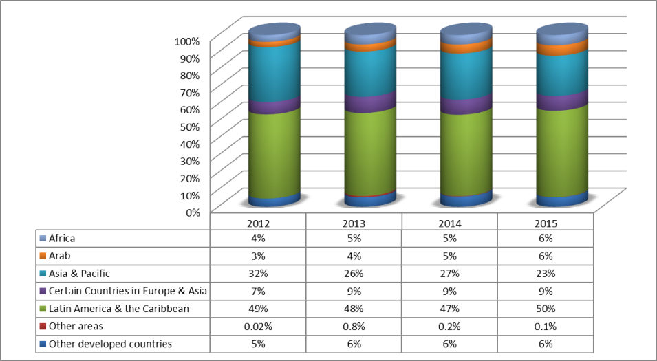

1. In addition, two new customizations were initiated with the IP Offices of Cambodia and Viet Nam, increasing the number of languages of the general courses from 13[74] in 2013 to 15 in 2014/15 (Arabic, Cambodian, Chinese, Croatian, English, French, German, Japanese, Korean, Portuguese, Russian, Spanish, Thai, Ukrainian, and Vietnamese).  Two new DL pilot courses were launched in 2014: (i) Intellectual Property, Traditional Knowledge and Traditional Cultural Expressions (DL-203) and (ii) Collective Management of Copyright and Related Rights (DL-501). Development of the DL course on IP and Access to Medical Technologies continued in 2015, and a pilot is expected to be launched in 2016/17. Development work was also started on several new modules, including: (i) Copyright Licensing Including Open Source; and (ii) Copyright Management in the Film Industry in Africa. Tailor-made IP training courses were held in collaboration with partner IP Offices and universities in Argentina, Bulgaria, Brazil, Cambodia, China, Croatia, Egypt, Jordan, the Republic of Korea, Mexico, the Russian Federation, Tunisia, Turkey, Uruguay, Viet Nam, Zambia, Zimbabwe, the African Regional Intellectual Property Organization (ARIPO) and the *Organisation Africaine de la Propriété Intellectuelle* (OAPI). Other enhancements to the DL Program in 2014/15 included: (i) the continued implementation of the Development Agenda recommendations through the addition of instructional modules on flexibilities and public domain to the advanced courses; and (ii) the implementation of a more systematic approach to the annual course review process, with an extensive review initiated in 2014/15 (Phase I), with the results to be implemented in specific courses in 2016/17 (Phase II).
2. The Academic Institutions Program (AIP) continued to offer joint IP Law Master’s Degree courses for the benefit of nationals of developing countries and countries in transition, in cooperation with a number of universities and the financial assistance of the Government of Japan and the Government of the Republic of Korea as related to four programs. In 2014/15, a total of 340 persons graduated from the seven joint IP Law Master programs, of which 178 students from 75 countries received scholarships. In the same biennium, 364[75] new students started one of the programs[76]. The overall average pass rate for the academic year 2014/15 was 85 per cent.
3. The Master’s Programs were offered jointly by the WIPO Academy and respective partner universities and institutions, namely: (i) Africa University (AU) and ARIPO (Zimbabwe); (ii) the Austral University and the National Industrial Property Institute of Argentina (INPI) (Argentina); (iii) the Queensland University of Technology (QUT) (Australia); (iv) Seoul National University (SNU) and the Korean Intellectual Property Office (KIPO) (Republic of Korea); (v) the University of Turin and the International Training Center of the International Labour Organization (ITC-ILO), Italy; (vi) the University of Yaoundé II and OAPI (Cameroon); and (vii) Haifa University, Israel.

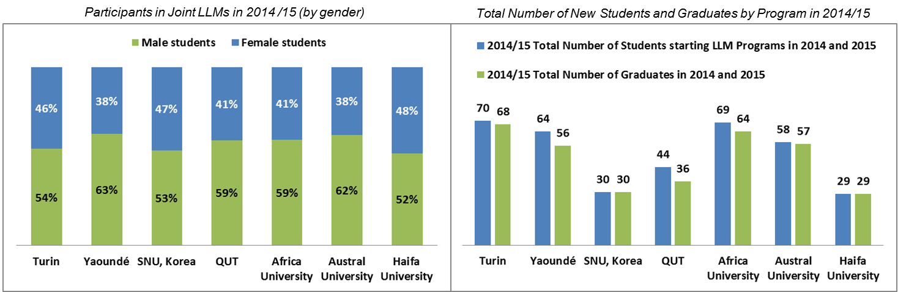

1. Two Colloquia for Teachers of IP were organized in cooperation with the WTO in 2014 and 2015 for the benefit of 53 IP teachers (27 in 2014[77] and 26 in 2015). The Colloquia continued to offer a forum for dialogue and debate on recent developments in key IP areas and pedagogic issues. The top research papers from 12 of the 2014 Colloquium scholars (representing Africa, Asia, Eastern Europe and Latin America) were published in 2015. Nine individuals received WIPO fellowships to participate in the Annual Congress of the International Association for the Advancement of Teaching and Research in Intellectual Property (ATRIP).
2. With assistance from WIPO in 2014/15, the following new IP teaching programs were offered: (i) the Bangladesh Institute of Management IP program; and (ii) two new IP courses at Africa University. Support that was provided in 2014/15, which will lead to new IP courses being offered in 2016, were: (i) the University of West Indies, Mona Campus (Jamaica) completed development of a new LL.M. in Intellectual Property in Creative & Cultural Industries to be launched in 2016; (ii) and the University of Botswana completed the development of a new course on IP Law and Research to be launched in 2016 and enhanced two courses on IP Law I and II. In addition, five universities enhanced their existing IP teaching programs: (i) Buenos Aires University (Argentina); (ii) *Universidad Central de Venezuela*; (iii) University of Alicante (Spain); (iv) Universitas Padjadjaran (Indonesia); and (v) University of Indonesia. In addition, 13 IP seminars for 309 graduate students, government officials and parliamentarians were organized at WIPO headquarters. Lastly, two national symposia on IP education (Botswana and China) and one sub-regional Roundtable on IP Teaching, Training and Research for the Caribbean region were organized in cooperation with host governments. In 2014/15, new partnership requests were received by the Academy and were examined in line with the new policy established in this respect.
3. In 2014/15, the Academy organized 19 sessions of the WIPO Summer Schools (WSS) Program in three languages (English, Russian and Spanish) with 12 national institutions in Chile, China, Croatia, India, Jamaica, Mexico, Republic of Korea, the Russian Federation, Singapore, South Africa, Switzerland and the United States of America. Some 689 participants from 80 countries participated in the WSS, with the majority of participants coming from Latin America and the Caribbean (300 participants or 43 per cent), followed by participants from Asia and the Pacific (190 participants or 28 per cent). A further 20 per cent were from Europe and nine per cent from Africa. Of the 689 participants in 2014/15, 390 or 57 per cent were female, and 299 or 43 per cent were male. Scholarships were provided by the Government of Japan to 20 participants for the sessions in South Africa and by the Government of the Republic of Korea to 16 participants for the sessions in the Republic of Korea. Summer school sessions continued to be developed in rotation taking into consideration geographical balance.

*Participants in the WIPO Summer School Programs in 2014 and 2015 (by gender)*

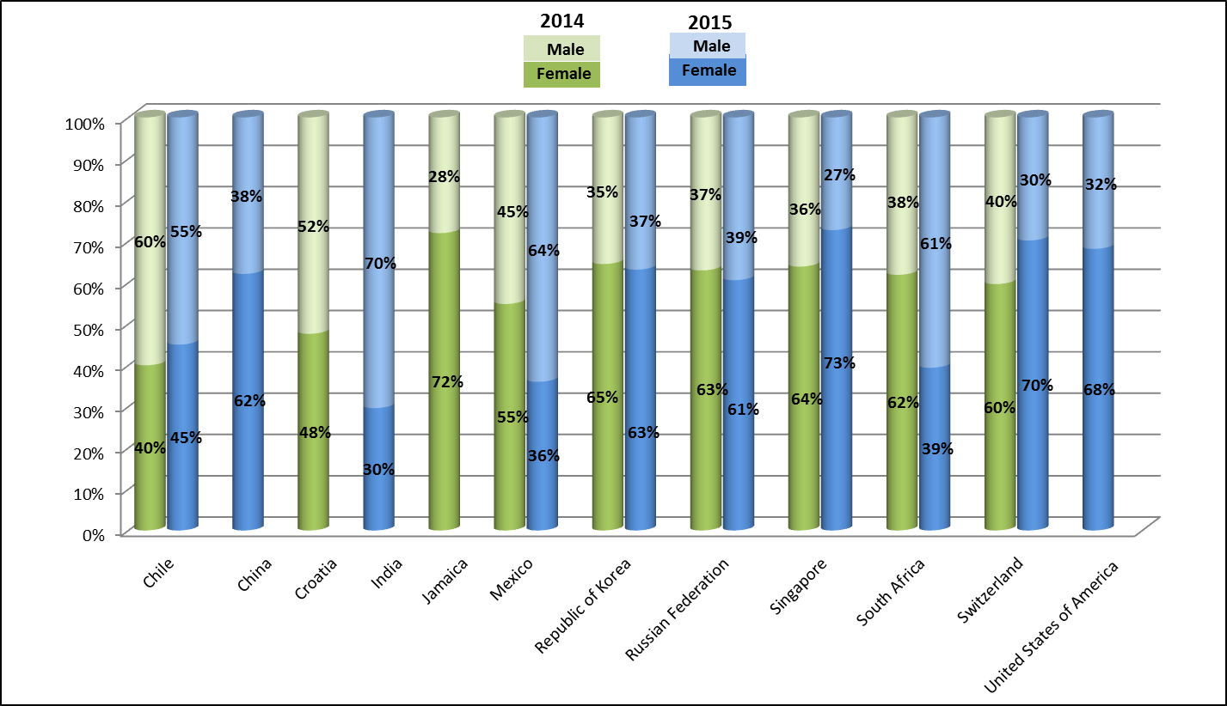

1. In 2014, the start-up academies project was mainstreamed into the WIPO Academy’s regular programs following approval by the fourteenth Session of the CDIP of an independent evaluation of the project. Cooperation continued, throughout the biennium with the six start-up academies that were established during the CDIP project phase (Colombia, Dominican Republic, Egypt, Ethiopia, Peru and Tunisia). New agreements to establish national IP Training Centers (start-up academies) were signed with the Governments of Azerbaijan, Cambodia, Costa Rica, Ecuador, El Salvador, Georgia and Turkey. Further requests from Member States seeking assistance to establish national IP Training Centers were received in 2014/15 and will be addressed in 2016/17.

PERFORMANCE DATA

|  |  |  |  |  |
| --- | --- | --- | --- | --- |
| **Expected Result:** III.2 Enhanced human resource capacities able to deal with the broad range of requirements for the effective use of IP for development in developing countries, LDCs and countries with economies in transition | | | | |
| **Performance Indicators** | **Baselines** | **Targets** | **Performance Data** | **TLS** |
| Revised Portfolio of training courses on IP for developing countries, LDCs and CETs / Relevance of content of training courses to capacity building requirements of developing countries, LDCs and CETs | Portfolio not revised on a global basis since establishment of Academy | Revised Portfolio available by end of biennium | The revision of the portfolio of training courses was completed in 2015. The portfolio of training courses was revised based on the findings of the survey on training needs conducted in 2015. | **Fully**  **Achieved** |
| Enhanced and multilingual access to e-learning on various IP aspects for developing countries, LDC and CETs / Relevance of content of portfolio of e-learning courses to the capacity building requirements of developing countries, LDCs and CETs | *Updated Baseline end 2013:*  In 2013:   * 5 DL courses were available in all 6 UN languages plus Portuguese; * 2 DL courses were available in 5 UN languages plus Portuguese ; * 1 course was available in 4 UN languages plus Portuguese; and * 4 DL courses available in only English.   70% of participants in the advanced courses indicated their professional and/or academic performance improved as a result of participation in the DL course.  *Original Baseline P&B 2014/15*: Not all courses available in all languages; revision of course content currently done by Academy staff only and on ad hoc basis. | All courses available in all UN languages | In 2014/15:   * 11 DL courses were available in all 6 UN languages plus Portuguese, * 1 DL course was available in 3 UN languages[78]   79% of the participants in the advanced courses indicated that their professional and/or academic performance improved as a result of participation in the DL course.   * 78% (2014) * 81% (2015) | **Fully Achieved** |
| Improved access to higher education on IP on the part of developing countries, LDCs and CETs / Number of universities in developing countries, LDCs and CETs, offering new teaching programs on IP | IP teaching at university level is currently available only on a limited number of developing countries, LDCs and CETs; WIPO offers Joint Master Program on IP with seven universities of which two in Africa and one in Latin America | 5 universities in developing countries, LDCs and CETs will be offering new teaching programs on IP by the end of biennium | By the end of 2015, three new teaching programs were offered: one at the Bangladesh Institute of Management in Bangladesh and two at the Africa University.  In addition, five universities enhanced existing IP Programs:   * Buenos Aires University, Argentina * *Universidad Central de Venezuela* * University of Alicante, Spain * 2 universities in Indonesia (Universitas Padjadjaran and University of Indonesia)   Two universities enhanced or completed development of new courses or programs to be launched in 2016:   * the University of West Indies, Mona Campus, Jamaica (new LL.M. in | **Partially Achieved** |
|  |  |  | Intellectual Property in Creative & Cultural Industries)   * University of Botswana, Botswana (new course on IP Law on Research; enhanced courses on IP Law I and II) |  |
| Progressive establishment of a network of IP experts in developing countries, LDCs and CETs | *Updated Baseline end 2013:* 326 academics from developing countries, LDCs and CETs members of ATRIP  *Original Baseline P&B 2014/15:* No. of academics from developing countries, LDCs and CETs members of ATRIP | An increase of 15% over the baseline | 397 academics from developing countries, LDCs and CETs members of ATRIP, as reported by ATRIP (22 % increase over 2012/13). | **Fully Achieved** |
| No. of new start-up academies projects initiated after the conclusion of the Pilot Phase | *Updated Baseline end 2013:*  Phase II of the pilot phase of the project was not completed at the end of 2013.  *Original Baseline P&B 2014/15:* 0 | 4 | 7 new agreements signed (Azerbaijan, Cambodia, Costa Rica, Ecuador, El Salvador, Georgia and Turkey) | **Fully Achieved** |

RISK REPORTING FOR THE BIENNIUM

|  |  |  |  |
| --- | --- | --- | --- |
| **Risk(s) to the Program achieving its Results** | **Mitigation plans in place or under implementation** | **Evolution of Risk(s) and Mitigation Strategies Over the Biennium** | **Impact on the Program’s Performance** |
| In a fast-changing technological and IP landscape, user expectations and preferences are also evolving rapidly.  The interface, graphics and IT platform of distance learning courses can become outdated and the IP content of the different training programs of the Academy could furthermore become misaligned in relation to emerging global challenges and developments. | Feedback from distance learning students and tutors will continue to be sought and after substantive advice from IP experts, updates to supported platforms and/or IP content will be made. | The WIPO Academy eLearning Centre (WeLC) was upgraded in 2015.  To stay relevant and current, the DL courses are expected to follow the plan for a more systemic approach in the annual course review process. | This risk and its evolution did not have any material impact on the Program’s performance in 2014/15. |

RESOURCE UTILIZATION

Budget and Actual Expenditure (by result)

*(in thousands of Swiss francs)*



Budget and Actual Expenditure (personnel and non-personnel)

*(in thousands of Swiss francs)*



1. 2014/15 Final Budget after Transfers
2. Resources available to the Program remained stable during the biennium. Redeployment of personnel resources from the Program to meet the needs related to WIPO platforms and IT applications across the Development Sector (Programs 8, 9 and 11) were compensated by the redeployment of personnel resources into the Program following the transition in the management of the Academy towards the end of 2014.
3. 2014/15 Budget Utilization
4. Budget utilization is within the expected range for the biennium.

## PROGRAM 30 SMALL AND MEDIUM-SIZED ENTERPRISES (SMES) AND INNOVATION

**Program Manager DIRECTOR GENERAL**

ACHIEVEMENTS IN THE 2014/15 BIENNIUM

SMALL AND MEDIUM-SIZED ENTERPRISES

1. Work continued in cooperation with national and regional IP Offices and other institutions in assisting entrepreneurs and SMEs in using the IP system, primarily through (a) adapting, and/or translating, content on IP for business to the local context, and (b) training of trainers programs. With respect to the latter, 33 programs on effective IP asset management by SMEs, benefitting over 700 participants, were organized, aiming at creating a critical mass of trainers in specific countries with knowledge, skills and experience to provide basic assistance to SMEs on IP asset management. The Program also contributed to the promotion of women’s empowerment in IP. To this end, two International Workshops for Women Inventors and Entrepreneurs were organized in 2014/15 by WIPO, the Korean Intellectual Property Office (KIPO) and the Korea Women Inventors Association (KWIA), which benefitted 236 women inventors and entrepreneurs from 25 countries.
2. In 2014/15, a new book on *Confidence - An Introduction to Trade Secrets for Small and Medium-sized Enterprises* was finalized. WIPO also contributed to an initial draft of a book on *Leveraging Intellectual Property as a Strategic Business Asset (Strategic IP Management)*[79].
3. Two online international certificate courses on IP asset management for business success based on IP PANORAMA in English were completed by 1,350 (709 in 2014 and 641 in 2015) students, and 70 students participated subsequently in an offline program on IP asset management held in Seoul, Republic of Korea, prepared by WIPO and implemented in coordination with KIPO, the Korea Invention Promotion Association (KIPA) and the Korea Advanced Institute of Science and Technology (KAIST). Preparations were made to launch Arabic, French, Russian and Spanish versions of the international certificate course in 2016/17 biennium.
4. Efforts to reach out directly to SMEs via the SMEs website in the six UN languages and the monthly e-newsletter continued. In 2015, in order to ensure a more targeted user base for the newsletter, the criteria to subscribe were modified, requiring existing SME Newsletter subscribers to re‑subscribe. Consequently, a large number of inactive subscribers were removed from the mailing list, ultimately resulting in a smaller but more focused user base. Five new case studies on IP for SMEs were created on the following topics: (i) Ezequiel Farca (Mexico); (ii) Haldiram (India); (iii) Wondereight (Lebanon); (iv) Developing Affordable Software for Small Businesses: HSCO LLP (UK/Jordan); and (v) Ensuring the Safe Flow of Energy - PipeWay Engenharia (Brazil), of which the last two were published in IP Advantage.
5. In line with DA Recommendations 1, 4, 10 and 11, the Program organized or participated in 40 SME-related seminars, workshops or training of trainers programs on IP management in 30 countries, mostly developing countries and LDCs in Africa, the Arab region, Asia and the Pacific and Latin America and the Caribbean and transition countries. These programs, delivered by 29 experts and speakers from developing (13), transition (4) and developed (12) countries, benefitted nearly 2,000 representatives of SMEs and SME support institutions from 93 countries, including 21 from LDCs, 56 from developing countries and 16 from transition economies. Taking a larger leading role, the IP Offices and/or the chambers of commerce of the concerned Member States were closely involved in the planning stages and made substantial contributions to the development and implementation stages of the programs, including in the selection of speakers and the program topics. In addition, the training of trainers program included a round table discussion on the subject of IP awareness and use of IP by SMEs, which identified the challenges facing local SMEs and SME-support institutions, and proposed a road map to address those challenges, in line with Recommendation 4.

Innovation Policy

1. Work continued throughout the biennium to identify the areas where innovation policy interacts with IP. Following the successful implementation of the pilot project on integrating IP into innovation policy formulation in Serbia during the previous biennium, national projects in Cameroon, Jamaica, Rwanda, Sri Lanka and Trinidad and Tobago were launched. These projects sought to map the innovation system in the selected countries, identify the principal actors and determine their participation in the innovation system, their awareness and reliance on the IP system and the gaps and needs in the innovation system from an IP perspective. This was done with a view to garnering more insight into the development of more effective national IP strategies, as well as to contribute to the design of more appropriate and focused support services to be provided by WIPO. A positive outcome of these projects was the ensuing collaboration with a larger EU-funded project in the Caribbean entitled IPICA ‑ Empowering knowledge transfer in the Caribbean through effective IPR and Knowledge Transfer (KT) regimes, coordinated by the University of Alicante. In addition, the Government of Sri Lanka launched a project on the effective management of research output in universities following the recommendations made in the above report.
2. In order to further develop the work on integrating IP into innovation policy formulation, a literature review of the interaction of IP in innovation policy formulation was completed with the assistance of the Manchester Institute of Innovation Research. The review mapped the thinking, the debate and the discussion in published works on the intersection of IP in innovation policy making.

INNOVATION STRUCTURES

1. Through tailored IP commercialization projects, capacity building programs and advisory services to WIPO Member States, the Program also facilitated the development of adequate legal and organizational infrastructure as well as professional human capital for the promotion of creativity and strategic IPR management of knowledge and research results from an early stage towards technology markets, by using the IP system and commercialization tools and processes. Using customized training approaches, , some 2,200 professionals (government officials, technology managers, scientists and patent agents) were trained through in situ events, and an additional 100 innovation stakeholders, including women entrepreneurs in Africa, through more than 123 distance practice modules and video conferences.
2. The geographic scope of the project for the “Establishment of Technology Transfer Offices (TTOs) in the Arab Region” was expanded in 2014 to accommodate Member State requests. In that context, implementation of the Tunisia Action Plan started focusing on legal institutional infrastructure of beneficiary institutions in Tunisia. Progress continued to be made towards strengthening four TTOs in Tunisia to be operationally independent and sustainable. To this end, institutional IP policies were finalized with WIPO assistance for the *Centre Technique de la Chimie (CTC)*; the Techno-Park El Gazhala; Packtec Technical Center for Packaging; and the Techno-Park of Sidi Thabet.
3. Some 42 training programs were organized in collaboration with internal and external partners as follows: 11 on Patent Drafting, 16 on IPR Management for Universities and R&D Institutions, 12 Successful Technology Licensing (STL) courses, and three IP Marketing and Valuation trainings. New topics in 2014/15 included: (i) IP Protection; (ii) Commercialization Strategies of Research Results for Universities and R&D and on the Interpretation of Patent Documents for the Judiciary Service; and (iii) IP Marketing for Universities.
4. In 2014/15, the University Initiative Program underwent a review to ensure its continued relevance to the changing needs of universities and R&D institutions in WIPO Member States, including in developing and developed countries. A new two-pronged approach was subsequently implemented: (i) to encourage Member States to establish a clear national regulatory framework on the ownership of IPRs developed within universities or public research institutions (PRIs); and (ii) to assist Member States in developing institutional IP policies and support services, which appropriately balance protection of IP and access to knowledge. In 2015, a project was launched in Botswana, aimed at creating a national model institutional IP policy to facilitate the efforts of Universities and PRIs to develop their internal policies.
5. Pursuant to DA Recommendations 19, 25, 26 and 28, in the context of the project on Intellectual Property and Technology Transfer: Common Challenges – Building Solutions, all six studies on aspects of technology transfer were peer-reviewed by international experts, and presented to the CDIP at its fourteenth session in November 2014 . Following the completion of the studies and as envisaged in the approved project document, a concept paper on building solutions was prepared and discussed at the High Level International Expert Forum held in Geneva February 16 to 18, 2015. A report on the WIPO expert forum on international technology transfer was presented to the fifteen session of the Committee and discussed together with the evaluation report of the project in the CDIP/16.
6. Concerning DA Recommendation 36, under the Project on Open Collaborative Projects and IP‑Based Models, an Expert Meeting was organized at WIPO Headquarters in the form of a WIPO Conference on Open Innovation: Collaborative Projects and the Future of Knowledge, in January 2014.  In addition, an In-Depth Evaluation Study and a study on Global Knowledge Flows, for incorporation into the planned Interactive Platform, were completed and presented to the CDIP at its fourteenth session. An evaluation report of the Project was discussed during the fifteen session of the Committee.

PERFORMANCE DATA

|  |  |  |  |  |
| --- | --- | --- | --- | --- |
| **Expected Result:** III.1 National innovation and IP strategies and plans consistent with national development objectives | | | | |
| **Performance Indicators** | **Baselines** | **Targets** | **Performance Data** | **TLS** |
| No. of countries with national innovation policies initiated, in progress or adopted | *Updated Baseline end 2013:* 1 country  *Original Baseline P&B 2014/15:* tbd | 5 countries | National innovation policies were initiated in five countries: Cameroon, Rwanda, Jamaica, Sri Lanka and Trinidad and Tobago | **Fully Achieved** |
| **Expected Result:** III.2 Enhanced human resource capacities able to deal with the broad range of requirements for the effective use of IP for development in developing countries, LDCs and countries with economies in transition | | | | |
| **Performance Indicators** | **Baselines** | **Targets** | **Performance Data** | **TLS** |
| % of trained IP professionals using upgraded skills in their work | *Updated Baseline end 2013:* N/A  *Original Baseline P&B 2014/15:* tbd | 50% | 77% | **Fully Achieved** |
| **Expected Result:** III.6 Increased capacity of SMEs to successfully use IP to support innovation | | | | |
| **Performance Indicators** | **Baselines** | **Targets** | **Performance Data** | **TLS** |
| No. of subscriptions to the SME Newsletter | *Updated Baseline end 2013:* 41,101  *Original Baseline P&B 2014/15:* tbd | Defined target: 40,000  Original Target P&B 2014/15: tbd | 40,510 subscriptions to the SME Newsletter in 2014  6,657 subscriptions to the SME Newsletter in 2015.  See paragraph 30.4 for additional information. | **Not Assessable** |
| No. of downloads of topical SME material and guidelines | *Updated Baseline end 2013:*  No. of downloads: 77,617 (2013)  No. of page views: 1,210,803 (2013)  *Original Baseline P&B 2014/15:* tbd | tbd | 2014:  No. of downloads: 70,559 (-9% as compared to 2013)  No. of page views of the SME web page: 821,150 (-32% as compared to 2013)  2015:  No. of downloads: 71,867 (+2% as compared to 2014)  No. of page views of the SME web page: 960,196 (+17% as compared to 2014) | **Not Assessable** |
| No. of SME related case- studies accessed via the IpAdvantage and/or other relevant databases | tbd | tbd | During the biennium, a total of 19 new SME-related case studies were published in the IP Advantage database, bringing the total number of available SME-related case studies to 206. There were 199,700 visits to the IP Advantage database in 2014/15; however it is not feasible to determine the number of SME-related case studies that were consulted. | **Not Assessable** |
| % of participants in training programs targeting SME support institutions who express satisfaction with the content and organization of these events | *Updated Baseline end 2013:* 90%  *Original Baseline P&B 2014/15:* tbd | tbd | 100% (46% very satisfied; 54% satisfied) of participants were satisfied with the content and organization of the training programs. | **Fully Achieved** |
| % of trained SMEs support institutions who provide information, support and advisory/consulting services on IP asset management | *Updated Baseline end 2013:* 100% of the assisted 15 SMEs support institutions provide information, support and/or advisory/ consulting services on IP asset management.  *Original Baseline P&B 2014/15:* tbd | Defined target: 80%  Original Target P&B 2014/15: tbd | 100% (very often (48%); often (32%); sometimes (20%)) of trained SME support institutions provided information, support and advisory/consulting services on IP asset management | **Fully Achieved** |
| No. of countries having established IP training programs for SMEs | tbd | tbd | The following 18 countries/regional organizations reported having established IP training programs for SMEs: ARIPO, Armenia, Argentina, Belarus, Colombia, Georgia, Iran (Islamic Republic of), Jordan, ,Kazakhstan, Lao People's Democratic Republic, Lebanon, Oman, Papua New Guinea, Saudi Arabia, Trinidad and Tobago, Uganda, United Arab Emirates and United Republic of Tanzania | **Not Assessable** |
| **Expected Result:** IV.2 Enhanced access to, and use of, IP information by IP institutions and the public to promote innovation and creativity | | | | |
| **Performance Indicators** | **Baselines** | **Targets** | **Performance Data** | **TLS** |
| No. of sustainable TTOs established and/or strengthened in Universities or R&D institutions | tbd | 5 TTOs established in the Arab Region | In 2014/15, the geographic scope of the project on TTOs for the Arab Region was expanded to accommodate Member State requests. Progress continued to be made towards strengthening four TTOs in Tunisia to be operationally independent and sustainable, including through the finalization of institutional IP policies:   * *Centre Technique de la Chimie (CTC)* * Technopark El Ghazala * Packtec Technical Center for Packaging * Technopark of Sidi Thabet (TST)   Based upon survey responses, the following universities in the Philippines reported in 2014 that WIPO advice and training was “useful” or “extremely useful” in strengthening their TTOs:  (i) Polytechnic University of the Philippines; (ii) Samar State University Research Office; (iii) State University of Western Philippines, College of Engineering; (iv) University of the Philippines; (v) University of Santo Tomas; (vi) University of Southeastern Philippines | **Not Achieved** |
| No. of universities and/or research institutions which have established IP policies | tbd | 20 additional universities | IP policies were established in 436 universities:   * Poland (434) (as a result of a change in the law in October 2014; * Russian Federation (1); and * Uzbekistan (1) [80] | **Fully Achieved** |

RISK REPORTING FOR THE BIENNIUM

|  |  |  |  |
| --- | --- | --- | --- |
| **Risk(s) to the Program achieving its Results** | **Mitigation plans in place or under implementation** | **Evolution of Risk(s) and Mitigation Strategies Over the Biennium** | **Impact on the Program’s Performance** |
| As a longer term risk, the SME support needs of developing and emerging regions may change, as the national IP systems become more mature.  Failure to adjust content development to this change will result in diminished benefit for beneficiaries from the implementation of capacity building activities. | Close collaboration with Programs, 9 & 10 in particular, who know the specificities of their regions, in order that the content that will be developed continues to be relevant to the regional specific needs. | Enhanced internal cooperation, in particular with Programs 9 and 10, and external cooperation with Member States and other international organizations has contributed to ensuring that the content was tailored and relevant to stakeholders’ needs. | There was no material impact on the Program’s performance. |
| SMEs in some countries may continue to be unaware of the benefits of using the IP system, leading to lost opportunities for enhancing competitiveness and income generating opportunities. | Parallel work streams, firstly to focus on awareness-raising among SMEs of the benefits of using the IP system to enhance economic benefits through better competitiveness and secondly to encourage national governments to create or improve SME support structures. | This risk is a continuous risk. The mitigation action has resulted in an increased interest and involvement of local governments in establishing IP training programs and awareness raising events for SMEs. | There was no material impact on the Program’s performance |

RESOURCE UTILIZATION

Budget and Actual Expenditure (by result)

*(in thousands of Swiss francs)*



Budget and Actual Expenditure (personnel and non-personnel)

*(in thousands of Swiss francs)*



A. 2014/15 Final Budget after Transfers

1. The decrease in personnel resources in the 2014/15 Final Budget after Transfers compared to the 2014/15 Approved Budget reflects (i) the transfer of responsibilities for the implementation of the DA project Open Collaborative Models and Technology Transfer to Program 5 (The PCT System) and (ii) delays in identifying the right skills and competencies in support of the Program’s activities to compensate for the transfer of a staff member out of the Program.
2. The net decrease in non-personnel resources primarily reflects: (i) a downward adjustment mainly due to the transfer of responsibility for patent drafting training to Program 1; and (ii) the transfer of non-personnel resources for an intern (to Program 23 which centrally manages interns).
3. Overall, the adjustments across Expected Results in the 2014/15 Final Budget after Transfers reflect the new and more accurate methodology for allocation of personnel resources resulting from enhancements made to the EPM planning system for the 2014 and 2015 annual work planning exercises, as well as an internal reorganization of the Program.

B. 2014/15 Budget Utilization

1. The slight under-utilization of non-personnel resources was primarily due to: (i) the overall slower than expected pace of implementation of activities under Results III.6 (Increased capacity of SMEs) and IV.2 (Enhanced access to, and use of, IP information and knowledge); and (ii) the postponement or cancellation of certain activities at the request of co-organizing institutions and/or Member States under Results III.1 (National innovation and IP strategies), III.6 (Increased capacity of SMEs) and IV.2 (Enhanced access to, and use of, IP information and knowledge).

STRATEGIC GOAL IV

**COORDINATION AND DEVELOPMENT OF GLOBAL IP INFRASTRUCTURE**

**Biennial Performance Dashboard**

The dashboard below provides a summary of the achievements of the expected results in the biennium 2014/15 as measured by the indicators under the Programs contributing to this Strategic Goal.

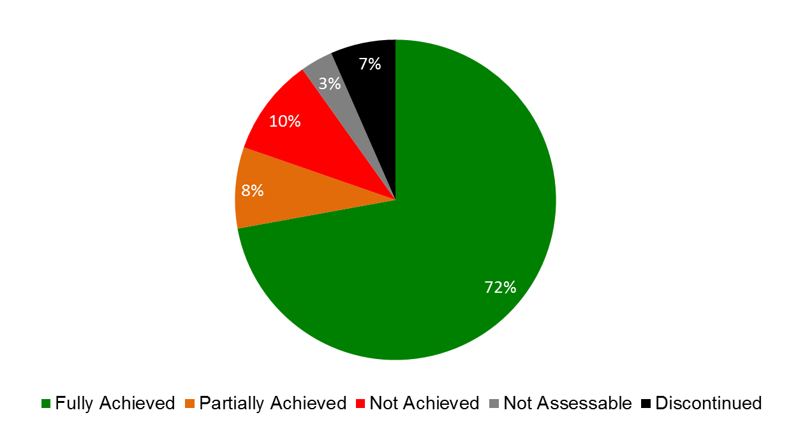

| **Expected Results** | **Performance Indicators** | **Responsible Program(s)** | **TLS** |
| --- | --- | --- | --- |
| IV.1 Updated and globally accepted system of international classifications and WIPO standards to facilitate access, use and dissemination of IP information among stakeholders in the world | No. of amendments and information files introduced into Nice Classification | Program 12 | ⚫⚫⚫ |
| No. of new subdivisions introduced into the IPC per year | Program 12 | ⚫⚫ |
|  | No. of amended and new standards adopted | Program 12 | ⚫ |
|  | No. of users accessing the internet publications of international classifications and standards, in particular from developing countries | Program 12 | ⚫⚫⚫⚫  ⚫⚫⚫ |
| IV.2 Enhanced access to, and use of, IP information by IP institutions and the public to promote innovation and creativity | No. of trusted intermediaries (TIs) and rights holders (RHs) having joined the TIGAR system network, including from developing countries and LDCs | Program 3 | ⚫ |
| No. of copyright protected works distributed among TIs and made accessible to VIPs across borders through the TIGAR system network | Program 3 | ⚫ |
|  | % of individuals satisfied with the capacity building support on copyright infrastructure | Program 3 | ⚫ |
|  | No. of institutions using GDA | Program 3 | ⚫ |
|  | Use of the WIPO Collective Management Reference Database | Program 3 | ⚫ |
|  | No. of legal instruments, guidelines, statements of principles other than Treaties agreed to or endorsed by the stakeholders concerned in areas such as IP and Sports and Copyright in the Digital Environment | Program 3 | ⚫ |
|  | Average number of users serviced by TISCs per quarter and country | Program 9 | ⚫ |
| Program 10 | ⚫ |
| Program 14 | ⚫ |
|  | No. of sustainable national networks of TISCs | Program 9 | ⚫⚫⚫⚫  ⚫ |
| Program 10 | ⚫ |
| Program 14 | ⚫ |
|  | No. of countries using IP Technical Assistance Database (IP-TAD), IP Roster of consultants (IP_ROC) | Program 9 | ⚫ |
|  | No. of established TTOs and/or IP information centers | Program 10 | ⚫ |
|  | No. of different users per quarter in all systems (PATENTSCOPE/Global Brand Database) | Program 13 | ⚫⚫⚫ |
|  | No. of languages in which cross-lingual search is available | Program 13 | ⚫ |
|  | No. of language pairs available for machine translation of titles and abstracts | Program 13 | ⚫ |
|  | No. of active registered users of ARDI and ASPI | Program 14 | ⚫ |
|  | % of users satisfied with the provision of value added patent information services (WPIS, ICE, patent family and legal status enquiry service) | Program 14 | ⚫ |
|  | % of users satisfied with PLRs | Program 14 | ⚫ |
|  | No. of countries that verified data and included national essential medicines into WIPO Essential | Program 18 | ⚫ |
|  | No. of users of WIPO's Global Databases: PATENTSCOPE and Global Brand Database | Program 20 | ⚫⚫⚫  ⚫⚫⚫ |
|  | Increase in the no. of WIPO Lex users | Program 21 | ⚫ |
| No. of sustainable TTOs established and/or strengthened in Universities or R&D institutions | Program 30 | ⚫ |
| No. of universities and/or research institutions which have established IP policies | Program 30 | ⚫ |
| IV.3 Broad geographical coverage of the content and use of WIPO Global IP Databases | No. of records contained in PATENTSCOPE | Program 13 | ⚫ |
| No. of records contained in Global Brand Databases | Program 13 | ⚫ |
|  | No. of national collections in PATENTSCOPE | Program 13 | ⚫ |
|  | No. of national collections in Global Brand Database | Program 13 | ⚫ |
| IV.4 Enhanced technical and knowledge infrastructure for IP Offices and other IP institutions leading to better services (cheaper, faster, higher quality) to their stakeholders | No. of governments and CMOs signing an agreement with WIPO to re-engineer WIPOCOS | Program 3 | ⚫ |
| No. of CMOs in developing countries and LDCs participating in regional and global networks facilitated by WIPO | Program 3 | ⚫ |
| Program 15 | ⚫ |
|  | % of governments that report positively on the improved effectiveness (and governance) of copyright offices and other institutions in the country | Program 3 | ⚫ |
|  | No. of offices using WIPO infrastructure platforms | Program 15 | ⚫ |
|  | Average Service Level of IP Offices assisted (ranging from 1 to 5) | Program 9 | ⚫ |
| Program 10 | ⚫ |
| Program 15 | ⚫ |

## PROGRAM 12 INTERNATIONAL CLASSIFICATIONS AND STANDARDS

**Program Manager Mr. Y. Takagi**

ACHIEVEMENTS IN THE 2014/15 BIENNIUM

1. Despite uneven progress in 2014, the situation as regards International Classifications and WIPO IP Standards improved substantially in 2015, exceeding expectations in certain areas and trailing behind in others.
2. As regards the Nice Classification (NCL), a total of 1,480 new amendments and 25 new information files were introduced in the biennium. The number of amendments represents a 94 per cent increase over 2012/13. In addition, the official Spanish version of the NCL 10-2016 was made available in the same format as the authentic English and French publications. Similarly, all past editions (from one to nine) were also made available in the new format.
3. In the International Patent Classification (IPC), the modified publication platform to facilitate the use of the system, including a new search tool and the IPC/CPC/FI parallel viewer, was launched in April 2014. Due to the increase of new revision projects coming from the IP5 Offices and from the IPC community, the number of new subdivisions introduced in 2015 (1,031) exceeded the annual target by 28 per cent, rebounding from 2014 to achieve the target.
4. At its fourth session, the Committee on WIPO Standards (CWS) was unable to adopt an agenda, resulting in informal decisions not being formalized. Despite this setback, one new Standard was adopted and one Standard was revised informally in 2014. This standstill continued in 2015, resulting in the lack of formal approval of new Standards. Nonetheless, the informal work continued in the Task Forces, groups consisting of experts nominated by the CWS members and observers to address specific tasks. Several Standards are expected to be adopted when the CWS resumes in 2016.
5. The use of internet tools for accessing Classifications and Standards publications showed stable growth with visits to the IPC Publications substantially higher (a 107 per cent increase over 2013) due to the inclusion of revised classifications and new tools. The number of visits to NICE Pub, Locarno Home and Vienna Home, also saw increases of 14 per cent, 39.1 per cent and 7.4 per cent respectively. The access to Nice Home remained stable, while IPC Home saw a 6.6 per cent decrease. Visits to the WIPO Standards Handbook also saw a decrease of 26.7 per cent as compared to 2013, possibly due to the institutional challenges faced in the CWS. In general, the second year of the biennium showed better results compared to the first year.
6. The work of Program 12 continued to support the implementation of DA Recommendations 8, 30 and 31 by facilitating access for developing countries to publicly available patent information. In doing so, it also contributed to efforts related to the transfer of technologies. From 2014 to 2015, the percentage of visits from developing countries to IPC Home, Nice Home, NICE Pub, and the WIPO Standards Handbook saw substantial increases of 9.1 per cent, 36 per cent, 11.7 per cent, and 15.7 per cent respectively, while Locarno Home and Vienna Home saw 12.8 per cent and 31.1 per cent decreases respectively.

PERFORMANCE DATA

|  |  |  |  |  |
| --- | --- | --- | --- | --- |
| **Expected Result:** IV.1 Updated and globally accepted system of international classifications and WIPO standards to facilitate access, use and dissemination of IP information among stakeholders in the world | | | | |
| **Performance Indicators** | **Baselines** | **Targets** | **Performance Data** | **TLS** |
| No. of amendments and information files introduced into the Nice Classification | *Updated Baseline end 2013:*  423 modifications in 2013[81]  339 modifications in 2012  9 information files revised and 17 new information files introduced  *Original Baseline P&B 2014/15:* No of amendments and info files introduced in 2013. | Increase compared to baseline | 1,480 amendments in the biennium:  560 amendments in 2014[82]   * 274 in English * 286 in French   920 amendments in 2015   * 496 in English * 424 in French   43 information files revised   * 39 (2014) * 4 (2015)   25 new information files introduced   * 20 (2014) * 5 (2015) | **Fully Achieved**  **Fully Achieved**  **Fully Achieved** |
| No. of new subdivisions introduced into the IPC per year | *Updated Baseline end 2013:* 617  *Original Baseline P&B 2014/15:* 500 new groups (average of 2009-13) | 800 new groups per year | 2014: 337 new groups were introduced in the 2015.01 version of the IPC  2015: 1,031 new groups were introduced in the 2016.01 version of the IPC | **Partially Achieved**  **Fully Achieved** |
| No. of amended and new standards adopted | *Updated Baseline end 2013:*  One new Standard adopted and two amended in 2012. One Standard and the Glossary amended in 2013.  *Original Baseline P&B 2014/15:* Average 2012/13 (tbd) | Increase compared to baseline | One new Standard informally adopted and one revised (2014)  No formal adoption of new Standards. Two Standards revised (2015) | **Partially Achieved** |
| No. of users accessing the Internet publications of international classifications and standards, in particular from developing countries | *Updated Baseline end 2013:*  IPC Home: 387,093  IPC Pub: 670,032 (extrapolated from data Jan-May 2013 and readjusted by the same method of measurement used for the 2014 data)  NICE Home: 533,846  NICE Pub: 2,386,409  LOCARNO Home: 36,727  VIENNA home: 32,416  WIPO Standards (Handbook): 94,463  *Original Baseline P&B 2014/15:* tbd end of 2013 | 5% increase compared to baseline | IPC home: 361,378 (6.6 % decrease) (48.1 % of visits from developing countries)  IPC Pub: 1,389,644 (107.4 % increase) (36.3 % of visits from developing countries)  NICE home: 532,493 (stable) (47.8 % of visits from developing countries)    NICE Pub: 2,721,537 (14 % increase) (49.1 % of visits from developing countries)  LOCARNO home: 51,075 (39.1 % increase) (33.5 % of visits from developing countries)  VIENNA home: 34,830 (7.4 % increase) (38.8 % of visits from developing countries)  WIPO Standards (Handbook): 69,288 (26.7 % decrease) (33.6 % of visits from developing countries) | **Not Achieved**  **Fully Achieved**  **Partially Achieved**  **Fully Achieved**  **Fully Achieved**  **Fully Achieved**  **Not Achieved** |

RISK REPORTING FOR THE BIENNIUM

|  |  |  |  |
| --- | --- | --- | --- |
| **Risk(s) to the Program achieving its Results** | **Mitigation plans in place or under implementation** | **Evolution of Risk(s) and Mitigation Strategies Over the Biennium** | **Impact on the Program’s Performance** |
| Differences between groups of countries result in limitation of technical development of standards and classifications. | Discuss and resolve issues outside of the Committees. Strengthen the technical discussions within the Committees. Monitor the implementation of long-term plans. | The problem concerning the session of the CWS remained despite several informal meetings in 2014 and 2015. | The CWS could not formalize the adoption of several new Standards. However the informal work continued, and several Standards are expected to be adopted in 2016. |

RESOURCE UTILIZATION

Budget and Actual Expenditure (by result)

*(in thousands of Swiss francs)*



Budget and Actual Expenditure (personnel and non-personnel)

*(in thousands of Swiss francs)*



A. 2014/15 Final Budget after Transfers

1. The slight decrease in the Final Budget after Transfers for 2014/15 (personnel resources) reflects the net result of reclassifications of posts.
2. The increase in non-personnel resources is primarily due to higher than expected costs for the development and hosting of the IPC reclassification software and higher interpretation fees for events organized in relation to the administration of the IPC Union.

B. 2014/15 Budget Utilization

1. Budget utilization is within the expected range for the biennium.

## PROGRAM 13 GLOBAL DATABASES

**Program Manager Mr. Y. Takagi**

ACHIEVEMENTS IN THE 2014/15 BIENNIUM

1. The PATENTSCOPE system was further strengthened in 2014/15, with a significant focus on improving access to the system in regions experiencing poor latency. Demonstrable improvements were also achieved for users in Asia. Two additional languages (Danish and Polish) were added to the Cross Lingual Information Retrieval (CLIR) multilingual searching system, bringing the total number of languages to 14 by the end of the biennium. WIPO Translate[83], a statistical machine translation system developed in-house, was extended to include three additional and difficult language pairs by biennium end: English and Korean, English and Russian, and English and Spanish, bringing the total number to seven, as well as expanding the coverage of English and Chinese to include descriptions and claims. The biennium also saw the introduction of the translation of full-length descriptions and claims of patents for the English/Chinese language pair. Research into additional machine translation functions also progressed in 2014/15. WIPO translate continued to find application in other UN Organizations, received excellent peer reviews, and consistently outperformed other machine translation tools such as Google Translate.
2. The biennium saw significant increases in data coverage and usage levels of WIPO’s IP databases. Of particular note in the biennium was the launch in January 2015 of a new service, the Global Design Database” for industrial designs. By the end of 2015, just one year after its introduction, the Global Design Database had already reached an impressive 14,000 unique visitors per quarter. In addition, the number of national collections (indicated as “non-Hague” in the graph below) had reached five and contained more than 1.5 million design documents.

Global Design Database Records 2015

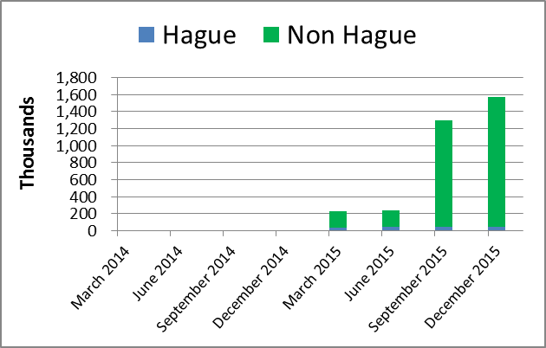

1. With the introduction of a powerful image similarity search function, the first of its kind in a public IP search system, use of the Global Brand Database exceeded expectations in 2014/15 with a fourfold increase in the number of unique visitors per quarter to more than 80,000 as compared to 23,000 at the end of 2013. The number of national collections (indicated as “non-Madrid” in the graph below) more than doubled from 12 at the end of 2013 to 26 at the end of 2015. Likewise, the total number of records contained in the system also more than doubled in 2014/15 from 12 million to over 24 million records.

Global Brand Database Records 2014/15

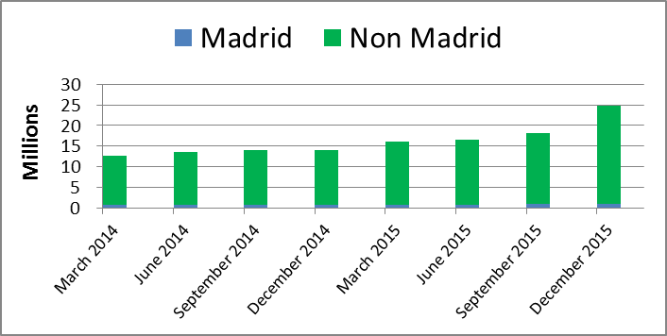

1. The PATENTSCOPE service continued to show high levels of usage with an average of 500,000 unique page views per day. The number of unique visitors remained stable with over 221,000 unique visitors per quarter by the end of the biennium, showing that service levels for the PATENTSCOPE search engine are now sufficiently mature to arrive at the point of diminishing returns. The number of collections in PATENTSCOPE also saw a 19 per cent increase from 2013, bringing the total number of national and regional collections (indicated as “non-PCT” in the graph below) to 43 (as compared to 36 at the end of 2013) and the total number of records contained to more than 50 million (as compared to 34 million at the end of 2013), a 47 per cent increase over 2013.

PATENTSCOPE Records 2014/15

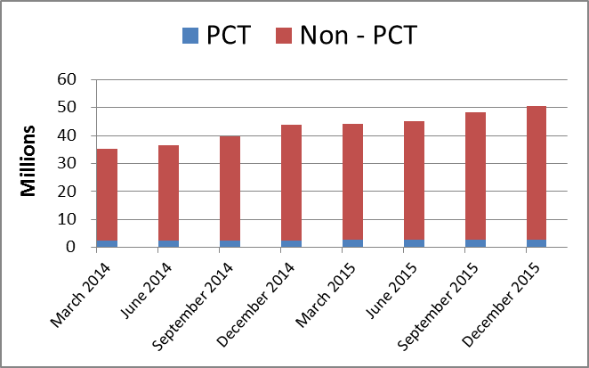

1. Program 13 continued to contribute to DA Recommendations 24 and 31, bridging the digital divide and facilitating better access to publicly available IP information by continuing to increase the amount of IP records available for searching and extending search and multilingual support functionalities.

PERFORMANCE DATA

|  |  |  |  |  |  |
| --- | --- | --- | --- | --- | --- |
| **Expected Result:** IV.2 Enhanced access to, and use of, IP information by IP institutions and the public to promote innovation and creativity | | | | | |
| **Performance Indicators** | **Baselines** | **Targets** | **Performance Data** | **TLS** | |
| No. of different users per quarter in all systems (PATENTSCOPE/Global Brand Database)[84] | *Updated Baseline  end 2013:* PATENTSCOPE 237,446 Global Brand Database 23,000  *Original Baseline*  *P&B 2014/15:* PATENTSCOPE 566,782 Global Brand Database 13,339 unique visitors (4th quarter 2012) | PATENTSCOPE 650,000  Global Brand Database 20,000 unique visitors per quarter[85] | PATENTSCOPE:  245,769 (2014)  221,981 (2015)  Global Brand Database:  49,977 (2014)  80,490 (2015)  Global Design Database: 13,946 (2015) | **Partially Achieved**  **Fully Achieved**  **Not Assessable** | |
| No. of languages in which cross-lingual search is available | *Updated Baseline  end 2013:* 12  *Original Baseline*  *P&B 2014/15:* 12 (Feb 2013) | 13 | In 2014/15, two additional languages (Danish and Polish) were added to the Cross Lingual Information Retrieval (CLIR) multilingual searching system, bringing the total number of languages to 14. | **Fully Achieved** | |
| No. of language pairs available for machine translation of titles and abstracts | *Updated Baseline  end 2013:* 4 (cumulative)  *Original Baseline*  *P&B 2014/15:* 2 (Feb 2013) | 5 | 3 additional language pairs in 2014/15 ( English-Korean, English-Russian, English-Spanish)  (7 cumulative)  In addition, the English-Chinese language pair was expanded to include descriptions and claims. | **Fully Achieved** | |
| **Expected Result:** IV.3 Broad geographical coverage of the content and use of WIPO Global IP Databases | | | | | |
| **Performance Indicators** | **Baselines** | **Targets** | **Performance Data** | | **TLS** |
| No. of records contained in PATENTSCOPE | *Updated Baseline  end 2013:* 34,000,000  *Original Baseline*  *P&B 20124/15: 18,733,406 (Feb 2013)* | 40,000,000 | 50,000,000 (cumulative) | | **Fully Achieved** |
| No. of records contained in Global Brand Databases | *Updated Baseline  end 2013:* 12,000,000  *Original Baseline*  *P&B 20124/15: 10,928,326 (Feb 2013)* | 20,000,000 | 24,500,000 (cumulative) | | **Fully Achieved** |
| No. of national/regional collections in PATENTSCOPE | *Updated Baseline  end 2013:* 36 (cumulative)  *Original Baseline*  *P&B 20124/15: 27 (Feb 2013)* | 35 | 43 (cumulative) | | **Fully Achieved** |
| No. of national/regional collections in Global Brand Database | *Updated Baseline  end 2013:* 12  *Original Baseline*  *P&B 20124/15: 9 (Feb 2013)* | 18 | 26 (cumulative) | | **Fully Achieved** |

RISK REPORTING FOR THE BIENNIUM

|  |  |  |  |
| --- | --- | --- | --- |
| **Risk(s) to the Program achieving its Results** | **Mitigation plans in place or under implementation** | **Evolution of Risk(s) and Mitigation Strategies Over the Biennium** | **Impact on the Program’s Performance** |
| Temporary or permanent loss of access to Global Databases owing to localized internet service disruption or technical failure at Geneva HQ. | Investigate possible locations for data hosting to contain duplicates of the data for disaster recovery and geodistribution. Investigate possible mirror sites to maintain access to data, during localized business disruption. | The geodistribution of the PATENTSCOPE system was addressed in the biennium with a mirror system in Asia, which provides the security of a remote duplicate and provides better latency for the Asian region, thereby reducing the risk. | This risk and its evolution did not have any material impact on the Program’s performance in 2014/15. |

RESOURCE UTILIZATION

Budget and Actual Expenditure (by result)

*(in thousands of Swiss francs)*



Budget and Actual Expenditure (personnel and non-personnel)

*(in thousands of Swiss francs)*

*.*



A. 2014/15 Final Budget after Transfers

1. The increase in the 2014/15 Final Budget after Transfers (personnel resources) reflects the reclassification of a post and the redeployment of additional personnel resources into the Program for the promotion of the global databases. This increase is also reflected under Expected Result IV.2 (Enhanced access to, and use of, IP information and knowledge). Furthermore, the increase under this Expected Result was due to the redistribution of personnel resources within the Program for the development of the database search engine.
2. The non-personnel resources reflect an upward adjustment resulting primarily from additional costs for the outsourcing of uploads of national collections by an external service provider and increased server-hosting costs.

B. 2014/15 Budget Utilization

1. Budget utilization is within the expected range for the biennium.

## PROGRAM 14 SERVICES FOR ACCESS TO INFORMATION AND KNOWLEDGE

**Program Manager Mr. Y. Takagi**

ACHIEVEMENTS IN THE 2014/15 BIENNIUM

1. The biennium 2014/15 saw the total number of Member States that had formally established Technology and Innovation Support Center (TISC) networks in their countries to 50, with 11 additional networks, a 28 per cent increase over 2012/13. The Program continued its focus on reinforcing the long-term sustainability of the networks, and by the end of 2015, 25 TISC networks were considered sustainable. In addition, two sub-regional TISC networks were also formally established in 2015: the ASEAN TISC network for its Member States and the CATI-CARD network for Central American countries and the Dominican Republic. At the end of 2015, 331 TISCs were listed in the TISC Directory[86].
2. The structured program of capacity building at the local level, including through onsite awareness raising and training events, additional training-of-trainers and project planning sessions, that had been started in 2013 was reinforced throughout the biennium. A total of 11 regional/sub-regional meetings, co-organized with some 14 organizations, and 50 national planning and training-of-trainers’ workshops were carried out to strengthen the exchange of experiences and best practices with countries at a regional level.
3. The eTISC knowledge management platform[87] continued to experience strong growth, more than doubling its membership to nearly 1,500 members from over 115 countries by the end of 2015, as compared to 700 members in the previous biennium. In 2014/15, the eTISC platform added 16 training webinars and hosted 10 live question-and-answer sessions with innovation support experts. Demand also continued for the interactive e-Tutorial on “Using and Exploiting Patent Information”, with availability on CD-ROM and online in English[88] and French[89]. A Spanish version was finalized at the end of 2015.
4. In 2015, the Inventor Assistance Program (IAP), a joint collaboration between WIPO and the World Economic Forum, which aims to reinforce national innovation by providing legal assistance with patent filing to financially under-resourced local innovators and small businesses, was launched, with two pilot projects initiated in in Colombia and Morocco. In this context, an interactive e-tutorial on patents and pro bono legal services was made available online.
5. The volume of accessible content of scientific and technical journals in the Access to Research for Development and Innovation (ARDI) program continued to increase, including through the Research4Life partner programs, reaching 21,243 journals, 48,988 e-books and 169 reference works and databases. The number of active ARDI users tripled in 2014/15 to 623, as compared to 207 in 2012/13. The number of registered active users of the Access to Specialized Patent Information (ASPI) program, which provides access to commercial patent databases, more than doubled in 2014/15, to 42 active institutional users, a 110 per cent increase from 2013.
6. In 2014/15, WIPO published the following four Patent Landscape Reports (PLRs): (i) Animal Genetic Resources, the first large-scale qualitative analysis related to patent-based information on animal genetic resources, which was produced in cooperation with the Food and Agricultural Organization (FAO) and with substantive input from Program 4; (ii) Assistive Devices for Visually and Hearing Impaired Persons, produced in cooperation with the World Health Organization (WHO), which also included the first-ever WIPO publication in an enhanced accessibility format; (iii) Palm Oil Related Technologies, in cooperation with the Intellectual Property Corporation of Malaysia (MyIPO) and the Malaysian Palm Oil Board (MPOB); and (iv) an updated version of the PLR on Selected Neglected Diseases.
7. Interest in PLRs, particularly on water technologies and e-waste recycling, remained high during the biennium, with 23,634 unique hits on the PLR website; 97,172 downloads of the PDF version of the PLRs; and 8,189 downloads of infographics. The PLR website was translated into French and Spanish and further enriched with 57 new PLRs prepared by various public and private sector organizations, including publications in eight languages other than English. Furthermore, the Guidelines for Preparing PLRs, which were drafted with an external expert in 2013 and finalized in 2014, were published in August 2015. Work was also initiated on a manual which explores various free and open source tools, with the aim of making patent data and analysis more accessible to non-technical people. To address the challenge of required programming skills normally associated with open source tools, the manual was written in a user-friendly way for non-programmers, including detailed, step-by-step instructions. Advanced, unedited versions of the chapters of the manual were made available on an open-source platform[90], and the final version will be made available on the Patent Landscapes webpage when finalized.
8. The design, planning and implementation of activities undertaken by Program 14 were informed by the relevant DA Recommendations, in particular Recommendations 1, 8, 19, 30 and 31.

PERFORMANCE DATA

|  |  |  |  |  |
| --- | --- | --- | --- | --- |
| **Expected Result:** IV.2 Enhanced access to, and use of, IP information by IP institutions and the public to promote innovation and creativity | | | | |
| **Performance Indicators** | **Baselines** | **Targets** | **Performance Data** | **TLS** |
| No. of sustainable national networks of TISCs | *Updated Baseline end 2013:* 15 sustainable (out of 39 established) TISC networks  *Original Baseline*  *P&B 2014/15:* 15 national TISC networks: (cumulative per end first quarter 2013): Africa (6);  Arab region (2);  Asia and the Pacific (2); Latin America and the Caribbean (4);  Certain Countries in Europe and Asia (1) | 25 national TISC networks (cumulative): Africa (10 of which 8 LDCs);  Arab region (3);  Asia and the Pacific (4 of which 2 LDCs);  Latin America and the Caribbean (6);  Certain Countries in Europe and Asia (2) | 25 sustainable national networks out of 50 formally established (cumulative): Africa (10 of which 8 LDCs);  Arab (3);  Asia and the Pacific (4 of which 1 LDC);  Latin America and the Caribbean (7);  Certain Countries in Europe and Asia (1) | **Fully Achieved** |
| Average number of users serviced by TISCs per quarter and country | *Updated Baseline end 2013:* 532 (min.) to 1370 (max.) average no. of users serviced by TISCs per day during 2013.  *Original Baseline*  *P&B 2014/15:* 200 (min.) – 630 (max.) | 300 (min.) – 750 (max.) | 874 (min.) – 2,631 (max.) | **Fully Achieved** |
| No. of active registered users of ARDI and ASPI | *Updated Baseline end 2013:* ARDI (207 active users)  ASPI (20 active users)  *Original Baseline*  *P&B 2014/15:*  ARDI 50  ASPI 20 | ARDI 300  ASPI 30 | ARDI 623  ASPI 42 | **Fully Achieved** |
| % of users satisfied with the provision of value added patent information services (WPIS, ICE, patent family and legal status enquiry service) | *Updated Baseline end 2013:* No satisfaction surveys for WPIS and ICE were conducted. Discussions with donor offices on how to evaluate and retrieve feedback for the work carried out are under way.  *Original Baseline*  *P&B 2014/15:* Not available | 75% | This indicator is discontinued due to the reorganization of patent information services. | **Dis-continued** |
| % of users satisfied with PLRs | *Updated Baseline end 2013:* A satisfaction survey for the PLR was carried out in March 2014 and received 39 responses (3 first level users; 36 second level users). The results showed that approximately 70% of the users were satisfied with the quality of the reports  *Original Baseline*  *P&B 2014/15:* Not available | 75% | No comparable follow-up satisfaction survey was carried out in 2015. | **Not Assessable** |

RISK REPORTING FOR THE BIENNIUM

| **Risk(s) to the Program achieving its Results** | **Mitigation plans in place or under implementation** | **Evolution of Risk(s) and Mitigation Strategies Over the Biennium** | **Impact on the Program’s Performance** |
| --- | --- | --- | --- |
| Inability to sustain and continue self-supporting operation of TISC network. This could lead to closure of certain TISC networks hence removing access to technology information services for individual inventors, SMEs and other relevant stakeholders | Greater involvement with host countries in the planning and implementation of the TISC project | National focal points and host institutions played an increasingly active role in the planning and implementation of the TISC project, rather than relying solely on WIPO’s support. | The mitigation strategy contributed to better coordination with host countries, national focal points and host institutions for enhanced sustainability. |
| Lack of utilization by targeted audience (individual inventors, researchers, industry academia, policy makers and decision makers in R&D) of the published PLRs. | Careful choice at the outset of suitable topics for PLRs and improved dissemination and better coordination with target stakeholders | The risk did not materialize as the targeted mitigation strategies successfully reduced the probability of its occurrence. Improved dissemination strategies through social media, as well as focused target audience meetings, allowed for reaching out to audiences that typically would not be aware of WIPO’s work and so increased the number of beneficiaries of the report. | The mitigation strategies contributed to increased awareness, access to and use of the PLRs. |
| The delivery of patent information services may suffer from a mismatch between demand and supply, in particular, between the expected and delivered quantity and quality of services, and their timeliness under constraints of available resources and in view of the voluntary and pro-bono participation of donor offices. | WIPO will mitigate the risks by monitoring the timeliness and quality of services delivered by donors, by collaborating for PLRs with external partner institutions that have demonstrated particular interest and needs, by requesting and evaluating feedback from the users of the services, by prioritizing requests in case of excessive quantitative demand, and by promotion of the services in case of low demand. | This risk did not materialize, as a result of the mitigation actions employed by the Program. | There was no material impact on the Program’s performance. |

RESOURCE UTILIZATION

Budget and Actual Expenditure (by result)

*(in thousands of Swiss francs)*



Budget and Actual Expenditure (personnel and non-personnel)

*(in thousands of Swiss francs)*



A. 2014/15 Final Budget after Transfers

1. The overall decrease in the 2014/15 Final Budget after Transfers (personnel resources) is primarily the net result of, on the one hand, regularizations of continuing functions and, on the other hand, the redeployment of posts to support work in the WIPO Office in China (Program 20) and on SMEs and Entrepreneurship Support (Program 30).
2. The decrease in non-personnel resources reflects primarily the transfer of resources to Program 13 (Global Databases) for the addition of chemical search capabilities to PATENTSCOPE and to Program 12 (Classifications and Standards) to fund higher than expected costs for the development and hosting of the IPC reclassification software.

B. 2014/15 Budget Utilization

1. Budget utilization is within the expected range for the biennium.

## PROGRAM 15 BUSINESS SOLUTIONS FOR IP OFFICES

**Program Manager Mr. Y. Takagi**

ACHIEVEMENTS IN THE 2014/15 BIENNIUM

1. The biennium 2014/15 saw an increase in demand for technical assistance from IP Offices, both in terms of the number of Offices requesting assistance and in the range of assistance requested, in particular with regard to electronic document management, online filing and online publication.
2. To respond to the demand, the IB continued to develop the products to support IP Offices’ business processes, in particular the Industrial Property Administration System (IPAS) and supporting modules. Major new features deployed during the biennium included better support for electronic document management and support for bilingual operations, particularly for Offices working in the Arabic language.
3. Two new modules were developed and piloted in several IP Offices:

* WIPO Publish was designed to meet Offices’ needs for online publication of IP data, documents, legal status and dossier information, as well as data exchange needs (including data exchange for WIPO global databases). It was deployed for internal use in more than 10 Offices and for online dissemination of IP information in several other Offices.
* WIPO File was designed to provide an online filing solution for small and medium-sized Offices, including the flexibility to be extensively customized for local conditions (e.g. for local payment systems). WIPO File was successfully piloted in one IP Office and is being used for online filing at that Office.

1. During the biennium, the Program implemented a new strategy to enhance support levels, knowledge transfer and training. As part of the strategy, a new support model, featuring an “IPAS Helpdesk”, was implemented with dedicated resources to support IP Offices according to industry-standard procedures. Eight technical training workshops were held in all regions to transfer knowledge to staff of IP Offices in order to increase their autonomy. Also as part of the new support strategy, a small number of trained experts from IP Offices were used to support other Offices in the same region, thereby increasing inter-Office cooperation and support and further increasing autonomy by building expert capacity in IP Offices.
2. With the assistance of the Government of Japan through the Funds-in-Trust (FITs), the Program supported digitization projects in IP Offices, some of which are ongoing, in particular in Africa (ARIPO, Ethiopia, Kenya, Nigeria, OAPI, Zimbabwe) and Asia and the Pacific (Brunei Darussalam, Cambodia, Lao People's Democratic Republic). Workshops were organized in both 2014 and 2015 on technical requirements to facilitate the ASEAN Patent Examination Cooperation (ASPEC) program and the ASEAN IP Portal. Substantial progress was made on integrating new providing Offices into WIPO CASE so that, by the end of the biennium, there were 10 providing Offices, including the IB (PCT dossier information) and the four largest patent Offices.
3. The WIPO Copyright Connection (WCC) project (successor to WIPOCOS) was also launched in 2014, with the aim of releasing an interconnected system for the management of author and neighboring rights. A Business Expert Group (BEG) made up of representatives of volunteering CMOs and business partners (representatives of international organizations and interested companies) worked to define the business requirements of the system. An external contractor was engaged at the end of 2014, and a technical Proof of Concept was delivered in mid-2015. The system was in the final development phase at the end of 2014/15 and will be deployed in CMOs in developing countries and LDCs starting in 2016.

**IP Office Business Software Systems**

1. The graph below provides an overview of the steady increase in usage of the WIPO IP Office systems over the past six years. Some 77 IP Offices were using WIPO IP Office Systems at the end of 2015 (comprising IPAS, the WIPO Arab Industrial Property Management System (AIPMS), EDMS, WIPOScan and the WIPO Madrid Module)[91].

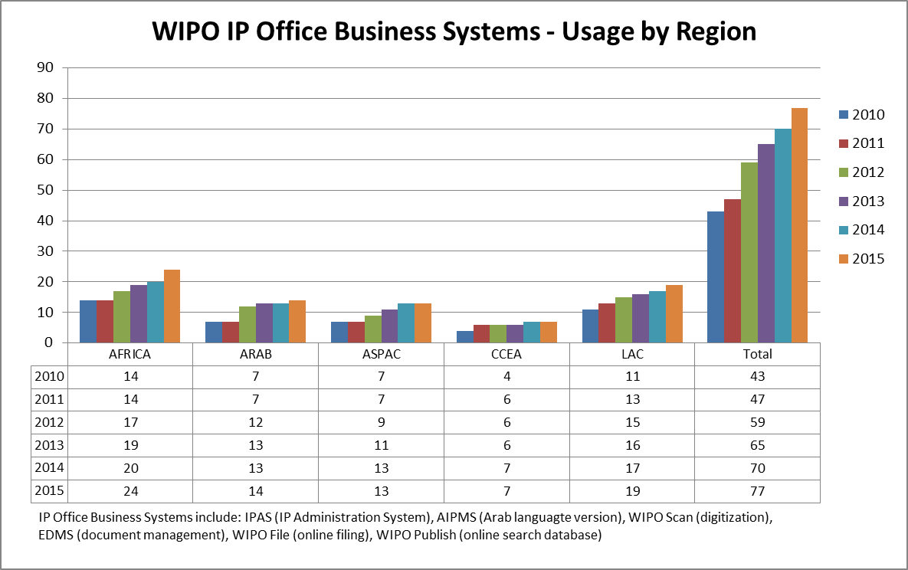

**Resource Sharing Platforms**

|  |  |
| --- | --- |
| WIPO DAS | Based on a specification and review process with participating Offices, a new version of the Digital Access Service (DAS) portal to support the revised framework of DAS 2.0 was launched in December 2014. The number of participating Offices remained steady at 11. |
| WIPO CASE | In April 2014, the WIPO Centralized Access to Search and Examination (CASE) was linked to the IP5 One Dossier Portal system, allowing full two-way exchange of dossier information between CASE and IP5 Offices. Several new Offices registered to use WIPO CASE during the biennium, bringing the total number of participating Offices to 21, of which 10 have agreed to provide their dossier information to others. |

1. The design, planning and implementation of activities undertaken by Program 15 were informed and guided by the relevant DA Recommendations, in particular 1, 2 and 10.

PERFORMANCE DATA

|  |  |  |  |  |
| --- | --- | --- | --- | --- |
| **Expected Result:** IV.4 Enhanced technical and knowledge infrastructure for IP Offices and other IP institutions leading to better services (cheaper, faster, higher quality) to their stakeholders | | | | |
| **Performance Indicators** | **Baselines** | **Targets** | **Performance Data** | **TLS** |
| No. of Offices using WIPO Infrastructure Platforms | *Updated Baseline end 2013:*  Asia and the Pacific (5): China, Mongolia, Republic of Korea[92], Singapore, Viet Nam  Other (11): Australia, Canada, Denmark, Finland, Israel, Japan, New Zealand, Spain, Sweden, United Kingdom, United States of America  (16 cumulative)  *Original Baseline P&B 2014/15:* North America - 2  Western Europe - 7  Asia/Pacific - 6 | 25 (by regional breakdown) | 9 additional Offices in 2014/15:   * 7 additional Offices in Asia and the Pacific (12 cumulative): Brunei Darussalam, , India, Indonesia, Lao People’s Democratic Republic, Malaysia, , Philippines, Thailand, * 1 additional Office in Latin America and the Caribbean (1 cumulative): Chile * 1 additional Office in Other countries (17 cumulative): the International Bureau   (25 Offices cumulative) | **Fully Achieved** |
| Average Service Level of IP Offices assisted (ranging from 1 to 5) | *Updated Baseline end 2013:* 2.8  *Original Baseline P&B 2014/15:* tbd | *Defined Target:* 3  *Original Target P&B 2014/15:* tbd | Overall average: 2.9   * Africa: 2.9 * Arab: 2.8 * Asia and the Pacific: 2.7 * Certain Countries in Europe and Asia: 3.3 * Latin America and the Caribbean: 3 * Other: 2.5 | **Fully Achieved** |
| No. of Collective Management Organizations (CMOs) in developing countries and LDCs participating in regional and global networks facilitated by WIPO | 0 zero | 10 | The WCC system was in the final development phase at the end of 2014/15 and will be deployed in CMOs in developing countries and LDCs starting in 2016. | **Not Achieved** |

RISK REPORTING FOR THE BIENNIUM

| **Risk(s) to the Program achieving its Results** | **Mitigation plans in place or under implementation** | **Evolution of Risk(s) and Mitigation Strategies Over the Biennium** | **Impact on the Program’s Performance** |
| --- | --- | --- | --- |
| Demand from IP Offices for deployment of WIPO software packages may be different from work plan. There is pressure to initiate projects in Offices where the necessary pre-requisites (especially local resources) may not be present. This may result in over-commitment of personnel and non-personnel resources. | Assessment of projects before initiation. Clearly agreed project plans, specifying roles, responsibilities and resource commitments of all parties. | This risk did materialize in the course of the biennium, but was addressed through flexible project management, especially through the reallocation of resources between projects, which enabled the Program to adapt to meet the unexpected changes in demand during the biennium. | This risk and its evolution did not have any material impact on the Program’s performance in 2014/15.  . |
| WIPO software packages (supplied to IP Offices) are developed and supported by external contractors. This may result in the fact that knowledge can be lost at short notice. | Key knowledge needs to be retained by WIPO staff, where possible. Contracts with external companies need to include a provision for knowledge transfer in the case of termination of contract. | In order to reduce this risk, a software architect was engaged in 2014 and additional personnel resources and contractors were involved in knowledge transfer from external contractors. As a result, knowledge sharing and retention improved during the biennium. | This risk and its evolution did not have any material impact on the Program’s performance in 2014/15. |
| Offices use WIPO software systems for their core business. A failure of one of those systems can have a severe effect on daily operations. There is therefore a high expectation for sufficient ongoing support from WIPO. | Allocate sufficient resources to software support. Ensure that local IP Office staff is trained for first level support. Establish formal procedures for software support and maintenance. | Critical incidents encountered in IP Offices during the biennium were handled effectively by local IP Office staff and WIPO experts. Additional resources were allocated to training and knowledge transfer. | This risk and its evolution did not have any material impact on the Program’s performance in 2014/15. |

RESOURCE UTILIZATION

Budget and Actual Expenditure (by result)

*(in thousands of Swiss francs)*



Budget and Actual Expenditure (personnel and non-personnel)

*(in thousands of Swiss francs)*



A. 2014/15 Final Budget after Transfers

1. The increase in the 2014/15 Final Budget after Transfers (personnel resources) was primarily the result of a transfer of one post into the Program to assist with the deployment of and support for WIPO business solutions for IP Offices notably regarding software architecture and design as well as for the WIPO Copyright Connection (WCC) project.
2. The slight net increase in non-personnel resources reflects on the one hand (i) the additional resources provided to cover ICT-related costs for TIGAR following the transfer of responsibilities for the ICT component of TIGAR to the Program from Program 3 (Copyright and Related Rights) and, on the other hand, (ii) the transfer of resources from the Program to Program 12 (International Classifications and Standards) to fund higher than expected costs for the development and hosting of the IPC reclassification database.

B. 2014/15 Budget Utilization

1. The budget utilization for non-personnel resources amounted to 91 per cent and reflects the finalization of the development phase of the WCC software platform resulting in its deployment in 2016 rather than the previous biennium as originally planned.

STRATEGIC GOAL V

**WORLD REFERENCE SOURCE FOR IP INFORMATION AND ANALYSIS**

**Biennial Performance Dashboard**

The dashboard below provides a summary of the achievements of the expected results in the biennium 2014/15 as measured by the indicators under the Programs contributing to this Strategic Goal.

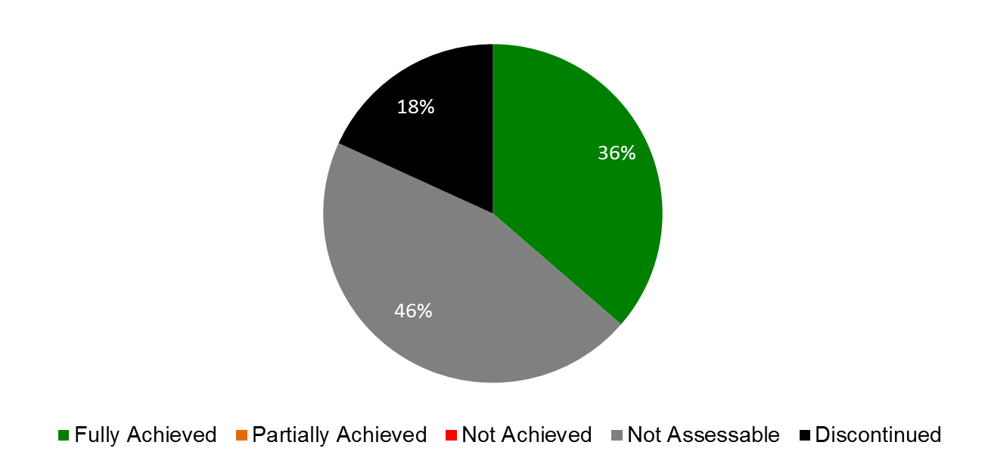

|  |  |  |  |
| --- | --- | --- | --- |
| **Expected Results** | **Performance Indicators** | **Responsible Program(s)** | **TLS** |
| V.1 Wider and better use of WIPO IP statistical information | No. of downloads of four main statistical reports (WIPI and PCT, Hague, Madrid Yearly Reviews) | Program 16 | ⚫⚫⚫⚫ |
|  | No. of visitors using IP Statistics data Center | Program 16 | ⚫ |
| V.2 Wider and better use of WIPO economic analysis in policy formulation | Use of WIPO economic studies on copyright by governments and NGOs in decision-making | Program 3 | ⚫ |
|  | National initiatives to develop further statistics on the creative industries based upon WIPO’s work in the field | Program 3 | ⚫ |
|  | No. of downloads of main economic publications | Program 16 | ⚫⚫ |
|  | No. of downloads of studies | Program 16 | ⚫ |
|  | No. of downloads of seminars | Program 16 | ⚫ |

## PROGRAM 16 ECONOMICS AND STATISTICS

**Program Manager Director General**

ACHIEVEMENTS IN THE 2014/15 BIENNIUM

1. The statistical work undertaken in the 2014/15 biennium fulfilled the objective of providing accurate, comprehensive, and timely statistical information on the performance of the IP system worldwide. Most importantly, annual statistical surveys of national and regional IP offices were conducted and saw the average number of responses rise to 127 compared to 112 in the previous biennium.
2. In addition, a wide range of statistical indicators on the Patent Cooperation Treaty (PCT), the Madrid and the Hague Systems were assembled in collaboration with Programs 5, 6 and 31. As in previous years, statistical collections were made available through a variety of publications and web tools ‑ notably the annual World IP Indicators and IP Facts and Figures reports; the annual PCT, Madrid, and Hague Yearly Reviews; the IP Statistics Data Center; and the IP Statistical Country Profiles. Throughout 2014/15, special efforts were made to deepen the analysis of statistical trends on the one hand, and improve the user-friendliness of statistical reporting on the other. Examples of such efforts are: special themes in statistical reports that explore certain statistical questions in greater depth, a new look for the World IP Indicators that makes it easier for readers to find the information they are looking for, and a short video on key trends in IP use worldwide. WIPO’s IP statistics and statistical reports continue to be widely used and cited in academic studies, policy reports, media articles and other publications worldwide.
3. The Program’s economic analysis work also made significant progress towards its objective of promoting high quality analysis addressing economic challenges in the international IP system and assessing the economic effects of IP policy choices. One major accomplishment was the publication of the third World Intellectual Property Report on Breakthrough Innovation and Economic Growth, which generated over 200 media articles and interest from policymakers and academia worldwide. In addition, WIPO continued to be a co-publisher of the Global Innovation Index (GII), along with Cornell University and INSEAD. In 2014/15, for the first time, the GII launches took place outside of Geneva, with the launches co-hosted by the Government of Australia in 2014 and the Government of the United Kingdom in 2015. News and social media coverage also reached new highs compared to the previous biennium. The GII is regularly used as an established reference source by national governments, international organizations – including UN organizations – and other stakeholders in the innovation system, as evidenced by citations, data inquiries and requests for advisory services.
4. Significant achievements in the 2014/15 biennium were also made with regard to targeted economic studies to support the work of WIPO committees. Above all, the Program concluded three Development Agenda (DA) projects on: (i) IP and socioeconomic development; (ii) IP and the informal economy; and (iii) IP and brain drain. A second phase of the project on IP and socioeconomic development that takes the underlying study work to new developing countries was also launched in 2015. In addition, the Program provided inputs into the work of other committees, notably the PCT Working Group and the Standing Committee on the Law of Patents (SCP). These studies generated empirical evidence that informed the deliberation of policymakers, whether at the national level or among WIPO Member States. They have also triggered follow-on research activities in academia.
5. Finally, the Program continued to coordinate a network of IP office economists – open to all IP Offices with an economic research capacity – to help foster and facilitate empirical and scientifically rigorous economic research on IP. The network experienced growth in the biennium, with four new IP Offices joining, bringing the total number of Offices to 13.

PERFORMANCE DATA

|  |  |  |  |  |
| --- | --- | --- | --- | --- |
| **Expected Result:** V.1 Wider and better use of WIPO IP statistical information | | | | |
| **Performance Indicators** | **Baselines** | **Targets** | **Performance Data** | **TLS** |
| No. of downloads of four main statistical reports (WIPI and PCT, Hague, Madrid Yearly Reviews) | *Updated Baseline end 2013:* In 2013, the latest available editions (2012 and 2013 editions) of the World Intellectual Property Indicators (publication n°941) and WIPO IP Facts and Figures (n°943) were downloaded, altogether, 52,670 times.  *Original Baseline P&B 2014/15:* tbdend 2013 | 10% increase in number of downloads and users over 2012/13 | In 2014/15, the two most recently published editions (2014 and 2015) of the following reports were downloaded altogether 215,996 times:   1. The World IP Indicators Report (No 941E/14 and 941E ) and the World IP Facts and Figures Reports (No. 943E/14 and 943E/15) were downloaded a total of 124,642 times:  * World IP Indicators (No 941E/14 and 941E): 82,914 times * WIPO IP Facts and Figures (No. 943E/14 and 943E/15): 41,728 times  1. PCT Yearly Review (No 901E/2014 and 901E/2015): 50,746 downloads 2. Madrid Yearly Review (No 940E/14 and 940E/15): 20,281 downloads 3. Hague Yearly Review (No 930E/14 and 930E15): 20,237 downloads | **Fully Achieved**  **Not Assessable**  **Not Assessable**  **Not Assessable** |
| No. of visitors using IP Statistics Data Center | *Updated Baseline end 2013:*  In 2013, the WIPO Statistics Data Center was used by 23,496 unique visitors (1,958 per month) who viewed 162,463 pages  *Original Baseline P&B 2014/15:* tbdend 2013 | 10% increase in number of users, over 2012/13 | In 2014/15, the WIPO Statistics Data Center was used by an estimated 51,383 unique visitors (2,141 per month) who viewed an estimated 608,277 pages[93] | **Fully Achieved** |

|  |  |  |  |  |
| --- | --- | --- | --- | --- |
| **Expected Result:** V.2 Wider and better use of WIPO economic analysis in policy formulation | | | | |
| **Performance Indicators** | **Baselines** | **Targets** | **Performance Data** | **TLS** |
| No. of downloads of main economic publications | Tbd end 2013 | 20% increase over 2012/13 | In 2014/15, the two most recent versions of the Global Innovation Index (GII) (2014 and 2015):   * were downloaded 123,161 times from, and had 50,368 unique visitors to, the WIPO GII web page[94]. * was downloaded 13,943 from, and had 300,283 unique visitors to, the GII-dedicated website[95].   In 2014/15, the most recent World IP Report (2015) (944E) was downloaded a total of 16,218 times from November 11, 2015, when it was published on the WIPO website, until the end of 2015. | **Not Assessable**  **Not Assessable** |
| No. of downloads of studies | *Updated Baseline end 2013:*  7 working papers published in 2013  *Original Baseline P&B 2014/15:* tbd end of 2013 | Eight new working papers | 11 working papers published in 2014; 6 working papers published in 2015 | **Fully Achieved** |
| No. of downloads of seminars | *Updated Baseline end 2013:*  n/a  *Original Baseline P&B 2014/15:* tbd end of 2013 | Maintain performance as in previous biennium | Data are not available | **Dis-continued** |

RISK REPORTING FOR THE BIENNIUM

|  |  |  |  |
| --- | --- | --- | --- |
| **Risk(s) to the Program achieving its Results** | **Mitigation plans in place or under implementation** | **Evolution of Risk(s) and Mitigation Strategies Over the Biennium** | **Impact on the Program’s Performance** |
| Member States are not in a position to respond or are late in responding to WIPO’s statistics survey. | Statistics questionnaires will be sent early in the year (by February); a list of statistical contact points in national IP offices will be maintained for follow up communication; sufficient resources will be devoted to follow up communication. | This risk is a continuous risk, which has been addressed and managed through focused mitigation plans as indicated. As a result, the coverage of the IP statistics questionnaire rose during the biennium | In a few cases, statistical data were reported with a delay, but this did not have any significant impact on the Program’s key statistical products. |
| WIPO publications misreport statistical data or reflect analytical shortcomings | Control mechanisms are instituted that identify data inconsistencies during the collection of IP statistics; all statistical publications are carefully reviewed by statistical experts and relevant WIPO sectors; all analytical publications are externally peer reviewed. | This is another continuing risk for the Program, managed through the mitigation plans in place, which have effectively identified data quality issues during the biennium (data inconsistencies) and enabled the resolution of these with relevant Member States | Reporting delays/errors created extra work internally but did not delay or affect the quality of the publications. |

RESOURCE UTILIZATION

Budget and Actual Expenditure (by result)

*(in thousands of Swiss francs)*



Budget and Actual Expenditure (personnel and non-personnel)

*(in thousands of Swiss francs)*



A. 2014/15 Final Budget after Transfers

1. The slight overall increase in personnel resources was due to the addition of two posts for data analysis and creative economy research. This increase was partially offset by the budgetary adjustment for the DA Project on IP and Socio-Economic Development following the approval of the second phase of the project at the fourteenth session of the CDIP (CDIP/14/7).
2. The overall decrease in non-personnel resources was primarily due to: (i) the budgetary adjustment for the DA Project on IP and Socio-Economic Development; and (ii) the transfer of non-personnel resources for internships to Program 23 (HRMD) to support the work of the Program. This decrease was partially offset by an increase in non-personnel resources for promotional activities for the World IP Report and the Global Innovation Index and the commissioning of a special study on the fee elasticity of filings under the Madrid System.

B. 2014/15 Budget Utilization

1. The 82 per cent budget utilization for non-personnel was primarily related to a delay in the recruitment of staff for (i) the DA Project on Socio-Economic Development and IP and (ii) the creative economy research program which resulted in a postponement of implementation of related activities.

STRATEGIC GOAL VI

**INTERNATIONAL COOPERATION ON BUILDING RESPECT FOR IP**

**Biennial Performance Dashboard**

The dashboard below provides a summary of the achievements of the expected results in the biennium 2014/15 as measured by the indicators under the Programs contributing to this Strategic Goal.

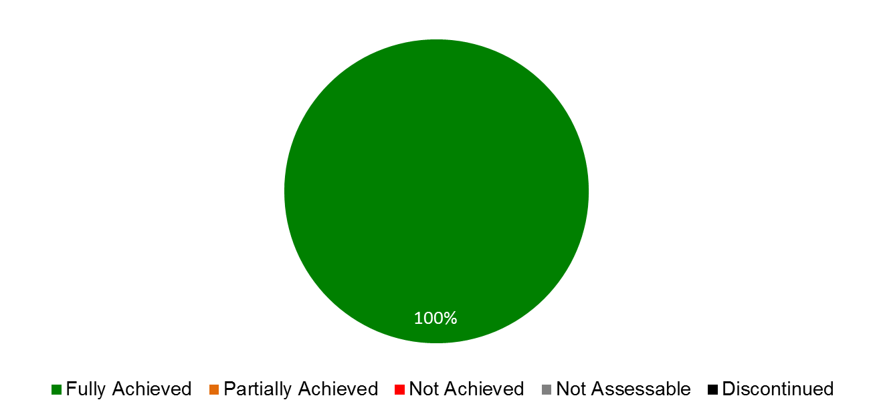

|  |  |  |  |
| --- | --- | --- | --- |
| **Expected Results** | **Performance Indicators** | **Responsible Program(s)** | **TLS** |
| VI.1 Progress in the international policy dialogue among WIPO Member States on building respect for IP, guided by Recommendation 45 of the WIPO Development Agenda | Continued agreement by Member States on the substantive work of the WIPO Advisory Committee on Enforcement (ACE), incorporating development-oriented concerns | Program 17 | ⚫ |
| VI.2 Systematic, effective and transparent cooperation and coordination between the work of WIPO and other international organizations in the field of building respect for IP | No. of joint activities on building respect for IP | Program 17 | ⚫ |

## PROGRAM 17 BUILDING RESPECT FOR IP

**Program Manager Mr. M. A. Getahun**

ACHIEVEMENTS IN THE 2014/15 BIENNIUM

17.1 Guided by Strategic Goal VI and DA Recommendation 45, the activities of Program 17 were geared towards enhanced international cooperation on building respect for IP, seeking to achieve the appropriate balance between private rights and the public interest.

17.2 Contributing to progress in the international policy dialogue on building respect for IP among Member States, the ninth and tenth sessions of the Advisory Committee on Enforcement (ACE) (March 3 to 5, 2014; and November 23 to 25, 2015) served as a “marketplace of ideas”, facilitating the exchange of practices and experiences in relation to alternative mechanisms for resolving IP disputes, as well as preventive strategies to complement enforcement, such as awareness raising and educational tools for young people, new business models, supply chain security, voluntary mechanisms, and national coordination to build respect for IP. The two sessions were accompanied by audiovisual exhibitions, presenting public communication campaigns on respect for IP and awareness tools for young people. The Committee agreed to exchange, at its eleventh session, information on national experiences on four topics: (i) awareness building activities and strategic campaigns as a means for building respect for IP among the general public, especially the youth, in accordance with Member States’ educational or any other priorities; (ii) institutional arrangements concerning IP enforcement policies and regimes, including mechanisms to resolve IP disputes in a balanced, holistic and effective manner; (iii) WIPO’s legislative assistance, with a focus on drafting national laws of enforcement that take into account the flexibilities, the level of development, the difference in legal tradition and the possible abuse of enforcement procedures; and (iv) WIPO’s capacity building and support for training activities in line with relevant Development Agenda Recommendations and the ACE mandate. The value that the Member States find in the ACE motivated the request that sessions be held annually.

17.3 To achieve international policy cohesion and maximum impact through shared resources, the Program coordinated its work with intergovernmental and non‑governmental organizations, associations of stakeholders, as well as academic institutions. Through systematic, transparent and effective collaboration, WIPO was able to ensure further integration of Strategic Goal VI in joint collaborations with its international partners, in line with DA Recommendation 40. A thematic focus lay on the intersection of IP and private international law, where a seminar in cooperation with the International Law Association was organized in January 2015 and the WIPO report *Private International Law Issues in Online Intellectual Property Infringement Disputes with Cross-border Elements – An Analysis of National Approaches[96]* was published in September 2015.

17.4 Demand for WIPO assistance in the form of legislative advice on the compatibility of draft or current national enforcement-related provisions with Part III of the TRIPS Agreement continued to rise throughout the biennium. In close dialogue with national drafters, the Program helped 12 Member States devise legislative solutions that were appropriate to their national requirements and take full account of the available flexibilities and options. Activities in this area of legislative, regulatory and policy assistance implemented DA Recommendations 1, 6, 12, 13, 14 and 17.

17.5 The Program’s capacity building activities sought to empower national authorities to build respect for IP through a combination of balanced enforcement activities and preventive measures designed to reduce demand for infringing goods and underscore the value of the IP-legitimate market. To enhance the sustainability of the knowledge transfer, specific collaborations were established with national law enforcement training institutions capable of serving as multipliers and a basic *Manual on IP Crime Investigation and Prosecution* was developed for the use or adaptation in the training of law enforcement officials and prosecutors. In addition, a French edition and an Arabic translation of the English edition of the *WIPO Casebook on the Enforcement of IP Rights* were published during the biennium. The activities in this area were steered by DA Recommendations 3, 10, and 11.

17.6 In order to support Member State IP education and awareness initiatives, seeking to reduce IP infringement through behavioral change, a modular methodology for devising national awareness-raising strategies was developed, and two Member States were assisted in its implementation in accordance with the respective particular national needs. In addition, the Program developed a set of educational materials for pupils aged from 10 to 15 years on respect for copyright; supported six Member States in the organization of school competitions around the Building Respect for IP theme; and published a DVD and a workbook featuring “Pororo the little penguin”. The WIPO Awards Program continued to celebrate the achievements of inventors, creators and innovative companies with 330 WIPO Awards and 470 certificates being bestowed on recipients from 54 Member States. The Program’s awareness-raising activities responded to DA Recommendation 3.

PERFORMANCE DATA

| **Expected Result:** I.2 Tailored and balanced IP legislative, regulatory and policy frameworks | | | | |
| --- | --- | --- | --- | --- |
| **Performance Indicators** | **Baselines** | **Targets** | **Performance Data** | **TLS** |
| No. of countries that have adopted or amended relevant frameworks (or are in the process of doing so) further to WIPO assistance | *Updated Baseline end 2013:*  9 countries/ organizations in the process of amending and/or adopting relevant frameworks towards effective IP enforcement: Africa (5), Asia and the Pacific (2), Latin America and the Caribbean (2)  *Original Baseline P&B 2014/15:* tbd | 6 | 12 countries/organizations have adopted and/or amended or are in the process of amending and/or adopting relevant frameworks towards effective IP enforcement: Africa (4); Asia and the Pacific (5); Latin America and the Caribbean (3).  (21 cumulative) | **Fully Achieved** |
| **Expected Result:** III.2 Enhanced human resource capacities able to deal with the broad range of requirements for the effective use of IP for development in developing countries, LDCs and countries with economies in transition | | | | |
| **Performance Indicators** | **Baselines** | **Targets** | **Performance Data** | **TLS** |
| % of trained participants that report satisfaction with the usefulness and relevance of the training provided for their professional life | *Updated Baseline end 2013:*  85%  *Original Baseline P&B 2014/15:* 75% | 75% | Average rate of usefulness of the training: 93%.    Average rate of satisfaction with the training: 92%. | **Fully Achieved** |
| % of targeted audience who have demonstrated a basic knowledge of a balanced IP system further to WIPO activities | n/a | 75% | >75%. Basic knowledge demonstrated through school competitions in participating countries. | **Fully Achieved** |
| No. of countries participating in WIPO Awards Program | *Updated Baseline end 2013: 42 in 2013*  *Original Baseline P&B 2014/15:* 40 per year | 40 *per* year | In 2014/15, a total of 54 different countries participated in the WIPO Awards Program:   * 40[97] in 2014: Africa (5); Arab (3); Asia and the Pacific (10); Certain Countries in Europe and Asia (8); Latin America and the Caribbean (7); Other (7)      * 43 in 2015: Africa (1); Arab (4); Asia and the Pacific (8); Certain Countries in Europe and Asia (15); Latin America and the Caribbean (9); Other (6) | **Fully Achieved** |
| **Expected Result:** VI.1 Progress in the international policy dialogue among WIPO Member States on building respect for IP, guided by Recommendation 45 of the WIPO Development Agenda | | | | |
| **Performance Indicators** | **Baselines** | **Targets** | **Performance Data** | **TLS** |
| Continued agreement by Member States on the substantive work of the WIPO Advisory Committee on Enforcement (ACE), incorporating development-oriented concerns | *Updated Baseline end 2013:* Agreement on work program for the 9th session of the ACE  *Original Baseline P&B 2014/15:* Agreement on work program for the 8th session of the ACE | Agreement on work program for the next ACE session | Agreement on the work program was reached during the ninth and tenth sessions of the ACE (WIPO/ACE/9/29 para 44 and WIPO/ACE/10/26 PROV.WIPO/ACE/10/26 PROV. para 40). | **Fully Achieved** |
| **Expected Result:** VI.2 Systematic, effective and transparent cooperation and coordination between the work of WIPO and other international organizations in the field of building respect for IP | | | | |
| **Performance Indicators** | **Baselines** | **Targets** | **Performance Data** | **TLS** |
| No. of joint activities on building respect for IP | *Updated Baseline end 2013:* 39 in 2012/13  *Original Baseline P&B 2014/15:* 30 | 30 | In 2014/15 a total of seven strategic collaborations[98] (cumulative) and 55 activities jointly held with partner organizations and stakeholders and/or in which Program 17 participated:   * 6 strategic collaborations and 29 other joint activities in 2014[99] * 7 strategic collaborations (1 additional) and 26 other joint activities in 2015 | **Fully Achieved** |

RISK REPORTING FOR THE BIENNIUM

|  |  |  |  |
| --- | --- | --- | --- |
| **Risk(s) to the Program achieving its Results** | **Mitigation plans in place or under implementation** | **Evolution of Risk(s) and Mitigation Strategies Over the Biennium** | **Impact on the Program’s Performance** |
| Lack of agreement among, and of political support by, Member States in the work of WIPO in the field of building respect for IP. WIPO’s role in building respect for IP may be compromised. | This Program engages in regular consultations with Member States aiming at facilitating the convergence of Member State views on the relevance, the work and the policy function of the ACE and related capacity building activities. Rigorous standards are applied in all activities, ensuring high quality, transparency, neutrality and a balanced approach. | While the risk persists, it has been managed through the strict and full implementation of the mitigation plan. Member States have expressed support in WIPO’s work in building respect for IP, as evidenced through the ACE and the IOD Evaluation for Strategic Goal VI[100]. | The risk did not materialize during the biennium. The strict adherence to the mitigation plan ensured support from the Member States and allowed the Program to perform fully. |

RESOURCE UTILIZATION

Budget and Actual Expenditure (by result)

*(in thousands of Swiss francs)*



Budget and Actual Expenditure (personnel and non-personnel)

*(in thousands of Swiss francs)*



A. 2014/15 Final Budget after Transfers

17.7 The adjustments across Results in the Final Budget after Transfers 2014/15 are due primarily to:

* a continued increase in Member State demand for legislative advice, including diagnostic missions, resulting in a redistribution of resources from Result VI.2 (Cooperation in the field of building respect for IP) to I.2 (Legislative advice); and
* the holding, at the request of the Member States, of two sessions of the ACE in the biennium, instead of one as originally foreseen, resulting in a redistribution of resources from Result VI.2 (Cooperation in the field of building respect for IP) to Result VI.1 (Progress in the international policy dialogue among WIPO Member States on building respect for IP)

17.8 The net increase in personnel resources reflects the temporary transfer of a staff member from Program 6 to support the increased demand for legislative advice.

B. 2014/15 Budget Utilization

17.9 Budget utilization is within the expected range for the biennium.

STRATEGIC GOAL VII

**ADDRESSING IP IN RELATION TO GLOBAL POLICY ISSUES**

**Biennial Performance Dashboard**

The dashboard below provides a summary of the achievements of the expected results in the biennium 2014/15 as measured by the indicators under the Programs contributing to this Strategic Goal.

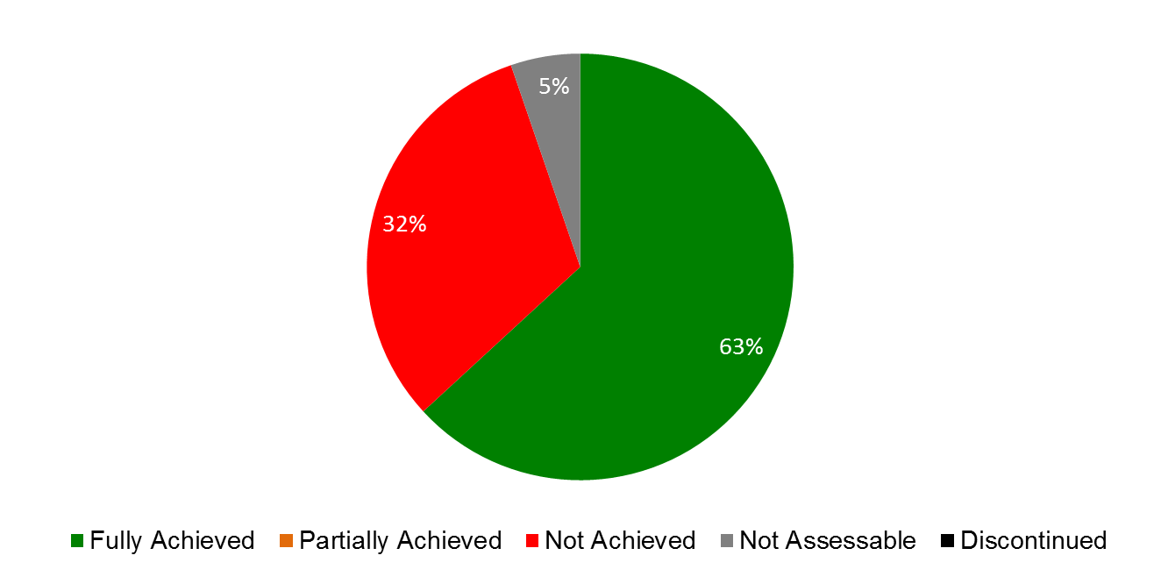

| **Expected Results** | **Performance Indicators** | **Responsible Program(s)** | **TLS** |
| --- | --- | --- | --- |
| VII.2 IP-based platforms and tools are used for knowledge transfer, technology adaptation and diffusion from developed to developing countries, particularly least developed countries, to address global challenges | Increase in membership in WIPO Re:Search, including from developing countries and LDCs | Program 18 | ⚫ |
| Increased contributions to WIPO Re:Search database | Program 18 | ⚫ |
| Increased no. of agreements under WIPO Re:Search which lead to new or accelerated R&D in NTDs, Malaria and TB | Program 18 | ⚫ |
|  | No. of WIPO GREEN Members | Program 18 | ⚫⚫⚫ |
|  | No. of established links of WIPO GREEN to relevant mechanisms, such as Climate Technology Centers and Networks (UNFCCC) and Climate Innovation Centers (infoDev) | Program 18 | ⚫ |
|  | No. of agreements catalyzed by WIPO GREEN facilitating knowledge transfer, technology adaptation, transfer and/or diffusion | Program 18 | ⚫ |
|  | No. of visits of Global Challenges website | Program 18 | ⚫⚫⚫⚫ |
|  | Participation of stakeholders in WIPO's platform such as WIPO GREEN and WIPO Re:Search | Program 20 | ⚫⚫⚫⚫⚫ |
| VII.3 Growing credibility of WIPO as a forum for analysis of issues in the field of IP and competition policy | No. of countries requesting WIPO’s specific contribution on IP in relation to CP-related issues | Program 18 | ⚫ |
| No. and diversity of stakeholders (IP offices, competition authorities, relevant IGOs and NGOs) engaged in dialogue with WIPO | Program 18 | ⚫ |

## PROGRAM 18 IP AND GLOBAL CHALLENGES

**Program Manager Mr. M. A. Getahun**

ACHIEVEMENTS IN THE 2014/15 BIENNIUM

1. Program 18 addresses innovation and IP at the intersection of global and interconnected issues, in particular global health, climate change and food security. In 2014/15, the Program continued to contribute to an enhanced understanding among policy makers on the interface between global challenges, innovation and IP, including through two multi-stakeholder platforms (WIPO Re:Search and WIPO GREEN, respectively), and the ongoing collaboration with WHO and WTO addressing the intersection of health, IP, innovation and trade. During the biennium, the Program continued to receive positive feedback from a wide range of stakeholders for WIPO’s work on IP and Global Challenges.
2. Working closely with relevant Programs within WIPO, most notably Programs 20 (External Relations, Partnerships and External Offices) and 30 (SMEs and Innovation), WIPO consolidated its position as a credible source of support, collaboration and reference for information on issues related to public policy and IP, resulting in continued requests for WIPO to contribute to and participate in fora by other international and non‑governmental organizations, including WHO, WTO, NGOs, the private sector and universities. In 2014/15, three WIPO Global Challenges Seminars were organized providing fora for participants to share ideas, expertise and information: (i) Patent Landscape for Renewable Energy (June 2014); (ii) Innovation and Access to Medicines: A Case Study for HIV/AIDS and Hepatitis C (December 2014); and (iii) Advancing a New Generation of Products to Combat Neglected Tropical Diseases (October 2015). In addition, four Global Challenges Briefs[101] and three Global Challenges Reports[102] were published. As part of the work of WIPO Re:Search to strengthen capacities in developing countries, two IP management training seminars were organized, together with Program 9 (Regional Bureaus) and Program 30 (SMEs and Innovation), for the benefit of developing country scientists who are Members of the platform.
3. Following its launch in November 2013, the year 2014 marked the first full year of WIPO GREEN operations. Through a targeted awareness campaign, the profile of WIPO GREEN -*The Marketplace for Sustainable Technology*, was raised significantly in 2014/15. The network of partners grew from 36 in 2013 to 54 in 2014 to 65 in 2015, and the number of registered users tripled from 160 in 2013 to 490 by the end of 2015. The WIPO GREEN database also more than doubled its content, from 830 entries in 2013 to 2,181 in 2015, as a result of database integration agreements and individual uploads.

*WIPO GREEN: No. of Partners, Registered Users and Uploads 2013-2015*

|  |  |
| --- | --- |
|  |  |

1. With the focus in 2014/15 remaining on building a robust set of partners and increasing the number of entries to promote increased levels of marketplace interaction and transactional usage, no records of catalyzed transactions that could be directly attributed to the use of WIPO GREEN are available at this stage. Moreover, the fact that WIPO GREEN does not currently have a “partnership hub” or service provider, coupled with the lengthy timeframe needed for deals to be concluded, also contributed to the lack of catalyzed transactions. In 2015, work focused on helping seekers in refining needs and facilitating connections. More detailed guidelines for seekers were therefore introduced in 2015, resulting in an improvement in the quality of needs description. The first matchmaking event organized by WIPO GREEN in 2015 Facilitating the Transfer and Diffusion of Clean Technology: Opportunities from a Pilot Project on Wastewater Treatment in South East Asia in Manila, Philippines resulted in 16 letters of intent signed by the parties.
2. WIPO Re:Search – *Sharing Innovation in the Fight Against Neglected Tropical Diseases* (NTDs) – gained in recognition as a platform to support innovation, knowledge and technology transfer and capacity building related to research for NTDs, tuberculosis and malaria. The biennium saw 52 additional collaborations between WIPO Re:Search Members and 20 new Members, six of which from developing countries, bringing the totals to 96 collaborations and 100 Members, 22 of which from developing countries. In addition, the platform’s potential for technology transfer from developed to developing countries of IP assets, including know-how and expertise, was further demonstrated by the continued facilitation of research sabbaticals for six African scientists in overseas research institutions. The sabbaticals, which began in the last biennium, were made possible by a Fund-in-Trust from the Government of Australia. At the end of the biennium, four of the sabbaticals were concluded.
3. The trilateral cooperation with WHO and WTO continued to focus on enhanced understanding among policymakers for the interplay between health, IP and trade. In November 2014 and October 2015, the fourth and fifth Trilateral Symposia took place in Geneva, exploring the challenges and opportunities in the health innovation area of middle-income countries, and the public policies necessary to ensure that rapid economic growth contributes to access and universal health coverage. In October 2015, a technical workshop on patentability criteria was jointly organized under the trilateral cooperation and was generally well received by the participants.
4. The area of IP and competition policy experienced sustained interest from Member States to engage in a dialogue for enhancing their understanding of the interface between IP and competition policy. Requests involved both IP Offices and Competition Authorities, including from countries that are less familiar with competition-related issues in the field of IP.
5. The number of stakeholders engaged in dialogue with WIPO reached 39 Competition Authorities and the structured, informal cooperation with other relevant Organizations in the field, most notably OECD, UNCTAD, the WTO, International Competition Network (ICN), and the Common market for Eastern and Southern Africa (COMESA) that was established in the previous biennium was further strengthened. WIPO jointly organized and/or participated in nine workshops. These joint efforts of both IP Offices and Competition Authorities provided an effective forum for dialogue and debate as regards the interface between IP and competition policy.
6. The design, planning and implementation of activities undertaken by Program 18 were guided by the relevant DA Recommendations, in particular DA Recommendations 19, 25, 30, 40, and 42.

PERFORMANCE DATA

|  |  |  |  |  |  |  |  |  |  |  |
| --- | --- | --- | --- | --- | --- | --- | --- | --- | --- | --- |
| **Expected Result:** III.2 Enhanced human resource capacities able to deal with the broad range of requirements for the effective use of IP for development in developing countries, LDCs and countries with economies in transition | | | | | | | | | | |
| **Performance Indicators** | **Baselines** | | | **Targets** | | | **Performance Data** | | | **TLS** |
| No. of hosting arrangements of developing country scientists | *Original Baseline P&B 2014/15:* *5* | | | 4 | | | 1 new hosting agreement | | | **Not Achieved** |
| **Expected Result:** IV.2 Enhanced access to, and use of, IP information by IP institutions and the public to promote innovation and creativity | | | | | | | | | | |
| **Performance Indicators** | **Baselines** | | | **Targets** | | | | | **Performance Data** | **TLS** |
| Number of countries that verified data and included national essential medicines into WIPO Essential | 0 (zero) | | | 1 country per region (Africa, Asia, Latin America and the Caribbean) | | | | | WIPO Essential was repurposed in 2014 as a study on the patent status of medicines contained in the WHO Model List of Essential Medicines (MLEM). | **Dis-continued** |
| **Expected Result:** VII.2 IP-based platforms and tools are used for knowledge transfer, technology adaptation and diffusion from developed to developing countries, particularly least developed countries, to address global challenges | | | | | | | | | | |
| **Performance Indicators** | | | **Baselines** | | **Targets** | | | | **Performance Data** | **TLS** |
| Increase in membership in WIPO Re:Search, including from developing countries and LDCs | | | *Updated Baseline end 2013:* During the biennium, WIPO Re:Search added 49 new members (providers, users and supporters) and 167 new entries in the database:   * 30 new members and 90 new entries in 2012; and * 19 new members and 77 new entries in 2013   bringing the total cumulative to 80 members and 247 entries.    *Original Baseline P&B 2014/15:* 67 Members; 16 from Developing Countries | | 15 (of which at least 5 from developing countries/LDCs) | | | | 20 new Members (of which 6 from developing countries /LDCs) 100 total Members (of which 22 from developing countries/LDCs) | **Fully Achieved** |
| Increased contributions to WIPO Re:Search database | | | *Updated Baseline end 2013:* By end of 2013 WIPO Re:Search had facilitated 44 research collaborations (11 in 2012 and 33 in 2013)    *Original Baseline P&B 2014/15:* 200 | | 50% | | | | 193 contributions by end of 2015 (-22% as compared to 247 at the end of 2013)  The decrease in the number of records was due to the withdrawal of two members | **Not Achieved** |
| Increased no. of agreements under WIPO Re:Search which lead to new or accelerated R&D in NTDs, Malaria and TB | | | *Updated Baseline end 2013:* 44    *Original Baseline P&B 2014/15:* 16 | | 20 | | | | 52 new collaboration agreements (96 total agreements) | **Fully Achieved** |
| No. of WIPO GREEN Members | | | *Updated Baseline end 2013:* 36 Partners, 160 users, 830 uploads[103]  *Original Baseline P&B 2014/15:* 1 partner; 48 uploads | | 10 new partners  160 users  400 uploads | | | | * 29 new partners (total 65) * 330 new users (490 total) * 1,351 new uploads  (2,181 total[104]) | **Fully Achieved**  **Fully Achieved**  **Fully Achieved** |
| No. of established links of WIPO GREEN to relevant mechanisms, such as Climate Technology Centers and Networks (UNFCCC) and Climate Innovation Centers (infoDev) | | | *Updated Baseline end 2013:*  1 (East Africa Climate Innovation Network (EACIN))    *Original Baseline P&B 2014/15:* 0 (zero) | | 3 | | | | 6 additional in 2014/15:   * Climate Technology Centre and Network (CTCN) * inforDev * EcoPatent Commons * Kenya Climate Innovation Center (KCIC) * Climate KIC * Waseda Environmental Institute   (7 cumulative) | **Fully Achieved** |
| No. of agreements catalyzed by WIPO GREEN facilitating knowledge transfer, technology adaptation, transfer and/or diffusion | | | *Updated Baseline end 2013:* During 2012 and 2013 WIPO GREEN concluded :  Two agreements with external partners for data integration  (Association of University Technology Managers (AUTM) and East Africa Climate Innovation Network (EACIN))  *Original Baseline P&B 2014/15:* 0 (zero) | | 250 | | | | 5 additional agreements in 2014/15:   * Danish Patent and Trademark Office (DKPTO) * KOTEC * Technologie Allianz * United Nations Office for South-South Cooperation (UNOSSC) * Ministry of Economy (Israel)   (7 cumulative) | **Not Achieved** |
| No. of visits of Global Challenges website | | | *Updated Baseline* end 2013:  6,476 page views (GCD)  3,773 downloads of pdf files  73,648 page views of WIPO GREEN  60,712 page views of WIPO Re:Search  *Original Baseline P&B 2014/15:* n/a | | 50% increase | | | | *No. of page views:*   * *GCD: 2,693* * *Downloads of pdf files: 45,253* * *WIPO GREEN: 207,716* * *WIPO Re:Search: 62,118* * *Global Health and IP: 31,800 Climate Change and IP: 4,952* | **Not Achieved**  **Fully Achieved Fully Achieved Not Achieved** |
| **Expected Result:** VII.3 Growing credibility of WIPO as a forum for analysis of issues in the field of IP and competition policy | | | | | | | | | | |
| **Performance Indicators** | | **Baselines** | | | | **Targets** | | **Performance Data** | | **TLS** |
| No. of countries requesting WIPO’s specific contribution on IP in relation to CP-related issues | | *Updated Baseline end 2013:* Six requests for bilateral discussions (Chile, Brazil, Ecuador, India, the Dominican Republic, the Republic of Moldova) and one request for legislative assistance (Bhutan).    *Original Baseline P&B 2014/15:* 12 | | | | 15 | | 16 requests/follow up for bilateral discussions (Brazil, Colombia, Cuba, Dominican Republic, Ecuador, El Salvador, Honduras, India, Italy, Kuwait, Macao Special Administrative Region of China, Peru, Philippines, Singapore, South Africa, Viet Nam) | | **Fully Achieved** |
| No. and diversity of stakeholders (IP offices, competition authorities, relevant IGOs and NGOs) engaged in dialogue with WIPO | | *Updated Baseline end 2013:* 19 workshops and meetings engaging 38 competition authorities and 5 IGOs. Establishment of informal coordination with UNCTAD, WTO and OECD. Active participation in the International Competition Network. Cooperation with the Common Market for Eastern and Southern Africa (COMESA).  *Original Baseline P&B 2014/15:* WIPO engaged 25 national competition authorities and 3 IGOs | | | | Increase of stakeholders engaged in WIPO’s activities: 35 national authorities and 5 IGOs/NGOs | | 39 additional competition authorities involved and continued engagement with 5 IGOs/NGOs (OECD, UNCTAD, the WTO, ICN, COMESA). Active participation in the International Competition Network (including the Unilateral Conduct Working Group membership). Cooperation with EU. | | **Fully Achieved** |

RISK REPORTING FOR THE BIENNIUM

| **Risk(s) to the Program achieving its Results** | **Mitigation plans in place or under implementation** | **Evolution of Risk(s) and Mitigation Strategies Over the Biennium** | **Impact on the Program’s Performance** |
| --- | --- | --- | --- |
| Lack of, or dwindling buy-in, from platform partners, members leaving, or insufficient upload of information by members have direct impact on the functioning of the platforms and the function they are supposed to fulfill as well as the credibility of the projects, making the platforms potentially irrelevant compared to similar platform projects outside of WIPO | Constantly scrutinize strategy, environment and planning to enable early identification of trends and taking appropriate action as soon as possible | A second WIPO Re:Search member withdrew in 2015 after a first private sector member had withdrawn in 2013. Ongoing efforts to bring on new corporate members were successful and proved adequate to compensate for the departure of the two members. No WIPO GREEN partner left the consortium. | The withdrawal of the WIPO Re:Search private sector member was offset by three new corporate members joining in 2014 (one member) and 2015 (two members). The withdrawal of the WIPO Re:Search member in 2013 had led to 27 per cent reduction in database entries in 2014, which was, in part compensated by the seven per cent increase of database entries in 2015. |
| The technical accessibility of the IP databases and the sustained functioning and reliability of the database infrastructure. Consistent availability issues may have a negative impact on WIPO’s reputation and credibility | Ensure that relevant services be offered, effective marketing and to maintain close contact with key stakeholders | The risk continues to be relevant. Regular review and testing of the functionality of both databases was performed by IT and proved to be an effective mitigation strategy. | The two databases ran generally stable so that there were no issues impacting on the Program’s performance.   . |
| The level of engagement by national agencies in WIPO’s work on IP and competition is lower than anticipated | Strengthen a systematic outreach towards Member States; showcase successful examples of cooperation between IP and competition authorities, as well as relevant IGOs and NGOs | The level of engagement remained strong in 2014/15, as well as the continued collaboration with IP Offices and Competition Authorities in the Program’s work, particularly in workshops where both communities shared their views on the IP/Competition interface. | No material impact on the Program’s performance in 2014/15. |

RESOURCE UTILIZATION

Budget and Actual Expenditure (by result)

*(in thousands of Swiss francs)*



Budget and Actual Expenditure (personnel and non-personnel)

*(in thousands of Swiss francs)*



A. 2014/15 Final Budget after Transfers

1. The net decrease in personnel resources reflects: (i) the temporary transfer of a staff member to Program 6 to support the work associated with the new accessions to the Madrid System; and (ii) the transfer of a staff member out of the Program as a result of organizational changes upon the taking up of duties of the new Senior Management Team in December 2014.
2. The increase in non-personnel resources reflects: (i) the transfer of funds from Programs 6 and 9 for contractual services to compensate for the temporary transfers of the above-referenced staff to ensure a seamless continuation of the work on the WIPO platforms and IT applications across the Global Issues Sector; (ii) the transfer of additional non-personnel resources to support the increased usage and enhancements of WIPO platforms; and (iii) the transfer of additional funds to cover WIPO’s obligations with regard to WIPO Re:Search pursuant to the Memorandum of Understanding (MoU) with Bio Ventures for Global Health (BVGH).
3. Overall, the adjustments across Expected Results in the 2014/15 Final Budget after Transfers reflect the new and more accurate methodology for allocation of personnel resources resulting from enhancements made to the EPM planning system for the 2014 and 2015 annual work planning exercises.
4. Resources linked to Expected Results I.1, II.8, II.9, VI.1, VI.2 and VIII.5 under this Program reflect efforts dedicated by the Office of the Assistant Director General of the Global Issues Sector to the activities of Programs 4, 7, 17 and 20 respectively.

B. 2014/15 Budget Utilization

1. The slight under-utilization of non-personnel resources reflects: (i) cost savings, in particular, in relation to travel and organization of meetings; and (ii) the retirement of the Director of IP and Competition Policy in mid-2015.

STRATEGIC GOAL VIII

**A RESPONSIVE COMMUNICATIONS INTERFACE BETWEEN WIPO, ITS MEMBERS AND ALL STAKEHOLDERS**

**Biennial Performance Dashboard**

The dashboard below provides a summary of the achievements of the expected results in the biennium 2014/15 as measured by the indicators under the Programs contributing to this Strategic Goal.

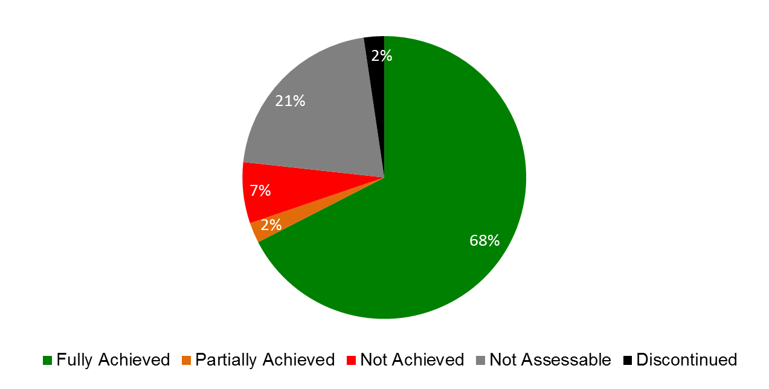

| **Expected Results** | **Performance Indicators** | **Responsible Program(s)** | **TLS** |
| --- | --- | --- | --- |
| VIII.1 More effective communication to a broad public about intellectual property and WIPO’s role | Level of public interest generated in selected major WIPO events/achievements | Program 19 | ⚫ |
| % of stakeholders with positive recognition of WIPO’s mission, activities and organizational image | Program 19 | ⚫ |
| Program 20 | ⚫⚫⚫ |
|  | % increase in views of WIPO press, video and photographic content | Program 19 | ⚫⚫⚫ |
|  | % increase in global participation in World IP Day via Facebook page (total reach of campaign) | Program 19 | ⚫ |
|  | % increase in views of online publications | Program 19 | ⚫⚫ |
|  | % of users satisfied with the WIPO website | Program 19 | ⚫ |
|  | Increased WIPO influence and engagement on social media | Program 19 | ⚫⚫ |
|  | Increased traffic to the website of WIPO External Offices | Program 20 | ⚫⚫⚫ |
| VIII.2 Improved service orientation and responsiveness to inquiries | % of users satisfied with Library services | Program 19 | ⚫ |
| Customer/stakeholder satisfaction rate | Program 19 | ⚫⚫⚫ |
| Program 20 | ⚫⚫⚫ |
|  | Service Standards targets as defined on WIPO website | Program 19 | ⚫⚫ |
|  | Processing time of information inquiries | Program 20 | ⚫⚫⚫ |
| VIII.3 Effective engagement with Member States | % of Committee Meetings for which pre-Committee information meetings for Member States are held | Program 21 | ⚫ |
|  | % of letters to the DG from Member States are responded to within 2 weeks | Program 21 | ⚫ |
|  | % of adherence and other WIPO Treaty-related actions by Member States processed in a timely manner | Program 21 | ⚫ |
|  | Member States satisfaction levels with the preparation and functioning of the Assemblies | Program 21 | ⚫ |
|  | Timeliness of publication of Assemblies documents | Program 21 | ⚫ |
| VIII.4 Open, transparent and responsive interaction with non-governmental stakeholders | Increased, effective engagement of non-governmental stakeholders at WIPO events and vice-versa | Program 20 | ⚫ |
| VIII.5 WIPO effectively interacts and partners with UN and other IGO processes and negotiations | Use of WIPO's contribution in reports, resolutions and documents from targeted processes | Program 20 | ⚫ |
|  | % of responses to external requests for contributions from the UN, IGOs etc. submitted on time | Program 20 | ⚫ |
|  | No. of IP Programs implemented jointly with other UN bodies and other IGOs | Program 20 | ⚫ |
|  | New joint initiatives with other UN agencies | Program 21 | ⚫ |
|  | HLCM and Subsidiary Networks Closed Recommendations | Program 24 | ⚫ |
|  | % of locally sourced goods and services compared to total amount procured for development activity | Program 24 | ⚫⚫ |
|  | % of spend subject to UN leverage (either common tender or piggy backing) | Program 24 | ⚫ |

## PROGRAM 19 COMMUNICATIONS

**Program Manager Mr. J. Tarpey (Officer in Charge)**

ACHIEVEMENTS IN THE 2014/15 BIENNIUM

1. Program 19 continued to focus on creating and delivering relevant, high quality content, on increasing the visibility and public understanding of WIPO’s work, and on strengthening the culture of service within the Organization.
2. The major e-newsletter project resulted in a new **email** **marketing** solution, which transformed WIPO’s capacity to deliver effective, tailored, digital communications to interested stakeholders. The project included the complete overhaul and redesign of WIPO’s multiple e-newsletter offerings, the establishment of a newsletter policy to assure quality service to subscribers, and the roll-out in June 2015 of a sophisticated newsletter mailing platform in six languages. Some 508 newsletter mailings from different WIPO areas were dispatched in the first six months of operation. The mailing platform also enabled the launch of the WIPO Wire, a biweekly newsletter in six languages, which – for the first time – provided a quick and engaging way to keep abreast of WIPO’s wide-ranging activities and free resources. The WIPO Wire gained over 10,000 subscribers within the six months from its launch to 2015 year-end, including Member State officials, IP professionals and policy-makers from 173 countries.
3. A more integrated content and media strategy resulted in greater communications **impact** for WIPO’s major events and product launches. The Global Innovation Index (GII) achieved Twitter “trending” status in London on the day of its 2015 United Kingdom launch. Coverage in some of the world’s most influential media helped position WIPO’s flagship IP reports (the GII; the World Intellectual Property Report (WIPR); the PCT, Madrid and the Hague Yearly Reviews; and the World Intellectual Property Indicators) as world reference sources for IP and innovation data. Promotion of the WIPR resulted in some 200 press articles in the week following its release. Concerted press and social media outreach to promote the 2014 Dakar Ministerial Conference gained wide coverage on African broadcast and online media, stimulating public interest in IP and development issues. For all major events, webpages were published in all six languages. Advocacy efforts in support of the Accessible Books Consortium (ABC) were strengthened by the production of a compelling video on ABC capacity building in India.
4. **Engagement** by Member States and the public in the annual World IP Day campaign remained at record levels for both years of the biennium. The 2015 theme, *Get Up, Stand Up – For Music*, inspired some 350 IP Day events reported in 105 countries (up from 236 events in 93 countries in 2013), including a well‑attended roundtable and exhibition at WIPO headquarters. WIPO’s 2015 #WorldIPDay tweets gained 5.2 million potential impressions (compared to 1.55 million in 2013) and some 900 retweets. Participation was truly global with views of the webpage in Chinese exceeding the English version in 2014; while the highest numbers of ’likes’ of the Facebook page came respectively from India, the United States of America, Mexico, Egypt and Brazil.
5. Face-to-face communications included the popular WIPO Briefings Program. In 2014/15, staff delivered tailored presentations to 178 visiting groups, comprising over 4,000 university students from across the globe. Participation in local events, such as the UN Open Day, also provided opportunities for well‑received outreach to the Geneva public.
6. The drive to create original, high quality **editorial and visual content** continued to pay dividends in 2014/15. An infographic created to present the 2015 GII data was retweeted over 400 times, making it WIPO’s most shared social media item to date. Over 425 design products were created for print and online use in 2014/15, including flyers, publications, web content and promotional materials in multiple languages. The bi-monthly WIPO Magazine reached over one million unique page views during the biennium, up 19 per cent, with readers regularly sharing the articles via social media. The revamped, web-based Media Center was developed as a window into WIPO’s work and how it globally benefits the general public, using video content, short reports and longer-form storytelling. In line with global communications trends, views of traditional press releases fell slightly (1.6 per cent), while the more accessible Media Center content drew over 500,000 unique views in the biennium.
7. WIPO’s **video** production continued to intensify in response to the global appetite for video as a preferred communication medium. Some 272 new videos were created, of which 161 were posted on YouTube in 2014/15, including news reporting, innovator/creator stories and promotional pieces. While the 2012/13 viral spike in viewings of the *Pororo* children’s cartoons subsided, the underlying viewing figures for other (non-cartoon) videos continued on an upward trend. Total lifetime views of the WIPO YouTube channel (since its April 2010 launch) sailed past the nine million milestone. WIPO’s photos on Flickr attracted over 2.5 million additional photo views during the 2014/15 biennium, bringing the lifetime total to more than 3.4 million as compared to 900,000 in 2012/13.
8. The second phase of the WIPO **website** overhaul made good progress with the systematic clean-up, improvement and redesign of lower-level pages; improved search functionality; a technical upgrade of the content management system; and preparation of further visual design improvements for implementation in 2016. New web content was created, for example, for the External Offices; Women and IP; the Assemblies; and for all major events, products and new initiatives. High priority was given to increasing the prompt translation and publishing of web content in all six languages. Language Division staff were trained in 2015 to directly input Arabic, Chinese and Russian content onto the website – improving the quality, quantity and speed of web publishing in these languages. WIPO’s **social media** continued to achieve strong engagement levels on Twitter, and work began on a social media strategy review for implementation in 2016/17.
9. The **publications** distribution policy was implemented to make all WIPO publications and studies available online for free downloading. Efforts were stepped up to cut the production, storage and shipping of paper publications, including the introduction of an external print-on-demand service. The new publications management system, introduced late 2015 and which replaced the obsolete stock control and order processing system, should help facilitate further cost efficiencies. In response to requests from Member States, 15 new Depository Libraries were established in the biennium, bringing the total to 105, while the WIPO Library welcomed 2,044 visitors and responded to 1,323 requests for information from around the world.
10. The **brand development** work carried out in 2012/13 to strengthen recognition of WIPO’s corporate identity was mainstreamed in 2014/15. Editorial and design review processes ensured systematic attention to clarity and consistency in the expression of WIPO’s role, mission and values across the Organization’s verbal and visual communications. The stakeholder perceptions survey conducted in 2014 resulted in the identification of the principal attributes on which WIPO is judged by its stakeholders, and the development of a tool for monitoring WIPO’s perceived performance in relation to “drivers” of the Organization’s reputation.
11. The strong commitment to responding promptly and effectively to all of WIPO’s diverse stakeholders remained at the heart of the Organization’s ongoing emphasis on promoting a **service culture** and included the roll out of the new WIPO Service Charter, internal presentations and awareness activities, and the second “Netiquette” Week. Staff in the central Customer Service Center processed 92 per cent of the 10,280 enquiries they received in less than one working day, and 100 per cent of the 283 complaints received in less than eight working hours. The WIPO Inquiry Notification System (WINS) was rolled out to Madrid Registry customer service teams, enabling the more efficient processing of over 7,000 customer queries per month, 12,000 across the Organization in general. **Customer satisfaction** monitoring included comprehensive satisfaction surveys of PCT (for the first time in nine languages) and Madrid Registry users.
12. The design, planning and implementation of activities undertaken by Program 19 were informed by relevant DA Recommendations. Program 19 continued to build the IP Advantage database of case studies (a CDIP-endorsed DA initiative), which gained 468,200 page views in 2104/15 (compared to 312,000 in 2012/13); and provided editorial, design, video, web and other communications support to numerous DA‑related products and outputs by other programs across the Organization.

PERFORMANCE DATA

|  |  |  |  |  |  |  |  |
| --- | --- | --- | --- | --- | --- | --- | --- |
| **Expected Result:** VIII.1 More effective communication to a broad public about intellectual property and WIPO’s role | | | | | | | |
| **Performance Indicators** | **Baselines** | | **Targets** | | **Performance Data** | | **TLS** |
| Level of public interest generated in selected major WIPO events/ achievements | *Updated Baseline end 2013:* Sample event= launch of annual Global Innovation Index (GII). Aggregate views (for 11 week period after 2013 launch) of all web content (webpages, press release, infographics) = 45,564 + 685 video views  *Original Baseline P&B 2014/15:* (Sample event) 12,111 unique page views of press release on the 2012 Global Innovation Index (GII) in a 1 month period. | | 10% increase in views of relevant web page | | Annual GII launch: Aggregate views (for 11 week period after launch) totaled 53,062 web content views + 9,563 video views for 2014; and 140,475 web content views + 10,653 video views for 2015.  Increase (2015 vs. 2013) = +208% for web content; and  +1455% for video. | | **Fully Achieved** |
| % of stakeholders with positive recognition of WIPO’s mission, activities and organizational image | *Updated Baseline end 2013:* 87% of survey respondents perceived WIPO’s public image as good, very good or excellent. 81% of survey respondents perceived WIPO as the global forum for the promotion of IP. (WIPO Service Orientation Survey results, August 2013).[105]  *Original Baseline P&B 2014/15:*  65% of survey respondents perceived WIPO as the global leader in the protection and promotion of IP (WIPO Stakeholders Perceptions Survey, January 2012) | | 75% | | 70% of survey respondents perceived WIPO as the global forum for the promotion of IP services, policy, information and cooperation[106]. 85% of survey respondents agree or strongly agree that WIPO has a good overall reputation. *(Source: WIPO Stakeholders Perceptions Survey, June 2014)* | | **Fully Achieved** |
| % increase in views of WIPO press, video and photographic content | *Updated Baseline end 2013:*  (i) average no. of unique views/press release was 5,506 (143,169 views for 26 press releases issued in 2013. All languages.)  (ii) average no. of views/video was 16,612 (3,787,601 views for 228[107] videos)  (iii) 900,000 lifetime photo views on Flickr  *Original Baseline P&B 2014/15:*  (i) In 2012, average no. of unique views/press release was 3,575. (92,958 for 26 articles issued in 2012)  (ii) In 2012, average no of views per video was 3,280 (478,888 views for 146 total videos)  (iii) 155,000 total photo views on Flickr at end 2012 | | (i) 10 % increase in average no. of views per press release  (ii) 10% increase in average views per video on the WIPO YouTube channel  (iii) Target: 300,000 additional photo views on Flickr | | In 2014/15:  (i) the average no. of unique views per press release was 4,467 (-1.6% compared to 2012/13)   * 75,173 views for 18 releases issued in 2014. (-24.2% as compared to 2013) * 72,232 views for 15 releases issued in 2015 (-12.5% as compared to 2014)   (ii) the average views per video was 12,871 (5,006,946 for 389 videos end 2014/15) (‑31%)  (iii) 2,541,702 additional photo views on Flickr (+182%) (3,441,702 lifetime views at end 2015) | | **Not Achieved**  **Not Achieved**  **Fully Achieved** |
| % increase in global participation in World IP Day via Facebook page (total reach of campaign) | *Updated Baseline end 2013:* 414,121 people saw World IP Day content through our 2013 Facebook campaign (cumulative reach [constant])  *Original Baseline P&B 2014/15:* 379,600 people saw World IP Day content through our 2012 Facebook campaign | | 30% increase in number of people who see our World IP Day Facebook content (total reach) | | In 2014/15, a total of 1,020,128 people saw World IP Day content through Facebook campaigns (+28.5% as compared to 2012/13):   * 563,816 in 2014 * 456,312 in 2015 | | **Fully Achieved** |
| % increase in views of online publications | (i) *Updated Baseline end 2013:* 3,940,490 downloads of free publications in 2013 (all languages)  (ii) 450,499 unique views of the WIPO Magazine site in 2013 (all languages)  (i) *Original Baseline P&B 2014/15:* tbd (comparable statistics not available for 2012)  (ii) 409,265 unique views of the WIPO Magazine site in 2012 | | (i) 10% increase in total publications views online  (ii) 10% increase in views of WIPO Magazine site | | (i) New web-base statistical tools and methodologies were still under development at the end of the biennium, as a result of a delay in project implementation.  (ii) 1,024,787 unique views of the WIPO Magazine site over 2014/15, representing a 19.2% increase compared to 2012/13. | | **Not Assessable**  **Fully Achieved** |
| % of users satisfied with the WIPO website | tbd | | ≥ 60% are satisfied | | No survey was conducted in 2014/15. | | **Not Assessable** |
| Increased WIPO influence and engagement on social media | *Updated Baseline end 2013:*  (i) “Klout” influence score was 64 (out of 100) at the end of 2013  (ii) 6,744 total retweets in 2013  *Original Baseline P&B 2014/15:*  (i) “Klout” influence score was 62 on Jan 1, 2013  (ii) 3,112 total retweets in 2012 | | (i) “Klout” influence score of 73  (ii) 30% increase in total yearly number of retweets | | (i) Klout scores were 66 at end 2015; and 64 at end 2014. *Note: Indicator discontinued due to limited comparability & relevance following changes in Klout methodology.*  (ii) yearly average of 13,362 retweets, i.e. 171% increase compared to previous biennium. | | **Dis- continued**  **Fully Achieved** |
| **Expected Result**: VIII.2 Improved service orientation and responsiveness to inquiries | | | | | | | |
| **Performance Indicators** | | **Baselines** | | **Targets** | | **Performance Data** | **TLS** |
| % of users satisfied with Library services | | *Updated Baseline end 2013:* 94% of respondents to a feedback questionnaire sent to the registered external visitors (Library users) who had used the Library in 2013 were satisfied or highly satisfied  *Original Baseline P&B 2014/15:* tbd | | ≥ 70 % satisfied visitors and online customers | | 70% of respondents to a feedback questionnaire of Library users were highly satisfied with the services. (100% satisfied or highly satisfied) | **Fully Achieved** |
| Customer/ stakeholder satisfaction rate | | *Updated Baseline end 2013:*  84% of Madrid and Hague customers satisfied or highly satisfied:  Madrid= 80%  Hague= 88%  *Original Baseline P&B 2014/15:* 2012 survey results: 86% of Madrid and Hague customers satisfied or highly satisfied | | ≥ 86% satisfied or highly satisfied | | Overall, 85% of PCT and Madrid customers were satisfied or highly satisfied:  PCT= 89%  Madrid= 81%  Hague customers’ satisfaction was not evaluated in 2014/15. | **Fully Achieved**  **Fully Achieved**  **Not Assessable** |
| Service Standards targets as defined on WIPO website | | *Updated Baseline end 2013:*  Not baselined  *Original Baseline P&B 2014/15:* to be defined for specific areas | | *Defined Target:* Customer Service Center standards:  (i) 90% of tickets processed within 1 day  (ii) 90% of complaints processed within 8 working hours  *Original Target P&B 2014/15*: to be defined for specific areas | | (i) 92% of tickets processed within 1 day  (ii) 100% of complaints processed within 8 working hours | **Fully Achieved**  **Fully Achieved** |

RISK REPORTING FOR THE BIENNIUM

| **Risk(s) to the Program achieving its Results** | **Mitigation plans in place or under implementation** | **Evolution of Risk(s) and Mitigation Strategies Over the Biennium** | **Impact on the Program’s Performance** |
| --- | --- | --- | --- |
| The proliferation of new demands prevents the Program from achieving the focus and impact necessary to deliver effective communications. | A limited number of major WIPO events/products/ achievements will be identified each year as the agreed top priorities for promotion and marketing. | Mitigation strategy was implemented effectively. Major events prioritized and successfully promoted included World IP Day; Global Innovation Index launch; launch of World IP Report; Assemblies; African Ministerial Conference. | Focus and impact is being achieved, as reflected in increased media/social media coverage and website traffic for all major events. |
| WIPO is unable to keep pace with changing trends and technological developments, and therefore loses visibility and influence in the digital communications environment. | Program staff are encouraged to continually acquire new skills and update their knowledge through training and self-learning; Flexible structures enable sharing of new knowledge and skills; External resources and partnerships are being used to extend the in-house capacity. | Mitigation strategies were implemented effectively. Digital skills training included web usability, web content writing, social media, web analytics, HTML.  New technology introduced to equip WIPO with high performance e-newsletter communications and marketing platform. Also, the re-profiling of print-based and clerical functions to digital-focused communications activities contributed to strengthened capacity. | No major impact on program performance except in the area of web analytics where the delayed implementation of new tools undermined the Program’s ability to measure certain key performance indicators. |

RESOURCE UTILIZATION

Budget and Actual Expenditure (by result)

*(in thousands of Swiss francs)*



Budget and Actual Expenditure (personnel and non-personnel)

*(in thousands of Swiss francs)*



A. 2014/15 Final Budget after Transfers

1. The decrease in the 2014/15 Final Budget after Transfers was mainly due to: (i) the transfer of the WIPO Information Center to Program 21 (Executive Management) in the second half of 2014; (ii) the transfer of personnel resources to support the increased workload in the Hague Registry following the accession of additional countries to the Geneva (1999) Act of the Hague Agreement; and (iii) the transfer of non‑personnel resources for an intern (to Program 23 which centrally manages interns) to support the work of the WIPO Magazine and to assist in the preparations for World IP Day 2015.

B. 2014/15 Budget Utilization

1. The slightly lower than budgeted personnel expenditure was primarily due to the retirement of staff and a subsequent delay in filling the vacated posts. The lower than budgeted non-personnel expenditure was mainly due to the postponement of a customer feedback survey for the Hague System and the partial postponement of the implementation of two IT projects (PROdest contact database and ACD Call Distribution System) to the next biennium.

## PROGRAM 20 EXTERNAL RELATIONS, PARTNERSHIPS AND EXTERNAL OFFICES

**Program Managers Director General**

**Mr. M. A. Getahun**

**Mr. Y. Takagi**

**Ms. B. Wang**

ACHIEVEMENTS IN THE 2014/15 BIENNIUM

EXTERNAL RELATIONS AND PARTNERSHIPS (Mr. M.A. Getahun)

1. In the 2014/15 biennium, the UN and its Member States concluded a number of major negotiating processes of relevance to WIPO’s work. These included the adoption of the Addis Ababa Action Agenda (AAAA) during the Third International Conference on Financing for Development Conference (FFD3); the adoption of Transforming Our World: the 2030 Agenda for Sustainable Development; and the adoption of the Paris Agreement under the framework of the UN Framework Convention on Climate Change (UNFCCC). As a specialized agency of the UN, and in line with its mandate and with WIPO DA Recommendations 30 and 40, WIPO continued to play its role in supporting these processes through its strategic engagement and the provision of balanced and evidence-based information and timely responses to specific requests for contributions and cooperation. In 2014/15, Program 20, including through the WIPO Coordination Office to the UN in New York, engaged, *inter alia*, in the following processes:

* Contributions to the implementation of the outcomes of the World Summit on the Information Society (WSIS) and the 10-year review of the implementation of the outcomes of WSIS in response to the Economic and Social Council (ECOSOC) resolution 2013/9, and in support of DA Recommendation 24. WIPO was also actively engaged in the WSIS+10 High Level events in both 2014 and 2015, where the Director General addressed the Opening Sessions. WIPO also engaged actively in the Internet Governance Forum (IGF) in 2014 by co-organizing two workshops on *“The Business of Creativity”* and on *“Creating, Protecting, and Providing Access to Digital Culture”.* In 2015, a WIPO Open Forum that examined WIPO’s work and engagement with Creative Commons (CC) along with other Intergovernmental Organizations (IGOs) was also organized to promote greater open access policies and to look at WIPO’s activities in the field of software development, including vis-à-vis Open Source and the Video Games Industry;
* Contribution to the 2014 and 2015 MDG Gap Task Force Reports, where in line with DA Recommendation 22, WIPO worked with the WTO and WHO on the sections of the Report related to access to affordable and essential medicines;
* WIPO contributed nine partnerships to the Small Island Developing States (SIDS) Action Platform, and participated in the Interagency Consultative Group working on implementation of the SAMOA Pathway outcome document. In the context of the Third International Conference on SIDS, Samoa, September 2014, WIPO organized a side event on Using the IP System for SIDS’ Sustainable Cultural and Economic Development;
* Participation in the Inter-Agency Task Team on Science, Technology and Innovation for the SDGs (IATT) as part of the Technology Facilitation Mechanism (TFM), as well as the Inter-Agency Expert Group on Indicators for the SDGs. WIPO participated in particular in the IATT work streams for the organization of the Multi-Stakeholder Forum on Science, Technology and Innovation for the SDGs, and the mapping exercise for an Online Platform for Technology Facilitation as part of the TFM. WIPO, together with UNCTAD and UNIDO, co-organized an event on Synergies among Industrialization, Innovation and Trade to Foster Sustainable Development, at the UN New York in May 2015. Also in this context, WIPO in collaboration with the UN Department of Economic and Social Affairs organized a side event on The Transformative Role of Technology and Innovation in Development, at the UN New York in October 2015;
* Work on technology in the UN Framework Convention on Climate Change (UNFCCC), in particular the UNFCCC Technology Mechanism, the Technology Executive Committee (TEC) and the Climate Technology Center and Network (CTCN). In this context, the Program supported a TEC Workshop on National Systems of Innovation presenting the Global Innovation Index at the UNFCCC June 2014 Sessions and co-organized a side event with the International Renewable Energy Agency (IRENA) in 2014. In 2015, the Program organized a side event on *"Policies and Evidence to Support Climate Change Technology Transfer and Innovation"* to launch the WIPO Global Challenges Report: *"Innovation and Diffusion of Green Technologies: The Role of Intellectual Property and Other Enabling Factors"* during the UNFCCC June 2015 Sessions as well as an exhibition of Innovative Clean Technologies during COP 21 in Paris, December 2015;
* In the context of the UN Convention on the Rights of Persons with Disabilities, and the UN campaign “2015 – Time for Global Action, For People, For Planet”, WIPO in collaboration with the UN Department of Economic and Social Affairs, organized a panel event on *Innovative Technologies: Making the world of books accessible to people who are print disabled,* at the UN in New York in March 2015; and
* Contributions to the UN Secretary-General (SG) reports on: (i) UN System Support for the New Partnership for Africa's Development (NEPAD); and (ii) the rights of persons with disabilities pursuant to the UN Human Rights Council resolution 24/3, as well as to the UN Enable Newsletter and the revision of the UNESCO Recommendation on the Status of Scientific Researchers (1974).

1. Throughout the biennium, WIPO also continued to promote strengthened partnerships with key institutional partner IGOs as follows:

* Working in cooperation with UNCTAD, the United Nations Office in Geneva (UNOG), the International Trade Center (ITC), the *Département du Développement Économique du Canton de Genève, Université de Genève* (UNIGE) and the *Fédération des Entreprises Romandes (FER)*, WIPO renewed its active participation in the Geneva based Global Entrepreneurship Week (GEW) and co-organized a week of events and training sessions for the GEW 2014 and 2015. WIPO’s focus was primarily on innovation promotion, youth entrepreneurship and the organization of capacity building sessions on patent information, SMEs and IP. (Supporting implementation of DA Recommendations 4, 11 and 40, as well as the work of Programs 11, 14 and 30);
* Cooperation with the WHO remained a high priority throughout the biennium. In addition to the work undertaken in cooperation with Programs 1, 14 and 18 in the context of the WIPO‑WHO‑WTO trilateral cooperation, WIPO effectively engaged at other relevant WHO meetings and processes, as well as at a series of meetings in the framework of the UN process on Non-communicable Diseases (NCDs). With respect to Recommendation 14 on providing advice to developing countries and LDCs on the implementation and operation of the rights and obligations, and the understanding and use of flexibilities contained in the TRIPS Agreement, Program 20, in cooperation with the substantive WIPO sectors, ensured that activities undertaken with the WTO and WHO reflected this Recommendation;
* Working with Programs 1, 2, 3, 4, 9, 17 and 18, Program 20 ensured WIPO’s effective engagement in the WTO TRIPS Council and coordinated WIPO’s participation in WTO national, regional and international workshops on various topics, and in the WTO Symposium “Realizing Development Objectives of the IP System: LDC Priority Needs for Technical and Financial Cooperation” in Geneva, and the WTO Annual Workshop on Trade and Public Health; and
* In addition, cooperation with other UN agencies, in particular, CERN, International Organization for Standardization (ISO), the ITU, UNESCO, and UNIDO were strengthened and continued to provide mutual support to achieve WIPO’s expected results and the implementation of the WIPO Development Agenda.

1. WIPO’s work to mobilize partnerships and voluntary financial contributions for IP projects continued throughout 2014/15 and reflected the continuing and successful mainstreaming of DA Recommendation 2 in the Program’s activities. A significant part of that work was to provide advice and guidance to WIPO projects such as WIPO GREEN, WIPO Re:Search and the Accessible Books Consortium (ABC) in identifying potential donors and developing strategies to establish partnerships and attract financial support.

NGO AND INDUSTRY RELATIONS (Director General)

1. Throughout the biennium, WIPO continued to identify and promote opportunities to enhance the engagement of non-governmental stakeholders in its activities. In 2014 and in 2015, WIPO facilitated a number of different fora through which it sought the participation of and cooperation with civil society representatives, including workshops and seminars, consultations on specific projects and side-events. Such opportunities provided for continued open, transparent and responsive interaction with these stakeholders, consistent with DA Recommendation 42. The third and fourth annual meetings with the Director General organized exclusively for accredited NGOs were held in the spring of 2014 and 2015, respectively, providing a valuable forum for a direct exchange of views on the international IP system generally and the work of WIPO specifically.
2. In addition, WIPO maintained its close collaboration with non-governmental stakeholders through the continued development of multi-stakeholder platforms and partnerships that contribute to the promotion of IP as a tool for economic growth and development worldwide. In particular, following the successful adoption of the Marrakesh VIP Treaty in 2013, WIPO launched a seminar series in 2014 entitled “From Policy to Practice: Implementing the Marrakesh Treaty and Making Accessible Books Available” to provide guidance to and help raise awareness among all stakeholders of the treaty provisions and practical multi-stakeholder initiatives aimed at increasing the availability of books in accessible formats, such as the Accessible Books Consortium. Further, in 2015, a notable example of effective engagement with non-governmental stakeholders that contributed to the objective of highlighting IP as a tool for the promotion of innovation, creativity and economic transformation was the organization of a Young African Innovators, Creators and Entrepreneurs Workshop in the context of the Dakar 2015 African Ministerial Conference. The results of this workshop, including its recommendations, were reported directly to the Ministerial Conference, which was also noted in the final *Dakar Declaration on Intellectual Property for Africa*.

EXTERNAL OFFICES

1. WIPO’s network of External Offices form an integral part of the Organization, designed to bring WIPO’s services and cooperation closer to Member States, stakeholders and partners with a view to enhancing efficiency and effectiveness of program delivery, as well as responding to the specific needs and priorities of the countries and/or regions they serve. In 2014, the network of Offices grew to five, with the opening of the WIPO Offices in China (WOC) and in the Russian Federation (WRO) in 2014. The results achieved during the reporting period continued to underscore the contribution that External Offices bring to the implementation of the Organization’s mandate.

WIPO Brazil Office (WBO) (Director General/Mr. N. Prasad)

1. During the biennium, the WBO devoted considerable attention to strengthening national capacity in Brazil and the promotion of WIPO services. In support of the National Institute of Industrial Property (INPI), which prioritized improving its productivity and efficiency, the WBO assisted in the organization of activities designed to build capacity in the area of patent examination. An example was the collaboration with the National Confederation of Industries on a series of workshops, which were held to inform about existing international initiatives concerning collaborative schemes for patent examination
2. The Office devoted considerable energy to engaging with stakeholders in Brazil to increase awareness of the benefits of IP protection and the importance of commercialization of IP assets. In this regard, the WBO engaged closely with the National Association of Research and Development of Innovative Enterprises (ANPEI) and was invited to participate in two committees established by it, namely, a committee concerned with fostering innovation and a committee focused on IP. This provided a valuable platform to highlight the importance of the PCT and to explain its procedures.
3. The Brazil Funds-in-Trust (FIT) for the support of South-South Cooperation, established in 2012 and managed by the WBO, continued to provide the Office with valuable opportunities to advance initiatives, particularly in the area of technology transfer and IP commercialization. The Regional Workshop on IP and Technology Transfer held in Uruguay in December 2014 brought together several countries (Argentina, Brazil, Chile, Paraguay and Uruguay) and provided an opportunity to share information and expertise regarding the development of national and institutional IP strategies and strategic models for fostering innovation. The FIT also permitted the organization of training programs in several regions of Brazil, which built local capacity in the areas of technology licensing and patent drafting.
4. The WBO reached out to local and UN partners in Brazil on issues of mutual interest as a way of leveraging and maximizing resources to advance the mandate. Working with UNDP and the Brazilian Innovation Agency (FINPE), a project was initiated to train negotiators on issues related to technology and development. To this end, under a new Fund-in-Trust signed with UNDP and FINPE in October 2015, a Training Program for Technology Development Negotiators was held, which benefitted twenty‑eight technology managers. With respect to the promotion of WIPO’s platforms, the Office continued its collaboration with the Brazilian National Association of Innovation and Technology Transfer Managers (FORTEC) on WIPO GREEN, which began to show results in 2015, as the first seven technologies developed by Brazilian institutions/firms were uploaded into the database.
5. The Office also focused attention in 2014/15 on the economic advantages conferred by geographical indications and the benefits of design protection. A concentrated focus was also directed to the promotion of the Madrid System, with Brazilian industry particularly active in co-organizing debates on the advantages of the Madrid Protocol for the competitiveness of global Brazilian companies.  In addition, the WBO worked in coordination with Program 7 (Arbitration, Mediation and Domain Names) to strengthen collaboration with the Brazilian Franchising Association (ABF) for the promotion of mediation services in the context of franchising and technology transfer contracts.
6. In cooperation with the Federation of Industries of the State of Rio de Janeiro in Brazil (FIRJAN), Cornell University and the Technology Network of Rio de Janeiro (REDETEC), and with the support of the National Institute of Industrial Property of Brazil (INPI), the WBO jointly organized the regional launch of the 2015 Global Innovation Index (GII), which took place in Rio de Janeiro.in September 2015.

WIPO Office in China (WOC) (Ms. B. Wang)

1. The WOC was established in July 2014 and was engaged throughout the latter half of the year in establishing itself and consolidating its administrative set-up. In this regard, close cooperation was established with the host country, particularly the Ministry of Foreign Affairs, the State Intellectual Property Office (SIPO), the State Administration for Industry and Commerce (SAIC), the National Copyright Administration of China (NCAC) and the Beijing Municipal Government which greatly facilitated the Office’s ability to quickly become operational.

1. In both 2014 and 2015, China was the third and seventh largest user of the PCT and Madrid systems respectively and so the promotion of WIPO’s services to the market in China was a priority for the Office from the outset. PCT applications from China saw a 38 per cent increase in 2014/15 (55,394) as compared to 2012/13 (40,134). Madrid System applications from China saw a two percent increase in 2014/15 (4,461) as compared to 2012/13 (4,373). Indeed, 2015 witnessed a record number of applications from China (2,401) since its accession to the System in 1989. Events were organized in and around Beijing and further afield aimed at the current and potential users of WIPO’s services. Linkages with industry and other stakeholders evolved and were further strengthened during the biennium with a view to broadening the Office’s outreach to users elsewhere in China.
2. The year 2014 witnessed China’s ratification of the Beijing Treaty on Audiovisual Performances. A number of events were organized by the Office in cooperation with the Chinese Government to promote wider understanding of the Treaty. In the meantime, the Office also focused efforts on the promotion of the Marrakesh Treaty. A Roundtable Workshop was organized by the Office in cooperation with NCAC in December 2014, attracting officials from universities and government, at which the possibility of accession and necessary preparatory steps were discussed. The Office also facilitated the production of the Marrakesh Treaty (Chinese version) in Braille, Daisy and audio formats.
3. In the area of industrial designs, the Office continued to support China’s intention to accede to the Hague System. Engagement with senior officials from the administration and legislature was initiated. The Office participated in an International Symposium and organized or co-organized numerous seminars on industrial designs, using these as opportunities to highlight the advantages and nature of the system. Concurrently, the Office engaged directly with the business community to promote the Hague system. As a result, the Chinese company Lenovo was the seventh largest user of the Hague System in 2014. In 2015, Huawei and Xiaomi also started to use the Hague System.
4. The Office was also active during the biennium on a variety of additional initiatives. Discussions with SAIC were advanced with respect to cooperation with China on data exchange concerning the WIPO Global Brand Database, leading to the initiation of a trial data exchange in 2015. The Office continued to promote WIPO’s platforms, and it was noteworthy that the Haier Group (one of the world’s largest electronic appliance manufacturers) and the China Technology Exchange joined WIPO GREEN in 2014 following the establishment of the Office. In addition, the WOC, in cooperation with the WIPO Arbitration and Mediation Center (AMC), undertook a number of promotional activities and training sessions to raise awareness and encourage Chinese stakeholders to use the services offered by the AMC.
5. Meanwhile, the Office initiated activities to promote awareness of its presence and the importance of IP and innovation to China’s development. Prominent examples of this were the 16thCeremony for the WIPO-SIPO Award for the Chinese Outstanding Patented Invention and Industrial Design and the 8th International Exhibition of Inventions hosted by the China Invention Association at which the Office also presented WIPO awards.
6. In November 2015, a MoU was signed between WIPO and NCAC, further strengthening the bi-lateral cooperation with the WOC’s host government. In addition, engagement and cooperation with local governments at the provincial and local levels continued to be strengthened. Notably, two MoUs were signed between WIPO and the Shanghai Municipal Government (2014) and the Beijing Municipal Government (2015).
7. In the area of technical assistance and capacity building, the WOC provided support to Program 11 (WIPO Academy) for the opening of the first WIPO Summer School at the campus of the East China University of Political Science and Law in May 2015, as well as on the preparation of a MoU with the China IP Training Center.
8. Outreach to relevant stakeholders with a view to raising public awareness about WIPO and IPR in China continued to be strengthened in collaboration with Chinese IP authorities, including on the occasion of World IP Day. In July 2015, the WOC organized a seminar for over 80 journalists.
9. In addition, the WOC continued to play an integral role in providing round-the-clock customer service. With two customer service hot-lines and one customer-email box, the WOC answered over 700 inquiries from users of WIPO services in China in Mandarin during local working hours, which significantly raised satisfaction.

WIPO Japan Office (WJO) (Mr. Y. Takagi)

1. During the biennium, the WJO continued to focus its attention on WIPO’ IP systems, Global Databases and multi-stakeholder platforms in the Japanese market. This included the provision of timely and efficient services to users of these services. At one level, this involved the Office’s provision of advice and information to the almost 1,500 inquiries received by the Office in the biennium. At another level, it involved reaching out to users of WIPO services and other stakeholders closely collaborating with and supported by host government institutions, industry and universities in Japan. In this regard, promotional activities included 75 presentations targeting key Japanese stakeholders and attracting approximately 10,000 participants.
2. A significant achievement in the biennium was the accession by Japan to the Hague System in February 2015 with the System entering into force in May, 2015. The WJO provided potential users such as companies and law firms with the latest information on the Hague System. In order to facilitate use of the System, the WJO provided practical training on e-filing and responded to user questions in order to reassure users and increase interest in and use of the System. By the end of the biennium, 411 designs had already been filed using the System in seven and half months.
3. The Office was also focused more broadly on raising awareness of WIPO and its activities. This was achieved through holding numerous meetings with Japanese stakeholders, participating in events, providing lectures at universities and through e-learning, producing key and important WIPO flyers in Japanese, and providing WIPO information on the WJO website. The Office continued to play an important role in ensuring WIPO’s round-the-clock customer service.
4. In addition to the promotion of the PCT and PATENTSCOPE, a member of the WJO who was fully engaged in the promotion of the Madrid System made individual visits to some 200 companies and participated as a speaker in numerous seminars. This initiative, to ensure that current and potential users remain updated with the latest information on legislative changes and trademark databases, contributed to a significant increase in the number of Madrid applications from Japan (as an Office of origin) from 1,845 in 2013 to 2,167 in 2015 (a 17 per cent increase).
5. Additionally, the WJO actively promoted WIPO’s multi-stakeholder platforms. The result of these efforts was reflected in the addition of four Japanese institutes as new partners of WIPO GREEN and one pharmaceutical institution as a member of WIPO Re:Search in the biennium. The WJO‘s efforts also contributed to an increase in WIPO GREEN registrations.
6. The WJO played a crucial role in connecting stakeholders in Japan with headquarters through positive interaction, such as relaying their feedback to relevant sectors at headquarters, creating opportunities for WIPO staff to follow up with stakeholders about WIPO’s Global Services, the Global Databases, the Arbitration and Mediation Center, and the World IP Report.

1. The Japan Funds-in-Trust (FIT) for industrial property continued to provide the WJO with valuable opportunities to assist in the implementation of activities in Japan. The Office maintained and updated a database of case studies in which IP was successfully leveraged to promote development (“IP Advantage”) on the WIPO website. The WJO added 22 new case studies highlighting the use of IP by SMEs and entrepreneurs to the database which now contains over 210 cases. The Office conducted six presentations at universities using the IP Advantage database to provide real-life examples of how IP contributes to development.
2. For the first time, the WJO implemented four short-term fellowships in coordination with counterparts at headquarters (including the WIPO Academy), which included two weeks of training at IP law firms in Tokyo to participants from developing countries in Asia and the Pacific. The fellowships targeted graduates of WIPO’s Master of Law in IP, serving to solidify participants’ classroom knowledge with real-world IP experience.
3. In addition, the WJO served as the pilot office for the implementation of the Global Office Architecture (GOA) IT solution, ensuring seamless integration and secure connectivity to all of WIPO’s administrative IT systems hosted at headquarters.

WIPO Office in the Russian Federation (WRO) (Director General)

1. The WRO was established in July 2014, and as with the WOC, was engaged throughout the latter half of 2014 in establishing itself and consolidating its administrative set-up. In this regard, close cooperation was established with the host country, particularly the Federal Service for Intellectual Property (ROSPATENT), and the Council of the Federation of the Federal Assembly of the Russian Federation, the Court for Intellectual Property Rights, and the Russian State Academy of Intellectual Property (RGAIS). This cooperation greatly facilitated the Office’s ability to quickly become operational.
2. The WRO focused during the biennium on the promotion of WIPO’s services to the Russian market. In this regard, the Office participated in several national events organized by ROSPATENT and WIPO as well as capacity building events in Moscow and other cities which were focused on the promotion of the PCT, Madrid and the Hague systems. In addition, these meetings provided an opportunity to assist the Russian Federation with the development of its TISC network, enhance the capacity of local universities and research institutions with respect to the development of IP policy and to increase awareness of the international IP system. These fora also connected the recently established WRO with national stakeholders, such as the Chamber of Commerce and Industry, which the Office expects to work closely with in the future as it faces the challenge of working across Russia’s many and distant regions and areas.
3. The Office also provided support to its host country on accession to the Beijing Treaty in November 2015, as well as the anticipated accessions to the Marrakesh Treaty and the Geneva Act of the Hague Agreement.
4. In an effort to enhance the capacity of local universities and research institutions with respect to the development of IP policies, the capacity of SME’s in the effective use of IP for the protection of their business assets and to increase awareness of the international IP system among the public, the WRO supported the growth of the TISC network in the Russian Federation, engaging with stakeholder in distant regions of the Russian Federation.
5. Following the proposal of the Government of the Russian Federation, at the end of 2015, the WRO relocated to its new premises in the western part of Moscow at the Skolkovo Innovation Center, an innovation ecosystem supporting new technologies and innovative businesses. The new premises were equipped with the GOA IT solution, ensuring seamless integration and secure connectivity to all of WIPO’s administrative IT systems hosted at headquarters.

WIPO Singapore Office (WSO) (Director General/Mr. N. Prasad)

1. During the 2014-2015 Biennium, the WIPO Singapore Office (WSO) continued to reinforce its presence as WIPO’s Service Center and IP forum for Member States, international organizations, NGOs and businesses in the region and its position as a key actor in the IP ecosystem in ASEAN. The Office remained active in promoting WIPO Global Services across ASEAN. Tangible outcomes in ASEAN for 2014/15 included: (i) a 17 per cent increase over 2012/13 in the number of PCT applications; and (ii) a four per cent increase over 2013 and a 45 per cent increase over 2014 in the number of Madrid applications.
2. The year 2015 marked the tenth anniversary of the establishment of the WIPO Singapore Office. In November 2015, at an event commemorating the milestone, more than 130 people from across ASEAN gathered to reflect on the progress made over the past decade in the context of the IP landscape, and consider the present situation and the likely developments in Singapore and ASEAN in the coming10 years. Attendees included more than 15 Ambassadors and High Commissioners, as well as leaders from Singapore and the region’s IP, innovation and creative communities.
3. Through its organization of, and participation in, events with numerous partners such as the Asian Legal Business (ALB) forum, relevant chambers of commerce and business associations, the Licensing Executive Society (LES), and the National University of Singapore (NUS), the WSO was able to reach out to a large number of stakeholders and users in promoting WIPO’s Global IP Services, WIPO GREEN, WIPO Re-Search, WIPO’s Global Databases, the TISC program, and WIPO CASE.
4. Engagement with ASEAN continued to be enhanced throughout the biennium, and the WSO played an increasingly central role in coordinating activities requested by the Working Group on Intellectual Property Cooperation (AWGIPC) in the implementation of the ASEAN IPR Action Plan 2011‑2015 in the context of the establishment of the ASEAN Economic Community (AEC) by the end of 2015. In addition, workshops were organized in every ASEAN Member State to progress efforts to accede to the Madrid and the Hague systems. Partnerships with stakeholders and partners rendered possible key events in the WSO such as the Sub-Regional Workshop for ASEAN Countries on The Hague System with the Office for Harmonization in the Internal Market/ EU-ASEAN Project on the Protection of Intellectual Property Rights (OHIM/ECAP III) and the WIPO - ASEAN Australia New Zealand Free Trade Area (AANZFTA) Sub Regional Workshop for ASEAN Trademark Examiners on the Madrid System.
5. In 2014/15, the WSO continued to manage and implement the MoU between WIPO and the Government of Singapore, which focuses on enhancing skills and knowledge of IP officials and stakeholders from Asia and the Pacific, organizing or co-organizing three regional seminars. In addition, some 27 technical assistance activities were delivered to 34 Member States to help implement effective IP administration systems, as well as assistance relating to the Madrid and Hague systems, copyright and related rights, CMOs, education, awareness and capacity building. The WSO also organized 17 study visits during the biennium, as compared to six in 2013, for IP stakeholders from across the region as well as from key institutions in Singapore. The WSO partnered with the Intellectual Property Office of Singapore (IPOS) to organize key events and workshops, and facilitated speakers for the annual regional IP Week@SG initiatives for government, businesses, innovators and creators. In addition, six workshops were organized covering a broad range of topics. The WSO continued its support of the activities undertaken by the WIPO AMC through the latter’s presence in Singapore.
6. Outreach was strengthened in 2014/15 through WSO’s speaking engagements at key events and conferences of intergovernmental organizations, NGOs, national institutions in the region or based in Singapore, such as the ASEAN IP Association (AIPA), Asia-Pacific Economic Cooperation (APEC), the Asia-Europe Foundation (ASEF), the Malaysian IP Association (MIPA), the Economic Institute for ASEAN and East Asia (ERIA), the Confederation of International Societies of Authors and Composers (CISAC), and the Central IP and International Trade Court of Thailand. In this respect, the WSO received study visits by a number of delegates covering all the range of IPRs and all WIPO activities. The office also strengthened its ties with academia through its participation in regular lectures at the National University of Singapore (NUS), the Singapore Management University (SMU) and the Assas-Sorbonne Campus at INSEAD Singapore. Its participation in WIPO Summer Schools in Singapore, the Republic of Korea and India, as well as involvement in a Master of Laws program in Australia and discussions relating to collecting societies in Japan has also broadened the geographical scope of its activities.

1. In 2015, the WSO was integrated into the broader IT environment of WIPO under GOA, providing staff with secured access to the full suite of WIPO’s administrative IT systems hosted at headquarters, and greatly enhanced video conferencing capability. This capability, along with the IP Phone system that was implemented in the WSO in 2014 significantly improved communication between headquarters and the WSO. The Office continued to play an important role in ensuring the WIPO round-the-clock customer service.

PERFORMANCE DATA[108]

|  |  |  |  |  |  |  |  |  |  |  |  |  |  |  |  |
| --- | --- | --- | --- | --- | --- | --- | --- | --- | --- | --- | --- | --- | --- | --- | --- |
| **Expected Result:** II.1 Increased use of the PCT route for filing international patent applications | | | | | | | | | | | | | | | |
| **Performance Indicators** | | **Baselines** | | | **Targets** | | **Performance Data[109]** | | | | | **TLS** | | | |
| % of PCT filings[110] | | *Updated Baseline end 2013:*  2012: 588  2013: 657 (WBO)  2012: 43,523  2013: 43,771 (WJO)  2012: 1,124  2013: 1,282 (WSO)  *Original Baseline P&B 2014/15:* 519 in 2011 (WBO) tbd (WJO) tbd (WSO) | | | 15% increase  (WBO)  1% increase (WJO)  5% increase (WSO) | | 2014/15: 1,128 (-9%)   * 2014: 580 (-12%) * 2015: 547 (-6%)   (WBO)  2014/15: 86,616 (-1%)   * 2014: 42,381 (-3%) * 2015: 44,235 (+4%)   (WJO)  2014/15: 2,809 (+17%)   * 2014: 1,394 (+9%) * 2015: 1,415 (+2%)   (WSO) | | | | | **Not Achieved**  **Not Achieved**  **Fully Achieved** | | | |
| % of policy makers, government officials, and IP Practitioners and participants in targeted workshops with enhanced understanding of the PCT and related topics | | n/a (WBO)  n/a (WJO)  n/a (WSO) | | | 75% (WBO)  75% (WJO)  75% (WSO) | | |  |  |  | | --- | --- | --- | |  | 2014 | 2015 | | WBO | 80% | 75% | | WJO | 94% | 91% | | WSO | 93% | 95% | | | | | | **Fully Achieved**  **Fully Achieved**  **Fully Achieved** | | | |
| **Expected Result:** II.4 Wider and better use of the Hague system, including by developing countries and LDCs | | | | | | | | | | | | | | | |
| **Performance Indicators** | | **Baselines** | | | **Targets** | | **Performance Data** | | | | | **TLS** | | | |
| No. of countries that have formulated and/or are engaged in policies outlining their accession to the Hague Agreement | | n/a (WSO) | | | 7 ASEAN Member States (WSO) | | 7 ASEAN Member States (Cambodia, Indonesia, Lao People’s Democratic Republic, Malaysia, Philippines, Thailand, Viet Nam) | | | | | **Fully Achieved** | | | |
| % of policy makers, government officials, and IP Practitioners and participants in targeted workshops with enhanced understanding of the Hague System | | n/a (WBO)  n/a (WJO)  n/a (WSO) | | | 75% (WBO)  75% (WJO)  75% (WSO) | | 75% (WBO)  94% (WJO)  85% (WSO) | | | | | **Fully Achieved**  **Fully Achieved**  **Fully Achieved** | | | | |
| No of contracting parties to the Hague System in the Asia and the Pacific Region | *Updated Baseline end 2013:*  Japan not party (WJO)  2 in the ASEAN region (Brunei Darussalam and Singapore) (WSO) | | | Accession by Japan (WJO)  7 in the ASEAN region (WSO) | | | | Accession by Japan in 2015 (WJO)  No additional contracting parties to the Hague System in the ASEAN Region (WSO) | | | **Fully Achieved**  **Not Achieved** | | | | | |
|  | *Original Baseline P&B 2014/15:*  1 in the ASEAN region (WSO) Japan not party | | |  | | | |  | | |  | | | | | |
| **Expected Result:** II.6 Wider and better use of the Madrid & Lisbon systems, including by developing countries and LDCs | | | | | | | | | | | | | | | | |
| **Performance Indicators** | **Baselines** | | | | | **Targets** | | | **Performance Data** | | **TLS** | | | | | |
| No. of countries that have formulated and/or are engaged in policies outlining their accession to the Madrid Protocol | n/a (WSO) | | | | | 6 ASEAN Member States (WSO) | | | 6 ASEAN Member States (Brunei Darussalam, Cambodia, Indonesia, Lao People’s Democratic Republic, Malaysia, Thailand) (WSO) | | **Fully Achieved** | | | | | |
| % of satisfied participants in targeted workshops/seminars held on Madrid related topics | *Updated Baseline end 2013:*  *Original Baseline P&B 2014/15:*  65% (WBO)  65% (WSO) | | | | | > 75% (WBO)  > 75% (WSO) | | | No Madrid-related workshops/seminars were held in Brazil during the biennium (WBO)  86% (WSO) | | **Not Achieved**  **Fully Achieved** | | | | | |
| No. of Contracting Parties to the Madrid Protocol | *Updated Baseline end 2013:* 3 (Philippines, Singapore, Viet Nam) (WSO)  *Original Baseline P&B 2014/15:* 3 (WSO) | | | | | 10 (WSO) | | | 2 additional ASEAN Member States in 2014/15 (Cambodia, Lao Democratic People’s Republic)  5 cumulative) | | **Partially Achieved** | | | | | |
| No. of new registrations (Madrid System) | *Updated Baseline end 2013:*  *2012:* 2,054 *2013:* 1,845 (WJO)  2012 = 327  2013 = 337 (WSO)  *Original Baseline P&B 14/15:*  Madrid statistics for ASEAN, Japan (WSO)  *Original Baseline P&B 2014/15:*  Madrid statistics for ASEAN (WSO) 2012/13  Madrid Statistics for ASEAN, Japan (WJO) 2012/13 | | | | | Increased fillings (WJO)  Increased filings by 5% (WSO)[111] | | | 2014/15: 4,200 (+8%)  2014: 2,033 (+10%)  2015: 2,167 (+7%)  2014/15: 860 (+30%)  2014: 351 (+4%)  2015: 509 (+44%[112]) | | **Fully Achieved**  **Fully Achieved** | | | | | |
| No. of renewals (Madrid System) | *Updated Baseline end 2013:*  2012: 187  2013: 311 (WJO)  2012: 51  2013: 62 (WSO)  *Original Baseline P&B 2014/15:*  Madrid statistics for ASEAN (WSO)  Madrid statistics for ASEAN, Japan (WJO) | | | | | tbd (WJO)  tbd (WSO) | | | |  |  |  | | --- | --- | --- | |  | 2014 | 2015 | | WJO | +49%  (462) | +27%  (588) | | WSO | +13%  (54)[113] | +52%  (82) | | | **Not**  **Assessable**  **Not Assessable** | | | | | |
| **Expected Result:** II.8 International and domestic intellectual property disputes are increasingly prevented or resolved through WIPO mediation, arbitration and other alternative dispute resolution methods | | | | | | | | | | | | | | | | |
| **Performance Indicators** | **Baselines** | | **Targets** | | | | | | **Performance Data** | | **TLS** | | | | | |
| Increased consideration of the use of alternative dispute resolution services in intellectual property transactions, including through the use of WIPO procedures | n/a (WBO) | | 30 disputes presented by Brazilian users at INPI and 4 disputes non-residents presented at WBO to be processed by WIPO MAC (WBO) | | | | | | Due to changes in INPI in 2014, the project on the use of alternative dispute resolution services in IP transactions was put on hold (WBO) | | **Not Achieved** | | | | | |
| **Expected Result:** III.2 Enhanced human resource capacities able to deal with the broad range of requirements for the effective use of IP for development in developing countries, LDCs and countries with economies in transition | | | | | | | | | | | | | | | | |
| **Performance Indicators** | **Baselines** | | **Targets** | | | | | | **Performance Data** | | **TLS** | | | | | |
| % of policy makers, government officials, IP practitioners and participants in targeted workshops with enhanced understanding of CMOs and how to effectively use IP for development | n/a (WBO)  n/a (WJO)  60% (WSO) | | 75% (WBO)  75% (WJO)  > 70% (WSO) | | | | | | 75% (WBO)  100% (WJO)  100% (WSO) | | **Fully Achieved**  **Fully Achieved**  **Fully Achieved** | | | | | |
| **Expected Result:** IV.2 Enhanced access to, and use of, IP information by IP institutions and the public to promote innovation and creativity | | | | | | | | | | | | | | | | |
| **Performance Indicators** | **Baselines** | | **Targets** | | | | | | **Performance Data[114]** | **TLS** | | | | | | |
| No. of users of WIPO's Global Databases: PATENTSCOPE and Global Brand Database | *Updated Baseline end 2013[115]:*  PATENTSCOPE (Q3 2013):   * 3,839 (WBO) * 14,906 (WJO) * 6,772 (WSO)   (Q3 2012):   * 3,891 (WBO) * 15,114 (WJO) * 6,595 (WSO)   Global Brands Database (Q 2013):   * 186 (WBO) * 543 (WJO) * 1,711 (WSO)   (Q3 2012):   * 75 (WBO) * 275 (WJO) * 415 (WSO)   *Original Baseline P&B 2014/15:*  Statistics end 2013 (WBO)  Statistics end 2013 (WJO)  tbd (WSO) | | 5% (WBO)  5% Increase (WJO)[116]  5% increase in ASEAN users (WSO) | | | | | | PATENTSCOPE:  2014/15: 8,533 (+10%)   * 2014: 4,688 (+22%) * 2015: 3,845 (-18%)   (WBO)  2014/15: 30,743 (+2%)   * 2014: 14,711 (-1%) * 2015: 16,032 (+2%[117])   (WJO)  2014/15: 15,525 (+16%)   * 2014: 8,054 (+19%) * 2015: 7,471 (-7.2%)   (WSO)  Global Brand Database:  2014/15: 8,533 (+302%)   * 2014: 532 (+186%) * 2015: 516 (+164%)   (WBO)  2014/15: 30,743 (+789%)   * 2014: 3,096 (+470%) * 2015: 4,173 (+632%)   (WJO)  2014/15: 15,525 (+1,153%)   * 2014: 8,941 (+423%) * 2015: 17,696 (+885%)   (WSO) | **Fully Achieved**  **Not Achieved**  **Fully Achieved**  **Fully Achieved**  **Fully Achieved**  **Fully Achieved** | | | | | | |
| **Expected Result:** VII.2 IP-based platforms and tools are used for knowledge transfer, technology adaptation and diffusion from developed to developing countries, particularly least developed countries, to address global challenges | | | | | | | | | | | | | | | | |
| **Performance Indicators** | **Baselines** | | **Targets** | | | | | | **Performance Data** | | | | **TLS** | | | |
| Participation of stakeholders in WIPO's platform such as WIPO GREEN and WIPO Re:Search | *Updated Baseline end 2013:*  n/a (WBO)  1 (JIPA) (WJO)  No baseline available for WIPO GREEN due to launch of platform in November 2013; 848 visitors to WIPO Re:Search (WSO)  *Original Baseline P&B 2014/15:*  n/a (WBO)  n/a (WJO)  tbd (WSO) | | 30 technologies developed by Brazilian institutions and firms in WIPO GREEN (WBO)  additional cases to WIPO GREEN or new participation to WIPO Re:Search (WJO)  5% increase in ASEAN users (WSO) | | | | | | Some 7 new technologies developed by Brazilian institutions/firms were uploaded in WIPO GREEN in 2015 (WBO)  WIPO GREEN: 22 additional cases in 2014/15 (50 cumulative); 4 additional partners (Waseda Institute, Team E-Kansai, APICI-JIPII and Teijin) in 2014/15 (WJO)  WIPO Re: Search: 4 companies uploaded technologies with the assistance of WJO; 1 new partner (Takeda Pharmaceutical Company)  (WJO)  WIPO GREEN: 21 Users in 2014/15 (WSO)  WIPO Re:Search:   * 959 ASEAN Visitors to WIPO Re:Search for 2014 (13% increase) * 417 ASEAN visitors in 2015 (‑57% decrease)   In addition, 1 new partner from the Philippines (Research Institute of Tropical Medicine)  (WSO) | | | | **Not Achieved**  **Fully Achieved**  **Fully Achieved**  **Not Assessable**  **Not Achieved** | | | |
| **Expected Result:** VIII.1 More effective communication to a broad public about intellectual property and WIPO’s role | | | | | | | | | | | | | | | | |
| **Performance Indicators** | **Baselines** | | **Targets** | | | | | | **Performance Data** | | | | **TLS** | | | |
| Increased traffic to the website of WIPO External Offices | *Updated Baseline end 2013:*  n/a (WBO)  5,900 (WJO)  9,717 page views (WSO)  *Original Baseline P&B 2014/15:*  tbd (WBO)  tbd (WJO)  tbd (WSO) | | Increase traffic by:  5% from Brazil (WBO)  5% (WJO)[118]  5% from ASEAN region (WSO) | | | | | | |  |  |  | | --- | --- | --- | |  | 2014 | 2015 | | WBO | n/a[119] | 1,966 | | WJO | +30%  (7,650 views) | +13%[120]  (7,027 views) | | WSO | +2%  (9,882 views) | +2%  (10,042 views) | | | | | **Not Assessable**  **Fully Achieved**  **Partially Achieved** | | | |
| % of stakeholders with a positive recognition of WIPO's mission, activities and organizational image | n/a (WBO)  n/a (WJO)  n/a (WSO) | | 75% WBO  75% (WJO)  > 70% of participants in major WIPO events (WSO) | | | | | | 75% (WBO)  94% (WJO)  90% (WSO) | | | | **Fully Achieved**  **Fully Achieved**  **Fully Achieved** | | | |
| **Expected Result:** VIII.2 Improved service orientation and responsiveness to inquiries | | | | | | | | | | | | | | | | |
| **Performance Indicators** | **Baselines** | | **Targets** | | | | | | **Performance Data** | | | | | | **TLS** | |
| Customer/stakeholder satisfaction rate | n/a (WBO)  n/a (WJO)  n/a (WSO) | | tbd (WBO)  tbd (WJO)  > 90% of callers are satisfied with the service WSO provides (WSO) | | | | | | No data available (WBO)  95% of callers are satisfied (WJO)  93% of callers are satisfied (WSO) | | | | | | **Not Assessable**  **Not Assessable**  **Fully Achieved** | |
| Processing time of information inquiries | n/a (WBO)  n/a (WJO)  n/a (WSO) | | Tbd (WBO)  Tbd (WJO)  Response prepared within 3 working days in 95% of cases (WSO) | | | | | | Data not available (WBO)  Response prepared within 3 working days in 99% of cases (WJO)  Responses prepared within 3 working days in 95% of cases (WSO) | | | | | | **Not Assessable**  **Not Assessable**  **Fully Achieved** | |
| **Expected Result:** VIII.4 Open, transparent and responsive interaction with non-governmental stakeholders | | | | | | | | | | | | | | | | |
| **Performance Indicators** | **Baselines** | | **Targets** | | | | | | **Performance Data** | | | | | **TLS** | | |
| Increased, effective engagement of non-governmental stakeholders at WIPO events and vice-versa | *Updated Baseline end 2013:*  As at December 31, 2013, 227 representatives of permanently accredited non-governmental organizations observers attended WIPO committee meetings  *Original Baseline P&B 2014/15:* tbd | | 10% increase in engagement of diverse stakeholders | | | | | | In 2014, 292 representatives of permanently accredited NGOs attended WIPO committee meetings (13), which comprised 71.4 per cent of the total number of observers present at those meetings.  In 2015, 196 representatives of permanently accredited NGOs attended WIPO committee meetings, which comprised 85.3 per cent of the total number of observers present at those meetings, resulting in a 13.9 percentage point increase over 2014 | | | | | **Fully Achieved** | | |
| **Expected Result:** VIII.5 WIPO effectively interacts and partners with UN and other IGO processes and negotiations | | | | | | | | | | | | | | | | |
| **Performance Indicators** | **Baselines** | | **Targets** | | | | | | **Performance Data** | | | | | | **TLS** | |
| Use of WIPO's contribution in reports, resolutions and documents from targeted processes | *Updated Baseline end 2013:* 38 submissions in 2012/13, all of which were satisfactorily reflected.  *Original Baseline P&B 2014/15:*  20 out of 24 (end of 2011) | | 100% use | | | | | | 33 submissions in 2014/15, all of which were satisfactorily reflected. | | | | | | **Fully Achieved** | |
| % of responses to external requests for contributions from the UN, IGOs etc. submitted on time | *Updated Baseline end 2013:* 90.5% processed within 5 working days.  *Original Baseline P&B 2014/15:*  tbd (data 2012) | | 100% | | | | | | 254 of 273 (93%) responses submitted on time (within 5 working days) | | | | | | **Fully Achieved** | |
| No. of IP Programs implemented jointly with other UN bodies and other IGOs | 0 (zero) (WSO) | | 2 (WSO) | | | | | | * 2 events with UN agencies (UNEP and UNIDO) * Multiple events with ASEAN-Australia-New Zealand Free Trade Agreement (AANZFTA), the ASEAN Secretariat, Asia-Pacific Economic Cooperation (APEC) and Office for Harmonization in the Internal Market/ EU-ASEAN Project on the Protection of Intellectual Property Rights (OHIM/ECAP) III * 1 forum of the IP Technical Assistance Providers * Joint event with the Pacific Economic Cooperation Council (PECC) attended by eight other international organizations and IGOs * *(cont. next page)* | | | | | | **Fully Achieved** | |
|  |  | |  | | | | | | * Participation in 1 event with the United Nations Association of Singapore (UNAS) * Participation in 1 event of the Policy Partnership on Science, Technology and Innovation group from the Asia-Pacific Economic Cooperation (APEC) (WSO) | | | | | |  | |

RISK REPORTING FOR THE BIENNIUM

|  |  |  |  |
| --- | --- | --- | --- |
| **Risk(s) to the Program achieving its Results** | **Mitigation plans in place or under implementation** | **Evolution of Risk(s) and Mitigation Strategies Over the Biennium** | **Impact on the Program’s Performance** |
| WIPO’s effective interaction with and relevance to UN and other IGO and NGO processes is dependent upon acceptance that WIPO is a credible and reliable source of support, assistance and information. | Ensuring that WIPO contributions are factual, empirically based, balanced, reflective of the views of all stakeholders and timely and well targeted. Development of partnerships to increase the impact of WIPO contributions | The risk was accentuated as major UN processes in the biennium resulted in increasingly detailed and complex requests for contributions. To ensure appropriate mitigation, more intensive coordination was emphasized, both internally and with external partners. | No material impact on the Program’s performance. |
| Resource mobilization targets are not met resulting in an inability to initiate specific IP for development projects. | Ensure high quality projects for resource mobilization which are well targeted to donor funding. Further develop organizational capacity to mobilize and manage extra budgetary resources. Increase understanding of donor priorities and contacts with donors. | This risk is a continuing risk for the Program, which was effectively addressed by the mitigation measures as planned. | No material impact on the Program’s performance. |
| Security concerns and/or natural disaster jeopardize External Offices in achieving Expected Results | Close cooperation with the host government and extension of WIPO business continuity plan to include External Offices | This is a continuous risk, which was effectively mitigated through the envisaged mitigation measures, including closer cooperation with relevant Authorities and enhanced disaster preparedness measures such as the procurement of survival supplies and the creation of an internal communication tree. | No material impact on the Program’s performance. |

RESOURCE UTILIZATION

Budget and Actual Expenditure (by result)

*(in thousands of Swiss francs)*



Budget and Actual Expenditure (personnel and non-personnel)

*(in thousands of Swiss francs)*



A. 2014/15 Final Budget after Transfers

1. The net decrease in personnel resources in the 2014/15 Final Budget after Transfers reflects the transfer of personnel resources to Program 9 to reinforce the activities of the Africa Bureau (reflected as a decrease under Result VIII.4 (Open, transparent and responsive interactions with NGOs).
2. The net increase in non-personnel resources in the 2014/15 Budget after Transfers is due primarily to: (i) the initial allocation of resources to the WOC and WRO; (ii) the transfer of additional funds to the WOC for infrastructure work under the GOA project; and (iii) the transfer of additional funds to the External Offices for the participation of the heads of the External Offices in the WIPO General Assemblies.
3. The adjustments across Expected Results are primarily due to: (i) the initial allocation of resources for the WOC and WRO, which are reflected, in particular, under Results II.1 (Increased use of the PCT) and II.6 (Wider and better use of the Madrid and Lisbon Systems); (ii) the increased focus of the External Offices on more effective communication about WIPO’s Global IP Services reflected under Result VIII.1 (More effective communication to a broad public) and improved customer service reflected under VIII.2 (Improved service orientation and responsiveness to inquiries); and, (iii) the redistribution of resources from VIII.4 (Open, transparent and responsive interactions with NGOs) to VIII.5 (WIPO effectively interacts and partners with UN and other IGO processes) following the internal reorganization of the Program.

B. 2014/15 Budget Utilization

1. Overall budget utilization for the biennium 2014/15 amounted to 81 per cent. This is primarily due to: (i) the openings of the WOC and WRO in July 2014, i.e. mid-year, reflected in particular under Results II.1 (Increased use of the PCT), II.6 (Wider and better use of the Madrid and Lisbon Systems) and III.2 (Enhanced human resources capacities); (ii) the postponement of the activities related to the project on the use of alternative dispute resolution services in IP transactions in the WBO as reflected in Result II.8 (International and domestic IP disputes); (iii) certain capacity building activities reflected under III.2 (Enhanced human resources capacities) being undertaken by other Programs directly in the countries/regions; and (iv) the implementation of cost efficiency measures as regards staff missions, in particular under VIII.5 (WIPO effectively interacts and partners with UN and other IGO processes).

STRATEGIC GOAL IX

**EFFICIENT ADMINISTRATIVE AND FINANCIAL SUPPORT**

**Biennial Performance Dashboard**

The dashboard below provides a summary of the achievements of the expected results in the biennium 2014/15 as measured by the indicators under the Programs contributing to this Strategic Goal.

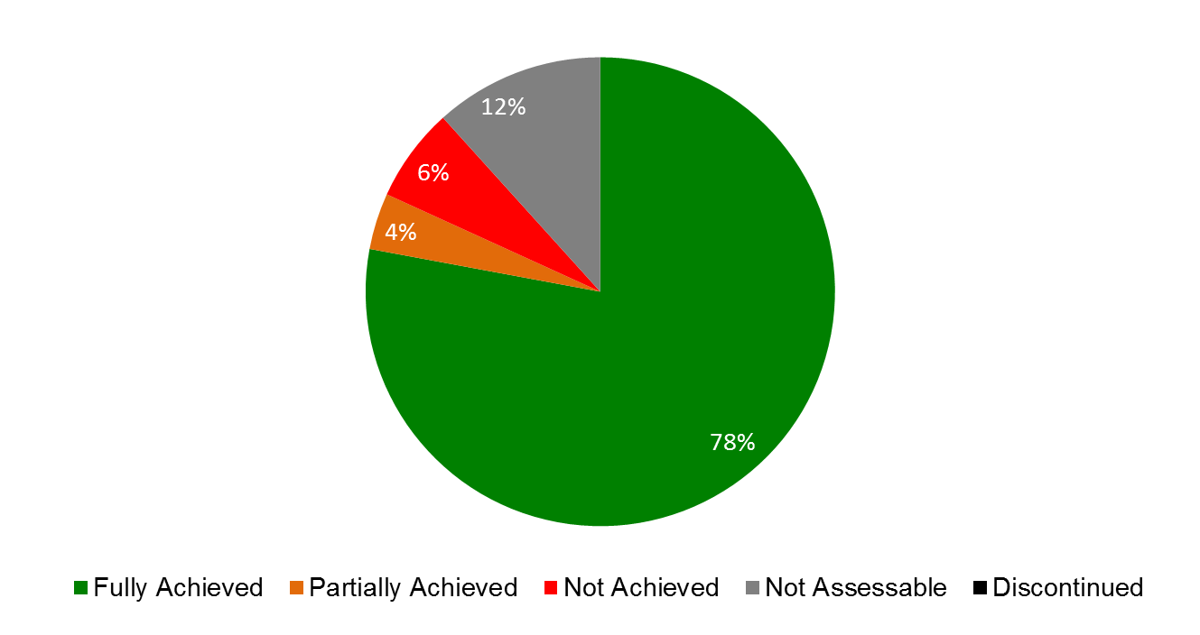

| **Expected Results** | **Performance Indicators** | **Responsible Program(s)** | **TLS** |
| --- | --- | --- | --- |
| IX.1 Effective, efficient, quality and customer-oriented support services both to internal clients and to external stakeholders | Provision of financial and management reports and analysis required by senior management, Program Managers and Member States in accordance with agreed deadlines | Program 22 | ⚫⚫⚫⚫ |
|  | Resolution of internal/external queries received in accordance with established timeframes | Program 22 | ⚫⚫ |
|  | % of staff satisfied with human resource services | Program 23 | ⚫ |
|  | Timely, accurate, and efficient human resources operations services | Program 23 | ⚫ |
|  | Completion of New Conference Hall Project in accordance with quality requirements, on time and within budgetary limits | Program 29 | ⚫ |
|  | Use of conference hall as preferred location for meetings and events by Member States | Program 29 | ⚫ |
|  | Cost savings for goods and services procured by WIPO (derived from RFPs or direct negotiations) | Program 24 | ⚫ |
|  | % of internal clients satisfied with procurement services | Program 24 | ⚫ |
|  | Processing time of travel related requests (eTA, ER, Visas) | Program 24 | ⚫ |
|  | Average ticket cost (TMC and UNDP tickets) | Program 24 | ⚫ |
|  | All types of space on the WIPO campus (workplaces, storage and archiving) are effectively managed | Program 24 | ⚫ |
|  | Buildings in the WIPO campus are renovated/modernized/  transformed to remain fit for purpose | Program 24 | ⚫ |
|  | All types of critical technical installations comply with applicable technical standards | Program 24 | ⚫ |
|  | ICT Systems are cost-effectively hosted and managed in line with business demands | Program 25 | ⚫⚫⚫⚫ |
|  | No. of SLAs for hosted systems and services that are compliant with ICT SLA framework | Program 25 | ⚫ |
|  | ICT Service Continuity of critical systems | Program 25 | ⚫ |
|  | % end-users and business sectors who are satisfied with ICT services | Program 25 | ⚫ |
|  | Comprehensive and integrated communication technologies are easily accessible to staff | Program 25 | ⚫ |
|  | % of internal and external participants satisfied with WIPO Conference Services | Program 27 | ⚫ |
|  | Effective implementation of WIPO Language Policy | Program 27 | ⚫⚫ |
|  | Cost per word of translation | Program 27 | ⚫ |
|  | Quality of translation | Program 27 | ⚫ |
|  | Reduction in printing costs (per page) | Program 27 | ⚫ |
|  | Timely publication of documents for committees and working groups | Program 27 | ⚫ |
| IX.2 An agile and smooth functioning Secretariat with a well managed and appropriately skilled workforce which is effectively delivering results | % of queries for legal advice and services which receive prompt, independent and reliable responses from the Office of the Legal Counsel | Program 21 | ⚫ |
|  | Satisfactory financial report from the External Auditors confirms the conformity of financial operations to the provisions of the applicable WIPO conventions and treaties, the WIPO Financial Regulations and Rules and IPSAS | Program 22 | ⚫⚫ |
|  | Return on invested funds in line with benchmarks established by the Investment Advisory Committee | Program 22 | ⚫ |
|  | Payments (including Madrid and Hague fees) made on time | Program 22 | ⚫ |
|  | % of staff trained expressing satisfaction with training (induction courses, ERP related training, RBM related training) | Program 22 | ⚫ |
|  | % of (WIPO) respondents who perceive that WIPO is accountable for its results | Program 22 | ⚫ |
|  | % of WIPO Programs using performance data for managing Program performance | Program 22 | ⚫ |
|  | Recruitment lead time | Program 23 | ⚫ |
|  | % of organizational units with existing workforce plans linked to annual workplans | Program 23 | ⚫ |
|  | % of newly recruited staff that fits organizational needs | Program 23 | ⚫ |
|  | % of staff whose performance is evaluated against their individual objectives and competencies | Program 23 | ⚫ |
|  | % of critical individual and collective training needs that have been fulfilled | Program 23 | ⚫⚫ |
|  | Average no. of sick leave days per employee (absenteeism) | Program 23 | ⚫ |
|  | % of women in professional and higher positions | Program 23 | ⚫⚫⚫⚫ |
|  | Geographical diversity -  % of Member States represented | Program 23 | ⚫ |
| IX.3 An enabling working environment supported by an effective regulatory framework and appropriate channels to address staff concerns | % of WIPO staff aware of services available from Ombuds-Office and informal conflict resolution mechanism | Program 21 | ⚫ |
| % of survey respondents being aware of WIPO ethics principles and policies | Program 21 | ⚫ |
|  | Financial Regulations and Rules and relevant Office Instructions up to date | Program 22 | ⚫ |
| IX.4 An environmentally and socially responsible Organization in which WIPO staff, delegates, visitors and information and physical assets are safe and secure | Improved physical access to the WIPO campus | Program 24 | ⚫ |
| Reduced impact of WIPO buildings on the environment | Program 24 | ⚫ |
| WIPO premises comply with recommendations in 2009 audit by Institute of Safety and Security (Neuchatel) and UN H-MOSS peripheral security measures | Program 24 | ⚫ |
|  | Information security is reinforced to protect against increasing attacks on the Internet | Program 25 | ⚫ |
|  | Status of ISO 27001 Certification and Information Risk management processes | Program 25 | ⚫⚫⚫ |
|  | Effectiveness of Information Security controls (internal and external facing) | Program 25 | ⚫ |
|  | % of WIPO staff, delegates & visitors reporting a work related injury or incident | Program 28 | ⚫ |
|  | % of timely requests for safety & security assistance at conferences or events held in or outside of Geneva | Program 28 | ⚫ |
|  | Monitoring of physical accessibility measures ensuring that the new conference hall and related facilities are in full compliance with the applicable standards during construction | Program 29 | ⚫ |
|  | Monitoring of environmentally sound measures and energy consumption reduction measures implemented during construction | Program 29 | ⚫ |
|  | Completion of UN H-MOSS peripheral security measures for the new conference hall | Program 29 | ⚫ |
| IX.8 Improved accountability, organizational learning, value for money, stewardship, internal control and corporate governance through assistance from effective and independent oversight | No. interference and perceived independence by key stakeholders | Program 26 | ⚫ |
| EFFECTIVENESS % of work of IAOD which covers high risk/high relevance areas | Program 26 | ⚫ |
| EFFICIENCY: (a) Timely and qualitative completion of oversight reports; (b) Number of audits & evaluations completed as per oversight workplan; (c) Number of complaints/reports of possible misconduct handled | Program 26 | ⚫⚫⚫⚫ |
|  | RELEVANCE, ADDED VALUE & STEWARDSHIP ‑ Tangible cost savings or improvements made in business processes and systems | Program 26 | ⚫ |
|  | ORGANIZATIONAL LEARNING ‑ Uptake of Lessons and Recommendations from Oversight Processes | Program 26 | ⚫⚫ |

## PROGRAM 21 EXECUTIVE MANAGEMENT

**Program Manager Director General**

ACHIEVEMENTS IN THE 2014/15 BIENNIUM

1. Effective engagement with Member States remains a critical element in achieving progress towards the realization of the Organization’s nine Strategic Goals. The biennium 2014/15 highlighted challenges in many areas as Member States sought to achieve consensus around the Strategic Goals. In this regard, the Director General led focused discussions with Member States in various fora to assist and provide the space in which consensus could be achieved. Progress was realized in some areas, notably the consensus achieved by Member States after several years of difficult negotiation on the way forward for opening new External Offices in WIPO. In other areas, particularly on the normative front, there was still a considerable distance to travel by Member States on many issues. These same mechanisms of communication, such as briefings for Ambassadors, provided an invaluable means by which to receive feedback and advice for enhancing progress on many issues.
2. Internal engagement also formed an important part of program implementation, driving progress towards realizing the Strategic Goals. Reaching out to staff, through regular briefings by the Director General and in other fora, formed a critical part of explaining and seeking buy-in to necessary change. Regular sessions of the Senior Management Team (SMT) provided direction to organizational units, operationalizing strategic decisions. The Director General’s second term provided an opportunity to inject new energy and ideas into the SMT with the introduction of four new members while retaining the experience of four members of the previous SMT. The SMT was also expanded to include managers responsible for human resources and legal affairs, important cross-cutting elements in strategic decision making. With successful completion of the Strategic Realignment Program in 2013, the SMT played a key role in ensuring that gains, in terms of culture and values, efficiency in business processes and better alignment of programs, structure and resources to Strategic Goals, were maintained.
3. The Office of the Legal Counsel (OLC) continued to deliver prompt and reliable legal advice and services consistent with statutory requirements and applicable law on constitutional, contract, and treaty law, as well as administrative and human resource related matters, to the Director General, the Secretariat and Member States in the context of strong and, in some areas, increasing demand. The OLC was closely involved in the process for the nomination and appointment of the Director General in 2014, as well as providing legal support and assistance to the Diplomatic Conference for the Adoption of a New Act of the Lisbon Agreement in May 2015. A key challenge in 2014/15 was the commencement of the new administration of justice system, which came into force on January 1, 2014. The OLC was able to seamlessly adapt to the new system in representing the Administration in staff appeals and complaints. The OLC ensured that the depositary functions of WIPO-administered treaties were carried out efficiently despite the increased requests for advice. In 2014/15, the WIPO Lex database of IP legal information was accessed by more than 3.3 million users worldwide, compared to 2.2 million in 2012/13. The OLC devoted considerable focus to engaging with non-governmental stakeholders, in particular through the annual meetings of accredited non-governmental organizations with the Director General in 2014 and 2015.
4. The Assemblies Affairs and Documentation Division (AADD) coordinated the organization of the regular sessions of the Assemblies in 2014 and 2015, in addition to two extraordinary sessions in March 2014 (Coordination Committee) and May 2014 (General Assembly). Around 1,000 delegates from more than 200 Member States and Observers attended each of the regular sessions. Organizational innovations and rationalizations continued to be introduced and/or refined (e.g. webcasting, electronic registration, badges with pictures, new travel procedures) to enhance the effectiveness of the meetings, to reduce their cost and carbon footprint, as well as to promote more openness and accessibility of the proceedings. Documentation was delivered well in advance. The attention to improving efficiency and the Member States’ experience of the Assemblies was reflected in the very high satisfaction levels achieved in surveys.
5. WIPO continued to engage actively with the UN system, including in the Chief Executives Board for Coordination (CEB) and in its two committees – the High Level Committee on Management (HLCM) and the High Level Committee on Programmes (HLCP), providing an important opportunity for WIPO to highlight its perspectives within UN System deliberations, to share good administrative and operational practices, as well as the opportunity to involve the Organization in assisting to build coherence across the UN System.
6. In December 2014, the ODG was allocated responsibility for the overall coordination of all External Offices and the supervisory responsibility for the WIPO Singapore Office and the WIPO Brazil Office. A dedicated series of initiatives were launched in January 2015 to ensure greater functional coherence and the full integration of the External Offices into the work of the Organization. These included the first ever meeting of Heads of Offices at headquarters, numerous working groups to examine organizational policy impact on External Offices, regular bi-monthly video conferences, the roll out of a new IT architecture to provide seamless connectivity between Offices and headquarters, and the revamping of webpages of the Offices. Indications were immediately evident that a new culture of External Offices is being inculcated in WIPO, which has positively impacted on mandate implementation.
7. The Ethics Office was impacted by the absence of a Chief Ethics Officer from April to July 2014. A Chief Ethics Officer *ad interim* was designated from August 2014 until September 2015 when the new Chief Ethics Officer was appointed. The Ethics Office continued to implement its Declaration of Interest Policy, which notably includes the disclosure of financial interests in compliance with IPSAS and oversaw the Policy to Protect Against Retaliation for Cooperating in an Oversight Activity or Reporting Misconduct or Other Wrongdoing (Whistleblower Protection Policy), which articulates the value placed on the participation of all staff in the Organization’s oversight by affording protection against retaliation. The WIPO Code of Ethics continued to provide a common platform of guiding principles and values expected to be observed by WIPO staff in the conduct of their functions, and the Office provided advisory services to staff at all levels on its implementation. In addition, mandatory ethics training was provided to staff upon joining the Organization, ensuring that new colleagues are well versed in the ethics culture of WIPO. Engagement with the Ethics Network of Multilateral Organizations was also intensified
8. The Office of the Ombudsperson, an integral part of the Organization’s accountability and integrity framework, was strengthened with the entering into force of the new administration of justice system on January 1, 2014. A key aspect of this reform was the recognition of the importance of conflict prevention by inclusion of informal conflict resolution in the Staff Regulations and Rules. Complementing this change, the Office focused on building awareness and conflict competency among staff through training initiatives, which included: workshops on nonviolent communication; an organization-wide roll-out of a two-day conflict management training for 631 staff; and orientation programs for new staff.
9. In May 2014, the role of Business Continuity Coordinator was established in the ODG. Considerable progress was made to put in place required elements of a dedicated organizational resilience system, such as the publication of an Organizational Resilience Policy and Strategy, and the implementation and launch of the Organization's first Emergency Notifications System (ENS). Building on these policy foundations, a business impact analysis was initiated to identify the Organization’s priorities and expectations for recovery and reconstitution in the event of a disruptive event. These elements are expected to provide a solid basis for further evolution of the system in the coming biennium.
10. In February 2014, with the appointment of the Chief of Protocol and Event Management, events activities were merged with Protocol to enhance and optimize engagement with Member States and other stakeholders. The General Assemblies in 2014 and 2015 saw a significant increase in the number of events and side-events requested and organized, including the inauguration of the new WIPO Conference Hall in 2014. These events were positively received, as reflected in Delegates’ satisfaction levels. The numbers of events held in WIPO, including national days, increased in 2015, thereby fulfilling an important role of the WIPO Campus as a meeting space for Member States and other stakeholders.
11. The Program, including the work of the ODG, continued to play a key role in providing the overall strategic guidance and oversight to facilitate the mainstreaming and implementation of the WIPO Development Agenda by all relevant Sectors within WIPO.

PERFORMANCE DATA

|  |  |  |  |  |  |
| --- | --- | --- | --- | --- | --- |
| **Expected Result:** IV.2 Enhanced access to, and use of, IP information by IP institutions and the public to promote innovation and creativity | | | | | |
| **Performance Indicators** | **Baselines** | **Targets** | **Performance Data** | | **TLS** |
| Increase in the no. of WIPO Lex users | *Updated Baseline end 2013:* Total of 2,236,486 users in 2012/13 (1,461,841 in 2013; 774,645 in 2012)  *Original Baseline P&B 2014/15:* 1,123,930[121] | 20% | A total of 3,350,643 users in 2014/15 (49.8% increase over 2012/13)   * 1,506,508 (2014) * 1,844,135 (2015) | | **Fully Achieved** |
| **Expected Result:** VIII.3 Effective engagement with Member States | | | | | |
| **Performance Indicators** | **Baselines** | **Targets** | | **Performance Data** | **TLS** |
| % of Committee Meetings for which pre-Committee information meetings for Member States are held | *Updated Baseline end 2013:* 81% from a survey of secretaries of committees.  *Original Baseline P&B 2014/15:* 80% | 90% | | 97% from a survey of secretaries of committees | **Fully Achieved** |
| % of letters to the DG from Member States are responded to within 2 weeks | *Updated Baseline end 2013:* 81% from an assessment of incoming and outgoing correspondence  *Original Baseline P&B 2014/15:* 80% | 80% | | 80% from an assessment of incoming and outgoing correspondence | **Fully Achieved** |
| % of adherence and other WIPO Treaty-related actions by Member States processed in a timely manner | *Updated Baseline end 2013:* 98% of notifications of adherence and other treaty related actions processed within three days.  *Original Baseline P&B 2014/15:* 95% processed within three days (end of 2012) | 90 % processed within three days | | 90% of notifications of adherence and other treaty related actions processed within three days. | **Fully Achieved** |
| Member States satisfaction levels with the preparation and functioning of the Assemblies | *Updated Baseline end 2013:* 88% from the 2012 WIPO Assemblies survey (a survey was not possible in 2013 due to exceptional circumstances; survey will be reintroduced in 2014).  *Original Baseline P&B 2014/15:* 88% satisfied with arrangements | 85% satisfied with arrangements | | 87% (2014 WIPO Assemblies Survey[122])  90% (2015 WIPO Assemblies Survey) | **Fully Achieved** |
| Timeliness of publication of Assemblies documents | *Updated Baseline end 2013:* For the regular Assemblies, 95% of all documents were published at least two months in advance of the Assemblies.  *Original Baseline P&B 2014/15:* 100% relevant documents published two months before the Assemblies | 100% relevant documents published two months before the Assemblies | | In 2014/15, 97% of all relevant documents were published two months before the Assemblies:   * 95% for the 2014 Assemblies * 99.5% for the 2015 Assemblies | **Fully Achieved** |
| **Expected Result:** VIII.5 WIPO effectively interacts and partners with UN and other IGO processes and negotiations | | | | | |
| **Performance Indicators** | **Baselines** | **Targets** | **Performance Data** | | **TLS** |
| New joint initiatives with other UN agencies | *Updated Baseline end 2013:* Two new initiatives undertaken by the Director General (Director General Chaired the HLCM in 2012; launch by the Director General of the Global Innovation Index at ECOSOC in Geneva in 2013).  *Original Baseline P&B 2014/15:* Two | Two | Two new initiatives undertaken by the Director General:   * Application for Observer Status to the International Organization for Migration (IOM) in 2014; * Membership in 2015 of the United Nations Interagency Working Group on a Technology Facilitation Mechanism (IAWG)(established by the Addis Ababa Action Agenda) | | **Fully Achieved** |
| **Expected Result:** IX.2 An agile and smooth functioning Secretariat with a well managed and appropriately skilled workforce which is effectively delivering results | | | | | |
| **Performance Indicators** | **Baselines** | **Targets** | **Performance Data** | | **TLS** |
| % of queries for legal advice and services which receive prompt, independent and reliable responses from the Office of the Legal Counsel | *Updated Baseline end 2013:* Despite an increase in the number of requests for advice as well as the fields covered, 98% of the queries received prompt and reliable responses from the OLC.  *Original Baseline P&B 2014/15:* 100% | 90% | In the context of strong and increasing demand for its services, the OLC continued to provide prompt, independent and reliable responses to 95% of queries and requests for advice received in 2014/15. | | **Fully Achieved** |
| **Expected Result:** IX.3 An enabling working environment supported by an effective regulatory framework and appropriate channels to address staff concerns | | | | | |
| **Performance Indicators** | **Baselines** | **Targets** | **Performance Data** | | **TLS** |
| % of WIPO staff aware of services available from Ombuds-Office and informal conflict resolution mechanism | *Updated Baseline end 2013:* 2013 Staff Feedback Survey: 63%  familiar with Ombuds-function,  32% somewhat familiar  77% as per the 2012 user feedback survey (conducted in March 2013).  *Original Baseline P&B 2014/15:* 2011 Staff Feedback Survey: 44% of staff familiar with Ombuds function, 49% somewhat familiar | Increase of staff awareness to 60% | The Staff feedback survey planned for 2015 was not conducted. | | **Not Assessable** |
| % of survey respondents being aware of WIPO ethics principles and policies | *Updated Baseline end 2013:* 98% from the SRP Core Values Survey (conducted from January to February 2013).  *Original Baseline P&B 2014/15:* 70% | 75% | The Staff survey planned for the biennium was not conducted. | | **Not Assessable** |

RISK REPORTING FOR THE BIENNIUM

|  |  |  |  |
| --- | --- | --- | --- |
| **Risk(s) to the Program achieving its Results** | **Mitigation plans in place or under implementation** | **Evolution of Risk(s) and Mitigation Strategies Over the Biennium** | **Impact on the Program’s Performance** |
| WIPO has made significant investments in and realized rapid progress and gains through the Strategic Realignment Program, which concluded in early 2013. If there is not a sustained focus on improvement by the senior management, staff and Member States, the Organization risks the gains made by the SRP being diminished. Initiatives which include new processes (e.g. business continuity management and risk management) are at particular risk. | From the outset, the governance structure of the SRP included SMT oversight and regular IAOC reporting which has helped entrench responsibility for the mainstreaming of the SRP.  As the Organization enters the post-SRP period, continued strong focus from Senior Management will ensure that the Core Values and the outcomes of each initiative are maintained and built on for the benefit of WIPO and its stakeholders. | This risk steadily reduced over the course of the biennium, primarily as a result of the pro-active follow up strategies in place, which included embedding responsibility for new and robust functions to further evolve and develop the initiatives seeded within the context of the SRP, including risk management, business continuity, ethics and integrity, internal communication etc.). | The impact on the Program’s performance was not material, however, the impact on the performance of the respective Programs where these SRP initiatives have found their homes, as well as on the performance of the Organization overall continued to be very positive, contributing significantly to the continued strengthening of transparency, accountability and providing an enabling platform for WIPO to serve its customers and stakeholders |
| WIPO's effective engagement with Member States is of paramount importance to achieve timely results. At risk is reduced progress in WIPO’s inter-governmental processes, including in normative discussions and increased cost or extended schedules for implementing approved Programs. As the international rule-making body for IP, such a situation would negatively impact WIPO’s credibility. | Continued close, trusted and transparent coordination between the Secretariat and Member States. | The overall risk for the Program as described has not changed materially during the period under consideration. The same applies to the mitigation plans in place, which will continue to be relevant for the 2016/17 biennium. | The risks that are inherent to the normative activities of the Organization are constantly mitigated through continued close, trusted and transparent coordination between the Secretariat and Member States.  No material impact was observed on the Program’s performance. |

RESOURCE UTILIZATION

Budget and Actual Expenditure (by result)

*(in thousands of Swiss francs)*



Budget and Actual Expenditure (personnel and non-personnel)

*(in thousands of Swiss francs)*



A. 2014/15 Final Budget after Transfers

1. The increase in personnel resources under the Final Budget after Transfers was primarily due to:
2. the transfer of posts into the Program following the merger of the events function with the protocol function reflected under Expected Result VIII.3 (Effective engagement with Member States);
3. the establishment of a Business Continuity Coordinator role reflected under Expected Result IV.2 (Enhanced access to, and use of, IP information); and,
4. the strengthening of the OLC to meet the increasing demand for legal services reflected under Expected Results VIII.3 (Effective engagement with Member States) and VIII.5 (WIPO effectively interacts and partners with UN and other IGO processes).
5. The increase in non-personnel resources was primarily due to additional requirements in support of enhanced effective engagement with Member States (Expected Result VIII.3).
6. In addition to the above, the shifts of resources across Expected Results, in particular Expected Result IX.2 (An agile and smooth functioning Secretariat), also reflect the new and more accurate methodology for allocation of personnel resources resulting from enhancements made to the EPM planning system for the 2014 and 2015 workplanning exercises.

B. 2014/15 Budget Utilization

1. The lower than budgeted personnel expenditure was primarily due to: (i) the absence of a Chief Ethics Officer during the first eight months of 2015; and (ii) ongoing recruitment processes, in particular in the Offices of the Legal Counsel and Ombudsperson. This also led to lower expenditure under the related non-personnel resources.

## PROGRAM 22 PROGRAM AND RESOURCE MANAGEMENT

**Program Manager Mr. A. Sundaram**

ACHIEVEMENTS IN THE 2014/15 BIENNIUM

1. Building on the strides made in 2012/13, WIPO’s program and financial management continued to be strengthened in 2014/15. In order to utilize resources more effectively, to establish best practice as regards planning, performance management, facilitation and support for operational activities across the Organization and to strengthen the “second line of defense[123]”, a strategic restructuring within the Program which was undertaken in November 2013, was fully embedded in 2014. This involved (i) the merger of the Program Management and Performance Section and the Budget Section, to create the Program Performance and Budget Division (PPBD), which allowed for a more holistic approach to program management; (ii) the refining of the role of the “Office of the Controller”, which enabled separation and assignment of clear responsibilities for risk management coordination, compliance and internal controls, the review and maintenance of the financial regulatory framework and follow-up on oversight recommendations; and (iii) the incorporation of the management and support of the Organization’s administrative applications into Program 22, allowing for synergy and effective mainstreaming of the systems delivered by the ERP portfolio of projects.
2. Good progress was made during the biennium with respect to further embedding a results-based culture and strengthening WIPO’s performance management cycle. The biennial and annual workplanning processes continued to be enhanced in 2014/15. In 2014, position level planning was introduced driving linkages between the Programs’ expected results and individual staff objectives closer together leading to increased transparency and accuracy with regard to personnel resource allocation and utilization.
3. The evolution of the ERP EPM planning system was integral to the progress made during the biennium. To this end, the year 2014 saw the launch of two new key modules to support WIPO’s performance cycle, namely the ‘Implementation and Monitoring’ and the ‘Performance Assessment’ modules, both of which enable a more proactive and improved approach to program management and assessment. In addition, these tools also enabled the ability for improved comparative analysis between the approved workplans and the changes throughout the year, enhancing program management and informing future planning cycles, including the planning for the biennium 2016/17.
4. Further integration of the ERP components in 2014/15 also enabled improved reporting capabilities and analytical tools. For the first time in 2014, the Administrative Integrated Management System (AIMS) financial and the EPM planning systems were integrated, allowing for improved reporting on budget versus actual expenditure from EPM. In addition, the ERP Human Resources (HR)/Payroll system was brought into operation in January of 2014, and integration with the EPM planning system was completed in April, resulting in significantly enhanced position management capabilities. The Business Intelligence (BI) module evolved during the biennium, with initial management dashboards having been developed and released to core administrative areas (HRMD, Procurement and Travel, and Program Planning and Finance) in 2014 and released organization wide in 2015. A Risk Management dashboard was also developed and released in 2015.
5. Other enhancements to the ERP portfolio of products during the biennium, which enabled strengthened and more efficient management functionalities, included: (i) a major upgrade of the AIMS financial system to version 9.2 that would ensure WIPO’s systems have the latest functionality with a view to reducing support costs; (ii) the release of a first phase of HR self-service, allowing personal information changes to be made by staff, reducing paper flows and manual data entry by HR operations; (ii) the payment of non-Geneva based staff through the PeopleSoft payroll system; (iii) an improved education grant process ; (iv) full integration of PCT Translation with the AIMS Financial System reducing manual workflows; (v) the creation of a single training portal for ERP, ICT and HRMD; (vi) absence and overtime data integrated into BI; (vii) the introduction of data control dashboards into BI to ensure consistency across applications, and proactively highlight discrepancies for investigation / resolution.
6. In accordance with the Risk Management Roadmap, a formalized and coherent risk management and internal controls framework for the Organization was developed, including WIPO’s Accountability Framework, WIPO’s Risk Appetite Statement, establishment of the Risk Management Group (RMG), issuance of the Risk Management Policy, and the development of a Risk Management and Internal Controls Manual.
7. In order to facilitate real-time access to risk and control information, to support proactive risk and control management, as well as to render efficient responses to audit bodies, an Enterprise Risk Management (ERM) tool was implemented in the second half of 2014 and used to support the 2015 workplanning process as well as the 2016/17 Program and Budget process. The processes of monitoring and reporting risks and internal controls were also strengthened, with (i) the introduction of semi-annual risk reviews and reports, (ii) the continued integration of risk management within the program performance management processes, and (iii) the development of an internal control framework, utilizing ERM to record WIPO’s identified and assessed controls.
8. The regulatory framework continued to be updated, with a number of Office Instructions (OIs) reviewed and/or issued (procurement, official hospitality, travel, home leave, salary advances, cash guidelines for external offices, reserves, property management, voluntary contributions, Policy on Usage of Mobile Telecommunication Devices, Establishment of the Risk Management Group, Risk Management Policy). The Financial Regulations and Rules (FRR) were reviewed and revised, as agreed by Member States, and a new electronic tool was put in place to support the management of programmatic designations.
9. The comprehensive study of WIPO’s treasury practices and risks, launched in 2013, was completed in spring 2014, resulting in a series of recommendations, including with regard to the practice of hedging as a means to reduce exposure to foreign currency fluctuations in the PCT. A comprehensive review of the proposed hedging strategy was carried out in 2015 with a final decision taken to build a hedging model, which will simulate the effects of hedging on the results of the 2014/15 biennium and those of the year 2016. Following extensive research amongst various banks and financial institutions and a study of the many investment policies in operation throughout the UN system, a new investment policy for the Organization was prepared and approved by Member States in 2015. Its implementation commenced in late 2015 with the preparation of an Expressions of Interest for investment fund management. Additional treasury-related initiatives implemented included: i) enhanced cash management to minimize the impact of the negative interest rates currently prevailing in Switzerland including work towards the establishment of two new banking relationships; ii) efforts made to increase the number of payees receiving payments from WIPO through electronic means; iii) introduction of two additional credit cards for payment by the Organization; and iv) introduction of a Dynamic Currency Converter allowing a credit card holder to be debited in his/her local currency with a view to reducing credit card commissions for the Organization.
10. With regard to the PCT, two new International Search Authorities (ISAs) were appointed in 2014, requiring new payments and system changes. New members have joined Madrid and Hague (eight in total) which has involved an adaptation of systems whilst new distributions have been introduced following the adherence of Benelux and later, Australia to the Madrid E-Filing service (IRPI).
11. Under the MOU with the USPTO, EPO and the IB, the pilot project to establish whether the management of foreign exchange risks associated with the payment of search fees can be improved was successfully launched and was, more recently, extended for two years. An evaluation of the project is planned in 2016 as part of the analysis of the netting proposal, which was one of the recommendations arising from the treasury study.

PERFORMANCE DATA

|  |  |  |  |  |
| --- | --- | --- | --- | --- |
| **Expected Result:** IX.1 Effective, efficient, quality and customer-oriented support services both to internal clients and to external stakeholders | | | | |
| **Performance Indicators** | **Baselines** | **Targets** | **Performance Data** | **TLS** |
| Provision of financial and management reports and analysis required by senior management, Program Managers and Member States in accordance with agreed deadlines | Monthly closure to be completed 10 working days after month end (except January where monthly close is determined by progress of annual close)  Static online reports available overnight; quarterly Observatory reports within 2 weeks of closure; monthly standard reports within 1 week of closure | Same as baselines  Parameterized interactive online reports available as result of ERP/BI work in the course of 14/15; quarterly Observatory reports within 2 weeks of closure; monthly standard reports within 1 week of closure | Closed on the 10th working day or earlier for 10 months. Exceptions were January (as per baseline) and October, as a result of the system upgrade.  Initial management dashboards were developed and released to core administrative areas (HRMD, Procurement and Travel, and Program Planning and Finance) in 2014 and released organization wide in 2015. A Risk Management dashboard was also developed and released in 2015.  On average, quarterly and monthly standard reports within 6 working days of closure  Quarterly Observatory Reports on average within 1 month of closure | **Fully Achieved**  **Fully Achieved**  **Fully Achieved**  **Not Achieved** |
| Resolution of internal/external queries received in accordance with established timeframes | 75% of tickets to be closed (resolved) within 3 days of receipt  Provide advice and/or respond to budgetary files and queries within 72 hours | Same as baselines  Provide advice and/or respond to budgetary files and queries within 48 hours | In 2014/15, on average 84.5% of tickets registered in the WINS system were closed within 3 days:   * In 2014, 86% within 3 days, of which 71% on the same day, 6% within 2 days and 9% within 3 days. * In 2015, 85% within 3 days, of which 67% the same day, 12% within 2 days and 6% within 3 days.   In 2014/15, the Program Performance and Budget Division (PPBD) received approximately 2,200 files requiring programmatic and/or budgetary validation. The average response time was 1.9 days. | **Fully Achieved**  **Fully Achieved** |
| **Expected Result:** IX.2 An agile and smooth functioning Secretariat with a well-managed and appropriately skilled workforce which is effectively delivering results | | | | |
| **Performance Indicators** | **Baselines** | **Targets** | **Performance Data** | **TLS** |
| Satisfactory financial report from the External Auditors confirms the conformity of financial operations to the provisions of the applicable WIPO conventions and treaties, the WIPO Financial Regulations and Rules and IPSAS | Clean audit report received for 2012 and 2013 and answers provided to all audit recommendations | Clean audit report for both years of the biennium | Clean audit report received for 2014.  At the time of publication, the results of the 2015 audit had yet to be released.  Answers provided to all audit recommendations received during 2014 and 2015. | **Fully Achieved**  **Not Assessable** |
| Return on invested funds in line with benchmarks established by the Investment Advisory Committee (IAC) | Return on invested funds in line with the benchmark established by the IAC in 2012/13 | Return on invested funds in line with the benchmark established by IAC in 2014/15 | This was achieved during the biennium. Investments continued to be with Swiss authorities, in line with the benchmark established in 2014/15.  New benchmarks are to be established by the IAC following the introduction of a new investment policy in autumn 2015. | **Fully Achieved** |
| Payments (including Madrid and Hague fees) made on time | 90% of payments made within seven days of payment terms or receipt date (in case of late receipting) for those without other workflow issues (e.g. PO not dispatched, etc...) | 90% of payments to be made within two three days of receipt of invoice | All invoices were paid in accordance with baselines except for ex-post facto invoices or where there was no requisition in the system.  Monthly distributions were paid/credited to a current account/applied against contributions in the following month as required by Regulations. | **Fully Achieved** |
| % of staff trained expressing satisfaction with training (induction courses, ERP related training, RBM related training) | *Updated Baseline end 2013:*  Induction courses: 94%  RBM/ERP related training: 96%    *Original Baseline P&B 2014/15:* tbd | 85% | * Induction courses: 94% * RBM/ERP-related training: 94% * ERM related training 87% (2015 only) * Project Management in a Results-based Environment: 97% (64%-excellent; 33% -good) | **Fully Achieved** |
| % of WIPO respondents who perceive that WIPO is accountable for its results | *Updated Baseline end 2013:* 80.7%  *Original Baseline P&B 2014/15:* 75% | 80% | 94% (30% strongly agree; 64% agree) of respondents[124] indicated that performance data are used for accountability to Member States. *(as per the 2014/15 PPR Validation Report)* | **Fully Achieved** |
| % of WIPO Programs using performance data for managing Program performance | *Updated Baseline end 2013: 79% (as per 2012/13 PPR Validation Report)*  55%[125] (as per 2010/11 PPR Validation Report)  *Original Baseline P&B 2014/15:* 50 | 70 | * 94% (30% strongly agree; 64% agree) of respondents[126] indicated that performance data are used to regularly monitor the implementation of Program Activities * 85% (27% strongly agree; 58% agree) of respondents[127] indicated that performance data are used for decision-making purposes   *(Data are as per the 2014/15 PPR Validation Report)* | **Fully Achieved** |
| **Expected Result:** IX.3 An enabling working environment supported by an effective regulatory framework and appropriate channels to address staff concerns | | | | |
| **Performance Indicators** | **Baselines** | **Targets** | **Performance Data** | **TLS** |
| Financial Regulations and Rules and relevant Office Instructions (OIs) up to date | *Updated Baseline end 2013:* OIs issued in 2012 and 2013. FRRs amended in 2012 and 2013 as deemed necessary  *Original Baseline P&B 2014/15:* OIs issued in 2012 and 2013. FRR amended in 2012 as deemed necessary | Review and revision of regulatory framework if/as appropriate | Review and/or issuance of OIs, including those dealing with:   * Procurement General Principles and Basic Rules * Salary Advances * Policy on Usage of Mobile Telecommunication Devices * Establishment of the Risk Management Group * Home leave * WIPO Risk Management Policy * Cash Management and Financial Guidelines for WIPO’s External Offices Scope and Purposes * Official Hospitality * Official Travel and Related Expenses * Policy on Reserves * WIPO Policy on Property Management * WIPO Policy on the Management of Voluntary Contributions   Review and amendments to the FRRs in October 2014 and in October 2015  Review of Programmatic and Administrative Designations and UNDP Signatories, and introduction of an electronic application to manage programmatic designations | **Fully Achieved** |

RISK REPORTING FOR THE BIENNIUM

|  |  |  |  |
| --- | --- | --- | --- |
| **Risk(s) to the Program achieving its Results** | **Mitigation plans in place or under implementation** | **Evolution of Risk(s) and Mitigation Strategies Over the Biennium** | **Impact on the Program’s Performance** |
| A continuing global economic and financial crisis may result in income levels being significantly lower than planned. This combined with an inability to react promptly in order to reduce expenditure to an appropriate level would potentially create a deficit and have detrimental impact on Program delivery. | The Organization maintains the amount of reserves at the appropriate level (around 18 per cent of the biennial budget) to be in a position to face a potential decrease in income.  The Secretariat monitors expenditure closely through a strengthened income and expenditure monitoring process and by means of the Crisis Management Group. | Income levels were higher than expected over the course of the biennium, and appropriate mitigation actions continued to be taken in respect of the risk identified.  The reserve target level was reviewed by Member States as part of the review of WIPO’s Policy on Reserves, and this target was increased to 22 per cent in order to better mitigate this risk.  The Organization, through the newly established Risk Management Group (RMG), continued to monitor the evolution of income and expenditures closely.  On January 15, 2015, the Swiss National Bank unpegged the Swiss franc from its minimum exchange rate of CHF1.20 per 1 Euro and introduced negative interest rates for retail customers. Enhanced cash management procedures have been introduced in order to minimize the impact of negative interest rates on WIPO’s cash balances. | This risk and its evolution did not have any material impact on the Program’s performance in 2014/15.  The removal of the peg has had an overall detrimental effect on the Swiss franc equivalent of income originally received in Euros and has also meant that the possibility of earning interest on surplus cash has been significantly reduced. |

RESOURCE UTILIZATION

Budget and Actual Expenditure (by result)

*(in thousands of Swiss francs)*



Budget and Actual Expenditure (personnel and non-personnel)

*(in thousands of Swiss francs)*



A. 2014/15 Final Budget after Transfers

1. The overall increase in personnel resources in the 2014/15 Final Budget after Transfers is the net result of ongoing regularizations of continuing functions and the redeployment of one temporary position (asset management function) into the Program.
2. The shift in resources between the Expected Results is primarily due to the fact that resources dedicated to the mainstreaming of the new modules and capabilities of the ERP system were linked to ER IX.2 (Agile and smooth functioning Secretariat) in the 2014/15 Approved Budget. Since these activities were primarily service related, however, they were more accurately reflected under ER IX.1 (Effective, efficient, quality and customer-oriented support services)in the 2014/15 Final Budget after Transfers. The increase under ER IX.8 (Improved accountability, internal control and corporate governance) is primarily due to the increased support provided by the Program to the work of the External Auditors.

B. 2014/15 Budget Utilization

1. Budget utilization is within the expected range for the biennium.

## PROGRAM 23 HUMAN RESOURCES MANAGEMENT AND DEVELOPMENT

**Program Manager Director General**

ACHIEVEMENTS IN THE 2014/15 BIENNIUM

1. The 2014/15 biennium saw the first biennium of implementation of the Human Resource (HR) Strategy, which was approved by Member States in 2013. Although the work of the Program remained largely operational, the Program continued its engagement with staff and managers to ensure the efficient and effective delivery of results.
2. Efforts to improve geographical and gender diversity in staffing were intensified in 2014/15. Changes to the Staff Regulations and Rules (SRR) were introduced as of November 1, 2014, requiring Appointment Boards to draw up a list of recommended candidates with the rationale for the recommendation rather than selected names in order of preference, thus allowing the Director General to exercise his discretion in filling posts to address gender and diversity imbalances. The engagement of Member States was sought to raise awareness and WIPO External Offices were proactively encouraged to promote WIPO as an ‘employer of choice’. To this end, an information stand and session were organized during the Assemblies in 2014. A diversity candidate roster was established, providing pre-screened, qualified candidates from unrepresented Member States for temporary and fixed-term positions. In addition, WIPO continued to strengthen its outreach through campaigns and social media (e.g. LinkedIn). Other initiatives included: (i) the development of a WIPO career website[128]; (ii) the development of a more user-friendly recruitment tool; (iii) the identification of focal points at national IP Offices and strategic national platforms for targeted advertising of WIPO jobs; and (iv) the establishment of direct mailing lists for applicants from unrepresented and poorly represented Member States. As a result of these intensified efforts, at the end of 2015, the percentage of staff members from Western Europe decreased to less than half of the staff in the Professional and higher categories, while the proportion of nationals from other regions, in particular Asia and the Pacific, Eastern and Central Europe and Central Asia, and North America, increased.

*Percentage of Professional and Higher Category Staff by Region 2012-2015*

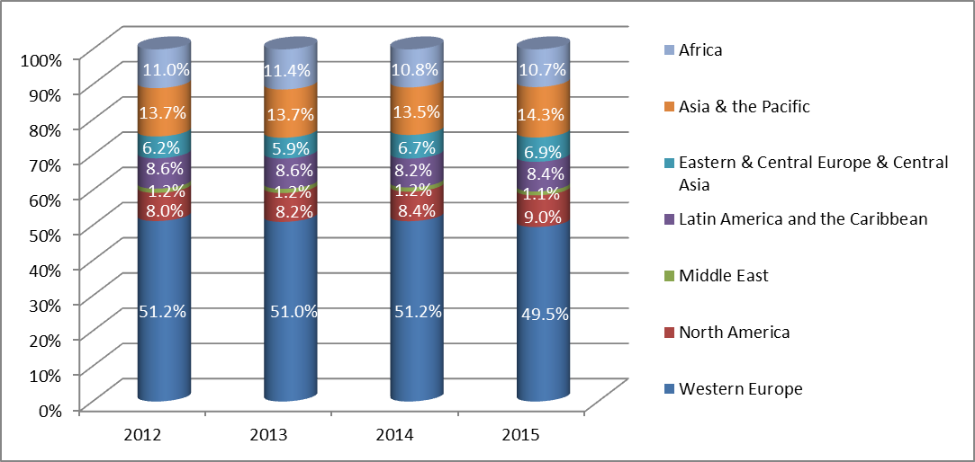

1. In 2014, WIPO issued its first Gender Equality Policy, with the twin objectives of mainstreaming the gender perspective in WIPO activities, and a time-specific goal for achieving gender balance at all staffing levels. Accordingly, a network of gender focal points covering all WIPO Programs was established, and WIPO joined the Geneva Champions network in its collective commitment to promote women in the workplace. Internally, recruitment efforts were intensified to redress the gender gap in staffing. Initiatives, such as the Gender at Work lunch time talks, and a pilot program for the career development of women in middle-management, were launched to promote gender equality in the workplace. The latter involved five P4 female staff, all with supervisory functions and outstanding performance records. Preliminary feedback was very encouraging, and an evaluation of the pilot was conducted by IOD with a report due in 2016. While the percentage of women at the P4 level (46.1 per cent) represented a 2.7 percentage point increase over the 2013 baseline, fully achieving the target, gender balance targets remained challenging at the more senior management levels. New appointments of women at P5 and D1 levels succeeded in avoiding any widening of the gender gap following separations of female staff at these levels, however women at the D2 level saw a decrease of 11.1 percentage points, as compared to 2013.

*Percentage of Professional and Higher Category Staff by Gender 2012-15*

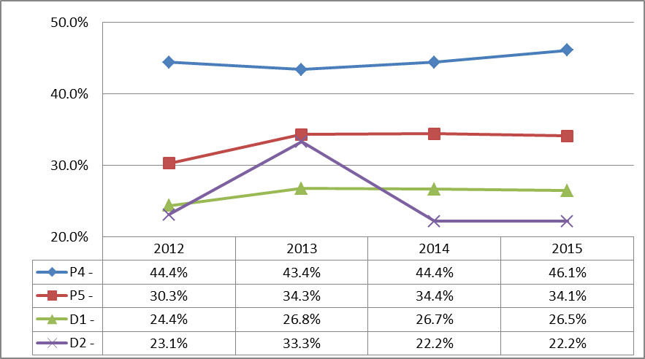

1. Progress also continued to be made on mainstreaming organizational design and workforce planning as fully integrated key business activities. Achievements for the biennium included: (i) increased manager engagement in workforce planning through delivery of introductory workshops as well as development of related guidelines; (ii) development of 2014/15 workforce action plans for each organizational unit to capture key HR-related actions to meet business needs; (iii) an organization-wide exercise to update all job descriptions, ensuring that they accurately reflect business priorities; and (iv) a more systematic and closer alignment of job descriptions and annual workplans. New post management guidelines were also issued to ensure that planning assumptions are systematically revisited and that upcoming cross-organizational priorities are considered prior to filling vacant posts. As part of workforce planning, managers were encouraged to consider the optimal mix of resources to efficiently address their business needs.
2. The regularization process for long-serving temporary employees (LSTEs) was completed in 2014, with 31 LSTEs regularized in 2014 following a competition. In addition, 40 fixed term posts were advertised for the regularization of continuing functions during the biennium (17 in 2014 and 23 in 2015), 30 of which were completed by the end of 2015.
3. The biennium continued to witness a significant level of recruitment activity, which resulted in a slower average recruitment time for the biennium of 19.77 weeks, as compared to 16.03 weeks for 2012/13. For the biennium, there were a total of 255 competitions (183 for fixed-term posts, a 29 per cent increase from 2012/13, and 72 for temporary positions). In total, some 30,320 applications were received.
4. Modernization of HRMD systems and processes continued during the biennium. Development of a new integrated recruitment platform (using Taleo) was launched in 2015 and is expected to deliver further efficiencies in recruitment. Early in 2014, the first phase of the ERP, aimed at integrating data and processes within HRMD and with other WIPO administrative and management functions, was completed. Further enhancements delivered throughout the biennium included the development and launch of the “Business Intelligence” HR management dashboard and self-service functionalities such as on-line personal information update and education grant requests, reinforcing self-responsibility while minimizing labor-intensive HR tasks.
5. A tender for employees’ health, accident and loss of earnings insurance resulted in a new contract with lower premiums.  In 2015, the contract for life insurance was renegotiated for a lower premium to go into effect in 2016. Occupational health-related services were also provided by the WIPO Medical and Social Welfare Unit or in collaboration with the UNOG Medical Services.
6. Growing maturity in WIPO’s performance management processes led to further enhancements of the Performance Management and Staff Development System (PMSDS). The existing PMSDS Guidelines were replaced by a new Office Instruction (OI) and related PMSDS Handbooks to separate regulatory provisions from guidance. In addition, changes were introduced to align PMSDS with the SRR, and related OIs, and to provide additional clarification on PMSDS-related matters based on experience gained through the application of the system. Compliance with the system continued to be very high, with 93.1 per cent of staff in 2014 and 92.8 per cent of staff in 2015 covered by PMSDS evaluated against individual objectives and competencies.
7. WIPO’s Rewards and Recognition Program (RRP) continued with a second pilot carried out in 2014 and subsequently evaluated by IOD. Two-thirds of respondents indicated that the RRP was relevant in recognizing good performance. Based on IOD recommendations for better transparency and staff involvement, a new handbook on “Showing Recognition” was issued, and an Intranet page was developed. In addition, a new category of award was established with direct staff participation in the nomination of candidates and the selection of awardees. Following the two pilot implementations, a formal policy on RRP was issued in 2015.
8. In 2014, implementation of the new Learning and Development Policy to facilitate staff development and reduction of skills gaps started. New initiatives on conflict resolution, stress management, quality management, project management and accreditation of prior learning were launched in order to increase managerial capacity and to support career development. For the first time in 2015, the average number of training days per staff[129] increased to six, as compared to five in 2014 (one day more than the reported UN practice of five days). This increase was due in part to the launch of the Conflict Management training in 2015, in which about half of WIPO staffparticipated.
9. In the context of HR policy development and following the first comprehensive overhaul of the Staff Regulations and Rules in more than 40 years in 2012, further review and adjustments of the SRR were carried out throughout 2014 and 2015 and the related HR policy framework was established. The changes carried out during the biennium allowed WIPO to maintain a sound regulatory framework aligned with best practices in the UN common system and fully adapted to support the changing needs and priorities of the Organization. In 2014, the National Professional Officer (NPO) category was incorporated into the SRR to meet the needs of the WIPO External Offices. The year 2015 saw the first temporary appointment of an NPO in the WBO.
10. The new Joint Advisory Group (JAG), for which HRMD provides the secretariat, was established in June 2014 to advise the Director General on personnel or administrative matters. Staff may directly petition the JAG, creating an additional channel of staff-management communication.

PERFORMANCE DATA

|  |  |  |  |  |  |  |  |
| --- | --- | --- | --- | --- | --- | --- | --- |
| **Expected Result:** IX.1 Effective, efficient, quality and customer-oriented support services both to internal clients and to external stakeholders | | | | | | | |
| **Performance Indicators** | **Baselines** | **Targets** | | **Performance Data** | | **TLS** | |
| % of staff satisfied with human resource services | *Updated Baseline end 2013:* Highly satisfied: 31.2%  Satisfied: 46.2 %  Dissatisfied: 18.9 %  Highly dissatisfied: 3.7 %  *Original Baseline P&B 2014/15:* Highly satisfied: 31.2%  Satisfied: 48.8%  Dissatisfied: 17.1%  Highly dissatisfied: 2.9% | 85 % highly satisfied or satisfied | | No survey was conducted in 2014/15 | | **Not Assessable** | |
| Timely, accurate, and efficient human resources operations services | Seven working days | Five working days | | 100% of queries registered in the WINS ticketing system were responded to in five working days | | **Fully Achieved** | |
| **Expected Result:** IX.2 An agile and smooth functioning Secretariat with a well-managed and appropriately skilled workforce which is effectively delivering results | | | | | | | |
| **Performance Indicators** | **Baselines** | **Targets** | | **Performance Data** | | | **TLS** |
| Recruitment lead time | *Updated Baseline end 2013:* Biennium Average: 16.03 weeks (as of March 19, 2014)  2012: 16.5 weeks  2013: 15.56 weeks  *Original Baseline P&B 2014/15:* 21 weeks | 19 weeks | | Biennium Average:  19.77  2014: 17.28 weeks[130] (includes 29 LSTEs)  2015: 22.29 weeks[131]  (no LSTEs in 2015) | | | **Fully Achieved** |
| % of organizational units with existing workforce plans linked to annual workplans | *Updated Baseline end 2013:* 0 (zero)  *Original Baseline P&B 2014/15:* tbd | 70% | | 90% | | | **Fully Achieved** |
| % of newly recruited staff that fits organizational needs | tbd | 80% satisfactory performance after probation | | 94.4% of staff who joined in 2013 and 2014 had a satisfactory performance under PMSDS | | | **Fully Achieved** |
| % of staff whose performance is evaluated against their individual objectives and competencies | *Updated Baseline end 2013:* Biennium: 90.75% of staff covered under PMSDS was evaluated against individual objectives and competencies  2012: 91% of staff covered under PMSDS were evaluated against individual objectives and competencies (as at end April 2012)  2013: 90.5% of staff covered under PMSDS were evaluated against individual objectives and competencies (as at end April 2013)  *Original Baseline P&B 2014/15:* 81% (2012) | 90% | | 2014: 93.1%  2015: 92.8% | | | **Fully Achieved** |
| **Expected Result:** IX.2 An agile and smooth functioning Secretariat with a well-managed and appropriately skilled workforce which is effectively delivering results | | | | | | | |
| **Performance Indicators** | **Baselines** | **Targets** | **Performance Data** | | **TLS** | | |
| % of critical individual and collective training needs that have been fulfilled | *Updated Baseline end 2013:* no assessment available  *Original Baseline P&B 2014/15:* no assessment available (will be available end 2013) | Critical individual training needs:  80% fulfilled  Critical collective training needs:  80% of the needs are addressed through a training program | 60.94%  81.04% | | **Partially Achieved**  **Fully Achieved** | | |
| Average no. of sick leave days per employee (absenteeism) | *Updated Baseline end 2013:* For the biennium: 10.34   * 2012: 9.07 * 2013: 11.6   *Original Baseline P&B 2014/15:* 9.07 (Dec 2012) | 9 | 2014: 11.2[132]  2015: 10.5 | | **Partially Achieved** | | |
| % of women in professional and higher positions | *Updated Baseline end 2013:*   |  |  |  | | --- | --- | --- | |  | 2012: | 2013: | | P4 - | 44.4% | 43.4% | | P5 - | 30.3% | 34.3% | | D1 - | 24.4% | 26.8% | | D2 - | 23.1% | 33.3% |   *Original Baseline P&B 2014/15:*  P4 – 44.1%  P5 – 31.8%  D1 – 26.2%  D2 – 23.1%  (Dec 2012) | P4 – 46%  P5 – 35%  D1 – 30%  D2 – 30% | |  |  |  | | --- | --- | --- | |  | 2014: | 2015: | | P4 - | 44.4% | 46.1% | | P5 - | 34.4% | 34.1% | | D1 - | 26.7% | 26.5% | | D2 - | 22.2% | 22.2% | | | **Fully Achieved**  **Not Achieved**  **Not Achieved**  **Not Achieved** | | |
| Geographical diversity -  % of staff[133] per region | *Updated Baseline end 2013:*  Africa 11.4%  Asia & the Pacific 13.7%  Eastern & Central Europe & Central Asia 5.9%  Latin America & the Caribbean 8.6%  Middle East 1.2%  North America 8.2% Western Europe 51.0%  *Original Baseline P&B 2014/15:* Africa 11.0%  Asia & the Pacific 13.7%  Eastern & Central Europe & Central Asia 6.2%  Latin America & the Caribbean 8.6%  Middle East 1.2%  North America 8.0%  Western Europe 51.2% | Tbd[134] | Africa: 10.7%  Asia & the Pacific: 14.3%  Eastern & Central Europe & Central Asia: 6.9%  Latin America & the Caribbean: 8.4%  Middle East: 1.1%  North America: 9.0% Western Europe: 49.5%  (Dec 2015) | | **Not Assessable** | | |

RISK REPORTING FOR THE BIENNIUM

|  |  |  |  |
| --- | --- | --- | --- |
| **Risk(s) to the Program achieving its Results** | **Mitigation plans in place or under implementation** | **Evolution of Risk(s) and Mitigation Strategies Over the Biennium** | **Impact on the Program’s Performance** |
| Rapidly evolving external business environment requiring new processes, skills and IT solutions, may lead to misalignment of workforce in critical WIPO business areas. This could lead to high costs for additional short term staff, process inefficiencies, backlogs in critical business areas, and a diminished WIPO reputation. | Gradual development of a more responsive and flexible workforce with a structure able to respond to fluctuations in demand; Detailed analysis and needs assessment in terms of skills and workforce strength, followed by implementation plans including reallocation of staff, adequate staff training, recruitment of critical skills and outsourcing. | The institutionalization of workforce planning combined with new post management guidelines ensured that the Organization regularly considered the Organization’s evolving need for human resources and that new/changed needs were addressed in a proactive manner through realignment, training, and outsourcing as appropriate. | The Program’s performance over the biennium was enhanced by the mitigation measures put in place, which contributed to more effective human resource management and talent sourcing strategies. |
| New functionalities from the ERP implementation may lead to a disruption of services as staff learn new procedures. The implementation may not incorporate enough business process review and re-engineering, and primarily be a system application replacement project. | Careful HR staff and end user training, regular communication plans, close monitoring of ERP project team progress, and early warning of problem areas to be managed. Continuous improvement of business processes as part of the configuration and development of the technical solution. | The risk materialized due to the need to internally compensate for constraints in project implementation. In order to address this, additional measures were taken, notably the addition of a business analyst. | The risk as it materialized resulted in certain delays in recruitment but risk mitigation minimized the impact. |

RESOURCE UTILIZATION

Budget and Actual Expenditure (by result)

*(in thousands of Swiss francs)*



Budget and Actual Expenditure (personnel and non-personnel)

*(in thousands of Swiss francs)*



A. 2014/15 Final Budget after Transfers

1. The overall increase in the 2014/15 Final Budget after Transfers was primarily due to: the funding of (i) temporary resourcing solutions to cover for long-term absences; (ii) increased costs of UN shared activities; (iii) additional resources for the WIPO Appeal Board; (iv) the launch of new initiatives including the WIPO RRP; (v) increased insurance costs for delegates and participants in WIPO meetings; and (vi) redeployment of resources for ICT specialized training previously under Program 25.

B. 2014/15 Budget utilization

1. The non-personnel budget utilization rate amounted to 91 per cent and reflected savings resulting primarily from the renegotiation of new insurance contracts and lower than anticipated spending on: (i) maternity and sickness backup; (ii) the ILO Administrative Tribunal; (iii) language training; and (iv) classification activities.

## PROGRAM 24 GENERAL SUPPORT SERVICES

**Program Manager Mr. A. Sundaram**

ACHIEVEMENTS IN THE 2014/15 BIENNIUM

1. In addition to providing strategic guidance and support in the areas of Administration and Management in WIPO, the Program includes Procurement and Travel, and Premises Infrastructure services.
2. In 2014/15, procurement and travel made good progress towards achieving targets through a series of measures with a view to optimizing the cost of WIPO procured goods and services and streamlining its processes. These measures included: (i) a new policy for Individual Contractual Services (ICS) as well as the incorporation of the management of ICS into the Procurement and Travel Division; (ii) a new legal framework for procurement, as well as the publications of a new Office Instruction (OI) in 2014 on Procurement General Principles and Basic Rules and a Procurement Manual; (iii) the creation of a vendor contract database; (iv) the implementation of annual procurement plans; and (v) the launch of an Online Booking Tool (OBT) for travel aimed at reducing both the transaction fee and the average air ticket fare through the use of more restrictive fares and more advanced ticketing.
3. As a result of these measures, savings for procured goods and services continued to be yielded from more stringent and direct price negotiations, which resulted in overall savings of 3.8 million Swiss francs in 2015 and 2.6 million Swiss francs in 2014. The percentage of collaborative procurement with the Common Procurement Activity Group also increased with 5.8 per cent of goods procured through this collaboration. As regards travel expenditure, the average ticket cost was reduced by 14 per cent in 2015 to 1,484 Swiss francs from 1,728 Swiss francs in 2013, a significant savings over the biennium. Since the implementation of the new OBT in December 2014, the total average transaction fee also decreased by 20 per cent, despite the increase in the agency fee resulting from a change in the supplier. The tables below illustrate the achievements in 2014/15 with regard to procurement and travel.

|  |  |
| --- | --- |
|  |  |

1. A substantial effort was made in the biennium to reduce travel expenditure, leading to a decrease in both the number of tickets issued and the number of late travel submissions. Finally, through close monitoring of the administrative processes related to procurement and travel, the average lead time to process purchase requisitions was reduced by half over the last five years, resulting in greater efficiency and more agility in procuring goods and services. It should also be noted that the percentage of locally sourced goods and services for development activities increased to 57 per cent in 2015, a nine per cent increase over 2013 and a 12 per cent increase over 2014.
2. As regards office space management in the headquarters buildings, at the end of 2015, an adequate balance between occupied (about 85 per cent) and non-occupied (about 15 per cent) workplaces was maintained for the third consecutive year, despite the fact that the balance was not evenly reached across all buildings, as explained in previous reports. The implementation of a more efficient and cost-effective use of storage and parking areas on- and off-site allowed for the termination of the leases for three off-site storage areas and off-site parking spaces, as well as a reduction in quantities of office supplies, for a total savings in 2014/15 of about 219,000 Swiss francs. Finally, a total of 390,000 Swiss francs revenue was generated during the biennium from the rental of certain spaces to other entities (the data center, roof spaces for telephony antennas, bank teller machine and one office for the *European Co-operative Association of International Civil Servants* (AMFIE)).
3. In respect of technical installations, regular maintenance of main and/or critical technical installations was undertaken throughout the year in accordance with the established schedule. The first detailed roster of all critical installations was completed in 2014, which will strengthen the future analysis of the wider preventative maintenance program of infrastructure and installations. The year 2015 was the first time a periodical update of the roster was carried out, thereby establishing the basis for future periodical updates.
4. In respect of the upgrading of older facilities, significant progress was made not only through the reserve-funded Capital Master Plan (CMP) projects, but also through a number of less significant and more technical improvements (please see details in the performance table).
5. Energy consumption, in particularily electricity and water, was reduced by five per cent and 33 per cent respectively, compared to the 2012/13 biennium, despite the additional consumption due to the new WIPO Conference Hall as from September 2014. The last phase of the major shift towards a locally generated and more environmentally friendly cooling technology, the Geneva Lake-produced chilled water, was completed on the WIPO Campus during the biennium through connection or upgrade of installations. While the energy consumption and the associated cost for this cooling technology in all WIPO buildings increased by 35 and 34 per cent, respectively, compared to the previous biennium, the building volume covered has approximately doubled during the same period. Furthermore, the increased cost was largely compensated by reductions in consumption of other sources of energy (electricity and water) and stabilized consumption of natural gas for heating, resulting in an overall savings of about 479,000 Swiss francs, as compared to the previous biennium. Finally, the electricity provider which was under contract with WIPO until end 2014, reimbursed a percentage of unused electricity over the year of reference (2014), amounting to 24,300 Swiss francs.
6. In respect of asset management, the biennium was the first time the new procedure for carrying out an externalized inventory of assets was implemented. In 2014, the assets concerned were those valued above 1,000 Swiss francs, as well as works of art and attractive items, regardless of value. In 2015, the assets concerned were those valued above 5,000 Swiss francs. This two-phased approach aligned to the biennium framework was aimed at structuring the asset management for both physical recording as well as reporting and financial reporting. By the end of the biennium, a new policy on asset management was issued, to serve as a basis to establish a more solid system under the framework of the Financial Rules and Regulations.
7. The year 2015 was the first year with a significant increase in the number and complexity of cultural and other events (including simultaneous cultural events). In 2015, six Member State national day celebrations were hosted on WIPO premises. In addition, on several occasions, various spaces (including the new WIPO Conference Hall) were rented to external entities, in some cases against payment of a rental fee and/or reimbursement of expenditure incurred in support of those events.[135]
8. Under the WIPO Accessibility Project, and based on recommendations resulting from audits carried out in 2012 and 2013, a number of improvement measures were implemented during the biennium in several buildings. In addition, several features, which had been included in the scope of the New Conference Hall Project and renovation of several levels of the AB Building, were also implemented in the course of 2014 during the construction and/or renovation phases. Improvements included: (i) additional ramps for wheelchair access (access to interpreters booths in a new meeting room in the NB, access to the podium in the new WIPO Conference Hall, access to interpreters booths in two new meeting rooms on the renovated floor of the AB Building); and (ii) the lowering of badge readers to be at the level of wheelchair access in the AB, PCT and NB Buildings and the new WIPO Conference Hall, some of which were implemented at no major cost and/or where the features could be integrated in other infrastructure or installations improvement at minimal extra cost. In addition, in 2015, a presentation was organized for the staff and for representatives of other Geneva-based UN agencies in order to show the enhancements made in the various buildings and share experience on the methodology used to choose and implement measures.
9. Under the framework of the WIPO Environmental Responsibility initiative, a number of activities were undertaken during the biennium, aimed at raising environmental awareness amongst staff and/or taking concrete and practical actions. These actions related to premises-related issues and the use of alternative means of commuting to and from work. Premises-related issues included: (i) upgrading of technical installations to more ecological solutions; (ii) upgrading of electrical installations, reducing electricity consumption under the framework of an agreement with the local electricity provider until 2014; (iii) NB renewal of the electricity tariff with the highest percentage of contribution to renewable electricity production in the Canton of Geneva in 2014; (iv) introduction of a new environmentally friendly scheme with the new electricity provider since January 2015. Actions related to alternative means of commuting included: (i) mobility days or months on public transport; (ii) free rental of electrical bikes; and (iii) bike repairs. In addition, WIPO participated in a number of initiatives within the UN-Interagency context, mainly through the United Nations Environment Programme (UNEP) and the Sustainable UN (“SUN”), e.g. participation in the annual collection of data for the Greenhouse Gas (GHG) Calculator, as well as participation in various meetings and fora. In line with WIPO’s commitment to off-setting carbon emissions the 2015 International Annual Meeting on Language Arrangements, Documentation and Publications (IAMLADP) was held in June 2015 on the WIPO Campus and was declared a “green” meeting by UNEP in line with UN references. In addition, in the context of the UN goal to achieve carbon neutrality by 2020, to which WIPO made a commitment in September 2014, WIPO purchased compensation certificates via the United Nations Framework Convention on Climate Change (UNFCCC) from 2014 until 2020. These certificates were calculated from the data used for the 2014 GHG calculator established by UNEP for the purposes of the UN contribution to the COP21 in November 2015. As a consequence, WIPO was in a position to declare that it has compensated its carbon emissions until 2020. The 2014/15 biennium was therefore the first biennium for this type of achievement by WIPO under the UN-wide 2020 objective.

PERFORMANCE DATA

|  |  |  |  |  |  |  |  |  |  |  |  |
| --- | --- | --- | --- | --- | --- | --- | --- | --- | --- | --- | --- |
| **Expected Result:** VIII.5 WIPO effectively interacts and partners with UN and other IGO processes and negotiations | | | | | | | | | | | |
| **Performance Indicators** | | **Baselines** | | | | **Targets** | | | **Performance Data** | **TLS** | |
| HLCM and Subsidiary Networks Closed Recommendations | | *Updated Baseline end 2013:* 13 of the 36 outstanding Joint Inspection Unit (JIU)/ Legislative Body recommendations were closed in 2013 (36%)  *Original Baseline P&B 2014/15:* Percentage of closed recommendations on January 1 2013 | | | | Percentage of closed recommendations on December 31, 2015[136] | | | In 2014/15, 64 per cent (23 out of 36) of the outstanding Joint Inspection Unit (JIU) recommendations addressed to the WIPO Legislative Bodies were closed. | **Not Assessable** | |
| % of locally sourced goods and services compared to total amount procured for development activity | | *Updated Baseline end 2013:* 48%  *Original Baseline P&B 2014/15:* 2013 result | | | | 2013 + 5% | | | 2014 : 45%  2015 : 57% | **Not Achieved**  **Fully Achieved** | |
| % of spend subject to UN leverage (either common tender or piggy backing) | | *Updated Baseline end 2013:* 4%  *Original Baseline P&B 2014/15:* 2013 result | | | | Defined Target: 4%  Original Target P&B 2014/15: tbd | | | 2014: 4.15%  2015: 5.8% | **Fully Achieved** | |
| **Expected Result:** IX.1 Effective, efficient, quality and customer-oriented support services both to internal clients and to external stakeholders | | | | | | | | | | | |
| **Performance Indicators** | | **Baselines** | | | | **Targets** | | **Performance Data** | | **TLS** | |
| Cost savings for goods and services procured by WIPO (derived from RFPs or direct negotiations) | | *Updated Baseline end 2013:* 531,000 Swiss francs  *Original Baseline P&B 2014/15:* 2013 result | | | | 2013 + 5% | | 2,663,000 Swiss francs (2014)  3,826,361 Swiss francs (2015) | | **Fully Achieved** | |
| % of internal clients satisfied with procurement services | | *Updated Baseline end 2013:* 73%  *Original Baseline P&B 2014/15:* 2012 result | | | | 2012 + 5% | | 89% | | **Fully Achieved** | |
| Processing time of travel related requests (eTA, ER, Visas) | | Processing time of travel related requests:  eTA = 1day  ER = 2 hours  Visa for 3rd party = 2 days (baseline 2013) | | | | eTA = 1/2 day  ER = 1 hour  Visas = 2 days | | eTA = 1/2 day  ER = <1 hour  Visas < 1day | | **Fully Achieved** | |
| Average ticket cost (TMC and UNDP tickets) | | *Updated Baseline end 2013:* 2013=1,728 Swiss francs  *Original Baseline P&B 2014/15:* cost (baseline 2013) | | | | Reduced average ticket cost | | 1,598 Swiss francs (2014)  1,481 Swiss francs (2015) | | **Fully Achieved** | |
| All types of space on the WIPO campus (workplaces, storage and archiving) are effectively managed | | *Updated Baseline end 2013:* 80 workplaces (No additional rental office space was required during the biennium.)  *Original Baseline P&B 2014/15:* Maintain number of workplaces throughout buildings in order to accommodate service expansion and changes in WIPO activities (number of employees at end 2013); maximum of 80 rented workplaces (end 2013); 6 off-site storage/archiving areas (end 2013) | | | | Maximum of 80 rented workplaces (out of a total of 1,582 workplaces); 6 storage/ archiving area | | 80 rented workplaces (out of a total of 1,645 workplaces); 4 storage /archiving areas due to termination of the lease for two off-site storage areas. In addition, termination of the lease for a stand-alone self-contained space in a warehouse storage, and termination of the rental of 57 off-site parking spaces. | | **Fully Achieved** | |
| **Expected Result:** IX.1 Effective, efficient, quality and customer-oriented support services both to internal clients and to external stakeholders | | | | | | | | | | | |
| **Performance Indicators** | **Baselines** | | | | **Targets** | | | **Performance Data** | | **TLS** | |
| Buildings in the WIPO campus are renovated/modernized/transformed to remain fit for purpose | *Updated Baseline end 2013:* The cooling installations in GBI and GB II Buildings using the Geneva Lake Water system were upgraded and completed in 2012 and June 2013 respectively.  The electrical installations in the oldest building (GBI) started to be upgraded in 2012 to comply with recently enacted local legislation, with the added benefit of setting a technical framework for reducing electricity consumption. It was completed in 2013.  *Original Baseline P&B 2014/15:* 6-year plan for first phase of implementation of required major renovation, transformation and/or modernization of premises on WIPO campus | | | | Implementation of major renovation, transformation and/or modernization projects according to 6-year plan | | | See Appendix III: Progress Report on the Capital Master Plan (CMP) in 2014[137] and 2015.  In addition to the CMP, the following modernization and transformation projects were implemented in 2014:  (i) main structural work for multimedia studio; (ii) upgrade of technical installations and technical management systems (electrical; water distribution system; increase in power and cooling capacity in NB data center; replacement of cooling tower for redundancy cooling; upgrade of lightning rod in PCT and GBII buildings); (iii) upgrade of ventilation system for AB building (11th and 13th floors); and (iv) upgrade of technical alarms in NB.  The following modernization and transformation projects were implemented in 2015:  (i) upgrade of electrical installations and replacement of light fixtures on various floors and underground levels of AB Building; (ii) creation of new service doors to facilitate access by vehicles to NB ground floor; (iii) upgrade of ventilation and cooling installation in AB and PCT Buildings; (iv) renovation of one set of used water pipes in AB Building; (v) replacement of industrial dishwasher in PCT cafeteria. | | **Fully Achieved** | |
| All types of critical technical installations comply with applicable technical standards | Compliance of technical installations with applicable standards and definition of critical installations | | | | Verification and/or improve/replace (if required) of critical technical installations as necessary | | | Critical installations periodically verified. The first detailed inventory of all critical installations was completed in 2014. Inventory is regularly updated as needed since 2015. | | **Fully Achieved** | |
| **Expected Result:** IX.4 An environmentally and socially responsible Organization in which WIPO staff, delegates, visitors and information and physical assets are safe and secure | | | | | | | | | | | |
| **Performance Indicators** | | | **Baselines** | **Targets** | | | **Performance Data** | | | | **TLS** |
| Improved physical access to the WIPO campus | | | *Updated Baseline end 2013:* The 5-year plan was not established at the end of 2013.  *Original Baseline P&B 2014/15:* 5-year plan for implementation of recommendations in 2012 Physical Accessibility Audit (plan established at end 2013) | Implementation of audit recommendations according to 5‑year plan | | | The 5-year plan was not established by the end of 2015 due to the lack of available resources and the worksite for the new WIPO Conference Hall.  Enhancements included:  (i) additional ramps for wheelchair access (access to interpreters booths in a new meeting room in NB); and (ii) lowering badge readers to be at level of wheelchair access in AB, PCT and NB Buildings. Some of these features were implemented at no major cost and/or where features could be integrated in other infrastructure or installations improvement at minimal extra cost. | | | | **Not Achieved** |
| Reduced impact of WIPO buildings on the environment | | | *Updated Baseline end 2013:* 2% reduction in electricity consumption due to the implementation of a variety of measures aimed at upgrading installations; 7% reduction in water consumption due to upgrading of cooling installation in one of the data centers  *Original Baseline P&B 2014/15:* Annual electricity and water consumption (at end 2013) | 4% reduction in electricity consumption and 10% reduction in water consumption by end-2015 | | | 5% reduction in electricity consumption and 33% reduction in water in 2014/15 as compared to 2012/13, despite the addition of the new WIPO Conference Hall as from September 2014.  The cooling system using the Geneva Lake produced chilled water implemented in the AB and PCT Buildings (under the CMP, see the Appendices) was handed over in 2014 and 2015, respectively, and has been fully integrated in building maintenance scheme.  An upgrade of the cooling system using the Geneva Lake to produce chilled water was implemented in the NB in 2014.  Additional environmentally-sound measures included the following main measures: (i) reduction of artificial light consumption by replacement of traditional light fixtures by new fixtures using LED technology, (ii) lighting activated by presence detection during off-hours on office floors in various areas of various older buildings, | | | | **Fully Achieved** |
| WIPO premises comply with recommendations in 2009 audit by Institute of Safety and Security (Neuchatel) and UN H-MOSS peripheral security measures | | | 6-year plan for implementation of recommendations in 2009 audit by Institute of Safety and Security (Neuchatel) | Implementation of audit recommendations according to 6-year plan phasing and peripheral security measures by end-2015 | | | See Appendix III Progress Report on the Capital Master Plan (CMP) in 2014 and 2015  In addition to the implementation of the recommendation covered by the CMP, the following recommendations were implemented:  (i) modernization of fire detection system (the latest generation of detectors) in the four basement levels of AB parking garage; and  (ii) upgrading of emergency lighting system on certain floors of the GBI Building. | | | | **Fully Achieved** |

RISK REPORTING FOR THE BIENNIUM

|  |  |  |  |
| --- | --- | --- | --- |
| **Risk(s) to the Program achieving its Results** | **Mitigation plans in place or under implementation** | **Evolution of Risk(s) and Mitigation Strategies Over the Biennium** | **Impact on the Program’s Performance** |
| Failure of key suppliers triggers a disruption to the service provided to our external customers | PTD and WIPO Programs should develop a contingency plan for contracts that are considered to be of high risk and vital for a continued operation | This risk is a continuing one for the Organization, which has been better identified through the listing of “critical” suppliers in Programs’ procurement plans, in consultation with PTD. Due consideration is given during the review of procurement plans to addressing service disruptions, and these are also reflected in contractual conditions where appropriate. Formal contingency plans will continue to be worked on with Programs with PTD’s involvement. | This risk and its evolution did not have any material impact on the Program’s performance in 2014/15.. |
| External event or incident prevents occupation of one or more buildings for a prolonged period, potentially causing disruption to external services and leading to wasted resources affecting negatively Program delivery | Develop renovation and major maintenance plan of all premises and continue to undertake – or reinforce as needed – regular maintenance of all key technical installations. Regularly review and update the business continuity plan and activate as necessary. Identify back-up office options | This is a continuing risk for the Organization, with appropriate mitigation strategies in place to address it. The subject was also integrated under the WIPO Business Continuity Plan and the WIPO Resilience Plan.  First phase of the renovation and major maintenance plan were established.  Back up office options consist first of the existing off-site rented premises, other more remote premises remain to be identified. | This risk and its evolution did not have any material impact on the Program’s performance in 2014/15. |

RESOURCE UTILIZATION

Budget and Actual Expenditure (by result)

*(in thousands of Swiss francs)*



Budget and Actual Expenditure (personnel and non-personnel)

*(in thousands of Swiss francs)*



A. 2014/15 Final Budget after Transfers

1. The increase in the 2014/15 Final Budget after Transfers (non-personnel resources) reflects the additional resource allocation into the Program for the: (i) furnishment of the AM building; and (ii) replenishment of various equipment and stocks such as mobile exhibition panels, electrical equipment, office partitions and carpets. This increase was compensated by the implementation of cost efficiency measures and the transfer of resources to Program 28 for the installation of the custom anti-intrusion fence below the new WIPO Conference Hall.
2. The slight increase in the 2014/15 Final Budget after Transfers (personnel resources) reflects, on the one hand, the redeployment of additional resources into the Program to: (i) support the WIPO Appeals Board; (ii) establish an ICS certifier function in procurement; and (iii) strengthen administrative support for renovation projects. On the other hand, this was partially offset by the redeployment of resources from the Program to support business needs in Program 16, Program 22 and Program 28.
3. The shift in resources between the Expected Results is primarily due to the redistribution of personnel resources from Expected Result IX.1 (Effective, efficient, quality and customer-oriented support service) to Expected Result IX.4 (An environmentally and socially responsible Organization) in order to implement environmental activities and increase safety of staff, visitors and assets, and to Expected Result VIII.5 (WIPO effectively interacts and partners with UN and other IGO processes) to enhance engagement with other UN Agencies in respect of: (i) procurement; and (ii) maintenance and renovation of premises.

B. 2014/15 Budget Utilization

1. Budget utilization is within the expected range for the biennium.

## PROGRAM 25 INFORMATION AND COMMUNICATION TECHNOLOGY

**Program Manager Mr. A. Sundaram**

ACHIEVEMENTS IN THE 2014/15 BIENNIUM

1. Information and Communication Technology (ICT) continued to play two vital roles during the biennium. Externally, it provided responsive, reliable and secured platforms for the delivery of global IP services, as well as the technical facilities for the new WIPO Conference Hall and other conference facilities. Internally, it provided efficient and cost-effective solutions to sustain WIPO’s daily operations both at headquarters and the External Offices (EOs).
2. Building on the progress made in the previous biennium, the following achievements highlight the progress in the field of Infrastructure Services and Business Solution Services (including Internet Services) in 2014/15:
3. ICT infrastructure resilience and service continuity were further enhanced, in particular the successful establishment and testing of a high level ICT disaster recovery capability to support the PCT System, whereby PCT systems and processes would not be affected should WIPO’s data center be compromised. Similar capabilities will be applied to other critical operations in the future.
4. A new Global Office Architecture (GOA) solution for WIPO’s EOs was designed to provide secure connectivity to all of WIPO’s administrative IT systems hosted at headquarters, together with centralized and consistent IT services. By the end of 2015, the GOA had been rolled out to three EOs (WJO, WSO and WRO).
5. ICT infrastructure for the new WIPO Conference Hall was delivered in time for the twenty-second session of the PBC and the fifty-fourth series of meetings of the WIPO Assemblies in 2014.
6. Outsourcing of network and server infrastructure management to the United Nations International Computing Center was completed to ensure proper 24/7 coverage and timely updates.
7. Through close collaboration with key business stakeholders, specific Service Delivery Agreements (SDAs) were established in 2014 to explicitly capture the ICT needs for the specific business areas, as well as to enable more systematic tracking and monitoring.
8. An advanced fax system, introduced to seamlessly integrate with computer systems for Madrid, as well as internal administrative systems, resulted in greater efficiency and significantly reduced fax error rates, which formerly required substantial amount of time to repeatedly resend the faxes.
9. In response to recommendations made in the 2014 Joint Inspection Unit’s Review of Management and Administration in the World Intellectual Property Organization and subsequent internal evaluations, in 2015, a Knowledge Management Strategy[138] was developed to: (i) foster a knowledge management culture in WIPO; (ii) implement an Organization-wide set of knowledge management processes and tools; (iii) identify and publish a “single source of truth” for knowledge and information assets: and (iv) ensure the alignment and integration of knowledge management with WIPO’s Organizational Resilience Strategy.
10. Processes for the transition operationalization and mainstreaming of ICT projects were formally defined, in order to ensure a more systematic and smoother transition flow.
11. Service contracts and operational processes were reviewed and measures taken to ensure more cost-effective operations, which resulted in savings of approximately 460,000 Swiss francs as compared to 2013.
12. As regards information assurance, the biennium 2014/15 saw a strategic organizational restructuring with the incorporation of the Information Security Section (ISS) under the newly created Safety and Information Assurance Division (SIAD), which allows for a better integration between physical and information security.
13. Whilst much of the work in relation to information assurance remained operational, the biennium 2014/15 saw several key achievements, which greatly contributed to enhancing the protection and security of WIPO’s information systems.
14. As part of the continuous improvement process promoted by the ISO 27001 Standard, in October 2014, the PCT underwent the second round of external surveillance audits for the ISO 27001 certification, and at the same time migrated the certification from the 2005 version to the latest ISO 27001:2013.  In October 2015, the certification was expanded to include both the Madrid and the Hague operations, in addition to PCT. No major or minor non-conformities were noted.
15. Following the organizational restructuring, resulting in the establishment of a new Division responsible for Information Assurance and Security (SIAD), the year 2015 saw the development and approval of an Information Assurance (IA) Strategy aimed at ensuring the provision of high quality and secure IP solutions to its Member States and customers.
16. In addition, significant steps were taken to improve technical security capabilities in the areas of privileged account management, security event and information management, monitoring and alerting for Indicators of Compromise (IOCs), and incident response and management. In 2014, a project to fully implement the ArcSight Security Event and Information Management (SEIM) system was completed, providing greater visibility on potential security events within WIPO’s IT network, and enabling more effective and efficient incident response. The deployment and integration of such technical solutions greatly reduced the time required to detect and respond to potential cyber-attacks or data compromises. As a result, the number of serious incidents was minimal, with only one major incident each year for the biennium, neither of which resulted in data loss or compromise.
17. The SIAD also contributed to the selection and implementation of an Enterprise Risk Management solution (Acuity Stream) in 2014 to enhance enterprise risk management capabilities within WIPO, and to enable the complete integration of the ISO-based risk management processes within the organizational risk management approaches. In 2015, the use of the ERM solution - Acuity Stream was expanded for the management of ISO related information risks as part of the scope expansion of the ISO 27001 certification.
18. Simulated phishing campaigns, first launched in 2014, continued to raise user awareness of information security threats, as evidenced by a sharp increase in users reporting phishing (from one per cent in 2014 to 59 per cent in 2015), as well as a ten per cent decline in users that fell for phishing campaigns (from an average of 17 per cent in 2014 to an average of seven per cent in 2015).
19. Through the provision of high quality risk assessments and risk remediation assistance, ISS also supported several business initiatives, such as the GOA, WIPO’s mobile-device environment, and the cloud-based recruitment solution, Taleo, and collaborated closely with the PCT development teams to formulate and implement a Secure Development LifeCycle approach for application development, ensuring that information security requirements and controls are addressed from the beginning of a development project, thus reducing dramatically the amount of re-work required to pass security testing of the applications.

PERFORMANCE DATA

|  |  |  |  |  |  |  |
| --- | --- | --- | --- | --- | --- | --- |
| **Expected Result:** IX.1 Effective, efficient, quality and customer-oriented support services both to internal clients and to external stakeholders | | | | | | |
| **Performance Indicators** | **Baselines** | | **Targets** | **Performance Data** | | **TLS** |
| ICT Systems are cost-effectively hosted and managed in line with business demands | *Updated Baseline end 2013:*  Enterprise server support monthly cost: $280; Virtual server monthly cost: $229  (2 core & 8GB); High-performance storage average monthly cost: $420/TB; Backup average monthly cost: $53.90  *Original Baseline P&B 2014/15:* Unit costs for physical, virtual servers, for storage and backup | | Unit costs of infrastructure hosting are at the level or below the baseline | 2014: Rates unchanged from baseline. New rates negotiated.  2015: Enterprise server support monthly cost: 250 Swiss francs  Virtual server monthly cost:  189 Swiss francs  High-performance storage monthly cost: 240 Swiss francs /TB  Backup average monthly cost: 41.10 Swiss francs  Number of service incidents with medium or high impact: 1.75 per month | | **Fully Achieved**  **Fully Achieved**  **Fully Achieved**  **Fully Achieved** |
| No. of SLAs for hosted systems and services that are compliant with ICT SLA framework | Standard ICT SLA Framework in place | | % of SLAs that comply with the ICT Framework | In 2014/15, 11 new SDAs signed (Enterprise Communication System, IRIS, IRPI, PCT, PEARL, SIGAGIP, PATENTSCOPE, CASE, DAS, External Collaboration Platform, GOA) in compliance with the ICT framework (100%) | | **Fully Achieved** |
| ICT Service Continuity of critical systems | *Updated Baseline end 2013:* 2 closely linked Data Centers established; server infrastructure and network architecture Centers partially developed to support the 2 centers; 38 core ICT services were assessed and suitable measures implemented for mitigating risks and ensuring their enhanced availability.  *Original Baseline P&B 2014/15:* Data backed-up offline, data restore may require several days | | Critical systems can be recovered in a timely manner without data loss in the event of localized major disruptions | Server, Storage, Backup and Network Infrastructure extended for core ICT services. In 2014/15, 12 additional core ICT services were assessed and suitable measures implemented for service continuity.  ICT Service Continuity capability validated in 2015 through successful 1-day Disaster Recovery (DR) test; PCT Failover exercise was completed in 30 minutes | | **Fully Achieved** |
| % end-users and business sectors who are satisfied with ICT services | *Updated Baseline end 2013:*  2013 Helpdesk Survey: "Highly satisfied" rating by 64% of participants  *Original Baseline P&B 2014/15:*  Business managers' satisfaction at the beginning of the biennium | | Maintain or improve against the baseline | 2014 Helpdesk Survey: 67% “Highly Satisfied”  2015 Helpdesk Survey: 97% "Satisfied or Completely Satisfied" with 70.5% "Completely Satisfied[139]" | | **Fully Achieved** |
| Comprehensive and integrated communication technologies easily accessible to staff | Available on desktops (and laptops) | | Available on other mobile devices | Access to Intranet and Corporate voice-mail via WIPO mobiles; Direct voice and video communications between External Offices and WIPO HQ; Fixed phone dialing from desktop; Capability to send and receive faxes via email. | | **Fully Achieved** |
| **Expected Result:** IX.4 An environmentally and socially responsible Organization in which WIPO staff, delegates, visitors and information and physical assets are safe and secure | | | | | | |
| **Performance Indicators** | | **Baselines** | **Targets** | | **Performance Data** | **TLS** |
| Information security is reinforced to protect against increasing attacks on the Internet | | No major breaches to WIPO information systems | No major breaches to WIPO information systems | | No major breaches to WIPO information systems during the 2014/15 biennium | **Fully Achieved** |
| Status of ISO 27001 Certification and Information Risk management processes | | *Updated Baseline end 2013:*  156 outstanding mitigation activities  The Information Security Risk Registry was updated biannually and was reviewed in detail in the context of the ISO 27001 certification of the PCT operations.  PCT certified to ISO27001:2005 (October 2013);  *Original Baseline P&B 2014/15:*  No. of outstanding risk mitigation activities at commencement of biennium; PCT Section ISO 27001 certified | 90% of baseline resolved within biennium;  60% of new risks mitigated within 3 months of identification; organizational units certified, as needed;  PCT certification maintained | | 100% of outstanding baseline risks were mitigated by end biennium:   * 2014: 89% of 156 baseline risks mitigated; 17 remaining * 2015: 100% of 23 risks (including 17 remaining baseline risks) mitigated   In 2014/15, 37 new ISO27001 risks were identified, of which 25 (67%) were remediated within 3 months of identification   * 8 out of 12 (66%) in 2014 * 17 out of 25 (68%) in 2015   The Information Security Risk Register was updated bi-annually, and expanded to include Madrid and Hague related Information Risks as part of the certification process;  PCT Certification to ISO 27001:2005 successfully transitioned to version ISO 27001:2013. Certification was renewed in October 2015, and the certification scope was extended to include Madrid and Hague October 2015. | **Fully Achieved**  **Fully Achieved**  **Fully Achieved** |
| Effectiveness of Information Security controls (internal and external facing) | | 5 or less incidents per year | 2 or less incidents per year | | 1 major incident recorded per year in the biennium  Incidents were managed and resolved within acceptable timeframes, in accordance with the Information Security Incident Management Policy. | **Fully Achieved** |

RISK REPORTING FOR THE BIENNIUM

| **Risk(s) to the Program achieving its Results** | **Mitigation plans in place or under implementation** | **Evolution of Risk(s) and Mitigation Strategies Over the Biennium** | **Impact on the Program’s Performance** |
| --- | --- | --- | --- |
| PCT and related Information Systems experience unacceptable level of interruptions, resulting in the inability to accept PCT filings and subsequently the effect on processing and publication of those applications. Reputation would be affected negatively | Introduce redundant infrastructure at separate locations, and further develop and refine business continuity plan | Redundant ICT infrastructure was established in two locations, enabling PCT to continue its operations even in the event that could adversely affect WIPO’s main buildings and its data center. | This risk and its evolution did not have any material impact on the Program’s performance in 2014/15. |
| Cyber-attacks against WIPO information systems cause Information systems’ security to be compromised, with the risk of malicious or accidental exposure of confidential information. WIPO’s reputation and operations would be seriously affected | Segregation of WIPO web contents and applications based on different confidentiality requirements and intended usages; introduce separate IT infrastructure and security measures accordingly. High level of IT Security activity | WIPO continued to experience opportunistic and targeted cyber-attacks from various threat actors determined to compromise and steal WIPO information.  Several procedural and technical controls were implemented in 2014/15 to ensure resiliency of WIPO’s information systems against cyber-attacks.  The phased implementation of the fit-for-purpose Information Assurance Strategy will allow WIPO to continually strengthen its information security posture and organizational resilience in the areas of IA governance, people, process and technology. | The 2014 and 2015 workplans and risk register sufficiently addressed the impact of risks during the reporting period; there was no material impact on the Program’s performance in 2014/15. |

RESOURCE UTILIZATION

Budget and Actual Expenditure (by result)

*(in thousands of Swiss francs)*



Budget and Actual Expenditure (personnel and non-personnel)

*(in thousands of Swiss francs)*



1. 2014/15 Final Budget after Transfers
2. The overall increase in the 2014/15 Final Budget after Transfers resulted primarily from the increase in non-personnel resources allocated to Expected Result IX.1 (Effective, efficient, quality and customer-oriented support services), in order to cover the: (i) implementation of a resilient infrastructure in the WIPO external offices; (ii) procurement of licenses for enterprise content management and the configuration management database; (iii) purchase of laptops to equip the WIPO CAM facility as a "hot site" in the case of a local emergency event; (iv) costs related to the study on identity access management; (v) purchase of information security solutions for increased capabilities of protection and incident response; and (vi) replacement of various IT equipment such as mobile phones, laptops and monitors.
3. The net increase in personnel resources was primarily driven by, on the one hand, reclassifications and completed regularizations of continuing functions, and on the other hand, the redeployment of a temporary position to Procurement and Travel in Program 24 for the establishment of an ICS certifier function.
4. 2014/15 Budget Utilization
5. Budget utilization is within the expected range for the biennium.

## PROGRAM 26 INTERNAL OVERSIGHT

**Program Manager Mr. T. Efendioglu (Acting Director IOD)**

ACHIEVEMENTS IN THE 2014/15 BIENNIUM

1. The Internal Oversight Division (IOD) went through three successful external quality assessments (EQAs) of, respectively, its audit[140], evaluation[141] and investigation[142] functions in 2014/15. All disciplines were found by the independent external assessors to be in general conformance with the standards for each profession[143].

1. IOD also contributed to the revision of WIPO’s Internal Oversight Charter which was approved by the General Assembly on September 30, 2014. The revision resulted in: (i) the change of name to “Internal Oversight Division (IOD)”; (ii) International Standards/UN Guidelines and Norms for internal audit, evaluation and investigation made mandatory; (iii) greater involvement of the Independent Advisory Oversight Committee (IAOC) in the preparation of IOD’s work plan; (iv) the public disclosure of internal audit, evaluation and management implication reports. WIPO was the first UN specialized agency to approve such a practice, which is now common in the UN Secretariat, its Funds and Programs.
2. IOD issued 13 audit reports, seven evaluation reports and the validation of the end-biennial PPR 2012/13 (WO/PBC/22/9), with a total of 161 recommendations for improvements (74 in 2014 and 87 in 2015). IOD’s Oversight Plan was developed using IOD’s risk assessment methodology and the WIPO corporate risk registers, taking into account WIPO’s operational entities and relevant business processes, as well as input received from Member States, the IAOC, Senior Management and the External Auditor. Audit and evaluation activities covered various program and project management areas, including results based management, data management, safety and security, rewards and recognition, knowledge management, events management and asset management in the Organization.
3. IOD registered 53 cases for investigative activities and closed 43 in the 2014/15 biennium. On average, all cases were closed within the timeframe set by WIPO’s Investigation Policy. More than 50 per cent of the cases dealt with harassment, statements/activities incompatible with the obligations of an international civil servant and fraud on benefits/entitlements.
4. Aimed at building and strengthening a culture of learning and a strong commitment to accountability while contributing to the fostering of improved organizational processes and operations, an Evaluation Seminar of WIPO was organized in 2015. The seminar was generally well-received among the participants.
5. To gain a better understanding of expectations from colleagues and get their feedback on oversight work, IOD continued to use client satisfaction surveys that were originally launched in 2013. Such surveys, which reflected an 84 per cent average satisfaction rate, enabled IOD to better measure stakeholders’ expectations of its performance and better identify areas of improvement to further enhance the quality of its work.
6. During the biennium, IOD continued to reach out to staff, management and Member States through various presentations and the issuance of four Newsletters. IOD also organized the annual meeting of Heads of Internal Audit in International Organizations in Europe (HOIA).
7. IOD followed up on previous years’ oversight recommendations to ensure effective follow-up by management, confirming that a total of 186 oversight recommendations were closed (94 in 2014 and 92 in 2015)[144]. IOD continued to provide WIPO management with professional advice and feedback on governance, risk management and internal controls and other issues such as drafting or revision of policies, Office Instructions (OIs) and/or guidelines and the preparation of external reviews.
8. IOD’s work continued to be closely reviewed by the IAOC. IOD benefitted from the IAOC’s guidance in the implementation of its oversight plan.

PERFORMANCE DATA

|  |  |  |  |  |
| --- | --- | --- | --- | --- |
| **Expected Result:** IX.8 Improved accountability, organizational learning, value for money, stewardship, internal control and corporate governance through assistance from effective and independent oversight | | | | |
| **Performance Indicators** | **Baselines** | **Targets** | **Performance Data** | **TLS** |
| No interference and perceived independence by key stakeholders | *Updated Baseline end 2013:* No interference in IOD's work  *Original Baseline P&B 2014/15:* No interference in IOD's work | Full independence and perceived independence by key stakeholders (Clients/IAOC/MS) | No interference in IOD's work, as reflected in the annual reports WO/PBC/22/4 and WO/PBC/24/6.  The Director of IOD met regularly with the Director General, IAOC and as and when required with Member States Representatives.  Cases of perceived impaired independence were referred to the IAOC in accordance with paragraph 18 of the Charter. | **Fully Achieved** |
| EFFECTIVENESS  % of work of IOD which covers high risk/high relevance areas | *Updated Baseline end 2013:* All work (100%) covers high risk/high relevance areas  *Original Baseline P&B 2014/15:* All work (100%) covers high risk/high relevance areas | All work (100%) covers high risk/high relevance areas | All work (100%) covers high risk/high relevance areas | **Fully Achieved** |
| EFFICIENCY:  (a) Timely and qualitative completion of oversight reports,  (b) Number of audits & evaluations completed as per oversight workplan;  (c) Number of complaints/reports of possible misconduct handled | *Updated Baseline end 2013:* (a) Investigations completed on average in 3 months;  (b) 7 audits and 2 evaluations;  (c)19 investigations;  (d) all work done in accordance with standards  *Original Baseline P&B 2014/15:* (a) Investigations, audits/evaluations completed on average in 10 and five months in 2012;  (b) three audits and five evaluations completed in 2012;  (c) 15 investigations closed in 2011 and 23 in 2012;  (d) all oversight work done in accordance with standards | (a) Investigations completed in six months on average, audits and evaluations in 5 months;  (b) 12 audits and six evaluations completed;  (c) At least 15 investigations closed;  (d)compliance with standards | In 2014/15:  (a)Investigations open and closed during the period were generally completed within less than five months  (b) 13 audit reports, seven evaluation reports, and the validation of the PPR 2012/13 completed  (c) 43 investigations closed over the period  (d) general compliance with the standards confirmed by the EQAs of the three functions | **Fully Achieved**  **Fully Achieved**  **Fully Achieved**  **Fully Achieved** |
| RELEVANCE, ADDED VALUE & STEWARDSHIP- Tangible cost savings or improvements made in business processes and systems | IOD recommendations led to issuance of 10 OIs/ICs for improvements in internal controls, business processes and operations | tbd | IOD recommendations led to the issuance of 10 OIs/ICs for improvements in internal controls, business processes and operations | **Not Assessable** |
| ORGANIZATIONAL LEARNING-Uptake of Lessons and Recommendations from Oversight Processes. | 90% of recommendations accepted  90% of recommendations implemented in two years’ time | 90% of recommendations accepted  90% of recommendations implemented in two years | More than 95% of recommendations have been accepted  40% implemented within two years. | **Fully Achieved**  **Partially**  **Achieved** |

RISK REPORTING FOR THE BIENNIUM

|  |  |  |  |
| --- | --- | --- | --- |
| **Risk(s) to the Program achieving its Results** | **Mitigation plans in place or under implementation** | **Evolution of Risk(s) and Mitigation Strategies Over the Biennium** | **Impact on the Program’s Performance** |
| Internal oversight activity is not independent and IOD staff are not objective in performing their work. Impartiality and credibility of the work undertaken would be at stake. Trust in the oversight function would be diminished. | IOD and its staff will abide by the Internal Oversight Charter; regularly report to the IAOC; and provide annual reports to the WIPO General Assembly on its independence | IOD and its staff abide by the Internal Oversight Charter and professional codes of conduct as appropriate. In the biennium, cases in which the IOD Director or staff perceived that there could be a conflict of interest, were referred to the IAOC in accordance with paragraph 18 of the Charter for advice on how to proceed. | The mitigation plans in place ensured that the impact on the achievement of the Program’s expected results and targets was minimized |
| IOD's work is not relevant and does not assist the Organization in reaching its results. The oversight plan does not target areas that are of interest for the Organization in reaching its objectives. Investigations are not completed in a timely manner. | Professional planning for audit, evaluation and investigations; Input to oversight plan by Director General, Senior Management, Member States; and coordination with other Sectors. | IOD’s Oversight Plan was developed using IOD’s risk assessment methodology and the WIPO corporate risk registers, taking into account WIPO’s operational entities and relevant business processes, as well as input received from Member States, the IAOC, Senior Management and the External Auditor.  In the biennium 2014/15 IOD experiencing challenges in completing investigations in a timely manner due to (i) an increase in the number of investigations, (ii) lack of cooperation on the part of staff members, as well as (iii) insufficient staffing to deal with the increasing workload. As a means to mitigate this risk, flexible resourcing was employed to manage the increasing investigation workload | Although the average time for completion of investigations increased as compared to the 2013 baseline, all investigation cases were closed within the timeframe set by WIPO’s Investigation Policy, and the target set for the biennium was fully achieved. |

RESOURCE UTILIZATION

Budget and Actual Expenditure (by result)

*(in thousands of Swiss francs)*



Budget and Actual Expenditure (personnel and non-personnel)

*(in thousands of Swiss francs)*



A. 2014/15 Final Budget after Transfers

26.10 The Final Budget after Transfers reflects a slight downward adjustment made for cost efficiency gains.

B. 2014/15 Budget Utilization

26.11 Budget utilization of personnel resources was slightly lower than planned due primarily to the departure of the Director of IOD at the end of April 2015. The utilization of non-personnel resources reflects the postponement to 2016 of the payment of a large investigation outsourced to a third party, which was originally expected to be paid in 2015.

## PROGRAM 27 CONFERENCE AND LANGUAGE SERVICES

**Program Manager Mr. A. Sundaram**

ACHIEVEMENTS IN THE 2014/15 BIENNIUM

1. During the biennium, the Secretariat continued to effectively implement the WIPO Language Policy by extending the six language coverage to Working Groups in a phased and cost-effective approach. According to the timeline set by Member States, coverage was extended in 2014/15 to: (i) the PCT Working Group; (ii) the Working Group on the Legal Development of the Hague System for the International Registration of Industrial Designs; (iii) the Working Group on the Legal Development of the Madrid System for the International Registration of Marks; and (iv) the IPC Revision Working Group.
2. Language services continued placing a high level of reliance on outsourcing of translation services in 2014/15, with 59 and 54 per cent of the workload outsourced to individual and institutional translators in 2014 and 2015 respectively, as compared to 56 per cent in 2013. In order to ensure the quality of translation, quality control measures were further enhanced with the help of the internal core team of translators and revisers. New measures and work processes were developed and streamlined across all languages in 2014/15.
3. In addition, quality control procedures for translation, including the concept of “quality at source”, was further strengthened in 2014/15 by a general revision of the contractual relationship with external translators. While retaining only those translators who conform to set standards, new individual translators were engaged only after an intensive examination process. Furthermore, systems were introduced to link payments with the quality and timely delivery of outsourced translations. As a result, the overall rate of translation subject to a quality control check rose from less than 10 per cent before the implementation of the Language Policy (end of 2011) to 39 per cent in 2014 and to 60 per cent by the end of the biennium.
4. Additional agencies were also selected through international tenders to cover Arabic, Chinese and Russian translations, taking into consideration the experiences gained in outsourcing translation work into French and Spanish.
5. Building on the new Computer-Assisted Translation and Terminological (CATT) tools, which were introduced in 2014, the Program embarked on a terminology project, aiming at publishing terminology assets, for the first time, in all six UN languages, through the newly launched WIPO Pearl terminology platform, which currently includes only PCT terminological entries. In 2015, substantial work was carried out to create, validate and enlarge its TermBase. By the end of the biennium, some 12,704 terms in the six official UN languages were pre-validated for publishing on the common terminology platform subject to completion of the technical design and testing work.
6. Finally, by rigorously continuing to apply the rationalization and control measures on the number and size of documents for all meetings in 2014/15, the translation volume saw an 8.5 per cent decrease (30.35 million words in 2014/15 as compared to 33.17 million words in 2012/13), despite the extended language coverage to four major Working Groups during the biennium. These measures and initiatives contributed to the achievement of cost efficiencies in 2014/15, with the per word cost of translation significantly reduced from 0.63 Swiss francs in 2013 to 0.59 and 0.57 Swiss francs in 2014 and 2015 respectively.

*Volume of Translation 2012-2015* *Cost of Translation per Word 2013-2015*

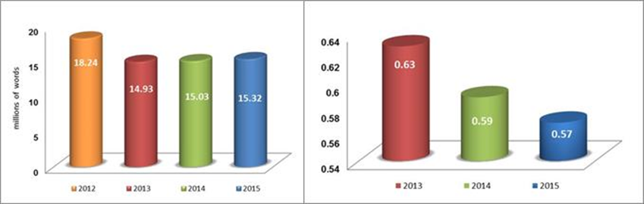

1. Efficient and quality interpretation service continued to be provided to all WIPO meetings and other events, at headquarters and in other locations, as required.
2. After several years of marked growth, the biennium 2014/15 saw a stabilization in the number of meetings organized in Geneva with 209 principal meetings, including the Diplomatic Conference for the Adoption of a New Act of the Lisbon Agreement for the Protection of Appellations of Origin and their International Registration, as compared to 260 in 2012/13. Conference support was also provided for an annual average of 5,600 (some 5,400 in 2014; 5,800 in 2015) ad-hoc meetings (informal consultations, bilateral meetings, presentations, side events, official visits and internal meetings) on the WIPO premises in Geneva; stable as compared with 11,200 in the 2012/13 biennium. Some 140 of these meetings were serviced outside the standard meeting hours, i.e. beyond 6.30 p.m. or during weekends, as compared to 167 in 2012/13.
3. Of particular note in the biennium was the smooth transition to the new conference facilities and registration infrastructure, both inaugurated in the last quarter of 2014. In 2015, following a series of consultations with relevant internal stakeholders, the terms and conditions of use required for the rental of the new WIPO Conference Hall and adjacent facilities to Member States or external entities for activities other than WIPO meetings were established and five such events accommodated[145].
4. With regard to the timely availability of meeting documents, the monitoring of publication dates implemented in 2014, and follow-up mechanisms deployed with meeting secretariats were effective in improving timeliness over the course of the biennium, with a 28 percentage point improvement in 2015 (69 per cent of documents published two months before the relevant meetings, as compared to 41 per cent in 2014).

1. Following the adoption of the Records Management and Archiving Policy in 2012/13, good progress was made in 2014/15 with regard to the establishment of retention schedules of records and enhancement of records management and archiving. To this end, Livelink, the software used for records management and archiving, was successfully upgraded in 2015, which ensured: (i) its compatibility with Windows 7 and Windows Server 2012; (ii) business continuity for the registration and storage of WIPO records and archives; and (iii) a better solution for archiving the documents of various sectors.
2. The Program continued its efforts to reduce mailing costs through tariff negotiations with external providers, an increased use of more cost-effective mailing options (e.g. registered mail as opposed to express mail), and by introducing a system of grouping addresses, which resulted in a four per cent decrease in the number of items sent in 2015 as compared to 2014. Overall, these concerted efforts resulted in an overall decrease in mailing costs of 7.2 per cent in 2015 as compared to 2014 and 11 per cent as compared to 2013.
3. In 2014/15, WIPO continued to provide printing services in an efficient and timely manner. The printing workload remained at similar levels in both years of the biennium. Moreover, the 25 per cent decrease in the printing cost per page realized in 2014 as a result of the renegotiation of leasing services was maintained at 0.15 Swiss francs in 2015, as compared to 0.20[146] Swiss francs at the end of 2013.

PERFORMANCE DATA

|  |  |  |  |  |
| --- | --- | --- | --- | --- |
| **Expected Result:** IX.1 Effective, efficient, quality and customer-oriented support services both to internal clients and to external stakeholders | | | | |
| **Performance Indicators** | **Baselines** | **Targets** | **Performance Data** | **TLS** |
| % of internal and external participants satisfied with WIPO Conference Services | *Updated Baseline end 2013:* Results of a satisfaction survey, conducted in 2013 indicated that 98% of users considered the overall quality of WIPO’s conference services either excellent (64%) or good (34%).  *Original Baseline P&B 2014/15:* Rate at end 2013 | 10% increase in rate by 2015 | Results of a satisfaction survey, conducted in 2014 and in 2015, indicated that 97% of users considered the overall quality of WIPO’s conference services either excellent or good in both years:   * 2014: excellent (48%) or good (49%); * 2015: excellent (60%) or good (37%). | **Fully Achieved** |
| Effective implementation of WIPO Language Policy | *Updated Baseline end 2013:* The language policy was extended to all WIPO Standing Committees and Main Bodies.  *Original Baseline P&B 2014/15:* Language coverage limited to certain Committees/Main bodies;  Variable length of documents | Quality translation to be made available for all Committees/Main Bodies;  Length of documents for Committees/ Main Bodies reduced to 3,300 words | In addition to all Committees/ Main Bodies, the six-language coverage was extended in 2014/15 to four Working Groups: (i) the PCT Working Group; (ii) the Working Group on the Legal Development of the Hague System for the International Registration of Industrial Designs; (iii) the Working Group on the Legal Development of the Madrid System for the International Registration of Marks; and (iv) the IPC Revision Working Group.  Around 87% of the documents received for translation (3,489 out of a total of 4,030 documents) were kept under 3,300 words. The rest which went beyond this word limit mainly concerned publications, verbatim reports or other annual reports, documents containing compilation of practices in Member States, and those prepared in response to specific requests by Member States, which are not subject to such limitation on document length.. | **Fully Achieved**  **Fully Achieved** |
| Cost per word of translation | *Updated Baseline end 2013:* 0.63 Swiss francs per word on average  *Original Baseline P&B 2014/15:* tbd | *Defined target:*  Maintain the average rate of translation  *Original target* *P&B 2014/15:* tbd | The translation cost per word was:  - 0.59 Swiss francs in 2014 (6.3% decrease as compared to 2013)  - 0.57 Swiss francs in 2015 (3.4% decrease as compared to 2014)  A total of 15.03 million words (45,537 UN standard pages) were translated in 2014, and 15.32 million words (46,420 pages) in 2015. | **Fully Achieved** |
| Quality of translation | *Updated Baseline end 2013:* 96% of documents which respect quality criteria  *Original Baseline P&B 2014/15:* % of documents which respect quality criteria | % of documents which respect quality criteria | In 2014/15, the rate of user satisfaction concerning the quality of translation was 96%. . | **Not Assessable** |
| Reduction in printing costs (per page) | *Updated Baseline end 2013:* 0.20 Swiss francs average cost per page in 2013[147]  *Original Baseline P&B 2014/15:* tbd | *Defined target:*  5% reduction in the average cost per page  *Original target* *P&B 2014/15:* tbd | 0.15 Swiss francs average cost per page in both 2014[148] and 2015 (25% reduction). | **Fully Achieved** |
| Timely publication of documents for committees and working groups | *Updated Baseline end 2013:* 26% of documents in all languages published two months before the relevant meetings  *Original Baseline P&B 2014/15:* % of documents published two months before the relevant meetings (tbd) | 65% of documents published two months before the relevant meetings | In 2014/15, 52.6% of all documents for major committees were published in all languages two months before the relevant meetings  - 2014: 41%  - 2015: 69% | **Fully Achieved** |

RISK REPORTING FOR THE BIENNIUM

|  |  |  |  |
| --- | --- | --- | --- |
| **Risk(s) to the Program achieving its Results** | **Mitigation plans in place or under implementation** | **Evolution of Risk(s) and Mitigation Strategies Over the Biennium** | **Impact on the Program’s Performance** |
| Inadequate implementation of the Language Policy  Due to increasing requests for translation and non‑adherence to prescribed limits, translation workloads mount significantly, leading to budgetary imbalances | Monitoring the number and size of documents; strictly enforcing rationalization and control measures; encouraging Sectors concerned to avoid repetitive text in documents | Through more focused controls and proactive rationalization measures, business sectors were encouraged to be more conscious of the importance of concise documentation, resulting in the translation workload being more effectively contained. As regards the effective implementation of the Language Policy, mitigation measures included a phased implementation approach and an increased reliance on outsourcing and use of translation technologies. | With the risk effectively mitigated, there was no impact on Program performance in 2014/15. |

RESOURCE UTILIZATION

Budget and Actual Expenditure (by result)

*(in thousands of Swiss francs)*



Budget and Actual Expenditure (personnel and non-personnel)

*(in thousands of Swiss francs)*



1. 2014/15 Final Budget after Transfers
2. The Final Budget after Transfers (non-personnel) reflects a slight net downward adjustment made for cost efficiency gains compensated by the redeployment of personnel resources to non-personnel for the hiring of temporary secretarial assistance for conference and printing services.
3. The decrease in the 2014/15 Final Budget after Transfers (personnel resources) was primarily the result of the redeployment of resources to: (i) reinforce administrative services in the WIPO Academy (Program 11); (ii) strengthen premises infrastructure services (Program 24); and (iii) transfers to non‑personnel as referenced above.
4. 2014/15 Budget Utilization
5. The underutilization of non-personnel resources was primarily due to cost efficiency savings achieved by a reduction in: (i) translation costs due to renegotiated contracts with external translators; (ii) printing costs following the renegotiation of leasing contracts for printers; (iii) mailing costs resulting from negotiated lower tariffs with external mail providers; and (iv) the transfer of resources for an intern (to Program 23 which centrally manages interns).

## PROGRAM 28 SAFETY AND SECURITY

**Program Manager Mr. A. Sundaram**

ACHIEVEMENTS IN THE 2014/15 BIENNIUM

1. The safety and security context within which WIPO operated in 2014/15 remained globally complex, but also broadly stable in the countries where WIPO has a presence. The Program continued to manage organization-wide safety and security systems throughout the biennium, including for the new WIPO Conference Hall facilities, which opened in September 2014.
2. International travel safety of WIPO staff members remained a critical area of focus in 2014/15, as various regions visited by staff were impacted by instability and security-related events, in particular towards the end of 2015. The unfortunate terrorist events in Paris, France in November 2015 impacted WIPO’s safety and security operations with the implementation of additional security measures, including the strengthening of the Organization’s collaboration with the Host Government. These efforts enabled WIPO to meet its commitments to participate in events and conferences such as the 21st session of the Conference of the Parties to the UNFCCC (COP 21), held in Paris from December 7 to 8, 2015.
3. The biennium 2014/15 also saw the finalization and advancement of a number of important safety and security achievements, notably the opening of the new WIPO Access Center (AB reception) and the Security Coordination Operations Center (SCOC), in time to successfully support the twenty-second session of the PBC and the WIPO Assemblies in 2014 as well as over 200 conferences and events in 2015 attended by staff, delegates, visitors, and the public. In addition, the Headquarters Minimum Operating Security Standards (H-MOSS) project was completed in 2015, resulting in enhancements that significantly strengthened safety and security management throughout the WIPO campus, notably: (i) the implementation of a new vehicle and pedestrian access control system; (ii) technically advanced anti-intrusion measures; (iii) a closed circuit television (CCTV) surveillance system; (iv) a secure Local Area Network (LAN); and (v) an emergency communications and response system; and (vi) a fire detection/control and risk management system. Furthermore, following an extensive competitive process, WIPO selected a new security guard service company to augment its internal safety and security, with the transition to the new guard service scheduled to occur in early 2016.
4. To further optimize operational capacity of the SCOC and the new systems, safety and security staff and members of the on-site security guard team underwent specialized trainings in 2014 and 2015. The biennium also saw the implementation of new safety management procedures, as well as the update of the existing standard operating procedures (SOPs) and other specific policies. Furthermore, new security staff performance measures were identified and incorporated in to the SOPs, with a view to further enhancing efficiency and emergency response capacity. Finally, as part of the Business Continuity Management Strategy (BCMS) and Crisis Management Plan, several safety and security improvements at WIPO’s CAM building (access control, the upgrade of firewall and detectors, and the installation of a CCTV system) continued to be implemented in 2015 with a focus on establishing an off-site crisis management hub.
5. In an effort to enhance the safety/security of WIPO staff, better protect the Organization’s assets and ensure compliance with UN safety and security procedures, safety and security assessment audits were completed for all five External Offices in 2014/15 with over 90 per cent of the audit recommendations closed by the end of the biennium. In addition, an out-reach program under the SCOC was established for WIPO’s External Offices to better address safety and security management through concerted coordination and a 24/7 security support service.
6. The total number of reported safety and security incidents remained low during the biennium with seven safety-related incidents out of 616 or 1.1 per cent resulting in injury: two out of 222 or 0.9 per cent in 2014 and five out of 394 or 1.3 per cent in 2015.

PERFORMANCE DATA

|  |  |  |  |  |
| --- | --- | --- | --- | --- |
| **Expected Result:** IX.4 An environmentally and socially responsible Organization in which WIPO staff, delegates, visitors and information and physical assets are safe and secure | | | | |
| **Performance Indicators** | **Baselines** | **Targets** | **Performance Data** | **TLS** |
| % of WIPO staff, delegates & visitors reporting a work related injury or incident | *Updated Baseline end 2013:*  The total percentage of staff related incidents with injuries amounted to less than 2% during 2012/13 (6 in 2012;4 in 2013)  *Original Baseline P&B 2014/15:* 2% or less of total stakeholders / clients reporting a work related injury or incident | 2% or less | The total percentage of safety related incidents with injuries in 2014/15 amounted to 1.1%:   * 2 safety related incidents (2014) * 5 safety related incidents (2015) | **Fully Achieved** |
| % of timely requests for safety & security assistance at conferences or events held in or outside of Geneva | *Updated Baseline end 2013:*  During the biennium, a total of seven audits of external conferences/meetings were completed with assistance from the respective country offices of UN DSS and complied with all UN safety/security management system standards:   * three (2012) * four (2013)   In addition, audits were completed for two external events managed directly by WIPO. (100% of all requests were responded to in a timely manner).  In 2012, there were two audits undertaken of External Office premises (Singapore and Tokyo).  *Original Baseline P&B 2014/15:* 65 % or more of total stakeholders / clients requesting timely for safety & security assistance at conferences or events held in or outside of Geneva | 80% or more | In 2014 and 2015, all requests (100%) for safety and security assistance for external and Geneva based conferences and events were met.  In 2014/15, safety and security assessment audits were completed for all WIPO External Offices, with over 90 per cent of the audit recommendations closed by the end of the biennium. | **Fully Achieved** |

RISK REPORTING FOR THE BIENNIUM

|  |  |  |  |
| --- | --- | --- | --- |
| **Risk(s) to the Program achieving its Results** | **Mitigation plans in place or under implementation** | **Evolution of Risk(s) and Mitigation Strategies Over the Biennium** | **Impact on the Program’s Performance** |
| Current antiquated/obsolete physical security systems and equipment in existing premises may lead to safety and security incidents if not replaced | With the existing premises upgrade project (2012/13), the current systems and equipment will be slowly phased out. The upgrades are planned for implementation starting 2014/15 | Towards the end of 2015 the global, regional and local threat and risk environment did evolve. However with the finalization of HMOSS upgrades and implementation of several security and safety systems, risks were managed within tolerance levels. | The 2014 and 2015 SSCS work plans and risk register activities sufficiently addressed the impact of risks during the reporting period. There was no material impact on the Program’s performance. |

RESOURCE UTILIZATION

Budget and Actual Expenditure (by result)

*(in thousands of Swiss francs)*



Budget and Actual Expenditure (personnel and non-personnel)

*(in thousands of Swiss francs)*



A. 2014/15 Final Budget after Transfers

1. The net increase in the 2014/15 Final Budget after Transfers in non-personnel resources was primarily driven by the allocation of additional resources to cover the costs related to: (i) a supervisor module linking electronic security systems; (ii) the expansion in monitoring and surveillance of the WIPO CAM building (access control, the upgrade of firewall and detectors, and the installation of a CCTV system); (iii) increased presence in physical security due to unforeseen events; (iv) enhancement of safety and security in WIPO’s external offices; and (v) the installation of the custom anti-intrusion fence below the NCH.
2. The overall increase in personnel resources in the 2014/15 Final Budget after Transfers is the net result of, on the one hand, the establishment of a Security Operations Officer function and a temporary function to support the maintenance of safety-related systems and equipment and enhancement of UN‑HMOSS standards, and on the other hand; (i) the reclassification downwards of one post; and (ii) shift of resources to non-personnel for an ICS to reinforce the safety and security coordination service.

B. 2014/15 Budget Utilization

1. Budget utilization is within the expected range for the biennium.

## PROGRAM 29 CONSTRUCTIONS PROJECTS

**Program Manager Mr. A. Sundaram**

ACHIEVEMENTS IN THE 2014/15 BIENNIUM

NEW CONSTRUCTION PROJECT

1. All the remaining repairs, replacement and finishing works, which had started mid-2011 after the handover of the New Building by the former general contractor, were completed by the end of 2015. The replacement of the ground floor windows, which was planned in 2014, was implemented after the winter season, i.e. from June 2015 onwards, immediately after the Diplomatic Conference, and until the end of 2015. The final closure of the July 2012 termination agreement with the former general contractor was amicably concluded at the end of August 2014, bringing to an end all the outstanding points on substitution works for the New Building. It should be noted that WIPO held sufficient funds to cover the cost of these works and that the Secretariat did not have to resort to any potentially lengthy legal or conflict resolution mechanisms in order to arrive at these results.

NEW CONFERENCE HALL PROJECT

1. As part of the aforementioned termination agreement, the former general contractor reimbursed to WIPO the final balance due on the Project. It is recalled that, in August 2012, the Secretariat had taken over the direct responsibility for the Project, with reinforced mandates for the architects, engineers and project pilot, as well as modifications to the internal governance and project management structure, in order to bring added flexibility and agility, and to deal in a proactive and timely manner with a number of project modifications and unforeseen matters identified during project execution. The Project was delivered in several stages, with various technical and system tests carried out in parallel, area by area. The new Access Center was delivered in July 2014; the exterior landscaping between the New Building, the new WIPO Conference Hall and the AB Building was delivered at the end of August; the new WIPO Conference Hall per se was delivered at the end of August and was available for the holding of the PBC session from September 1 to 5, 2014; the entirety of the new and renovated construction was completed in September in the new WIPO Conference Hall and three floors of the AB Building, and made available to hold the session of the WIPO Assemblies from September 22 to 30, 2014, which included the inauguration of the Hall on the opening day in the presence of officials from the Host Country (federal, cantonal and municipal levels), representatives from other UN Agencies, and from the 70-odd companies and firms that had contributed to the construction and completion of the Project, in addition to WIPO Member States and observers. A number of elements of the exterior landscaping had to be dealt with in the course of 2015. The new WIPO Conference Hall and adjacent new or renovated facilities have been used on several occasions since end 2014 for meetings of WIPO Member States and other meetings, as well as for rentals to Member States and external entities. The Project was completed on time for the WIPO Assemblies, even though it was delayed from April 2014 to September 2014, in view of the complexity of the worksite, in particular in the last few months. The validation of the final accounts with some of the companies and firms were completed by the end of 2014 and with the majority of the remaining accounts completed by the end of 2015, leaving only a handful to be completed at the beginning of 2016.

PERFORMANCE DATA

|  |  |  |  |  |
| --- | --- | --- | --- | --- |
| Expected Result: IX.1 Effective, efficient, quality and customer-oriented support services both to internal clients and to external stakeholders | | | | |
| **Performance Indicators** | **Baselines** | **Targets** | **Performance Data** | **TLS** |
| Completion of New Conference Hall Project in accordance with quality requirements, on time and within budgetary limits | Ensuring hall is delivered within budget and according to the revised completion date (due to termination of contract with the general contractor) for 2014 Assemblies of Member States | 2014 Assemblies of Member States to be held in new conference hall | The New Conference Hall Project was completed and delivered on time in accordance with quality requirements.  The first official meeting held in the new WIPO Conference Hall in 2014 was the PBC from September 1 to 5, 2014. The 2014 WIPO Assemblies of Member States were held as from September 22 to 30, 2014, with the inauguration ceremonies held on the first day.  By the end of 2015, the estimated remaining balance due on all final accounts was expected to be fully covered by the additional budget approved by Member States in 2014 and in 2015, with the final project cost to be established in 2016, after payment of all balances due. | **Fully Achieved** |
| Use of conference hall as preferred location for meetings and events organized by Member States | Starting 2015, requests for use of facilities by Member States (for meetings and events other than those organized by WIPO) | At least two requests per annum by Member States or other international organizations or other entities for the organization of meetings and/or events (other than those organized by WIPO) | The year 2015 was the first year during which the new WIPO Conference Hall and adjacent facilities could be used for rental to Member States or external entities for activities other than WIPO meetings. There were five such meetings: (i) ITU World Forum in May 2015; (ii) International Center for Sport Security in September 2015; (iii)  Geneva Water Hub Launch by Switzerland in November 2015; (iv) Swiss Firefighters (Ecole latine) Federal Diploma Ceremony in November 2015; (v) International Organization of Migration (IOM) Annual Meeting in November 2015. | **Fully Achieved** |
| Expected Result: IX.4 An environmentally and socially responsible Organization in which WIPO staff, delegates, visitors and information and physical assets are safe and secure | | | | |
| **Performance Indicators** | **Baselines** | **Targets** | **Performance Data** | **TLS** |
| Monitoring of physical accessibility measures ensuring that the new conference hall and related facilities are in full compliance with the applicable standards during construction | *Updated Baseline end 2013:* n/a  *Original Baseline P&B 2014/15: To be established beginning 2014 when new conference hall is delivered and on the basis of the specific architectural and technical assessment carried out in 2013* | To be established beginning 2014 when new conference hall is delivered and on the basis of the specific architectural and technical assessment carried out in 2013 | Physical accessibility measures implemented during construction (until end of construction in August 2014, rather than at the beginning of 2014) included the following main measures: (i) ramp for wheelchair access to the podium in the new WIPO Conference Hall, and all (31 if in full configuration) seats on the podium accessible by wheelchair; (ii) 26 seats in three different locations in the delegates desk areas accessible by wheelchairs; (iii) all 850-odd chairs for delegates’ desks removable and replaceable on demand by any other chair for disability needs; (iv) additional emergency exit door at the bottom area of the new WIPO Conference Hall, for independent access by wheelchair, directly onto an exterior ramp leading to the outside esplanade; (v) ramps for wheelchair access to interpreters booths in two new meeting rooms on one renovated floor of the AB Building; (vi) restrooms fitted for access by wheelchair; (vii) anti-slip bands affixed on steps of all staircases in and around the new WIPO Conference Hall; (viii) ramp for wheelchair access created from the new WIPO Conference Hall foyer doors leading towards the emergency exit point at the perimeter of the WIPO Campus; (ix) access from the street to the main new WIPO entrance fit for wheelchair, and interior speed gates leading to reception and registration | **Not Assessable** |
|  |  |  | counters fit for independent access by wheelchair; and (x) dedicated mobile seat for persons with disabilities, to be used on demand from the interpreters’ booths floor in case of emergency |  |
| Monitoring of environmentally sound measures and energy consumption reduction measures implemented during construction | *Updated Baseline end 2013:* n/a  *Original Baseline P&B 2014/15:* To be established beginning 2014 when new conference hall is delivered | To be established beginning 2014 when new conference hall is delivered | Environmentally sound measures implemented during construction (until end of construction in August 2014, rather than at the beginning of 2014) included the following main measures: (i) local wood for the main structure and interior paneling (ceiling, walls and floor) of the new WIPO Conference Hall; (ii) natural gas for heating; (iii) cooling system using the Geneva Lake produced chilled water; (iv) reduction of artificial light consumption by extensive use of LED technology (in all areas covered by the Project) and natural light through large bay windows and several rooftop windows (in the new WIPO Conference Hall); (v) extensive use of natural air through a mixed ventilation system; (vi) vegetation roof for the Access Center enhancing cooling capacity and rain water drainage; (vii) lighting activated by presence detection during off-hours. | **Not Assessable** |
| Completion of UN  H-MOSS peripheral security measures for the new conference hall | *n/a* | Completion of peripheral UN H-MOSS measures by end-2015 | The security perimeter in front of the new WIPO Conference Hall on the AB Building side, as well as the anti-blast wall on the Route de Ferney side were completed in August 2014. All other security measures required for the completion of the project were completed by the end of 2015. | **Fully Achieved** |

RISK REPORTING FOR THE BIENNIUM

|  |  |  |  |
| --- | --- | --- | --- |
| **Risk(s) to the Program achieving its Results** | **Mitigation plans in place or under implementation** | **Evolution of Risk(s) and Mitigation Strategies Over the Biennium** | **Impact on the Program’s Performance** |
| Major architectural or construction flaw discovered during remaining construction time of construction, or afterwards, hampers or delays use of the new conference hall | Selected high quality architect and contractors. The timber consortium with its own wood engineers is composed of highly qualified and experienced local companies. The construction site manager exercises a close monitoring of the project implementation at tight intervals. | Risk closed at the end of the biennium since the use of the new WIPO Conference Hall was effective as from September 2014, for WIPO meetings, including the 2014 and 2015 WIPO Assemblies and numerous other meetings and events throughout the remainder of the biennium. | This risk and its evolution did not have any material impact on the Program’s performance in 2014/15. |

RESOURCE UTILIZATION

Budget and Actual Expenditure (by result)

*(in thousands of Swiss francs)*



Budget and Actual Expenditure (personnel and non-personnel)

*(in thousands of Swiss francs)*



A. 2014/15 Final Budget after Transfers

1. The overall increase in the 2014/15 Final Budget after Transfers was primarily due to additional resources provided to cover the expenses related to the completion and closure of the new Conference Hall Project, as approved by the WIPO Assemblies in October 2015. This is reflected under Expected Result IX.1.

B. 2014/15 Budget Utilization

1. The slight under-utilization of personnel resources is attributable to the difference between the standard cost methodology used in the 2014/15 biennium and actual personnel expenditure.

# APPENDICES

## APPENDIX I BREAKDOWN OF THE PERFORMANCE ASSESSMENTS BY PROGRAM

The performance assessments for individual Programs in the PPR 2014/15 comprise:

*Section I: Achievements in the 2014/15 Biennium*

An analytical summary presenting results achieved in the biennium 2014/15 by the Program concerned and any challenges encountered during the period under review. As in 2014, the assessment of the implementation of the Development Agenda (DA) has been mainstreamed and therefore integrated into the *Achievements in the 2014/15 Biennium.* In line with the Budgetary Process for Projects Proposed by the Committee on Development and Intellectual Property (CDIP) for the Implementation of the DA Recommendations, approved by the WIPO Assemblies in 2010[149], the reporting on the DA continues to include detailed reporting on both the implementation of DA projects and DA Recommendations.

*Section II: Performance Data*

The table in this section recapitulates the Expected Results to which the Program contributes and the Performance Indicators, which measure Programs’ contribution to the Results as approved by Member States in the Program and Budget 2014/15. Baselines have been updated, as appropriate, to reflect the status at the end of 2013. The performance data tables continue to reflect both the original baselines (as per the Program and Budget 2014/15), the updated baselines (as per the end of 2013), and targets (as per the Program and Budget 2014/15) for comparability purposes in relation to the performance data and assessments. In line with Member States’ requests, the tables have been further enhanced in 2014/15. Programs were provided an opportunity to define targets that had not been defined in the Program and Budget 2014/15, i.e. “tbd” targets, during the baseline update exercise (launched in July 2014), using the year-end 2013 data as the basis. Targets that were not defined during this process remain undefined, and performance data are consequently rated as “not assessable.” The performance data for 2014/15 in relation to each indicator is provided in the fourth column. As a general rule, where performance data are measured by percentage changes (increases or decreases), unless otherwise indicated, the percentage changes are in comparison to the previous year, i.e. the percentage change in 2014 as compared to 2013, and the percentage change in 2015 as compared to 2014. The fifth column provides an assessment of performance using the “traffic light system”.

*Section III: Risk Reporting for the Biennium*

As part of WIPO’s commitment to strengthening its risk management, the PPR 2014/15 includes, for the first time, a dedicated section on *Risk Reporting for the Biennium*. The table contains four columns. The first two columns - *Risk(s) to the Program achieving its Results*and*Mitigation plans in place or under implementation –* reflect the risks and mitigation strategies, respectively, as approved in the Program and Budget 2014/15. The third column - *Evolution of Risk(s) and Mitigation Strategy Over the Biennium ‑* provides the consequent evolution of the risk during the biennium, including whether the risk materialized, and the implementation of the mitigation strategies foreseen or new ones added to address these risks. The fourth column - *Impact on the Program’s Performance* - describes the impact of the evolution of the risk and its mitigation strategy on the performance of the Program over the course of the biennium.

*Section IV: Resource Utilization for 2014/15*

The final section provides information on the Approved Budget 2014/15, the Final Budget after Transfers 2014/15, and actual expenditure and budget utilization in 2014/15. The reporting in this section includes two tables:

The *Budget and Actual Expenditure (by result)* provides information on the Approved Budget 2014/15, the Final Budget after Transfers 2014/15, and actual expenditure by Result for 2014/15. In 2014, the EPM planning system was enhanced to support the Organizational move to position level planning. The adjustments across Results in the Budget after Transfers 2014/15 in Programs reflect this new and more accurate methodology for allocation of personnel resources.

The *Budget and Actual Expenditure (personnel and non-personnel resources)* provides information on the Approved Budget 2014/15, the Final Budget after Transfers 2014/15, and actual expenditure 2014/15 (personnel and non-personnel). Explanations are provided for the differences between the Approved Budget and Final Budget after Transfers, as well as for budget utilization, taking into account both a Results view and a view of type of expenditure (personnel and non-personnel).

[Appendix II follows]

## APPENDIX II IMPLEMENTATION OF FUNDS-IN-TRUST 2014/15

As part of the efforts to enhance the integration of all activities under the results-based management framework of the Organization, irrespective of the source of funds, this Appendix provides an overview of activities implemented under the WIPO Funds-in-Trust (FITs). At the same time, this report responds to a request by donors for a more comprehensive report on all FITs, including both programmatic and financial information. In order to streamline reporting, the FIT report is an integral part of the Program Performance Report, providing an annual view of activities implemented in 2015. The next annual FIT report will be included in the PPR for 2016. This Appendix reports on the FITs listed in the table below and excludes the FITs for Junior Professional Officers (JPOs).

|  |  |
| --- | --- |
| **FUND-IN-TRUST** | **IMPLEMENTING SECTOR** |
| Australia | Office of the Director General |
| Brazil | Office of the Director General |
| Brazil South | Office of the Director General |
| Brazil UNDP | Office of the Director General |
| EU/Pakistan | Development Sector |
| Finland Copyright | Culture and Creative Industries Sector |
| France IP | Development Sector |
| Ibero-American Program for Industrial Property | Development Sector |
| Italy | Development Sector |
| Japan Copyright | Culture and Creative Industries Sector |
| Japan IP | Development Sector |
| Japan IP/Africa | Development Sector |
| Republic of Korea Building Respect for IP | Global Issues Sector |
| Republic of Korea Copyright | Culture and Creative Industries Sector |
| Republic of Korea Education | Development Sector |
| Republic of Korea IP | Development Sector |
| Mexico | Development Sector |
| Spain | Development Sector |
| Uruguay | Development Sector |

**AUSTRALIA**

|  |  |  |  |  |  |
| --- | --- | --- | --- | --- | --- |
| **RESULT:** II.1. Increased use of the PCT route for filing international patent applications | | | | | |
| **Activity** | **Date** | **Host Country/ Recipients** | | | **Purpose(s)/Description(s)** |
| PCT Roving Seminars for Universities | March 25 to 26, 2015 | South Africa / 52 participants | | | The Seminars provided participants with knowledge of how they can utilize the PCT and the international patent system in general for knowledge transfer, with real life examples. |
| Training on PCT and ePCT for ASEAN countries | March 24 to 25, 2015 | Singapore/ 18 participants from Brunei Darussalam, Cambodia, Indonesia, Lao People's Democratic Republic, , Malaysia, Myanmar, Philippines, Thailand, Viet Nam | | | The training served to provide the key PCT and ePCT functions and procedures to be applied by these Offices. It also provided valuable opportunity for the participants to exchange their experiences. This sub-regional workshop was also a timely occasion to learn up-to-date PCT related issues especially ePCT. |
| **RESULT:** III.1. National innovation and IP strategies and plans consistent with national development | | | | | |
| **Activity** | **Date** | **Host Country/ Recipients** | | | **Purpose(s)/Description(s)** |
| National Consultation on the Draft National IP Strategy | April 9 and 10, 2015 | Cook Islands | | | To meet with the main stakeholders to introduce and discuss in detail the draft National IP Strategy. Based on the discussions held, a revised IP Strategy was then submitted to the Government for their approval. |
| National Consultation on the Draft National IP Strategy | April 14 to 16, 2015 | Solomon Islands | | | To hold face-to-face consultations with the national stakeholders on the current draft of the National IP Strategy and make final revisions before a revised draft national IP Strategy is submitted to the Government for approval. |
| National Consultation Workshop for the Development of a National IP Strategy | February 13, 2015 | Myanmar | | | To enhance the knowledge about the methodology and process of formulating and implementing a national IP strategy and discuss policy issues to be addressed by, and the possible elements to be incorporated in such a strategy, taking into account the existing national developmental objectives and goals. The National Consultation Workshop paved the way for the formulation process and the project team, consisting of two international consultants and one national expert, undertook comprehensive desk research, conducted a baseline survey and produced a report with preliminary findings, which in turn, served as a basis for further consultation meetings at the national level. |
| **RESULT**: III.2. Enhanced human resource capacities able to deal with the broad range of requirements for the effective use of IP for development in developing countries, LDCs and countries with economies in transition | | | | | |
| **Activity** | **Date** | | **Host Country/ Recipients** | | **Purpose(s)/Description(s)** |
| WIPO/FIT Australia National Workshop on Patent Drafting and use of Patent System | May 26 to 29, 2015 | | Indonesia | | Upon finalization of this training, professionals were provided with: an enhanced understanding of the use of the patent system as part of their IP commercialization strategy; skills to be able to support patent attorneys in drafting patent claims regarding specific technologies and; an enhanced understanding of the advantages of the PCT filing route. |
| WIPO/FIT Australia Advanced Successful Technology Licensing (STL) Training Program | June 9 to 12, 2015 | | Indonesia | | Participants upgraded their knowledge about IP licensing so as to be able to significantly contribute to licensing negotiations and to be able to create first drafts of licensing agreements. |
| WIPO/FIT Australia Advanced IP Marketing and Valuation Training Program | June 15 to 18, 2015 | | Philippines | | Participants were provided enhanced understanding of the interrelationships between IP marketing and valuation, and they obtained knowledge so as to be able to identify potential markets for knowledge and technology developed in their research institutions. In general, they were provided skills to be able to determine the value of intellectual assets that are the subject of licensing negotiations. |
| National Workshop on Copyright and Related Rights | April 22 to 24, 2015 | | Cook Islands | | This was the first WIPO-organized national workshop on copyright in the Cook Islands. The workshop, which was addressed to government officials and other interested stakeholders, provided information on copyright and related rights, their cultural and economic importance and the importance of establishing a national system for the protection and management of copyright and related rights. |
| Sub-regional workshop on Copyright and Development for Decision Makers | January 19 and 20, 2015 | | Fiji, Niue, Papua New Guinea, Samoa, Solomon Islands, Tonga, Tuvalu, Vanuatu | | The workshop focused on increasing awareness and understanding of the role and value of copyright in cultural and economic development among decision makers from participating countries and the Pacific Islands Forum Secretariat. |
| National Seminar on Copyright and Related Rights | January 21 and 22, 2015 | | Vanuatu | | The seminar, held back-to-back with the activity mentioned above, provided information on copyright and related rights, including how the system works at a practical level, to an audience of government officials and other national stakeholders. |
| **RESULT**: IV.2. Enhanced access to, and use of, IP information by IP institutions and the public to promote innovation and creativity | | | | | |
| **Activity** | **Date** | **Host Country/ Recipients** | | **Purpose(s)/Description(s)** | |
| Capacity building (through a Memorandum of Understanding) | Ongoing from 2014 and completed in May 2015 | Bangladesh | | To provide a local organization, Young Power in Social Action (YPSA) with the expertise and funding to carry out capacity building activities in Bangladesh.  Activities included: (i) the training of local government and commercial publishers, as well as local NGOs, on the production of accessible books; (ii) the production of 162 educational books in accessible formats in Bengali; and (iii) the purchase of 35 Android devices that will be loaned to visually impaired students so that they can read these books. Anticipated beneficiaries of produced books are 10,000 visually impaired students. | |
| Capacity building (through a Memorandum of Understanding) | Ongoing from 2014 and completed in May 2015 | Sri Lanka | | To: (i) provide a local organization, the DAISY Lanka Foundation (DLF), with the expertise and funding to carry out capacity building activities in Sri Lanka.  Activities included: (i) the training of local government and commercial publishers, as well as local NGOs, on the production of accessible books: (ii) the production of 1069 educational books in accessible formats in Sinhalese; and (iii) the purchase of 80 DAISY reading devices that will be loaned to visually impaired students so that they can read these books. Anticipated beneficiaries of produced books are 10,000 visually impaired students. | |
| Capacity building (through a Memorandum of Understanding) | Ongoing from 2014 and completed in September 2015 | Sri Lanka | | Developed a better quality text-to-speech application in Sinhalese for use by the visually impaired in reading accessible format books. Previously, only a very “synthetic sounding” text-to-speech application in Sinhalese existed. The application was developed by the University of Colombo, School of Computing. | |
| Capacity building (through a Memorandum of Understanding) | Ongoing from 2014 and completed in May 2015 | Nepal | | To provide a local organization, the Action on Disability Rights and Development (ADRAD), with the expertise and funding to carry out capacity building activities in Nepal.  Activities included: (i) the training of local government and commercial publishers, as well as local NGOs, on the production of accessible books; (ii) the production of 140 educational books in accessible formats in English and Nepalese; and (iii) the purchase of 100 Android devices that will be loaned to visually impaired students so that they can read these books. Anticipated beneficiaries of produced books are 1,500 visually impaired students. | |
| Capacity building – DAISY Starter Kit | Ongoing from 2014 and completed in March 2016 | India | | Provided funding to a partner organization, the DAISY Consortium, which produced a Starter Kit of guidelines and best practices for the production of books in accessible formats in developing countries. | |
| **RESULT**: VII.2. IP-based platforms and tools are used for knowledge transfer, technology adaptation and diffusion from developed to developing countries, particularly least developed countries, to address global challenges | | | | | |
| **Activity** | **Date** | **Host Country/ Recipients** | | **Purpose(s)/Description(s)** | |
| Continuation of Hosting Arrangements for African Biomedical Scientists in research facilities outside Africa | October to December 2015[150] | University of California San Diego, USA/ Dr. Christian Agyare and Ms. Kyere-Davies. | | To promote: (i) the effective use of IP to address a global health challenge (neglected tropical diseases (NTDs), which affect many LDCs; and (ii) knowledge transfer for scientists, particularly from LDCs.  Customized research programs were developed to ensure that participants upgrade research skills and are able to make a significant contribution in their home countries on NTDs. | |

**AUSTRALIA Donor Contributions and Expenditure in 2015**

|  |  |  |  |  |
| --- | --- | --- | --- | --- |
| **Balance as of December 31, 2014** | **Income 2015** | **Expenditure 2015** | **Reimbursements** | **Balance as of December 31, 2015** |
| 493,374 | 727 | 383,882 | - | 110,219 |

**BRAZIL**

|  |  |  |  |
| --- | --- | --- | --- |
| **RESULT**: III.2. Enhanced human resource capacities able to deal with the broad range of requirements for the effective use of IP for development in developing countries, LDCs and countries with economies in transition | | | |
| **Activity** | **Date** | **Host Country/ Recipients** | **Purpose(s)/Description(s)** |
| IX Annual Meeting of the Brazilian Forum of Innovation and Technology Transfer Managers (FORTEC) | May 19 to 22, 2015 | Brazil | To discuss topics related to innovation policies and strategies and develop competencies in the fields of technology transfer and IP management. |
| Workshop on IP Protection and Commercialization Strategies of Research Results | July 6 to 10, 2015 | Brazil | To provide practical training on the management and protection strategies of intellectual property rights in universities and R&D institutions |
| VIII ENAPID - Academic Meeting on Intellectual Property, Innovation and Development | August 11 to 14, 2015 | Brazil | To promote sustainable innovation and foster the relevant role of the IP system in the global economic context |
| Seminar on Franchising and Alternative Dispute Resolution | September 3, 2015 | Brazil | To encourage the use of WIPO ADR clauses in franchise-related agreements involving members of the Brazilian Franchising Association. |
| Seminar on International Technology - Licenses and Dispute Resolution | September 4, 2015 | Brazil | To encourage the use of WIPO ADR clauses by lawyers and contract managers involved in licensing and research and development agreements in Brazil. |
| II Seminar on Geographical Indications (GIs) and Collective Trademarks in the Handicraft Sector | September 24 and 25, 2015 | Brazil/ Colombia, Mexico, Peru | To promote a debate on the potential economic and social gains that GIs and Collective Trademarks provide to national development and in particular to the handicraft industry. |
| XVII Intellectual Property and Technology Commercialization Meeting - XVII REPICT | October 1, 2015 | Brazil | To discuss the technology transfer tools based on the intangible assets protection focused on the micro and small enterprises. |

**BRAZIL Donor Contributions and Expenditure in 2015**

|  |  |  |  |  |
| --- | --- | --- | --- | --- |
| **Balance as of December 31, 2014** | **Income 2015** | **Expenditure 2015** | **Reimbursements** | **Balance as of December 31, 2015** |
| 333,211 | (27) | 102,850 | - | 230,334 |

**BRAZIL SOUTH**

|  |  |  |  |
| --- | --- | --- | --- |
| **RESULT**: III.2. Enhanced human resource capacities able to deal with the broad range of requirements for the effective use of IP for development in developing countries, LDCs and countries with economies in transition | | | |
| **Activity** | **Date** | **Host Country/ Recipients** | **Purpose(s)/Description(s)** |
| II Regional Workshop on IP and Technology Transfer | May 7 to 8, 2015 | Peru/ Costa Rica, Dominican Republic, Ecuador, Mexico, Peru and Uruguay | To discuss: (i) the structuring of national and institutional IP strategies; (ii) the establishment of technology transfer offices; and (iii) strategic models to foster innovation. |
| Regional Workshop on Free and Open Source Tools for Patent Analysis | August 27 to 28, 2015 | Brazil/ Chile, Colombia, Mexico and Uruguay | To: (i) complement the training provided during the Regional Patent Analytics Workshop held in August 2013, in Rio de Janeiro, Brazil; and (ii) serve as a platform for discussion and feedback to the Manual on Open Source Patent Analytics Tools, which is currently under preparation. |
| III Regional Workshop on IP and Technology Transfer | November 18 to 20, 2015 | Mexico/ Colombia, Cuba, El Salvador, Peru and Mexico | To discuss: (i) the establishment of technology transfer policies; and (ii) present practical aspects related to the negotiation and drafting of technology agreements. |
| XXXIII Seminar for IP Offices of Latin America | August 31 to September 3, 2015 | Brazil/ Argentina, Bolivia, Chile, Colombia, Costa Rica, Cuba, Dominican Republic, Ecuador, El Salvador, Guatemala, Honduras, Mexico, Nicaragua, Panama, Paraguay, Peru, Uruguay and Venezuela | To promote the exchange of experiences among officials of national IP Offices on selected topics, focusing in particular on International cooperation in IP. |
| Regional Launch of the Global Innovation Index (GII) 2015 | September 30, 2015 | Brazil/ Chile, Colombia, Costa Rica and Mexico | To: (i) publicize the 2015 edition of the GII in the Latin American Region; and (ii) bring together experts and representatives from the Government and the industry sectors to discuss issues related to the economics of innovation. |
| Regional Intermediate Training Program on Patent Examination for Latin American Countries | November 23 to December 4, 2015 | Brazil/ Argentina, Bolivia, Colombia, Costa Rica, Cuba, Dominican Republic, Ecuador, El Salvador, Guatemala, Honduras, Mexico, Nicaragua, Panama, Paraguay, Peru and Uruguay | To improve capacity on patent examination in Latin American countries. |
| Regional Workshop on Advanced Successful Technology Licensing (STL - Advanced) | December 7 to 11, 2015 | Brazil/ Cuba, Peru and Uruguay | To upgrade the knowledge of technology managers, business innovation professionals and lawyers from academic institutions and industry regarding: (i) commercialization of IP, with particular focus on IP marketing and valuation of technology; and (ii) negotiations and the drafting of license agreements. |

**BRAZIL SOUTH Donor Contributions and Expenditure in 2015**

|  |  |  |  |  |
| --- | --- | --- | --- | --- |
| **Balance as of December 31, 2014** | **Income 2015** | **Expenditure 2015** | **Reimbursements** | **Balance as of December 31, 2015** |
| 384,809 | (17) | 146,478 | - | 238,315 |

**BRAZIL UNDP[151]**

|  |  |  |  |
| --- | --- | --- | --- |
| **RESULT**: III.2. Enhanced human resource capacities able to deal with the broad range of requirements for the effective use of IP for development in developing countries, LDCs and countries with economies in transition | | | |
| **Activity** | **Date** | **Host Country/ Recipients** | **Purpose(s)/Description(s)** |
| Training Program for Technology Development Negotiators | October 19 to 30, 2015 | Brazil | To promote the training of 28 professionals in the field of management and negotiation of collaborative processes, with a special focus on IP related provisions for the establishment of technology development agreements. |

**BRAZIL UNDP Donor Contributions and Expenditure in 2015**

|  |  |  |  |  |
| --- | --- | --- | --- | --- |
| **Balance as of December 31, 2014** | **Income 2015** | **Expenditure 2015** | **Reimbursements** | **Balance as of December 31, 2015** |
| - | 39,489 | 39,489 | - | - |

**EUROPEAN UNION (Pakistan Project)**

|  |  |  |  |
| --- | --- | --- | --- |
| **RESULT:** I.2. Tailored and balanced IP legislative, regulatory and policy frameworks | | | |
| **Activity** | **Date** | **Host Country/ Recipients** | **Purpose(s)/Description(s)** |
| Roundtable on the Development of a National Intellectual Property (IP) Strategy | April 23 to 24, 2015 | Pakistan/ 53 participants | To: (i) review the overall aims and key elements of IP strategies; (ii) discuss the possible linkages between a national IP strategy and key policy areas (e.g. trade, innovation, health); (iii) exchange views on methodologies of formulating and implementing IP strategies; and (iv) identify measures that may be taken by the national authorities to develop an IP strategy for the country. |
| **RESULT**: IV.4. Enhanced technical and knowledge infrastructure for IP Offices and other IP institutions leading to better services (cheaper, faster, higher quality) to their stakeholders | | | |
| **Activity** | **Date** | **Host Country/ Recipients** | **Purpose(s)/Description(s)** |
| Development of IPO Pakistan’s Web Portal[152] | January to December, 2015  (Ongoing) | Pakistan/ IPO Pakistan | To upgrade IPO Pakistan’s existing web site by introducing new features such as: (i) online Patent Gazette and Trademark Journals; (ii) online access to check status of IP applications; (iii) public search of IP databases; and (iv) implementation of an intranet for internal communication between offices of IPO Pakistan in Karachi, Lahore and Islamabad. |
| Customization of HR and Financial Management Software in IPO Pakistan[153] | January to December, 2015  (Ongoing) | Pakistan/ IPO Pakistan | To enhance IPO Pakistan’s capacity to deliver services by introducing automation systems for its core human resource and financial management functions. |
| Consultations to Review Ongoing Activities under the Trade Related Technical Assistance (TRTA) II Program | April 20 to 24, 2015 | Pakistan/ IPO Pakistan and UNIDO | Consultations with national stakeholders (IPO Patent Office, Trade Marks Registry and Copyright Office, Karachi, IPO Head Office and UNIDO Project Management Office, Islamabad) to review the status of implementation of the TRTA II Program and the measures needed to ensure successful completion of the Program, especially to achieve tangible outcomes. |

**EUROPEAN UNION (Pakistan Project) Donor Contributions and Expenditure in 2015**

|  |  |  |  |  |
| --- | --- | --- | --- | --- |
| **Balance as of December 31, 2014** | **Income 2015** | **Expenditure 2015** | **Reimbursements** | **Balance as of December 31, 2015** |
| 383,115 | (41,520) | 189,256 | 99,868 | 52,470 |

**FINLAND/ COPYRIGHT**

|  |  |  |  |
| --- | --- | --- | --- |
| **RESULT:** V.2. Wider and better use of WIPO economic analysis in policy formulation | | | |
| **Activity** | **Date** | **Host Country/ Recipients** | **Purpose(s)/Description(s)** |
| Publication of the second edition of the *WIPO Guide on Surveying the Economic Contribution of the Copyright-Based Industries[154]* | March to June, 2015 | All countries | To update the WIPO tool for surveying the economic contribution of the copyright-based industries. |
| Develop guidelines to assess the economic, social and cultural impact of copyright in the creative industries | May 1 to December 31, 2015 | Finland/ All countries | To pilot a project on testing and finalizing the WIPO tool for analyzing broader copyright impact |
| Studies on the economic contribution of copyright industries and on assessing copyright piracy | January to May, 2015 | Ethiopia, Republic of Moldova | Finalized for publication two additional WIPO studies on the economic contribution of the copyright industries (Ethiopia and Republic of Moldova). |

**FINLAND/ COPYRIGHT Donor Contributions and Expenditure in 2015**

|  |  |  |  |  |
| --- | --- | --- | --- | --- |
| **Balance as of December 31, 2014** | **Income 2015** | **Expenditure 2015** | **Reimbursements** | **Balance as of December 31, 2015** |
| 66,020 | - | 51,660 | - | 14,360 |

**FRANCE/ INDUSTRIAL PROPERTY**

|  |  |  |  |
| --- | --- | --- | --- |
| **RESULT:** III.2. Enhanced human resource capacities able to deal with the broad range of requirements for the effective use of IP for development in developing countries, LDCs and countries with economies in transition | | | |
| **Activity** | **Date** | **Host Country/ Recipients** | **Purpose(s)/Description(s)** |
| Regional Workshop: "Innovating through Patents" | May 19 to 20, 2015 | Morocco/ 15 participants from Algeria, OAPI, and Tunisia | To engage enterprises, universities, IP Offices, R&D institutions and the private sector to use patent information: (i) in the innovation process; (ii) for knowledge capitalization; (iii) for formulating new ideas; and (iv) in the process of protecting and exploiting their inventions. |
| National Workshop on Building Respect for Intellectual Property for Judges  National Workshop on building respect for Intellectual Property for Custom Officials | June 30 to July 2, 2015  June 30 to July 1, 2015 | Benin/30 judges  Benin/ 15 Customs Officers | To: (i) develop and strengthen the capacities of the judiciary and customs officials of Benin in the enforcement of intellectual property rights and building respect for IP; (ii) improve the knowledge and skills of participants in respect of legal proceedings and management of IP litigation and the application of customs measures to enhance use the procedures as described under of Part III of the TRIPS Agreement; (iii) provide an opportunity for each participating group to exchange experiences and discuss the challenges in the implementation of legal and regulatory provisions on enforcement of IP rights; and (iv) familiarize the judges with the jurisprudence tools developed respectively by WIPO and OAPI. |
| Regional Seminar on Collaborative Innovation and Intellectual Property : “Developing Partnerships between Universities and Enterprises” | July 2 to 3, 2015 | Vietnam/ 70 participants including nine from Cambodia, Laos People’s Democratic Republic and Myanmar | To: (i) present various models that help in establishing a conducive environment for innovation and IP rights protection; (ii) develop innovation capacities through an efficient use of the IP system; and (iii) address the topics of collaborative innovation and open innovation. |
| Regional Training on Trademark and Counterfeiting for Judges of the Countries of the Cooperation Council of Arab States of the Gulf (GCC) | October 25 to 26, 2015 | United Arab Emirates/ 23 participants from Bahrein, Kuwait, Lebanon, Oman, Qatar, Saudi Arabia and United Arab Emirates | To: (i) sensitize the judiciary on industrial property; (ii) ensure court decisions comply with the provisions of their national laws and international treaties to which their respective countries are party; and (iii) increase consistency in the decisions taken by the judges both at the national and regional level. |
| Side Events at the COP21 | November 30 to December 11, 2015 | France | To give the opportunity to French and international SMEs to demonstrate: (i) that Industrial Property is not an obstacle to sustainable development and climate protection; and (ii) how Industrial Property can contribute to the development of innovations that mitigate, among others, negative effects of climate change. |
| CAPI (*Certificat d’animateur propriété intellectuelle*) Training Program with the *Institut national de la propriété industrielle* (INPI) France and the *Office Marocain de la Propriété Industrielle et Commerciale* (OMPIC) | December 12 to 31, 2015  (Expected completion April 8, 2016) | Morocco/ 10 participants from Algeria, Cameroon, Côte d’Ivoire, Senegal and Tunisia | A certified training program aimed at meeting the needs of businesses and professionals who wish to: (i) develop expertise in the management of Industrial Property rights; (ii) understand the challenges of Industrial Property; (iii) improve efficiency in the management and valuation of intangible assets; and (iv) master the use of protection and search tools. |

**FRANCE/ INDUSTRIAL PROPERTY Donor Contributions and Expenditure in 2015**

|  |  |  |  |  |
| --- | --- | --- | --- | --- |
| **Balance as of December 31, 2014** | **Income 2015** | **Expenditure 2015** | **Reimbursements** | **Balance as of December 31, 2015** |
| 1,027,640 | 292,662 | 359,804 | - | 960,497 |

**IBERO–AMERICAN PROGRAM FOR INDUSTRIAL PROPERTY[155]**

|  |  |  |  |
| --- | --- | --- | --- |
| **RESULT:** III.2. Enhanced human resource capacities able to deal with the broad range of requirements for the effective use of IP for development in developing countries, LDCs and countries with economies in transition | | | |
| **Activity** | **Date** | **Host Country/ Recipients** | **Purpose(s)/Description(s)** |
| Platform in Spanish on IP services and contents to the Ibero-American entrepreneurial sector with special focus on SMEs (CIBEPYME). | January to December, 2015  (ongoing) | All Ibero-American countries | To strengthen the capacity and promote the use of IP as an important tool for business. |
| **RESULT:** III.4. Strengthened cooperation mechanisms and programs tailored to the needs of developing countries and LDCs | | | |
| **Activity** | **Date** | **Host Country/ Recipients** | **Purpose(s)/Description(s)** |
| Preparation of a situation analysis and action plan proposal by an external expert consultant. | January to December, 2015  (ongoing) | All Ibero-American countries | To design a roadmap on strengthening and development of national information services and an implementation schedule, with a view to enhancing national capacities.  Horizontal cooperation among IP offices to reduce asymmetries in relation to quality management in information technology. The tasks of the consultant are: (i) to detect asymmetries between OPIS on quality management and information technology; (ii) design a program of action aimed at eliminating asymmetries through training; and (iii) coordinate the implementation of this project. |
| Encouraging cooperation between Latin American IPOs, for the creation of a Platform for member countries to facilitate the exchange of experiences and good practices between offices. | January to December, 2015  (ongoing) | All Ibero-American countries | To promote the virtual exchange of best practices among IPOs on issues such as: (i) quality management; (ii) organization of online registration services and information ; (iii) the provision of databases; (iv) examination of patents, designs and trademarks; (v) service organization of technological and commercial information; (vi) organization of training programs; and (vii) the provision of mediation or arbitration. |

**IBERO–AMERICAN PROGRAM FOR INDUSTRIAL PROPERTY Donor Contributions and Expenditure in 2015**

|  |  |  |  |  |
| --- | --- | --- | --- | --- |
| **Balance as of December 31, 2014** | **Income 2015** | **Expenditure 2015** | **Reimbursements** | **Balance as of December 31, 2015** |
| 232,961 | 13,103 | 6,110 | - | 239,955 |

**ITALY**

|  |  |  |  |
| --- | --- | --- | --- |
| **RESULT:** IV.2. Enhanced access to, and use of, IP information by IP institutions and the public to promote innovation and creativity | | | |
| **Activity** | **Date** | **Host Country/ Recipients** | **Purpose(s)/Description(s)** |
| Creation of an online national patent database at the Italian Patent and Trademark Office (DGLC-UIBM) | January to December, 2015  (Ongoing)[156] | Italy | To: (i) facilitate Italy’s participation in existing multilateral arrangements for sharing patent information and documents; (ii) set the basis for the participation of Italy in PATENTSCOPE and in other global or international patent databases (e.g. Espacenet); and (iii) contribute to increased dissemination of digitized patent collections for the benefit of all WIPO Member States, including developing countries. |
| Content review and publication of a guide on *Intellectual Property for Agri-food Small and Medium Enterprises*[157] | January to July, 2015[158] | Italy | Publication and dissemination of the guide at the World Expo Milan 2015, centered on the theme Feeding the Planet, Energy for Life. contributed to the reflection on the use of IP in the world agri-food business. |

**ITALY Donor Contributions and Expenditure in 2015**

|  |  |  |  |  |
| --- | --- | --- | --- | --- |
| **Balance as of December 31, 2014** | **Income 2015** | **Expenditure 2015** | **Reimbursements** | **Balance as of December 31, 2015** |
| 1,233,536 | - | 436,938 | - | 796,598 |

**JAPAN/COPYRIGHT**

|  |  |  |  |
| --- | --- | --- | --- |
| **RESULT:** III.2. Enhanced human resource capacities able to deal with the broad range of requirements for the effective use of IP for development in developing countries, LDCs and countries with economies in transition | | | |
| **Activity** | **Date** | **Host Country/ Recipients** | **Purpose(s)/Description(s)** |
| National Workshop on Copyright and Related Rights | March 3 to 4, 2015 | Bangladesh/ over 50 local participants | To promote better awareness of copyright and related rights and their role in contributing to cultural and economic development. |
| National Workshop on the Role of Copyright and Related Rights in Economic and Cultural Development | July 6 to 7, 2015 | Myanmar/ about 90 local participants | To: (i) promote better understanding on the role of copyright and related rights in cultural and economic development; and (ii) assist in encouraging efficient exploitation of cultural works through copyright and related rights. |
| National Workshop on Copyright and Related Rights and Emerging Issues | August 5 to 6, 2015 | Viet Nam/ about 100 local participants | To: (i) better understand the recent development of copyright and related rights as well as the technology and its implications on the copyright system; and (ii) discuss issues and challenges in the field of copyright and related rights in the digital environment. |
| **RESULT:** IV.4. Enhanced technical and knowledge infrastructure for IP Offices and other IP institutions leading to better services (cheaper, faster, higher quality) to their stakeholders | | | |
| **Activity** | **Date** | **Host Country/ Recipients** | **Purpose(s)/Description(s)** |
| Workshop on the Protection of Copyright and Related Rights | February 2 to 13, 2015 | Japan/ 11 participants from China, India, Malaysia, Philippines, Sri Lanka and Thailand | To inform the officials from the copyright offices and other related institutions in Asia and the Pacific region of the importance in protection of copyright and related rights. |
| Study Visit to Copyright Management Organizations | February 9 to 13, 2015 | Japan/ 8 participants from Bhutan, Cambodia, Lao People's Democratic Republic and Myanmar | To: (i) deepen the knowledge and understanding of the participants on copyright management issues; (ii) facilitate cooperation and coordination among copyright offices and copyright management organizations; and (iii) learn the Japanese experience in the field of copyright and related rights. |
| Workshop on the Protection of Copyright and Related Rights | October 19 to 30, 2015 | Japan/ 10 participants from Indonesia, Malaysia, Philippines, Thailand and Viet Nam | To: (i) inform the officials from the copyright offices and other related institutions in the Asia Pacific region of the importance of protection of copyright and related rights; and (ii) exchange experiences with Japanese colleagues. |
| Study Visit to Copyright Management Organizations | October 26 to 30, 2015 | Japan/ 6 participants from Bangladesh, Mongolia and Sri Lanka | To: (i) deepen the knowledge and understanding of the participants on copyright management issues; (ii) facilitate cooperation and coordination among copyright Offices and CMOs; and (iii) learn the Japanese experience in the field of copyright and related rights. |

**JAPAN/COPYRIGHT Donor Contributions and Expenditure in 2015**

|  |  |  |  |  |
| --- | --- | --- | --- | --- |
| **Balance as of December 31, 2014** | **Income 2015** | **Expenditure 2015** | **Reimbursements** | **Balance as of December 31, 2015** |
| 339,511 | 469,462 | 464,038 | - | 344,935 |

**JAPAN/ INDUSTRIAL PROPERTY**

|  |  |  |  |  |  |  |
| --- | --- | --- | --- | --- | --- | --- |
| **RESULT**: III.2. Enhanced human resource capacities able to deal with the broad range of requirements for the effective use of IP for development in developing countries, LDCs and countries with economies in transition | | | | | | |
| **Activity** | | | **Date** | **Host Country/ Recipients** | | **Purpose(s)/Description(s)** |
| Training Course on the Examination Practices of Industrial Property Basic Program | | January 19  to 30, 2015 | | Japan/ Afghanistan, Algeria, Brunei Darussalam, Cambodia, Chile, Indonesia, Kenya, Lao People’s Democratic Republic, Madagascar, Malaysia, Myanmar, Pakistan, Peru, Singapore, Sri Lanka, Tajikistan, Tanzania, Viet Nam and ARIPO | | To enhance important basic knowledge of the laws and substantive examination procedures in the field of examination of industrial property rights. |
| Training Course on IP Management and the Formulation and Implementation of Results-Based IP Office Plans | | February 6 to 13, 2015 | | Japan/ Bangladesh, Brazil, Brunei Darussalam, Cambodia, Chile, India, Indonesia, Lao People’s Democratic Republic, Malaysia, Mexico, Morocco, Myanmar, Nigeria, Pakistan, Peru, Philippines, Singapore, South Africa, Thailand and Viet Nam | | To: (i) increase the knowledge of participants of modern IP management practices including a manner of making policies, strategies and plans concerning capacity building for patent examiners and also quality management of patent examinations; and (ii) enhance the capacity of participants to formulate, implement and evaluate IP Office plans that are time-bound, result-oriented, and have a measurable impact. |
| Training Course for Patent Examiners on Specified Technology (Pharmaceutical) | | February 19 to 26, 2015 | | Japan/ China, Egypt, India, Indonesia, Malaysia, Pakistan, Philippines, Thailand, Turkey, Viet Nam and ARIPO | | To: (i) acquaint the participants with current trends and modern practices in the examination of patents related to pharmaceuticals; (ii) impart practical knowledge and insights on patent examination methodologies; (iii) offer an opportunity to share experiences and views among participants on patent examination issues; and (iv) enhance participants’ professional capabilities for examination of pharmaceutical patents. |
| Training Course on the Use of Information Technology in Industrial Property Administration | | October 26 to November 6, 2015 | | Japan/ Algeria, Argentina, Brunei Darussalam, Cambodia, Chile, India, Indonesia, Lao People’s Democratic Republic, Malaysia, Mexico, Myanmar, Papua New Guinea, Peru, Philippines, South Africa, Thailand, Viet Nam and ARIPO | | To: (i) familiarize the participants with recent developments in information technology in relation to industrial property administration, dissemination of industrial property information, and provision of online services; (ii) impart practical knowledge of latest tools and technologies via interactive sessions, as well as through visits to relevant private entities; (iii) provide an opportunity to exchange views and concerns among participants on topical related issues, and enhance the participants’ professional capacities in planning and managing the use of information technology in industrial property administration. |
| Training Course on Enforcement of Intellectual Property Rights | | November 30 to December 10, 2015 | | Japan/ China, Indonesia, Malaysia, Philippines, Thailand, United Arab Emirates and Viet Nam | | To: (i) promote respect for IP through a review and discussion of the minimum standards and flexibilities in IP enforcement contained in Part III of the TRIPS Agreement; (ii) provide participants with an opportunity to demonstrate their skills in appreciating evidence and in deciding on IP cases, and assess the recent developments in case law and issues discussed at WIPO’s Advisory Committee on Enforcement; (iii) enable participants to acquire a broader knowledge on matters relating to intellectual property and litigation systems; (iv) enable them to deepen their understanding of procedures in relation to IP litigation and trial methods; and (v) enhance professional capacity in connection with infringement litigation processes. |
| Long-term Fellowship at the Japan Patent Office (JPO) | | May to September, 2015 | | Japan/ Viet Nam | | To enhance the knowledge and understanding of the fellows on selected topics in the field of industrial property, primarily by providing an opportunity for independent research on subjects of their choice. The candidate from NOIP (Viet Nam) chose the topic of “Effective IP promotion in a developing country”. |
| Short-Term Practicum/Internship in Patent Attorney Offices | | November 2 to 13, 2015 | | Japan/ Nepal | To provide Intellectual Property graduates with knowledge, skills and insights of the real world of IP through classroom learning, complemented with hands-on training and actual work experience. | |
| **RESULT**: III.4. Strengthened cooperation mechanisms and programs tailored to the needs of developing countries and LDCs | | | | | | |
| **Activity** | | | **Date** | **Host Country/ Recipients** | | **Purpose(s)/Description(s)** |
| Head of Intellectual Property Office Conference | June 29 to 30, 2015 | | | Japan/ Bangladesh, Bhutan, Cambodia, India, Lao People’s Democratic Republic, Malaysia, Myanmar, Nepal, Pakistan, Philippines, Singapore, Sri Lanka and Thailand | | To: (i) sensitize new Directors General to the world of IP and provide executive learning to increase their understanding of IP and development; (ii) discuss the implementation strategy of WIPO’s technical assistance focusing on sustainability; (iii) provide a secure environment for heads of IP Offices to exchange views and experiences; and (iv) facilitate south-south cooperation by building stronger ties among heads of IP Offices in the region. |
| **RESULT**: IV.2. Enhanced access to, and use of, IP information by IP institutions and the public to promote innovation and creativity | | | | | | |
| **Activity** | | | **Date** | **Host Country/ Recipients** | | **Purpose(s)/Description(s)** |
| Regional Seminar on Dissemination and Effective Utilization of Patent Information | November 5  to 6, 2015 | | | Japan/ Indonesia, Malaysia, Philippines, Thailand and Viet Nam | | To provide participants with an opportunity to learn: (i) the economic advantage of patent information; and (ii) the general trend of the data exchange of patent information among IP Offices. |
| Manual for Open Source Patent Analytics Tools | March to December, 2015 | | | All WIPO Member States | | To strengthen the capacities of patent information specialists of Intellectual Property Offices and other public institutions for preparing patent landscape reports. |
| Inter-regional Workshop on Open Source Tools for Patent Analytics | November 25 to 27, 2015 | | | Philippines/ Brazil, Chile, Brunei Darussalam, India, Indonesia. Malaysia, Mongolia, Pakistan, Philippines and Viet Nam | | To: (i) present the manual to potential users; (ii) provide practical training on selected open source and free tools for various patent analytics tasks; and (iii) facilitate collaboration among IP Offices and other institutions working in the field of patent analytics to exchange views and best practices. |
| Research by WIPO Japan Office on Successful Cases Linking Business and IP | January  to March, 2015 | | | Greece, Jordan and Malaysia/ All WIPO Member States | | The WIPO Japan Office undertook research and collected successful cases linking business and IP, with a particular emphasis on cases associated with developing countries, which contributed to enriching the IP Advantage database:   * The Case of Feta (Greece); * (i) Developing Affordable Software for Small Businesses; (ii) Evolving towards IP-Fueled Innovation (Jordan); and * Technology, Licensing and Trees and University R&D to Feed a Nation (Malaysia) |
| Translation of WIPO Publications | 2015 (Initiated) | | | Myanmar | | The following WIPO publications are undergoing translation into Burmese: (i) *Making a Mark - An Introduction to Trademarks for Small and Medium-sized Enterprises (SMEs)*; (ii) *Inventing the Future – An Introduction to Patents for Small and Medium-sized Enterprises*; and (iii) *Creative Expression - An Introduction to Copyright and Related Rights for Small and Medium-sized Enterprises*. |
| Provision of IP Reference Material | 2015 | | | Thailand | | Provision of a set of essential IP publications to the Central Intellectual Property and International Trade Court of Thailand. |
| **RESULT**: IV.4. Enhanced technical and knowledge infrastructure for IP Offices and other IP institutions leading to better services (cheaper, faster, higher quality) to their stakeholders | | | | | | |
| **Activity** | | | **Date** | **Host Country/ Recipients** | | **Purpose(s)/Description(s)** |
| Workshop in the utilization of CASE platform and efficient and effective ASEAN work sharing | | | February 2015 | Singapore/ ASEAN Member States | | To assist ASEAN members drive the patent work sharing initiative with a clear understanding of business needs and improve the quality of search and examination at the national level. The objectives of the seminar were to: (i) enhance the operational practices of the ASEAN Patent Examination Co-operation (ASPEC) program with a more strategic and business-oriented approach; (ii) review the current level of ASPEC practices and the effectiveness and efficiency of the WIPO CASE platform for the purposes of facilitating ASPEC processes; (iii) make WIPO CASE a useful platform for patent examiners to learn about patent examination practices in different IP Offices and apply it to their current work; and (iv) provide recommendations, including specific actions items, for enhancement and improved efficiencies of ASPEC work process. |
| Project on Strengthening the Infrastructure of ASEAN IP Offices to Support Regional Cooperation in Patent Work Sharing | | | April 2015 (Initiated) | ASEAN Member States | | To: (i) expand and improve ASEAN IP Offices’ sharing of dossier information, including patent search and examination results, with other IP Offices through WIPO CASE network; (ii) develop regional-level information systems effectively utilizing a software platform; and (iii) provide necessary technical assistance to ASEAN IP Offices to support the sharing of dossier information and other IP information through the upgrade of IP management systems. |
| Directorate General of Intellectual Property (DGIP) of Indonesia Study Visit to the Japan Patent Office | | | September 2015 | Indonesia | | Benchmarking of JPO on business process review (BPR) and examination practices using information systems. |
| ASEAN Information Technology (IT) Workshop towards On-line Business Service in Cambodia | | | November 2 to 6, 2015 | Cambodia/ Brunei Darussalam, Indonesia, Lao People’s Democratic Republic, Malaysia, Myanmar, Philippines, Singapore, Thailand and Viet Nam | | To support the technical development of on-line business service in the ASEAN region and better utilization of the Industrial Property Administration System (IPAS) for that purpose. |
| Digitization and EDMS project in Cambodia | | | February to December, 2015 | Cambodia | | Digitization of the patent documents of the Department of Industrial Property (DIP) of the Ministry of Industry, Mines and Energy (MIME) and trademark documents of the Department of Intellectual Property Rights (DIPRs) of the Ministry of Commerce (MoC) of Cambodia |
| Centralized Access to Search and Examination (CASE) development activities | | | January to December, 2015 | CASE participating Offices | | To develop a new portal for office users and complete the integration of WIPO CASE with OPD. |
| IP Office Business Solutions development activities | | | January to December, 2015 | ASEAN and ASPAC Member States | | To improve data extraction systems with development and pilot deployment of WIPO Publish for extraction, formatting and dissemination of data. |
| **RESULT**: VII.2. IP-based platforms and tools are used for knowledge transfer, technology adaptation and diffusion from developed to developing countries, particularly least developed countries, to address global challenges | | | | | | |
| **Activity** | | | **Date** | **Host Country/ Recipients** | | **Purpose(s)/Description(s)** |
| Development of a Case Study on Green Technology Needs and Opportunities | | | January to March, 2015 | Philippines/ Indonesia, Philippines and Viet Nam | | To: (i) identify the specific needs of Indonesia, Philippines and Viet Nam on green technology; (ii) recognize collaboration opportunities around the identified needs with particular emphasis on national capacity and SME contributions; (iii) facilitate the development of a technology transfer agreement; (iv) develop a case-study based on the findings and evidence on the technology transfer landscape, also including a part on WIPO GREEN’s contribution to overcoming the challenges; and (v) showcase WIPO GREEN as an effective marketplace tool for finding and displaying needs and technological solutions. |
| Regional Seminar on Facilitating the Transfer and Diffusion of Clean Technology: Opportunities from a Pilot Project on Wastewater Treatment in South East Asia | | | April 23 to 24, 2015 | Philippines/ Indonesia, Philippines and Viet Nam | | At the end of the project, a Regional Seminar was organized in Manila in cooperation with the Asian Development Bank (ADB) and the Intellectual Property Office of the Philippines (IPOPHL) with a matchmaking component in order to strengthen the linkages with Climate Technology Centre and Network (CTCN) and establish strategic contacts with National Designated Entities (NDEs). |

**JAPAN/ INDUSTRIAL PROPERTY**

|  |  |  |  |  |
| --- | --- | --- | --- | --- |
| **Balance as of December 31, 2014** | **Income 2015** | **Expenditure 2015** | **Reimbursements** | **Balance as of December 31, 2015** |
| 4,912,335 | 3,828,469 | 3,770,805 | - | 4,969,999 |

**JAPAN/IP/AFRICA-LDCs**

|  |  |  |  |
| --- | --- | --- | --- |
| **RESULT**: III.1. National innovation and IP strategies and plans consistent with national development objectives | | | |
| **Activity** | **Date** | **Host Country/ Recipients** | **Purpose(s)/Description(s)** |
| Stakeholder Meeting for Integrating IP Innovation Policies | May 4 to 5, 2015 | Rwanda | To present the findings and conclusions of a report on Integrating IP into Innovation Policy Formulation in Rwanda to the innovation system stakeholders of the country for their consideration and validation. |
| African Ministerial Conference 2015: Intellectual Property (IP) for an Emerging Africa | November 3 to 5, 2015 | Senegal/ 400 participants, including around 50 African ministers | To: (i) highlight the relevance of IP as a tool for the transformation of African economies through science, technology and innovation; and (ii) to provide a forum for African policy makers and regional experts to meet and share views on how to make use of options available in the IP system to promote innovation and creativity for economic transformation. |
| **RESULT**: III.2. Enhanced human resource capacities able to deal with the broad range of requirements for the effective use of IP for development in developing countries, LDCs and countries with economies in transition | | | |
| **Activity** | **Date** | **Host Country/ Recipients** | **Purpose(s)/Description(s)** |
| IP Examination (Basic) - Patent Training Course on Industrial Property Examination (Basic Program) | January 19 to 30, 2015 | Japan/ Algeria, Kenya, Madagascar, United Republic of Tanzania and ARIPO | To assist participants in acquiring basic knowledge of the laws and substantive examination procedures in the field of examination of industrial property rights. |
| Training Course on IP Administration | February 6 to 13, 2015 | Japan/ Morocco, Nigeria and South Africa | To: (i) increase the knowledge of participants of modern IP management practices including a methodology for making policies, strategies and plans concerning capacity building for patent examiners and also quality management for patent examinations; and (ii) enhance the capacity of participants to formulate, implement and evaluate IP Office plans that are time-bound, result-oriented, and have a measurable impact. |
| Training Course for Patent Examiners on Specified Technology (Pharmaceutical) | February 19 to 26, 2015 | Japan/ Egypt and ARIPO | To: (i) acquaint the participants with current trends and modern practices in the examination of patents related to pharmaceuticals; (ii) impart practical knowledge and insights on patent examination methodologies; (iii) offer an opportunity to share experiences and views among participants on patent examination issues; and (iv) enhance participants’ professional capabilities for examination of pharmaceutical patents. |
| Stakeholder Meeting and Training Workshop of a Branding Project for Kisii Soapstone | March 16 to 20, 2015 | Kenya | To launch a branding project leveraging the market potential and intangible asset of the Kisii Soapstone through innovation and IP. |
| High Level Meeting for Members of Parliament of ARIPO Member States: Strategic Use of IP System for Economic, Cultural, Social and Technological Development | March 25 to 27, 2015 | Uganda/ 28 members of parliament from the Gambia, Ghana, Kenya, Malawi, Mozambique, Sao Tome and Principe, Swaziland, Uganda, Zambia and Zimbabwe | To: (i) provide a platform for the parliamentarians to gain a better understanding of the IP system as one of the pillars for economic, cultural, social and technological development; (ii) sensitize parliamentarians on the political range of perspectives and interests in WIPO treaties; (iii) raise awareness among parliamentarians on the need to build and strengthen the use of the IP system in their respective countries; and (iv) equip parliamentarians to play a key role in the elaboration and adoption of appropriate national IP laws to meet their national development goals. |
| Expert Mission on Technology Transfer and IP Commercialization | April 6 to 10, 2015 | Morocco | To: (i) share the knowledge and experience of Japan for the promotion of technology transfer and commercialization of research results created by universities and research institutions; (ii) identify the issues to be addressed; and (iii) propose possible solutions for the country. |
| Partnership between WIPO/OAPIand the University of Yaoundé II | January to June, 2015 (Ongoing) | Cameroon/ 10 scholarships to selected trainees from Benin, Burkina Faso, Cameroon, Comoros, Congo, Gabon, Guinea, Madagascar, Niger and Togo | To: (i) provide general and specialized IP training for government officials and IP professionals; and (ii) provide opportunities for human resource development and capacity building through IP training and teaching for persons engaged in teaching and research on IP at universities and other institutions. |
| Partnership between WIPO/ARIPO and Africa University in Mutare, Zimbabwe | May to December, 2015  (Ongoing) | Zimbabwe/ 9 scholarships to selected trainees from Ghana, Kenya, Namibia, Nigeria, Rwanda, Sierra Leone, Uganda, United Republic of Tanzania and Zimbabwe | To: (i) provide general and specialized IP training for government officials and IP professionals; and (ii) provide opportunities for human resource development and capacity building through IP training and teaching for persons engaged in teaching and research on IP at universities and other institutions. |
| Production of a Film to Showcase Success Story - Zanzibar Clove Industry | August to November, 2015 | Tanzania | To highlight the role of IP and the importance of engagement of national government and other partners in a branding project. |
| Patent Drafting Course for Patent Agents | September 7 to October 9, 2015 | Zimbabwe/ 22 participants from the Gambia, Ghana, Kenya, Malawi, Mozambique, Namibia, Nigeria, Rwanda, Sao Tome and Principe, Sierra Leone, Swaziland, United Republic of Tanzania, Zambia and Zimbabwe | To: (i) enhance drafting skills of practitioners/patent agents from ARIPO Member States and Observer States; and (ii) familiarize them with new techniques to assist them in better defining the scope and description of claims. |
| Feasibility Study Mission for a Branding Project | September 21 to 25, 2015 | Kenya | To assess the feasibility of a branding project using IP for Taita Basket in Kenya. |
| Training Course on the Use of Information Technology in Industrial Property Administration | October 26 to November 6, 2015 | Japan/ Algeria, South Africa and ARIPO | To: (i) familiarize the participants with recent developments in information technology in terms of administering industrial property, disseminating industrial property information, and providing online services; (ii) impart practical knowledge of the latest tools and technologies via interactive sessions and visits to relevant private entities; and (iii) provide an opportunity for participants to exchange views and concerns with each other on topical related issues, thereby enhancing the participants’ professional capacities in planning and managing the use of information technology in industrial property administration. |
| IP Examination (Advanced) - Training Course on Industrial Property Examination - Patent I | November 9 to 20, 2015 | Japan/ Egypt | To: (i) provide participants with a basic knowledge of laws and procedures involved with the examination of industrial property rights; and (ii) exchange views on topical issues in the intellectual property field. |
| WIPO-South Africa Advanced Summer School on Intellectual Property (IP) and Transfer of Technology (ToT) | November 30 to December 11, 2015 | South Africa/ 10 scholarships to selected trainees from Botswana, Kenya, Lesotho, Malawi, Namibia, Nigeria and Zimbabwe | To provide an opportunity for senior students (graduates and post-graduates) and young professionals to: (i) acquire deep knowledge on the interface between IP and transfer of technology; and (ii) discuss IP issues pertaining to licensing negotiations through case studies and simulation exercises. |
| **RESULT:** III.6. Increased capacity of SMEs to successfully use IP to support innovation | | | |
| **Activity** | **Date** | **Host Country/ Recipients** | **Purpose(s)/Description(s)** |
| Regional Workshop on Utility Models and Industrial Design for SMEs in ARIPO Member States | June 24 to 26, 2015 | Zimbabwe/ 25 participants from Botswana, the Gambia, Ghana, Kenya, Malawi, Namibia, Uganda, United Republic of Tanzania and Zambia | To: (i) provide a platform for officials from IP Offices, SMEs, inventors, research institutions, universities, innovation hubs, chambers of commerce, associations of SMEs and designers from the region to learn about the utility model and the industrial design systems; and (ii) exchange views with international and national experts on the benefits of using utility models and designs for small, micro and medium-sized enterprises. |
| **RESULT:** IV.2. Enhanced access to, and use of, IP information by IP institutions and the public to promote innovation and creativity | | | |
| **Activity** | **Date** | **Host Country/ Recipients** | **Purpose(s)/Description(s)** |
| TISC Second Workshop on the Effective Use of Technical and Scientific Information | February 24 to 26, 2015 | Ghana/ Approximately 50 local participants | To strengthen capacities of participants on searching and using technologies and scientific information in order to develop their respective activities. |
| TISC Seminar on the Use of Technical and Scientific Information | March 23 to 27, 2015 | Burkina Faso/ Approximately 50 local participants | To train researchers, professors and students on searching and retrieving patent information and non-patent literature. |
| Seminar on the Effective Use of Technical and Scientific Information and TISC Launch | June 1 to 5, 2015 | Rwanda/ Approximately 350 local participants | To present the TISC project and its benefits to two higher learning institutions in the country. |
| **RESULT:** IV.4. Enhanced technical and knowledge infrastructure for IP Offices and other IP institutions leading to better services (cheaper, faster, higher quality) to their stakeholders | | | |
| **Activity** | **Date** | **Host Country/ Recipients** | **Purpose(s)/Description(s)** |
| Digitization of IP Documents for ARIPO | April to December, 2015  (Ongoing) | ARIPO | To: (i) ease procedures for examination and processing of applications/registrations; (ii) secure and preserve IP files by having them available in both physical and digital formats; (iii) facilitate the exchange of IP data both nationally and internationally; and (iv) improve IP process governance, transparency, and accountability. |
| Digitization of IP Documents for the Kenya Industrial Property Institute (KIPI) | April to December, 2015  (Ongoing) | Kenya | To: (i) ease procedures for examination and processing of applications/registrations; (ii) secure and preserve IP files by having them available in both physical and digital formats; (iii) facilitate the exchange of IP data both nationally and internationally; and (iv) improve IP process governance, transparency, and accountability. |
| Digitization of Patents and Trademarks Project for the Zimbabwe Intellectual Property Office (ZIPO) | April to December, 2015  (Ongoing) | Zimbabwe | To: (i) create electronic dossiers for all patents and trademark files; (ii) accelerate the administrative/examination processes in the IP Office; (iii) improve accessibility to IP information; and (iv) improve IP process governance, transparency, and accountability by making all file info easily accessible and available in digital format. |
| WIPO Regional Training Workshop on the WIPO IPAS for the IP Process and Governance Supervisors | April 13 to 17, 2015 | Namibia/ 24 participants from Botswana, Ethiopia, the Gambia, Ghana, Kenya, Lesotho, Madagascar, Malawi, Mauritius, Mozambique, Namibia, Nigeria, Rwanda, Seychelles, Swaziland, Uganda, United Republic of Tanzania, Zambia, Zimbabwe, ARIPO and OAPI | To: (i) introduce participants to the basic concepts and IPAS tools for business process governance, accountability, transparency and supervision; and (ii) enhance understanding of IPAS capabilities and tools for producing statistical reports, process governance and accountability reports for supervision and productivity reports for administrative process of IP applications and registrations. |
| WIPO Regional Training Workshop on IP Data Validation and Exchange | October 19 to 23, 2015 | Zimbabwe/ 33 participants from Botswana, Ethiopia, the Gambia, Ghana, Kenya, Lesotho, Madagascar, Malawi, Mauritius, Mozambique, Namibia, Rwanda, Seychelles, Swaziland, Uganda, United Republic of Tanzania, Zambia, Zimbabwe, ARIPO and OAPI. | To: (i) introduce participants to WIPO Standards on IP Data and best practices; (ii) introduce the IPAS system and its data validation and verification built-in functionalities; (iii) introduce system functions and tools for supervision, productivity, and process governance; and (iv) demonstrate to participants on how to produce data quality control reports for random checks and controls. |

**JAPAN/IP/AFRICA-LDCs Donor Contributions and Expenditure in 2015**

|  |  |  |  |  |
| --- | --- | --- | --- | --- |
| **Balance as of December 31, 2014** | **Income 2015** | **Expenditure 2015** | **Reimbursements** | **Balance as of December 31, 2015** |
| 1,435,090 | 1,602,617 | 1,386,067 | - | 1,651,640 |

**REPUBLIC OF KOREA/BUILDING RESPECT FOR INTELLECTUAL PROPERTY**

|  |  |  |  |
| --- | --- | --- | --- |
| **RESULT:** III.2. Enhanced human resource capacities able to deal with the broad range of requirements for the effective use of IP for development in developing countries, LDCs and countries with economies in transition | | | |
| **Activity** | **Date** | **Host Country/ Recipients** | **Purpose(s)/Description(s)** |
| Interregional Workshop on Copyright Enforcement | September 14 to 18, 2015 | Republic of Korea / 20 foreign participants from 10 countries | Within the framework of Strategic Goal VI of WIPO to: (i) consider the value of copyright and related rights (CR) protection and enforcement to the social, economic and cultural development of the participating countries; (ii) provide basic training on remedies and CR enforcement measures, with a particular focus on the digital environment; (iii) discuss topical issues in the area of building respect for CR; and (iv) envisage national and transnational strategies for effective cooperation to build respect for IP. |
| WIPO-Ministry of Culture, Sports and Tourism (MCST) Teaching Materials on Respect for Copyright | January to October, 2015 | All WIPO Member States | Development of a public outreach tool to assist teachers in educating children about copyright, comprising five sets of lesson plans for pupils in the age range of 10 to 15 years |

**REPUBLIC OF KOREA/BUILDING RESPECT FOR INTELLECTUAL PROPERTY Donor Contributions and Expenditure in 2015**

|  |  |  |  |  |
| --- | --- | --- | --- | --- |
| **Balance as of December 31, 2014** | **Income 2015** | **Expenditure 2015** | **Reimbursements** | **Balance as of December 31  2015** |
| 42,310 | 122,960 | 114,795 | - | 50,475 |

**REPUBLIC OF KOREA/COPYRIGHT**

|  |  |  |  |
| --- | --- | --- | --- |
| **RESULT:** III.2. Enhanced human resource capacities able to deal with the broad range of requirements for the effective use of IP for development in developing countries, LDCs and countries with economies in transition | | | |
| **Activity** | **Date** | **Host Country/ Recipients** | **Purpose(s)/Description(s)** |
| National Workshop on Copyright and Related Rights | August 31 to September 1, 2015 | Cambodia / about 100 local participants | To raise awareness among policy makers and key stakeholders on the importance of copyright and related rights. |
| Country Project for Enhancing Awareness on Copyright and Related Rights | February to June, 2015 | Malawi / about 350 local participants in five programs | To assist Malawi in its endeavors to establish a viable copyright infrastructure and strengthen the national capacity to undertake public awareness building programs in the area of copyright and related rights. |
| Accessible Books Consortium (ABC) Project | January 1 to July 31, 2015[159] | India | To: (i) end the book famine of high-school students with print disabilities in Madhya Pradesh, Bihar and Rajasthan, India; and (ii) build capacity among government publishers of textbooks so that future books can be borne accessible. |
| Country Project of Translation and Publication | January to December, 2015[160]  (Ongoing) | Tonga | To enhance IPO’s capacity to undertake public outreach programs, thereby establishing an environment that is conducive for the effective use and protection of copyright and related rights. |
| **RESULT:** IV.4. Enhanced technical and knowledge infrastructure for IP Offices and other IP institutions leading to better services (cheaper, faster, higher quality) to their stakeholders | | | |
| **Activity** | **Date** | **Host Country/ Recipients** | **Purpose(s)/Description(s)** |
| Inter-Regional Workshop for Heads of Copyright Offices on Copyright Capacity Building | February 3 to 5, 2015 | Republic of Korea/ 27 participants from China, Ecuador, Kenya, Lebanon, Malawi, Mexico, Mongolia, Paraguay, Philippines, Qatar, Saudi Arabia, Thailand, Viet Nam and ARIPO | To update knowledge, share experience in copyright capacity building, exchange views on and methodologies of various copyright capacity building programs, and discuss how to enhance those programs at national, regional and international levels. |
| Sub-Regional Workshop on Cooperation in Copyright and Related Rights | June 18 to 20, 2015 | Mongolia/ 15 participants from China, Mongolia, Republic of Korea and Russia | To share information and experience among participating countries regarding the development of the copyright system and seek further opportunities to enhance cooperation among those countries in the area of copyright and related rights. |
| Sub-Regional Workshop on Copyright and Related Rights | September 2 to 4, 2015 | Cambodia/ 15 participants from Cambodia, Lao People’s Democratic Republic, Myanmar, Thailand and Viet Nam | To share information and experience among participating countries regarding the development of copyright policies and systems with special focus on capacity building. |
| Study Visit to the Korea Copyright Commission | November 2 to 6, 2015 | Republic of Korea/ 13 participants from Cambodia, China, Cook Islands, Costa Rica, Côte d’Ivoire, El Salvador, Ghana, Honduras, India, Philippines, Tonga, Tunisia and the United Republic of Tanzania | To share the Korean experience in the administration of copyright and related rights to strengthen their capacity to formulate copyright policies, modernize legislative and administrative frameworks, and improve the functioning of the copyright organizations in their respective countries. |

**REPUBLIC OF KOREA/COPYRIGHT Donor Contributions and Expenditure in 2015**

|  |  |  |  |  |
| --- | --- | --- | --- | --- |
| **Balance as of December 31, 2014** | **Income 2015** | **Expenditure 2015** | **Reimbursements** | **Balance as of December 31, 2015** |
| 579,780 | 310,768 | 360,896 | - | 529,652 |

**REPUBLIC OF KOREA (EDUCATION) - Scholarships on IP (Academy)**

|  |  |  |  |
| --- | --- | --- | --- |
| **RESULT:** III.2. Enhanced human resource capacities able to deal with the broad range of requirements for the effective use of IP for development in developing countries, LDCs and countries with economies in transition | | | |
| **Activity** | **Date** | **Host Country/ Recipients** | **Purpose(s)/Description(s)** |
| Scholarships for the WIPO Academy – Queensland University of Technology (WIPO-QUT) Master of Laws in IP (MIP) Program | February 3 to October 30, 2015 | Australia/ 6 students from Bangladesh (1) and Republic of Korea (5) | To provide higher education for government officials and other IP experts in order to enhance their capacity for using IP and administering IP rights. |
| Scholarships for the WIPO Academy-Seoul National University (WIPO-SNU) MIP Program | March 2015 to December 2016 | Republic of Korea/ 2 students from India (1) and Pakistan (1) | To provide higher education for government officials and other IP experts in order to enhance their capacity for using IP and administering IP rights. |
| Scholarships for the WIPO-Korea Summer School | July 13 to 24, 2015 | Republic of Korea/ 6 participants from Brazil, Bangladesh, India, Mongolia, Romania and Zimbabwe | To: (i) build the capacity of senior students and young professionals through deeper knowledge of IP  rights-related fields; and (ii) increase their understanding on the roles and functions of the IP system. |

**REPUBLIC OF KOREA (EDUCATION) - Scholarships on IP (Academy) Donor Contributions and Expenditure in 2015**

|  |  |  |  |  |
| --- | --- | --- | --- | --- |
| **Balance as of December 31, 2014** | **Income 2015** | **Expenditure 2015** | **Reimbursements** | **Balance as of December 31, 2015** |
| 276,726 | 164,735 | 124,143 | - | 317,318 |

**REPUBLIC OF KOREA/ INDUSTRIAL PROPERTY**

|  |  |  |  |  |
| --- | --- | --- | --- | --- |
| **RESULT:** II.2. Tailored and balanced IP legislative, regulatory and policy frameworks | | | | |
| **Activity** | | **Date** | **Host Country/ Recipients** | **Purpose(s)/Description(s)** |
| Study on Industrial Designs in Southeast Asian countries | | May 2015 (initiated) | Indonesia, Philippines and Thailand | To: (i) create unit-record datasets on ID filings in a number of Southeast Asian countries; (ii) provide a comparative review of ID use; (iii) discuss the main historical trends; (iv) provide breakdowns by type of user, sector and other characteristics; and (v) analyze grant rates and renewal behavior, based on data availability. |
| Production of a Guide on Alternative Dispute Resolution (ADR) Procedures | | January to July, 2015[161] | All WIPO Member States | To: (i) provide a better understanding of ADR procedures in IP disputes; (ii) share the WIPO Center’s experience in ADR with national ADR authorities; and (iii) encourage developing countries to develop and implement appropriate procedures of ADR. |
| **RESULT:** III.1. National innovation and IP strategies and plans consistent with national development | | | | |
| **Activity** | | **Date** | **Host Country/ Recipients** | **Purpose(s)/Description(s)** |
| Study Visit on IP Management in the Innovation Value Chain for a Selected Number of African Officials | | June 2 to 5, 2015 | Republic of Korea/ Botswana, Rwanda and United Republic of Tanzania | To showcase: (i) the Korean experience in transforming knowledge into commercially viable products; (ii) the role public policy plays in the process; (iii) the role technology transfer offices (TTOs) play as connectors of research and industries; and (iv) how the entire innovation value chain (from the lab to the market place) is organized. |
| Study Visit of Indonesian Delegation on Formulation of National Intellectual Property (IP) Strategy for Building Effective IP Ecosystem | | December 21 to 24, 2015 | Republic of Korea/ Indonesia | To: (i) enhance the knowledge of IP government officials/professionals on policy initiatives and approaches that may be taken to strengthen IP systems; and (ii) assist in building the capacities of national IP Offices/organizations to undertake programs to effectively use IP for development. |
| Expert Mission | | November 4 to 5, 2015 | Republic of Korea | To: (i) assess the progress made in PCT operations; and (ii) strengthen cooperation between WIPO and the Korean Intellectual Property Office (KIPO). |
| **RESULT:** III.2. Enhanced human resource capacities able to deal with the broad range of requirements for the effective use of IP for development in developing countries, LDCs and countries with economies in transition | | | | |
| **Activity** | | **Date** | **Host Country/ Recipients** | **Purpose(s)/Description(s)** |
| WIPO-KIPO-DIP Regional Colloquium on Intellectual Property Enforcement for Judges and Prosecutors | | October 28 to 29, 2015 | Thailand/Brunei Darussalam, Cambodia, China, Indonesia, Lao People’s Democratic Republic, Malaysia, Myanmar, Philippines, Republic of Korea, Singapore, Thailand and Viet Nam | To: (i) enhance knowledge of IP enforcement and its challenges; (ii) increase the effectiveness of civil and criminal IP proceedings in the interest of development and consumer protection; and (iii) create an international network of IP experts from the judiciary that allows for ongoing exchange and cooperation. |
| Workshop on Patent Law and Examination | | March 3 to 12, 2015  (OJT Pilot Program; March 16 to 27, 2015) | Republic of Korea/ Bangladesh, Cambodia, Colombia, Ghana, India, Indonesia, Lao People’s Democratic Republic, Malaysia, Mongolia, Pakistan, Peru, Philippines, Sri Lanka, Thailand, Tunisia and Viet Nam | To: (i) enhance the knowledge and skills of patent examiners on examination procedures; (ii) provide practical sessions on access to, and use of, foreign examination results, and understanding of notifications communicated; (iii) to provide a forum for participants to share views and discover the differences and commonalities in practice on patent substantive examination among the national patent Offices; and (iv) enhance patent examination credibility through patent quality control. |
| Exhibition on the IP IGNITE | | April 20, 2015 | All WIPO Member States | Commemoration of the Launching of the IP IGNITE, which was developed by KIPO in cooperation with the WIPO Academy, to provide an audio/visually-enhanced general course on intellectual property using the content of WIPO’s DL-101 course. |
| Regional Seminar on Formulation and Implementation of National Intellectual Property Policy | | June 9 to 11, 2015 | Republic of Korea/ Cambodia, Cameroon, Dominican Republic, the Gambia, Ghana, India, Mexico, Mongolia, Myanmar, Paraguay, Philippines, Saudi Arabia, Viet Nam, Zambia, and Zimbabwe | To: (i) share KIPO’s experience in formulating and implementing IP policy; (ii) review the challenges that developing countries face in IP policy; and (iii) discuss appropriate methodologies for formulating and implementing IP Policy in developing countries. |
| IP Panorama Multimedia Toolkit | | January to December, 2015[162] | Cambodia, Lao People’s Democratic Republic and Myanmar | Translation of the 12 modules of the WIPO product IP Panorama Multimedia Toolkit in three countries, namely Cambodia, Lao People’s Democratic Republic and Myanmar |
| Production of Pororo Animation Guide in Spanish and French | | February to April, 2015 | Republic of Korea/ All WIPO Member States | To (i) provide user-friendly IP materials to non-IP experts; (ii) enhance the interest of the public on IP issues; (iii) assist schools and other educational institutions in accessing creativity enhancing curricula; and (iv) provide IP users with enhanced accessibility to IP material in local languages. |
| Production of Intellectual Property Educational Material | | January to December, 2015[163] | Republic of Korea | To (i) develop IP educational content for secondary school students to understand the process of inventions and transforming ideas into intellectual property; and (ii) assist schools and other educational institutions in developing creativity enhancing curricula. |
| **RESULT: IV.2. Enhanced access to, and use of, IP information by IP institutions and the public to promote innovation and creativity** | | | | |
| **Activity** | **Date** | | **Host Country/ Recipients** | **Purpose(s)/Description(s)** |
| Regional Seminar on the Dissemination of Appropriate Technology (AT) Inventions | April 29 to 30, 2015 | | Republic of Korea/ Ethiopia, Mexico, Mongolia, Philippines and Viet Nam. | To: (i) share experiences in developing and disseminating AT inventions; (ii) enhance the understanding of issues involved in increasing local ownership and sustainability of ATs; (iii) discuss the measures to build close collaboration among the private sector, research institutions/universities, and governments in order to produce and disseminate the AT products; and (iv) identify challenges in disseminating AT products and seek ways to overcome them. |
| Appropriate Technology (AT) Competition | April 1 to December 18, 2015 | | Mongolia | To: (i) encourage and reward excellence in the invention of AT that could be easily and economically utilized by local communities to meet their needs; and (ii) contribute to create sustainable development of local communities.  The effective utilization of patent information for devising solutions was a key element of the Competition. |
| Appropriate Technology (AT) Competition | July 2015 (initiated) | | Dominican Republic | To encourage and reward excellence in the invention of AT for agriculture that could be easily and economically utilized by local communities to meet their needs and contribute to the sustainable development of local communities.  The effective utilization of patent information for devising solutions was a key element of the competition. |

**REPUBLIC OF KOREA/ INDUSTRIAL PROPERTY Donor Contributions and Expenditure in 2015**

|  |  |  |  |  |
| --- | --- | --- | --- | --- |
| **Balance as of December 31, 2014** | **Income 2015** | **Expenditure 2015** | **Reimbursements** | **Balance as of December 31, 2015** |
| 1,180,774 | 659,148 | 786,531 | - | 1,053,391 |

**MEXICO[164]**

|  |  |  |  |
| --- | --- | --- | --- |
| **RESULT:** III.1. National innovation and IP strategies and plans consistent with national development | | | |
| **Activity** | **Date** | **Host Country/ Recipients** | **Purpose(s)/Description(s)** |
| Consultation meeting of the Pacific Alliance countries and other invited countries held in Geneva | October 6, 2015 | Mexico/ Chile, Colombia, Cuba, Peru, the European Patent Office (EPO), and the Spanish Patent and Trademark Office (OEPM). | To promote dialogue on common issues in the field of industrial property among the Pacific Alliance countries as well as other invited countries. |

**MEXICO Donor Contributions and Expenditure in 2015**

|  |  |  |  |  |
| --- | --- | --- | --- | --- |
| **Balance as of December 31, 2014** | **Income 2015** | **Expenditure 2015** | **Reimbursements** | **Balance as of December 31, 2015** |
| 163,131 | 53 | 18,758 | - | 144,426 |

**SPAIN[165]**

|  |  |  |  |  |  |  |  |  |  |
| --- | --- | --- | --- | --- | --- | --- | --- | --- | --- |
| **RESULT:** III.2. Enhanced human resource capacities able to deal with the broad range of requirements for the effective use of IP for development in developing countries, LDCs and countries with economies in transition | | | | | | | | | |
| **Activity** | | | | **Date** | | **Host Country/ Recipients** | | | **Purpose(s)/Description** |
| III WIPO/OEPM/AECID Regional Seminar on Trademarks and Industrial Designs as Innovation Factors and Enterprise Assets: Building a National Branding Strategy | | | | October 26 to 29, 2015 | | Colombia / All Latin-American countries | | | To: (i) encourage the use of national branding Programs. (ii) provide a forum to discuss the legal nature of these Programs and promote a regional approach to this issue; (iii) promote the exchange of experience as well as the presentation of best practices |
| **RESULT:** III.4. Strengthened cooperation mechanisms and programs tailored to the needs of developing countries and LDCs | | | | | | | | | |
| **Activity** | | **Date** | | | **Host Country/ Recipients** | | **Purpose(s)/Description(s)** | | |
| XIV WIPO/OEPM/AECID Regional Seminar on Intellectual Property (IP) for Judges and Prosecutors from Latin- American Countries | | February 16 to 20, 2015 | | | Guatemala/ All Latin-American countries and Tribunal of Andean Community | | To: (i) provide judges and public prosecutors responsible for IP from Latin American countries with training on IP matters to improve the decision‑making process on litigation cases; and (ii) provide participants with updated information and practical training in the field of patents, trademarks, copyright and enforcement cases. | | |
| Platform in Spanish on industrial property services and contents to the Ibero-American entrepreneurial sector with special focus on SMEs (CIBEPYME) | | January to December, 2015  (Project ongoing since 2010) | | | All Ibero-American countries | | | To continue to design and create one Platform addressed to the private sector in order to: (i) provide assistance and services in their use of IP; (ii) to increase the value of their business; and (iii) provide a private sector forum for the exchange of ideas and experiences | |
| Regional Automation Project for translation of the advanced level of the International Patent Classification (IPC) into Spanish | | January to December, 2015  (Project ongoing since 2010) | | | All Ibero-American countries | | | To: (i) implement automation for Spanish translation of the advanced level of the IPC, as it was originally commissioned in English and French only; and (ii) make it available to the service of industrial property offices in Latin American countries. | |
| PCT and Budapest Treaty Regional Seminar for Latin- American countries, | | | July 28 to 31, 2015 | | Ecuador/ All Latin American countries | | | To share experiences and keep national offices updated about the latest development in the PCT system | |
| Regional Seminar on Enforcement of Industrial Property (IP) Rights[166] | | July 27 to 28, 2015 | | | Mexico/ Ecuador, Honduras, Paraguay, Peru, Mexico and Spain | | | To: (i) update public IP authorities in the enforcement of IP rights through different approaches; (ii) provide a forum where national IP offices from Latin American countries exchange experiences on the promotion and development of the respect of IP rights; (iii)strengthen ties for territorial and institutional collaboration in the field of enforcement. | |
| Anti-Counterfeiting Day for Chambers of Commerce and Entrepreneurs[167] | | July 29, 2015 | | | Mexico/ Ecuador, Honduras, Paraguay, Peru, Mexico and Spain | | | To: (i) bring together high-level Government officials and business leaders to pool their experience for enhanced international coordination and cooperation for more effective solutions in pursuit of combating counterfeiting; and(ii) offer an overview of services and public support available to enforce IP rights. | |
| Sub-Regional Meeting on Patents from Central American Countries, Panama and the Dominican Republic for the Review and Approval of a Manual on the Examination of Patents Applications, and Strengthened cooperation mechanisms | | June 30 to July 2, 2015 | | | Panama/ Central American countries and Dominican Republic | | | To: (i) provide an opportunity for an update of the Manual on Patents Examination for Central American Countries, Panama and the Dominican Republic; (ii) propose measures conducive to future use of the Manual in examination processes; and (iii) establish measures to strengthen cooperation mechanisms with a view to achieving consensus in order to maintain the relevance of the Manual moving forward. | |
| Ibero-American IP Program (IBEPI) | | January to December, 2015 | | | All Ibero- American countries | | To promote the social and economic development in the region in the framework of the Summit of Heads of States and Governments from Ibero-American countries. | | |
| Meeting of the Intergovernmental Committee of the IBEPI Program | | October 1 to 2, 2015 | | | Spain/ All Ibero-American countries | | To facilitate the organization of the meeting of the Intergovernmental Committee of the IBEPI Program, which was co-organized with the Secretariat of IBEPI. | | |
| **RESULT:** IV.4. Enhanced technical and knowledge infrastructure for IP Offices and other IP institutions leading to better services (cheaper, faster, higher quality) to their stakeholders | | | | | | | | | |
| **Activity** | **Date** | | | | **Host Country/ Recipients** | | **Purpose(s)/Description(s)** | | |
| VI Regional Seminar on the Management of  National Industrial Property Offices: the Role of Work-Sharing Programs | March 16 to 19, 2015 | | | | Colombia / All Latin-American countries | | To: (i) provide participants with updated information, practical training and useful tools for the management of national Offices; (ii) provide a forum for the sharing of good practices; and (iii) to develop an important sense of service-oriented management among administrators in IP Offices from Latin American countries. | | |
| LATIPAT PROJECT XI Regional Meeting WIPO/OEPM/EPO of IT Specialist and Management of Patent Information of Industrial Property Offices in Latin America , | November 4 to 6 2016 | | | | Mexico/All Latin American countries | | The LATIPAT Project was created to develop and provide a database with patent information from all Latin American countries. Currently, the LATIPAT Project is an example, not only for the Latin American countries, but also for the different international fora related to patent information, commitment, perseverance and teamwork. Over a period of 15 years, the database has amassed more than 2 million documents and receives an average of 14,000 hits per month. | | |

**SPAIN Donor Contributions and Expenditure in 2015**

|  |  |  |  |  |
| --- | --- | --- | --- | --- |
| **Balance as of December 31, 2014** | **Income 2015** | **Expenditure 2015** | **Reimbursements** | **Balance as of December 31, 2015** |
| 120,153 | 169,146 | 182,078 | - | 107,221 |

**URUGUAY**

|  |  |  |  |
| --- | --- | --- | --- |
| **RESULT:** III.2. Enhanced human resource capacities able to deal with the broad range of requirements for the effective use of IP for development in developing countries, LDCs and countries with economies in transition | | | |
| **Activity** | **Date** | **Host Country/ Recipients** | **Purpose(s)/Description** |
| Provision of funding for an IP professional for a Master Program in Strategic Management in Information Technology (MSMIT), within the framework of the Ibero-American University Foundation (FUNIBER) | January to December, 2015  (ongoing)[168] | Uruguay | To enhance the capacity of an IP professional with a focus on the role of information technology in the strategic management of business processes. |
| **RESULT:** III.4. Strengthened cooperation mechanisms and programs tailored to the needs of developing countries and LDCs | | | |
| **Activity** | **Date** | **Host Country/ Recipients** | **Purpose(s)/Description(s)** |
| Participation of government officials in the WIPO Assemblies | January to December, 2015 | Switzerland/ Uruguay | To represent the government in different fora where different issues and programs on IP are analyzed. |
| **RESULT:** IV.4. Enhanced technical and knowledge infrastructure for IP Offices and other IP institutions leading to better services (cheaper, faster, higher quality) to their stakeholders | | | |
| **Activity** | **Date** | **Host Country/ Recipients** | **Purpose(s)/Description(s)** |
| Renewal of the Thomson-Reuters IP database | January to October, 2015 (ongoing since 2013) | All Latin American countries | To increase the coverage range and quality of information contained in the databases of the National Directorate for Industrial Property (DNPI) |
| Study Visit on Industrial Property Automation System (IPAS)  Renewal of the Global Patent Information (GPI) EPO’s database | February 16 to 20, 2015  January to December, 2015  (ongoing) | Peru/ DNPI Official  All Latin American countries | To enhance efficiency in DNPI internal processes.  To increase the coverage range and quality of information contained in the databases of the DNPI. |

**URUGUAY Donor Contributions and Expenditure in 2015**

|  |  |  |  |  |
| --- | --- | --- | --- | --- |
| **Balance as of December 31, 2014** | **Income 2015** | **Expenditure 2015** | **Reimbursements** | **Balance as of December 31, 2015** |
| 157,932 | (144) | 9,164 | - | 148,624 |

[Appendix III follows]

## APPENDIX III CAPITAL MASTER PLAN (CMP) PROGRESS REPORT 2014/15

**I. INTRODUCTION**

The fifty-first session of the Assemblies of the Member States of WIPO in September 2013 endorsed the principles under which projects are included in the Organization’s Capital Master Plan (CMP), and approved funding for a total estimated amount of 11.2 million Swiss francs from available reserves for seven projects (document A/51/16[169]).

As part of efforts to streamline reporting across the Organization, the Capital Master Plan (CMP) Progress Report 2015 is being included as an annex to the PPR 2014/15. This report is the third progress report submitted to the PBC, providing Member States with an overview of progress, milestones reached and resource utilization during the period January to December 2015 under the following projects:

* 1. ICT-Related Projects
     1. Security Enhancement: Data Encryption and User Management (CMP 1)
     2. Enterprise Content Management (ECM) Implementation (CMP 2)
  2. Buildings-Related Projects
     1. Renovation of the facades and cooling/heating installation of the PCT building (CMP 3)
     2. Deployment of Geneva Lake water ("GLN") cooling system to AB and PCT Buildings (CMP 4)
     3. Arpad Bogsch Building – phase 1 of basement renovation (resizing of data center and renovation of the printshop) (CMP 5)
     4. Arpad Bogsch Building – replacement of certain windows (CMP 6)
  3. Safety/Security-Related Projects
     1. Safety and Fire Protection Measures (CMP 7)

**II. APPROVED GOVERNANCE STRUCTURE**

In line with industry best practice for project management, a governance framework for the CMP was implemented in 2014 to: (i) define the structures and processes for the management and monitoring of the activities of the projects towards the achievement of objectives, and (ii) ensure that responsibility and accountability are clearly delineated and communicated.

The PBC, at the twenty-second session in September 2014, took note of the governance structure set up to manage, oversee and report on the implementation of the portfolio of CMP projects, as recorded in document WO/PBC/22/21[170].

**ICT-RELATED PROJECTS**

**PROJECT 1 SECURITY ENHANCEMENT: DATA ENCRYPTION AND USER MANAGEMENT (CMP 1)**

**Project Manager Mr. R. LANE**

EXPECTED RESULT

*IX.1 Effective, efficient, quality and customer-oriented support services both to internal clients and to external stakeholders*

1. Implementing data encryption and user management would enhance WIPO's ability to respond to increasing information security threats, while allowing more cost-effective sourcing options to be considered and increasing number of user access rights to be comprehensively managed.

OBJECTIVES, SCOPE AND APPROACH – BACKGROUND

1. This project serves three primary objectives – protecting the essential data, enabling more cost-effective sourcing options, and holistically managing user access rights.
2. WIPO has already taken multifaceted approaches in protecting confidential information. These approaches include traditional perimeter defense mechanisms, security information and event management systems, and intrusion detection and prevention, among others. However, in response to increasingly sophisticated security threats, information security best practices have now also put emphasis on protecting the source directly.
3. In addition, having cost-effective sourcing options available is a necessity in today's world of information technology management, which expects diversified and rapidly changing competencies on the one hand and the ability to quickly mobilize the workforce in response to changing business priorities on the other. However, the increase of sourcing options also brings the increase of information security exposures.
4. Enterprise data encryption technologies can provide effective solutions in response to these two challenges. Such solutions complement other information security measures by encrypting the data source. They also allow more flexibility in choosing cost-effective service providers by keeping the encryption under tight control while enabling the service providers to perform their support functions.
5. Effective access rights management further complements the investments in enterprise data encryption solutions. Traditionally, access rights management is focused on systems. That is, given a system, it should be clear who has access to what. This mechanism can be effective when number of users and software applications are relatively small.
6. However, it is expected that, as WIPO continues to enhance its online services, the number of users will steadily increase in the coming years. Investments are needed for solutions that focus the access rights management on users. That is, given a user, it should be clear what access rights the user has across the entire spectrum of the systems.
7. In the future, technologies may become even more mature to manage access rights according to users’ roles within and across complex systems, such as ERP. At present, it is difficult to forecast where and how such technologies will evolve. Therefore this has not been included as part of the scope of this project.

OVERVIEW OF PROGRESS IN 2015 (KEY MILESTONES)

1. Limited progress was made on this project in 2015 due to operational exigencies within Information Security, as well as the establishment in February 2015 of a separate Information Assurance and Security Division (SIAD). Under the leadership of the newly created Chief Security Officer, a selection process for an independent expert to perform an assessment of the Current State of Encryption and User Management (Identity and Access Management (IAM)), to provide a reference architecture solution, as well as an implementation roadmap of process and technical solutions, was launched in mid-2015. The assessment commenced in November 2015. This first milestone is expected to be completed in mid‑2016, providing the requisite basis to define the more detailed project implementation.
2. Due to the additional due diligence, including a more rigorous internal approval process, with regard to the selection of the independent expert, the selection process took longer than expected, thereby resulting in a delay of the project schedule. The project timeline has been updated accordingly.

BENEFITS REALIZATION

| **Expected Benefits 2017** |
| --- |
| The implementation of the architectural, process and technical solutions to enhance IAM and Encryption will result in:   1. the standardization and reuse of Encryption and IAM reference security architecture across critical WIPO systems and applications; and 2. the enhanced protection of sensitive information assets from unauthorized access and/or disclosure. |

RESOURCE UTILIZATION[171]

**Project Budget Utilization**

*(in Swiss francs, as at December 31, 2015)*

|  |  |  |  |  |
| --- | --- | --- | --- | --- |
| **Project Name** | **Project Budget** | **Actual Expenditure to Date** | **Actual Budget Utilization** | **Implementation Progress Rate of the Project** |
| Security enhancement: data encryption and user management | 700,000 | 0 | 0% | 15% |

**Project Budget Utilization (by Milestone)**

*(in Swiss francs, as at December 31, 2015)*

|  |  |  |  |  |
| --- | --- | --- | --- | --- |
| **Key Milestone** | **Project Budget** | **Actual Expenditure to Date** | **Actual Budget Utilization** | **Implementation Progress Rate by Milestone** |
| Current state assessment and development of reference architecture solution, and implementation roadmap | 130,000 | 0 | 0% | 30% |
| Prioritized implementation of a roadmap for IAM and Encryption capabilities and use cases | 570,000 | 0 | 0% | - |
| **Total** | **700,000** | **0** |  |  |

**Project Budget Utilization (by Cost Category)**

*(in Swiss francs, as at December 31, 2015)*

|  |  |  |  |
| --- | --- | --- | --- |
| **Cost Category** | **Project Budget** | **Actual Expenditure to Date** | **Actual Budget Utilization** |
| Contractual Services | 130,000 | 0 | 0% |
| To be determined[172] | 570,000 | 0 | 0% |
| **Total** | **700,000** | **0** |  |

RISK AND MITIGATION STRATEGIES

| **Risk/ Risk Description** | **Risk Mitigation** | **Comment** |
| --- | --- | --- |
| Lack of adequate budget needed to implement the IAM and Encryption roadmap. | Prioritization of the roadmap, with a focus on remediating areas of high risk first. | The current state assessment will determine the gaps in WIPO’s current IAM and Encryption capabilities and recommend a prioritized roadmap for remediating these gaps. As these gaps and remedial projects are currently unknown, the current project budget may not be sufficient. |

PROJECT TIMELINE BY MILESTONE

|  | **2015** | | | | **2016** | | | | **2017** | | | | |
| --- | --- | --- | --- | --- | --- | --- | --- | --- | --- | --- | --- | --- | --- |
| **Key Milestone** | **Q1** | **Q2** | **Q3** | **Q4** | **Q1** | **Q2** | **Q3** | **Q4** | **Q1** | **Q2** | **Q3** | **Q4** |
| Current state assessment and reference architecture and implementation roadmap |  |  |  | X | X | X |  |  |  |  |  |  |
| Prioritized implementation of a roadmap for IAM and Encryption capabilities and use cases |  |  |  |  |  |  | X | X | X | X | X | X |

**ICT-RELATED PROJECTS**

**PROJECT 2 ENTERPRISE CONTENT MANAGEMENT (ECM) IMPLEMENTATION (CMP 2)**

**Project Manager Mr. G. Beaver**

EXPECTED RESULT

*IX.2 An agile and smooth functioning Secretariat with a well managed and appropriately skilled workforce which is effectively delivering results*

OBJECTIVES, SCOPE AND APPROACH- BACKGROUND

1. The project is to introduce a central enterprise repository to store documents. This will enable users to work together (collaborate) on document creation, to search and access information more easily, and will allow documents to be linked to transactions in the ERP system.
2. During the planning phase of the implementation of the ECM project, changes to the approach and scope were proposed whilst maintaining the original objectives.  These changes to approach and scope serve to further increase the probability of successful delivery of both the organizational changes and technical implementation elements of ECM.  The revised approach is based upon a phased implementation with a number of ‘early wins’ (detailed below), where business benefits will be realized by specific business sectors, through the automation of a number of their document- centric processes, prior to the corporate level deployment of ECM.
3. The objectives of the ECM project are:

* The implementation of an organizational wide system for the storage, retrieval and management of WIPO documents, records and archives (the ECM application);
* The implementation of process-specific configurations of the ECM Processes within the ECM Application to support content rich business processes. These processes may be sector specific or organizational wide;
* Integration where required, with the sub components of the ERP, to allow the linkage of supporting content (held in ECM) to transactional records (held in ERP) where the business processes implemented in ERP require;
* The ECM application and supporting infrastructure will be hosted and managed in a manner to meet the service availability and security objectives of such a system based upon its business criticality;
* The implementation of the records and archives components of the ECM application and supporting processes will be compliant with the WIPO Records Management and Archiving Policy (OI 15/2013);
* End users will be trained in the use of the system, as well as the processes and procedures to ensure ongoing operational compliance with WIPO OI 15/2013 (ECM processes);
* The system will implement sufficient security controls to maintain compliance with the WIPO Security policies; and
* The ECM Application design, license procurement, implementation, base configuration, individual ‘early win’ project specific configurations, full organizational wide base ECM capability, user training and transition top live operation will be delivered within the budget allocated to the project under the Capital Master Plan (see WO/PBC/21/18, July 31,2013).

1. The project will be broken down into a number of phases/sub-projects, each delivering a set of business benefits to one or more business areas. Each sub-project will include:

* business analysis required to specify the business process which the ECM solution will support;
* the identification and documentation of the interfaces to existing systems, including the ERP system where required;
* the design of the ECM configuration based upon the business process;
* the implementation of the ECM system configuration to support the business process;
* the system testing and user acceptance testing of the ECM system configuration to support the business process; and
* the training for the end-users on the business process specific ECM configuration.

1. The currently identified sub-projects in order of implementation are:

**Corporate Records and Archives** – a sub-project to increase the functionality of the records and archive service, including the enhancement/replacement of their document scanning processes, as well as the implementation of an incoming and outgoing mail scanning and tracking process (scan and workflow), and the implementation of section level archiving based upon the WIPO records management policy (records & archive management).

**Translation request** – the automation of a document based workflow with tracking and reporting, for the allocation of documents to be translated by the Languages Division.

**ODG Incoming Mail** – the scanning and document workflow of Incoming Mail for the Office of the Director General, with the links to the resulting response, with monitoring of progress to ensure that the response is completed and sent within the appropriate time frames.

**Vendor and Contract Management System –** an ‘early win sub-project’ to implement a solution/processes to manage contract information, allowing for creation of contract documents (document management), the storage of documents related to a contract (case management), the reporting and alerting of events during the contract lifecycle (workflow and case management), and the searching against the contracts (search).

**Mission Reports** – the management of the creation of mission reports (document management), the processes of review and publication of the mission report (work flow), and the searching of previous mission reports (search) based upon categorization (locations, personnel, topic and organizations visited).

**Human Resources (Staff eFile)** – the creation of secure HR folders (cases) for each employee, to contain the electronic documents and records for that employee, with the inclusion of electronic scans of the existing paper records (imaging & scanning). HRMD staff will have the ability to search across the eFiles to identify and retrieve any required files (search).

**Organizational wide ECM Capability** – the integration of ECM into the standard WIPO Corporate Desktop so allowing all WIPO users to perform Document Management (storage, categorization, search & retrieval, and version control) on user, unit and organizational created content. The content will include user desktop created content such as word processing files (e.g. Microsoft Word and PDF documents), Spreadsheets (e.g. Microsoft Excel), presentations (e.g. Microsoft PowerPoint), diagrams (e.g. Microsoft visio), project plans (e.g. Microsoft Project) emails.

OVERVIEW OF PROGRESS IN 2015 (KEY MILESTONES)

1. The revised ECM project approach was approved by the WIPO ICT Board in April 2015, including the re‑prioritization of ‘early win projects’.
2. In 2015, the following progress was made:

* The technology choice, OpenText, for the implementation of the ECM was finalized in the third quarter following the recommendations of an independent consultant, as well as further market analysis;
* The existing corporate records and archives system was upgraded to the new OpenText platform during the fourth quarter, two quarters earlier than originally planned, due to Microsoft’s support for the existing underlying platform having been discontinued in mid-September 2015;
* The procurement activities for the appointment of a vendor to provide design, configuration, implementation and support services for the ECM project was launched with a Request for Information (RFI) in November 2015. The companies short listed following the RFI will be invited to the full Request for Proposal (RFP) process in March 2016.

1. Due to the additional due diligence, including a more rigorous internal approval process, with regard to the selection of the technical solution, the selection process took longer than expected, thereby resulting in a delay of the project schedule. The project timeline has been updated accordingly.

BENEFITS REALIZATION

| **Expected Benefits 2016** | **Expected Benefits 2017** | **Expected Benefits 2018** |
| --- | --- | --- |
| ***Following the enhancement of the Corporate Records and Archives:***  An ‘early win’ benefit will be more efficient document scanning processes including for incoming mail scanning, resulting in a reduction in staff time required.  The longer-term benefits will be realized following the operational deployment of the Organizational wide ECM configuration in 2018. | ***Following operational deployment of the eCourier ECM system configuration***  The ODG and the Senior Management Team will have a single system for the distribution and tracking of the creation of responses to external correspondence, this will result in:   * The time taken to complete responses to external correspondence being reduced as the correspondence and responses will not need to be physically distributed around the WIPO campus, thereby assisting in the achievement of the response time objectives;   The status and progress of each response to an external correspondence will be known via a management dashboard, thereby reducing the staff effort required in tracking the status of responses to ensure compliance with objectives. This will release administrative staff to focus on other activities. | ***Following the operational deployment of the Organizational wide ECM configuration:***  The implementation of Enterprise Content Management to the wider WIPO organization when in support of the knowledge sharing and information management culture changes within WIPO, in addition to the ‘early win’ sub-project will result in:   * The ability to search across the complete WIPO knowledge base, reducing the amount of duplicate knowledge creation and recording through information sharing; * The ability to expand the compliance with the WIPO Records Management and Archiving Policy (OI 15/2013).to a wider number of business units; * An ability to reduce the ongoing cost for physical archiving of documents as these documents become electronic; * An ability to reduce the cost of electronic storage of documents, as the ability to search across the complete Organizational knowledge base should reduce the level of rework and duplication of the recording of knowledge. |
| ***Following the operational deployment of the Translation workflow and status ECM configuration:***  The creation of Document translation work flow and status tracking system for the Language Division will result in:   * a reduction in the staff effort required to report on the status of the translation requests, as the system will produce automated reporting; * the ability to ensure the translation service levels are achieved through active monitoring and reporting of the status of each translation request | ***Following the operational deployment of the Contract & vendor management ECM system configuration:***  The Procurement Section will have a single searchable source of information relating to ongoing and concluded procurement tenders, this will result in:   * Reduction in the time taken to identify and retrieve current information; * Reduction in error and re-work by ensuring that the latest version of each document can be clearly identified.   The Procurement Section will have a single dashboard showing the progress of active tenders as well as information on when existing contracts will need to be re-tendered, this will result in:   * Greater staff utilization of productive task through better forward planning of procurement activities. |  |
|  | ***Following the operational deployment of the Mission Reports ECM system configuration***  The contents of Mission reports, as well as information relating to planned missions, will be searchable across the Organization. This will result in;   * The number of missions being potentially reduced if overlapping trips and agenda items are identified, thereby reducing costs; * Missions will become more productive as WIPO staff will have access to greater amounts of information relating to previous missions to a particular country or organization. This will enable staff to better prepare for follow-up missions by being able to respond to outstanding questions, which may have been asked during a previous mission. |  |
|  | ***Following the operational deployment of the electronic HR staff record ECM system configuration***  The HR Management Department will have a single repository for the storage of documents relating to staff, covering both historical documents, which will be scanned, as well as the capture of newly created documents. This will result in:   * The continued capture, management and preservation of key HR files and related documents. The single repository of information will reduce the time and HR staff effort required to identify and extract relevant documents in support of key organizational processes; * The latest version of each HR document relating to WIPO staff will be clearly identifiable thereby reducing the time and effort required in identifying the latest version of documents, and reducing the level of re-work. |  |

RESOURCE UTILIZATION[173]

**Project Budget Utilization**

*(in Swiss francs, as at December 31, 2015)*

|  |  |  |  |  |
| --- | --- | --- | --- | --- |
| **Project Name** | **Project Budget** | **Actual Expenditure to Date** | **Actual Budget Utilization** | **Implementation Progress Rate of the Project** |
| ECM Implementation Project | 2,068,000 | 75,170 | 3.6% | 3% |

**Project Budget Utilization (by Milestone)**

*(in Swiss francs, as at December 31, 2015)*

|  |  |  |  |  |
| --- | --- | --- | --- | --- |
| **Key Milestone** | **Project Budget** | **Actual Expenditure to Date** | **Actual Budget Utilization** | **Implementation Progress Rate by Milestone** |
| Study & development of approach, including the selection of the ECM technology | 36,000 | 36,000 | 100% | 100% |
| Re-platforming and version upgrade of the existing Corporate Records and Archives | 42,000 | 39,170 | 93% | 100% |
| Award of contract for Client side Project Manager and ECM Specialist | 400,000 | 0 | 0% | - |
| ECM hosting and maintenance fees | 1,298,000 | 0 | 0% | - |
| Installation & Base configuration | 205,000 | 0 | 0% | - |
| Project 1: Translation request management | 58,000 | 0 | 0% | - |
| Project 2: ODG Incoming Mail | 80,000 | 0 | 0% | - |
| Project 3: Vendor & Contract management | 46,000 | 0 | 0% | - |
| Project 4: Mission Reports | 37,000 | 0 | 0% | - |
| Project 5: HR Staff Case Files | 140,000 | 0 | 0% | - |
| Project 6: Organizational wide ECM Capability | 46,000 | 0 | 0% | - |
| **Total** | **2,068,000** | **75,170** |  |  |

**Project Budget Utilization (by Cost Category)**

*(in Swiss francs, as at December 31, 2015)*

|  |  |  |  |
| --- | --- | --- | --- |
| **Cost Category** | **Project Budget** | **Actual Expenditure to Date** | **Actual Budget Utilization** |
| Individual Contractual Services | 400,000 | 36,000 | 9% |
| Contractual Services | 690,000 | 39,170 | 6% |
| OpenText Software Support (Maintenance Fees) | 514,000 | 0 | 0% |
| Hosting (UNICC) | 144,000 | 0 | 0% |
| Miscellaneous and unforeseen | 320,000 | 0 | 0% |
| **Total** | **2,068,000** | **75,170** |  |

PROJECT TIMELINE BY MILESTONE

|  | **2014** | | | | **2015** | | | | **2016** | | | | **2017** | | | |
| --- | --- | --- | --- | --- | --- | --- | --- | --- | --- | --- | --- | --- | --- | --- | --- | --- |
| **Key Milestone** | **Q1** | **Q2** | **Q3** | **Q4** | **Q1** | **Q2** | **Q3** | **Q4** | **Q1** | **Q2** | **Q3** | **Q4** | **Q1** | **Q2** | **Q3** | **Q4** |
| Study and development of approach |  |  |  | X |  |  |  |  |  |  |  |  |  |  |  |  |
| ECM Technology selected |  |  |  |  |  |  | X |  |  |  |  |  |  |  |  |  |
| Re-platforming and version upgrade of the existing Corporate Records and Archives |  |  |  |  |  |  |  | X |  |  |  |  |  |  |  |  |
| Implementation partner tender completed |  |  |  |  |  |  |  |  | X |  |  |  |  |  |  |  |
| Base ECM Configuration accepted |  |  |  |  |  |  |  |  |  | X |  |  |  |  |  |  |
| Enhanced Records & Archives configuration accepted |  |  |  |  |  |  |  |  |  |  | X |  |  |  |  |  |
| Translation workflow and status tracking ECM configuration operational |  |  |  |  |  |  |  |  |  |  |  | X |  |  |  |  |
| OGD Incoming Mail ECM configuration operational |  |  |  |  |  |  |  |  |  |  |  |  | X |  |  |  |
| Vendor & Contract management ECM configuration operational |  |  |  |  |  |  |  |  |  |  |  |  | X |  |  |  |
| Mission Reports ECM configuration operational |  |  |  |  |  |  |  |  |  |  |  |  |  | X |  |  |
| HR Staff eFile ECM configuration operational |  |  |  |  |  |  |  |  |  |  |  |  |  |  | X |  |
| Organizational wide ECM Capability configuration operational |  |  |  |  |  |  |  |  |  |  |  |  |  |  |  | X |

**BUILDINGS-RELATED PROJECTS**

**PROJECT 3 RENOVATION OF THE FACADES AND COOLING/HEATING INSTALLATION IN PCT BUILDING (CMP 3)**

**Project Manager Mr. A. FAVERO**

EXPECTED RESULT

*IX.1 Effective, efficient, quality and customer-oriented support services both to internal clients and to external stakeholders*

OBJECTIVES, SCOPE AND APPROACH- BACKGROUND

1. The project objectives are twofold: (i) a complete replacement of the false ceiling installation for the cooling and heating system in the upper floors of the PCT Building, and (ii) a major renovation of structural elements of all the facades of that Building (in other words, the windows *per se* are generally not implicated). It has been determined in recent years that the minor low-scale reactive repairs – for such as breakdowns and uncontrollable excessively high or low temperature inside the offices – which have been ongoing for about 10 years, were no longer sustainable. Furthermore, a number of components of the current cooling/heating installation are no longer available on the market and spare parts can no longer be purchased, which would in the short-term put at risk the viability of the whole cooling and heating installation in the Building. The wasted energy consumption caused by the defective systems and installations and by the defective structural elements of the facades is significant and will only continue to increase year after year. A technical audit of the cooling and heating installation was carried out in 2011; a technical audit of the facades was carried out during the first semester of 2013.
2. The expected results of the renovation are fully operational and reliable cooling and heating installations and facades, and significant energy consumption reduction by eliminating current waste.
3. The objectives of the project are to: (i) reduce energy loss (facades); (ii) reduce energy consumption (thermal false ceilings and facades); (iii) improve technical facilities to reduce the need for maintenance (thermal false ceilings and facades); (iv) improve the comfort of occupants; (v) use new, more environmentally-friendly technology; and (vi) modernize for longer life-cycles (thermal false ceilings).

OVERVIEW OF PROGRESS IN 2015 (KEY MILESTONES)

1. In 2014, the following progress was made:

* drafting and launch of the call for Expressions of Interest for the pilot/architect;
* completion of the short-listing and evaluation of the call for Expressions of Interest for the pilot/architect mandate; and
* drafting of the technical specifications for the call for tenders for the pilot/architect.

1. Due to the delayed completion (from beginning 2014 to September 2014) of the new WIPO Conference Hall, the start of the project was delayed by nine months relative to the original plan. The timeline for the project was extended to 2018.
2. In 2015, the following progress was made:

* call for tender for the pilot/architect;
* award of contract to the pilot/architect in December 2015, which was delayed from the original timeline of second quarter 2015 due to the final closure of the New Conference Hall Project;
* preparation of preliminary specifications for HVAC and facade engineers; and
* launch of the call for tender for HVAC and facade engineers. In order for the selected pilot/architect to be fully involved in this process[174], the timeline for the completion of the call for tender was pushed back.

1. The timeline for the project has been further updated to reflect the shifts in schedule referenced above.

BENEFITS REALIZATION

| **Expected Benefits 2017** | **Expected Benefits 2018** |
| --- | --- |
| Partial improvements in technical facilities. | Full improvement in technical facilities. |
| Partial improvement in the comfort of occupants. | Full improvement in the comfort of occupants. |
|  | Partial reduction in energy loss thanks to improved facades. |
|  | Partial reduction in energy consumption due to new thermal false ceilings. |
|  | Increased life-cycle of new thermal false ceilings. |
|  | Reduced cost in corrective maintenance due to new thermal false ceilings. |

RESOURCE UTILIZATION[175]

**Project Budget Utilization**

*(in Swiss francs, as at December 31, 2015)*

|  |  |  |  |  |
| --- | --- | --- | --- | --- |
| **Project Name** | **Project Budget** | **Actual Expenditure to Date** | **Actual Budget Utilization** | **Implementation Progress Rate of the Project** |
| Renovation of the facades and cooling/heating installation of the  PCT Building (CMP3) | 6,000,000 | 83,651 | 1.4% | 10% |

**Project Budget Utilization (by Milestone)**

*(in Swiss francs, as at December 31, 2015)*

|  |  |  |  |  |
| --- | --- | --- | --- | --- |
| **Key Milestone** | **Project Budget** | **Actual Expenditure to Date** | **Actual Budget Utilization** | **Implementation Progress Rate by Milestone** |
| Award of contract to the pilot/architect | 124,000 | 0 | 0% | 100% |
| Award of contracts to agents | 900,000 | 0 | 0% | 30% |
| Internal and external resource commitment | 867,000 | 83,651 | 9.6% | 15% |
| Work and commissioning | 4,109,000 | 0 | 0% | - |
| **Total** | **6,000,000** | **83,651** |  |  |

**Project Budget Utilization (by Cost Category)**

*(in Swiss francs, as at December 31, 2015)*

|  |  |  |  |
| --- | --- | --- | --- |
| **Cost Category** | **Project Budget** | **Actual Expenditure to Date** | **Actual Budget Utilization** |
| Construction-related costs | 3,569,000 | 0 | 0% |
| Honoraria | 1,024,000 | 0 | 0% |
| Internal/external resources | 867,000 | 83,651 | 9.6% |
| Fees | 120,000 | 0 | 0% |
| Miscellaneous and unforeseen | 420,000 | 0 | 0% |
| **Total** | **6,000,000** | **83,651** |  |

RISK AND MITIGATION STRATEGIES

| **Risk / Risk Description** | **Risk Mitigation** | **Comment** |
| --- | --- | --- |
| Delay in starting project by up to one year due to the delay in completion of the new WIPO Conference Hall. | Shift the project’s general schedule. | This risk event did occur in 2014. The project’s general schedule was delayed by nine months relative to the original plan. The timeline for the project was extended to 2018, as per the planned risk mitigation measure. There was no material impact to the project deliverables.  *This risk has been closed.* |
| Delay in starting the works, as this will depend on the time needed to choose the technical solution. | Shift the works timetable. | Due to the final closure of the New Conference Hall Project taking longer than anticipated, the project timeline was further delayed, with the start of works scheduled to begin in the third quarter of 2017 as compared to the first quarter of 2017, as previously reported. There was no material impact to the project deliverables. |
| Delay in commissioning the renovation as a result of the technical solution selected and/or the internal logistics for office relocations. | * Appraisal of the choice of technical solution. * Appraisal with a view to shortening the schedule. * Planning with PCT, IT, SSCS. |  |
| Financial risk due to unknown cost of the technical solution to be chosen. The cost of the project may also be higher than the approved budget as a result of the construction market situation during the call for tenders from firms in 2016. | Review of the choice of technical solution, and monitor construction market situation – include mitigating clauses in contracts as appropriate. |  |

PROJECT TIMELINE BY MILESTONE

|  | **2014** | | | | **2015** | | | | | | **2016** | | | | | **2017** | | | | | **2018** | | | |
| --- | --- | --- | --- | --- | --- | --- | --- | --- | --- | --- | --- | --- | --- | --- | --- | --- | --- | --- | --- | --- | --- | --- | --- | --- |
| **Key Milestone** | **Q1** | **Q2** | **Q3** | **Q4** | | **Q1** | **Q2** | **Q3** | **Q4** | **Q1** | | **Q2** | **Q3** | **Q4** | **Q1** | | **Q2** | **Q3** | **Q4** | **Q1** | | **Q2** | **Q3** | **Q4** |
| Call for expressions of interest pilot/architect |  |  |  | X | |  |  |  |  |  | |  |  |  |  | |  |  |  |  | |  |  |  |
| Call for tenders and selection of pilot/architect and engineers |  |  |  |  | |  |  | X | X | X | |  |  |  |  | |  |  |  |  | |  |  |  |
| Comprehensive study on implementation |  |  |  |  | |  |  |  |  |  | | X | X |  |  | |  |  |  |  | |  |  |  |
| Choice of technical solution |  |  |  |  | |  |  |  |  |  | |  |  | X |  | |  |  |  |  | |  |  |  |
| Call for tenders from firms |  |  |  |  | |  |  |  |  |  | |  |  |  | X | | X | X |  |  | |  |  |  |
| Works |  |  |  |  | |  |  |  |  |  | |  |  |  |  | |  | X | X | X | | X |  |  |
| Commissioning |  |  |  |  | |  |  |  |  |  | |  |  |  |  | |  |  |  |  | |  | X | X |

**BUILDINGS–RELATED PROJECTS**

**PROJECT 4 DEPLOYMENT OF GENEVA LAKE WATER (“GLN”) COOLING SYSTEM TO AB AND PCT BUILDINGS (CMP 4)**

**Project Manager Mr. A. FAVERO**

EXPECTED RESULT

*IX.1 Effective, efficient, quality and customer-oriented support services both to internal clients and to external stakeholders*

OBJECTIVES, SCOPE AND APPROACH- BACKGROUND

1. The Geneva Lake Water (“GLN”) cooling system – which is a system created a few years ago, managed by and made operational by the local energy provider (*Services Industriels de Genève* (SIG)) through which cool water is drawn from the deep waters of the Lake Geneva and brought to the northern bank of the City of Geneva to be used for producing the cooling capacity for a variety of administrative buildings in the area of Place des Nations. WIPO has been, since a few years ago, one of the first clients amongst the UN Agencies to enter into an agreement with the SIG to reserve the capacity required for all its buildings (including the then-construction projects). By the end of 2013, the following buildings of the WIPO Campus were fully connected to the GLN system for cooling: the New Building (operational since 2011), the GBI and GBII Buildings (operational by mid-2013), the new WIPO Conference Hall (integrated during the construction phase and operational by end-2013). The only two buildings left to be connected to the GLN system are the AB Building and the PCT Building, which are the subject of this particular feature of the Capital Master Plan Project. It should also be noted that the passed life time of the remaining various existing cooling production machines for the AB Building and the PCT Building range from about ten years to about 33 years, while their expected life time is 30 years.
2. The project objectives are to (i) complete the deployment of an improved technological solution in building maintenance relating to cooling installations already implemented in more than half of the overall buildings volume concerned in the WIPO Campus; (ii) anticipate the need to replace the classical cooling machines in the two remaining buildings by doing so before the installations break down (which is what happened to the installation in GBII in 2011); (iii) reduce the maintenance cost of the installations compared to the cost of maintenance of classic cooling installations; and (iv) upgrade this type of the technical installations and equipment with more environmentally friendly solutions.

OVERVIEW OF PROGRESS IN 2015 (KEY MILESTONES)

1. In 2014, the following progress was made:

AB Building

* Award of contract to the HVAC engineer
* Requests for offers and selection of firms
* Work carried out
* Project completed.

PCT Building

* Award of contract to the HVAC engineer
* Validation of the project with HVAC engineer
* Ducting work within the building, by SIG

1. In 2015, the following progress was made on the PCT Building:

* Requests for offers and selection of firms
* Work carried out

BENEFITS REALIZATION

| **Benefits Delivered 2014** | **Benefits Delivered 2015** | **Expected Benefits 2016** |
| --- | --- | --- |
| AB Building cooling system commissioned on August 13, 2014, and partial reduction in electrical energy consumption. | Reduction in electrical energy use and environmental impact of the consumption of electricity to cool the AB Building. | Reduction in electricity consumption and the environmental impact of the use of electricity to cool the PCT Building. |
|  | Reduction in the corrective maintenance cost of the AB Building cooling system. | Reduction in corrective maintenance cost of the PCT Building cooling system. |
|  | Increase in the life-cycle of the AB Building cooling system. | Increase in the life-cycle of the PCT Building cooling system. |
|  | Installation and maintenance of a more environmentally-friendly AB Building cooling system. | Installation and maintenance of a more environmentally-friendly PCT Building cooling system. |
|  | Commissioning of the PCT cooling system in October 2015, and partial reduction in electricity consumption. |  |

RESOURCE UTILIZATION[176]

**Project Budget Utilization**

*(in Swiss francs, as at December 31, 2015)*

|  |  |  |  |  |
| --- | --- | --- | --- | --- |
| **Project Name** | **Project Budget** | **Actual Expenditure to Date** | **Actual Budget Utilization** | **Implementation Progress Rate of the Project** |
| Deployment of Geneva Lake Water (“GLN”) cooling system to AB and PCT Buildings | 750,000 | 262,727 | 35% | AB 100%  PCT 90% |

**Project Budget Utilization (by Milestone)**

*(in Swiss francs, as at December 31, 2015)*

|  |  |  |  |  |
| --- | --- | --- | --- | --- |
| **Key Milestone** | **Project Budget** | **Actual Expenditure to Date** | **Actual Budget Utilization** | **Implementation Progress Rate by Milestone** |
| Award of contract to the HVAC engineer for AB Building | 30,000 | 16,200 | 54% | 100% |
| Award of contract to the engineer for PCT Building | 83,000 | 43,440 | 52.3% | 100% |
| Commissioning of GLN facilities in AB Building | 170,000 | 61,791 | 36.3% | 100% |
| Commissioning of GLN facilities in PCT Building | 467,000 | 141,296 | 30.3% | 90% |
| **Total** | **750,000** | **262,727** |  |  |

**Project Budget Utilization (by Cost Category)**

*(in Swiss francs, as at December 31, 2015)*

|  |  |  |  |
| --- | --- | --- | --- |
| **Cost Category** | **Project Budget** | **Actual Expenditure to Date** | **Actual Budget Utilization** |
| Construction-related costs | 585,000 | 203,087 | 34.7% |
| Honoraria | 113,000 | 59,640 | 52.8% |
| Miscellaneous and unforeseen | 52,000 | 0 | 0% |
| **Total** | **750,000** | **262,727** |  |

RISK AND MITIGATION STRATEGIES

| **Risk / Risk Description** | **Risk Mitigation** | **Comment** |
| --- | --- | --- |
| |  | | --- | | Inability to carry out works before summer 2015 in the PCT Building due to unavailability of firms within the WIPO schedule. | | Delay works until Oct/Nov 2015. | This risk event did occur. The project’s general schedule was delayed. |
| Unforeseen circumstances in PCT construction site such as delay in the PCT Building internal equipment installation works by SIG and/or technical problems arising during or caused by the dismantling of existing ducting. | Carry out any repairs and update the works timetable where necessary, including for 2016. |  |
| Unforeseen circumstances during the guarantee period of the installations, such as breakdown due to defective equipment or bad installation. | Carry out possible repairs during the guarantee period. |  |

PROJECT TIMELINE BY MILESTONE

|  |  |  |  |  |  |  |  |  |  |  |
| --- | --- | --- | --- | --- | --- | --- | --- | --- | --- | --- |
|  | **2014** | | | | **2015** | | | | **2016** | |
| **Key Milestone** | **Q1** | **Q2** | **Q3** | **Q4** | **Q1** | **Q2** | **Q3** | **Q4** | **Q1** | **Q2** |
| Award of contract to the HVAC engineer (AB and PCT) |  | X |  |  |  |  |  |  |  |  |
| Requests for offers from firms (AB) |  | X |  |  |  |  |  |  |  |  |
| Execution and commissioning of works (AB) |  |  | X |  |  |  |  |  |  |  |
| Validation of project with HVAC engineer (PCT) |  |  |  | X |  |  |  |  |  |  |
| Call for tenders from firms (PCT) |  |  |  |  | X | X |  |  |  |  |
| Execution and commissioning of works (PCT) |  |  |  |  |  | X | X | X | X |  |

**BUILDINGS – RELATED PROJECTS**

**PROJECT 5 ARPAD BOGSCH BUILDING - PHASE 1 OF BASEMENT RENOVATION (RESIZING OF DATA CENTER AND RENOVATION OF THE PRINTSHOP) (CMP 5)**

**Project Manager: Mr. A. FAVERO**

EXPECTED RESULT

*IX.1 Effective, efficient, quality and customer-oriented support services both to internal clients and to external stakeholders*

OBJECTIVES, SCOPE AND APPROACH – BACKGROUND

1. The existing data center located in the basement of the AB Building needs to be resized in order to correspond to its updated and reduced purpose of a computer room for servicing the AB Building only. The resizing is expected to free a significant floor surface area, which will subsequently become available for enlarging the current printshop in need of renovation.
2. The objectives of the project are to: (i) establish the appropriate surface area needed for the printshop, documents and computer room by reducing the area of the data center to free up a relatively large space to allow for the expansion and renovation of the printshop; (ii) reduce energy consumption via the removal of specific technical equipment from the data center; and (iii) improve the working spaces of the printshop and documents staff.

OVERVIEW OF PROGRESS IN 2015 (KEY MILESTONES)

1. In 2014, the following progress was made:

* drafting of the terms of reference for the architect;
* launching a call for tenders for the architect; and
* award of the contracts to the architect and HVAC engineer.

1. Due to the delayed completion (from beginning 2014 to September 2014) of the new WIPO Conference Hall, the start of the project was delayed by six months relative to the original plan. As such, the project schedule was amended.
2. In 2015, the following progress was made:

* start of studies by the architect; and
* moving of computer equipment in the resized data center in order to determine the available surface area for the future printshop.

1. At the end of 2015, the space necessary for the expanded and renovated printshop still remained to be validated internally, resulting in further delays to the project implementation. As such, the project schedule has been amended.

BENEFITS REALIZATION

| **Expected Benefits 2017** |
| --- |
| Better allocation of space according to respective uses. |
| Partial reduction in energy consumption in the area affected by the works in the AB Building. |
| Improvement of the working spaces of printshop and documents staff. |

RESOURCE UTILIZATION[177]

**Project Budget Utilization**

*(in Swiss francs, as at December 31, 2015)*

|  |  |  |  |  |
| --- | --- | --- | --- | --- |
| **Project Name** | **Project Budget** | **Actual Expenditure to Date** | **Actual Budget Utilization** | **Implementation Progress Rate of the Project** |
| Arpad Bogsch Building — phase 1 of basement renovation (resizing of data center and renovation of printshop) | 960,000 | 5,000 | 0.5% | 15% |

**Project Budget Utilization (by Milestone)**

*(in Swiss francs, as at December 31, 2015)*

|  |  |  |  |  |
| --- | --- | --- | --- | --- |
| **Key Milestone** | **Project Budget** | **Actual Expenditure to Date** | **Actual Budget Utilization** | **Implementation Progress Rate by Milestone** |
| Award of contracts to the architect and engineers | 144,000 | 5,000[178] | 3.5% | 100% |
| Works and commissioning | 816,000 | 0 | 0% | - |
| **Total** | **960,000** | **5,000** | **0.5%** |  |

**Project Budget Utilization (by Cost Category)**

*(in Swiss francs, as at December 31, 2015)*

|  |  |  |  |
| --- | --- | --- | --- |
| **Cost Category** | **Project Budget** | **Actual Expenditure to Date** | **Actual Budget Utilization** |
| Construction-related costs | 759,000 | 0 | 0% |
| Honoraria | 144,000 | 5,000[179] | 3.5% |
| Miscellaneous and unforeseen | 67,000 | 0 | 0% |
| **Total** | **960,000** | **5,000** | **0.5%** |

RISK AND MITIGATION STRATEGIES

| **Risk / Risk Description** | **Risk Mitigation** | **Comment** |
| --- | --- | --- |
| Delay in starting the project by six months to one year as a result of the delay in completion of the new WIPO Conference Hall. | Adjust timeline to accommodate delay. | This risk event did occur in 2014. The project’s general schedule was delayed by six months relative to the original plan. The timeline for the project was adjusted, as per the planned risk mitigation measure. There was no material impact to the project deliverables. |
| Delay in starting the works due to uncertainty in internal decisions regarding the options for installing machines and staff in the planned printshop for a better use of the space by the units concerned. | Review necessary surface area to better assess needs. | This risk event did occur in 2015, resulting in further delays to project implementation. At the end of the year, a review of the necessary surface area was in the process of being completed, as per the risk mitigation measure. The project timeline has been further amended. |
| Delay in finishing the works due to technical problem discovered during or caused by the dismantling of existing installations. | Carry out any repairs and update the works timetable as necessary. |  |
| Financial risk as a result of the costs incurred for the partial temporary relocation of printshop and documents staff. | Use the “miscellaneous and unforeseen” provision in the approved budget. |  |

PROJECT TIMELINE BY MILESTONE

|  |  |  |  |  |  |  |  |  |  |  |  |  |  |  |  |  |
| --- | --- | --- | --- | --- | --- | --- | --- | --- | --- | --- | --- | --- | --- | --- | --- | --- |
|  | **2014** | | | | **2015** | | | | **2016** | | | | **2017** | | | |
| **Key Milestone** | **Q1** | **Q2** | **Q3** | **Q4** | **Q1** | **Q2** | **Q3** | **Q4** | **Q1** | **Q2** | **Q3** | **Q4** | **Q1** | **Q2** | **Q3** | **Q4** |
| In-house definition of project goals |  | X |  |  |  |  |  |  |  |  |  |  |  |  |  |  |
| Award of contracts to the architect |  |  | X | X | X | X |  |  |  |  |  |  |  |  |  |  |
| Award of contracts to the engineers |  |  |  |  |  |  |  |  | X | X |  |  |  |  |  |  |
| Comprehensive works execution review |  |  |  |  |  |  |  | X | X | X |  |  |  |  |  |  |
| Call for tenders from firms and selection |  |  |  |  |  |  |  |  |  | X | X |  |  |  |  |  |
| Works |  |  |  |  |  |  |  |  |  |  | X | X | X | X | X |  |
| Commissioning |  |  |  |  |  |  |  |  |  |  |  |  |  |  |  | X |

**BUILDINGS – RELATED PROJECTS**

**PROJECT 6 ARPAD BOGSCH BUILDING - REPLACEMENT OF CERTAIN WINDOWS (CMP 6)**

**Project Manager: Mr. A. FAVERO**

EXPECTED RESULT

*IX.1 Effective, efficient, quality and customer-oriented support services both to internal clients and to external stakeholders*

OBJECTIVES, SCOPE AND APPROACH – BACKGROUND

1. The windows on the South-West facade of the AB Building are those which have suffered most over the past three decades from their sunniest and warmest exposure and from the greatest temperature differences each year between winter and summer, with the consequence that their thermic qualities have significantly deteriorated. In addition, for a number of the same windows as well as for other windows elsewhere on the facade, there has been a color degradation of the blue shade (turning to a variety of pink and purple shades) due to the ageing of the gas components filling the space between the layers of glass.
2. The replacement of these windows will reduce the energy consumption required mainly for cooling the offices concerned in warm weather periods. It will also allow for a needed aesthetic improvement to the AB Building, which is one of Geneva’s landmark buildings.
3. The objectives of the project are to: (i) improve the thermic quality and the energy efficiency of the South-West facade of the AB Building; (ii) reduce energy consumption; (iii) improve the thermic comfort of occupants; and (iv) improve the aesthetics of the AB Building.

OVERVIEW OF PROGRESS IN 2015 (KEY MILESTONES)

1. In 2014, the following progress was made:

* drafting of terms of reference (ToRs) for the mandate of facade engineer;
* launching a call for tenders for a facade engineer;
* award of contract to the facade engineer; and
* review and validation of the project with the facade engineer.

1. Due to the delayed completion (from beginning 2014 to September 2014) of the new WIPO Conference Hall, the start of the project was delayed by one year relative to the original plan. As such, the project schedule was amended.
2. In 2015, the following progress was made:

* carrying out of preparatory work (July and August 2015) to order the windows;
* discovery of technical problems[180] during restricted sample work, which resulted in the work being stopped;
* decision to engage experts to re-assess the technical situation, which will now require a much more complex dismantling operation for the windows and their frames, and advise on the next course of actions; and
* postponement of the execution of the project until technical problems are solved.

1. At the end of 2015, the full impact of the technical problems on the project was still unknown. In order to mitigate the risk event, additional experts will be engaged and studies conducted to advise WIPO on the best course of action.

BENEFITS REALIZATION

| **Benefits Delivered 2015** | **Future Expected Benefits** |
| --- | --- |
| No benefits were delivered in 2015 due to the interruption of the work following the discovery of technical problems. | Complete reduction in energy loss through the south-west facade of the AB Building. |
|  | Better thermic comfort year-round. |
|  | Recycling of least damaged windows for use in other facades of the AB Building. |
|  | Improved aesthetics of the south-west facade of the AB Building. |
|  | Better energy efficiency. |

RESOURCE UTILIZATION[181]

**Project Budget Utilization**

*(in Swiss francs, as at December 31, 2015)*

|  |  |  |  |  |
| --- | --- | --- | --- | --- |
| **Project Name** | **Project Budget** | **Actual Expenditure to Date** | **Actual Budget Utilization** | **Implementation Progress Rate of the Project** |
| Arpad Bogsch Building: replacement of certain windows | 300,000 | 47,042 | 15.7% | 15% |

**Project Budget Utilization (by Milestone)**

*(in Swiss francs, as at December 31, 2015)*

|  |  |  |  |  |
| --- | --- | --- | --- | --- |
| **Key Milestone** | **Project Budget** | **Actual Expenditure to Date** | **Actual Budget Utilization** | **Implementation Progress Rate by Milestone** |
| Award of contract to the facade engineer | 45,000 | 36,812 | 81.8% | 90% |
| Works and commissioning | 255,000 | 10,230 | 4% | 6% |
| **Total** | **300,000** | **47,042** |  |  |

**Project Budget Utilization (by Cost Category)**

*(in Swiss francs, as at December 31, 2015)*

|  |  |  |  |
| --- | --- | --- | --- |
| **Cost Category** | **Project Budget** | **Actual Expenditure to Date** | **Actual Budget Utilization** |
| Construction-related costs | 234,000 | 10,230 | 4.4% |
| Honoraria | 45,000 | 36,812 | 81.8% |
| Miscellaneous and unforeseen | 21,000 | 0 | 0% |
| **Total** | **300,000** | **47,042** |  |

RISK AND MITIGATION STRATEGIES

| **Risk / Risk Description** | **Risk Mitigation** | **Comment** |
| --- | --- | --- |
| Delay in starting the project by up to one year as a result of delay in completion of the new WIPO Conference Hall. | Adjust timelines and carry out works over the summer to the extent possible. | This risk event did occur in 2014. The project’s general schedule was delayed by 12 months relative to the original plan. The timeline for the project was adjusted, as per the planned risk mitigation measure. There was no material impact to the project deliverables. |
| Conflicting priorities between advancing works and use of the offices by their occupants, resulting in an inability to free the offices of their occupants to be able to begin works on the floor concerned. | Reorganize the construction works if possible, and review the works timetable. |  |
| Inability to carry out the works during Summer 2015 due to unavailability of firms within WIPO’s requested deadline. | Postpone the works until Summer 2016. |  |
| Delay or interruption of works due to site accident. | Revalidation and strengthening of the security measures and review of the works timetable, as far ahead as 2016. |  |
| Work interrupted on the construction site due to technical problems discovered during preparatory works for the worksite. | Engage appropriate expertise to advise on best way of addressing the problems encountered. | The risk event did occur in 2015. Additional experts were engaged to conduct studies to advise the Secretariat on the best course of action in order to reduce the impact. |

PROJECT TIMELINE BY MILESTONE

|  |  |  |  |  |  |  |  |  |  |  |  |  |
| --- | --- | --- | --- | --- | --- | --- | --- | --- | --- | --- | --- | --- |
|  | **2014** | | | | **2015** | | | | **2016** | | | |
| **Key Milestone** | **Q1** | **Q2** | **Q3** | **Q4** | **Q1** | **Q2** | **Q3** | **Q4** | **Q1** | **Q2** | **Q3** | **Q4** |
| Award of contract to the facade engineer |  |  | X | X |  |  |  |  |  |  |  |  |
| Development and validation of project with facade engineer |  |  |  |  | X |  |  |  |  |  |  |  |
| Call for tenders and selection of firms |  |  |  |  |  | X |  |  |  |  |  |  |
| Execution and commissioning of works |  |  |  |  |  |  | X |  |  | X |  |  |
| Award of contract to experts to conduct studies to advise the Secretariat on the best course of action |  |  |  |  |  |  |  |  |  | X | X |  |

**SAFETY/SECURITY-RELATED PROJECTS**

**PROJECT 7 SAFETY AND FIREPROTECTION MEASURES (CMP 7)**

**Project Manager Mr. M. Gibb**

EXPECTED RESULT

*IX.4 An environmentally and socially responsible Organization in which WIPO staff, delegates, visitors and information and physical assets are safe and secure*

OBJECTIVES, SCOPE AND APPROACH - BACKGROUND

1. On the basis of a safety and security audit carried out by a specialized institute at the request of the Secretariat, a number of recommendations related to safety and fire protection measures need to be implemented in the older WIPO buildings in order to bring those buildings to the updated compliance level (note that the New Building and the new WIPO Conference Hall are excluded from this Project since the technical specifications already reflect the updated compliance level). The safety and fire protection measures to be implemented in the older WIPO buildings are: (i) the compartmentalization between buildings; and (ii) further compartmentalization between particular areas of a given building (building partitioning). The aim of this two layered compartmentalization is to better isolate a single building or area from another building or area in case a fire or smoke may have spread after an incident. The building partitioning will be done by means of building infrastructure elements or doors in addition to, or instead of, the existing doors and, in some cases, new doors will be installed in existing corridors or pathways.
2. Implementation of the project should result in:

* cost reductions in: (i) damage caused to premises or internal assets from the prevention and limitation of potential incidents; and (ii) repairs, replacement and cleaning;
* enhancement of protection of data relating to filing of applications according to various registration systems;
* creation of a safer working environment, i.e. in the event of an incident, strengthening of security and measures for the protection of staff and other people working in the buildings, and improvement of evacuation procedures;
* better protection and material separation of critical installations in buildings;
* compliance with Geneva Canton Fire Safety Standards; and
* alignment with UN Fire Safety Policy.

OVERVIEW OF PROGRESS IN 2015 (KEY MILESTONES)

1. The compartmentalization of the PCT building was conducted and finalized in 2014 and included a feasibility study, installation, and connection for the fire doors. In 2015, the work on the AB (-2 level) fire partition between the AB underground parking and the AB building, started in 2014, was completed and the fire proof equipment fully operational. The cost to complete this work was higher than originally budgeted and will be covered from savings under the project related to compartmentalization between GBI and AB (see below).
2. In the second half of 2015, as part of the project related to compartmentalization between GBI and AB, the Secretariat conducted a study and prepared Terms of Reference (ToR) for three additional fire doors to be installed between the AB and GB I building (level -1, ground floor and first floor) in 2016, which took longer than expected due to the unexpected departure of the consultant originally responsible for conducting the study, resulting in a 6-month delay for this deliverable. The project schedule has been amended accordingly.
3. At the end of 2015, enhanced coordination and planning was under way to ensure that the project is completed on time and within budget.

BENEFITS REALIZATION

| **Benefits Delivered 2014** | **Benefits Delivered 2015** | **Expected Benefits  2016** | **Expected Benefits 2017** |
| --- | --- | --- | --- |
| Enhancement of security and safety measures for the protection of staff upon completion of PCT compartmentalization. | Maintained level of safety and security in PCT building. | Maintained level of safety and security in PCT building. | Maintained level of safety and security in PCT building. |
|  | Enhancement of security linked to staff and delegates by creating an airlock on landing of lifts AB -2. | Maintained level of security and safety of access to landing AB -2. | Maintained level of security and safety of access to landing AB -2. |
|  |  | Improved level of security and safety between buildings AB and GBI. | Improved level of security and safety between buildings AB and GBI. |
|  |  | Improved level of security and safety between buildings GBI and GBII. | Improved level of security and safety between buildings GBI and GBII. |
|  |  |  | Improved level of security and safety between part of AB building. |

RESOURCE UTILIZATION[182]

**Project Budget Utilization**

*(in Swiss francs, as at December 31, 2015)*

|  |  |  |  |  |
| --- | --- | --- | --- | --- |
| **Project Name** | **Project Budget** | **Actual Expenditure to Date** | **Actual Budget Utilization** | **Implementation Progress Rate of the Project** |
| Safety and Fire Protection Measures | 400,000 | 122,587 | 31% | 40% |

**Project Budget Utilization (by Milestone)**

*(in Swiss francs, as at December 31, 2015)*

|  |  |  |  |  |
| --- | --- | --- | --- | --- |
| **Key Milestone** | **Project Budget** | **Actual Expenditure to Date** | **Actual Budget Utilization** | **Implementation Progress Rate by Milestone** |
| Compartmentalization of PCT | 45,000 | 44,392 | 98% | 100% |
| Improved space planning in delegates’ area AB -2/Creation of an airlock on the landing of lifts on AB -2 | 55,000 | 78,195 | 142% | 100% |
| Study and project related to compartmentalization between GBI and AB | 175,000 | 0 | 0% | 10% |
| Project related to compartmentalization between GBI and GBII (all levels except -1) | 65,000 | 0 | 0% | - |
| Project relating to compartmentalization in AB (except -2) | 60,000 | 0 | 0% | - |
| **Total** | **400,000** | **122,587** |  |  |

**Project Budget Utilization (by Cost Category)**

*(in Swiss francs, as at December 31, 2015)*

|  |  |  |  |
| --- | --- | --- | --- |
| **Cost Category** | **Project Budget** | **Actual Expenditure to Date** | **Actual Budget Utilization** |
| Construction-related costs | 312,000 | 122,587 | 39% |
| Honoraria | 60,000 | 0 | 0% |
| Miscellaneous and unforeseen | 28,000 | 0 | 0% |
| **Total** | **400,000** | **122,587** |  |

RISK AND MITIGATION STRATEGIES

| **Risk / Risk Description** | **Risk Mitigation** | **Comment** |
| --- | --- | --- |
| Inability to carry out the works during the planned timeframe due to the unavailability of a vendor within WIPO’s requested timeframe. | Use WIPO staff to address gaps where possible/appropriate. | In 2015, the study for the project related to compartmentalization between GBI and AB was delayed by six-months due to the unexpected departure of the consultant originally responsible for conducting the study. In order to mitigate the impact of the risk event on the project implementation, the Secretariat conducted the study using WIPO staff. |
| Delay or interruption of works due to site accident. | Revalidation and strengthening of the security measures and review of the works timetable. |  |

PROJECT TIMELINE BY MILESTONE

|  | **2014** | | | | **2015** | | | | **2016** | | | | **2017** | | | |
| --- | --- | --- | --- | --- | --- | --- | --- | --- | --- | --- | --- | --- | --- | --- | --- | --- |
| **Key Milestone** | **Q1** | **Q2** | **Q3** | **Q4** | **Q1** | **Q2** | **Q3** | **Q4** | **Q1** | **Q2** | **Q3** | **Q4** | **Q1** | **Q2** | **Q3** | **Q4** |
| PCT compartmentalization Completion of work | X |  |  |  |  |  |  |  |  |  |  |  |  |  |  |  |
| Compartmentalization AB -2 Creation of an airlock |  |  | X | X | X | X |  |  |  |  |  |  |  |  |  |  |
| Study and project related to compartmentalization between GBI and AB |  |  |  |  |  |  | X | X | X | X | X | X |  |  |  |  |
| Project related to compartmentalization between GBI and GBII (all levels except -1) |  |  |  |  |  |  |  |  | X | X | X | X |  |  |  |  |
| Project relating to compartmentalization in AB (except -2) |  |  |  |  |  |  |  |  |  |  |  |  | X | X | X | X |

[Appendix IV follows]

## APPENDIX IV ACRONYMS AND ABBREVIATIONS USED IN THE PRESENT DOCUMENT

**A**CE Advisory Committee on Enforcement

AADD Assemblies Affairs and Documentation Division

ABC Accessible Books Consortium

AIMS Administrative Integrated Management System

AIPMS Arab IP Management System

AMFIE *Association Coopérative Financière des Fonctionnaires Internationaux*

ARDI Access to Research for Development and Innovation

ARIPO African Regional Intellectual Property Organization

ASEAN Association of South East Asian Nations

ASHI After-Service Health Insurance

ASPI Access to Specialized Patent Information

ATRIP Association for the Advancement of Teaching and Research in Intellectual Property

**C**ASE Centralized Access to Search and Examination Results

CATT Computer-Assisted Translation and Terminological tool

CBD Convention on Biological Diversity

ccTLDs country code Top-Level Domain

CDIP Conference on Development and Intellectual Property

CEIPI *Centre d’Études Internationales de la Propriété Intellectuelle*

CERLALC *Centro Regional para el Fomento del Libro en América Latina y el Caribe* (

CISAC Confederation of International Societies of Authors and Composers

CLIR Cross Lingual Information Retrieval

CMG Crisis Management Group

CMOs collective management organizations

COMESA Common market for Eastern and Southern Africa

CTCN Climate Technology Center and Network

CWS Committee on WIPO Standards

**D**A Development Agenda

DAG Development Agenda Group

DAS Digital Access Service for Priority Documents

DL distance learning

**E**CAF WIPO Electronic Case Facility

ECLA patent classification assigned by the European Patent office

ECOSOC Economic and Social Council

EDMS Electronic Document Management System

EPM enterprise performance management

EPO European Patent Office

ERM enterprise risk management

ERP enterprise resource planning

ETSI European Telecommunications Standards Institute

EU European Union

**F**AO Food and Agricultural Organization

FI patent classification assigned by the Japanese Patent office

FIT Fund-in-Trust

**G**CC Cooperation Council for the Arab States of the Gulf

GDA software for collective management of copyright and neighboring rights

GII Global Innovation Index

GIs geographical indications

GNIPA Global Network of IP Academies

GRs genetic resources

gTLDs generic Top-Level Domains

**H**LCM High Level Committee on Management

HR human resources

HRMD Human Resources Management Department

**I**B International Bureau

IAOC Independent Advisory and Oversight Committee

IOD Internal Oversight Division

ICANN Internet Corporation for Assigned Names and Numbers

ICE International Cooperation on Examination

ICN International Competition Network

ICS Individual Contractual Servies

ICT Information and Communication Technology

IEEE Institute of Electrical and Electronics Engineers

IFFRO International Federation of Reproduction Rights Organisations

IGC Intergovernmental Committee on Intellectual Property and Genetic Resources, Traditional Knowledge and Folklore

IGF Internet Governance Forum

IGOs inter-governmental organizations

ICOM

IIA Institute of Internal Auditors

ILO International Labour Organisation

IP Intellectual Property

IPAS IP Office Administration System

IPC International Patent Classification

IPO Intellectual Property Office

IPRs Intellectual Property Rights

IPSAS International Public Sector Accounting Standards

IT Information Technology

ITIL Information Technology Infrastructure Library

ITU International Telecommunications Union

**J**AG Joint Advisory Group

**L**DCs Least Developed Countries

LTSEs long-serving temporary employees

**M**DGs Millenium Development Goals

MoU Memorandum of Understanding

MTSP Medium Term Strategic Plan

**N**GOs non-governmental organizations

NPO National Professional Officer

**O**API *l’Organisation Africaine de la Propriété Intellectuelle* (African Intellectual Property Organization)

OECD Organization for Economic Cooperation and Development

OECS Organization of the East Caribbean States

OHIM Office for Harmonization in the Internal Market (Community Trademarks)

OIC Organisation of Islamic Cooperation

OIF Organisation Internationale de la Francophonie

OPD One Portal Dossier system

**P**CT Patent Cooperation Treaty

PIFS Pacific Islands Secretariat

PLR Patent Landscape Reports

PLT Patent Law Treaty

PMSDS Performance Management and Staff Development System

PPR Program Performance Report

**R**BM Results-based Management

R&D research and development

RFPs Requests for Proposals

RO Receiving Office

**S**CCR Standing Committee on Copyright and Related Rights

SCP Standing Committee on the Law of Patents

SCT Standing Committee on the Law of Trademarks, Industrial Designs and Geographical Indications

SLC Special Labor Contract

SMEs small and medium sized enterprises

SSA Special Service Agreements

SRP Strategic Realignment Program

**T**A Travel Authorization

TAPTA Translation Assistant for Patent Titles and Abstracts

TAD IP Technical Assistance Database

TCEs Traditional Cultural Expressions/Folklore

TIGAR Trusted Intermediary Global Accessible Resources

TISCs Technology Innovation Support Centers

TK Traditional Knowledge

TTO Technology Transfer Office

**U**DRP Uniform Domain Name Dispute Resolution Policy

UN United Nations

UNCDF United Nations Capital Development Fund

UNCTAD United Nations Conference on Trade and Development

UN CEB United Nations Chief Executives Board

UNEP United Nations Environmental Programme

UNECA United Nations Economic Commission for Africa

UNESCAP United Nations Economic Commission for Asia and the Pacific

UNESCO United Nations Educational, Scientific and Cultural Organization

UNFCCC UN Framework Convention on Climate Change

UNICC UN International Computing Centre

UNIDO United Nations Industrial Development Organization

UNPFII United Nations Permanent Forum on Indigenous Issues

USPTO United States Patent and Trademark Office

**V**IP Visually Impaired Persons and other persons with print disabilities

**W**BO WIPO Brazil Office

WCC WIPO Copyright Connection

WCT WIPO Copyright Treaty

WHO World Health Organization

WINS WIPO Inquiry Notification System

WIPOCOS software for collective management of copyright and neighboring rights

WWIEA World Women Inventors and Entrepreneurs Association

WJO WIPO Japan Office

WPIS WIPO Patent Information Services

WPPT WIPO Performances and Phonograms Treaty

WSIS World Summit on the Information Society

WSO WIPO Singapore Office

WTO World Trade Organization

[End of Appendix IV and of document]

1. As a general rule, where performance data are measured by percentage changes (increases or decreases), unless otherwise indicated, the percentage changes are in comparison to the previous year, i.e. the percentage change in 2014 as compared to 2013, and the percentage change in 2015 as compared to 2014.
2. In line with Member States’ requests, Programs were provided an opportunity to define targets that had not been defined in the Program and Budget 2014/15, i.e. “tbd” targets, during the baseline update exercise (launched in July 2014), using the year-end 2013 data as the basis. Targets that were not defined during this process remain undefined, and performance data are consequently rated as “not assessable.”
3. At the end of 2015, there were a total of 29,567 gTLD cases and 3,520 country code Top-Level Domains (ccTLD) cases.
4. The increase of 138 per cent in the demand for the DL advanced courses is related to the high participation of TISCs, in particular from Morocco, Madagascar and South Africa, and the increased availability of DL courses in all six UN languages by the end of 2015.
5. Formerly called Translation Assistant for Patent Titles and Abstracts (TAPTA).
6. In the PPR 2012/13, it was reported that reference to the annual World IP Day campaign was reported in 89 countries. The actual number of countries reporting was 93.
7. Consistent with past practice, countries with economies in transition were included for the purpose of the Program and Budget.
8. The data reported in 2015 reflects a new methodology for calculating the percentage of satisfaction.
9. Report of the WIPO General Assembly forty-seventh session: [WO/GA/47/19](http://www.wipo.int/meetings/en/doc_details.jsp?doc_id=327197)
10. Corrigendum: The number of requests for communication under Article 6*ter* dealt with in 2012 was actually 69, as reported in the PPR 2012/13.
11. Corrigendum: The number of signs published in Article *6ter* database at the end of 2012 was actually 84, as reported in the PPR 2012/13.
12. The target refers to the number of signs published during the biennium 2014/15.
13. http://www.bakermckenzie.com/intellectualproperty/csh2014/
14. Corrigendum: The countries listed above reflect a more systematic tracking system for monitoring the TAG, which was implemented in 2015. In 2014, Cape Verde and Ethiopia had not formally signed an expression of interest, as reflected in the PPR 2014.
15. Corrigendum: Due to a clerical error, it was inadvertently reported that there were 18 copyright offices using GDA at the end of 2013. The cumulative number was actually 15, which was in line with the target of 15 offices set or the 2012/13 biennium.
16. http://www.wipo.int/edocs/pubdocs/en/wipo_pub_1043.pdf
17. Exceptionally, the original target “Decisions by appropriate PCT bodies up to the end of 2015” has been changed in order to better enable the measurement of the progress made towards further developing the PCT system in line with the PCT roadmap recommendations.
18. The increase in the unit cost in 2015 was due to higher direct and indirect expenditures, combined with a lower number of applications published in 2015 as compared to 2014. For a more detailed explanation, please see the section ‘Unit cost of processing an application’ in the Annex: Indicators for PCT Operations.
19. The updated figure, as compared to the figure (95.3 per cent) published in the PPR 2014, was calculated using the most   
    up-to-date data.
20. A record copy is a PCT application transmitted to the International Bureau (IB) by a receiving Office after its filing at, and its processing by, that Office. Because record copies are only received at the IB after processing at a receiving Office, the figures are strongly influenced by processing times at these Offices. For this reason, trends in the receipt of record copies, while valid indicators of IB workloads, do no exactly match trends in the filing of PCT applications.
21. Following an independent review of PCTIS performance metrics, its definition slightly changed from the one described in the Program and Budget 2014/15
22. Data was updated to reflect the most recent figures since the finalization of the PPR 2014.
23. The updated figure, as compared to the figure (95.3 per cent) published in the PPR 2014, was calculated using the most   
    up-to-date data.
24. Corrigendum: The percentage of irregularities at the end of 2013 was 32 per cent and not 36 per cent as reflected in the PPR 2014.
25. Corrigendum: The percentage of irregularities at the end of 2012 was 32 per cent and not 34 per cent as reflected in the PPR 2014 and the Program and budget 2014/15.
26. Corrigendum: In the PPR 2014, the percentage of irregularities was incorrectly reflected as 36 per cent in the Performance Data Table. The correct percentage was 34 per cent.
27. The target figure for 2014: Registrations and renewals (71,676).
28. The percentage change and the rating for 2015 are calculated using the 2014 target figure, i.e. assuming that the target for 2014 had been met. The actual percentage change from 2014 to 2015 was an increase in registrations and renewals of 18 per cent.
29. The percentage change and the rating for 2015 are calculated using the 2014 target figure, i.e. assuming that the target for 2014 had been met. The actual percentage change from 2014 to 2015 was an increase in corrections of 0.9 per cent.
30. The scale in 2012 used a different set of criteria. The set of criteria was refined for 2013 to consider more relevant factors. This change explains the differences in the ratings for 2013 and 2014 (e.g. 38 and 39 respectively) and 2012 (79).
31. Expenditure related to translation and IT developments of the Hague and Lisbon Systems are an integral part of the expenditure of Program 6. There is currently no methodology that allows for the separation of such expenditures from the Madrid System expenditure.
32. The Lisbon Registry was created as a separate budgetary unit in 2015 only. For the years prior to 2015, the expenditures of the Lisbon System are included in the total cost of production of the Madrid System.
33. See “Total workload” above.
34. See “Total workload” above
35. The Madrid Registry QMF is available on request at [madrid.qp@wipo.int](mailto:madrid.qp@wipo.int).
36. Corrigendum: The actual number of designs contained in 2012 was 12,454 and not 12,506, as published in the Program and Budget 2014/15 or 11,971 (the number of international registrations in 2012), as published in the PPR 2012/13.
37. Target figures for 2014: Applications (4,004); Designs contained (17,519); Renewals (2,942).
38. The percentage changes and the ratings for 2015 are calculated using the 2014 target figures, i.e. assuming that the targets for 2014 had been met. The actual percentage changes from 2014 to 2015 are as follows: Applications (41% increase); Designs contained (14% increase); Renewals (18% increase).
39. Corrigendum: The PPR 2012/13 reported renewals and grant of protection as the two automated processes. The grant of protection process was not automated at the end of 2013.
40. Data was updated to reflect the most recent figures since the finalization of the PPR 2014.
41. In the graphical views of the total cost of production and of the unit costs, the expenditure relating exclusively to the Hague System is presented as “direct costs” and the expenditure of activities supporting the System as “indirect costs”.
42. The Madrid System provides support to the Hague System, in particular related to translation and IT developments. The expenditure associated with these services cannot easily be distinguished from the overall expenditure in relation to translation and IT developments in Program 6 (Madrid and Lisbon Systems), and are therefore not included.
43. The revisions in question were explained in detail in the [PPR 2014](http://www.wipo.int/edocs/mdocs/govbody/en/a_55/a_55_6.pdf) and included in particular aligning the methodology for calculating direct and indirect costs for the Hague with the methodologies for calculating PCT and Madrid unit costs.
44. See the ratios for applications and renewals in “Total Workload”, above.
45. Data was updated to reflect the most recent figures since the finalization of the PPR 2014.
46. http://www.wipo.int/amc/en/rules/
47. http://www.wipo.int/amc-apps/clause-generator/
48. At the end of 2015, there were a total of 29,567 gTLD cases and 3,520 country code Top-Level Domains (ccTLD) cases.
49. The total number of ccTLDs for which WIPO provides such services is 71, following the discontinuation of one administrator in 2015.
50. Corrigendum: The cumulative number of schemes adopted by the end of 2013 was 12 and not 10 as reported in the PPR 2012/13 or as reflected as the updated baseline in the PPR 2014.
51. Corrigendum: The cumulative number of ccTLD-only cases per end 2013 was 2,798 and not 2,788 as reported in the PPR 2012/13 and as reflected as the updated baseline in the PPR 2014.
52. <http://www.wipo.int/meetings/en/doc_details.jsp?doc_id=208882> and

    <http://www.wipo.int/meetings/en/doc_details.jsp?doc_id=239806>
53. [Evaluation of Sida’s International Training Programmes in Intellectual Property - Final Report](http://www.sida.se/English/publications/Publication_database/publications-by-year1/2015/march/evaluation-of-sidas-international-training-programmes-in-intellectual-property---final-report/)
54. http://www.wipo.int/cooperation/en/south_south/
55. The mapping of WIPO SSC activities will be presented and discussed at CDIP/17 in April 2016.
56. http://www.wipo.int/edocs/mdocs/mdocs/en/ompi_pi_dak_15/ompi_pi_dak_15_www_319536.pdf
57. http://www.wipo.int/export/sites/www/cooperation/en/pdf/ta_manual.pdf
58. The data reported in 2015 reflects a new methodology for calculating the percentage of satisfaction.
59. Corrigendum: In the PPR 2012/13, it was reported that Ethiopia had adopted an IP policy in 2012/13. The IP Policy was finalized in 2014 for consideration in the national approval process.
60. Corrigendum: In the PPR 2012/13, it was reported that a national IP innovation strategy was under development in Tunisia. Discussions began on the possibility of developing such a strategy but the process has not yet moved on.
61. Corrigendum: In the PPR 2012/13, it was reported that Algeria was in the course of adopting a national IP strategy. WIPO collaborated with Algeria in elaborating a Draft national IP strategy and this Document is still under consideration.
62. The process was delayed because of structural changes in the Government.
63. The process had stalled in 2011. In 2014, a consultative process was re-initiated.
64. Corrigendum: Bangladesh is currently in the process of formulating its national IP strategy and has not yet adopted as reported in previous biennia; it has been removed from this baseline.
65. No available existing mechanism. An appropriate mechanism will be developed in the course of 2016/17.
66. http://www.wipo.int/edocs/mdocs/africa/en/ompi_pi_dak_15/ompi_pi_dak_15_declaration.pdf
67. Corrigendum: The awareness raising cartoon movie program on building respect for IP in cooperation with the League of Arab States (LAS) that was reported in the PPR 2014 was implemented under an MoU with LAS that was signed prior to the 2014/15 biennium.
68. Corrigendum: The cooperation with the South Asia Association for Regional Cooperation (SAARC), reported in the PPR 2014, was implemented under an agreement that pre-dated the 2014/15 biennium.
69. (i) Patent & Trademark harmonization projects in Central America jointly with the European Patent Office (EPO), the Spanish Patent and Trademark Office (OEPM), and with the collaboration of the Mexican Institute of Industrial Property (IMPI); (ii) LATIPAT jointly with the EPO and OEPM; (iii) Project on Geographical Indications, Origin Linked Products (OLPs) and Branding in partnership with the Inter-American Development Bank (IDB), Caribbean Export Development Agency (CEDA) and Technical Centre for Agricultural and Rural Corporation (CTA); (iv) Regional Patent Office in Caribbean with Caribbean Patent Administration (CPAS); (v) Ibero-American Program under the Funds-in-Trust; (vi) Continued collaboration on the Regional Entrepreneurial Asset Commercialization Hub (REACH) with IDB and the Young Americas Business Trust (YABT)
70. Corrigendum: The number of participants in the Professional Development Program was 226 in 2014, not 216 as reported in the PPR 2014.
71. Of the 12 official courses offered in both biennia, 11 were available in the six UN languages as well as Portuguese and one course was made available in 3 UN languages.
72. The increase of 138 per cent in the demand for the DL advanced courses is related to the high participation of TISCs, in particular from Morocco, Madagascar and South Africa, and the increased availability of DL courses in all six UN languages by the end of 2015.
73. The higher level of participation from Latin America and the Caribbean was primarily due to the customized version of the General course on IP (DL-101) in Portuguese and Spanish.
74. Corrigendum: In 2014, general courses were offered in 13 languages (including English), not 12 as reported in the PPR 2014.
75. It should be noted that in most instances the academic year overlaps the calendar year (e.g. programs run from 2013 to 2014, 2014 to 2015). Consequently, it is not possible in this report to correlate the number of new students with the number of graduates. However, an overall pass rate has been included by consolidating results from all LLM courses for the academic year 2014/15.
76. In 2014, the Joint Master Program with the Haifa University (Israel) was discontinued.
77. Corrigendum: Due to a typographical error, the figure reported in the PPR 2014 was reported at 247 teachers.
78. Available is defined as having been translated into the language and able to be offered to partner IP Offices. It should be noted that in a given year not all available courses are offered in all language versions, depending on when the new language version might become available in the year and/or the preparedness of the partner IP Offices with whom the courses are run.
79. Contribution to this publication was done under the FIT US SMEs, which was closed during Q1 2015.
80. See Program 10.
81. Corrigendum: The total number of amendments in 2013 was 423 as reported in the PPR 2012/13, not 432 as reported in the PPR 2014.
82. Corrigendum: The total number of amendments in 2014 was 560, not 570 as reported in the PPR 2014.
83. Formerly called Translation Assistant for Patent Titles and Abstracts (TAPTA).
84. The number of users refers to unique ‘users’ rather than unique ‘visitors’, which avoids the risk of counting the number of unique visitors who only view the page and do not perform searches, and thus provides a more accurate representation of the database usage.
85. *Idem*.
86. <http://www.wipo.int/tisc/en/search/>
87. [http://etisc.wipo.org](http://etisc.wipo.org/)
88. <http://www.wipo.int/tisc/en/etutorial.html>
89. <http://www.wipo.int/tisc/fr/etutorial/main.html>
90. http://poldham.github.io/project_files/
91. Statistics from previous years have been updated with information received since the date of publication of the last report.
92. Corrigendum: In the 2014 PPR, Republic Korea was included under ‘Other’ and not the Asia and the Pacific Region.
93. In June 2014, a new version of the IP Statistics Data Center was implemented, resulting in the inability to track the data for the second half of the year.
94. http://www.wipo.int/econ_stat/en/economics/gii/
95. https://www.globalinnovationindex.org/content/page/GII-Home
96. http://www.wipo.int/edocs/pubdocs/en/wipo_rep_rfip_2015_1.pdf
97. Corrigendum: The actual number of countries that participated in the WIPO Awards Program in 2014 was 40 and not 38 as reported in the PPR 2014.
98. Strategic collaborations capture partnerships of systematic and long-term nature, including those established through cooperation agreements, and address elements of building respect for IP.
99. Corrigendum: The total number of jointly held activities for 2014 was actually 35 and not 30 as reported in the PPR 2014.
100. http://www.wipo.int/export/sites/www/about-wipo/en/oversight/iaod/evaluation/pdf/evaluation_strategic_goal_vi.pdf
101. Global Challenges Briefs published in 2014/15: (i) [*The Acceleration of Climate Change and Mitigation Technologies: Intellectual Property Trends in the Renewable Energy Landscape*](http://www.wipo.int/publications/en/details.jsp?id=3887&plang=EN) *(2014); (ii)* [*Incentivizing the Adoption of Green Technology on a Global Scale*](http://www.wipo.int/publications/en/details.jsp?id=3912&plang=EN)*, released at UNFCCC’s COP 20 in Lima (2014); (iii)* [*The Changing Landscape of Medical Innovation: How Have Business Models Responded?*](http://www.wipo.int/publications/en/details.jsp?id=3893&plang=EN) *(2014); (iv)* [*Promoting Medical Innovation and Access, Together*](http://www.wipo.int/publications/en/details.jsp?id=3990&plang=EN) *(2015)*
102. Global Challenges Reports published in 2014/15: (i) [Renewable Energy Technology: Evolution and Policy Implications – Evidence from Patent Literature](http://www.wipo.int/publications/en/details.jsp?id=3891&plang=EN) *(2014)*; (ii) [*Innovation and Diffusion of Green Technologies: The Role of Intellectual Property and Other Enabling Factors*](http://www.wipo.int/publications/en/details.jsp?id=3924&plang=EN) (2015); (iii) [*Strategic Review of WIPO Re:Search*](http://www.wipo.int/export/sites/www/research/en/docs/wipo_research_external_review.pdf) (2015)
103. Corrigendum: The actual number of Partners at the end of 2013 was 36 and the actual number of uploads 820, as opposed to the 37 and 800 reported in the PPR 2012/13.
104. Corrigendum: The total number of uploads at the end of 2014 was 1,773 and not 2,050 as reported in the PPR 2014.
105. Because a WIPO Stakeholders Perceptions Survey was not conducted in 2013, the data reported in the PPR 2012/13 were extrapolated from the WIPO Service Orientation Survey, which uses a different methodology and is sent to a different stakeholder group. As such, the updated baseline for 2013 is not comparable with the data for 2014.
106. The 2014 performance data is comparable with the Original Baseline P&B 2014/15 of 65 per cent, which was based on the WIPO Stakeholders Perceptions Survey 2012.
107. In the 2012/13 PPR, it was reported that there were 226 videos. The actual number of videos at the end of 2013 was 228. The average number of views has been updated accordingly.
108. Unless otherwise indicated, the percentage changes are in comparison to the previous year, i.e. the percentage change in 2014 is as compared to 2013, and the percentage change in 2015 is as compared to 2014.
109. The percentage change for 2014/15 is as compared to 2012/13.
110. As the data for this performance indicator in the PPR 2014 were based on estimated figures at the time of publication, the figures have been updated where relevant to reflect the most accurate data.
111. The target for 2014 was 354 new registrations.
112. The percentage change for 2015 is calculated using the 2014 target, i.e. assuming that the target for 2014 had been met.
113. Corrigendum:. In 2014, Madrid renewals for the WSO were 54, not 56, as reported in the PPR 2014.
114. The percentage change for 2014/15 is as compared to 2012/13.
115. The Updated Baseline end 2013 has been updated to include 2012 data for the purpose of the biennium comparison.
116. The 2014 target for the WJO is 15,651.
117. The percentage change for 2015 is calculated using the 2014 target, i.e. assuming that the target for 2014 had been met.
118. The 2014 target for WJO was 6,195 page views.
119. The WIPO Brazil Office web page was not created until February 2015.
120. The percentage change for 2015 is as measured against the 2014 target (6,195 page views). The actual percentage change as measured against the previous year was an eight per cent decrease.
121. The original baseline in the Program and Budget 2014/15 was calculated using estimated figures as at mid-2013. These figures have now been updated.
122. Link to the 2014 WIPO Assemblies Survey: http://www.wipo.int/export/sites/www/about-wipo/en/assemblies/pdf/survey_2014.pdf
123. See also WO/PBC/22/12 WIPO’s Accountability Framework
124. Some 21 out of 31 Programs (67 per cent) responded to the IOD survey questionnaire for the validation of the PPR 2014/15.
125. Corrigendum: In the 2012/13 PPR, it was reported that 53 per cent of Programs were using performance data for managing program performance.
126. Some 21 out of 31 Programs (67 per cent) responded to the IOD survey questionnaire for the validation of the PPR 2014/15.
127. Idem.
128. http://www.wipo.int/erecruitment/en/
129. Calculated as follows: total number of training days (number of participants * days of training) divided by total number of staff (as of December 31 of a given year).
130. Corrigendum: The 2014 PPR figure for recruitment lead time (14.7 weeks) was calculated based on the 2014 competitions that had been completed by DATE. The updated figure reflects the final calculation, with all 2014 competitions now having been completed.
131. The 2015 figure for recruitment lead time reflects 2015 competitions completed as of April 19, 2015.
132. Corrigendum: The average number of sick leave days per employee in 2014 was actually 11.2, which reflects the most current statistics, and not 9 as reported in the PPR 2014.
133. Only staff members in the Professional and higher categories.
134. The Coordination Committee is yet to reach a conclusion on whether or not a formal system should replace the 1975 accord on geographical distribution.
135. See Program 29 for more details.
136. Corrigendum: Due to a typographical error, the target date as published in the Program and Budget 2014/15 reflected the December 31, 2013 instead of December 31, 2015.
137. In the PPR 2014: http://www.wipo.int/edocs/mdocs/govbody/en/a_55/a_55_6.pdf
138. http://www.wipo.int/edocs/mdocs/govbody/en/a_55/a_55_inf_5.pdf
139. The terminology of the scale used in the Helpdesk survey relevant to this Performance Indicator was changed in 2015. The term “Completely Satisfied” corresponds to the term “Highly satisfied” in the Updated Baseline end 2013.
140. [EQA Report of Audit function](http://www.wipo.int/about-wipo/en/oversight/iaod/pdf/qa_report.pdf)
141. [EQA Report of Evaluation function](http://www.wipo.int/about-wipo/en/oversight/iaod/pdf/eqa_report.pdf)
142. [EQA Report of Investigation function](http://www.wipo.int/about-wipo/en/oversight/pdf/external_quality_assessment_wipo_investigation_function.pdf)
143. For Audit, the Institute of Internal Auditors (IIA) Standards. For Evaluation, the United Nations Evaluation Group (UNEG) norms and standards. For Investigation, the Uniform guidelines for investigation from the Conference of International Investigators (CII).
144. Thirty of the 186 recommendations come from the EQAs of IOD’s Audit and Evaluation functions.
145. (i) the ITU World Forum in May 2015, (ii) the International Center for Sport Security in September 2015, (iii) the Geneva Water Hub Launch by Switzerland in November 2015, (iv) the Swiss Firefighters (Ecole latine) Federal Diploma Ceremony in November 2015, and (v) the IOM Annual Meeting in November 2015. See Program 29 for additional details.
146. Corrigendum: The baseline has been updated to reflect the most recent figures. The cost per page was 0.20 Swiss francs at the end of 2013 and not 0.19 Swiss francs, as reported in the PPR 2014.
147. Idem
148. Corrigendum: The baseline has been updated to reflect the most recent figures. The cost per page was 0.15 Swiss francs in 2014 and not 0.14 Swiss francs, as reported in the PPR 2014.
149. Review of Budgetary Process Applied to Projects Proposed by the Committee on Development and Intellectual Property (CDIP) for the Implementation of the Development Agenda Recommendations (A/48/5 REV.)
150. Expected date of completion: March 2016
151. The Fund in Trust was established under a MoU between WIPO and UNDP signed in October 2015, and conducted in the context of a project the Brazilian Innovation Agency (FINEP) has with UNDP-Brazil (PNUD: BRA 12/001 *Promoção da Inovação para o Desenvolvimento Sustentável*).
152. Project initiated in August 2014.
153. Project initiated in September 2014.
154. <http://www.wipo.int/publications/en/details.jsp?id=259&plang=EN>
155. In October 2012, a Memorandum creating the FIT/IBERO was signed as a financial instrument of the Ibero American Program of Industrial Property. The MoU was renewed in October 2015.
156. Initiated in June 2013.
157. <http://www.uibm.gov.it/attachments/FINAL%20Guide_for_IP%20Agri-food%20SME%20_Italian_publication_EN_GBA-Jaiya.pdf>
158. Initiated in March 2014.
159. Initiated October 2014
160. Initiated February 2013
161. Initiated in October 2014.
162. Initiated in December 2014.
163. Initiated in September 2014.
164. The FIT Mexico also co-funded two activities in collaboration with FIT Spain (see below).
165. The year 2015 marked the 10th anniversary the Spanish Fund in Trust (FIT/ES). The FIT/ES is devoted to the design, planning and implementation of regional projects in Industrial Property (IP) for the Ibero-American region. IP is a tool that is progressively incorporated in the adoption of public policies to promote innovation and hence economic activity as a whole for the benefit of the society. In this context, the objectives of the FIT/ES cooperation are: (i) promotion Spanish as a technological language; (ii) support for institutional strengthening and training of human resources; (iii) dissemination of industrial property in SMEs and universities; and (iv) modernization as well as exchanges of experiences among industrial property Offices to promote quality services.
166. This activity was co-funded in collaboration with FIT Mexico.
167. Idem.
168. Initiated in May 2014. Expected date of completion: May 2016.
169. http://www.wipo.int/edocs/mdocs/govbody/en/a_51/a_51_16.pdf
170. http://www.wipo.int/edocs/mdocs/govbody/en/wo_pbc_22/wo_pbc_22_21.pdf
171. It should be noted that in the resource utilization tables below, the “Actual Expenditure to Date” columns do not include encumbrances.
172. The more detailed breakdown by cost category will be defined following the completion of the current state of assessment, when the full technical solution will be defined.
173. It should be noted that in the resource utilization tables below, the “Actual Expenditure to Date” columns do not include encumbrances.
174. As the selection of the pilot/architect was only completed in December 2015, the successful candidate came on board during the first quarter of 2016.
175. It should be noted that in the resource utilization tables below, the “Actual Expenditure to Date” columns do not include encumbrances.
176. It should be noted that in the resource utilization tables below, the “Actual Expenditure to Date” columns do not include encumbrances.
177. It should be noted that in the resource utilization tables below, the “Actual Expenditure to Date” columns do not include encumbrances.
178. In 2015, encumbrances for the honoraria due to the architect and engineers totaled 115,000 Swiss francs
179. Idem.
180. During the preparatory work, it was realized that the initial installation of the windows at the time of construction in the late 1970s will prevent the originally planned dismantling operation for the windows from being technically simple and straightforward.
181. It should be noted that in the resource utilization tables below, the “Actual Expenditure to Date” columns do not include encumbrances.
182. It should be noted that in the resource utilization tables below, the “Actual Expenditure to Date” columns do not include encumbrances.