|  |  |  |
| --- | --- | --- |
|  | WIPO-E | **E** |
| A/55/6 | | |
| ORIGINAL: ENGLISH | | |
| DATE: AUGUST 4, 2015 | | |

**Assemblies of the Member States of WIPO**

**Fifty-Fifth Series of Meetings**

**Geneva, October 5 to 14, 2015**

PROGRAM PERFORMANCE REPORT FOR 2014

*presented by the Director General*

1. The present document contains the Program Performance Report for 2014 (document WO/PBC/23/2), which was submitted to the WIPO Program and Budget Committee (PBC) at its twenty-third session (July 13 to 17, 2014).
2. The decisions of the PBC in respect of that document appear in the Decisions Taken by the Program and Budget Committee (document A/55/4).

[Document WO/PBC/23/2 follows]

|  |  |  |
| --- | --- | --- |
|  | WIPO-E | **E** |
| wo/pbc/23/2 | | |
| ORIGINAL: ENGLISH | | |
| DATE: JUNE 15, 2015 | | |

**Program and Budget Committee**

**Twenty-Third Session**

**Geneva, July 13 to 17, 2015**

PROGRAM PERFORMANCE REPORT for 2014

*presented by the Director General*

1. The Program Performance Report (PPR) for 2014 has been prepared in accordance with WIPO’s results-based management framework. The present report is based on the performance criteria established in the 2014/15 Program and Budget, as approved by the Assemblies of the Member States of WIPO in December 2013 (publication No. 360E/PB14/15). The Report provides an assessment of progress made in 2014 towards achieving the expected results for the biennium 2014/15.

*2.* *The Program and Budget Committee (PBC), having reviewed the Program Performance Report (PPR) for 2014 (document WO/PBC/23/2), and recognizing its nature as a self‑assessment of the Secretariat, recommended that the Assemblies of the Member States of WIPO acknowledge Programs’ progress made in 2014 towards achieving the expected results.*

[Program Performance Report for 2014 follows]

**PROGRAM PERFORMANCE REPORT FOR 2014**

TABLE OF CONTENTS

I. INTRODUCTION 3

II. SUMMARY OF ACHIEVEMENTS IN 2014 4

III. OVERVIEW OF PROGRESS IN 2014 BY STRATEGIC GOAL 18

STRATEGIC GOAL I 18

PROGRAM 1 PATENT LAW 20

PROGRAM 2 TRADEMARKS, INDUSTRIAL DESIGNS AND GEOGRAPHICAL INDICATIONS 23

PROGRAM 3 COPYRIGHT AND RELATED RIGHTS 26

PROGRAM 4 TRADITIONAL KNOWLEDGE, TRADITIONAL CULTURAL EXPRESSIONS AND GENETIC RESOURCES 33

STRATEGIC GOAL II 36

PROGRAM 5 THE PCT SYSTEM 39

Program 5 Annex: Indicators of PCT Operations 43

PROGRAM 6 MADRID AND LISBON SYSTEMS 54

Program 6 Annex: Indicators of Madrid Operations 59

PROGRAM 31 THE HAGUE SYSTEM 71

Program 31 Annex: Indicators of the Hague System Operations 74

PROGRAM 7 ARBITRATION, MEDIATION AND DOMAIN NAMES 82

STRATEGIC GOAL III 86

PROGRAM 8 DEVELOPMENT AGENDA COORDINATION 90

PROGRAM 9 AFRICA, ARAB, ASIA AND THE PACIFIC, LATIN AMERICA AND THE CARIBBEAN COUNTRIES, LEAST DEVELOPED COUNTRIES 94

PROGRAM 10 COOPERATIONS WITH CERTAIN COUNTRIES IN EUROPE AND ASIA 103

PROGRAM 11 THE WIPO ACADEMY 110

PROGRAM 30 SMALL AND MEDIUM-SIZED ENTERPRISES (SMES) AND INNOVATION 115

STRATEGIC GOAL IV 120

PROGRAM 12 INTERNATIONAL CLASSIFICATIONS AND STANDARDS 123

PROGRAM 13 GLOBAL DATABASES 126

PROGRAM 14 SERVICES FOR ACCESS TO INFORMATION AND KNOWLEDGE 129

PROGRAM 15 BUSINESS SOLUTIONS FOR IP OFFICES 132

STRATEGIC GOAL V 135

PROGRAM 16 ECONOMICS AND STATISTICS 136

STRATEGIC GOAL VI 139

PROGRAM 17 BUILDING RESPECT FOR IP 140

STRATEGIC GOAL VII 143

PROGRAM 18 IP AND GLOBAL CHALLENGES 144

STRATEGIC GOAL VIII 149

PROGRAM 19 COMMUNICATIONS 151

PROGRAM 20 EXTERNAL RELATIONS, PARTNERSHIPS AND EXTERNAL OFFICES 156

STRATEGIC GOAL IX 167

PROGRAM 21 EXECUTIVE MANAGEMENT 171

PROGRAM 22 PROGRAM AND RESOURCE MANAGEMENT 176

PROGRAM 23 HUMAN RESOURCES MANAGEMENT AND DEVELOPMENT 182

PROGRAM 24 GENERAL SUPPORT SERVICES 187

PROGRAM 25 INFORMATION AND COMMUNICATION TECHNOLOGY 194

PROGRAM 26 INTERNAL OVERSIGHT 198

PROGRAM 27 CONFERENCE AND LANGUAGE SERVICES 201

PROGRAM 28 SAFETY AND SECURITY 205

PROGRAM 29 CONSTRUCTIONS PROJECTS 208

IV. APPENDICES 212

APPENDIX I BREAKDOWN OF THE PERFORMANCE ASSESSMENTS BY PROGRAM 212

APPENDIX II IMPLEMENTATION OF FUNDS-IN-TRUST 2014 213

APPENDIX III CAPITAL MASTER PLAN (CMP) PROGRESS REPORT 2014 243

PROJECT: SECURITY ENHANCEMENT: DATA ENCRYPTION AND USER MANAGEMENT (CMP 1) 244

PROJECT: ENTERPRISE CONTENT MANAGEMENT (ECM) IMPLEMENTATION (CMP 2) 246

PROJECT: RENOVATION OF THE FACADES AND COOLING/HEATING INSTALLATION IN PCT BUILDING (CMP 3) 250

PROJECT: DEPLOYMENT OF GENEVA LAKE WATER COOLING SYSTEM TO AB AND PCT BUILDINGS (CMP 4) 254

[PROJECT: ARPAD BOGSCH BUILDING - PHASE 1 OF BASEMENT RENOVATION (RESIZING OF DATA CENTER AND  
 RENOVATION OF THE PRINTSHOP) (CMP 5) 258](#_Toc422210527)

PROJECT: ARPAD BOGSCH BUILDING - REPLACEMENT OF CERTAIN WINDOWS (CMP 6) 261

PROJECT: SAFETY AND FIREPROTECTION MEASURES (CMP 7) 264

APPENDIX IV ACRONYMS AND ABBREVIATIONS USED IN THE PRESENT DOCUMENT 267

# INTRODUCTION

1. The Program Performance Report (PPR) is the principal accountability tool for reporting on organizational performance to Member States and an integral part of WIPO’s Results Based Management (RBM) framework. The Report also serves as an important learning tool ensuring that lessons from past performance are learned and duly incorporated into the future implementation of WIPO’s activities. The PPR is a self-assessment by Program Managers based on the results framework approved by Member States. To strengthen the validity of the information in the PPR, the Internal Oversight Division (IOD) carries out a validation of the performance data on a biennial basis. The next validation exercise will be conducted for the PPR 2014/15. For the first time in 2014, the assessment of the implementation of the Development Agenda (DA) has been mainstreamed and therefore integrated into the *Overview of Progress*, as opposed to addressed in a separate section*.*
2. The PPR 2014 is a mid-biennium report, focusing on the progress made towards achieving the Expected Results (as opposed to the end-biennium report which focuses on the extent to which Expected Results were achieved), measured by the Performance Indicators and with the resources approved in the Program and Budget 2014/15. A performance indicator could be measured by more than one target. In such cases, the rating for each target is provided, resulting in multiple ratings. The following assessment criteria have been used for the PPR 2014:
3. Key to Traffic Light System (TLS):

* **On track** is applied when progress towards achievement of the target is 40 per cent or more;
* **Not on track** is applied when progress towards achievement of the target is less than 40 per cent*;*
* **N/A 2014** is applied when performance data is not available for 2014 but is expected to be available at the end of the biennium;
* **Not Assessable[1]** is applied when assessment of the performance is not feasible due to target data not having been adequately defined, when a baseline is not available or when the performance data is insufficient to determine the TLS, and;
* **Discontinued** is applied when a performance indicator is no longer used to measure the performance of the Program.

1. Of a total of 358 performance indicator ratings in the Program and Budget 2014/15, 254 have been assessed as “On track”, or 71 per cent. Performance on a total of 56 indicator ratings, or 16 per cent, were assessed to be “Not on track”, and 27 indicator ratings, or about eight per cent, were assessed to be “N/A 2014”. Some 17 indicator ratings, or five per cent, were “Not Assessable”, and four indicator ratings, or one per cent, were “Discontinued”.

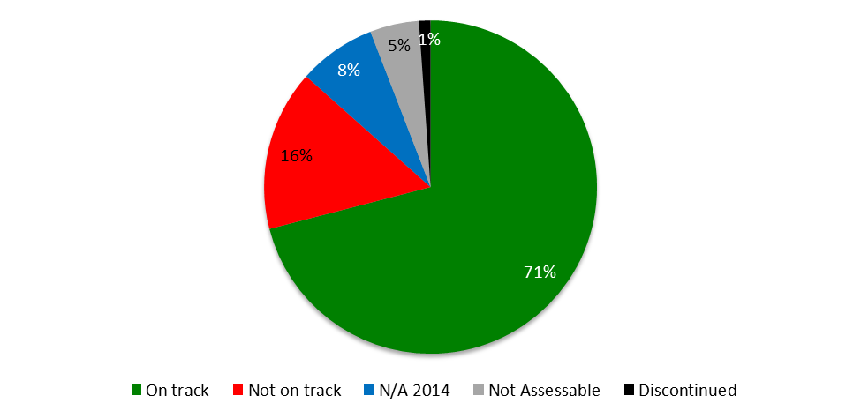

# SUMMARY OF ACHIEVEMENTS IN 2014

1. In line with Member States’ requests and enhancements made in the last reporting period, the PPR 2014 includes views of actual expenditure by Expected Result at the end of 2014 and Mid-term Performance Dashboards for each of the nine Strategic Goals (SGs), providing a graphic summary of the progress towards the achievement of the Expected Results in 2014 as measured by the Performance Indicators under the Programs contributing to the respective Strategic Goals. In assessing performance, the impact of risks identified in the Program and Budget 2014/15 was duly taken into consideration. An overview of WIPO’s strengthened risk management processes can be found under SG IX and Program 22. A more in-depth risk analysis and impact on the delivery of expected results will be provided in the PPR 2014/15.
2. Highlights of achievements in 2014 towards the nine Strategic Goals are summarized below.

**Consolidated view of progress in 2014 towards the achievement of**

**the Expected Results by Strategic Goal**

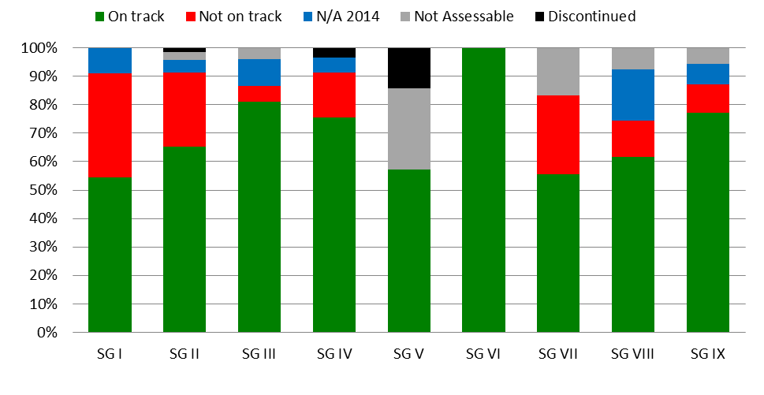

**Strategic Goal I: Balanced Evolution of the International Normative Framework for IP**

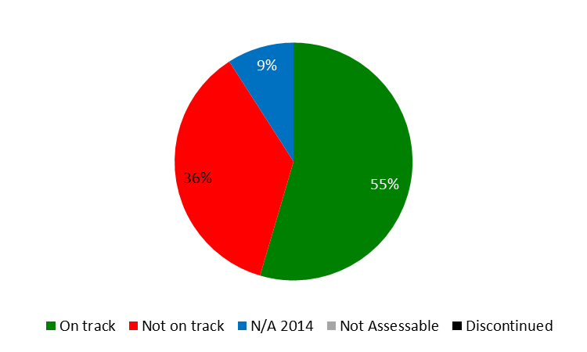

1. Progress continued to be made in 2014 under this Strategic Goal, albeit at a slightly slower pace than anticipated. At the end of 2014, several outstanding issues still remained in the Standing Committees.
2. The progress of the two new copyright treaties toward entry into force continued in 2014. The Beijing Treaty on Audiovisual Performances (Beijing Treaty) obtained four additional ratifications and accessions (China, Japan, Slovakia, United Arab Emirates) for a total of six of the thirty needed to bring it into force. The Marrakesh Treaty to Facilitate Access to Published Works for Persons Who Are Blind, Visually Impaired or Otherwise Print Disabled (Marrakesh VIP Treaty) obtained a total of 80 signatures by the June deadline, as well as its first five ratifications and accessions (El Salvador, India, Mali, United Arab Emirates, Uruguay) toward the twenty needed to bring it into force. Considering the ambitious targets for ratification/accession in the 2014/15 biennium for these treaties set at the twentieth session of the Program and Budget Committee, assisting Member States with treaty ratification was and remains a priority, with a likelihood that the Marrakesh VIP Treaty target may be met by the end of the biennium.
3. Further discussions were held on the other items on the agenda of the Standing Committee on Copyright and Related Rights (SCCR) during the three meetings held in April/May 2014, June/July 2014, and December 2014.  The SCCR discussions addressed a proposed treaty for broadcasting organizations and limitations and exceptions related to libraries and archives, educational and research institutions, and persons with other disabilities.
4. The Standing Committee on the Law of Trademarks, Industrial Designs and Geographical Indications (SCT) continued at its thirty-first and thirty-second sessions work on a draft Design Law Treaty to be adopted at a possible Diplomatic Conference. The question of convening such a Diplomatic Conference was dealt with by the WIPO General Assembly at its forty-fifth (24th extraordinary) session in May 2014, and at its forty-sixth (25th extraordinary) session in September 2014, without a decision on that matter being taken. The SCT continued its work on the protection of country names and considered a study prepared by the Secretariat, as well as a proposal by the Delegation of Jamaica.
5. The year under review saw continued progress in the negotiations of the WIPO Intergovernmental Committee on Intellectual Property and Genetic Resources, Traditional Knowledge and Folklore (the IGC). Under its new mandate for the current biennium established in 2013, the IGC met three times (IGCs 26, 27 and 28). The IGC followed a clearly defined work program and sound working methods. Member States continued to organize consultations and preparatory meetings before IGC sessions. The IGC made progress in “text-based negotiations” pursuant to its mandate. By the end of the third and final session for the year (IGC 28), the IGC had further streamlined a consolidated text on genetic resources (GRs) and made further progress on the texts on traditional knowledge (TK) and traditional cultural expressions (TCEs). The Secretariat continued to endeavor to play a neutral, professional and efficient facilitatory role in support of the IGC process and to further improve the services provided to IGC participants as a follow up to the evaluation conducted by WIPO’s Internal Oversight Division (IOD) in 2013, which found a high rate (96 per cent) of satisfaction among IGC participants. Although the Secretariat continued to facilitate the participation in the IGC process of indigenous peoples and local communities as far as possible, the Voluntary Fund for Accredited Indigenous and Local Communities remained depleted. The WIPO General Assembly in October 2014, while taking stock and considering the texts and the progress made, was not in a position at that particular juncture to agree on an IGC work program for 2015.

1. In view of enhancing cooperation among Member States on further developing balanced policy and normative frameworks for the international patent system, the twentieth and twenty first sessions of the Standing Committee on the Law of Patents (SCP) were held in January and November 2014, respectively.  The SCP continued to examine five topics on its agenda, namely:  (i) exceptions and limitations to patent rights;  (ii) quality of patents, including opposition systems;  (iii) patents and health;  (iv) confidentiality of communication between clients and their patent advisors; and (v) transfer of technology.

**Strategic Goal II: Provision of Premier Global IP Services**

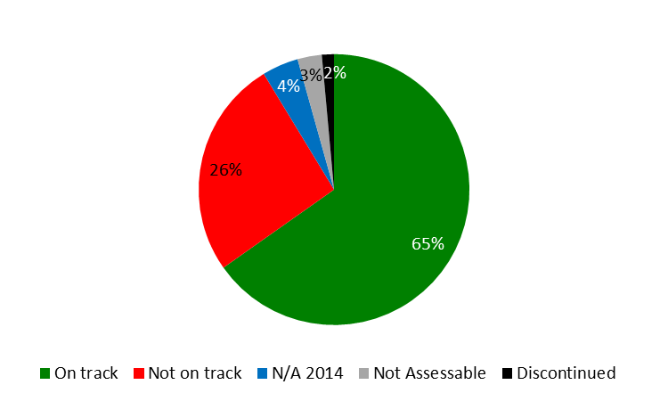

1. The year 2014 saw considerable growth in the international registration systems for the fifth consecutive year despite a continuing fragile global economy. The Organization successfully managed to deliver quality services and enhance the customer experience on the one hand, while improving productivity through well‑designed ICT initiatives on the other hand.
2. International patent filings under the Patent Cooperation Treaty (PCT) showed robust growth in 2014, with a total of 214,500 applications, representing an increase of 4.5 per cent over 2013. Three telecom giants from China and the United States of America led the international patent filing activity in 2014.
3. At its seventh session, held in June 2014, the PCT Working Group continued its discussions on a number of proposals aimed at improving the functioning of the PCT system, in line with the recommendations, endorsed by the Working Group at its third session. Particular achievements in 2014 included agreement on new eligibility criteria for fee reductions for applicants from certain countries, which expanded the number of developing countries and LDCs benefitting from such fee reductions. Member States further concluded their discussions on possible fee reductions for small and medium-sized enterprises (SMEs), agreeing that there was no clear way forward and that no further work on this issue would thus take place until a Member State would make a concrete proposal. It was agreed that Discussions among Member States on possible fee reductions for universities and not-for-profit research institutes, especially but not limited to those from developing countries and LDCs, would continue in 2015. In addition, Member States agreed on a revised procedure for the appointment of new International Searching and Preliminary Examining Authorities and advanced discussions on how to improve quality and timeliness of PCT work products (international search and preliminary examination reports). They also noted progress towards acceptance of metrics for measuring the overall performance of the PCT system, and in particular, as to the quality of PCT work products.
4. Use of the Madrid System also increased in 2014, although at a slower rate than originally anticipated. A record 47,885 applications were received in 2014, representing a 2.3 per cent growth over 2013. The United States of America accounted for more than half of the total growth, overtaking Germany as the largest user of the System, marking a significant development in 2014 and illustrating the transformation of the System into a truly global system. The geographical expansion of the System also saw important positive developments. In December, Zimbabwe and the *Organisation Africaine de la Propriété Intellectuelle* (OAPI) acceded to the Madrid Protocol. With OAPI being a 17-country intergovernmental organization, these two accessions alone increased the number of countries in which users can protect and manage their trademarks centrally through the Madrid System from 94 to 110, also significantly contributing to its transformation.
5. Designs contained in international industrial design applications filed under the Hague System increased to 14,441 designs in 2014, representing a growth of 9.6 per cent over 2013, although overall growth was slower than anticipated. Significant progress towards the enhancement of the legal framework of the Hague System was achieved in 2014. Notably, following the fourth session of the Working Group on the Legal Development of the Hague System for the International Registration of Industrial Designs, the Hague Union Assembly adopted provisions that introduced a “feedback mechanism”. In addition, changes to the Administrative Instructions were introduced with a view to giving users more flexibility in respect of the formal disclosure of their designs. In 2014, the Republic of Korea became party to the Geneva (1999) Act of the Hague Agreement Concerning the International Registration of Industrial Designs (hereinafter referred to as “the 1999 Act”). The accessions of other prospective members, notably Japan and the United States of America, were postponed to 2015, resulting in a lower than anticipated growth rate in membership in 2014. Furthermore, by the end of 2014, three consents were still required for the termination of the 1934 Act, and four Contracting Parties outside the European Union (EU) and OAPI remained bound by the 1960 Act.
6. The Assembly of the Lisbon Union mandated the Working Group on the Development of the Lisbon System, in 2009, to engage in a full review of the Lisbon System aimed at making the system more attractive for users and prospective new Members, while preserving its principles and objectives. In view of the progress made by the Working Group, the Lisbon Union Assembly approved in 2013 the convening of a Diplomatic Conference for the Adoption of a Revised Lisbon Agreement on Appellations of Origin and Geographical Indications in 2015. In October 2014, the Working Group finished its preparatory work for a New Act of the Lisbon Agreement on Appellations of Origin and Geographical Indications, and the Preparatory Committee decided that the Diplomatic Conference be convened in Geneva from May 11 to 21, 2015.
7. Building on the findings of the WIPO Center’s 2013 International Survey on Dispute Resolution in International Technology Transactions, the WIPO Center in 2014 worked to optimize the potential of its procedures to meet the needs of IP right holders and users. In 2014, cybersquatting case filings with WIPO increased by two per cent, with 2,634 cases concerning 5,591 domain names lodged by trademark owners alleging abuse of their mark. Country code Top-Level Domains (ccTLDs) accounted for 13 per cent of all filings, with 72 national domain registries now designating this WIPO service. WIPO UDRP cases in 2014 involved parties from 108 countries. Among the top five users, the United States of America saw the highest growth in cases filed, 14.3 per cent. The top three sectors of complainant activity were retail (13 per cent of all cases), banking and finance (11 per cent) and fashion (10 per cent). Cases were decided by 297 WIPO panelists from 43 countries, with 16 different languages of proceedings.

**Strategic Goal III: Facilitating the Use of IP for Development**

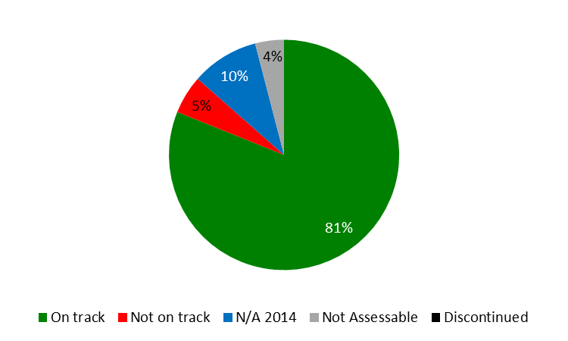

1. Facilitating the use of IP for development and empowering developing countries, LDCs and countries in transition, to harness IP for enhancing national innovation potential and capacities continued to be a priority in 2014.
2. WIPO continued to assist developing countries and LDCs in 2014 in the design, development and implementation of National IP Strategies that are both consistent with their overall development plans and able to foster innovation and creativity. The application of the standardized, yet flexible, methodology and set of practical tools for the formulation of national IP strategies and plans, developed as part of the DA project on Improvement of National, Sub-regional and Regional IP Institutional and User Capacity in 2012, continued to guide the process. As a result, nine countries (six in Africa, two in Asia and the Pacific and one in Latin America and the Caribbean), initiated the process of formulating national IP strategies/development plans, and 18 countries (six in Africa, three in the Arab region, four in Asia and the Pacific, and five in Latin America and the Caribbean) were still in the process of formulation and/or adoption at the end of 2014. Moreover, National IP strategies/development plans had been adopted and/or were under implementation in a total of 37 countries (21 in Africa, two in the Arab region, eight in Asia and the Pacific and six in Latin America and the Caribbean), of which 17 in LDCs.
3. The following Central European and Baltic States, Central Asian, Eastern European and Caucasian countries, as well as some Mediterranean countries, amended their national IP legislation in line with their national IP strategies: Kazakhstan, Lithuania, Montenegro, Republic of Moldova and Tajikistan. Promotion of the importance of and/or assistance in the development and implementation of long-term and comprehensive national IP strategies to meet the needs of Member States remained a priority in 2014, resulting in three countries (Slovenia, Tajikistan and Turkey) having adopted IP related national strategies and four countries (Bulgaria, Poland, Turkmenistan and Ukraine) having initiated the development of a new strategy.
4. In 2014, the WIPO Academy initiated the implementation of a reform process and its repositioning as the core entity in WIPO for IP training and capacity building activities for government officials and other stakeholders. As part of continued efforts to enhance national and regional capacities for the effective use of IP for development, a major achievement in 2014 was the roll-out of the WIPO e-Learning Center (WeLC) platform, developed by the DL Program in 2011, to the other Academy Programs in order to facilitate the registration, selection and enrollment processes of candidates. In 2014, some 34,935 persons (30,552 under its general courses and 4,383 under its advanced courses) from more than 192 countries benefited from the enhanced e-learning Centre (WeLC) platform. Two new DL pilot courses were launched in 2014: (i) *Intellectual Property, Traditional Knowledge and Traditional Cultural Expressions (DL-203)* and (ii) *Collective Management of Copyright and Related Rights (DL-501)*. The second phase of the Start-up Academies Project, started in May 2012, was fully completed in 2014. An external independent evaluation report (CDIP/14/4) was presented to the CDIP at its fourteenth session. In 2014, two new agreements were signed with the Governments of Cambodia and Ecuador for the establishment of start-up academies. Cooperation was formally initiated with Ecuador in September 2014.
5. Enhancing human resource capabilities to deal with the broad range of requirements for the effective use of IP for development and fostering innovation and creativity remained a priority in 2014. Focused capacity building and skills development programs were delivered to specific target groups such as government officials, policy-makers, IP professionals, enforcement officials, researchers and academics, entrepreneurs and industrialists, as well as SMEs, at the national, sub-regional and regional levels.
6. With a view to instilling a cohesive, development-oriented and innovation enabling architecture in LDCs, greater focus was given in 2014 to the implementation of the WIPO Deliverables, a set of priority thematic areas for cooperation with LDCs as identified by LDC ministers on the occasion of the Fourth United Nations Conference on the Least Developed Countries (UN LDC IV). Following the successful completion of Phase I of the DA Project on Capacity Building in the Use of Appropriate Technology-Specific Technical and Scientific Information as a Solution for Identified Development Challenges, Phase II (CDIP/13/9) was approved at the thirteenth session of this CDIP in May, 2014. Important progress was made during the remainder of the year with regard to establishing MoUs, clearly identifying the responsibilities of the partners, i.e. WIPO and the beneficiary country (an LDC), in the overall implementation process of the project. Consultations with the Ministries of Foreign Affairs, Justice, and Science and Technology, Permanent Missions in Geneva, and the IP focal points were held with the four beneficiary countries. The MoUs are expected to be signed in 2015.
7. During its thirteenth and fourteenth sessions held in 2014, the CDIP considered: (i) the annual Director General’s Report on Implementation of the Development Agenda; (ii) a Progress Report on the Implementation of Recommendations for Immediate Implementation and DA Projects; (iii) eight independent reports and one self-evaluation report of DA projects; and (iv) a document on WIPO General Assembly Decision on CDIP related matters. In addition, the Committee approved second phases for two completed and evaluated projects, approved new activities Related to Using Copyright to Promote Access to Information and Creative content, and considered a project proposal by the Arab Republic of Egypt on IP and Tourism. The Committee also discussed: (i) a document forwarded by the General Assembly on the Description of the Contribution of the Relevant WIPO Bodies on the Implementation of respective Development Agenda Recommendations and (ii) a Revised Report on the Measurement of the Millennium Development Goals (MDGs) in Other United Nations Agencies and Specialized Agencies, and on the Contribution of WIPO to the Implementation of the MDGs. Furthermore, the Committee approved the Terms of Reference (TORs) for the Independent Review of the Implementation of the DA Recommendations and the convening of the International Conference on Intellectual Property and Development.

**Strategic Goal IV: Coordination and Development of Global IP Infrastructure**

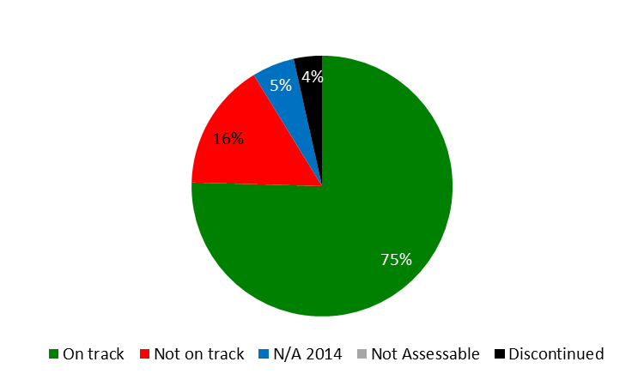

1. With a focus on enhancing the global IP infrastructure to help meet the growing global demand on the IP system and facilitating the participation of developing countries and LDCs in the system, good progress was made in the areas of global IP databases, classifications, IP office modernization, and Technology Innovation Support Centers (TISCs) in 2014.
2. The PATENTSCOPE system was further strengthened in 2014, with a significant focus on improving access to the system in regions experiencing poor latency. Two additional languages were developed for inclusion in the Cross Lingual Information Retrieval (CLIR) multilingual searching system, to be added to the existing 12 languages by the end of the biennium, pending the finalization of the interface. The Translation Assistant for Patent Titles and Abstracts (TAPTA)[2], a statistical machine translation system developed in-house, was extended to include one additional and difficult language pair, English and Chinese, bringing the total number to five.
3. Use of PATENTSCOPE increased by 3.5 per cent from 237,446 unique users per quarter in 2013 to 245,769 unique users per quarter in 2014 from 169 countries, and the number of collections held in PATENTSCOPE also saw a 12 per cent increase over 2014, bringing the total number of national and regional collections to 41 and the total number of records contained to 43 million, a 26 per cent increase over 2013.
4. With the introduction of a powerful image similarity search function, use of the Global Brand Database exceeded expectations in 2014, more than doubling the number of users per quarter from 23,000 in 2013 to 49,977 in 2014. The number of national collections increased significantly (50 per cent), bringing the total number to 18 in 2014. Likewise, the total number of records contained in the system increased 28 per cent, from 12 million in 2013 to 15.4 million in 2014.
5. Progress was uneven as regards International Classifications and WIPO IP Standards in 2014, exceeding expectations in certain areas and trailing behind in others. As regards the Nice Classification, a total of 570 new amendments and 20 new information files were introduced in 2014. The number of amendments represented a 32 per cent increase over 2013. In addition, the official Spanish version of the NCL 10-2015 was made available in XLS format in November 2014. In the IPC, the modified publication platform to facilitate the use of the system, including a new search tool and the International Patent Classification / Cooperative Patent Classification/ File Index (IPC/CPC/FI) parallel viewer, was launched in April 2014. At its fourth session, the Committee on WIPO Standards (CWS) was unable to adopt an agenda, resulting in informal decisions not being formalized. Despite this set-back, there was one new standard adopted and one standard revised informally in 2014. The use of internet tools for accessing classifications and standards publications showed stable growth with visits to the IPC Publications substantially higher (a 61 per cent increase over 2013), due to the inclusion of revised classifications and new tools.
6. The year 2014 brought the total number of Member States that had established TISCs in their countries to 45. The focus remained on reinforcing the long-term sustainability of the networks, and by the end of 2014, 20 TISC networks were considered sustainable. The eTISC knowledge management platform continued to experience strong growth with a 57 per cent increase in the number of registered members from 700 at the end of 2013 to over 1,100 members from more than 90 countries by the end of 2014. The eTISC platform added 14 training webinars in 2014 and hosted six live question-and-answer sessions with innovation support experts
7. WIPO continued to develop products to support IP Offices’ business processes, in particular the Industrial Property Administration System (IPAS). Some 68 IP Offices were using WIPO IP Office Systems (comprising IPAS, the WIPO Arab Industrial Property Management System (AIPMS), EDMS, WIPOScan and the WIPO Madrid Module) at the end of 2014. Two new modules were also developed and are now being tested and piloted in several IP Offices:

* WIPO Publish was designed to meet Offices’ needs for online publication of IP data, documents, legal status and dossier information, as well as data exchange needs (including data exchange for WIPO global databases).
* WIPO File was designed to provide an online filing solution for small and medium offices, including the flexibility to be extensively customized for local conditions (e.g. for local payment systems).

1. Based on a specification and review process with participating Offices, a new version of the Digital Access Service (DAS) portal to support the revised framework of DAS 2.0 was launched in December 2014. The number of participating Offices remained steady in 2014 at 11. In April 2014, the WIPO Centralized Access to Search and Examination (CASE) was linked to the IP5 One Dossier Portal system, allowing full two way exchange of dossier information between CASE and IP5 Offices. By mid-2014, the system was being utilized by several Offices as part of a pilot project. Five new Offices registered to use the WIPO CASE, bringing the total number of participating Offices to 14.
2. A new multi-stakeholder entity was established to increase the number of books worldwide in accessible formats - such as braille, audio and large print - and to make them available to people who are print disabled. The Accessible Books Consortium (ABC) is composed of WIPO, organizations that serve persons with print disabilities, libraries for the print disabled and organizations that represent authors and publishers. The ABC carried out three main activities: capacity building (funded by the Governments of Australia and the Republic of Korea) in Bangladesh, India, Nepal and Sri Lanka; inclusive publishing, which promotes technologies that allow for “born accessible” publishing so that new books are usable from the start by both sighted people and people with print disabilities; and the ABC International Book Exchange (known as the TIGAR Service), an international database of some 286,000 accessible titles in 55 languages. There were 2,500 downloaded audio books by participating libraries at the end of 2014, with some 16,000 persons with print disabilities having benefitted.

**Strategic Goal V: World Reference Source for IP Information and Analysis**

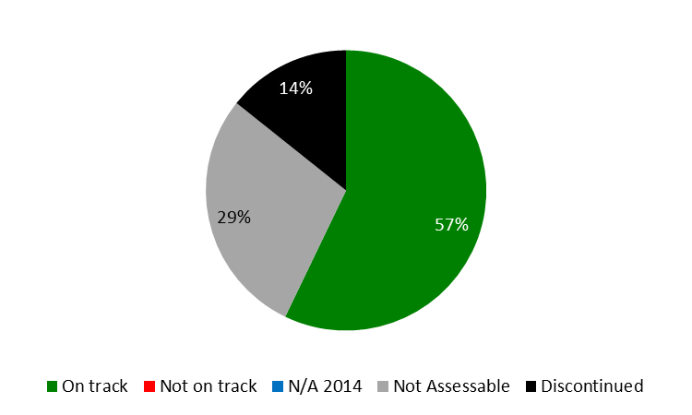

1. During the biennium, key achievements under this goal encompassed the upgrade of the functionality of the Data Center, including the development of user interfaces in French and Spanish and the re-design of the World Intellectual Property Indicators (WIPI) report, with a view to making it easier for readers to find the desired information. Good progress was also made towards the development of a new World IP Report, which will be published in the second half of 2015. As in previous years, WIPO co-published the Global Innovation Index (GII), in partnership with INSEAD and Cornell University. The 2014 GII covered 143 economies and was launched in Sydney, Australia at a gathering of international business leaders known as the B20. It was subsequently presented at national and international conferences across the world. The publication of the GII also continued to attract significant media attention. In addition, national governments, international organizations and other stakeholders in the innovation system regularly employed the GII as a reference source for analyzing innovation performance, as captured by numerous citations, data inquiries, and requests for advisory services.
2. In addition, assisting WIPO Member States with country studies continued to be an important pillar of the Program’s economic analysis work and took place under the umbrella of the DA project on IP and Socio-Economic Development. In 2014, the first phase of this project (CDIP/5/7) came to an end and underwent an external evaluation (CDIP/14/3), which was presented at the fourteenth session of the CDIP. WIPO Member States approved a second phase of the project (CDIP/14/7), which will be implemented in 2015 through 2017.

**Strategic Goal VI: International Cooperation on Building Respect for IP**

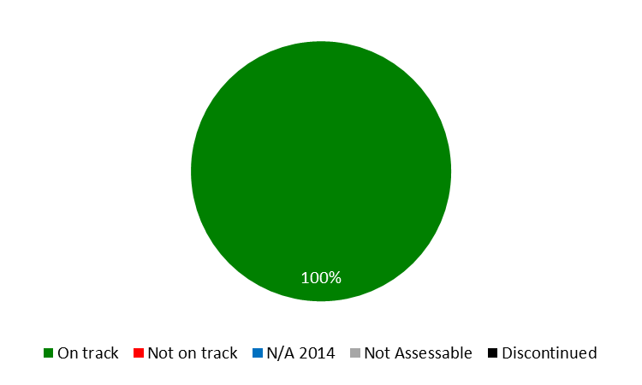

1. With a view to achieving progress in the international policy dialogue among WIPO Member States on building respect for IP, the ninth session of the Advisory Committee on Enforcement (ACE) (March 3 to 5, 2014) served as a “marketplace of ideas”, allowing for the exchange of national practices and experiences. The three day meeting showed growing interest in effective preventive strategies, ranging from awareness raising, new business models and supply chain security, to alternative mechanisms for resolving IP disputes. For the first time, an audiovisual exhibition was organized with the session, presenting nine national and one regional awareness raising initiatives. Member States agreed for the work program of the tenth session to remain dedicated to: (i) alternative dispute resolution practices in the field of IP and (ii) preventive actions, measures or successful experiences to complement enforcement measures with a view to reducing the size of the market for pirated or counterfeited goods.

**Strategic Goal VII: Addressing IP in Relation to Global IP Policy Issues**

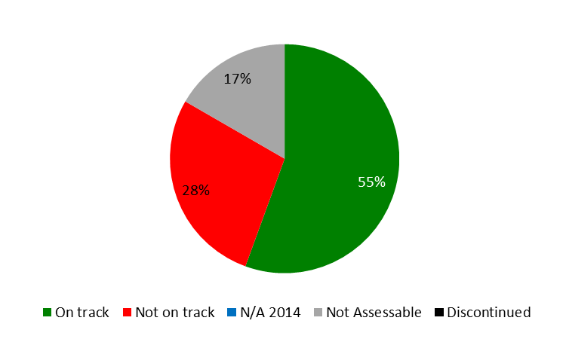

1. At the intersection of pressing global and interconnected issues, in particular global health, climate change and food security, substantive progress was made in supporting an enhanced understanding among policy makers on the interface between global challenges and innovation and IP. Following its launch in November 2013, the year 2014 marked the first full year of WIPO GREEN operations. Through a targeted awareness raising campaign, the profile of WIPO GREEN was raised significantly. The network of partners grew from 36 to 54, and the number of registered users almost doubled from 160 to 300. This growth reflects the success of outreach efforts encompassing a wide range of channels, including social and specialist media, the regular WIPO GREEN Newsletter and attendance at a range of global, regional and national fora. The WIPO GREEN database also more than doubled from 830 to 1,773 entries resulting from a combination of database integration agreements and individual uploads.
2. WIPO Re:Search, a consortium of a broad range of private and public sector institutions from developed and developing countries providing royalty-free access to IP assets to stimulate new R&D for neglected tropical diseases, tuberculosis, and malaria, gained in recognition as a platform to support innovation and technology transfer related to research for NTDs, tuberculosis and malaria. The year 2014 saw 38 additional collaborations and 16 new Members, bringing the totals to 82 collaborations and 96 Members, 6 of which from developing countries. In addition, the platform’s potential for technology transfer from developed to developing countries of IP assets, including know-how and expertise, was further demonstrated by the continued facilitation of research sabbaticals for five African scientists in overseas research institutions. The sabbaticals, which began in the last biennium, were made possible by a Fund-in-Trust from the Government of Australia. At the end of 2014, four of the sabbaticals were concluded.
3. Providing a forum for participants to share ideas, expertise and information relating to the three core areas, a WIPO Global Challenges Seminar  [“Innovation and Access to Medicines: A Case Study for HIV/AIDS and Hepatitis C](http://www.wipo.int/meetings/en/details.jsp?meeting_id=35262)” was organized in 2014, and two Global Challenges Briefs were published.
4. The trilateral cooperation with WHO and WTO continued to focus on enhanced understanding among policymakers for the interplay between health, IP and trade. In November 2014, the fourth Trilateral Symposium took place in Geneva, exploring the challenges and opportunities in the health innovation area of middle-income countries, and the public policies necessary to ensure that rapid economic growth contributes to access and universal health coverage.

**Strategic Goal VIII: A Responsive Communications Interface between WIPO, its Member States and All Stakeholders**

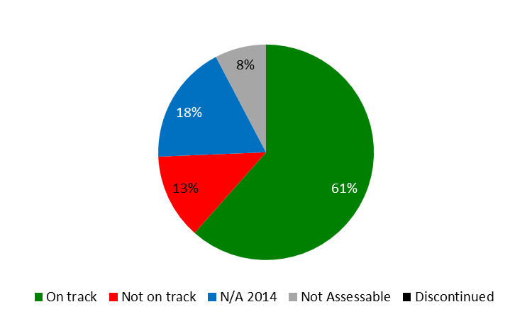

1. Priorities in 2014 focused on the consolidation of the results of a number of major Organization-wide strategic projects on web communications, branding, internal communications and customer service, which were completed in 2013; the continued implementation of core strategies for improving the delivery and quality of WIPO content, increasing visibility and understanding of WIPO’s work, and strengthening the culture of service; and laying the groundwork for further initiatives to enhance the effectiveness of communications activities.
2. The visibility of key WIPO events, offerings and results – from the Accessible Books Consortium (ABC) to new tools such as the WIPO Pearl terminology portal – was increased through a fully integrated approach to press, social media, video, print and online communications, delivered across multiple platforms. High priority was given to promoting the Organization’s flagship economics and statistics reports so as to strengthen recognition of WIPO as the world reference source for authoritative IP information. Concerted promotional efforts resulted in a 16 per cent increase in views of web content relating to the 2014 Global Innovation Index (GII) launch compared to 2013, and an exponential increase (1,300 per cent) in views of related video content. High profile press coverage of the 2014 World Intellectual Property Indicators (WIPI) was achieved in influential media outlets worldwide, together with an 18 per cent increase in views of the press release. WIPO’s Twitter following grew by over 60 percent, coupled with a 76.8 per cent increase in the number of retweets of WIPO content.
3. Engagement by Member States and the public in the annual World IP Day campaign reached a record level. The theme *Movies – A Global Passion* was the focus for over 350 events reported in 110 countries (up from 236 events in 93[3] countries in 2013). WIPO’s World IP Day tweets gained 1.67 million potential impressions, as compared to 1.55 million in 2013, and promotional materials created for the campaign were downloaded from the website over 9,000 times. Views of the World IP Day webpage in Chinese exceeded the English version for the first time, while the highest numbers of ‘likes’ of the Facebook page came from Brazil, Egypt, India, Mexico and the United States of America. A mini-film festival held in Geneva from April 24 to 28, 2014 drew good participation from the local community, particularly for the Swiss premiere screening of the Nigerian co-production, “Half a Yellow Sun,” which played to a capacity audience.
4. With regard to External Relations, as a specialized agency of the UN, and in line with its mandate and with WIPO DA Recommendations 30 and 40, WIPO continued to play its role in supporting key UN processes through its strategic engagement and contributions, in particular with regard to, *inter alia*: (i) the Post-2015 Development Agenda via the work of the inter-agency UN Task Team (UNTT) and the UN Technical Support Team (TST) to the Open Working Group on Sustainable Development Goals (OWG); and (ii) work on technology in the UN Framework Convention on Climate Change (UNFCCC), in particular the UNFCCC Technology Mechanism, the Technology Executive Committee (TEC) and the Climate Technology Center and Network (CTCN).
5. WIPO’s network of External Offices continued to form an integral part of the Organization designed to bring WIPO’s services and cooperation closer to Member States, stakeholders and partners with a view to enhancing efficiency and effectiveness of program delivery, as well as responding to the specific needs and priorities of the countries and/or regions they serve. In 2014, the network of Offices grew to five, with the opening of the WIPO Offices in China (WCO) and in the Russian Federation (WRO).

**Strategic Goal IX: Efficient Administrative and Financial Support Structure to Enable WIPO to Deliver its Programs**

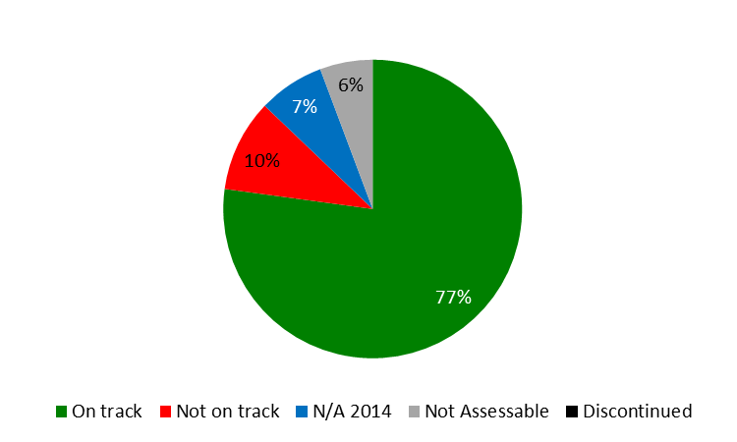

1. The Administration and Management, through its Programs, enabled the Organization in delivering the results expected by Member States and stakeholders, on the one hand, while navigating through the continuing financial instability and serious uncertainties in the economic environment, on the other hand.
2. Despite these uncertainties, WIPO closed the year with a positive overall result of 37 million Swiss francs on an IPSAS basis, as a result of higher than expected income, the implementation of cost efficiency measures and prudent management of expenditure.
3. WIPO’s program and financial management continued to be strengthened in 2014 in order to utilize resources more effectively as well as to establish best practice in an area of administration, which deals with planning, performance management, facilitation and support for various operational activities across the Organization.
4. The comprehensive study of WIPO’s treasury practices and risks, launched in 2013, was completed in the spring 2014, resulting in a series of recommendations, including with regard to the practice of hedging as a means to reduce exposure to foreign currency fluctuations in the PCT. The Secretariat is currently in the process of reviewing the full set of recommendations and defining an implementation strategy.
5. Good progress was made in 2014 with respect to further embedding a results-based culture and strengthening WIPO’s performance management cycle. The workplanning process continued to be enhanced in 2014, with the introduction of position level planning. To support this enhancement, new functionality was developed in the Enterprise Resource Planning (ERP) Enterprise Performance Management (EPM) (ERP EPM) workplanning module to enable the allocation of individual staff members to specific program activities, driving linkages between the Programs’ expected results and individual staff objectives closer together. This enhancement also enabled more transparency and accuracy with regard to personnel resource allocation and utilization.
6. The ERP portfolio of projects, approved by the WIPO General Assemblies in 2010, as part of the Administrative and Management Sector modernization, also continued to evolve. To this end, the year 2014 saw the launch of two new key modules to support WIPO’s performance cycle, namely the ‘Implementation and Monitoring’ and the ‘Performance Assessment’ modules. Further integration of the ERP components in 2014 also enabled improved reporting capabilities and analytical tools. For the first time in 2014, the Administrative Integrated Management System (AIMS) financial and the EPM planning systems were integrated, allowing for improved reporting on budget versus actual expenditure from EPM. In addition, the ERP Human Resources (HR)/Payroll system was operationalized in January 2014, and integration with the EPM planning system was completed in April, resulting in significantly enhanced position management capabilities. Progress was made on the Business Intelligence module, with initial management dashboards having been developed and released to core administrative areas (HRMD, Procurement and Travel, and Program Planning and Finance). An Organization-wide release is planned for the second half of 2015.
7. In the course of 2014 the Organization developed a number of documents that establish a formalized and coherent risk management and internal controls framework, which include WIPO’s Accountability Framework, WIPO’s Risk Appetite Statement, Office Instructions (OIs) on the establishment of WIPO’s Risk Management Group (RMG) as well as its Risk Management Policy, and the Risk Management and Internal Controls Manual.
8. WIPO’s Accountability Framework and WIPO’s Risk Appetite Statement were reviewed and endorsed by Member States at the end of 2014.
9. Enterprise Risk Management (ERM), a new risk management application, went live in October 2014, integrating in a single organizational risk register all of WIPO’s information security risks, as well as all program and organizational risks.
10. The year 2014 was the first year of implementation of the Human Resource (HR) Strategy that was approved by Member States in 2013, providing the basis for the short- and medium-term HR plan of action for the 2014/15 biennium. Progress continued to be made on mainstreaming organizational design and workforce planning as fully integrated key business activities. Achievements in 2014 included: (i) increased manager engagement through delivery of introductory workshops on workforce planning and the development of related guidelines; (ii) development of 2014/15 workforce action plans for each organizational unit to capture and record key HR-related actions to meet business needs; and (iii) closer alignment of job descriptions and annual workplans. As part of the workforce planning exercise mangers were encouraged to consider the optimal mix of resources to efficiently address their business needs.
11. In August 2014, WIPO issued its first Policy on Gender Equality, which included a time-specific goal to achieve gender balance in staffing.  While the percentages of women at P4 (44.4 per cent) and P5 (34.4 per cent) levels as of December 2014 showed only a slight increase as compared to 2013 (43.4 per cent and 34.3 per cent respectively), they nevertheless represented the highest ever in WIPO’s history.  To support the Policy objective related to the mainstreaming of gender perspectives in WIPO’s work Gender Focal Points were appointed in each Program.
12. The regularization process for long-serving temporary employees (LSTEs) was completed in 2014, with 31 LSTEs on continuing functions regularized following a competition. The regularization of the remaining 66 temporary functions of a continuing nature approved by the Member States will be completed in 2016. In 2014, some 23 posts were published for external competition. The year 2014 also witnessed significant recruitment activity, with 97competitions for fixed-term posts and 37for temporary positions, representing an increase of 26 per cent over 2013. In 2014, the recruitment lead time was on track to meet the target of 14.7 weeks, however with 20 of the selection processes still not completed.
13. In the area of procurement and travel, savings for procured goods and services continued to be yielded from more stringent price negotiations, which resulted in an overall savings of 2,663,000 Swiss francs in 2014. As regards travel expenditure, the average air ticket price was reduced by 7.5 per cent to 1,598 Swiss francs compared to 1,728 Swiss francs in 2013, thanks to the utilization of more economical fares. It should also be noted that in 2014, a substantial effort was made to reduce travel expenditure leading to a decrease in both the number of tickets issued and the number of late travel submissions. Finally, through close monitoring of the administrative process, the average lead time to process purchase requisitions was reduced by half in four years, resulting in greater efficiency and more agility in procuring goods and services
14. As regards ICT enhancements, specific accomplishments in 2014 included: preliminary tests on enhancements of ICT infrastructure resilience, showing promising results; completion of the ICT infrastructure for the new WIPO Conference Hall in time for its opening for the twenty-second session of the PBC and the fifty-fourth series of meetings of the WIPO Assemblies; the establishment of Service Delivery Agreements (SDAs) to explicitly capture the ICT needs for the specific business areas and also to enable more systematic tracking and monitoring; enhanced mobile telecommunications with more integrated services offered at lower costs; and further migration of traditional server platforms to virtual servers, consolidation of database licenses, optimizing policies in managing unused user accounts.
15. In the field of information assurance, as part of the continuous improvement process promoted by the ISO 27001 Standard, the PCT underwent re-certification to the updated 2013 version of the standard (ISO 27001:2013), with no major or minor non-conformities. As part of this process, a series of third party service provider risk assessments was carried out to ensure improved supply-chain security for services. The year 2014 also saw the launch of a solution aimed at raising user awareness around the topic of Phishing. The first such campaign resulted in a dramatic increase in the number of phishing attempts being reported by the user community.
16. The WIPO Language Policy continued to be effectively implemented by extending the six-language coverage to Working Groups in a phased and cost effective manner. According to the timeline set by Member States, coverage was extended in 2014 to the PCT Working Group and the Working Group on the Legal Development of the Hague System for the International Registration of Industrial Designs.
17. A key achievement in 2014 was the inauguration of the new WIPO Conference Hall. The New Conference Hall Project was delivered in several stages, with various technical and system tests carried out in parallel, area by area. The new Access Center was delivered in July 2014; the exterior landscaping between the New Building, the new WIPO Conference Hall and the AB Building was delivered at the end of August 2014; the new WIPO Conference Hall per se was delivered at the end of August and was available for the holding of the PBC session from September 1 to 5, 2014; the entirety of the new and renovated construction was completed in September 2014 in the new WIPO Conference Hall and three floors of the AB Building, and made available for the session of the WIPO Assemblies from September 22 to 30, 2014, which included the inauguration of the new WIPO Conference Hall on the opening day in the presence of WIPO Member States and observers, officials from the Host Country (federal, cantonal and municipal levels), representatives from other UN Agencies, and from the 70-odd companies and firms that had contributed to the construction and completion of the Project.
18. The year 2014 also saw a number of important safety and security achievements, notably the opening of the new WIPO Access Center (AB reception) and the Security Coordination Operations Center (SCOC). In addition, the H-MOSS project neared completion, with 95 per cent of new systems fully operational by the end of 2014. These enhancements significantly strengthened safety and security throughout the WIPO campus, and in line with the project plan, enabled a gradual reduction in the level of on-site security staff in 2014, although not to the extent originally foreseen.

# OVERVIEW OF PROGRESS IN 2014 BY STRATEGIC GOAL

STRATEGIC GOAL I

**BALANCED EVOLUTION OF THE INTERNATIONAL**

**NORMATIVE FRAMEWORK FOR IP**

**Mid-term Performance Dashboard (2014)**

The dashboard below provides a summary of the progress towards the achievement of the Results in 2014 as measured by the indicators under the Programs contributing to this Strategic Goal.



| **Expected Results** | **Performance Indicators** | **Responsible Program(s)** | **TLS** |
| --- | --- | --- | --- |
| I.1 Enhanced cooperation among Member States on development of balanced international normative frameworks for IP and agreement on specific topics on which international instruments are agreed | Progress on the implementation of SCP agreed steps/plans | Program 1 | ⚫ |
|  | % of satisfied participants in targeted workshops/seminars/conferences held on specific patent-related topics | Program 1 | ⚫ |
|  | Agreement on a normative framework for industrial design registration and maintenance procedures | Program 2 | **⚫** |
|  | Progress towards agreement on current issues on the SCT Agenda | Program 2 | ⚫ |
|  | No. of ratifications/ accessions to the Singapore Treaty | Program 2 | ⚫ |
|  | Progress towards agreement on current issues on the SCCR agenda | Program 3 | **⚫** |
|  | Agreement in the IGC’s negotiations on an international legal instrument(s) on TK, TCEs and GRs | Program 4 | ⚫ |
| I.2 Tailored and balanced IP legislative, regulatory and policy frameworks | No. and % of Member States which found the provided information concerning the legal principles and practices of the patent system, including the flexibilities existing in the system and the challenges it faces, useful | Program 1 | ⚫ |
|  | No. and % of Member States which were satisfied with the quality of legal advice related to patents, utility models, trade secrets and integrated circuits | Program 1 | ⚫ |
| Program 9 | ⚫ |
|  | Subject to approval by Member States, progress on the revision of the Patent Model Law for developing countries and LDCs | Program 1 | **⚫** |
|  | No. and % of Member States/regional organizations providing positive feedback on the legislative advice offered in the area of trademarks, industrial designs and geographical indications | Program 2 | ⚫ |
| Program 9 | ⚫ |
|  | No. of countries that have ratified the Beijing Treaty | Program 3 | **⚫** |
|  | No. and % of countries that have provided positive feedback about WIPO’s legislative advice | Program 3 | ⚫ |
| Program 9 | ⚫ |
|  | No. of ratifications to the WIPO Internet Treaties | Program 3 | ⚫ |
|  | No. of countries that have ratified the Marrakesh Treaty on the VIP | Program 3 | **⚫** |
|  | No. of countries with updated laws and/or regulations | Program 10 | ⚫ |
|  | No. of countries that have adopted or amended relevant frameworks (or are in the process of doing so) further to WIPO assistance | Program 17 | ⚫ |
| I.3 Increased protection of State emblems and names and emblems of International Intergovernmental Organizations | No. of requests for communication under Article *6ter* dealt with | Program 2 | **⚫** |
|  | No. of signs published in Article *6ter* database | Program 2 | **⚫** |

## PROGRAM 1 PATENT LAW

**Program Manager Mr. J. Sandage**

OVERVIEW OF PROGRESS IN 2014

1. In view of enhancing cooperation among Member States on further developing balanced policy and normative frameworks for the international patent system, the twentieth and twenty first sessions of the Standing Committee on the Law of Patents (SCP) were held in January and November 2014, respectively.  The SCP continued to examine five topics on its agenda, namely:  (i) exceptions and limitations to patent rights;  (ii) quality of patents, including opposition systems;  (iii) patents and health;  (iv) confidentiality of communication between clients and their patent advisors;  and (v) transfer of technology.
2. The examination of substantive studies allowed the SCP to review the current international patent system in a holistic manner that took into account different needs and interests of Member States and stakeholders.  A step-by-step approach broadened the common base from which the Committee could develop its discussions.  Further, various methodologies employed by the Committee, including preparation of background studies, seminar and sharing sessions on national implementation of patent law and national experiences and challenges, contributed to advancing discussions on issues of common interest at the SCP.  During 2014, a number of proposals were put forward by Member States on the above topics, showing commitments by Member States in the SCP process.
3. With respect to WIPO administered treaties in the field of patents, in 2014, one State (Kuwait) joined the Paris Convention.
4. WIPO’s legislative and policy assistance was consistently based on the multilateral legal framework.  Member States’ legislative activity has grown, particularly due to their participation in regional economic integration processes and preferential trade agreements.  Additionally, a number of Member States are revising their patent laws to accommodate local public policies or because of their accession to multilateral treaties on patents, namely, PCT, Budapest and PLT.  Moreover, the countries joining the WTO systematically revise their legal framework.  Therefore requests for legislative advice follow the same trend.
5. Furthermore, during 2014 the Secretariat continued to contribute to the promotion of a greater awareness of the legal principles and practices of the patent system through the provision of relevant information to intergovernmental organizations, United Nations bodies, non-governmental organizations and other parties on issues covered by this Program.
6. The design, planning and implementation of activities by Program 1 were informed and guided by the relevant DA Recommendations.  Discussions on the progressive development of the international patent system within the SCP continued to be inclusive and member-driven, taking into account different levels of development, representing a participatory process and being in line with the principle of neutrality of the WIPO Secretariat (Recommendation 15).  The discussions also took into account existing flexibilities in international IP agreements (Recommendation 17).  The activities of the SCP were based upon open and balanced consultations (Recommendations 21 and 42), while being supportive of the UN development goals (Recommendation 22).In particular, in line with Recommendation 22, working documents of the SCP addressed issues such as:  (i) patent-related transfer of technology; and (ii) potential flexibilities, exceptions and limitations for Member States.
7. The Program’s capacity building and legislative and policy assistance activities were development-oriented, demand-driven and carried out within the timeframe planned (Recommendations 1, 13 and 14).
8. In addition, in accordance with Recommendations 16 and 20, the Program was engaged in a final assessment of the outputs of the DA Project on Patents and the Public Domain, which was presented and discussed at the thirteenth session of the Committee on Development and Intellectual Property (CDIP), which took place from May 19 to 23, 2014.
9. The Program also prepared document CDIP/13/10, which covers two new patent-related flexibilities, which was discussed at the same session of the CDIP and undertook activities aimed at raising awareness on the practical implementation of flexibilities at the national level.  In this regard, a WIPO Regional Seminar on issues of Patent Protection in the pharmaceutical field in Bishkek, Kyrgyzstan and six national seminars or workshops on patent legal framework and public policy were organized.

PERFORMANCE DATA

|  |  |  |  |  |  |
| --- | --- | --- | --- | --- | --- |
| **Expected Result:** I.1Enhanced cooperation among Member States on development of balanced international normative frameworks for IP and agreement on specific topics on which international instruments are agreed | | | | | |
| **Performance Indicators** | **Baselines** | **Targets** | **Performance Data** | | **TLS** |
| Progress on the implementation of SCP agreed steps/plans | *Updated Baseline end 2013:* The SCP concentrated its efforts on progressing the five topics on its agenda, and advanced its discussions through, for example, collecting information through a questionnaire, preparing studies and exchanging national practices and experiences among Member States.  *Original Baseline  P&B 2014/15:* To be determined | Advancement on issues of common interest at the SCP | SCP/21 (11/2014) five topics: exceptions and limitations to patents rights; quality of patents; patents and health; confidentiality of communication between clients and their patent advisors, and transfer of technology . Discussions were based on delegations’ proposals (11) and documents prepared by the Secretariat (10) (Summary by the Chair, document SCP/21/11 Rev.) | | **On track** |
| % of satisfied participants in targeted workshops/ seminars/ conferences held on specific patent-related topics | *Updated Baseline end 2013:* 92.5%, based on 2012/13 survey  *Original Baseline  P&B 2014/15:* Surveys 2012 | 90% | 92.75 % based on 2014 survey | | **On track** |
| **Expected Result:** I.2Tailored and balanced IP legislative, regulatory and policy frameworks | | | | | |
| **Performance Indicators** | **Baselines** | **Targets** | | **Performance Data** | **TLS** |
| No. and % of Member States which found the provided information concerning the legal principles and practices of the patent system, including the flexibilities existing in the system and the challenges it faces, useful | *Updated Baseline end 2013:* 90% based on survey conducted by IOD in 2013 among 47 Member States  *Original Baseline  P&B 2014/15:* To be determined | 90% | | 6 out of 7 respondents (85.7%) | **On track** |
| No and % of Member States which were satisfied with the quality of legal advice related to patents, utility models, trade secrets and integrated circuits | *Updated Baseline end 2013:* 9 respondents (90%), based on survey conducted by IOD in 2013  *Original Baseline  P&B 2014/15:* Surveys 2012 | 90% | | Eight respondents reported on average a 90% satisfaction rate (Africa-2; Arab-1; Asia and the Pacific-1; Certain Countries in Europe and Asia-2; Latin America and the Caribbean-1; Other- 1). | **On track** |
| Subject to approval by Member States, progress on the revision of the Patent Model Law for developing countries and LDCs | *Updated Baseline end 2013:* One meeting of experts  *Original Baseline  P&B 2014/15:* To be determined | Advancement in the preparatory work for updating the WIPO Patent Model Law | | SCP Summary by the Chair document SCP/21/11 Rev. | **Not  on track** |

RESOURCE UTILIZATION

Budget and Actual Expenditure (by result)

*(in thousands of Swiss francs)*



Budget and Actual Expenditure (personnel and non-personnel)

*(in thousands of Swiss francs)*



*NOTE: The 2014/15 Budget after Transfers reflects transfers as of March 31, 2015 to address needs during the 2014/15 biennium in line with Financial Regulation 5.5.*

A. Budget after Transfers 2014/15

1. The overall increase in the 2014/15 Budget after Transfers resulted primarily from the allocation of additional personnel resources to Result I.2 (Legislative advice) in order to more efficiently respond to an increase of requests for legislative advice.

B. Budget utilization 2014

1. Budget utilization is within the expected range of 40-60 per cent for the first year of the biennium and is on track.

## PROGRAM 2 TRADEMARKS, INDUSTRIAL DESIGNS AND GEOGRAPHICAL INDICATIONS

**Program Manager Ms. B. Wang**

OVERVIEW OF PROGRESS IN 2014

1. In 2014, the Standing Committee on the Law of Trademarks, Industrial Designs and Geographical Indications (SCT) continued at its thirty-first and thirty-second sessions work on a draft Design Law Treaty to be adopted at a possible Diplomatic Conference. The question of convening such a Diplomatic Conference was dealt with by the WIPO General Assembly at its forty-fifth (24th extraordinary) session in May 2014, and at its forty-sixth (25th extraordinary) session in September 2014, without a decision on that matter being taken. The SCT continued its work on the protection of country names and considered a study prepared by the Secretariat, as well as a proposal by the Delegation of Jamaica. Furthermore, a number of delegations presented proposals for work by the SCT on geographical indications. The Program’s norm-setting activities within the SCT continued to be inclusive and member-driven in line with DA Recommendation 15, and the SCT negotiations were based upon open and balanced consultations in line with DA Recommendations 21 and 42.
2. The year 2014 also saw ratification of and/or accession to the Singapore Treaty on the Law of Trademarks by seven new Contracting Parties (Belarus, Belgium, Benelux Organization for Intellectual Property (BOIP), Iraq, Luxembourg, Netherlands and Tajikistan), bringing the total number of Contracting Parties to 38 at the end of 2014.
3. As regards increased protection of State emblems and names and emblems of international intergovernmental organizations under Article *6ter* Paris Convention, communications and responses to requests were dealt with in a timely and efficient manner during the period under review. The discrepancy between the target for requests to be dealt with and the actual number of requests is due to the fluctuation of requests and the fact that the estimated target was based on a biennial average. The same applies for the actual number of signs published (49), which falls short of the target. At the end of 2014, a total of 3,057 signs were contained in the Article *6ter* database.
4. Concerning the work on tailored and balanced IP legislative, regulatory and policy frameworks, the Program provided advice to 20 Member States/intergovernmental organizations in the area of trademark, industrial design and geographical indications law. The Program’s technical assistance, capacity building and legislative assistance activities were development-oriented, demand-driven and reported on during the year in line with DA Recommendations 1 and 13.
5. In addition, the Program implemented the first year of the DA Pilot Project on IP and Design Management for Business Development in Developing and Least Developed Countries (DA_4_10_02). The two pilot countries, namely Argentina and Morocco, and the local Lead Agencies were selected in 2014. Following a formal agreement on the project scope statement with both countries, national design protection strategies, outreach plans and exit strategies were drafted. Feasibility studies were then carried out in both countries, and country project coordinators, national experts and an overall 70 beneficiary SMEs were selected. The national project kick-off events were successfully implemented. Key stakeholders, including ministries, are expected to sign project charters in both countries in 2015.

PERFORMANCE DATA

|  |  |  |  |  |  |  |  |
| --- | --- | --- | --- | --- | --- | --- | --- |
| **Expected Result:** I.1Enhanced cooperation among Member States on development of balanced international normative frameworks for IP and agreement on specific topics on which international instruments are agreed | | | | | | | |
| **Performance Indicators** | **Baselines** | | **Targets** | | **Performance Data** | | **TLS** |
| Agreement on a normative framework for industrial design registration and maintenance procedures | *Updated Baseline end 2013:* No normative framework for industrial design registration procedures  *Original Baseline P&B 2014/15:*  No normative framework for industrial design registration and maintenance procedures | | Adoption of a Design Law Treaty by a possible Diplomatic Conference | | No decision to convene a Diplomatic Conference for the adoption of a Design law Treaty was taken. | | **Not  on track** |
| **Performance Indicators** | **Baselines** | | **Targets** | | **Performance Data** | | **TLS** |
| Progress towards agreement on current issues on the SCT Agenda | *Updated Baseline end 2013:* Agreement by the SCT on a substantive number of draft Articles and Rules for a Design Law Treaty.  SCT agreement on the continuation of work on the protection of country names.  *Original Baseline P&B 2014/15:*  Draft Reference Document on the Protection of Country Names Against Registration and Use of Trademarks | | SCT agreed outcomes | | SCT agreement on the continuation of work on the protection of country names.  In 2014, work continued on the protection of country names, and a study prepared by the Secretariat, as well as a proposal by the Delegation of Jamaica, were considered during the two SCT sessions (SCT/31 and 32). | | **On track** |
| No. of ratifications/accessions to the Singapore Treaty | *Updated Baseline end 2013:* 31 Contracting Parties (end 2013  *Original Baseline P&B 2014/15:*  29 Contracting Parties (end 2012) | | Eight new ratifications/accessions | | Seven new Contracting Parties in 2014: Belarus, Belgium, Benelux Organization for Intellectual Property (BOIP), Iraq, Luxembourg, Netherlands and Tajikistan, which brings the total number of Contracting Parties to 38 at the end of 2014. | | **On track** |
| **Expected Result:** I.2 Tailored and balanced IP legislative, regulatory and policy frameworks | | | | | | | |
| **Performance Indicators** | **Baselines** | | **Targets** | **Performance Data** | | | **TLS** |
| No. and % of Member States/regional organizations providing positive feedback on the legislative advice offered in the area of trademarks, industrial designs and geographical indications | *Updated Baseline end 2013:*  2013: Advice was provided to 13 Member States on 18 individual pieces of draft legislation  Positive feedback received from nine out of 13 countries. Four countries did not reply.  *Original Baseline P&B 2014/15:*  11 Member States/regional organizations received legislative advice out of which three provided positive feedback on legislative advice received in 2012 | | Legislative advice provided to 10 Member States/regional organizations. 90% of respondents satisfied with the advice offered | Advice was provided to 20 Member States/Regional Organizations (Africa 7; Arab 1; Asia and the Pacific 11; Latin America and the Caribbean 1)  Feedback was received from seven respondents, all of whom (100%) reported satisfaction with the advice offered. | | | **On track** |
| **Expected Result:** I.3Increased protection of State emblems and names and emblems of International Intergovernmental Organizations | | | | | | | |
| **Performance Indicators** | **Baselines** | **Targets** | | **Performance Data** | | **TLS** | |
| No. of requests for communication under Article *6ter* dealt with | *Updated Baseline end 2013:* 126 requests for publication under Article 6*ter* dealt with by the end of 2013  *Original Baseline P&B 2014/15:*  70 requests[4] for communication under Article 6*ter* dealt with in 2012 | 140 requests for communication under Article *6ter* dealt with | | 51 requests for communication received and dealt with, of which 11 resulted in publication | | **Not  on track** | |
| No. of signs published in Article *6ter* database | *Updated Baseline end 2013:* 132 signs published in Article 6*ter* database in 2012/13  *Original Baseline P&B 2014/15:*  75 signs[5] published in Article 6*ter* database in 2012 | 150 signs published in Article *6ter* database[6] | | 49 new signs published (2014)  A total of 3,057 signs contained in the Article *6ter* database at the end of 2014. | | **Not  on track** | |

RESOURCE UTILIZATION

Budget and Actual Expenditure (by result)

*(in thousands of Swiss francs)*



Budget and Actual Expenditure (personnel and non-personnel)

*(in thousands of Swiss francs)*



*NOTE: The 2014/15 Budget after Transfers reflects transfers as of March 31, 2015 to address needs during the 2014/15 biennium in line with Financial Regulation 5.5.*

A. Budget after Transfers 2014/15

1. The 2014/15 Budget after Transfers reflects a downward adjustment under Result I.1 (Development of balanced international normative frameworks for IP) due to the transfer out of the Program of non-personnel resources initially budgeted for a possible Diplomatic Conference.

B. Budget utilization 2014

1. The under-utilization of non-personnel resources resulted primarily from:

* the postponement of the Diplomatic Conference under I.1 (Development of balanced international normative frameworks for IP);
* cost savings due to a reduction in staff missions under Result I.2 (Legislative advice); and
* a delay in the recruitment of a project manager for the DA Pilot Project on IP and Design Management for Business Development in Developing and Least Developed Countries, reflected under III.4 (Strengthened cooperation mechanisms and programs tailored to the needs of developing countries and LDCs).

## PROGRAM 3 COPYRIGHT AND RELATED RIGHTS

**Program Manager Ms. A. Leer**

OVERVIEW OF PROGRESS IN 2014

1. The work of this Programin 2014 focused on achieving the Expected Results in three broad areas: advancing the normative work in the Standing Committee on Copyright and Related Rights (SCCR), strengthening the development of copyright infrastructure, and enhancing the institutional and human capacity in developing countries and LDCs, with a view to using the copyright system to exploit the economic potential of their cultural and creative industries. Significant progress has been made in each of these areas, as demonstrated by the performance indicators discussed below.

Normative and Policy Related Work

1. The progress of the two new copyright treaties toward entry into force continued in 2014. The Beijing Treaty on Audiovisual Performances (Beijing Treaty) obtained four additional ratifications and accessions (China, Japan, Slovakia, United Arab Emirates) for a total of six of the thirty needed to bring it into force. The Marrakesh Treaty to Facilitate Access to Published Works for Persons Who Are Blind, Visually Impaired or Otherwise Print Disabled (Marrakesh VIP Treaty) obtained a total of 80 signatures by the June deadline, as well as its first five ratifications and accessions (El Salvador, India, Mali, United Arab Emirates, Uruguay) toward the twenty needed to bring it into force. The ratification/accession targets requested for the 2014/15 biennium for these treaties at the twentieth session of the Program and Budget Committee were quite ambitious given the need to hold resource allocations to their proposed levels; however assisting Member States with treaty ratification was and remains a priority for the Program, with a likelihood that the Marrakesh VIP Treaty target may be met by the end of the biennium.
2. The Program’s SCCR norm-setting activities were inclusive and member-driven (Recommendation 15), duly considering the boundaries, role and contours of the public domain (Recommendations 16 and 20) and taking into account flexibilities in international IP agreements (Recommendation 17).
3. Legislative advice on copyright and related rights issues provided to Member States, at their request, was development-oriented, balanced and tailored to unique Member State situations, in accordance with DA principles (Recommendation 13), and bore in mind the applicable flexibilities relevant to countries at differing levels of development (Recommendations 14 and 17). In 2014, advice was provided to 16 Member States in various regions.  Requests for such advice increased in 2014, in part due to the interest of Member States in joining the Beijing Treaty and the Marrakesh VIP Treaty. Advice on the new ten-year regime of the Berne Appendix was also provided to developing countries and LDCs upon request.
4. Further discussions were held on the other items on the agenda of the SCCR during the three meetings held in April/May 2014, June/July 2014, and December 2014.  The SCCR discussions addressed a proposed treaty for broadcasting organizations and limitations and exceptions related to libraries and archives, educational and research institutions, and persons with other disabilities.  SCCR negotiations were based upon open and balanced consultations (Recommendations 21 and 42) while being supportive of UN development goals (Recommendation 22).
5. Moreover, good progress was also made on a variety of projects aimed at enhancing WIPO’s role in copyright in the digital environment. The Program was engaged in a number of activities in different fora, such the World Summit on the Information Society, the Internet Governance Forum and the World Economic Forum, aimed at raising awareness of relevant copyright-related topics, including user-generated content, legal protection of video games, and emerging licensing modalities.

Copyright Infrastructure

1. During 2014, progress was made in establishing a new, voluntary, international quality assurance standard for collective management known as the “*TAG of Excellence*” (i.e. excellence in transparency, accountability and governance). Reaction to the proposed new standard has been positive. Most of the international trade associations involved with collective management organizations (CMOs) have formed a Consortium, which has agreed to a compendium of principles that will form the foundation of the *TAG* norms. The initiative has attracted considerable support from individual CMOs and governments in both the developing and developed world (nine governments and 61 CMOs have signed expressions of interest).
2. 3.8. Capacity building, support and maintenance activities continued for WIPO’s current copyright data management tool, WIPOCOS. WIPO’s objective is to continue support for WIPOCOS until the WIPO Copyright Connection (WCC), the new data management system to enhance global data and rights flows in beneficiary CMOs, is ready for deployment.
3. In 2014, WIPO published four national studies on the economic contribution of copyright industries in Argentina, Indonesia, Serbia and Turkey and one study in the Member States of the Organization of the East Caribbean States (OECS), for a total of 46 studies. The studies are based on the WIPO Guide on Surveying the Economic Contribution of the Copyright Based Industries 2003. The guide is currently being revised. The studies indicate that, on average, the creative industries account for 5.18 per cent of GDP and 5.32 per cent of total employment. WIPO also developed (with external partners) the first international survey on text and image copyright levies. Pilot studies on assessing the broader economic, social and cultural impact of copyright in the creative industries and a study on assessing copyright piracy were also launched during the reporting period.
4. WIPO published two new tools for creators: Mastering the Game - Business and Legal Issues for Video Game Developers, and Monetization of Copyright Assets by Creative Enterprises. The second edition of the WIPO publication How to Make a Living from Music was released in July 2014. These tools are widely used in capacity building programs and are in great demand (they were downloaded over 100,000 times in 2014). WIPO has also co-produced a new online Collective Societies Handbook 2014 containing key facts and figures on CMOs around the world.
5. WIPO developed a distance learning course that uses the full range of 21st century communications techniques to create a practical collective management tool for staff of CMOs, policy makers and legal practitioners. The course was piloted in the latter part of the year. Throughout 2014, WIPO also signed MoUs and organized a series of capacity building programs and events with NGOs such as *Instituto de Derecho de Autor IA), Sociedade Portuguesa de Autores* (SPA), the International Federation of Phonographic Industry (IFPI) and The Societies’ Council for the Collective Management of Performers’ Rights (SCAPR), as well as with governments, including that of the United States of America.
6. In 2014, a new multi-stakeholder entity was established to increase the number of books worldwide in accessible formats - such as braille, audio and large print - and to make them available to people who are print disabled. The Accessible Books Consortium (ABC) is composed of WIPO, organizations that serve persons with print disabilities, libraries for the print disabled and organizations that represent authors and publishers. The ABC carried out three main activities: capacity building (funded by the Governments of Australia and the Republic of Korea) in Bangladesh, India, Nepal and Sri Lanka; inclusive publishing, which promotes technologies that allow for “born accessible” publishing so that new books are usable from the start by both sighted people and people with print disabilities; and the ABC International Book Exchange (known as the TIGAR Service), an international database of some 286,000 accessible titles in 55 languages.

Technical Assistance to Developing Countries and LDCs

1. Technical assistance provided to developing countries and LDCs in the field of copyright and related rights in 2014 was development-oriented and demand-driven in line with DA Recommendations 1 and 13.
2. Based on requests received from developing country Member States, over 40 programs and projects were implemented at national, regional and inter-regional levels to respond to needs and identified priorities, reaching 85 developing countries and LDCs from all regions and three regional intergovernmental organizations (the African Regional Industrial Property Organization (ARIPO), *Centro Regional para el Fomento del Libro en América Latina y el Caribe* (CERLALC) *and Organisation Africaine de la Propriété Intellectuelle* OAPI). The activities encompassed awareness raising in copyright and related rights and capacity building among heads of national copyright offices, decision makers and key stakeholders. Activities addressed both basic principles of copyright and related rights and emerging topical issues of particular relevance and importance to developing countries and LDCs, including new developments at the national and international level, and contributed to: (i) the enhancement of capacity to formulate and implement national copyright policies and strategic frameworks for coherent and effective use of IP for sustainable development; and (ii) improving the institutional capacities and skills and knowledge structure of national copyright offices to deliver services to their stakeholders.
3. According to the evaluations conducted at the end of the workshops, more than 80 per cent of the participants considered the content of the workshops relevant to their jobs and thought they would be able to use the information and knowledge from the workshops in their work. These results demonstrated positive steps for enhancing participation of developing countries in the global creative economy.
4. In addition, Program 3 was engaged in the implementation of the following DA projects:

* The Comparative Analysis of National Approaches on Voluntary Copyright Relinquishment (Document CDIP/13/INF/6) was presented and received positively by the CDIP as part of the implementation of Recommendations 1c, 1f and 2a of the Scoping Study on Copyright and Related Rights and the Public Domain.
* A Revised Implementation Proposal on Possible New WIPO Activities Related to Using Copyright to Promote Access to Information and Creative Content (CDIP/13/11), based on the discussion held on document CDIP/12/9, was presented and approved by the CDIP for further implementation and action as appropriate.
* The Project on Strengthening and Development of the Audiovisual Sector in Burkina Faso and Certain African Countries, presented by the Delegation of Burkina Faso and which was approved at the ninth session of the CDIP, was under implementation in Burkina Faso, Kenya and Senegal in accordance with the approved terms of reference.

PERFORMANCE DATA

|  |  |  |  |  |  |
| --- | --- | --- | --- | --- | --- |
| **Expected Result:** I.1 Enhanced cooperation among Member States on development of balanced international normative frameworks for IP and agreement on specific topics on which international instruments are agreed | | | | | |
| **Performance Indicators** | **Baselines** | **Targets** | **Performance Data** | | **TLS** |
| Progress towards agreement on current issues on the SCCR agenda | *Updated Baseline end 2013:* Beijing Treaty text adopted in June 2012. Marrakesh VIP Treaty text adopted in June 2013. Progress consistent with SCCR work plan on all issues on the agenda.  *Original Baseline P&B 2014/15:* Two Treaties adopted in biennium 2012/13 (as to date). Two Diplomatic Conferences convened during the biennium 2012/13 | One Diplomatic Conference convened and one Treaty adopted in the biennium 2014/15 | The SCCR and the 2014 WIPO General Assembly did not reach agreement on steps toward the convening of a diplomatic conference for a treaty on the protection of broadcasting organizations. | | **Not  on track** |
| **Expected Result:** I.2 Tailored and balanced IP legislative, regulatory and policy frameworks | | | | | |
| **Performance Indicators** | **Baselines** | **Targets** | **Performance Data** | | **TLS** |
| No. of countries that have ratified the Beijing Treaty | *Updated Baseline end 2013:* 2 (Botswana, Syrian Arab Republic)  *Original Baseline P&B 2014/15:*  None | 30 countries | 4 additional countries have deposited instruments of ratification or accession for the Beijing Treaty (China, Japan, Slovakia, United Arab Emirates) (6 countries in total) | | **Not  on track** |
| No. and % of countries that have provided positive feedback about WIPO´s legislative advice | Data not available | 15 countries | 16 countries received legislative advice in 2014. (Africa 6; Asia and the Pacific 2; Latin America and the Caribbean 4; Arab 2; Other 2). Survey to be conducted in 2015. | | **N/A 2014** |
| **Performance Indicators** | **Baselines** | **Targets** | **Performance Data** | | **TLS** |
| No. of ratifications to the WIPO Internet Treaties | *Updated Baseline end 2013:* 184  *Original Baseline P&B 2014/15:*  181 (end 2012) | 190 | Four instruments of ratification or accessions were deposited in 2014, for a total of 188:   * WIPO Copyright Treaty (Canada, Madagascar) * WIPO Performances and Phonogram treaty (Canada, Madagascar) | | **On track** |
| No. of countries that have ratified the Marrakesh Treaty on the VIP | None | 20 countries | Five instruments of ratification or accession were deposited in 2014  (El Salvador, India, Mali, United Arab Emirates, Uruguay) | | **Not  on track** |
| **Expected Result:** III.2 Enhanced human resource capacities able to deal with the broad range of requirements for the effective use of IP for development in developing countries, LDCs and countries with economies in transition | | | | | |
| **Performance Indicators** | **Baselines** | **Targets** | | **Performance Data** | **TLS** |
| No. of governments and CMOs signing an agreement with WIPO to develop a new transparency, accountability and governance quality assurance standard | n/a | Four governments and six CMOs | | 9 governments (Cape Verde, Ethiopia, the Gambia, Indonesia, Liberia, Malaysia, Mauritius, Nepal, Sri Lanka), and 61 CMOs have signed expressions of interest in the TAG project. | **On track** |
| % of creators satisfied with the training provided on using copyright data and information for the efficient management of their copyright | *Updated Baseline end 2013:*  *Original Baseline P&B 2014/15:*  Not yet started | 60% | | 80% | **On track** |
| % of participants’ positive rating of the usefulness of copyright related capacity building meetings and workshops | *Updated Baseline end 2013:* Over 80% of the participants in the copyright and related rights capacity building programs rated the received training as being useful.  *Original Baseline P&B 2014/15:*  70% of satisfactory rate | 70% agree or strongly agree | | Over 80% | **On track** |
| No. of Member States that take initiatives to improve their use of the copyright and related rights system to exploit the economic potentials of their cultural works and products | *Updated Baseline end 2013:* 60% of countries received assistance  *Original Baseline P&B 2014/15:*  60% of countries that requested technical assistance | 60% of countries that received assistance | | Over 60% | **On track** |
| **Expected Result:** IV.2 Enhanced access to, and use of, IP information by IP institutions and the public to promote innovation and creativity | | | | | |
| **Performance Indicators** | **Baselines** | **Targets** | | **Performance Data** | **TLS** |
| No. of trusted intermediaries (TIs) and rights holders (RHs) having joined the TIGAR system network, including from developing countries and LDCs | *Updated Baseline end 2013:*  By the end of 2013, 25 TIs and 45 RHs had signed the TIGAR Memorandum of Understanding, including TIs from developing and least developed countries. Eleven TIs had uploaded their accessible format titles to the TIGAR database by the end of 2013.  *Original Baseline P&B 2014/15:*  19 TIs and 40 RHs | 24 TIs and 46 RHs (cumulative) | | The Stakeholders’ Platform has now been moved to the Accessible Books Consortium (ABC). | **Dis-continued** |
| **Performance Indicators** | **Baselines** | **Targets** | | **Performance Data** | **TLS** |
| No. of copyright protected works distributed among TIs and made accessible to VIPs across borders through the TIGAR system network | *Updated Baseline end 2013:* By the end of 2013, approximately 600 books in accessible formats had been downloaded from the TIGAR database in various countries.  *Original Baseline P&B 2014/15:*  400 | 1,000 cumulative | | There were 2,500 downloaded audio books by participating libraries at the end of 2014. Some 16,000 persons with print disabilitiesbenefitted by end 2014*.* | **On track** |
| % of individuals satisfied with the capacity building support on copyright infrastructure | Data not available | 60% | | 100% | **On track** |
| No. of institutions using GDA | *Updated Baseline end 2013:* 15[7] Copyright Offices using GDA (cumulative)  *Original Baseline P&B 2014/15:* 15 | 15 | | 16 Copyright Offices using GDA (cumulative)  WIPO’s support of the GDA system is expected to be phased out by the end of 2015. | **On track** |
| Use of the WIPO Collective Management Reference Database | Data not available | 100 users | | 1,600 users | **On track** |
| No. of legal instruments, guidelines, statements of principles other than Treaties agreed to or endorsed by the stakeholders concerned in areas such as IP and Sports and Copyright in the Digital Environment | *Updated Baseline end 2013:*  *Original Baseline P&B 2014/15:* One (WIPO Review of Contractual Considerations in the Audiovisual Sector) | 1 | | The WIPO Draft Guidelines on Assessing the Economic, Social and Cultural Impact of Copyright on the Economy (ESCIA Guidelines) were finalized in 2014 and entered into a pilot phase of implementation. | **On track** |
| **Expected Result:** IV.4 Enhanced technical and knowledge infrastructure for IP Offices and other IP institutions leading to better services (cheaper, faster, higher quality) to their stakeholders | | | | | |
| **Performance Indicators** | **Baselines** | **Targets** | | **Performance Data** | **TLS** |
| No. of governments and CMOs signing an agreement with WIPO to re-engineer WIPOCOS | Not yet started | Four governments and Five NGOs | | 7 governments (Chad, Democratic Republic of the Congo, Malaysia, Mali, Nepal, Philippines, Uganda) and 43 CMOs | **On track** |
| No. of CMOs in developing countries and LDCs participating in regional and global networks facilitated by WIPO | 0 (zero) | 10 | | 13 | **On track** |
| % of governments that report positively on the improved effectiveness (and governance) of copyright offices and other institutions in the country | *Updated Baseline end 2013:* Over 70% of Governments that received assistance reported positively on the improved effectiveness and governance of related institutions in the country after training.  *Original Baseline P&B 2014/15:* 80% satisfactory rate | 80% of countries that received technical assistance | | Over 80% | **On track** |
| **Expected Result:** V.2 Wider and better use of WIPO economic analysis in policy formulation | | | | | |
| **Performance Indicators** | **Baselines** | **Targets** | | **Performance Data** | **TLS** |
| Use of WIPO economic studies on copyright by governments and NGOs in decision-making | *Updated Baseline end 2013:*  10 countries in 2012/13: Bulgaria, China, Colombia, Croatia, Jamaica, Kenya, Malaysia, the United Republic of Tanzania, Thailand and Trinidad and Tobago  *Original Baseline P&B 2014/15*: Eight governments or NGOs using WIPO studies | 12 governments or NGOS using WIPO studies (cumulative) | | 8 additional countries (Finland, Latvia, Lithuania, Malawi, Netherlands, Republic of Korea, Serbia, United States of America) using WIPO studies  17 countries (cumulative) | **On track** |
| National initiatives to develop further statistics on the creative industries based upon WIPO’s work in the field | 10 national initiatives (Bulgaria, China, Colombia, Croatia, Jamaica, Kenya, Malaysia, Thailand, Trinidad and Tobago, the United Republic of Tanzania. | 15 national initiatives (cumulative) | | 6 additional national initiatives (Australia (2), Finland, Lithuania, Netherlands, United States of America) in 2014  16 national initiatives (cumulative) | **On track** |

RESOURCE UTILIZATION

Budget and Actual Expenditure (by result)

*(in thousands of Swiss francs)*



Budget and Actual Expenditure (personnel and non-personnel)

*(in thousands of Swiss francs)*



NOTE: The 2014/15 Budget after Transfers reflects transfers as of March 31, 2015 to address needs during the 2014/15 biennium in line with Financial Regulation 5.5.

A. Budget after Transfers 2014/15

1. The shift of resources from Expected Result I.1 to Expected Result I.2 was mainly due to the allocation of additional personnel and non-personnel resources to respond to requests for assistance related to the ratification and implementation of the Marrakesh and Beijing Treaties.
2. The increase in resources allocated to Expected Result IV.2 was primarily due to a greater emphasis on ABC-related activities.
3. The decrease in resources allocated to Expected Result IV.4 was due to certain WIPOCOS related activities being undertaken by personnel outside of the Program.
4. Resources linked to Expected Result VIII.1 reflects efforts dedicated by the Office of the Deputy Director General of the Copyright and Related Rights Sector to the activities of Program 19.

B. Budget utilization 2014

1. Budget utilization is within the expected range of 40-60 per cent for the first year of the biennium and is on track.

## PROGRAM 4 TRADITIONAL KNOWLEDGE, TRADITIONAL CULTURAL EXPRESSIONS AND GENETIC RESOURCES

**Program Manager Mr. M. A. Getahun**

OVERVIEW OF PROGRESS IN 2014

1. The year under review saw continued progress in the negotiations of the WIPO Intergovernmental Committee on Intellectual Property and Genetic Resources, Traditional Knowledge and Folklore (the IGC). Under its new mandate for the current biennium established in 2013, the IGC met three times (IGCs 26, 27 and 28). The IGC followed a clearly defined work program and sound working methods. Member States continued to organize consultations and preparatory meetings before IGC sessions. The IGC made progress in “text-based negotiations” pursuant to its mandate. By the end of the third and final session for the year (IGC 28), the IGC had further streamlined a consolidated text on genetic resources (GRs) and made further progress on the texts on traditional knowledge (TK) and traditional cultural expressions (TCEs). The Secretariat continued to endeavor to play a neutral, professional and efficient facilitatory role in support of the IGC process and to further improve the services provided to IGC participants as a follow up to the evaluation conducted by WIPO’s Internal Oversight Division (IOD) in 2013, which found a high rate (96 per cent) of satisfaction among IGC participants. Although the Secretariat continued to facilitate the participation in the IGC process of indigenous peoples and local communities as far as possible, the Voluntary Fund for Accredited Indigenous and Local Communities remained depleted. The WIPO General Assembly in October 2014, while taking stock and considering the texts and the progress made, was not in a position at that particular juncture to agree on an IGC work program for 2015.
2. The successful conclusion of the IGC’s negotiations is the subject of DA Recommendation 18, which urges the IGC “to accelerate the process on the protection of GRs, TK and folklore, without prejudice to any outcome, including the possible development of an international instrument or instruments”. The Program’s norm-setting activities within the IGC continued to be inclusive, member-driven and based upon open and balanced consultations, involving civil society at large (Recommendations 15, 21 and 42), taking into account the public domain (Recommendations 16 and 20) and flexibilities in international IP agreements (Recommendations 14 and 17). The IGC’s negotiations contributed to the mainstreaming of development considerations and were supportive of the UN development goals (Recommendations 12 and 22).
3. In terms of capacity building and awareness raising, work continued on outreach to indigenous peoples and local communities with a view to enhancing their familiarity with IP and facilitating their effective participation in the IGC process; supporting, upon request, the development of national and regional legislation and policies; and forging practical solutions at all levels through increasing understanding of the issues and options. In 2014, the Secretariat responded positively to slightly more than 40 requests from Member States, NGOs, indigenous peoples and local communities, industry associations and universities for briefings and other presentations on IP and TK, TCEs and GRs, whether in Geneva or abroad. Given the intensity of and focus on the IGC process, large capacity building or technical assistance projects or events were kept to a minimum. One country received legislative and policy assistance at its request. A Practical Workshop for Indigenous Peoples and Local Communities on Intellectual Property and Traditional Knowledge was organized in December 2014. WIPO continued to contribute as a technical partner to regional projects in Africa, Asia and the Pacific, and Latin America and the Caribbean. WIPO also continued to make available a series of short, accessible publications on the key issues, and published a practical guide regarding Intellectual Property and Folks, Arts and Cultural Festivals[8].

1. In fostering cooperation with other relevant intergovernmental organizations and fora, the Secretariat cooperated even more closely with the Secretariat of the Convention on Biological Diversity (CBD) and the Nagoya Protocol on Access to Genetic Resources and the Fair and Equitable Sharing of Benefits Arising from their Utilization, including through co-organizing workshops for officials and indigenous and local communities. The Secretariat also worked with the United Nations Permanent Forum on Indigenous Issues (UNPFII) and participated in its 13th session in May 2014 and the World Conference on Indigenous Peoples in September 2014, in order to further engage with indigenous and local community organizations and other UN organizations and extend its outreach to them. At the request of the Secretariat of the UNPFII, the WIPO Secretariat provided financial support for the drafting, by an indigenous expert, of a technical review for the UNPFII of the draft IGC texts from a human rights perspective.
2. The Program’s technical assistance, capacity building and legislative assistance activities contributed directly to development and the fulfillment of other DA Recommendations, notably ensuring development-oriented, demand-driven technical assistance (Recommendations 1 and 12), providing legislative and policy advice on national legislation (Recommendations 11, 13 and 14), raising awareness on TK, TCEs and GRs related IP issues (Recommendation 3), and cooperating on IP related issues with UN agencies (Recommendation 40).

PERFORMANCE DATA

|  |  |  |  |  |
| --- | --- | --- | --- | --- |
| **Expected Result:** I.1Enhanced cooperation among Member States on development of balanced international normative frameworks for IP and agreement on specific topics on which international instruments are agreed | | | | |
| **Performance Indicators** | **Baselines** | **Targets** | **Performance Data** | **TLS** |
| Agreement in the IGC’s negotiations on an international legal instrument(s) on TK, TCEs and GRs | *Updated Baseline end 2013:* The WIPO General Assembly in October 2013 agreed on a renewed mandate of the IGC for 2014/15 and a work program for 2014  *Original Baseline P&B 2014/15:*  Negotiations underway under IGC mandate for 2012-2013 and work program for 2013 | Adoption of an international legal instrument(s) by a possible Diplomatic Conference | After three further sessions in 2014, the IGC made progress in its text-based negotiations pursuant to its mandate.  The WIPO General Assembly in October 2014 did not agree on a work program for the IGC in 2015. | **Not  on track** |
| **Expected Result:** III.2Enhanced human resource capacities able to deal with the broad range of requirements for the effective use of IP for development in developing countries, LDCs and countries with economies in transition | | | | |
| **Performance Indicators** | **Baselines** | **Targets** | **Performance Data** | **TLS** |
| % of participants in WIPO activities who report enhanced capacity to understand and use IP principles, systems and tools for the protection of TK and TCEs, and for management of the interface between IP and GRs | *Updated Baseline end 2013:* 95 % (79 out of 83) participants reported positively (feedback questionnaire used in five activities organized by the TK Division in 2012/13)  *Original Baseline P&B 2014/15:*  Not yet available | 80% | 91% (163 out of 179) participants reported positively (feedback questionnaire used in nine activities organized by the TK Division in 2014) | **On track** |

RESOURCE UTILIZATION

Budget and Actual Expenditure (by result)

*(in thousands of Swiss francs)*



Budget and Actual Expenditure (personnel and non-personnel)

*(in thousands of Swiss francs)*



*NOTE: The 2014/15 Budget after Transfers reflects transfers as of March 31, 2015 to address needs during the 2014/15 biennium in line with Financial Regulation 5.5*.

A. Budget after Transfers 2014/15

1. The decrease in the Budget after Transfers under result I.1 (Development of balanced international normative frameworks for IP) reflects a reduction in respect of the initially planned resource allocation for a Diplomatic Conference in the area of IP and Genetic Resources, Traditional Knowledge and Folklore (IGC).
2. Program 4 includes resources allocated to the Department of Traditional Knowledge and Global Challenges relevant to Expected Result VII.2.

B. Budget utilization 2014

1. Budget utilization is within the expected range of 40-60 per cent for the first year of the biennium and is on track.

STRATEGIC GOAL II

**Provision of Premier Global IP Services**

**Mid-term Performance Dashboard (2014)**

The dashboard below provides a summary of the progress towards the achievement of the Results in  2014 as measured by the indicators under the Programs contributing to this Strategic Goal.



| **Expected Results** | **Performance Indicators** | **Responsible Program(s)** | **TLS** |
| --- | --- | --- | --- |
| II.1 Increased use of the PCT route for filing international patent applications | Level of satisfaction of PCT users with  user-focused information and training services | Program 5 | ⚫ |
|  | Satisfaction of Offices and International Authorities with PCT cooperative activities | Program 5 | ⚫ |
|  | No. of PCT applications originating from transition and developed countries | Program 10 | ⚫ |
|  | % of PCT filings | Program 20 | ⚫⚫⚫ |
|  | % of policy makers, government officials, and IP Practitioners and participants in targeted workshops with enhanced understanding of the PCT and related topics | Program 20 | ⚫⚫⚫ |
| II.2 Improvement of the PCT system | Further development of the PCT system, notably implementation of the PCT roadmap recommendations endorsed by PCT Member States | Program 5 | ⚫ |
|  | Improved electronic services for applicants, third parties, Offices and Authorities | Program 5 | ⚫ |
| II.3 Improved productivity and service quality of PCT operations | Application unit cost  Aggregate quality of formalities examination (including timelines) | Program 5  Program 5 | ⚫  ⚫ |
|  | Quality of translation | Program 5 | ⚫ |
|  | Timelines of report translation | Program 5 | ⚫ |
|  | Quality of software development (QSD) | Program 5 | ⚫ |
|  | Information systems service levels | Program 5 | ⚫ |
| II.4 Wider and better use of the Hague system, including by developing countries and LDCs | No. of Hague system applications originating from transition and developed countries  No. of countries that have formulated and/or are engaged in policies outlining their accession to the Hague Agreement | Program 10  Program 20 | ⚫  ⚫ |
|  | % of policy makers, government officials, and IP Practitioners and participants in targeted workshops with enhanced understanding of the Hague System | Program 20 | ⚫⚫⚫ |
|  | No. of Contracting Parties to the Hague in the Asia and Pacific Region | Program 20 | ⚫⚫ |
|  | Membership of the Geneva (1999) Act | Program 31 | ⚫ |
|  | Share of Offices concerned providing information on the Hague system | Program 31 | ⚫ |
|  | Hague filings and renewals | Program 31 | ⚫ |
| II.5 Improved productivity and service quality of the Hague operations | Predominance of the Geneva (1999) Act in the Hague system | Program 31 | ⚫ |
|  | Progress towards the enhancement of the legal framework | Program 31 | ⚫ |
|  | Flexibility of data recorded in the International Register | Program 31 | ⚫ |
|  | No. of automated processes | Program 31 | ⚫ |
| II.6 Wider and better use of the Madrid & Lisbon systems, including by developing countries and LDCs | Expansion of geographical coverage (Madrid) | Program 6 | ⚫ |
| Expansion of geographical coverage (Lisbon) | Program 6 | ⚫ |
|  | Adoption of provisions streamlining or modernizing the Lisbon system legal framework | Program 6 | ⚫ |
|  | No. of International Applications (Madrid) | Program 6 | ⚫ |
|  | Share of Offices concerned providing updated information on the Madrid System | Program 6 | ⚫ |
|  | % of participants in Lisbon system events satisfied and reporting enhanced awareness post an event | Program 6 | ⚫ |
|  | No. and proportion of Lisbon registrations in force from developing countries and LDCs | Program 6 | ⚫ |
|  | Decrease in the number of irregularities (Madrid) | Program 6 | ⚫ |
|  | No. of Madrid & Lisbon system applications originating from transition and developed countries | Program 10 | ⚫ |
|  | No. of countries that have formulated and/or are engaged in policies outlining their accession to the Madrid Protocol | Program 20 | ⚫ |
|  | % of satisfied participants in targeted workshops/seminars held on Madrid related topics | Program 20 | ⚫⚫ |
|  | No. of Contracting Parties to the Madrid Protocol | Program 20 | ⚫ |
|  | No. of new registrations (Madrid System) | Program 20 | ⚫⚫ |
|  | No. of renewals (Madrid System) | Program 20 | ⚫⚫ |
| II.7 Improved productivity and service quality of Madrid & Lisbon operations | Progress towards streamlining and simplification of the Madrid system legal framework | Program 6 | ⚫ |
|  | No. of registrations  No. of renewals processed  No. of modifications, including subsequent designations (Madrid) | Program 6 | ⚫⚫⚫ |
|  | Translation of applications in a timely manner (Madrid) | Program 6 | ⚫ |
|  | Decrease in the number of corrections (Madrid) | Program 6 | ⚫ |
|  | Improved client satisfaction (Madrid) | Program 6 | ⚫ |
|  | Increased use of electronic exchange (Madrid) | Program 6 | ⚫⚫⚫⚫ |
|  | Refinement of the electronic International Register of the Lisbon system | Program 6 | ⚫ |
|  | Refinement of the electronic means of communication and publication under the Lisbon procedures | Program 6 | ⚫ |
| II.8 International and domestic intellectual property disputes are increasingly prevented or resolved through WIPO mediation, arbitration and other alternative dispute resolution methods | Increased consideration of the use of alternative dispute resolution services in intellectual property transactions, including through the use of WIPO procedures | Program 7 | ⚫ |
| Program 20 | ⚫ |
| Alternative dispute resolution policies to the development and implementation of which policies the Center has contributed | Program 7 | ⚫ |
|  | No. of users in transition and developed countries using the AMC services | Program 10 | ⚫ |
| II.9 Effective intellectual property protection in the gTLDs and the ccTLDs | No. of gTLD UDRP cases administered | Program 7 | ⚫ |
|  | No. of ccTLD UDRP based cases administered | Program 7 | ⚫ |
|  | Dispute resolution policies in the Domain Name System to the development and implementation of which policies the Center has contributed | Program 7 | ⚫ |
|  | No. of ccTLD administrators with WIPO assisted design or administration of intellectual property protection mechanisms in accordance with international standards | Program 7 | ⚫ |

## PROGRAM 5 THE PCT SYSTEM

**Program Manager Mr. J. Sandage**

OVERVIEW OF PROGRESS IN 2014

1. The International Bureau (IB) received approximately 217,700 record copies in 2014, representing an increase of seven per cent compared to 2013. The share of fully electronic filings continued to increase in 2014 and now represents 91 per cent of total filings. While English accounts for the majority of filings with 51.6 per cent in 2014, the shares of Asian languages have increased over the past decade. The combined share of the PCT applications filed in Japanese, Chinese and Korean has increased from 29.5 per cent in 2009 to 34.5 per cent in 2012, and has remained stable from 2012 to 2014.
2. Use of the ePCT system increased significantly in 2014, as applicants and Offices became increasingly aware of the system. The ePCT-filing functionality, which in 2013 was only available to the receiving Office of the IB, was made accessible in 2014 to all receiving Offices willing to receive and process international applications--by the end of 2014, 10 receiving Offices had received applications filed via ePCT filing, including from developing countries such as Brazil, India, and Malaysia. Other countries were in various stages of testing, while many of the receiving Offices and International Authorities allowed for submission of post-filing documents via ePCT.
3. At its seventh session, held in June 2014, the PCT Working Group continued its discussions on a number of proposals aimed at improving the functioning of the PCT system, in line with the recommendations, endorsed by the Working Group at its third session. Particular achievements in 2014 included agreement on new eligibility criteria for fee reductions for applicants from certain countries, which expanded the number of developing countries and LDCs benefitting from such fee reductions. Member States further concluded their discussions on possible fee reductions for small and medium-sized enterprises (SMEs), agreeing that there was no clear way forward and that no further work on this issue would thus take place until a Member State would make a concrete proposal. It was agreed that Discussions among Member States on possible fee reductions for universities and not-for-profit research institutes, especially but not limited to those from developing countries and LDCs, would continue in 2015.
4. In addition, Member States agreed on a revised procedure for the appointment of new International Searching and Preliminary Examining Authorities and advanced discussions on how to improve quality and timeliness of PCT work products (international search and preliminary examination reports). They also noted progress towards acceptance of metrics for measuring the overall performance of the PCT system, and in particular, as to the quality of PCT work products.
5. The Program continued to devote an important part of its work and resources to technical cooperation and assistance to developing countries and LDCs. Training and capacity building activities were conducted with the goal of assisting Member States to strengthen national capacity for protection of national creativity and innovation, in accordance with the DA. The activities were demand-driven, development-oriented and transparent. They were developed in coordination with the local organizers, taking into account the level of PCT awareness, technical knowledge, and PCT-related skills of the participants. These activities contributed to strengthening the capacities of PCT Member States and States considering accession to the PCT by enhancing local knowledge of and skills in utilizing the PCT System.
6. Awareness of the PCT among users and potential users was enhanced in 2014 through a variety of training and outreach activities (53 seminars, 54 presentations, 17 webinars and 33 user visits). In addition, the IB responded to 12,426 PCT-related inquiries from PCT users and potential users (an average of 50 inquiries per day) and resolved 1,233 “special handling” cases during the year.
7. The IB continued to improve and expand automation of certain processes relating to formalities examination of PCT international applications. In addition to the applications filed electronically in XML and PDF format, the IB made significant progress in automatically processing the International Search Reports and Written Opinions received from China and the European Patent Office in XML format. This noticeably improved the productivity and the quality of the formalities examination of PCT international applications, which enabled the IB to absorb the continued workload increase with the same or fewer staff, while maintaining a high quality of service. Productivity, measured by the number of PCT publications divided by the number of staff, increased by 18 per cent in 2014 over 2013, and the overall quality, as measured by the aggregate index, improved markedly from 87.5 per cent in 2013 to 93.1 per cent in 2014.
8. The IB also made progress in making translation workflow management more flexible and secure as well as promoting translation reuse and automating translation distribution.

PERFORMANCE DATA

|  |  |  |  |  |
| --- | --- | --- | --- | --- |
| **II.1 Expected Result:** Increased use of the PCT route for filing international patent applications | | | | |
| **Performance Indicators** | **Baselines** | **Targets** | **Performance Data** | **TLS** |
| Level of satisfaction of PCT users with user-focused information and training services | 2009 level of user PCT satisfaction with PCT user information and training services | Maintain or increase 2009 level of PCT user satisfaction | Biennial survey to be conducted in 2015. | **N/A 2014** |
| Satisfaction of Offices and International Authorities with PCT cooperative activities | *Updated Baseline end 2013:* 56 (95 % out of 59 beneficiaries of PCT cooperative activities; 85% out of the 66 survey respondents) (2012 survey)  *Original Baseline P&B 2014/15:* 59 respondents expressed satisfaction with the activities in 2011 (95% out of 62 involved in the activities/ 86% out of all 69 respondents) | Maintain the 2011 level of satisfaction of Offices and International Authorities | Biennial survey to be conducted in 2016 to cover 2014/2015 biennium. | **N/A 2014** |
| **II.2 Expected Result:** Improvement of the PCT system | | | | |
| **Performance Indicators** | **Baselines** | **Targets** | **Performance Data** | **TLS** |
| Further development of the PCT system, notably implementation of the PCT roadmap recommendations endorsed by PCT Member States | *Updated Baseline end 2013:* State of the PCT system at the end of 2013  *Original Baseline P&B 2014/15:* Decisions by appropriate PCT bodies up to the end of 2013 | Progress  towards furthering the aims of the  Treaty, for the benefit of all  stakeholders, in line with the PCT  roadmap recommendations  endorsed by Member States[9] | In 2014, progress towards furthering the aims of the Treaty, for the benefit of all stakeholders, in line with the PCT roadmap recommendations endorsed by Member States, was made in the following respects: (a) Agreement by Member States on eligibility criteria for fee reductions; (b) Agreement by Member States on a revised procedure for appointment of International Searching and Preliminary Examining Authorities; (c) Member States’ advanced discussions on how to improve quality and timeliness of PCT work products. | **On Track** |

|  |  |  |  |  |
| --- | --- | --- | --- | --- |
| **Performance Indicators** | **Baselines** | **Targets** | **Performance Data** | **TLS** |
| Improved electronic services for applicants, third parties, Offices and Authorities | *Updated Baseline end 2013:* No. of transactions carried out using ePCT services at the end of 2013 for:  -- 8,005 public applicants;  -- 4,754 private applicants;  -- 74 third parties;  -- 2,474 Offices; and  -- 2,398 Authorities  *Original Baseline P&B 2014/15:* No. of transactions carried out using ePCT services at the end of 2013 for:  -- applicants;  -- third parties;  -- Offices; and  -- Authorities | Increased no. of transactions carried out using ePCT services for:  -- applicants;  -- third parties;  -- Offices; and  -- Authorities | At the end of 2014, compared to the end of 2013:   * 10,567 public applicants (+32%) * 9,508 private applicants (+100%) * 93 third party observers (+25%); * 8,139 receiving Offices (+329%); * 647 International Authorities (-73%) (largest user Office moved to the next level of automation) | **On Track** |
| **II.3 Expected Result:** Improved productivity and service quality of PCT operations | | | | |
| **Performance Indicators** | **Baselines** | **Targets** | **Performance Data** | **TLS** |
| Application unit cost | *Updated Baseline end 2013:* 722 Swiss francs (2013)  *Original Baseline P&B 2014/15:* Unit cost in 2013 | Lower unit cost | 662 Swiss francs (2014) | **On Track** |
| Aggregate quality of formalities examination (including timeliness) | *Updated Baseline end 2013:* 88.74% (average 2011-13)  *Original Baseline P&B 2014/15:* Average of last three years | Higher Quality | 89.60% (2012-2014) | **On Track** |
| Quality of translation | *Updated Baseline end 2013:* 86.23% (2011-2013)  *Original Baseline P&B 2014/15:* Average of last three years | Higher quality | 86.77% (2012-2014) | **On Track** |
| Timeliness of report translation | *Updated Baseline end 2013:* 64% on time (2013)  *Original Baseline P&B 2014/15:* Timelines in 2013 | Improvement | 82.5% (2014) | **On Track** |
| Quality of software development (QSD) | *Updated Baseline end 2013:* 89.4% (2013)  *Original Baseline P&B 2014/15:* QSD for latest build of  ePCT and eDossier in 2013 | Higher QSD | 94.3% (2014) | **On Track** |
| Information systems service levels | *Updated Baseline end 2013:* 93.0% (2013)  *Original Baseline P&B 2014/15:* Information systems  service levels for 2013 | Higher information systems service levels. | 95.3% (2014) | **On Track** |

RESOURCE UTILIZATION

Budget and Actual Expenditure (by result)

*(in thousands of Swiss francs)*



Budget and Actual Expenditure (personnel and non-personnel)

*(in thousands of Swiss francs)*



*NOTES: (1) The 2014/15 Budget after Transfers reflects transfers as of March 31, 2015 to address needs during the 2014/15 biennium in line with Financial Regulation 5.5. (2) The resources for the DA projects (IP and Technological Transfer with the amount of 280 thousands Swiss francs and Open Collaborative Projects with the amount of 153 thousands Swiss francs) are reflected under Expected Result IV.2. The substantive progress on these projects are reported on under Program 30.*

A. Budget after Transfers 2014/15

1. The overall decrease in the Budget after Transfers is primarily due to:

* an increase in productivity that resulted in efficiency gains and lower overall costs for the processing of international applications;
* more efficient use of non-personnel resources through enhanced processing of financial commitments for the outsourcing of translation services; and,
* the transfer of resources to Program 25 to fund developments for the WIPO Pearl Terminology database.

1. The adjustments in the Budget after Transfers between Results are mainly due to reallocation of personnel resources.

B. Budget utilization 2014

1. Budget utilization is within the expected range of 40-60 per cent for the first year of the biennium and is on track.

**Program 5 Annex: Indicators of PCT Operations**

PERFORMANCE INDICATORS FOR THE EXPECTED RESULT

“IMPROVED PRODUCTIVITY AND SERVICE QUALITY OF PCT OPERATIONS”

**General**

1. As background for the performance indicators for the expected result “improved productivity and service quality of PCT operations”, the evolution of the following factors need to be considered:

* The PCT workloads;
* The language distribution of those workloads;
* The number of staff assigned to process those workloads; and
* The level of automation.

*Workloads*

1. The workloads are tracked on the basis of the yearly number of record copies received by the IB[10].

**Evolution of Record Copies by Medium of Filing**

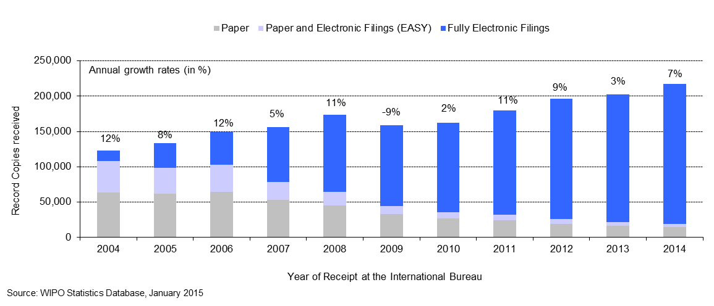

* The IB received approximately 217,700 record copies in 2014, representing an increase of 7 per cent compared to 2013.
* The share of fully electronic filing methods kept increasing in 2014 and now represents 91 per cent of total filings.

*Language distribution*

1. One fundamental development driving change in the IB is the increasing language diversity of filings, resulting, in particular, from continued increased usage of the PCT System in East Asian countries.

**Languages of Filing** *(all languages)*

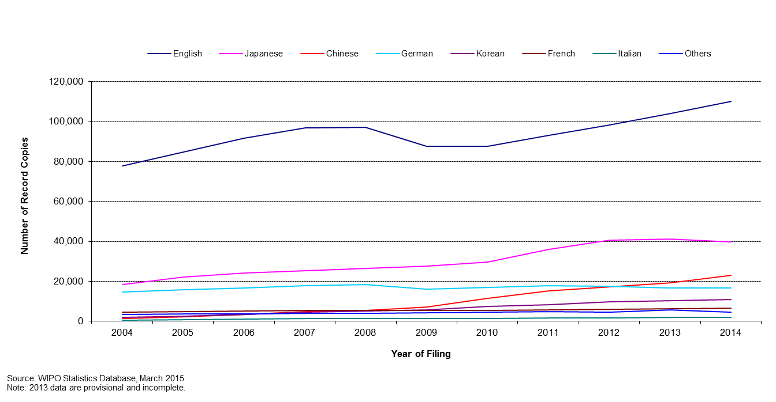

1. As can be observed, while English accounts for the majority of filing, with 51.6 per cent of filings in 2014, the shares of Asian languages have increased over the past decade. The combined share of the PCT applications filed in Japanese, Chinese and Korean has increased from 29.5 per cent in 2009 to 34.5 per cent in 2012. This share has remained stable from 2012 to 2014. Zooming in on languages other than English provides the following picture:

**Languages of Filing** (all languages except English)

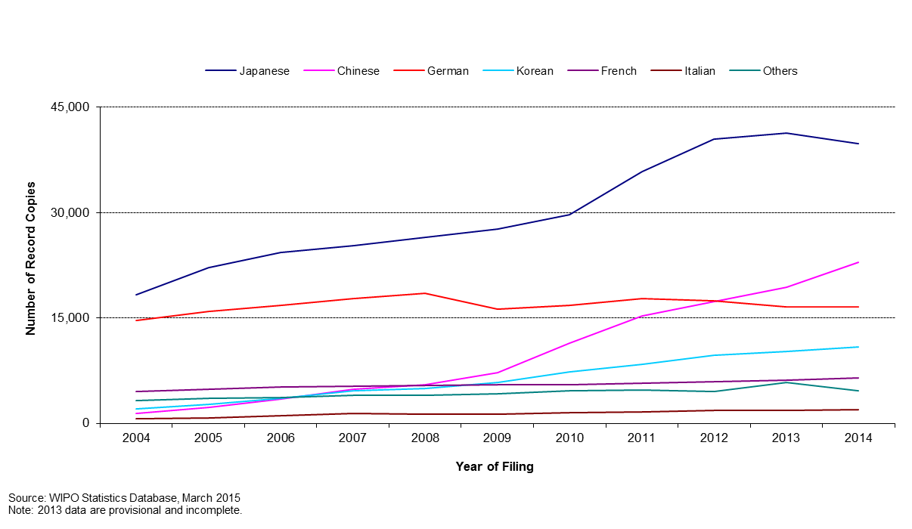

1. The sharp increase of applications filed in Asian languages in the last five years put a considerable strain on the IB due to the limited number of staff resources able to work in these languages. Mitigation for this issue is automation of certain tasks and recruitment of staff able to work in these languages.

*Staff*

1. The chart below shows the number of PCT Operations staff since 2001, in Full Time Staff Equivalent (FTSE ‑ total number of full-time staff plus the full-time equivalent of part-time staff).

**Number of Personnel in PCT Operations**

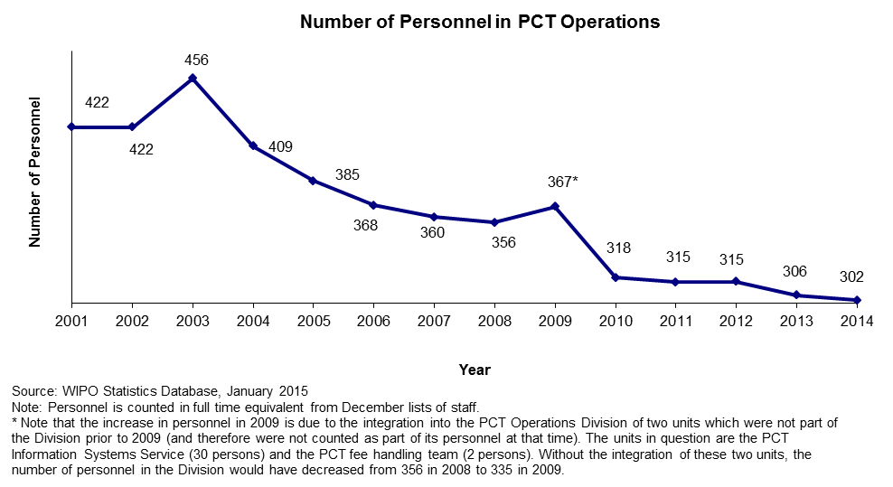

* The PCT Operations Division’s personnel further decreased in 2014.

*Unit cost of processing an application*

1. The IB’s productivity in processing PCT applications can be measured by the unit cost of processing, defined as the average total cost of publishing a PCT application. Average total cost is determined by total direct PCT system expenditure (expenditure incurred by the IB in the administration of the PCT system and related Programs), plus a proportion of indirect expenditure on support and management activities (e.g., buildings and information technology, among others). Indirect costs are weighted to take into account only the share attributable to the PCT system. The unit cost thus includes the cost of all PCT activities, including translation, communication, management and others.
2. The methodology to compute the unit cost was revised in 2013 in order to align it with other WIPO unit/union cost calculations and to better capture a fast changing environment. For example, the old method, which was designed in 2007, included a cost of storage (over 30 years) in warehouses, whereas paper filings (including PCT EASY filings) accounted for less than 10 per cent of filings in 2013. The 2012 PCT unit cost has been calculated using both methods. The 2012 unit cost amounted to 680 Swiss francs using the old method and to 712 Swiss francs using the new method. The 32 Swiss francs difference is due to the new method for allocating indirect costs.
3. Formally, unit cost is defined as:



1. The graphs below depict the evolution of the unit cost of processing from 2004 to 2012 using the old method and from 2012 to 2014 using the new method, including a breakdown of the contribution of direct and indirect costs.

**Unit Cost of Processing a Published PCT Application**

|  |  |
| --- | --- |
| Old method | New method |
|  |  |

* The average cost of processing a published PCT application was 662 Swiss francs in 2014, representing a decrease of 8.3 per cent compared to 2013. This decrease is due to various efficiency measures including automation.
* The average cost of processing a published PCT application calculated by the old method decreased by an average of 5 per cent per year from 1,042 Swiss francs in 2004 to 680 Swiss francs in 2012.

*Productivity of formalities examination*

1. The definition of staff productivity is output (i.e., the number of PCT publications) divided by the number of staff for formalities examination.

**Productivity of Formality Examination**

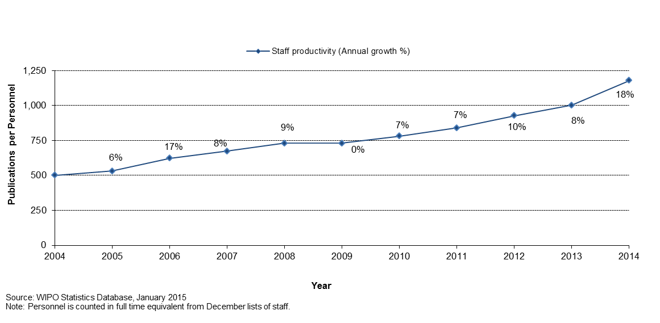

* Historically, productivity of formalities examination has increased, mainly due to automation which has permitted the processing of much larger workloads with less or equal staff.

*Aggregate quality of formalities examination*

1. In order to measure the quality of the work performed by the IB in a simple and comprehensive manner, the IB has developed an aggregate quality index, calculated as the average of four lead quality indicators. Three of these indicators are based on the timeliness of key transactions: acknowledgement of receipt of the PCT application, publication, and republication. The fourth indicator reflects errors made during the processing of PCT applications.

**Quality Index of Formalities Examination**

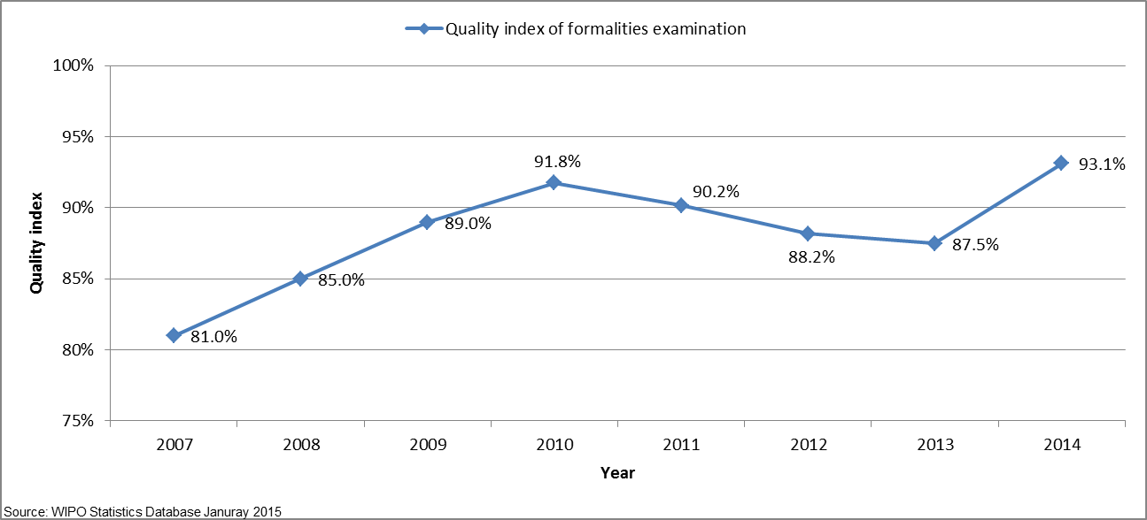

* The overall quality, as measured by the aggregate index, improved markedly from an average of 81 per cent in 2007 to 93.1 per cent in 2014.
* The remarkable increase of the quality index in 2014 is mainly due to improved timeliness in performing formalities examination as well as reduced delays in republishing applications with the ISR. The delay in formalities examination and republication mainly explained the decrease of the quality index observed during the 2010–2013 period.

*Timeliness of formalities examination*

1. This indicator reflects in more detail one of the components of the aggregate quality indicator, namely the time required by the IB to issue Form 301. This form is issued after the formality examination of the application has been completed. Applicants appreciate receiving this Form as soon as possible because it acknowledges receipt of the application at the IB and allows them to know whether their application has any formal defects.

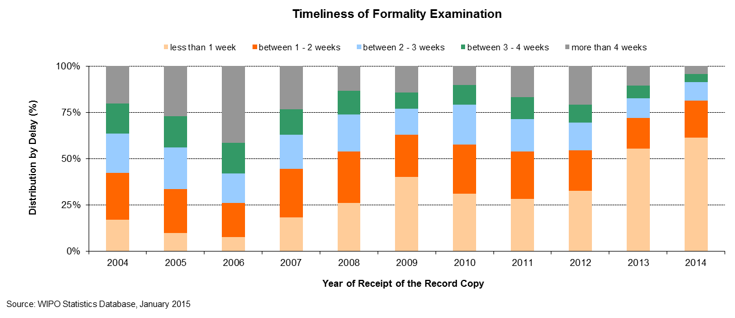

*Timeliness of publication*

1. This indicator reflects in more detail one of the components of the aggregate quality indicator, namely the time required by the IB to publish the application. Article 21 (2) (a) of the PCT states that the “… international publication of the international application shall be effected promptly after the expiration of 18 months from the priority date of that application.”

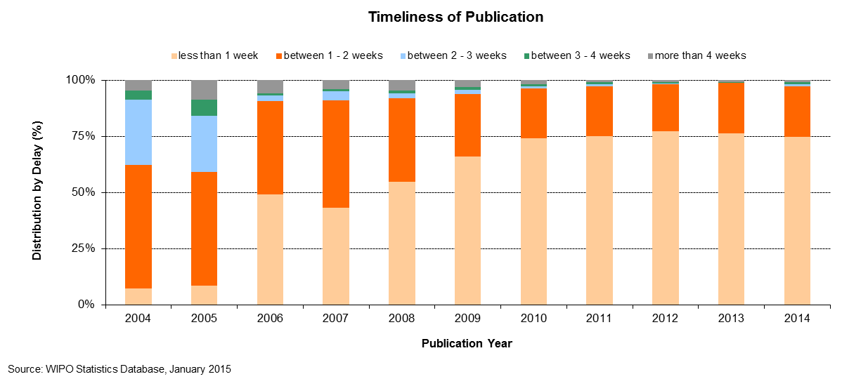

*Timeliness of republication*

1. This indicator reflects in more detail one of the components of the aggregate quality indicator, namely the time required by the IB to republish the application with the ISR. Due to delays in the communication of ISRs by ISAs, a number of international applications are published without the ISR. When the ISR becomes available, the international application needs to be republished with the ISR as soon as possible, so as to complete the international publication.

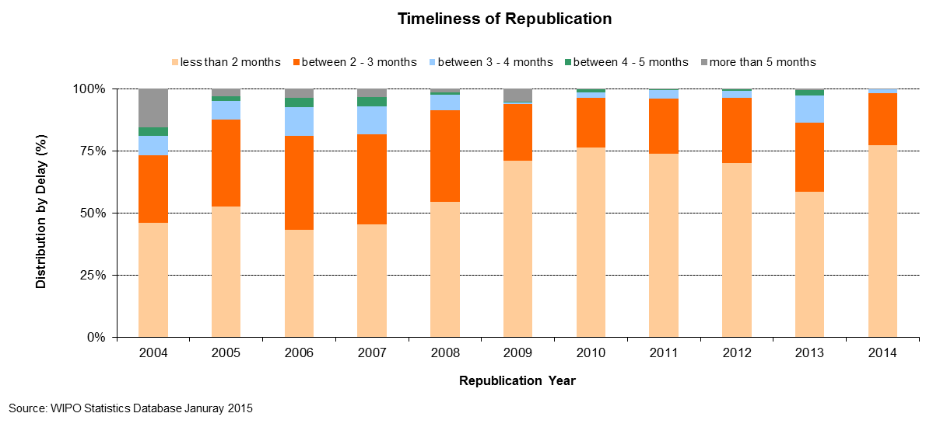

*Quality of translation*

1. Statistically calculated numbers of documents are selected at random from translations of abstracts and patentability reports prepared under the responsibility of the IB for quality control. The evaluation determines whether a translation is “acceptable” or “not acceptable”. This indicator aggregates the results of such quality control performed by the IB across all language combinations and document types. Relationships with any agencies that consistently have less than 80 per cent of their translations deemed “acceptable” are discontinued.

**Quality of PCT Translation**

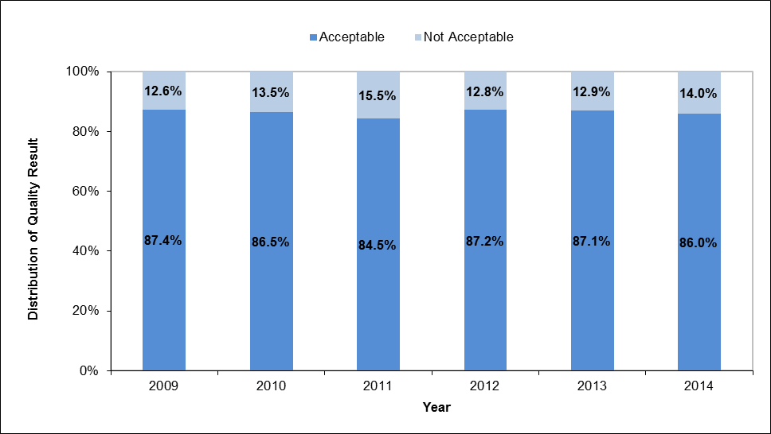

*Timeliness of report translation*

1. This indicator provides information on the timeliness with which patentability report translations are made available by the IB to applicants and Offices. The share of patentability report translations delivered at 30 months from the priority date of the international application has steadily increased since 2010. In 2014, 82.5 per cent of patentability report translations were delivered at 30 months from the priority date.

**Timeliness of Report Translation**

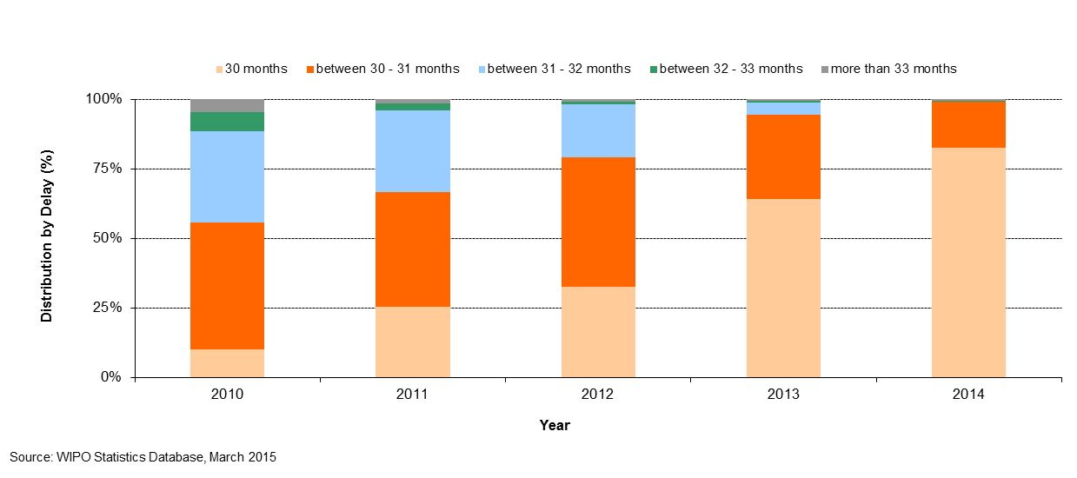

*Quality of software development*

1. The quality of software development (QSD) indicator provides a measure of the quality of major software releases for eDossier and ePCT projects. The QSD reflects the share of the time spent delivering new functionality in the release (i.e. work) out of the total time spent (i.e. work + rework). Rework is the time spent correcting defective work that was detected in the production environment.
2. Under this approach, development outputs that contain low levels of rework are deemed high quality as it reflects the extent of value added to the product through the delivery of new features.
3. The QSD is defined as:



1. In 2014, the quality of major releases, as defined by the QSD, was 94.3 per cent. This share is nearly five percentage points higher than in 2013.

**Quality of Software Development**

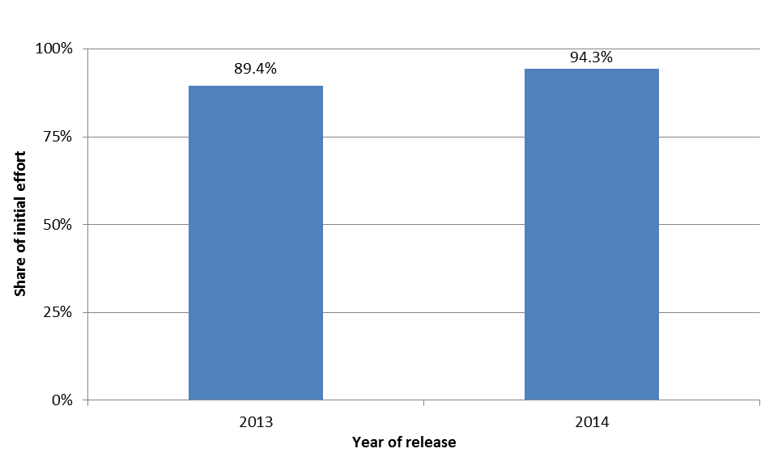

*Information systems service levels*

1. The performance indicator entitled information systems service levels (ISSL) reflects the performance of the service provided by the PCT information systems service to users, based on its ability to meet agreed targets.
2. This composite indicator is calculated using the weighted average of five target-based performance indicators[11]. Each indicator is expressed as the percentage of the target actually attained.

1. In 2014, overall service level was 95.3 per cent towards meeting the target performance levels.

**Information Systems Service Levels**

|  |  |  |  |  |  |
| --- | --- | --- | --- | --- | --- |
| **Id** | **Performance Indicator**  ***Short description*** | **Target** | **Conditions** | **2013 Result** | **2014 Result** |
| (1) | Incident resolution time  *Working time (7am-7pm on WIPO working days) between a ticket being created and resolved.* | Severity 1: 4 hours  Severity 2: 2 days  Severity 3: 5 days  Severity 4: 10 days | Production and Support tickets resolved by the support team | 85.5% | 88.8% |
| (2) | Document load time  *elapsed time between receipt of document at IB and its availability in eDossier* | 8 hours | Documents loaded by a semi or fully automated process | 80.0% | 88.2% |
| (3) | Batch job processing success rate | 100% | Batch jobs to be completed successfully by the close of business on the scheduled date | 99.6% | 99.5% |
| (4) | eDossier system availability | 99% | 7am-7pm on working days | 100.0% | 100.0% |
| (5) | ePCT system availability | 99% | 24 hours | 100.0% | 100.0% |
|  | **Information systems service levels (ISSL)**  ***Weighted average of the above indicators: (1): 20% (2): 20% (3) 20% (4) 20% (5) 20%.*** |  |  | **93.0%** | **95.3%** |

**Receiving Office at the International Bureau (RO/IB)**

*Filings*

1. This table presents PCT filings by the top ten receiving offices over the past five years to 2014. In principle, a PCT application is filed at the national patent office of the applicant’s home country or at a regional patent office acting for the applicant’s home jurisdiction. The IB is a competent receiving office (RO/IB) for applicants from all PCT contracting states. The evolution of the filings at the RO/IB, its ranking in terms of the number of filings among other receiving offices, as well as its market share can be observed in this table.



1. In the Program and Budget 2014/15, the following two performance indicators were added for the RO/IB:

*Timeliness of notification of international filing date*

1. This indicator reflects the time required by the RO/IB to issue Form 105. This form is issued after the international filing date has been accorded. Applicants appreciate receiving this form as soon as possible, because an international application has the effect of a regular national application in each designated State as of the international filing date, which date shall be considered to be the actual filing date in each designated State.

**Timeliness of Notification of International Filing Date**

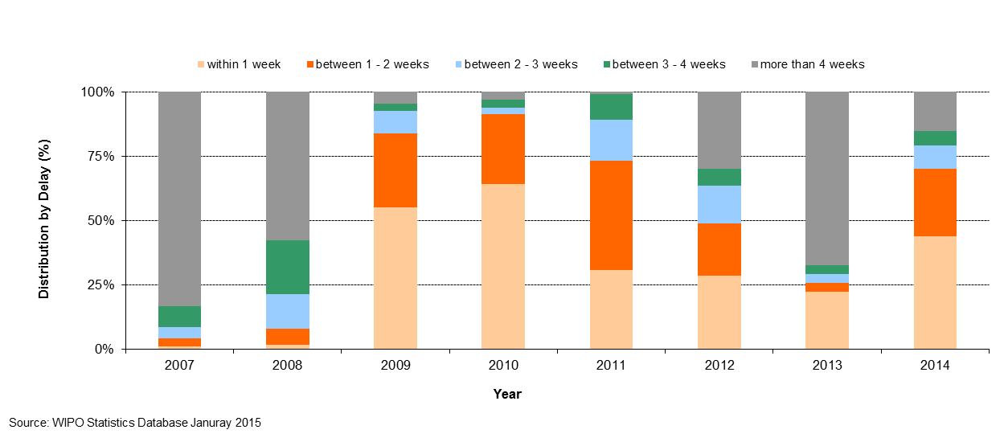

*Timeliness of transmittal of search copy*

1. This indicator reflects the time required by the RO/IB to transmit the search copies to the ISAs. The search copy is to be transmitted promptly after payment of the search fee, so that the ISA can establish the ISR within the deadlines stipulated by the PCT regulatory framework. Delays in paying the fee will delay the transmission of the search copies to the ISAs and therefore negatively impact upon the ability of ISAs to meet these deadlines.

**Timeliness of Transmittal of Search Copy**

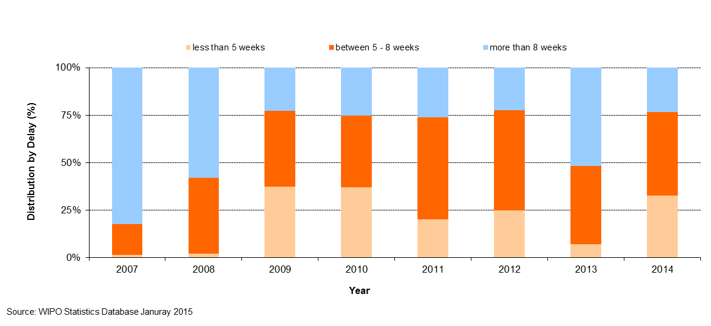

## PROGRAM 6 MADRID AND LISBON SYSTEMS

**Program Manager Ms. B. Wang**

OVERVIEW OF PROGRESS IN 2014

1. THE MADRID SYSTEM
2. The geographical expansion of the System saw important positive developments in 2014. In December, Zimbabwe and the *Organisation Africaine de la Propriété Intellectuelle* (OAPI) acceded to the Madrid Protocol. With OAPI being a 17-country intergovernmental organization, these two accessions alone increased the number of countries in which users can protect and manage their trademarks centrally through the Madrid System from 94 to 110 and thus contributed significantly to the transformation of the System into a truly global system.
3. Use of the Madrid System also increased in 2014, although at a slower rate than originally anticipated. A record 47,885 applications were received in 2014, representing a 2.3 per cent growth over 2013. The United States of America surpassed Germany as the biggest user of the Madrid System in 2014, further illustrating the transformation of the System.
4. The discussions in the Working Group on the Legal Development of the Madrid System led to a number of important changes to the Common Regulations, which entered into force in January 2015.  As a result of the changes, a new relief measure entitled “continued processing” is now available to applicants or holders who fail to meet given time limits in specific procedures before the IB. In addition, the renewal procedure has been simplified through the introduction of an option to renew an international registration only for a reduced list of goods and services, rather than having to request the recording of a limitation prior to the renewal, as was previously the case.
5. The most challenging aspects in 2014 concerned Madrid operational work at the IB. The Madrid Service Orientation Satisfaction Index (Madrid Service Orientation 2014 Survey) improved slightly from 38 to 39. However, a major, long-term reform initiative aimed at improving the maturity level of the operational environment was launched in early 2014 and required the implementation of various new activities and projects, as well as the diversion of certain resources previously dedicated to examination. Consequently, backlogs accumulated in various examination categories (some pre-dating 2014), and other operational delays were incurred, resulting in a number of indicators not being on track. Mitigation measures were put in place, including the retention of a number of additional flexible resources, to allow the IB to improve upon the situation moving forward, while, at the same time, to implement the multiple improvement initiatives still required.
6. An independent review of the preparations necessary for the deployment of the modernized back office ICT systems supporting the Madrid Registry was undertaken during the third and fourth quarters of 2014. The principle recommendations of the review were the engagement of specialist resources to oversee the deployment from both the business and ICT. As regards the front office ICT systems, work continued as planned, including the deployment of the Madrid eFiling tool in the Benelux Office for Intellectual Property (BOIP), the evolution of additional Madrid System web forms and enhanced functionalities in the ROMARIN search system.
7. THE LISBON SYSTEM
8. The Assembly of the Lisbon Union mandated the Working Group on the Development of the Lisbon System, in 2009, to engage in a full review of the Lisbon System aimed at making the system more attractive for users and prospective new Members, while preserving its principles and objectives. In view of the progress made by the Working Group, the Lisbon Union Assembly approved in 2013 the convening of a Diplomatic Conference for the Adoption of a Revised Lisbon Agreement on Appellations of Origin and Geographical Indications in 2015. In October 2014, the Working Group finished its preparatory work for a New Act of the Lisbon Agreement on Appellations of Origin and Geographical Indications, and the Preparatory Committee decided that the Diplomatic Conference be convened in Geneva from May 11 to 21, 2015.
9. The Lisbon Registry received 80 new applications for the registration of appellations of origin, 26 statements of grant of protection and 15 refusal declarations, which amounts to an overall total of 121 transactions. The total number of registrations in force increased in 2014 to 896 from 809 in 2013. Of these, 78 originated from developing countries or LDCs (14 in the Arab region; 22 in Asia and the Pacific; and 42 in Latin America and the Caribbean).
10. The number of competent authorities that had given their consent to the use of electronic means for communications under the procedures of the Lisbon System increased to 24 from 23 in 2013. The electronic interface linking the International Register and the Lisbon Express database on the WIPO website was completed and deployed in 2014. The notifications procedure was further streamlined through the use of the WIPO Inquiry Notification System (WINS). Further development towards an electronic system for the generation of notification letters is planned for 2015.
11. As regards raising awareness of the Lisbon System, the IB organized and/or participated in five information and promotion events with a specific focus on the Lisbon System, including its planned revision, in all regions.
12. The design, planning and implementation of activities by Program 6 were informed and guided by the relevant DA Recommendations, in particular Recommendations 1 and 6. In addition, the legislative assistance provided to Member States was development-oriented, balanced and tailored to unique Member State requests, in accordance with the DA principles (Recommendation 13), and bearing in mind the applicable flexibilities relevant to countries at differing levels of development (Recommendations 14 and 17).

PERFORMANCE DATA

|  |  |  |  |  |  |  |
| --- | --- | --- | --- | --- | --- | --- |
| **Expected Result:** II.6Wider and better use of the Madrid & Lisbon Systems, including by developing countries and LDCs | | | | | | |
| **Performance Indicators** | **Baselines** | **Targets** | **Performance Data** | | | **TLS** |
| Expansion of geographical coverage (Madrid) | *Updated Baseline end 2013:*  92 Contracting Parties to the Madrid System(end 2013)  *Original Baseline P&B 2014/15:*  The number of Contracting Parties at the end of 2013 | A total of 100 Contracting Parties by end of 2015 | 94 Contracting Parties to the Madrid System (2 additional Contracting Parties in 2014: OAPI and Zimbabwe) | | | **On track** |
| Expansion of geographical coverage (Lisbon) | *Updated Baseline end 2013:* 28 (end 2013)  *Original Baseline P&B 2013/14:*  28 (April 2013) | 32 | No new Contracting Parties | | | **Not  on track** |
| Adoption of provisions streamlining or modernizing the Lisbon System legal framework | *Updated Baseline end 2013:* A revision of the Lisbon Agreement and amendments to the Lisbon Regulations are in preparation in the Working Group on the Development of the Lisbon System.  *Original Baseline P&B 2013/14:*  Lisbon Agreement, Regulations and Administrative Instructions in force at the end of 2013 | Revision of the Lisbon Agreement and amendments to the Regulations and Administrative Instructions | The Working Group finished its preparatory work for a New Act of the Lisbon Agreement on Appellations of Origin and Geographical Indications, and the Preparatory Committee decided that the Diplomatic Conference be convened in Geneva from May 11 to 21, 2015. | | | **On track** |
| No. of International Applications (Madrid) | *Updated Baseline end 2013:*  44,018 (2012)  46,829 (2013)  *Original Baseline P&B 2014/15:*  The number of International Applications at the end of 2013 | 8.1% increase by end of 2015 | A record 47,885 International Applications received in 2014, representing a 2.3% increase compared to 2013. | | | **Not on track** |
| Share of Offices concerned providing updated information on the Madrid System | Share of such Offices providing such information | Increased share |  | | | **Dis-continued** |
| **Expected Result:** II.6 Wider and better use of the Madrid & Lisbon Systems, including by developing countries and LDCs | | | | | | |
|  |  |  | | |  |  |
| % of participants in Lisbon System events satisfied and reporting enhanced awareness post an event | *Updated Baseline end 2013:* Evaluation questionnaires showed a satisfaction rate of more than 90%  *Original Baseline P&B 2013/14:*  No. of events and % of satisfied participants in 2013 | At least eight events with 85% of participants satisfied | | | Five information and promotion events with a specific focus on the Lisbon System, including its planned revision, in all regions with 84% of participants satisfied | **On track** |
| No. and proportion of Lisbon registrations in force from developing countries and LDCs | *Updated Baseline end 2013:* 67 out of 816  *Original Baseline P&B 2013/14:*  67 (out of 809) (April 2013) | 80 (out of 825) | | | 78 (out of 896):   * Arab (14) * Asia and the Pacific (22) * Latin America and the Caribbean (42) | **On track** |
| Decrease in the number of irregularities (Madrid) | *Updated Baseline end 2013:*  2013: 36%  *Original Baseline P&B 2014/15:*  Irregular applications 34% (in 2012) | Decrease in the number of irregularities by 10% | | | 2014: 36% | **Not on track** |
| **Expected Result:** II.7Improved productivity and service quality of Madrid & Lisbon operations | | | | | | |
| **Performance Indicators** | **Baselines** | **Targets** | | **Performance Data** | | **TLS** |
| Progress towards streamlining and simplification of the Madrid System legal framework | Madrid System Common Regulations and Administrative Instructions in force at the end of 2013 | Amendments to the Madrid System Common Regulations and Administrative Instructions | | Amendments to the Common Regulations approved by Madrid Union Assembly in 2014 and to be implemented by Jan 1, 2015 | | **On track** |
| No. of registrations  No. of renewals processed  No. of modifications, including subsequent designations (Madrid) | *Updated Baseline end 2013:*  2013: 44,414 registrations;  23,014 renewals;  117,673 modifications including 14,373 subsequent designations  *Original Baseline P&B 2013/14:*  Registrations, renewals (See Annex VII).  97,500 modifications were inscribed in the Registry (2012) | 2014: 6.3% increase in registrations and renewals  2015: 3.3% increase in registrations and renewals  Total registrations 92,500.  Total renewals 49,000  Total modifications 200,000, including 35,000 subsequent designations | | 1.1% increase in registrations and renewals:   * 42,430 registrations * 25,729 renewals   99,558 modifications including 15,824 subsequent designations | | **Not  on track**  **Not**  **on track**  **On track** |
| Translation of applications in a timely manner (Madrid) | data not available | Four weeks | | Average processing time is 3 weeks | | **On track** |
| Decrease in the number of corrections (Madrid) | *Updated Baseline end 2013:* 2013: 5,197 corrections received and  4,499 processed  *Original Baseline P&B 2013/14:* Corrections figures in 2012 ( 5,000 requests) | Decrease corrections by 10% | | 2014: 6,073 corrections received and  5,737 processed | | **Not  on track** |

|  |  |  |  |  |
| --- | --- | --- | --- | --- |
| **Performance Indicators** | **Baselines** | **Targets** | **Performance Data** | **TLS** |
| Improved client satisfaction (Madrid) | *Updated Baseline end 2013:*  Service Orientation Index 38  *Original Baseline P&B 2013/14:* Customer Service Orientation Survey 2012. Service Orientation Index 79[12]. | Higher satisfaction rate in the next Survey, focusing on responsiveness and timeliness | 2014: Service Orientation Index 39 | **On track** |
| Increased use of electronic exchange (Madrid) | *Updated Baseline end 2013:*  67% of documents received electronically  158,717 email notifications  714 MPM Clients  16 Offices sending XML  *Original Baseline P&B 2013/14:*  60% of documents received electronically; 85,000 marks notified by email; 200 clients using the MPM; 17 Offices sending applications in XML | 70% of documents received electronically; 110,000 marks notified by email; 1,000 clients using the MPM; 23 Offices sending applications in XML | 70% of documents received electronically  220,000 email notifications  1,800 MPM Clients  17 Offices sending XML | **On track**  **On track**  **On track**  **Not  on track** |
| Refinement of the electronic means of communication and publication under the Lisbon procedures | The electronic means in place at the end of 2013 | Electronic filing system and incorporation of the Lisbon Bulletin into the Lisbon Express database | Streamlined procedure for notifications implemented via the WIPO Inquiry Notification System (WINS) notification system. | **On track** |
| Refinement of the electronic International Register of the Lisbon System | *Updated Baseline end 2013:* IT applications for an electronic International Register in use since the Summer 2013  *Original Baseline P&B 2013/14:*  The electronic International Register (to be) established in 2013 | Electronic system linking International Register and Lisbon Express database on the WIPO website | Electronic interface linking the International Register and Lisbon Express database on the WIPO website was completed and deployed in 2014, | **On track** |

RESOURCE UTILIZATION

Budget and Actual Expenditure (by result)

*(in thousands of Swiss francs)*



Budget and Actual Expenditure (personnel and non-personnel)

*(in thousands of Swiss francs)*



*NOTE: The 2014/15 Budget after Transfers reflects transfers as of March 31, 2015 to address needs during the 2014/15 biennium in line with Financial Regulation 5.5.*

A. Budget after Transfers 2014/15

1. The Budget after Transfers under Result II.6 (Wider and better use of the Madrid and Lisbon Systems) reflects an upward adjustment primarily due to the expansion of the Madrid Fellowship Program.
2. The shift from personnel to non-personnel resources in the 2014/15 Budget after Transfers reflects a move towards move flexible and agile resourcing of Madrid Operations as part of the Madrid Reform initiative.

B. Budget utilization 2014

1. Budget utilization is within the expected range of 40-60 per cent for the first year of the biennium and is on track.

**Program 6 Annex: Indicators of Madrid Operations**

PERFORMANCE INDICATORS FOR THE EXPECTED RESULT

“IMPROVED PRODUCTIVITY AND SERVICE QUALITY OF MADRID OPERATIONS”

1. As background for the performance indicators for the expected result “improved productivity and service quality of Madrid operations”, the evolution of the following factors needs to be considered:

* Madrid workloads;
* Composition of those workloads;
* Number of staff assigned to process those workloads;
* Level of automation; and
* Total cost of production.

1. **Incoming documents**
2. The International Bureau (IB) receives six different categories of documents, namely international applications, renewals, subsequent designations, modifications, decisions and corrections. The latest trend for each of these documents is presented below. Additional information on applications, such as their average number of classes and average number of words is also provided. For technical reasons, some indicators show data based on processed documents rather than on incoming documents. Backlogs in processing may therefore affect some indicators.

International applications

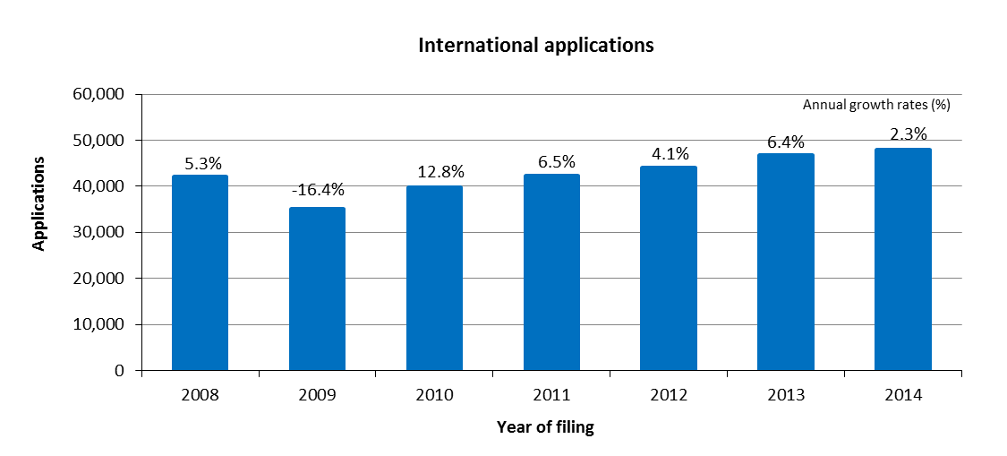

* The IB received 47,885 applications in 2014, representing an increase of 2.3 per cent compared to 2013.
* The numbers of applications received have increased continuously since 2010.

*Distribution of applications by language of filing*

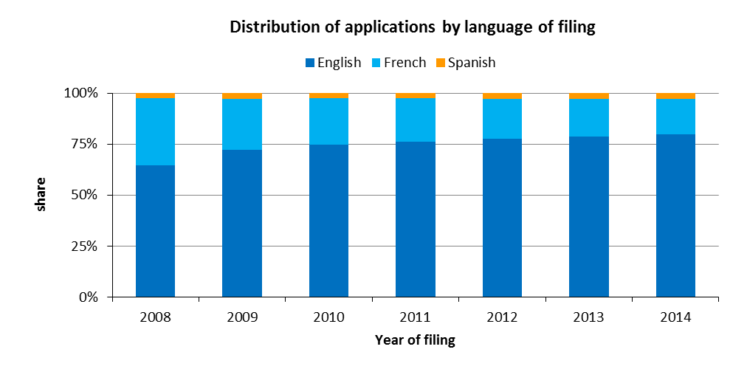

* In 2014, 80 per cent of all applications were filed in English. This share grew by 15 percentage points from 65 per cent in 2008 to 80 per cent in 2014.

*Average* *number of designations per registration*

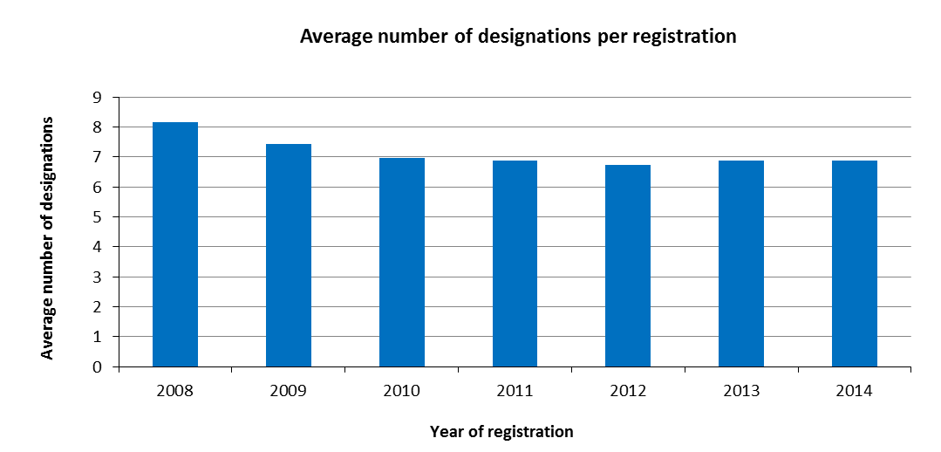

* An average 6.9 designations were made in applications registered in 2014.
* The average number of designations per registration has remained almost unchanged since 2010.

*Average number of classes per registration*

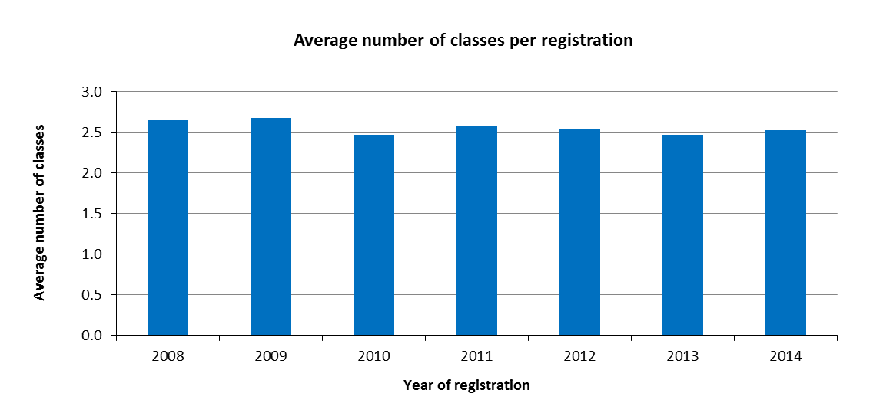

* On average, 2.5 classes were specified in all applications registered in 2014.

*Average length of applications*

1. The length of an application is determined by the total number of words used by applicants to describe their mark, by the basic list of goods and services and by any accompanying limitations. These three elements are translated by the IB into two languages (English, French or Spanish).
2. The length of applications has an impact on the workload of examiners, which includes classifying the goods and/or services in the application according to the Nice Classification.
3. The average length of an application is determined by the total number of words in basic lists of goods and services, limitations and descriptions divided by the number of applications registered.

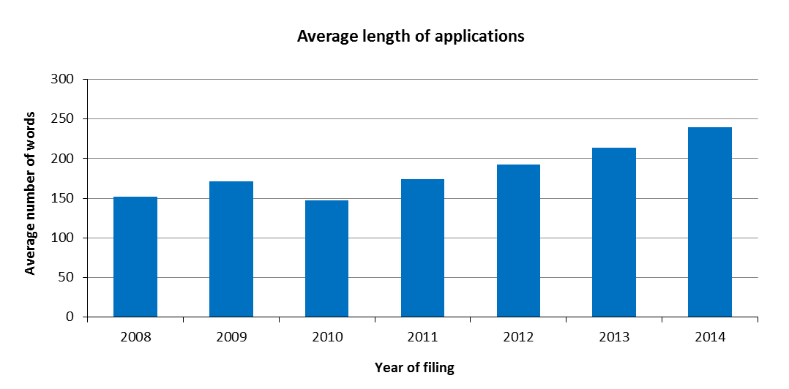

* In 2014, the average length of an application was 239 words. This represents an increase of 12 per cent compared to 2013.
* While certain aspects of the translation and classification work are automated, significant increases in the length of applications has a large impact on the workload of the IB.

*Distribution of regular and irregular applications*

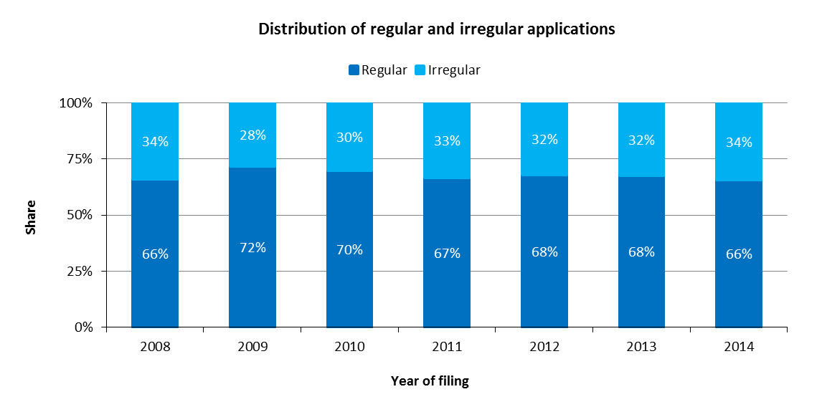

* The share of regular applications has remained more or less the same since 2011.

Renewals

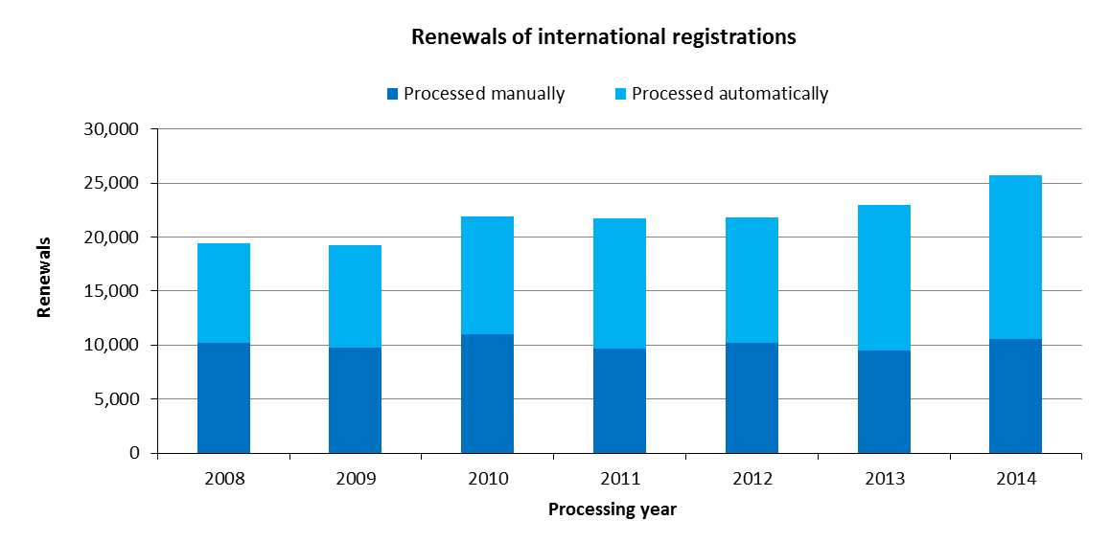

* In 2014, the IB registered 25,729 renewals, up 12 per cent from 2013.
* Despite the increase in renewals between 2009 and 2014, the numbers of renewals processed manually have remained relatively stable. In 2014, 59 per cent of renewals were processed automatically.

Subsequent Designations

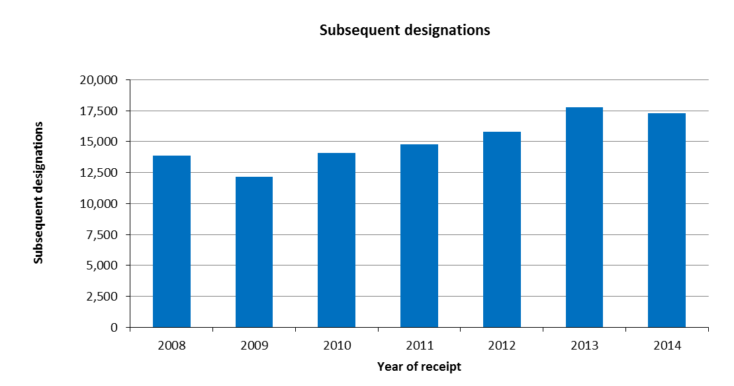

* In 2014, the IB recorded 17,316 subsequent designations, down 2.5 per cent from 2013.
* In 2014, a new web form called E-Subsequent Designation was made available to applicants. This electronic form enabled the IB to process 14 per cent of all subsequent designations automatically.

Modifications

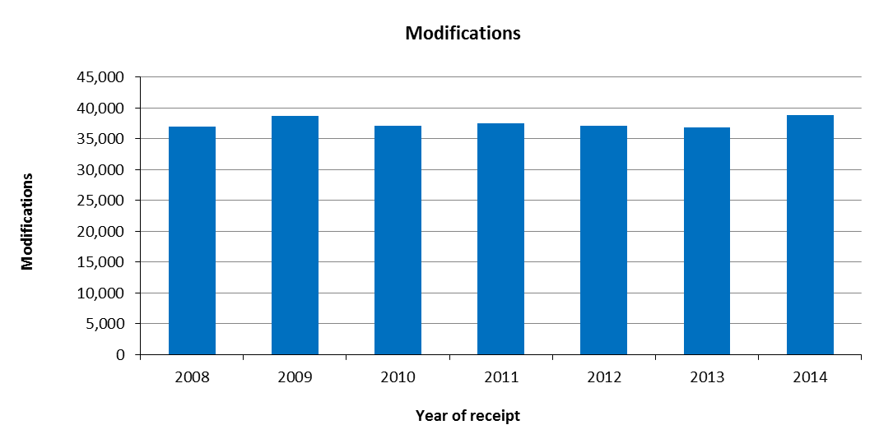

* In 2014, the IB received 38,817 requests for modification, up 5.5 per cent from 2013.

Decisions

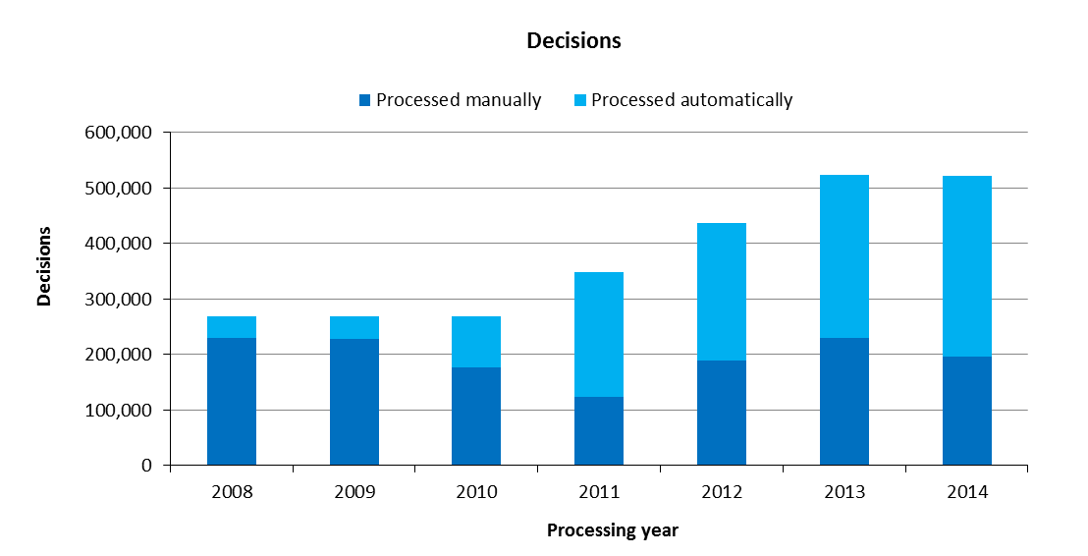

* In 2014, the number of decisions registered decreased by 0.3 per cent compared to 2013, totaling 521,208. The number of decisions processed has rapidly increased since 2010.
* In 2014, 62 per cent of decisions were processed automatically. The majority of decisions have been processed automatically since 2011.

Corrections

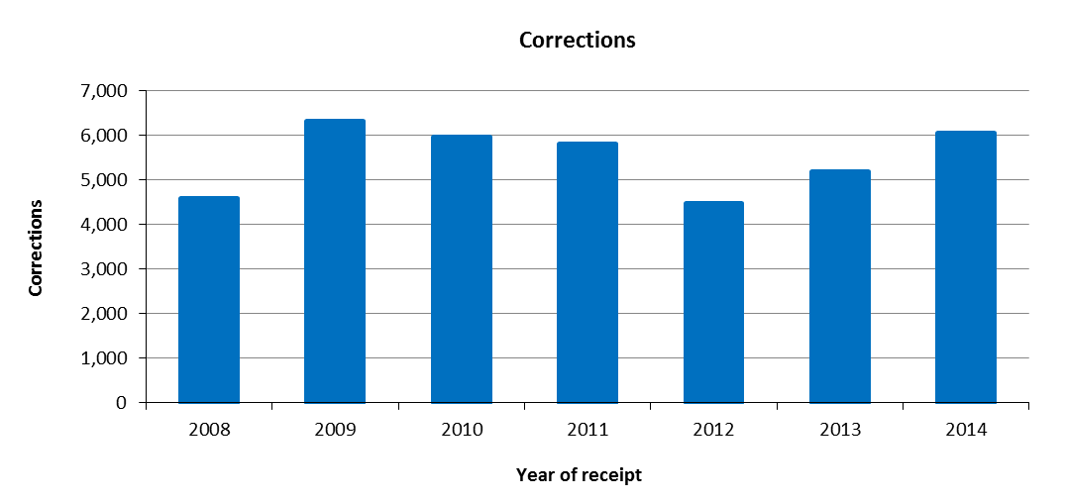

* In 2014, the IB recorded approximately 6,000 corrections. This represents an increase of 17 per cent compared to 2013.

1. **Total workload**
2. The total workload represents the weighted total number of documents processed by the IB. All six categories of documents are included (applications, renewals, subsequent designations, modifications, decisions and corrections).
3. As processing these types of documents do not require equal resources, they are each weighted differently. According to this weighted system, during the time required to process an international application, an examiner can process 1.6 renewals, 1.8 subsequent designations, 1.8 modifications or 10 decisions. Similarly, during the time required to process an international application, an employee involved in the automation process can be deemed to process 17 documents.

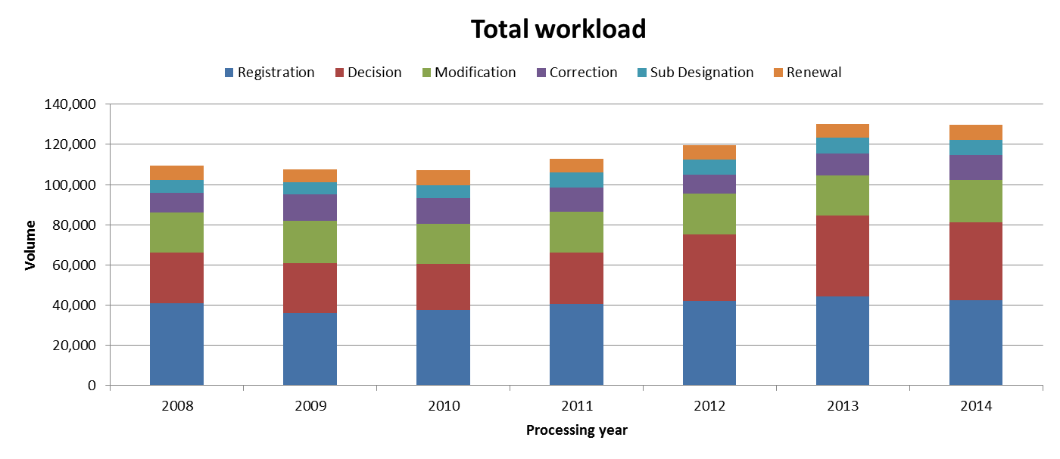

* In 2014, the total workload remained stable compared to 2013. Applications, decisions and modifications represented nearly 80 per cent of the total workload.
* Between 2011 and 2013, the workload increased sharply, mainly due to the increasing number of decisions.

1. **Medium of Transmission of Incoming Documents**

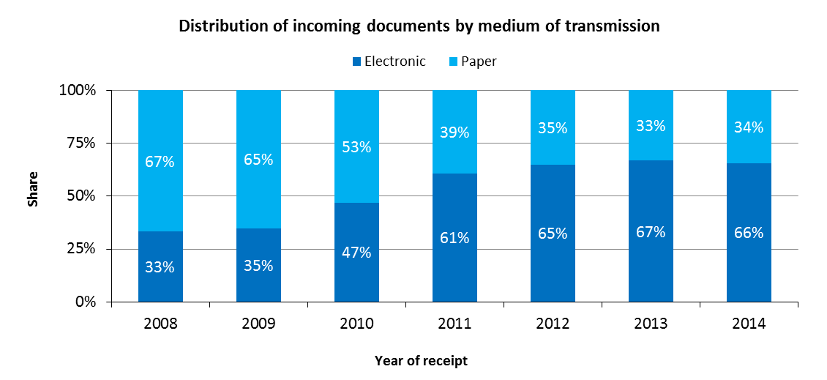

* In 2014, 66 per cent of all incoming documents were transmitted electronically to the IB.
* The share of documents transmitted electronically has been stable since 2012.

1. **Processing**

Total cost of production

1. The total cost of production has direct and indirect components. Direct costs reflect expenditure incurred by the IB in administering the Madrid System (such as management, translation and registration). Indirect costs reflect expenditure for supporting activities (such as those associated with buildings and information technology). Indirect costs are weighted to take into account only the share attributable to the Madrid System.

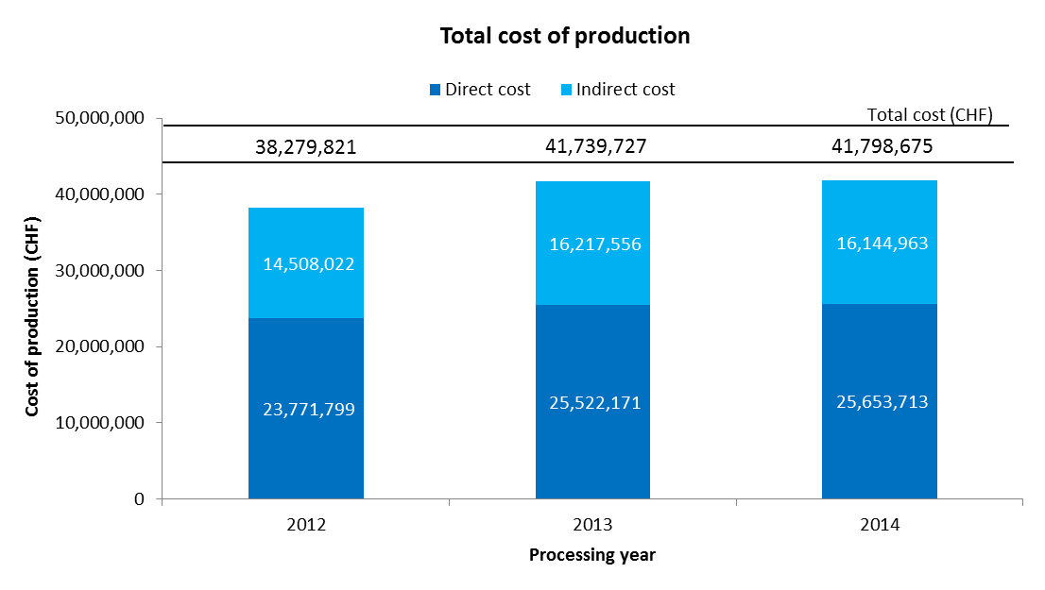

* The total cost of production is estimated at 41.8 million Swiss francs in 2014. This represents a slight increase of 0.1 per cent compared to 2013.
* In 2014, the direct costs accounted for 61 per cent of total costs.

Unit cost

1. The IB’s efficiency in processing transactions can be measured by the unit cost, defined as the average cost of producing one unit of output.
2. As the IB registers new applications and maintains existing registrations, it is relevant to have a unit of output which includes a set of transactions. Two unit cost indicators are presented below using two different units of output.
3. As part of the IB’s efforts to continuously refine the methodology for calculating unit costs, the methodology has been revised in the Program and Budget 2016/17 to reflect more accurately the cost of processing Madrid workloads at the IB:

* The methodology for calculating direct and indirect Madrid costs have been aligned with the methodologies for calculating PCT and the Hague unit costs.
* A weighted system has been introduced to better approximate the actual work required to process the six categories of documents, taking into account that certain of these documents are more labor-intensive than others.[13]
* The first unit cost has been redefined to include only new international registrations and renewals (the unit cost in the Program and Budget 2014/15 also included subsequent designations). The rationale for removing subsequent designations as a component of this unit cost is a sharper focus on the core Madrid outputs, namely the international registration and its renewal. All other Madrid transactions (subsequent designations, modifications, decisions and corrections) can be considered secondary to these two core transactions. Furthermore, there is no real justification for including one of these secondary transactions as a component of unit costs, while not including the others.
* The second unit cost is based on the number of documents inscribed in the register rather than the number of inscriptions due to the different levels of efforts required to process the various documents.

1. For ease of comparison, the graphs below depict the evolution of the two unit costs from 2008 to 2014 using the old methodology and from 2012 to 2014 using the new methodology, including a breakdown of the contribution of direct and indirect costs.

*Unit cost per new/renewed international registration*

1. New international registrations consist of applications that are registered within a given year, and renewed international registrations consist of existing registrations that are renewed within a given year. Combined, these two types of transactions reflect the core business of the IB.
2. As processing these two types of transactions do not require equal resources, they are each weighted differently. [14] The unit cost is calculated by dividing the total cost of production by the number of new/renewed international registrations.

|  |  |
| --- | --- |
| Old method | New method |
|  |  |

* The average cost of processing a new/renewed international registration was 837 Swiss francs in 2014. This represents an increase of 2.6 per cent compared to 2013. The increase was mainly due to a processing cost that remained relatively stable, combined with a decrease of 4.5 per cent in the number of international applications registered.

*Unit cost per document inscribed in the register*

1. The documents inscribed in the register correspond to the total volume of workload (see “Total volume of workload” above).

|  |  |
| --- | --- |
| Old method | New method |
|  |  |

* The average cost of inscribing a document in the register increased slightly from 320 Swiss francs in 2012 to 322 Swiss francs in 2014.

1. **Productivity of examination**
2. The definition of examination productivity is the number of new/renewed international registrations processed by examiners divided by the number of personnel involved in examination. The number of personnel includes fellows, interns and external contractors.

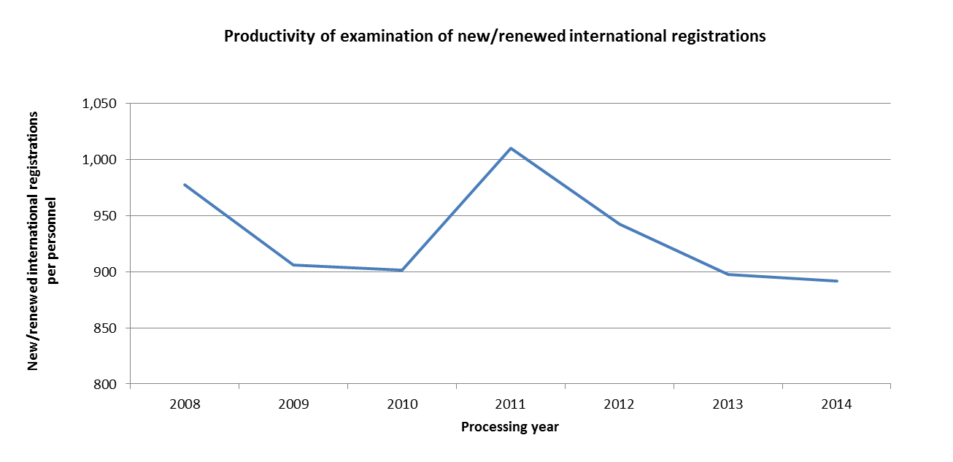

* The productivity of examination remained relatively stable in 2014 compared to 2013.

1. **Personnel**

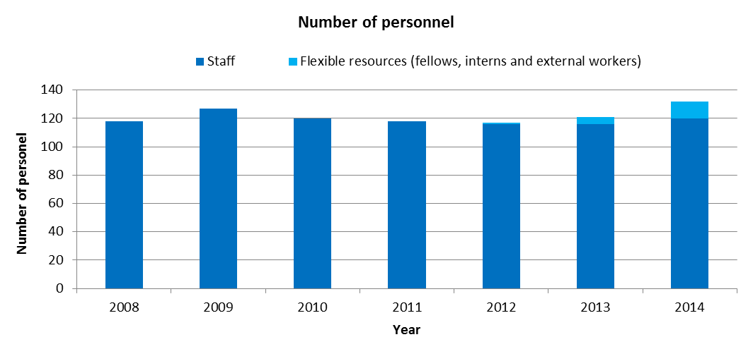

* The number of staff has remained relatively stable since 2010, while the number of flexible resources has increased from 1 in 2012 to 12 in 2014.
* Personnel of outsourcing companies not working on WIPO premises are not included in this indicator.

1. **Pendency**
2. The average pendency for each of the six transactions performed by the IB is shown below. The pendency is calculated from the date a document is received to the date it is inscribed.

|  |  |
| --- | --- |
|  |  |
|  |  |
|  |  |

* Compared to 2013, the average pendency in 2014 increased for applications, corrections, modifications and subsequent designations. The average pendency time for renewals remained stable, whereas that for decisions decreased for the second consecutive year.
* Improving and stabilizing pendency across all transactions is a major objective of the IB.

## PROGRAM 31 THE HAGUE SYSTEM

**Program Manager Ms. B. Wang**

OVERVIEW OF PROGRESS IN 2014

1. In 2014, the Republic of Korea became party to the Geneva (1999) Act of the Hague Agreement Concerning the International Registration of Industrial Designs (hereinafter referred to as “the 1999 Act”). The accessions of other prospective members, notably Japan and the United States of America, were postponed to 2015, resulting in a lower than anticipated growth rate in membership in 2014. Furthermore, by the end of 2014, three consents were still required for the termination of the 1934 Act, and four Contracting Parties outside the EU and OAPI remained bound by the 1960 Act.
2. Significant progress towards the enhancement of the legal framework of the Hague System was achieved in 2014. Notably, following the fourth session of the Working Group on the Legal Development of the Hague System for the International Registration of Industrial Designs, the Hague Union Assembly adopted provisions that introduced a “feedback mechanism”. In addition, changes to the Administrative Instructions were introduced with a view to giving users more flexibility in respect of the formal disclosure of their designs. These two developments provide the foundation for moving forward with the long-awaited expansion to jurisdictions where substantive examination is undertaken. Together with the changes made to the electronic filing interface to cater for the accession of the Republic of Korea, the System should be better equipped to cope with the additional complexities arising from the anticipated accessions.
3. Filings also remained considerably below the forecasted figure for 2014, in spite of a general increase in terms of designs filed and recorded international registrations. As a result, progress was limited with respect to the introduction of greater flexibility in the database, which was meant to be pursued only after experience with an expanded membership was gained. Nonetheless, progress towards introducing more automated processes in the existing information technology platform continued on track, with one additional process (Statement of Grant of Protection) being automated in 2014, for a total of three automated processes.
4. The design, planning and implementation of activities by Program 31 were informed and guided by the relevant Recommendations, in particular Recommendations 1 and 6.

PERFORMANCE DATA

|  |  |  |  |  |
| --- | --- | --- | --- | --- |
| **Expected Result:** II.4 Wider and better use of the Hague system, including by developing countries and LDCs | | | | |
| **Performance Indicators** | **Baselines** | **Targets** | **Performance Data** | **TLS** |
| Membership of the Geneva (1999) Act | *Updated Baseline end 2013: 46 Contracting Parties (end 2013)*  *Original Baseline P&B 2014/15:* 45 Contracting Parties | 58 Contracting Parties | 47 Contracting Parties to the Geneva Act (end 2014) | **Not  on track** |
| Share of Offices concerned providing information on the Hague system | *Updated Baseline end 2013: 42 national or regional Offices were providing adequate information on the Hague System. Nine Offices had no web site.*  *Original Baseline P&B 2014/15: Share of Offices providing such information* | Increased share | 38 national or regional Offices were providing information on the Hague System at the end of 2014. Ten Offices had no website (end 2014) | **Not on track** |

|  |  |  |  |  |  |  |  |  |  |
| --- | --- | --- | --- | --- | --- | --- | --- | --- | --- |
| **Performance Indicators** | **Baselines** | | | | **Targets** | **Performance Data** | | | **TLS** |
| Hague filings and renewals | *Updated Baseline end 2013: Applications:*  *2,990*  *Designs contained: 13,172*  *Renewals: 2,859*  *(2013)*  *Original Baseline P&B 2014/15: Applications: 2,604*  *Designs contained: 12,454[15]*  *Renewals: 3,120*  *(2012)* | | | | 2014:  Applications:  33.9% increase  Designs contained: 33% increase Renewals:  2.9% decrease  2015:  Applications:  23.4% increase Designs contained: 23.5% increase Renewals:  5.5% increase | 2014:  Applications:  2.2% decrease (2,924)  Designs contained:  9.6% increase (14,441)  Renewals:  5.5% decrease (2,703) | | | **Not  on track** |
| **Expected Result:**  II.5 Improved productivity and service quality of Hague operations | | | | | | | | | |
| **Performance Indicators** | | **Baselines** | | | **Targets** | | **Performance Data** | | **TLS** |
| Predominance of the Geneva (1999) Act in the Hague system | | *Updated Baseline end 2013: Three consents were still required for the termination of the 1934 Act, and four Contracting Parties outside the EU and OAPI remained bound by the 1960 Act*  *Original Baseline P&B 2014/15: 15 Hague members still not bound by the Geneva (1999) Act; Five consents to termination of the 1934 Act still outstanding (end 2012)* | | | No (zero) countries bound only by the Hague (1960) Act outside the EU or OAPI; all the remaining consents (five) to termination of the 1934 Act received | | Three consents still required for the termination of the 1934 Act, and four Contracting Parties outside the EU and OAPI still bound only by the 1960 Act. | | **Not  on track** |
| Progress towards the enhancement of the legal framework | | *Updated Baseline end 2013:*  *Original Baseline P&B 2014/15: Current legal framework* | | | Amendments to the Hague Regulations and Administrative Instructions as well as new features introduced following accessions of some new Contracting Parties. | | | Amendments to the Common Regulations, among others, introducing a "feedback mechanism", were adopted by the Hague Union Assembly in 2014, and will come into force on January 1, 2015.  Amendments to the Administrative Instructions, among others, relaxing certain requirements concerning reproductions and representations, came into force on July 1, 2014. | **On track** |
| Flexibility of data recorded in the International Register | | *Original Baseline P&B 2014/15: Inability to record granular design information* | | | Ability to record granular design information | | | Postponement due to legacy system adjustments for new accessions, and delay in Modernization Program implementation | **Not on track** |
| No. of automated processes | | | *Updated Baseline end 2013: Two (e- Filing and e-Renewal)[16]*  *Original Baseline P&B 2014/15: 2* | 4 | | | | 1 additional automated process (Statement of Grant of Protection)  (3 cumulative) | **On track** |

RESOURCE UTILIZATION

Budget and Actual Expenditure (by result)

*(in thousands of Swiss francs)*



Budget and Actual Expenditure (personnel and non-personnel)

*(in thousands of Swiss francs)*



*NOTE: The 2014/15 Budget after Transfers reflects transfers as of March 31, 2015 to address needs during the 2014/15 biennium in line with Financial Regulation 5.5*.

A. Budget after Transfers 2014/15

1. The 2014/15 Budget after Transfers reflects a net increase in personnel resources primarily due to the temporary transfer of a staff member from Program 10 to Program 31 to provide additional support for the Working Group meetings and promotional activities. This is reflected under Result II.5 (Improved productivity and service quality of the Hague operations).
2. The net decrease in non-personnel resources is primarily due to: (i) the transfer of non-personnel resources for an intern (to Program 23 which centrally manages interns) to support the work on new accessions under Result II.4 (Wider and better use of the Hague System); and (ii) a slight downward adjustment made for cost efficiency gains.

B. Budget utilization 2014

1. The non-personnel budget utilization rate for the Program amounted to 29 per cent of the 2014/15Budget after Transfers. This resulted primarily from a delay in IT-related work due to the postponement of the accessions of certain Contracting Parties under Result II.4 (Wider and better use of the Hague System).

**Program 31 Annex: Indicators of the Hague System Operations**

PERFORMANCE INDICATORS FOR THE EXPECTED RESULT

“IMPROVED PRODUCTIVITY AND SERVICE QUALITY OF THE HAGUE OPERATIONS”

1. As background for the performance indicators for the expected result “improved productivity and service quality of the Hague operations”, the evolution of the following factors needs to be considered:

* The Hague System workloads;
* The composition of those workloads;
* The level of automation; and
* The resources assigned to cope with the workload.

1. The International Bureau (IB) receives four main types of documents, namely international applications, renewals, changes and decisions. The latest trend for each of these documents is presented below. Additional information on the applications received, such as their average number of designs, are also provided. For technical reasons, the indicator on the irregularities issued shows data based on processed documents rather than on incoming documents.

**I. Incoming Documents**

Applications received

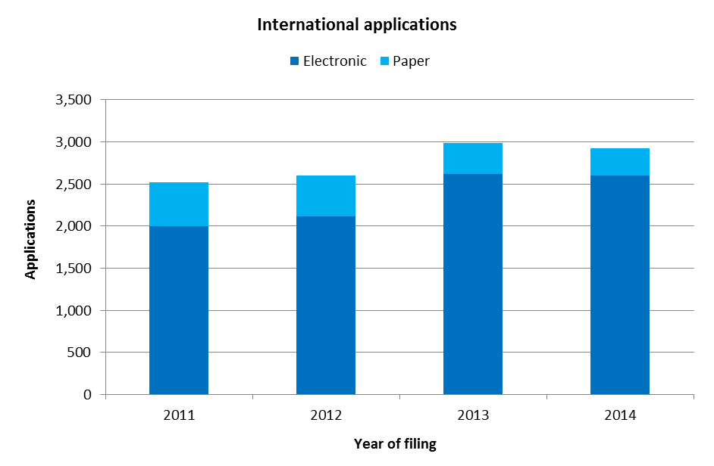

* In 2014, the IB received 2,924 international applications, down 2.2 per cent from 2013. In 2013, applications received sharply grew by 15 per cent.
* In 2014, 89 per cent of applications were filed electronically. The share of electronic filings increased by 10 percentage points from 2011 to 2014, from 79 per cent in 2011 to 89 per cent in 2014.

*Average number of designs per application*

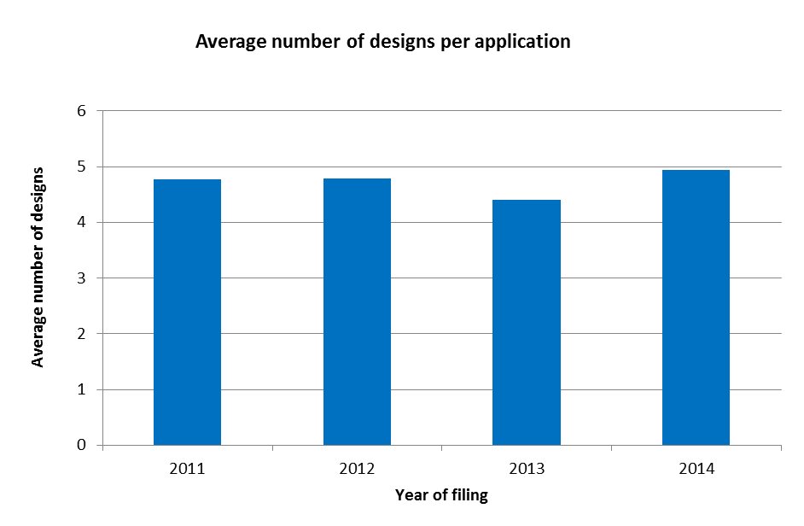

* In 2014, an application contained, on average, nearly five designs. Between 2011 and 2014, the average number of designs per application varied between 4.5 and 5 designs.

*Average number of designations per application*

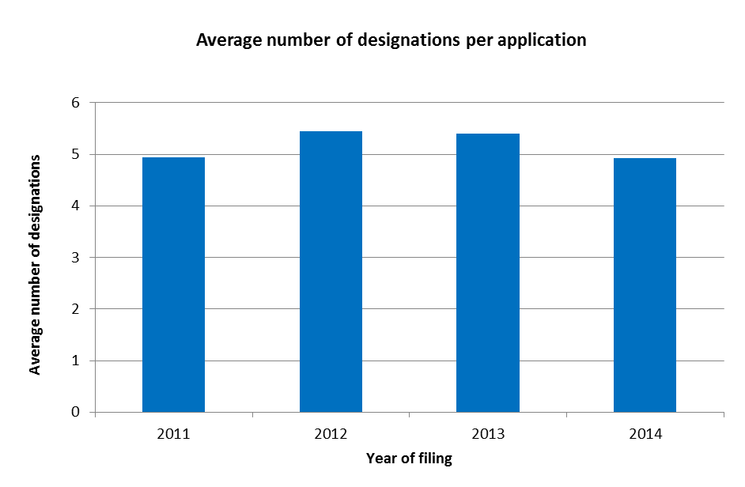

* In 2014, an application contained, on average, nearly five designations.

*Trend of irregularities in applications*

1. Irregularities in applications are grouped among the ten categories shown below.

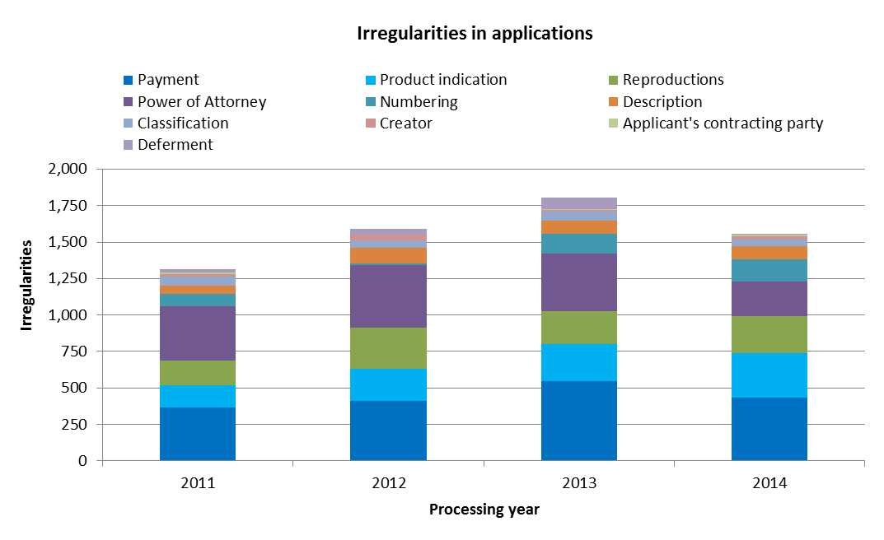

* In 2014, the IB identified 1,557 irregularities in applications, down 14 per cent over 2013.
* Despite this sharp decrease, the irregularities related to product indications increased for the third consecutive year. Together with irregularities of payment, they nearly accounted for half of total irregularities in 2014.

Renewals

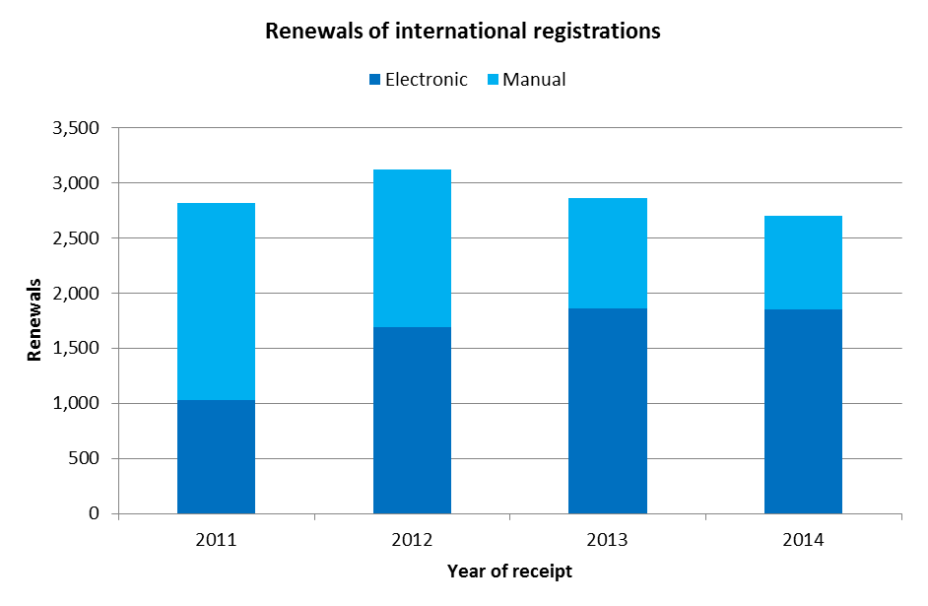

* The number of renewals decreased for the second consecutive year to 2,703 renewals in 2014. This represented a 5 per cent drop on 2013.
* Since 2013, a majority of renewals were processed automatically. They accounted for 60 per cent of total renewals in 2014

Changes

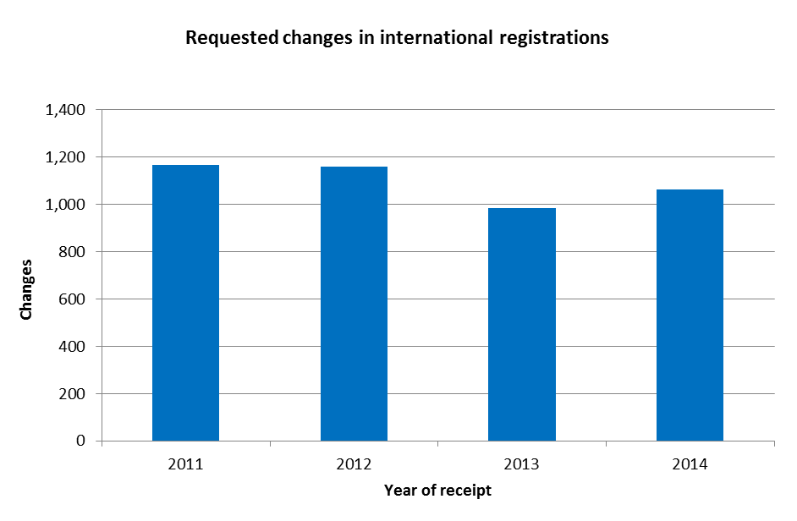

* Applicants requested 1,063 changes in international registrations in 2014, up 8 per cent from 2013.

Decisions

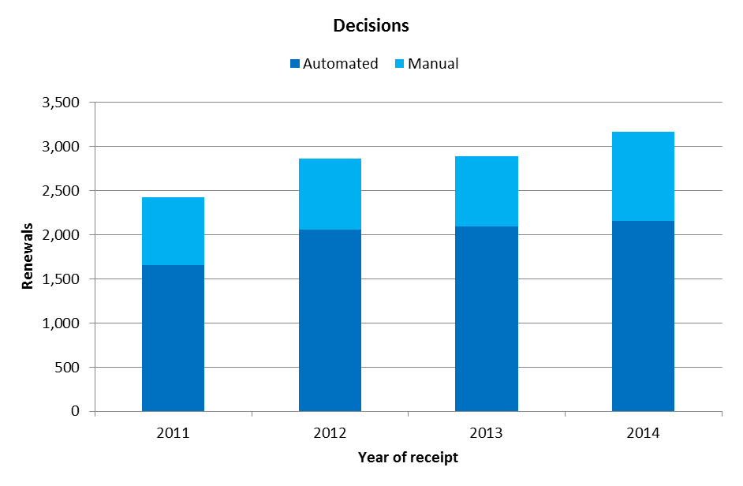

* The number of decisions received in 2014 increased by 10 per cent, to 3,169 decisions.
* Between 68 per cent and 72 per cent of decisions were processed automatically since 2011.

**II. Total workload**

1. The total workload represents the weighted total number of documents received at the IB. All four categories of documents are included (applications, renewals, changes and decisions).
2. As processing these types of documents does not require equal resources, they are each weighted differently. According to this weighting, during the time required to process an international application, an examiner can process eight renewals, four changes or four decisions. Similarly, during the time required to process an international application, an employee involved in the automation process can be deemed to process 13 documents.

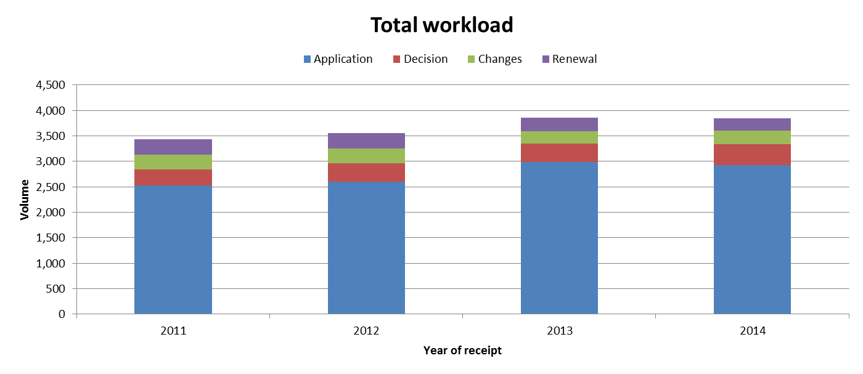

* In 2014, the total workload remained stable compared to 2013. In 2014, applications alone represented 76 per cent of the total workload.
* Between 2011 and 2013, the increase in workload was mainly due to the increase in the number of applications received.

**III. Cost of Processing**

Total cost of production

1. The total cost of production is the total Hague System expenditure, plus a proportion of expenditure on support and management activities. It has direct and indirect components. Direct costs reflect expenditure incurred by the IB in administering the Hague System.[17] Indirect costs reflect expenditure for supporting activities (such as buildings and information technology). Indirect costs are weighted to take into account only the share attributable to the Hague System.

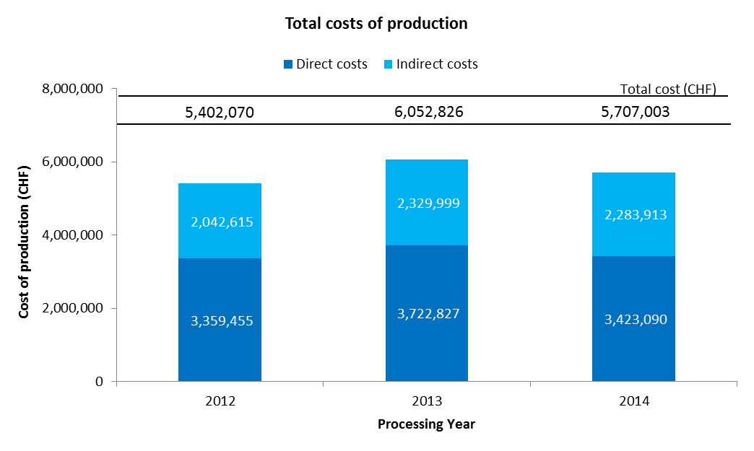

* The total expenditures related to the processing of the Hague System are estimated at 5.7 million Swiss francs in 2014. This represents a decrease of 5.7 per cent on 2013. Direct and indirect costs have decreased, by respectively 8.1 per cent and 2 per cent.
* In 2014, the direct costs accounted for 60 per cent of total expenditures.

Unit cost

1. The IB’s efficiency in processing transactions can be measured by the unit cost, defined as the average cost of producing one unit of output.
2. As the IB registers new applications and maintains existing registrations, it is relevant to have a unit of output which includes a set of transactions. Two unit cost indicators are presented below using two different units of output.
3. As part of the IB’s efforts to continuously refine the methodology for calculating unit costs, the methodology has been revised in the Program and Budget to reflect more accurately the cost of processing Hague workloads at the IB.
4. The revisions in question are the following:

* The methodology for calculating direct and indirect costs for the Hague have been aligned with the methodologies for calculating PCT and Madrid unit costs.
* A weighted System has been introduced to better approximate the actual work required to process the four categories of documents, taking into account that certain of these documents are more labor-intensive than others.[18]
* The first unit cost has been redefined to include designs contained in new international registrations and in renewals (the unit cost in the Program and Budget 2014/15 included only designs contained in new international registrations). The rationale for adding designs contained in renewals as a component of this unit cost is a sharper focus on the core Hague outputs, namely the international registration and its renewal.
* The second unit cost is based on the number of documents processed and recorded in the register rather than the number of recordings due to the different levels of efforts required to process the various documents.

1. For ease of comparison, the graphs below depict the evolution of the two unit costs from 2008 to 2014 using the old methodology and from 2012 to 2014 using the new methodology, including a breakdown of the contribution of direct and indirect costs.

*Unit cost per new/renewed design*

1. New designs consist of designs in international applications that are registered within a given year, and renewed designs consist of existing designs in international registrations that are renewed within a given year. Combined, designs contained in these two types of transactions reflect the core business of the IB.
2. As processing designs contained in these two types of documents do not require equal resources, they are each weighted differently.[19] The unit cost is calculated by dividing the total cost of production by the number of new/renewed designs.

|  |  |
| --- | --- |
| Old method | New method |
|  |  |

* The average cost of processing a new/renewed design was of 366 Swiss francs in 2014, down 12.8 per cent from 2013. This decrease was mainly due to a decrease of 5.7 per cent of the cost of production combined with an increase of 8.2 per cent of the number of new/renewed designs.

*Unit cost per document recorded in the register*

1. The documents recorded in the register correspond to the total workload (see “Total workload” above).

|  |  |
| --- | --- |
| Old method | New method |
|  |  |

* The average cost of recording a document in the register decreased to 1,483 Swiss francs in 2014. This is due to the decrease of 5.7 per cent of the cost of production.

**III. Timeliness to process international applications**

1. This indicator reflects the time required by the IB to process regular applications. The timeliness is calculated between the time elapsed between the date of receipt of an application and the date it was registered.

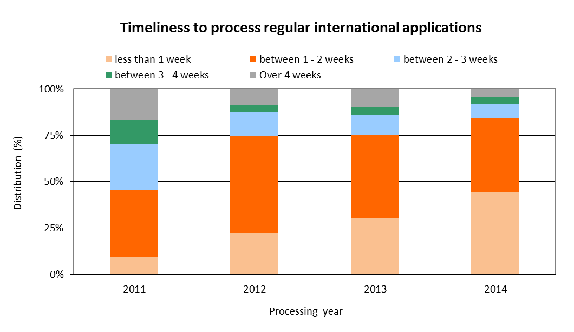

* The share of applications processed within less than one week constantly increased since 2011, to 45 per cent of applications in 2014.
* In 2014, 85 per cent of applications were processed within 2 weeks from the date of receipt at the IB.

## PROGRAM 7 ARBITRATION, MEDIATION AND DOMAIN NAMES

**Program Manager Mr. J. Sandage**

OVERVIEW OF PROGRESS IN 2014

1. The WIPO Arbitration and Mediation Center (WIPO Center) is recognized as a global resource for timely and cost effective alternatives to court litigation of IP disputes, acting as a provider of legal and organizational expertise and as an administrator of cases. This also includes the provision of services for Internet domain name disputes.
2. Building on the findings of the WIPO Center’s 2013 International Survey on Dispute Resolution in International Technology Transactions, the WIPO Center in 2014 worked to optimize the potential of its procedures to meet the needs of IP right holders and users. The WIPO Center also held tailored and regular arbitration and mediation workshops.
3. The WIPO Center actively managed WIPO cases in different IP areas using up-to-date case administration infrastructure, in particular the WIPO Electronic Case Facility (ECAF). Following international consultations, the WIPO Center developed and launched revised WIPO Arbitration and Mediation Rules[20]. Effective June 1, 2014, these Rules incorporate recent developments in alternative dispute resolution (ADR), enhancing the basis for proceedings that are time and cost efficient.
4. National courts and competition authorities in some jurisdictions have been encouraging parties involved in standards-related disputes involving telecom patents in multiple jurisdictions to resolve such disputes through mediation and arbitration. As a result, 2014 saw an increase in the number of party queries regarding the use of WIPO’s tailored agreements to refer a dispute concerning fair, reasonable and non-discriminatory (FRAND) licensing terms to WIPO Mediation and Arbitration.
5. In 2014, the WIPO Center concluded Memoranda of Understanding (MoUs) with the Spanish Franchisors Association (AEF), the National Copyright Directorate of Colombia (DNDA), the Directorate General of Intellectual Property Rights of Indonesia (DGIPR), the Mexican Institute of Industrial Property (IMPI), and the Intellectual Property Office of the Philippines (IPOPHL), adding to existing Member State collaborations. These collaborations concern the development of optional ADR frameworks that provide cost-effective and flexible options for parties to resolve their disputes before such Offices in relation to pending applications or granted rights.
6. The WIPO Center continued to strive to provide leadership in the development of ADR solutions in relation to the unauthorized use of IP on the Internet. WIPO continued to engage in IP-related policy activity in relation to the introduction, in 2013, by the Internet Corporation for Assigned Names and Numbers (ICANN) of up to 1,400 new generic Top-Level Domains (gTLDs). In 2014, the WIPO Center implemented the ICANN [Post-Delegation Dispute Resolution Procedure](http://www.wipo.int/amc/en/domains/tmpddrp/), a trademark-based mechanism aiming to encourage responsible registry operator conduct once a domain has become operational.
7. The year 2014 marked the 15th anniversary of the WIPO-developed Uniform Domain Name Dispute Resolution Policy (UDRP). Since the WIPO Center administered the first UDRP case in 1999, total WIPO case filings in 2014 passed the 30,000 mark (27,189 gTLD and 3,134 ccTLD cases), encompassing almost 57,000 domain names. In 2014, cybersquatting case filings with WIPO increased by 2 per cent from the 2013 level, with 2,634 cases concerning 5,591 domain names lodged by trademark owners alleging abuse of their mark. This included the first UDRP cases in relation to registrations in new gTLDs.
8. The WIPO Center liaised with the administrators of country code Top-Level Domains (ccTLDs) in different regions in relation to dispute resolution policies. In 2014, the WIPO Center became a provider for the .VG (Virgin Islands (British)) and .GQ (Equatorial Guinea) domains, bringing the total of ccTLDs, for which WIPO provides such services, to 72.
9. The design, planning and implementation of WIPO Center activities were informed and guided by the relevant DA Recommendations, in particular Recommendations 1, 6 and 10. Notably, this concerned the WIPO Center’s organization of tailor‑made arbitration and mediation programs for IP officials and practitioners, assistance to IP Offices in establishing optional ADR frameworks for disputes pending before them, and assistance to ccTLD authorities in the establishment of best registry practices and dispute resolution mechanisms, as relevant to developing countries and countries with economies in transition.

PERFORMANCE DATA

|  |  |  |  |  |
| --- | --- | --- | --- | --- |
| **Expected Result:** II.8 International and domestic intellectual property disputes are increasingly prevented or resolved through WIPO mediation, arbitration and other alternative dispute resolution methods | | | | |
| **Performance Indicators** | **Baselines** | **Targets** | **Performance Data** | **TLS** |
| Increased consideration of the use of alternative dispute resolution services in intellectual property transactions, including through the use of WIPO procedures | *Updated Baseline end 2013:* 375 disputes and 95 bons offices (cumulative per end 2013)  4,000 incoming queries (2012/13)  3.5 million Web visits (2012/13)  408 participants at Center standard events (2012/13)  4,000 participants at Center external events (2012/13)  *Original Baseline P&B 2014/15:* 284 disputes and 79 bons offices (cumulative per end 2012)  4,000 incoming queries (2010/11)  Web visits 30 million (cumulative per end 2012)  276 participants at Center standard events (2010/11);  3,000 participants at Center external events (2010/11) | 40 additional disputes and bons offices  4,000 additional queries  3.5 million additional visits  250 participants at Center standard events  6,000 participants at Center external events | 18 additional disputes and 53 additional bons offices (2014)  3,725 additional incoming queries (2014)  1.553 million Web visits (2014)  138 participants at Center events (2014)  4,300 participants at events involving Center representation (2014) | **On track** |
| Alternative dispute resolution policies to the development and implementation of which policies the Center has contributed | *Updated Baseline end 2013:* 10 schemes adopted (AGICOA, EGEDA, ETSI, Film and Media, ICOM, INPI-BR, IPAG, IPOS(M), IPOS(ED), ITPGRFA) (cumulative per end 2013)  Original Baseline P&B 2014/15: 6 schemes adopted (AGICOA, EGEDA, Film and Media, ICOM, IPOS, ITPGRFA) (cumulative per end 2012) | 1 to 3 additional schemes | 5 additional schemes adopted (AEF, DGIPR, DNDA, IMPI, IPOPHL) | **On track** |
| **Expected Result:** II.9 Effective intellectual property protection in the gTLDs and the ccTLDs | | | | |
| **Performance Indicators** | **Baselines** | **Targets** | **Performance Data** | **TLS** |
| No. of gTLD UDRP cases administered | *Updated Baseline end 2013:* 24,901 gTLD cases administered by the Center(cumulative per end 2013)  *Original Baseline P&B 2014/15:* 22,644 gTLD cases administered by the Center(cumulative per end 2012) | 3,000 additional cases | 2,288 gTLD additional cases (2014)  (27,189 gTLD cases cumulative) | **On track** |
| **Performance Indicators** | **Baselines** | **Targets** | **Performance Data** | **TLS** |
| No. of ccTLD UDRP based cases administered | *Updated Baseline end 2013:* 2,788 ccTLD-only cases administered by the Center (cumulative per end 2013)  *Original Baseline P&B 2014/15:* 2,470 ccTLD-only cases administered by the Center (cumulative per end 2012 | 350 additional cases | 346 additional ccTLD-only cases (2014)  (3,134 cumulative) | **On track** |
| Dispute resolution policies in the Domain Name System to the development and implementation of which policies the Center has contributed | *Updated Baseline end 2013:* UDRP, Pre-Delegation Dispute Resolution Policy, Trademark Post-Delegation Dispute Resolution Procedure (cumulative per end 2013)  *Original Baseline P&B 2014/15:* UDRP, Pre-Delegation Dispute Resolution Policy (cumulative per end 2012) | Implementation in the Domain Name System of WIPO policy and process recommendations | Continued applicability of UDRP, ICANN Pre-Delegation Dispute Resolution Policy, ICANN Trademark Post-Delegation Dispute Resolution Procedure (cumulative per end 2014); no additional policies or recommendations to be implemented. | **On track** |
| No. of ccTLD administrators with WIPO assisted design or administration of intellectual property protection mechanisms in accordance with international standards | *Updated Baseline end 2013:* 70 ccTLD administrators (cumulative per end 2013)  *Original Baseline P&B 2014/15:* 67 ccTLD administrators (cumulative per end 2012) | Four new administrators | 2 new administrators (.GQ, .VG) (2014)  (72 cumulative) | **On track** |

RESOURCE UTILIZATION

Budget and Actual Expenditure (by result)

*(in thousands of Swiss francs)*



Budget and Actual Expenditure (personnel and non-personnel)

*(in thousands of Swiss francs)*



*NOTE: The 2014/15 Budget after Transfers reflects transfers as of March 31, 2015 to address needs during the 2014/15 biennium in line with Financial Regulation 5.5*.

A. Budget after Transfers 2014/15

1. The increase in resources under ER II.8 (International and domestic IP disputes) reflects a shift in the Center’s personnel resources to better manage the demand for WIPO’s ADR Services.

B. Budget utilization 2014

1. Budget utilization is within the expected range of 40-60 per cent for the first year of the biennium and is on track.

STRATEGIC GOAL III

**FACILITATING THE USE OF IP FOR DEVELOPMENT**

**Mid-term Performance Dashboard (2014)**

The dashboard below provides a summary of the progress towards the achievement of the Results in 2014 as measured by the indicators under the Programs contributing to this Strategic Goal.



| **Expected Results** | **Performance Indicators** | **Responsible Program(s)** | **TLS** |
| --- | --- | --- | --- |
| III.1 National innovation and IP strategies and plans consistent with national development objectives | No. of countries which are in the process of formulating/adopting national IP strategies and/or development plans | Program 9 | ⚫⚫⚫⚫⚫ |
|  | No. of countries which have adopted and are implementing national IP strategies and/or development plans | Program 9 | ⚫⚫⚫⚫⚫ |
|  | No. of Universities having developed IP policies | Program10 | ⚫ |
|  | No. of countries having developed national IP strategies/plans | Program 10 | ⚫ |
| No. of countries with national innovation policies initiated, in progress or adopted | Program 30 | ⚫ |
| III.2 Enhanced human resource capacities able to deal with the broad range of requirements for the effective use of IP for development in developing countries, LDCs and countries with economies in transition | No. of governments and CMOs signing an agreement with WIPO to develop a new transparency, accountability and governance quality assurance standard | Program 3 | ⚫ |
|  | % of creators satisfied with the training provided on using copyright data and information for the efficient management of their copyright | Program 3 | ⚫ |
|  | % of participants’ positive rating of the usefulness of copyright related capacity building meetings and workshops | Program 3 | ⚫ |
|  | No. of Member States that take initiatives to improve their use of the copyright system to exploit the economic potentials of their cultural works and products | Program 3 | ⚫ |
|  | % of participants in WIPO activities which report enhanced capacity to understand and use IP principles, systems and tools for the protection of TK and TCEs, and for management of the interface between IP and GRs | Program 4 | ⚫ |
|  | % of participants in WIPO events who express satisfaction with the content and organization of these events | Program 9 | ⚫⚫⚫⚫⚫ |
|  | % of participants in WIPO workshops who apply the skills learned in their work/enterprise | Program 9 | ⚫⚫⚫⚫⚫ |
|  | % of national/regional IP experts are used as resource persons in WIPO events | Program 9 | ⚫⚫⚫⚫⚫ |
|  | No. of countries in transition having established annual IP training programs and/or courses for IP professionals | Program 10 | ⚫ |
|  | % of trained IP professionals and IP Office officials using upgraded skills in their work | Program 10 | ⚫ |
| Program 30 | ⚫ |
|  | Revised Portfolio of training courses on IP for developing countries, LDCs and CETs / Relevance of content of training courses to capacity building requirements of developing countries, LDCs and CETs | Program 11 | ⚫ |
|  | Enhanced and multilingual access to e‑learning on various IP aspects for developing countries, LDC and CETs / Relevance of content of portfolio of e-learning courses to the capacity building requirements of developing countries, LDCs and CETs | Program 11 | ⚫ |
|  | Improved access to higher education on IP on the part of developing countries, LDCs and CETs / Number of universities in developing countries, LDCs and CETs, offering new teaching programs on IP | Program 11 | ⚫ |
|  | Progressive establishment of a network of IP experts in developing countries, LDCs and CETs | Program 11 | ⚫ |
|  | No. of new start-up academies projects initiated after the conclusion of the Pilot Phase | Program 11 | ⚫ |
|  | % of trained participants that report satisfaction with the usefulness and relevance of the training provided for their professional life | Program 17 | ⚫ |
|  | % of targeted audience who have demonstrated a basic knowledge of a balanced IP system further to WIPO activities | Program 17 | ⚫ |
|  | No. of countries participating in WIPO Awards Program | Program 17 | ⚫ |
|  | No. of hosting arrangements of developing country scientists | Program 18 | ⚫ |
|  | % of policy makers, government officials, IP practitioners and participants in targeted workshops with enhanced understanding of CMOs and how to effectively use IP for development | Program 20 | ⚫⚫⚫ |
| % of trained IP professionals using upgraded skills in their work | Program 30 | ⚫ |
| III.3 Mainstreaming of the DA recommendations in the work of WIPO | No. of DA recommendations that have been addressed by the CDIP through projects, activities and studies | Program 8 | ⚫ |
| Rate of satisfaction among Member States with the results of the projects, activities and studies | Program 8 | ⚫ |
|  | Implementation of the coordination mechanism as approved by Member States | Program 8 | ⚫ |
|  | No. of Programs in which DA recommendations are mainstreamed into the regular work of WIPO | Program 8 | ⚫ |
|  | No. of DA projects and the manner in which they have been mainstreamed into the regular work of WIPO (norm-setting, technical assistance and service delivery) | Program 8 | ⚫ |
|  | Effective system in place for the planning, monitoring and evaluation of the implementation of DA recommendations | Program 8 | ⚫ |
| % of DA projects which have been independently evaluated | Program 8 | ⚫ |
| III.4 Strengthened cooperation mechanisms and programs tailored to the needs of developing countries and LDCs | No. of new or strengthened cooperation mechanisms, programs or partnerships supported to promote/strengthen sub-regional or regional cooperation in IP | Program 9 | ⚫⚫⚫⚫⚫⚫ |
|  | No. of established partnerships where the party offering assistance originates from a developed country | Program 10 | ⚫⚫ |
| III.5 Enhanced understanding of the DA by Member States, IGOs, civil society and other stakeholders | No. of countries requesting technical assistance through DA projects and expressing interest in DA related activities | Program 8 | ⚫ |
|  | % of participants in WIPO meetings (Member States, IGOs, civil society and other stakeholders) satisfied with information received on the DA recommendations | Program 8 | ⚫ |
| III.6 Increased capacity of SMEs to successfully use IP to support innovation | % of participants in training programs targeting SME support institutions who express satisfaction with the content and organization of these events | Program 10 | ⚫ |
|  | % of trained SME support institutions who provide information, support and advisory/consulting services on IP asset management | Program 10 | ⚫ |
|  | No. of countries having established IP training programs for SMEs | Program 10 | ⚫ |
|  | No. of subscriptions to the SME Newsletter | Program 30 | ⚫ |
|  | No. of downloads of topical SME material and guidelines | Program 30 | ⚫ |
|  | No. of SME related case-studies accessed via the IpAdvantage and/or other relevant databases | Program 30 | ⚫ |
|  | % of participants in training programs targeting SME support institutions who express satisfaction with the content and organization of these events | Program 30 | ⚫ |
|  | % of trained SME support institutions who provide information, support and advisory/consulting services on IP asset management | Program 30 | ⚫ |
|  | No. of countries having established IP training programs for SMEs | Program 30 | ⚫ |

## PROGRAM 8 DEVELOPMENT AGENDA COORDINATION

**Program Manager Mr. M. Matus**

OVERVIEW OF PROGRESS IN 2014

1. In 2014, the Program continued to coordinate the WIPO Development Agenda implementation, notably through facilitating the work of the Committee on Development and Intellectual Property (CDIP) at the thirteenth and fourteenth sessions of the Committee held in 2014; the project-based implementation of the DA recommendations; an effective mainstreaming of the DA principles into the work of the Organization; and a number of activities to support Member States in deriving benefits from the implementation of the DA.
2. In 2014, the CDIP considered: (i) the annual Director General’s Report on Implementation of the Development Agenda; (ii) a Progress Report on the Implementation of Recommendations for Immediate Implementation and DA Projects; (iii) eight independent and one self-evaluation reports of DA projects; and (iv) a document on WIPO General Assembly Decision on CDIP related matters. In addition, the Committee approved second phases for two completed and evaluated projects, approved new activities Related to Using Copyright to Promote Access to Information and Creative content, and considered a project proposal by the Arab Republic of Egypt on IP and Tourism. The Committee discussed: (i) a document forwarded by the General Assembly on the Description of the Contribution of the Relevant WIPO Bodies on the Implementation of respective Development Agenda Recommendations and (ii) a Revised Report on the Measurement of the Millennium Development Goals (MDGs) in Other United Nations Agencies and Specialized Agencies, and on the Contribution of WIPO to the Implementation of the MDGs. The Committee also continued to discuss Patent-Related Flexibilities in the Multilateral Legal Framework and their Legislative Implementation at the National and Regional Levels and agreed on a Future Work Program on Flexibilities in the Intellectual Property System. It also continued its discussions on the External Review of WIPO Technical Assistance in the Area of Cooperation for Development together with the Management Response and the Joint Proposal by the Development Agenda and African Groups. Furthermore, the Committee approved the Terms of Reference (TORs) for the Independent Review of the Implementation of the DA Recommendations and the convening of the International Conference on Intellectual Property and Development. In addition, the Committee discussed: (i) seven studies undertaken in the context of the Project on IP and Socio-Economic Development; (ii) six studies undertaken under the Project on Intellectual Property and Technology Transfer: Common Challenges – Building Solutions; (iii) two studies undertaken under the Project in Open Collaborative Projects and IP-Based Models; (iv) four studies under the Project Intellectual Property and Informal Economy; and (v) one study undertaken under the project on Strengthening and Development of the Audiovisual Sector in Burkina Faso and Certain African Countries. The CDIP continued to benefit from an increasing participation of IGO’s and NGO’s. By the end of 2014, fifty nine observers participated in the work of the Committee.
3. The Program continued to ensure that DA related activities and projects were properly implemented, monitored, evaluated and reported upon. In this regard, efforts continued to ensure an effective implementation of the 19 Recommendations for immediate implementation. In addition, the Program continued to coordinate the monitoring, evaluation and reporting on the implementation of the projects approved by CDIP and is responsible for the coordination of the implementation of all 45 WIPO DA Recommendations.

PERFORMANCE DATA

|  |  |  |  |  |
| --- | --- | --- | --- | --- |
| **Expected Result:** III.3 Mainstreaming of the DA recommendations in the work of WIPO | | | | |
| **Performance Indicators** | **Baselines** | **Targets** | **Performance Data** | **TLS** |
| No. of DA recommendations that have been addressed by the CDIP through projects, activities and studies | *Updated Baseline end 2013:* 45 DA recommendations  *Original Baseline P&B 2014/15:* 42 recommendations addressed by the Committee in December 2011 | 45 recommendations to be addressed by the CDIP | 45 DA recommendations addressed as per the Progress Report (CDIP/14/2) | **On track** |
| Rate of satisfaction among Member States with the results of the projects, activities and studies | 80% | 80% | Survey conducted on a biennial basis | **N/A 2014** |
| Implementation of the coordination mechanism as approved by Member States | *Updated Baseline end 2013:*  Two Annual reports to the Assemblies on the description of the contribution of WIPO Bodies to the implementation of the respective Development Agenda Recommendations discussed by the CDIP (WO/GA/41/12 and WO/GA/43/10).[21]  *Original Baseline P&B 2014/15:* Coordination Mechanisms and Monitoring, Assessing and Reporting Modalities approved by the Committee in April 2010 | Coordination Mechanisms implemented in accordance with the decision of Member States | Coordination Mechanisms implemented in accordance with the decision of Member States as detailed in the Director General’s Report on the Implementation of the DA (CDIP/15/2) | **On track** |
| No. of Programs in which DA Recommendations are mainstreamed into the regular work of WIPO | *Updated Baseline end 2013:* 23 programs have DA related activities (fully or partly)  *Original Baseline P&B 2014/15:* tbd | 20 | 23 programs  contained in the PB  2014/15 reflect the  mainstreaming of DA  activities | **On track** |

|  |  |  |  |  |
| --- | --- | --- | --- | --- |
| **Performance Indicators** | **Baselines** | **Targets** | **Performance Data** | **TLS** |
| No. of DA projects, and the manner in which, they have been mainstreamed into the regular work of WIPO (norm-setting, technical assistance and service delivery) | *Updated Baseline end 2013:* 6 DA projects mainstreamed in WIPO regular work  *Original Baseline P&B 2014/15:* tbd | 12 | Four additional DA projects were mainstreamed in 2014. (10 cumulative)   * National Start up Academies in Program 11 (technical assistance and capacity building) * Specialized Databases Access and Support in Program 14 (technical assistance) * Developing Tools for Access to Patent Information in Program 14 (Access to knowledge) * IP and Product Branding in Program 9 (technical assistance and capacity building) | **On track** |
| **Performance Indicators** | **Baselines** | **Targets** | **Performance Data** | **TLS** |
| Effective system in place for the planning, monitoring and evaluation of the implementation of DA recommendations | *Updated Baseline end 2013:* Effective centralized system for planning monitoring and evaluation of the implementation of DA recommendation  *Original Baseline P&B 2014/15:* tbd | All Programs have in place an effective planning, monitoring and evaluation system on the implementation of DA recommendations | All relevant Programs have in place an effective planning, monitoring and evaluation system on the implementation of DA recommendations | **On track** |
| % of DA projects which have been  independently evaluated | *Updated Baseline end 2013:* 100%; 14 evaluation reports discussed by the CDIP. (evaluated during the biennium 2012/13)  *Original Baseline P&B 2014/15:* 100% | 100% | 100%: Eight completed projects were independently evaluated and discussed by the CDIP in 2014. | **On track** |
| **Expected Result:** III.5 Enhanced understanding of the DA by Member States, IGOs, civil society and other stakeholders | | | | |
| **Performance Indicators** | **Baselines** | **Targets** | **Performance Data** | **TLS** |
| No. of countries requesting technical assistance through DA projects and expressing interest in DA related activities | *Updated Baseline end 2013:* Projects and DA related activities in 50 countries  *Original Baseline P&B 2014/15:* Projects and DA related activities in 43 countries (April 2013) | Projects and DA related activities in 50 countries | 53 developing countries participated in the context of DA projects, of which 11 participants were financed. | **On track** |
| % of participants in WIPO meetings (Member States, IGOs, civil society and other stakeholders) satisfied with information received on the DA recommendations | n/a | 80% | Survey conducted on a biennial basis | **N/A 2014** |

RESOURCE UTILIZATION

Budget and Actual Expenditure (by result)

*(in thousands of Swiss francs)*



Budget and Actual Expenditure (personnel and non-personnel)

*(in thousands of Swiss francs)*



*NOTE: The 2014/15 Budget after Transfers reflects transfers as of March 31, 2015 to address needs during the 2014/15 biennium in line with Financial Regulation 5.5*.

A. Budget after Transfers 2014/15

1. The 2014/15 Budget after Transfers is primarily due to the redeployment of personnel resources (one post) out of the Program.

B. Budget utilization 2014

1. Budget utilization is within the expected range of 40-60 per cent for the first year of the biennium and is on track.

## PROGRAM 9 AFRICA, ARAB, ASIA AND THE PACIFIC, LATIN AMERICA AND THE CARIBBEAN COUNTRIES, LEAST DEVELOPED COUNTRIES

**Program Manager Mr. M. Matus**

OVERVIEW OF PROGRESS IN 2014

1. In line with WIPO’s Strategic Goal III, facilitating the use of IP for social, cultural and economic development and empowering developing countries and LDCs to harness IP for enhancing national innovation potential and capacities continued to drive the work of the Program in 2014. Serving as the primary interface between the beneficiary Member States and the various Programs of WIPO, Program 9 continued to ensure country-specific, needs-based, coherent and well-coordinated delivery of technical assistance throughout the year. Overall, the design, planning and implementation of technical cooperation activities were informed and guided by the relevant DA Recommendations, in particular the Recommendations under Cluster A on WIPO’s technical assistance and capacity building. Also in line with the DA Recommendations, delivery of development-oriented activities to developing countries and LDCs continued to be mainstreamed across the various specialized Programs of the Organization in 2014 to further strengthen WIPO’s technical cooperation.
2. In 2014, existing partnerships with sub-regional/regional and multilateral institutions were further strengthened, and exchanges of experiences and expertise among countries in the different regions and through horizontal cooperation, with the aim of enhancing synergies for greater development results, continued to be fostered. In May 2014, a new MoU was signed with *l’Organisation Internationale de la Francophonie* (OIF).
3. WIPO continued to assist developing countries and LDCs in the design, development and implementation of National IP Strategies that are both consistent with their overall development plans and able to foster innovation and creativity. The application of the standardized, yet flexible, methodology and set of practical tools for the formulation of national IP strategies and plans, developed as part of the DA project on Improvement of National, Sub-regional and Regional IP Institutional and User Capacity in 2012, continued to guide the process. As a result, nine countries (six in Africa, two in Asia and the Pacific and one in Latin America and the Caribbean), initiated the process of formulating national IP strategies/development plans, and 18 countries (six in Africa, three in the Arab region, four in Asia and the Pacific, and five in Latin America and the Caribbean) were still in the process of formulation and/or adoption at the end of 2014. At the end of 2014, national IP strategies/development plans had been adopted and/or were under implementation in a total of 37 countries (21 in Africa, two in the Arab region, eight in Asia and the Pacific and six in Latin America and the Caribbean), of which 17 in LDCs.
4. In October 2014, one focal point from each of the Association of Southeast Asian Nations (ASEAN) countries participated in a brainstorming workshop for the development of the ASEAN IPR Strategic Plan for 2016-2025, in line with the ASEAN Economic Community (AEC) 2016- 2025 strategy. This collaboration represented the first time that WIPO had been so extensively involved in assisting a regional group in the formulation of a comprehensive regional IP framework.
5. The Program continued to coordinate and facilitate technical assistance to developing countries and LDCs in formulating and modernizing legislation in the field of IP, taking into account specific national requirements and international flexibilities. To enable Member States to make more informed choices as regards WIPO’s priority areas, the *Manual on Delivery of WIPO Technical Assistance* (finalized in 2013) was published in all six official UN languages in 2014 and made available online[22] (for more details see Programs 1, 2, 3 and 4).
6. Enhancing human resource capabilities to deal with the broad range of requirements for the effective use of IP for development and fostering innovation and creativity remained a priority in 2014. Focused capacity building and skills development programs were delivered to specific target groups such as government officials, policy-makers, IP professionals, enforcement officials, researchers and academics, entrepreneurs and industrialists, as well as SMEs, at the national, sub-regional and regional levels.
7. In 2014, WIPO continued to strengthen its assistance to IP Offices in developing countries and LDCs to enable them to provide cost-effective and high-quality IP modernization and technical infrastructure services to their stakeholders, creating a more favorable environment for the effective use of IP information, particularly by the institutions in charge of the administration of IP rights, the national innovation system and the productive sector. By the end of 2014, some 62 Offices were using WIPO IP Office Systems in the different regions: 19 in Africa, 14 in the Arab region, 13 in Asia and the Pacific and 16 in Latin America and the Caribbean (for more details see Program 15)
8. Facilitating access to global technology information databases also remained a high priority. In 2014, increased emphasis was placed on strengthening existing Technology Innovation Support Centers (TISCs) with a view to long-term sustainability. Out of the 39 established TISCs, some 19 were considered sustainable in 2014: nine in Africa (of which six in LDCs); two in the Arab region; three in Asia and the Pacific (of which one in an LDC); and five in Latin America and the Caribbean (for more details see Program 14).
9. In 2014, the Program facilitated and internally coordinated the accession of several countries and regional groups to treaties and conventions administrated by WIPO: two in Africa (OAPI and Zimbabwe) and two in the Arab region (Kuwait and the United Arab Emirates).
10. With a view to instilling a cohesive, development-oriented and innovation enabling architecture in LDCs, greater focus was given in 2014 to the implementation of the WIPO Deliverables, a set of priority thematic areas for cooperation with LDCs as identified by LDC ministers on the occasion of the Fourth United Nations Conference on the Least Developed Countries (UN LDC IV). An inter-regional cooperation partnership program was implemented for LDCs with the International Telecommunication Union (ITU), the United Nations Capital Development Fund (UNCDF), and the United Nations Industrial Development organization (UNIDO) on July 29, 2014 at the Ministerial Conference on New Partnerships for Productive Capacity Building in LDCs in Cotonou, Benin on the theme “Innovation, Creativity, Technology, Broadband Connectivity and Financing as Vectors for Sustainable Development for LDCs”.
11. Following the successful completion of Phase I of the DA Project on Capacity Building in the Use of Appropriate Technology-Specific Technical and Scientific Information as a Solution for Identified Development Challenges, Phase II (CDIP/13/9) was approved at the thirteenth session of this CDIP in May, 2014. Important progress was made during the remainder of the year with regard to establishing MoUs clearly identifying the responsibilities of the partners, i.e., WIPO and the beneficiary country (an LDC), in the overall implementation process of the project. Consultations with the Ministries of Foreign Affairs, Justice, and Science and Technology, Permanent Missions in Geneva, and the IP focal points were held with the four beneficiary countries. The MoUs are expected to be signed in 2015.
12. The Project on Enhancing South-South Cooperation on IP and Development among Developing Countries and LDCs was completed and evaluated in 2014. The Committee at its thirteenth session agreed to extend the duration of the Project for one year to allow for the completion of the outstanding activities within the remaining project budget. In May 2014, the South-South webpage[23], which was completed at the end of 2013, was officially launched. Amongst other useful information and tools, the webpage features customized South-South web platforms- South-South Technical Assistance (South-South IP-TAD) and Roster of Consultants (South-South IP-ROC) to highlight relevant information on technical assistance activities where both the beneficiary country(ies) and the host country/provider were a developing country, LDC, or a country in transition and experts and resource persons in developing countries, LDCs and countries in transition, respectively.
13. The Program also continued to capitalize on the experience of protecting and branding origin-based products in selected developing countries, stemming from the implementation of the DA Project on IP and Product Branding for Business Development in Developing and Least Developed Countries, completed in 2013. In this context, the focus in 2014 was on conducting specialized training courses in order to enhance stakeholders’ capacities to develop the full brand and market potential of selected origin-linked products. To complement WIPO’s work in this area the Program collaborated with international and regional partners, notably in the Caribbean region, to address the full range of stakeholder training needs.
14. Specialized databases continued to be used to support the delivery of technical assistance, in particular the databases on IP Technical Assistance (IP-TAD) and the Roster of Consultants (IP-ROC), including the interfaces to store information on South-South cooperation, and the IP Development Matchmaking Database (IP-DMD). The year 2014 also saw the deployment of the specialized National IP Strategy Database (NIPS-D)[24], which was developed in 2013 to capture relevant data for the baseline assessment phase of national IP strategies development, as necessitated by the increasing number of countries using the WIPO methodology to develop IP strategies. In an effort to maximize the potential of these databases, their usage was closely monitored in 2014, and user-feedback collected to glean insights into further enhancing the systems with a view to making them more user friendly, as well as to identifying more strategic approaches for promoting their uses in different countries. With respect to IP-DMD, a targeted outreach plan to bolster uploads and catalyze matches in the database was also under development in 2014.

PERFORMANCE DATA

|  |  |  |  |  |
| --- | --- | --- | --- | --- |
| **Expected Result:** I.2 Tailored and balanced IP legislative, regulatory and policy frameworks | | | | |
| **Performance Indicators** | **Baselines** | **Targets** | **Performance Data** | **TLS** |
| No. and % of Member States which were satisfied with the quality of legal advice related to patents, utility models, trade secrets and integrated circuits | *Updated Baseline end 2013:* 9 Member States (90%), based on survey conducted by IOD in 2013  *Original Baseline  P&B 2014/15:* Surveys 2012 | 90% | Five respondents reported on average a 90% satisfaction rate (Africa-2; Arab-1; Asia and the Pacific-1; Latin America and the Caribbean-1). | **On track** |
| No. and % of Member States/regional organizations providing positive feedback on the legislative advice offered in the area of trademarks, industrial designs and geographical indications | *Updated Baseline end 2013:* Positive feedback received from nine out of 13 countries. Four countries did not reply.  *Original Baseline  P&B 2014/15:* Three Member States/regional organizations having provided positive feedback on legislative advice received in 2012 | Positive feedback received from 10 Member States/regional organizations (regional breakdown) | Advice was provided to 20 Member States/Regional Organizations (Africa 7; Arab 1; Asia and the Pacific 11; Latin America and the Caribbean 1)  Feedback was received from seven respondents, all of whom (100%) reported satisfaction with the advice offered. | **On track** |
| No. and % of countries that have provided positive feedback about WIPO´s legislative advice | No feedback information has yet been collected | 15 countries (regional breakdown) | 14 countries received legislative advice in 2014. (Africa 6; Asia and the Pacific 2; Latin America and the Caribbean 4; Arab 2). Survey to be conducted in 2015. | **N/A 2014** |

|  |  |  |  |  |
| --- | --- | --- | --- | --- |
| **Expected Result:** III.1 National innovation and IP strategies and plans consistent with national development objectives | | | | |
| **Performance Indicators** | **Baselines** | **Targets** | **Performance Data** | **TLS** |
| No. of countries which are in the process of formulating/adopting national IP strategies and/or development plans | *Updated Baseline end 2013:*  Africa: 18 cumulative (Botswana, Burundi, Cameroon, Central African Republic, Chad, the Congo, Equatorial Guinea, Ethiopia[25], the Gambia, Kenya, Lesotho, Malawi, Mali, Mauritius, Seychelles, Sierra Leone, Togo, United Republic of Tanzania)  Arab: 6 cumulative[26] (Algeria[27], Oman, Qatar[28], Sudan, United Arab Emirates, Yemen)  Asia and the Pacific: 12 cumulative (Bangladesh, Bhutan, Cambodia, Fiji, Mongolia, Papua New Guinea, Samoa, Solomon Islands, Sri Lanka, Tonga, Vanuatu, Viet Nam)  Latin America and the Caribbean: 11 cumulative (Barbados, Costa Rica, Dominican Republic, Ecuador, El Salvador, Guatemala, Honduras, Nicaragua, Panama, Saint Kitts & Nevis, Trinidad & Tobago)  19 LDCs included in the above regional breakdown  *Original Baseline*  *P&B 2014/15:*  Africa (12 cumulative)  Arab (4)  Asia and the Pacific (8)  Latin America and the Caribbean (9)  5 LDCs included in the above regional breakdown | Africa (18 cumulative  Arab (7 cumulative)  Asia and the Pacific (13 cumulative)  Latin America and the Caribbean (13 cumulative)  10 LDCs included in the above regional breakdown | Africa (6 additional countries): Benin, the Democratic Republic of the Congo[29], Madagascar, Niger, Swaziland, Uganda (24 cumulative)  Arab (no additional countries);   * United Arab Emirates (no additional movement); * Yemen (process delayed due to the political situation)   Asia and the Pacific (2 additional countries): Brunei Darussalam and Cook Islands  (14 cumulative)  Latin America and the Caribbean (1 additional country): Peru  (12 cumulative)  24 LDCs included in the above regional breakdown | **On track**  **On track**  **On track**  **On track**  **On track** |

|  |  |  |  |  |  |
| --- | --- | --- | --- | --- | --- |
| **Performance Indicators** | **Baselines** | **Targets** | **Performance Data** | | **TLS** |
| No. of countries which have adopted and are implementing national IP strategies and/or development plans | *Updated Baseline end 2013:*  Africa (9 cumulative): Comoros, Ghana, Kenya, Liberia, Mauritius, Mozambique, Senegal, Seychelles, Zambia  Arab countries (2 cumulative): (Oman, Sudan);  Asia and the Pacific (4 cumulative); Bangladesh, Fiji, Papua New Guinea, Samoa)  Latin America and the Caribbean (3 cumulative): Costa Rica, Dominican Republic, Honduras  7 LDCs included in the above regional breakdown  *Original Baseline*  *P&B 2014/15:*  Africa (4)  Arab (3)  Asia and the Pacific (3)  Latin America and the Caribbean (4)  5 LDCs included in the above regional breakdown | Africa (6 cumulative)  Arab (6) cumulative  Asian and Pacific (7) cumulative  Latin America and the Caribbean (12)  11 LDCs included in the above regional breakdown | Africa (12 additional countries): Botswana, Burundi, Cameroon, Chad, Cote d’Ivoire[30], Lesotho, Malawi, Rwanda[31], Sao Tome and Principe, Togo, United Republic of Tanzania, Zimbabwe  (21 cumulative)  Arab (no additional countries)  Asia and the Pacific (4 additional countries): Cambodia, Sri Lanka, Tonga, Vanuatu  (8 cumulative)  Latin America and the Caribbean (3 additional countries): Barbados, El Salvador, Saint Kitts and Nevis  (6 cumulative):  17 LDCs included in the above cumulative regional breakdown | | **On track**  **Not  on track**  **On track**    **On track**  **On track** |
| **Expected Result:** III.2 Enhanced human resource capacities able to deal with the broad range of requirements for the effective use of IP for development in developing countries, LDCs and countries with economies in transition | | | | | |
| **Performance Indicators** | **Baselines** | **Targets** | | **Performance Data** | **TLS** |
| % of participants in WIPO events who express satisfaction with the content and organization of these events | *Updated Baseline end 2013:*  Asia and the Pacific (65%); LDCs (60%)  *Original Baseline P&B 2014/15:* No data available | Africa (70%)  Arab (80%)  Asia and the Pacific (65%)  Latin America and the Caribbean (80%)  LDCs (80%) | | Africa (70%)  Arab (Not available; system to be implemented in 2015)  Asia and the Pacific (92%)  Latin America and the Caribbean (Not available; system to be implemented in 2015)  LDCs (90%) | **On track**  **N/A 2014**  **On track**  **N/A 2014**  **On track** |

|  |  |  |  |  |
| --- | --- | --- | --- | --- |
| **Performance Indicators** | **Baselines** | **Targets** | **Performance Data** | **TLS** |
| % of participants in WIPO workshops who apply the skills and knowledge learned in their work/enterprise | *Updated Baseline end 2013:* Africa: Information not available  Arab: Information not available  Asia and the Pacific: 65%;  Latin American and the Caribbean: Information not available;  LDCs: Information not available  *Original Baseline P&B 2014/15:*  Africa: Information not available;  Arab: Information not available;  Asia and the Pacific (65%);  Latin American and the Caribbean: Information not available;  LDCs: Information not available | Africa (70%)  Arab (70%)  Asia and the Pacific (65%)  Latin America and the Caribbean (30%)  LDCs (80%) | Africa (70 %)  Arab (Not available; system to be implemented in 2015)  Asia and the Pacific (89%)  Latin America and the Caribbean (Not available; system to be implemented in 2015)  LDCs (95%) | **On track**  **N/A 2014**  **On track**  **N/A 2014**  **On track** |
| % of national/regional IP experts used as resource persons in WIPO events | *Updated Baseline end 2013:*  Africa: (70%)  Arab (50%)  Asia and the Pacific: Data not available  Latin America and the Caribbean (70%)  LDCs (60%)  *Original Baseline P&B 2014/15:*  Africa (65%)  Arab (70%)  Asia and the Pacific: Data not available  Latin America and the Caribbean (70%)  LDCs (70%) | Africa (75%)  Arab (80%)  Asia and the Pacific (55%)  Latin America and the Caribbean (80%)  LDCs (80%) | Africa (80%)  Arab (35%)  Asia and the Pacific (71%)  Latin America and the Caribbean (80%)  LDCs (95%) | **On track**  **Not  on track**  **On track**  **On track**  **On track** |
| **Expected Result:** III.4 Strengthened cooperation mechanisms and programs tailored to the needs of developing countries and LDCs | | | | |
| **Performance Indicators** | **Baselines** | **Targets** | **Performance Data** | **TLS** |
| No. of new or strengthened cooperation mechanisms, programs or partnerships supported to promote/strengthen sub-regional or regional cooperation in IP | Africa (3)  Arab (2)  Asia and the Pacific (4)  Latin America and the Caribbean (3)  2 LDCs included in the above regional breakdown  Appropriate Technology Projects in 3 LDCs | Africa (2)  Arab (1)  Asia and the Pacific (4) | Africa: MoU signed with *l’Organisation Internationale de la Francophonie* (OIF) in May 2014.  Arab (1): Awareness raising cartoon movie program on building respect for IP in cooperation with the League of Arab States (LAS)  Asia and the Pacific (2): Association of Southeast Asian Nations (ASEAN); South Asia Association for Regional Cooperation (SAARC) | **On track**  **On track**  **On track** |
|  |  | Latin America and the Caribbean (7)  4 LDCs included in the above regional breakdown  Additional appropriate technology in at least 4 LDCs | Latin America and the Caribbean (6 ongoing projects): (i) Patent & Trademark harmonization projects in Central America jointly with the European Patent Office (EPO), the Spanish Patent and Trademark Office (OEPM), and with the collaboration of the Mexican Institute of Industrial Property (IMPI); (ii) LATIPAT jointly with the EPO and OEPM; (iii) Project on Geographical Indications, Origin Linked Products (OLPs) and Branding in partnership with the Inter-American Development Bank (IDB), Caribbean Export Development Agency (CEDA) and Technical Centre for Agricultural and Rural Corporation (CTA); (iv) Regional Patent Office in Caribbean with Caribbean Patent Administration (CPAS); (v) Ibero-American Program under the Funds-in-Trust; (vi) Continued collaboration on the Regional Entrepreneurial Asset Commercialization Hub (REACH) with IDB and the Young Americas Business Trust (YABT)  3 of the organizations in the above regional breakdown include LDCs  As part of Phase II of the DA Project on Capacity building in the Use of Appropriate Technology Specific Technical and Scientific Information as a Solution for Identified Development Challenges, important progress was made on the establishment of MoUs with four beneficiary countries. The MoUs will be signed in 2015.  An inter-regional cooperation partnership program was implemented for LDCs with ITU, UNCDF, and UNIDO on July 29, 2014 at the Ministerial Conference on New Partnerships for Productive Capacity Building in LDCs in Cotonou, Benin on the theme “Innovation, Creativity, Technology, Broadband Connectivity and Financing as Vectors for Sustainable Development for LDCs”. | **On track**  **On track**  **On track** |

|  |  |  |  |  |  |
| --- | --- | --- | --- | --- | --- |
| **Expected Result:** IV.2 Enhanced access to, and use of, IP information by IP institutions and the public to promote innovation and creativity | | | | | |
| **Performance Indicators** | **Baselines** | | **Targets** | **Performance Data** | **TLS** |
| No. of sustainable national TISC networks | *Updated Baseline end 2013:* 14 sustainable (out of 36 established) TISC networks  *Original Baseline P&B 2014/15:*  *14 national TISC networks:*  Africa (6)  Arab (2)  Asia and the Pacific (2)  Latin America and the Caribbean (4)  6 LDCs included in the above regional breakdown | | 23 national TISC networks (cumulative):  Africa (10 of which 8 LDCs)  Arab (3)  Asia and the Pacific (4 of which 2 LDCs)  Latin America and the Caribbean (6) | 19 sustainable (out of 39 established) TISC networks   * Africa (9 of which 6 LDCs) * Arab region (2) * Asia and the Pacific (3 of which 1 LDC) * Latin America and the Caribbean (5) * 7 LDCs (cumulative) | **On track**  **On track**  **On track**  **On track**  **On track** |
| Average number of users serviced by TISCs per quarter and country | *Updated Baseline end 2013:* 532 (min.) to 1370 (max.) average no. of users serviced by TISCs per day during 2013.  *Original Baseline P&B 2014/15:*  200 (min) – 630 (max) | | 300 (min) – 750 (max) | 513 (min) - 1521 (max) average no. of users serviced by TISCs per day during 2014. | **On track** |
| No. of countries using IP Technical Assistance Database (IP-TAD), IP Roster of consultants (IP_ROC) | *Updated Baseline end 2013:*  IP-TAD: 43 countries  IP-ROC: 8 countries (in 2013)  *Original Baseline P&B 2014/15:* 60 (as of 01.03.2013) | | 70 | IP-TAD: 37 countries  IP-ROC: 9 countries | **Not  on track** |
| **Expected Result:** IV.4 Enhanced technical and knowledge infrastructure for IP Offices and other IP institutions leading to better services (cheaper, faster, higher quality) to their stakeholders | | | | | |
| **Performance Indicators** | **Baselines** | **Targets** | | **Performance Data** | **TLS** |
| Average Service Level of IP Offices assisted (ranging from 1 to 5) | *Updated Baseline end 2013:* 2.8  *Original Baseline P&B 2014/15:* tbd | *Defined Target:* 3  *Original Target P&B 2014/15:* tbd | | Overall average: 2.9   * Africa: 3 * Arab: 2.7 * Asia and the Pacific: 2.7 * Latin America and the Caribbean: 3.1 | **On track** |

RESOURCE UTILIZATION

Budget and Actual Expenditure (by result)

*(in thousands of Swiss francs)*



Budget and Actual Expenditure (personnel and non-personnel)

*(in thousands of Swiss francs)*



*NOTE: The 2014/15 Budget after Transfers reflects transfers as of March 31, 2015 to address needs during the 2014/15 biennium in line with Financial Regulation 5.5.*

A. Budget after Transfers 2014/15

1. The shift in resources between the Expected Results reflects enhanced focus on the facilitation and coordination of: (i) WIPO’s legislative advice activities in the area of patents, trademarks, industrial designs and copyright (reflected under Expected Result I.2); (ii) WIPO activities on the access to and use of IP information through the increased number of sustainable national TISC networks (reflected under Expected Result IV.2) and (iii) efforts to assist IP Offices and other IP institutions to develop their technical and knowledge infrastructure (reflected under Expected Result IV.4).

B. Budget Utilization 2014/15

1. The lower than anticipated utilization rate of non-personnel resources was primarily due to the postponement or cancellation of certain planned events/activities at the request of certain Member States or in compliance with UN security guidelines.

## PROGRAM 10 COOPERATIONS WITH CERTAIN COUNTRIES IN EUROPE AND ASIA

**Program Manager Director General**

OVERVIEW OF PROGRESS IN 2014

1. Program 10 continued to develop, and in cooperation with all relevant Sectors, coordinate the implementation of country cooperation activities in countries in transition. To this end, efforts in 2014 were focused on a strategic multi-year planning approach to promoting the use of the IP system to stimulate innovation and creativity for economic, social and cultural development.
2. Promotion of the importance of and/or assistance in the development and implementation of long-term and comprehensive national IP strategies to meet the needs of Member States remained a priority in 2014. Three countries (Slovenia, Tajikistan and Turkey) adopted IP related national strategies and four countries (Bulgaria, Poland, Turkmenistan and Ukraine) initiated the development of a new strategy. Moreover, the Program conducted post-implementation evaluations in three countries (Belarus, the Republic of Moldova and Serbia) in 2014 in order to assess the outcomes of implementation of the IP strategies and to identify lessons learned.
3. In line with cooperation plans and national IP strategies and, following WIPO assistance, including promotional activities, five countries (Kazakhstan, Lithuania, Montenegro, Republic of Moldova, Tajikistan) amended their national IP legislation. Progress was slower than anticipated in certain countries, however, due to political and economic changes. In line with the Program’s risk mitigation plan, close cooperation with the relevant stakeholders was maintained throughout the year, and a flexible approach in the development and/or implementation of cooperation plans allowed for postponement of certain activities and close monitoring of the situation.
4. In order to support the development of IP policies in universities, relevant projects and activities were implemented in Estonia, Lithuania, Poland, Russian Federation, Slovakia and Uzbekistan. With WIPO assistance, one university in the Russian Federation and one university in Uzbekistan developed IP policies in 2014. In addition, on October 1, 2014, Poland adopted a Law on Higher Education, which made it obligatory for all higher educational institutions (120 public and 294 non-public) to have in place an up-to-date IP policy by March 31, 2015. At the end of 2014, 148 universities had already developed IP policies.
5. The Program continued to support countries in transition in building their national human resource capacities and enhancing awareness and the knowledge base for an effective use of IP. In 2014, more than 3,400 specialists and experts were trained in tailored IP programs, including on technology transfer, SMEs, enforcement, copyright, IP teaching and WIPO services. Participants in these events provided positive feedback with 80 percent of respondents reporting that the trainings met their objectives and resulted in the upgrading of their day-to-day work skills.
6. WIPO Summer schools were organized in Croatia and the Russian Federation.
7. With a view to mainstreaming gender perspectives into the work of the Program, the excellent cooperation established with the World Women Inventors and Entrepreneurs Association (WWIEA) continued in 2014 and resulted in the co-organization of the International Educational Program on Idea, Invention, Innovation and Intellectual Property – Seed Project 2014, an effective training program for women in Central Asia, in November. In addition, the Seventh International Conference on Innovation and Creativity of Women, which gathered around 150 participants from 20 countries, was successfully organized in Warsaw, Poland in March.
8. The Program continued to strengthen efforts to improve the coordination, promotion and delivery of WIPO services, with the objective to increase their use in transition and developed countries.
9. In 2014, some 1,320 professionals from 11 countries (Austria, Germany, Ireland, Italy, Japan, Luxembourg, Netherlands, Portugal, Sweden, United Kingdom and United States of America) attended 21 Roving Seminars on WIPO Services and Initiatives. The seminars were highly perceived with 88 per cent of respondents either agreeing or strongly agreeing that the seminars were relevant for their professional work. The format of the Roving Seminars evolved in 2014 to enable greater interaction with local stakeholders, with a view to creating synergies amongst a broader group.
10. Efforts were increased to strengthen institutional ties and promote partnerships with stakeholders in transition and developed countries, including regional Organizations, IP Offices, NGOs and trade associations representing users of WIPO services.  To this end, the Program welcomed numerous visits of stakeholders from the countries concerned and facilitated WIPO briefings on different issues of interest. A number of scoping missions were organized to better evaluate the needs and requests from the countries concerned and four new Memoranda of Understanding (MoUs) were agreed in 2014 with stakeholders from Denmark, Germany, Israel and Spain.
11. Program 10 continued to play a key role in the implementation of the WIPO DA in its cooperation with certain countries in Europe and Asia. This was particularly the case for DA Recommendations relating to WIPO’s technical assistance and capacity building activities, the Recommendations under Cluster A, which continued to shape the design and implementation of activities under Program 10.

PERFORMANCE DATA

|  |  |  |  |  |
| --- | --- | --- | --- | --- |
| **Expected Result:** I.2 Tailored and balanced IP legislative, regulatory and policy frameworks | | | | |
| **Performance Indicators** | **Baselines** | **Targets** | **Performance Data** | **TLS** |
| No. of countries with updated laws and/or regulations | *Updated Baseline end 2013:* 18 cumulative:Albania, Armenia, Belarus, Bosnia and Herzegovina, Poland, Romania, Slovenia and Tajikistan updated their national IP legislation in 2012/13.    Kazakhstan and the Russian Federation have initiated the amendment of their legislation.  *Original Baseline P&B 2014/15:* 18 by end of 2013 | 4 additional countries | 5 (Kazakhstan, Lithuania, Montenegro, Republic of Moldova, Tajikistan) | **On track** |
| **Expected Result:** II.1 Increased use of the PCT route for filing international patent applications | | | | |
| **Performance Indicators** | **Baselines** | **Targets** | **Performance Data** | **TLS** |
| No. of PCT applications originating from transition and developed countries | *Updated Baseline end 2013:*  166,517 (2013)  160,309 (2012)  *Original Baseline P&B 2014/15:* tbd | 2% increase | 170,317 (2014) +2.28%[32] | **On track** |
| **Expected Result:** II.4 Wider and better use of the Hague system, including by developing countries and LDCs | | | | |
| **Performance Indicators** | **Baselines** | **Targets** | **Performance Data** | **TLS** |
| No. of Hague System applications originating from transition and developed countries | *Updated Baseline end 2013:*  2,927 (2013)  2,553 (2012)  *Original Baseline P&B 2014/15:* tbd | 2% increase | 2,776 (2014) -5.16%[33] | **Not on track** |

|  |  |  |  |  |  |  |  |
| --- | --- | --- | --- | --- | --- | --- | --- |
| **Expected Result:** II.6 Wider and better use of the Madrid & Lisbon systems, including by developing countries and LDCs | | | | | | | |
| **Performance Indicators** | **Baselines** | | **Targets** | | **Performance Data** | | **TLS** |
| No. of Madrid & Lisbon System applications originating from transition and developed countries | *Updated Baseline end 2013:*  Madrid:  43,149 (2013)  40,640 (2012)  Lisbon:  749 out of 816 registrations in force  *Original Baseline P&B 2014/15:* tbd | | 2% increase | | Madrid:  43,748 (2014) +1.39%[34]  Lisbon: 818 out of 896 registrations in force (2014) +9.2% | | **On track** |
| **Expected Result:** II.8 International and domestic intellectual property disputes are increasingly prevented or resolved through WIPO mediation, arbitration and other alternative dispute resolution methods | | | | | | | |
| **Performance Indicators** | **Baselines** | | **Targets** | | **Performance Data** | | **TLS** |
| No. of users in transition and developed countries using the AMC services | *Updated Baseline end 2013:* 359 disputes and 51 bons offices involving parties from transition and developed countries (cumulative per end 2013)  *Original Baseline P&B 2014/15:*tbd | | 2% increase | | 18 additional disputes and 25 additional bons offices involving parties from transition and developed countries (2014) | | **On track** |
| **Expected Result:** III.1 National innovation and IP strategies and plans consistent with national development objectives | | | | | | | |
| **Performance Indicators** | **Baselines** | | **Targets** | | **Performance Data** | | **TLS** |
| No. of Universities having developed IP policies | tbd | | 30 additional Universities | | In 2014, 150 universities developed IP policies:   * Poland (148); * the Russian Federation (1); and * Uzbekistan (1)   On October 1, 2014, Poland adopted a Law on Higher Education, which made it obligatory for all higher education institutions (120 public and 294 non-public) to have in place an up-to-date IP policy by March 31, 2015.  Universities in Estonia, Lithuania and Slovakia were in the process of developing IP policies in 2014.  A survey will be conducted during the biennium to ascertain how many policies were developed by end of 2015. | | **On track** |
| No. of countries having developed national IP strategies/plans | 14 (cumulative per end 2013) | | 6 additional countries | | 3 additional countries (Slovenia, Tajikistan, Turkey) developed national IP strategies/plans (17 cumulative)  4 countries (Bulgaria, Poland, Turkmenistan, Ukraine) initiated the process. | | **On track** |
| **Expected Result:** III.2 Enhanced human resource capacities able to deal with the broad range of requirements for the effective use of IP for development in developing countries, LDCs and countries with economies in transition | | | | | | | |
| **Performance Indicators** | **Baselines** | | **Targets** | | **Performance Data** | | **TLS** |
| No. of countries in transition having established annual IP training programs and/or courses for IP professionals | tbd | | 10 | | 6 (Bulgaria, Croatia, Czech Republic, Kazakhstan, Poland, Turkey) | | **On track** |
| % of trained IP professionals and IP Office officials using upgraded skills in their work | *Updated Baseline end 2013:* 69% of trained IP office officials were using upgraded skills in their work  *Original Baseline P&B 2014/15:* 40% | | 50% | | 80% of trained IP professionals and IP Office officials were using upgraded skills in their work | | **On track** |
| **Expected Result:** III.4 Strengthened cooperation mechanisms and programs tailored to the needs of developing countries and LDCs | | | | | | | |
| **Performance Indicators** | **Baselines** | **Targets** | | **Performance Data** | | **TLS** | |
| No. of established partnerships where the party offering assistance originates from a developed country | tbd | 4 additional MoUs; 10 additional matches in the matchmaking database | | 4 new MoUs (Denmark, Germany, Israel, Spain)  In 2014, no matches in the matchmaking database were established due to the development during 2014 of a targeted outreach plan to bolster uploads and catalyze matches. | | **On track**  **Not  on track** | |
| **Expected Result:** III.6 Increased capacity of SMEs to successfully use IP to support innovation | | | | | | | |
| **Performance Indicators** | **Baselines** | **Targets** | | **Performance Data** | | **TLS** | |
| % of participants in training programs targeting SME support institutions who express satisfaction with the content and organization of these events | tbd | *Defined target:* 75%  *Original target P&B 2014/15:* tbd | | 85% | | **On track** | |
| % of trained SME support institutions who provide information, support and advisory/consulting services on IP asset management | tbd | *Defined target:* 90% (18 support institutions)  *Original target P&B 2014/15:* tbd | | 90% | | **On track** | |
| No. of countries having established IP training programs for SMEs | tbd | tbd | | 4 (Armenia, Belarus, Georgia, Kazakhstan) | | **On track** | |

|  |  |  |  |  |
| --- | --- | --- | --- | --- |
| **Expected Result:** IV.2 Enhanced access to, and use of, IP information by IP institutions and the public to promote innovation and creativity | | | | |
| **Performance Indicators** | **Baselines** | **Targets** | **Performance Data** | **TLS** |
| No. of established TTOs and/or IP information centers | *Updated Baseline end 2013:* Two Universities/Institutions in Georgia were directly assisted in developing their knowledge transfer ecosystem, policy and infrastructure in the CCEA region: Ivane Javakhishvili Tbilisi State University and Georgian Technology Transfer Center followed by the Plan of Action.  *Original Baseline P&B 2014/15:* tbd | 6 additional TTOs/IP information centers | 8 new TISCs established in the Russian Federation | **On track** |
| No. of sustainable national TISC networks | *Updated Baseline end 2013:* 1 sustainable (out of 3 established) TISC networks  *Original Baseline P&B 2014/15:* 1 national TISC network: (cumulative per end first quarter 2013:  Certain Countries in Europe and Asia (1) | 2 national TISC networks (cumulative):  Certain Countries in Europe and Asia (2) | Certain Countries in Europe and Asia (1) | **On track** |
| Average number of users serviced by TISCs per quarter and country | *Updated Baseline end 2013:* 532 (min.) to 1370 (max.) average no. of users serviced by TISCs per day during 2013.  *Original Baseline P&B 2014/15:* 200 (min) – 630 (max) | 300 (min) – 750 (max) | 513 (min) - 1521 (max) average no. of users serviced by TISCs per day during 2014 | **On track** |
| **Expected Result:** IV.4 Enhanced technical and knowledge infrastructure for IP Offices and other IP institutions leading to better services (cheaper, faster, higher quality) to their stakeholders | | | | |
| **Performance Indicators** | **Baselines** | **Targets** | **Performance Data** | **TLS** |
| Average Service Level of IP Offices assisted (ranging from 1 to 5) | *Updated Baseline end 2013:* 3  *Original Baseline P&B 2014/15:* tbd | *Defined Target:* 3  *Original Target P&B 2014/15:* tbd | Certain Countries in Europe and Asia: 3.2 | **On track** |

RESOURCE UTILIZATION

Budget and Actual Expenditure (by result)

*(in thousands of Swiss francs)*



Budget and Actual Expenditure (personnel and non-personnel)

*(in thousands of Swiss francs)*



*NOTE: The 2014/15 Budget after Transfers reflects transfers as of March 31, 2015 to address needs during the 2014/15 biennium in line with Financial Regulation 5.5.*

A. Budget after Transfers 2014/15

1. The adjustments across Results in the 2014/15 Budget after Transfers reflect the new and more accurate methodology for allocation of personnel resources resulting from enhancements made to the EPM planning system for the 2014 annual work planning exercise.

B. Budget utilization 2014

1. The slight under-utilization of non-personal resources was due primarily to: (i) the implementation of cost efficiency measures as regards staff missions and events and (ii) the postponement to 2015 of certain activities in the region.

## PROGRAM 11 THE WIPO ACADEMY

**Program Manager Mr. M. Matus**

OVERVIEW OF PROGRESS IN 2014

1. In 2014, the WIPO Academy initiated the implementation of a reform process and its repositioning as the core entity in WIPO for IP training and capacity building activities for government officials and other stakeholders. During the reform, the Academy endeavored to maintain, to the extent possible, the quantity, quality and frequency of the training programs regularly provided in order to meet the ongoing training obligations with partners; to respond to new and urgent training requests of Member States and other stakeholders; and to preserve the continuum of the training provided.
2. To this end, in 2014, the Academy continued to organize through a combination of a diversified range of training and teaching activities to meet the capacity building requirements of developing countries, LDCs and countries in transition: (i) face-to-face training activities for government officials from industrial property and copyright Offices and other public sector institutions that are directly or indirectly involved in the management of, and international negotiations, related to IP (Professional Development Program); (ii) a portfolio of 17 distance learning (DL) courses in 14 languages (Distance Learning Program); and (iii) a number of joint master programs on IP law and other activities for the promotion of higher education on IP (Academic Institutions Program), as well as specific activities for students and young IP professionals (Summer Schools Program). A major achievement in 2014 was the roll-out of the WIPO e-Learning Center (WeLC) platform, developed by the DL Program in 2011, to the other Academy Programs in order to facilitate the registration, selection and enrollment processes of candidates.
3. With regard to the Professional Development Program (PDP), in 2014, the Academy organized 20 training courses in partnership with the industrial property and/or copyright authorities of Algeria, Austria, Canada, Costa Rica, Finland, France, Germany, Israel, Mexico, Morocco, Norway, Paraguay, Peru, Spain, Switzerland, and the United Kingdom, as well as the WTO and the *Centre d’Études Internationales de la Propriété Intellectuelle* (CEIPI), in Strasbourg, France. A total of 216 participants from developing countries, LDCs and countries in transition benefited from these activities, which represents a 14 per cent decrease compared to 2013. The decrease was primarily due to the “WIPO-Sweden Advanced Training Course on Industrial Property in the Global Economy”, traditionally offered annually to 25 officials, not taking place in 2014. The course program continued to include the following main topics: patents, trademarks, copyright and related rights, collective management of copyright and related rights, management of IP offices, IP for policy makers, and was expanded to include two new courses on branding and transfer of technology and licensing. Moreover, as part of the reform process, the training model was placed under review for further development and improvement in 2014.

|  |
| --- |
| *Geographical Distribution of Participants in Professional Development Program, 2012-2014* |

1. The Distance Learning Program (DL) continued to attract participants from all over the world including special target groups of IP Office staff, TISCs and Start-Up Academies.  The development of a tailor- made course with the Croatian IP Office was successfully completed and launched in 2014.  In addition, two new customizations were initiated with the IP Offices of Cambodia and Viet Nam, increasing the number of languages of the general courses from 12 in 2013 to 14 (Arabic, Cambodian, Chinese, Croatian, French, German, Japanese, Korean, Portuguese, Russian, Spanish, Thai, Ukrainian, and Vietnamese) in 2014.  In 2014, some 34,935 persons (30,552 under its general courses and 4,383 under its advanced courses) from more than 192 countries benefited from the enhanced e-learning Centre (WeLC) platform. Two new DL pilot courses were launched in 2014: (i) *Intellectual Property, Traditional Knowledge and Traditional Cultural Expressions (DL-203)* and (ii) *Collective Management of Copyright and Related Rights (DL-501)*. Development of the DL course on *IP and Public Health* started in 2014, and will be launched as a pilot course in 2015.  A more systematic approach to the annual course review process was implemented in 2014, and the DL course content underwent an extensive review (Phase I), the results of which will be implemented in 2015 (Phase II).

*Geographical Distribution of Participants in all of Distance Learning Program, 2012-2014[35]*

1. The Academic Institutions Program (AIP) continued to offer joint IP Law Master’s Degree courses for the benefit of nationals of developing countries and countries in transition, in cooperation with a number of universities and the financial assistance of the Government of Japan and the Government of the Republic of Korea as related to four programs.  In 2014, a total of 196 persons were trained, 92 students from 58 countries received scholarships to attend one of the seven joint IP Law Master programs offered by the WIPO Academy jointly with:  the Africa University (AU) and the African Regional Intellectual Property Organization (ARIPO) (Zimbabwe); the Austral University and the National Industrial Property Institute of Argentina (INPI) (Argentina);  the Haifa University (Israel);  the Queensland University of Technology (QUT) (Australia);  Seoul National University (SNU) and the Korean Intellectual Property Office (KIPO) (Republic of Korea);  the University of Turin (Italy) and the International Training Center of the International Labor Organization (ITC-ILO); and the University of Yaoundé II and the Organisation Africaine de la Propriété Intellectuelle (OAPI) (Cameroon).   The Colloquium for Teachers of IP was organized in cooperation with the WTO for the benefit of 247 persons.  The Colloquium continued to offer a forum for dialogue and debate on recent developments in key IP areas and teaching and pedagogic issues. In addition, 5 persons received WIPO fellowships to participate in the Annual Congress of the International Association for the Advancement of Teaching and Research in Intellectual Property (ATRIP).   With assistance from WIPO, two universities in Indonesia (Universitas Padjadjaran and University of Indonesia) started to offer new teaching programs on IP. Four other programs in Bangladesh, China, Jamaica and Venezuela were in the process of being established. In 2014, new partnership requests were received by the Academy and were examined in line with the new policy established in this respect.
2. The Academy organized nine sessions of the WIPO Summer School (WSS) Program in three languages (English, Russian and Spanish) in cooperation with nine national institutions in Chile, Croatia, Jamaica, Mexico, Republic of Korea, the Russian Federation, Singapore, South Africa and Switzerland. In 2014, some 352 participants participated in the WSS, with the majority of participants coming from Latin America and the Caribbean (124 participants or 35 per cent), followed by participants in transition countries (85 participants or 24 per cent), whilst participants from Asia and the Pacific, Africa, the Arab region and other countries accounted for 72 (or 21 per cent), 39 (or 11 per cent), five (or one per cent) and 27 (or eight per cent) of participants respectively. Summer school sessions continued to be developed in rotation taking into consideration geographical balance.
3. The design, planning and implementation of activities by Program 11 continued to be guided by the relevant DA Recommendations in 2014. The Academy programs were development-oriented and responsive to stakeholder demands (Recommendation 1) and sought to introduce IP at different academic levels with a view to generating greater public awareness on IP (Recommendation 3).  Prioritization of the DA principles is paramount to the design of the Academy’s reform process.
4. In 2014, the start-up academies’ project was mainstreamed into the Academy’s regular budget.  The project focused on continuing cooperation with countries that had implementation delayed during the pilot phase for political reasons (Egypt and Tunisia) and in identifying new beneficiary countries.  Cooperation strategies were prepared for Cambodia, Costa Rica, Ecuador, Turkey and Bangladesh, taking into consideration recently established national IP strategies whenever available. Two new agreements were signed with the Governments of Cambodia and Ecuador for the establishment of start-up academies Cooperation was formally initiated with Ecuador in September, 2014.  An external independent evaluation report of the pilot phase was presented and approved at the fourteenth session of the CDIP.

PERFORMANCE DATA

|  |  |  |  |  |
| --- | --- | --- | --- | --- |
| **Expected Result:** III.2 Enhanced human resource capacities able to deal with the broad range of requirements for the effective use of IP for development in developing countries, LDCs and countries with economies in transition | | | | |
| **Performance Indicators** | **Baselines** | **Targets** | **Performance Data** | **TLS** |
| Revised Portfolio of training courses on IP for developing countries, LDCs and CETs / Relevance of content of training courses to capacity building requirements of developing countries, LDCs and CETs | Portfolio not revised on a global basis since establishment of Academy | Revised Portfolio available by end of biennium | Consultations with the Bureaus and preparation of the training needs assessment questionnaire for the revision of the training portfolio were underway in 2014. | **On track** |
| Enhanced and multilingual access to e-learning on various IP aspects for developing countries, LDC and CETs / Relevance of content of portfolio of e-learning courses to the capacity building requirements of developing countries, LDCs and CETs | *Updated Baseline end 2013:*  In 2013:   * 5 DL courses were available in all 6 UN languages plus Portuguese; * 2 DL courses were available in 5 UN languages plus Portuguese ; * 1 course was available in 4 UN languages plus Portuguese; and * 4 DL courses available in only English.   70% of participants in the advanced courses indicated their professional and/or academic performance improved as a result of participation in the DL course. | All courses available in all UN languages | In 2014:   * 9 DL courses were available in all 6 UN languages plus Portuguese; * 1 DL course was available in 5 UN languages plus Portuguese ; * 1 course was available in 3 UN languages; and * 1 DL course available in only English (DL 401 is expected to be replaced by DL 501-Collective Management of Copyright and Related Rights in 2015).[36]   78% of participants in the advanced courses indicated their professional and/or academic performance improved as a result of participation in the DL course. | **On track** |

|  |  |  |  |  |
| --- | --- | --- | --- | --- |
| **Performance Indicators** | **Baselines** | **Targets** | **Performance Data** | **TLS** |
|  | *Original Baseline P&B 2014/15:* Not all courses available in all languages; revision of course content currently done by Academy staff only and on *ad hoc* basis |  |  |  |
| Improved access to higher education on IP on the part of developing countries, LDCs and CETs / Number of universities in developing countries, LDCs and CETs, offering new teaching programs on IP | IP teaching at university level is currently available only on a limited number of developing countries, LDCs and CETs; WIPO offers Joint Master Program on IP with seven universities of which two in Africa and one in Latin America | Five universities in developing countries, LDCs and CETs will be offering new teaching programs on IP by the end of the biennium | With assistance from WIPO, two universities in Indonesia (Universitas Padjadjaran and University of Indonesia) started to offer new teaching programs on IP. Four universities were in the process of establishing new teaching programs on IP at the end of 2014:   * Bangladesh Institute of Management; * University of West Indies in Jamaica; * Renmin University in China; and * Universidad Central de Venezuela in Caracas, Venezuela.   . | **On track** |
| Progressive establishment of a network of IP experts in developing countries, LDCs and CETs | *Updated Baseline end 2013:* 326 academics from developing countries, LDCs and CETs members of ATRIP  *Original Baseline P&B 2014/15:* No. of academics from developing countries, LDCs and CETs members of ATRIP | An increase of 15% over the baseline | 362 academics from developing countries, LDCs and CETs members, as reported by ATRIP (+11%) | **On track** |
| No. of new start-up academies projects initiated after the conclusion of the Pilot Phase | *Updated Baseline end 2013:*  Phase II of the pilot phase of the project was not completed at the end of 2013.  *Original Baseline P&B 2014/15:* 0 | 4 | Phase II of the pilot phase of the project was completed and evaluated in 2014.  Two new agreements were signed with the Governments of Cambodia and Ecuador for the establishment of start-up academies. Cooperation with Ecuador was formally initiated in September 2014. | **On track** |

RESOURCE UTILIZATION

Budget and Actual Expenditure (by result)

*(in thousands of Swiss francs)*



Budget and Actual Expenditure (personnel and non-personnel)

*(in thousands of Swiss francs)*



*NOTE: The 2014/15 Budget after Transfers reflects transfers as of March 31, 2015 to address needs during the 2014/15 biennium in line with Financial Regulation 5.5*.

A. Budget after Transfers 2014/15

1. The decrease in personnel resources in the 2014/15 Budget after Transfers is primarily due to the redeployment of personnel resources from the Program to meet the needs related to WIPO platforms and IT applications across the Development Sector. This was compensated by the redeployment of personnel resources into the Program following the transition in the management of the Academy towards the end of 2014. This resulted in a net increase of one post in the Academy compared to the 2014/15 Approved Budget.

B. Budget utilization 2014

1. Budget utilization is within the expected range of 40-60 per cent for the first year of the biennium and is on track.

## PROGRAM 30 SMALL AND MEDIUM-SIZED ENTERPRISES (SMES) AND INNOVATION

**Program Manager DIRECTOR GENERAL**

OVERVIEW OF PROGRESS IN 2014

SMALL AND MEDIUM-SIZED ENTERPRISES

1. Work continued in cooperation with national and regional IP Offices and other institutions in assisting entrepreneurs and SMEs in using the IP system, primarily through (a) adapting and/or translating content on IP for business to the local context, and (b) training of trainers programs. With respect to the latter, 15 programs on effective IP asset management by SMEs, benefitting over 561 participants, were organized, aiming at creating a critical mass of trainers in specific countries with knowledge, skills and experience to provide basic assistance to SMEs on IP asset management. The Program also contributed to the promotion of women’s empowerment in IP. To this end, the International Workshop for Women Inventors and Entrepreneurs was organized by WIPO, the Korean Intellectual Property Office (KIPO) and the Korea Women Inventors Association (KWIA), in which 137 women inventors and entrepreneurs from 17 countries participated.
2. In 2014, a new book on *Confidence - An Introduction to Trade Secrets for Small and Medium-sized Enterprises* was finalized. Another new publication, *Beyond Taste: Intellectual Property for Healthy Agro-Food SMEs*, and updated versions of three former publications (namely *Making a Mark - An Introduction to Trademarks for Small and Medium-Sized Enterprises*; *Inventing the Future - An Introduction to Patents for Small and Medium-sized Enterprises*; and *A Stitch in Time - Smart Use of Intellectual Property by Textile Companies*) were awaiting approval for publication. A book entitled *Intellectual Capital Readiness: The Use of Intangibles to Access Capital Markets – An Introduction for Business and Investors*, originally completed in 2012, was updated in preparation for publication in 2015, and an additional new guide on IP and Finance was prepared and is under final review. WIPO also contributed to an initial draft of a book on *Leveraging Intellectual Property as a Strategic Business Asset (Strategic IP Management)*[37].
3. An online international certificate course on IP asset management for business success based on IP PANORAMATM was taken by 709 students, and 38 students participated subsequently in an offline program on IP asset management held in Seoul, Republic of Korea, prepared by WIPO and implemented in a coordinated fashion by WIPO, KIPO, the Korea Invention Promotion Association (KIPA) and the Korea Advanced Institute of Science and Technology (KAIST).
4. Efforts to reach out directly to SMEs continued via the SMEs website in the six UN languages and the monthly e-newsletter, which was distributed to over 40,000 subscribers worldwide. Five new case studies on IP for SMEs were created on the following topics: (i) Ezequiel Farca (Mexico); (ii) Haldiram (India), (iii) Wondereight (Lebanon); (iv), Developing Affordable Software for Small Businesses: HSCO LLP (UK/Jordan); and (v) Ensuring the Safe Flow of Energy - PipeWay Engenharia (Brazil), of which the last two were published in IP Advantage.
5. In line with DA Recommendations 1, 4, 10 and 11, the Program organized or participated in 20 SME-related seminars, workshops or training of trainers programs on IP management in 19 countries, mostly developing countries and LDCs in Africa, the Arab region, Asia and the Pacific and Latin America and the Caribbean. These programs benefitted over 900 representatives of SMEs and SME support institutions from 50 countries, including 15 LDCs and 35 developing countries and transition economies. Taking a larger lead role, the IP Offices and/or the chambers of commerce of the concerned Member States were closely involved during the planning stages and made substantial contributions during the development and implementation stages of the programs, including in the selection of speakers and the program topics. In addition, the training of trainers program included a round table discussion on the subject of IP awareness and use by SMEs, which identified the challenges facing local SMEs and SME‑support institutions, and proposed a road map to address those challenges, in line with Recommendation 4.

Innovation Policy

1. In 2014, work continued to identify the areas where innovation policy interacts with IP. Following the successful implementation of the pilot project on integrating IP into innovation policy formulation implemented in Serbia during the previous biennium, national projects in Cameroon, Rwanda, Sri Lanka and Trinidad and Tobago were launched in 2014. The national projects in Cameroon, Rwanda, Serbia and Sri Lanka were completed in 2014. The national project in Trinidad and Tobago is foreseen to be completed in 2015. These projects sought to map the innovation system in the selected countries, identify the principal actors and determine their participation in the innovation system, their awareness and reliance on the IP system and the gaps and needs in the innovation system from an IP perspective, with a view to garnering more insight into the development of more effective national IP strategies, as well as to contribute to the design of more appropriate and focused support services to be provided by WIPO. A positive outcome of these projects was the ensuing collaboration with a larger EU-funded project in the Caribbean entitled IPICA – Empowering knowledge transfer in the Caribbean through effective IPR and Knowledge Transfer (KT) regimes, coordinated by the University of Alicante.

INNOVATION STRUCTURES

1. Through tailored IP commercialization projects, capacity building programs and advisory services to WIPO Member States, the Program also facilitated the development of adequate legal and organizational infrastructure as well as professional human capital to promote creation and strategic IPR management of knowledge and research results from an early stage towards technology markets, by using IP system and commercialization tools and processes. Using customized training services, the number of stakeholders (government officials, technology managers, scientists and patent agents) that were trained in 2014 grew compared to previous years, with more than 1,300 participants trained through in situ events, and an additional 90 innovation stakeholders, including entrepreneurial women in Africa, through more than 120 distance practice modules and video conferences. Evaluation methods were also strengthened in 2014 by a) introducing the gender perspective in evaluation questionnaires, in line with the Organization’s Policy on Gender Equality adopted in 2014, and also by b) measuring the potential number of indirect users of training materials and knowledge disseminated through capacity building.
2. The project for the “Establishment of Technology Transfer Offices (TTOs) in the Arab Region” was redesigned in 2014 to expand the geographic scope to accommodate Member State requests. In that context, implementation of the Tunisia Action Plan started focusing on legal institutional infrastructure of beneficiary institutions in Tunisia. Progress was made towards strengthening four TTOs in Tunisia to be operationally independent and sustainable.
3. The University Initiative Program was under review for improvement and customization to the changing needs of universities and R&D institutions in WIPO Member States, including in developing and developed countries. Assistance regarding IP Institutional Policies was provided to 16 universities and R&D institutions.
4. Some 33 training programs were organized in 2014 in collaboration with internal and external partners as follows: nine on Patent Drafting, 15 on IPR Management for Universities and R&D Institutions, seven Successful Technology Licensing (STL) courses, and two IP Valuation trainings.
5. Partnerships with the European Commission Joint Research Center (EC JRC) and the European Organization for Nuclear Research (CERN) were particularly strengthened in very fruitful collaboration with the “Danube Initiative Program” and “Establishment of Technology Transfer Offices (TTOs) in Arab Region”.
6. Pursuant to DA Recommendations 19, 25, 26 and 28,in the context of the project on Intellectual Property and Technology Transfer: Common Challenges – Building Solutions, all six studies on aspects of technology transfer were peer-reviewed by international experts, and presented to the CDIP at its fourteenth session in November 2014 . Following the completion of the studies and as envisaged in the approved project document, a concept paper on building solutions was prepared to provide the basis for discussion at the High Level International Expert Forum, to be held in Geneva in February, 2015. ,
7. Concerning DA Recommendation 36, under the Project on Open Collaborative Projects and IP-Based Models, an Expert Meeting was organized in the WIPO Headquarters in the form of a WIPO Conference on Open Innovation: Collaborative Projects and the Future of Knowledge, held in January 2014.  In addition, an In-Depth Evaluation Study and a study on Global Knowledge Flows, for incorporation into the planned Interactive Platform, were completed and presented to the CDIP at its fourteenth session.

PERFORMANCE DATA

|  |  |  |  |  |
| --- | --- | --- | --- | --- |
| **Expected Result:** III.1 National innovation and IP strategies and plans consistent with national development objectives | | | | |
| **Performance Indicators** | **Baselines** | **Targets** | **Performance Data** | **TLS** |
| No. of countries with national innovation policies initiated, in progress or adopted | *Updated Baseline end 2013:* 1 country  *Original Baseline P&B 2014/15:* tbd | 5 countries | National innovation policies were initiated in four countries: Cameroon, Rwanda, Serbia and Sri Lanka. | **On track** |
| **Expected Result:** III.2 Enhanced human resource capacities able to deal with the broad range of requirements for the effective use of IP for development in developing countries, LDCs and countries with economies in transition | | | | |
| **Performance Indicators** | **Baselines** | **Targets** | **Performance Data** | **TLS** |
| % of trained IP professionals using upgraded skills in their work | *Updated Baseline end 2013:* N/A  *Original Baseline P&B 2014/15:* tbd | 50% | More than 60% of trained IP professionals reported using upgraded skills in their work. | **On track** |
| **Expected Result:** III.6 Increased capacity of SMEs to successfully use IP to support innovation | | | | |
| **Performance Indicators** | **Baselines** | **Targets** | **Performance Data** | **TLS** |
| No. of subscriptions to the SME Newsletter | *Updated Baseline end 2013:* 41,101  *Original Baseline P&B 2014/15:* tbd | Defined target: 40,000  Original Target P&B 2014/15: tbd | 40,510 subscriptions to the SME Newsletter in 2014 | **On track** |
| No. of downloads of topical SME material and guidelines | *Updated Baseline end 2013:*  No. of downloads: 77,617 (2013)  No. of page views: 1,210,803 (2013)  *Original Baseline P&B 2014/15:* tbd | tbd | 2014:  No. of downloads: 70,559  No. of page views of the SME web page: 821,150 | **Not assessable** |
| No. of SME related case- studies accessed via the IpAdvantage and/or other relevant databases | tbd | tbd | In 2014, a total of 19 new SME-related case studies were published in the IP Advantage database, bringing the total number of SME-related case studies available to 206. There were 199,700 visits to the IP Advantage database in 2014; however it is not feasible to determine the number of SME-related case studies that were accessed. | **Not assessable** |
| % of participants in training programs targeting SME support institutions who express satisfaction with the content and organization of these events | *Updated Baseline end 2013:* 90%  *Original Baseline P&B 2014/15:* tbd | tbd | 100% of participants were satisfied with the content and organization of the training programs. | **On track** |
| **Performance Indicators** | **Baselines** | **Targets** | **Performance Data** | **TLS** |
| % of trained SMEs support institutions who provide information, support and advisory/consulting services on IP asset management | *Updated Baseline end 2013:* 100% of the assisted 15 SMEs support institutions provide information, support and/or advisory/ consulting services on IP asset management.  *Original Baseline P&B 2014/15:* tbd | Defined target: 80%  Original Target P&B 2014/15: tbd | 100% of trained SME support institutions provided information, support and advisory/consulting services on IP asset management | **On track** |
| No. of countries having established IP training programs for SMEs | tbd | tbd | The following 13 countries/ regional organizations reported having established IP training programs for SMEs: ARIPO, Armenia, Argentina, Belarus, Colombia, Georgia, Jordan, Lebanon, Kazakhstan, Papua New Guinea, Uganda, United Arab Emirates and United Republic of Tanzania. | **Not assessable** |
| **Expected Result:** IV.2 Enhanced access to, and use of, IP information by IP institutions and the public to promote innovation and creativity | | | | |
| **Performance Indicators** | **Baselines** | **Targets** | **Performance Data** | **TLS** |
| No. of sustainable TTOs established and/or strengthened in Universities or R&D institutions | tbd | 5 TTOs established in the Arab Region | In 2014, TTOs for Arab Region project was redesigned to expand the geographic scope to accommodate Member State requests. Progress was made towards strengthening four TTOs in Tunisia to be operationally independent and sustainable:   * *Centre Technique de la Chimie (CTC)* * Technopark El Ghazala * Packtec Technical Center for Packaging * Technopark of Sidi Thabet (TST)   Based upon survey responses, the following universities in the Philippines reported that WIPO advice and training was “useful” or “extremely useful” in strengthening their TTOs:  (i) Polytechnic University of the Philippines, Office of the Vice President for Research, Extension Planning and Development; (ii) Samar State University Research Office  State University of Western Philippines, College of Engineering TTO; (iii) Technology Application and Promotion Institute, Invention Development Division  Technology University of the Philippines, Visayas Innovation and Technology Support Office; (iv) University of Santo Tomas, Innovation and Technology Support Office; (v) University of Southeastern Philippines, Research Division; (vi) University of the Philippines, Directorate of IP and Commercialization Activities | **Not  on track** |
| No. of universities and/or research institutions which have established IP policies | tbd | 20 additional universities | IP policies were established in150 universities:   * Poland (148) (as a result of a change in the law in October 2014); * the Russian Federation (1); and * Uzbekistan (1).[38] | **On track** |

RESOURCE UTILIZATION

Budget and Actual Expenditure (by result)

*(in thousands of Swiss francs)*



Budget and Actual Expenditure (personnel and non-personnel)

*(in thousands of Swiss francs)*



*NOTE: The 2014/15 Budget after Transfers reflects transfers as of March 31, 2015 to address needs during the 2014/15 biennium in line with Financial Regulation 5.5.*

A. Budget after Transfers 2014/15

1. The decrease in personnel resources in the 2014/15 Budget after Transfers compared to the 2014/15 Approved Budget reflects (i) the transfer of responsibilities for the implementation of the DA projects Open Collaborative Models and Technology Transfer to Program 5 (The PCT System) and (ii) delays in identifying the right skills and competencies in support of the Program’s activities to compensate for the transfer of a staff member out of the Program.
2. The net decrease in non-personnel resources reflects a downward adjustment primarily due to the transfer of responsibility for patent drafting training to Program 1.

B. Budget utilization 2014

1. The low resource utilization under non-personnel resources was primarily due to the overall slower than expected pace of implementation of activities, particularly under Expected Result IV.2 (Enhanced access to, and use of, IP information and knowledge).

STRATEGIC GOAL IV

**COORDINATION AND DEVELOPMENT OF GLOBAL IP INFRASTRUCTURE**

**Mid-term Performance Dashboard (2014)**

The dashboard below provides a summary of the progress towards the achievement of the Results in 2014 as measured by the indicators under the Programs contributing to this Strategic Goal.



| **Expected Results** | **Performance Indicators** | **Responsible Program(s)** | **TLS** |
| --- | --- | --- | --- |
| IV.1 Updated and globally accepted system of international classifications and WIPO standards to facilitate access, use and dissemination of IP information among stakeholders in the world | No. of amendments and information files introduced into Nice Classification | Program 12 | ⚫ |
| No. of new subdivisions introduced into the IPC per year | Program 12 | ⚫ |
|  | No. of amended and new standards adopted | Program 12 | ⚫ |
|  | No. of users accessing the internet publications of international classifications and standards, in particular from developing countries | Program 12 | ⚫⚫⚫⚫  ⚫⚫⚫ |
| IV.2 Enhanced access to, and use of, IP information by IP institutions and the public to promote innovation and creativity | No. of trusted intermediaries (TIs) and rights holders (RHs) having joined the TIGAR system network, including from developing countries and LDCs | Program 3 | ⚫ |
|  | No. of copyright protected works distributed among TIs and made accessible to VIPs across borders through the TIGAR system network | Program 3 | ⚫ |
|  | % of individuals satisfied with the capacity building support on copyright infrastructure | Program 3 | ⚫ |
|  | No. of institutions using GDA | Program 3 | ⚫ |
|  | Use of the WIPO Collective Management Reference Database | Program 3 | ⚫ |
|  | No. of legal instruments, guidelines, statements of principles other than Treaties agreed to or endorsed by the stakeholders concerned in areas such as IP and Sports and Copyright in the Digital Environment | Program 3 | ⚫ |
|  | Average number of users serviced by TISCs per quarter and country | Program 9 | ⚫ |
| Program 10 | ⚫ |
| Program 14 | ⚫ |
|  | No. of sustainable national networks of TISCs | Program 9 | ⚫⚫⚫⚫  ⚫ |
| Program 10 | ⚫ |
| Program 14 | ⚫ |
|  | No. of countries using IP Technical Assistance Database (IP-TAD), IP Roster of consultants (IP_ROC) | Program 9 | ⚫ |
|  | No. of established TTOs and/or IP information centers | Program 10 | ⚫ |
|  | No. of different users per quarter in all systems (PATENTSCOPE/Global Brand Database) | Program 13 | ⚫⚫ |
|  | No. of languages in which cross-lingual search is available | Program 13 | ⚫ |
|  | No. of language pairs available for machine translation of titles and abstracts | Program 13 | ⚫ |
|  | No. of active registered users of ARDI and ASPI | Program 14 | ⚫ |
|  | % of users satisfied with the provision of value added patent information services (WPIS, ICE, patent family and legal status enquiry service) | Program 14 | **⚫** |
|  | % of users satisfied with PLRs | Program 14 | **⚫** |
|  | No. of countries that verified data and included national essential medicines into WIPO Essential | Program 18 | ⚫ |
|  | No. of users of WIPO's Global Databases: PATENTSCOPE and Global Brand Database | Program 20 | ⚫⚫⚫  ⚫⚫⚫ |
|  | Increase in the no. of WIPO Lex users | Program 21 | ⚫ |
| No. of sustainable TTOs established and/or strengthened in Universities or R&D institutions | Program 30 | ⚫ |
| No. of universities and/or research institutions which have established IP policies | Program 30 | ⚫ |
| IV.3 Broad geographical coverage of the content and use of WIPO Global IP Databases | No. of records contained in PATENTSCOPE | Program 13 | ⚫ |
| No. of records contained in Global Brand Databases | Program 13 | ⚫ |
|  | No. of national collections in PATENTSCOPE | Program 13 | ⚫ |
|  | No. of national collections in Global Brand Database | Program 13 | ⚫ |
| IV.4 Enhanced technical and knowledge infrastructure for IP Offices and other IP institutions leading to better services (cheaper, faster, higher quality) to their stakeholders | No. of governments and CMOs signing an agreement with WIPO to re-engineer WIPOCOS | Program 3 | **⚫** |
| No. of CMOs in developing countries and LDCs participating in regional and global networks facilitated by WIPO | Program 3 | **⚫**  **⚫** |
| Program 15 |
|  | % of governments that report positively on the improved effectiveness (and governance) of copyright offices and other institutions in the country | Program 3 | **⚫** |
|  | No. of offices using WIPO infrastructure platforms | Program 15 | **⚫** |
|  | Average Service Level of IP Offices assisted (ranging from 1 to 5) | Program 9 | **⚫** |
| Program 10 | **⚫** |
| Program 15 | **⚫** |

## PROGRAM 12 INTERNATIONAL CLASSIFICATIONS AND STANDARDS

**Program Manager Mr. Y. Takagi**

OVERVIEW OF PROGRESS IN 2014

1. In 2014, progress was uneven as regards International Classifications and WIPO IP Standards, exceeding expectations in certain areas and trailing behind in others.
2. As regards the Nice Classification, a total of 570 new amendments and 20 new information files were introduced in 2014. The number of amendments represents a 32 per cent increase over 2013. In addition, the official Spanish version of the NCL 10-2015 was made available in XLS format in November 2014.
3. In the International Patent Classification (IPC), the modified publication platform to facilitate the use of the system, including a new search tool and the IPC/CPC/FI parallel viewer, was launched in April 2014. Due to the implementation of several new revision projects for the maintenance and enhancement of the IPC, the number of new subdivisions introduced in 2014 (337) was lower than anticipated. The number of new groups being introduced is expected to be achieved by the end of the biennium.

1. At its fourth session, the Committee on WIPO Standards (CWS) was unable to adopt an agenda, resulting in informal decisions not being formalized. Despite this set-back, there was one new standard adopted and one standard revised informally in 2014.
2. The use of internet tools for accessing classifications and standards publications showed stable growth with visits to the IPC Publications substantially higher (a 61 per cent increase over 2013), due to the inclusion of revised classifications and new tools. The number of visits to NICE Pub and to Locarno Home also saw increases of 8.4 per cent and 21.3 percent respectively. The Vienna Home publication and the WIPO Standards Handbook saw decreases of 8.7 per cent and 29.7 per cent as compared to 2013, possibly due to the institutional challenges faced in the CWS.
3. The work of Program 12 continued to support the implementation of DA Recommendations 8, 30 and 31 by facilitating access for developing countries to publicly available patent information. In doing so, it also contributed to efforts related to the transfer of technologies.

PERFORMANCE DATA

|  |  |  |  |  |
| --- | --- | --- | --- | --- |
| **Expected Result:** IV.1 Updated and globally accepted system of international classifications and WIPO standards to facilitate access, use and dissemination of IP information among stakeholders in the world | | | | |
| **Performance Indicators** | **Baselines** | **Targets** | **Performance Data** | **TLS** |
| No. of amendments and information files introduced into the Nice Classification | *Updated Baseline end 2013:*  432 modifications in 2013  339 modifications in 2012  9 information files revised and 17 new information files introduced  *Original Baseline P&B 2014/15:* No of amendments and info files introduced in 2013. | Increase compared to baseline | 279 amendments in English  291 amendments in French  570 Total  20 new information files  39 information files revised | **On track** |

|  |  |  |  |  |
| --- | --- | --- | --- | --- |
| **Performance Indicators** | **Baselines** | **Targets** | **Performance Data** | **TLS** |
| No. of new subdivisions introduced into the IPC per year | *Updated Baseline end 2013:* 617  *Original Baseline P&B 2014/15:* 500 new groups (average of 2009-13) | 800 new groups per year | 337 new groups were introduced in 2015.01 version of the IPC | **Not on track** |
| No. of amended and new standards adopted | *Updated Baseline end 2013:*  One new Standard adopted and two amended in 2012. One Standard and the Glossary amended in 2013.  *Original Baseline P&B 2014/15:* Average 2012/13 (tbd) | Increase compared to baseline | One new standard adopted and one revised informally (2014) | **Not  on track** |
| No. of users accessing the Internet publications of international classifications and standards, in particular from developing countries | *Updated Baseline end 2013:*  IPC Home: 387,093  IPC Pub: 670,032 (extrapolated from data Jan-May 2013 and readjusted by the same method of measurement used for the 2014 data)  NICE Home: 533,846  NICE Pub: 2,386,409  LOCARNO Home: 36,727  VIENNA home: 32,416  WIPO Standards(Handbook): 94,463  *Original Baseline P&B 2014/15:* tbd end of 2013 | 5% increase compared to baseline | IPC Home: 291,845 (24.6 % decrease) (44.08 % of visits from developing countries)  IPC Pub: 1,078,752 (61% increase; (extrapolated from data Jun-Dec 2014)  NICE Home: 497,629 (6.8 % decrease) (35.14% of visits from developing countries)  NICE Pub: 2,587,788 (8.4% increase) (43.97% of visits from developing countries  LOCARNO Home: 44,557 (21.3 % increase) (38.42% of visits from developing countries)  VIENNA home: 29,596 (8.7% decrease) (56.32 % of visits from developing countries)  WIPO Standards (Handbook): 66,399 (29.7 decrease %) (29.04% of visits from developing countries) | **Not on track**  **On track**  **Not on track**  **On track**  **On track**  **Not on track**  **Not  on track** |

RESOURCE UTILIZATION

Budget and Actual Expenditure (by result)

*(in thousands of Swiss francs)*



Budget and Actual Expenditure (personnel and non-personnel)

*(in thousands of Swiss francs)*



*NOTE: The 2014/15 Budget after Transfers reflects transfers as of March 31, 2015 to address needs during the 2014/15 biennium in line with Financial Regulation 5.5.*

A. Budget after Transfers 2014/15

The slight decrease in the Budget after Transfers for 2014/15 reflects the result of reclassifications downward of two posts (personnel resources) and a reduction under non-personnel resources to implement cost efficiency savings.

B. Budget utilization 2014

1. Budget utilization is within the expected range of 40-60 per cent for the first year of the biennium and is on track.

## PROGRAM 13 GLOBAL DATABASES

**Program Manager Mr. Y. Takagi**

OVERVIEW OF PROGRESS IN 2014

1. The PATENTSCOPE system was further strengthened in 2014, with a significant focus on improving access to the system in regions experiencing poor latency. Two additional languages were developed for inclusion in the Cross Lingual Information Retrieval (CLIR) multilingual searching system, to be added to the existing 12 languages by the end of the biennium, pending the finalization of the interface. The Translation Assistant for Patent Titles and Abstracts (TAPTA)[39], a statistical machine translation system developed in-house, was extended to include one additional and difficult language pair, English and Chinese, bringing the total number to five. Research into additional machine translation functions also progressed in 2014, and the system continued to find application in other UN Organizations.
2. Use of PATENTSCOPE increased by 3.5 per cent from 237,446 unique users per quarter in 2013 to 245,769 unique users per quarter in 2014 from 169 countries. The number of collections held in PATENTSCOPE also saw a 12 per cent increase over 2014, bringing the total number of national and regional collections (indicated as “non-PCT” in the graph below) to 41 and the total number of records contained to 43 million, a 26 per cent increase over 2013.

PATENTSCOPE Records 2014



1. With the introduction of a powerful image similarity search function, use of the Global Brand Database exceeded expectations in 2014, more than doubling the number of users per quarter from 23,000 in 2013 to 49,977 in 2014. The number of national collections (indicated as “non-Madrid” in the graph below) increased significantly (50 per cent), bringing the total number to 18 in 2014. Likewise, the total number of records contained in the system increased 28 per cent, from 12 million in 2013 to 15.4 million in 2014.

Global Brand Database Records 2014



1. Program 13 continued to contribute to DA Recommendations 24 and 31, bridging the digital divide and facilitating better access to publicly available intellectual property information by continuing to increase the amount of IP records available for searching and extending search and multilingual support functionalities.

PERFORMANCE DATA

|  |  |  |  |  |
| --- | --- | --- | --- | --- |
| **Expected Result:** IV.2 Enhanced access to, and use of, IP information by IP institutions and the public to promote innovation and creativity | | | | |
| **Performance Indicators** | **Baselines** | **Targets** | **Performance Data** | **TLS** |
| No. of different users per quarter in all systems (PATENTSCOPE/Global Brand Database)[40] | *Updated Baseline  end 2013:* PATENTSCOPE 237,446 Global Brand Database 23,000  *Original Baseline*  *P&B 2014/15:* PATENTSCOPE 566,782 Global Brand Database 13,339 unique visitors (4th quarter 2012) | PATENTSCOPE 650,000  Global Brand Database 20,000 unique visitors per quarter[41] | PATENTSCOPE 245,769  Global Brand Database 49,977 | **On track**  **On track** |
| No. of languages in which cross-lingual search is available | *Updated Baseline  end 2013:* 12  *Original Baseline*  *P&B 2014/15:* 12 (Feb 2013) | 13 | In 2014, two additional languages were developed and will be made available by end 2015, pending finalization of the interface. | **On track** |
| No. of language pairs available for machine translation of titles and abstracts | *Updated Baseline  end 2013:* 4 (cumulative)  *Original Baseline*  *P&B 2014/15:* 2 (Feb 2013) | 5 | One additional language pair (English-Chinese) in 2014  (5 cumulative) | **On track** |
| **Expected Result:** IV.3 Broad geographical coverage of the content and use of WIPO Global IP Databases | | | | |
| **Performance Indicators** | **Baselines** | **Targets** | **Performance Data** | **TLS** |
| No. of records contained in PATENTSCOPE | *Updated Baseline  end 2013:* 34,000,000  *Original Baseline*  *P&B 20124/15: 18,733,406 (Feb 2013)* | 40,000,000 | 43,000,000 | **On track** |
| No. of records contained in Global Brand Databases | *Updated Baseline  end 2013:* 12,000,000  *Original Baseline*  *P&B 20124/15: 10,928,326 (Feb 2013)* | 20,000,000 | 15,400,000 | **On track** |
| No. of national collections in PATENTSCOPE | *Updated Baseline  end 2013:* 36 (cumulative)  *Original Baseline*  *P&B 20124/15: 27 (Feb 2013)* | 35 | 41 national and regional collections (cumulative) | **On track** |
| No. of national collections in Global Brand Database | *Updated Baseline  end 2013:* 12  *Original Baseline*  *P&B 20124/15: 9 (Feb 2013)* | 18 | 18 | **On track** |

RESOURCE UTILIZATION

Budget and Actual Expenditure (by result)

*(in thousands of Swiss francs)*



Budget and Actual Expenditure (personnel and non-personnel)

*(in thousands of Swiss francs)*



*NOTE: The 2014/15 Budget after Transfers reflects transfers as of March 31, 2015 to address needs during the 2014/15 biennium in line with Financial Regulation 5.5.*

A. Budget after Transfers 2014/15

1. The slight increase in the 2014/15 Budget after Transfers reflects the reclassification of a post and the redeployment of additional personnel resources into the Program for the promotion of the global databases. This is reflected in the increase under Expected Result IV.2. The increase in resources under Expected Result IV.2 is furthermore due to the redistribution of personnel resources within the Program for the development of the database search engine.
2. The slight reduction under non-personnel resources reflects cost efficiency savings.

B. Budget utilization 2014

1. Budget utilization is within the expected range of 40-60 per cent for the first year of the biennium and is on track.

## PROGRAM 14 SERVICES FOR ACCESS TO INFORMATION AND KNOWLEDGE

**Program Manager Mr. Y. Takagi**

OVERVIEW OF PROGRESS IN 2014

1. The year 2014 brought the total number of Member States that had established Technology Innovation Support Centers (TISCs) in their countries to 45. The Program continued its focus on reinforcing the long-term sustainability of the networks, and by the end of 2014, 20 TISC networks were considered sustainable.
2. The structured program of capacity building at the local level, including through onsite awareness raising and training events, additional training-of-trainers and project planning sessions that had been started in 2013 continued throughout 2014. A total of three sub-regional events, co-organized with the Association of Southeast Asian Nations (ASEAN); the Organisation of Islamic Cooperation (OIC); and the IP Office of Honduras (DIGEPIH) and the Honduras National Autonomous University (UNAH) and 14 national training events were carried out to strengthen the exchange of experiences and best practices between countries at a regional level.
3. The eTISC knowledge management platform[42] continued to experience strong growth with a 57 per cent increase in the number of registered members from 700 at the end of 2013 to over 1,100 members from more than 90 countries by the end of 2014. The eTISC platform added 14 training webinars in 2014 and hosted six live question-and-answer sessions with innovation support experts. Demand also continued for the interactive e-Tutorial on using and exploiting patent information launched in the last biennium and available on CD-ROM and online in both English[43] and French[44].
4. The volume of accessible content of scientific and technical journals in the Access to Research for Development and Innovation (ARDI) program, including through the Research4Life partner programs, continued to increase, reaching 16,758 journals, 46,318 e-books and 116 reference works and databases. The number of active ARDI users doubled from 207 in 2013 to 411 in 2014. The number of registered active users of the Access to Specialized Patent Information (ASPI) program, which provides access to commercial patent databases, also increased steadily, albeit at a more moderate level, to 35 active institutional users, a 75 per cent increase from 2013.
5. In October 2014, the WIPO Patent Information Services (WPIS) published a Patent Landscape Report (PLR) on Animal Genetic Resources in cooperation with the Food and Agricultural Organization (FAO) and with substantive input from Program 4. The report is the first large-scale qualitative analysis related to patent-based information on animal genetic resources. The PLR on Assistive Devices for Visually and Hearing Impaired Persons, which includes a section on technologies that could facilitate access of visually impaired persons to published works, was finalized. Since the report is intended to complement the Marrakesh VIP treaty, the launch is scheduled to take place at a side event during the SCCR 2015 and will be made available in an accessible to visually impaired persons format. As part of the dissemination activities, a series of webinars with Ministries of Environment, organized by the Secretariat of the Basel Convention (SBC), presented the findings of the PLR on E-waste Recycling Technologies, which was completed in 2013. Also in 2014, cooperation was initiated with Malaysia for the preparation of a PLR on palm oil related technologies.
6. Interest in PLRs, particularly on water technologies and e-waste recycling, remained high in 2014, as indicated by the 11,111 unique hits on the PLR website, 42,629 downloads of the PDF version of the PLRs and 2,808 downloads of infographics. The PLR website was further enriched with 36 new PLRs prepared by various public and private sector organizations and translated into French and Spanish. Furthermore, the Guidelines for Preparing PLRs, drafted with an external expert in 2013, were finalized and is expected to be published in 2015.
7. The design, planning and implementation of activities undertaken by Program 14 were informed by the relevant DA Recommendations, in particular Recommendations 1, 8, 19, 30 and 31.

PERFORMANCE DATA

|  |  |  |  |  |
| --- | --- | --- | --- | --- |
| **Expected Result:** IV.2 Enhanced access to, and use of, IP information by IP institutions and the public to promote innovation and creativity | | | | |
| **Performance Indicators** | **Baselines** | **Targets** | **Performance Data** | **TLS** |
| No. of sustainable national networks of TISCs | *Updated Baseline end 2013:* 15 sustainable (out of 39 established) TISC networks  *Original Baseline*  *P&B 2014/15:* 15 national TISC networks: (cumulative per end first quarter 2013): Africa (6);  Arab region (2);  Asia and the Pacific (2); Latin America and the Caribbean (4);  Certain Countries in Europe and Asia (1) | 25 national TISC networks (cumulative): Africa (10 of which 8 LDCs);  Arab region (3);  Asia and the Pacific (4 of which 2 LDCs);  Latin America and the Caribbean (6);  Certain Countries in Europe and Asia (2) | 20 sustainable national TISC networks out of 45 established (cumulative): Africa (9 of which 6 LDCs); Arab region (2); Asia and the Pacific (3 of which 1 LDC); Latin America and the Caribbean (5); Certain Countries in Europe and Asia (1) | **On track** |
| Average number of users serviced by TISCs per quarter and country | *Updated Baseline end 2013:* 532 (min.) to 1370 (max.) average no. of users serviced by TISCs per day during 2013.  *Original Baseline*  *P&B 2014/15:* 200 (min.) – 630 (max.) | 300 (min.) – 750 (max.) | 513 (min) - 1521 (max) average no. of users serviced by TISCs per day during 2014. | **On track** |
| No. of active registered users of ARDI and ASPI | *Updated Baseline end 2013:* ARDI (207 active users)  ASPI (20 active users)  *Original Baseline*  *P&B 2014/15:*  ARDI 50  ASPI 20 | ARDI 300  ASPI 30 | ARDI 411 active users  ASPI (35 active users) | **On track** |
| % of users satisfied with the provision of value added patent information services (WPIS, ICE, patent family and legal status enquiry service) | *Updated Baseline end 2013:* No satisfaction surveys for WPIS and ICE were conducted. Discussions with donor offices on how to evaluate and retrieve feedback for the work carried out are under way.  *Original Baseline*  *P&B 2014/15:* Not available | 75% | Survey data to be collected in 2014. Analysis and results to be reported in 2015. | **N/A 2014** |
| % of users satisfied with PLRs | *Updated Baseline end 2013:* A satisfaction survey for the PLR was carried out in March 2014 and received 39 responses (3 first level users; 36 second level users). The results showed that approximately 70% of the users were satisfied with the quality of the reports  *Original Baseline*  *P&B 2014/15:* Not available | 75% | A voluntary online survey is under preparation and expected to be launched in 2015. . | **N/A 2014** |

RESOURCE UTILIZATION

Budget and Actual Expenditure (by result)

*(in thousands of Swiss francs)*



Budget and Actual Expenditure (personnel and non-personnel)

*(in thousands of Swiss francs)*



*NOTE: The 2014/15 Budget after Transfers reflects transfers as of March 31, 2015 to address needs during the 2014/15 biennium in line with Financial Regulation 5.5*.

A. Budget after Transfers 2014/15

1. The overall decrease in the 2014/15 Budget after Transfers is primarily the net result of, on the one hand, ongoing regularizations of continuing functions and, on the other hand, the redeployment of a post from the Program to the External Offices.
2. The slight increase in non-personnel resources is due to additional resources provided for the completion of the DA project *Developing Tools for Access to Patent Information - Phase 2 for Patent Landscape component (project now closed)*.

B. Budget utilization 2014

1. The overall budget utilization is within the expected range of 40-60% for the first year of the biennium. The low utilization of non-personnel resources was due to a concerted promotion of self-sustainability for existing TISC networks.

## PROGRAM 15 BUSINESS SOLUTIONS FOR IP OFFICES

**Program Manager Mr. Y. Takagi**

OVERVIEW OF PROGRESS IN 2014

1. During 2014, demand for technical assistance from IP Offices continued to increase both in terms of the number of offices requesting assistance and in the range of assistance requested, in particular with regard to electronic document management, online filing, and online publication.
2. In response, the IB continued to develop the products to support IP Offices’ business processes, in particular the Industrial Property Administration System (IPAS). Major new features added in 2014 included better support for electronic document management and support for bilingual operations, particularly for offices working in the Arabic language.
3. Two new modules were developed and are now being tested and piloted in several IP offices:

* WIPO Publish was designed to meet Offices’ needs for online publication of IP data, documents, legal status and dossier information, as well as data exchange needs (including data exchange for WIPO global databases).
* WIPO File was designed to provide an online filing solution for small and medium offices, including the flexibility to be extensively customized for local conditions (e.g. for local payment systems).

1. In 2014, the Program began implementation of a new strategy defined in 2013 to enhance support levels, knowledge transfer and training. As part of the strategy, a new support model, featuring an “IPAS Helpdesk” was implemented with dedicated resources and more formal procedures. In addition, several technical training workshops to enhance capacities on relevant topics were organized in several regions.
2. With the assistance of the Government of Japan through the Funds-in-Trust (FITs), the Program supported digitization projects in IP Offices, in particular in Africa (ARIPO, Ethiopia, Nigeria, OAPI) and Asia and the Pacific (Brunei Darussalam, Cambodia). A workshop was organized in July 2014 on technical requirements to facilitate the ASEAN Patent Examination Cooperation program (ASPEC) and the ASEAN IP Portal. Substantial progress was made on the implementation of new requirements for ASEAN in WIPO CASE, resulting in the successful development of a communication forum for ASEAN IP offices that was made available for testing purposes by participating IP office examiners.
3. The WIPO Copyright Connection (WCC) project (successor to WIPOCOS) was also launched in 2014, with the aim of releasing an interconnected system for the management of author and neighboring rights. A Business Expert Group (BEG) made up of representatives of volunteering CMOs and business partners (representatives of international organizations and interested companies) was set up to define the business requirements of the system. An external contractor was engaged at the end of 2014, and a technical Proof of Concept is in progress. The system is planned to be deployed in the relevant developing countries and LDCs in 2016.

**IP Office Business Software Systems**

1. The graph below provides an overview of the steady increase in usage of the WIPO IP Office systems over the past five years. Some 68 IP Offices were using WIPO IP Office Systems at the end of 2014 (comprising IPAS, the WIPO Arab Industrial Property Management System (AIPMS), EDMS, WIPOScan and the WIPO Madrid Module).

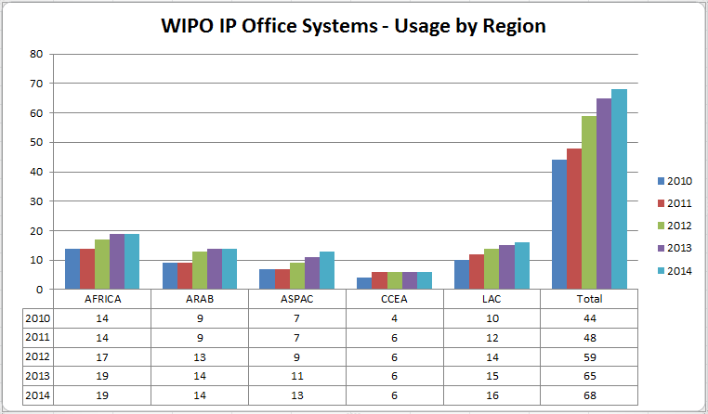

**Resource Sharing Platforms**

|  |  |
| --- | --- |
| WIPO DAS | Based on a specification and review process with participating Offices, a new version of the Digital Access Service (DAS) portal to support the revised framework of DAS 2.0 was launched in December 2014. The number of participating Offices remained steady in 2014 at 11. |
| WIPO CASE | In April 2014, the WIPO Centralized Access to Search and Examination (CASE) was linked to the IP5 One Dossier Portal system, allowing full two way exchange of dossier information between CASE and IP5 Offices. By mid-2014, the system was being utilized by several Offices as part of a pilot project. Five new Offices registered to use the WIPO CASE, bringing the total number of participating Offices to 14[45]. |

1. The design, planning and implementation of activities undertaken by Program 15 were informed and guided by the relevant DA Recommendations, in particular 1, 2 and 10.

PERFORMANCE DATA

|  |  |  |  |  |
| --- | --- | --- | --- | --- |
| **Expected Result:** IV.4 Enhanced technical and knowledge infrastructure for IP Offices and other IP institutions leading to better services (cheaper, faster, higher quality) to their stakeholders | | | | |
| **Performance Indicators** | **Baselines** | **Targets** | **Performance Data** | **TLS** |
| No. of offices using WIPO Infrastructure Platforms | *Updated Baseline end 2013:*  Asia and the Pacific (4): China, Mongolia, Singapore, Viet Nam  Other (12): Australia, Canada, Denmark, Finland, Israel, Japan, Republic of Korea, New Zealand, Spain, Sweden, United Kingdom, United States of America  (16 cumulative)  *Original Baseline P&B 2014/15:* North America - 2  Western Europe - 7  Asia/Pacific - 6 | 25 (by regional breakdown) | 5 additional offices in Asia and the Pacific: Brunei Darussalam, India, Indonesia, Malaysia, Philippines  (21 cumulative) | **On track** |
| **Performance Indicators** | **Baselines** | **Targets** | **Performance Data** | **TLS** |
| Average Service Level of IP Offices assisted (ranging from 1 to 5) | *Updated Baseline end 2013:* 2.8  *Original Baseline P&B 2014/15:* tbd | *Defined Target:* 3  *Original Target P&B 2014/15:* tbd | Overall average: 2.9   * Africa: 3 * Arab: 2.7 * Asia and the Pacific: 2.7 * Certain Countries in Europe and Asia: 3.2 * Latin America and the Caribbean: 3.1 * Other: 2.4 | **On track** |
| No. of Collective Management Organizations (CMOs) in developing countries and LDCs participating in regional and global networks facilitated by WIPO | 0 zero | 10 | The WCC system is under development and is expected to be deployed in 2015. | **N/A 2014** |

RESOURCE UTILIZATION

Budget and Actual Expenditure (by result)

*(in thousands of Swiss francs)*



Budget and Actual Expenditure (personnel and non-personnel)

*(in thousands of Swiss francs)*



NOTE: *The 2014/15 Budget after Transfers reflects transfers as of March 31, 2015 to address needs during the 2014/15 biennium in line with Financial Regulation 5.5.*

A. Budget after Transfers 2014/15

1. The increase in the 2014/15 Budget after Transfers is primarily the result of (i) additional non-personnel resources provided to cover ICT-related costs for TIGAR following the transfer of responsibilities for the ICT component of TIGAR to Program 15 from Program 3; and (ii) a transfer of one position into the Program to assist with the deployment and support of WIPO business solutions for IP Offices.

B. Budget utilization 2014

1. The overall budget utilization is within the expected range of 40-60% for the first year of the biennium. The low budget utilization for non-personnel is primarily due to uneven expenditure on the WCC project for CMOs in the biennium (the majority of biennial expenditure for WCC is expected in 2015).

STRATEGIC GOAL V

**WORLD REFERENCE SOURCE FOR IP INFORMATION AND ANALYSIS**

**Mid-term Performance Dashboard (2014)**

The dashboard below provides a summary of the progress towards the achievement of the Results in 2014 as measured by the indicators under the Programs contributing to this Strategic Goal.



|  |  |  |  |
| --- | --- | --- | --- |
| **Expected Results** | **Performance Indicators** | **Responsible Program(s)** | **TLS** |
| V.1 Wider and better use of WIPO IP statistical information | No. of downloads of four main statistical reports (WIPI and PCT, Hague, Madrid Yearly Reviews) | Program 16 | ⚫ |
|  | No. of visitors using IP Statistics data Center | Program 16 | **⚫** |
| V.2 Wider and better use of WIPO economic analysis in policy formulation | Use of WIPO economic studies on copyright by governments and NGOs in decision-making | Program 3 | **⚫** |
|  | National initiatives to develop further statistics on the creative industries based upon WIPO’s work in the field | Program 3 | **⚫** |
|  | No. of downloads of main economic publications | Program 16 | ⚫ |
|  | No. and number of downloads of studies | Program 16 | **⚫** |
|  | No. and number of downloads of seminars | Program 16 | ⚫ |

## PROGRAM 16 ECONOMICS AND STATISTICS

**Program Manager Director General**

OVERVIEW OF PROGRESS IN 2014

1. The statistical work fully achieved its objective in promoting the availability of accurate, comprehensive, and timely statistical information on the performance of the IP system worldwide. As in previous years, the Program conducted a statistical survey of national and regional IP offices. Responses covered more than 90 countries, including the largest IP-using jurisdictions. For many IP Offices from small and less developed economies, resource limitations continued to pose an obstacle towards responding to the statistics survey. However, through outreach programs and targeted assistance, the Program has been able to gradually improve coverage over the years.
2. The Program also fulfilled its statistical reporting function, notably through the timely release of the World IP Indicators, the WIPO IP Facts and Figures report, the Yearly Reviews for the Patent Cooperation Treaty (PCT), Madrid, and Hague Systems, as well as through the IP Statistics Data Center and IP statistical country profiles available on WIPO’s statistics webpage. One major achievement in 2014 was the upgrade of the functionality of the Data Center, including the development of user interfaces in French and Spanish. Another achievement was the re-design of the World Intellectual Property Indicators (WIPI) report, with a view to making it easier for readers to find the desired information. Overall, the Program’s statistical offerings served the data and statistical analysis needs of a wide range of users – from specialists in IP Offices and academia to more general users outside of the IP community.
3. The Program’s economic analysis work also made good progress on the promotion of high quality empirical analysis in support of evidence-based policymaking. As in previous years, WIPO co-published the Global Innovation Index (GII), in partnership with INSEAD and Cornell University. The 2014 GII covered 143 economies and was launched in Sydney, Australia at a gathering of international business leaders known as the B20. It was subsequently presented at national and international conferences across the world. The publication of the GII also continued to attract significant media attention. In addition, national governments, international organizations and other stakeholders in the innovation system regularly employed the GII as a reference source for analyzing innovation performance, as captured by numerous citations, data inquiries, and requests for advisory services.
4. Notable achievements were made on other fronts as well. Good progress was made towards the development of a new World IP Report, which will be published in the second half of 2015. The Program also directly supported the work of WIPO committees – notably through a study on PCT fee elasticity for the PCT Working Group and a seminar on exceptions and limitations to patent rights during the SCP. In addition, assisting WIPO Member States with country studies continued to be an important pillar of the Program’s economic analysis work and took place under the umbrella of the DA project on IP and Socio-Economic Development. In 2014, the first phase of this project (CDIP/5/7) came to an end and underwent an external evaluation (CDIP/14/3), which was presented at the fourteenth session of the CDIP. WIPO Member States approved a second phase of the project (CDIP/14/7), which will be implemented in 2015 through 2017. The studies under the DA project continued to respond to relevant DA Recommendations, in particular Recommendations 35 and 37.
5. Finally, the Program continued to coordinate a network of IP office economists – open to all IP Offices with an economic research capacity – to help foster and facilitate empirical and scientifically rigorous economic research on IP.

PERFORMANCE DATA

|  |  |  |  |  |  |
| --- | --- | --- | --- | --- | --- |
| **Expected Result:** V.1 Wider and better use of WIPO IP statistical information | | | | | |
| **Performance Indicators** | **Baselines** | **Targets** | **Performance Data** | **TLS** | |
| No. of downloads of four main statistical reports (WIPI and PCT, Hague, Madrid Yearly Reviews) | *Updated Baseline end 2013:* In 2013, the latest available editions (2012 and 2013 editions) of the World Intellectual Property Indicators (publication n°941) and WIPO IP Facts and Figures (n°943) were downloaded, altogether, 52,670 times.  *Original Baseline P&B 2014/15:* tbdend 2013 | 10% increase in number of downloads and users over 2012/13 | New web-based statistical tools and methodologies are being developed and tested. Data to be available end 2015. | **Not Assessable** | |
| No. of visitors using IP Statistics Data Center | *Updated Baseline end 2013:*  In 2013, the WIPO Statistics Data Center was used by 23,496 unique visitors (1,958 per month) who viewed 162,463 pages  *Original Baseline P&B 2014/15:* tbdend 2013 | 10% increase in number of users, over 2012/13 | 2,999 sessions per month on average[46] | **On track** | |
| **Expected Result:** V.2 Wider and better use of WIPO economic analysis in policy formulation | | | | | |
| **Performance Indicators** | **Baselines** | **Targets** | **Performance Data** | | **TLS** |
| No. of downloads of main economic publications | Tbd end 2013 | 20% increase over 2012/13 | New web-based statistical tools and methodologies are being developed and tested. Data to be available end 2015. | | **Not Assessable** |
| No. of downloads of studies | *Updated Baseline end 2013:*  7 working papers published in 2013  *Original Baseline P&B 2014/15:* tbd end of 2013 | Eight new working papers | 11 working papers published in 2014 | | **On track** |
| No. of downloads of seminars | *Updated Baseline end 2013:*  n/a  *Original Baseline P&B 2014/15:* tbd end of 2013 | Maintain performance as in previous biennium | Data are not available. | | **Dis- continued** |

RESOURCE UTILIZATION

Budget and Actual Expenditure (by result)

*(in thousands of Swiss francs)*



Budget and Actual Expenditure (personnel and non-personnel)

*(in thousands of Swiss francs)*



*NOTE: The 2014/15 Budget after Transfers reflects transfers as of March 31, 2015 to address needs during the 2014/15 biennium in line with Financial Regulation 5.5.*

A. Budget after Transfers 2014/15

1. The overall net decrease in non-personnel resources is primarily due to: (i) the adjustment in the allocation for the DA Project on IP and Socio-Economic Development following the approval of the second phase of the project at the fourteenth session of the CDIP (CDIP/14/7); and (ii) the transfer of non-personnel resources for an intern to support the work of the Program.

B. Budget utilization 2014

1. Budget utilization is within the expected range of 40-60 per cent for the first year of the biennium and is on track.

STRATEGIC GOAL VI

**INTERNATIONAL COOPERATION ON BUILDING RESPECT FOR IP**

**Mid-term Performance Dashboard (2014)**

The dashboard below provides a summary of the progress towards the achievement of the Results in 2014 as measured by the indicators under the Programs contributing to this Strategic Goal.



|  |  |  |  |
| --- | --- | --- | --- |
| **Expected Results** | **Performance Indicators** | **Responsible Program(s)** | **TLS** |
| VI.1 Progress in the international policy dialogue among WIPO Member States on building respect for IP, guided by Recommendation 45 of the WIPO Development Agenda | Continued agreement by Member States on the substantive work of the WIPO Advisory Committee on Enforcement (ACE), incorporating development-oriented concerns | Program 17 | ⚫ |
| VI.2 Systematic, effective and transparent cooperation and coordination between the work of WIPO and other international organizations in the field of building respect for IP | No. of joint activities on building respect for IP | Program 17 | ⚫ |

## PROGRAM 17 BUILDING RESPECT FOR IP

**Program Manager Mr. M.A. Getahun**

OVERVIEW OF PROGRESS IN 2014

1. Guided by Strategic Goal VI and DA Recommendation 45, all of the various activities of Program 17 were geared towards enhanced international cooperation on building respect for IP that seeks to achieve the appropriate balance between private rights and public interest.
2. With a view to achieving progress in the international policy dialogue among WIPO Member States on building respect for IP, the ninth session of the Advisory Committee on Enforcement (ACE) (March 3 to 5, 2014) served as a “marketplace of ideas”, allowing for the exchange of national practices and experiences. The three day meeting showed growing interest in effective preventive strategies, ranging from awareness raising, new business models and supply chain security, to alternative mechanisms for resolving IP disputes. For the first time, an audiovisual exhibition was organized with the session, presenting nine national and one regional awareness raising initiatives. Member States agreed for the work program of the tenth session to remain dedicated to: (i) alternative dispute resolution practices in the field of IP and (ii) preventive actions, measures or successful experiences to complement enforcement measures with a view to reducing the size of the market for pirated or counterfeited goods.
3. To achieve international policy cohesion and maximum impact through shared resources in the area of building respect for IP, Program 17 coordinated its work with intergovernmental and non-governmental organizations, associations of stakeholders as well as academic institutions. Through systematic, transparent, and effective collaboration, WIPO was able to mainstream its development-oriented approach to building respect for IP into the work of its international partners. The joint activities were guided by DA Recommendation 40.
4. Demand for WIPO assistance in the form of legislative advice on the compatibility of draft or current national enforcement-related provisions with Part III of the TRIPS Agreement continued to rise in 2014. In close dialogue with national drafters, Program 17 helped Member States devise legislative solutions that are appropriate to their national requirements and take full account of the available flexibilities and options. Activities in this area of legislative, regulatory and policy assistance implemented DA Recommendations 1, 6, 12, 13, 14 and 17.
5. The Program’s capacity building activities sought to empower national authorities to build respect for IP through a combination of balanced enforcement activities and preventive measures designed to reduce demand for infringing goods and underscore the value of the IP-legitimate market. To enhance the sustainability of the knowledge transfer, specific collaborations were established with national law enforcement training entities capable of serving as multipliers. In addition, a French edition and an Arabic translation of the English edition of the *WIPO Casebook on the Enforcement of IP Rights* were published. The activities in this area were informed by DA Recommendations 3, 10, and 11.
6. In order to support Member State IP education and awareness initiatives, seeking to reduce IP infringement through behavioral change, a modular methodology for devising national awareness raising strategies was developed and two Member States were assisted in its implementation in accordance with the respective particular national needs. The Program also supported six Member States in the organization of school competitions around the 2014 IP Day theme and published workbooks featuring “Pororo the little penguin” in English and French as a way to increase popular understanding of the value of IP, particularly by young people. In addition, the WIPO Awards Program continued to celebrate the achievements of inventors, creators and innovative companies with 160 WIPO Awards being bestowed on recipients from 38 Member States. The Program’s awareness raising activities contributed to the implementation of DA Recommendation 3.

PERFORMANCE DATA

|  |  |  |  |  |
| --- | --- | --- | --- | --- |
| **Expected Result:** I.2 Tailored and balanced IP legislative, regulatory and policy frameworks | | | | |
| **Performance Indicators** | **Baselines** | **Targets** | **Performance Data** | **TLS** |
| No. of countries that have adopted or amended relevant frameworks (or are in the process of doing so) further to WIPO assistance | *Updated Baseline end 2013:*  9 countries/ organizations in the process of amending and/or adopting relevant frameworks towards effective IP enforcement: Africa (5), Asia and the Pacific (2), Latin America and the Caribbean (2)  *Original Baseline P&B 2014/15:* tbd | 6 | 9 additional countries/ organizations in the process of amending and/or adopting relevant frameworks towards effective IP enforcement: Africa (4), Asia and the Pacific (3), Latin America and the Caribbean (2)  (18 cumulative) | **On track** |
| **Expected Result:** III.2 Enhanced human resource capacities able to deal with the broad range of requirements for the effective use of IP for development in developing countries, LDCs and countries with economies in transition | | | | |
| **Performance Indicators** | **Baselines** | **Targets** | **Performance Data** | **TLS** |
| % of trained participants that report satisfaction with the usefulness and relevance of the training provided for their professional life | *Updated Baseline end 2013:*  85%  *Original Baseline P&B 2014/15:* 75% | 75% | An average of 90% of participants reported that they found the training useful for their professional life.  An average of 90% of participants reported that they were satisfied with the training. | **On track** |
| % of targeted audience who have demonstrated a basic knowledge of a balanced IP system further to WIPO activities | n/a | 75% | >75% | **On track** |
| No. of countries participating in WIPO Awards Program | *Updated Baseline end 2013: 42 in 2013*  *Original Baseline P&B 2014/15:* 40 per year | 40 *per* year | 38 in 2014 | **On track** |
| **Expected Result:** VI.1 Progress in the international policy dialogue among WIPO Member States on building respect for IP, guided by Recommendation 45 of the WIPO Development Agenda | | | | |
| **Performance Indicators** | **Baselines** | **Targets** | **Performance Data** | **TLS** |
| Continued agreement by Member States on the substantive work of the WIPO Advisory Committee on Enforcement (ACE), incorporating development-oriented concerns | *Updated Baseline end 2013:* Agreement on work program for the 9th session of the ACE  *Original Baseline P&B 2014/15:* Agreement on work program for the 8th session of the ACE | Agreement on work program for the next ACE session | Agreement on the following work program for the 10th session of the ACE: (i) alternative dispute resolution practices in the field of IP and (ii) preventive actions, measures or successful experiences to complement enforcement measures with a view to reducing the size of the market for pirated or counterfeited goods. (WIPO/ACE/9/29 PROV.) | **On track** |
| **Expected Result:** VI.2 Systematic, effective and transparent cooperation and coordination between the work of WIPO and other international organizations in the field of building respect for IP | | | | |
| **Performance Indicators** | **Baselines** | **Targets** | **Performance Data** | **TLS** |
| No. of joint activities on building respect for IP | *Updated Baseline end 2013:* 39 in 2014/15  *Original Baseline P&B 2014/15:* 30 | 30 | 30 activities jointly organized with partner organizations and stakeholders and/or in which Program 17 participated | **On track** |

RESOURCE UTILIZATION

Budget and Actual Expenditure (by result)

*(in thousands of Swiss francs)*



Budget and Actual Expenditure (personnel and non-personnel)

*(in thousands of Swiss francs)*



*NOTE: The 2014/15 Budget after Transfers reflects transfers as of March 31, 2015 to address needs during the 2014/15 biennium in line with Financial Regulation 5.5.*

A. Budget after Transfers 2014/15

1. The adjustments across Results in the Budget after Transfers 2014/15 reflects the new and more accurate methodology for allocation of personnel resources resulting from enhancements made to the EPM planning system for the 2014 annual work planning exercise.

B. Budget utilization 2014

1. Budget utilization is within the expected range of 40-60 per cent for the first year of the biennium and is on track.

STRATEGIC GOAL VII

**ADDRESSING IP IN RELATION TO GLOBAL POLICY ISSUES**

**Mid-term Performance Dashboard (2014)**

The dashboard below provides a summary of the progress towards the achievement of the Results in the 2014 as measured by the indicators under the Programs contributing to this Strategic Goal.



| **Expected Results** | **Performance Indicators** | **Responsible Program(s)** | **TLS** |
| --- | --- | --- | --- |
| VII.2 IP-based platforms and tools are used for knowledge transfer, technology adaptation and diffusion from developed to developing countries, particularly least developed countries, to address global challenges | Increase in membership in WIPO Re:Search, including from developing countries and LDCs | Program 18 | ⚫ |
| Increased contributions to WIPO Re:Search database | Program 18 | ⚫ |
| Increased no. of agreements under WIPO Re:Search which lead to new or accelerated R&D in NTDs, Malaria and TB | Program 18 | ⚫ |
|  | No. of WIPO GREEN Members | Program 18 | ⚫ |
|  | No. of established links of WIPO GREEN to relevant mechanisms, such as Climate Technology Centers and Networks (UNFCCC) and Climate Innovation Centers (infoDev) | Program 18 | ⚫ |
|  | No. of agreements catalyzed by WIPO GREEN facilitating knowledge transfer, technology adaptation, transfer and/or diffusion | Program 18 | ⚫ |
|  | No. of visits of Global Challenges website | Program 18 | ⚫⚫⚫⚫⚫ |
|  | Participation of stakeholders in WIPO's platform such as WIPO GREEN and WIPO Re:Search | Program 20 | ⚫⚫⚫⚫⚫ |
| VII.3 Growing credibility of WIPO as a forum for analysis of issues in the field of IP and competition policy | No. of countries requesting WIPO’s specific contribution on IP in relation to CP-related issues | Program 18 | ⚫ |
|  | No. and diversity of stakeholders (IP offices, competition authorities, relevant IGOs and NGOs) engaged in dialogue with WIPO | Program 18 | ⚫ |

## PROGRAM 18 IP AND GLOBAL CHALLENGES

**Program Manager Mr. M. A. Getahun**

OVERVIEW OF PROGRESS IN 2014

1. Program 18 addresses innovation and IP at the intersection of pressing global and interconnected issues, in particular global health, climate change, and food security. In 2014, the Program continued to contribute to an enhanced understanding among policy makers on the interface between global challenges, innovation and IP, including through two multi-stakeholder innovation and technology transfer and diffusion platforms (WIPO Re:Search and WIPO GREEN, respectively), and the ongoing collaboration with WHO and WTO addressing the intersection of health, IP, innovation and trade. During the year, the Program continued to receive positive feedback from a wide range of stakeholders for WIPO’s work on IP and Global Challenges.
2. Working closely with relevant Programs within WIPO, most notably Programs 20 (External Relations, Partnerships and External Offices) and 30 (SMEs and Innovation), WIPO consolidated its position as a credible source of support and reference for information on issues related to public policy and IP, resulting in continued requests for WIPO to contribute to and participate in relevant public policy fora by other organizations, including WHO, WTO, NGOs, the private sector and universities. A WIPO Global Challenges Seminar  [“Innovation and Access to Medicines: A Case Study for HIV/AIDS and Hepatitis C](http://www.wipo.int/meetings/en/details.jsp?meeting_id=35262)” was organized and provided a forum for participants to share ideas, expertise and information. A Global Challenges Brief on *Renewable Energy Technology: Evolution and Policy Implications –Evidence from Patent Literature* was published in June 2014. A further Global Challenges Brief on *Incentivizing the adoption of green technology on a global scale* was released at UNFCCC’s COP 20 in Lima in November 2014. As part of the work of WIPO Re:Search to strengthen capacities in developing countries, an IP management training seminar was organized, together with Program 30 (SMEs and Innovation), for the benefit of developing country scientists who are Members of the platform.
3. Following its launch in November 2013, the year 2014 marked the first full year of WIPO GREEN operations. Through a targeted awareness raising campaign, the profile of WIPO GREEN was raised significantly in 2014. The network of partners grew from 36 to 54, and the number of registered users almost doubled from 160 to 300. This growth reflects the success of outreach efforts encompassing a wide range of channels, including social and specialist media, the regular WIPO GREEN Newsletter and attendance at a range of global, regional and national fora. The WIPO GREEN database also more than doubled from 830 to 1,773 entries resulting from a combination of database integration agreements and individual uploads. With the focus in 2014 remaining on building a robust set of partners and increasing the number of entries to promote increased levels of marketplace interaction and transactional usage, the progress, nevertheless, did not yet translate into transactions that could be directly attributed to the use of WIPO GREEN. Moreover, the fact that WIPO GREEN does not currently have a “partnership hub” or service provider, coupled with the lengthy timeframe needed for deals to be concluded, also contribute to the lack of catalyzed transactions.
4. WIPO Re:Search ‑ *Sharing Innovation in the Fight Against Neglected Tropical Diseases* (NTDs) ‑ gained in recognition as a platform to support innovation and knowledge sharing related to research for NTDs, tuberculosis and malaria. The year 2014 saw 38 additional collaborations and 16 new Members, bringing the totals to 82 collaborations and 96 Members, 6 of which from developing countries. In addition, the platform’s potential for technology transfer from developed to developing countries of IP assets, including know-how and expertise, was further demonstrated by the continued facilitation of research sabbaticals for five African scientists in overseas research institutions. The sabbaticals, which began in the last biennium, were made possible by a Fund-in-Trust from the Government of Australia. At the end of 2014, four of the sabbaticals were concluded.
5. The trilateral cooperation with WHO and WTO continued to focus on enhanced understanding among policymakers for the interplay between health, IP and trade. In November 2014, the fourth Trilateral Symposium took place in Geneva, exploring the challenges and opportunities in the health innovation area of middle-income countries, and the public policies necessary to ensure that rapid economic growth contributes to access and universal health coverage. .
6. The area of IP and competition policy experienced sustained interest from Member States to engage in a dialogue for enhancing their understanding of the interface between IP and competition policy. Requests involved both IP Offices and Competition Authorities, including from economies that are less familiar with competition-related issues in the field of IP.
7. The number of stakeholders engaged in dialogue with WIPO reached 26 Competition Authorities, and the structured, informal cooperation with other relevant Organizations in the field, most notably OECD, UNCTAD, the WTO, International Competition Network (ICN), and the Common market for Eastern and Southern Africa (COMESA) that was established in the previous biennium was further strengthened.. WIPO jointly organized and/or participated in nine workshops. These joint efforts of both IP Offices and Competition Authorities provided an effective forum for dialogue and debate as regards the interface between IP and competition policy.
8. The design, planning and implementation of activities undertaken by Program 18 were guided by the relevant DA Recommendations, in particular DA Recommendations 19, 25, 30, 40, and 42.

PERFORMANCE DATA

|  |  |  |  |  |  |  |  |  |
| --- | --- | --- | --- | --- | --- | --- | --- | --- |
| **Expected Result:** III.2 Enhanced human resource capacities able to deal with the broad range of requirements for the effective use of IP for development in developing countries, LDCs and countries with economies in transition | | | | | | | | |
| **Performance Indicators** | **Baselines** | | **Targets** | | | | **Performance Data** | **TLS** |
| No. of hosting arrangements of developing country scientists | *Original Baseline P&B 2014/15:* *5* | | 4 | | | | No additional hosting arrangements were facilitated in 2014. | **Not  on track** |
| **Expected Result:** IV.2 Enhanced access to, and use of, IP information by IP institutions and the public to promote innovation and creativity | | | | | | | | |
| **Performance Indicators** | **Baselines** | | **Targets** | | | | **Performance Data** | **TLS** |
| Number of countries that verified data and included national essential medicines into WIPO Essential | 0 (zero) | | 1 country per region (Africa, Asia, Latin America and the Caribbean) | | | | WIPO Essential was re-purposed in 2014 as a study on the patent status of medicines contained in the WHO Model List of Essential Medicines (MLEM). Publication is expected by the end of 2015. | **Dis-continued** |
| **Expected Result:** VII.2 IP-based platforms and tools are used for knowledge transfer, technology adaptation and diffusion from developed to developing countries, particularly least developed countries, to address global challenges | | | | | | | | |
| **Performance Indicators** | | **Baselines** | | **Targets** | | **Performance Data** | | **TLS** |
| Increase in membership in WIPO Re:Search, including from developing countries and LDCs | | *Updated Baseline end 2013:* During the biennium, WIPO Re:Search added 49 new members (providers, users and supporters) and 167 new entries in the database:   * 30 new members and 90 new entries in 2012; and * 19 new members and 77 new entries in 2013   bringing the total cumulative to 80 members and 247 entries.    *Original Baseline P&B 2014/15:* 67 Members; 16 from Developing Countries | | 15 (of which at least 5 from developing countries/LDCs) | | 16 new Members (of which 6 from developing countries/LDCs)  96 total Members (27 of which from developing countries) | | **On track** |
| **Performance Indicators** | | **Baselines** | | **Targets** | | **Performance Data** | | **TLS** |
| Increased contributions to WIPO Re:Search database | | *Updated Baseline end 2013:* By end of 2013 WIPO Re:Search had facilitated 44 research collaborations (11 in 2012 and 33 in 2013)    *Original Baseline P&B 2014/15:* 200 | | 50% | | 180 database records  The decrease in the number of records in 2014 was due to the withdrawal of two members. | | **Not  on track** |
| Increased no. of agreements under WIPO Re:Search which lead to new or accelerated R&D in NTDs, Malaria and TB | | *Updated Baseline end 2013:* 44    *Original Baseline P&B 2014/15:* 16 | | 20 | | 38 new agreements in 2014 (82 in total) | | **On track** |
| No. of WIPO GREEN Members | | *Updated Baseline end 2013:* 36 Partners, 160 users, 830 uploads[47]    *Original Baseline P&B 2014/15:* 1 partner; 48 uploads | | 10 new partners; 400 uploads | | * 18 new partners (total 54) * 140 new users (total 300) * 943 new uploads (total 2,050) | | **On track** |
| No. of established links of WIPO GREEN to relevant mechanisms, such as Climate Technology Centers and Networks (UNFCCC) and Climate Innovation Centers (infoDev) | | *Updated Baseline end 2013:*  1 (East Africa Climate Innovation Network (EACIN))    *Original Baseline P&B 2014/15:* 0 (zero) | | 3 | | 3 (Climate Technology Centre and Network (CTCN), Waseda Environmental Institute and EcoPatent Commons) | | **On track** |
| No. of agreements catalyzed by WIPO GREEN facilitating knowledge transfer, technology adaptation, transfer and/or diffusion | | *Updated Baseline end 2013:* During 2012 and 2013 WIPO GREEN concluded :  Two agreements with external partners for data integration  (Association of University Technology Managers (AUTM) and East Africa Climate Innovation Network (EACIN))  *Original Baseline P&B 2014/15:* 0 (zero) | | 250 | | 3 additional agreements: Danish Patent and Trademark Office (DKPTO); Technologie Allianz; United Nations Office for South-South Cooperation (UNOSSC) | | **Not  on track** |
| No. of visits of Global Challenges website | | *Updated Baseline* end 2013:  6,476 page views (GCD)  3,773 downloads of pdf files  73,648 page views of WIPO GREEN  60,712 page views of WIPO Re:Search  *Original Baseline P&B 2014/15:* n/a | | | 50% increase | No. of page views:   * GCD: 1,353 * Global Health and IP: 4,778 * Climate Change and IP: 2,462 * WIPO Re:Search: 38,852 * WIPO GREEN: 77,752 | | **Not  on track**  **Not Assessable**  **Not Assessable**  **Not  on track**  **On track** |

|  |  |  |  |  |
| --- | --- | --- | --- | --- |
| **Expected Result:** VII.3 Growing credibility of WIPO as a forum for analysis of issues in the field of IP and competition policy | | | | |
| **Performance Indicators** | **Baselines** | **Targets** | **Performance Data** | **TLS** |
| No. of countries requesting WIPO’s specific contribution on IP in relation to CP-related issues | *Updated Baseline end 2013:* Six requests for bilateral discussions (Chile, Brazil, Ecuador, India, the Dominican Republic, the Republic of Moldova) and one request for legislative assistance (Bhutan).    *Original Baseline P&B 2014/15:* 12 | 15 | 12 requests received (Brazil,  Colombia, Cuba, Dominican Republic, Ecuador, India, Italy, Peru, Philippines, Singapore, South Africa, Viet Nam) | **On track** |
| No. and diversity of stakeholders (IP offices, competition authorities, relevant IGOs and NGOs) engaged in dialogue with WIPO | *Updated Baseline end 2013:* 19 workshops and meetings engaging 38 competition authorities and 5 IGOs. Establishment of informal coordination with UNCTAD, WTO and OECD. Active participation in the International Competition Network. Cooperation with the Common Market for Eastern and Southern Africa (COMESA).  *Original Baseline P&B 2014/15:* WIPO engaged 25 national competition authorities and 3 IGOs | Increase of stakeholders engaged in WIPO’s activities: 35 national authorities and 5 IGOs/NGOs | 26 additional competition authorities involved and continued engagement with 5 IGOs/NGOs (OECD, UNCTAD, the WTO, ICN, COMESA) | **On track** |

RESOURCE UTILIZATION

Budget and Actual Expenditure (by result)

*(in thousands of Swiss francs)*



Budget and Actual Expenditure (personnel and non-personnel)

*(in thousands of Swiss francs)*



*NOTE: The 2014/15 Budget after Transfers reflects transfers as of March 31, 2015 to address needs during the 2014/15 biennium in line with Financial Regulation 5.5.*

A. Budget after Transfers 2014/15

1. The net decrease in personnel resources reflects the temporary transfer of a staff member to Program 6 to support the work associated with the new accessions to the Madrid System.
2. The net increase in non-personnel resources reflects the transfer of funds from Program 6 for consultant services to compensate for the temporary transfer of the above-referenced staff to ensure a seamless continuation of the work on the WIPO platforms and IT applications across the Global Issues Sector.
3. Overall, the adjustments across Expected Results in the 2014/15 Budget after Transfer reflect the new and more accurate methodology for allocation of personnel resources resulting from enhancements made to the EPM planning system for the 2014 annual work planning exercise.
4. Resources linked to Expected Results I.1, VI.1, VI.2 and VIII.5 under this Program reflect efforts dedicated by the Office of the Assistance Director General of the Global Issues Sector to the activities of Programs 4, 17 and 20 respectively.

B. Budget utilization 2014

1. The slight under-utilization of non-personnel resources reflects cost savings, in particular, in relation to travel and organization of meetings.

STRATEGIC GOAL VIII

**A RESPONSIVE COMMUNICATIONS INTERFACE BETWEEN WIPO, ITS MEMBERS AND ALL STAKEHOLDERS**

**Mid-term Performance Dashboard (2014)**

The dashboard below provides a summary of the progress towards the achievement of the Results in 2014 as measured by the indicators under the Programs contributing to this Strategic Goal.



| **Expected Results** | **Performance Indicators** | **Responsible Program(s)** | **TLS** |
| --- | --- | --- | --- |
| VIII.1 More effective communication to a broad public about intellectual property and WIPO’s role | Level of public interest generated in selected major WIPO events/achievements | Program 19 | ⚫ |
|  | % of stakeholders with positive recognition of WIPO’s mission, activities and organizational image | Program 19 | ⚫ |
| Program 20 | ⚫⚫⚫ |
|  | % increase in views of WIPO press, video and photographic content | Program 19 | ⚫⚫⚫ |
|  | % increase in global participation in World IP Day via Facebook page (total reach of campaign) | Program 19 | ⚫ |
|  | % increase in views of online publications | Program 19 | ⚫⚫ |
|  | % of users satisfied with the WIPO website | Program 19 | ⚫ |
|  | Increased WIPO influence and engagement on social media | Program 19 | ⚫⚫ |
|  | Increased traffic to the website of WIPO External Offices | Program 20 | ⚫⚫⚫ |
| VIII.2 Improved service orientation and responsiveness to inquiries | % of users satisfied with Library services | Program 19 | ⚫ |
|  | Customer/stakeholder satisfaction rate | Program 19 | ⚫⚫ |
| Program 20 | ⚫ |
|  | Service Standards targets as defined on WIPO website | Program 19 | ⚫⚫ |
|  | Processing time of information inquiries | Program 20 | ⚫⚫⚫ |
| VIII.3 Effective engagement with Member States | % of Committee Meetings for which pre-Committee information meetings for Member States are held | Program 21 | ⚫ |
|  | % of letters to the DG from Member States are responded to within 2 weeks | Program 21 | ⚫ |
|  | % of adherence and other WIPO Treaty-related actions by Member States processed in a timely manner | Program 21 | ⚫ |
|  | Member States satisfaction levels with the preparation and functioning of the Assemblies | Program 21 | ⚫ |
|  | Timeliness of publication of Assemblies documents | Program 21 | ⚫ |
| VIII.4 Open, transparent and responsive interaction with non-governmental stakeholders | Increased, effective engagement of non-governmental stakeholders at WIPO events and vice-versa | Program 20 | ⚫ |
| VIII.5 WIPO effectively interacts and partners with UN and other IGO processes and negotiations | Use of WIPO's contribution in reports, resolutions and documents from targeted processes | Program 20 | ⚫ |
|  | % of responses to external requests for contributions from the UN, IGOs etc. submitted on time | Program 20 | ⚫ |
|  | No. of IP Programs implemented jointly with other UN bodies and other IGOs | Program 20 | ⚫ |
|  | New joint initiatives with other UN agencies | Program 21 | ⚫ |
|  | HLCM and Subsidiary Networks Closed Recommendations | Program 24 | ⚫ |
|  | % of locally sourced goods and services compared to total amount procured for development activity | Program 24 | ⚫ |
|  | % of spend subject to UN leverage (either common tender or piggy backing) | Program 24 | ⚫ |

## PROGRAM 19 COMMUNICATIONS

**Program Manager Ms. A. Leer**

OVERVIEW OF PROGRESS IN 2014

1. Program 19 focused in 2014 on consolidating the results of a number of major Organization-wide strategic projects on web communications, branding, internal communications and customer service, which were completed in 2013; and on continuing to implement core strategies for improving the delivery and quality of WIPO content, increasing visibility and understanding of WIPO’s work, and strengthening the culture of service. The Program also laid the groundwork for further initiatives to enhance the effectiveness of communications activities.
2. The visibility of key WIPO events, offerings and results – from the Accessible Books Consortium (ABC) to new tools such as the WIPO Pearl terminology portal – was increased through a fully integrated approach to press, social media, video, print and online communications, delivered across multiple platforms. High priority was given to promoting the Organization’s flagship economics and statistics reports so as to strengthen recognition of WIPO as the world reference source for authoritative IP information. Concerted promotional efforts resulted in a 16 per cent increase in views of web content relating to the 2014 Global Innovation Index (GII) launch compared to 2013, and an exponential increase (1,300 per cent) in views of related video content. High profile press coverage of the 2014 World Intellectual Property Indicators (WIPI) was achieved in influential media outlets worldwide, together with an 18 per cent increase in views of the press release. WIPO tweets about the WIPI were seen 83,700 times and extensively retweeted, including by many government offices. Original infographics, created to enhance communications, were among the most shared form of content.
3. Engagement by Member States and the public in the annual World IP Day campaign reached a record level. The theme *Movies – A Global Passion* was the focus for over 350 events reported in 110 countries (up from 236 events in 93[48] countries in 2013). WIPO’s World IP Day tweets gained 1.67 million potential impressions, as compared to 1.55 million in 2013, and promotional materials created for the campaign were downloaded from the website over 9,000 times. Views of the World IP Day webpage in Chinese exceeded the English version for the first time, while the highest numbers of ‘likes’ of the Facebook page came from Brazil, Egypt, India, Mexico and United States of America. A mini-film festival held in Geneva from April 24 to 28, 2014 drew good participation from the local community, particularly for the Swiss premiere screening of the Nigerian co-production, “Half a Yellow Sun,” which played to a capacity audience.
4. The production of quality content, tailored for specialist and non-specialist audiences, remained key to meeting users’ expectations. The bi-monthly WIPO Magazine continued to generate positive feedback, with 93 per cent of survey respondents rating the Magazine good or very good. In keeping with external trends, and responding to the diminishing role of formal press releases as a primary form of public communication, the new WIPO Media Center webpage was used in conjunction with Twitter and YouTube to promote understanding of IP and of WIPO activities in a less formal style, with shorter articles, videos and accessible background briefs. While views of the press releases decreased (largely reflecting the smaller number of high profile news events in 2014 compared to 2013), overall views of Media Center content increased.
5. Work continued to improve the presentation of, and open access to, all WIPO publications. Development of a major new publications platform on the website neared completion. The WIPO Library distributed over 110,000 print products, and the total number of Depository Libraries of WIPO publications in Member States reached 99, an 11 per cent increase over 2013.
6. Quality visuals enhanced the accessibility and presentation of numerous publicity and informational materials. The Flickr photo galleries of WIPO’s activities, including the new WIPO Conference Hall inauguration and Committee meetings, attracted well over a million additional photo-views in 2014, as compared to 900,000 in 2013. Video production was further intensified with the production of 155 new videos, including news content, IP stories and tutorials. The viral spike in 2012/13 of the popular *Pororo* children’s cartoons subsided, leading to a decrease in the overall average video views. The underlying viewing figures for the other (non-cartoon) videos, however, continued on an upward trend. Total video views on the WIPO YouTube channel since its April 2010 launch exceeded 7.13 million.
7. In order to enhance digital delivery channels, a major project was conducted to transform the effectiveness and user-friendliness of WIPO’s email newsletters and mailing platform. The results will be implemented in 2015. The project is driven by WIPO’s commitment to provide users with relevant information in the format and via the channels that best suit their needs. A second project underway to develop a contact database to facilitate the mailing of promotional and protocol-related communications will further support this objective. Good progress was also made on the second phase of the WIPO website overhaul, with systematic clean-up, improvement and redesign of lower level pages, and significant improvement to the in-site search functionality. On social media, WIPO’s Twitter following grew by over 60 per cent, coupled with a 76.8 per cent increase in the number of retweets of WIPO content. Work began to analyze the Organization’s requirements in the area of web analytics with a view to meeting needs for more sophisticated indicators for measuring impact and performance.
8. The brand development work carried out in the previous biennium to strengthen recognition of WIPO’s identity was mainstreamed in 2014, with systematic attention to establishing clear and consistent expression ‑ both verbal and visual ‑ of WIPO’s role, mission and values across all communications. A stakeholder perceptions survey conducted in 2014 resulted in the identification of the principal attributes on which WIPO is judged by its stakeholders, and the development of a tool for monitoring of WIPO’s perceived performance in relation to these reputational drivers. The survey was sent to 24,000 users in 2014, including IP Offices, Missions, NGOs, service users and academics, and the results analyzed to identify areas requiring attention.
9. The enhancement of WIPO’s customer services continued in 2014. Program 19’s work with Madrid Operations to review the customer service structure and operations included, *inter alia*, the introduction of a ticketing system to improve and streamline the processing of Madrid customers’ inquiries. Customer satisfaction monitoring continued with a survey of Madrid System users, 81 per cent of whom were satisfied or highly satisfied, and the preparation of a PCT-user survey in nine languages to be conducted in 2015. Internally, staff awareness of service-orientation and best practices was further promoted through activities including the second Netiquette Week*.* The central WIPO Customer Service Center processed 92 per cent of the 4,693 email inquiries received within less than one working day, and 100 percent of the 127 complaints received in less than eight working hours, 86 per cent of which were processed in less than four working hours.
10. The design, planning and implementation of activities undertaken by Program 19 were informed by relevant DA Recommendations. Program 19 continued to build the IP Advantage database of case studies (a DA initiative endorsed by the CDIP), which attracted over 199,671 page views in 2014 (compared to 193,004 in 2013), and provided editorial, design, video, web and other communications support to numerous DA-related products and outputs by other programs across the Organization.

PERFORMANCE DATA

|  |  |  |  |  |
| --- | --- | --- | --- | --- |
| **Expected Result:** VIII.1 More effective communication to a broad public about intellectual property and WIPO’s role | | | | |
| **Performance Indicators** | **Baselines** | **Targets** | **Performance Data** | **TLS** |
| Level of public interest generated in selected major WIPO events/ achievements | *Updated Baseline end 2013:* Sample event= launch of annual Global Innovation Index (GII). Aggregate views (for 11 week period after 2013 launch) of all web content (webpages, press release, infographics) = 45,564 + 685 video views  *Original Baseline P&B 2014/15:* (Sample event) 12,111 unique page views of press release on the 2012 Global Innovation Index (GII) in a 1 month period. | 10% increase in views of relevant web page | Launch of annual Global Innovation Index (GII): Aggregate views (for 11 week period after launch) of all web content (webpages, press release, infographics) = 53,062 + 9,563 video views. Increase = 16.5% and 1296% (video) | **On track** |

|  |  |  |  |  |
| --- | --- | --- | --- | --- |
| **Performance Indicators** | **Baselines** | **Targets** | **Performance Data** | **TLS** |
| % of stakeholders with positive recognition of WIPO’s mission, activities and organizational image | *Updated Baseline end 2013:* 87% of survey respondents perceived WIPO’s public image as good, very good or excellent. 81% of survey respondents perceived WIPO as the global forum for the promotion of IP. (WIPO Service Orientation Survey results, August 2013).[49]  *Original Baseline P&B 2014/15:*  65% of survey respondents perceived WIPO as the global leader in the protection and promotion of IP (WIPO Stakeholders Perceptions Survey, January 2012) | 75% | 70% of survey respondents perceived WIPO as the global forum for the promotion of IP services, policy, information and cooperation.[50] ; 85% of survey respondents agree or strongly agree that WIPO has a good overall reputation.  (Source: WIPO Stakeholders Perceptions Survey, June 2014) | **On track** |
| % increase in views of WIPO press, video and photographic content | *Updated Baseline end 2013:*  (i) average no. of unique views/press release was 5,506 (143,169 views for 26 press releases issued in 2013. All languages.)  (ii) average no. of views/video was 16,612 (3,787,601 views for 228[51] videos)  (iii) 900,000 lifetime photo views on Flickr  *Original Baseline P&B 2014/15:*  (i) In 2012, average no. of unique views/press release was 3,575. (92,958 for 26 articles issued in 2012)  (ii) In 2012, average no of views per video was 3,280 (478,888 views for 146 total videos)  (iii) 155,000 total photo views on Flickr at end 2012 | (i) 10 % increase in average no. of views per press release  (ii) 10% increase in average views per video on the WIPO YouTube channel  (iii) Target: 300,000 additional photo views on Flickr | (i) average no. of unique views per press release was 4,176  (75,173 views for 18 releases issued) (-24.15%)  (ii) average views per video was 8,864 (2,730,260 for 308 videos) (-46%)  (iii) 1,449,204 additional photo views on Flickr (+61%) | **Not  on track**  **Not  on track**  **On track** |
| % increase in global participation in World IP Day via Facebook page (total reach of campaign) | *Updated Baseline end 2013:* 414,121 people saw World IP Day content through our 2013 Facebook campaign (cumulative reach [constant])  *Original Baseline P&B 2014/15:* 379,600 people saw World IP Day content through our 2012 Facebook campaign | 30% increase in number of people who see our World IP Day Facebook content (total reach) | 563,816 (+36%) people saw World IP Day content through our 2014 Facebook campaign. | **On track** |
| % increase in views of online publications | *Updated Baseline end 2013:* (i) 3,940,490 downloads of free publications in 2013 (all languages)  (ii) 450,499 unique views of the WIPO Magazine site in 2013 (all languages)  *Original Baseline P&B 2014/15:* (i) tbd (comparable statistics not available for 2012)  (ii) 409,265 unique views of the WIPO Magazine site in 2012 | (i) 10% increase in total publications views online  (ii) 10% increase in views of WIPO Magazine site | New web-based statistical tools and methodologies are being developed and tested. Data to be available end 2015.  New web-based statistical tools and methodologies are being developed and tested. Data to be available end 2015. | **N/A 2014**  **N/A 2014** |
| **Performance Indicators** | **Baselines** | **Targets** | **Performance Data** | **TLS** |
| % of users satisfied with the WIPO website | tbd | ≥ 60% are satisfied | New web-based statistical tools and methodologies are being developed and tested. Data to be available end 2015. | **N/A 2014** |
| Increased WIPO influence and engagement on social media | *Updated Baseline end 2013:*  (i) “Klout” influence score was 64 (out of 100) at the end of 2013  (ii) 6,744 total retweets in 2013  *Original Baseline P&B 2014/15:*  (i) “Klout” influence score was 62 on Jan 1, 2013  (ii) 3,112 total retweets in 2012 | (i) “Klout” influence score of 73    (ii) 30% increase in total yearly number of retweets | (i) “Klout” influence score of 63.65 (out of 100) on December 31, 2014  (ii) 11,922 retweets in 2014 (76.8% increase in total yearly number of retweets) | **Not  on track**  **On track** |
| **Expected Result:** VIII.2Improved service orientation and responsiveness to inquiries | | | | |
| **Performance Indicators** | **Baselines** | **Targets** | **Performance Data** | **TLS** |
| % of users satisfied with Library services | *Updated Baseline end 2013:* 94% of respondents to a feedback questionnaire sent to the registered external visitors (Library users) who had used the Library in 2013 were satisfied or highly satisfied  *Original Baseline P&B 2014/15:* tbd | ≥ 70 % satisfied visitors and online customers | 100% of respondents to a feedback questionnaire of Library users were satisfied with the services, of which 72% were highly satisfied. | **On track** |
| Customer/ stakeholder satisfaction rate | *Updated Baseline end 2013:*  84% of Madrid and Hague customers satisfied or highly satisfied:  Madrid= 80%  Hague= 88%  *Original Baseline P&B 2014/15:* 2012 survey results: 86% of Madrid and Hague customers satisfied or highly satisfied | ≥ 86% satisfied or highly satisfied | 81% of Madrid customers were satisfied or highly satisfied  In 2014, the customer satisfaction survey for the Hague System was postponed. | **On track**  **N/A 2014** |
| Service Standards targets as defined on WIPO website | *Updated Baseline end 2013:*  Not baselined  *Original Baseline P&B 2014/15:* to be defined for specific areas | *Defined Target:* Customer Service Center standards:  (i) 90% of tickets processed within 1 day  (ii) 90% of complaints processed within 8 working hours  *Original Target P&B 2014/15*: to be defined for specific areas | (i) 92% of tickets were processed within 1 day.  (ii) 100% of complaints were processed in less than 8 working hours. | **On track**  **On track** |

RESOURCE UTILIZATION

Budget and Actual Expenditure (by result)

*(in thousands of Swiss francs)*



Budget and Actual Expenditure (personnel and non-personnel)

*(in thousands of Swiss francs)*



*NOTE: The 2014/15 Budget after Transfers reflects transfers as of March 31, 2015 to address needs during the 2014/15 biennium in line with Financial Regulation 5.5.*

A. Budget after Transfers 2014/15

1. The overall net decrease in the 2014/15 Budget after Transfers is primarily due to: (i) the transfer of the WIPO Information Center to Program 21; and (ii) the transfer of non-personnel resources for an intern (to Program 23 which centrally manages interns) to support the work of the WIPO Magazine and to assist in the preparations for the World IP Day 2015.

B. Budget utilization 2014

1. Budget utilization is within the expected range of 40-60 per cent for the first year of the biennium and is on track.

## PROGRAM 20 EXTERNAL RELATIONS, PARTNERSHIPS AND EXTERNAL OFFICES

**Program Manager Mr. M. A. Getahun**

OVERVIEW OF PROGRESS IN 2014

EXTERNAL RELATIONS AND PARTNERSHIPS

1. The United Nations (UN) and its Member States, in close cooperation with a wide range of stakeholders, are at a critical stage in establishing a universal framework to address the three key pillars of sustainable development. By the end of the 2014/15 biennium, agreements are expected on the main elements of the Post-2015 Development Agenda and on climate change. As a specialized agency of the UN, and in line with its mandate and with WIPO DA Recommendations 30 and 40, WIPO continued to play its role in supporting these processes through its strategic engagement and contribution. In 2014, Program 20, including through the WIPO New York Office, engaged, *inter alia*, in the following processes:

* The work of the inter-agency UN Task Team (UNTT) on the Post-2015 Development Agenda, the UN Technical Support Team (TST) to the Open Working Group on Sustainable Development Goals (OWG), and the President of the UN General Assembly’s Structured Dialogues on possible arrangements for a facilitation mechanism to promote the development, transfer and dissemination of clean and environmentally sound technologies.
* Work on technology in the UN Framework Convention on Climate Change (UNFCCC), in particular the UNFCCC Technology Mechanism, the Technology Executive Committee (TEC) and the Climate Technology Center and Network (CTCN). In this context, the Program supported a TEC Workshop on National Systems of Innovation presenting the Global Innovation Index at the UNFCCC June 2014 Sessions and co-organized a side event with the International Renewable Energy Agency (IRENA).
* The Third International Conference on SIDS held in Apia, Samoa in September 2014. WIPO conducted a side event on traditional knowledge and IP, and contributed nine partnerships to the SIDS Action Platform, and also participated in the Interagency Consultative Group working on implementation of the SAMOA Pathway outcome document.
* Contribution to the MDG Gap Task Force Report 2014. In line with DA Recommendation 22, WIPO worked with WTO and WHO on the section of the Report related to access to essential and affordable medicines.
* Contributions to the implementation of the outcomes of the World Summit on the Information Society (WSIS) and the 10-year review of the implementation of the outcomes of WSIS in response to the Economic and Social Council (ECOSOC) resolution 2013/9. In support of DA Recommendation 24, WIPO was actively engaged in the WSIS+10 High Level Event that took place in Geneva from June 10 to 13, 2014, at which the Director General addressed the Opening Session. In coordination with Program 3, a workshop on *“Media and the Internet”* was organized for the WSIS Forum Track. WIPO also engaged actively in the Internet Governance Forum (IGF) in 2014. WIPO also co-organized two workshops at the IGF: on *“The Business of Creativity”* and on *“Creating, Protecting, and Providing Access to Digital Culture”*.

1. Throughout 2014, WIPO continued to promote strengthened partnerships with the following key institutional partner IGOs:

* Working with Programs 1, 2, 3, 4, 9, 17 and 18, Program 20 ensured WIPO’s effective engagement in the WTO TRIPS Council and coordinated WIPO’s participation in WTO national, regional and international workshops on various topics, and in the WTO Symposium “*Realizing Development Objectives of the IP System: LDC Priority Needs for Technical and Financial Cooperation*” in Geneva, June 11 and 12.
* Cooperation with the WHO remained a high priority in 2014. In addition to the work undertaken in cooperation with Programs 1, 14 and 18 in the context of the WIPO-WHO-WTO trilateral, WIPO effectively engaged at other relevant WHO meetings and processes, as well as at a series of meetings in the framework of the UN process on Non-communicable Diseases (NCDs). With respect to Recommendation 14 on providing advice to developing countries and LDCs on the implementation and operation of the rights and obligations, and the understanding and use of flexibilities contained in the TRIPS Agreement, Program 20, in cooperation with the substantive WIPO sectors, ensured that activities undertaken with the WTO and WHO reflected this Recommendation.
* Program 20 coordinated WIPO’s participation in the 21st session of the Intergovernmental Council of the International Hydrological Programme (IHP), UNESCO, Paris, June 18 to 20; at the 3rdInternational Conference on “*Water Resources and Environmental Management”.* (ICWRE‑2014), Antalya, May 13 to 15; and in the organization of a side event with IHP UNESCO at the World Water Week, Stockholm, August 31 to September 6.
* Working in cooperation with UNCTAD, the United Nations Office in Geneva (UNOG), the International Trade Center (ITC), the *Département du Développement Économique du Canton de Genève*, *Université de Genève* (UNIGE) and the *Fédération des Entreprises Romandes* (FER), WIPO was an active partner in the Geneva based Global Entrepreneurship Week (GEW) and co-organized a week of events and training sessions for the GEW 2014. WIPO’s focus was primarily on innovation promotion, youth entrepreneurship and the organization of capacity building sessions on patent information, SMEs and IP. (Supporting implementation of DA Recommendations 4, 11 and 40, as well as the work of Programs 11, 14 and 30).
* Cooperation with other UN agencies, in particular the ITU, UNESCO, UNIDO and UNCTAD continued to provide mutual support to achieve WIPO’s expected results and the implementation of the WIPO Development Agenda.

1. WIPO’s work to mobilize partnerships and voluntary financial contributions for IP projects continued throughout 2014 and reflected the continuing and successful mainstreaming of DA Recommendation 2 in the Program’s activities. A significant part of that work was to provide advice and guidance to WIPO projects such as WIPO GREEN, WIPO Re:Search and the ABC Consortium in identifying potential donors and developing strategies to establish partnerships and attract financial support. In addition, in June 2014, the Program working with the UN Global Compact and in close cooperation with the Ethiopian Intellectual Property Office (EIPO), organized a field trip to a coffee processing facility of the Oromia Coffee Farmers’ Cooperative Union (OCFCU) as part of the UN Global Compact’s Annual UN Private Sector Focal Point Meeting in Addis Ababa. The event showcased ways in which IP and partnership can support development.

NGO AND INDUSTRY RELATIONS:

1. Throughout 2014, work also continued to ensure the active engagement of non-governmental stakeholders in WIPO’s Programs. WIPO pursued sustained outreach efforts and organized activities to facilitate more effective discussions with civil society representatives, including, in particular, those relating to the WIPO DA, consistent with DA Recommendation 42. In 2014, WIPO hosted the third annual meeting with the Director General exclusively for accredited NGOs, continuing a valuable tradition of open, transparent and responsive interaction with them on WIPO’s work and achievements. WIPO also facilitated a number of different fora through which it sought the participation of and cooperation with non-governmental stakeholders, including workshops and seminars, consultations on specific projects, and side-events.
2. Notably, following the successful adoption of the Marrakesh VIP Treaty in 2013, WIPO launched a seminar series entitled “From Policy to Practice: Implementing the Marrakesh Treaty and Making Accessible Books Available” to provide guidance to and help raise awareness among all stakeholders of the treaty provisions and practical multi-stakeholder initiatives aimed at increasing the availability of books in accessible formats, such as the Accessible Books Consortium. Through these and other events, WIPO maintained its commitment to identifying and promoting opportunities and to enhancing measures that ensure the wide participation of civil society at large in WIPO activities.

EXTERNAL OFFICES

1. WIPO’s network of External Offices continued to form an integral part of the Organization designed to bring WIPO’s services and cooperation closer to Member States, stakeholders and partners with a view to enhancing efficiency and effectiveness of program delivery, as well as responding to the specific needs and priorities of the countries and/or regions they serve. In 2014, the network of Offices grew to five, with the opening of the WIPO Offices in China (WCO) and in the Russian Federation (WRO).

WIPO Brazil Office (WBO)

1. During the year, the WBO devoted considerable attention to strengthening national capacity in Brazil and promoting the use of WIPO services. In support of the National Institute of Industrial Property (INPI), which has prioritized improving its productivity and efficiency, the WBO assisted in the organization of activities designed to build capacity in the area of patent examination. An example was the collaboration with the National Confederation of Industries on a series of workshops, which were held to inform about existing international initiatives concerning collaborative schemes for patent examination.
2. The Office devoted considerable energy to engaging with stakeholders in Brazil to increase awareness of the benefits of IP protection and the importance of commercialization of IP assets. In this regard, the WBO engaged closely with the National Association of Research and Development of Innovative Enterprises (ANPEI) and was invited to participate in two committees established by it, namely, a committee concerned with fostering innovation and a committee focused on IP. This provided a valuable platform to highlight the importance of the PCT and to explain its procedures.
3. The Brazil Funds-in-Trust (FIT) for the support of South-South Cooperation, established in 2012 and managed by the WBO, continued to provide the Office with valuable opportunities to advance initiatives, particularly in the area of technology transfer and IP commercialization. The Regional Workshop on IP and Technology Transfer held in Uruguay in December brought together several countries (Argentina, Brazil, Chile, Paraguay and Uruguay) and provided an opportunity to share information and expertise in the areas of the structuring of national and institutional IP strategies and strategic models for fostering innovation. The FIT also permitted the holding of training programs in several regions of Brazil, which built local capacity in the areas of technology licensing and patent drafting.
4. The WBO reached out to local and UN partners in Brazil on issues of mutual interest as a way of leveraging and maximizing resources to advance the mandate. Working with UNDP and the Brazilian Innovation Agency, a project was initiated to train negotiators on issues related to technology and development. With respect to the promotion of WIPO’s platforms, the Office collaborated with the Brazilian National Association of Innovation and Technology Transfer Managers (FORTEC) on WIPO GREEN, and this is expected to result in the first uploads of technologies into the database in 2015.
5. The Office also focused attention in 2014 on the economic advantages conferred by geographical indications and the benefits of design protection. In October, the WBO helped organize an International Seminar, which provided a forum for the discussion of the economic and social gains that geographical indications and collective trademarks could bring to national development, particularly in the agribusiness sector. Later in the year, the Office facilitated another International Seminar, this time promoting the use of industrial design protection as a tool for businesses to improve competitiveness.

WIPO China Office (WCO)

1. The WCO was established in July and was engaged throughout the latter half of the year in establishing itself and consolidating its administrative set-up.  In this regard, close cooperation was established with the host country, particularly the Ministry of Foreign Affairs, the State Intellectual Property Office (SIPO), the State Administration for Industry and Commerce (SAIC), the National Copyright Administration of China (NCAC) and the Beijing Municipal Government which greatly facilitated the Office’s ability to quickly become operational.
2. In 2014, China was the third and seventh largest user of the PCT and Madrid systems respectively and so the promotion of WIPO’s services to the market in China was a priority for the Office from the outset.  Events were organized in and around Beijing and further afield aimed at the users of WIPO’s services.  An additional key benefit of this was the establishment of linkages with industry and other stakeholders that will be important as the Office broadens its outreach to users elsewhere in China in 2015.
3. The year 2014 witnessed China’s ratification of the Beijing Treaty on Audiovisual Performances.  Consequently, in the area of culture and creative industries, the Office focused efforts on the promotion of the Marrakesh Treaty.  A Roundtable Workshop was organized by the Office in cooperation with NCAC in December, attracting officials from universities and government, at which the possibility of accession and necessary preparatory steps were discussed.
4. In the area of industrial designs, the Office quickly became operational in supporting China’s intention to accede to The Hague System.  Engagement with senior legislative officials was initiated and the Office participated in an International Symposium and a seminar on industrial designs, using these as opportunities to highlight the advantages and nature of the system.
5. The Office was also active during the year on a variety of additional initiatives.  Discussions with SAIC were advanced with respect to cooperation with China on data exchange concerning the WIPO Global Brand Database.  The Office continued to promote WIPO’s platforms, and it was noteworthy that the Haier Group (one of the world’s largest electronic appliance manufacturers) joined WIPO GREEN following the establishment of the Office.  Meanwhile, the Office initiated activities to promote awareness of its presence and the importance of IP and innovation to China’s development.  Prominent examples of this were the 16th Ceremony for the WIPO-SIPO Award for the Chinese Outstanding Patented Invention and Industrial Design and the 8th International Exhibition of Inventions hosted by the China Invention Association at which the Office also presented WIPO awards.

WIPO Japan Office (WJO)

1. During the year, the WJO continued to focus its attention on WIPO’s IP systems in the Japanese market. This included the provision of timely and efficient services to the users of these systems. At one level, this involved the provision of advice and information to the almost 700 inquiries received by the Office throughout the year from Japanese users and other stakeholders. At another level, it involved reaching out to users of WIPO services and other stakeholders, closely collaborating with and supported by host government institutions, Japanese industry and Japanese universities. In this regard, promotional activities included 27 presentations targeting key Japanese stakeholders and attracting approximately 4,200 participants.
2. The Office was also focused throughout the year on raising awareness of WIPO and its activities more broadly. This was achieved through holding numerous meetings and events with Japanese stakeholders and,, ensuring the provision of translations into Japanese of key and important WIPO information on the WJO website. The Office continued to play an important role in ensuring the WIPO round-the-clock customer service.
3. The WJO was active in promoting WIPO’s platforms. The result of these efforts was reflected in the addition of another Japanese institute as a partner of WIPO GREEN. The WJO also promoted WIPO GREEN and WIPO Re:Search to stakeholders in Japan, and these efforts contributed to the increase of WIPO GREEN registrations.
4. The Japan Funds-in-Trust (FIT) continued to provide the WJO with valuable opportunities to implement activities in Asia and the Pacific aimed at building IP capacity in the region. The Office conducted four presentations on the IP Advantage database of examples of how IP works for development in the real world,and the Office held three workshops to share experiences on successful IP utilization cases in developing countries. These benefitted around 70 participants from developing counties.

WIPO Office in the Russian Federation (WRO)

1. The WRO was established in July and as with the WIPO China Office, was engaged throughout the latter half of the year in establishing itself and consolidating its administrative set-up. In this regard, close cooperation was established with the host country, particularly the Federal Service for Intellectual Property (ROSPATENT), and the Council of the Federation of the Federal Assembly of the Russian Federation, the Court for Intellectual Property Rights, and the Russian State Academy of Intellectual Property (RGAIS). This cooperation greatly facilitated the Office’s ability to quickly become operational.

The early focus of the WRO’s activities was on the promotion of WIPO’s services to the Russian market. In this regard, the Office participated in several national events organized by ROSPATENT and WIPO as well as capacity building events in Moscow and other cities which were focused on the promotion of the PCT, Madrid and Hague systems. In addition, these meetings provided an opportunity to assist the Russian Federation with the development of its TISC network, enhance the capacity of local universities and research institutions with respect to the development of IP policy and to increase awareness of the international IP system. These forums also connected the recently established WRO with national stakeholders, such as the Chamber of Commerce and Industry, which the Office expects to work closely with in the future as it faces the challenge of working across Russia’s many and distant regions and areas.

WIPO Singapore Office (WSO)

1. The WSO continued to reinforce its presence as WIPO’s service center and IP forum for Member States, international organizations, NGOs and businesses in the region. The Office was active in promoting WIPO Global services and it was encouraging that across ASEAN, there was an eight per cent PCT application increase and an increase of 4 per cent for Madrid applications from 2013 to 2014.
2. Through its organization of and participation in events with numerous partners such as the Asian Legal Business (ALB) forum, relevant chambers of commerce and business associations, the Licensing Executive Society (LES), and the National University of Singapore (NUS), the WSO was able to reach out to a large number of stakeholders and users in promoting WIPO’s global IP services, WIPO GREEN, WIPO Re-Search, WIPO’s global databases, the TISC program, and WIPO CASE.
3. Engagement with ASEAN continued to be enhanced in 2014, and the WSO played an increasingly central role in coordinating activities requested by the Working Group on Intellectual Property Cooperation (AWGIPC) in the implementation of the ASEAN IPR Action Plan 2011-2015 in the context of the establishment of the ASEAN Economic Community (AEC) by the end of 2015. In addition, workshops were organized in every ASEAN Member State to progress efforts to accede to the Madrid and the Hague systems. Partnerships with stakeholders and partners rendered possible key events in the WSO such as the Sub-Regional Workshop for ASEAN Countries on The Hague System with the Office for Harmonization in the Internal Market/ EU-ASEAN Project on the Protection of Intellectual Property Rights (OHIM/ECAP III) and the WIPO - ASEAN Australia New Zealand Free Trade Area (AANZFTA) Sub Regional Workshop for ASEAN Trademark Examiners on the Madrid System.
4. In 2014, the WSO continued to manage and implement the MoU between WIPO and the Government of Singapore, which focuses on enhancing skills and knowledge of IP officials and stakeholders from Asia and the Pacific. In addition, 20 technical assistance activities were delivered to 12 Member States to help implement effective IP administration systems, as well as assistance relating to the Madrid and Hague systems, copyright and related rights, Collective Management Organizations (CMOs), education, awareness and capacity building. The WSO also organized 11 study visits, as compared to six in 2013, for IP professionals from across the region as well as from key institutions in Singapore. The WSO partnered with the Intellectual Property Office of Singapore (IPOS) to organize key events and workshops, and facilitated speakers for the third annual regional IP Week@SG 2014 initiative for businesses, innovators and creators.
5. Outreach was also strengthened in 2014 through WSO’s speaking engagements at key events and conferences of intergovernmental organizations, NGOs, national institutions in the region or based in Singapore, such as the ASEAN IP Association (AIPA), Asia-Pacific Economic Cooperation (APEC), the Asia-Europe Foundation (ASEF), the Malaysian IP Association (MIPA), the Economic Institute for ASEAN and East Asia (ERIA), the Confederation of International Societies of Authors and Composers (CISAC), and the Central IP and International Trade Court of Thailand.
6. In order to achieve cost savings on travel and more effective use of WIPO staff time, the WSO represented the Organization on several occasions, for example at the WIPO Academy’s program of Summer Schools in Asia and the WIPO-Queensland University of Technology Master of Laws in IP. The Office continued to play an important role in ensuring the WIPO round-the-clock customer service.

PERFORMANCE DATA

|  |  |  |  |  |
| --- | --- | --- | --- | --- |
| **Expected Result:** II.1 Increased use of the PCT route for filing international patent applications | | | | |
| **Performance Indicators** | **Baselines** | **Targets** | **Performance Data** | **TLS** |
| % of PCT filings | *Updated Baseline end 2013:*  2012: 588; 2013: 657 (WBO)  *2012:* 43,523; *2013:* 43,771 (WJO)  2012 : 1,124  2013: 1,282 (WSO)  *Original Baseline P&B 2014/15:*  519 in 2011 (WBO)  tbd (WJO)  tbd (WSO) | 15% increase (WBO)  1% increase (WJO)  5% increase (WSO) | 2014: 581 (12% decrease from 2013) (WBO)  2014: 42,459 ( 3% decrease from 2013) (WJO)  2014: 1,387 (8% increase from 2013) (WSO) | **Not  on track**  **Not  on track**  **On track** |
| % of policy makers, government officials, and IP Practitioners and participants in targeted workshops with enhanced understanding of the PCT and related topics | n/a (WBO)  n/a (WJO)  n/a (WSO) | 75% (WBO)  75% (WJO)  75% (WSO) | 80% (WBO)  94% (WJO)  93% (WSO) | **On track**  **On track**  **On track** |
| **Expected Result:** II.4 Wider and better use of the Hague system, including by developing countries and LDCs | | | | |
| **Performance Indicators** | **Baselines** | **Targets** | **Performance Data** | **TLS** |
| No. of countries that have formulated and/or are engaged in policies outlining their accession to the Hague Agreement | n/a (WSO) | 7 ASEAN Member States (WSO) | 7 ASEAN Member States (Cambodia, Indonesia, Lao People’s Democratic Republic, Malaysia, Philippines, Thailand, Viet Nam) | **On track** |
| % of policy makers, government officials, and IP Practitioners and participants in targeted workshops with enhanced understanding of the Hague System | n/a (WBO)  n/a (WJO)  n/a (WSO) | 75% (WBO)  75% (WJO)  75% (WSO) | 75% (WBO)  94% (WJO)  85% (WSO) | **On track**  **On track**  **On track** |
| No of contracting parties to the Hague System in the Asia and the Pacific Region | *Updated Baseline end 2013:*  Japan not party (WJO)  2 in the ASEAN region (Brunei Darussalam and Singapore) (WSO)  *Original Baseline P&B 2014/15:*  1 in the ASEAN region (WSO)  Japan not party (WJO) | 7 in the ASEAN region (WSO)  Accession by Japan (WJO) | No additional contracting parties to the Hague System in the ASEAN Region in 2014 (WSO)  No accession in 2014 (Accession by Japan to be completed in February 2015) | **Not  on track**  **On track** |
| **Expected Result:** II.6 Wider and better use of the Madrid & Lisbon systems, including by developing countries and LDCs | | | | |
| **Performance Indicators** | **Baselines** | **Targets** | **Performance Data** | **TLS** |
| No. of countries that have formulated and/or are engaged in policies outlining their accession to the Madrid Protocol | n/a (WSO) | 6 ASEAN Member States (WSO) | 6 ASEAN Member States (Brunei Darussalam, Cambodia, Indonesia, Lao People’s Democratic Republic), Malaysia, Thailand) (WSO) | **On track** |

|  |  |  |  |  |  |
| --- | --- | --- | --- | --- | --- |
| **Performance Indicators** | **Baselines** | | **Targets** | **Performance Data** | **TLS** |
| % of satisfied participants in targeted workshops/seminars held on Madrid related topics | *Updated Baseline end 2013:*  *Original Baseline P&B 2014/15:*  65% (WBO)  65% (WSO) | | > 75% (WBO)  > 75% (WSO) | No Madrid-related workshops were held in Brazil in 2014.  89% based on feedback from participants (WSO) | **N/A 2014**  **On track** |
| No. of Contracting Parties to the Madrid Protocol | *Updated Baseline end 2013:* 3 (Philippines, Singapore, Viet Nam) (WSO)  *Original Baseline P&B 2014/15:*  3 (WSO) | | 10 (WSO) | No new Contracting Parties in the ASEAN region in 2014. (WSO) | **Not  on track** |
| No of new registrations (Madrid System) | *Updated Baseline end 2013:*  *2012:* 2,054 *2013:* 1,845 (WJO)  2012 = 327  2013 = 337 *14/15:*  Madrid statistics for ASEAN, Japan (WSO)  *Original Baseline P&B 2014/15:*  Madrid statistics for ASEAN (WSO) 2012/13  Madrid Statistics for ASEAN, Japan (WJO) 2012/13 | | Increased filings by 5% (WSO)  Increased fillings (WJO) | 2014: 351 (4% increase from 2013) (WSO)  2014: 2,033 (10% increase from 2013) (WJO) | **On track**  **On track** |
| No. of renewals (Madrid System) | *Updated Baseline end 2013:*  2012: 187  2013: 311 (WJO)  2012: 51  2013: 62 (WSO)  *Original Baseline P&B 2014/15:*  Madrid statistics for ASEAN (WSO)  Madrid statistics for ASEAN, Japan (WJO) | | tbd (WJO)  tbd (WSO) | Renewals in 2014:   * 462 (48.6% increase from 2013) (WJO) * 56 (9.7% decrease from 2013) (WSO) | **Not Assessable**  **Not Assessable** |
| **Expected Result: II.8 International and domestic intellectual property disputes are increasingly prevented or resolved through WIPO mediation, arbitration and other alternative dispute resolution methods** | | | | | |
| **Performance Indicators** | **Baselines** | **Targets** | | **Performance Data** | **TLS** |
| Increased consideration of the use of alternative dispute resolution services in intellectual property transactions, including through the use of WIPO procedures | n/a (WBO) | 30 disputes presented by Brazilian users at INPI and 4 disputes non-residents presented at WBO to be processed by WIPO MAC (WBO) | | Due to changes in INPI in 2014, the project on the use of alternative dispute resolution services in intellectual property transactions was put on hold. (WBO) | **Not  on track** |
| **Expected Result: III.2 Enhanced human resource capacities able to deal with the broad range of requirements for the effective use of IP for development in developing countries, LDCs and countries with economies in transition** | | | | | |
| **Performance Indicators** | **Baselines** | **Targets** | | **Performance Data** | **TLS** |
| % of policy makers, government officials, IP practitioners and participants in targeted workshops with enhanced understanding of CMOs and how to effectively use IP for development | n/a (WBO)  n/a (WJO)  60% (WSO) | 75% (WBO)  75% (WJO)  > 70% (WSO) | | 75% (WBO)  No CMO-related workshops were held in Japan in 2014. (WJO)  100% of participants agreed that the skills and knowledge gained from the seminar added value to their organization (WSO) | **On track**  **N/A 2014**  **On track** |
| **Expected Result: IV.2 Enhanced access to, and use of, IP information by IP institutions and the public to promote innovation and creativity** | | | | | |
| **Performance Indicators** | **Baselines** | **Targets** | | **Performance Data** | **TLS** |
| No. of users of WIPO's Global Databases: PATENTSCOPE and Global Brand Database | *Updated Baseline end 2013:*  PATENTSCOPE (Q3 2013):   * 3,839 (WBO) * 14,906 (WJO) * 6,772 (WSO)   Global Brands Database (2013):   * 186 (WBO) * 543 (WJO) * 1,711 (WSO)   *Original Baseline P&B 2014/15:*  Statistics end 2013 (WBO)  Statistics end 2013 (WJO)  tbd (WSO) | 5% (WBO)  5% Increase (WJO)  5% increase in ASEAN users (WSO) | | PATENTSCOPE (Q4 2014):   * 4,688 (+22%) (WBO) * 14,711 (-1.3%) (WJO) * 8,054 (+19%) (WSO)     Global Brands Database (2014):   * 532 (+186%) (WBO) * 3,096 (+470%) (WJO) * 8,941 (+423%) (WSO) | **On track**  **Not  On track**  **On track**  **On track**  **On track**  **On track** |
| **Expected Result:** VII.2 IP-based platforms and tools are used for knowledge transfer, technology adaptation and diffusion from developed to developing countries, particularly least developed countries, to address global challenges | | | | | |
| **Performance Indicators** | **Baselines** | **Targets** | | **Performance Data** | **TLS** |
| Participation of stakeholders in WIPO's platform such as WIPO GREEN and WIPO Re:Search | *Updated Baseline end 2013:*  n/a (WBO)  1 (JIPA) (WJO)  No baseline available for WIPO GREEN due to launch of platform in November 2013; 848 visitors to WIPO Re:Search (WSO)  *Original Baseline P&B 2014/15:*  n/a (WBO)  n/a (WJO)  tbd (WSO) | 30 technologies developed by Brazilian institutions and firms in WIPO GREEN (WBO)  additional cases to WIPO GREEN or new participation to WIPO Re:Search (WJO)  5% increase in ASEAN users (WSO) | | No technologies developed by Brazilian institutions were uploaded in WIPO GREEN in 2014. The collaboration with FORTEC on the collection of technologies for upload into the database made good progress in 2014, with the first uploads expected in 2015. (WBO)  WIPO GREEN: 15 additional users in 2014 (43 cumulative); 2 additional partners (Waseda Institute, Team E-Kansai) in 2014. (WJO)  Four companies uploaded technologies into WIPO Re:Search with the assistance of WJO in 2014. (WJO)  21 WIPO GREEN Users (WSO)  959 ASEAN Visitors to WIPO Re:Search (13% increase) ; (WSO) | **Not  on track**  **On track**  **On track**  **Not assessable**  **On track** |
| **Expected Result:** VIII.1 More effective communication to a broad public about intellectual property and WIPO’s role | | | | | |
| **Performance Indicators** | **Baselines** | **Targets** | | **Performance Data** | **TLS** |
| Increased traffic to the website of WIPO External Offices | *Updated Baseline end 2013:*  n/a (WBO)  5,900 (WJO)  9,717 page views (WSO)  *Original Baseline P&B 2014/15:*  tbd (WBO)  tbd (WJO)  tbd (WSO) | Increase traffic by 5% from Brazil (WBO)  5% (WJO)  Increase traffic of 5% from ASEAN region (WSO) | | No page created until February 2015 (WBO)  2014: 7,650 (29% increase) (WJO)  2014: 9,882 (2% increase) (WSO) | **N/A 2014**  **On track**  **Not  on track** |
| **Performance Indicators** | **Baselines** | **Targets** | | **Performance Data** | **TLS** |
| % of stakeholders with a positive recognition of WIPO's mission, activities and organizational image | n/a (WBO)  n/a (WJO)  n/a (WSO) | 75% WBO  75% (WJO)  > 70% of participants in major WIPO events (WSO) | | Data not available for 2014; a tracking system will be implemented for 2015 (WBO)  94% (WJO)  97% of participants in seminars delivered in 2014 under the WIPO-Singapore MoU as adding value. (WSO) | **N/A 2014**  **On track**  **On track** |
| **Expected Result:** VIII.2 Improved service orientation and responsiveness to inquiries | | | | | |
| **Performance Indicators** | **Baselines** | **Targets** | | **Performance Data** | **TLS** |
| Customer/stakeholder satisfaction rate | n/a (WBO)  n/a (WJO)  n/a (WSO) | tbd (WBO)  tbd (WJO)  > 90% of callers are satisfied with the service WSO provides (WSO) | | A uniform customer satisfaction monitoring mechanism to be developed in 2015 (WBO, WJO, WSO) | **N/A 2014** |
| Processing time of information inquiries | n/a (WBO)  n/a (WJO)  n/a (WSO) | Tbd (WBO)  Tbd (WJO)  Response prepared within 3 working days in 95% of cases (WSO) | | Data not available for 2014; a tracking system will be implemented for 2015 (WBO)  94% of enquiries are processed within 3 working days (WJO)  94% of enquiries were processed within 3 working days (WSO) | **Not assessable**  **Not assessable**  **On track** |
| **Expected Result:** VIII.4 Open, transparent and responsive interaction with non-governmental stakeholders | | | | | |
| **Performance Indicators** | **Baselines** | **Targets** | | **Performance Data** | **TLS** |
| Increased, effective engagement of non-governmental stakeholders at WIPO events and vice-versa | *Updated Baseline end 2013:*  As at December 31, 2013, 227 representatives of permanently accredited non-governmental organizations observers attended WIPO committee meetings  *Original Baseline P&B 2014/15:* tbd | 10% increase in engagement of diverse stakeholders | | As at December 31, 2014, 292 representatives of permanently accredited NGO observers attended WIPO committee meetings (29% increase) | **On track** |
| **Expected Result:** VIII.5 WIPO effectively interacts and partners with UN and other IGO processes and negotiations | | | | | |
| **Performance Indicators** | **Baselines** | **Targets** | | **Performance Data** | **TLS** |
| Use of WIPO's contribution in reports, resolutions and documents from targeted processes | *Updated Baseline end 2013:*  38 submissions in 2012/13, all of which were satisfactorily reflected.  *Original Baseline P&B 2014/15:*  20 out of 24 (end of 2011) | 100% use | | 12 out of 15 submissions used (80%), 3 on-going | **On track** |
| **Performance Indicators** | **Baselines** | **Targets** | | **Performance Data** | **TLS** |
| % of responses to external requests for contributions from the UN, IGOs etc. submitted on time | *Updated Baseline end 2013:*  90.5% processed within 5 working days.  *Original Baseline P&B 2014/15:*  tbd (data 2012) | 100% | | 174 of 185 (94%) responses submitted on time (within 5 working days) | **On track** |
| No. of IP Programs implemented jointly with other UN bodies and other IGOs | 0 (zero) (WSO) | 2 (WSO) | | * 2 events with UN agencies (UNEP and UNIDO) in 2014 * Multiple events with ASEAN-Australia-New Zealand Free Trade Agreement (AANZFTA), the ASEAN Secretariat, Asia-Pacific Economic Cooperation (APEC) and Office for Harmonization in the Internal Market/ EU-ASEAN Project on the Protection of Intellectual Property Rights (OHIM/ECAP) III * 1 meeting of the IP Technical Assistance Providers (WSO) | **On track** |

RESOURCE UTILIZATION

Budget and Actual Expenditure (by result)

*(in thousands of Swiss francs)*



Budget and Actual Expenditure (personnel and non-personnel)

*(in thousands of Swiss francs)*



*NOTE: The 2014/15 Budget after Transfers reflects transfers as of March 31, 2015 to address needs during the 2014/15 biennium in line with Financial Regulation 5.5.*

A. Budget after Transfers 2014/15

1. The net increase in the 2014/15 Budget after Transfers reflects, on the one hand, the transfer of personnel resources to the WCO and WRO, including the temporary transfer of a staff member from Program 10 to assist with the initial establishment of the Office and, on the other hand, the transfer of personnel resources to Program 9 to reinforce the activities of the Africa Bureau (reflected as a decrease under Result VIII.4 (Open, transparent and responsive interactions with NGOs).
2. The adjustments across Expected Results are primarily due to: (i) the initial allocation of resources for the WCO and WRO, which are reflected, in particular, under Results II.1 (Increased use of the PCT) and II.6 (Wider and better use of the Madrid and Lisbon Systems); (ii) the increased focus of the External Offices on more effective communication about WIPO’s Global IP Services reflected under Result VIII.1 (More effective communication to a broad public) and improved customer service reflected under VIII.2 (Improved service orientation and responsiveness to inquiries); and, (iii) the redistribution of resources from VIII.4 (Open, transparent and responsive interactions with NGOs) to VIII.5 (WIPO effectively interacts and partners with UN and other IGO processes) following the internal reorganization of the Program.

B. Budget utilization 2014

1. The low budget utilization is primarily due to: (i) the openings of the WCO and WRO in July 2014, i.e. mid-year, reflected in particular under Results II.1 (Increased use of the PCT), II.6 (Wider and better use of the Madrid and Lisbon Systems) and III.2 (Enhanced human resources capacities); (ii) the postponement of the activities related to the project on the use of alternative dispute resolution services in intellectual property transactions in the WBO as reflected in Result II.8 (International and domestic IP disputes); (iii) the implementation of certain capacity building activities reflected under III.2 (Enhanced human resources capacities) being undertaken by other Programs directly in the countries/regions; and (iv) the implementation of cost efficiency measures as regards staff missions, in particular under VIII.5 (WIPO effectively interacts and partners with UN and other IGO processes).

STRATEGIC GOAL IX

**EFFICIENT ADMINISTRATIVE AND FINANCIAL SUPPORT**

**Mid-term Performance Dashboard (2014)**

The dashboard below provides a summary of the progress towards the achievement of the Results in 2014 as measured by the indicators under the Programs contributing to this Strategic Goal.



| **Expected Results** | **Performance Indicators** | **Responsible Program(s)** | **TLS** |
| --- | --- | --- | --- |
| IX.1 Effective, efficient, quality and customer-oriented support services both to internal clients and to external stakeholders | Provision of financial and management reports and analysis required by senior management, Program Managers and Member States in accordance with agreed deadlines | Program 22 | ⚫⚫⚫⚫ |
|  | Resolution of internal/external queries received in accordance with established timeframes | Program 22 | ⚫ |
|  | % of staff satisfied with human resource services | Program 23 | ⚫ |
|  | Timely, accurate, and efficient human resources operations services | Program 23 | ⚫ |
|  | Completion of New Conference Hall Project in accordance with quality requirements, on time and within budgetary limits | Program 29 | ⚫ |
|  | Use of conference hall as preferred location for meetings and events by Member States | Program 29 | ⚫ |
|  | Cost savings for goods and services procured by WIPO (derived from RFPs or direct negotiations) | Program 24 | ⚫ |
|  | % of internal clients satisfied with procurement services | Program 24 | ⚫ |
|  | Processing time of travel related requests (eTA, ER, Visas) | Program 24 | ⚫⚫⚫ |
|  | Average ticket cost (TMC and UNDP tickets) | Program 24 | ⚫ |
|  | All types of space on the WIPO campus (workplaces, storage and archiving) are effectively managed | Program 24 | ⚫ |
|  | Buildings in the WIPO campus are renovated/modernized/  transformed to remain fit for purpose | Program 24 | ⚫ |
|  | All types of critical technical installations comply with applicable technical standards | Program 24 | ⚫ |
|  | ICT Systems are cost-effectively hosted and managed in line with business demands | Program 25 | ⚫ |
|  | No. of SLAs for hosted systems and services that are compliant with ICT SLA framework | Program 25 | ⚫ |
|  | ICT Service Continuity of critical systems | Program 25 | ⚫ |
|  | % end-users and business sectors who are satisfied with ICT services | Program 25 | ⚫ |
|  | Comprehensive and integrated communication technologies are easily accessible to staff | Program 25 | ⚫ |
|  | % of internal and external participants satisfied with WIPO Conference Services | Program 27 | ⚫ |
|  | Effective implementation of WIPO Language Policy | Program 27 | ⚫⚫ |
|  | Cost per word of translation | Program 27 | ⚫ |
|  | Quality of translation | Program 27 | ⚫ |
|  | Reduction in printing costs (per page) | Program 27 | ⚫ |
|  | Timely publication of documents for committees and working groups | Program 27 | ⚫ |
| IX.2 A smooth functioning Secretariat with a well managed and appropriately skilled workforce which is effectively delivering results | % of queries for legal advice and services which receive prompt, independent and reliable responses from the Office of the Legal Counsel | Program 21 | ⚫ |
|  | Satisfactory financial report from the External Auditors confirms the conformity of financial operations to the provisions of the applicable WIPO conventions and treaties, the WIPO Financial Regulations and Rules and IPSAS | Program 22 | ⚫ |
|  | Return on invested funds in line with benchmarks established by the Investment Advisory Committee | Program 22 | ⚫ |
|  | Payments (including Madrid and Hague fees) made on time | Program 22 | ⚫ |
|  | % of staff trained expressing satisfaction with training (induction courses, ERP related training, RBM related training) | Program 22 | ⚫ |
|  | % of (WIPO) respondents who perceive that WIPO is accountable for its results | Program 22 | ⚫ |
|  | % of WIPO Programs using performance data for managing Program performance | Program 22 | ⚫ |
|  | Recruitment lead time | Program 23 | ⚫ |
|  | % of organizational units with existing workforce plans linked to annual workplans | Program 23 | ⚫ |
|  | % of newly recruited staff that fits organizational needs | Program 23 | ⚫ |
|  | % of staff whose performance is evaluated against their individual objectives and competencies | Program 23 | ⚫ |
|  | % of critical individual and collective training needs that have been fulfilled | Program 23 | ⚫⚫ |
|  | Average no. of sick leave days per employee (absenteeism) | Program 23 | ⚫ |
|  | % of women in professional and higher positions | Program 23 | ⚫⚫⚫⚫ |
|  | Geographical diversity -  % of Member States represented | Program 23 | ⚫ |
| IX.3 An enabling working environment supported by an effective regulatory framework and appropriate channels to address staff concerns | % of WIPO staff aware of services available from Ombuds-Office and informal conflict resolution mechanism | Program 21 | ⚫ |
|  | % of survey respondents being aware of WIPO ethics principles and policies | Program 21 | ⚫ |
|  | Financial Regulations and Rules and relevant Office Instructions up to date | Program 22 | ⚫ |
| IX.4 An environmentally and socially responsible Organization in which WIPO staff, delegates, visitors and information and physical assets are safe and secure | Improved physical access to the WIPO campus | Program 24 | ⚫ |
|  | Reduced impact of WIPO buildings on the environment | Program 24 | ⚫ |
|  | WIPO premises comply with recommendations in 2009 audit by Institute of Safety and Security (Neuchatel) and UN H-MOSS peripheral security measures | Program 24 | ⚫ |
|  | Information security is reinforced to protect against increasing attacks on the Internet | Program 25 | ⚫ |
|  | Status of ISO 27001 Certification and Information Risk management processes | Program 25 | ⚫⚫⚫ |
|  | Effectiveness of Information Security controls (internal and external facing) | Program 25 | ⚫ |
|  | % of WIPO staff, delegates & visitors reporting a work related injury or incident | Program 28 | ⚫ |
|  | % of timely requests for safety & security assistance at conferences or events held in or outside of Geneva | Program 28 | ⚫ |
|  | Monitoring of physical accessibility measures ensuring that the new conference hall and related facilities are in full compliance with the applicable standards during construction | Program 29 | ⚫ |
|  | Monitoring of environmentally sound measures and energy consumption reduction measures implemented during construction | Program 29 | ⚫ |
|  | Completion of UN H-MOSS peripheral security measures for the new conference hall | Program 29 | ⚫ |
| IX.8 Improved accountability, organizational learning, value for money, stewardship, internal control and corporate governance through assistance from effective and independent oversight | No. interference and perceived independence by key stakeholders | Program 26 | ⚫ |
|  | EFFECTIVENESS % of work of IAOD which covers high risk/high relevance areas | Program 26 | ⚫ |
|  | EFFICIENCY: (a) Timely and qualitative completion of oversight reports; (b) Number of audits & evaluations completed as per oversight workplan; (c) Number of complaints/reports of possible misconduct handled | Program 26 | ⚫ |
|  | RELEVANCE, ADDED VALUE & STEWARDSHIP ‑ Tangible cost savings or improvements made in business processes and systems | Program 26 | ⚫ |
|  | ORGANIZATIONAL LEARNING ‑ Uptake of Lessons and Recommendations from Oversight Processes | Program 26 | ⚫ |

## PROGRAM 21 EXECUTIVE MANAGEMENT

**Program Manager Director General**

OVERVIEW OF PROGRESS IN 2014

1. Program 21 covers the Office of the Director General (ODG), the Office of the Legal Counsel (OLC), the Assemblies Affairs and Documentation Division (AADD), the Ethics Office, the Office of the Ombudsperson, and the Protocol and Event Management Section.
2. Effective engagement with Member States remains a critical element in achieving progress towards the realization of the Organization’s nine Strategic Goals. The year 2014 highlighted challenges in many areas as Member States sought to achieve consensus around the Strategic Goals. In this regard, the Director General led focused discussions with Member States in various fora to assist and provide the space in which consensus could be achieved. It was clear by the end of the year that, while Member States had advanced their discussions, there was still a considerable distance to travel on many issues. These efforts at facilitation and the provision of a trusted space for discussion will continue in earnest in the second year of the biennium. Meanwhile, these same mechanisms of communication, such as briefings for Ambassadors, continued to provide an invaluable means by which to receive feedback and advice for enhancing progress on many issues.
3. Internal engagement also formed an important part of program implementation and driving progress towards realizing the Strategic Goals. Reaching out to staff, through regular briefings by the Director General and in other fora, remained a critical part of explaining and seeking buy-in to necessary change. At the same time, the regular sessions of the Senior Management Team (SMT) provided direction to organizational units, operationalizing strategic decisions. The commencement of the Director General’s second term provided an opportunity to inject new energy and ideas into the SMT with the introduction of four new members while retaining the experience of four members of the previous SMT. The SMT was also expanded slightly bringing in managers responsible for human resources and legal affairs, important cross-cutting elements in strategic decision making in all areas. Indeed, with the successful completion of the Strategic Realignment Program in 2013, the SMT played an important role throughout the year in ensuring that the gains from the SRP in terms of culture and values, efficiency in business processes and better alignment of programs, structure and resources to Strategic Goals were maintained.
4. The OLC continued to deliver prompt and reliable legal advice and services consistent with statutory requirements and applicable law on constitutional, contracts, treaty law, administrative and human resource related matters, to the Director General, the Secretariat and Member States in the context of strong and, in some areas, increasing demand. A key challenge was the commencement of the new administration of justice system which came into force on January 1, 2014. The OLC was able to seamlessly adapt to the new system in representing the Administration in staff appeals and complaints. The OLC ensured that the depositary functions of WIPO-administered treaties were carried out efficiently despite the increased number of requests for advice. It was encouraging that the WIPO Lex database of intellectual property legal information remained the largest open resource on the Web accessed by more than 1.5 million users worldwide annually. At the same time, the OLC devoted considerable focus throughout the year to engaging with non-governmental stakeholders. In particular, there were sustained outreach efforts and organized activities to facilitate more effective discussions with civil society representatives and ensure an open, transparent and responsive interaction with them on a range of issues including the WIPO Development Agenda. The third annual meeting of accredited non-governmental organizations with the Director General was a case in point.
5. The benefits of establishing a dedicated and centralized unit, AADD, to manage delivery of the Assemblies continued to be realized. Two extraordinary sessions were efficiently organized, in March (Coordination Committee) and May (General Assembly), in addition to the usual autumn session of the Assemblies. Organizational innovations and rationalizations, such as webcasting of proceedings, electronic registration and new travel procedures, continued to be introduced and/or refined. Documentation was delivered well in advance. The attention to improving efficiency and the Member States’ experience of the Assemblies was reflected in the very high satisfaction levels achieved in a survey of delegates.
6. WIPO continued to engage actively with the UN system, including in the Chief Executives Board for Coordination (CEB) and in its two committees – the High Level Committee on Management (HLCM) and the High Level Committee on Programmes (HLCP). Our collaboration with these mechanisms provided an important opportunity for WIPO to highlight its perspectives within UN System deliberations, to share good administrative and operational practices, as well as the opportunity to involve the Organization in assisting to build coherence across the UN System.
7. The performance of the Ethics Office was impacted in 2014 by the absence of a Chief Ethics Officer for the period from April to July. A Chief Ethics Officer *ad interim* was designated in early August; the procedure to fill this important position on a continuing basis was ongoing at the end of the reporting period. Owing to these circumstances, establishment of the full financial disclosure program was postponed to 2015-2016. However, the Ethics Office continued to implement its Declaration of Interest policy, which notably includes the disclosure of financial interests in compliance with IPSAS. Furthermore, existing policies continued to guide the Office’s efforts and underpin the Organization’s ethics and integrity system. The Ethics Office oversaw the Whistleblower Protection Policy, which articulates the value placed by WIPO on the participation of all staff members in the Organization’s oversight by affording protection against retaliation. The WIPO Code of Ethics continued to provide a common platform of guiding principles and values expected to be observed by WIPO staff in the conduct of their functions, and the Office provided advisory services to staff at all levels on its implementation.
8. The position of the Office of the Ombudsperson as an integral part of the Organization’s accountability and integrity framework was further cemented with the commencement of the new administration of justice system, which came into force on January 1, 2014. A key aspect of this reform was the recognition of the importance of conflict prevention by the inclusion of informal conflict resolution in the Staff Regulations and Rules. Complementing this change, the Office of the Ombudsperson focused on building awareness and conflict competency among staff through pilot trainings, which are envisaged to rollout out on a wider basis in the future. Meanwhile, the Office continued to receive visitors and provide independent and confidential conflict coaching and mediation services at levels similar to previous years, reflecting a positive response to informal conflict resolution services.
9. In May, the role of Business Continuity Coordinator was established in the ODG. Considerable progress was made during the ensuing months in putting in place required elements of a dedicated organizational resilience system, such as the publication of an Organizational Resilience Policy and Strategy and the implementation and launch of the organization's first Emergency Notifications System (EMS). These will provide a good basis as elements of this system evolve in the coming months and years.
10. In February 2014, with the appointment of the Chief of Protocol and Event Management, events activities were merged with protocol to enhance and optimize engagement with Member States and other stakeholders.  The Fifty-Fourth Series of Meetings of the Assemblies of the Member States of WIPO in September 2014 saw a significant increase in the number of events and side-events requested and organized, including the inauguration of the new WIPO Conference Hall. These events were positively received, as reflected in Delegates’ satisfaction levels: 91 per cent for the inauguration and 82 per cent for the side events.
11. Program 21, including the work of the Office of the Director General, continued to play a key role in providing the overall strategic guidance and oversight to facilitate the mainstreaming and implementation of the WIPO Development Agenda by all relevant Sectors within WIPO.

PERFORMANCE DATA

|  |  |  |  |  |
| --- | --- | --- | --- | --- |
| **Expected Result:** IV.2 Enhanced access to, and use of, IP information by IP institutions and the public to promote innovation and creativity | | | | |
| **Performance Indicators** | **Baselines** | **Targets** | **Performance Data** | **TLS** |
| Increase in the no. of WIPO Lex users | *Updated Baseline end 2013:* Total of 2,236,486 users in 2012/13 (1,461,841 in 2013; 774,645 in 2012)  *Original Baseline P&B 2014/15:* 1,123,930[52] | 20% | 1,506,508 users in 2014 | **On track** |
| **Expected Result:** VIII.3 Effective engagement with Member States | | | | |
| **Performance Indicators** | **Baselines** | **Targets** | **Performance Data** | **TLS** |
| % of Committee Meetings for which pre-Committee information meetings for Member States are held | *Updated Baseline end 2013:* 81% from a survey of secretaries of committees.  *Original Baseline P&B 2014/15:* 80% | 90% | 93% | **On track** |
| % of letters to the DG from Member States are responded to within 2 weeks | *Updated Baseline end 2013:* 81% from an assessment of incoming and outgoing correspondence  *Original Baseline P&B 2014/15:* 80% | 80% | 80% | **On track** |
| % of adherence and other WIPO Treaty-related actions by Member States processed in a timely manner | *Updated Baseline end 2013:* 98% of notifications of adherence and other treaty related actions processed within three days.  *Original Baseline P&B 2014/15:* 95% processed within three days (end of 2012) | 90 % processed within three days | 95% of notifications of adherence and other treaty related actions processed within three days. | **On track** |
| Member States satisfaction levels with the preparation and functioning of the Assemblies | *Updated Baseline end 2013:* 88% from the 2012 WIPO Assemblies survey (a survey was not possible in 2013 due to exceptional circumstances; survey will be reintroduced in 2014).  *Original Baseline P&B 2014/15:* 88% satisfied with arrangements | 85% satisfied with arrangements | 87% (2014 WIPO Assemblies Survey[53]) | **On track** |
| Timeliness of publication of Assemblies documents | *Updated Baseline end 2013:* For the regular Assemblies, 95% of all documents were published at least two months in advance of the Assemblies.  *Original Baseline P&B 2014/15:* 100% relevant documents published two months before the Assemblies | 100% relevant documents published two months before the Assemblies | 95% of all relevant documents were published at least two months in advance of the 2014 Assemblies. | **On track** |
| **Expected Result:** VIII.5 WIPO effectively interacts and partners with UN and other IGO processes and negotiations | | | | |
| **Performance Indicators** | **Baselines** | **Targets** | **Performance Data** | **TLS** |
| New joint initiatives with other UN agencies | *Updated Baseline end 2013:* Two new initiatives undertaken by the Director General (Director General Chaired the HLCM in 2012; launch by the Director General of the Global Innovation Index at ECOSOC in Geneva in 2013).  *Original Baseline P&B 2014/15:* Two | Two | One new initiative undertaken: Application for Observer Status to the International Organization for Migration (IOM) | **On track** |
| **Expected Result:** IX.2 An agile and smooth functioning Secretariat with a well managed and appropriately skilled workforce which is effectively delivering results | | | | |
| % of queries for legal advice and services which receive prompt, independent and reliable responses from the Office of the Legal Counsel | *Updated Baseline end 2013:* Despite an increase in the number of requests for advice as well as the fields covered, 98% of the queries received prompt and reliable responses from the OLC.  *Original Baseline P&B 2014/15:* 100% | 90% | 95% | **On track** |
| **Expected Result:** IX.3 An enabling working environment supported by an effective regulatory framework and appropriate channels to address staff concerns | | | | |
| % of WIPO staff aware of services available from Ombuds-Office and informal conflict resolution mechanism | *Updated Baseline end 2013:* 2013 Staff Feedback Survey: 63%  familiar with Ombuds-function,  32% somewhat familiar  77% as per the 2012 user feedback survey (conducted in March 2013).  *Original Baseline P&B 2014/15:* 2011 Staff Feedback Survey: 44% of staff familiar with Ombuds function, 49% somewhat familiar | Increase of staff awareness to 60% | A survey on the Ombuds-function is planned as part of the JIU review during the second quarter of 2015 | **N/A 2014** |
| % of survey respondents being aware of WIPO ethics principles and policies | *Updated Baseline end 2013:* 98% from the SRP Core Values Survey (conducted from January to February 2013).  *Original Baseline P&B 2014/15:* 70% | 75% | Survey to be conducted in  2015 only. | **N/A 2014** |

RESOURCE UTILIZATION

Budget and Actual Expenditure (by result)

*(in thousands of Swiss francs)*



Budget and Actual Expenditure (personnel and non-personnel)

*(in thousands of Swiss francs)*



*NOTE: The 2014/15 Budget after Transfers reflects transfers as of March 31, 2015 to address needs during the 2014/15 biennium in line with Financial Regulation 5.5.*

A. Budget after Transfers 2014/15

1. The increase in personnel resources was primarily due to (i) the transfer of posts into the Program following the merger of events related activities with the protocol function, the establishment of a Business Continuity Coordinator role and (ii) the regularization of a continuing function in OLC to meet the increasing demand for legal services.

B. Budget utilization 2014

1. Budget utilization is within the expected range of 40-60 per cent for the first year of the biennium and is on track.

## PROGRAM 22 PROGRAM AND RESOURCE MANAGEMENT

**Program Manager Mr. A. Sundaram**

OVERVIEW OF PROGRESS IN 2014

1. Building on the strides made in 2012/13, WIPO’s program and financial management continued to be strengthened in 2014. In order to utilize resources more effectively, to establish best practice as regards planning, performance management, facilitation and support for operational activities across the Organization and to strengthen the “second line of defense[54]”, a strategic restructuring within the Program which was undertaken in November 2013, was fully embedded in 2014. This involved (i) the merger of the Program Management and Performance Section and the Budget Section, to create the Program Performance and Budget Division (PPBD), which allowed for a more holistic approach to program management; (ii) the refining of the role of the “Office of the Controller”, which enabled separation and assignment of clear responsibilities for risk management coordination, compliance and internal controls, the review and maintenance of the financial regulatory framework and follow-up on oversight recommendations; and (iii) the incorporation of the management and support of the Organization’s administrative applications into Program 22, allowing for synergy and effective mainstreaming of the systems delivered by the ERP portfolio of projects.
2. Good progress was made in 2014 with respect to further embedding a results-based culture and strengthening WIPO’s performance management cycle. The workplanning process continued to be enhanced in 2014, with the introduction of position level planning. To support this enhancement, new functionality was developed in the Enterprise Resource Planning (ERP) Enterprise Performance Management (EPM) workplanning module to enable the allocation of individual staff members to specific program activities, driving linkages between the Programs’ expected results and individual staff objectives closer together. This enhancement also enabled more transparency and accuracy with regard to personnel resource allocation and utilization.
3. The evolution of the ERP EPM planning system was integral to the progress made in 2014. To this end, the year 2014 saw the launch of two new key modules to support WIPO’s performance cycle, namely the ‘Implementation and Monitoring’ and the ‘Performance Assessment’ modules. The former provides Program Managers, for the first time, a tool to enable the regular updating of the approved workplans, significantly improving the ability to monitor their implementation, both in terms of substance, as well as utilization of financial resources. In addition, this tool also enabled the ability for improved comparative analysis between the approved workplans and the changes throughout the year, enhancing program management and informing future planning cycles. The latter tool enables a more proactive and uniform approach to performance assessment, including more frequent interim performance reviews and tracking of progress towards the targets as set out in the Program and Budget 2014/15.
4. Further integration of the ERP components in 2014 also enabled improved reporting capabilities and analytical tools. For the first time in 2014, the Administrative Integrated Management System (AIMS) financial and the EPM planning systems were integrated, allowing for improved reporting on budget versus actual expenditure from EPM. In addition, the ERP Human Resources (HR)/Payroll system was brought into operation in January of 2014, and integration with the EPM planning system was completed in April, resulting in significantly enhanced position management capabilities. Progress was made on the Business Intelligence module, with initial management dashboards having been developed and released to core administrative areas (HRMD, Procurement and Travel, and Program Planning and Finance). An Organization-wide release is planned for the second half of 2015.
5. In accordance with the Risk Management Roadmap, a number of documents were developed that established a formalized and coherent risk management and internal controls framework for the Organization, including WIPO’s Accountability Framework, WIPO’s Risk Appetite Statement, establishment of the Risk Management Group (RMG), the Risk Management Policy, and the Risk Management and Internal Controls Manual. WIPO’s Accountability Framework and WIPO’s Risk Appetite Statement were reviewed and endorsed by Member States at the end of 2014.
6. In order to facilitate real-time access to risk and control information, support proactive risk and control management, as well as to render efficient responses to audit bodies, an Enterprise Risk Management (ERM) tool was implemented in the second half of 2014 and used to support the 2015 workplanning process. The processes of monitoring and reporting risks were also strengthened, with the (i) introduction of semi-annual risk reviews, which also form the basis for (ii) the semi-annual risk management reports reviewed by the RMG, as well as (iii) the continued strengthening of the integration of risk management within the program performance management processes.
7. The regulatory framework continued to be updated, with a number of OIs reviewed and issued (procurement, official hospitality, travel, home leave, salary advances, cash guidelines for external offices, etc.), and/or still ongoing review (asset management, voluntary contributions and financial disclosure). The Financial Regulations and Rules (FRR) were reviewed and revised, as agreed by Member States, and a new electronic tool was put in place to support the management of programmatic designations.
8. In addition, a number of internal controls were reviewed and strengthened over the course of 2014, supported by management initiatives as well as follow up and implementation of the recommendations of oversight bodies. The process of following up on oversight recommendations, including those of the internal as well as the external auditors and the Joint Inspection Unit (JIU), was also reinforced.
9. The comprehensive study of WIPO’s treasury practices and risks, launched in 2013, was completed in spring 2014, resulting in a series of recommendations, including with regard to the practice of hedging as a means to reduce exposure to foreign currency fluctuations in the PCT. The Secretariat is currently in the process of reviewing the full set of recommendations and defining an implementation strategy. Additional initiatives implemented in the finance area included: (i) further refinement of processes related to the management and forecasting of WIPO’s income for the preparation of the Program and Budget 2016/17; (ii) the establishment of cash management and financial guidelines for the prudent and effective management of financial resources in the External Offices; (iii) the continued transformation of foreign currency Funds-in-Trust (FITs) into Swiss franc based accounts with a view to further reducing exposure to foreign currency fluctuations; and (iv) the adoption by certain Programs of the AIMS module for invoicing for subscriptions, extracts and other services provided by the IB for fee payment, resulting in more streamlined and efficient invoice management.
10. Furthermore, in order to address certain issues, which arise with WIPO’s main partner financial institutions regarding payments to/from sensitive countries, WIPO worked closely with the financial institutions towards an agreement to facilitate the processing of such payments while ensuring full regulatory compliance.
11. With regard to the PCT, two new International Searching Authorities (ISAs) - the National Institute of Industrial Property of Chile and the Swedish Patent and Registration Office - were appointed in 2014, requiring new payments and system changes.
12. Following the initial filings from Benelux trademark holders in October 2013 during a pilot phase, testing and modifications to the Madrid E-Filing service continued in 2014 in order to accommodate an anticipated growth in the user base. In addition, for the first time in 2014, the IB began to manage the collection and distribution of handling fees, ensuring timely distribution, i.e. within the month following receipt of the fees, to the appropriate parties.
13. Under the MoU with the USPTO, EPO and the IB, the pilot project to establish whether the management of foreign exchange risks associated with the payment of search fees can be improved was successfully launched and was, more recently, extended for another year. An evaluation of the project is planned at the end of the biennium.

PERFORMANCE DATA

|  |  |  |  |  |
| --- | --- | --- | --- | --- |
| **Expected Result:** IX.1 Effective, efficient, quality and customer-oriented support services both to internal clients and to external stakeholders | | | | |
| **Performance Indicators** | **Baselines** | **Targets** | **Performance Data** | **TLS** |
| Provision of financial and management reports and analysis required by senior management, Program Managers and Member States in accordance with agreed deadlines | Monthly closure to be completed 10 working days after month end (except January where monthly close is determined by progress of annual close)  Static online reports available overnight; quarterly Observatory reports within 2 weeks of closure; monthly standard reports within 1 week of closure | Same as baselines  Parameterized interactive online reports available as result of ERP/BI work in the course of 14/15; quarterly Observatory reports within 2 weeks of closure; monthly standard reports within 1 week of closure | Closure dates for both January and February were impacted by the annual closure. One month closed on the 10th working day and all other months closed on either the 8th or 9th working day.  Initial management dashboards were developed and released to core administrative areas (HRMD, Procurement and Travel, and Program Planning and Finance). An Organization-wide release is planned for the second half of 2015.  Quarterly and monthly standard reports within 10 working days of closure  Observatory Reports within 1 month of closure | **On track**  **On track**  **On track**  **Not  on track** |
| Resolution of internal/external queries received in accordance with established timeframes | 75% of tickets to be closed (resolved) within 3 days of receipt  Provide advice and/or respond to budgetary files and queries within 72 hours | Same as baselines  Provide advice and/or respond to budgetary files and queries within 48 hours | In 2014, 86% of tickets registered in the WIPO Inquiry Notification System (WINS) were closed (resolved) on the same day of their opening, 6% within 2 days and 9% within 3 days.  In 2014, the Program Performance and Budget Division (PPBD) received approximately 1,200 files requiring programmatic and/or budgetary validation, The average response time was 2.3 days. | **On track** |
| **Expected Result:** IX.2 An agile and smooth functioning Secretariat with a well-managed and appropriately skilled workforce which is effectively delivering results | | | | |
| **Performance Indicators** | **Baselines** | **Targets** | **Performance Data** | **TLS** |
| Satisfactory financial report from the External Auditors confirms the conformity of financial operations to the provisions of the applicable WIPO conventions and treaties, the WIPO Financial Regulations and Rules and IPSAS | Clean audit report received for 2012 and 2013 and answers provided to all audit recommendations | Clean audit report for both years of the biennium | Management letter on Interim Financial Audit (Nov 2014) received on Feb 19, 2015, and action was taken during the closure period to address recommendations which have an impact on the financial statements for 2014. | **On track** |
| Return on invested funds in line with benchmarks established by the Investment Advisory Committee (IAC) | Return on invested funds in line with the benchmark established by the IAC in 2012/13 | Return on invested funds in line with the benchmark established by IAC in 2014/15 | Investments continue to be with Swiss authorities, in line with the benchmark established by IAC in 2014/15 | **On track** |

|  |  |  |  |  |  |
| --- | --- | --- | --- | --- | --- |
| **Performance Indicators** | **Baselines** | **Targets** | | **Performance Data** | **TLS** |
| Payments (including Madrid and Hague fees) made on time | 90% of payments made within seven days of payment terms or receipt date (in case of late receipting) for those without other workflow issues (e.g. PO not dispatched, etc...) | 90% of payments to be made within two three days of receipt of invoice | | 1. All invoices paid timely except ex-post facto, or when there is no requisition in the system  2. Monthly distribution paid/credited to a current account/applied against contributions in the following month as required by Regulations | **On track** |
| % of staff trained expressing satisfaction with training (induction courses, ERP related training, RBM related training) | *Updated Baseline end 2013:*  Induction courses: 94%  RBM/ERP related training: 96%    *Original Baseline P&B 2014/15:* tbd | 85% | | * Induction courses: 94% * RBM/ERP-related training: 95% * Project Management in a Results-based Environment: 100% (76%-excellent; 24% -good) | **On track** |
| % of WIPO respondents who perceive that WIPO is accountable for its results | *Updated Baseline end 2013:* 80.7%  *Original Baseline P&B 2014/15:* 75% | 80% | | Survey to be conducted at the end of 2015 | **N/A 2014** |
| % of WIPO Programs using performance data for managing Program performance | *Updated Baseline end 2013:* 55%[55] (as per 2010/11 PPR Validation Report)  *Original Baseline P&B 2014/15:* 50 | 70 | | 79% (as per 2012/13 PPR Validation Report)[56] | **On track** |
| **Expected Result:** IX.3 An enabling working environment supported by an effective regulatory framework and appropriate channels to address staff concerns | | | | | |
| **Performance Indicators** | **Baselines** | **Targets** | **Performance Data** | | **TLS** |
| Financial Regulations and Rules and relevant Office Instructions (OIs) up to date | *Updated Baseline end 2013:* OIs issued in 2012 and 2013. FRRs amended in 2012 and 2013 as deemed necessary  *Original Baseline P&B 2014/15:* OIs issued in 2012 and 2013. FRR amended in 2012 as deemed necessary | Review and revision of regulatory framework if/as appropriate | * Review and/or issuance of OIs, including those dealing with:   + Procurement General Principles and Basic Rules (OI 1/2014)   + Salary Advances (10/2014)   + Policy on Usage of Mobile Telecommunication Devices (17/2014)   + Establishment of the Risk Management Group (OI 18/2014)   + Home leave (22/2014)   + WIPO Risk Management Policy (34/2014)   + Cash Management and Financial Guidelines for WIPO’s External Offices Scope and Purpose (45/2014)   + Official Hospitality (3/2012 Rev.)   + Official Travel and Related Expenses (29/2013 Rev.) * Review and amendments to the FRRs (OI/60/2014) in October 2014 * Review of Programmatic and Administrative Designations and UNDP signatories, and introduction of an electronic application to manage programmatic designations * Ongoing work on the review and/or drafting of new OIs on:   + Property Management   + Management of Voluntary Contributions   + Financial Disclosure and Declaration of Interest | | **On track** |

RESOURCE UTILIZATION

Budget and Actual Expenditure (by result)

*(in thousands of Swiss francs)*



Budget and Actual Expenditure (personnel and non-personnel)

*(in thousands of Swiss francs)*



*NOTE: The 2014/15 Budget after Transfers reflects transfers as of March 31, 2015 to address needs during the 2014/15 biennium in line with Financial Regulation 5.5.*

A. Budget after Transfers 2014/15

1. The slight increase in the 2014/15 Budget after Transfers emanates primarily from an increase in personnel resources, due to the ongoing regularization of continuing functions within the Program.
2. The shift in resources between the Expected Results, is primarily due to the fact that resources dedicated to the mainstreaming of the new modules and capabilities of the ERP system were linked to ER IX.2 in the 2014/15 Approved Budget, however since these activities are primarily service related, there were more accurately reflected under ER IX.1 in the 2014/15 Budget after Transfers. The increase under ER IX.8 is primarily due to the increased support provided by the Program to the work of the External Auditors.

B. Budget utilization 2014

1. Budget utilization is within the expected range of 40-60 per cent for the first year of the biennium and is on track.

## PROGRAM 23 HUMAN RESOURCES MANAGEMENT AND DEVELOPMENT

**Program Manager Director General**

OVERVIEW OF PROGRESS IN 2014

1. The year 2014 was the first year of implementation of the Human Resource (HR) Strategy that was approved by Member States in 2013, providing the basis for the short- and medium-term HR plan of action for the 2014/15 biennium.
2. In 2014, progress continued to be made on mainstreaming organizational design and workforce planning as fully integrated key business activities. Achievements in 2014 included: (i) increased manager engagement through delivery of introductory workshops on workforce planning and the development of related guidelines; (ii) development of 2014/15 workforce action plans for each organizational unit to capture and record key HR-related actions to meet business needs; and (iii) closer alignment of job descriptions and annual workplans. As part of the workforce planning exercise managers were encouraged to consider the optimal mix of resources to efficiently address their business needs.
3. In August 2014, WIPO issued its first Policy on Gender Equality, which included a time-specific goal to achieve gender balance in staffing.  While the percentages of women at P4 (44.4 per cent) and P5 (34.4 per cent) levels as of December 2014 showed only a slight increase as compared to 2013 (43.4 per cent and 34.3 per cent respectively), they nevertheless represented the highest ever in WIPO’s history.  To support the Policy objective related to the mainstreaming of gender perspectives in WIPO’s work Gender Focal Points were appointed in each Program.
4. Efforts to improve geographical and gender diversity in staffing were redoubled. Changes to the Staff Regulations and Rules were introduced as of November 1,2014 requiring Appointment Boards to draw up a list of recommended candidates with the rationale for the recommendation rather than selected names in order of preference, thus allowing the Director General to exercise his discretion in filling posts to address gender and diversity imbalances. The engagement of Member States was sought and WIPO External Offices were also proactively encouraged to raise awareness of WIPO as an ‘employer of choice’. To this end, an information stand and session were organized during the Assemblies. A diversity candidate roster was established, providing pre-screened, qualified candidates from unrepresented Member States for temporary and fixed-term positions. In addition, WIPO continued to strengthen its outreach through campaigns and social media (e.g. LinkedIn). Other initiatives included a WIPO career website, which is still under development, and the introduction of a more user-friendly recruitment tool.
5. The regularization process for long-serving temporary employees (LSTEs) was completed in 2014, with 31 LSTEs on continuing functions regularized following a competition. The regularization of the remaining 66 temporary positions with functions of a continuing nature approved by the Member States will be completed in 2016. In 2014, some 23 posts were published for external competition.
6. The year 2014 also witnessed significant recruitment activity, with 97competitions for fixed-term posts and 37for temporary positions, representing an increase of 26 per cent over 2013. In 2014, the recruitment lead time for fixed-term posts was on track to meet the target (19 weeks), at 14.7 weeks. It should be noted, however, that due to the unusually high number of posts advertised, 20 of the selection processes for fixed-term posts were still not completed at the end of 2014, and the recruitment lead time for all competitions published in 2014 is expected to increase significantly.. Of the 97fixed-term posts, 57 were in the Professional and 40 in the General Service categories. In total, some 12,587 applications were received**.**
7. The first phase of the ERP aimed at strengthening the integration of data and processes, both within HRMD and in relation to other WIPO administration and management functions. Since mid-2014, after a period of stabilization, the development of the “Business Intelligence” HR management dashboard was initiated, and the staff self-service functions were activated.
8. A tender for employees’ insurance was also completed resulting in a new insurance contract with lower premiums for health, accident and loss of earnings insurances.
9. In 2014, WIPO continued to further develop its Performance Management and Staff Development System (PMSDS). The existing PMSDS Guidelines were replaced by a new Office Instruction (OI) and related PMSDS Handbooks to separate regulatory provisions from guidance. In addition, changes were introduced to align PMSDS with the Staff Regulations and Rules, and related OIs, and to provide additional clarification on PMSDS-related matters based on experience gained through the application of the system. Compliance with the system continued to be very high, with 93.1 per cent of staff covered by PMSDS evaluated against individual objectives and competencies.
10. With respect to the WIPO Rewards and Recognition Program (RRP) – Pilot 2013, an all-staff ceremony was held to announce the award winners in March 2014. After the RRP ceremony, a preliminary lessons-learned review was conducted with selected individual and team beneficiaries of the program. Based on the positive and encouraging outcome of the first assessment, it was decided to extend the pilot program in 2014. A more comprehensive evaluation was conducted towards the end of 2014, and a final Rewards and Recognition Policy is planned to be issued in 2015.
11. In 2014, implementation of a new Learning and Development Policy started to facilitate staff development and reduction of skills gaps. In addition to regular training activities, new initiatives on conflict resolution, stress management, quality management, accreditation of prior learning and project management were launched in order to increase the managerial capacity of the Organization. Also, the WIPO training catalog was reworked, and new training evaluation tools were introduced.
12. The Staff Regulations and Rules on the new internal justice system entered into force on January 1, 2014, and six OIs were issued to provide the accompanying policy framework. Staff briefings were held to facilitate staff understanding and acceptance of the new system.   In order to strengthen and streamline grievance and dispute resolution mechanisms, two advisory bodies, the Joint Grievance Panel (workplace-related grievances) and the Joint Advisory Committee (disciplinary cases), were abolished, and a new WIPO Appeal Board was established with increased capacity.  While promoting informal conflict resolution mechanisms, HRMD has become responsible for the management of formal complaints of harassment and discrimination, as well as rebuttals of performance appraisals, and has also taken a more prominent role in requests for review of administrative decisions and disciplinary cases.
13. The new Joint Advisory Group (JAG), for which HRMD provides the secretariat, was established in June 2014 to advise the Director General on personnel or administrative matters. Staff may directly petition the JAG, creating an additional channel of staff-management communication.
14. In terms of policy development, the National Professional Officer (NPO) category was incorporated into the Staff Regulations and Rules to meet the needs of the WIPO External Offices.
15. Some 20 HR policy-related OIs were issued in 2014, including on outside activities, home leave, mobility and hardship, termination for reasons of health, employment of retirees, sick leave, delegation of authority and reserve lists, to ensure that WIPO has a modernized, cost-effective HR policy framework, meeting the standards of the International Civil Service Commission (ICSC) and best practices in the UN common system. Furthermore, ICSC standards of conduct continued to be incorporated in all WIPO contracts, and the Roster of Consultants (ROC) presented at CDIP/3, which was integrated within the Intellectual Property Technical Assistance Database (IP-TAD) in the last biennium, continued to be regularly updated in 2014.

PERFORMANCE DATA

|  |  |  |  |  |  |
| --- | --- | --- | --- | --- | --- |
| **Expected Result:** IX.1 Effective, efficient, quality and customer-oriented support services both to internal clients and to external stakeholders | | | | | |
| **Performance Indicators** | **Baselines** | **Targets** | **Performance Data** | | **TLS** |
| % of staff satisfied with human resource services | *Updated Baseline end 2013:* Highly satisfied: 31.2%  Satisfied: 46.2 %  Dissatisfied: 18.9 %  Highly dissatisfied: 3.7 %  *Original Baseline P&B 2014/15:* Highly satisfied: 31.2%  Satisfied: 48.8%  Dissatisfied: 17.1%  Highly dissatisfied: 2.9% | 85 % highly satisfied or satisfied | Highly satisfied: 30.8%  Satisfied: 49.1%  Dissatisfied: 17.6%  Highly dissatisfied: 2.5% | | **On track** |
| Timely, accurate, and efficient human resources operations services | Seven working days | Five working days | Between 6 and 6.5 days | | **On track** |
| **Expected Result:** IX.2 An agile and smooth functioning Secretariat with a well managed and appropriately skilled workforce which is effectively delivering results | | | | | |
| **Performance Indicators** | **Baselines** | **Targets** | **Performance Data** | **TLS** | |
| Recruitment lead time | *Updated Baseline end 2013:* Biennium Average: 16.03 weeks (as of March 19, 2014)  2012: 16.5 weeks  2013: 15.56 weeks  *Original Baseline P&B 2014/15:* 21 weeks | 19 weeks | 14.7 weeks (with LSTE)  19.07 weeks (without LSTE) | **On track** | |
| % of organizational units with existing workforce plans linked to annual workplans | *Updated Baseline end 2013:* 0 (zero)  *Original Baseline P&B 2014/15:* tbd | 70% | 81.5% | **On track** | |
| % of newly recruited staff that fits organizational needs | tbd | 80% satisfactory performance after probation | 81.25% of staff recruited in 2013 and having completed a PMSDS cycle performed satisfactorily or better.  Probation policy to be published in March 2015. | **On track** | |
| % of staff whose performance is evaluated against their individual objectives and competencies | *Updated Baseline end 2013:* Biennium: 90.75% of staff covered under PMSDS was evaluated against individual objectives and competencies  2012: 91% of staff covered under PMSDS were evaluated against individual objectives and competencies (as at end April 2012)  2013: 90.5% of staff covered under PMSDS were evaluated against individual objectives and competencies (as at end April 2013)  *Original Baseline P&B 2014/15:* 81% (2012) | 90% | 93.1% of staff covered under PMSDS were evaluated against individual objectives and competencies | **On track** | |
| **Performance Indicators** | **Baselines** | **Targets** | **Performance Data** | **TLS** | |
| % of critical individual and collective training needs that have been fulfilled | *Updated Baseline end 2013:* no assessment available  *Original Baseline P&B 2014/15:* no assessment available (will be available end 2013) | Critical individual training needs: 80 % fulfilled  Critical collective training needs: 80 % of the needs are addressed through a training program | Critical individual: 61 %  Critical collective: 49.8% | **On track**  **On track** | |
| Average no. of sick leave days per employee (absenteeism) | *Updated Baseline end 2013:* For the biennium: 10.34   * 2012: 9.07 * 2013: 11.6   *Original Baseline P&B 2014/15:* 9.07 (Dec 2012) | 9 | 9.9 | **On track** | |
| % of women in professional and higher positions | *Updated Baseline end 2013:*   |  |  |  | | --- | --- | --- | |  | 2012: | 2013: | | P4 - | 44.4% | 43.4% | | P5 - | 30.3% | 34.3% | | D1 - | 24.4% | 26.8% | | D2 - | 23.1% | 33.3% |   *Original Baseline P&B 2014/15:*  P4 – 44.1%  P5 – 31.8%  D1 – 26.2%  D2 – 23.1%  (Dec 2012) | P4 – 46%  P5 – 35%  D1 – 30%  D2 – 30% | P4 - 44.4%  P5 - 34.4%  D1 - 26.7%  D2 - 22.2% | **Not  on track**  **On track**  **Not  on track**  **Not  on track** | |
| Geographical diversity -  % of staff[57] per region | *Updated Baseline end 2013:* Africa 11.4%  Asia & the Pacific 13.7%  Eastern & Central Europe & Central Asia 5.9%  Latin America & the Caribbean 8.6%  Middle East 1.2%  North America 8.2% Western Europe 51.0%  *Original Baseline P&B 2014/15:* Africa 11.0%  Asia & the Pacific 13.7%  Eastern & Central Europe & Central Asia 6.2%  Latin America & the Caribbean 8.6%  Middle East 1.2%  North America 8.0% Western Europe 51.2% | Tbd[58] | Africa: 10.8%  Asia & the Pacific: 13.5%  Eastern & Central Europe & central Asia: 6.7%  Latin America & the Caribbean: 8.2%  Middle East: 1.2%  North America: 8.4%  Western Europe: 51.2% | **Not Assessable** | |

RESOURCE UTILIZATION

Budget and Actual Expenditure (by result)

*(in thousands of Swiss francs)*



Budget and Actual Expenditure (personnel and non-personnel)

*(in thousands of Swiss francs)*



*NOTE: The 2014/15 Budget after Transfers reflects transfers as of March 31, 2015 to address needs during the 2014/15 biennium in line with Financial Regulation 5.5.*

A. Budget after Transfers 2014/15

1. The overall increase in the Budget after Transfers 2014/15 is primarily due to (i) the funding of temporary resourcing solutions to cover for long-term absences, (ii) increased costs of UN shared activities, (iii) strengthened capacity of the WIPO Appeal Board, (iv) the launch of new initiatives including the WIPO Rewards & Recognition Program, and (v) increased insurance costs for delegates and participants in WIPO meetings

B. Budget utilization 2014

1. Budget utilization is within the expected range of 40-60 per cent for the first year of the biennium and is on track.

## PROGRAM 24 GENERAL SUPPORT SERVICES

**Program Manager Mr. A. Sundaram**

OVERVIEW OF PROGRESS IN 2014

1. In addition to providing strategic guidance and support in the areas of Administration and Management in WIPO, the Program includes Procurement and Travel and Premises Infrastructure services.
2. In 2014, procurement and travel made good progress towards achieving the targets through several measures aimed at improving efficiency and further reducing WIPO non-personnel expenditure, as illustrated by the performance data below.
3. Two major deliverables were completed in 2014: (i) the implementation of a new policy for Individual Contractual Services (ICS), as well as the integration of the management of ICS into the Procurement and Travel Division, and (ii) an On- Line Booking Tool launched in December that should yield significant savings in 2015. With regard to the regulatory framework, a new Office Instruction (OI) on Procurement General Principles and Basic Rules as well as a Procurement Manual were published to reflect enhancements to the procurement process.
4. Savings for procured goods and services continued to be yielded from more stringent price negotiations, which resulted in an overall savings of 2,663,000 Swiss francs in 2014. As regards travel expenditure, the average air ticket price was reduced by 7.5 per cent to 1,598 Swiss francs compared to 1,728 Swiss francs in 2013, thanks to the utilization of more economical fares. It should also be noted that in 2014, a substantial effort was made to reduce travel expenditure leading to a decrease in both the number of tickets issued and the number of late travel submissions. Finally, through close monitoring of the administrative process, the average lead time to process purchase requisitions was reduced by half in four years, resulting in greater efficiency and more agility in procuring goods and services, as illustrated in the graph below.



1. As regards premises management, in 2014, the interaction and sharing of experiences and information with other UN Agencies, mainly Geneva-based agencies, was significantly increased in respect of both the management of large construction and renovation projects (such as the Strategic Heritage Plan for the Geneva headquarters of the UN) and the management and occupation of premises (office spaces, conference and meeting facilities, technical and specialized spaces and semi-public areas).
2. As regards space management in the headquarters buildings, at the end of 2014, an adequate balance between occupied (85 per cent) and non-occupied (15 per cent) workplaces was reached for the second consecutive year, despite the fact that the balance was not evenly reached across all buildings, as explained in previous reports. The implementation of a more efficient and cost-effective use of storage and parking areas on- and off-site allowed for the termination of the leases for two off-site storage areas and off-site parking spaces, as well as a reduction in quantities of office supplies (for a total savings of about 23,800 Swiss francs by the end of 2014). Finally, a total of 195,000 Swiss francs revenue was generated in 2014 from the rental of certain spaces to other entities (the data center, roof spaces for telephony antennas, the bank teller machine and one office for the *Association Coopérative Financière des Fonctionnaires Internationaux* (AMFIE)).
3. In respect of technical installations, regular maintenance of main and/or critical technical installations was undertaken throughout the year in accordance with the established schedule. The first detailed inventory of all critical installations was completed in 2014, which will strengthen the future analysis of the wider preventative maintenance program of infrastructure and installations.
4. In respect of the upgrading of older facilities, significant progress was made not only through the reserve-funded Capital Master Plan (CMP) projects[59], but also through a number of less significant and more technical improvements (please see details in the performance table).
5. Energy consumption (including electricity and water) was reduced by 2.2 per cent and 10 per cent respectively despite the additional consumption due to the new WIPO Conference Hall as from September 2014. An upgrading of the cooling system using the Geneva Lake-produced chilled water was implemented in the New Building (NB). The total savings on energy consumption and upgrading of the cooling system using the Geneva Lake chilled water amounted to about 70,000 Swiss francs. Furthermore, the electricity provider reimbursed a percentage of unused electricity over the year of reference (2014), amounting to 21,300 Swiss francs.
6. In respect of asset management, 2014 was the first time the new procedure for carrying out an externalized inventory of assets was implemented. The assets concerned were those valued above 1,000 Swiss francs, as well as works of art regardless of value and attractive items regardless of value. In the second year of the biennium, the assets targeted to be inventoried will be those with a value higher than 5,000 Swiss francs. This two-phased approach aligned to the biennium framework was aimed at structuring the asset management for both physical recording and reporting and financial reporting.
7. Under the WIPO Accessibility Project, and based on recommendations resulting from audits carried out in 2012 and 2013, a number of improvement measures were implemented in 2014 in several buildings.  In addition, several features, which had been included in the scope of the New Conference Hall Project and renovation of several levels of the AB Building, were also implemented in the course of 2014 during the construction and/or renovation phases.  Improvements included: (i) additional ramps for wheelchair access (access to interpreters booths in a new meeting room in the NB, access to the podium in the new WIPO Conference Hall, access to interpreters booths in two new meeting rooms on the renovated floor of the AB Building); and (ii) the lowering of badge readers to be at the level of wheelchair access in the AB, PCT and NB Buildings and the new WIPO Conference Hall, some of which were implemented at no major cost and/or where the features could be integrated in other infrastructure or installations improvement at minimal extra cost.
8. Under the framework of the WIPO Environmental Responsibility, a number of activities were undertaken in 2014 aimed at raising environmental awareness amongst staff and/or taking concrete and practical actions. These actions related to: premises-related issues (e.g. upgrading of technical installations to more ecological solutions, upgrading of electrical installations, reducing electricity consumption under the framework of an agreement with the local electricity provider, renewal for the NB of the electricity tariff with the highest percentage of contribution to renewable electricity production in the Canton of Geneva), use of alternative means of commuting to and from work (mobility days or months on public transport and free rental of electrical bikes and bike repairs). In addition, WIPO participated in a number of initiatives within the UN-Interagency context, mainly through the United Nations Environment Programme (UNEP) and the Sustainable UN (“SUN”), e.g. participation in the annual collection of data for the Greenhouse Gas (GHG) Calculator, as well as participation in various meetings and forums.

PERFORMANCE DATA

|  |  |  |  |  |  |  |
| --- | --- | --- | --- | --- | --- | --- |
| **Expected Result:** VIII.5 WIPO effectively interacts and partners with UN and other IGO processes and negotiations | | | | | | |
| **Performance Indicators** | **Baselines** | | **Targets** | | **Performance Data** | **TLS** |
| HLCM and Subsidiary Networks Closed Recommendations | *Updated Baseline end 2013:* 13 of the 36 outstanding Joint Inspection Unit (JIU)/ Legislative Body recommendations were closed in 2013 (36%)  *Original Baseline P&B 2014/15:* Percentage of closed recommendations on January 1 2013 | | Percentage of closed recommendations on December 31, 2015[60] | | 12 of the 24 outstanding Joint Inspection Unit (JIU)/ Legislative Body recommendations were closed in 2014 (50%) | **Not assessable** |
| % of locally sourced goods and services compared to total amount procured for development activity | *Updated Baseline end 2013:* 48%  *Original Baseline P&B 2014/15:* 2013 result | | 2013 + 5% | | 45% | **Not  on track** |
| % of spend subject to UN leverage (either common tender or piggy backing) | *Updated Baseline end 2013:* 4%  *Original Baseline P&B 2014/15:* 2013 result | | Defined Target: 4%  Original Target P&B 2014/15: tbd | | 4.15% | **On track** |
| **Expected Result:** IX.1 Effective, efficient, quality and customer-oriented support services both to internal clients and to external stakeholders | | | | | | |
| **Performance Indicators** | **Baselines** | **Targets** | | **Performance Data** | | **TLS** |
| Cost savings for goods and services procured by WIPO (derived from RFPs or direct negotiations) | *Updated Baseline end 2013:* 531,000 Swiss francs  *Original Baseline P&B 2014/15:* 2013 result | 2013 + 5% | | 2,663,000 Swiss francs | | **On track** |
| % of internal clients satisfied with procurement services | *Updated Baseline end 2013:* 73%  *Original Baseline P&B 2014/15:* 2012 result | 2012 + 5% | | 89% | | **On track** |
| Processing time of travel related requests (eTA, ER, Visas) | Processing time of travel related requests:  eTA = 1day  ER = 2 hours  Visa for 3rd party = 2 days (baseline 2013) | eTA = 1/2 day  ER = 1 hour  Visas = 2 days | | e-TA = <1/2 day  ER = <1hour  Visa= <1 day | | **On track** **On track**  **On track** |
| Average ticket cost (TMC and UNDP tickets) | *Updated Baseline end 2013:* 2013=1,728 Swiss francs  *Original Baseline P&B 2014/15:* cost (baseline 2013) | Reduced average ticket cost | | 2014=1,598 Swiss francs | | **On track** |

|  |  |  |  |  |  |
| --- | --- | --- | --- | --- | --- |
| **Performance Indicators** | **Baselines** | **Targets** | **Performance Data** | | **TLS** |
| All types of space on the WIPO campus (workplaces, storage and archiving) are effectively managed | *Updated Baseline end 2013:* 80 workplaces (No additional rental office space was required during the biennium.)  *Original Baseline P&B 2014/15:* Maintain number of workplaces throughout buildings in order to accommodate service expansion and changes in WIPO activities (number of employees at end 2013); maximum of 80 rented workplaces (end 2013); 6 off-site storage/archiving areas (end 2013) | Maximum of 80 rented workplaces (out of a total of 1,582 workplaces); 6 storage/archiving area | 80 rented workplaces (out of a total of 1,627 workplaces); 5 storage /archiving areas due to termination of the lease for one off-site storage area. In addition, termination of the lease for a stand-alone self-contained space in a warehouse storage, and termination of the rental of 32 off-site parking spaces. | | **On track** |
| Buildings in the WIPO campus are renovated/modernized/transformed to remain fit for purpose | *Updated Baseline end 2013:* The cooling installations in GBI and GB II Buildings using the Geneva Lake Water system were upgraded and completed in 2012 and June 2013 respectively.  The electrical installations in the oldest building (GBI) started to be upgraded in 2012 to comply with recently enacted local legislation, with the added benefit of setting a technical framework for reducing electricity consumption. It was completed in 2013.  *Original Baseline P&B 2014/15:* 6-year plan for first phase of implementation of required major renovation, transformation and/or modernization of premises on WIPO campus | Implementation of major renovation, transformation and/or modernization projects according to 6-year plan | See Appendix III: Progress Report on the Capital Master Plan (CMP) in 2014.  In addition to the CMP, the following modernization and transformation projects were implemented in 2014: (i) the main structural work for the multimedia studio; (ii) the upgrading of technical installations and technical management systems (electrical; water distribution system; increase in power and cooling capacity in the NB data center; replacement of the cooling tower for redundancy cooling; upgrading of the lightning rod in the PCT and GBII buildings); (iii) the upgrading of the ventilation system for the AB building (11th and 13th floors); and (iv) the upgrading of the technical alarms in the NB. | | **On track** |
| All types of critical technical installations comply with applicable technical standards | Compliance of technical installations with applicable standards and definition of critical installations | Verification and/or improve/replace (if required) of critical technical installations as necessary | Critical installations periodically verified. The first detailed inventory of all critical installations was completed. | | **On track** |
| **Expected Result:** IX.4 An environmentally and socially responsible Organization in which WIPO staff, delegates, visitors and information and physical assets are safe and secure | | | | | |
| **Performance Indicators** | **Baselines** | **Targets** | **Performance Data** | **TLS** | |
| Improved physical access to the WIPO campus | *Updated Baseline end 2013:* The 5- year plan was not established at the end of 2013.  *Original Baseline P&B 2014/15:* 5-year plan for implementation of recommendations in 2012 Physical Accessibility Audit (plan established at end 2013) | Implementation of audit recommendations according to 5-year plan | The 5-year plan was not established by the end of 2014 due to the lack of available resources and the worksite for the new WIPO Conference Hall.    Improvements included: (i) additional ramps for wheelchair access (access to interpreters booths in a new meeting room in the NB,; and (ii) the lowering of badge readers to be at the level of wheelchair access in the AB, PCT and NB Buildings Some of these features were implemented at no major cost and/or where the features could be integrated in other infrastructure or installations improvement at minimal extra cost. | **Not on track** | |
| Reduced impact of WIPO buildings on the environment | *Updated Baseline end 2013:* 2% reduction in electricity consumption due to the implementation of a variety of measures aimed at upgrading installations; 7% reduction in water consumption due to upgrading of cooling installation in one of the data centers  *Original Baseline P&B 2014/15:* Annual electricity and water consumption (at end 2013) | 4% reduction in electricity consumption and 10% reduction in water consumption by end-2015 | 2.2% reduction in electricity consumption and 10% reduction in water in the first year of the biennium.  An upgrading of the cooling system using the Geneva Lake produced chilled water was implemented in the NB.  Additional environmentally-sound measures included the following main measures: (i) reduction of artificial light consumption by replacement of traditional light fixtures by new fixtures using LED technology, (ii) lighting activated by presence detection during off-hours on office floors in various areas of various older buildings, | **On track** | |

|  |  |  |  |  |
| --- | --- | --- | --- | --- |
| **Performance Indicators** | **Baselines** | **Targets** | **Performance Data** | **TLS** |
| WIPO premises comply with recommendations in 2009 audit by Institute of Safety and Security (Neuchatel) and UN H-MOSS peripheral security measures | 6-year plan for implementation of recommendations in 2009 audit by Institute of Safety and Security (Neuchatel) | Implementation of audit recommendations according to 6-year plan phasing and peripheral security measures by end-2015 | See Appendix III Progress Report on the Capital Master Plan (CMP) in 2014  In addition to the implementation of the recommendation covered by the Capital Master Plan, the following recommendation was implemented:  modernization of the fire detection system (the latest generation of detectors) in the 2nd and 3rd basement levels of the AB parking garage. | **On track** |

RESOURCE UTILIZATION

Budget and Actual Expenditure (by result)

*(in thousands of Swiss francs)*



Budget and Actual Expenditure (personnel and non-personnel)

*(in thousands of Swiss francs)*



*NOTE: The 2014/15 Budget after Transfers reflects transfers as of March 31, 2015 to address needs during the 2014/15 biennium in line with Financial Regulation 5.5.*

A. Budget after Transfers 2014/15

1. The 2014/15 Budget after Transfers reflects a slight increase compared to the 2014/15 Approved Budget. The net decrease under non-personnel resources is due, on the one hand, to the implementation of cost efficiency measures and, on the other hand, the transfer of additional resources to the Program for (i) JIU related activities and (ii) the inauguration of the new WIPO Conference Hall, the total cost of which was charged to the Program although several other Programs were involved in the implementation of that event.
2. The increase under personnel resources is primarily due to regularizations of continuing functions and the redeployment of three posts into the Program for support to the WIPO Appeals Board and maintenance and renovation of premises.
3. The shift of resources by Expected Results is primarily due to the redistribution of personnel resources for the implementation of environmental activities and enhanced engagement with other UN Agencies in respect of (i) procurement and (ii) the management of large construction and renovation projects.

B. Budget utilization 2014

1. Budget utilization is within the expected range of 40-60 per cent for the first year of the biennium and is on track.

## PROGRAM 25 INFORMATION AND COMMUNICATION TECHNOLOGY

**Program Manager Mr. A. Sundaram**

OVERVIEW OF PROGRESS IN 2014

1. The following highlights serve as indicators of progress in the field of Infrastructure Services and Business Solution Services (including Internet Services) in 2014:

(i) ICT infrastructure resilience and service continuity were further enhanced. Preliminary tests were conducted showing promising results;

(ii) ICT infrastructure for the new WIPO Conference Hall was completed in time for its opening for the twenty-second session of the PBC and the fifty-fourth series of meetings of the WIPO Assemblies;

(iii) Through close collaboration, ICT capacity expectations from key business areas were better understood and documented. As a result, Service Delivery Agreements (SDAs) were established to explicitly capture the ICT needs for the specific business areas and also to enable more systematic tracking and monitoring;

(iv) In response to an ever-changing business environment, technology evolutions were explored with a view to developing a future end-user computing strategy to address the nascent need for greater business mobility, e.g. through the use of handheld devices (tablets and smartphones) as opposed to traditional computing devices (desktops and laptops);

(v) Mobile telecommunications were enhanced with more integrated services offered at lower costs. In keeping up with industry development, a Mobile Device Management (MDM) system was introduced to allow cost-effective communications among WIPO staff through various means regardless of where they are; and

(vi) Further migration of traditional server platforms to virtual servers, consolidation of database licenses, optimizing policies in managing unused user accounts.

1. Whilst much of the work in relation to information assurance was operational, the year 2014 saw several key achievements which greatly contributed to enhancing the protection and security of WIPO’s information and systems.
2. As part of the continuous improvement process promoted by the ISO 27001 Standard, the PCT underwent re-certification to the updated 2013 version of the standard (ISO 27001:2013), with no major or minor non-conformities. As part of this process, a series of third party service provider risk assessments was carried out to ensure improved supply-chain security for services.
3. The Information Security Section (ISS) also contributed to the selection and implementation of an Enterprise Risk Management solution (Acuity Stream) to enhance enterprise risk management capabilities within WIPO, and to enable the complete integration of the ISO-based risk management processes within the organizational risk management approaches. The ISO related risk management activities for the PCT were greatly enhanced by the implementation of this solution which provides better reporting and visualization of current levels of risk and mitigation status.
4. ISS also collaborated closely with the PCT development teams to formulate and implement a Secure Development LifeCycle approach for application development, ensuring that information security requirements and controls are addressed from the beginning of a development project, thus reducing dramatically the amount of re-work required to pass security testing of the applications.
5. A project to fully implement the ArcSight Security Event and Information Management (SEIM) system was completed, providing greater visibility on potential security events within WIPO’s network, and enabling more effective and efficient incident response.
6. The year 2014 also saw the launch of a solution aimed at raising user awareness around the topic of Phishing. The first such campaign resulted in a dramatic increase in the number of phishing attempts being reported by the user community.
7. The number of major incidents related to information security was very low during the year, with only one incident that affected a whole business unit.

PERFORMANCE DATA

|  |  |  |  |  |
| --- | --- | --- | --- | --- |
| **Expected Result:** IX.1 Effective, efficient, quality and customer-oriented support services both to internal clients and to external stakeholders | | | | |
| **Performance Indicators** | **Baselines** | **Targets** | **Performance Data** | **TLS** |
| ICT Systems are cost-effectively hosted and managed in line with business demands | *Updated Baseline end 2013:*  Enterprise Server Support Monthly cost: $280;  Virtual Server Monthly cost (2 core & 8GB): $229;  High-Performance. Storage Average Monthly cost: $420/TB Backup Average Monthly cost: $53.9  *Original Baseline P&B 2014/15:* Unit costs for physical, virtual servers, for storage and backup | Unit costs of infrastructure hosting are at the level or below the baseline | The rates for 2014 did not change from the 2013 updated baseline.  New rates negotiated in 2014 to take effect in 2015:   * Unit cost of Servers: 448 CHF/month; Unit cost per TB of storage: 299 CHF/month * Unit cost of backup per TB of storage: 370 CHF/month (End-2014) * Number of service incidents with medium or high impact: 1.75 per month | **On Track** |
| No. of SLAs for hosted systems and services that are compliant with ICT SLA framework | Standard ICT SLA Framework in place | % of SLAs that comply with the ICT Framework | 6 new SDAs signed (Enterprise Communication System, IRIS, IRPI, PCT, PEARL, SIGAGIP) in compliance with the ICT framework (100%) | **On Track** |
| ICT Service Continuity of critical systems | *Updated Baseline end 2013:* 2 closely linked Data Centers established; server infrastructure and network architecture Centers partially developed to support the 2 centers; 38 core ICT services were assessed and suitable measures implemented for mitigating risks and ensuring their enhanced availability.  *Original Baseline P&B 2014/15:*  Data backed-up offline, data restore may require several days | Critical systems can be recovered in a timely manner without data loss in the event of localized major disruptions | ICT infrastructure resilience and service continuity were further enhanced. Preliminary tests were conducted showing promising results | **On Track** |

|  |  |  |  |  |
| --- | --- | --- | --- | --- |
| **Performance Indicators** | **Baselines** | **Targets** | **Performance Data** | **TLS** |
| % end-users and business sectors who are satisfied with ICT services | *Updated Baseline end 2013:*  2013 Helpdesk Survey: "Highly satisfied" rating by 64% of participants  *Original Baseline P&B 2014/15:*  Business managers' satisfaction at the beginning of the biennium | Maintain or improve against the baseline | 2014 Helpdesk Survey: "Highly satisfied" rating by 67% of participants | **On Track** |
| Comprehensive and integrated communication technologies easily accessible to staff | Available on desktops (and laptops) | Available on other mobile devices | Access to Intranet and Corporate voice-mail via WIPO mobiles | **On Track** |
| **Expected Result:** IX.4 An environmentally and socially responsible Organization in which WIPO staff, delegates, visitors and information and physical assets are safe and secure | | | | |
| **Performance Indicators** | **Baselines** | **Targets** | **Performance Data** | **TLS** |
| Information security is reinforced to protect against increasing attacks on the Internet | No major breaches to WIPO information systems | No major breaches to WIPO information systems | No major breaches to WIPO information systems | **On Track** |
| Status of ISO 27001 Certification and Information Risk management processes | *Updated Baseline end 2013:*  156 outstanding mitigation activities  PCT certified to ISO27001:2005 (October 2013);  The Information Security Risk Registry was updated biannually and was reviewed in detail in the context of the ISO 27001 certification of the PCT operations.  *Original Baseline P&B 2014/15:*  No. of outstanding risk mitigation activities at commencement of biennium; PCT Section ISO 27001 certified | 90% of baseline resolved within biennium; 60% of new risks mitigated within 3 months of identification; organizational units certified, as needed; PCT certification maintained | 17 out of the 156 baseline risks remained open end Q4 (11%)  12 new risks identified during/carried forward to Q4, of which 8 were mitigated within 3 months of identification (66%).  PCT transition to ISO 27001:2013 from 27001:2005 was successfully completed. Certification was awarded in October 2014. | **On Track**  **On Track**  **On Track** |
| Effectiveness of Information Security controls (internal and external facing) | 5 or less incidents per year | 2 or less incidents per year | 1 major incident for the year. | **On Track** |

RESOURCE UTILIZATION

Budget and Actual Expenditure (by result)

*(in thousands of Swiss francs)*



Budget and Actual Expenditure (personnel and non-personnel)

*(in thousands of Swiss francs)*



*NOTE: The 2014/15 Budget after Transfers reflects transfers as of March 31, 2015 to address needs during the 2014/15 biennium in line with Financial Regulation 5.5.*

A. Budget after Transfers 2014/15

1. The overall increase of approximately one million Swiss francs in the 2014/15 Budget after Transfers as compared to the 2014/15 Approved Budget is primarily due to an increase in non-personnel resources which is the net result of, on the one hand, cost efficiency measures implemented in 2014/15, and, on the other hand, additional resources provided to the Program to cover UNICC costs, the implementation of a resilient infrastructure for External Offices and costs related to the hosting of the Pearl Terminology database. The increase in personnel resources is primarily due to reclassifications and completed regularizations.  The increases are reflected under Expected Result XI.1.

B. Budget utilization 2014

1. Budget utilization is within the expected range of 40-60 per cent for the first year of the biennium and is on track.

## PROGRAM 26 INTERNAL OVERSIGHT

**Program Manager Mr. T. Efendioglu (Acting Director IOD)**

OVERVIEW OF PROGRESS IN 2014

1. The Internal Oversight Division (IOD) went through two successful external quality assessments (EQAs) of its audit and evaluation functions in 2014. The internal audit function[61] was found to be generally in conformance with the *Standards*, the IIA Code of Ethics, and the Definition of Internal Auditing, the highest possible rating. The review of the evaluation function concluded that it was generally consistent with UNEG norms and standards.
2. IOD also contributed to the revision of WIPO’s Internal Oversight Charter, which was approved by the General Assembly on September 30, 2014. The revision resulted in: (i) change of the name of the “Internal Audit and Oversight Division” to “Internal Oversight Division (IOD)”; (ii) International Standards/UN Guidelines and Norms became mandatory for internal audit, evaluation and investigation; (iii) greater involvement of the Independent Advisory Oversight Committee (IAOC) in the preparation of IOD’s work plan; and (iv) the public disclosure of internal audit, evaluation and management implication reports. WIPO is the first UN specialized agency to approve such a practice, which is now common in the UN Secretariat, its Funds and Programs. The first IOD report was available online at the end of 2014; additional IOD reports will be made available in 2015.
3. IOD issued six audit reports, three evaluation reports and the validation of the end-biennial PPR 2012/13 (WO/PBC/22/9), with a total of 74 recommendations for improvements. IOD’s Oversight Plan was developed using IOD’s risk assessment methodology taking into account WIPO’s operational entities and relevant business processes, as well as inputs received from Member States, the IAOC, Senior Management and the External Auditor. Audit and evaluation activities covered various program and project management areas, including results based management, data management, information security, knowledge management and events management in the Organization.
4. IOD registered 21 cases for investigative activities and closed 19 in 2014. On average, all cases were closed within the timeframe set by the WIPO’s Investigation Policy. More than 50 per cent of the cases dealt with harassment, statements/activities incompatible with the obligations of an international civil servant and fraud on benefits/entitlements.
5. To gain a better understanding of expectations from colleagues and obtain their feedback on oversight work, IOD continued to use client satisfaction surveys that were originally launched in 2013. Such surveys, which reflected an 84 per cent average satisfaction rate, enabled IOD to better measure stakeholders’ expectations of its performance and identify areas for improvement.
6. In 2014, IOD continued to reach out to staff, management and Member States through various presentations and the issuance of two Newsletters. IOD also organized the annual meeting of Heads of Internal Audit in Organizations based in Europe (HOIA).
7. IOD followed up on previous years’ oversight recommendations to ensure effective follow-up by management confirming that 94 recommendations were closed in 2014. IOD continued to provide WIPO management with professional advice and feedback on internal controls, risk management and other issues such as drafting or revision of policies and the preparation of external reviews.
8. IOD’s work continued to be closely reviewed by the IAOC. IOD benefitted from the IAOC’s guidance in the implementation of its Oversight Plan.

PERFORMANCE DATA

|  |  |  |  |  |
| --- | --- | --- | --- | --- |
| **Expected Result:** IX.8 Improved accountability, organizational learning, value for money, stewardship, internal control and corporate governance through assistance from effective and independent oversight | | | | |
| **Performance Indicators** | **Baselines** | **Targets** | **Performance Data** | **TLS** |
| No interference and perceived independence by key stakeholders | *Updated Baseline end 2013:* No interference in IOD's work  *Original Baseline P&B 2014/15:* No interference in IOD's work | Full independence and perceived independence by key stakeholders (Clients/IAOC/MS) | No interference in IOD's work, as reflected in annual report WO/PBC/22/4.  Cases of perceived impaired independence referred to IAOC in accordance with para 18 of the Charter. | **On track** |
| EFFECTIVENESS  % of work of IOD which covers high risk/high relevance areas | *Updated Baseline end 2013:* All work (100%) covers high risk/high relevance areas  *Original Baseline P&B 2014/15:* All work (100%) covers high risk/high relevance areas | All work (100%) covers high risk/high relevance areas | All work (100%) covers high risk/high relevance areas | **On track** |
| EFFICIENCY:  (a) Timely and qualitative completion of oversight reports,  (b) Number of audits & evaluations completed as per oversight workplan;  (c) Number of complaints/reports of possible misconduct handled | *Updated Baseline end 2013:* (a) Investigations completed on average in 3 months;  (b) 7 audits and 2 evaluations;  (c)19 investigations;  (d) all work done in accordance with standards  *Original Baseline P&B 2014/15:* (a) Investigations, audits/evaluations completed on average in 10 and five months in 2012;  (b) three audits and five evaluations completed in 2012;  (c) 15 investigations closed in 2011 and 23 in 2012;  (d) all oversight work done in accordance with standards | a) Investigations completed in six months on average, audits and evaluations in 5 months;  (b) 12 audits and six evaluations completed;  (c) At least 15 investigations closed;  (d)compliance with standards | (a) Investigations on average completed in 79 days; audits and evaluations completed respectively.in 5 and 6 months  (b) 6 audit reports[62], 3 evaluation[63] reports, and the validation of the PPR 2012/13 completed;  (c) 19 investigations closed  (d) compliance with the standards confirmed by the EQA or IAOC | **On track** |
| RELEVANCE, ADDED VALUE & STEWARDSHIP- Tangible cost savings or improvements made in business processes and systems | Not available | tbd | Data to be available in 2015. | **N/A 2014** |
| ORGANIZATIONAL LEARNING-Uptake of Lessons and Recommendations from Oversight Processes. | 90% of recommendations accepted  90% of recommendations implemented in two years time | 90% of recommendations accepted  90% of recommendations implemented in two years time | 84% of satisfaction rate; 100% of recommendations accepted; 90% of recommendations implemented within two years | **On track** |

RESOURCE UTILIZATION

Budget and Actual Expenditure (by result)

*(in thousands of Swiss francs)*



Budget and Actual Expenditure (personnel and non-personnel)

*(in thousands of Swiss francs)*



*NOTE: The 2014/15 Budget after Transfers reflects transfers as of March 31, 2015 to address needs during the 2014/15 biennium in line with Financial Regulation 5.5.*

A. Budget after Transfers 2014/15

1. The 2014/15 Budget after Transfers reflects a slight downward adjustment made for cost efficiency gains.

B. Budget utilization 2014

1. Budget utilization is within the expected range of 40-60 per cent for the first year of the biennium and is on track.

## PROGRAM 27 CONFERENCE AND LANGUAGE SERVICES

**Program Manager Mr. A. Sundaram**

OVERVIEW OF PROGRESS IN 2014

1. During the year under review, the Secretariat continued to effectively implement the WIPO Language Policy by extending the six-language coverage to Working Groups in a phased and cost effective manner. According to the timeline set by Member States, coverage was extended in 2014 to the PCT Working Group and the Working Group on the Legal Development of the Hague System for the International Registration of Industrial Designs.
2. By rigorously applying the rationalization and control measures on the number and size of documents for all meetings, the translation volume was kept at a similar level to the previous year, despite the extended language coverage to these two major Working Groups.
3. Language services continued placing a higher reliance on outsourcing of translation services, with 59 per cent of the workload outsourced to individual and institutional translators in 2014, compared to 56 per cent in 2013. In order to ensure the quality of translation, quality control measures were further enhanced with the help of the internal core team of translators and revisers. New measures and work processes were developed and streamlined across all languages. The overall quality control rate rose from less than 10 per cent before the implementation of the Language Policy (end of 2011) to around 39 per cent in 2014.
4. Building on the new Computer-Assisted Translation and Terminological (CATT) tools, which were fully integrated in 2014, the Program embarked on a terminology project, aiming at publishing terminology assets, for the first time, in all six UN languages, through the newly launched WIPO Pearl terminology platform, which currently includes only PCT terminological entries.
5. In addition, the concept of “quality at source” was further strengthened by a general revision of the contractual relationship with external translators. While retaining only those translators who conform to set standards, new individual translators were engaged only after an intensive examination process. Furthermore, systems were introduced to link payments with the quality and timely delivery of outsourced translations.
6. Additional agencies were selected through international tenders to cover Arabic, Chinese and Russian translations, taking into consideration the experiences gained in outsourcing translation work into French and Spanish.
7. These measures and initiatives contributed to the achievement of cost efficiencies, with the per-word translation cost reduced from 0.63 Swiss francs in 2013 to 0.59 Swiss francs in 2014.
8. Efficient and quality interpretation service continued to be provided to all WIPO meetings and events, as required.
9. After several years of marked growth, 2014 saw a stabilization in the number of meetings organized in Geneva, which had reached a peak in 2013, largely as a result of the Diplomatic Conference and the extraordinary session of the Assemblies.  There was a slight dip in intergovernmental conferences held in Geneva which numbered 101 in 2014, versus 108 in 2013, as well as in *ad hoc* meetings (study visits, consultations, groups, bilateral meetings, presentations, side events, official visits and internal meetings), the number standing at 5,400 in 2014 compared to 5,600 the previous year. In addition, a total of 81 meetings, as compared to 80 in 2013, were serviced outside the standard meeting hours, i.e. beyond 6:30 p.m. or during weekends.
10. To improve services to conference stakeholders, an electronic questionnaire to participants of principal sessions was distributed systematically. Mechanisms were also established for monitoring feedback, analyzing results, and implementing corrective measures.
11. With regard to the timely availability of meeting documents, a tracking system was developed in 2014 and relevant data collected over the course of the year. The results of the exercise, conducted for the first time, have led to discussions on corrective measures, in collaboration with meeting secretariats.
12. Of particular note was the smooth transition to the new conference facilities and registration infrastructure, both inaugurated in the last quarter of the year. A conference participant badging system, with enhanced security features, was introduced in conjunction with the inauguration of the Access Center and relocation of conference registration activities to this new facility.
13. During the year, WIPO continued to provide printing services in an efficient and timely manner. The renegotiation of leasing services led to a decrease in the printing cost per page by 26 per cent from 0.19 Swiss francs in 2013 to 0.14 Swiss francs in 2014. In an effort to improve the carbon footprint of WIPO meetings, the practice of mailing paper copies of meeting agendas was discontinued, and print runs for document-counter distribution were further reduced.
14. Following the adoption of the Records Management and Archiving Policy in the biennium 2012/13, work was initiated on establishing retention schedules of records.
15. In line with WIPO’s continued commitment to reducing costs, tariffs with external mail service providers continued to be negotiated, resulting in an additional four per cent reduction in 2014.

PERFORMANCE DATA

|  |  |  |  |  |
| --- | --- | --- | --- | --- |
| **Expected Result:** IX.1 Effective, efficient, quality and customer-oriented support services both to internal clients and to external stakeholders | | | | |
| **Performance Indicators** | **Baselines** | **Targets** | **Performance Data** | **TLS** |
| % of internal and external participants satisfied with WIPO Conference Services | *Updated Baseline end 2013:* Results of a satisfaction survey, conducted in 2013 indicated that 98% of users considered the overall quality of WIPO’s conference services either excellent (64%) or good (34%).  *Original Baseline P&B 2014/15:* Rate at end 2013 | 10% increase in rate by 2015 | Results of a satisfaction survey, conducted in 2014 indicated that 97% of users considered the overall quality of WIPO’s conference services either excellent (48%) or good (49%). | **On track** |
| Effective implementation of WIPO Language Policy | *Updated Baseline end 2013:* The language policy was extended to all WIPO Standing Committees and Main Bodies.  *Original Baseline P&B 2014/15:* Language coverage limited to certain Committees/Main bodies;  Variable length of documents | Quality translation to be made available for all Committees/ Main Bodies;  Length of documents for Committees/ Main Bodies reduced to 3,300 words | The six-language coverage was extended to two Working Groups (PCT Working Group and the Working Group on the Legal Development of the Hague System for the International Registration of Industrial Designs) as determined by Member States  Despite strengthened efforts, it was not possible to restrict the length of all documents to 3,300 words. Additional efforts will continue in 2015 to more rigorously apply the rationalization and control measures. | **On track**  **Not  on track** |

|  |  |  |  |  |
| --- | --- | --- | --- | --- |
| **Performance Indicators** | **Baselines** | **Targets** | **Performance Data** | **TLS** |
| Cost per word of translation | *Updated Baseline end 2013:* 0.63 Swiss francs per word on average  *Original Baseline P&B 2014/15:* tbd | *Defined target:*  Maintain the average rate of translation  *Original target* *P&B 2014/15:* tbd | 0.59 Swiss francs per word | **On track** |
| Quality of translation | *Updated Baseline end 2013:* 96% of documents which respect quality criteria  *Original Baseline P&B 2014/15:* % of documents which respect quality criteria | % of documents which respect quality criteria | Quality of translations was improved to 97% following strengthened efforts by the internal core team on quality control work of outsourced translations, as confirmed by the survey on the satisfaction of Member States and other stakeholders | **Not**  **assessable** |
| Reduction in printing costs (per page) | *Updated Baseline end 2013:* 0.19 Swiss francs average cost per page in 2013  *Original Baseline P&B 2014/15:* tbd | *Defined target:*  5% reduction in the average cost per page  *Original target* *P&B 2014/15:* tbd | Cost efficiencies resulted in a 26% reduction in the cost per page to 0.14 Swiss francs in 2014. | **On track** |
| Timely publication of documents for committees and working groups | *Updated Baseline end 2013:* 26% of documents in all languages published two months before the relevant meetings  *Original Baseline P&B 2014/15:* % of documents published two months before the relevant meetings (tbd) | 65% of documents published two months before the relevant meetings | 41% of documents in all languages published two months before the relevant meetings | **Not  on track** |

RESOURCE UTILIZATION

Budget and Actual Expenditure (by result)

*(in thousands of Swiss francs)*



Budget and Actual Expenditure (personnel and non-personnel)

*(in thousands of Swiss francs)*



*NOTE: The 2014/15 Budget after Transfers reflects transfers as of March 31, 2015 to address needs during the 2014/15 biennium in line with Financial Regulation 5.5.*

A. Budget after Transfers 2014/15

1. The reduction in the 2014/15 Budget after Transfers reflects (i) the redeployment of a post to reinforce administrative services in the WIPO Academy and (ii) adjustments made to the budget due to savings in primarily the translations and printing services.

B. Budget utilization 2014

1. Budget utilization is within the expected range of 40-60 per cent for the first year of the biennium and is on track.

## PROGRAM 28 SAFETY AND SECURITY

**Program Manager Mr. A. Sundaram**

OVERVIEW OF PROGRESS IN 2014

1. Costs related to safety and security services during 2014 continued to be consistent with previous years’ costs as a percentage of total organizational expenditure. The Program continued to manage organization-wide safety and security systems throughout the year, including the new WIPO Conference Hall facilities, which opened in September 2014.
2. The year 2014 saw a number of important safety and security achievements, notably the opening of the new WIPO Access Center (AB reception) and the Security Coordination Operations Center (SCOC), in time to successfully support the twenty-second session of the PBC and the fifty-fourth series of meetings of the WIPO Assemblies. In addition, the H-MOSS project neared completion, with 95 per cent of new systems, including a new access control system, technically advanced anti-intrusion measures, a closed circuit television (CCTV) camera system, an emergency communications and response system and a fire detection/control system, fully operational by the end of 2014. These enhancements significantly strengthened safety and security throughout the WIPO campus, and in line with the project plan, enabled a gradual but less than anticipated reduction in the level of on-site security staff in 2014.
3. The H-MOSS project is expected to be completed in 2015. As a result, several dependent, non-critical safety/security aspects (upgrades to lighting systems in two facilities, a VHF radio system upgrade, and enhanced access and CCTV systems for the WIPO CAM facility), originally planned to be started in 2014/15, have been deferred to the 2016/17 biennium.
4. To optimize operational capacity of the SCOC and the new systems, safety and security staff and members of the on-site security guard team underwent specialized trainings. New safety management procedures were implemented, and the existing standard operating procedures (SOPs) and specific policies were updated. Furthermore, new security staff performance measures were identified and incorporated into the SOPs, with a view to further enhancing efficiency and emergency response capacity.
5. In November 2014, safety and security assessment audits of the Rio de Janeiro and New York Offices were undertaken resulting in a number of recommendations for both Offices to enhance the safety/security of WIPO staff, better protect the Organization’s assets and ensure compliance with UN safety and security procedures. In addition, an out-reach program under the SCOC was established for WIPO’s External Offices to better address safety and security management through concerted coordination and a 24/7 security support service.
6. The total number of reported safety and security incidents in 2014 remained low, with only two safety-related incidents resulting in injury. The total percentage of safety-related incidents with injuries amounted to 0.9 per cent for the year.

PERFORMANCE DATA

|  |  |  |  |  |
| --- | --- | --- | --- | --- |
| **Expected Result:** IX.4 An environmentally and socially responsible Organization in which WIPO staff, delegates, visitors and information and physical assets are safe and secure | | | | |
| **Performance Indicators** | **Baselines** | **Targets** | **Performance Data** | **TLS** |
| % of WIPO staff, delegates & visitors reporting a work related injury or incident | *Updated Baseline end 2013:*  The total percentage of staff related incidents with injuries amounted to less than 2 % during 2012/13 (6 in 2012; 4 in 2013)  *Original Baseline P&B 2014/15:* 2% or less of total stakeholders / clients reporting a work related injury or incident | 2% or less | The total percentage of safety-related incidents with injuries amounted to 0.9% in 2014, with two safety-related incidents being reported. | **On track** |
| % of timely requests for safety & security assistance at conferences or events held in or outside of Geneva | *Updated Baseline end 2013:*  During the biennium, a total of seven audits of external conferences/meetings were completed with assistance from the respective country offices of UN DSS and complied with all UN safety/security management system standards:   * three (2012) * four (2013)   In addition, audits were completed for two external events managed directly by WIPO. (100% of all requests were responded to in a timely manner).  In 2012, there were two audits undertaken of External Office premises (Singapore and Tokyo)..  *Original Baseline P&B 2014/15:* 65 % or more of total stakeholders / clients requesting timely for safety & security assistance at conferences or events held in or outside of Geneva | 80% or more | In 2014, all requests (100%) for safety and security assistance for all internal Geneva-based meetings and social functions, as required, were met.  In November 2014, two safety and security assessment audits of the Rio de Janeiro and New York Offices were undertaken. | **On track** |

RESOURCE UTILIZATION

Budget and Actual Expenditure (by result)

*(in thousands of Swiss francs)*



Budget and Actual Expenditure (personnel and non-personnel)

*(in thousands of Swiss francs)*



*NOTE: The 2014/15 Budget after Transfers reflects transfers as of March 31, 2015 to address needs during the 2014/15 biennium in line with Financial Regulation 5.5.*

A. Budget after Transfers 2014/15

1. The slight increase in the 2014/15 Budget after Transfers is the net result of, on the one hand, implementation of cost efficiency measures in 2014/15 (non-personnel resources) and, on the other hand, an increase in personnel resources to enhance safety and security at WIPO, in particular in relation to the maintenance of safety-related systems and equipment and the enhancement of UN-HMOSS standards.

B. Budget utilization 2014

1. Budget utilization is within the expected range of 40-60 per cent for the first year of the biennium and is on track.

## PROGRAM 29 CONSTRUCTIONS PROJECTS

**Program Manager Mr. A. Sundaram**

OVERVIEW OF PROGRESS IN 2014

NEW CONSTRUCTION PROJECT

1. Almost all the remaining repairs, replacement and finishing works, which had started mid-2011 after the handover of the New Building by the former general contractor, were completed by the end of 2014. The planning for the replacement of the ground floor windows was finalized in 2014, with implementation originally to begin in April 2015 and then postponed to June, to accommodate the holding of the Diplomatic Conference. The work is scheduled to last until the end of 2015. The final closure of the July 2012 termination agreement with the former general contractor was amicably concluded at the end of August 2014, bringing to an end all the outstanding points on substitution works for the New Building. It should be noted that WIPO held sufficient funds to cover the cost of these works.

NEW CONFERENCE HALL PROJECT

1. As part of the final closure of the July 2012 termination agreement, which was amicably concluded at the end of August 2014, the former general contractor reimbursed to WIPO the final balance due on the Project. It is recalled that, in August 2012, the Secretariat had taken over the direct responsibility for the Project, with reinforced mandates for the architects, engineers and project pilot, as well as modifications to the internal governance and project management structure, in order to bring added flexibility and agility, and to deal with a number of project modifications and unforeseen matters identified during project execution in a proactive and timely manner. The Project was delivered in several stages, with various technical and system tests carried out in parallel, area by area. The new Access Center was delivered in July 2014; the exterior landscaping between the New Building, the new WIPO Conference Hall and the AB Building was delivered at the end of August 2014; the new WIPO Conference Hall per se was delivered at the end of August and was available for the holding of the PBC session from September 1 to 5, 2014; the entirety of the new and renovated construction was completed in September 2014 in the new WIPO Conference Hall and three floors of the AB Building, and made available for the session of the WIPO Assemblies from September 22 to 30, 2014, which included the inauguration of the Hall on the opening day in the presence of WIPO Member States and observers, officials from the Host Country (federal, cantonal and municipal levels), representatives from other UN Agencies, and from the 70-odd companies and firms that had contributed to the construction and completion of the Project. A number of elements of the exterior landscaping were left pending and will be addressed in the spring 2015. The new WIPO Conference Hall and adjacent new or renovated facilities were subsequently used on several occasions for meetings of WIPO Member States and other meetings. The Project was completed on time for the WIPO Assemblies, even though it was delayed from April 2014 to September 2014, in view of the complexity of the worksite in particular in the last few months. In addition, a complementary budget was sought from Member States in September 2014, *via* the PBC (documents WO/PBC/22/14 and A/54/11). The validation of the final accounts with some companies and firms were completed by the end of 2014, while the majority of the accounts are expected to be completed during the first semester of 2015.

PERFORMANCE DATA

|  |  |  |  |  |
| --- | --- | --- | --- | --- |
| Expected Result: IX.1 Effective, efficient, quality and customer-oriented support services both to internal clients and to external stakeholders | | | | |
| **Performance Indicators** | **Baselines** | **Targets** | **Performance Data** | **TLS** |
| Completion of New Conference Hall Project in accordance with quality requirements, on time and within budgetary limits | Ensuring hall is delivered within budget and according to the revised completion date (due to termination of contract with the general contractor) for 2014 Assemblies of Member States | 2014 Assemblies of Member States to be held in new conference hall | The New Conference Hall Project was completed and delivered on time in accordance with quality requirements.  The first official meeting held in the new WIPO Conference Hall in 2014 was the PBC from September 1 to 5, 2014. The 2014 WIPO Assemblies of Member States were held as planned in the new WIPO Conference Hall from September 22 to 30, 2014, with the inauguration ceremonies held on the first day.  The budgetary situation will be assessed once the validation of the final accounts is completed in 2015. | **On track** |
| Use of conference hall as preferred location for meetings and events organized by Member States | Starting 2015, requests for use of facilities by Member States (for meetings and events other than those organized by WIPO) | At least two requests per annum by Member States or other international organizations or other entities for the organization of meetings and/or events (other than those organized by WIPO) | Data to be available at the end of 2015. | **N/A 2014** |
| Expected Result: IX.4 An environmentally and socially responsible Organization in which WIPO staff, delegates, visitors and information and physical assets are safe and secure | | | | |
| **Performance Indicators** | **Baselines** | **Targets** | **Performance Data** | **TLS** |
| Monitoring of physical accessibility measures ensuring that the new conference hall and related facilities are in full compliance with the applicable standards during construction | *Updated Baseline end 2013:* n/a  *Original Baseline P&B 2014/15: To be established beginning 2014 when new conference hall is delivered and on the basis of the specific architectural and technical assessment carried out in 2013* | To be established beginning 2014 when new conference hall is delivered and on the basis of the specific architectural and technical assessment carried out in 2013 | Physical accessibility measures implemented during construction (until end of construction in August 2014, rather than at the beginning of 2014) included the following main measures: (i) ramp for wheelchair access to the podium in the new WIPO Conference Hall , and all (31 if in full configuration) seats on the podium accessible by wheelchair, (ii) 26 seats in 3 different locations in the delegates desks areas accessible by wheelchairs, (iii) all 850-odd chairs for delegates’ desks removable and replaceable on demand by any other chair for disability needs, (iv) additional emergency exit door at the bottom area of the new WIPO Conference Hall , for independent access by wheelchair, directly onto an exterior ramp leading to the outside esplanade, (v) ramps for wheelchair access to interpreters booths in two new meeting rooms on one renovated floor of the AB Building, (vi) restrooms fitted for access by wheelchair, (vii) anti-slip bands affixed on steps of all staircases in and around the new WIPO Conference Hall , (viii) ramp for wheelchair access created from the new WIPO Conference Hall foyer doors leading towards the emergency exit point at the perimeter of the WIPO Campus, (ix) access from the street to the main new WIPO entrance fit for wheelchair, and interior speed gates leading to reception and registration counters fit for independent access by wheelchair, (x) dedicated mobile seat for persons with disabilities, to be used on demand from the interpreters’ booths floor in case of emergency. | **Not assessable** |
| **Performance Indicators** | **Baselines** | **Targets** | **Performance Data** | **TLS** |
| Monitoring of environmentally sound measures and energy consumption reduction measures implemented during construction | *Updated Baseline end 2013:* n/a  *Original Baseline P&B 2014/15: To be established beginning 2014 when new conference hall is delivered* | To be established beginning 2014 when new conference hall is delivered | Environmentally sound measures implemented during construction (until end of construction in August 2014, rather than at the beginning of 2014) included the following main measures: (i) local wood for the main structure and interior paneling (ceiling, walls and floor) of the new WIPO Conference Hall , (ii) natural gas for heating, (iii) cooling system using the Geneva Lake produced chilled water, (iv) reduction of artificial light consumption by extensive use of LED technology (in all areas covered by the Project) and natural light through large bay windows and several rooftop windows (in the new WIPO Conference Hall ), (v) extensive use of natural air through a mixed ventilation system, (vi) vegetation roof for the Access Center enhancing cooling capacity and rain water drainage, (vii) lighting activated by presence detection during off-hours,. | **Not assessable** |
| Completion of UN H-MOSS peripheral security measures for the new conference hall | *n/a* | Completion of peripheral UN H-MOSS measures by end-2015 | The security perimeter in front of the new WIPO Conference Hall on the AB Building side, as well as the anti-blast wall on the Route de Ferney side were completed in August 2014. The deadline for completion of the other measures is foreseen for the end of 2015. | **On track** |

RESOURCE UTILIZATION

Budget and Actual Expenditure (by result)

*(in thousands of Swiss francs)*



Budget and Actual Expenditure (personnel and non-personnel)

*(in thousands of Swiss francs)*



*NOTE: The 2014/15 Budget after Transfers reflects transfers as of March 31, 2015 to address needs during the 2014/15 biennium in line with Financial Regulation 5.5*.

A. Budget after Transfers 2014/15

1. The slight reduction in the 2014/15 Budget after Transfers is the result of the implementation of cost efficiency measures in 2014/15. The slight shift of resources by Expected Results is primarily due to the redistribution of personnel resources towards ensuring compliance with applicable standards related to physical accessibility, environment and energy efficiency as well as implementation of  peripheral security measures according to UN-HMOSS standards (in coordination with Program 28) for the new WIPO Conference Hall.

B. Budget utilization 2014

1. Budget utilization is within the expected range of 40-60 per cent for the first year of the biennium and is on track.

# APPENDICES

## APPENDIX I BREAKDOWN OF THE PERFORMANCE ASSESSMENTS BY PROGRAM

The performance assessments for individual Programs in the PPR 2014 comprise:

*Section I: Overview of Progress in 2014*

An analytical summary presenting progress made in 2014 towards achieving the Results by the Program concerned and any challenges encountered during the period under review. For the first time in 2014, the assessment of the implementation of the Development Agenda (DA) has been mainstreamed and therefore integrated into the *Overview of Progress.* In line with the Budgetary Process for Projects Proposed by the Committee on Development and Intellectual Property (CDIP) for the Implementation of the DA Recommendations, approved by the WIPO Assemblies in 2010[64], the reporting on the DA continues to include detailed reporting on both the implementation of DA projects and DA Recommendations.

*Section II: Performance Data*

The table in this section recapitulates the Expected Results to which the Program contributes and the Performance Indicators, which measure Programs’ contribution to the Results as approved by Member States in the Program and Budget 2014/15. Baselines have been updated, as appropriate, to reflect the status at the end of 2013. The performance data tables continue to reflect both the original baselines (as per the Program and Budget 2014/15), the updated baselines (as per the end of 2013), and targets (as per the Program and Budget 2014/15) for comparability purposes in relation to the performance data and assessments. In line with Member States’ requests, the tables have been further enhanced in 2014. Programs were provided an opportunity to define targets that had not been defined in the Program and Budget 2014/15, i.e. “tbd” targets, during the baseline update exercise (launched in July 2014), using the year-end 2013 data as the basis. Targets that were not defined during this process remain undefined, and performance data are consequently rated as “not assessable.” The performance data for 2014 in relation to each indicator is provided in the fourth column. The fifth column provides an assessment of performance using the “traffic light system”.

*Section III: Resource Utilization for 2014*

The final section provides information on the Approved Budget 2014/15, the Budget after Transfers 2014/15, and actual expenditure and budget utilization in 2014. The reporting in this section includes two tables:

The *Budget and Actual Expenditure (by result)* provides information on the Approved Budget 2014/15, the Budget after Transfers 2014/15, and actual expenditure by Result for 2014. In 2014, the EPM planning system was enhanced to support the Organizational move to position level planning. The adjustments across Results in the Budget after Transfers 2014/15 in Programs reflect this new and more accurate methodology for allocation of personnel resources.

The *Budget and Actual Expenditure (personnel and non-personnel resources)* provides information on the Approved Budget 2014/15, the Budget after Transfers 2014/15, and actual expenditure 2014 (personnel and non-personnel). Explanations are provided for the differences between the Approved Budget and Budget after Transfers, as well as for budget utilization, taking into account both a Results view and a view of type of expenditure (personnel and non-personnel).

[Appendix II follows]

## APPENDIX II IMPLEMENTATION OF FUNDS-IN-TRUST 2014

As part of the efforts to enhance the integration of all activities under the results-based management framework of the Organization, irrespective of the source of funds, this Appendix provides an overview of activities implemented under the WIPO Funds-in-Trust (FITs). At the same time, this report responds to a request by donors for a more comprehensive report on all FITs, including both programmatic and financial information. In order to streamline reporting, the FIT report is an integral part of the Program Performance Report, providing an annual view of activities implemented in 2014. The next annual FIT report will be included in the PPR for 2014/15. This Appendix reports on the FITs listed in the table below and excludes the FITs for Junior Professional Officers (JPOs).

|  |  |
| --- | --- |
| **FUND-IN-TRUST** | **IMPLEMENTING SECTOR** |
| Australia | Office of the Director General |
| Brazil | Office of the Director General |
| Brazil South | Office of the Director General |
| EU/Pakistan | Development Sector |
| Finland Copyright | Culture and Creative Industries Sector |
| France IP | Development Sector |
| Ibero-American Program for Industrial Property | Development Sector |
| Italy | Development Sector |
| Japan Copyright | Culture and Creative Industries Sector |
| Japan IP | Development Sector |
| Japan IP/Africa | Development Sector |
| Republic of Korea Building Respect for IP | Global Issues Sector |
| Republic of Korea Copyright | Culture and Creative Industries Sector |
| Republic of Korea Education | Development Sector |
| Republic of Korea IP | Development Sector |
| Spain | Development Sector |
| Uruguay | Development Sector |
| United States of America Copyright | Culture and Creative Industries Sector |
| United States of America SMEs | Office of the Director General |

**AUSTRALIA**

|  |  |  |  |  |  |  |  |
| --- | --- | --- | --- | --- | --- | --- | --- |
| **RESULT:** II.1. Increased use of the PCT route for filing international patent applications | | | | | | | |
| **Activity** | **Date** | | **Host Country/ Recipients** | | | | **Purpose(s)/Description(s)** |
| National Seminar and Workshop on Patent Examination Procedures | July 8 to 11, 2014 | | Philippines/ 45 participants | | | | To provide comprehensive training including with respect to updates of recent PCT developments and substantive patent examination. |
| Training of two officials from the Chilean Institute of Industrial Property (INAPI) on International Searching Authorities (ISA) / International Preliminary Examining Authorities (IPEA) – Patent Examination Procedures | July 9 to 11, 2014 | | Australia/ 2 participants from Chile | | | | To: provide a sound administrative and technical overview of the processing of international applications under the PCT system, from receipt to procedure for grant, by IP Australia as an experienced Office that functions in all capacities under the PCT (receiving, designated, elected Office, and as an ISA/IPEA). |
| PCT Workshop for Cambodia, Lao People's Democratic Republic and Myanmar | July 9 to 11, 2014 | | Singapore/ 3 participants from Cambodia, Lao People's Democratic Republic and Myanmar | | | | To provide an overview of Receiving Office (RO) functions and the processing of International Applications by an experienced PCT Office for future possible accession to the PCT. |
| **RESULT:** II.6. Wider and better use of the Madrid & Lisbon systems, including by developing countries and LDCs | | | | | | | |
| **Activity** | **Date** | | **Host Country/ Recipients** | | | | **Purpose(s)/Description(s)** |
| Study visit to the New Zealand IP Office in support of accession to the Madrid System | February 17 to 21, 2014 | | New Zealand/ Cambodia (2), Indonesia (2), Lao People's Democratic Republic (2) | | | | To increase understanding of how the Madrid System was implemented in New Zealand from an operational perspective. |
| **RESULT:** III.1. National innovation and IP strategies and plans consistent with national development | | | | | | | |
| **Activity** | **Date** | | **Host Country/ Recipients** | | | | **Purpose(s)/Description(s)** |
| Advisory mission to develop a National IP Strategy | April 28 to May 6, 2014 | | Solomon Islands | | | To: (i) follow-up on the recommendations made in the Needs Assessment Report of May 2013; and (ii) provide a strategic framework (i.e. National IP Strategy) for the development of an IP system in the Solomon Islands.    The draft Strategy defines the priority steps needed to be undertaken in the modernization of the national IP system, including IP legislation, administration and capacity building. Final consultations with the government and other stakeholders will take place from April 14 to 16, 2015, and the final draft strategy is expected to be submitted to the Government in May 2015. | |
| Advisory mission to develop a National IP Strategy | May 5 and 6, 2014 | | Vanuatu | | | To hold national consultation meetings on the draft National IP Strategy with a view to finalize it and to proceed with the process of national approval through the National Council of Ministers and the Council of Chiefs.  This was the final phase of the IP Strategy preparation process. The final draft submitted by WIPO was approved by the Council of Ministers of the Vanuatu Government in November 2014. | |
| **Activity** | **Date** | | **Host Country/ Recipients** | | | **Purpose(s)/Description(s)** | |
| Advisory mission to develop a National IP Strategy | May 8 and 9, 2014 | | Tonga | | | This was the final phase of the IP Strategy preparation process involving national stakeholder consultations on the draft national IP strategy.  The Minister in charge of IP and the Education Minister provided positive feedback on the report. The final draft submitted by WIPO was approved by the Government of Tonga in November 2014. | |
| Advisory mission to develop a National IP Strategy | November 10 to 14, 2014 | | Cook Islands | | | To prepare the national IP strategy for the Cook Islands, which involved collective and separate meetings with stakeholders and meetings with members of the Cabinet? The final draft of the strategy is under preparation. | |
| **RESULT**: III.2. Enhanced human resource capacities able to deal with the broad range of requirements for the effective use of IP for development in developing countries, LDCs and countries with economies in transition | | | | | | | |
| **Activity** | **Date** | | **Host Country/ Recipients** | | **Purpose(s)/Description(s)** | | |
| Study Visit of Trademark and Patent Examiners from Intellectual Property Office of Papua New Guinea (IPOPNG) to IP Australia | February 24 to March 7, 2014 | | Australia/ Three Trademark and one Patent Examiner from IPOPNG (Papua New Guinea) | | To: (i) assist examiners with formality check, search and examination, and substantive examination.  The knowledge gained from this training should be used to train other examiners in IPOPNG and also for the recipients to apply in their day to day work. | | |
| Sub-Regional Workshop on Copyright, Creativity and Development for Decision Makers | March 24 to 26, 2014 | | New Zealand/ Cook Islands, Fiji, Kiribati, Marshall Islands, Niue, Papua New Guinea, Samoa, Solomon Islands, Tonga, Tuvalu, Vanuatu) | | To: (i) raise awareness of the role of copyright in promoting and protecting creativity; (ii) improve understanding and capacity of policy makers; and (iii) encourage establishment/enhancement of copyright systems and participation in the international framework of copyright and related rights. | | |
| Training Program on Financial and Human Resource Management of a National IP Office | November 10 to 14, 2014 | | Myanmar/ approximately 30 staff from the Ministry of Science and Technology | | To provide training to designated staff of the future national IP office on financial and human resource aspects of managing an IP office.  This training was delivered by experienced officials from IP Australia and formed part of the ongoing efforts to assist the Government of Myanmar in building capacity of the designated staff from the Ministry of Science and Technology who will man the future national IP office. | | |
| Training Program on Trademark Filing and Registration Management | November 17 to 21, 2014 | | Myanmar/ approximately 30 staff from the Ministry of Science and Technology | | To: (i) enhance participants’ knowledge and skills; (ii) build their confidence in dealing with trademark registrations and related issues; and (iii) improve the management of workload and minimize the backlog of trademark registrations.  This training was delivered by an experienced official from IP Australia and formed part of the ongoing efforts to assist the Government of Myanmar in building capacity of the designated staff from the Ministry of Science and Technology who will man the future national IP office. | | |
| **RESULT**: IV.2. Enhanced access to, and use of, IP information by IP institutions and the public to promote innovation and creativity | | | | | | | |
| **Activity** | **Date** | **Host Country/ Recipients** | | **Purpose(s)/Description(s)** | | | |
| Capacity building (through a Memorandum of Understanding) | Ongoing throughout the year | Sri Lanka | | To: (i) provide a local organization, the DAISY Lanka Foundation (DLF), with the expertise and funding to carry out capacity building activities in Sri Lanka.  Activities included: (i) the training of local government and commercial publishers, as well as local NGOs, on the production of accessible books: (ii) the production of 870 educational books in accessible formats in Sinhalese; and (iii) the purchase of 80 DAISY reading devices that will be loaned to visually impaired students so that they can read these books. | | | |
| Capacity building (through a Memorandum of Understanding) | Ongoing throughout the year | Sri Lanka | | To develop a high quality text-to-speech application in Sinhalese for use by the visually impaired in reading accessible format books in Sinhalese. The application is being developed by the University of Colombo, School of Computing. Currently, only a very “synthetic sounding” text- to- speech application in Sinhalese exists. | | | |
| Capacity building (through a Memorandum of Understanding) | Ongoing throughout the year | Nepal | | To provide a local organization, the Action on Disability Rights and Development (ADRAD), with the expertise and funding to carry out capacity building activities in Nepal.  Activities included: (i) the training of local government and commercial publishers, as well as local NGOs, on the production of accessible books; (ii) the production of 140 educational books in accessible formats in English and Nepalese; and (iii) the purchase of 100 Android devices that will be loaned to visually impaired students so that they can read these books. | | | |
| Capacity building (through a Memorandum of Understanding) | Ongoing throughout the year | Bangladesh | | To provide a local organization, Young Power in Social Action (YPSA), with the expertise and funding to carry out capacity building activities in Bangladesh.  Activities included: (i) the training of local government and commercial publishers, as well as local NGOs, on the production of accessible books; (ii) the production of 152 educational books in accessible formats in Bengali; and (iii) the purchase of 35 Android devices that will be loaned to visually impaired students so that they can read these books. | | | |
| **RESULT**: VII.2. IP-based platforms and tools are used for knowledge transfer, technology adaptation and diffusion from developed to developing countries, particularly least developed countries, to address global challenges | | | | | | | |
| **Activity** | **Date** | **Host Country/ Recipients** | | **Purpose(s)/Description(s)** | | | |
| Continuation of Hosting Arrangements for African Biomedical Scientists in research facilities outside Africa | January to May 2014 | Stanford University, USA/ Dr. Olfat Hammam, Theodore Bilharz Research Institute, Egypt | | To promote: (i) the effective use of IP to address a global health challenge (neglected tropical diseases (NTDs)), which affects many LDCs; and (ii) knowledge transfer for scientists, particularly from LDCs. Customized research programs were developed to ensure that participants upgrade research skills and are able to make a significant contribution in their home countries on NTDs.  Dr. Hammam focused on using mouse models to diagnose genito-urinary tract infections of the schistosome parasite. | | | |
| National Training on “Successful Technology  Licensing (STL)” | May 5 to 8, 2014 | Philippines | | Participants acquired knowledge of how to use licensing agreements as a tool to transfer technology, to identify benefits and risks in licensing negotiations and to be able to contribute to licensing negotiations. | | | |
| WIPO National Workshop on Patent Drafting and the Use of the Patent System | May, 19 to 23, 2014 | Indonesia | | To train professionals to: (i) use the patent system as a part of their IP commercialization strategy; (ii) provide support to patent attorneys in drafting patent claims regarding specific technologies; and (iii) understand the advantages of PCT filing. | | | |
| **Activity** | **Date** | **Host Country/ Recipients** | | **Purpose(s)/Description(s)** | | | |
| National Training on “Successful Technology Transfer (STL)” | June 17 to 20, 2014 | Indonesia | | Participants acquired knowledge of how to use licensing agreements as a tool to transfer technology, to identify benefits and risks in licensing negotiations and to be able to contribute to licensing negotiations. | | | |
| WIPO National Workshop on Patent Drafting and the Use of the Patent System | June 23 to 27, 2014 | Thailand | | To train professionals to: (i) use the patent system as a part of their IP commercialization strategy; (ii) provide support to patent attorneys in drafting patent claims regarding specific technologies: and (iii) understand the advantages of PCT filing. | | | |
| WIPO / FIT Australia National Training Program on Advanced Successful Technology Licensing (STL) | September 1 to 4, 2014 | Philippines | | To provide advanced training in the area of IP licensing to national experts who attended the basic STL course under the FIT Australia program in order to upgrade their knowledge to the level that at which they can significantly contribute to licensing negotiations. | | | |
| WIPO Regional Training on IPR Management in Research and Development (R&D) Institutions from the Re:Search Network | November 4 to 5, 2014 | New York, USA/ Cameroon, Egypt, Ghana, Mali, Mauritius, Nigeria and Tunisia | | To: (i) raise the awareness of R&D Institutions from the African Network for Drugs and Diagnostics (ANDI) about the importance of institutional IPR management policies and organizational infrastructure in order to systematically create and strategically manage their IP; and (ii) provide them with concrete training on how to develop IP institutional policies for their institutions. | | | |
| WIPO / FIT Australia Patent Drafting Training of Trainers Program | November 11 to 14, 2014 | Viet Nam | | To enhance capacity of trainees through a train-the-trainer course to organize and deliver future “Patent Drafting Workshops” in Vietnamese, so that already provided capacity building programs will have more sustainable impact. | | | |
| WIPO / FIT Australia National Workshop on Successful Technology Licensing (STL) | December 15 to 19, 2014 | Viet Nam | | Participants acquired knowledge of how to use licensing agreements as a tool to transfer technology, to identify benefits and risks in licensing negotiations and to be able to contribute to licensing negotiations. | | | |
| ‘Tool Box’ – Models of Institutional Legal Infrastructure for Knowledge Transfer | Ongoing throughout the year | LDCs and developing countries, in particular in the Asian region | | To deliver a complete training kit in the area of Institutional IPR Policy with models of technology transfer contracts that will support technology management professionals from LDCs and developing countries, in particular in the Asian region, to develop their legal frameworks and infrastructure for effective knowledge transfer. | | | |
| Translation of WIPO Patent Drafting Manual in Vietnamese | June 2014 | Viet Nam | | The WIPO Patent Drafting Manual was printed in Vietnamese to enable: (i) further dissemination of knowledge in the national language through train- the- trainer courses; and (ii) more sustainable impact of WIPO/FIT Australia capacity building programs in the area of Patent Strategy and Patent Drafting. | | | |

**AUSTRALIA Donor Contributions and Expenditure in 2014**

|  |  |  |  |  |
| --- | --- | --- | --- | --- |
| **Balance as of December 31, 2013** | **Income 2014** | **Expenditure 2014** | **Reimbursements** | **Balance as of December 31, 2014** |
| 1,133,310 | (189) | 639,747 | - | 493,374 |

**BRAZIL**

|  |  |  |  |
| --- | --- | --- | --- |
| **RESULT**: III.2. Enhanced human resource capacities able to deal with the broad range of requirements for the effective use of IP for development in developing countries, LDCs and countries with economies in transition | | | |
| **Activity** | **Date** | **Host Country/ Recipients** | **Purpose(s)/Description(s)** |
| International Conference on Intellectual Property and Innovation in the Information and Communication (ICT) Industry | March 19 and 20, 2014 | Brazil | To discuss the importance IP protection for competitiveness of firms of the ICT Sector. Economic analysis, policy initiatives and businesses best practices shaped the debates. |
| WIPO Successful Technology Licensing Training Program (STL) for the Biotechnology Sector | March 31 to April 4, 2014 | Brazil | To develop competencies in the negotiation and transfer of technology through the establishment of licensing agreements.  The Program was dedicated to the biotechnology sector and was organized by WIPO in cooperation with the National Institute of Industrial Property (INPI) and the Network of Technology Transfer Offices of the Northeast Region of Brazil. |
| Conference on the Strategic Use of Intellectual Property by the Sport Industry | May 6, 2014 | Brazil | The Conference focused on: (i) the protection of intangible assets present in the sport business; and (ii) the role that big sports events may have with regard to economic and social development. |
| VIII Annual Meeting of the Brazilian Forum of Innovation and Technology Transfer Managers (FORTEC) | May 18 to 21, 2014 | Brazil | To promote dialogue about public policies for innovation and best practices on technology transfer.  WIPO presented the WIPO Award for Best Inventor to a research team of four scientists whose invention has successfully reached the market and has become an important innovation in the energy field. |
| Seminar on IP and Technological Development Agreements | May 23, 2014 | Brazil | To train professionals in the field of technology management with a focus on strategic partnerships and technological platforms |
| Patent Drafting Training Program | August 18 to 22, 2014 | Brazil | To: (i) train new professionals in technology protection and commercialization; and (ii) strengthen the Technology Transfer Offices (TTOs) of universities, research institutes and enterprises. |
| WIPO Workshop on Interpretation of Patent Documents | August 27 to 29, 2014 | Brazil | Organized in cooperation with the Regional Federal Judiciary School to discuss the analysis of patents and implications on legal cases with members of the judiciary. |
| VII ENAPID – Academic Meeting on Intellectual Property, Innovation and Development | September 10 to 12, 2014 | Brazil | To present research results in the area of IP and innovation developed by academic groups. |
| Workshop on Technological Development Agreements | October 27 to 29, 2014 | Brazil | The Workshop was organized in collaboration with the University of Campinas (UNICAMP) and was centered on contract models, definition of contract objectives and terms, and the design of a typology of technology transfer contracts frequently used by Brazilian institutions and enterprises. |
| **Activity** | **Date** | **Host Country/ Recipients** | **Purpose(s)/Description(s)** |
| International Seminar on Geographical Indications and Collective Trademarks in the Agribusiness Sector | October 27 to 29, 2014 | Brazil/ Colombia | To: (i) provide a forum for discussion on the economic and social gains that GIs and collective trademarks can bring to national development as a whole, in particular to the agribusiness community; and (ii) exchange experiences and cases with speakers from Colombia, India, Mexico and Spain. |
| WIPO Successful Technology Licensing (STL) Training Program | November 10 to 14, 2014 | Brazil/ 120 participants from institutions in the South Region of Brazil | To develop competencies on the negotiation of contract terms of licensing agreements.  This edition of the STL was organized in the State of Paraná to address the increased demand for training in IP commercialization from institutions based in the south of the country and highlighted the use of design protection as a central expertise for competitiveness in certain industrial sectors. |
| International Seminar on the Strategic Importance of Industrial Design Protection | December 1 and 2, 2014 | Brazil | To promote the use of Industrial Design protection as a tool for businesses for the improvement of competitiveness. |

**BRAZIL Donor Contributions and Expenditure in 2014**

|  |  |  |  |  |
| --- | --- | --- | --- | --- |
| **Balance as of December 31, 2013** | **Income 2014** | **Expenditure 2014** | **Reimbursements** | **Balance as of December 31, 2014** |
| 490,729 | (596) | 156,922 | - | 333,211 |

**BRAZIL SOUTH**

|  |  |  |  |
| --- | --- | --- | --- |
| **RESULT**: III.2. Enhanced human resource capacities able to deal with the broad range of requirements for the effective use of IP for development in developing countries, LDCs and countries with economies in transition | | | |
| **Activity** | **Date** | **Host Country/ Recipients** | **Purpose(s)/Description(s)** |
| XXXII Seminar for IP Offices of Latin American | November 3 to 6, 2014 | Brazil/ Argentina, Bolivia, Chile, Colombia, Costa Rica, Cuba, Dominican Republic, Ecuador, El Salvador, Guatemala, Honduras, Mexico, Nicaragua, Panama, Paraguay, Peru, Uruguay | To: (i) train the officials of IP Offices on the use of technological information as a strategic tool for development; and (ii) to provide a forum for discussion on information services offered by IP Offices, the elaboration of patent mining studies as a subsidy for public policies, strategies of technological monitoring, and the use of patent databases |
| I Regional Workshop on IP and Technology Transfer | December 10 to 12, 2014 | Uruguay/ Argentina, Brazil, Chile, Paraguay, Uruguay | To discuss: (i) the structuring of national and institutional IP strategies; (ii) the establishment of technology transfer offices; and (iii) strategic models for fostering innovation |

**BRAZIL SOUTH Donor Contributions and Expenditure in 2014**

|  |  |  |  |  |
| --- | --- | --- | --- | --- |
| **Balance as of December 31, 2013** | **Income 2014** | **Expenditure 2014** | **Reimbursements** | **Balance as of December 31, 2014** |
| 75,048 | 372,786 | 63,025 | - | 384,809 |

**EUROPEAN UNION (Pakistan Project)**

|  |  |  |  |
| --- | --- | --- | --- |
| **RESULT:** I.2. Tailored and balanced IP legislative, regulatory and policy frameworks | | | |
| **Activity** | **Date** | **Host Country/ Recipients** | **Purpose(s)/Description(s)** |
| Stakeholders Consultations on Plant Breeders Rights (PBRs) | February 11 to 13, 2014 | Pakistan/ 23 national participants | To hold consultations with national stakeholders on protection of PBRs, including on practical measures to operationalize and administer a system for PBR protection. |
| Finalization of a Paper on Branding Options for a Citrus Fruit (Kinnow) | March 2014 | Pakistan/ Intellectual Property Organization (IPO) of Pakistan | To identify/elaborate IP options for branding Kinnows through the use of Marks and GIs. |
| **RESULT**: III.2. Enhanced human resource capacities able to deal with the broad range of requirements for the effective use of IP for development in developing countries, LDCs and countries with economies in transition | | | |
| **Activity** | **Date** | **Host Country/ Recipients** | **Purpose(s)/Description(s)** |
| Completion of WIPO Turin University’s LLM Course in IP | February 2014 | Pakistan/ 1 official from IPO Pakistan | To: (i) enhance knowledge and understanding of IP law for IPO Pakistan officials; and (ii) enable the trained official to provide inputs (papers, policy briefs, comments) on specific IP law questions. |
| Delivery of IP reference material to two institutions | February 2014 | Pakistan/ IPO Pakistan and Pakistan Institute of Trade and Development (PITAD) | To build capacity in the field of teaching and training of IP in Pakistan. |
| Finalization of a paper on IP curriculum for law, business and engineering schools | June 2014 | Pakistan/ Higher Education Commission and IPO Pakistan | To provide guidelines/model syllabi for development of IP curricula in law, business and engineering schools. |
| **RESULT**: IV.4. Enhanced technical and knowledge infrastructure for IP Offices and other IP institutions leading to better services (cheaper, faster, higher quality) to their stakeholders | | | |
| **Activity** | **Date** | **Host Country/ Recipients** | **Purpose(s)/Description(s)** |
| Contract awarded for development of an IPO Pakistan web portal | August 2014 | Pakistan/ IPO Pakistan | To upgrade IPO Pakistan’s existing website by introducing new features such as: (i) online access to the Patent Gazette and Trademark Journals; (ii) online access to check status of IP applications; (iii) access to public search of IP databases; and (iv) implementation of an intranet for internal communication between offices of IPO Pakistan in Karachi, Lahore and Islamabad. |
| Contract initiated for customization of software for HR and financial management in IPO Pakistan | September 2014 | Pakistan/ IPO Pakistan | To enhance IPO Pakistan’s capacity to deliver services by introducing automation systems for its core human resource and financial management functions. |
| Expert Mission to IPO Pakistan for onsite technical support and training of an IPO IT team | February 24 to March 7, 2014 | Pakistan/ 7 participants from IPO Pakistan | To ensure greater autonomy of IPO Pakistan in the management, configuration and user support of the upgraded IP Automation System (WIPO IPAS), including integration of the digitized IP records. |
| Training of IPO IT team on the Oracle Database Management System (DBMS) | May 5 to 9, 2014 | Pakistan/ 7 participants from IPO Pakistan | To enhance skills of the IPO IT team in Oracle database technologies, including architecture, security, performance, backup and recovery for efficient operation of their IP automation system. |
| **Activity** | **Date** | **Host Country/ Recipients** | **Purpose(s)/Description(s)** |
| Development of a pilot version of an e-Forum | October 2014 | Pakistan/ IPO Pakistan | To strengthen linkages between research institutions and industry through a web-based e-Forum (PiNET) where available technologies and research can be paired with industry needs. |
| Workshop on WIPO IPAS, Electronic Document Management System (EDMS) and WIPOScan for the IPO IT team | November 3 to 11, 2014 | Pakistan/  5 participants from IPO Pakistan | To enhance technical skills of the IPO IT team through knowledge transfer of advanced features of WIPO IPAS, EDMS and WIPOScan systems to ensure their effective deployment, operation and ongoing support at the IPO Patent Office and Trademarks Registry. |

**EUROPEAN UNION (Pakistan Project) Donor Contributions and Expenditure in 2014**

|  |  |  |  |  |
| --- | --- | --- | --- | --- |
| **Balance as of December 31, 2013** | **Income 2014** | **Expenditure 2014** | **Reimbursements** | **Balance as of December 31, 2014** |
| 605,533 | (8,601) | 213,817 | - | 383,115 |

**FINLAND/ COPYRIGHT**

|  |  |  |  |
| --- | --- | --- | --- |
| **RESULT:** V.2. Wider and better use of WIPO economic analysis in policy formulation | | | |
| **Activity** | **Date** | **Host Country/ Recipients** | **Purpose(s)/Description(s)** |
| Expert meeting on the revision of the WIPO Guide on surveying the economic contribution of the copyright industries | March 25 to 27, 2014 | Finland/all countries | To review and update the WIPO methodology on surveying the economic contribution of the copyright industries. |
| Regional Conference on Intellectual Property and the Creative Industries | February 10 to 12, 2014 | Caribbean countries | To provide an international forum for discussion on the role of IP in the creative industries. |
| Launch of a pilot to assess the economic, social and cultural impact of copyright in the creative Industries | May 1 to December 31, 2014 | Finland/all countries | To pilot a project on testing the WIPO guidelines on measuring the broader impact of copyright. |
| Studies on the economic contribution of copyright industries and on assessing copyright piracy | August 1 to September 30, 2014 | Philippines, Serbia, Turkey, | Publication of the WIPO studies on the economic contribution of the copyright industries (Serbia and Turkey), and a study on assessing copyright piracy in the Philippines. |

**FINLAND/ COPYRIGHT Donor Contributions and Expenditure in 2014[65]**

|  |  |  |  |  |
| --- | --- | --- | --- | --- |
| **Balance as of December 31, 2013** | **Income 2014** | **Expenditure 2014** | **Reimbursements** | **Balance as of December 31, 2014** |
| 15,319[66] | (85) | 69 | 15,165 | - |
| 8,671[67] | (50) | 61 | 8,560 | - |
| 170,138[68] | (734) | 124,236 | 45,168 | - |
| - | 105,116 | 39,096 | - | 66,020 |

**FRANCE/ INDUSTRIAL PROPERTY**

|  |  |  |  |
| --- | --- | --- | --- |
| **RESULT:** III.2. Enhanced human resource capacities able to deal with the broad range of requirements for the effective use of IP for development in developing countries, LDCs and countries with economies in transition | | | |
| **Activity** | **Date** | **Host Country/ Recipients** | **Purpose(s)/Description(s)** |
| Participation in the 3rd Euro-Mediterranean Meeting of National Committees against Counterfeiting | November 25 and 26, 2014 | Italy/ representatives from Bulgaria, Croatia, France, Greece, Malta, Portugal, Romania, Serbia, Slovenia and Spain | Following the success of the Euro-Mediterranean Meetings held in Cannes in 2008 and in Tangier in 2009, organized by the National Industrial Property Institute of France (INPI) and the Euro-Mediterranean National Committees against counterfeiting, and in consultation with the Director General of the Fight against Counterfeiting, Italian Patent and Trademark Office, Ministry of Economic Development, the third meeting focused on awareness and education issues, especially as regards the younger generation. |

**FRANCE/ INDUSTRIAL PROPERTY Donor Contributions and Expenditure in 2014**

|  |  |  |  |  |
| --- | --- | --- | --- | --- |
| **Balance as of December 31, 2013** | **Income 2014** | **Expenditure 2014** | **Reimbursements** | **Balance as of December 31, 2014** |
| 752,474 | 303,279 | 28,113 | - | 1,027,640 |

**IBERO–AMERICAN PROGRAM FOR INDUSTRIAL PROPERTY[69]**

|  |  |  |  |
| --- | --- | --- | --- |
| **RESULT:** III.2. Enhanced human resource capacities able to deal with the broad range of requirements for the effective use of IP for development in developing countries, LDCs and countries with economies in transition | | | |
| **Activity** | **Date** | **Host Country/ Recipients** | **Purpose(s)/Description(s)** |
| Platform in Spanish on IP services and contents to the Ibero-American entrepreneurial sector with special focus on SMEs (CIBEPYME). | January to December, 2014 | All Ibero-American countries | To strengthen capacity for and promote the use of IP as an important tool for business. |
| **RESULT:** III.4. Strengthened cooperation mechanisms and programs tailored to the needs of developing countries and LDCs | | | |
| **Activity** | **Date** | **Host Country/ Recipients** | **Purpose(s)/Description(s)** |
| Preparation of a situation analysis and action plan proposal by an external expert consultant. | January to December, 2014 | All Ibero-American countries | To design a roadmap on strengthening and development of national information services and an implementation schedule, with a view to enhancing national capacities.  Horizontal cooperation among IP Offices to reduce asymmetries in relation to quality management in information technology. The tasks of the consultant are: (i) to detect asymmetries between IP Offices as regards quality management and information technology; (ii) design a program of action aimed at eliminating asymmetries through training; and (iii) coordinate the implementation of this project. |
| Encouraging cooperation between Latin American IPOs, for the creation of a Platform for member countries to facilitate the exchange of experiences and good practices between Offices. | January to December, 2014 | All Ibero-American countries | To promote the virtual exchange of best practices between IPOs on issues such as: (i) quality management; (ii) organization of online registration services and information; (iii) the provision of databases; (iv) examination of patents, designs and trademarks; (v) service organization of technological and commercial information; (vi) organization of training programs; and (vii) the provision of mediation or arbitration. |

**IBERO –AMERICAN PROGRAM FOR INDUSTRIAL PROPERTY   
Donor Contributions and Expenditure in 2014**

|  |  |  |  |  |
| --- | --- | --- | --- | --- |
| **Balance as of December 31, 2013** | **Income 2014** | **Expenditure 2014** | **Reimbursements** | **Balance as of December 31, 2014** |
| 108,828 | 167,212 | 43,079 | - | 232,961 |

**ITALY**

|  |  |  |  |
| --- | --- | --- | --- |
| **RESULT:** IV.2. Enhanced access to, and use of, IP information by IP institutions and the public to promote innovation and creativity | | | |
| **Activity** | **Date** | **Host Country/ Recipients** | **Purpose(s)/Description(s)** |
| Creation of an online national patent database at the Italian Patent and Trademark Office (DGLC-UIBM) | June 2013 to December 2014  (Ongoing) | Italy | To: (i) facilitate Italy’s participation in existing multilateral arrangements for sharing patent information and documents; (ii) set the basis for the participation of Italy in PATENTSCOPE and in other global or international patent databases (e.g. Espacenet); and (iii) contribute to increased dissemination of digitized patent collections for the benefit of all WIPO Member States, including developing countries. |

**ITALY Donor Contributions and Expenditure in 2014**

|  |  |  |  |  |
| --- | --- | --- | --- | --- |
| **Balance as of December 31, 2013** | **Income 2014** | **Expenditure 2014** | **Reimbursements** | **Balance as of December 31, 2014** |
| 624,680 | 609,218 | 362 | - | 1,233,536 |

**JAPAN/COPYRIGHT**

|  |  |  |  |
| --- | --- | --- | --- |
| **RESULT:** III.2. Enhanced human resource capacities able to deal with the broad range of requirements for the effective use of IP for development in developing countries, LDCs and countries with economies in transition | | | |
| **Activity** | **Date** | **Host Country/ Recipients** | **Purpose(s)/Description(s)** |
| National Workshop on Copyright, Creativity and Development | May 8 to 9, 2014 | Cambodia/ about 100 local participants | To: (i) raise awareness among policy makers and key stakeholders on the relevance and importance of copyright; and (ii) assist in encouraging efficient exploitation of cultural works through copyright and related rights. |
| **RESULT:** IV.4. Enhanced technical and knowledge infrastructure for IP Offices and other IP institutions leading to better services (cheaper, faster, higher quality) to their stakeholders | | | |
| **Activity** | **Date** | **Host Country/ Recipients** | **Purpose(s)/Description(s)** |
| Study Visit to WIPO Headquarters by the Delegation from Viet Nam for Understanding of Copyright and WIPO Treaties | February 5 to 7, 2014 | WIPO Headquarters/ 3 officials from Viet Nam | To assist government officials, legislators and policy makers from a developing country to an gain in-depth understanding of copyright and related rights as well as treaties administrated by WIPO. |
| Asia-Pacific Regional Workshop on Copyright and Related Rights for Heads of Copyright Offices | October 27 to 30, 2014 | Japan/ 24 foreign participants from 24 countries in Asia and the Pacific | To: (i) exchange views and information on policy and strategy considerations relating to copyright and related rights; (ii) exchange views and experiences on strengthening the capacities of governmental copyright institutions in policy formulation including those related to cultural and economic development; and (iii) explore new potential areas of cooperation among copyright offices in the region. |

**JAPAN/COPYRIGHT Donor Contributions and Expenditure in 2014**

|  |  |  |  |  |
| --- | --- | --- | --- | --- |
| **Balance as of December 31, 2013** | **Income 2014** | **Expenditure 2014** | **Reimbursements** | **Balance as of December 31, 2014** |
| 277,402 | 468,692 | 406,583 | - | 339,511 |

**JAPAN/INDUSTRIAL PROPERTY**

|  |  |  |  |  |
| --- | --- | --- | --- | --- |
| **RESULT:** I.2. Tailored and balanced IP legislative, regulatory and policy frameworks | | | | |
| **Activity** | **Date** | **Host Country/ Recipients** | | **Purpose(s)/Description(s)** |
| Expert Mission on the implementation of the Geneva Act of the Hague Agreement | February 12 to 13, 2014 | Indonesia | To: (i) foster preparatory work for accession of the ASEAN Member States (AMS) to the Hague Agreement through further sharing of information, experiences and issues of each AMS with respect to accession to the Geneva Act; and (ii) discuss the possible solutions and best practices among AMS and the International Bureau of WIPO. | |
| WIPO National Workshop on Mediation in Intellectual Property Disputes | March 11  to 12, 2014 | Indonesia | To provide a better understanding of: (i) the process of mediation in IP disputes; and (ii) benefits of mediation to lawyers and in-house counsels who assist their clients or organizations in IP filings with the concerned IP Offices or who advise or represent their clients or organizations in IP disputes before that Office. | |
| Project on Integration of Intellectual Property into National Innovation Policy Formulation | April to November 2014 | Sri Lanka | To: (i) assess the efforts that have gone into innovation policy making in the country and the impact of those efforts on the ground; (ii) identify gaps and needs, if any; and (iii) make recommendations as to the support that can be provided towards integrating the IP actors and the IP system into the innovation system. | |
| WIPO Sub-regional Workshop on the Hague System for the International Registration of Industrial Designs | September 18 to 19, 2014 | Singapore/ Brunei Darussalam, Cambodia, Indonesia, Lao People’s Democratic Republic, Malaysia, Myanmar, Philippines, Thailand and Viet Nam | To enhance understanding of the issues involved in accession to the Hague Agreement. | |
| WIPO Regional Seminar on Building Respect for IP for Members of the Judiciary | November 24 and 25, 2014 | Sri Lanka/Bangladesh, Bhutan, India, Myanmar, Nepal, Pakistan | To: (i) discuss the scope and impact of counterfeiting and piracy in the region, including the need for public awareness; (ii) examine evidentiary and procedural requirements in criminal and civil proceedings, interim measures and orders, corrective measures, as well as sentencing options; (iii) review topical issues, case-law developments, including online IP infringements; and (iv) exchange experiences and information. | |
| Translation of National Legislation | 2014 (Initiated) | Bhutan | The national legislations on Industrial Property and Copyright are undergoing translation into Dzongkha. | |
| **RESULT**: III.2. Enhanced human resource capacities able to deal with the broad range of requirements for the effective use of IP for development in developing countries, LDCs and countries with economies in transition | | | | |
| **Activity** | **Date** | **Host Country/ Recipients** | | **Purpose(s)/Description(s)** |
| Expert Mission on Patent Search and Examination | March 10  to 14, 2014 | Philippines | | To: (i) provide training on patent information, publication practices, utility of patent information, and patent databases; and (ii) train on patent search strategies, Intellectual Patent Classification (IPT), International Search Report (ISR) and International Preliminary Examination Report (IPER). |
| Expert Mission on Trademark Examination and Related Administration | March 24  to 28, 2014 | Myanmar | | To focus on the basics of trademark examination (formality as well as substantive examination), trademark search, and opposition procedures. |
| WIPO Regional Seminar on IP, Technology Transfer and Commercialization | August 27  and 28, 2014 | Singapore/ Bangladesh, Brunei Darussalam, Cambodia, India, Indonesia, Lao People’s Democratic Republic, Malaysia, Myanmar, Pakistan, Sri Lanka, Thailand and Viet Nam | | To strengthen the capacity of IP Offices and research institutes to address IP issues involved in technology transfer and commercialization of inventions. |
| WIPO Sub-regional Seminar on Effective Utilization of the Trademark Classification Systems | October 27 and 28, 2014 | Brunei Darussalam/ Cambodia, Indonesia, Lao People’s Democratic Republic, Malaysia, Philippines, Thailand and Viet Nam | | To provide the participants with an opportunity to learn about trademark classification systems, including the Nice, Vienna and other useful classifications systems. |
| Development of a Case Study on Green Technology Needs and Opportunities | April 2014 (Initiated) | Indonesia, Philippines and Viet Nam | | To: (i) identify the specific needs of two countries (to be selected) on green technology; (ii) describe and formulate the needs for uploading into the WIPO GREEN database; (iii) identify collaboration opportunities around the identified needs with particular emphasis on national capacity and SME contributions, and facilitate the development of a technology transfer agreement; (iv) develop a case study based on the findings and the evidence on the technology transfer landscape, which will also include a part on WIPO GREEN’s contribution to overcoming the challenges; (v) showcase WIPO GREEN as an effective marketplace tool for finding and displaying needs and technological solutions; and (vi) build capacity on IP issues related to technology transfer and for using IP as a tool for development (commercialization, licensing and IP management). |
| Development of a WIPO IP Statistics Manual | April 2014 (Initiated) | All WIPO Member States | | To: (i) disseminate best practices in the compilation and reporting of IP statistics; (ii) establish statistical definitions that promote the harmonized reporting of IP statistics, including IP statistics reported to WIPO; and (iii) guide users of IP statistics on statistical definitions and classifications, as well as possible analytical uses of IP statistics. |
| Training Course on the Examination Practices of Industrial Property (Basic Program) | January 20  to 31, 2014 | Japan/ Cambodia, Indonesia, Lao People’s Democratic Republic, Malaysia, Mongolia, Myanmar, Pakistan, Papua New Guinea, Peru, Singapore,  Tajikistan and Viet Nam | | To enhance important basic knowledge of the laws and substantive examination procures in the field of examination of industrial property rights. |
| **Activity** | **Date** | **Host Country/ Recipients** | | **Purpose(s)/Description(s)** |
| Training Course on IP Management and the Formulation and Implementation of Results-Based IP Office Plans | January 29  to February 5, 2014 | Japan/ Bangladesh, India, Indonesia, Malaysia, Myanmar, Pakistan, Philippines, Sri Lanka, Thailand and Viet Nam | | To: (i) increase the knowledge of participants of modern IP management practices; and (ii) enhance the capacity of participants to formulate, implement and evaluate IP Office plans that are time-bound, results-oriented, and have a measurable impact. |
| Training Course for Patent Examiners on Specified Technology (Biotechnology) | February 12  to 19, 2014 | Japan/ India, Indonesia, Philippines, Thailand and Viet Nam | | To: (i) acquaint the participants with current trends and modern practices in the examination of patents related to Biotechnology; (ii) impart practical knowledge and insights on patent examination methodologies;  (iii) offer an opportunity to share experiences and views among participants on patent examination issues; and (iv) enhance participants’ professional capabilities for examination of Biotechnology patents. |
| Training Course for Patent Examiners on Specified Technology (Optical Apparatus) | February 20  to 27, 2014 | Japan/ Indonesia, Malaysia, Mexico, Philippines, Thailand and Viet Nam | | To: (i) acquaint the participants with current trends and modern practices in the examination of patents related to Optical Apparatus; (ii) impart practical knowledge and insights on patent examination methodologies;  (iii) offer an opportunity to share experiences and views among participants on patent examination issues; and (iv) enhance participants’ professional capabilities for examination of Optical Apparatus patents. |
| Training Course on the Use of Information Technology in Industrial Property Administration | October 27 to November 7, 2014 | Japan/Bangladesh, Brazil, Brunei Darussalam, Cambodia, Chile, India, Indonesia, Lao People’s Democratic Republic, Malaysia, Mexico, Mongolia, Myanmar, Pakistan, Papua New Guinea, Philippines, Thailand and Viet Nam | | To: (i) familiarize the participants with recent developments in information technology in relation to industrial property administration, dissemination of industrial property information, and provision of online services; (ii) impart practical knowledge of latest tools and technologies via interactive sessions, as well as through visits to relevant private entities; and (iii) provide an opportunity to exchange views and concerns among participants on topical related issues, and thereby enhance the participants’ professional capacities in planning and managing the use of information technology in industrial property administration. |
| Training Course on the Examination Practice of Industrial Property (Intermediate/ Advanced Program) | November 10 to 21, 2014 | Japan/Brazil, Chile, China, India, Indonesia, Malaysia, Mexico, Pakistan, Philippines, Thailand, Turkey and Viet Nam | | To: (i) provide the participants with a basic knowledge of laws and procedures in the field of examination of IPRs; (ii) showcase emphasis on dialogue with JPO examiners on relevant issues through interactive sessions; (iii) enhance JPO examiners’ professional skills through their active participation in the on-the-job training; and (iv) provide the participants with an opportunity to exchange views on topical issues in the field of industrial property. |
| Training Course on Enforcement of Intellectual Property Rights | December 1  to 12, 2014 | Japan/Bhutan, Cambodia, China, Indonesia, Lao People’s Democratic Republic, Malaysia, Myanmar, Pakistan, Philippines, Thailand and Viet Nam | | To enhance the judges’ and prosecutors’ skills in the area of IP enforcement by: (i) examining the minimum standards and flexibilities contained in Part III of the TRIPS Agreement; (ii) considering evidence in judicial proceedings; (iii) reflecting on recent case-law developments; and (iv) discussing other related topical issues in the context of the Advisory Committee on Enforcement. |
| Long-term Fellowship | April to October 2014 | Japan/Cambodia and Lao People’s Democratic Republic | | To increase the pool of IP experts in the region who can undertake teaching and research assignments on IP issues. |
| Research by WIPO Japan Office on Successful Cases Linking Business and IP | January  to December 2014 | All WIPO Member States | | To: (i) undertake research and collection of successful cases linking business and IP, by the WIPO Japan Office, with particular emphasis on cases associated with developing countries; and (ii) enrich the IP Advantage Database. |
| Translation of WIPO Publications | 2014 (Initiated) | Viet Nam | | The following WIPO publications are undergoing translation into Vietnamese: Trademarks, Industrial Designs and Geographical Indications (DL-302: WIPO Academy e-learning material) and Patent Information Search (DL-318: WIPO Academy e-learning material). |
| **Activity** | **Date** | **Host Country/ Recipients** | | **Purpose(s)/Description(s)** |
| Provision of IP Reference Material | 2014 | India | | One set of essential IP publications was provided to the Department of Industrial Policy and Promotion (DIPP), Ministry of Commerce and Industry and Government of India. |
| **RESULT**: IV.4. Enhanced technical and knowledge infrastructure for IP Offices and other IP institutions leading to better services (cheaper, faster, higher quality) to their stakeholders | | | | |
| **Activity** | **Date** | **Host Country/ Recipients** | | **Purpose(s)/Description(s)** |
| Project on Strengthening the Infrastructure of ASEAN IP Offices to Support Regional Cooperation in Patent Work Sharing | April 2014 (Initiated) | ASEAN Member States | | To consist of the following elements: (i) development of a standard server (software platform) that enables ASEAN IP Offices to securely share their dossier information, including patent search and examination results, with other IP offices through the WIPO CASE network, as well as retrieve documents from other IP Offices and effective utilization of the software platform; (ii) a WIPO Sub-regional Workshop on Knowledge-Sharing and Strategic Planning to Support Regional Cooperation in Patent Work Sharing; and (iii) WIPO Sub-regional Workshop on Software Platforms for Patent Work Sharing. |
| Manual for Open Source Patent Analytics Tools and Related WIPO  Sub-regional Seminar | April 2014 (Initiated) | All WIPO Member States | | To strengthen the capacities of patent information specialists of IPOs and of other public institutions in preparing patent landscape reports by: (i) preparing a manual on the use of open source patent analytics tools; and (ii) organizing a sub-regional seminar to present the Manual to potential users and explain how to effectively use it. |
| Capacity Building for Effective Innovation Support Services, in particular Access to and use of Technology Database | April 2014 (Initiated) | Malaysia, Mongolia, Bangladesh, Cambodia, Viet Nam | | To contribute to effective innovation support services, in particular the use and exploitation of technology databases by local researchers in the ASPAC region by: (i) reinforcing training of staff in national Technology and Innovation Support Centers (TISCs), and (ii) making available translated training/information materials in selected local languages. The project would consist of the following elements: (i) A sub-regional seminar to discuss and develop a practical roadmap for the ASEAN countries for implementing innovation support services, held in Malaysia, November 2014; (ii) WIPO National TISC Training Seminar to be held in Mongolia, in 2015 and (iii) Translation into local languages of WIPO patent information search training materials for Bangladesh (Bengali), Cambodia (Khmer), and Viet Nam (Vietnamese) in 2015. |

**JAPAN/ INDUSTRIAL PROPERTY Donor Contributions and Expenditure in 2014**

|  |  |  |  |  |
| --- | --- | --- | --- | --- |
| **Balance as of December 31, 2013** | **Income 2014** | **Expenditure 2014** | **Reimbursements** | **Balance as of December 31, 2014** |
| 4,287,471 | 4,331,080 | 3,706,216 | - | 4,912,335 |

**JAPAN/IP/AFRICA-LDCs**

|  |  |  |  |
| --- | --- | --- | --- |
| **RESULT**: III.1. National innovation and IP strategies and plans consistent with national development objectives | | | |
| **Activity** | **Date** | **Host Country/ Recipients** | **Purpose(s)/Description(s)** |
| Project for Integrating IP Innovation Policies in Cameroon | January to June 2014 | Cameroon | To: (i) understand the efforts that have gone into innovation policy making in Cameroon and the impact of those efforts on the ground; (ii) identify gaps and needs, if any, from an IP perspective; and (iii) make recommendations on integrating the IP actors and the IP system into the innovation system. |
| Project for Integrating IP Innovation Policies in Rwanda | February to December 2014  (Ongoing) | Rwanda | To understand the efforts that have gone into innovation policy making in Rwanda and the impact of those efforts on the ground; (ii) identify gaps and needs, if any, from an IP perspective; and (iii) make recommendations on integrating the IP actors and the IP system into the innovation system. |
| **Activity** | **Date** | **Host Country/ Recipients** | **Purpose(s)/Description(s)** |
| Regional Policy Dialogue on the Importance of the Elaboration and Implementation of National Policies Relating to Intellectual Property and the Promotion of Research and Innovation for Competitiveness | October 21 to 23, 2014 | Morocco/ 37 participants from Burkina Faso, Cameroon, Congo, Egypt, Gabon, Ghana, Kenya, Morocco, Senegal, Tunisia and United Republic of Tanzania | To: (i) provide a platform for discussion and exchange of national experiences highlighting the importance of intellectual property for the industrial and commercial sectors; and (ii) encourage integration of national IP policies and strategies to promote research and innovation for the competitiveness of industries. |
| **RESULT**: III.2. Enhanced human resource capacities able to deal with the broad range of requirements for the effective use of IP for development in developing countries, LDCs and countries with economies in transition | | | |
| **Activity** | **Date** | **Host Country/ Recipients** | **Purpose(s)/Description(s)** |
| IP Examination (Basic) - Patent Training Course on Industrial Property Examination (Basic Program) | January 20 to 31, 2014 | Japan/ Morocco | To assist participants in acquiring a basic knowledge of laws and substantive examination procedures in the field of examination of patent. |
| IP Examination (Basic) - Trademark Training Course on Industrial Property Examination (Basic Program) | January 20 to 31, 2014 | Japan/ Ghana and Nigeria | To assist participants in acquiring a basic knowledge of laws and substantive examination procedures in the field of examination of trademark. |
| Training Course on the IP Management and the Formulation and Implementation of Results-Based Industrial Property Management of IP Offices | January 29 to February 5, 2014 | Japan/ Egypt and Kenya | To: (i) increase the knowledge of participants of modern IP management practices; and (ii) enhance the capacity of participants to formulate, implement and evaluate IP Office plans that are time-bound, results-oriented and have a measurable impact. |
| Training Course for Patent Examiners on Specified Technology (Biotechnology) | February 12 to 19, 2014 | Japan/ African Regional Industrial Property Organization (ARIPO), Egypt, and *Organisation Africaine de la Propriété Intellectuelle* (OAPI) | To: (i) acquaint the participants with current trends and modern practices in the examination of patents related to biotechnology; (ii) impart practical knowledge and insights on relevant patent examination methodologies; (iii) offer an opportunity to share experiences and views among participants on patent examination issues; and (iv) enhance participants’ professional capabilities for examination of biotechnology patents. |
| **Activity** | **Date** | **Host Country/ Recipients** | **Purpose(s)/Description(s)** |
| Training Course for Patent Examiners on Specified Technology (Optical Apparatus) | February 20 to 27, 2014 | Japan/ ARIPO and Egypt | To: (i) acquaint the participants with current trends and modern practices in the examination of patents related to optical apparatus; (ii) impart practical knowledge and insights on relevant patent examination methodologies; (iii) offer an opportunity to share experiences and views among participants on patent examination issues; and (iv) enhance participants’ professional capabilities for examination of optical apparatus patents. |
| Partnership between WIPO/ARIPO and Africa University in Mutare, Zimbabwe | May to December 2014  (Ongoing) | Zimbabwe/ 8 scholarships to selected trainees from Burundi, Kenya, Lesotho, Malawi, Nigeria, Uganda, United Republic of Tanzania and Zimbabwe | To: (i) provide general and specialized IP training for government officials and IP professionals; and (ii) provide opportunities for human resource development and capacity building through IP training and teaching for persons engaged in teaching and research on IP at universities and other institutions. |
| Partnership between WIPO/OAPI (Denis Ekani Training Center) and the University of Yaoundé II | January to June 2014  (Ongoing) | Cameroon/ 10 scholarships to selected trainees from Benin, Burkina Faso, Congo, Gabon, Guinea, Niger, Senegal and Togo | To: (i) provide general and specialized IP training for government officials and IP professionals; and (ii) provide opportunities for human resource development and capacity building through IP training and teaching for persons engaged in teaching and research on IP at universities and other institutions. |
| High-Level Sub-regional Meeting for the parliamentarians of the Member States of the OAPI and Burundi, Djibouti and Madagascar | June 10 to 11, 2014 | Togo/ 23 participants from Benin, Burundi, Comoros, Congo, Equatorial Guinea, Gabon, Guinea, Madagascar, Mali, Mauritania, Niger, Senegal, Chad and Togo | To: (i) help participants familiarize themselves with and better understand the functioning of IP, one of the levers of the twenty-first century knowledge-based economy, technological innovation and competitiveness. |
| Workshop on Human Resource Development of Patent/Trademark Agents for ARIPO Member States and Observer States | October 27 to 28, 2014 | Zimbabwe/ 34 participants from Botswana, Gambia, Ghana, Kenya, Lesotho, Malawi, Mozambique, Namibia, Rwanda, Swaziland, Uganda, United Republic of Tanzania, Zambia and Zimbabwe | To: (i) assist ARIPO with exchanges among practicing patent/trademark agents in order to find the best ways and means to improve the quality of the current business procedures before ARIPO; and (ii) discuss initiatives that can be implemented to improve the quality of their services to meet the needs of IP system users. |
| Training Course on the Use of Information Technology in Industrial Property Administration | October 27 to November 7, 2014 | Japan/ ARIPO, Botswana, Egypt, Kenya, and OAPI | To: (i) familiarize participants with recent developments in information technology in relation to industrial property administration, dissemination of industrial property information, and provision of online services; (ii) impart practical knowledge of latest tools and technologies via interactive sessions, as well as through visits to relevant private entities; and (iii) provide an opportunity to exchange views and concerns among participants on topical related issues, and thereby enhance the participants’ professional capacities in planning and managing the use of information technology in industrial property administration. |
| IP Examination (Advanced) - Patent Training Course on Industrial Property Examination (Advanced Program) | November 10 to 21, 2014 | Japan/ Egypt | To: (i) provide participants with a basic knowledge of laws and procedures in the field of examination of industrial property rights; and (ii) provide on-the-job training to enhance their professional skills. |
| **Activity** | **Date** | **Host Country/ Recipients** | **Purpose(s)/Description(s)** |
| WIPO-South Africa Advanced Summer School on Intellectual Property (IP) and Transfer of Technology (TOT) | November 24 to December 5, 2014 | South Africa/ 10 scholarships to selected trainees from Botswana, Cameroon, Ethiopia, Ghana, Kenya, Nigeria, Uganda, United Republic of Tanzania and Zimbabwe | To provide an opportunity for graduate and post-graduate students, and young professionals to acquire deeper knowledge on intellectual property and transfer of technology. |
| Enforcement of Intellectual Property Rights | December 1 to 12, 2014 | Japan/ Nigeria | To promote respect for IP through a review and discussion of the minimum standards and flexibilities in IP enforcement contained in Part III of the Trade-Related Aspects of Intellectual Property Rights (TRIPS) Agreement. |
| **RESULT:** III.6. Increased capacity of SMEs to successfully use IP to support innovation | | | |
| **Activity** | **Date** | **Host Country/ Recipients** | **Purpose(s)/Description(s)** |
| Training of Trainers Program on Effective Intellectual Property Asset Management by Small and Medium Sized Enterprises (SMEs) in Portuguese-Speaking African Countries (PALOP) | April 9 to 11, 2014 | Portugal/ 6 participants from Angola, Cape Verde, Mozambique and Sao Tome and Principe | To: (i) enhance understanding of the use of the IP system by SMEs; (ii) create a critical mass of trainers within the region who have the basic knowledge, skills and experience to provide preliminary IP assistance to SMEs on effective IP asset management; (iii) discuss the obstacles and challenges facing SMEs, which prevents them from taking advantage of the IP system; and (iv) propose a road map to overcome the challenges and obstacles. |
| **RESULT:** IV.2. Enhanced access to, and use of, IP information by IP institutions and the public to promote innovation and creativity | | | |
| **Activity** | **Date** | **Host Country/ Recipients** | **Purpose(s)/Description(s)** |
| TISC Seminar on the Effective Use of Technology Information and Training of Trainers | May 19 and 21, 2014 | Sao Tome and Principe/ approximately 40 local participants | To: (i) provide training to Technology and Innovation Support Center (TISC) staff members and participants; and (ii) raise awareness on the TISC project. |
| TISC Seminar on the effective use of technical and scientific information, strengthening of training of trainers and official TISC Launch | June 10 to 14, 2014 | Senegal/ approximately 40 local participants | To: (i) strengthen capacities of participants on searching and exploiting technologies and scientific information to develop their respective activities; and (ii) officially launch two new TISCs. |
| Meeting on Developing the TISC Project: Innovation Support Seminar, Training of Trainers Workshop and TISC Project Planning Meeting | June 16 to 18, 2014 | Zambia/ approximately 25 local participants | To bring major stakeholders together in order to discuss the establishment of a national TISC network. |
| TISC Second Workshops on the Effective Use of Technical and Scientific Information | September 4 to 5 and 8 to 9, 2014 | United Republic of Tanzania/ approximately 50 local participants in Dar es Salaam; approximately 30 local participants in Zanzibar | To strengthen capacities of participants on searching and exploiting technologies and scientific information to develop their respective activities. |
| **Activity** | **Date** | **Host Country/ Recipients** | **Purpose(s)/Description(s)** |
| Access to scientific and technical information for technological capacity building and product branding for goods of export interest for English speaking LDCs | October 21 to 24, 2014 | Zimbabwe/ 11 participants from Ethiopia, Rwanda, Uganda, United Republic of Tanzania and Zambia | To provide a platform for the participants to share country experiences and learn how to: (i) access technological information and the acquisition of foreign technology using state-of-the-art searches and training on search and search methods for patent information on databases and on the Internet as well as the use of scientific journals; (ii) build capacity to enable LDCs to effectively utilize the industrial property system to increase their trading opportunity (increasing productive capacity, diversification of products, efficient and competitive business process); and (iii) harness the private-public partnerships in LDCs for targeted initiatives in the field of the industrial property system to generate increased economic gains. |
| **RESULT:** IV.4. Enhanced technical and knowledge infrastructure for IP Offices and other IP institutions leading to better services (cheaper, faster, higher quality) to their stakeholders | | | |
| **Activity** | **Date** | **Host Country/ Recipients** | **Purpose(s)/Description(s)** |
| Data capture project at the Nigerian Register of Trademarks, Patents and Designs | April to December 2014  (Ongoing) | Nigeria | To assist the office with the capture of its bibliographic data corresponding to registered/active trademarks, patents and design files from a paper into a digital format with the assistance of a specialized provider.  The call for tender was launched in April 2014. |
| Digitization project for the Intellectual Property Office (IPO) in Ethiopia | June to December 2014  (Ongoing) | Ethiopia | To assist the national IP Office in increasing the efficiency of procedures for the grant of industrial property rights, and streamlining IP administration through rationalization of administrative procedures, utilization of technology and office automation. |
| Digitization of IP Files at the OAPI | April to December 2014  (Ongoing) | OAPI | To: (i) reduce the burden for, and to optimize performance of, the data entry procedures of IP related documentation; (ii) efficiently and effectively deal with the backlog that should have been digitized; and (iii) accelerate the administrative/examination processes.  The call for tender was launched in April 2014. |
| Expert Advisory Missions | April 28 to May 7, 2014 | Nigeria | To: (i) identify the need and requirements with regard to IP operations of the Nigerian registry; (ii) undertake an office audit; (iii) evaluate structural needs of the IP office bearing in mind modernization factors, such as business processes and ICT infrastructure; and (iv) make proposals and recommendations concerning restructuring of the IP office. |
| Deployment of the IPAS Electronic Document Management System (EDMS) in Botswana | May 5 to 9, 2014 | Botswana | To: (i) create logical infrastructure for the storage and management of scanned images (e-dossiers); (ii) transfer skills and build capacity for the capture and digitization of front-files; and (iii) open the door for online services for IPO in Botswana. |
| Deployment of the IPAS Electronic Document Management System (EDMS) in Namibia | May 12 to 16, 2014 | Namibia | To: (i) create logical infrastructure for the storage and management of scanned images (e-dossiers); (ii) transfer skills and build capacity for the capture and digitization of front-files; and (iii) open the door for online services for IPO in Namibia. |
| Deployment of the IPAS Electronic Document Management System (EDMS) in Malawi | May 19 to 23, 2014 | Malawi | To: (i) create logical infrastructure for the storage and management of scanned images (e-dossiers); (ii) transfer skills and build capacity for the capture and digitization of front-files; and (iii) open the door for online services for IPO in Malawi. |
| Deployment of the IPAS Electronic Document Management System (EDMS) in Kenya | June 2 to 6, 2014 | Kenya | To: (i) create logical infrastructure for the storage and management of scanned images (e-dossiers); (ii) transfer skills and build capacity for the capture and digitization of front-files; and (iii) open the door for online services for IPO in Kenya. |
| **RESULT:** VI.1. Progress in the international policy dialogue among WIPO Member States on building respect for IP, guided by Recommendation 45 of the WIPO Development Agenda | | | |
| **Activity** | **Date** | **Host Country/ Recipients** | **Purpose(s)/Description(s)** |
| Regional Colloquium on Building Respect for IP for Members of the Judiciary of the Common Law Countries of the Southern African Development Community (SADC) | October 29 to 30, 2014 | South Africa/ 17 participants from Botswana, Lesotho, Malawi, Mauritius, Seychelles, South Africa, Swaziland, United Republic of Tanzania, Zambia and Zimbabwe | To enhance the understanding of IP enforcement among members of the Judiciary to ensure a fair and efficient provision of adjudication of IP cases. |
| **RESULT:** VII.2. IP-based platforms and tools are used for knowledge transfer, technology adaptation and diffusion from developed to developing countries, particularly least developed countries, to address global challenges | | | |
| **Activity** | **Date** | **Host Country/ Recipients** | **Purpose(s)/Description(s)** |
| WIPO Re: Search– Making of Video to Showcase Success stories | April to August 2014 | Cameroon | To showcase success stories in the research of NTDs in Cameroon. |

**JAPAN/ IP/ AFRICA- LDCs Donor Contributions and Expenditure in 2014**

|  |  |  |  |  |
| --- | --- | --- | --- | --- |
| **Balance as of December 31, 2013** | **Income 2014** | **Expenditure 2014** | **Reimbursements** | **Balance as of December 31, 2014** |
| 1,391,783 | 1,100,544 | 1,057,237 | - | 1,435,090 |

**REPUBLIC OF KOREA/BUILDING RESPECT FOR INTELLECTUAL PROPERTY**

|  |  |  |  |
| --- | --- | --- | --- |
| **RESULT:** III.2. Enhanced human resource capacities able to deal with the broad range of requirements for the effective use of IP for development in developing countries, LDCs and countries with economies in transition | | | |
| **Activity** | **Date** | **Host Country/ Recipients** | **Purpose(s)/Description(s)** |
| Interregional Workshop on Copyright Enforcement | **October  13 to 17, 2014** | Republic of Korea /  18 foreign participants from 9 countries | Within the framework of Strategic Goal VI of WIPO:  (i) to consider the value of copyright and related rights (copyright) protection and enforcement to the social, economic and cultural development of the participating countries;  (ii) to provide basic training on remedies and copyright enforcement measures, with a particular focus on the digital environment;  (iii) to discuss topical issues in the area of building respect for copyright; and  (iv) to envisage national and transnational strategies for effective cooperation to build respect for copyright. |

**REPUBLIC OF KOREA/BUILDING RESPECT FOR INTELLECTUAL PROPERTY Donor Contributions and Expenditure in 2014**

|  |  |  |  |  |
| --- | --- | --- | --- | --- |
| **Balance as of December 31, 2013** | **Income 2014** | **Expenditure 2014** | **Reimbursements** | **Balance as of December 31, 2014** |
| - | 131,267 | 88,957 | - | 42,310 |

**REPUBLIC OF KOREA/COPYRIGHT**

|  |  |  |  |  |
| --- | --- | --- | --- | --- |
| **RESULT:** III.2. Enhanced human resource capacities able to deal with the broad range of requirements for the effective use of IP for development in developing countries, LDCs and countries with economies in transition | | | | |
| **Activity** | **Date** | **Host Country/ Recipients** | | **Purpose(s)/Description(s)** |
| National Seminar on the Role of Copyright in Promoting Creativity and Cultural Prosperity | March 5 to 6, 2014 | Lao People’s Democratic Republic/ 80 local participants | | To: (i) raise awareness among policy makers and key stakeholders in the field of copyright and related rights on the relevance and importance of copyright; and (ii) provide them with practical knowledge for developing appropriate copyright policies and strategies. |
| **Activity** | **Date** | **Host Country/ Recipients** | | **Purpose(s)/Description(s)** |
| Inter-Regional Workshop for Local Experts on Capacity Building in Copyright | April 9 to11, 2014 | Republic of Korea/ 19 foreign participants from 12 countries (Algeria, China, Jordan, Malawi, Mexico, Mongolia, Namibia, Paraguay, Peru, Philippines, Russian Federation, Thailand), ARIPO and some local participants | | To: (i) provide local/national experts with updated information and knowledge on copyright; (ii) share experience in capacity building; (iii) exchange views on, and methodologies of effective capacity building programs: and (iv) discuss how to enhance capacity building programs at national, regional and international level. |
| Sub-Regional Workshop on Cooperation in Copyright and Related Rights | April 14 and 15, 2014 | Seoul, Republic of Korea/ 16 foreign participants from 4 countries(China, Mongolia, Republic of Korea and Russia Federation), observers from Korea Communications Commission (KCC) | | To: (i) share information and experience among neighboring countries regarding the development of copyright systems (ii) seek possibilities for enhanced cooperation among the countries to further raise public awareness of copyright and related rights. |
| National Seminar on Financing Culture Through Copyright in the 21st Century | September 18, 2014 | China/organizer and participants of the 5th International Copyright Expo | | To share information and experience among speakers and participants on the role of copyright in promoting creativity and cultural prosperity for developing countries, in particular support and finance cultural creativity in the changed environment in the 21st century. |
| **RESULT:** IV.4. Enhanced technical and knowledge infrastructure for IP Offices and other IP institutions leading to better services (cheaper, faster, higher quality) to their stakeholders | | | | |
| **Activity** | **Date** | **Host Country/ Recipients** | **Purpose(s)/Description(s)** | |
| Country Project for Enhancing Awareness of Copyright and Related Rights in Bhutan | April, 2014 (completed) | Bhutan | To enhance the country’s capacity to undertake systematic and sustainable awareness programs, thereby establishing an environment that is conducive to effective use and protection of copyright and related rights. | |
| WIPO-ASEAN Sub-Regional Workshop on New Developments and Emerging Issues in the Area of Copyright and Related Rights | June 25 to 26, 2014 | Thailand/ over 60 local participants from Thailand, and 14 foreign participants representing 8 countries (Cambodia, Indonesia, Lao People’s Democratic Republic, Malaysia, Myanmar, Philippines, Singapore and Viet Nam) | To provide an opportunity for member states of the Association of Southeast Asian Nations (ASEAN) to better understand and share information on recent developments and emerging issues of copyright and related rights as well as their implications. | |
| **Activity** | **Date** | **Host Country/ Recipients** | **Purpose(s)/Description(s)** | |
| Study Visit to the Korea Copyright Commission | November 18 to 21, 2014 | Republic of Korea/ 11 foreign participants representing 10 countries (Colombia, Egypt, Kazakhstan, Oman, Paraguay, Philippines, Sri Lanka, Thailand, Uzbekistan and Viet Nam) | To: (i) share the Korean experience in the protection and administration of copyright and related rights: and (ii) strengthen the participants’ capacity to formulate copyright policies, modernize legislative and administrative frameworks and improve the functioning of copyright offices and other related organizations in their respective countries. | |
| Compilation of Cases of Copyright and Related Rights in the Field of Music in the Asia-Pacific Region | December, 2014 (completed) | Countries in Asia and the Pacific | To provide updated information to developing countries in Asia and the Pacific on the latest cases regarding copyright and related rights in the music industry. | |

**REPUBLIC OF KOREA/COPYRIGHT Donor Contributions and Expenditure in 2014**

|  |  |  |  |  |
| --- | --- | --- | --- | --- |
| **Balance as of December 31, 2013** | **Income 2014** | **Expenditure 2014** | **Reimbursements** | **Balance as of December 31, 2014** |
| 565,824 | 350,168 | 336,212 | - | 579,780 |

**REPUBLIC OF KOREA (EDUCATION) - Scholarships on IP (Academy)**

|  |  |  |  |
| --- | --- | --- | --- |
| **RESULT:** III.2. Enhanced human resource capacities able to deal with the broad range of requirements for the effective use of IP for development in developing countries, LDCs and countries with economies in transition | | | |
| **Activity** | **Date** | **Host Country/ Recipients** | **Purpose(s)/Description(s)** |
| Scholarships for the WIPO Academy – Queensland University of Technology (WIPO-QUT) Master of Laws in IP (MIP) Program | February 24 to November 3, 2014 | Australia/ 6 students from Nepal and Republic of Korea (5) | To provide higher education for government officials and other IP experts to enhance their capacity for using IP and administering IP rights. |
| Scholarships for the WIPO Academy-Seoul national university (WIPO-SNU) MIP Program | September 2012 to June 2014 | Republic of Korea/ 6 students from China (2), Malaysia, Philippines and Uzbekistan (2) | To provide higher education for government officials and other IP experts to enhance their capacity for using IP and administering IP rights. |
| Scholarships for the WIPO-Korea Summer School | July 14 to 25, 2014 | Republic of Korea/ 11 participants from Bangladesh, Cameroon, Egypt, Lesotho, Malaysia, Mongolia, Vietnam (2), Zambia (2), and Zimbabwe | To: (i) build the capacity of senior students and young professionals through deeper knowledge of IP rights-related fields: and (ii) increase their understanding on the roles and functions of the IP system. |

**REPUBLIC OF KOREA (EDUCATION) - Scholarships on IP (Academy) Donor Contributions and Expenditure in 2014**

|  |  |  |  |  |
| --- | --- | --- | --- | --- |
| **Balance as of December 31, 2013** | **Income 2014** | **Expenditure 2014** | **Reimbursements** | **Balance as of December 31, 2014** |
| 247,488 | 174,193 | 144,955 | - | 276,726 |

**REPUBLIC OF KOREA/ INTELLECTUAL PROPERTY**

|  |  |  |  |
| --- | --- | --- | --- |
| **RESULT:** I.2. Tailored and balanced IP legislative, regulatory and policy frameworks | | | |
| **Activity** | **Date** | **Host Country/ Recipients** | **Purpose(s)/Description(s)** |
| Production of a Guide on Alternative Dispute Resolution (ADR) Procedures | October 2014 (Initiated) | All WIPO Member States | To: (i) provide a better understanding of ADR procedures in IP disputes; (ii) share the WIPO Center’s experience in ADR with national ADR authorities; (iii) and encourage the developing countries to develop and implement appropriate ADR procedures. |
| **RESULT:** III.1. National innovation and IP strategies and plans consistent with national development | | | |
| **Activity** | **Date** | **Host Country/ Recipients** | **Purpose(s)/Description(s)** |
| Study Visit | December 15 to 18, 2014 | Republic of Korea/ 8 participants from Pakistan | To: (i) increase the understanding of IP mechanisms for promoting linkages between research institutions and industry; and (ii) strengthen the capacity to foster university-industry collaboration especially through better matching of the supply and demand.  Pakistan delegation, comprising two government officials, four from the Office of Research, Innovation and Commercialization of universities and two from industry, visited Daejeon and Seoul, Republic of Korea. |
| Expert Mission | March 3 to 6, 2014 | Brunei Darussalam | To enhance the operations of the Trademark Registry and train newly recruited trademark examiners. |
| **RESULT:** III.2. Enhanced human resource capacities able to deal with the broad range of requirements for the effective use of IP for development in developing countries, LDCs and countries with economies in transition | | | |
| **Activity** | **Date** | **Host Country/ Recipients** | **Purpose(s)/Description(s)** |
| Workshop on Patent Law and Examination | March 4 to 13, 2014 | Republic of Korea/16 patent examiners from 16 countries | To provide an overview and explanation of the global patent system, principles of patent law and examination procedures. |
| Workshop on Trademark Law and Examination | April 23 to 30, 2014 | Republic of Korea/19 trademark examiners from 19 countries | To provide an overview and explanation of principles of trademark law and examination procedures, as well as the Madrid System. |
| Workshop on the Nice and Vienna Classifications | August 25 to 29, 2014 | Indonesia/26 participants | To enhance the knowledge and capacity of Directorate General of IPR, Indonesia, in using the Nice and Vienna classification systems. |
| Workshop on Non-Traditional Marks | April 28 to 30, 2014 | The Philippines/40 participants | To train examiners of non-traditional trademarks and explore the possibility to promote the introduction of non-traditional trademarks in the Trademark Law of the Philippines. |
| Workshop on Patent Search and Examination | May 19 to 23, 2014 | Thailand/35 participants | To: (i) raise the ability to search the prior art and the patent family; and (ii) enhance the knowledge and skills on patent examination. |
| Production of Intellectual Property Educational Material | December 2014 | All WIPO Member States | The Material includes activities and exercises which secondary school students may be encouraged to undertake in order to better grasp basic concepts pertaining to creativity, inventiveness and IP. |
| Production of Dubbed Versions of Pororo Animation | August, 2014 | All WIPO Member States | To: (i) help children easily understand concepts of creativity and IP through Pororo animation; and (ii) enhance the utilization of Pororo animation produced by WIPO.  Dubbed versions of the Pororo animation were produced in two additional languages, French and Spanish, based on the original English version. |

|  |  |  |  |
| --- | --- | --- | --- |
| **Activity** | **Date** | **Host Country/ Recipients** | **Purpose(s)/Description(s)** |
| Production of Intellectual Property Educational Guide | August, 2014 | All WIPO Member States | To: (i) support teachers to educate children on basic concepts of IP, the relationship of IP to creativity, and the benefits to be derived from the use of IP.  Three workbooks and one guidebook were produced with the intention of helping students, teachers, and parents better understand basic IP concepts. |
| **RESULT:** IV.2. Enhanced access to, and use of, IP information by IP institutions and the public to promote innovation and creativity | | | |
| **Activity** | **Date** | **Host Country/ Recipients** | **Purpose(s)/Description(s)** |
| Appropriate Technology Competition | July 15 to November 22, 2014 | Viet Nam/400 participants | To encourage and reward excellence in innovative solutions to frequently occurring problems, especially solutions that utilize technologies appropriate to local conditions. The utilization of patent information for devising solutions was a key element of the competition.  The competition comprised an orientation workshop (August 25, 27 and 29, 2014), evaluation and short-listing of submitted entries (176 submissions), presentations by shortlisted candidates and an award ceremony (November 2014). |
| Appropriate Technology Competition | April 1 to November 7, 2014 | Mongolia/200 participants | The competition comprised an orientation workshop (May 15, 2014), evaluation and short-listing of submitted entries (27 submissions), presentations by shortlisted candidates, an award ceremony and a workshop on commercialization (November 5 to 7, 2014). |
| Regional Seminar on Utilization of IP to Develop and Disseminate Appropriate Technology (AT) | July 2 to 4, 2014 | Republic of Korea/15 government officials from 13 countries | To: (i) exchange views on IP issues related to development of AT; (ii) share national experiences on utilizing ATs for community-based development; (iii) define the role of IP Offices in promoting ATs; and (iv) identify ways to overcome challenges in dissemination and commercialization of ATs. |

**REPUBLIC OF KOREA/ INTELLECTUAL PROPERTY Donor Contributions and Expenditure in 2014**

|  |  |  |  |  |
| --- | --- | --- | --- | --- |
| **Balance as of December 31, 2013** | **Income 2014** | **Expenditure 2014** | **Reimbursements** | **Balance as of December 31, 2014** |
| 1,272,754 | 696,899 | 788,879 | - | 1,180,774 |

**SPAIN**

|  |  |  |  |
| --- | --- | --- | --- |
| **RESULT:** III.2. Enhanced human resource capacities able to deal with the broad range of requirements for the effective use of IP for development in developing countries, LDCs and countries with economies in transition | | | |
| **Activity** | **Date** | **Host Country/ Recipients** | **Purpose(s)/Description** |
| Participation of Spanish Experts in the International Symposium on Industrial Design | September 3 to 4, 2014 | Argentina/International | To share experiences and knowledge between specialists and officials in both business and academic sectors, and the competent authorities in the field of Industrial Design, with a special emphasis on analyzing the current challenges, as well as on effective use of industrial design facing future opportunities in this area. |
| **Activity** | **Date** | **Host Country/ Recipients** | **Purpose(s)/Description** |
| II Regional Seminar OMPI/OEPM/AECID on Trademarks & Industrial Design as innovation factor: Innovating through arts craft | October 27 to 31, 2014 | Colombia/ All Latin-American countries | To: (i) provide participants with updated information, practical training and useful tools in the field of the strategic use of trademarks and industrial design for business; (ii) promote and exchange experiences among them; and (iii) present best practices in order to identify successful mechanisms for making IP rights more accessible and relevant to the entrepreneurial sector in Latin America. |
| **RESULT:** III.4. Strengthened cooperation mechanisms and programs tailored to the needs of developing countries and LDCs | | | |
| **Activity** | **Date** | **Host Country/ Recipients** | **Purpose(s)/Description(s)** |
| XIII WIPO/OEPM/AECID Regional Seminar on Intellectual Property for Judges and Prosecutors from Latin American countries. | March 17 to 20, 2014 | Guatemala/All Latin American countries and Tribunal of Andean Community | To: (i) provide judges and public prosecutors responsible for IP from Latin American countries with training on IP matters to improve the decision-making process on litigation cases; and (ii) provide participants with updated information and practical training in the field of patents, trademarks, copyright and enforcement cases. |
| Platform in Spanish on industrial property services and contents to the Ibero-American entrepreneurial sector with special focus on SMEs (CIBEPYME) | January to December 2014  (Project ongoing since 2010) | All Ibero-American countries | To continue to design and create one Platform addressed to the private sector in order to: (i) provide assistance and services in their use of IP; (ii) to increase the value of their business; and (iii) provide a private sector forum for the exchange of ideas and experiences |
| Regional Automation Project for translation of the advanced level of the International Patent Classification (IPC) into Spanish | January to December 2015  (Project ongoing since 2010) | All Ibero-American countries | To: (i) implement automation for Spanish translation of the advanced level of the IPC, as it was originally commissioned in English and French only; and (ii) make it available to the service of industrial property offices in Latin American countries. |
| Sub-Regional Meeting on Patents from Central American Countries, Panama and the Dominican Republic for the Review and Approval of a Manual on the Examination of Patents Applications, and Strengthened cooperation mechanisms | January 22 to 24, 2014 | Dominican Republic/ Dominican Republic and Central American countries | To: (i) provide an opportunity for an update of the Manual on Patents Examination for Central American Countries, Panama and the Dominican Republic; (ii) propose measures conducive to future use of the Manual in examination processes: and (iii) establish measures to strengthen cooperation mechanisms with a view to achieving consensus in order to maintain the relevance of the Manual moving forward. |
| Consultation Meeting of the Working Group on the Jurisprudence Database | November 27 to 28, 2014 | Mexico City/All Ibero- American countries | To: (i) discuss the legal aspects to be taken into consideration in the design of the new database, including the criteria for selecting decisions from administrative authorities and the judiciary in order to assure the quality, accessibility and usefulness of such database, among other issues; (ii) preparation of a situation analysis and proposal for the functional design for the new system, forming the basis for the terms of reference (TOR) for an external consultant. |
| Ibero-American IP Program (IBEPI) | Ongoing | All Ibero- American countries | To promote the social and economic development in the region in the framework of the Summit of Heads of States and Governments from Ibero-American countries. |

|  |  |  |  |
| --- | --- | --- | --- |
| **Activity** | **Date** | **Host Country/ Recipients** | **Purpose(s)/Description(s)** |
| Regional Meetings of IBEPI Program | July 2014 | Ecuador/All Ibero- American countries | To: (i) conduct a meeting of the Information Technology Committee with the purpose of advancing consultation process on the IBEPI Program, Component Number 2, i.e. the design of a technological cooperation system; and (ii) analyze the situation of IPOs in order to propose actions to reduce asymmetries related to quality management in information technology among IPOs. |
| Meeting of Ibero-American countries during the WIPO Assemblies 2014 to review the work of the IBEPI Program | September 2014 | Switzerland/All Ibero- American countries | To follow-up on the IBEPI Program with a view to ensuring its effective and efficient implementation. |
| **RESULT:** IV.4. Enhanced technical and knowledge infrastructure for IP Offices and other IP institutions leading to better services (cheaper, faster, higher quality) to their stakeholders | | | |
| **Activity** | **Date** | **Host Country/ Recipients** | **Purpose(s)/Description(s)** |
| V Regional Seminar on Strategic Planning and Management for Industrial Property (IP) Offices from Latin American Countries | February 24 to 27, 2014 | Colombia/All Latin-American countries | To: (i) provide participants with updated information, practical training and useful tools in the field of strategic planning, human resources policies and management of quality; (ii) provide a good opportunity to modernize IP administrations; and (iii) to develop an important sense of service-oriented management among administrators in IP Offices from Latin American countries. |
| **Activity** | **Date** | **Host Country/ Recipients** | **Purpose(s)/Description(s)** |
| LATIPAT PROJECT X Regional Meeting WIPO/OEPM/EPO of IT Specialist and Management of Patent Information of Industrial Property Offices in Latin America | November 24 to 26, 2014 | Peru/ All Latin American countries | The LATIPAT Project was created to develop and provide a database with patent information from all Latin American countries. Currently, the LATIPAT Project is an example, not only for the Latin American countries, but also for the different international fora related to patent information, commitment, perseverance and teamwork. Over a period of 14 years, the database has amassed more than 2 million documents and receives an average of 14,000 hits per month. |

**SPAIN Donor Contributions and Expenditure in 2014**

|  |  |  |  |  |
| --- | --- | --- | --- | --- |
| **Balance as of December 31, 2013** | **Income 2014** | **Expenditure 2014** | **Reimbursements** | **Balance as of December 31, 2014** |
| 165,592 | 158,519 | 203,958 | - | 120,153 |

**URUGUAY**

|  |  |  |  |
| --- | --- | --- | --- |
| **RESULT:** III.2. Enhanced human resource capacities able to deal with the broad range of requirements for the effective use of IP for development in developing countries, LDCs and countries with economies in transition | | | |
| **Activity** | **Date** | **Host Country/ Recipients** | **Purpose(s)/Description** |
| Provision of funding for an IP professional for a Master Program in Strategic Management in Information Technology (MSMIT), within the framework of the Ibero-American University Foundation (FUNIBER) | May 2014-December 2014  (ongoing)[70] | Uruguay | To enhance the capacity of an IP professional with a focus on the role of information technology in the strategic management of business processes. |
| **RESULT:** III.4. Strengthened cooperation mechanisms and programs tailored to the needs of developing countries and LDCs | | | |
| **Activity** | **Date** | **Host Country/ Recipients** | **Purpose(s)/Description(s)** |
| Participation of government officials in the WIPO Assemblies | January to December 2014 | Switzerland/ Uruguay | To represent the government in different fora where different issues and programs on IP are being analyzed. |
| **RESULT:** IV.4. Enhanced technical and knowledge infrastructure for IP Offices and other IP institutions leading to better services (cheaper, faster, higher quality) to their stakeholders | | | |
| **Activity** | **Date** | **Host Country/ Recipients** | **Purpose(s)/Description(s)** |
| Training Workshop on Intellectual Property Automation System (IPAS) | September 8 to 12, 2014 | Costa Rica/ 1 participant from Uruguay | To improve efficiency in the National Directorate for Industrial Property (DNPI) internal processes. |
| Launch of the Global Patent Information EPO database | January to December 2014  (ongoing) | All Latin American countries | To increase the coverage range and quality of information contained in the databases of the DNPI. |
| Renewal of the Thomson-Reuters IP database | January 1 to October 31, 2014  (ongoing since 2013) | All Latin American countries | To increase the coverage range and quality of information contained in the databases of the DNPI |

**URUGUAY Donor Contributions and Expenditure in 2014**

|  |  |  |  |  |
| --- | --- | --- | --- | --- |
| **Balance as of December 31, 2013** | **Income 2014** | **Expenditure 2014** | **Reimbursements** | **Balance as of December 31, 2014** |
| 102,336 | 68,683 | 13,087 | - | 157,932 |

**UNITED STATES OF AMERICA/ COPYRIGHT**

|  |  |  |  |
| --- | --- | --- | --- |
| **RESULT:** V.2 Wider and better use of WIPO economic analysis in policy formulation | | | |
| **Activity** | **Date** | **Host Country/ Recipients** | **Purpose(s)/Description(s)** |
| Publication of National Studies on the Economic Contribution of the Copyright Industries | November 2014 | Argentina, Indonesia, Organization of Eastern Caribbean States (OECS), Serbia, Turkey | To ensure wider dissemination of the results of WIPO studies on the economic contribution of copyright |

**UNITED STATES OF AMERICA/ COPYRIGHT Donor Contributions and Expenditure in 2014**

|  |  |  |  |  |
| --- | --- | --- | --- | --- |
| **Balance as of December 31, 2013** | **Income 2014** | **Expenditure 2014** | **Reimbursements** | **Balance as of December 31, 2014** |
| 2,708 | 5,041 | 27,101 | 1,583 | 0[71] |

**UNITED STATES OF AMERICA/ SMALL AND MEDIUM SIZED ENTERPRISES**

|  |  |  |  |
| --- | --- | --- | --- |
| **RESULT:** III.6. Increased capacity of SMEs to successfully use IP to support innovation | | | |
| **Activity** | **Date** | **Host Country/ Recipients** | **Purpose(s)/Description(s)** |
| In Good Company - Managing Intellectual Property Issues in Franchising (WIPO publication No. 1035): translations and graphic design. | March to December 2014 | All | To upgrade knowledge and capacity of SMEs to manage their IP through franchising agreements. |
| In Confidence - An Introduction to Trade Secrets for Small and Medium-sized Enterprises (WIPO publication No. 929): editing, translations and graphic design. | January to June 2014 | All | To enhance the use of trade secrets as an IP business tool for SMEs. |
| Intellectual Capital Readiness: The Use of Intangibles to Access Capital Markets – An Introduction for Business and Investors: revisions, new chapters and prepublication process. | June to December 2014  Expected date of publication is January 2015) | All | To support the use of IP by SMEs as collateral in fund- raising and venture capital investment for business, including IP valuation and taxation. |
| Leveraging Intellectual Property as a Strategic Business Asset (Strategic IP Management) | Ongoing | All | To empower SMEs to leverage IP through strategic IPR management of intangible assets. |

**UNITED STATES OF AMERICA/ SMALL AND MEDIUM SIZED ENTERPRISES Donor Contributions and Expenditure in 2014**

|  |  |  |  |  |
| --- | --- | --- | --- | --- |
| **Balance as of December 31, 2013** | **Income 2014** | **Expenditure 2014** | **Reimbursements** | **Balance as of December 31, 2014** |
| 92,731 | 8,588 | 3,515 | - | 97,804 |

[Appendix III follows]

## APPENDIX III CAPITAL MASTER PLAN (CMP) PROGRESS REPORT 2014

**I. INTRODUCTION**

1. The fifty-first session of the Assemblies of the Member States of WIPO in September 2013 endorsed the principles under which projects are included in the Organization’s Capital Master Plan (CMP), and approved funding for a total estimated amount of 11.2 million Swiss francs from available reserves for seven projects (document A/51/16[72]).
2. As part of efforts to streamline reporting across the Organization, the Capital Master Plan (CMP) Progress Report 2014 is being included as an annex to the PPR 2014. This report is the second progress report submitted to the PBC and provides Member States with an overview of progress, milestones reached and resource utilization during the period January to December 2014 under the following projects:
   1. ICT-Related Projects
      1. Security Enhancement: Data Encryption and User Management (CMP 1)
      2. Enterprise Content Management (ECM) Implementation (CMP 2)
   2. Buildings-Related Projects
      1. Renovation of the facades and cooling/heating installation of the PCT Building (CMP 3)
      2. Deployment of Geneva Lake water ("GLN") cooling system to AB and PCT Buildings (CMP 4)
      3. Arpad Bogsch Building – phase 1 of basement renovation (resizing of data center and renovation of the printshop) (CMP 5)
      4. Arpad Bogsch Building – replacement of certain windows (CMP 6)
   3. Safety/Security-Related Projects
      1. Safety and Fire Protection Measures (CMP 7)

**II. APPROVED GOVERNANCE STRUCTURE**

1. In line with industry best practice for project management, a governance framework for the CMP was implemented in 2014 to: (i) define the structures and processes for the management and monitoring of the activities of the projects towards the achievement of objectives, and (ii) ensure that responsibility and accountability are clearly delineated and communicated.
2. The PBC, at the twenty-second session in September 2014, took note of the governance structure set up to manage, oversee and report on the implementation of the portfolio of CMP projects (document WO/PBC/22/21[73]).

**ICT-RELATED PROJECTS**

**PROJECT: SECURITY ENHANCEMENT: DATA ENCRYPTION AND USER MANAGEMENT (CMP 1)**

**Project Manager Mr. R. LANE**

EXPECTED RESULT

*IX.1 Effective, efficient, quality and customer-oriented support services both to internal clients and to external stakeholders*

1. Implementing data encryption and user management would enhance WIPO's ability to respond to increasing information security threats, while allowing more cost-effective sourcing options to be considered and increasing number of user access rights to be comprehensively managed.

OBJECTIVES, SCOPE AND APPROACH- BACKGROUND

1. This project serves three primary objectives – protecting the essential data, enabling more cost-effective sourcing options, and holistically managing user access rights.
2. WIPO has already taken multifaceted approaches in protecting confidential information. These approaches include traditional perimeter defense mechanisms, security information and event management system, intrusion detection and prevention etc. However, in response to increasingly sophisticated security threats, information security best practices have now also put emphasis on protecting the source directly.
3. In addition, having cost-effective sourcing options available is a necessity in today's world of information technology management, which expects diversified and rapidly changing competencies on the one hand and the ability to quickly mobilize the workforce in response to changing business priorities on the other. However, the increase of sourcing options also brings the increase of information security exposures.
4. Enterprise data encryption technologies can provide effective solutions in response to these two challenges. Such solutions complement other information security measures by encrypting the data source. They also allow more flexibility in choosing cost-effective service providers by keeping the encryption under tight control while enabling the service providers to perform their support functions.
5. Effective access rights management further compliments the investments in enterprise data encryption solutions. Traditionally, access rights management is focused on systems. That is, given a system, it should be clear who has access to what. This mechanism can be effective when number of users and software applications are relatively small.
6. However, it is expected that, as WIPO continues to enhance its online services, the number of users will steadily increase in the coming years. Investments are needed for solutions that focus the access rights management on users. That is, given a user, it should be clear what access rights the user has across the entire spectrum of the systems.
7. In the future, technologies may become even more mature to manage access rights according to users’ roles within and across complex systems, such as ERP. At present, it is difficult to forecast where and how such technologies will evolve. Therefore this has not been included as part of the scope of this project.

OVERVIEW OF PROGRESS IN 2014 (KEY MILESTONES)

1. This project was put on hold during 2014 due to the launch of the IT Platform Segregation and Resilience (ITSR) project, which has significant impact on the business requirements for, and the selection/implementation of the required solutions for, both Enterprise Encryption and User Management.

RESOURCE UTILIZATION

**Project Budget Utilization**

*(In Swiss francs, as at December 31, 2014)*

|  |  |  |  |  |
| --- | --- | --- | --- | --- |
| **Project Name** | **Project Budget** | **Actual Expenditure to Date** | **Actual Budget Utilization** | **Implementation Progress Rate of the Project** |
| Security enhancement: data encryption and user management | 700,000 | 0 | 0% | - |

**ICT-RELATED PROJECTS**

**PROJECT: ENTERPRISE CONTENT MANAGEMENT (ECM) IMPLEMENTATION (CMP 2)**

**Project Manager TBD**

EXPECTED RESULT

*IX.2 An agile and smooth functioning Secretariat with a well managed and appropriately skilled workforce which is effectively delivering results*

OBJECTIVES, SCOPE AND APPROACH- BACKGROUND

1. The project is to introduce a central enterprise repository to store documents. This will enable users to work together (collaborate) on document creation, to search and access information more easily, and will allow documents to be linked to transactions in the ERP system.
2. During the planning phase of the implementation of the ECM project, changes to the approach and scope were proposed whilst maintaining the original objectives.  These changes to approach and scope serve to further increase the probability of successful delivery of both the organizational changes and technical implementation elements of ECM.  The revised approach is based upon a phased implementation with a number of ‘early wins’ (detailed below), where business benefits will be realized by specific business sectors, through the automation of a number of their document- centric processes, prior to the corporate level deployment of ECM.
3. The objectives of the ECM project are:

* The implementation of an organizational wide system for the storage, retrieval and management of WIPO documents, records and archives (the ECM application);
* The implementation of process-specific configurations of the ECM Processes within the ECM Application to support content rich business processes. These processes may be sector specific or organizational wide;
* Integration where required, with the sub components of the ERP, to allow the linkage of supporting content (held in ECM) to transactional records (held in ERP) where the business processes implemented in ERP require;
* The ECM application and supporting infrastructure will be hosted and managed in a manner to meet the service availability and security objectives of such a system based upon its business criticality;
* The implementation of the records and archives components of the ECM application and supporting processes will be compliant with the WIPO Records Management and Archiving Policy (OI 15/2013);
* End users will be trained in the use of the system, as well as the processes and procedures to ensure ongoing operational compliance with WIPO OI 15/2013 (ECM processes);
* The system will implement sufficient security controls to maintain compliance with the WIPO Security policies;
* The ECM Application design, license procurement, implementation, base configuration, individual ‘early win’ project specific configurations, full organizational wide base ECM capability, user training and transition top live operation will be delivered within the budget allocated to the project under the Capital Master Plan (see WO/PBC/21/18, July 31,2013).

1. The project will be broken down into a number of phases /sub -projects, each delivering a set of business benefits to one or more business areas. Each sub-project will include:

* business analysis required to specify the business process which the ECM solution will support;
* the identification and documentation of the interfaces to existing systems, including the ERP system where required;
* the design of the ECM configuration based upon the business process;
* the implementation of the ECM system configuration to support the business process;
* the system testing and user acceptance testing of the ECM system configuration to support the business process; and
* the training for the end-users on the business process specific ECM configuration.

1. The currently identified sub-projects are:

**Corporate Records and Archives** - a sub-project to increase the functionality of the Records and Archive service, including the enhancement / replacement of their document scanning processes, as well as the implementation of an incoming mail scanning and tracking process (scan and workflow), and the implementation of section level archiving based upon the WIPO records management policy (records & archive management).

**Vendor & Contract Management System** - an ‘early win sub-project’ to implement a solution/processes to manage contract information, allowing for creation of contract documents (document management), the storage of documents related to a contract (case management), the reporting and alerting of events during the contract lifecycle (workflow and case management), and the searching against the contracts (search).

**ODG Incoming Mail** - the scanning and document workflow of Incoming Mail for the Office of the Director General, with the links to the resulting response, with monitoring of progress to ensure that the response is completed and sent within the appropriate time frames.

**Mission Reports** - the management of the creation of mission reports (document management), the processes of review and publication of the mission report (work flow), and the searching of previous mission reports (search) based upon categorization (locations, personnel, topic and organizations visited).

**Human Resources (Staff eFile )**- the creation of secure HR folders (cases) for each employee, to contain the electronic documents and records for that employee, with the inclusion of electronic scans of the existing paper records (imaging & scanning). HRMD staff will have the ability to search across the eFiles to identify and retrieve any required files (search).

**Translation request** - the automation of a document based workflow with tracking and reporting, for the allocation of documents to be translated by the Languages Division.

**Organizational wide ECM Capability** - the integration of ECM into the standard WIPO Corporate Desktop so allowing all WIPO users to perform Document Management (storage, categorization, search & retrieval, and version control) on user, unit and organizational created content. The content will include user desktop created content such as word processing files (e.g. Microsoft Word and PDF documents), Spreadsheets (e.g. Microsoft Excel), presentations (e.g. Microsoft PowerPoint), diagrams (e.g. Microsoft visio), project plans (e.g. Microsoft Project) emails.

OVERVIEW OF PROGRESS IN 2014 (KEY MILESTONES)

1. In 2014, a study was undertaken by an external consultant to: (i) validate the project approach to be aligned with best practices; (ii) capture comprehensive business requirements through Organizational stakeholder engagement; (iii) prioritize “early wins” following discussions with stakeholders; and (iv) recommend a technology solution. The study was completed at the end of 2014, and the findings will be reviewed and considered in 2105, with an anticipated start date of project implementation in 2016.

BENEFITS REALIZATION

1. The benefits for the initial phases of the ECM Project will be realized on a sector-by-sector basis through the implementation of particular ECM configurations to support knowledge-centric business processes.

| **Expected Benefits 2016** | **Expected Benefits 2017** |
| --- | --- |
| ***Following the operational deployment of the Contract & vendor management ECM system configuration:***  The Procurement Section will have a single searchable source of information relating to ongoing and concluded procurement tenders, this will result in:   * The reduction in the time taken to identify and retrieve current information; * The reduction in error and re-work through ensuring that the latest version of each document can be clearly identified, so reducing errors and re-work.   The Procurement Section will have a single dashboard showing the progress of active tenders as well as information of when existing contracts will need to be re-tendered, this will result in:   * Greater staff utilization of productive task through better forward planning of procurement activities. | ***Following the operational deployment of the electronic HR staff record ECM system configuration:***  The HR Management Department will have a single repository for the storage of documents relating to staff, covering both historical documents, which will be scanned, as well the capture of newly created documents. This will result in:   * The continued capture, management and preservation of key HR files and delated documents. The single repository of information will reduce the time and HR staff effort required to identify and extract relevant documents in support of key organizational processes; * The latest version of each HR document relating to WIPO staff will be clearly identifiable so reducing the time and effort required in identifying the latest version of documents, and reducing the level of re-work. |
| ***Following operational deployment of the eCourier ECM system configuration:***  The OGD and the Senior Management Team will have a single system for the distribution and tracking of the creation of responses to external correspondences, this will result in:   * The time taken to complete responses to external correspondence will be reduced as the correspondences and responses will not need to be physically distributed around the WIPO campus, so assisting in the achievement of the response time objectives; * The status and progress of each response to an external correspondence will be known via a management dashboard, so reducing the staff effort required in tracking the status of responses to ensure compliance with objectives, this will release administrative staff to focus on other activities. | ***Following the operational deployment of the Translation workflow and status ECM configuration:***  The creation of Document translation work flow and status tracking system for the Language Division will result in:   * a reduction in the staff effort required to report on the status of the translation requests, as the system will produce automated reporting; * the ability to ensure the translation service levels are achieved through active monitoring and reporting of the status of each translation request. |
| ***Following the operation deployment of the Mission Reports ECM system configuration:***  The contents of Mission reports, as well as information relating to planned missions will be searchable across the organization. This will result in:   * The number of missions could be reduced if overlapping trips and agenda items are identified, so reducing costs; * Missions will become more productive as the WIPO staff will have access to greater amounts of information relating to previous missions to a particular country or organization, and be able be prepared to respond to outstanding questions which may have been asked at a previous mission. | ***Following the operational deployment of the Organizational wide ECM configuration:***  The implementation of Enterprise Content Management to the wider WIPO organization when in support of the knowledge sharing and information management culture changes within WIPO, in addition to the ‘early win’ sub-project will result in:   * The ability to search across the complete WIPO knowledge base, reducing the amount of duplicate knowledge creation and recording through information sharing; * The ability to expand the compliance with the Records and Archives policy to a wider number of business units; * An ability to reduce the ongoing cost for physical archiving of documents as these documents become electronic; * An ability to reduce the cost of electronic storage of documents, as the ability to search across the complete Organizational knowledge base should reduce the level of rework and duplication of the recording of knowledge. |

RESOURCE UTILIZATION

**Project Budget Utilization**

*(In Swiss francs, as at December 31, 2014)*

|  |  |  |  |  |
| --- | --- | --- | --- | --- |
| **Project Name** | **Project Budget** | **Actual Expenditure to Date** | **Actual Budget Utilization** | **Implementation Progress Rate of the Project** |
| ECM Implementation Project | 2,068,000 | 35,170 | 1.7% | - |

PROJECT TIMELINE BY MILESTONE

|  |  |  |  |  |  |  |  |  |  |  |  |  |  |  |  |  |
| --- | --- | --- | --- | --- | --- | --- | --- | --- | --- | --- | --- | --- | --- | --- | --- | --- |
|  | **2014** | | | | **2015** | | | | **2016** | | | | **2017** | | | |
| **Key Milestone** | **Q1** | **Q2** | **Q3** | **Q4** | **Q1** | **Q2** | **Q3** | **Q4** | **Q1** | **Q2** | **Q3** | **Q4** | **Q1** | **Q2** | **Q3** | **Q4** |
| Study |  |  |  | X |  |  |  |  |  |  |  |  |  |  |  |  |
| ECM Technology selected |  |  |  |  |  | X |  |  |  |  |  |  |  |  |  |  |
| Implementation partner tender completed |  |  |  |  |  |  |  | X |  |  |  |  |  |  |  |  |
| Base ECM Configuration accepted |  |  |  |  |  |  |  |  |  | X |  |  |  |  |  |  |
| Records & Archives configuration accepted |  |  |  |  |  |  |  |  |  | X |  |  |  |  |  |  |
| Vendor & Contract management ECM configuration operational |  |  |  |  |  |  |  |  |  |  | X |  |  |  |  |  |
| OGD Incoming Mail ECM configuration operational |  |  |  |  |  |  |  |  |  |  | X |  |  |  |  |  |
| Mission Reports ECM configuration operational |  |  |  |  |  |  |  |  |  |  |  | X |  |  |  |  |
| HR Staff eFile ECM configuration operational |  |  |  |  |  |  |  |  |  |  |  |  | X |  |  |  |
| Translation workflow and status tracking ECM configuration operational |  |  |  |  |  |  |  |  |  |  |  |  |  | X |  |  |
| Organizational wide ECM Capability configuration operational |  |  |  |  |  |  |  |  |  |  |  |  |  |  | X |  |

**BUILDINGS-RELATED PROJECTS**

**PROJECT: RENOVATION OF THE FACADES AND COOLING/HEATING INSTALLATION IN PCT BUILDING (CMP 3)**

**Project Manager Mr. A. FAVERO**

EXPECTED RESULT

*IX.1 Effective, efficient, quality and customer-oriented support services both to internal clients and to external stakeholders*

OBJECTIVES, SCOPE AND APPROACH- BACKGROUND

1. The project objectives are twofold: (i)  a complete replacement of the false ceiling installation for the cooling and heating system in the upper floors of the PCT Building, and (ii) a major renovation of structural elements of all the facades of that Building (in other words, the windows per se are generally not at stake). It has been determined in recent years that the minor low-scale reactive repairs – in case of breakdowns and un-controllable excessively high or low temperature inside the offices – which have been ongoing for about 10 years, were no longer sustainable. Furthermore, a number of components of the current cooling/heating installation are no longer available on the market and spare parts can no longer be purchased, which would in the short-term put at risk the viability of the whole cooling and heating installation in the Building. The wasted energy consumption caused by the defective systems and installations and by the defective structural elements of the facades is significant and will only continue to increase year after year. A technical audit of the cooling and heating installation had been carried out in 2011; a technical audit of the facades was carried out during the first semester of 2013.
2. The expected results of the renovation are fully operational and reliable cooling and heating installation and facades, and significant energy consumption reduction by eliminating the current wastes.
3. The objectives of the project are to: (i) reduce energy loss (facades); (ii) reduce energy consumption (thermal false ceilings and facades); (iii) improve technical facilities to reduce the need for maintenance (thermal false ceilings and facades); (iv) improve the comfort of occupants; (v) use new, more environmentally-friendly technology; and (vi) modernize for longer life-cycles (thermal false ceilings).

OVERVIEW OF PROGRESS IN 2014 (KEY MILESTONES)

1. In 2014, the following progress was made:

* drafting and launch of the call for expressions of interest for the pilot/architect;
* completion of the short-listing and evaluation of the call for expressions of interest for the pilot/architect mandate; and
* drafting of the technical specifications for the call for tenders for the pilot/architect.

1. Due to the delayed completion (from beginning 2014 to September 2014) of the new WIPO Conference Hall, the start of the project was delayed by nine months relative to the original plan. The timeline for the project has been extended to 2018, as reflected in the tables below.

BENEFITS REALIZATION

| **Expected Benefits 2017** | **Expected Benefits 2018** |
| --- | --- |
| Partial improvements in technical facilities | Full improvement in technical facilities |
| Partial improvement in the comfort of occupants | Full improvement in the comfort of occupants |
|  | Partial reduction in energy loss thanks to improved facades |
|  | Partial reduction in energy consumption due to new thermal false ceilings |
|  | Increased life-cycle of new thermal false ceilings |
|  | Reduced cost in corrective maintenance due to new thermal false ceilings |

RESOURCE UTILIZATION

**Project Budget Utilization**

*(In Swiss francs, as at December 31, 2014)*

|  |  |  |  |  |
| --- | --- | --- | --- | --- |
| **Project Name** | **Project Budget** | **Actual Expenditure to Date** | **Actual Budget Utilization** | **Implementation Progress Rate of the Project** |
| Renovation of the facades and cooling/heating installation of the  PCT Building (CMP3) | 6,000,000 | 0 | 0% | 2% |

**Project Budget Utilization (by Milestone)**

*(In Swiss francs, as at December 31, 2014)*

|  |  |  |  |  |
| --- | --- | --- | --- | --- |
| **Key Milestone** | **Project Budget** | **Actual Expenditure to Date** | **Actual Budget Utilization** | **Implementation Progress Rate by Milestone** |
| Award of contract to the pilot/architect | 124,000 | 0 | 0% | 30% |
| Award of contracts to agents | 900,000 | 0 | 0% | 10% |
| Internal and external resource commitment | 867,000 | 0 | 0% | - |
| Work and commissioning | 4,109,000 | 0 | 0% | - |
| **Total** | **6,000,000** | **0** | **0%** |  |

**Project Budget Utilization (by Cost Category)**

*(In Swiss francs, as at December 31, 2014)*

|  |  |  |  |
| --- | --- | --- | --- |
| **Cost Category** | **Project Budget** | **Actual Expenditure to Date** | **Actual Budget Utilization** |
| Construction-related costs | 3,569,000 | 0 | 0% |
| Honoraria | 1,024,000 | 0 | 0% |
| Internal/external resources | 867,000 | 0 | 0% |
| Fees | 120,000 | 0 | 0% |
| Miscellaneous and unforeseen | 420,000 | 0 | 0% |
| **Total** | **6,000,000** | **0** | **0%** |

RISK AND MITIGATION STRATEGIES

| **Risk** | **Description** | **Risk Mitigation** |
| --- | --- | --- |
| Delay in starting project | Project delayed by one year due to the delay in completion of the new WIPO Conference Hall | Shift the project’s general schedule |
| Delay in starting works | The start of works will depend on the time needed to choose the technical solution, which is not expected before 2016. | Shift the works timetable |
| Delay in commissioning the renovation | Delay in the works schedule because of the chosen technical solution  Internal logistics for office relocations | Appraisal of the choice of technical solution  Appraisal with a view to shortening the schedule  Planning with PCT, Information and Communication Technology (ICT), and Safety and Security Coordination Service (SSCS) |
| Financial risk | Insufficient budget to implement the chosen technical solution  Estimated costs higher than the approved budget as a result of the construction market situation during the call for tenders from firms in 2016 | Review of the choice of technical solution  Request additional funds |

PROJECT TIMELINE BY MILESTONE

|  |  |  |  |  |  |  |  |  |  |  |  |  |  |  |  |  |  |  |  |  |  |  |  |  |
| --- | --- | --- | --- | --- | --- | --- | --- | --- | --- | --- | --- | --- | --- | --- | --- | --- | --- | --- | --- | --- | --- | --- | --- | --- |
|  | **2014** | | | | **2015** | | | | | | **2016** | | | | | **2017** | | | | | **2018** | | | |
| **Key Milestone** | **Q1** | **Q2** | **Q3** | **Q4** | | **Q1** | **Q2** | **Q3** | **Q4** | **Q1** | | **Q2** | **Q3** | **Q4** | **Q1** | | **Q2** | **Q3** | **Q4** | **Q1** | | **Q2** | **Q3** | **Q4** |
| Call for expressions of interest pilot/architect |  |  |  | X | |  |  |  |  |  | |  |  |  |  | |  |  |  |  | |  |  |  |
| Call for tenders and selection of pilot/architect and engineers |  |  |  |  | | X | X |  |  |  | |  |  |  |  | |  |  |  |  | |  |  |  |
| Comprehensive study on implementation |  |  |  |  | |  |  | X | X |  | |  |  |  |  | |  |  |  |  | |  |  |  |
| Choice of technical solution |  |  |  |  | |  |  |  |  | X | |  |  |  |  | |  |  |  |  | |  |  |  |
| Call for tenders from firms |  |  |  |  | |  |  |  |  |  | | X | X | X |  | |  |  |  |  | |  |  |  |
| Works |  |  |  |  | |  |  |  |  |  | |  |  |  | X | | X | X | X |  | |  |  |  |
| Commissioning |  |  |  |  | |  |  |  |  |  | |  |  |  |  | |  |  |  | X | | X |  |  |

**BUILDINGS–RELATED PROJECTS**

**PROJECT: DEPLOYMENT OF GENEVA LAKE WATER (“GLN”) COOLING SYSTEM TO AB AND PCT BUILDINGS (CMP 4)**

**Project Manager Mr. A. FAVERO**

EXPECTED RESULT

*IX.1 Effective, efficient, quality and customer-oriented support services both to internal clients and to external stakeholders*

OBJECTIVES, SCOPE AND APPROACH- BACKGROUND

1. The Geneva Lake Water (“GLN”) cooling system – which is a system created a few years ago, managed by and made operational by the local energy provider (*Services Industriels de Genève* (SIG)) through which cool water is drawn from the deep waters of the Lake Geneva and brought to the northern bank of the City of Geneva to be used for producing the cooling capacity for a variety of administrative buildings in the area of Place des Nations. WIPO has been, since a few years ago, one of the first clients amongst the UN Agencies to enter into an agreement with the SIG to reserve the capacity required for all its buildings (including the then-construction projects). By the end of 2013, the following buildings of the WIPO Campus were fully connected to the GLN system for cooling: the New Building (operational since 2011), the GBI and GBII Buildings (operational by mid-2013), the new WIPO Conference Hall (integrated during the construction phase and operational by end-2013). The only two buildings left to be connected to the GLN system are the AB Building and the PCT Building, which are the subject of this particular feature of the Capital Master Plan Project. It should also be noted that the passed life time of the remaining various existing cooling production machines for the AB Building and the PCT Building range from about ten years to about 33 years, while their expected life time is 30 years.
2. The project objectives are to (i) complete the deployment of an improved technological solution in building maintenance relating to cooling installations already implemented in more than half of the overall buildings volume concerned in the WIPO Campus; (ii) anticipate the need to replace the classical cooling machines in the two remaining buildings by doing so before the installations break down (which is what happened to the installation in GBII in 2011); (iii) reduce the maintenance cost of the installations compared to the cost of maintenance of classic cooling installations; and (iv) upgrade this type of the technical installations and equipment with more environmentally friendly solutions.

OVERVIEW OF PROGRESS IN 2014 (KEY MILESTONES)

1. AB Building (Project completed)

* Award of contract to the HVAC engineer
* Requests for offers and selection of firms
* Work carried out

1. PCT Building

* Award of contract to the HVAC engineer
* Validation of the project with HVAC engineer
* Ducting work within the building, by SIG

BENEFITS REALIZATION

| **Benefits Delivered 2014** | **Expected Benefits 2015** | **Expected Benefits 2016** |
| --- | --- | --- |
| AB Building cooling system commissioned on August 13, 2014, and partial reduction in electrical energy consumption | Reduction in electrical energy use and environmental impact of the consumption of electricity to cool the AB Building |  |
|  | Reduction in the corrective maintenance cost of the AB Building cooling system |  |
|  | Increase in the life-cycle of the AB Building cooling system |  |
|  | Installation and maintenance of a more environmentally-friendly AB Building cooling system |  |
|  | Commissioning of the PCT Building cooling system expected in July, and partial reduction in electricity consumption | Reduction in electricity consumption and the environmental impact of the use of electricity to cool the PCT Building |
|  |  | Reduction in corrective maintenance cost of the PCT Building cooling system |
|  |  | Increase in the life-cycle of the PCT Building cooling system |
|  |  | Installation and maintenance of a more environmentally-friendly PCT Building cooling system |

RESOURCE UTILIZATION

**Project Budget Utilization**

*(In Swiss francs, as at December 31, 2014)*

|  |  |  |  |  |
| --- | --- | --- | --- | --- |
| **Project Name** | **Project Budget** | **Actual Expenditure to Date** | **Actual Budget Utilization** | **Implementation Progress Rate of the Project** |
| Deployment of Geneva Lake Water (“GLN”) cooling system  to AB and PCT Buildings | 750,000 | 88,791 | 12% | AB 100%  PCT 8% |

**Project Budget Utilization (by Milestone)**

*(In Swiss francs, as at December 31, 2014)*

|  |  |  |  |  |
| --- | --- | --- | --- | --- |
| **Key Milestone** | **Project Budget** | **Actual Expenditure to Date** | **Actual Budget Utilization** | **Implementation Progress Rate by Milestone** |
| Award of contract to the HVAC engineer for AB Building | 30,000 | 16,200 | 54% | 100% |
| Award of contract to the engineer for PCT Building | 83,000 | 10,800 | 13% | 50% |
| Commissioning of GLN facilities in AB Building | 170,000 | 61,791 | 36% | 100% |
| Commissioning of GLN facilities in PCT Building | 467,000 | 0 | 0% | - |
| **Total** | **750,000** | **88,791** | **12%** |  |

**Project Budget Utilization (by Cost Category)**

*(In Swiss francs, as at December 31, 2014)*

|  |  |  |  |
| --- | --- | --- | --- |
| **Cost Category** | **Project Budget** | **Actual Expenditure to Date** | **Actual Budget Utilization** |
| Construction-related costs | 585,000 | 61,791 | 11% |
| Honoraria | 113,000 | 27,000 | 24% |
| Miscellaneous and unforeseen | 52,000 | 0 | 0% |
| **Total** | **750,000** | **88,791** |  |

RISK AND MITIGATION STRATEGIES

| **Risk** | **Description** | **Risk Mitigation** |
| --- | --- | --- |
| Inability to carry out works before summer 2015 in the PCT Building | Unavailability of firms within the WIPO schedule | Delay works until Oct/Nov 2015 |
| Unforeseen circumstances in PCT construction site | Delay in the PCT Building internal equipment installation works by SIG and/or technical problems arising during or caused by the dismantling of existing ducting | Carry out any repairs and update the works timetable where necessary, including for 2016 |

PROJECT TIMELINE BY MILESTONE

|  |  |  |  |  |  |  |  |  |
| --- | --- | --- | --- | --- | --- | --- | --- | --- |
|  | **2014** | | | | **2015** | | | |
| **Key Milestone** | **Q1** | **Q2** | **Q3** | **Q4** | **Q1** | **Q2** | **Q3** | **Q4** |
| Award of contract to the HVAC engineer (AB and PCT) |  | X |  |  |  |  |  |  |
| Requests for offers from firms (AB) |  | X |  |  |  |  |  |  |
| Execution and commissioning of works (AB) |  |  | X |  |  |  |  |  |
| Validation of project with HVAC engineer (PCT) |  |  |  | X |  |  |  |  |
| Call for tenders from firms (PCT) |  |  |  |  | X | X |  |  |
| Execution and commissioning of works (PCT) |  |  |  |  |  | X | X |  |

**BUILDINGS – RELATED PROJECTS**

**PROJECT: ARPAD BOGSCH BUILDING - PHASE 1 OF BASEMENT RENOVATION (RESIZING OF DATA CENTER AND RENOVATION OF THE PRINTSHOP) (CMP 5)**

**Project Manager: Mr. A. FAVERO**

EXPECTED RESULT

*IX.1 Effective, efficient, quality and customer-oriented support services both to internal clients and to external stakeholders*

OBJECTIVES, SCOPE AND APPROACH – BACKGROUND

1. The existing data center located in the basement of the AB Building needs to be resized in order to correspond to its updated and reduced purpose of a computer room for servicing the AB Building only. The resizing is expected to free a significant floor surface area, which will subsequently become available for enlarging the current printshop in need of renovation.
2. The objectives of the project are to: (i) establish the appropriate surface area needed for the printshop, documents and computer room by reducing the area of the data center to free up a relatively large space to allow for the expansion and renovation of the printshop; (ii) reduce energy consumption via the removal of specific technical equipment from the data center; and (iii) improve the working spaces of the printshop and documents staff.

OVERVIEW OF PROGRESS IN 2014 (KEY MILESTONES)

1. In 2014, the following progress was made:

* drafting of the terms of reference for the architect;
* launching a call for tenders for the architect; and
* award of the contracts to the architect and HVAC engineer.

1. Due to the delayed completion (from beginning 2014 to September 2014) of the new WIPO Conference Hall, the start of the project was delayed by six months relative to the original plan. As such, the project schedule has been amended.

BENEFITS REALIZATION

| **Expected Benefits 2017** |
| --- |
| Better allocation of space according to respective uses |
| Partial reduction in energy consumption in the area affected by the works in the AB Building |
| Improvement of the working spaces of printshop and documents staff |

RESOURCE UTILIZATION

**Project Budget Utilization**

*(In Swiss francs, as at December 31, 2014)*

|  |  |  |  |  |
| --- | --- | --- | --- | --- |
| **Project Name** | **Project Budget** | **Actual Expenditure to Date** | **Actual Budget Utilization** | **Implementation Progress Rate of the Project** |
| Arpad Bogsch Building — phase 1 of basement renovation (resizing of data center and renovation of printshop) | 960,000 | 0 | 0% | - |

**Project Budget Utilization (by Milestone)**

*(In Swiss francs, as at December 31, 2014)*

|  |  |  |  |  |
| --- | --- | --- | --- | --- |
| **Key Milestone** | **Project Budget** | **Actual Expenditure to Date** | **Actual Budget Utilization** | **Implementation Progress Rate by Milestone** |
| Award of contracts to the architect and engineers | 144,000 | 0 | 0% | 80% |
| Works and commissioning | 816,000 | 0 | 0% | - |
| **Total** | **960,000** | **0** | **0%** |  |

**Project Budget Utilization (by Cost Category)**

*(In Swiss francs, as at December 31, 2014)*

|  |  |  |  |
| --- | --- | --- | --- |
| **Cost Category** | **Project Budget** | **Actual Expenditure to Date** | **Actual Budget Utilization** |
| Construction-related costs | 759,000 | 0 | 0% |
| Honoraria | 144,000 | 0 | 0% |
| Miscellaneous and unforeseen | 67,000 | 0 | 0% |
| **Total** | **960,000** | **0** | **0%** |

RISK AND MITIGATION STRATEGIES

| **Risk** | **Description** | **Risk Mitigation** |
| --- | --- | --- |
| Delay in starting the project | Start of project delayed by six months to one year as a result of the delay in completion of the new WIPO Conference Hall | Shift the project’s general schedule |
| Delay in starting the works | Uncertainty in internal decisions regarding the options for installing machines and staff in the planned printshop for a better use of the space by the units concerned | Review the necessary surface area |
| Delay in finishing the works | Technical problem discovered during or caused by the dismantling of existing installations | Carry out any repairs and update the works timetable as necessary |
| Financial risk | Cost of a partial temporary relocation of printshop and documents staff | Use the “miscellaneous and unforeseen” provision in the approved budget |

PROJECT TIMELINE BY MILESTONE

|  |  |  |  |  |  |  |  |  |  |  |  |  |  |  |  |  |
| --- | --- | --- | --- | --- | --- | --- | --- | --- | --- | --- | --- | --- | --- | --- | --- | --- |
|  | **2014** | | | | **2015** | | | | **2016** | | | | **2017** | | | |
| **Key Milestone** | **Q1** | **Q2** | **Q3** | **Q4** | **Q1** | **Q2** | **Q3** | **Q4** | **Q1** | **Q2** | **Q3** | **Q4** | **Q1** | **Q2** | **Q3** | **Q4** |
| In-house definition of project goals |  | X |  |  |  |  |  |  |  |  |  |  |  |  |  |  |
| Award of contracts to the architect |  |  | X | X |  |  |  |  |  |  |  |  |  |  |  |  |
| Award of contracts to the engineers |  |  |  |  | X | X |  |  |  |  |  |  |  |  |  |  |
| Comprehensive works execution review |  |  |  |  |  |  | X | X |  |  |  |  |  |  |  |  |
| Call for tenders from firms and selection |  |  |  |  |  |  |  | X | X | X |  |  |  |  |  |  |
| Works |  |  |  |  |  |  |  |  |  |  | X | X | X |  |  |  |
| Commissioning |  |  |  |  |  |  |  |  |  |  |  |  |  | X |  |  |

**BUILDINGS – RELATED PROJECTS**

**PROJECT: ARPAD BOGSCH BUILDING - REPLACEMENT OF CERTAIN WINDOWS (CMP 6)**

**Project Manager: Mr. A. FAVERO**

EXPECTED RESULT

*IX.1 Effective, efficient, quality and customer-oriented support services both to internal clients and to external stakeholders*

OBJECTIVES, SCOPE AND APPROACH – BACKGROUND

1. The windows on the South-West facade of the AB Building are those which have suffered most over the past three decades from their sunniest and warmest exposure and from the greatest temperature differences each year between winter and summer, with the consequence that their thermic qualities have significantly deteriorated. In addition, for a number of the same windows as well as for yet other windows elsewhere on the facade, there has been a color degradation of the blue shade (turning to a variety of pink and purple shades) due to the ageing of the gas components filling the space between the layers of glass.
2. The replacement of these windows will reduce the energy consumption required mainly for cooling the offices concerned in warm weather periods. It will also allow for a needed aesthetic improvement for the AB Building which is one of Geneva’s landmark buildings.
3. The objectives of the project are to: (i) improve the thermic quality and the energy efficiency of the South-West facade of the AB Building; (ii) reduce energy consumption; (iii) improve the thermic comfort of occupants; and (iv) improve the aesthetics of the AB Building.

OVERVIEW OF PROGRESS IN 2014 (KEY MILESTONES)

1. In 2014, the following progress was made:

* drafting of terms of reference (ToRs) for the mandate of facade engineer;
* launching a call for tenders for a facade engineer;
* award of contract to the facade engineer; and
* review and validation of the project with the facade engineer.

1. Due to the delayed completion (from beginning 2014 to September 2014) of the new WIPO Conference Hall, the start of the project was delayed by one year relative to the original plan. As such, the project schedule has been amended.

BENEFITS REALIZATION

| **Expected Benefits 2015** | **Expected Benefits 2016** |
| --- | --- |
| Partial reduction in energy loss through the South-West facade of the AB Building | Complete reduction in the energy loss from the South-West facade of the AB Building |
| Better thermic comfort during winter | Better thermic comfort year-round |
| Recycling of least damaged windows for use in other facades of the AB Building | Better energy efficiency |
| Improved aesthetics of the South-West facade of the AB Building |  |

RESOURCE UTILIZATION

**Project Budget Utilization**

*(In Swiss francs, as at December 31, 2014)*

|  |  |  |  |  |
| --- | --- | --- | --- | --- |
| **Project Name** | **Project Budget** | **Actual Expenditure to Date** | **Actual Budget Utilization** | **Implementation Progress Rate of the Project** |
| Arpad Bogsch Building — replacement of certain windows | 300,000 | 0 | 0% | - |

**Project Budget Utilization (by Milestone)**

*(In Swiss francs, as at December 31, 2014)*

|  |  |  |  |  |
| --- | --- | --- | --- | --- |
| **Key Milestone** | **Project Budget** | **Actual Expenditure to Date** | **Actual Budget Utilization** | **Implementation Progress Rate by Milestone** |
| Award of contract to the facade engineer | 45,000 | 0 | 0% | 20% |
| Works and commissioning | 255,000 | 0 | 0% | - |
| **Total** | **300,000** | **0** | **0%** |  |

**Project Budget Utilization (by Cost Category)**

*(In Swiss francs, as at December 31, 2014)*

|  |  |  |  |
| --- | --- | --- | --- |
| **Cost Category** | **Project Budget** | **Actual Expenditure to Date** | **Actual Budget Utilization** |
| Construction-related costs | 234,000 | 0 | 0% |
| Honoraria | 45,000 | 0 | 0% |
| Miscellaneous and unforeseen | 21,000 | 0 | 0% |
| **Total** | **300,000** | **0** | **0%** |

RISK AND MITIGATION STRATEGIES

| **Risk** | **Description** | **Risk Mitigation** |
| --- | --- | --- |
| Delay in starting the project | Start of project delayed by one year as a result of delay in completion of the new WIPO Conference Hall  Works to be carried out over the summer | Shift the project’s general schedule  Rethink the schedule to start the works at the beginning of Summer 2015 |
| Conflicting priorities between advancing works and use of the offices by their occupants | Inability to free the offices of their occupants to be able to begin works on the floor concerned | Reorganize the construction works if possible, and review the works timetable |
| Inability to carry out the works during Summer 2015 | Unavailability of firms within WIPO's requested deadline | Postpone works until Summer 2016 |
| Delay or interruption of works | Site accident | Revalidation and strengthening of security measures  Review of the works timetable, as far ahead as 2016 |

PROJECT TIMELINE BY MILESTONE

|  |  |  |  |  |  |  |  |  |
| --- | --- | --- | --- | --- | --- | --- | --- | --- |
|  | **2014** | | | | **2015** | | | |
| **Key Milestone** | **Q1** | **Q2** | **Q3** | **Q4** | **Q1** | **Q2** | **Q3** | **Q4** |
| Award of contract to the facade engineer |  |  | X | X |  |  |  |  |
| Development and validation of project with facade engineer |  |  |  |  | X |  |  |  |
| Call for tenders and selection of firms |  |  |  |  |  | X |  |  |
| Execution and commissioning of works |  |  |  |  |  |  | X |  |

**SAFETY/SECURITY-RELATED PROJECTS**

**PROJECT: SAFETY AND FIREPROTECTION MEASURES (CMP 7)**

**Project Manager Mr. J. GAGNON**

EXPECTED RESULT

*IX.4 An environmentally and socially responsible Organization in which WIPO staff, delegates, visitors and information and physical assets are safe and secure*

OBJECTIVES, SCOPE AND APPROACH - BACKGROUND

1. On the basis of a safety and security audit carried out by a specialized institute at the request of the Secretariat, a number of recommendations related to safety and fire protection measures need to be implemented in the older WIPO buildings in order to bring the relevant compliance level of those buildings to the updated compliance level (note that the New Building and the new WIPO Conference Hall are excluded from this Project since the technical specifications already reflect the updated compliance level). The safety and fire protection measures to be implemented in the older WIPO buildings are the compartmentalization between buildings and between particular areas of a given building (building partitioning), in order to better isolate a single building or area from another building or area in case a fire or smoke may have spread after an incident. The building partitioning will be done by means of building infrastructure elements or doors in addition to, or instead of, the existing doors and, in some cases, new doors will be installed in existing corridors or pathways.
2. Implementation of the project should result in:

* cost reduction in: (i) damage caused to premises or internal assets by virtue of potential limitation of potential incidents; and (ii) repairs, replacement and cleaning;
* enhancement of protection of data relating to filing of applications according to various registration systems;
* creation of a safer working environment, i.e. in the event of an incident, strengthening of security and measures for the protection of staff and other people working in the buildings, and improvement of evacuation procedures; and
* better protection and material separation of critical installations in buildings.

OVERVIEW OF PROGRESS IN 2014 (KEY MILESTONES)

1. Compartmentalization of PCT Building:

* Completion of the installation and connection of fire doors
* Completion and acceptance of work

1. Improved space planning in delegates’ area AB -2/Creation of an airlock on the landing of the lifts on AB -2

* Definition of objectives prior to pre-structural work
* Requests for offers, award of contracts to various firms, completion of pre-structural work for airlock.
* Phase 1 work- Installation of partitions:
  + Studies and internal implementation of work project
  + Requests for offers and awards of contracts
  + Implementation of compartmentalization work, i.e. installation of partitions

BENEFITS REALIZATION

| **Benefits Delivered 2014** | **Expected Benefits 2015** | **Expected Benefits 2016** |
| --- | --- | --- |
| Enhancement of security and measures for the protection of staff upon completion of PCT compartmentalization | Maintain level of safety and security in PCT building |  |
|  | Enhancement of security linked to staff and delegates by creating an airlock on landing of lifts AB -2 | Maintain level of security and safety of access to landing  AB -2 |
|  |  | Improve level of security and safety between buildings GBI and GBII |
|  |  | Improve level of security and safety between buildings AB and GBI |

RESOURCE UTILIZATION

**Project Budget Utilization**

*(In Swiss francs, as at December 31, 2014)*

|  |  |  |  |  |
| --- | --- | --- | --- | --- |
| **Project Name** | **Project Budget** | **Actual Expenditure to Date** | **Actual Budget Utilization** | **Implementation Progress Rate of the Project** |
| Safety and Fire Protection Measures | 400,000 | 96,544 | 24% | 40% |

**Project Budget Utilization (by Milestone)**

*(In Swiss francs, as at December 31, 2014)*

|  |  |  |  |  |
| --- | --- | --- | --- | --- |
| **Key Milestone** | **Project Budget** | **Actual Expenditure to Date** | **Actual Budget Utilization** | **Implementation Progress Rate by Milestone** |
| Compartmentalization of PCT | 45,000 | 44,392 | 99% | 100% |
| Improved space planning in delegates’ area AB -2/Creation of an airlock on the landing of lifts on AB -2 | 55,000 | 52,152 | 95% | 80% |
| Study and project related to compartmentalization between GBI and AB | 175,000 | 0 | 0% | - |
| Project related to compartmentalization between GBI and GBII (all levels except -1) | 65,000 | 0 | 0% | - |
| Project relating to compartmentalization in AB (except -2) | 60,000 | 0 | 0% | - |
| **Total** | **400,000** | **96,544** | **24%** |  |

**Project Budget Utilization (by Cost Category)**

*(In Swiss francs, as at December 31, 2014)*

|  |  |  |  |
| --- | --- | --- | --- |
| **Cost Category** | **Project Budget** | **Actual Expenditure to Date** | **Actual Budget Utilization** |
| Construction-related costs | 312,000 | 96,544 | 31% |
| Honoraria | 60,000 | 0 | 0% |
| Miscellaneous and unforeseen | 28,000 | 0 | 0% |
| **Total** | **400,000** | **96,544** | **24%** |

RISK AND MITIGATION STRATEGIES

| **Risk** | **Description** | **Risk Mitigation** |
| --- | --- | --- |
| Inability to carry out the works during the planned timeframe | The unavailability of a vendor within WIPO’s requested timeframe | Postpone work until vendor is available |
| Delay or interruption of works | Site accident | Revalidation and strengthening of the security measures  Review of the works timetable |

PROJECT TIMELINE BY MILESTONE

|  |  |  |  |  |  |  |  |  |  |  |  |  |  |  |  |  |
| --- | --- | --- | --- | --- | --- | --- | --- | --- | --- | --- | --- | --- | --- | --- | --- | --- |
|  | **2014** | | | | **2015** | | | | **2016** | | | | **2017** | | | |
| **Key Milestone** | **Q1** | **Q2** | **Q3** | **Q4** | **Q1** | **Q2** | **Q3** | **Q4** | **Q1** | **Q2** | **Q3** | **Q4** | **Q1** | **Q2** | **Q3** | **Q4** |
| PCT compartmentalization  Completion of work | X |  |  |  |  |  |  |  |  |  |  |  |  |  |  |  |
| Compartmentalization AB -2 Creation of an airlock |  |  | X | X | X |  |  |  |  |  |  |  |  |  |  |  |
| Study and project related to compartmentalization between GBI and AB |  |  |  |  |  |  | X | X | X |  |  |  |  |  |  |  |
| Project related to compartmentalization between GBI and GBII (all levels except -1) |  |  |  |  |  |  |  |  | X | X | X | X |  |  |  |  |
| Project relating to compartmentalization in AB (except -2) |  |  |  |  |  |  |  |  |  |  |  |  | X | X | X | X |

[Appendix IV follows]

## APPENDIX IV ACRONYMS AND ABBREVIATIONS USED IN THE PRESENT DOCUMENT

**A**CE Advisory Committee on Enforcement

ADR Alternative Dispute Resolution

AGICOA Association of International Collective Management of Audiovisual Works

AIPMS Arab IP Management System

AMFIE *Association Coopérative Financière des Fonctionnaires Internationaux*

ANPEI National Association of Research and Development of Innovative Enterprises

APEC Asia-Pacific Economic Cooperation

ARDI Access to Research for Development and Innovation

ARIPO African Regional Intellectual Property Organization

ASEAN Association of South East Asian Nations

ASEF Asia-Europe Foundation

ASHI After-Service Health Insurance

ASPI Access to Specialized Patent Information

ATRIP Association for the Advancement of Teaching and Research in Intellectual Property

**C**ASE Centralized Access to Search and Examination Results

CBD Convention on Biological Diversity

ccTLDs country code Top-Level Domain

CDIP Conference on Development and Intellectual Property

CEIPI *Centre d’Études Internationales de la Propriété Intellectuelle*

CERN European Organization for Nuclear Research

CISAC Confederation of International Societies of Authors and Composers

CLIR Cross Lingual Information Retrieval

CMG Crisis Management Group

CMOs collective management organizations

CTCN Climate Technology Center and Network

CWS Committee on WIPO Standards

**D**A Development Agenda

DAG Development Agenda Group

DAS Digital Access Service for Priority Documents

DIGEPIH IP Office of Honduras

DL distance learning

**E**CLA patent classification assigned by the European Patent office

ECOSOC Economic and Social Council

EDMS Electronic Document Management System

EGEDA *Entidad de Gestión de Derechos de los Productores Audiovisuales*

EPM enterprise performance management

EPO European Patent Office

ERM enterprise risk management

ERP enterprise resource planning

EU European Union

**F**AO Food and Agricultural Organization

FI patent classification assigned by the Japanese Patent office

FIT Fund-in-Trust

**G**CC Cooperation Council for the Arab States of the Gulf

GDA software for collective management of copyright and neighboring rights

GEW Global Entrepreneurship Week

GII Global Innovation Index

GIs geographical indications

GNIPA Global Network of IP Academies

GRs genetic resources

gTLDs generic Top-Level Domains

**H**LCM High Level Committee on Management

HR human resources

HRMD Human Resources Management Department

**I**B International Bureau

IAOC Independent Advisory and Oversight Committee

IOD Internal Oversight Division

ICANN Internet Corporation for Assigned Names and Numbers

ICE International Cooperation on Examination

ICS Individual Contractual Servies

ICSEI International Cooperation for the Search and Examination of Inventions

ICSC International Civil Service Commission

ICT Information and Communication Technology

IGC Intergovernmental Committee on Intellectual Property and Genetic Resources, Traditional Knowledge and Folklore

IGF Internet Governance Forum

IGOs inter-governmental organizations

IIA Institute of Internal Auditors

ILO International Labour Organisation

IP Intellectual Property

IPAS IP Office Administration System

IPC International Patent Classification

IPO Intellectual Property Office

IPRs Intellectual Property Rights

IPSAS International Public Sector Accounting Standards

IT Information Technology

ITIL Information Technology Infrastructure Library

ITU International Telecommunications Union

**J**AG Joint Advisory Group

**L**DCs Least Developed Countries

LTSEs long-serving temporary employees

**M**DGs Millenium Development Goals

MGS Madrid Goods and Services Manager

MoU Memorandum of Understanding

MTSP Medium Term Strategic Plan

**N**GOs non-governmental organizations

NPO National Professional Officer

**O**API *l’Organisation Africaine de la Propriété Intellectuelle* (African Intellectual Property Organization)

OECD Organization for Economic Cooperation and Development

OHIM Office for Harmonization in the Internal Market (Community Trademarks)

OIC Organisation of Islamic Cooperation

OIF Organisation Internationale de la Francophonie

OPD One Portal Dossier system

**P**CT Patent Cooperation Treaty

PLR Patent Landscape Reports

PLT Patent Law Treaty

PMSDS Performance Management and Staff Development System

PPR Program Performance Report

**R**BM Results-based Management

R&D research and development

RFPs Requests for Proposals

RO Receiving Office

**S**CCR Standing Committee on Copyright and Related Rights

SCP Standing Committee on the Law of Patents

SCT Standing Committee on the Law of Trademarks, Industrial Designs and Geographical Indications

SLC Special Labor Contract

SMEs small and medium sized enterprises

SSA Special Service Agreements

SRP Strategic Realignment Program

**T**A Travel Authorization

TAPTA Translation Assistant for Patent Titles and Abstracts

TAD IP Technical Assistance Database

TCEs Traditional Cultural Expressions/Folklore

TIGAR Trusted Intermediary Global Accessible Resources

TISCs Technology Innovation Support Centers

TK Traditional Knowledge

TTO Technology Transfer Office

**U**DRP Uniform Domain Name Dispute Resolution Policy

UN United Nations

UNAH Honduras National Autonomous University

UNCDF United Nations Capital Development Fund

UNCTAD United Nations Conference on Trade and Development

UN CEB United Nations Chief Executives Board

UNEP United Nations Environmental Programme

UNESCO United Nations Educational, Scientific and Cultural Organization

UNFCCC UN Framework Convention on Climate Change

UNICC UN International Computing Centre

UNIDO United Nations Industrial Development Organization

UNPFII United Nations Permanent Forum on Indigenous Issues

USPTO United States Patent and Trademark Office

UNTT UN Task Team (on the Post-2015 Development Agenda)

**V**IP Visually Impaired Persons and other persons with print disabilities

**W**BO WIPO Brazil Office

WCT WIPO Copyright Treaty

WHO World Health Organization

WINS WIPO Inquiry Notification System

WIPOCOS software for collective management of copyright and neighboring rights

WJO WIPO Japan Office

WPIS WIPO Patent Information Services

WPPT WIPO Performances and Phonograms Treaty

WSIS World Summit on the Information Society

WSO WIPO Singapore Office

WTO World Trade Organization

[End of Appendix IV and of document]

1. In line with Member States’ requests, Programs were provided an opportunity to define targets that had not been defined in the Program and Budget 2014/15, i.e. “tbd” targets, during the baseline update exercise (launched in July 2014), using the year-end 2013 data as the basis. Targets that were not defined during this process remain undefined, and performance data are consequently rated as “not assessable.”
2. Renamed WIPO Translate.
3. In the PPR 2012/13, it was reported that reference to the annual World IP Day campaign was reported in 89 countries. The actual number of countries reporting was 93.
4. Corrigendum: The number of requests for communication under Article 6*ter* dealt with in 2012 was actually 69, as reported in the PPR 2012/13.
5. Corrigendum: The number of signs published in Article *6ter* database at the end of 2012 was actually 84, as reported in the PPR 2012/13.
6. The target refers to the number of signs published during the biennium 2014/15.
7. Corrigendum: It was reported that there were 18 copyright offices using GDA at the end of 2013. The cumulative number was actually 15, which was in line with the target of 15 offices set or the 2012/13 biennium.
8. http://www.wipo.int/edocs/pubdocs/en/wipo_pub_1043.pdf
9. Exceptionally, the original target “Decisions by appropriate PCT bodies up to the end of 2015” has been changed in order to better enable the measurement of the progress made towards further developing the PCT system in line with the PCT roadmap recommendations.
10. A record copy is a PCT application transmitted to the International Bureau (IB) by a receiving Office after its filing at, and its processing by, that Office. Because record copies are only received at the IB after processing at a receiving Office, the figures are strongly influenced by processing times at these Offices. For this reason, trends in the receipt of record copies, while valid indicators of IB workloads, do no exactly match trends in the filing of PCT applications.
11. Following an independent review of PCTIS performance metrics, its definition slightly changed from the one described in the Program and Budget 2014/15
12. The scale in 2012 used a different set of criteria. The set of criteria was refined for 2013 to consider more relevant factors. This change explains the differences in the ratings for 2013 and 2014 (e.g. 38 and 39 respectively) and 2012 (79).
13. See “Total workload” above.
14. See “Total workload” above.
15. Corrigendum: The actual number of designs contained in 2012 was 12,454 and not 12,506 as published in the Program and Budget 2014/15 or 11,971 (the number of international registrations in 2012), as published in the PPR 2012/13.
16. Corrigendum: The PPR 2012/13 reported renewals and grant of protection as the two automated processes. The grant of protection process was not automated at the end of 2013.
17. The Madrid System provides support to the Hague System, in particular in translation and IT activities. These costs were disregarded in this method.
18. See “Total workload” above
19. See the ratios for applications and renewals in “Total workload”, above.
20. http://www.wipo.int/amc/en/rules/newrules.html
21. <http://www.wipo.int/meetings/en/doc_details.jsp?doc_id=208882> and

    <http://www.wipo.int/meetings/en/doc_details.jsp?doc_id=239806>
22. http://www.wipo.int/export/sites/www/cooperation/en/pdf/ta_manual.pdf
23. http://www.wipo.int/cooperation/en/south_south/
24. In the PPR 2012/13, it was reported that the NIPS-D database was in use at the end of 2013, following completion of the development phase. Implementation of the database did not begin until 2014.
25. Corrigendum: In the PPR 2012/13, it was reported that Ethiopia had adopted an IP policy in 2012/13. The IP Policy was finalized in 2014 for consideration in the national approval process.
26. Corrigendum: In the PPR 2012/13, it was reported that a national IP innovation strategy was under development in Tunisia. In 2014, Tunisia began discussions on the possibility of developing such a strategy.
27. Corrigendum: In the PPR 2012/13, it was reported that Algeria was in the course of adopting a national IP strategy in 2012/13. At the end of 2014, Algeria was in the process of reformulating a national IP strategy.
28. The process was delayed because of structural changes in the Government.
29. The process had stalled in 2011. In 2014, a consultative process was re-initiated.
30. The IP strategy was country-led. In 2014, WIPO assistance was provided on the innovation component of the strategy.
31. Idem.
32. The number of applications is based on the country of origin. Figures for 2014 are estimated. The percentage of increase/decrease is in comparison to 2013.
33. Idem.
34. Idem.
35. The higher level of participation from Latin America and the Caribbean is primarily due the customized versions of the General Course on IP (DL101) in Portuguese and Spanish.
36. Available is defined as having been translated into the language and able to be offered to partner IP Offices. It should be noted that in a given year not all available courses are offered in all language versions, depending on when the new language version might become available in the year and/or the preparedness of the partner IP Offices with whom the courses are run.
37. Contribution to this publication was done under the FIT US SMEs, which was closed during Q1 2015.
38. See Program 10.
39. Renamed WIPO Translate.
40. The number of users refers to unique ‘users’ rather than unique ‘visitors’, which avoids the risk of counting the number of unique visitors who only view the page and do not perform searches, and thus provides a more accurate representation of the database usage.
41. Idem.
42. http://etisc.wipo.org/
43. http://www.wipo.int/tisc/en/etutorial.html
44. http://www.wipo.int/tisc/fr/etutorial.html
45. Corrigendum: In the PPR 2012/13 it was reported that there were seven Offices using WIPO CASE at the end of 2013. The actual number of Offices using the platform at the end of 2013 was nine.
46. The average monthly figure is extrapolated from data from January to May 2014. In June 2014, a new version of the IP Statistics Data Center was implemented, resulting in the inability to track the data for the second half of the year.
47. Corrigendum: The actual number of Partners at the end of 2013 was 36 and the actual number of uploads 820, as opposed to the 37 and 800 reported in the PPR 2012/13.
48. In the PPR 2012/13, it was reported that reference to the annual World IP Day campaign was reported in 89 countries. The actual number of countries reporting was 93.
49. Because a WIPO Stakeholders Perceptions Survey was not conducted in 2013, the data reported in the PPR 2012/13 were extrapolated from the WIPO Service Orientation Survey, which uses a different methodology and is sent to a different stakeholder group. As such, the updated baseline for 2013 is not comparable with the data for 2014.
50. The 2014 performance data is comparable with the Original Baseline P&B 2014/15 of 65 per cent, which was based on the WIPO Stakeholders Perceptions Survey 2012.
51. In the 2012/13 PPR, it was reported that there were 226 videos. The actual number of videos at the end of 2013 was 228. The average number of views has been updated accordingly.
52. The original baseline in the Program and Budget 2014/15 was calculated using estimated figures as at mid-2013. These figures have now been updated.
53. Link to 2014 WIPO Assemblies Survey: http://www.wipo.int/export/sites/www/about-wipo/en/assemblies/pdf/survey_2014.pdf
54. See also WO/PBC/22/12 WIPO’s Accountability Framework
55. Corrigendum: In the 2012/13 PPR, it was reported that 53 per cent of Programs were using performance data for managing program performance.
56. Data available on a biennial basis only.
57. Only staff members in the Professional and higher categories.
58. The Coordination Committee is yet to reach a conclusion on whether or not a formal system should replace the 1975 accord on geographical distribution.
59. Appendix III contains an overview of progress in 2014 on the four CMP projects falling under premises management.
60. Corrigendum: Due to a typographical error, the target date as published in the Program and Budget 2014/15 reflected the December 31, 2013 instead of December 31, 2015.
61. http://www.wipo.int/about-wipo/en/oversight/iaod/
62. http://www.wipo.int/about-wipo/en/oversight/iaod/audit/reports.html
63. http://www.wipo.int/about-wipo/en/oversight/iaod/evaluation/reports.html
64. Review of Budgetary Process Applied to Projects Proposed by the Committee on Development and Intellectual Property (CDIP) for the Implementation of the Development Agenda Recommendations (A/48/5 REV.)
65. In order to streamline the financial management of the multiple funds-in-trust from the Government of Finland, which were received in multiple currencies, in 2014, the funds were consolidated into one fund, FIT Finland (CHF), based in Swiss francs.  
66. Finland Copyright I
67. Finland Copyright II
68. Finland Copyright III
69. In October 2012, a Memorandum creating the FIT/IBERO was signed as a financial instrument of the Ibero-American Program of Industrial Property
70. Expected date of completion: May 2016.
71. Due to fluctuations in the foreign exchange rates, the amount of 20,935 Swiss francs was absorbed by WIPO in 2014, resulting in a zero balance.
72. http://www.wipo.int/edocs/mdocs/govbody/en/a_51/a_51_16.pdf
73. http://www.wipo.int/edocs/mdocs/govbody/en/wo_pbc_22/wo_pbc_22_21.pdf