 |  | E
A/55/5 REV.
ORIGINAL: ENGLISH
DATE: OCTOBER 2, 2015

Assemblies of the Member States of WIPO

Fifty-Fifth Series of Meetings
Geneva, October 5 to 14, 2015

PROPOSED PROGRAM AND BUDGET FOR THE 2016/17 BIENNIUM

Document prepared by the Secretariat

- This revised Proposed Program and Budget for the 2016/17 Biennium contains the modifications agreed to at the twenty-fourth session of the Program and Budget Committee (September 14 to 18, 2015) (see document A/55/4, “Decisions Taken by the Program and Budget Committee”).
- The Assemblies of the Member States of WIPO and of the Unions, each as far as it is concerned, are invited to approve the Program and Budget for the 2016/17 Biennium (document A/55/5 Rev.).

[Proposed Program and Budget for the 2016/17 Biennium follows]

WORLD INTELLECTUAL PROPERTY ORGANIZATION

PROPOSED PROGRAM AND BUDGET FOR THE 2016/17 BIENNIUM

TABLE OF CONTENTS

FOREWORD BY THE DIRECTOR GENERAL 5
I. FINANCIAL AND RESULTS OVERVIEW 7
INCOME 7
RESULTS AND RESOURCES 13
NON-PERSONNEL RESOURCES 20
PERSONNEL COSTS 21
DEVELOPMENT ACTIVITIES AND DEVELOPMENT AGENDA RESOURCES 23
II. PROGRAM NARRATIVES BY STRATEGIC GOAL 25
STRATEGIC GOAL I BALANCED EVOLUTION OF THE INTERNATIONAL NORMATIVE FRAMEWORK FOR IP 25
PROGRAM 1 PATENT LAW 27
PROGRAM 2 TRADEMARKS, INDUSTRIAL DESIGNS AND GEOGRAPHICAL INDICATIONS 31
PROGRAM 3 COPYRIGHT AND RELATED RIGHTS 35
PROGRAM 4: TRADITIONAL KNOWLEDGE, TRADITIONAL CULTURAL EXPRESSIONS AND GENETIC RESOURCES 40
STRATEGIC GOAL II PROVISION OF PREMIER GLOBAL IP SERVICES 44
PROGRAM 5 THE PCT SYSTEM 47
PROGRAM 6 MADRID SYSTEM 51
PROGRAM 31 THE HAGUE SYSTEM 55
PROGRAM 32 LISBON SYSTEM 59
PROGRAM 7 WIPO ARBITRATION AND MEDIATION CENTER 62
STRATEGIC GOAL III FACILITATING THE USE OF IP FOR DEVELOPMENT 66
PROGRAM 8 DEVELOPMENT AGENDA COORDINATION 69
PROGRAM 9 AFRICA, ARAB, ASIA AND THE PACIFIC, LATIN AMERICA AND THE CARIBBEAN COUNTRIES, LEAST DEVELOPED COUNTRIES 72
PROGRAM 10 TRANSITION AND DEVELOPED COUNTRIES 79
PROGRAM 11 THE WIPO ACADEMY 85
PROGRAM 30 SMALL AND MEDIUM-SIZED ENTERPRISES (SMES) AND ENTREPRENEURSHIP SUPPORT 90
STRATEGIC GOAL IV COORDINATION AND DEVELOPMENT OF GLOBAL IP INFRASTRUCTURE 95
PROGRAM 12 INTERNATIONAL CLASSIFICATIONS AND STANDARDS 98
PROGRAM 13 GLOBAL DATABASES SERVICE 102
PROGRAM 14 SERVICES FOR ACCESS TO INFORMATION AND KNOWLEDGE 105
PROGRAM 15 BUSINESS SOLUTIONS FOR IP OFFICES 109
STRATEGIC GOAL V WORLD REFERENCE SOURCE FOR IP INFORMATION AND ANALYSIS 113
PROGRAM 16 ECONOMICS AND STATISTICS 114
STRATEGIC GOAL VI INTERNATIONAL COOPERATION ON BUILDING RESPECT FOR IP 117
PROGRAM 17 BUILDING RESPECT FOR IP 118
STRATEGIC GOAL VII ADDRESSING IP IN RELATION TO GLOBAL POLICY ISSUES 123
PROGRAM 18 IP AND GLOBAL CHALLENGES 124
STRATEGIC GOAL VIII A RESPONSIVE COMMUNICATIONS INTERFACE BETWEEN WIPO, ITS MEMBERS AND ALL STAKEHOLDERS 130
PROGRAM 19 COMMUNICATIONS 132
PROGRAM 20 EXTERNAL RELATIONS, PARTNERSHIPS AND EXTERNAL OFFICES 137
STRATEGIC GOAL IX EFFICIENT ADMINISTRATIVE AND FINANCIAL SUPPORT 147
PROGRAM 21 EXECUTIVE MANAGEMENT 151
PROGRAM 22 PROGRAM AND RESOURCE MANAGEMENT 156
PROGRAM 23 HUMAN RESOURCES MANAGEMENT AND DEVELOPMENT 161
PROGRAM 24 GENERAL SUPPORT SERVICES 165
PROGRAM 25 INFORMATION AND COMMUNICATION TECHNOLOGY 169
PROGRAM 26 INTERNAL OVERSIGHT 172
PROGRAM 27 CONFERENCE AND LANGUAGE SERVICES 175
PROGRAM 28 INFORMATION ASSURANCE, SAFETY AND SECURITY 178
III. ANNEXES 182
ANNEX I 2014/15 BUDGET AFTER TRANSFERS BY PROGRAM 182
ANNEX II 2016/17 PROPOSED RESOURCES BY PROGRAM 183
ANNEX III ALLOCATION OF PROJECTED INCOME AND BUDGET BY UNION 185
ANNEX IV EVOLUTION AND DEMAND FOR SERVICES UNDER THE PCT, MADRID AND THE HAGUE SYSTEMS IN THE MEDIUM TERM 189
ANNEX V INDICATORS OF PCT OPERATIONS 206
ANNEX VI INDICATORS OF MADRID OPERATIONS 216
ANNEX VII INDICATORS OF THE HAGUE SYSTEM OPERATIONS 227
ANNEX VIII FUNDS IN TRUST RESOURCES POTENTIALLY AVAILABLE FOR PROGRAMMING 235
ANNEX IX ANNUAL BUDGET TABLES FOR IPSAS REPORTING 236
ANNEX X 2016/17 BUDGET BY EXPECTED RESULT AND PROGRAM 238
ANNEX XI 2016/17 BUDGET BY EXPECTED RESULT 240
ANNEX XII WIPO ORGANIGRAM 243
IV. APPENDICES 244
APPENDIX A MEMBER STATES’ CONTRIBUTIONS 244
APPENDIX B DEFINITION OF COST CATEGORIES 248
APPENDIX C COSTING FOR PERSONNEL 250
APPENDIX D FLEXIBILITY FORMULAS 251
APPENDIX E ACRONYMS AND ABBREVIATIONS USED IN THE PRESENT DOCUMENT 252

FOREWORD BY THE DIRECTOR GENERAL

The Program and Budget provides an opportunity for the Member States to fix the results that they wish the Organization to achieve in the next biennium and for the Organization to design the programs that will enable those results to be delivered.

The Organization is fortunate to enjoy a sound financial basis on which to plan and execute this process of defining results and designing programs for the delivery of the results. We expect to complete the current biennium (2014-2015) with a moderate surplus. Income over the next biennium (2016-2017) is expected to rise by 6 per cent to 756.3 million Swiss francs as a result of growth in demand under the Global IP Systems (principally, the Patent Cooperation Treaty (PCT), the Madrid System for trademarks and the Hague System for designs). We propose that expenditure should rise by 4.9 per cent to 707 million Swiss francs, delivering a projected surplus, after estimated adjustments for International Public Sector Accounting Standards (IPSAS), of 20.8 million Swiss francs, which it is proposed would be used primarily for building the reserves to a more secure level.

The healthy financial position of the Organization should not be taken for granted. It has been underpinned by the expansion of the Global IP Systems. While we expect both the Madrid System and the Hague System to expand quite rapidly in the coming years, the principal source of revenue remains the PCT (around 76 per cent of total revenue). Increase in demand under the PCT is influenced by a variety of factors, some of which suggest that the increase in demand experienced over recent years may not continue at the same level in the medium term.

At the same time, the Organization is facing several major investment requirements. The Global IP Systems rely for their income on high-quality and cost-effective services increasingly delivered through sophisticated IT platforms. These IT platforms have enabled significant productivity gains and the containment of staff costs, but they require constant improvement and development. In addition, like all other organizations and enterprises in the contemporary networked world, the Organization is exposed to the vulnerability of the online environment. The mitigation of that vulnerability requires major investments in IT security and in business continuity and organizational resilience.

We are proposing that these additional major investments be absorbed in the next biennium without any fee increases in the Global IP Systems. This continues the outstanding record of the past seven years of no fee increases. This record is, however, unprecedented when compared to fee increases in national and regional IP offices and the time will come in the future, naturally, when reasonable fee increases will be needed.

An additional financial challenge arises from the current volatile global economic environment and, in particular, from the incidence of negative interest rates. Negative interest rates have arrived at the same time as the Organization is required to move from its traditional secure investment resource of the Federal Department of Finance of the Swiss Confederation. These factors will necessitate the adoption of a prudent and responsible investment policy that will enable the Organization to conserve capital, as well as the adoption of a prudent hedging policy in respect of the currency exposures engendered by the system of payment of PCT fees.

The key program priorities proposed for the next biennium are set out in paragraphs 17 to 39. Please allow me to comment on four areas, in particular, in a larger perspective than the coming biennium.

The first area is the Organization’s normative agenda (Strategic Goal I). Member States have concluded three international agreements in the past four years – the Beijing Treaty on Audiovisual Performances, the Marrakesh Treaty on Facilitating Access to Published Works for Person who are Blind, Visually Impaired or Otherwise Print Disabled and the Geneva Act of the Lisbon Agreement on Appellations of Origin and Geographical Indications. The effect and legitimacy of these agreements will depend on their speedy and widespread ratification by Member States. Important subjects on the normative agenda, including some that are very long-standing, remain unresolved. In addition, in a globalized and complex world, characterized by very rapid and fundamental technological change, in which intellectual property plays an increasingly prominent role, it is timely that a dialogue commence about the future normative agenda of the Organization as the multilateral venue for the development of international intellectual property policy. These issues and the questions that they raise lie within the preserve of the Member States. They require commitment to multilateralism, engagement and appropriate compromise from the Member States. Without that, we can expect a static multilateral framework without any advancement.

The second area is the Organization’s Global IP Systems (Strategic Goal II). They form the basis of the Organization’s revenue, accounting for about 95 per cent of total revenue. The membership of these Systems, particularly the Madrid System and the Hague System, is undergoing rapid geographical expansion from relatively limited bases (at present, 95 Contracting Parties for the Madrid System and 49 Contracting Parties for the latest Act of the Hague System). It is important for the legitimacy and sustainability of these systems that they continue to expand and be embraced by an increasingly wide geographical participation. It is also important that they continue to be modernized, work which is carried out in Working Groups of Member States convened under the respective treaties.

A third area is the rich array of IT platforms that are managed by the Organization (Strategic Goal IV) and that underlie the operation of the intellectual property system worldwide. Enormous progress had been made in this area in recent years. With the IT platforms of the PCT, the Madrid System and the Hague System, together with the Global IP Databases (PATENTSCOPE, the Global Brands Database and the Global Designs Database) and platforms such as the Digital Access Service (DAS), WIPO CASE (Centralized Access to Search and Examination) and IPAS (Intellectual Property Automation System), which is used in over 80 countries, many of the elements of a true global IP infrastructure exist. All these platforms enjoy widespread use throughout the developed and developing world, and extensive buy-in from diverse communities, whether IP Offices, industry, NGOs or the general public. We hope to see these various platforms increasingly form part of an integrated global IP platform.

Finally, there is the area of the extensive programs of the Organization in respect of development. Following the direction of the member States, development has been main-streamed in all substantive Strategic Goals of the Organization. The programs dedicated exclusively to development, notably the regional bureaus, the Academy and Development Agenda Coordination, face increasing challenges in meeting the rise in demand for services that is a natural consequence of the increased prominence of intellectual property in the economy. Part of the response to this challenge that we continue to work on is the achievement of greater coherence in the allocation of responsibilities for capacity building, which now permeates the whole program of the Organization.

Francis Gurry

Director General

I. FINANCIAL AND RESULTS OVERVIEW

- This Program and Budget provides the planning for the biennium 2016/17 guided by the inputs received from Member States. Table 1 below provides an overview of the key financial planning parameters for 2016/17.

- Income in the biennium 2016/17 is estimated at 756.3 million Swiss francs with the proposed expenditure budget for the biennium at 707.0 million Swiss francs. After estimated International Public Sector Accounting Standards (IPSAS) adjustments on both income and expenditure, a surplus of approximately 20.8 million Swiss francs is predicted at the end of the biennium.

Table 1. Proposed Budget for 2016/17 and Key Planning Parameters
(in millions of Swiss francs)

INCOME

- The demand for the Organization’s international registration services is expected to continue to increase. The registration volume planning parameters for the 2016/17 budget are summarized in Table 2.

- Projections for 2016/17 are, as in previous biennia, established based on the Chief Economist’s forecasts. The Chief Economist’s base case registration figures serve as the planning parameters for the PCT and Hague registration systems in 2016/17. The planning assumptions for the Madrid registration system are established slightly below the base case projected by the models. This takes into consideration multiple factors, including uncertainties as regards the application volumes from new members of those systems.

Table 2. Estimates for Demand for Services under the PCT, Madrid and Hague Systems

- Overall income in 2016/17, projected at the level of 756.3 million Swiss francs, represents an increase of 6.0 per cent over the budgeted income in 2014/15. Compared to the updated income forecasts for 2014/15 (as at April 2015) this represents an increase of 2.1 per cent.

Table 3. Evolution of the Income of the Organization from 2006/07 to 2016/17
(in millions of Swiss francs)

*Note: Lisbon fee income (2014/15 budgeted estimate: 8,000 Swiss francs; 2016/17: 30,000 Swiss francs)

- Income in 2016/17 is estimated to increase for all registration systems, with an increase of 5.5 per cent, 12.3 per cent and 20.3 per cent respectively for the PCT, Madrid and the Hague Systems as compared to the 2014/15 budget.

- Income from Contributions of Member States amounts to 34.7 million Swiss francs for the 2016/17 biennium, a slight decrease as compared to 2014/15. The value of one unit of Member States’ contribution remains unchanged for 2016 and 2017 as compared to 2014 and 2015.

- Income from other revenue streams - services provided by the Arbitration and Mediation Center (AMC), publications, and interest income - is estimated to decrease by 10.7 per cent, 74.2 per cent and 100 per cent respectively compared to the 2014/15 budget. Miscellaneous income is expected to remain stable.
- The decrease in revenue estimates from the AMC is primarily related to the potential negative impact of increased market competition on the number of WIPO UDRP cases. The income from sale of publications is expected to decrease following the new data dissemination policy whereby WIPO publications will become available to the wider public at little or no cost. The negative interest rates on the Swiss franc are expected to potentially bring WIPO interest income to zero. Miscellaneous income is budgeted in the next biennium at the same level as the 2014/15 Approved Budget.

- Overall income levels have continued to increase steadily over the past decade as illustrated in Chart 1 below.

Chart 1. Evolution of Income from 1990/91 to 2016/17*

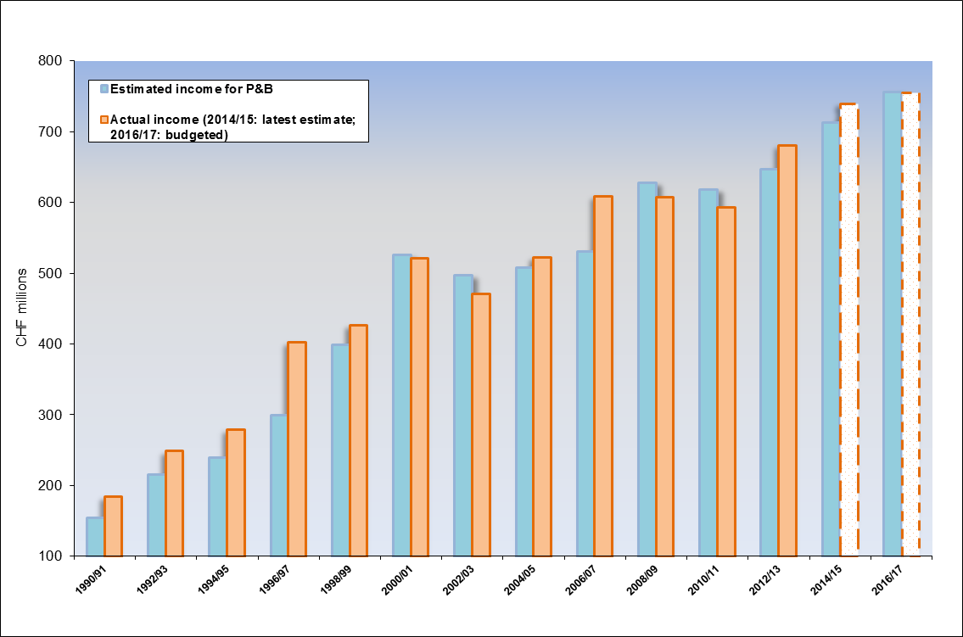
*Figures for 2014/15 and 2016/17 are budgeted income estimates

- The main source of income for the Organization remains fee income from its international registration services. The share of fee income of the Organization’s total income has continued to grow and is estimated at 94.5 per cent in 2016/17 as illustrated in the chart below.

Chart 2. Share of Fee Income / Total Income from 2004/05 to 2016/17

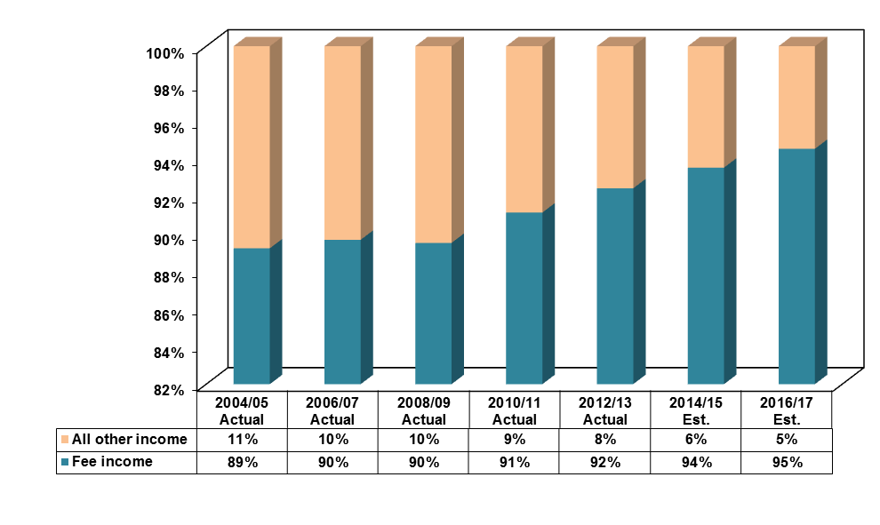
- The Organization continues to rely on the PCT fees for approximately 76 per cent of its revenue (in 2016/17), which is a high dependence on one income stream. In response to this strategic risk, the Organization will continue to explore opportunities to improve financial sustainability through the expansion of other revenue streams, including cost recovery opportunities.

Chart 3. Share of PCT Fee Income / Total Income from 2004/05 to 2016/17

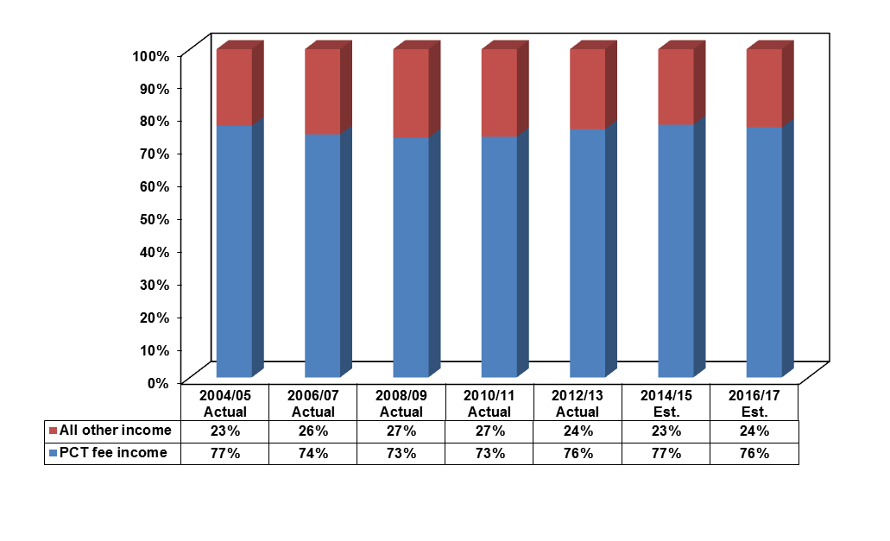

The income estimates by Union are contained in Annex III.

RESULTS FRAMEWORK AND PROGRAM AND BUDGET 2016/17 INCLUDING DEVELOPMENT SHARE BY RESULT
(in thousands of Swiss francs)
Mainstreaming Strategic Goal III - Facilitating the Use of IP for Development & Development Agenda | Strategic Goal VIII: A Responsive Communications Interface between WIPO, its Member States and All Stakeholders
 |  | VIII.1. More effective communication to a broad public about intellectual property and WIPO’s role  Proposed Budget 16/17: 12,033  Development share: 4,268 | VIII.2. Improved service orientation and responsiveness to inquiries  Proposed Budget 16/17: 6,219 Development share: 2,779 | VIII.3. Effective engagement with Member States  Proposed Budget 16/17: 7,099  Development share : - | VIII.4. Open, transparent and responsive interaction with non-governmental stakeholders  Proposed Budget 16/17: 1,128  Development share: - | VIII.5. WIPO effectively interacts and partners with UN and other IGO processes and negotiations  Proposed Budget 16/17: 6,196  Development share: 3,784 | Total proposed budget SG VIII: 32,675  Total development share SG VIII: 10,831
 | Strategic Goal I:  Balanced Evolution of the International Normative  Framework for IP | Strategic Goal II:  Provision of Premier  Global IP Services | Strategic Goal III:  Facilitating the Use of  IP for Development | Strategic Goal IV:  Coordination and Development of  Global IP Infrastructure | Strategic Goal V:  World Reference Source for  IP Information and Analysis | Strategic Goal VI:  International Cooperation on  Building Respect for IP | Strategic Goal VII:  Addressing IP in Relation  to Global Policy Issues
 | I.1. Enhanced cooperation among Member States on development of balanced international normative frameworks for IP  Proposed Budget 16/17: 13,976  Development share: 8,712  I.2. Tailored and balanced IP legislative, regulatory and policy frameworks  Proposed Budget 16/17: 9,748  Development share: 8,292  I.3. Increased protection of State emblems and names and emblems of International Intergovernmental Organizations  Proposed Budget 16/17: 544  Development share: -  I.4 Growing interest in WIPO as a forum for analysis of issues in relation to the international protection of patents, utility models, layout designs (topographies) of integrated circuits and confidential information  Proposed Budget 16/17: 494  Development share: - | II.1. Wider and more effective use of the PCT system for filing international patent applications  Proposed Budget 16/17: 29,156  Development share: 7,002  II.3. Improved productivity and service quality of PCT operations  Proposed Budget 16/17: 181,080  Development share: -  II.4. Wider and more effective use of the Hague system, including by developing countries and LDCs  Proposed Budget 16/17: 6,617  Development share: 1,085  II.5. Improved productivity and service quality of the Hague operations  Proposed Budget 16/17: 2,234  Development share: -  II.6. Wider and more effective use of the Madrid System, including by developing countries and LDCs  Proposed Budget 16/17: 17,069  Development share: 11,188  II.7. Improved productivity and service quality of Madrid operations  Proposed Budget 16/17: 42,253  Development share: 893  II.8. International and domestic intellectual property disputes are increasingly prevented or resolved through WIPO mediation, arbitration and other alternative dispute resolution methods  Proposed Budget 16/17: 4,802  Development share: 661  II.9. Effective intellectual property protection in the gTLDs and the ccTLDs  Proposed Budget 16/17: 6,899  Development share: 101  II.10 Wider and more effective use of the Lisbon system, including by developing countries and LDCs  Proposed Budget 16/17: 896  Development share: 597  II.11 Improved productivity and service quality of Lisbon operations  Proposed Budget 16/17: 648  Development share: - | III.1. National innovation and IP strategies and plans consistent with national development objectives  Proposed Budget 16/17: 10,957  Development share: 10,957  III.2. Enhanced human resource capacities able to deal with the broad range of requirements for the effective use of IP for development in developing countries, LDCs and countries with economies in transition  Proposed Budget 16/17: 39,734  Development share: 39,322  III.3. Mainstreaming of the DA recommendations in the work of WIPO  Proposed Budget 16/17: 2,492  Development share: 2,492  III.4. Strengthened cooperation mechanisms and programs tailored to the needs of developing countries, LDCs and countries with economies in transition  Proposed Budget 16/17: 6,273  Development share: 5,853  III.5. Enhanced understanding of the DA by Member States, IGOs, civil society and other stakeholders  Proposed Budget 16/17: 1,393  Development share: 1,393  III.6. Increased capacity of SMEs to successfully use IP to support innovation  Proposed Budget 16/17: 3,125 Development share: 3,125 | IV.1. Updated and globally accepted system of international classifications and WIPO standards to facilitate access, use and dissemination of IP information among stakeholders in the world  Proposed Budget 16/17: 7,070  Development share: 1,078  IV.2. Enhanced access to, and use of, IP information by IP institutions and the public to promote innovation and creativity  Proposed Budget 16/17: 22,539  Development share: 16,937  IV.3. Broad geographical coverage of the content and use of WIPO Global IP Databases  Proposed Budget 16/17: 1,956  Development share: 489  IV.4. Enhanced technical and knowledge infrastructure for IP Offices and other IP institutions leading to better services (cheaper, faster, higher quality) to their stakeholders and better outcome of IP administration  Proposed Budget 16/17: 15,409  Development share: 13,499 | V.1. Wider and better use of WIPO IP statistical information  Proposed Budget 16/17: 2,677  Development share: -  V.2. Wider and better use of WIPO economic analysis in policy formulation  Proposed Budget 16/17: 3,395  Development share: 1,525 | VI.1. Progress in the international policy dialogue among WIPO Member States on building respect for IP, guided by Recommendation 45 of the WIPO Development Agenda  Proposed Budget 16/17: 756  Development share: 507  VI.2. Systematic, effective and transparent cooperation and coordination between the work of WIPO and other international organizations in the field of building respect for IP  Proposed Budget 16/17: 1,308  Development share: 981 | VII.2. IP-based platforms and tools for knowledge transfer, technology adaptation and diffusion from developed to developing countries, particularly least developed countries, to address global challenges  Proposed Budget 16/17: 3,950  Development share: 3,016
 | Total proposed budget SG I: 24,762  Total development share SG I: 17,005 | Total proposed budget SG II: 291,655  Total development share SG II: 21,527 | Total proposed budget SG III: 63,974  Total development share SG III: 63,142 | Total proposed budget SG IV: 46,974  Total development share SG IV: 32,003 | Total proposed budget SG V: 6,072  Total development share SG V: 1,525 | Total proposed budget SG VI: 2,064  Total development share SG VI: 1,488 | Total proposed budget SG VII: 3,950  Total development share SG VII: 3,016
 | Strategic Goal IX: Efficient Administrative and Financial Support Structure to enable WIPO to Deliver its Programs
 |  | IX.1. Effective, efficient, quality and customer-oriented support services both to internal clients and to external stakeholders  Proposed Budget 16/17: 165,356  Development share: - | IX.2. An agile and smooth functioning Secretariat with a well managed and appropriately skilled workforce which is effectively delivering results  Proposed Budget 16/17: 35,257 Development share: - | IX.3. An enabling working environment supported by an effective regulatory framework and appropriate channels to address staff concerns  Proposed Budget 16/17: 2,540  Development share: - | IX.4. An environmentally and socially responsible Organization in which WIPO staff, delegates, visitors and information and physical assets are safe and secure  Proposed Budget 16/17: 18,403  Development share: - | IX.8. Improved accountability, organizational learning, value for money, stewardship, internal control and corporate governance through assistance from effective and independent oversight  Proposed Budget 16/17: 7,035  Development share: 963 | Total proposed budget SG IX: 228,591  Total development share SG IX: 963
 | ¹ The proposed budget by results does not include the proposed budget for unallocated: 6.319 million Swiss francs  ² Development share: Expenditure is qualified as development expenditure only where the beneficiary is a developing country and the equivalent expenditure is not available for developed countries (consistent with past practice, countries with economies in transition are included for the purposes of the Program and Budget)  ³ The figures for Development Share include Development Agenda project resources  ⁴ Figures might not add up to total budget due to rounding |  |  |  |  | Total proposed budget 2016/17: 707,036  Total development share: 151,500

RESULTS AND RESOURCES

- The proposal for the biennium 2016/17 ensures that the Organization’s resources continue to be deployed towards the achievement of results that are of highest value to our Member States and stakeholders. The total proposed expenditure for the 2016/17 biennium amounts to 707.0 million Swiss francs, representing an increase of 33 million Swiss francs or 4.9 per cent over the 2014/15 Approved Budget of 674 million Swiss francs. This should be seen in the context of an estimated increase in income of 6.0 per cent compared to the 2014/15 Approved Budget. This illustrates the Secretariat’s efforts to contain costs in spite of increasing demands for its services.

- The Results Framework Chart sets out the 37 organizational Expected Results for the 2016/17 biennium providing the mandate for the Programs contributing to these results. The Chart also provides the results-based view of the budget for the biennium 2016/17 and the development share of resources for each result. Furthermore, a breakdown of the extra-budgetary resources potentially available under each Program is reflected at the program level and in Annex VIII.

- The 2016/17 budget by Program and by cost category is summarized in tables 4 and 5 below. The program structure remains the same as in the biennium 2014/15, except for (i) Program 29 (New Conference Hall) which, following the completion of the construction, is not required in the biennium 2016/17, and (ii) Program 28 which now comprises Information Assurance (moved from Program 25 (Information and Communication Technology)) as well as Safety and Security. The comparison of the 2016/17 budget by Program with the 2014/15 Approved Budget and Budget after Transfers is provided in Annex I. Annex III, Table 13 contains the 2016/17 Budget by Program and Union.

- The budget is prepared on a modified accrual basis in accordance with the Organization’s Financial Regulations and Rules. WIPO’s budget continues to be presented and adopted by the Assemblies on a biennial basis. The IPSAS requirement for annual reporting of the Organization’s financial statements also requires the Organization to present its budget on an annual basis. For this purpose, annual budget figures are provided for both income and expenditure in Annex IX of this document.

Table 4. 2016/17 Proposed Budget by Program
(in thousands of Swiss francs)

Key priorities in the biennium

- Ensuring a more widespread and better use of the services provided by WIPO’s global registration systems, in particular, the PCT, Madrid and the Hague, remains a key priority in 2016/17. Appropriate and adequate resourcing of the Programs that deliver registration services, being the main foundation for the Organization’s long term financial sustainability, is key to ensuring that WIPO meets its treaty obligations and continues to satisfy applicants through high quality services. This will require meeting the challenges of the changing geographical composition of demand for such services, including the associated language skills requirements, and of the rapidly expanding membership of, in particular, the Madrid and the Hague Systems. Operational efficiency of the registration systems will also continue to be a priority as WIPO continues to move towards a fully electronic environment for the PCT, Madrid and the Hague.

- The associated total resources for the Hague System are reflected in Program 31 (The Hague System) and the associated increases for the PCT and the Madrid Systems are reflected in Program 5 (PCT) and Program 6 (Madrid System).

- As the external environment increasingly presents threats to WIPO’s operations, WIPO’s contingency planning capabilities will be enhanced through the establishment of an Organizational Resilience Framework with a view to mitigating or minimizing, to the extent possible, the impact of disruptions to the Organization’s critical operations.

- The associated total resources are reflected in Program 21 (Executive Management)

- The Organization is ever more dependent on reliable and effective ICT infrastructure and services. Global clients expect WIPO’s ICT services to be more responsive to their needs and increasingly reliable, accessible and secure against natural and man-made disasters including cyber attacks. Information security and business continuity therefore takes highest priority and will be the focus throughout the next biennium.

- The associated increases in total resources are reflected in Programs 5 (PCT), Program 25 (ICTD) and 28 (Information Assurance, Safety and Security).

- Facilitating enhanced cooperation and agreement among Member States on the further development of a balanced international normative framework for IP will continue in 2016/17 based on the decisions by Member States. The planning assumption for 2016/17 includes up to three sessions of the Standing Committee on the Law of Patents (SCP) and the Standing Committee on the Law of Trademarks, Industrial Designs and Geographical Indications (SCT) and up to four sessions of the Standing Committee on Copyright and Related Rights (SCCR) and the Intergovernmental Committee on Intellectual Property and Genetic Resources, Traditional Knowledge and Folklore (IGC), reflected in Programs 1 (Patent Law), Program 2 (Trademark Law), Program 3 (Copyright and Related Rights) and 4 (Traditional Knowledge, Traditional Cultural Expressions and Genetic Resources).

- A provision of 1 million Swiss francs has been made in the budget for the possibility of a Diplomatic Conference should Member States decide to convene one in the biennium 2016/17. The provision is reflected in “Unallocated”.

- Work will continue to encourage accession to and implementation of WIPO treaties, in particular, the Beijing Treaty, the Marrakesh Treaty, the WIPO Internet Treaties, the Singapore Treaty and the Patent Law Treaty.
- The associated total resources are reflected in Programs 1 (Patent Law), Program 2 (Trademarks, Industrial designs and Geographical Indications) and Program 3 (Copyright and Related Rights).

- The IP Statistics Data Center will continue to make available all statistics to users worldwide. Special efforts will be made to collect and report new statistics on geographical indications and copyright-related activities and to further improve the user-friendliness of WIPO statistics. In the area of economic analysis, WIPO will continue to be a co-publisher of the Global Innovation Index (GII), seeking to contribute to the measurement of innovation and providing policymakers with a tool to benchmark innovation performance. WIPO’s World Intellectual Property Report series will equally continue, seeking to explore new themes and deepen the analysis on global IP topics provided to date. In addition, a new line of research on policy and performance in copyright- related industries will be established in 2016/17.

- The associated increase in total resources is reflected in Program 16 (Economics and Statistics).

- Development continues to be a priority in the biennium 2016/17. This has resulted in the development share remaining stable at 21.1 per cent for the next biennium.

- This represents an absolute increase in estimated development expenditure of 4 per cent compared to the 2014/15 Approved Budget.

- The DA recommendations continue to guide WIPO development activities. Program linkages to the DA recommendations continue to be substantively reflected in each relevant Program narrative. DA projects have been mainstreamed, both in terms of substance and resources, in each Program in line with the Budgetary Process for Projects Proposed by the Committee on Development and Intellectual Property (CDIP) for the Implementation of the DA recommendations approved by the WIPO Assemblies in 2010.

- A total of six DA Projects are proposed in the biennium 2016/17, subject to approval by the CDIP, with an associated total resource envelope of 2.5 million Swiss francs.

- With the anticipated adoption by UN Member States of the Post 2015 Development Agenda and a new international climate change agreement, the UN is set to shift from negotiation to action. WIPO as a strongly committed member of the UN family, and embracing both the spirit and recommendations of the WIPO Development Agenda, will play its full part in the Global Partnership for Development to support implementation of all elements of the post 2015 Development Agenda.

- The associated total resources are, primarily, reflected in Programs 9 (Africa, Arab, Asia and the Pacific, Latin America and the Caribbean Countries, Least Developed Countries), 10 (Transition and Developed Countries), 18 (IP and Global Challenges) and 20 (External Relations, Partnerships and External Offices).

- Enhancing access to, and use of, IP information by IP institutions and the public to promote innovation and creativity will continue. The global databases will be expanded in terms of their geographical coverage of national data collections, including for the Global Designs Database developed in the biennium 2014/15.

- The associated increase in total resources is reflected in Program 13 (Global databases).

- Enhanced access to IP knowledge content will continue to be facilitated through the creation and/or strengthening of sustainable Technology Innovation Support Center (TICS) networks and special projects facilitating access to commercial databases.

- The associated total resources are reflected in Program 14 (Services for Access to Information and Knowledge).

- The strengthening of the technical infrastructure of IP offices through the revised technical assistance model, focusing on sustainable results at the country level, will continue in 2016/17. In addition, a first version of the WCC (WIPO Copyright Connection) system will be made available to a first group of collective management organizations CMOs in developing countries or LDCs.

- The associated increase in total resources is reflected in Program 15 (Business Solutions for IP Offices).

- Work in the area of copyright and related rights infrastructure, will focus on establishing the TAG of Excellence international quality assurance standard for (CMOs) as well as a TAG education program on the transparency, accountability and governance of CMOs. To complement the TAG-related activities, a new portal will be designed and developed to deliver many of WIPO’s copyright infrastructure projects via the Internet and in partnership with third parties. Work will also continue towards making the Accessible Books Consortium (ABC) the premier global entity for facilitating access to books by the print disabled around the world.

- The associated total resources are reflected in Program 3 (Copyright and Related Rights).

- Improved delivery and coherence of WIPO’s technical cooperation in developing countries, least developed countries (LDCs) and countries with economies in transition will receive particular attention in 2016/17, building on progress made in developing national IP strategies in 2014/15. To this end, country plans, developed and maintained by the Regional Bureaus on the basis of the needs and realities of the recipient countries, and containing all projects and activities that will take place in each country, will be institutionalized. Technical cooperation will also increasingly be delivered through project-based approaches, leveraging the experience gained in recent years through the implementation of DA and other special development projects. A coherent planning and reporting of South-South activities at the Organizational level and interface with all internal and external stakeholders will also be ensured.

- The associated total resources are reflected in Programs 9 (Africa, Arab, Asia and the Pacific, Latin America and the Caribbean Countries, Least Developed Countries) and 10 (Transition and Developed Countries).

- The special focus on LDCs will be reinforced in order to respond to increasing individual and common needs. Special emphasis will be given to develop their national and technological IP capacity to assist in their main goals such as poverty alleviation and economic growth and other development policies. The DA project on Capacity-building in the Use of Appropriate Technology-specific Technical and Scientific Information as a solution for identified development challenges is the main vehicle of support in this area. Furthermore, WIPO will, in particular, continue supporting activities within the priority areas identified in the WIPO Deliverables, adopted on the occasion of the Fourth United Nations Conference on the LDCs (LDC IV) and designed to contribute towards the implementation of the Istanbul Programme of Action (IPoA).

- The associated total resources are reflected in Programs 9 (Africa, Arab, Asia and the Pacific, Latin America and the Caribbean Countries, Least Developed Countries).

- In order to achieve a more integrated planning and delivery of WIPO training and capacity building activities, and to enhance quality and cost-effectiveness, the WIPO Academy embarked, in 2014/15, on a gradual and consistent reform process to reposition the Academy as the organization-wide vehicle for professional training and capacity-building. This process will continue in 2016/17.

- The associated total resources are reflected in Program 11 (The WIPO Academy).

- Building upon initiatives launched in 2014/15 to enhance the added value and further improve the productivity and efficiency of the External Offices, efforts will continue in 2016/17 to enhance the seamless integration of existing External Offices into all relevant aspects of the functioning of the Organization. This will be supported by the roll-out of a standard Global Office system and architecture. This will be critical to ensuring that WIPO continues to evolve as a truly global Organization that is responsive to its Member States and stakeholders and is able to realize its ambitious goals of delivering its services more efficiently through closer co-operation.

- The associated total resources are reflected in Program 20 (External Relations, Partnerships and External Offices). Should Member States agree on the opening of new External Offices in 2016/17, these could be funded from the provision of 1 million Swiss francs under non-personnel resources in “Unallocated”.

- Efforts to achieve an agile and smooth functioning Secretariat with a well-managed and appropriately skilled workforce which is effectively delivering results will continue to be pursued under Strategic Goal IX. Gender balance and geographical diversity will receive particular attention in the biennium. Further efforts will be made to develop managerial and leadership skills of women in the Organization, with a view to enabling them to take up positions at higher levels, while continuing the outreach to potential women candidates. As regards geographical diversity, proactive and increased efforts will be made, with support from Member States, to reach out to potential candidates from countries that are not well represented among staff in the professional and higher categories. Following the implementation of the revised Staff Regulations and Rules (SRR), approved by the Coordination Committee in 2012 and 2013, including the strengthening of the internal justice system, an important focus area in 2016/17 will be conflict prevention and mitigation and the effective management of cases through the internal justice system. The Organization will also continue to engage with the Review of the UN common system compensation package.

- The associated total resources are reflected in Program 23 (Human Resources Management and Development).

- With the adoption of the Language Policy by Member States in 2011, and the extension of the six-language cover to all documentation for WIPO Committees and Main Bodies in the 2012/13 biennium, similar coverage was extended to several Working Groups in the 2014/15 biennium. It is expected that the remaining Working Groups will be covered in the 2016/17 biennium. In order to contain translation costs, the network of external individual translators and translation companies has been strengthened to ensure the ‘right-sourcing’ of translation work and new technology tools have been deployed to improve the translation environment, build terminology databases and ensure quality control. The length and number of documents will also continue to be closely monitored. These rationalization measures have resulted in a containment of translation costs.

- The associated total resources are reflected in Program 27 (Conference and Language Services). Part of the increase in the non-personnel budget approved for the Program in the 2014/15 biennium, is therefore estimated not to be required in 2016/17.

- The next biennium will be characterized by several changes in the banking and investment domain on account of the current advantageous banking facility provided to WIPO by the Swiss Federal Department of Finance coming to an end in December 2015 and the introduction of negative interest rates on Swiss franc deposits. There will therefore be a need to ensure a more active and yet prudent investment planning and management approach guided by a revised investment policy approved by Member States.

- A provision of 2.4 million Swiss francs has been made in the non-personnel budget for the payment of the negative interest rates on WIPO deposits.

- Absorption into operations of the new modules and capabilities of the ERP system will intensify in 2016/17, resulting in the need to support and sustain a complex and fully integrated ERP system in a cost-effective and service–oriented manner. Outsourcing of support, maintenance and technical development under a robust management and quality assurance framework will remain a key strategy.

- A provision of 1.6 million Swiss francs has been made for the increased ERP footprint under the non-personnel budget of Program 22 (Program and Resource Management).

- Further improvements have been made to the measurements metrics, i.e. performance indicators, baselines and targets in line with the recommendations made by the independent validation carried out by the Internal Oversight Division (IOD) and the call for improvements made by Member States in respect of the Program Performance Report (PPR). Baselines in the Program and Budget have, to the extent possible, been aligned with the performance data in the 2014 PPR.

- The implementation of a structured and periodical Risk Management process across the Organization has resulted in improved planning and understanding of events that could hinder the achievement of Expected Results. All Programs now undertake risk assessments as part of biennial planning and annual work planning. Throughout this document, the key risks and mitigation strategies for each Program are detailed at the end of each Program narrative.

Table 5. 2016/17 Proposed Budget by Object of Expenditure
(in thousands of Swiss francs)

Notes:
- The 2014/15 Budget after Transfers reflects transfers to address needs during the 2014/15 biennium in line with Financial Regulation 5.5: “The Director General may make transfers from one program of the program and budget to another for any given financial period, up to the limit of five per cent of the amount corresponding to the biennial appropriation of the receiving program, or to one per cent of the total budget, whichever is higher, when such transfers are necessary to ensure the proper functioning of the services”. The 2014/15 Budget after Transfers is as of March 31, 2015.
- Changes in cost categories between the biennium 2014/15 and 2016/17are explained in the section “Cost Category Changes” below.

NON-PERSONNEL RESOURCES

- The increase in non-personnel resources in 2016/17 amounts to 22.8 million Swiss francs, or 10 per cent, compared to the Approved Budget for 2014/15. However, compared to the 2012/13 non-personnel Approved Budget, the non-personnel budget for 2016/17 represents an increase of 4.9 per cent only.

- The increase in non-personnel costs has been enabled through a conscious strategy of moving to a more flexible resourcing model resulting in a containment of personnel costs.

- The increase in non-personnel costs is driven primarily by:

- Increase in the PCT translation volumes

- Additional estimated translation costs of 4.2 million Swiss francs (reflected in Program 5 – The PCT System)

- Expanding membership of the Madrid System and enhancement of the operational efficiencies of the system

- Additional estimated non-personnel resources requirements for the Madrid System of 2.5 million Swiss francs (reflected in Program 6 – Madrid System)

- Increased dependencies on Information and Communication Technologies, and need for enhanced PCT resilience and ICT security

- Additional estimated non-personnel resources requirements of 1.4 million Swiss francs (reflected under Program 5 – The PCT System), 6.9 million Swiss francs (reflected in Program 25 – Information and Communication Technology) and 3.9 million Swiss francs (reflected in Program 28 – Information Assurance, Safety and Security)

- Increased ERP footprint in operations

- Additional estimated non-personnel resources requirements of 1.6 million Swiss francs (reflected under Program 22 – Program and Resource Management)

- Negative interest rates on Swiss franc deposits

- Estimated non-personnel resources requirements of 2.4 million Swiss francs (reflected under Program 22 – Program and Resource Management)

- The Secretariat has budgeted for requirements related to renovations, transformations and/or modernization of premises within the regular budget of Program 24 (General Support Services).

- Cost efficiency measures identified in the biennium 2014/15 are baselined into the Program and Budget 2016/17 (i.e. travel cost and contract efficiencies, reduction in printing costs, right sourcing of translation, etc). Further cost efficiency measures will continue to be identified and implemented during the biennium, including through the Geneva International Collaboration Group, an informal group of Geneva-based international organizations established in 2014. The Group aims at achieving economies of scale in areas including insurance, conference and printing services and host country services.

Cost category changes

- The changes in cost categories for 2016/17 are as follows:

- A new cost category “Finance Cost” has been created following the recommendation of the External Auditor to report separately the interest payments on the loan on the New Building (budgeted in Program 24) and bank charges, including the payment of negative interest rates on Swiss franc deposits (budgeted in Program 22). As a result, an increase of 6.4 million Swiss francs can be observed under “Finance Costs” partially offset by a decrease of 3.5 million Swiss francs under “Premises and Maintenance” (the interest payments on the loan were previously budgeted under the latter cost category). In 2016 /17, the former “Admin and Bank Charges” cost category is therefore replaced by “Finance Costs”.

- The new cost category “Representation and other operating expenses”, groups representation costs and other operating expenses (budgeted in 2014/15 under “Admin and Bank Charges”). This results in an increase of 0.3 million Swiss francs for 2016/17.

- The former cost category “Course Fellowships” has been renamed “Training and related travel grants” to better distinguish the nature of this expenditure from the “WIPO Fellowships”. Although the decrease in this category compared to the 2014/15 Budget after Transfers amounts to 0.8 million Swiss francs, the decrease compared to the 2014/15 Approved Budget amounts only to 0.2 million Swiss francs. The observed changes reflect a redistribution of resources within the WIPO Academy and Program 3 (Copyright and Related Rights).

- The increase in “Other Contractual Services” of 21.4 million, or 21.6 per cent, compared to the 2014/15 Budget after Transfers primarily relates to the increase in PCT translation volumes, the need for enhanced PCT resilience, increased dependencies on ICT and information security. The latter also results in an increase in “Supplies and Materials” (notably the increased cost of software and licenses).

- Increased operational needs under the international registration systems result in increased resources of 0.7 million Swiss francs budgeted for “WIPO Fellowships” in 2016/17 compared to the 2014/15 Budget after Transfers.

- The decrease of 0.5 million in budgeted resources under “Conferences” is due to the provision for two diplomatic conferences in 2014/15 under Programs 2 and 4, as compared to a provision for one possible diplomatic conference in 2016/17 budgeted under “Unallocated Non-personnel”.

- In the biennium 2016/17 internships are no longer budgeted centrally in Program 23 (Human Resources Management and Development) but have been decentralized to Programs. The budgeted provision for 2016/17 represents an increase of 0.1 million Swiss francs compared to the 2014/15 Approved Budget which reflects a more realistic planning assumption based on expected needs.

PERSONNEL COSTS

Methodology

- A change in the costing methodology has been adopted for the personnel resources budget by moving from a methodology based on average standard costs to actuals based costing. The new methodology is aimed at enhancing the solidity of personnel cost assumptions based on the actual entitlements of incumbents on board.

- While costs for occupied positions are based on the latest available UN salary and pensionable remuneration scales, benefits and entitlements (in line with the applicable policies and applicable entitlements), the cost for positions that are vacant is based on average standard costs.

- The implementation of the new methodology has been facilitated by the ERP at the planning stage and will enable the Secretariat to better monitor actual personnel expenditure at position level during implementation.

Planning Assumptions

- For occupied positions the costing of salaries for 2016/17 takes into account the step increment (within grade) as per the applicable International Civil Service Commission (ICSC) salary scale at the time of costing and the Staff Regulations and Rules (SRR);

- The exchange rate and post adjustment multiplier (PAM) are applied as of February 2015, where applicable (for salaries of professional and higher categories);

- USD/CHF is applied at a 1:1 ratio for pensionable remunerations at the applicable ICSC salary scale at the time of costing;

- Benefits and entitlements are estimated at position level as per latest payroll information for occupied positions. An average cost has been determined for vacant positions;

- Provisions for home leave have been decreased to take into account the estimated savings of approximately 4 million Swiss francs for the biennium resulting from the full implementation of the new policy on home leave;

- No new positions are foreseen in 2016/17. An overall vacancy rate of 3 per cent has been applied to the overall costing based on the assumption that productivity improvements and automation will result in the non-filling of 20 posts during the biennium without affecting the achievement of Expected Results. Recruitments will also be prudently managed to ensure that an additional 10 positions remain vacant at any point in time;

- Provisions for ASHI have been maintained at 6.0 per cent for fixed term and continuing positions;

- Other Staff Costs include the budgeted biennial provisions for Professional Accident Insurance (PAI) (900,000 Swiss francs), the Closed Pension Fund (700,000 Swiss francs), litigation costs (400,000 Swiss francs) and the WIPO Rewards and Recognition Program (120,000 Swiss francs); the latter was introduced in 2014;

- Provisions for reclassification are budgeted at the level of 1.5 million Swiss francs in “Unallocated (Personnel)” based on actual reclassification costs in 2014/15;

- The 2014/15 biennium will see the near completion of the regularization of long serving temporary staff and continuing functions, establishing a solid base for the Organization’s personnel needs. In the upcoming biennia, the emphasis will be on ensuring that increasing demands are met through more innovative and sustainable resourcing models. A provision of 800,000 Swiss francs has been earmarked in “Unallocated (Personnel)” for the remaining regularization of continuing functions, within the framework of the 156 regularization posts approved in principle by Member States at their Assemblies in 2010 (reference document WO/CC/63/5). A total of 41 regularizations are currently pending;

- In order to enable the Secretariat to better monitor and control overtime expenses, the estimated overtime costs are budgeted in a separate provision in “Unallocated (Personnel)”. On the basis of past expenditure patterns, the provision amounts to 2 million Swiss francs. The overtime costs will be closely monitored in coordination with Program 23 (Human Resources Management and Development) and concerned Program areas.

- Based on the above planning assumptions, the increase in personnel costs in 2016/17 has been contained at 9.6 million Swiss francs, or 2.1 percent, compared to the 2014/15 Approved Budget. Compared to the 2014/15 Budget after Transfers, the increase amounts to 10.3 million or 2.3 per cent. The share of budgeted personnel costs compared to the total budget has decreased from 66.3 per cent in 2014/15 to 64.6 per cent in 2016/17. This is the result of a conscious strategy to contain personnel costs as well as the share of the personnel cost of the total expenditure of the Organization and move towards a more agile and flexible workforce which can easily adapt to business needs.

- The overall increase in 2016/17 under “Posts” compared to the 2014/15 Approved Budget relates primarily to statutory increases. It also reflects completed regularizations offset by a reduction under “Temporary Staff”.

- The net reduction under “Other Staff Costs” is due to estimated savings of 400,000 Swiss francs in respect of Professional Accident Insurance (PAI), partly offset by an increase of 50,000 Swiss francs for the Closed Pension Fund and an increase of approximately 120,000 Swiss francs under the WIPO Rewards and Recognition program.

- The net increase under “Unallocated (Personnel)” is mainly due to the provisioning of overtime expenses of 2 million Swiss francs, previously budgeted under “Posts”, partly offset by an overall reduction of 500,000 Swiss francs for reclassifications and approximately 500,000 Swiss francs for regularizations as compared to the 2014/15 Approved Budget.

Chart 4. Cost Structure Evolution 1990/91-2016/17

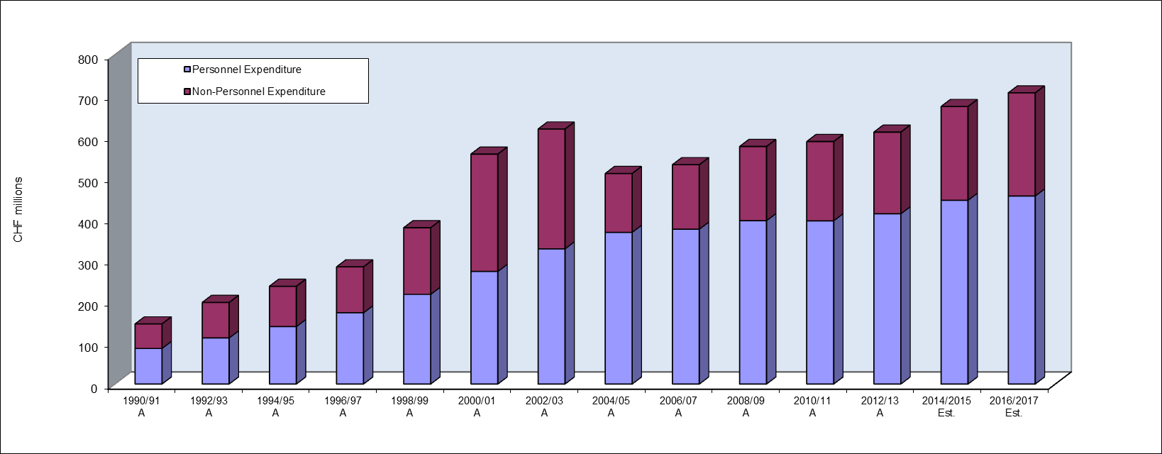

DEVELOPMENT ACTIVITIES AND DEVELOPMENT AGENDA RESOURCES

- Development continues to be a priority in the biennium 2016/17 reflected by a stable development share of 21.1 per cent in the next biennium. The absolute increase in development expenditure in 2016/17 represents 5.8 million Swiss francs, or 4 per cent, compared to the 2014/15 Approved Budget. The table below provides details of the development expenditure for 2016/17 by Program. Expenditure is qualified as development expenditure, only where the beneficiary is a developing country and the equivalent expenditure is not available for developed countries. These amounts exclude foregone revenues resulting from the fee reductions accorded under the international registration systems for applicants from developing countries. If such expenditure were to be included, the overall figure for development expenditure would be higher.

Table 6. Development Expenditures in 2016/17 by Program
(in thousands of Swiss francs)
- The methodology applied to estimate the development share of the budget for 2016/17 is fully in line and consistent with the methodology adopted in 2014/15.

- A total of 2.5 million Swiss francs have been specifically earmarked within the budget for 2016/17 for the implementation of DA projects, subject to approval by the CDIP.

Table 7. Development Agenda Projects in 2016/17
(in thousands of Swiss francs)

*Subject to CDIP approval. Total estimated cost of the project is 540,000 Swiss francs. Implementation timeframe: 2016-2018.
**Subject to CDIP approval. Total estimated cost of the project is 800,000 Swiss francs. Implementation timeframe: 2016-2018.
***Subject to CDIP approval.
II. PROGRAM NARRATIVES BY STRATEGIC GOAL

STRATEGIC GOAL I BALANCED EVOLUTION OF THE INTERNATIONAL NORMATIVE FRAMEWORK FOR IP

This Strategic Goal aims to ensure that the development of international IP law keeps pace with the rapidly evolving global technological, geo-economic, social and cultural environment, while taking into account implementation of the recommendations of the Development Agenda on norm-setting. A balanced evolution is critical to ensuring that the international intellectual property system continues to serve its fundamental purpose of encouraging innovation and creativity; that it takes into account the needs and interests of countries at different stages of development, including through the flexibilities within international IP agreements; and that it strikes the right balance between (i) the rights of creators and IP owners and the rights of users and the public; and (ii) the encouragement of innovation and creativity and the diffusion of the social benefit of innovation and creative works.

Expected Results | Performance Indicators | Responsible Program(s)
I.1 Enhanced cooperation among Member States on development of balanced international normative frameworks for IP | Progress on the implementation of agreed work according to SCP Agenda | Program 1
 | Level of satisfaction of participants in targeted workshops/seminars held on specific patent related topics | Program 1
 | Level of satisfaction of participants in the Inventor Assistant Program (IAP) | Program 1
 | Progress towards agreement on current issues on the SCT Agenda | Program 2
 | Progress in the implementation of agreed work according to the SCCR agenda | Program 3
 | Progress towards implementation of normative activities on IP and GRs, TK and TCEs as agreed by Member States | Program 4
 | No. of ratifications/accessions to the Singapore Treaty | Program 2  Program 20
I.2 Tailored and balanced IP legislative, regulatory and policy frameworks | % of recipients which found information concerning legal principles and practices of the patent, utility model and integrated  circuit systems, including the flexibilities, useful | Program 1
 | No. and % of Member States satisfied with the legislative and policy advice provided | Program 1
 | No. and % of Member States/regional organizations providing positive feedback on the legislative advice offered in the area of trademarks, industrial designs and geographical indications | Program 2
 | No. of countries that have ratified or acceded to the Beijing Treaty | Program 3  Program 20
 | No. of countries that have ratified or acceded to the Marrakesh Treaty | Program 3  Program 20
 | No. of ratifications or accessions to the copyright treaties in force including the Berne Convention, Rome Convention, and Internet Treaties | Program 3  Program 20
 | % of countries that have provided positive feedback about WIPO’s legislative advice | Program 3
 | No. and/or % of countries providing positive feedback on WIPO’s Legislative policy advice | Program 9
 | No. of transition countries with updated national laws | Program 10
 | No. of ratifications to WIPO administered treaties | Program 10
 | No. of countries/regional organizations having adopted or amended relevant frameworks towards effective IP enforcement in the light of Part III of the TRIPS Agreement and DA Recommendation 45, or being in the process of doing so, further to WIPO assistance | Program 17
 | No. of countries that have adopted and/or implemented a national strategy on Building Respect for IP, or are in the process of doing so, with WIPO assistance | Program 17
 | No. of countries requesting WIPO’s specific contribution on IP in relation to competition policy-related issues | Program 18
 | No. and diversity of stakeholders (IP Offices, competition and authorities, relevant IGOs and NGOs) engaged in dialogue with WIPO | Program 18
I.3 Increased protection of State emblems and names and emblems of International Intergovernmental Organizations | No. of signs contained in the Article 6ter database | Program 2
I.4 Growing interest in WIPO as a forum for analysis of issues in relation to the international protection of utility models, layout designs (topographies) of integrated circuits and confidential information | % of recipients which found information concerning legal principles and practices on the protection of utility models, layout designs (topographies) of integrated circuits and confidential information, useful | Program 1

PROGRAM 1 PATENT LAW

PLANNING CONTEXT

- Program 1 covers issues relating to patents, utility models, layout designs (topographies) of integrated circuits and protection of confidential technical/business information (hereinafter referred to as “confidential information”). Key challenges addressed by this Program include promoting multilateral solutions in a manner that the development of international patent law keeps pace with the rapidly evolving technological, economic and social environment. The most important challenges anticipated for the 2016/17 biennium are as follows:

  - The role of the patent system in increasingly complex and globalized innovation mechanisms, and different perceptions as to its role, including its benefits for society at large;

  - The increasing demand for empirical information that supports policy makers in making public policy choices relating to the appropriate scope and application of the patent system;

  - More targeted information about the role, impact and implementation of the international patent system, including flexibilities, in both multilateral fora and through legislative and policy advice to Member States;

  - The increasing demand for legislative and policy advice to Member States;

  - Against the backdrop of the increasing use of the patent system, the need to address effectiveness, efficiency and quality of patent administration work that supports the objectives of the patent system;

  - Insufficient capacities for preparing, filing, and prosecuting patent applications;

  - As a consequence of the better appreciation of the complexity of knowledge transfer mechanisms, the need to address patent law in the context of other closely related categories of IP, such as protection of utility models, layout designs (topographies) of integrated circuits and confidential information; and

  - Keeping pace with technological developments to understand what, if any, actions may be needed to address the developments at the international level, taking into account various needs of countries at different level of development while respecting their international obligations.

IMPLEMENTATION STRATEGIES

- The work of the Standing Committee on the Law of Patents (SCP) has been stalled because of the absence of agreement among Member States. As the normative process is Member State driven, the Program will focus its efforts on providing reliable information and supporting an environment conducive to engagement and dialogue among Member States regarding areas of common interest. The Secretariat will also endeavor to assist the Member States to conduct more efficient meetings, with outputs of the SCP better corresponding to the inputs. The Program will continue to improve its responsiveness and efficiency in legislative and policy assistance. The relevant DA recommendations will be taken into account in the context of the activities of this Program during the biennium. In particular, provision of patent-related information and legislative advice fully takes into account the relevant DA Recommendations thus supporting the DA objectives of “evidence-based international and national policy and decision making on IP” and “national and international IP regulatory frameworks that promote creativity and innovation and reflect the level of development of the different WIPO member States”. In addition, the work undertaken under the completed DA projects, in particular, IP and the Public Domain, and Patents and the Public Domain will be taken into consideration.

- Specifically, during the next biennium, the Program expects to:

  - Organize sessions of the SCP;

  - Organize, upon request, information meetings for Member State representatives, to provide information on topics related to patent policy, law and practices taking duly into account DA Recommendation 15 and 16;

  - Continue to provide, upon request, legislative advice to Member States relating to patents, utility models, layout designs (topographies) of integrated circuits and protection of confidential information in line with DA Recommendations 17, 20 and 22;

  - Continue to support and assist Member States regarding the Paris Convention, the Budapest Treaty and the Patent Law Treaty;

  - Continue to support and assist Member States with a view to enhancing capacities for designing functional systems regarding patents, utility models, layout designs (topographies) of integrated circuits and protection of confidential information;

  - Address issues relating to protection of patents, utility models, layout designs (topographies) of integrated circuits and confidential information in the context of promotion of innovation and dissemination of technology; and

  - Continue to support the work of Program 9 (Africa, Arab, Asia and the Pacific, Latin America and the Caribbean Countries, Least Developed Countries) relating to Patent Law issues, including the provision of studies relevant to DA Recommendations 12, 13 and 14, as requested by the CDIP.

- Program 1 collaborates primarily with other Programs as illustrated below:

MAJOR RISKS AND MITIGATION STATEGIES

Risk | Mitigation
Reduced relevance of the Standing Committee on the Law of Patents as a multilateral forum. | Provision of impartial, professional and inclusive environment for dialogue among Member States.
 | Provision of timely, accurate and substantive information to Member States.

RESULTS FRAMEWORK

Expected Results | Performance Indicators | Baselines | Targets
I.1 Enhanced cooperation among Member States on development of balanced international normative frameworks for IP | Progress on the implementation of agreed work according to SCP Agenda | Current state of work in the Committee as documented by SCP/21 Report | SCP agreed outcomes
 | Level of satisfaction of participants in targeted workshops/seminars held on specific patent related topics | 92.75 % - 2014 survey | 90%
 | Level of satisfaction of participants in the Inventor Assistant Program (IAP) | n/a | 90%
I.2 Tailored and balanced IP legislative, regulatory and policy frameworks | % of recipients which found information concerning legal principles and practices of the patent, utility model and integrated  circuit systems, including the flexibilities, useful | 7 countries/ participants (85.7%) - 2014 survey | 90%
 | No. and % of Member States satisfied with the legislative and policy advice provided | 8 Member States (90 %) - 2014 survey | 90%
I.4 Growing interest in WIPO as a forum for analysis of issues in relation to the international protection of patents, utility models, layout designs (topographies) of integrated circuits and confidential information | % of recipients which found information concerning legal principles and practices on the protection of utility models, layout designs (topographies) of integrated circuits and confidential information, useful | n/a | 90%

RESOURCES FOR PROGRAM 1

1.5 The slight increase in the overall resources for Program 1 in 2016/17 compared to the 2014/15 Budget after Transfers, is the result of (i) the transfer of responsibilities for patent drafting to the Program from Program 30 (SMEs and Entrepreneurship Support) and (ii) activities linked to addressing issues relating to protection of patents, utility models, layout designs (topographies) of integrated circuits and confidential information in the context of promotion of innovation and dissemination of technology.

Program 1: Resources by Result
(In thousands of Swiss francs)

Program 1: Resources by Object of Expenditure
(In thousands of Swiss francs)

PROGRAM 2 TRADEMARKS, INDUSTRIAL DESIGNS AND GEOGRAPHICAL INDICATIONS

PLANNING CONTEXT

- Brands are one of the primary sources of competitive advantage. They are critical to the commercialization of new products (including services), and for providing information about products to customers in a fast-moving economy. A growing number of economic studies has demonstrated the role of brands for innovation and their overall economic importance. Likewise, the role of designs in the world economy is constantly gaining importance and evidence on the function of designs as a source of innovation and economic growth is emerging. Against this background, policy makers need to keep the legal framework for the protection of brands and designs under continued scrutiny with a view to fostering innovation and business performance, and to developing informed responses to newly emerging challenges. Program 2 will endeavor to produce outcomes, which will allow WIPO to advance a balanced evolution of the international framework for brands and designs and to enable the establishment of a legal environment that responds to the specific needs and requirements of Member States’ brand and design industries.

IMPLEMENTATION STRATEGIES

- Progress in the development of a balanced international legal framework for brands and designs that is conducive for innovation and economic growth is the Program’s main objective. With regard to an international regulatory framework for industrial design registration procedures, the Standing Committee on the Law of Trademarks, Industrial Designs and Geographical Indications (SCT) has significantly advanced work on a draft Design Law Treaty, aiming at simplifying design registration procedures. Subject to a decision by the WIPO General Assembly, this work could result in the holding of a Diplomatic Conference for the adoption of a Design Law Treaty during the biennium. Moreover, the SCT will continue to service the work of Member States on agreed topical subjects in the area of trademarks, industrial designs and geographical indications. The SCT will continue to observe developments in the Domain Name System (DNS) (in cooperation with Program 7) and in the area of International Nonproprietary Names for Pharmaceutical Substances (INNs). Due consideration will be given to Cluster B of the DA Recommendations (Recommendations 15 to 17 and 20 to 22), ensuring that account is taken of the different levels of development of WIPO Member States; flexibilities of interest to developing countries and LDCs; the views of all Member States and other stakeholders; and development goals agreed within the UN system. WIPO will also deliver the appropriate legal and administrative support to Member States and certain international intergovernmental organizations for the protection of certain of their emblems under Article 6ter of the Paris Convention.

- Implementation will include organizing sessions of the SCT. In line with DA Recommendation 15, sessions of the SCT will be open to all Member States and accredited observers. Working documents will be prepared by the Secretariat and presented in all six official languages of the UN.

- The Secretariat will continue to ensure the efficient administration of Article 6ter Paris Convention communication procedures and produce biannual electronic publications containing all signs to be communicated under Article 6ter(3).
- As regards Strategic Goal III (Facilitating the Use of IP for Development), Program 2 will provide country-specific advice to Member States in response to priorities identified within their national IP strategies. The provision of legal advice will be coordinated with other Programs as illustrated below.

MAJOR RISKS AND MITIGATION STRATEGIES

Risk | Mitigation
Agreements at the multilateral level remain challenging and the successful conclusion of normative activities under Program 2 will depend to a large degree on Member States’ commitment to define mutually agreed outcomes. | This is an inherent risk of every norm developing activity which, by its nature, will have to be retained by the Program. Nevertheless, specific program activities, in particular sessions of the SCT, will allow ongoing dialogue and exchange of views with a view to identifying common areas of common understanding and potential agreed outcomes.

RESULTS FRAMEWORK

Expected Results | Performance Indicators | Baselines | Targets
I.1 Enhanced cooperation among Member States on development of balanced international normative frameworks for IP | Progress towards agreement on current issues on the SCT Agenda | State of advancement of SCT work at the end of 2015 as per relevant working documents | SCT agreed outcomes
 | No. of ratifications/accessions to the Singapore Treaty | Seven new Contracting Parties in 2014: Belarus, Belgium, Benelux Organization for Intellectual Property (BOIP), Iraq, Luxembourg, the Netherlands and Tajikistan, which brings the total number of Contracting Parties to 38 at the end of 2014. | Eight new ratifications/accessions
I.2 Tailored and balanced IP legislative, regulatory and policy frameworks | No. and % of Member States/regional organizations providing positive feedback on the legislative advice offered in the area of trademarks, industrial designs and geographical indications | 2014: Advice was provided to 20 Member States/Regional Organizations. Feedback was received from seven respondents, all of whom (100%) reported satisfaction with the advice offered | 90% of respondents satisfied with the advice offered
I.3 Increased protection of State emblems and names and emblems of International Intergovernmental Organizations | No. of signs contained in the Article 6ter database | 3,103 (as at April 15, 2015) | 120 new signs published during the biennium

RESOURCES FOR PROGRAM 2

- The overall resources for Program 2 in 2016/17 show a decrease compared to both the 2014/15 Approved Budget and the 2014/15 Budget after Transfers. This is due to: (i) a budgetary provision of up to three sessions of the SCT in 2016/17 as compared to four sessions in 2014/15 and (ii) the budgetary provision for a possible diplomatic conference in 2016/17 now reflected under “Unallocated”. This is reflected in the decrease of resources under Expected Result I.1.

- The resources under Expected Result III.4 in the 2014/15 Approved Budget reflect the DA project on IP and Design Creation for Business Development in Developing and Least Developed Countries is expected to be completed by the end of 2015. Hence no resources are foreseen under this Expected Result in 2016/17.

Program 2: Resources by Result
(In thousands of Swiss francs)

Program 2: Resources by Object of Expenditure
(In thousands of Swiss francs)

PROGRAM 3 COPYRIGHT AND RELATED RIGHTS

PLANNING CONTEXT

- Fundamental changes have occurred in the global environment for creative works, which produce challenges and opportunities for WIPO. This is most evident in the area of copyright and related rights where digital technology, the Internet and mobile applications are profoundly changing the culture and creative industries.

- The following issues and challenges continue to be relevant in the next biennium. As regards, normative and policy related work, a number of outstanding issues remain to be resolved on the copyright normative agenda. Subjects for the future agenda of the Standing Committee on Copyright and Related Rights (SCCR) will also need to be identified.

- In addition, a key challenge for the Secretariat will be to respond to Member States’ requests for advice in making their national laws compatible with their international obligations, taking into account the existing flexibilities in the multi-lateral system.

- Developing and least developed countries continue to be challenged by rapid technological developments and the interface of these new technologies with copyright protection systems. It is therefore essential for WIPO to put in place sustainable technical assistance programs which assist such countries to meet related challenges.

- In a rapidly changing world which is increasingly dependent upon digital technologies, the biggest infrastructure challenge will be to ensure that rightsholders receive their full due and that rights users have easy, legal access to the copyright content of their choice.

IMPLEMENTATION STRATEGIES

- Against the above background, the Program will focus on the following priorities in the next biennium the implementation of which will take duly into account DA Recommendations 1, 6, 12 to 17, 19 and 20.

Normative and Policy Related Work

- Two SCCR meetings will be scheduled each year. Advancement of the normative agenda will focus primarily on facilitating substantive negotiations on SCCR agenda items and responding to Member State requests regarding implementation of new and existing treaties. The facilitation work will relate to the proposed broadcasting treaty, limitations and exceptions for libraries, archives and educational and research institutions, as well as for persons with disabilities (other than print disabilities).

- The new treaties to be implemented are the Beijing Treaty on Audiovisual Performances and the Marrakesh Treaty to Facilitate Access to Published Works for Persons Who Are Blind, Visually Impaired or Otherwise Print Disabled. Work will be undertaken to encourage the implementation of the Beijing and Marrakesh Treaties, in coordination with representatives of the beneficiaries of the Treaties, intermediaries involved with implementation, and Member States.

- A number of studies requested by the SCCR and conferences on topical issues will be undertaken during this biennium.

Technical Assistance to Developing Countries and LDCs

- Technical assistance to developing countries and LDCs will continue to focus on building technical and knowledge capacity within institutions, such as national copyright offices, and among stakeholders, to facilitate the effective use of the copyright system for social, cultural and economic development. To this end, internal coordination with other Programs which provide technical assistance will be strengthened and awareness and capacity building programs and/or tools for national copyright offices will be designed and developed.

Advancing the Development of Copyright and Related Rights Infrastructure

- Work in the area of copyright and related rights infrastructure, will focus on establishing the TAG of Excellence (TAG) international quality assurance standard for collective management organizations (CMOs) as well as an education program on the transparency, accountability and governance of CMOs. TAG is an inclusive project, which will involve a prior consultation process with WIPO’s Member States, national Copyright Offices and other key stakeholders.

- To complement the above activities, a new portal will be designed and developed in time to deliver many of WIPO’s copyright infrastructure projects via the Internet and in partnership with third parties.

- Program 3 will provide expertise in copyright and contribute to the development of research studies in close collaboration with Program 16.

- Program 3 collaborates primarily with other Programs as illustrated below:

MAJOR RISKS AND MITIGATION STATEGIES

Risk | Mitigation
The inability of the copyright system to adapt to rapid technological change threatens to undermine the relevance of the copyright system. | Continuation of awareness-raising activities and initiatives to demonstrate the importance of copyright.

RESULTS FRAMEWORK

Expected Results | Performance Indicators | Baselines | Targets
I.1 Enhanced cooperation among Member States on development of balanced international normative frameworks for IP | Progress in the implementation of agreed work according to the SCCR agenda | The SCCR and the 2014 WIPO General Assembly did not reach agreement on steps toward the convening of a diplomatic conference for a treaty on the protection of broadcasting organizations (2014 PPR) | SCCR agreed outcomes
I.2 Tailored and balanced IP legislative, regulatory and policy frameworks | No. of countries that have ratified or acceded to the Beijing Treaty | 6 (end 2014) | 30
 | No. of countries that have ratified or acceded to the Marrakesh Treaty | 5 (end 2014) | 20
 | No. of ratifications or accessions to the copyright treaties in force including the Berne Convention, Rome Convention, and Internet Treaties | n/a (revised indicator) | 10
 | % of countries that have provided positive feedback about WIPO’s legislative advice | n/a in 2014  (biennial survey to be conducted in 2015) | 70% of respondents satisfied with advice offered
III.2 Enhanced human resource capacities able to deal with the broad range of requirements for the effective use of IP for development in developing countries, LDCs and countries with economies in transition | No. of national Copyright Offices actively engaged in the TAG consultative process | n/a | 25 national Copyright Offices
 | No. of CMOs applying for TAG accreditation | 0 (end 2014) | 0 (2016)  2 CMOs applying for accreditation (2017)
 | % of participants that report positively on the collective management capacity building programs | 0 (end 2014). | 70% of surveyed participants approve or strongly approve
 | No. of visits to the Portal on Copyright Infrastructure. | 0 (end 2014) | 500 visits to the portal
 | No. of publishers signing ABC Charter for Accessible Publishing (“Charter”)  No. of books in accessible formats loaned to persons who are print-disabled | Nine publishers signed ABC Charter  16,000 loans to persons who are print disabled. | 15 publishers sign (cumulative)  20,000 loans (cumulative)
 | % of participants' positive rating of the usefulness of copyright and related rights capacity building meetings and workshops | 70% | 70 % of the participants agree or strongly agree
 | % of participants in copyright related capacity building workshops reporting practical use of knowledge nine months after the workshop | About 70% | About 80% of the participants
 | % of participants with improved knowledge and skills in conducting training activities in their respective countries | n/a (new indicator) | 70% of participants that received training
IV.2 Enhanced access to, and use of, IP information by IP institutions and the public to promote innovation and creativity | No. of ABC constituent members  No. of donors | 10 ABC constituent members  Two donors contributing funding | 15 ABC constituent members registered (cumulative)  Four donors contribute funding (cumulative)
 | No. of legal instruments, guidelines, statements of principles other than binding instruments with the participation of the stakeholders concerned in areas such as new copyright treaties and Copyright in the Digital Environment | One (IP and Sports Guidelines) | One

RESOURCES FOR PROGRAM 3

- The overall resources for Program 3 in 2016/17 remain at the same level as in 2014/15. A slight reduction can be observed in personnel resources following the transfer of the responsibilities for the WCC to Program 15 (Business Solutions for IP Offices) which is offset by a net increase in non-personnel resources reflecting, on the one hand: a) the transfer of responsibilities for copyright economic studies to Program 16 (Economics and Statistics) and, on the other hand, b) increased emphasis on TAG, the international quality assurance standard for CMOs; a new portal on Copyright Infrastructure; and the Accessible Books Consortium (ABC). The changes are reflected in resource variations for Expected Results IV.4, V.2 and III.2 between the two biennia.

Program 3: Resources by Result
(In thousands of Swiss francs)

Program 3: Resources by Object of Expenditure
(In thousands of Swiss francs)

Funds in Trust Potentially Available for Programming in 2016/17 (BY PROGRAM) ¹
(in thousands of Swiss francs)

¹The figures do not include interest and exchange rate adjustments. It should also be noted that these funds generally provide for activities spanning a period of time exceeding or overlapping a single biennium, as income is received and expenditure incurred.
²These figures are purely indicative and are based on previous funding patterns. They do not represent Member States' commitments except in those cases where the FIT Agreement includes such a commitment.
³Annual contributions vary and fluctuations have been observed from one year to another.

PROGRAM 4: TRADITIONAL KNOWLEDGE, TRADITIONAL CULTURAL EXPRESSIONS AND GENETIC RESOURCES

PLANNING CONTEXT

- This Program aims at enabling the more effective use of existing and emerging IP principles, systems and tools for the protection of traditional knowledge (TK) and traditional cultural expressions (TCEs) against misappropriation and misuse, and for addressing the IP issues related to genetic resources (GRs), including those that arise in the course of access to and equitable benefit-sharing in GRs.

- Against this backdrop, Program 4 facilitates meetings of Member States on normative activities on IP, TK, TCEs and GRs. The international negotiations on the text(s) of an international legal instrument(s) that will ensure the effective protection of TK, TCEs and GRs have been taking place within the Intergovernmental Committee on Intellectual Property and Genetic Resources, Traditional Knowledge and Folklore (the IGC). The General Assembly will be invited to decide upon the renewal of the IGC’s mandate and its terms.

- Practical assistance in the form of specialized awareness raising, capacity building, training, and legal, technical assistance will continue to be provided to Member States, regional organizations, indigenous peoples and local communities and other stakeholders. The Program makes available a wide range of practical tools, training courses, publications and other information resources.

- The normative and practical pillars of the Program are inter-related and complementary.

IMPLEMENTATION STRATEGIES

- As a Member State-driven process, progress towards international outcomes is largely dependent on decisions by Member States. The results of the Program should, therefore, include, first, an environment conducive to focused normative activities, as may be decided upon by the General Assembly, which could lead to shared understandings, a convergence of views and, ultimately, decisions by Member States.

- A second result relates to greater awareness among States, indigenous peoples and local communities (including women), and other stakeholders of how the relationship between IP and TK, TCEs and GRs is integral to national development strategies and innovation, cultural and other policies, and more specifically, to greater capacity in line with the DA, to use IP principles, systems and tools for the effective protection of TK and TCEs and for managing the interface between IP and GRs, for economic, social and cultural development.

- In order to achieve its expected results, the Program will seek to implement the following three inter-related and complementary strategies:

  - providing professional and neutral logistical, technical and substantive support for meetings and conferences on normative activities as decided upon by the General Assembly; administrative support for initiatives aimed at enhancing the effective participation of representatives of indigenous peoples and local communities in WIPO’s work, including logistical management of the WIPO Voluntary Fund for Accredited Indigenous and Local Communities; and, close coordination and cooperation with other intergovernmental organizations and fora, as appropriate;

  - developing and making available a streamlined and integrated suite of relevant and practical resources, programs, courses and tools for effective and useful capacity building and legal technical assistance, in line with national development strategies and policies, and, where possible, in cooperation with relevant intergovernmental and other organizations; and

  - advising on the IP aspects and implications of databases, inventories, registers and other such platforms, as well as institutions, authorities and agencies, which could complement and support implementation of legal and policy frameworks that States, regional organizations and communities may decide to establish.

- DA Recommendation 18 refers explicitly to the IGC. The norm-setting activities in the IGC are Member State-led, participatory and based upon open and balanced consultations (Recommendations 15, 21 and 42), take into account the public domain (Recommendations 16 and 20) and flexibilities in international IP agreements (Recommendations 12, 14 and 17), and are supportive of the UN’s development goals (Recommendation 22). This Program therefore contributes directly and explicitly to development and to the attainment of other DA Recommendations, notably ensuring development-oriented and demand-driven technical assistance (Recommendations 1 and 12), assisting regional groupings to develop and/or implement regional policies and frameworks (Recommendations 10, 11, 13 and 14), providing legislative and policy information on national legislation to Member States (Recommendations 11, 13 and 14), raising awareness on TK, TCE and GR-related IP issues (Recommendation 3), and cooperating on IP-related issues with UN agencies (Recommendation 40).

- The Expected Results of Program 4 will also be achieved through cooperation and coordination, where relevant, with other WIPO Programs as illustrated below

MAJOR RISKS AND MITIGATION STATEGIES

Risk | Mitigation
Member States unable to implement the mandate for normative activities as decided upon by the General Assembly. | The Secretariat is committed to facilitate and create a conducive environment for the normative activities, for example, through providing clear and objective information about the issues being discussed and providing an efficient and neutral Secretariat service.
Loss of relevance of normative activities on these issues at WIPO if Member States de-prioritize TK, TCEs and GRs as IP issues and/or believe other fora are more likely to deliver desirable outcomes. | The Secretariat raises awareness of the importance for IP policy of TK, TCEs and GRs issues. The Secretariat follows the negotiations in other fora closely, in order to be able to provide neutral information about the issues to Member States in those other fora, and coordinates with other Secretariats to try to avoid duplication of efforts among Secretariats which can cause confusion among the Member States.

RESULTS FRAMEWORK

Expected Results | Performance Indicators | Baselines | Targets
I.1 Enhanced cooperation among Member States on development of balanced international normative frameworks for IP | Progress towards implementation of normative activities on IP and GRs, TK and TCEs as agreed by Member States | Current stage of negotiations among Member States on IP and GRs, TK and TCEs, as reflected in documents WIPO/GRTKF/IC/28/4, WIPO/GRTKF/IC/28/5 and WIPO/GRTKF/IC/28/6, respectively | Agreed outcomes of normative activities.
III.2 Enhanced human resource capacities able to deal with the broad range of requirements for the effective use of IP for development in developing countries, LDCs and countries with economies in transition | % of participants in WIPO activities who report enhanced capacity to understand and use IP principles, systems and tools for the protection of TK and TCEs and for addressing the interface between IP and GRs. | 91% (163 out of 179) participants reported positively (feedback questionnaire used in nine activities organized by the TK Division in 2014) | 80%

RESOURCES FOR PROGRAM 4

- The overall resources for Program 4 in 2016/17 show a slight decrease compared to the 2014/15 Budget after Transfers. This is due to the change in the costing methodology for personnel resources in 2016/17 based on actuals.

- The decrease in non-personnel resources in 2016/17 compared to the 2014/15 Budget after Transfers is due to budgetary provision for a possible diplomatic conference in 2016/17 now reflected under “Unallocated”.

Program 4: Resources by Result
(In thousands of Swiss francs)

Program 4: Resources by Object of Expenditure
(In thousands of Swiss francs)

STRATEGIC GOAL II PROVISION OF PREMIER GLOBAL IP SERVICES

This Strategic Goal addresses the core services of WIPO, which are also the income-generating businesses of the Organization. The aim is to make WIPO’s global systems and alternative dispute resolution services the systems of first choice for users through attractive, cost-effective services which provide added value for users.

Expected Results | Performance Indicators | Responsible Program(s)
II.1 Wider and more effective use of the PCT system for filing international patent applications | Level of satisfaction of PCT users with PCT-specific legal advice, information, training and customer service | Program 5
 | Satisfaction of Offices and International Authorities with PCT cooperative activities | Program 5
 | Further development of the PCT system, notably implementation of the PCT roadmap recommendations endorsed by PCT Member States | Program 5
 | Improved electronic services for applicants, third parties, Offices and Authorities | Program 5
 | No. of PCT applications originating from developing, transition and developed countries. | Program 9  Program 10  Program 20
 | No. of survey respondents showing increased use of WIPO services within 6 months of attending Roving Seminars on WIPO Services and Initiatives | Program 10
 | % of policy makers, government officials, and IP Practitioners and participants in targeted workshops with enhanced understanding of the PCT and related topics | Program 20
II.3 Improved productivity and service quality of PCT operations | Application unit cost  Aggregate quality of formalities examination (including timeliness) | Program 5  Program 5
 | Timeliness of Report Translation | Program 5
 | Quality of Translation | Program 5
 | Quality of software development (QSD) | Program 5
 | Information systems service levels | Program 5
II.4 Wider and more effective use of the Hague system, including by developing countries and LDCs | No. of Hague applications originating from developing, transition and developed countries | Program 9  Program 10  Program 20
 | Membership of the Geneva (1999) | Program 20  Program 31
 | % of policy makers, government officials, and IP Practitioners and participants in targeted workshops with enhanced understanding of the Hague System | Program 20
 | Share of Offices concerned providing information on the Hague System to their users | Program 31
 | Hague filings and renewals | Program 31
II.5 Improved productivity and service quality of the Hague operations | Predominance of the Geneva (1999) Act in the Hague System | Program 31
 | Processes and procedures adapted to geographical and legal evolution of the system | Program 31
 | Progress towards the enhancement of the legal framework | Program 31
 | Improved operation of the Hague Registry, including electronic processes and procedures | Program 31
 | Flexibility of data recorded in the International Register | Program 31
 | Stable provision of evolving the Hague back office IT services | Program 31
 | Flexibility of data recorded in the International Register | Program 31
 | 3 deployed versions of DIRIS and 3 deployed versions of Hague e-Filing | Program 31
II.6 Wider and more effective use of the Madrid System, including by developing countries and LDCs | Total Membership of the Madrid System  Market share (i.e., national route versus Madrid route) (Madrid) | Program 6  Program 20  Program 6
 | Filing rate (Madrid) | Program 6
 | Registrations (Madrid) | Program 6
 | Renewals (Madrid) | Program 6
 | Total no. of registrations (Madrid) | Program 6
 | Total no. of designations (Madrid) | Program 6
 | Irregularity rate (Article 12 and 13) (Madrid) | Program 6
 | Functional improvements to the Madrid System | Program 6
 | No. of Madrid System applications originating from developing, transition and developed countries | Program 9  Program 10  Program 20
 | % of policy makers, government officials, IP practitioners and participants in targeted workshops with enhanced understanding of the Madrid System | Program 20
II.7 Improved productivity and service quality of Madrid operations | Client satisfaction (Madrid) | Program 6
 | Unit cost (Madrid) | Program 6
 | Timeliness of transactions  (days) (Madrid) | Program 6
 | Quality (Madrid) | Program 6
 | Improved operation of the Madrid Registry, including electronic processes and procedures | Program 6
 | Stable provision of evolving Madrid back office IT services | Program 6
 | 3 deployed versions of M-IRIS and 3 deployed versions of Madrid eFiling (IRPI) | Program 6
II.8 International and domestic intellectual property disputes are increasingly prevented or resolved through WIPO mediation, arbitration and other alternative dispute resolution methods | Increased use of alternative dispute resolution services and clauses in intellectual property transactions and registrations, including through WIPO procedures  Alternative dispute resolution policies to which the Center has contributed in respect of their development and implementation | Program 7  Program 7
 | No. of IP disputes originating from transition and developed countries prevented/resolved by WIPO mediation, arbitration and other alternative dispute resolution methods  Increased consideration of the use of alternative dispute resolution services in IP transactions, including through the use of WIPO procedures | Program 10  Program 20
II.9 Effective intellectual property protection in the gTLDs and the ccTLDs | No. of UDRP based gTLD and ccTLD cases administered by the Center | Program 7
 | Dispute resolution policies in the Domain Name System to which the Center has contributed in respect of their development and implementation | Program 7
II.10 Wider and more effective use of the Lisbon System, including by developing countries and LDCs | Expansion of the geographical coverage of the Lisbon System | Program 32
 | % of participants in Lisbon System events satisfied and reporting enhanced awareness post an event | Program 32
 | No. of international applications and other transactions (Lisbon) | Program 32
 | No. of international registrations from developing countries and LDCs in force under the Lisbon System (in relation to the total no.) | Program 32  Program 9
 | No. of Lisbon system international registrations for transition and developed countries in force | Program 10
II.11 Improved productivity and service quality of Lisbon operations | Adoption of provisions streamlining the Lisbon System legal framework | Program 32
 | Increased use of electronic means for filing and processing international applications and other transactions (Lisbon) | Program 32
 | Improved electronic services for the Lisbon Registry and Article 6ter | Program 32

PROGRAM 5 THE PCT SYSTEM

PLANNING CONTEXT

- The PCT system accounts for approximately three quarters of WIPO’s income. The PCT also accounts for 54 per cent of patent applications filed in more than one country. To maintain and strengthen the PCT as the preferred route for users of the international patent system in the next biennium, it will be necessary to ensure that the PCT System meets the challenges of an increasingly dynamic global market for patent services, characterized by:

- An uncertain economic environment with a hesitant performance of the world economy;
- The need for quality and timeliness of reports prepared by International Searching and Preliminary Examination Authorities;
- Increasingly diverse geographical composition of demand for patent protection and of PCT international application filing activities;
- Increasing linguistic diversity of both prior art and PCT international applications;
- Limited numbers of international applications filed by many developing and least developed countries;
- Growing demand from existing and new PCT users for training;
- Variation in how, and the extent to which, customers use the PCT over other methods; and
- Availability of new information and communication technologies, increasing both expectations and practicality of making a fully electronic processing environment available to all applicants.

IMPLEMENTATION STRATEGIES

- The engagement of all stakeholders is crucial for the optimum functioning of the PCT system. Therefore, the Program will focus on communication and cooperation among stakeholders, as well as on efficiency gains to the benefit of stakeholders. The following implementation strategies will be pursued:

- Using ePCT and other tools to provide greater automation of processing and more effective communication between applicants, the International Bureau and national Offices, with a view towards more efficient and higher quality interaction with the PCT system by its participants and towards perfecting security requirements;
- Initiate efforts to further enhance the resilience and security levels of the ICT Infrastructure underlying the PCT business and information systems in collaboration with Program 25 (ICT)
- Support for efforts by the International Authorities to improve the quality and timeliness of their work products, including the development of quality metrics and investigation of collaborative search and examination of PCT applications;
- Continued study of additional ways to improve the PCT system, while implementing specific measures already approved by the Member States;
- Enhanced communications with PCT customers and stakeholders, through surveys and other outreach to identify needs and to improve effectiveness of PCT service;
- Provision of training to more PCT users, employing technological methods, such as webinars and video conferencing;
- Streamlined preparation and dissemination of PCT information;
- Continued alignment of staff skill sets with needs, particularly in view of changing linguistic and geographical demand.
- Continued study and implementation of cost control and efficiency measures within PCT operations; and
- Continued cooperation with other Programs concerning PCT technical assistance and capacity building for developing countries and LDCs as illustrated below.

MAJOR RISKS AND MITIGATION STRATEGIES

Risk | Mitigation
Decrease in PCT filings, in absolute terms or relative to Paris route filings | Continued promotion of the PCT to current and potential users
Prolonged unavailability of PCT services | Preparation and regular testing of Business Continuity Management plan and application of resilience improvements in system architecture.
Malicious or unintentional disclosure of confidential information | Continued awareness program for staff; increase cutting-edge controls in the physical and electronic environment; continue to improve strategic surveillance; maintain high level of oversight with outsourced service providers.
Regression in quality of international work products | Improve staff profile alignment; continue to strengthen quality control procedures; provide training support, in particular in relation to new technologies such as XML, ePCT etc.

RESULTS FRAMEWORK

Expected Results | Performance Indicators | Baselines | Targets
II.1 Wider and more effective use of the PCT system for filing international patent applications | Level of satisfaction of PCT users with PCT-specific legal advice, information, training and customer service | Results of 2009 and 2015 Surveys | Increase or at least maintain the level of satisfaction of PCT users
 | Satisfaction of Offices and International Authorities with PCT cooperative activities | 56 (95% out of 59 beneficiaries of PCT cooperative activities; 85% out of the 66 survey respondents) (2012 survey) The satisfaction survey is conducted once every biennium. | Maintain the 2015  level of satisfaction  of Offices and  International  Authorities
 | Further development of the PCT system, notably implementation of the PCT roadmap recommendations endorsed by PCT Member States | Decisions by appropriate PCT bodies up to the end of 2014 (Document PCT/A/46/6) | Decisions by appropriate PCT bodies up to the end of 2017
 | Improved electronic services for applicants, third parties, Offices and Authorities | At the end of 2014, compared to the end of 2013:  +32% applicants public;  +100% applicants private;  +25% third party observers; +329% Receiving Offices;  -73% International Authorities (largest user Office moved to next level of automation) | Increased number of Offices accepting e-filing from ePCT; Offices using ePCT or accepting documents transmitted by applicants using ePCT; applications filed using ePCT
II.3 Improved productivity and service quality of PCT operations | Application Unit Cost | 662 Swiss francs (2014) | Maintain unit cost despite foreseen investments to enhance PCT resilience and security levels
 | Aggregate quality of formalities examination (including timeliness) | 93.1% (2014) | Higher quality indicator
 | Timeliness of Report Translation | 82.5% (2014) | Improvement
 | Quality of Translation | 86% (2014) | Higher quality
 | Quality of software development (QSD) | 94.3% (2014) | Higher QSD
 | Information systems service levels | 95.3% (2014) | Higher information systems service levels

RESOURCES FOR PROGRAM 5

- The increase in the overall resources for Program 5 is due to: (i) an increase in PCT translation costs of 4.2 million Swiss francs in non-personnel resources, (ii) a provision for the strengthening of PCT resilience of 1.4 million Swiss francs (non-personnel resources), and (iii) increase in personnel costs following the change in the costing methodology for personnel resources in 2016/17 based on actuals based costing. These increases are reflected under Expected Result II.3.

- The increase in resources under Expected Result II.1 reflects the merge of Expected Results II.1 and II.2 in the biennium 2016/17.

- The decrease in resources under Expected Result IV.2 in 2016/17 compared to the 2014/15 Budget After Transfers is the result of the completion of the DA Projects on IP and Technology Transfer and Open Collaborative Projects and IP-Based Models

Program 5: Resources by Result
(In thousands of Swiss francs)

Program 5: Resources by Object of Expenditure
(In thousands of Swiss francs)

PROGRAM 6 MADRID SYSTEM

PLANNING CONTEXT

- The Madrid System is anticipated to face the following challenges in the biennium 2016/17: (i) accurately forecasting the number of Madrid filings due to the continuing fragility of the global economy; (ii) ensuring the ability to effectively absorb the likely increase in the number of accessions by new countries; (iii) enhancement of the Madrid System as a whole so that it may operate more effectively for both private sector users and Offices alike, including those in new member countries; (iv), improvement in the consistency, predictability and overall quality of the work of the International Bureau (IB) in as cost-effective a manner as possible; and (v) adequately identifying, harnessing and mastering opportunities offered by increased levels of automation in all aspects of the international procedure.

IMPLEMENTATION STRATEGIES

- The IB will actively engage with potential new members at the early stages of the accession process to provide guidance on the requisite preparatory work, such as change management leadership, legislation, organizational and institutional considerations, procedural and operational issues, IT automation and community changes. The IB will also provide operational support and guidance to new members in the stages immediately following the entry into effect of the Madrid Protocol. Given the extent of work likely to be involved and the need to bring various perspectives to the matter, the IB will use the WIPO External Offices, national and regional Offices and other key stakeholders to bring these efforts to a successful conclusion.

- The series of initiatives launched in early 2014 to improve performance in the handling of Madrid international applications and the management of the International Register will also be sustained. Foundational progress already made in the areas of workload/resource planning, customer services and staff training will be strengthened with a view to yielding tangible benefits for private sector users and Offices. As these aspects of the work continue to mature, the focus will shift increasingly to quality, including more consistent and predictable examination results through enhanced examination documentation and process control. In conjunction therewith, special efforts will be made to make the IB’s classification process more effective through advancement of the development of a seamless platform for the Nice listed goods and services and the Madrid Goods and Services Manager (MSG) database in order to make the classification practices in all concerned Offices more transparent.

- In the area of promotion, greater emphasis will be placed on market research and marketing/outreach plans tailored to the specific needs and profiles of potential local users. Additional and improved quality information regarding the Madrid System, including examination practices both within the IB and at designated Contracting Parties, will be made available on the IB’s web site, catering to the needs of both new and more experienced users. The existing online tools for managing Madrid trademark portfolios by trademark owners will be streamlined into an integrated electronic environment, permitting users to seamlessly search, file, monitor and manage their trademarks online. In addition, the existing online tools permitting Offices to manage Madrid applications, notifications of designations and other official notifications will be similarly streamlined into an integrated electronic environment.

- With the rapid expansion of its geographical scope, the Madrid System will need to serve the interests of all stakeholders equally to deliver its full potential in the new environment. The Working Group on the Legal Development of the Madrid System will consider how the System’s legal framework needs to evolve to cater to the changing needs.

- As opportunities for increased and improved application of information and communication technologies present themselves, the IB will follow a number of guiding implementation policies aimed at accommodating the expectations of the various Madrid System stakeholders, including Offices, applicants, rights holders or IP professionals, as part of efforts towards moving to a fully electronic environment. Such implementation policies will ensure that stakeholders can safely and progressively interact with the international register online and synchronously, in a real-time, self-service mode. Great attention will be paid to delivering improved online services that offer identical services and performance to all stakeholders, irrespective of geographic location.

- Program 6 collaborates primarily with other Programs as illustrated below:

MAJOR RISKS AND MITIGATION STRATEGIES

Risk | Mitigation
Madrid System is considered less attractive than the national route in respect of certain Designated Contracting Parties. | Enhance the effectiveness of the Madrid System through legal and practical adjustments which facilitate the securing of trademark protection in all designated Contracting Parties  Promote new accessions in key regions and countries
Quality of the International Bureau’s services does not meet customer expectations | Improve staff profile alignment; improve consistency of operational practices and their compliance with the legal framework; continue to strengthen quality control procedures; and provide training support.
Prolonged unavailability of operations at the International Bureau. | Further develop the Business Continuity Plan of the International Bureau.

RESULTS FRAMEWORK

Expected Results | Performance Indicators | Baselines | Targets
II.6 Wider and more effective use of the Madrid System, including by developing countries and LDCs | Total Membership of the Madrid System  Market share (i.e., national route versus Madrid route) (Madrid) | 95 members (as at April 15, 2015)  63.4% market share (as of Dec 31, 2012) | 103  Increase of market share
 | Filing rate (Madrid) | 47,885 applications  2.3% filing rate (as of Dec 31, 2014) | 2016: + 4.6% Filing rate  2017: + 2.3% Filing rate
 | Registrations (Madrid)  Renewals (Madrid)  Total no. of registrations (Madrid)  Total no. of designations (Madrid) | 42,430 (2014)  25,729 (2014)  594,477 registrations  (as of Dec 31, 2014)  5.61 million designations  (as of Dec 31, 2014) | 47,387 (2016)  48,652 (2017)  29,850 (2016)  31,020 (2017)  2016: 630,000 registrations  2017: 650,000 registrations  2016: 5.68 million designations  2017: 5.7 million designations
 | Irregularity rate (Article 12 and 13) (Madrid) | 36% Irregularity rate  (as of Dec 31,2014)  Acceptable terms in Madrid Goods and Services Database (MGS) (In English) 67,050 (May 2015) | Decrease  80,000
 | Functional improvements to the Madrid System | Common Regulations and Administrative Instructions in force at December 31, 2014 | Amendments to the Common Regulations and Administrative Instructions
II.7 Improved productivity and service quality of Madrid operations | Client satisfaction (Madrid) | Service Orientation Index in 2014 (39) | Improvement in Index
 | Unit cost (Madrid) | Registration/renewal Cost:  837 Swiss francs  Inscription Unit Cost: 320 Swiss francs | Reduction in both unit cost categories
 | Timeliness of transactions  (days) (Madrid) | Applications: 70  Renewals: 63  Subsequent Designations: 56  Decisions:12  Modifications:79  Corrections 232  (as at December 31,2014) | Improvement across all transactions
 | Quality (Madrid) | tbd | tbd
 | Improved operation of the Madrid Registry, including electronic processes and procedures (Madrid) | 70% of documents received electronically  220,000 email notifications  1800 MPM Clients  17 Offices sending XML  1 Intelligent web form  690,000 documents inbound  1,750,000 documents outbound | 75% of documents received electronically  250,000 email notifications  2000 MPM Clients  20 Offices sending XML  6 Intelligent web forms  750,000 documents inbound  2,000,000 documents outbound
 | Stable provision of evolving Madrid back office IT services | No service interruption  (no. of ICT incidents)  Enhancements delivered and deployed on time | No service interruption  (no. of ICT incidents)  Enhancements delivered and deployed on time
 | 3 deployed versions of M-IRIS and 3 deployed versions of Madrid eFiling (IRPI) | M-IRIS deployed  Madrid eFiling deployed | 3 new versions of  M-IRIS/D-IRIS  3 new versions of Madrid eFiling

RESOURCES FOR PROGram 6

- The resources under this Program reflect the separation of the Lisbon System from Program 6 to Program 32 and the transfer of the relevant personnel and non-personnel resources accordingly.

- The increase in resources under this Program is driven by the expanding membership of the Madrid System and the resulting expected increase in the demand for services and provisions to enhance the operational efficiencies of the system. The increase is reflected under Expected Result II.7.

Program 6: Resources by Result
(in thousands of Swiss francs)

Program 6: Resources by Object of Expenditure
(in thousands of Swiss francs)

PROGRAM 31 THE HAGUE SYSTEM

PLANNING CONTEXT

- Efforts to expand the geographical scope of the Hague System by encouraging accession to the Geneva (1999) Act of the Hague Agreement started to bear fruit during the 2014/15 biennium, with certain countries representing some of the world’s major trading areas joining or standing close to accession. In as much as they will be new to the Hague System, they are amongst the world’s largest sources of design filings and are likely to stimulate further accessions. As such, the number of international applications filed during the 2016/17 biennium is expected to increase considerably. Furthermore, some of these countries are those for which a number of features of the 1999 Act were developed, particularly in view of the thorough novelty examination undertaken by their Offices. These features are among the more complex and have yet to be tested in practice.

- In view of the above, the challenges for the 2016/17 biennium consist of coping with the expected growth; successfully implementing the features of the Geneva Act not yet put in practice and ensuring that the System remains attractive to users.

IMPLEMENTATION STRATEGIES

- WIPO aims at making the Hague System the first choice for design registrations. To achieve this, WIPO will enhance awareness of the Hague System and promote its wider and better use, while, at the same time, improve its administration in the face of rising complexity and workloads.

- Coordinated actions will take place on three fronts: visibility, geographical scope and system development.

(i) Visibility: promotion will continue in the existing membership where there is significant untapped potential. Promotion will also start in countries whose accession is imminent so as to foster immediate usage of the system after effective accession.

(ii) Geographical scope: promotion and technical assistance to foster expansion of the Hague System through new accessions to the Geneva Act will continue in cooperation with relevant Programs. Priority will be given to countries whose accession is likely to make the System more attractive to users or to prompt further accessions

(iii) System development: as the System expands, the sophistication of the IT support services will need to increase in order to achieve higher levels of productivity through efficiency gains and to accommodate the expectations of the various Hague System stakeholders, in particular the possibility of safely interacting with the international register online and in a real-time, self-service mode. Great attention will be paid to delivering improved online services that offer identical service and performance to all stakeholders, irrespective of geographic location. Also, further development of the legal framework will be required in order to ensure that it remains in step with new Contracting Parties’ legal systems and users’ needs. Finally, focusing the System around the 1999 Act appears essential in view of simplification, starting with continued efforts to terminate the antiquated London (1934) Act.

- Program 31 collaborates primarily with other Programs as illustrated below:

RISKS AND MITIGATION STRATEGIES

Risk | Mitigation
Decline in the level of customer satisfaction due to difficulties in coping with growth in filings and information requests and to the growing complexity of the system as a result of the implementation of features supporting novelty examination in certain designated Offices. | Enhancing efficiency and effectiveness in all aspects of system administration, promotion of best practices and convergence amongst the Offices concerned; development of IT solutions to assist users and examiners of Offices and the International Bureau.

RESULTS FRAMEWORK

Expected Results | Performance Indicators | Baselines | Targets
II.4 Wider and more effective use of the Hague system, including by developing countries and LDCs | Membership of the Geneva (1999) Act | 49 Contracting Parties as of February 13, 2015. | 60 Contracting Parties
 | Share of Offices concerned providing information on the Hague System to their users. | 38 national or regional Offices were providing information on the Hague System. Ten Offices have no web site (end 2014) | Increased share of Offices providing information on the Hague System.
 | Hague filings and renewals | Applications 2,924  Designs contained: 14,441  Renewals: 2,703 (2014) | 2016  Applications 4,940  Designs contained 22,730  Renewals 2,830 (-1.0%)  2017  Applications 5,710  Designs contained 26,140  Renewals 2,940 (+ 3.9%)
II.5 Improved productivity and service quality of Hague operations | Predominance of the Geneva (1999) Act in the Hague System | 10 consents to termination of the 1934 Act received (3 still missing). 4 Contracting Parties bound only by the 1960 Act (which are not members of an intergovernmental organization party to the 1999 Act). | All (13) consents to termination received. All CPs to be bound by the 1999 Act (or members of an intergovernmental organization party to the 1999 Act).
 | Processes and procedures adapted to geographical and legal evolution of the system | Processes and procedures adapted | processes and procedures adapted
 | Progress towards the enhancement of the legal framework | Amendments to the Common Regulations (into force on 1.1.2015) and the Administrative Instructions (into force on 1.7.2014) to adapt the Hague System to its geographical expansion to new and prospective CPs with examination systems. | Updating the Hague legal framework to keep pace with the evolvement in the design field worldwide.
 | Improved operation of the Hague Registry, including electronic processes and procedures | 2 electronic Hague interfaces | 6 electronic Hague interfaces
 | Stable provision of evolving the Hague back office IT services | No service interruption Enhancements delivered and deployed on time | No service interruption Enhancements delivered and deployed on time
 | Flexibility of data recorded in the International Register | Following amendments to the legal framework of the Hague System, more flexibility concerning optional contents of an international application may be indicated and recorded in the International Register.  Inability to record granular design information | Flexibility of data recorded in the International Register  and possible specification of further optional contents to be recorded in the International Register.  Ability to record granular design information
 | 3 deployed versions of DIRIS and 3 deployed versions of Hague e-Filing | DIRIS not deployed, e-Filing HPM in production, current database design does not reflect the newly required granularity, e-Filing does not enable the electronic reply to irregularity letters | 3 deployed new versions of DIRIS, 3 deployed updated versions of Hague e-Filing, electronic irregularity response enabled and a revised logical database design

RESOURCES FOR PROGRAM 31

- The total resources for the Hague System show a slight decrease in 2016/17 compared to the 2014/15 Budget after Transfers. The decrease in personnel resources is due to the change in the costing methodology for personnel resources in 2016/17 based on actuals. Non-personnel resources for the Program have been re-adjusted based on expenditure patterns in 2014/15.

Program 31: Resources by Result
(In thousands of Swiss francs)

Program 31: Resources by Object of Expenditure
(In thousands of Swiss francs)

PROGRAM 32 LISBON SYSTEM

PLANNING CONTEXT

- The main focus as regards the Lisbon System will be the effective administration of the International Registry for Appellations of Origin and preparations for the possible entry into force of the Geneva Act of the Lisbon Agreement on Appellations of Origin and Geographical Indications (“Geneva Act”).

IMPLEMENTATION STRATEGIES

- The Geneva Act is expected to pave the way for a significant increase in the membership of the Lisbon Union. Although the accession rate is difficult to predict, entry into force of the Geneva Act may already occur in the course of the biennium or soon thereafter. Consequently, as the Geneva Act will coexist with the current Lisbon Agreement for as long as not all Member States of the current Lisbon Agreement have acceded to the Geneva Act, preparations need to be made for the adoption of Common Regulations under the two instruments.

- The preparation of future Common Regulations will also provide an opportunity for critically reviewing current administration procedures and further developing electronic notification and publication tools to maximize efficiency.

- In addition, technical assistance will be provided to Member States and relevant regional organizations, in particular to developing countries and LDCs, interested in adhering to the Lisbon System. Also in this context, outreach and additional training activities will be undertaken to further promote the use of the System.

- The average number of international applications and other requests for recording in the International Register under the Lisbon System since 1967 has amounted to approximately 25 such transactions per year, with large variations, however, between years (for example, seven requests for the recording of transactions were received in 2009 and 596 requests in 2007). The number of transactions was considerably higher in 2014 (121) and in 2015 is also expected to be higher than the average. In view of the possible entry into force of the Geneva Act and further accessions, it is estimated that such an increased level of registration activity will continue in the years to come.

- Program 32 collaborates primarily with other Programs as illustrated below:

RESULTS FRAMEWORK

Expected Results | Performance Indicators | Baselines | Targets
II.10 Wider and more effective use of the Lisbon System, including by developing countries and LDCs | Expansion of the geographical coverage of the Lisbon System | No. of Contracting Parties to the Geneva Act at the end of 2015 | Up to 5 Contracting parties to the Geneva Act by the end of 2017
 | % of participants in Lisbon System events satisfied and reporting enhanced awareness post an event | 84% of participants satisfied (2014) in 5 events | 85% of participants satisfied
 | No. of international applications and other transactions (Lisbon) | 121 transactions in 2014:  - 80 international applications  - 26 statements of grant protection  - 15 refusal declarations | 100 transactions in 2016/17  - 20 new international applications (per annum)  - 60 statements of grant protection  - 20 refusal declarations
 | No. of international registrations from developing countries and LDCs in force under the Lisbon System (in relation to the total no.) | 78 (out of 896)  (March 2015) | 90 (out of 950)
II.11 Improved productivity and service quality of Lisbon operations | Adoption of provisions streamlining the Lisbon System legal framework | Current legal framework and legal framework of the Geneva Act of May 2015 | Adoption of Common Regulations under Lisbon Agreement and Geneva Act
 | Increased use of electronic means for filing and processing international applications and other transactions (Lisbon) | Current data entry tool  Current Bulletin and database | Improved data entry tool  Integration of the Bulletin into the Lisbon Express database
 | Improved electronic services for the Lisbon Registry and Article 6ter | Simple implementation of an electronic register | Electronic filing web forms

RESOURCES FOR PROGRAM 32

- The biennium 2016/17 marks the creation of Program 32, separating the Lisbon System from Program 6. The resources under this Program reflect the transfer of both personnel and non-personnel resources from Program 6.As the Program is new, No comparisons with the 2014/15 Approved Budget or 2014/15 Budget after transfers are available.

Program 32: Resources by Result
(in thousands of Swiss francs)

Program 32: Resources by Object of Expenditure
(in thousands of Swiss francs)

PROGRAM 7 WIPO ARBITRATION AND MEDIATION CENTER

PLANNING CONTEXT
  - In an IP-driven economy, stakeholders need to integrate conflict management into business processes (for example, the development of new technologies), contracting practices, and broader enforcement policies. Awareness of dispute resolution risks and opportunities can help to minimize the disruption, which such disputes can cause in the exploitation of IP rights.

  - Courts and IP authorities tend to offer formal territorial solutions resulting from generally applicable rights-based procedures, but as the creation and use of IP are becoming more internationalized, rights holders and users are increasingly looking for cross-border solutions to their disputes. As a global resource center, the WIPO Arbitration and Mediation Center, assists in these efforts by enhancing awareness and, as a service provider, by offering dispute management tools on the basis of WIPO-facilitated clauses and rules. The potential beneficiaries of this activity include private entities as well as public authorities aiming to use alternative dispute resolution (ADR) options.

  - The WIPO Arbitration and Mediation Center develops and maintains ADR frameworks for IP. At the same time, for commercial and policy reasons, numerous private as well as public ADR service providers compete in the provision of such mechanisms.

  - An example of the potential of ADR for IP is the WIPO-initiated Uniform Domain Name Dispute Resolution Policy (UDRP). Under this global online alternative to court litigation for addressing trademark abuse in the Domain Name System (DNS), the WIPO Arbitration and Mediation Center has processed over 30,000 cases through 2014. The DNS landscape is undergoing considerable change in the form of a broad expansion of the number of generic top-level Domains (gTLDs) and the introduction of internationalized (non-Latin script) gTLDs and domain names.

  - In order to reduce the adverse impact of these uncertain conditions on IP, the WIPO Arbitration and Mediation Center continues to play a proactive role in monitoring solutions to be adopted by the Internet Corporation for Assigned Names and Numbers (ICANN). In the same connection, substantial changes in UDRP demand may impact on this WIPO service.

  - The WIPO Arbitration and Mediation Center assists country code top-level Domains (ccTLDs) in the establishment of best registry practices and domain name dispute resolution mechanisms. In the area of IP ADR more generally, national IP authorities call on the WIPO Arbitration and Mediation Center for input on the development of optional ADR mechanisms complementing their existing procedures. The WIPO Arbitration and Mediation Center also organizes training programs for IP officials, practitioners and students, including online programs. These training and capacity building activities, conducted in line with DA Recommendations 1 and 6, will contribute to the implementation of DA Recommendation 10 by ensuring that developing countries and LDCs have enhanced institutional capacity to efficiently, fairly and cost-effectively resolve IP disputes.

IMPLEMENTATION STRATEGIES

  - Against this background, the WIPO Arbitration and Mediation Center will pursue the following strategies:

    - Enhancing awareness among stakeholders of IP ADR options.

    - Increasing the attractiveness of dispute resolution services offered by the WIPO Arbitration and Mediation Center by adapting its procedures and case infrastructure to the evolving needs of users, including through IT-based solutions.

    - Working with IP owners, users, Offices and other entities to establish procedures specifically adapted to the particular features of recurrent disputes in their areas of activity.

  - Program 7 collaborates primarily with other Programs as illustrated below:

MAJOR RISKS AND MITIGATION STRATEGIES

Risk | Mitigation
Reduced market recognition of WIPO arbitration and mediation services. | Leveraging Center position as the international IP ADR specialist: intensified collaboration with the PCT and other Programs; participation in events through WIPO neutrals; more regular partnering with IP and related associations; maximizing use of Center presence in Singapore for increased regional activity; working off new research on user practices and expectations; upgrading of marketing infrastructure.
Decrease in UDRP filing, affecting WIPO DNS policy influence and Center status in DNS ADR. | Increasing user-friendliness; Adjusting UDRP procedures (where ICANN-tolerated); continued Uniform Rapid Suspension (i.e.(URS)) monitoring; participating in ICANN UDRP review; more regular partnering with IP and related associations; prioritizing case administration and policy development resources to strike balance between “staying in the market” and adding specific WIPO value.

RESULTS FRAMEWORK

Expected Results | Performance Indicators | Baselines | Targets
II.8 International and domestic intellectual property disputes are increasingly prevented or resolved through WIPO mediation, arbitration and other alternative dispute resolution methods | Increased use of alternative dispute resolution services and clauses in intellectual property transactions and registrations, including through WIPO procedures | 393 disputes and 148 bons offices (cumulative per end 2014)  4,000 incoming queries (2012/13)  1.553 million Web visits (2014)  408 participants at Center events (2012/13)  4,000 participants at events involving Center representation (2012/13) | 40 additional disputes and bons offices  4,000 additional queries  1.5 million additional Web visits  250 participants at Center events  6,000 participants at events involving Center representation
 | Alternative dispute resolution policies to which the Center has contributed in respect of their development and implementation | 15 schemes adopted (AEF, AGICOA, DGIPR, DNDA, EGEDA, ETSI, Film and Media, ICOM, IMPI, INPI-BR, IPAG, IPOPHL, IPOS(M), IPOS(ED), ITPGRFA) (cumulative per end 2014) | One to three additional schemes
II.9 Effective intellectual property protection in the gTLDs and the ccTLDs | No. of UDRP based gTLD and ccTLD cases administered by the Center | 27,189 gTLD cases administered by the Center (cumulative per end 2014)  3,144 ccTLD-only cases administered by the Center (cumulative per end 2014) | 3,000 additional gTLD cases  350 additional ccTLD-only cases
 | Dispute resolution policies in the Domain Name System to which the Center has contributed in respect of their development and implementation | UDRP, Pre-Delegation Dispute Resolution Policy, Trademark Post-Delegation Dispute Resolution Procedure (cumulative per end 2014)  72 ccTLD administrators (cumulative per end 2014) | Implementation in the Domain Name System of WIPO policy and process recommendations  Two to four new ccTLD administrators

RESOURCES FOR PROGRAM 7

  - A slight increase can be observed in the overall resources for the Program in 2016/17 compared to the 2014/15 Budget after Transfers. This is due to the change in the costing methodology for personnel resources in 2016/17 based on actuals.

  - The shift in resources from Expected Result II.9 to II.8 reflects the enhanced emphasis on developing the use of alternative dispute resolution (ADR) options in response to member States requests.

Program 7: Resources by Result
(in thousands of Swiss francs)

Program 7: Resources by Object of Expenditure
(in thousands of Swiss francs)

STRATEGIC GOAL III FACILITATING THE USE OF IP FOR DEVELOPMENT

The goal of facilitating the use of IP for social, cultural and economic development drives WIPO’s multiple technical assistance and capacity building activities, which are delivered through programs in every sector of the Organization. Covering all these activities, the medium term focus of this cross-cutting Strategic Goal is to assist developing countries, least developed countries and countries with economies in transition to make effective use of the IP system in their specific context.

The WIPO Development Agenda plays a central role in ensuring that all areas of WIPO’s activities contribute to this Strategic Goal.

Expected Results | Performance Indicators | Responsible Program(s)
III.1 National innovation and IP strategies and plans consistent with national development objectives | No. of countries which are in the process of formulating national IP strategies | Program 9
 | No. of countries which have adopted national innovation and IP strategies | Program 9
 | No. of countries which are in the process of implementing national innovation and IP strategies and IP development plans | Program 9
 | No. of countries having developed national IP strategies or IP plans, dovetailed with national development goals | Program 10
 | No. of national IP strategies that address the promotion of creativity including innovation | Program 30
III.2 Enhanced human resource capacities able to deal with the broad range of requirements for the effective use of IP for development in developing countries, LDCs and countries with economies in transition | No. of national Copyright Offices actively engaged in the TAG consultative process  No. of CMOs applying for TAG accreditation  % of participants that report positively on the collective management capacity building programs | Program 3  Program 3  Program 3
 | No. of visits to the Portal on Copyright Infrastructure. | Program 3
 | No. of publishers signing ABC Charter for Accessible Publishing (“Charter”) | Program 3
 | No. of books in accessible formats loaned to persons who are print-disabled | Program 3
 | % of participants' positive rating of the usefulness of copyright and related rights capacity building meetings and workshops | Program 3
 | % of participants in copyright related capacity building workshops reporting practical use of knowledge nine months after the workshop | Program 3
 | % of participants with improved knowledge and skills in conducting training activities in their respective countries | Program 3
 | % of participants in WIPO activities who report enhanced capacity to understand and use IP principles, systems and tools for the protection of TK and TCEs and for addressing the interface between IP and GRs | Program 4
 | % of participants in WIPO events who express satisfaction with the content and organization of these events | Program 9
 | % of participants in WIPO workshops who apply the skills learned in their work/enterprise | Program 9
 | % of national and regional IP experts used as resource persons in WIPO events | Program 9
 | No. of countries in transition having established annual IP training programs and/or courses for IP Professionals | Program 10
 | % of trained IP professionals and IP Officials using upgraded skills in their work. | Program 10
 | % of trainees and supervisors who are satisfied with the training programs developed based on training needs assessment exercises | Program 11
 | % of participants using enhanced knowledge and skills in various IP areas | Program 11
 | No. of cooperation agreements and partnerships established in line with the Academy’s new vision | Program 11
 | % of increase in the no. of participants following the Academy’s distance learning (DL) courses | Program 11
 | No. of DL courses that have been reviewed and updated | Program 11
 | No. of national start-up academies created under the project which have become sustainable | Program 11
 | New and improved IP courses and curricula in teaching institutions | Program 11
 | Enhanced balance in geographical distribution of summer schools | Program 11
 | % of trained participants reporting satisfaction with the usefulness and relevance of the training provided for the exercising of their professional duties | Program 17
 | No. of hosting arrangements for developing country scientists | Program 18
 | % of participants of the IP and Health DL module who affirm use of IP for development through transfer of knowledge and creation of skills | Program 18
 | % of policy makers, governments officials, IP practitioners and other targeted groups, including universities, CMOs, journalists, with enhanced understanding of IP policies, and how to effectively use IP development  % of trained IP professionals using upgraded skills in their work | Program 20  Program 30
III.3 Mainstreaming of the DA recommendations in the work of WIPO | Development principles included in the DA recommendations effectively integrated in the work of WIPO programs  Effective follow up to the implementation of the recommendations of the Independent Review of the DA | Program 8  Program 8
 | Improved mechanism for the development, implementation, monitoring, evaluation of and reporting on, new DA projects and activities | Program 8
III.4 Strengthened cooperation mechanisms and programs tailored to the needs of developing countries, LDCs and countries with economies in transition | No. of national, sub regional and regional/ interregional cooperation agreements, projects, programs, and partnerships to promote the effective use of the IP systems through sharing of best practices. | Program 9
 | No. of established partnerships | Program 10
III.5 Enhanced understanding of the DA by Member States, IGOs, civil society and other stakeholders | Technical assistance activities undertaken by WIPO reflect the Development Agenda dimension and outcomes of DA projects. | Program 8
 | % of satisfied participants in events on the WIPO Development Agenda targeting Member States, Civil Society, IGOs and stakeholders | Program 8
III.6 Increased capacity of SMEs to successfully use IP to support innovation | No. of subscriptions to the SME Newsletter | Program 30
 | No. of downloads of topical SME material and guidelines | Program 30
 | % of participants in training programs targeting SME support institutions who express satisfaction with the content and organization of these events | Program 30
 | % of trained SMEs support institutions who provide information and advisory services on IP asset management | Program 30
 | % of participants in training programs targeting SME support institutions using enhanced knowledge and upgraded skills in their work | Program 30
 | No. of countries having established or improved IP training programs for SMEs | Program 30

PROGRAM 8 DEVELOPMENT AGENDA COORDINATION

PLANNING CONTEXT

  - The increasing imprint of the DA on the Organization’s work and the corresponding needs and requests of Member States will be the driving force for the Program’s activities in the 2016/17 biennium. Considerable progress has been made in previous biennia in the implementation of DA Recommendations, notably through the implementation of DA projects with a more mature project management methodology including systematic monitoring and evaluation of all DA projects mainstreaming of completed project activities into the Organization’s regular activities, implementation of the Coordination Mechanisms and Monitoring, Assessing and Reporting Modalities (‘Coordination Mechanism’) as approved by Member States in the form of progress and evaluation reports, undertaking of the Independent Review of the implementation of the DA Recommendations, and an increased involvement of Member States, in particular, developing countries and LDCs.

  - The continuation of the mainstreaming of the DA and the realization of its goals will continue to guide the expanding developmental landscape of the Organization’s work during the biennium.

IMPLEMENTATION STRATEGIES

  - The Program will continue to ensure that DA Recommendations and principles are mainstreamed in an appropriate, responsive and sustainable manner throughout the Organization’s development-related work. To this end, it will continue to coordinate and facilitate the work of other programs in the implementation of the DA Recommendations. The Program will facilitate the implementation of the decisions of the WIPO General Assembly and the Committee on Development and Intellectual Property (CDIP) through active coordination across all WIPO sectors, and by working collaboratively and proactively with Member States. In this regard, the Program will support new projects and activities proposed by Member States and their implementation by the concerned Programs in the Organization.

  - The work of the CDIP will continue to be supported, in particular, through facilitating negotiation processes among Member States; developing strategies for the implementation of DA Recommendations; coordinating the management and effective implementation, monitoring, evaluation and reporting of DA projects and mainstreamed DA-related activities; implementing recommendations and activities arising from the Independent Review; and supporting the dissemination of information and awareness raising on DA-related matters. DA projects, including subsequent phases of ongoing projects approved by the CDIP will continue to be fully funded in accordance with the Budgetary Process Applied to Projects, contained in document A/48/5/Rev., as approved by Member States in 2010.

  - The biennium 2016/17 will see the organization of an International Conference on IP and Development. In addition, the Program will continue to facilitate the discussion and implementation of any new activities related to IP and development as requested by the CDIP and the WIPO General Assembly.

MAJOR RISKS AND MITIGATION STRATEGIES

Risk | Mitigation
Divergent Member States' views regarding the mainstreaming of DA recommendations in the work of WIPO | Engage in regular consultations with Member States aiming at facilitating the convergence of Member State views on the mainstreaming of DA recommendations.

RESULTS FRAMEWORK

Expected Results | Performance Indicators | Baselines | Targets
III.3 Mainstreaming of the DA recommendations in the work of WIPO | Development principles included in the DA recommendations effectively integrated in the work of WIPO programs | n/a (new PI) | Enhanced mainstreaming of principles included in the 45 DA recommendations into WIPO's programs
 | Effective follow up to the implementation of the recommendations of the Independent Review of the DA | n/a (new PI) | WIPO has in place an effective system to monitor the implementation of the recommendations emanating from the review
 | Improved mechanism for the development, implementation, monitoring, evaluation of and reporting on, new DA projects and activities | n/a (new PI) | New mechanism that takes into account recommendations emanating from the evaluations of DA Projects discussed during the 12th, 13th, 14th and 15th sessions of the CDIP.
III.5 Enhanced understanding of the DA by Member States, IGOs, civil society and other stakeholders | Technical assistance activities undertaken by WIPO reflect the Development Agenda dimension and outcomes of DA projects. | n/a (new PI) | System developed to ensure that all technical assistance activities undertaken are in compliance with the DA principles
 | % of satisfied participants in events on the WIPO Development Agenda targeting Member States, Civil Society, IGOs and stakeholders | n/a in 2014 (per PPR 2014) | 80%

RESOURCES FOR PROGRAM 8

  - The overall resources for Program 8 in the 2016/17 biennium remain at the same level as the 2014/15 Budget after Transfers. The variances in resources across Expected Results III.3 and III.5 are primarily due to the postponement of the International Conference on IP and Development from 2014/15 to 2016/17 and increased focus on events on the WIPO Development Agenda targeting Member States, IGOs, civil society and other stakeholders. As a result, additional resources are directed towards activities under Expected Result III.5.

Program 8: Resources by Result
(in thousands of Swiss francs)

Program 8: Resources by Object of Expenditure
(in thousands of Swiss francs)

PROGRAM 9 AFRICA, ARAB, ASIA AND THE PACIFIC, LATIN AMERICA AND THE CARIBBEAN COUNTRIES, LEAST DEVELOPED COUNTRIES

PLANNING CONTEXT
- In line with WIPO’s Strategic Goal III, the main driver of Program 9 continues to be the facilitation of the use of IP to promote economic, social and cultural development in developing countries and LDCs thereby contributing to the achievement of the Post 2015 Development Agenda and Sustainable Development Goals (SDGs). At the heart of this Program is therefore the enabling of the effective use of IP for development in Member States in Africa, the Arab region, Asia and the Pacific, and Latin America and the Caribbean countries.

- The Program seeks to empower countries to use the IP system as a contributing factor in achieving their national development goals, to leverage their participation in the global knowledge and innovation economy, in line with the relevant DA Recommendations, and to assist them in the development and implementation of comprehensive, coherent and well-coordinated IP national policies.

- Several key challenges need to be overcome in order to achieve these objectives. These consist of (a) limited resources; (b) diversity in terms of social, economic, cultural, political and legal systems; (c) different stages of development; (d) broad range and multiplicity of stakeholders with varying skills, competencies and knowledge requirements; (d) an ever-increasing need and demand for development-related, as well as other WIPO services; and (e) the challenge of translating the notion of IP for development into concrete sustainable results with tangible benefits. These challenges are reflected in the heterogeneous status of national IP systems, in particular in terms of IP Institutional frameworks and countries’ absorptive capacity of the technical cooperation.

- The design, planning and implementation of technical cooperation activities under this Program is informed and guided by the relevant DA Recommendations, in particular Recommendations under Cluster A on WIPO’s technical assistance and capacity building.

IMPLEMENTATION STRATEGIES

- To achieve the above objectives, emphasis in the next biennium will be on improving the Organization’s delivery by working closely with other Programs and in close consultation with beneficiary Member States.

- National IP strategies. The development and adoption of national IP strategies should address the specific needs of each country and will be prepared on the basis of an inclusive process of national consultation involving, inter alia, government officials, legislators, the private sector, academia and civil society. High-level government commitment is a central prerequisite for this process both in terms of funding and political support. The IP strategy formulation methodology, designed under a DA project, will serve as a basis and a model for achieving this objective. The intention is to increase the number of countries with customized IP strategies during the biennium.

- Country plans. The process of adopting IP strategies is usually lengthy and a limited number of countries have to date fully completed it. Where the process is still ongoing, country plans will continue to be the main tool for delivery of technical assistance. The country plans, developed and maintained by the Regional Bureaus on the basis of the needs and realities of the recipient countries, are designed to cover a minimum period of two years and contain all IP-related projects and activities that will take place in each country. The plans are defined and implemented in close consultation with other Programs and all relevant stakeholders in beneficiary countries. The goal is to improve the delivery and coherence of technical cooperation provided by WIPO.

- Project-based approach. In order to maximize the effectiveness of technical assistance efforts, technical cooperation will increasingly be delivered through project-based approaches, leveraging the experience gained in recent years through the implementation of DA and other special development projects

- Areas of specific activities. The Program will continue to strengthen the development of human and professional skills, facilitate the modernization of IP infrastructure and the development of appropriate IP legal and regulatory frameworks, taking into account the specific commitments and national development objectives of the recipient countries, and promoting accessions to WIPO administered treaties and conventions. In these undertakings Regional Bureaus have a pivotal role as overall coordinators to ensure efficient and effective planning and implementation of coherent and concrete deliverables in Member States.

- The special focus on LDCs will be reinforced in order to respond to increasing individual and common needs. Special emphasis will be given to develop the national and technological IP capacity of LDCs to assist in achieving their main development goals of poverty alleviation, economic growth and social and cultural development. The WIPO program of work for LDCs will, in particular, continue supporting activities within the priority areas identified in the WIPO Deliverables, adopted on the occasion of the Fourth United Nations Conference on the LDCs (LDC IV) and designed to contribute towards the implementation of the Istanbul Programme of Action (IPoA).

- Noting the increasing relevance of sub-regional, regional as well as interregional cooperation, including South-South cooperation, among developing countries, the Regional Bureaus will play an instrumental role in facilitating the modalities of this horizontal cooperation. This will include strengthening partnerships between and among countries and regions, especially in the context of existing sub-regional or regional groupings. The Program will ensure a coherent planning and reporting of South South activities at the Organizational level and interface with all internal and external stakeholders.

- Existing databases (IP-TAD, IP-ROC and IP-DMD) have proved to be a useful tool to monitor and orient the Organization's development cooperation. During the biennium, these databases will be synchronized with the Enterprise Performance Management system in order to automate data entries. This will ensure that Member States and other users have access to the most current information on development cooperation activities. In addition, new tools, intended to facilitate the process of formulation of national IP strategies, as well as the assessment of South-South cooperation projects, will continue to be developed and implemented.

- Cooperation with UN Bodies and other relevant intergovernmental organizational and non-governmental institutions will continue to be promoted as a means to mobilize and pool more resources and expertise for higher impact. No effort will be spared to constantly improve the quality and effectiveness of technical cooperation, focusing on concrete and tangible results, and to ensure sustainability and continuity of programs.

- Program 9 collaborates primarily with other Programs as illustrated below:

MAJOR RISKS AND MITIGATION STRATEGIES

Risk | Mitigation
Political change leading to IP policy changes at the national level may affect the delivery of services.  Political instability in Member States and the resulting change in UN security assessment may result in delays in technical assistance delivery. | Flexibility retained to make adjustments in work plans for individual countries.  Monitoring with IP office and stakeholders to develop alternative plans.

RESULTS FRAMEWORK
Expected Results | Performance Indicators | Baselines | Targets
I.2 Tailored and balanced IP legislative, regulatory and policy frameworks | No. and/or % of countries providing positive feedback on WIPO’s Legislative policy advice | Regional breakdowns to be determined in cooperation with Programs 1, 2, 3 and 4 | Africa (90%)  Arab (90%)  Asia and Pacific (90%)  Latin America & the Caribbean (90%)
II.1 Wider and more effective use of the PCT system for filing international patent applications | No. of PCT applications originating from developing countries and LDCs. | 43,972 (2014)  - Africa (352)  - Arab (616)  - Asia and the Pacific (41,569)  - Latin America and the Caribbean (1,412) | - Africa (maintain)  - Arab (2% annual)  - Asia and the Pacific (2.5% annual)  - Latin America and the Caribbean (1.5% annual)
II.4 Wider and more effective use of the Hague system, including by developing countries and LDCs | No. of Hague applications originating from developing countries and LDCs | 105 (2014)  - Africa (5)  - Arab (6)  - Asia and the Pacific (94) | - Africa (maintain)  - Arab (maintain)  - Asia and the Pacific (10% annual)
II.6 Wider and more effective use of the Madrid System, including by developing countries and LDCs | No. of Madrid System applications originating from developing countries and LDCs  No. of international registrations from developing countries and LDCs in force under the Lisbon System (in relation to the total no.) | 3,629 (2014)  - Africa (18)  - Arab (122)  - Asia and the Pacific (3,338)  - Latin America and the Caribbean (151)  78 out of 896:  - Arab (14)  - Asia and the Pacific (22)  - Latin America and the Caribbean (42)  (March 2015) | - Africa (maintain)  - Arab (maintain)  - Asia and the Pacific (5% annual)  - Latin America and the Caribbean (10% annual)  90 (out of 950) (biennial)
III.1 National innovation and IP strategies and plans consistent with national development objectives | No. of countries which are in the process of formulating national IP strategies | Africa (24 cumulative)  Arab (4 in 2014)  Asia and Pacific (14 cumulative)  Latin America & the Caribbean (12 cumulative) | Africa (additional 3)  Arab (additional 4)  Asia and Pacific (additional 4)  Latin America & the Caribbean (additional 5)
 | No. of countries which have adopted national innovation and IP strategies | Africa (21 cumulative)  Arab (2 cumulative)  Asia and Pacific (8 cumulative)  Latin America & the Caribbean (6 cumulative) | Africa (additional 8)  Arab (additional 2)  Asia and Pacific (additional 7)  Latin America & the Caribbean (additional 2)
 | No. of countries which are in the process of implementing national innovation and IP strategies and IP development plans | Africa (21 cumulative)  Arab (2 cumulative)  Asia and Pacific (4 cumulative)  Latin America & the Caribbean (6 cumulative) | Africa (additional 8)  Arab (additional 2)  Asia and Pacific (additional 7)  Latin America & the Caribbean (additional 6)
III.2 Enhanced human resource capacities able to deal with the broad range of requirements for the effective use of IP for development in developing countries, LDCs and countries with economies in transition | % of participants in WIPO events who express satisfaction with the content and organization of these events | Africa (70%)  Arab (not available in 2014; system to be implemented in 2015)  Asia and Pacific (92%)  Latin America & the Caribbean (not available in 2014; system to be implemented in 2015)  LDCs (90%) | Africa (70%)  Arab (70%)  Asia and Pacific (70%)  Latin America & the Caribbean (85%)  LDCs (70%)
 | % of participants in WIPO workshops who apply the skills learned in their work/enterprise | Africa (70%)  Arab (not available in 2014; system to be implemented in 2015)  Asia and Pacific (89%)  Latin America & the Caribbean (not available in 2014; system to be implemented in 2015)  LDCs (95%) | Africa (70%)  Arab (50%)  Asia and Pacific (70%)  Latin America & the Caribbean (45%)  LDCs (50%)
 | % of national and regional IP experts used as resource persons in WIPO events | Africa (80%)  Arab (35%)  Asia and Pacific (71%)  Latin America & the Caribbean (80%)  LDCs (95%) | Africa (85%)  Arab (55%)  Asia and Pacific (40%)  Latin America & the Caribbean (80%)  LDCs (70%)
III.4 Strengthened cooperation mechanisms and programs tailored to the needs of developing countries, LDCs and countries with economies in transition | No. of national, sub regional and regional/ interregional cooperation agreements, projects, programs, and partnerships to promote the effective use of the IP systems through sharing of best practices. | Africa (1 in 2014)  Arab (1 in 2014)  Asia and Pacific (2 in 2014)  Latin America & the Caribbean (6 in 2014)  LDCs: 1 regional/sub regional program, 4 national programs (2014) | Africa (additional 2)  Arab (additional 2)  Asia and Pacific (additional 1)  Latin America & the Caribbean (–additional 4)  LDCs: 3 regional/sub-regional programs, 8 national programs
IV.2 Enhanced access to, and use of, IP information by IP institutions and the public to promote innovation and creativity | No. of sustainable national TISC networks (numbers cumulative) | Africa (9)  Arab (2)  Asia and the Pacific (3)  Latin America & the Caribbean (5) | Africa (11)  Arab (4)  Asia and Pacific (5)  Latin America & the Caribbean (9)
 | No. of organizations, communities, individuals that applied and used the Appropriate Technology as a solution to identified development challenges in LDCs | Organizations in 6 LDCs (2014) | Organizations in 3 additional LDCs
 | Use of Appropriate Technology for development through patent searches and reports, technology landscapes, business plans (Number of experts, National Expert Groups (NEGs) in LDCs) | 6 in LDCs (2014) | Additional 3 in LDCs
 | Identified Appropriate Technology commercialized in LDCs  Projects replicated in other areas in LDCs  Institutions established to continue working on Appropriate Technology in LDCs | 6 ATs (2014)  n/a  3 institutions (2014) | At least 3 additional ATs  1 LDC  Additional 3 Institutions
 | Continuation and expansion of national technological capacity building programs on Appropriate Technology in LDCs | 7 programs (2014) | Additional 6 programs
 | Utilization of Appropriate Technology for economic development included in the national innovation and IP policies and strategies in LDCs | n/a | 1 LDC
IV.4 Enhanced technical and knowledge infrastructure for IP Offices and other IP institutions leading to better services (cheaper, faster, higher quality) to their stakeholders and better outcome of IP Administration | Average Service Level of IP Offices assisted (ranging from 1 to 5) | Average service level as per the 2014 PPR: 2.9 | Average of 3.0 (by end of 2017)

RESOURCES FOR PROGRAM 9

- An increase of 4.3 percent in non-personnel resources can be observed for Program 9 in 2016/17 compared to the 2014/15 Budget after Transfers. This is primarily due to additional resources allocated for the implementation of two DA projects, namely, the project on IP and Tourism and the project on Capacity-Building in the Use of Appropriate Technology in LDCs (Phase II). The increase is reflected under Expected Result III.2.

- The increase in resources under Expected Result IV.2 is due to an enhanced focus on enhancing access to, and use of, IP information by IP institutions and the public to promote innovation and creativity. The decrease in resources dedicated to Expected Result I.2 and IV.4 reflects the completion of the mainstreaming of activities related to legislative advice and business solutions for IP Offices to Programs 1, 2, 3, 4 and 15 respectively. Resources linked to Expected Result III.3 under this Program reflects efforts dedicated by the Office of the Deputy Director General of the Development Sector to the activities of Program 8.

- The resources for temporary staff shows a decrease in 2016/17 compared to the 2014/15 Budget after Transfers due to the regularization of long-serving temporary staff in 2014/15. The decrease in the resources for staff reflects the finalization of several DA projects in previous biennia.

Program 9: Resources by Result
(in thousands of Swiss francs)

Program 9: Resources by Object of Expenditure
(in thousands of Swiss francs)

Funds in Trust Potentially Available for Programming in 2016/17 (BY PROGRAM) ¹
(in thousands of Swiss francs)

¹The figures do not include interest and exchange rate adjustments. It should also be noted that these funds generally provide for activities spanning a period of time exceeding or overlapping a single biennium, as income is received and expenditure incurred.
²These figures are purely indicative and are based on previous funding patterns. They do not represent Member States' commitments except in those cases where the FIT Agreement includes such a commitment.
³Annual contributions vary and fluctuations have been observed from one year to another.

PROGRAM 10 TRANSITION AND DEVELOPED COUNTRIES

PLANNING CONTEXT

- The consequences of the global financial crisis and the instability of markets continue to impact national economies. On the one hand, such impact limits the availability of funds for research and development (R&D) and encourages cautious behavior. On the other hand, it opens the door for innovation and creativity to promote economic growth. Many countries consider the role of innovation and IP a key factor for economic growth, investing resources to create a balanced and effective IP ecosystem. Internationalization of innovative and creative activities enables cross-country and inter-regional partnerships, potentially leading to more effective usage of international IP protection systems.

- Against this backdrop, a growing demand is expected from countries in transition for the development of tailored, long-term, results-oriented national IP strategies and plans aligned with national economic and cultural goals.

- It therefore also appears indispensable to enhance and streamline the interaction between WIPO and all stakeholders in transition and developed countries with a view to further raise the profile and standing of the Organization in the countries concerned, as well as increase awareness about the opportunities related to WIPO’s normative agenda, initiatives and services. The demand for developing tailored, long-term, results-oriented national IP strategies and plans, aligned with national economic and cultural strategies, will continue to grow in the biennium.

- A coordinated institutional approach will bring benefits to both WIPO and its Member States. Strengthening institutional relations and increasing awareness of WIPO services and activities among a broader audience in the countries concerned will remain a priority.

- In addition, many transition and developed countries have joined the WIPO Systems, in particular the PCT and the Madrid Systems, and some countries are planning to join. The full potential of these Systems in the region has not yet been fully realized. For this reason, there is a need to further strengthen their promotion and continue to organize targeted training on their use.

IMPLEMENTATION STRATEGIES

- The Program will continue to provide assistance to Central European and Baltic States, Central Asian, Eastern European and Caucasian countries, as well as some Mediterranean countries, by focusing on tailored and balanced IP legislative regulatory and policy frameworks; enhanced use of WIPO Services; clearly defined and coherent national innovation and IP policies, strategies and development plans consistent with national development goals and objectives; enhanced human resource capacities to deal with the broad range of requirements for the effective use of IP for development, as well as to strengthen the cooperation mechanisms and programs. Regarding developed countries, the Program will focus on the promotion of the use of WIPO services and initiatives.

- Through the support and close coordination with other relevant Programs and inputs from Member States, Program 10 will guide the development and implementation of balanced, long-term and results-oriented country cooperation plans, ensuring that WIPO’s assistance dovetails with the national IP strategy objectives.

- Program 10 collaborates primarily with other Programs as illustrated below:

- Promotion of WIPO products and services will be prioritized. The Roving Seminars on WIPO Services and Initiatives, which have been successfully organized in many countries, will be further expanded into new regions.

- Two important aspects of expanding the usage of WIPO services during the biennium will be: (i) to ensure that current users are able to maximize the potential of the Systems; and (ii) that potential users, many of whom are located in Member States accounting for the highest usage of WIPO Systems, are actively engaged. In response, targeted and sustained outreach with the aim of maximizing usage in national markets where WIPO system value is already proven and recognized will be established.

- In addition, the Program will continue to build on certain commonalities and shared features of the economic and IP systems of transition and developed countries and will support the exchange of experience, lessons learned and best practices.

- Capacity building activities will be planned and implemented in line with the national cooperation plans and, where applicable, national IP strategies, with a focus on the establishment of self-sufficient national training programs, which can be conducted by local authorities.

- An enhanced two-stage evaluation of activities will enable the Program to further improve and tailor its activities to the specific needs of the countries, including the streamlining of gender equality into relevant activities.

- In order to better ensure a balanced development of the IP system, the interaction with all concerned stakeholders, including governments, industry and users, will be strengthened. Sustainable IP experience sharing platforms, which will potentially lead to better coordination between stakeholders, will be developed.

- Taking into consideration the membership of transition and developed countries in relevant regional organizations, the Program will further strengthen synergies and promote joint efforts to reach common IP objectives. Accordingly, it will closely cooperate inter alia with the EU, the European Patent Organization (EPO), the Inter-State Council for the Legal Protection and Enforcement of Intellectual Property (ICPIP), the Inter-parliamentary Assembly of the CIS Member States (IPACIS), the Eurasian Patent Organization and the Eurasian Economic Commission (EEC).

- The DA recommendations will continue to guide Program 10 in its technical assistance activities, particularly Recommendations 1,3,4,6, 10, 11 and 13.

MAJOR RISKS AND MITIGATION STRATEGIES

Risk | Mitigation
Economic and political changes might hamper or slowdown the implementation of national IP strategies.  Decisions taken at the international or national level result in the loss of stakeholder commitment to actively engage in the implementation of activities which affect long term plans for enhancing human resource capacities in countries in transition. | Immediate follow-up communication when relevant change in country; advanced planning on all levels; maintaining relations with all stakeholders in the countries; provide flexibility in the cooperation plans.  Working closely with beneficiaries, donors and Members States. Planning and coordination of all IP related matters with other international and national organizations and partners.

RESULTS FRAMEWORK

Expected Results | Performance Indicators | Baselines | Targets
I.2 Tailored and balanced IP legislative, regulatory and policy frameworks | No. of transition countries with updated national laws and regulations  No of ratifications to WIPO administered treaties | 6 countries (2014)  n/a | 6 additional countries  4 additional countries
II.1 Wider and more effective use of the PCT system for filing international patent applications | No. of PCT applications originating from transition and developed countries.  % of survey respondents showing increased use of WIPO services within 6 months of attending Roving Seminars on WIPO Services and Initiatives | 170,317 (2014)  18% | 1.5% increase (annual)  20% of survey respondents showing increased use of WIPO services.
II.4 Wider and more effective use of the Hague system, including by developing countries and LDCs | No. of Hague applications originating from transition and developed countries | 2,776 (2014) | 1.5% increase (annual)
II.6 Wider and more effective use of the Madrid System, including by developing countries and LDCs | No. of Madrid System applications originating from transition and developed countries | 43,748 (2014 estimate): | 2% increase (annual)
II.8 International and domestic intellectual property disputes are increasingly prevented or resolved through WIPO mediation, arbitration and other alternative dispute resolution methods | No. of IP disputes originating from transition and developed countries prevented/resolved by WIPO mediation, arbitration and other alternative dispute resolution methods | 18 additional disputes and 25 additional bons offices involving parties from transition and developed countries (2014)  377 disputes and 76 bons offices (cumulative) | 33 additional disputes and bons offices involving parties from transition and developed countries
II.10 Wider and more effective use of the Lisbon System, including by developing countries and LDCs | No. of Lisbon system international registrations for transition and developed countries in force | 818 out of 896 registrations in force (2014) | 2% increase (biennial)
III.1 National innovation and IP strategies and plans consistent with national development objectives | No. of countries which are in the process of formulating national IP strategies | 4 countries in 2014  (21 cumulative) | 7 additional countries
 | No. of countries having developed national IP strategies or IP plans, dovetailed with national development goals | 3 countries in 2014  (17 cumulative) | 7 additional countries
III.2 Enhanced human resource capacities able to deal with the broad range of requirements for the effective use of IP for development in developing countries, LDCs and countries with economies in transition | No. of countries in transition having established annual IP training programs and/or courses for IP Professionals | 6 countries (2014) | 8 countries
 | % of trained IP professionals and IP Officials using upgraded skills in their work. | 80% | 70%
III.4 Strengthened cooperation mechanisms and programs tailored to the needs of developing countries, LDCs and countries with economies in transition | No. of established partnerships | 4 MoUs signed (2014) | 6 IP partnerships established

RESOURCES FOR PROGRAM 10

- The overall resources for Program 10 show a decrease of 0.43 million Swiss francs, primarily due to (i) the transfer of responsibilities for activities targeting SMEs to Program 30 (SME and Entrepreneurship Support), and (ii) a reduction in personnel resources equivalent to one post. The reduction in personnel should be seen as temporary in nature pending the finalization of the regularization of a continuing function in the Program expected to be completed in the second half of 2015.

- The shift in resources observed under the Expected Results reflects the completion of the mainstreaming of activities related to TISCs and Business Solutions for IP Offices to Programs 14 and 15 respectively.

Program 10: Resources by Result
(in thousands of Swiss francs)

Program 10: Resources by Object of Expenditure
(in thousands of Swiss francs)

PROGRAM 11 THE WIPO ACADEMY

PLANNING CONTEXT

- The WIPO Academy is the core entity in WIPO for training and human capacity-building activities, particularly for developing countries, LDCs and countries in transition. The Academy acts as an in-house center of excellence on training, including professional training; a catalyst for networks and partnerships to expand the range and impact of training opportunities at the national level; an open-access on-line clearing house of information on all WIPO training activities, tools and services; a unique and multi-lingual provider of on-line distance learning and training; and a hub of virtual network of partners, experts and teachers in development-oriented IP training.

- In the biennium 2014/15, the Academy embarked on a gradual and consistent reform process to reposition the Academy as the organization-wide vehicle for professional training and capacity-building.

IMPLEMENTATION STRATEGIES

- In working to attain the objectives of its reform, the Academy will draw on its experience and comparative advantages. These include its neutrality, credibility and brand name; its prior investments in training and teaching materials and tools including its distance learning platform; its large international network of experts, teachers and tutors; its long-standing cooperation and partnership with national and regional institutions; its diverse linguistic content; its experience in identifying and catering to the training priorities and needs of Member States and other stakeholders; and its non-profit status.

- The Academy will work closely with all concerned Sectors in the Organization to develop regular and effective processes and mechanisms for internal consultations, planning and information sharing for identifying and responding in a timely and efficient manner to training needs and requests.

- The Academy will continue to review and update the content of its training materials and distance learning courses, in close cooperation with the concerned substantive sectors in WIPO, tutors, renowned experts and professors. Emphasis will also be placed on translation into different languages where a clear demand has been identified. Efforts will be made to develop ICT tools that would enable more effective administration and delivery of the distance learning courses. Priority will be given to promote a larger participation of women in the Academy’s programs as well as equal geographical distribution in all instances where the Academy has selection prerogatives. The Academy will also seek to improve its evaluation tools in order to draw upon lessons learned and thereby adapt training programs to better meet training requirements for intended beneficiaries.

- In the delivery of its programs in the 2016/17 biennium, the Academy will endeavor to develop new partnerships with national and regional institutions in Member States. Such partnerships would have the objective of developing national expertise and long-term local capacities, enhancing impact and extending geographical outreach. A policy with specific criteria and conditions for partnerships will be developed.

- In 2016/17, the Academy will in particular focus on:

- Professional Development Program: A set of core training courses covering high priority topics will continue to be delivered to government officials and public sector employees. A new set of courses will be carefully designed and developed to meet priorities established by Member States. The Academy will continue to assist Member States in the establishment of national Start-up Academies based on acquired experience and lessons learned as well as to help existing IP Academies become sustainable and part of an active IP Academy network.

- Distance Learning Program: Some 35,000 participants worldwide follow each year the distance learning courses offered by the WIPO Academy. Their participation will continue to be facilitated by a dedicated registration and learning platform and the availability of a selection of 17 modules in eleven different languages. The Academy will also work to promote the use of its distance learning courses as a prerequisite for participating in certain specialized training activities organized by different sectors in WIPO.

- Academic Institutions Program: The WIPO Academy will continue its support for graduate level education on IP through the joint Master’s programs. The current model will be revisited with a view to evolve the Academy’s role from granting scholarships to individual beneficiaries to a hybrid model where a varied range of advice and assistance will be offered to academic institutions, including by renowned academic institutions with which WIPO maintains close and privileged cooperation. An emphasis will be placed on developing new and improved IP courses and curricula with more national and regional focus, promoting the use of national and regional expertise, developing local capacities and talents, and using ICT platforms, such as the DL platform, to provide for necessary material and instruction. A limited number of summer schools will continue to be jointly organized with existing and new partners on a rotational basis, taking into consideration factors such as partners’ contributions, geographical location, linguistic balance and program sustainability.

- While the WIPO Academy cooperates with most Programs of the Organization for the development and delivery of tailored training programs, the below diagram illustrates those Programs with which the Academy has the most regular day-to-day cooperation.

MAJOR RISKS AND MITIGATION STRATEGIES

Risk | Mitigation
The decrease of financial contribution from partner institutions may impact the delivery of the training programs and the establishment of new training courses. | Continuous discussions with current and prospective new partner institutions
In a fast-changing technological and IP landscape, user expectations and preferences are also evolving rapidly. The content interface, graphics and IT platform of distance learning courses can become outdated | Feedback surveys from DL students and tutors. Engagement of experts to review courses and modernize platforms
IP content of the training programs of the Academy could become misaligned in relation to emerging global challenges and developments of the IP system. | Continuous assessment and feedback from stakeholders in Member States as well as training partners, participants, tutors and experts contributing to WIPO Academy activities

RESULTS FRAMEWORK

Expected Results | Performance Indicators | Baselines | Targets
III.2 Enhanced human resource capacities able to deal with the broad range of requirements for the effective use of IP for development in developing countries, LDCs and countries with economies in transition | % of trainees and supervisors who are satisfied with the training programs developed based on training needs assessment exercises. | No data available | 70% of respondents
 | % of participants using enhanced knowledge and skills in various IP areas | No data available | 60% of respondents
 | No. of cooperation agreements and partnerships established in line with the Academy’s new vision | Not available | 5
 | % of increase in the no. of participants following the Academy’s distance learning (DL) courses | 35,000 (2014) | 10%
 | No. of DL courses that have been reviewed and updated | 0 | 4
 | No. of national start-up academies created under the project which have become sustainable | 0 | 4
 | New and improved IP courses and curricula in teaching institutions | 5 | 20% increase
 | Enhanced balance in geographical distribution of summer schools | 6 regions | 7 regions

RESOURCES FOR PROGRAM 11

- Overall resources for Program 11 are increasing in 2016/17 by 13.9 per cent compared to the 2014/15 Budget after Transfers. The increase is primarily due to (i) the internal redeployment of resources to the WIPO Academy in support of the ongoing reform process and (ii) the budgetary provision for the new DA project “Cooperation with Judicial Training Institutes in Developing and Least Developed Countries”.

Program 11: Resources by Result
(In thousands of Swiss francs)

Program 11: Resources by Object of Expenditure
(In thousands of Swiss francs)

Funds in Trust Potentially Available for Programming in 2016/17 (BY PROGRAM) ¹
(in thousands of Swiss francs)

¹The figures do not include interest and exchange rate adjustments. It should also be noted that these funds generally provide for activities spanning a period of time exceeding or overlapping a single biennium, as income is received and expenditure incurred.
²These figures are purely indicative and are based on previous funding patterns. They do not represent Member States' commitments except in those cases where the FIT Agreement includes such a commitment.
³The Expected Balance end 2015 takes into account encumbrances and obligations.

PROGRAM 30 SMALL AND MEDIUM-SIZED ENTERPRISES (SMES) AND ENTREPRENEURSHIP SUPPORT

PLANNING CONTEXT

- Small and medium-sized enterprises (SMEs) make significant contributions in countries around the world to GDP, employment generation, innovation, exports, women empowerment, poverty alleviation and sustainable growth. Also making highly significant contributions to innovation and its benefits are universities and public research institutions (PRIs), which have varying capacity and capabilities regarding strategic knowledge transfer and IP commercialization of research results. Both of these segments of activity are affected by the national IP strategies of their respective countries.

- The lack of awareness and competency in the field of IP management, the perceived high cost and complexity of the IP system and difficulties in protecting and defending IP rights prevent SMEs, universities and PRIs around the world from benefiting from the advantages of the IP system. This is reflected by their low use of the IP system in general and WIPO’s global services in particular.

- Related challenges include low R&D expenditure, weak or non-existent partnerships with academic and research institutions and inadequate access to information, knowledge and technologies available in IP databases. The absence of effective institutional IP policies, incentives and funding for SMEs and the absence of vibrant SME support institutions, in several countries, pose additional challenges in enhancing the better use of the IP system by SMEs, universities and PRIs.

IMPLEMENTATION STRATEGIES

- The Program will continue contributing to ensuring that national IP strategies address promotion of creativity including innovation based on a thorough assessment of the development objectives and an understanding of the strengths, weaknesses, opportunities and challenges of individual countries.

- In order to address the formidable challenge of enhancing awareness and use of the IP system by SMEs in an effective and sustainable manner, the Program will adopt a coordinated project based approach bringing together on a common platform, expertise, experience and best practices of internal and external stakeholders. Appropriate inputs and recommendations will be obtained from national/regional studies on IP and SMEs and from national, regional and international fora and symposia. Novel approaches such as SME IP ambassador/champion and SME IP hand-holding projects may be tried on a pilot basis in certain countries.

- The Program acts as the dedicated central reference point within WIPO for SMEs-related IP issues in developing countries, LDCs and transition countries, guided by inputs from Member States and DA Recommendations 1, 4 and 11. The Program will continue to ensure that a solid platform of SME, university and R&D related IP content and support are developed in order to guide the training and capacity building activities being undertaken by the Program itself and by Programs 9 (the Regional Bureaus) and 10 (Cooperation with Certain Countries in Europe and Asia), in close coordination with the WIPO Academy (Program 11). This will encompass the development of materials tailored to the needs of SMEs available for localization and identification of good practices (inter alia to be included in the IP Advantage database) of using the IP system to demonstrate the positive impact on economic benefit, employment and competitiveness. Opportunities for collaboration with other international and regional organizations, as well as with professional associations, with dedicated SMEs and entrepreneurship support programs will also be explored in order to strengthen the development of relevant content and its delivery to achieve high quality results. The training and capacity-building activities will be based on the materials developed by this Program.

- In order to maximize the outreach directly to SMEs, universities and PRIs, the Program will revamp the WIPO SME and WIPO University Initiative web sites to leverage them as additional platforms for sharing information on IP management in partnership with national support institutions for SMEs, universities, PRIs and entrepreneurship support institutions. The SME Newsletter will continue to be regularly issued in all UN languages.

- Entrepreneurship support to WIPO Member States’ academic institutions to develop an adequate legal and organizational infrastructure, as well as professional human capital to promote strategic IPR management of knowledge and research results from an early stage towards technology markets, will be provided through tailored IP commercialization projects and customized regional and national programs. As in the previous biennium, assistance will be provided to universities and R&D institutions in WIPO Member States in order to establish their IP Institutional Policies, as well as to develop their capacity and human capital to protect and commercialize knowledge and research results through processes such as IP protection, IP valuation, IP marketing, licensing, creation of startups etc.

- Pursuant to DA recommendation 26, WIPO will, under this Program, Program 9 and Program 10, strengthen the scope of its activities towards assisting the establishment of Technology Transfer Offices (TTOs) and enhance access to, and use of, IP information by IP institutions and the public to promote innovation and creativity.

- Broad-based expertise and tools for the research base (universities and PRIs) will continue to be developed. The research base will receive assistance in implementing tailored models of IP strategic development, protection and commercialization structures and in developing skilled human capital able to strategically commercialize IP for economic growth.

- Designing the work of Program 30 to achieve impact as well as monitoring and assessing WIPO’s work relating to SMEs, universities and PRIs will receive particular attention in the biennium 2016/17, in line with WIPO’s results-based management framework.

- Program 30 collaborates primarily with other Programs as illustrated below:

MAJOR RISKS AND MITIGATION STRATEGIES

Risk | Mitigation
Economic or political changes may lead to reprioritizing of focus on the development of national innovation and IP strategies. | Working closely with beneficiaries, donors and Members States. Planning and coordination of all IP related matters with other international organizations and partners.

RESULTS FRAMEWORK

Expected Results | Performance Indicators | Baselines | Targets
III.1 National innovation and IP strategies and plans consistent with national development objectives | No. of national IP strategies that address the promotion of creativity including innovation | 4 initiated (2014) | 5 countries
III.2 Enhanced human resource capacities able to deal with the broad range of requirements for the effective use of IP for development in developing countries, LDCs and countries with economies in transition | % of trained IP professionals using upgraded skills in their work | >60% | 50%
III.6 Increased capacity of SMEs to successfully use IP to support innovation | No. of subscriptions to the SME Newsletter | 40,510  (2014) | 10%
 | No. of downloads of topical SME material and guidelines | 2014:  No. of downloads: 70,559  No. of page views of the SME web page: 821,150 | 10%  10%
 | % of participants in training programs targeting SME support institutions who express satisfaction with the content and organization of these events | 100% | 90%
 | % of trained SMEs support institutions who provide information and advisory services on IP asset management | 100% | 80%
 | % of participants in training programs targeting SME support institutions using enhanced knowledge and upgraded skills in their work | n/a | 50%
 | No. of countries having established or improved IP training programs for SMEs | 13 | 10 additional
 | No. of countries in which IP policies were developed or adopted for SMEs | n/a | 5 countries
IV.2 Enhanced access to, and use of, IP information by IP institutions and the public to promote innovation and creativity | No. of Technology Transfer Offices (TTOs) that were established or strengthened in Universities or R&D institutions under the WIPO University Initiative Program | tbd | 6 TTOs
 | No. of universities and/or research institutions having developed and/or improved their IP policies | 150 universities in transition countries (2014) | 10 additional universities

RESOURCES FOR PROGRAM 30

- An increase in the total resources for Program 30 in 2016/17 can be observed compared to the 2014/15 Budget after Transfer. This reflects the redeployment of personnel resources to the Program in the 2014/15 biennium to strengthen, in particular, work on national IP strategies and capacity building for SMEs as reflected under Expected Results III.1 and III.2.

- The decrease in personnel resources in the 2014/15 Budget after Transfers compared to the 2014/15 Approved Budget reflects (i) the transfer of responsibilities for the implementation of the DA projects Open Collaborative Models and Technology Transfer to Program 5 (The PCT System) and (ii) delays in identifying the right skills and competencies in support of the Program’s activities to compensate for the transfer of a staff member out of the Program.

Program 30: Resources by Result
(In thousands of Swiss francs)

Program 30: Resources by Object of Expenditure
(In thousands of Swiss francs)

STRATEGIC GOAL IV COORDINATION AND DEVELOPMENT OF GLOBAL IP INFRASTRUCTURE

Information and Communication Technology (ICT) has created opportunities for greater efficiencies in the international IP system, more effective access to the output of the system, and increased participation in the system by least developed, developing and transition countries. The aim of this Strategic Goal is to strengthen the infrastructure of Member States, in particular, least developed, developing and transition countries, to enhance international cooperation in infrastructure and data flows throughout the system, and to develop global IP databases and voluntary platforms for increased technical cooperation.
The coordination and development of global IP infrastructure also contributes to Strategic Goal III (Use of IP for Development), Strategic Goal II (Provision of Premier Global IP Services) and Strategic Goal V (World Reference Source for IP Information). It includes the implementation of a number of Development Agenda recommendations.

Expected Results | Performance Indicators | Responsible Program(s)
IV.1 Updated and globally accepted system of international classifications and WIPO standards to facilitate access, use and dissemination of IP information among stakeholders in the world | No. of amendments and information files introduced into the Nice Classification  No. of new subdivisions introduced into the IPC per year | Program 12  Program 12
 | No. of amended and new standards adopted | Program 12
 | No. of users accessing the Internet publications of international classifications and standards, in particular from developing countries | Program 12
IV.2 Enhanced access to, and use of, IP information by IP institutions and the public to promote innovation and creativity | No. of ABC constituent members | Program 3
 | No. of donors | Program 3
 | No. of legal instruments, guidelines, statements of principles other than binding instruments with the participation of the stakeholders concerned in areas such as new copyright treaties and Copyright in the Digital Environment | Program 3
 | % of participants in seminars and workshops on copyright in the digital environment expressing positive feedback | Program 3
 | No. of sustainable national TISC networks (numbers cumulative) | Program 9  Program 14  Program 20
 | No. of organizations, communities, individuals that applied and used the Appropriate Technology as a solution to identified development challenges in LDCs | Program 9
 | Use of Appropriate Technology for development through patent searches and reports, technology landscapes, business plans (Number of experts, National Expert Groups (NEGs) in LDCs) | Program 9
 | Identified Appropriate Technology commercialized in LDCs | Program 9
 | Projects replicated in other areas in LDCs | Program 9
 | Institutions established to continue working on Appropriate Technology in LDCs | Program 9
 | Continuation and expansion of national technological capacity building programs on Appropriate Technology in LDCs | Program 9
 | Utilization of Appropriate Technology for economic development included in the national innovation and IP policies and strategies in LDCs | Program 9
 | No. of different users per quarter in all Global Database systems | Program 13
 | No. of languages in which cross-lingual search is available | Program 13
 | No. of language pairs available for translation of descriptions and claims | Program 13
 | No. of records contained in PATENTSCOPE | Program 13
 | Timeliness of data uploading (the average delay in days between the publication date of the records in their official register and availability in Global Databases for a representative subset of national collections) | Program 13
 | Average no. of users serviced by TISCs per annum | Program 14
 | No. of Member States in the respective regions collaborating with Global Databases | Program 14
 | No. of active registered users of ARDI and ASPI | Program 14
 | No. of TISC Clinic requests submitted to TISCs | Program 14
 | No. of TISCs offering patent analytical services | Program 14
 | No. of users of WIPO’s global Databases, PATENTSCOPE, Global Brands Database, and Designs Database | Program 20
 | Increase in the no. of WIPO Lex users  No. of Technology Transfer Offices (TTOs) that were established or strengthened in Universities or R&D institutions under the WIPO University Initiative Program  No. of universities and/or research institutions having developed and/or improved their IP policies | Program 21  Program 30  Program 30
IV.3 Broad geographical coverage of the content and use of WIPO Global IP Databases | No. of records contained in Global Brands Database  No. of records contained in Global Designs Database | Program 13  Program 13
 | No. of National Collections in PATENTSCOPE | Program 13
 | No. of National Collections in Global Brands Database | Program 13
IV.4 Enhanced technical and knowledge infrastructure for IP Offices and other IP institutions leading to better services (cheaper, faster, higher quality) to their stakeholders and better outcome of IP Administration | No. of Offices using WIPO Infrastructure Platforms | Program 15  Program 20
 | Average Service Level of IP Offices assisted (ranging from 1 to 5 | Program 9  Program 15
 | No. of Collective Management Organizations (CMOs) in developing countries and LDCs participating in regional and global networks facilitated by WIPO ) | Program 15

PROGRAM 12 INTERNATIONAL CLASSIFICATIONS AND STANDARDS

PLANNING CONTEXT

- The global infrastructure of IP systems increasingly needs interlinked and interoperable platforms and databases. International classifications and standards are crucial tools and instruments to bridge various IP Offices working in different systems and languages, and to enable data to flow between Offices and on common platforms and databases. With technologies, business solutions and collaborative arrangements of IP Offices constantly evolving, International Classifications and WIPO Standards also need to be dynamically updated and refined.

- Against this background, WIPO aims at providing Member States with the most updated and globally accepted system of international classifications and WIPO standards to facilitate access, use and dissemination of IP information among various stakeholders worldwide. In that respect, the activities of this Program are linked to DA Recommendations 30 and 31.

IMPLEMENTATION STRATEGIES

- Strategies in the 2016/17 biennium will focus on further improving and developing International Classifications and Standards through extensive use of e-fora, on-line conferences and physical meetings of the respective Committees. Actions will be taken to increase the awareness of Classifications and Standards amongst all groups of users. In that respect, demand-driven training will be provided for the use of Classifications and Standards, in particular in developing countries.

IPC (International Patent Classification)

- Enhancement of the IPC will continue within the framework of the IPC Revision Roadmap adopted by the IPC Committee of Experts in 2013. The Roadmap aims at developing the IPC in those technical areas where a large amount of patent applications, with an increased growth rate, is submitted in emerging countries. Under the auspices of the Committee of Experts, WIPO will closely facilitate and monitor the implementation of the Roadmap and will train IP Office officials to allow for a wider participation in the IPC revision process. The international cooperation on reclassification of patent documents, according to the latest version of the IPC, will be enhanced and entirely administered by WIPO. WIPO will further promote and facilitate wider use of the IPC system through assistance in the implementation of national translations of the IPC.

Nice Classification (list of goods and services for registration of trademarks)

- Enhancement of the Nice Classification will continue under the auspices of the Nice Committee of Experts. Emphasis will be given to ensuring that the list of goods and services takes due account of the specificities of emerging markets and the speedier integration in the list of goods and services of new widely-used indications. This will be achieved by closely monitoring the Madrid and national databases, and by removing obsolete indications through a planned streamlined revision management system. The development of a seamless platform for the Nice listed goods and services and the Madrid Goods and Services Manager database will be advanced. WIPO will actively participate in regional and international cooperation initiatives related to trademark classification to facilitate the introduction of widely accepted practices into the Nice Classification. Self-explanatory material and interactive training courses on how to classify will be further developed and made available on-line. IP Offices will be more closely involved in these processes.

Vienna Classification (figurative elements of trademarks) and Locarno Classification (Industrial Designs)

- The new publication platforms for Vienna and Locarno Classifications, following the example of the Nice Classification, will be finalized. IP Offices will be more closely involved in the revision process of Vienna and Locarno Classifications. Following the decision of the Locarno Committee of Experts in fall 2015, the Locarno subclasses will be further subdivided in order to allow more efficient searching in design databases. Self-explanatory material and interactive training courses on how to classify will be developed and made available on-line.

WIPO Standards

- WIPO Standards provide a basis for the processing, transmission, exchange, dissemination and sharing of IP information and documentation. In developing new WIPO Standards, or revising existing Standards, WIPO will coordinate with IP Offices in a more flexible and efficient way in order to better respond to users’ needs and requests. Further use of electronic means for the revision and adoption of Standards will also be promoted. The revision of existing Standards will include the updating of XML Standards (for a better structured digital data format) and of relevant tools to facilitate their use, whereas the development of new Standards will address the dissemination and exchange of patent legal status information and data on new types of trademarks. WIPO will continue collaboration with IP Offices in order to publish up-to-date information on their practices related to WIPO Standards and will assist the Offices in the implementation of WIPO Standards. WIPO Standards and related surveys will be accessible from IP databases in a more efficient manner.

ICT systems for International Classifications and Standards

- The ICT systems for managing International Classifications and Standards will be upgraded and consolidated. New tools will be developed to increase the efficiency of the international cooperation in the reclassification of patent documents. Revision management systems will be developed for the Nice, Vienna and Locarno Classifications in order to facilitate control of the respective data by WIPO, allow more efficient exchanges with IP Offices during the revision process and foster cost and time-efficiency in the regular publication of the Classifications. The publication of the Standards and surveys will be reviewed to allow better integration with IP information databases.

- Program 12 collaborates primarily with other Programs as illustrated below:

MAJOR RISKS AND MITIGATION STRATEGIES

Risk | Mitigation
Divergent opinions between groups of countries result in limitation of technical development of standards and classifications. | Discuss and resolve political issues outside of the Committees. Strengthen the technical discussions within the Committees. Monitor the implementation of long term plans.
 | Undertake training missions in developing countries, in particular at regional level, to increase awareness on classifications and standards. Take into account regional needs in the development of classifications and standards

RESULTS FRAMEWORK

Expected Results | Performance Indicators | Baselines | Targets
IV.1 Updated and globally accepted system of international classifications and WIPO standards to facilitate access, use and dissemination of IP information among stakeholders in the world | No. of amendments and information files introduced into the Nice Classification | 570 amendments in English and French,  50 new or amended info files (2014) | Increase compared to baseline
 | No. of new subdivisions introduced into the IPC per year | 337 new groups (2014) | Increase compared to baseline
 | No. of amended and new standards adopted | Two new standards (2014) | Increase compared to baseline
 | No. of users accessing the Internet publications of international classifications and standards, in particular from developing countries | NicePub: 2,587,788  Locarno Home: 44,557  Vienna Home: 29,596  IPCPub: 1,170,000  WIPO Standards(Handbook): 66,399 | 5% increase compared to baseline

RESOURCES FOR PROGRAM 12

- A slight decrease can be observed in the overall resources for the Program in 2016/17 compared to the 2014/15 Budget after Transfers. Non-personnel resources in 2016/17 are maintained at the level of the 2014/15 Budget after Transfers. The decrease in personnel resources is due to the transfer of one post to Program 15 (Business Solutions for IP Offices) to reinforce the support to IP Offices globally.

Program 12: Resources by Result
(In thousands of Swiss francs)

Program 12: Resources by Object of Expenditure
(In thousands of Swiss francs)

PROGRAM 13 GLOBAL DATABASES SERVICE

PLANNING CONTEXT

- WIPO contributes to developing global IP infrastructure by providing IP knowledge content, as public goods, available through global databases. WIPO global databases (PATENTSCOPE, Global Brands Database and Global Designs Database) include data from the collections of PCT, Madrid, Lisbon, Paris 6ter emblems and the Hague systems. The databases also include national and regional applications/registrations contributed by IP Offices which have agreed to cooperate in expanding WIPO database coverage. The databases narrow the knowledge gap by promoting the utilization of IP information, including in developing countries and LDCs, and provide data to promote innovation.

- The Program ensures publication of the PCT international applications and will aim to ensure also the publication of Madrid, the Hague, and Lisbon applications. WIPO Global Databases support Programs 5 (The PCT System), 6 (Madrid System), 31 (The Hague System) and 32 (Lisbon System) and contribute to Development Agenda Recommendation 8.

IMPLEMENTATION STRATEGIES

- WIPO will continue to expand global databases in terms of their geographical coverage of national data collections, and to improve the quality of data and timeliness of updating. The sophisticated search tools will be further refined to aid innovators and other users to search and analyze IP data. In particular, multilingual searching of patents with the Cross Lingual Information Retrieval (CLIR) tool, the machine translation tool WIPO Translate and the content-based image retrieval system for visually-similar brands will continue to be developed. The possibility to search complex work units (like chemical formulae) in the patent texts available in PATENTSCOPE will also be investigated.

- PATENTSCOPE: PATENTSCOPE is not only the global patent database covering national and regional patent data collections but also the legal mechanism for meeting the treaty obligation under the PCT, namely, the international publication of PCT applications. National data collections will be converted to full text using WIPO’s Optical Character Recognition (OCR) conversion processes. The system will be further expanded to cover some 50 national/regional data collections and 50 million inventions by the end of the biennium. Main challenges include the processing of the high volume of data and improving the quality of the data received, ensuring timeliness and completeness of the disseminated data, overcoming linguistic barriers with sophisticated translation tools and maximizing the number of national collections. Dossier information will be made available to the public through linkages with WIPO-CASE and with other IP offices public global dossier systems. Finally, a study will be carried out to evaluate the feasibility of indexing open access scientific literature in PATENTSCOPE to facilitate non-patent literature prior art searching.

- WIPO GLOBAL BRANDS DATABASE: The database covering international registrations under the Madrid and Lisbon Systems, national and regional trademark data collections, and emblems protected under the Paris Convention Article 6ter, will be further developed to cover some 30 national data collections during the biennium. Main challenges include the uploading of more data in different data formats and the research to improve the efficiency of the image similarity search system for trademarks.

- WIPO GLOBAL DESIGNS DATABASE: The database covering international registrations under the Hague system, and national and regional design data collections will be further developed to cover some 10 national data collections during the biennium. Main challenges include the uploading of image data in different data formats and the implementation of an efficient image similarity search system for registered designs in two dimensions (Locarno class 32).

- Program 13 collaborates primarily with other Programs as illustrated below:

MAJOR RISKS AND MITIGATION STRATEGIES

Risk | Mitigation
Loss of access to Global Databases owing to localized internet service disruption or technical failure at Geneva HQ. | Service duplication and geographical diversity will be achieved by means of installing remote mirror servers to provide improved service to users and maintain access to data in the case of local disruption in Geneva.

RESULTS FRAMEWORK

Expected Results | Performance Indicators | Baselines | Targets
IV.2 Enhanced access to, and use of, IP information by IP institutions and the public to promote innovation and creativity | No. of different users per quarter in all Global Database systems | Unique visitors (Q4 2014) PATENTSCOPE 592,000; GBD 49,000; GDD N/A | PATENTSCOPE 650,000; GBD 70,000; GDD 15,000
 | No. of languages in which cross-lingual search is available | 12 (end 2014) | 14
 | No. of language pairs available for translation of descriptions and claims. | 0 (end 2014) | 4
 | No. of records contained in PATENTSCOPE | 43,000,000 (end 2014) | 50,000,000
 | Timeliness of data uploading (the average delay in days between the publication date of the records in their official register and availability in Global Databases for a representative subset of national collections) | n/a | 45 days
IV.3 Broad geographical coverage of the content and use of WIPO Global IP Databases | No. of records contained in Global Brand s Database | 15,800,000 (end 2014) | 25,000,000
 | No. of records contained in Global Design s Database | n/a | 1'000'000
 | No. of National Collections in PATENTSCOPE | 40 (end 2014) | 50
 | No. of National Collections in Global Brands Database | 18 (end 2014) | 32

RESOURCES FOR PROGRAM 13

- Overall resources for the Program increase by approximately 20 per cent in 2016/17 compared to the 2014/15 Budget after Transfers. Non-personnel resources have been maintained at the level of 2014/15 Budget after Transfers. The increase in personnel resources is due to the internal redeployment of resources in support of activities related to the development of the search engine and search interface for the Global Databases. In addition, resources have been reallocated within the Program reflecting the enhanced emphasis on expanding the geographical coverage of the Global Databases. The net result of the above is reflected as an increase in resource under Expected Results IV.2 and IV.3.
Program 13: Resources by Result
(In thousands of Swiss francs)

Program 13: Resources by Object of Expenditure
(In thousands of Swiss francs)

PROGRAM 14 SERVICES FOR ACCESS TO INFORMATION AND KNOWLEDGE

PLANNING CONTEXT

- Access to technological information contained in patent information as well as science and technical journals has been recognized as being critically important to narrow the global knowledge gap. Having made good progress in providing access to such information, an emerging need now consists of building the capacity in developing and least developed countries to utilize and analyze the information.

- The work of the Program is related to the DA recommendations aimed at enhanced access to and utilization of technology information and strengthening of IP institutions, namely Recommendations 1, 8, 10, 11, 19, 30 and 31. In addition, the Program will coordinate closely with Member States, IGOs and NGOs for the development of compatible platforms, tools and infrastructure.

IMPLEMENTATION STRATEGIES

- The Program continues to facilitate access by least developed countries to commercially available patent and non-patent search tools and databases and to assist Member States in establishing institutional access points to high quality technology information services. The Program will focus its efforts on sustaining Technology and Innovation Support Centers (TISCs) and enhancing their capacity for information analysis to support local home-grown innovation.

Providing access to commercial patent and scientific and technical information databases

- Free-of-charge or low-cost access to commercial patent and scientific and technical information databases will continue to be provided through the Access to Research for Development and Innovation (ARDI) and the Access to Specialized Patent Information (ASPI) programs. Both programs enable IP Offices and academic and research institutions in over 100 eligible Member States to obtain free or low-cost access to over 20,000 peer-reviewed journals, books, reference works and sophisticated patent search and analysis tools, respectively. ARDI will continue to be further integrated within the activities of the Research4Life (R4L) partnership, which includes WHO, FAO and UNEP, in particular as regards the technical back-office administration of the programs, communications, marketing and training.

Developing effective and sustainable TISCs networks

- While the previous two biennia aimed at the establishment of TISCs, efforts in 2016/17 will increasingly focus on supporting and reinforcing their long-term sustainability and effectiveness of their services. Support will in particular include: making available a greater variety of onsite and online training of trainers programs for TISC staff; developing further the interactive e-tutorial on using and exploiting patent information; encouraging networking and knowledge sharing through the eTISC platform and development of regional TISC networks and platforms; conducting sustainability assessments on a continuous basis; and sharing “success stories” on concrete results achieved by TISCs through the services they offer.

Enhancement of value-added services

- TISCs services will be further enhanced, taking into account demands from users for a broader range of value-added services such as patent information analysis. Support will allow TISCs to provide users with value-added services such as: state-of-the-art search provided to date by the WIPO Patent Information Services; and patent landscape reports (PLRs) through the use of WIPO’s guidelines for patent information analytics (“Guidelines for Preparing Patent Landscape Reports” and the “Manual on Open Source Patent Analytics Tools”). To address demands for advice on IP asset management and commercialization, TISCs services will also launch two projects: WIPO’s portal of available national patent legal status databases; and the “TISC Clinic” which will allow eligible local inventors to submit an invention for a state-of-the-art search carried out by a TISC and receive advice from a pro bono attorney on how best to gain value from the invention, including possible patent filing and subsequent business related aspects.

- In coordination with Program 13 (Global Databases) and 15 (Business Solutions for IP offices), the Program will continue to assist developing countries in creating digital and machine-readable full text and legal status information of patents through partnerships programs such as LATIPAT (a regional database for Latin American countries) and ARABPAT (a regional database for certain Arab countries).

- Program 14 collaborates primarily with other Programs as illustrated below:

MAJOR RISKS AND MITIGATION STRATEGIES

Risk | Mitigation
Inability of the host country to sustain and continue self-supporting operation of TISC network. This could lead to closure of certain TISC centers. | Greater involvement with host countries in the planning and implementation of the TISC project

RESULTS FRAMEWORK

Expected Results | Performance Indicators | Baselines | Targets
IV.2 Enhanced access to, and use of, IP information by IP institutions and the public to promote innovation and creativity | No. of sustainable national TISCs networks  (numbers cumulative) | 20 sustainable national TISC networks out of 45 established (cumulative): Africa (9 of which 6 LDCs); Arab region (2); Asia and Pacific (3 of which 1 LDC); Latin America and the Caribbean (5); Certain Countries in Europe and Asia (1) | 30 national TISC networks (cumulative): Africa region (11 of which 8 LDCs); Arab region (4); Asia and the Pacific region (5 of which 2 LDCs); Latin America and the Caribbean region (7); Certain Countries in Europe and Asia (3)
 | Average no. of users serviced by TISCs per annum | 548 (min) to 1625 (max) | 1100
 | No. of Member States in the respective regions collaborating with Global Databases. | 15 PATENTSCOPE, 1 GBD, 0 GDD LATIPAT  3 PATENTSCOPE, 1 GBD, 0 GDD ARABPAT (Feb 2015) | +2 PATENTSCOPE, +4 GBD, +2 GDD overall
 | No. of active registered users of ARDI and ASPI | ARDI 411 active users  ASPI (35 active users)  (end 2014) | ARDI - 600  ASPI - 60
 | No. of TISC Clinic requests submitted to TISCs | n/a (new) | 10
 | No. of TISCs offering patent analytical services | n/a (new) | 5

RESOURCES FOR PROGRAM 14

- The overall resources for Program 14 in 2016/17 remain at approximately the same level as compared to the 2014/15 Budget after Transfers. This is the net result of a decrease in personnel resources due to the redeployment of a post from the Program and an overall increase of 450,000 Swiss francs for the implementation of the DA project “Use of Information in the Public Domain for Research and Development in Developing Countries”.

Program 14: Resources by Result
(In thousands of Swiss francs)

Program 14: Resources by Object of Expenditure
(In thousands of Swiss francs)

PROGRAM 15 BUSINESS SOLUTIONS FOR IP OFFICES

PLANNING CONTEXT

- This Program forms the basis of global infrastructure with the technical architecture of the IP system complementing the legal and operational architecture. The Program provides customized software solutions and associated training and project management services to support the efficient processing of IP applications in Member States, effective collaboration between IP Offices, and support to copyright collective management organizations (CMOs). The activities of the Program are targeted particularly for IP Offices in developing and least developed countries.

- All WIPO business solutions are provided at no cost, although the remaining project costs (for example IT hardware and staff costs) are borne by the IP Office. 17 of the IP Offices using WIPO software platforms are in LDCs. The systems provided include the IP Office Administration System (IPAS), WIPO Scan, WIPO EDMS (Electronic Document Management System). This Program also develops and provides international platforms for processing and prosecution of IP applications such as WIPO DAS (Digital Access Service for transmission of priority documents) and WIPO CASE (Central Access to Search and Examination dossier information) to facilitate international cooperation by IP Offices and to provide cost-effective and efficient services to global users of the IP system.

IMPLEMENTATION STRATEGIES

- In view of current trends and demands from IP Offices, it is expected that the growth in the number of IP Offices benefiting from the WIPO solutions will reach a total of around 80. While responding to new demands, implementation strategies will see a progressive shift towards improvement, consolidation and integration of WIPO’s software platforms and its services as well as resultant sustainability and ownerships of administration systems at IP Offices.

- The use of WIPO business solutions will continue to be a very cost-effective option for IP Offices, resulting in costs savings and lower risk than other available alternatives. WIPO’s business solutions will continue to be improved and its services consolidated. The challenge for the biennium will be to continue the provision of high quality services in a cost-effective manner, while demand continues to increase.

- The following outlines the specific priorities for the biennium:

- Sustainability of service levels and business continuity will continue to be enhanced by implementing a business continuity and contingency plan and by prioritizing knowledge transfer, training activities and reactive support services;

- New software modules for online filing (WIPO File) and for online publication and data exchange (WIPO Publish) will be completed and made available to IP Offices that are ready to deploy them;

- The IPAS system will be enhanced to support new features, including better support for Madrid and PCT applications, better support for industrial designs, and other features requested by users;

- The AIPMS system will be phased out and replaced by IPAS which now fully supports the Arabic language;

- Support processes will continue to be refined (online helpdesk);

- A first version of the WCC (WIPO Copyright Connection) system will be made available to a first group of CMOs in developing countries or LDCs;

- The WIPO CASE (Centralized Access to Search and Examination results) system will be extended to new participating offices and a public version will be developed to provide global access to the dossier content of participating offices;​

- Technical assistance for IP Offices in LDCs for the digitization and data capturing of backlog IP records.

- The design, planning and implementation of activities undertaken by Program 15 are informed and guided by the relevant DA Recommendations in particular 1, 2 and 10.

- Program 15 collaborates primarily with other Programs as illustrated below:

MAJOR RISKS AND MITIGATION STRATEGIES

Risk | Mitigation
Inability of IP offices to sustain and continue self-supporting operation of WIPO software systems used for their core business. | Ensure training for local IP Office staff. Establish formal procedures for software support and maintenance.
Lack of access to technical and proprietary information held by relevant stakeholders, which may be required for the implementation of the WCC project. | Invite relevant stakeholders to participate in the WCC project Business expert Group meetings to share relevant information.

RESULTS FRAMEWORK

Expected Results | Performance Indicators | Baselines | Targets
IV.4 Enhanced technical and knowledge infrastructure for IP Offices and other IP institutions leading to better services (cheaper, faster, higher quality) to their stakeholders and better outcome of IP Administration | No. of Offices using WIPO Infrastructure Platforms | 22 Offices as of March 2015  Asia and the Pacific: 12  Transition countries: 1  Developed countries: 9 | 29 Offices end 2017
 | Average Service Level of IP Offices assisted (ranging from 1 to 5) | 2.9 end 2015 | 3 end 2017
 | No. of Collective Management Organizations (CMOs) in developing countries and LDCs participating in regional and global networks facilitated by WIPO | Zero CMOs end 2015 | 7 CMOs end 2017

RESOURCES FOR PROGRAM 15

- The increase in the overall resources (both personnel and non-personnel resources) in 2016/17 compared to the 2014/15 Budget after Transfers reflects the transfer of responsibilities for the development, deployment of the WCC software platform and related support to CMOs from Program 3 (Copyright and Related rights) to the Program. In addition, the increase reflects the additional personnel resources deployed from Program 12 to reinforce the support to IP Offices globally.

Program 15: Resources by Result
(In thousands of Swiss francs)

Program 15: Resources by Object of Expenditure
(In thousands of Swiss francs)

STRATEGIC GOAL V WORLD REFERENCE SOURCE FOR IP INFORMATION AND ANALYSIS

WIPO is the generator and repository of outstanding collections of technology disclosures, brand data, and technical and legal IP information. These collections provide a window onto what is happening in important sectors of the economy and in the IP system. They are of immense value to policy-makers; industry, business and other users of the IP system; and the interested public. That value has also been recognized in the Development Agenda, where there is strong demand for the Organization to provide empirical economic analysis and studies.
The value of WIPO’s data reference collections, however, depends upon the collections being accurate, up-to-date and responsive to the needs of stakeholders, as well as freely and universally accessible. WIPO is in a unique position to serve as a host and portal to the world’s most comprehensive and valuable collections of IP information. Under this strategic goal, WIPO would strive to realize the potential of that unique position.

Expected Results | Performance Indicators | Responsible Program(s)
V.1 Wider and better use of WIPO IP statistical information | No. of searches on IP Statistics Data Center | Program 16
 | No. of downloads of annual statistics reports within 6 months of their publication | Program 16
 | Difference between January forecasts and actual numbers of PCT, Madrid, and Hague filings are within threshold ranges | Program 16
V.2 Wider and better use of WIPO economic analysis in policy formulation | Annual number of visitors to Global Innovation Index websites | Program 16
 | No. of downloads of World IP Report within 6 months of publication | Program 16

PROGRAM 16 ECONOMICS AND STATISTICS

PLANNING CONTEXT

- As the recovery of the world economy continues at an uneven pace, innovation will remain essential in sustaining long-term growth and improving human development. Fortunately, a changing innovation landscape offers new opportunities for harnessing knowledge for societies’ benefit. In particular, countries are investing more resources than ever before in the knowledge economy, and new sources of innovation have emerged – especially in Asia. However, despite rapid economic growth in certain developing countries, a significant share of the world’s population continues to live in poverty and has not been able to harness knowledge for economic prosperity.

- Against this background, the global IP system faces significant challenges. Policymakers need to respond to an ever rising demand for IP rights, new technologies and business models and the need for fostering an international framework that promotes balanced IP protection. For policymakers in developing countries special challenges exist in tailoring IP policy to the needs of their economies, taking into account different resource endowments and different industrial structures.

- Thus, there are two objectives: first, to provide accurate, comprehensive and timely statistical information on the performance of the IP system worldwide; and second, to provide high quality empirical analysis in support of evidence-based policymaking.

IMPLEMENTATION STRATEGIES

- In the area of IP statistics, WIPO works with national and regional IP offices in collecting data on IP activity worldwide through its annual statistics survey. The statistics on the WIPO-administered filing treaties are generated in-house. WIPO’s statistical flagship publication – the World Intellectual Property Indicators – will continue to summarize the main statistical trends in the area of patents, utility models, trademarks, industrial designs and plant varieties. Separate statistical publications will report on the performance of the PCT, Madrid, and the Hague Systems. The IP Statistics Data Center will continue to make available all statistics to users worldwide. In light of the priorities identified above, the Program will make special efforts to collect and report new statistics on geographical indications, collective and certification trademarks, and copyright-related activities and to further improve the user-friendliness of WIPO statistics.

- In the area of economic analysis, WIPO will continue to be a co-publisher of the Global Innovation Index (GII), seeking to contribute to the measurement of innovation and providing policymakers with information on innovation performance. WIPO will continue to seek feedback from Member States on how to improve the Index. WIPO’s World Intellectual Property Report series will equally continue, seeking to explore new themes and deepen the analysis on global IP topics provided to date. In addition, the Program will seek to establish a new line of research on policy and performance in the creative economy. In implementing this new line of research, the Program will collaborate closely with Program 3.

- As in the past, the Program will stand ready to respond to requests for economic analysis from WIPO committees. Finally, the study work in developing countries, as part of a DA project, will be extended to four to five new countries. Responding to the needs of Member States, these studies will continue to be informed by the relevant DA Recommendations, especially Recommendations 34, 35, 37, and 39, and provide empirical input into understanding the economic effects of different IP policy choices.

- To promote high quality economic analysis and to maximize synergies, WIPO will draw on its wide international network of academic economists and continue to coordinate the global network of IP office economists.

- Program 16 collaborates primarily with other Programs as illustrated below:

MAJOR RISKS AND MITIGATION STRATEGIES

Risk | Mitigation
Publication of incomplete statistical information (WIPI). | Provide sufficient time for response, and contribute to building statistical capacity at the national level.
WIPO publications misreport statistical data or reflect analytical shortcomings. | Control mechanisms are instituted that identify data inconsistencies during the collection of IP statistics; all statistical publications are carefully reviewed by statistical experts and relevant WIPO sectors; all analytical publications are externally peer reviewed.

RESULTS FRAMEWORK

Expected Results | Performance Indicators | Baselines | Targets
V.1 Wider and better use of WIPO IP statistical information | No. of searches on IP Statistics Data Center | tbd end 2015 | tbd
V.1 Wider and better use of WIPO IP statistical information | No. of downloads of annual statistics reports within 6 months of their publication | tbd | tbd
V.1 Wider and better use of WIPO IP statistical information | Difference between January forecasts and actual numbers of PCT, Madrid, and Hague filings are within threshold ranges | tbd in early 2016 | Forecasts within 80 % confidence interval
V.2 Wider and better use of WIPO economic analysis in policy formulation | Annual no.of visitors to Global Innovation Index websites | tbd end 2015 | tbd
 | No. of downloads of World IP Report within 6 months of publication | Tbd¹⁸ | tbd

RESOURCES FOR PROGRAM 16

- The increase in both personnel and non-personnel resources under Expected Result V.1 (Wider and better use of WIPO IP Statistical information) reflects strengthened efforts for the provision of statistical information on the performance of the IP system worldwide in particular for the collection and report of new statistics on trademarks, geographical indications and copyright, the latter in close cooperation with Program 3.

- Increased personnel and non-personnel resources under Expected Result V.2 (Wider and better use of WIPO economic analysis) illustrate the enhanced research commitments notably on policy and performance in the creative industries and on studies under the DA project IP & Socio-Economic Development.

Program 16: Resources by Result
(In thousands of Swiss francs)

Program 16: Resources by Object of Expenditure
(In thousands of Swiss francs)

STRATEGIC GOAL VI INTERNATIONAL COOPERATION ON BUILDING RESPECT FOR IP

Building respect for IP embodies a broader approach than that covered by the enforcement of IP rights alone. It calls for a focus on international cooperation where WIPO can make a difference. This is a broad, cross-cutting goal, supported by many different areas of WIPO’s activities. The WIPO Advisory Committee on Enforcement (ACE) serves as a mechanism for Member States to coordinate work towards this goal. Work under this Strategic Goal is guided by DA Recommendation 45.

Expected Results | Performance Indicators | Responsible Program(s)
VI.1 Progress in the international policy dialogue among WIPO Member States on building respect for IP, guided by Recommendation 45 of the WIPO Development Agenda | Continued agreement by Member States on the substantive work of the WIPO Advisory Committee on Enforcement (ACE), incorporating development-oriented concerns | Program 17
VI.2 Systematic, effective and transparent cooperation and coordination between the work of WIPO and other international organizations in the field of building respect for IP | No. of strategic collaborations or other joint activities with partner organizations on building respect for IP | Program 17

PROGRAM 17 BUILDING RESPECT FOR IP

PLANNING CONTEXT

- Respect for IP is a basic principle shared by all WIPO Member States. Yet its full realization remains elusive as IP infringing activities – most notably counterfeiting and piracy – represent a prevalent phenomenon in many parts of the world. In order to devise appropriate responses, it is necessary to have a solid understanding of the motivations of producers and consumers of IP-infringing goods and the impact IP infringements have on the welfare of societies. A broad spectrum of both curative and preventive measures may then be adopted in light of national strategic needs, targeting, for example, improvements in legislation and enforcement frameworks, awareness and cultural change recognizing the value of IP, business and technology solutions that foster legal alternatives, or institutional collaboration.

- A multiplicity of actors influence international and national IP policies in the area of building respect for IP, often with varied interests and perspectives. In parallel, Member States endeavor to adopt measures attuned to the diverse social and economic realities in their respective countries. The challenge for Program 17 will be to safeguard WIPO’s continued relevance in steering the debate on the proper balance in the protection and enforcement of IP rights. The Program will seek to ensure that WIPO’s contributions to building an environment respectful of IP have a sustainable impact. The contributions aim to strengthen the capacities of Member States to reinforce legitimate markets for IP protected goods and services and improve IP compliance, in the interests of broader societal benefits, especially consumer protection, and development-oriented concerns.

- Program 17 continues to facilitate policy dialogue on building respect for IP among Member States through the Advisory Committee on Enforcement (ACE) and engages in systematic, effective, and transparent partnerships to achieve synergies in this area. In its demand-driven technical assistance activities, Program 17 focuses on providing balanced legislative and policy advice, enhancing national capacities to promote respect for IP, offering strategic support for the incorporation of respect for IP in national strategies, and encouraging consumer participation, including by young people, with a view to fostering a shared understanding of the social benefits of a solid IP ecosystem.

IMPLEMENTATION STRATEGIES

- In all its activities, Program 17 is guided by DA Recommendation 45. Valued as a “marketplace of ideas”, the ACE provides a forum for the exchange of national practices and experiences. The Program will facilitate Member States’ continued agreement on a theme-based work program that advances the building respect for IP discourse and explores it in all its complexities, by organizing two ACE meetings in the biennium. Based on the ACE discussions, Member States may individually configure national strategies for building respect for IP relying, as the case may be, on preventive or curative measures and taking full account of the social and economic realities in the country concerned as well as its level of development.

- With the aim of achieving international policy cohesion and maximum impact through shared resources, Program 17 will build strategic collaborative partnerships, develop joint building respect for IP activities, and participate in relevant activities of its partners. In addition, the sharing of practical experiences in building respect for IP will be facilitated by creating fora that bring together a broad array of relevant international actors and field experts. The collaborations, which mainstream WIPO’s development-oriented approach to building respect for IP, are informed by DA Recommendation 40.

- Program 17 continues to assist Member States, on request, in formulating tailored and balanced legislative, regulatory, or policy frameworks for building respect for IP, in line with a country’s specific characteristics and needs. Assistance is equally provided to a variety of audiences in the form of capacity building activities on building respect for IP. To achieve sustainable results, a particular focus will be on increasing the capacities of national legal training institutions, such as police or judicial academies, to act as multipliers, supplemented by making available specifically designed training material on building respect for IP. Program 17 will also support the development of national awareness raising strategies aimed at reducing IP infringement through behavioral change. This will be complemented by activities aimed at increasing popular understanding of the value of IP, such as competitions on the occasion of the annual IP Day and the WIPO Awards Program, with a particular focus on helping young people appreciate the benefits of IP for society. Technical assistance activities are guided by DA Recommendations 1, 6, 12, 13, 14, 17 (legislative, regulatory, and policy assistance), 45 (legislative, regulatory, and policy assistance) and 3, 10 and 11 (capacity building and awareness raising).

- Program 17 collaborates primarily with other Programs as illustrated below:

MAJOR RISKS AND MITIGATION STRATEGIES

Risk | Mitigation
Lack of agreement among, and of political support by, Member States in the work of WIPO in the field of building respect for IP. WIPO’s role in building respect for IP may be compromised. | Engage in regular consultations with Member States aiming at facilitating the convergence of Member State views on the relevance, the work and the policy function of the ACE and related capacity building activities. Rigorous standards are applied in all activities, ensuring high quality, transparency, neutrality and a balanced approach.
Countries/stakeholders turning away from WIPO to look towards other international or regional organizations developing activities in the area of building respect for IP. | Leverage partnerships, identify and build synergies with clear, delineated roles between the partners.  Integrate activities and strategies on building respect for IP into IP national policies in cooperation with WIPO regional bureaus and the Department for Transition and Developed Countries.  Focus on policy-oriented activities where WIPO can offer a distinct role and competitive advantage.

RESULTS FRAMEWORK

Expected Results | Performance Indicators | Baselines | Targets
I.2 Tailored and balanced IP legislative, regulatory and policy frameworks | No. of countries/regional organizations having adopted or amended relevant frameworks towards effective IP enforcement in the light of Part III of the TRIPS Agreement and DA Recommendation 45, or being in the process of doing so, further to WIPO assistance | 13 countries in the process of amending and/or adopting relevant frameworks towards effective IP enforcement  (as at February 15, 2015) | 1 country/regional organization having adopted and/or amended relevant frameworks towards effective IP enforcement
 | No. of countries that have adopted and/or implemented a national strategy on Building Respect for IP, or are in the process of doing so, with WIPO assistance | 2 countries in the process of adopting such strategy | 2 countries have adopted such strategy
III.2 Enhanced human resource capacities able to deal with the broad range of requirements for the effective use of IP for development in developing countries, LDCs and countries with economies in transition | % of trained participants reporting satisfaction with the usefulness and relevance of the training provided for the exercising of their professional duties | Relevance : 90%  Usefulness : 90%  (as at February 15, 2015) | Relevance: >85%  Usefulness: > 85%
VI.1 Progress in the international policy dialogue among WIPO Member States on building respect for IP, guided by Recommendation 45 of the WIPO Development Agenda | Continued agreement by Member States on the substantive work of the WIPO Advisory Committee on Enforcement (ACE), incorporating development-oriented concerns | Agreement on the work program for the 10th session of the ACE | Agreement on the work program for the next ACE session
VI.2 Systematic, effective and transparent cooperation and coordination between the work of WIPO and other international organizations in the field of building respect for IP | No. of strategic collaborations or other joint activities with partner organizations on building respect for IP | 6 strategic collaborations; 24 other joint activities (as at February 15, 2015) | 6 strategic collaborations; 25 other joint activities
VIII.1 More effective communication to a broad public about intellectual property and WIPO’s role | No. of Member States participating in the WIPO Awards Program | 38 (in 2014) | 45 in 2016/17

RESOURCES FOR PROGRAM 17

- The overall resources for Program 17 in the 2016/17 biennium remain at the same level as the 2014/15 Approved Budget (the decrease compared to the 2014/15 Budget after Transfers reflect a temporary assignment of a legal officer in 2014/15 to the Program).

- A shift in resources from Expected Result III.2 to Expected Results I.2 and VIII.1 can be observed. This reflects a better balance among the various Expected Results, with (i) the assignment of resources for the assistance rendered, based on increasing requests from Member States, in relation to legislative assistance and national strategies on building respect for IP, and (ii) the assignment of resources for the WIPO Awards Program to Expected Result VIII.1 (rather than Expected Result III.2 in the biennium 2014/15).

Program 17: Resources by Result
(In thousands of Swiss francs)

Program 17: Resources by Object of Expenditure
(In thousands of Swiss francs)

Funds in Trust Potentially Available for Programming in 2016/17 (BY PROGRAM) ¹
(in thousands of Swiss francs)

¹The figures do not include interest and exchange rate adjustments. It should also be noted that these funds generally provide for activities spanning a period of time exceeding or overlapping a single biennium, as income is received and expenditure incurred.
²These figures are purely indicative and are based on previous funding patterns. They do not represent Member States' commitments except in those cases where the FIT Agreement includes such a commitment.

STRATEGIC GOAL VII ADDRESSING IP IN RELATION TO GLOBAL POLICY ISSUES

This Strategic Goal reflects WIPO’s potential to serve as the leading intergovernmental forum for addressing the intersection between IP, innovation and global public policy issues. It implies proactive and substantive engagement with other UN, intergovernmental, and non-governmental organizations in order to contribute to the search for shared solutions to the major challenges facing humanity, including climate change, food security, public health, the protection of biodiversity and meeting the Millennium Development Goals (MDGs). The most immediate impact of many of these global problems is borne by developing and least developed countries, and the programs under this Strategic Goal will be closely involved in the realization of development objectives and Development Agenda recommendations.

Expected Results | Performance Indicators | Responsible Program(s)
VII.2 IP-based platforms and tools for knowledge transfer, technology adaptation and diffusion from developed to developing countries, particularly least developed countries, to address global challenges | Increased membership in WIPO Re:Search, including from developing countries and LDCs  No. of records in the WIPO Re:Search database | Program 18  Program 18
 | Increased no. of agreements under WIPO Re:Search which lead to new or accelerated R&D in NTDs, Malaria and TB" | Program 18
 | No. of WIPO GREEN Members | Program 18
 | No. of records in the WIPO GREEN database | Program 18
 | No. of agreements catalyzed by WIPO GREEN facilitating knowledge transfer, technology adaptation, transfer and/or diffusion | Program 18
 | Progress towards an international collaborative framework for effective contribution of IP to food security through consultative process | Program 18
 | No. of visits to the Global Challenges website | Program 18
 | Participation of stakeholders in WIPO's platform such as WIPO GREEN and WIPO Re:Search | Program 20

PROGRAM 18 IP AND GLOBAL CHALLENGES

IP AND GLOBAL CHALLENGES

PLANNING CONTEXT

- This Program addresses innovation and IP at the nexus of interconnected global issues, in particular global health and climate change, and, to a lesser extent, food security. The choice of priorities reflects both the focus of Member States (e.g., in the post-2015 Development Agenda) and the potential for innovation-driven solutions to deliver tangible results.
- Solutions to these global problems depend in part on unlocking the potential of innovation in such a way that countries, at all levels of development, benefit. Increasingly, capacity building, technology transfer and the diffusion of practical tools are taking place via novel forms of collaborations involving a broad range of stakeholders.
- The Program has implemented two multi-stakeholder platforms, WIPO Re:Search (with the goal of facilitating access to IP to accelerate research and development into drugs against neglected tropical diseases, malaria and Tuberculosis) in global health and WIPO GREEN (a marketplace to enhance the environment for innovation while enabling faster diffusion of green technologies) in climate change. .Across both platforms, the Program will undertake a number of steps, in line with the functions of the Secretariat as defined in the Guiding Principles of WIPO Re:Search and the Charter of WIPO GREEN, and continue developing and implementing strategies to maintain momentum of the consortia and mobilize additional capacity to adequately resource ongoing and planned activities.

IMPLEMENTATION STRATEGIES

- Effective and constructive contribution to innovation-based solutions and to the global policy dialogue will be pursued through a three-pronged implementation strategy:

Developing and maintaining practical IP-based platforms and tools for addressing global challenges

- The core element of the Program’s strategy rests on the further implementation and sustainability of its two multi-stakeholder platforms that facilitate effective collaborative networks and technology transfer relevant to health and climate change. Initiatives will build on partnerships and collaborations using open innovation structures, networked innovation and other forms of partnerships to accelerate their impact. Emphasis will also be placed on increasing North–South and South–South collaborations and partnerships that facilitate the global connectivity of developing country innovators.

- Together with external partners, technology sharing tools to facilitate the diffusion and transfer of both health and green technologies will be increased, consistent with the goals of the DA, in particular Recommendations 19 (access to knowledge and technology), 25 (transfer of technology) and 30, 40 and 42 (cooperation with IGOs and NGOs).

- A strategy to address IP and food security that builds upon WIPO’s previous activities in this area will also be developed during the biennium in consultation with relevant WIPO Programs, as well as external stakeholders, notably IGOs, the private sector and civil society.

Providing enhanced access to, and use of IP information to support Member States, IGOs, the private sector, civil society and other stakeholders and assisting them in the identification of feasible approaches
- The Program will continue to contribute to policy dialogues on IP and global challenges, with the aim of reinforcing WIPO’s role as a credible source of fact-based information and analysis, offering WIPO events as a forum for discussion on these issues. Working in close coordination with Program 20, the Program will ensure that WIPO, as a part of the UN System and as an observer organization to various UN processes, responds in a timely and quality manner to requests for such information from the UN, international organizations and Member States. Work will be guided by the relevance of IP and innovation to global health, climate change, and food security, the DA and the UN post-2015 Development Agenda.

- Policy studies will continue to be developed on topics such as the role of IP and IP management in innovation, technology transfer and technology diffusion in addressing global challenges. Substantive analyses, in the forms of reports and briefs, will aim to facilitate a better understanding of the policy and strategic drivers of innovation; and demonstrate proactively the value of IP as a development tool. This includes the sharing of experiences from the two platforms through case studies aimed at raising awareness of the Program’s activities.

- Also, in response to requests from Member States, IGOs, civil society, and other stakeholders, the Program will provide input, as appropriate, in fora related to the Program’s core issues. Ensuring WIPO’s constructive engagement in relevant public policy discussions provides support to other actors and helps establish WIPO as the forum and reference point on IP as it touches on global public policy issues. Integral to this objective is the Program’s ongoing successful trilateral cooperation with the World Health Organization (WHO) and World Trade Organization (WTO).

Enhancing human resource capacities on the relationships among global challenges, innovation and technology transfer

- A key aspect of this work will be the exploration of synergies with other Programs of WIPO. For example, as the substantive platforms have been developed, they should increasingly serve as entry points for developing country institutions to access a range of relevant WIPO services and training programs that facilitate access to technical IP information (e.g. patent databases). Projects funded under Funds-in-Trust will continue and build on previous accomplishments from earlier biennia.

IP AND COMPETITION POLICY

PLANNING CONTEXT

- WIPO’s work on IP and competition policy is linked to Strategic Goals I and III. In the context of Strategic Goal I, the work aims at providing WIPO Member States the tools for establishing – at the national level – a balanced normative setting that ensures that IP remains the legal framework for free and open markets. At the same time, ensuring the freedom of markets is a strong catalyst for development.

- WIPO will continue to serve as a forum for the sharing of experiences between Member States on IP and competition policy through awareness raising and dissemination of information, with a special focus on developing and least-developed countries.

IMPLEMENTATION STRATEGIES

- Activities linked to the exchange of experiences and assistance to Member States in addressing the interface between IP and competition policy will be continued in 2016/17. These activities will include study and analysis of the use by a number of Member States of the rules of protection against unfair competition as complementary mechanisms to competition law enforcement.

- In addition, to ensure that efforts will not be duplicated with other intergovernmental organizations, WIPO will continue coordinating on a regular basis with the Organisation for Economic Co-operation and Development (OECD), the WTO, the United Nations Conference on Trade and Development (UNCTAD) and, when appropriate, with the International Competition Network (ICN).

- Program 18 collaborates primarily with other Programs as illustrated below:

MAJOR RISKS AND MITIGATION STRATEGIES

Risk | Mitigation
Lack of commitment of members or partners for WIPO Re:Search and WIPO GREEN could result in insufficient records and thus reduced credibility of the platforms. | WIPO Re:Search: Increase efforts to enhance resources and activities of Partnership Hub.  WIPO GREEN: Ensure that the services offered are aligned with customers’ needs, effective marketing and maintain close collaboration with existing partners/stakeholders.

RESULTS FRAMEWORK

Expected Results | Performance Indicators | Baselines | Targets
I.2 Tailored and balanced IP legislative, regulatory and policy frameworks | No. of countries requesting WIPO’s specific contribution on IP in relation to competition policy-related issues | 12 countries (2014) | 12 countries in 2016/17
 | No. and diversity of stakeholders (IP offices, competition and authorities, relevant IGOs and NGOs) engaged in dialogue with WIPO | 64 national IP/Competition authorities and 5 IGO's/NGO's (cumulative) | 26 additional national IP/Competition authorities and 5 IGO's/NGO's
III.2 Enhanced human resource capacities able to deal with the broad range of requirements for the effective use of IP for development in developing countries, LDCs and countries with economies in transition | No. of hosting arrangements for developing country scientists  % of participants of the IP and Health DL module who affirm use of IP for development through transfer of knowledge and creation of skills | 5  n/a | 2 additional hosting arrangements  At least 70% of respondents
VII.2 IP-based platforms and tools for knowledge transfer, technology adaptation and diffusion from developed to developing countries, particularly least developed countries, to address global challenges | Increased membership in WIPO Re:Search, including from developing countries and LDCs  No. of records in the WIPO Re:Search database  Increased no. of agreements under WIPO Re:Search which lead to new or accelerated R&D in NTDs, Malaria and TB  " | 96 Members; 27 from developing countries  (as at end December 2014)  186 database records  (as at April 24, 2015)  90 agreements  (as at April 9, 2015) | 8 new Members; 7 from developing countries  300 database records in total  30 new agreements of which 20 are follow-on agreements
 | No. of WIPO GREEN Members  No. of records in the WIPO GREEN database  No. of agreements catalyzed by WIPO GREEN facilitating knowledge transfer, technology adaptation, transfer and/or diffusion | 57 Partners; 430 users  (as at April 24, 2015)  2,050 records  (as at April 24, 2015)  7 agreements (AUTM, DKPTO, EACIN, Eco-patent commons, KOTEC, TechnologieAllianz, UNOSSC) (as at April 24, 2015) | 14 additional Partners; 200 additional users  1,200 additional records  10 agreements
 | Progress towards an international collaborative framework for effective contribution of IP to food security through consultative process | n/a | A comprehensive draft framework developed
 | No. of visits to the Global Challenges website | No. of page views:  - GCD: 1,353  - Global Health and IP:  4,778  - Climate Change and IP:  2,462  - WIPO Re:Search: 38,852  - WIPO GREEN: 77,752 | 10% increase

RESOURCES FOR PROGRAM 18

- A slight reduction can be observed in the total resources for 2016/17 for Program 18 compared to the 2014/15 Budget after Transfers. This is due to a reduction in non-personnel resources for IP and competition policy and a reduction in personnel resources for the Program in 2016/17 due to the change in the costing methodology for personnel resources in 2016/17 based on actuals based costing.

- The Expected Result VII.3 has been merged with Expected Result I.2 in 2016/17 resulting in a shift of resources from VII.3 in 2014/15 to I.2 in 2016/17.

- Resources associated with global health related activities have been linked to Expected Result VIII.5 in the biennium 2016/17 to better reflect the trilateral cooperation with the WHO and WTO. This is compensated by a shift of resources linked to Expected Result IV.2.

- Resources linked to Expected Results I.1, VI.1, VI.2 and VIII.5 under this Program reflects efforts dedicated by the Office of the Assistance Director General of the Global Issues Sector to the activities of Programs 4, 17 and 20 respectively.

Program 18: Resources by Result
(In thousands of Swiss francs)

Program 18: Resources by Object of Expenditure
(In thousands of Swiss francs)

STRATEGIC GOAL VIII A RESPONSIVE COMMUNICATIONS INTERFACE BETWEEN WIPO, ITS MEMBERS AND ALL STAKEHOLDERS

This Strategic Goal signals the high priority which the WIPO Secretariat attaches to effective communication as an essential enabler of success in every aspect of its work, and to service as a core, corporate value. WIPO provides diverse services to a wide range of stakeholders – first and foremost, as a United Nations Specialized Agency, to its Member States. Such services include support to the Committees in their normative activities, capacity building services to developing countries, information and technical services, as well as the global IP registration, filing and dispute resolution services.

Expected Results | Performance Indicators | Responsible Program(s)
VIII.1 More effective communication to a broad public about intellectual property and WIPO’s role | No. of Member States participating in the WIPO Awards Program | Program 17
 | Stakeholders with a positive perception of WIPO's reputation; and increased brand recognition of WIPO. | Program 19
 | No. of people who view content about major WIPO events, achievements, activities | Program 19
 | Global participation in World IP Day campaign | Program 19
 | Online traffic to the WIPO Publications site and WIPO Magazine site | Program 19
 | Views of WIPO press, video and photographic content | Program 19
 | Fewer users who leave the WIPO website directly from the portal and key gateway pages. | Program 19
 | WIPO influence and stakeholder engagement on social media | Program 19
 | Increased traffic to the website of WIPO External Offices | Program 20
VIII.2 Improved service orientation and responsiveness to inquiries | User satisfaction with Library services | Program 19
 | Customer/stakeholder satisfaction rate | Program 19
 | Service Standards for the WIPO Customer Service Center | Program 19
 | Processing time of inquiries | Program 20
VIII.3 Effective engagement with Member States | % of Committee meetings for which pre-Committee information meetings for Member States are held | Program 21
 | % of adherence and other WIPO Treaty-related actions by Member States processed in a timely manner | Program 21
 | Timeliness of publication of Assemblies documents | Program 21
 | Satisfaction rate of Member States and stakeholders with the organization of events | Program 21
 | Delegates’ satisfaction levels with the organization of the Assemblies | Program 21
VIII.4 Open, transparent and responsive interaction with non-governmental stakeholders | No. of permanent observer NGOs engaging in WIPO’s work and vice versa | Program 21
VIII.5 WIPO effectively interacts and partners with UN and other IGO processes and negotiations | WIPO's contributions reflected in UN and IGO reports, resolutions and documents from relevant, targeted processes | Program 20
 | No. of WIPO-led initiatives in partnership with UN and other IGOs to implement the SDGs | Program 20
 | No. of joint activities with ASEAN Secretariat, ECAP/OHIM, Asia/Europe Foundation, AANZFTA | Program 20
 | New joint initiatives with other UN agencies/IGOs | Program 21
 | % of locally sourced goods and services compared to total amount procured for development activity | Program 24
 | % of spend subject to UN leverage (either common tender or piggy-backing) | Program 24

PROGRAM 19 COMMUNICATIONS

PLANNING CONTEXT

- WIPO is a multifaceted organization dealing with many complex subject matters and activities. The challenge for Communications is to cut through the complexity and connect with diverse audiences worldwide. To build the understanding, engagement and trust needed to fulfill its mandate, WIPO must communicate clearly its purpose, values, and what it does to make IP work for innovation and creativity. It must strengthen recognition of its unique position as the global forum for IP, and the demand for WIPO IP tools and services.

- IP is a crowded field, in which WIPO’s marketing and promotional communications for its services, products, events and achievements compete for the attention of stakeholders. To maximize impact, more integrated internal coordination will be required; external partnerships should be more systematically exploited; and WIPO’s communications must be innovative, accessible, engaging and user-centric, with a strong focus on the relevance of IP to people and economies around the world. To be able to keep pace with the rapidly evolving global digital communications environment, and to exploit the opportunities presented by new technologies, the focus will continue on building multimedia skills in digital content creation and management, and on accelerating the transition from traditional to “born digital” publishing.

- Good communication and responsiveness constitute an essential element in service delivery - both internal and external. WIPO must continue to improve its understanding of the needs and expectations of its many different stakeholders and to foster an Organization-wide culture of service orientation supported by improved technical tools and applications.

IMPLEMENTATION STRATEGIES

- The work of Program 19 in 2016/17 should result in effective communication about IP and WIPO. The success of the Program’s contribution will be measured through increased reach of public information content, including publications, videos, visuals, media materials and web-based resources; as well as enhanced stakeholder engagement on social media platforms and in events. Successful communication of key events and achievements will result in increased visibility in international media, and in positive recognition of WIPO’s role and reputation by stakeholders. Improved responsiveness in handling external enquiries will result in an increased stakeholder satisfaction rate. Strategies to achieve these results will continue to include the following:

(i) Prioritization. Focus will be tightened on content production in support of top organizational objectives. A limited number of major WIPO events, products and achievements will be identified each year as strategic communications and marketing priorities. These will be given higher media visibility, with tailored communications plans as a means of mobilizing available resources for greater impact and reach. Strategic media partnerships will be developed to increase the visibility and reach of high profile events. Newly-developed marketing tools, such as the central Contact Database and email newsletter platform, will help ensure that promotional communications reach intended audiences.

(ii) User-focused content and delivery. High quality content, from data-based information products to IP stories, will be created, tailored and disseminated through diverse channels to meet the needs and interests of different audiences and different levels of IP knowledge. Close attention will continue to be paid to geographical considerations and gender balance; and to telling the stories of how innovators around the world are using IP to improve lives. The new WIPO Wire fortnightly newsletter will help stakeholders stay abreast of WIPO news and resources; and the new mailing platform will make all WIPO’s e-newsletters and e-alerts more user-friendly. Further improvements to the information architecture, design and content on the WIPO website will help different users find what they need more easily. Analytics tools will provide insights to help gauge communications effectiveness and better serve users’ interests.

(iii) Widening access. The WIPO Open Access policy – supported by Creative Commons licensing tools - will be rolled out on the website. A new comprehensive, text-searchable, online publication platform (launched in 2015 together with print-on-demand) will make all WIPO publications and studies freely and easily available online, including facilitating access to different language versions. Archived WIPO publications will be digitized and added to the collection. Alternative formats of WIPO flagship titles will be explored for wider accessibility, and to build on WIPO’s commitments to accessible publishing. In the Library, as many ebooks and journals as possible will be made available in electronic format for WIPO staff and visitors. The WIPO Depository Library program will continue to respond to requests from developing countries for printed and digital IP reference materials.

(iv) Stakeholder engagement. Program 19 will continue to lead the integration and expansion of social media tools and strategies to enable multi-directional communication, improve WIPO’s responsiveness, and increase the direct engagement and voice of stakeholders. Shareable media content will be created and disseminated via a greater diversity of platforms. A more interactive online WIPO Magazine will be launched. The annual World IP Day campaign will be further expanded as a popular platform for connecting with new audiences and promoting the positive association between IP and innovation. Media engagement will remain a powerful tool. To strengthen WIPO’s position as the world reference source and trusted authority on IP, and to help change public perceptions where necessary, there will be continued proactive outreach to targeted influential press, blogs and digital media.

(v) Video and visual communication. Meaningful images, graphics and design will be used creatively across web-based, digital and print media to enhance the visual impact and immediacy of WIPO communications. Capacity will be built to increase production of quality infographics and visuals in order to promote high value data-rich content, such as WIPO’s unique statistical and economic reports. The global public appetite for video will be exploited through increased production of interviews, news content, stories, motion graphics, video-tutorials and other audiovisual content which explain WIPO’s work and products.

(vi) A strong WIPO identity. A consistent verbal and visual expression of WIPO’s “brand” - its mission, values and role - will be mainstreamed Organization-wide into editorial, design, content creation, media, publishing and customer service activities. Implementation of the updated corporate look will be completed. Stakeholder perceptions of WIPO’s image and performance in relation to key reputational drivers will be surveyed and lessons will be drawn to improve areas of weakness.

(vii) Internal coordination. A more strategic approach to communications and marketing will continue to be fostered across the Organization, supported by more systematic cross-sector planning and coordination. Program 19 will lead initiatives to strengthen “same page” communication and will continue to support efforts to encourage horizontal communication and information-sharing.

(viii) Service-oriented culture. Program 19 will continue to strengthen the organizational culture of service and responsiveness to WIPO’s stakeholders and to support customer services across the Organization. The service orientation of staff will be further improved through training and awareness activities based on the WIPO Service Charter. Tools will continue to be provided to streamline the handling of enquiries (central contact database, ticketing systems, enquiry volume measurement, etc.). External expectations will be systematically monitored through customer feedback and surveys in order to help improve satisfaction.

MAJOR RISKS AND MITIGATION STRATEGIES
Risk | Mitigation
WIPO must adhere to the highest standards of transparency and accountability and is subject to continuous scrutiny from its customers, stakeholders, staff, as well as the general public. Reputational impact may result from the occurrence of any risk event and can cause significant harm to the credibility of the Organization’s work. | Public disclosure, proactive provision of information, media awareness and openness in responding to queries. Continuous monitoring of press and social media coverage to enable timely reaction if required.
WIPO's web and social media presences fail to keep pace with evolving trends in digital communications or with stakeholder preferences. | Implementation of responsive web design across the WIPO website to ensure optimal display in mobile devices.  Use of external resources and partnerships to extend in-house capacity.

RESULTS FRAMEWORK

Expected Results | Performance Indicators | Baselines | Targets
VIII.1 More effective communication to a broad public about intellectual property and WIPO’s role | Stakeholders with a positive perception of WIPO's reputation; and increased brand recognition of WIPO. | 85.3% of survey respondents agree/strongly agree that WIPO has a good overall reputation. 70.2% of respondents perceived WIPO as the global forum for IP (WIPO Stakeholders Perceptions Survey, Jun 2014) | 85% have a positive perception of WIPO's reputation. 75% recognize WIPO as the global forum for IP.
 | No. of people who view content about major WIPO events, achievements, activities | tbd | 23% of recipients of the WIPO Wire newsletter open it to view content
 | Global participation in World IP Day campaign | Events in 110 countries were published on the 2014 World IP Day Events Map | Events in ≥ 100 countries published on the World IP Day Events Map
 | Online traffic to the WIPO Publications site and WIPO Magazine site | (i) 97,804 unique page views of the publications site; (ii) 432,342 unique views of the WIPO Magazine site in 2014 | (i) 20% increase in unique page views of the publications site; (ii) 10% increase in unique page views of the Magazine site
 | Views of WIPO press, video and photographic content | (i). 250,000 unique page views of Media Center web content (all lang.s) in 2014  (ii).467,180 views on WIPO YouTube channel in 2013/14 (excl. pre-school)  (iii). 1.44 million additional photo views on Flickr in 2014. (Lifetime views end 2014: 2.41 million) | (i) 10% increase in unique page views of Media Center web content  (ii) 10% increase in total videos views on the WIPO YouTube channel (excl. pre-school)  (iii) Target: 1 million additional photo views on Flickr (by end 2017)
 | Fewer users who leave the WIPO website directly from the portal and key gateway pages. | (i) Portal bounce rate 25.1% (ii) Exit rates from “gateway” pages: Services: 13%; Policy: 16.9%; Cooperation: 15.3%; Reference: 19.1%; About IP: 55.1%; Inside WIPO: 23.5% | (i) stable bounce rate from the portal; (ii) stable exit rate from the "gateway" page for each of the 6 main areas of the website (IP Services, Policy, Cooperation, Reference, About IP, About WIPO)
 | WIPO influence and stakeholder engagement on social media | (i) number of favorites (2014=5,121)  (ii) total retweets (2014 = 11,920) | (i) 25% increase in yearly number of "favorited" WIPO tweets  (ii) 15% increase in total yearly number of retweets
VIII.2 Improved service orientation and responsiveness to inquiries | User satisfaction with Library services | 72.2% of respondents to a feedback questionnaire to users of Library services in 2014 were highly satisfied | ≥ 70 % highly satisfied visitors and online customers
 | Customer/stakeholder satisfaction rate | 86% of Madrid and Hague customers satisfied or highly satisfied (2013 survey) | ≥ 90% satisfied or highly satisfied
 | Service Standards for the WIPO Customer Service Center | 92% of tickets processed within 1 day; 100% of complaints processed within 8 working hours | 90% of tickets processed within 1 day; ii. 90% of complaints processed within 8 working hours

RESOURCES FOR PROGRAM 19

- The overall resources for Program 19 in the 2016/17 biennium remain at the same level as the 2014/15 Budget after Transfers. The shift in resources across the two Expected Results reflects a further strengthening of the support to customer services across the Organization.

Program 19: Resources by Result
(in thousands of Swiss francs)

Program 19: Resources by Object of Expenditure
(in thousands of Swiss francs)

PROGRAM 20 EXTERNAL RELATIONS, PARTNERSHIPS AND EXTERNAL OFFICES

PLANNING CONTEXT

- In the 2016/17 biennium, the UN is set to shift from negotiation to implementation as a number of major negotiating processes converge and conclude towards the end of 2015. The expectation is that Member States will finalize negotiations on the post-2015 Development Agenda at the UN Summit in New York in September 2015: “Delivering on and Implementing a Transformative Post–2015 Development Agenda”. Prior to that, in July 2015, Member States are expected to agree on the Outcome Document of the Third International Conference on Financing for Development (FfD). This is connected to discussions on the “Means of Implementation” for the Sustainable Development Goals (SDGs) covering both finance and the scaling up of support for innovation capacity building and the development and transfer of technologies for sustainable development. Also closely linked to this is work on a technology transfer facilitation mechanism, originating in the Rio+20 Outcome Document and subsequent follow-up processes. Concurrently, negotiations also continue apace to agree on a new international climate change agreement under the framework of the UN Framework Convention on Climate Change (UNFCCC), due to be adopted at the UNFCCC 21st Conference of the Parties in Paris in December 2015. In addition, work continues on a number of other IGO processes of importance to WIPO such as on the digital divide, public health, and non-communicable diseases.

- Technology, innovation, creativity and cultural development remain central components of all of these processes. The Global Partnership for the post-2015 Development Agenda envisages the creation of multi-stakeholder alliances around key issues. WIPO will play its full part in facilitating such partnerships. and will work to strengthen its relationships with traditional partners such as the World Trade Organization (WTO), World Health Organization (WHO), United Nations Conference on Trade and Development (UNCTAD), United Nations Environment Programme (UNEP), United Nations Industrial Development Organization (UNIDO), United Nations Educational, Scientific and Cultural Organization (UNESCO), International Telecommunications Union (ITU), UNFCCC, United Nations department for Economic and Social Affairs (UN-DESA), as well as with the United Nations Economic Commissions. Program 20 will also look afresh at how WIPO can work with the full range of stakeholders (IGOs, NGOs and the private sector) at the global, regional and national levels to ensure greater coordination and coherence in the delivery of WIPO’s specialized technical assistance. This must be done in a strategic, focused manner and deliver on WIPO’s mandate and relevant WIPO Development Agenda (DA) Recommendations (DA Recommendations 2, 9, 22, 30, 40 and 42).

- WIPO also seeks strategic and effective engagement with a wide range of non-governmental stakeholders, including non-governmental organizations (NGOs), private enterprise and civil society at large, whose varied technical expertise and insights help advance this goal. WIPO benefits from the strong participation of a broad range of international and national NGOs accredited as observers at its official meetings, as well as their contributions – and those of their respective constituencies – to WIPO programs and events. Representatives of private enterprise who are directly engaged in the creation and use of innovation and creative works can also offer a unique and valuable contribution to the work of WIPO through their first-hand experience in the use of IP for economic growth and development. Securing more strategic and effective engagement with all these non-governmental stakeholders will be a critical component of a policy dialogue that can truly contribute to the use of IP as a tool for development through international and multi-stakeholder cooperation.

IMPLEMENTATION STRATEGIES

- Program 20’s primary role is one of coordination, engagement, monitoring and reporting aimed at ensuring that WIPO’s contributions to these processes are relevant to the Organization’s mandate and focused on where our specialist expertise can best add value. Implementation strategies in the biennium 2016/17 address these aims and in addition the focus will shift to ways in which WIPO can best support implementation of the post 2015 Development Agenda. These will include:

- Further strengthening existing partnerships and developing new and innovative multi-stakeholder partnerships, issues-based alliances and coalitions to support sustainable development and the implementation of the post-2015 Development Agenda;

- Working in close cooperation with other Programs (see diagram below) to enhance the integration of WIPO’s expertise into cooperation and collaboration at the global, regional and national levels, working more closely with sister UN organizations, including the UN Regional Economic Organizations, regional development banks and UN Country teams;

- Improving the quality of WIPO’s contributions to the post 2015 Development Agenda monitoring, review and accountability mechanisms;

- Support to the UNFCCC process, in particular, the UNFCCC Technology Mechanism, including practical collaboration between WIPO GREEN and the UNFCCC Climate Technology Center and Network (CTCN).

- Continued engagement in the WIPO-WTO-WHO trilateral work on public health, the Global Coordination Mechanism on Non-Communicable Diseases; and the World Summit on the Information Society (WSIS+10) and the Internet Governance Forum on the digital divide.

- Promoting WIPO’s expertise, projects, programs and tools with the UN and other IGOs to achieve greater awareness, recognition and use of WIPO’s services;

- Enhancing outreach efforts to donors and partners providing support to WIPO Member States and other WIPO Programs to increase partnership and resource mobilization for IP projects; and

- In coordination with other Programs, continue to develop institutional arrangements and practical partnerships with non-governmental stakeholders to harness the capacity and expertise of these stakeholders in advancing WIPO’s objectives, as well as to enhance their effective engagement in WIPO activities.

WIPO Coordination Office to the United Nations in New York

- The WIPO New York Office liaises between WIPO Headquarters in Geneva and the UN, and its stakeholders in New York. The WIPO New York Office engages in a wide range of intergovernmental and civil society-led processes in NY, both to contribute to a balanced debate on IP issues and to provide information and analysis on IP issues to the diplomatic community and UN system organizations. Working closely with various WIPO Programs, the Office engages in outreach and briefings to the UN diplomatic community to develop a greater understanding of WIPO’s work, promotes WIPO’s treaties, processes, services and platforms, and provides reports and briefings on New York based fora. While deciding to extend throughout the biennium 2016/17 the current operating model of the WIPO Coordination Office to the UN in New York, the Secretariat will continue looking for further efficiencies in its operations.

MAJOR RISKS AND MITIGATION STRATEGIES

Risk | Mitigation
Decisions/actions taken at the international level within the UN and other intergovernmental processes are detrimental to the international IP system. | Active engagement in major UN processes and ensuring an effective network of contacts within the UN Secretariat and UN Permanent Missions.  Supporting a balanced and inclusive IP perspective by providing a space for all WIPO stakeholders (NGOs and business) to have a voice in WIPO's work.

RESULTS FRAMEWORK

Expected Results | Performance Indicators | Baselines | Targets
VIII.5 WIPO effectively interacts and partners with UN and other IGO processes and negotiations | WIPO's contributions reflected in UN and IGO reports, resolutions and documents from relevant, targeted processes  No. of WIPO-led initiatives in partnership with UN and other IGOs to implementation of the SDGs | 2012/13 – 38 out of 38;  2014 12 out of 15, 3 on-going  None | 80%  5

EXTERNAL OFFICES

PLANNING CONTEXT

- The establishment of a network of WIPO External Offices commenced over ten years ago and at present comprises five offices: the WIPO Singapore Office (established in 2005), the WIPO Japan Office (established in 2006), the WIPO Brazil Office (established in 2010), the WIPO Office in China (established in 2014), and the WIPO Russia Office (established in 2014).

- WIPO’s External Offices form an integral part of the Organization, working with all Programs at Headquarters to contribute to the achievement of the Strategic Goals. As such, the External Offices are an important physical extension of WIPO’s presence in the countries and/or surrounding region. In this regard, they are ideally suited to bringing the Organization closer to its Member States and stakeholders.

- The establishment of the network of External Offices has been predicated upon the core principles that: (1) External Offices should add value, efficiency and effectiveness to program delivery in a coordinated manner complementary to the work at Headquarters; (2) External Offices have different mixes of functions in response to local priorities and specificities; (3) External Offices should be cost-effective; and (4) External Offices are an integral part of WIPO’s result based management and regulatory framework.

- In this context, WIPO’s External Offices have been contributing to the Expected Results and realization of WIPO Strategic Goals. External Offices have provided support services for WIPO’s Global IP Systems; delivered technical assistance in developing countries in relation to the global infrastructure programs of the Organization; delivered capacity building activities facilitating the use of IP for development; promoted WIPO’s treaties in furtherance of the balanced evolution of the international normative framework for IP; provided more effective communications to a broad public, leveraged their close proximity to undertake targeted outreach and forged closer relationships with stakeholders; and offered ‘round the clock’ services to ensure the availability of WIPO outside of Geneva business hours.

- Recognizing the challenges of fully integrating a relatively new network into the operations of an Organization which is largely Headquarters-based, there has been a felt need to further improve the productivity and efficiency of the External Offices, streamline their coordination with all Programs at Headquarters and enhance the coherence of their overall management through concrete steps. To this end, initiatives have been launched in 2014/15 to: improve the IT infrastructure in External Offices and integrate them seamlessly into the overall IT architecture of the Organization; improve and rationalize human resource policies concerning the staffing of External Offices; enhance program planning, implementation and monitoring of External Offices; evolve a comprehensive communications strategy for External Offices; improve and institutionalize reporting and communication between External Offices and Headquarters; and evolve business continuity plans for each External Office.

IMPLEMENTATION STRATEGIES

- Building upon the abovementioned initiatives, there will be continued efforts to improve the seamless integration of External Offices into all aspects of the functioning of the Organization. This will be critical to ensuring that WIPO continues to evolve as a truly global Organization that is responsive to its Member States and stakeholders and is able to realize its ambitious goals of delivering its services more efficiently through closer co-operation. In pursuit of this, WIPO’s External Offices will, within their respective host country and/or surrounding region, contribute to the achievement of the Expected Results and Strategic Goals in coordination with Headquarters. In addition, the following specific strategies for the External Offices will be implemented.

WIPO Singapore Office (WSO)

- The WIPO Singapore Office (WSO) will continue to act as a Service Center in the region, including facilitating the use of IP for development, promoting WIPO’s Global IP Services and supporting and promoting the WIPO Arbitration and Mediation Center in Singapore.

- There will continue to be particular focus on the sub-region of the Association of South East Asian Nations (ASEAN) by assisting in the implementation of the ASEAN IP Action Plan (2016-2025) in accordance with the country plans and national IP strategies. Close cooperation with the ASEAN Working Group on Intellectual Property Cooperation (AWGIPC) and the ASEAN Secretariat will be instrumental in this regard.

WIPO Brazil Office (WBO)

- As the WIPO Service Center in Brazil, the WIPO Brazil Office (WBO) will focus on the promotion of WIPO’s Global IP Services as well as on facilitating the use of IP for development through enhancing human resource capacities in particular in Brazil and in other developing countries having cooperation programs with Brazil.

- The WBO manages two Funds-in-Trust between the Government of Brazil and WIPO, which, inter alia, aims at promoting an IP culture among national and international institutions and users through south-south cooperation among developing countries within and outside the Latin American region.

WIPO Japan Office (WJO)

- The WIPO Japan Office (WJO) will reinforce its role as the WIPO Service Center in Japan, focusing, in particular, on the promotion of WIPO’s Global IP Services to current and potential future users. Achievements in this area will be attained through further enhancing cooperation with Japanese institutions, academia, industry and other stakeholder groups.

- The WJO will continue its collaboration with the Government of Japan under the Funds-in-Trust agreement for the implementation of activities aimed at capacity building, reinforcing technical infrastructure and enhancing the use of IP in businesses, including through special projects such as the further development of the IP Advantage database, in countries primarily in the Asia Pacific region.

- The WJO will place particular emphasis on the promotion of the Hague System (bearing in mind the ratification of the Hague Agreement by Japan in 2015) and focus on reaching out to SMEs to encourage their use of WIPO Services.

WIPO Office in China (WOC)

- As a relatively new Office, the WIPO Office in China (WOC) will continue with targeted activities and initiatives to further enhance its role as the WIPO Service Center in China. Central to this will be, in particular, the promotion of WIPO’s Global IP Services to current and potential future users. Given China’s size, a particular challenge will be reaching out to the administrative and territorial regions of the country. Efforts will therefore be based on further strengthening the constructive cooperation with the Government of China as well as broadening outreach to, and strengthening links with, industry and other stakeholders.

WIPO Russia Office (WRO)

- The WIPO Russia Office (WRO) was established in 2014 and will therefore be active in further establishing its role as the WIPO Service Center in the Russian Federation. The promotion of WIPO’s Global IP Services will be important in this regard. Given the size of the Russian Federation, a particular challenge will be reaching out to the various regions in the country. The further strengthening of the constructive cooperation with the Government of the Russian Federation, and targeted outreach to academia, industry and other stakeholders, will be critical in this process.

- The WRO will focus, in particular, on delivering targeted and tailored capacity building and technical assistance programs, including continuing support to the development of a sustainable national TISC network.

MAJOR RISKS AND MITIGATION STRATEGIES

Risk | Mitigation
The geographical separation of External Offices from Headquarters can potentially result in fragmentation in coordination and communication. | Continued close, constant and structured engagement to ensure that the work of the External Offices is fully integrated into a coherent and coordinated network, in line with the Results Framework, workplans and day to day functioning of the Organization

RESULTS FRAMEWORK

Expected Results | Performance Indicators | Baselines | Targets
I.1 Enhanced cooperation among Member States on development of balanced international normative frameworks for IP | No. of ratifications and/or accessions to Marrakesh Treaty | 0 (WSO)  0 (WBO)  0 (WJO)  0 (WRO)  0 (WOC) | 2(WSO)  1(WBO)  1(WJO)  1(WRO)  1(WOC)
 | No. of ratifications and/or accessions to Beijing Treaty | 0 (WSO)  0 (WRO) | 2(WSO)  1(WRO)
 | No. of ratifications and/or accessions to Singapore Treaty | 1 (WSO)  0 (WJO) | 1 additional (WSO)  1 (WJO)
 | No. of ratifications and/or accessions to the Internet Treaties | WIPO Copyright Treaty:  4 (WSO)  WIPO Performances and Phonograms Treaty:  4 (WSO) | 1 additional (WSO)  1 additional (WSO)
II.1 Wider and more effective use of the PCT system for filing international patent applications | No. of PCT applications | 1,387 (in 2014) (WSO)  581 (in 2014) (WBO)  42,459 (in 2014) (WJO)  890 (in 2014) (WRO)  25,539 (in 2014) (WOC) | Annual increase of 2% (all Offices)
 | % of policy makers, government officials, and IP practitioners and participants in targeted workshops with enhanced understanding of PCT and related topics | 93% (WSO)  75% (WBO)  94% (WJO) | 75% (all Offices)
II.4 Wider and better use of the Hague system, including by developing countries and LDCs | Membership of the Geneva (1999) Act | 2 (WSO)  0 (WRO) | 3 additional (WSO)  1 (WRO)
 | No. of Hague applications | 50 (WSO)  0 (WJO) | 2% annual growth
 | % of policy makers, government officials, and IP practitioners and participants in targeted workshops with enhanced understanding of the Hague System | 85% (WSO)  75% (WBO)  94% (WJO) | 75%
II.6 Wider and more effective use of the Madrid System, including by developing countries and LDCs | Total Membership of the Madrid System  No. of Madrid applications | 4 (WSO)  351 (WSO)  0 (WBO)  2,033 (WJO)  1,543 (WRO)  2,140 (WOC) | 5 additional (WSO)  2% annual growth (all Offices)
 | % of policy makers, government official, IP practitioners and participants in targeted workshop with enhanced understanding of the Madrid System | 89% based on feedback from participants (WSO) | 75%
III.2 Enhanced human resource capacities able to deal with the broad range of requirements for the effective use of IP for development in developing countries, LDCs and countries with economies in transition | % of policy makers, governments officials, IP practitioners and other targeted groups, including universities, CMOs, journalists, with enhanced understanding of IP policies, and how to effectively use IP development | 100% of participants agreed that the skills and knowledge gained from the seminar added value to their organization (WSO)  75% (WBO)  N/A (in 2014 the WJO did not organize seminars) (WJO) | 75%
IV.2 Enhanced access to, and use of, IP information by IP institutions and the public to promote innovation and creativity | No. of users of WIPO’s Global Databases: PATENTSCOPE, Global Brands Database, Designs Database | PATENTSCOPE:  8,054 (WSO)  4,688 (WBO)  14,711 (WJO)  6,257 (WRO)  56,355 (WOC)  Global Brands Database:  9,162 (WSO)  596 (WBO)  2,871 (WJO)  2,352 (WRO)  3,398 (WOC)  Designs Database: n/a | 5% increase  5% increase
 | No. of sustainable national TISCs network(s) | 2 (WSO)  0 (WOC) | 2 additional (WSO)  1 (WOC)
IV.4 Enhanced technical and knowledge infrastructure for IP Offices and other IP institutions leading to better services (cheaper, faster, higher quality) to their stakeholders and better outcome of IP Administration | No. of offices using WIPO Infrastructure Platforms | 7 (WSO)  0 (WBO) | Tbd (WSO)  1 (WBO)
VII.2 IP-based platforms and tools for knowledge transfer, technology adaptation and diffusion from developed to developing countries, particularly least developed countries, to address global challenges | Participation of stakeholders in WIPO's platforms such as WIPO GREEN and WIPO Re: Search | WIPO GREEN  21 (WSO)  48 for the LAC region (WBO)  45 (WJO)  1 (WRO)  29 (WOC)  WIPO Re:Search: n/a | 20% increase both WIPO GREEN and Re:Search  (all Offices)
VIII.1 More effective communication to a broad public about intellectual property and WIPO’s role | Increased traffic to the website of WIPO External Offices | 9,882 (WSO)  WBO & WJO: tbd  0 (WRO)  0 (WOC) | 5% increase all Offices
VIII.2 Improved service orientation and responsiveness to inquiries | Processing time of inquiries | 48h (all Offices) | 36h (all Offices)
VIII.5 WIPO effectively interacts and partners with UN and other IGO processes and negotiations | No. of joint activities with ASEAN Secretariat, ECAP/OHIM, Asia/Europe Foundation, AANZFTA | 11 (WSO) | 8 additional

RESOURCES FOR PROGRAM 20

- Resources required to continue the current operating model for the WIPO Coordination Office in New York throughout the biennium 2016/17 will be ensured through cost efficiencies and savings in the overall implementation of WIPO’s Program and Budget.

- Variations in resources across Expected Results as compared to the 2014/15 Budget after Transfers are largely the result of more accurately aligning resources to Expected results for all WIPO External Offices for the 2016/17 Biennium.

Program 20: Resources by Result
(In thousands of Swiss francs)

Program 20: Resources by Object of Expenditure
(In thousands of Swiss francs)

Funds in Trust Potentially Available for Programming in 2016/17 (BY PROGRAM) ¹
(in thousands of Swiss francs)

¹The figures do not include interest and exchange rate adjustments. It should also be noted that these funds generally provide for activities spanning a period of time exceeding or overlapping a single biennium, as income is received and expenditure incurred.
²These figures are purely indicative and are based on previous funding patterns. They do not represent Member States' commitments except in those cases where the FIT Agreement includes such a commitment.

STRATEGIC GOAL IX EFFICIENT ADMINISTRATIVE AND FINANCIAL SUPPORT

Strategic Goal IX is the second of two enabling goals. It reflects and responds to the needs of the Organization as a whole for an administrative, financial and management support structure focused on enabling program delivery, with efficiency and transparency as guiding principles. This strategic goal also covers the broad institutional reform (the Strategic Realignment Program) that will enable WIPO to provide better, more efficient and cost-effective support and to achieve enhanced performance.

Expected Results | Performance Indicators | Responsible Program(s)
IX.1 Effective, efficient, quality and customer-oriented support services both to internal clients and to external stakeholders | % of queries for legal advice and services which receive prompt responses from OLC | Program 21
 | Provision of financial and management reports and analysis required by senior management, Program Managers and Member States in accordance with agreed deadlines | Program 22
 | No. of PBC documents submitted on time to the Member States | Program 22
 | WIPO’s ERP system (AIMS) is operating efficiently according to business needs and in line with best practices | Program 22
 | ERP projects are delivered according to plan and within the budget of the portfolio | Program 22
 | % of staff satisfied with human resource services | Program 23
 | Increase in automated versus currently manually-processed actions | Program 23
 | % of queries processed within 5 working days | Program 23
 | Optimized insurance coverage | Program 23
 | Cost savings for goods and services procured by WIPO (derived from RFPs or direct negotiations) | Program 24
 | Processing time ER | Program 24
 | Processing time ETA | Program 24
 | Processing time Visa | Program 24
 | TMC average ticket fare | Program 24
 | Global average ticket fare | Program 24
 | Average service fee | Program 24
 | WIPO premises and installations remain fit for purpose | Program 24
 | Optimum use and occupation of WIPO premises and all types of space | Program 24
 | % of high value items (e.g >5,000 Swiss francs) inventoried | Program 24
 | % of value items 1,000-5,000 Swiss francs, works of arts and attractive items | Program 24
 | ICT Platforms are cost-effectively hosted and managed in line with business demands | Program 25
 | Application development activities adhere to the WIPO reference and master data standards | Program 25
 | ICT Projects are managed as per WIPO Project Management guidelines | Program 25
 | % of customers that are satisfied with the Service Desk services | Program 25
 | ICT Projects in WIPO are managed in accordance with the WIPO project management and service transition guidelines | Program 25
 | % of internal and external participants satisfied with WIPO Conference Services | Program 27
 | Effective implementation of WIPO Language Policy | Program 27
 | Reduction in printing costs (per page) | Program 27
 | Timely publication of documents for Committees and Working Groups | Program 27
 | Cost per word of translation | Program 27
 | IA governance defined and enforced | Program 28
 | No. of staff aware of their information security responsibilities, security policies and best practices | Program 28
IX.2 An agile and smooth functioning Secretariat with a well-managed and appropriately skilled workforce which is effectively delivering results | Establishment of a new Organizational Resilience and Business Continuity framework and associated documentation | Program 21
 | Satisfactory financial report from the External Auditors confirms the conformity of financial operations to the provisions of the applicable WIPO conventions and treaties, the WIPO Financial Regulations and Rules and IPSAS | Program 22
 | Enhanced maturity of managing for results (RBM) | Program 22
 | Return on invested funds in line with benchmarks established by the Investment Advisory Committee (IAC) | Program 22
 | Effective management of expenditure and reserves | Program 22
 | Payments (including Madrid and Hague fees) made on time | Program 22
 | % of women in professional and higher positions | Program 23
 | Recruitment lead time | Program 23
 | % of staff whose performance is evaluated against their individual objectives and competencies | Program 23
 | No. of days to: (i) notify staff of decisions on RfR/grievances,( ii) notify staff of decisions on rebuttals/disciplinary cases and (iii) provide responses to requests for advice | Program 23
 | Geographical diversity:% of Staff per region | Program 23
 | No. of applications received from unrepresented Member States as a % of total | Program 23
 | Enhanced maturity of HR Planning | Program 23
 | % of trainings needs fulfilled of which: (i) critical collective training needs and (ii) individual training needs | Program 23
IX.3 An enabling working environment supported by an effective regulatory framework and appropriate channels to address staff concerns | % of WIPO staff aware of services available from Ombuds-Office and informal conflict resolution mechanism | Program 21
 | % of WIPO staff being aware of WIPO ethics principles and policies | Program 21
 | Financial Regulations and Rules and relevant Office Instructions (OIs) up to date | Program 22
 | Increase in maturity of Risk Management and Internal controls, in accordance with the Roadmap | Program 22
 | Effective follow-up of oversight recommendations | Program 22
IX.4 An environmentally and socially responsible Organization in which WIPO staff, delegates, visitors and information and physical assets are safe and secure | Reduced impact of WIPO activities on the environment | Program 24
 | Improved physical access to the WIPO campus | Program 24
 | ICT service continuity of critical systems | Program 25
 | % of information risks, including third party risks, reported and managed consistently within WIPO's risk tolerances | Program 28
 | Proactive identification and timely remediation of vulnerabilities within agreed service levels | Program 28
 | Increased compliance to IA policies and standards | Program 28
 | Widely adopted information classification and handling policy to ensure confidentiality of information | Program 28
 | Reduced duplication of information security technical capabilities through reusable security architecture patterns | Program 28
 | Enhanced capability to detect and respond to information security threats much faster ensuring minimal business disruption | Program 28
 | % of WIPO staff, delegates and visitors reporting a work related injury or incident | Program 28
 | % of timely requests for safety & security assistance at conferences or events held in or outside of Geneva | Program 28
IX.8 Improved accountability, organizational learning, value for money, stewardship, internal control and corporate governance through assistance from effective and independent oversight | INDEPENDENCE - No interference and perceived independence by key stakeholders | Program 26
 | EFFECTIVENESS - % of work that covers high risk, relevant areas aligned with the Organization’s Strategy | Program 26
 | EFFICIENCY - IOD's reports are issued timely with SMART recommendations | Program 26
 | RELEVANCE, ADDED VALUE & STEWARDSHIP- Tangible cost savings or improvements made in business processes and systems | Program 26
 | ORGANIZATIONAL LEARNING-Uptake of Lessons and Recommendations from Oversight Processes | Program 26

PROGRAM 21 EXECUTIVE MANAGEMENT

PLANNING CONTEXT

- WIPO’s Executive Management Program provides the strategic direction for the Organization, enabling it to progress towards realizing its Strategic Goals. The Program is also responsible for leading the change required to ensure that WIPO efficiently and effectively delivers its mandate in a rapidly changing external environment.

- The external environment in which WIPO operates continues to be demanding and pose challenges for the achievement of organizational objectives. Global economic recovery has been uneven and shocks such as recent currency volatility underline the external risks which the Organization continues to face. Against this backdrop, IP and innovation remain at the center of intense economic competition, underlining the importance which they continue to play for economic success and national development. This continues to be reflected in the strong demand from Member States for WIPO’s support and assistance. At the same time, the pace of the development of new norms around IP stands in contrast to the rapid pace of technological and social change. Looking ahead, the Organization faces multiple challenges of providing equitable and effective responses to requests for assistance, ensuring that the income-generating services of the Organization are adequately resourced, reformed and remain competitive, and providing an enabling space in which Member States can coalesce and seek consensus around the normative framework.

IMPLEMENTATION STRATEGIES

- The enduring focus on IP and the balancing of interests in the current context will require the Program to place considerable emphasis on leading efforts to strengthen trusted and transparent communication with Member States and stakeholders, so as to assist in the achievement of consensus around progressing the Strategic Goals.

- The Program will champion and support the implementation of strategies and initiatives that enhance decisive, integrated and accountable management focused on the delivery of results while fostering ethical conduct and governance responsibility. In this context, the Program will devote particular energy to ensuring that External Offices are effective and fully integrated into Organizational efforts to achieve the Strategic Goals. There will be a focus on building organizational resilience to a broad range of risks and safeguarding crucial operational processes. Work within the Program will also aim to achieve a productive work environment, which reflects organizational values, and is supported by a fair and equitable rules framework, respectful workplace policies and effective channels to address staff concerns.

- The following strategies will be pursued in 2016/17:

  - Strengthening communication with Member States: Continued regular and quality communication, consultation and dialogue with Member States will ensure the dissemination of information at all levels, and further enhance transparency with respect to program activities.

  - Improving internal coherence and efficiency: This will continue to be strengthened through Senior Management Team (SMT)-level coordination and management reporting processes. The institution of well-defined coordination mechanisms will ensure the integration of External Offices into management processes and enhance their functioning.

  - Providing prompt legal advice and services in harmony with statutory requirements and applicable law will facilitate the orderly conduct of business by the Secretariat and the constituent organs of the Organization. Continued development and maintenance of the WIPO Lex database will continue to serve as a universal resource of IP laws and treaties in line with current technological innovation.

  - Establishing an Organizational Resilience Framework: Through the development of policy, strategy and plans, WIPO’s contingency planning capabilities will be enhanced with a view to mitigating or minimizing, to the extent possible, the impact of disruptions to the Organization’s critical operations.

  - Building WIPO’s contribution to the Chief Executives Board (CEB): WIPO will continue to enhance its participation as an active player within the UN system, including through its contributions at the CEB. Through its active participation in these bodies, WIPO will continue to strengthen UN-wide initiatives that have relevance for the promotion of innovation and creativity and highlight its good management practices.

  - Deepening WIPO’s comprehensive ethics and integrity system: Following the establishment of a comprehensive ethics and integrity system at WIPO, the Ethics Office will build on previous work (including the Code of Ethics, anti-retaliation policy and staff training) by continuing to mainstream the system at WIPO through norm-setting, provision of clear and authoritative advice to management and staff of all levels, and awareness-raising and promotional activities. In particular, following the establishment of WIPO’s Declaration of Interest Policy, a new Policy for Financial Disclosure will be developed.

  - Enhancing the organization of the WIPO Assemblies: Efficient internal coordination and planning will contribute to the thorough and timely preparation of the Assemblies and thereby facilitate the work of Member States in WIPO’s most important governing bodies.

  - Strengthening the event-related services offered to Member States and other stakeholders: Continued and enhanced support to Member States and other stakeholders in organizing high-level events will increase the visibility and raise awareness of the role of IP in fostering economic, social and cultural advancement and development.

  - Improving the handling of grievances and conflict: The Organization will continue to encourage recourse to informal mechanisms, whenever possible, to prevent conflict escalation and to work towards positive outcomes. To this end, the Organization will continue to further develop and strengthen its workplace policies, mechanisms and procedures thereby providing staff with a variety of entry points for formal and informal conflict resolution.

MAJOR RISKS AND MITIGATION STRATEGIES

Risk | Mitigation
WIPO's effective engagement with Member States is of paramount importance to achieve timely results. At risk is reduced progress in WIPO’s inter-governmental processes, including in normative discussions and increased cost or extended schedules for implementing approved Programs. As the international rule-making body for IP, such a situation would negatively impact WIPO’s credibility. | Continued close, trusted and transparent coordination between the Secretariat and Member States.

RESULTS FRAMEWORK

Expected Results | Performance Indicators | Baselines | Targets
IV.2 Enhanced access to, and use of, IP information by IP institutions and the public to promote innovation and creativity | Increase in the no. of WIPO Lex users | 2,236,486 (2012/13)  1,506,508 (2014) | 20% increase
VIII.3 Effective engagement with Member States | % of Committee meetings for which pre-Committee information meetings for Member States are held | 93% (end 2014) | 90%
VIII.3 Effective engagement with Member States | % of adherence and other WIPO Treaty-related actions by Member States processed in a timely manner | 95% processed within three days (end 2014) | 95% processed within three days
VIII.3 Effective engagement with Member States | Timeliness of publication of Assemblies documents | 96% relevant documents published two months before the 2014 Assemblies | 95% relevant documents published two months before the Assemblies
VIII.3 Effective engagement with Member States | Satisfaction rate of Member States and stakeholders with the organization of events | 2014 survey results: 82% | 85%
VIII.3 Effective engagement with Member States | Delegates’ satisfaction levels with the organization of the Assemblies | 87% satisfied with arrangements (2014 WIPO Assemblies Survey) | 80% satisfied with arrangements
VIII.4 Open, transparent and responsive interaction with non-governmental stakeholders | No. of permanent observer NGOs engaging in WIPO's work and vice versa | tbd | Maintain or increase engagement
VIII.5 WIPO effectively interacts and partners with UN and other IGO processes and negotiations | New joint initiatives with other UN agencies/IGOs | One (2014) | Two
IX.1 Effective, efficient, quality and customer-oriented support services both to internal clients and to external stakeholders | % of queries for legal advice and services which receive prompt responses from OLC | 95% | 95%
IX.2 An agile and smooth functioning Secretariat with a well managed and appropriately skilled workforce which is effectively delivering results | Establishment of a new Organizational Resilience and Business Continuity framework and associated documentation | Current framework is not comprehensive and needs to be replaced | Organizational Resilience and Business Continuity strategies and plans drawn up for the core areas of the Organization
IX.3 An enabling working environment supported by an effective regulatory framework and appropriate channels to address staff concerns | % of WIPO staff aware of services available from Ombuds-Office and informal conflict resolution mechanism | 2013 Survey: 63% fully aware. Another survey is planned in 2015. | 70%
 | % of WIPO staff being aware of WIPO ethics principles and policies | 98% from the SRP Core Values Survey (conducted in 2013). Another survey is planned in 2015. | 95% of staff awareness

RESOURCES FOR PROGRAM 21

- A slight increase can be observed in the overall resources for the Program in 2016/17 compared to the 2014/15 Budget after Transfers. The increase is due to a slightly higher provision for the organization of the WIPO Assemblies, based on expenditure patterns in 2014/15, the continued development of the WIPO Lex database and External Offices coordination activities.

- Regarding variances in the resources for the Expected Results, it is considered more appropriate to link the resources related to legal services and advice related activities to Expected Result IX.1 instead of Expected Result IX.2 being the case in 2014/15.

21.8 The resources under Expected result VIII.4 in 2016/17 reflect the work related to granting permanent observer status to NGOs.

Program 21: Resources by Result
(in thousands of Swiss francs)

Program 21: Resources by Object of Expenditure
(in thousands of Swiss francs)

Funds in Trust Potentially Available for Programming in 2016/17 (BY PROGRAM) ¹
(in thousands of Swiss francs)

¹The figures do not include interest and exchange rate adjustments. It should also be noted that these funds generally provide for activities spanning a period of time exceeding or overlapping a single biennium, as income is received and expenditure incurred.
²These figures are purely indicative and are based on previous funding patterns. They do not represent Member States' commitments except in those cases where the FIT Agreement includes such a commitment.

PROGRAM 22 PROGRAM AND RESOURCE MANAGEMENT

PLANNING CONTEXT

- The uncertainties of the global economy, the volatility in the currency markets, changes in the banking environment, the modest increase in income growth, the increase in staff costs and the increasing overall demand for WIPO’s services continue to set a challenging context for this Program in the 2016/17 biennium. The current biennium has seen the positive impact of a fully embedded results based management approach, a more mature risk management process and a sharper focus on strengthened financial management and internal controls. As a consequence of better integration of program performance, budget and financial management and risk management processes and systems, this Program is now well placed to take a more comprehensive Organizational performance management approach that encompasses business, operational and financial management principles.

IMPLEMENTATION STRATEGIES

- One of the main areas of focus during the 2016/17 biennium will be to ensure that the full suite of processes from planning through to monitoring, assessment and reporting are of consistent quality across the Organization, thus enabling this Program to better support the Director General and engage with Program Managers to further enhance program delivery. Program delivery will be further enabled through newly deployed business intelligence capabilities that will work on integrated data from our ERP systems which now integrate financial, procurement, program performance, budget, human resources and risk related data. The Program will continue, in the next biennium, to actively support Program Managers in analyzing their business operations and delivery models to identify opportunities to continuously improve performance and cost-effectiveness. This will include strengthened financial management of projects. These initiatives will result in a further strengthening of the Organization’s RBM maturity.

- The Program’s priorities will include further improvement of both the processes which forecast and manage WIPO’s income as well as those which track expenditure. This will imply collaborating further with the revenue generating Programs to develop further insights into payment patterns in respect of PCT fees received from Receiving Offices and to improve processes and customer-service levels in respect of Madrid fees. The Program will also, in collaboration with Program 5, follow up on the Member State decisions in respect of hedging against exchange rate losses associated with PCT fees. These initiatives are expected to further strengthen financial risk management. The next biennium will be characterized by several changes in the banking and investment domain on account of the current advantageous banking facility provided to WIPO by the Swiss Federal Department of Finance coming to an end in December 2015 and the introduction of negative interest rates on Swiss franc deposits. This Program will therefore need to ensure a more active and yet prudent investment planning and management approach guided by a revised investment policy approved by Member States. The Program will furthermore ensure, in collaboration with Program 23 (Human Resources Management and Development), a very tight monitoring of personnel costs to ensure that these are contained in accordance with the plan.

- The Program will continue to absorb into operations the deployment of the new modules and capabilities of the ERP system resulting in the need to support and sustain a complex and fully integrated ERP system in a cost-effective and service–orientated manner. Outsourcing of support, maintenance and technical development under a robust management and quality assurance framework will remain a key strategy. The implementation of the ERP and enhanced reporting capabilities present a major opportunity to systematize the use of analytics and business intelligence to inform Program and resource management decisions. Enhanced reporting will also enable the Program to assess and further strengthen controls where necessary. The effective completion of the ERP Portfolio of projects, transition of the systems deployed to operational status and an increased focus on benefits tracking and assessment will ensure that the value delivered by the Portfolio of projects is sustained.

- The current biennium has seen a significant increase in maturity of our risk management process and culture. Building on this, the Program will continue to facilitate the work of the Risk Management Group through the review and monitoring of critical and organizational risks as well as systematic reporting on risk and support of the risk management process across the Organization. The Program’s focus on visibly increasing the maturity of the Organization’s internal control system will be high. In this context, efforts will continue to ensure that key process controls are documented, that greater and wider awareness of the control environment and key controls is achieved, that the control system is better supported by information and analytics from the ERP systems and that the effectiveness of key controls are then assessed on an on-going basis. The Program will accord high priority to the continuous dialog established with the Audit and Oversight bodies and a systematic follow-up on all outstanding recommendations.

MAJOR RISKS AND MITIGATION STRATEGIES

Risk | Mitigation
Income levels decrease significantly below planned. This combined with an inability to react promptly in order to reduce expenditure to an appropriate level would potentially create a deficit and have detrimental impact on Program delivery. | The Organization currently maintains the amount of reserves at the appropriate level (around 18 per cent of the biennial budget) to be in a position to face a potential decrease in income. An increase in the targeted reserves would further mitigate this risk.  The Secretariat updates income forecasts on a quarterly basis and monitors both income and expenditures closely.
In the context of a risk averse Organization and a change in the Swiss National Bank’s policy regarding the managing of accounts for international organizations, the risk of increased expenditure as well as a reduction in net assets (reserves) may occur owing to: (i) negative interest rates, (ii) additional charges for multiple placements, and (iii) lack of full capital guarantee to cover the liquid assets which will need to be placed with multiple lower rated commercial banks. | The approval of a new investment policy by Member States would (i) enable the Organization to place its liquid assets with financial institutions that have ratings below that of the Swiss National Bank, (ii) allow the liquid assets of the Organization to be invested with some return if the possibility of some limited loss is accepted and iii) allow the Organization’s ASHI funds to be invested in a manner that would earn a positive rate of return over the longer term.

RESULTS FRAMEWORK

Expected Results | Performance Indicators | Baselines | Targets
IX.1 Effective, efficient, quality and customer-oriented support services both to internal clients and to external stakeholders | Provision of financial and management reports and analysis required by senior management, Program Managers and Member States in accordance with agreed deadlines | Monthly closure to be completed 10 working days after month end (except January where monthly close is determined by progress of annual close) | Same as baseline
 | No. of PBC documents submitted on time to the Member States | 12% (2014 on the basis of 8 week deadline) | 15% (on the basis of 8 week deadline)
 | WIPO’s ERP system (AIMS) is operating efficiently according to business needs and in line with best practices | In 2014, uptime of AIMS was 99.80%. The highest number of high priority Incidents open at any one time was 25. | Uptime of AIMS is greater than 99.90%  No more than 20 high priority incidents are open at any one time. High priority Incidents are not open longer than 8 days.
 | ERP projects are delivered according to plan and within the budget of the portfolio | Updated Plan as communicated to Member States in 2015. Budget as approved by Member States in 2010. | In accordance with plan
IX.2 An agile and smooth functioning Secretariat with a well-managed and appropriately skilled workforce which is effectively delivering results | Satisfactory financial report from the External Auditors confirms the conformity of financial operations to the provisions of the applicable WIPO conventions and treaties, the WIPO Financial Regulations and Rules and IPSAS | Clean audit report received for 2014 and 2015 and answers provided to all audit recommendations | Clean audit report for both years of the biennium
 | Enhanced maturity of managing for results (RBM) | Maturity level 2 | Maturity level 3
 | Return on invested funds in line with benchmarks established by the Investment Advisory Committee (IAC) | Investments continue to be with Swiss authorities, in line with the benchmark established by IAC in 2014/15 | Return on invested funds in line with the benchmark established by the IAC in 2016/17
 | Effective management of expenditure and reserves | Expenditure outlook 2014/15 (budgetary before IPSAS adjustments) : 659.9 million Swiss francs (as at April 2015). | Expenditure managed within the overall budgetary envelope but Expenditure not to exceed income ( should income be exceptionally foreseen to drop below planned expenditure levels.)
 | Payments (including Madrid and Hague fees) made on time | 90% of payments made within seven days of payment terms or receipt date (in case of late receipting) for those without other workflow issues (e.g. PO not dispatched, etc.) | 90% of payments to be made within two three days of receipt of invoice
IX.3 An enabling working environment supported by an effective regulatory framework and appropriate channels to address staff concerns | Financial Regulations and Rules and relevant Office Instructions (OIs) up to date | OIs issued in 2014 and 2015. FRR amended in 2014 as deemed necessary | Review and revision of regulatory framework if/as appropriate
 | Increase in maturity of Risk Management and Internal controls, in accordance with the Roadmap | 75% progress on Roadmap for Risk Management; 25% progress on Roadmap for Internal Controls | 100% progress on Roadmap for Risk Management; 80% progress on Roadmap for Internal Controls
 | Effective follow-up of oversight recommendations | EA = 47% rec's closed in 2014 of those outstanding at end 2013 (whole organization)  IOD = 64 % rec’s closed in 2014 of those outstanding at end 2013 (program 22)  JIU = 61% rec's closed in 2014 of those outstanding at end 2013 (starting with 2010) | EA = 55% for rec's closed in 2016/17 out of those outstanding at end 2015  IOD = 70% for rec's closed in 2016/17 out of those outstanding at end 2015  JIU = 70% for rec's closed in 2016/17 out of those outstanding at end 2015 (starting with 2010)

RESOURCES FOR PROGRAM 22

- An overall increase of 5 million Swiss francs in 2016/17 can be observed compared to the 2014/15 Budget after Transfers. The net increase under Expected Result IX.1 is mainly due to an additional 1.6 million Swiss francs in non-personnel resources for the absorption into operations of the new modules and capabilities of the ERP system as well as an additional 4.3 million increase under ER IX.2 related to the provision for negative interest rates on Swiss franc deposits (2.4 million Swiss francs) and statutory increases under personnel. The marginal increase under ER IX.3 takes into account resources planned for ERM, strengthening of internal controls as well as the transfer of responsibilities for JIU coordination and related costs from Program 24 (General Support Services) into the Program.

- The resources associated with Expected Result IX.8 reflect the budgetary provision for External Auditors and the Independent Advisory Oversight Committee (IAOC). The provision of non-personnel resources for the IAOC amounts to 446,600 Swiss francs, an increase of .14 percent compared to the 2014/15 Approved Budget.

Program 22: Resources by Result
(In thousands of Swiss francs)

Program 22: Resources by Object of Expenditure
(In thousands of Swiss francs)

PROGRAM 23 HUMAN RESOURCES MANAGEMENT AND DEVELOPMENT

PLANNING CONTEXT

- In order to achieve its substantive goals, WIPO must have an efficient Secretariat with a well-managed and appropriately-skilled workforce coupled with clear policies, efficient procedures and modern systems. Many of the challenges faced by the Organization in this context have been addressed through the implementation of the Human Resources Strategy. Some challenges however still remain to be addressed, in particular, ensuring that staff skills and competencies are adequate to meet the Organization’s evolving needs, as well as enhancing gender balance and geographical diversity.

- The implementation of the ERP in this biennium will permit further integration of human resources processes and systems within HRMD and also with the rest of the Organization.

IMPLEMENTATION STRATEGIES

- Gender balance and geographical diversity will receive particular attention in the biennium. Further efforts will be made to develop managerial and leadership skills of women in the Organization, with a view to enabling them to take up positions at higher levels, while continuing the outreach to potential women candidates. In line with the Policy on Gender Equality, WIPO will build staff capacities, especially that of Gender Focal Points and managers, and engage with Member States with a view to mainstreaming gender in the Programs of the Organization.

- As regards geographical diversity, proactive and increased efforts will be made, with support from Member States, to reach out to potential candidates from countries that are not well represented among staff in the professional and higher categories. These efforts will be underpinned by lessons learned from outreach initiatives piloted with selected Member States in 2015. New functionalities provided by the recruitment tool TALEO will also be used to further develop WIPO’s capacity for targeted recruitment, including proactive outreach and direct sourcing through focal points at the national level.

- The mainstreaming of workforce planning, fully integrated with biennial and annual work planning, will gradually allow the Organization to close the gap between present and future workforce needs, by systematically reviewing workforce issues and facilitating medium and long-term decision-making. This will include further imbedding workforce planning concepts and best practice facilitated through system enhancements. In addition, WIPO managers will be in a better position to forecast and manage their workforce through improved management reporting tools (Business Intelligence).

- Following the implementation of the revised Staff Regulations and Rules (SRR), approved by the Coordination Committee in 2012 and 2013, including the strengthening of the internal justice system, the next biennium will see further adjustments and enhancements to the SRR and related human resources policies to ensure a clear, modern and up-to-date staff regulatory framework that meets the evolving needs of the Organization and is in line with best practices in the United Nations system. An important focus area will be conflict prevention and mitigation and the effective management of cases through the internal justice system. The Organization will also continue to engage with the International Civil Service Commission (ICSC) and other UN agencies on the Review of the UN common system compensation package.

- The integration of the Performance Management and Staff Development System (PMSDS) and Training database will be complemented by new ERP functionalities, such as inventory of skills and better tracking of training data, to improve the user-friendliness of the system and facilitate access and exchange of data between different areas of the Organization.

- With a view to enhancing the managerial capacity in the Organization, managers will be provided with mandatory training in particular on program, people and time management.

- Work processes and practices related to the processing of benefits and entitlements will be reviewed and updated and, where feasible, aligned with more automated solutions. Also, systems and procedures related to time management will be adjusted following recommendations of the time management work group. Through the ERP phase II, HR self-service Intranet tools will be made available to staff at large to deal with routine requests in an automated manner, enabling the HR Department staff to concentrate on more complex requests thus offering a full range of quality customer-oriented service. Related work is also planned to update services and information made available to staff on the intranet.

- Improvement of the medical services at WIPO will also continue with a focus on occupational health and enhanced follow up on long term absences.

MAJOR RISKS AND MITIGATION STRATEGIES

Risk | Mitigation
Rapidly evolving external business environment requiring new processes, skills and IT solutions, may lead to misalignment of workforce in critical WIPO business areas. This could lead to high costs for additional short term staff, process inefficiencies, backlogs in critical business areas, and a diminished WIPO reputation. | Gradual development of a more responsive and flexible workforce with a structure able to respond to fluctuations in demand and new pragmatic objectives; Detailed analysis and needs assessment in terms of skills and workforce strength, followed by implementation plans including reallocation of staff, adequate staff training, recruitment of critical skills and outsourcing and using a broader mix of contractual tools to source talent.

RESULTS FRAMEWORK

Expected Results | Performance Indicators | Baselines | Targets
IX.1 Effective, efficient, quality and customer-oriented support services both to internal clients and to external stakeholders | % of staff satisfied with human resource services | Highly satisfied: 30,8%  Satisfied: 49,1%  Dissatisfied: 17,6%  Highly dissatisfied: 2,5% | 85 % highly satisfied or satisfied
 | Increase in automated versus currently manually-processed actions | 0% | 67%
 | % of queries processed within 5 working days | tbd end 2015 | 90%
 | Optimized insurance coverage | tbd end 2015 | tbd end 2015
IX.2 An agile and smooth functioning Secretariat with a well-managed and appropriately skilled workforce which is effectively delivering results | % of women in professional and higher positions  Recruitment lead time | P4 – 44.4% P5 – 34.4% D1 – 26.7% D2 – 22.2% (Dec 2014)  14.7 weeks (with LSTE)  19.07 weeks (without LSTE) | P4 – 46% P5 – 35% D1 – 30% D2 – 30%  19 weeks
 | % of staff whose performance is evaluated against their individual objectives and competencies | 82.9% (2014) | 90%
 | No. of days to: (i) notify staff of decisions on RfR/grievances, (ii) notify staff of decisions on rebuttals/disciplinary cases and (iii) provide responses to requests for advice | n/a | (i) 60 days from receipt of RfR/response to grievance  (ii) 30 days from receipt of rebuttal/response to charge letter and (iii) 10 working days from receipt of request
 | Geographical diversity:% of Staff per region | Africa - 10.8%  Asia & the Pacific - 13.5%  Eastern & Central Europe & central Asia - 6.7%  Latin America and the Caribbean - 8.2%  Middle East - 1.2%  North America - 8.4%  Western Europe - 51.2%  (Dec. 2014) | WIPO’s policy on geographical distribution requires consideration by Member States.
 | No. of applications received from unrepresented Member States as a % of total | tbd end 2015 | tbd end 2015 (based on % increase between 2014-2015)
 | Enhanced maturity of HR Planning | tbd | tbd
 | % of trainings needs fulfilled of which: (i) critical collective training needs and (ii) individual training needs | tbd end 2015 | (i) 60% of the needs are addressed by a training program  (ii) 55% of individual training needs are fulfilled

RESOURCES FOR PROGRAM 23

- The total resources for the Program in 2016/17 remain stable compared to the 2014/15 Budget after Transfers. The decrease in Internships, which is now budgeted directly at program level, is offset by additional resources foreseen for (a) geographical diversity and gender balance related activities, (b) the WIPO Rewards and Recognition Program and (c) contributions to UN system-wide common costs.

- The increase observed in the number of posts between the 2016/17 Proposed Budget and the 2014/15 Approved Budget reflects the regularization of temporary positions in the biennium.

Program 23: Resources by Result
(In thousands of Swiss francs)

Program 23: Resources by Object of Expenditure
(In thousands of Swiss francs)

PROGRAM 24 GENERAL SUPPORT SERVICES

PLANNING CONTEXT

- Procured goods and services as well as travel constitute some of the Organization’s most important non-personnel related costs and are therefore areas with potentially high efficiency and cost saving opportunities for the Organization. Multiple measures have been introduced in the current and previous biennia to optimize both procurement and travel costs through the implementation of new tools, revised rules and procedures, negotiation of contracts and air fares and enhanced efficiency of processes, while at the same time ensuring continuous high quality and customer-oriented support to users across the Organization. In the biennium 2014/15 the responsibilities of the Program was enlarged to also manage individual contractual services in addition to commercial service providers.

- Following the completion of the WIPO Campus with the recent addition of the New Conference Hall and related renovated facilities in the AB Building, the main focus in the biennium 2016/17 will be on ensuring compliance of all technical installations with applicable standards, as well as on their optimum functioning in order to facilitate Program delivery throughout the Organization. Several of the WIPO buildings are in need of major renovation, transformation and/or modernization. These are major undertakings, the most significant of which are also expected to bring about a reduction of energy consumption while others will have the added benefit of improving the physical accessibility (an element of social responsibility).

- The environmental responsibility will remain amongst WIPO’s core values to be mainstreamed into Program delivery, in particular as far as premises management is concerned under the overarching UN-system wide goal of reaching climate neutrality by 2020.

IMPLEMENTATION STRATEGIES

- Building on the work initiated in the 2014/15 biennium with the implementation of the On-Line Booking Tool, and a new tool to manage travel requests, new cost-saving opportunities on ticket fares and service fees will continue to be explored. Administrative efficiencies will also be pursued through revisions of the regulatory framework, the simplification of processes enabled by new IT tools for managing event and travel requests as well as the Procure-to-Pay module of the ERP. To continue the optimization of the costs of goods and services, the biennium will focus on enhancing the competition process for individual contractual services with a dedicated IT tool. In parallel, to improve value for money, vendor performance management will be strengthened building on the tools developed for this purpose in 2014/15. Additionally, the effort to enhance leveraged opportunities with other international organizations will be actively pursued.

- To ensure the continuous and uniform upgrading of the technical facilities in WIPO premises, the overall plan for renovation and enhancement of technical installations throughout the WIPO Campus, initiated in the previous biennium, will continue to be implemented. Critical installations will be prioritized in this process. A number of choices for the renovation and/or enhancement of technical installations will be, inter alia, based on their ability to reduce environmental impact and improve physical accessibility to persons with disabilities. Major renovations, transformations and/or modernization of premises, will be implemented and managed in accordance with both these priorities reflected in the Capital Master Plan and in various smaller scale preventive maintenance exercises. Regarding the management of premises, an optimal allocation of workspace to host all WIPO staff and a review of the optimal usage, conversion or upgrading of certain spaces other than workspaces, will be enhanced on the basis of the formal space management policy developed in the previous biennium.

- To ensure compliance, by 2020, with the UN-system wide goal of reaching climate neutrality, efforts will be pursued to implement selected measures, not limited to premises, including a program for offsetting carbon and other emissions caused by WIPO activities at large.

MAJOR RISKS AND MITIGATION STRATEGIES

Risk | Mitigation
Failure of key suppliers to deliver services triggers a disruption to the service provided to our external customers. | Develop a contingency plan for contracts that are considered to be of high risk and vital for a continued operation.
Loss of safe access to, or impossibility to occupy, one or more buildings for a given period of time. | Continue to undertake renovation and major preventative maintenance of all key technical installations and premises. Regular review of organizational resilience plans and activation as necessary.
Inability for WIPO, as a UN agency, to be effectively climate neutral by 2020 as committed to UN Secretary General. | Ongoing monitoring of Organizational environmental data leading to proposals to reduce or offset carbon and other emissions.

RESULTS FRAMEWORK

Expected Results | Performance Indicators | Baselines | Targets
VIII.5 WIPO effectively interacts and partners with UN and other IGO processes and negotiations | % of locally sourced goods and services compared to total amount procured for development activity | 45% (end 2014) | Equal or higher than 2014 result
 | % of spend subject to UN leverage (either common tender or piggy-backing) | 4.15% (end 2014) | Equal or higher than 2014 result
IX.1 Effective, efficient, quality and customer-oriented support services both to internal clients and to external stakeholders | Cost savings for goods and services procured by WIPO (derived from RFPs or direct negotiations) | 2.6 million Swiss francs (end 2014) | Equal or higher than 2014
 | Processing time ER  Processing time ETA  Processing time Visa | 1/2 day (2014)  1/2 day (2014)  less than a day (2014) | Less than 1/2 day  Less than 1/2 day  Less than a day
 | TMC average ticket fare  Global average ticket fare  Average service fee | 1,850 Swiss francs (Dec2014)  1,600 Swiss francs (Dec2014)  118 Swiss francs (end 2014) | ≤ 1,850 Swiss francs  ≤ 1,600 Swiss francs  < 100 Swiss francs
 | WIPO premises and installations remain fit for purpose | Maximum of one working day per year with breakdown of a technical installations (electricity, water, heating, cooling, ventilation) affecting WIPO core activities. | Maintain maximum of one working day per year with breakdown of a technical installations (electricity, water, heating, cooling, ventilation) affecting WIPO core activities.
 | Optimum use and occupation of WIPO premises and all types of space  % of high value items (e.g >5,000 Swiss francs) inventoried | 80 rented workplaces, 5 offsite storage/archiving areas  95% | Maintain 80 rented workplaces, 5 off-site storage/archiving areas  Maintain 95%
 | % of value items 1,000-5,000 Swiss francs, works of arts and attractive items | n/a | 90%
IX.4 An environmentally and socially responsible Organization in which WIPO staff, delegates, visitors and information and physical assets are safe and secure | Reduced impact of WIPO activities on the environment | A. Commitment to UN Climate Neutral Framework announced by the United Nations Secretary General in September 2014  B. Commitment to Host Country and local regulations for energy consumption  C. Energy consumption levels as at end-2015 | A. Maintain carbon emissions and greenhouse gases at end-2015 levels  B. Implementation of measures by end-2017 to maintain energy consumption at end-2015 levels and at comparable weather conditions (for electricity, water, gas and heating oil)
 | Improved physical access to the WIPO campus | Recommendations contained in 2012 Physical Accessibility Audit | Implementation of following measures by end-2017:  1. badge readers at required level for persons with disabilities  2. guard rails where required

RESOURCES FOR PROGRAM 24

- A slight decrease can be observed in the total resources for 2016/17 compared to the 2014/15 Budget after Transfers. The net decrease under personnel resources results from a combination of statutory increases as well as redeployment of three posts out of the Program. The slight increase in non-personnel resources is the net result of, on the one hand, additional resources foreseen for improvements to the WIPO buildings and infrastructure related works for the medical unit, and on the other hand, targeted savings related to parking for WIPO staff and a reduction of 2 million Swiss francs in the provision for the payment of interests on the loan on the NB building compared to the provision in the 2014/15 Approved Budget.

- The reduction under Expected Result VIII.5 is due to an overall decrease in the allocation of personnel resources to this result due to the transfer of UN Joint Services related responsibilities to Program 22. The net increase under Expected Result IX.1 is mainly due to an increase in personnel resources in support of the WIPO Appeals Board, a new responsibility of the Program. The reduction under ER IX.4 reflects the completion of the UN H-MOSS security measures project in the biennium 2014/15 and the resulting decrease in personnel resources.

Program 24: Resources by Result
(In thousands of Swiss francs)

Program 24: Resources by Object of Expenditure
(In thousands of Swiss francs)

PROGRAM 25 INFORMATION AND COMMUNICATION TECHNOLOGY

PLANNING CONTEXT

- Information and Communications Technology (ICT) continues to play two vital roles at WIPO. Externally, it has become the critical channel for delivering WIPO’s services to its clients all over the world. These include registration services, the global IP infrastructure services, access to IP information and analysis, access to platforms in relation to addressing IP in the context of global policy issues, communications to Member States and stakeholders through webcasting of WIPO meetings, etc. Internally, ICT enables WIPO to sustain its daily operations through the provision of services such as telecommunications, email and the processing of a wide range of administrative transactions. Thus all nine Strategic Goals of WIPO are highly dependent on reliable and effective ICT infrastructure and services for Program delivery.

- WIPO’s ability to remain responsive to its strategic and operational ICT needs will depend on its ability to continuously improve the performance, scope and resilience of its ICT systems. This will require substantial investments, strategic sourcing and partnerships, and a balance between innovation and maintaining stability. The Program is faced with a significant challenge of containing costs while remaining responsive to rapidly increasing demands, as well as to manage risks, which are inherent in making major ICT infrastructure improvements.

IMPLEMENTATION STRATEGIES

- The Enterprise Architecture discipline that has been established will be further embedded to ensure that WIPO’s ICT systems and landscape are better aligned with its business needs, that standardization and coherence of the ICT architecture are further advanced, that re-architecting efforts are well coordinated, that solutions, technology and product decisions are taken in accordance with the target enterprise architecture and that enterprise data, user access and information are managed in an integral and coherent manner.

- Implementation in the new biennium will largely build on the earlier ICT investments and achievements, such as expanding ICT resilience to cyber threats and large scale disasters as well as supporting the seamless integration of External Offices through the roll-out of a standard Global Office system and architecture. Technology enhancements that have been implemented through projects will be operationalized. Strategic sourcing and building of partnerships are expected to achieve higher cost-effectiveness and geographical responsiveness.

- In collaboration with the relevant specialized Programs and Information Assurance, this Program will ensure that ICT systems with highly sensitive information are less vulnerable to external threats. The Program will further ensure that WIPO seeks to establish more cost-effective and resilient hosting solutions for ICT systems without confidentiality concerns

- The implementation of Enterprise Content Management technology to improve management of documents, collaboration and sharing and retrieval of information will make progress through the next biennium. This is expected to improve the Organizational wide knowledge sharing and information management.

MAJOR RISKS AND MIGRATION STRATGIES

Risk | Mitigation
PCT and related Information Systems experience unacceptable level of interruptions, resulting in the inability to accept PCT filings and subsequently the effect on processing and publication of those applications. Reputation would be affected negatively. | Utilize the redundancy infrastructure established during the 2014/15 biennium whilst introducing additional redundant capability and capacity to further develop and refine business continuity plan.

RESULTS FRAMEWORK

Expected Results | Performance Indicators | Baselines | Targets
IX.1 Effective, efficient, quality and customer-oriented support services both to internal clients and to external stakeholders | ICT Platforms are cost-effectively hosted and managed in line with business demands | n/a | New SDAs are created and agreed with largest consumers of ICT Platform services
 |  | Unit cost of Servers: 448 Swiss francs/month; Unit cost per TB of storage: 299 Swiss francs/month; Unit cost of backup per TB of storage: 370 Swiss francs/month (End-2014); Number of service incidents with medium or high impact: 1.75 per month | Unit costs decrease by at least 5% per year; No increase in service incidents of medium or high impact
 | Application development activities adhere to the WIPO reference and master data standards. | n/a | The WIPO reference and master data strategy and repository used by at least one application development team
 | % of customers that are satisfied with the Service Desk services | 97% satisfied or very satisfied with the Service Desk | Maintain similar high-level of user satisfaction
 | ICT Projects in WIPO are managed in accordance with the WIPO Project Management Guidelines and the WIPO Service Transition Guidelines | n/a (new)  Transition Guidelines not defined | More than 70% of projects are managed in accordance with the WIPO Project Management Guidelines.  70% of delivered new projects comply with with the WIPO Service Transition Guidelines
IX.4 An environmentally and socially responsible Organization in which WIPO staff, delegates, visitors and physical assets are safe and secure | ICT service continuity of critical systems | Critical systems can be recovered in a timely manner without data loss in the event of localized major disruptions | Progress made on a ICT platform to allow critical systems to continue operating in the event of a major regional disruption

RESOURCES FOR PROGRAM 25

- Total resources for the Program represent a net increase of approximately 5.7 million Swiss francs in 2016/17 compared to the 2014/15 Budget after Transfers. This is due to, on the one hand, a decrease in personnel resources resulting from the transfer of information assurance related activities to Program 28 (Information Assurance, safety and Security), reflected under Expected Result IX.4 and, on the other hand, a substantial increase in non-personnel resources due to the Organization’s increased dependence on reliable and effective ICT infrastructure and services, reflected under Expected Result IX.1. The resources under Expected Result IX.4 reflect the Program’s collaboration with the Program 5 (The PCT System) to enhance PCT resilience and security levels.

Program 25: Resources by Result
(In thousands of Swiss francs)

Program 25: Resources by Object of Expenditure
(In thousands of Swiss francs)

PROGRAM 26 INTERNAL OVERSIGHT

PLANNING CONTEXT

- The Internal Oversight Division (IOD) serves as an independent and objective reviewer of WIPO operations, program implementation and business systems. IOD examines the aforementioned based on risk and relevance to WIPO management and constituencies with a view towards promoting economy, efficiency, effectiveness and impact of the Secretariat’s work. IOD evaluates, in an independent manner, WIPO’s control and business systems and processes in order to identify good practices, shortcomings and to provide recommendations for their improvement. IOD also investigates allegations of fraud, abuse and other misconduct, and provides recommendations to prevent such practices. Administratively, IOD reports to the Director General and provides reasonable and objective assurance to the Member States on the effectiveness, efficiency, economy and relevance of WIPO operations, program implementation and business systems. IOD also assesses the safeguarding of assets, whether funds entrusted to the Organization are fully accounted for and that management practices and internal controls are adequate and functioning well. IOD activities have been designed to add value to the Organization in accordance with WIPO’s Internal Oversight Charter.
IMPLEMENTATION STRATEGIES
- IOD will conduct objective assessments of management processes and systems to assess the adequacy of good stewardship of both the monetary and physical resources of the Organization. It will also assess the adequacy and effectiveness of internal controls, risk management and governance processes and provide reasonable assurance as to whether WIPO‘s operations are in conformity with its governing regulations. Institutional learning and accountability through transparent and participatory oversight processes will continue to be fostered.

- IOD will continue to support management in the development and implementation of an efficient and effective Ethics and Integrity Framework within which duties, roles, responsibilities and rights of all WIPO staff have clearly been defined. This will be accomplished through provision of timely investigation reports conducted in accordance with generally accepted investigation standards and good practices within the UN system.

- IOD will build on the results and recommendations of the external quality assessments of its three functions, audit, evaluation and investigation, performed in 2014/15 to improve its service delivery to the Organization. It will use the three disciplines to provide high level services to the Organization and strengthen the synergies between them through common planning, training and follow-up activities, among other tools. In addition, appropriate oversight tools, such as manuals, policies and guidelines will continue to be developed and updated in line with internationally recognized professional standards and good practices from the UN and other international organizations.

- Professional support and advice will continue to be provided, as appropriate, to all Program Managers, including real time advice through continuous auditing and short cycle evaluations and reviews. IOD will continue to provide for a “hot line” for reporting wrongdoing and possible misconduct in WIPO, in conjunction with proactive investigations, which will be conducted to identify unreported instances of fraud or abuse and propose controls to mitigate the consequences of such actions.

- Cooperation and coordination with the External Auditor and other oversight assurance providers will remain a high priority. Cooperation with the UN internal oversight community and international and professional associations will continue during the biennium to ensure that internal oversight at WIPO contributes to and benefits from latest developments.

- Progress in implementing oversight recommendations will be regularly monitored and reported to the Director General, the Independent Advisory Oversight Committee (IAOC) and the WIPO Assemblies.

- To share lessons and insights from oversight activities with key stakeholders inside and outside WIPO, the main results and outcomes of oversight work will be published and regularly shared through presentations at information and training events.

MAJOR RISKS AND MITIGATION STRATEGIES

Risk | Mitigation
Internal oversight activity is not independent and IOD staff are not objective in performing their work. Impartiality and credibility of the work undertaken would be at stake. Trust in the oversight function would be diminished. | Abide by the revised Internal Oversight Charter. Regular reports to the IAOC. Annual report to General Assembly on Independence  External assessments of the independence of oversight functions.

RESULTS FRAMEWORK

Expected Results | Performance Indicators | Baselines | Targets
IX.8 Improved accountability, organizational learning, value for money, stewardship, internal control and corporate governance through assistance from effective and independent oversight | INDEPENDENCE - No interference and perceived independence by key stakeholders | No interference in IOD's work | No interference in IOD's work
 | EFFECTIVENESS - % of work that covers high risk, relevant areas aligned with the Organization's Strategy  EFFICIENCY - IOD's reports are issued timely with SMART recommendations | 100% high risk/ high relevance areas  75% of audit and evaluation reports issued in less than 4 months;  All investigation activities reports issued in accordance with Investigation Policy;  75 % of recommendations are SMART | 100% work in high risk/ high relevance areas and in alignment with WIPO's Strategic Goal's  85 % of audit and evaluation reports issued in less than 4 months;  All investigation reports issued by Investigation Policy deadline;  100% of recommendations SMART
 | RELEVANCE, ADDED VALUE & STEWARDSHIP- Tangible cost savings or improvements made in business processes and systems | n/a (to be provided end 2015) | 50% of recommendations lead to efficiency gains
 | ORGANIZATIONAL LEARNING-Uptake of Lessons and Recommendations from Oversight Processes | 90% of recommendations accepted; 90% of recommendations implemented in two years’ time | 90% of recommendations accepted; 90% of recommendations implemented in two years’ time

RESOURCES FOR PROGRAM 26
- The overall resources for Program 26 in the 2016/17 biennium shows a slight increase compared to the 2014/15 Budget after Transfers. This is due to the change in the costing methodology for personnel resources in 2016/17 based on actuals based costing.

Program 26: Resources by Result
(In thousands of Swiss francs)

Program 26: Resources by Object of Expenditure
(In thousands of Swiss francs)

PROGRAM 27 CONFERENCE AND LANGUAGE SERVICES

PLANNING CONTEXT

- The Program facilitates the activities of the Organization by providing efficient and effective conference, translation, interpretation, records management and archives, printing and mail expedition services. It also deals with the formulation, presentation, adoption and implementation of related policy issues and manages IT projects to streamline and improve the functioning of these areas.

- With the adoption of the Language Policy by Member States in 2011, and the extension of the six-language cover to all documentation for WIPO Committees and Main Bodies in the 2012/13 biennium, similar coverage was extended to a few Working Groups in the 2014/15 biennium. It is expected that the remaining Working Groups will be covered in the 2016/17 biennium. Within this context, the Secretariat continues to face the twin challenge of managing translation workloads and maintaining quality, within the available resources. To overcome these challenges, the network of external individual translators and translation companies has been strengthened to ensure the ‘right-sourcing’ of translation work and quality at source. New management and technology tools have also been deployed to improve the translation environment, build terminology databases and ensure quality control.

- The introduction of new technologies for conference and interpretation services has helped modernize operations to further facilitate the participation of Member States’ delegations in meetings. These services continue to face the challenges posed by the ever increasing number and extended hours of meetings organized at WIPO, including for external users of the New Conference Hall.

- The Program maintains efficient and timely printing operations to provide Member States and other stakeholders with the necessary documents and publications to facilitate the work of the Committees and other bodies as well as to disseminate information on IP. The records management and mailing services provide cost-efficient services to all the organizational units.

IMPLEMENTATION STRATEGIES

- In order to meet the workload challenges faced by the language service, the current level of outsourcing will be maintained, and simultaneously steps will be taken to contain the workload. The focus will be on striking a balance between the need to fulfill the projected demands of the Member States and optimize the use of available resources. The Secretariat will continue to rigorously enforce rationalization and control measures to reduce the number of pages per document as well as the overall number of documents. While maintaining the core team of expert revisers and translators in-house, workload increases will be met mainly through outsourcing to individual and institutional translators. Quality management practices will be strengthened and the “quality at source” concept retained to engage proficient translators.

- With the deployment of new translation management and technology tools, the IP terminology database, which has been developed in the six UN languages, will be made available for external use. This database will be used as a tool to ensure consistency and quality in translation and represents an asset to the Organization in its strive to become a world reference source for IP information and analysis.

- The records management and archiving policy will be implemented by developing streamlined procedures for all the sectors. Conference services will endeavor to optimize the use of available resources; hire temporary staff from agencies, whenever necessary; and enhance the application of information technology tools and systems. This will also help to manage the higher expected demand from the extended use of the New Conference Hall. The on-line registration system will be strengthened and efforts made to streamline the electronic distribution of documents. While maintaining efficient printing operations, the service will endeavor to reduce paper consumption by introducing systems based on ‘print-on-demand’. Further cost-efficiency opportunities will also be explored through the Geneva International Collaboration Group. Mailing services will continue to provide speedy and cost-efficient services, constantly striving to obtain competitive rates from the major mail carriers.

MAJOR RISKS AND MITIGATION STRATEGIES

Risk | Mitigation
Inadequate implementation of the Language Policy due to increasing requests for translation and non-adherence to prescribed limits, translation workloads mount significantly, leading to budgetary imbalances. | Monitor the number and size of documents. Strictly enforce rationalization and control measures; encouraging sectors concerned to avoid repetitive text in documents. Continue to utilize cost-effective resourcing options.

RESULTS FRAMEWORK

Expected Results | Performance Indicators | Baselines | Targets
IX.1 Effective, efficient, quality and customer-oriented support services both to internal clients and to external stakeholders | % of internal and external participants satisfied with WIPO Conference Services | 97% of participants satisfied with services (end of 2014) | Maintain rate at end of 2014
 | Effective implementation of WIPO Language Policy | Language coverage extended to documents for all Committees/Main Bodies and some Working Groups | Language coverage extended to documents for all Committees/Main Bodies/Working Groups with lengths maintained as per provisions of Language Policy
 | Reduction in printing costs (per page) | 0.14 Swiss francs per page | Maintain the rate
 | Timely publication of documents for Committees and Working Groups | 21% of documents published in all languages two months before the relevant meetings | 65% of documents published in all languages two months before the relevant meetings
 | Cost per word of translation | 0.59 Swiss francs per word | Maintain cost

RESOURCES FOR PROGRAM 27

- The reduction under ER IX.1 is due primarily to a decrease in resources for translation of 0.5 million Swiss francs, as a result of the containment of translation costs as per expenditure patterns in 2014/15 following. An additional saving of 0.55 million Swiss francs for printing services has been baselined into the budget for 2016/17.

Program 27: Resources by Result
(In thousands of Swiss francs)

Program 27: Resources by Object of Expenditure
(In thousands of Swiss francs)

PROGRAM 28 INFORMATION ASSURANCE, SAFETY AND SECURITY

PLANNING CONTEXT

- WIPO is presented with a growing threat coming from adversaries with varying motivations to steal sensitive IP information and personal identities, as well as to disrupt WIPO’s operations and gain market, political, and competitive intelligence. This presents a threat to WIPO’s reputation and relevance as a trusted service provider to its Member States and customers.

- WIPO’s capability to address these evolving threats protect its own IP and that of its customers, and consistently manage information risks within WIPO’s risk appetite relies largely on its ability to strengthen and operate a sound and agile Information Assurance (IA) governance, risk management, and continuous compliance strategy.

- As regards safety and physical security, WIPO continues to be exposed to actual and perceived global threats targeting the UN system. Therefore this Program will continue to ensure the safety and security of WIPO staff, delegates, visitors and assets, both at Headquarters and External Offices. With the completion of the major Headquarters Minimum Operating Security Standards (HMOSS) perimeter project involving safety and security upgrades to meet the UN Department of Safety and Security (DSS) minimum standards in 2015, WIPO will have to continue to effectively operate, maintain and sustain the newly implemented security measures. WIPO’s security and safety services will continue to comply with the UN Security Management System standards and guidelines.

IMPLEMENTATION STRATEGIES

- This Program now combines information assurance, physical security and safety enabling WIPO to take an end-to-end view of safety and security and manage operational risks in a holistic manner. It allows for convergence in several areas, including sharing of cyber and physical threat intelligence, a coordinated incident response, and ensuring the resiliency of physical security and safety systems.

- It is imperative that WIPO not only strengthens its current IA capabilities but also aspires to implement an effective, reliable and sustainable IA strategy that will enable the Organization to maintain leadership in providing high quality and secure IP solutions to its Member States and customers with a very high degree of confidence.

- To this end, the following Information Assurance strategies will be pursed starting in 2016/17:

  - Developing a security-focused culture: The current governance of IA will be strengthened ensuring greater accountability. Security awareness and training of staff will be improved, and actionable IA metrics will be analyzed and used to inform decisions on information risk management and demonstrate return on IA investments.

  - Adopting a business focused risk management approach: The delivery of an enterprise view of information risk through integration and convergence of information risk management processes across business areas will be tightened, and information risk elements will be incorporated into the organization’s Enterprise Risk Management capability.

  - Limiting exposure and ensuring continuous compliance: A continuous enhancement of the capability to proactively identify threats and vulnerabilities to WIPO’s information assets will allow for prioritized remediation efforts to protect areas of highest risks to WIPO’s business. A continuous compliance program will be implemented to ensure compliance to IA policies and mandates and industry standards (e.g. like ISO 27001), thereby providing greater assurance of internal control effectiveness in protecting WIPO’s information assets.

  - Protecting WIPO’s sensitive information assets: An information classification and handling policy will be implemented to ensure cost-effective and risk-based protection of WIPO’s sensitive information assets. Deriving from this policy, protection mechanisms (process and technical controls) will be implemented enhancing the resilience of WIPO’s PCT and other sensitive business systems.

  - Enhancing situational awareness and response capability: Enhancements will be made to WIPO’s existing cyber-security operations and improving knowledge of actionable internal and external threat intelligence, both cyber and physical, to proactively identify indicators of compromise. WIPO’s response capability to information security incidents will also be significantly improved to ensure rapid containment and minimal business disruption.

- Physical and safety enhancements will continue to be implemented through proactive risk management and continuous monitoring of physical security and safety threats. Enhancement of safety and security policies and procedures, awareness and training of guards and strengthened monitoring of supplier performance will also be pursued. Additionally, physical security and safety will be fully integrated into crisis management processes and business continuity management.

- Awareness among WIPO staff of physical security and safety measures will continue to be a focus. With the introduction of the new physical security and safety systems, greater integration between these systems will be achieved, and aging systems will be phased out.

MAJOR RISKS AND MITIGATION STRATEGIES

Risk | Mitigation
Like other organizations, WIPO is exposed to the risk of cyber-attacks and the risk of malicious or accidental breach of data leading to unauthorized disclosure or misuse of WIPO’s confidential information, or disruption of business operations. Such an event can potentially impact WIPO’s reputation as a trusted advisor and service provider to its membership and clients. | Phased implementation of a fit-for-purpose IA Strategy will allow WIPO to continue to strengthen its information security posture and its organizational resilience in the areas of IA governance, people, process and technology.
Risks associated with manmade or natural disasters involving WIPO’s staff, its visitors and infrastructure (fire, explosion, flood, collapse and technical systems failures). Failures in preparing, monitoring and responding to these events may cause personal injury, death and/or seriously impact WIPO’s business operations. | Effective emergency/evacuation plans and response mechanisms for all WIPO HQ’s facilities currently in place, including emergency response and coordination capabilities. Proactive safety/security facilities inspection program established in 2013 to monitor and address identified controlled deficiencies.
Criminal occurrences both internal and external impacting the Organization (theft, sabotage, terrorism); malicious acts disrupting the Organization's operations and/or acts that disrupt the Organization’s work (demonstrations/civil unrest/anti-globalization/anarchist groups). | Comprehensive safety and security framework currently in place, risk management protocols and concentric layers of physical security control that include anti-intrusion measures, CCTV cameras and a state-of-the-art premises access system.

RESULTS FRAMEWORK

Expected Results | Performance Indicators | Baselines | Targets
IX.1 Effective, efficient, quality and customer-oriented support services both to internal clients and to external stakeholders | IA governance defined and enforced.  No. of staff aware of their information security responsibilities, security policies and best practices. | Limited governance of IA  Limited capacity to execute the IA strategy.  12% of staff have fallen for phishing campaigns (average based on 2 simulation campaigns conducted in 2014 and the first half of 2015) | Approved IA governance framework enactment.  Less than 5% staff fall for phishing campaigns.
IX.4 An environmentally and socially responsible Organization in which WIPO staff, delegates, visitors and information and physical assets are safe and secure | % of information risks, including third party risks, reported and managed consistently within WIPO's risk tolerances. | Information risks reported on an ad-hoc basis.  Third party information risks not consistently identified and managed. | Quarterly reporting of enterprise information risks to internal IA governance bodies  Active management of third party information risks (<10% High).
 | Proactive identification and timely remediation of vulnerabilities within agreed service levels.  Increased compliance to IA policies and standards. | Limited information security vulnerabilities identified and remediated.  Compliance and certification to ISO 27001 standards limited to PCT applications. | Information security vulnerabilities identified and remediated on 90% of sensitive information assets.  Compliance and certification to ISO 27001 standards extended to the Hague, Madrid and HR applications.
 | Widely adopted information classification and handling policy to ensure confidentiality of information.  Reduced duplication of information security technical capabilities through reusable security architecture patterns. | Limited adoption of information classification and handling policy.  Disparate and limited deployment of security capabilities reducing reusability and flexibility. | Adoption of information classification and handling increased by 40%.  A security reference architecture adopted to increase reusability and flexibility of security capabilities by 30%.
 | Enhanced capability to detect and respond to information security threats much faster ensuring minimal business disruption. | Basic security operations cyber threat intelligence and incident response capabilities exist | Implementation of a Cyber Security Operations Center (CSOC) improving the capability to monitor, detect and respond to information security incidents by 30%.
 | % of WIPO staff, delegates and visitors reporting a work related injury or incident | 2 % or less of total stakeholders/clients reporting a work related injury or incident | 2% or less
 | % of timely requests for safety & security assistance at conferences or events held in or outside of Geneva | 90 % or more of total stakeholders/clients requesting timely safety & security assistance for conferences or events held in or outside Geneva | 90% or more

RESOURCES FOR PROGRAM 28

- An overall increase of 6.9 million Swiss francs can be observed under the Program compared to the 2014/15 Budget after Transfers. The increase is primarily due to the move of Information Assurance from Program 25 (Information and Communication Technology) into the Program. This is reflected primarily under personnel resources and under Expected result IX.4.

- The increase in non-personnel resources reflects an additional provision of approximately 4 million Swiss francs for the implementation of the Information Assurance strategies in 2016/17. An enhanced emphasis on strengthening Information Assurance accountabilities and responsibilities is reflected through the Program’s contribution to the Expected Result IX.1.

Program 28: Resources by Result
(In thousands of Swiss francs)

Program 28: Resources by Object of Expenditure
(In thousands of Swiss francs)

III. ANNEXES

ANNEX I 2014/15 BUDGET AFTER TRANSFERS BY PROGRAM

Table 8. 2014/15 Budget after Transfers by Program
(in thousands of Swiss francs)

*WIPO Financial Regulations and Rules provide for the possibility of transfer of resources under Regulation 5.5: "The Director General may make transfers from one program of the program and budget to another for any given financial period, up to the limit of five per cent of the amount corresponding to the biennial appropriation of the receiving program, or to one per cent of the total budget, whichever is higher, when such transfers are necessary to ensure the proper functioning of the services." The 2014/15 Budget after Transfers is as of March 31, 2015.

ANNEX II 2016/17 PROPOSED RESOURCES BY PROGRAM

Table 9. 2016/17 Budget by Program
(in thousands of Swiss francs)

Table 10. 2016/17 Posts by Program

*The Unallocated line under the 2014/15 Budget after Transfers and 2016/17 Proposed Budget includes 41 posts shown under "General Services" category in the table above, which are intended for the regularization of temporary staff. However, the grades of these posts and their categories (Professional or General Services) are not yet known.

ANNEX III ALLOCATION OF PROJECTED INCOME AND BUDGET BY UNION

INTRODUCTION

- The WIPO Financial Regulations and Rules (Rule 102.2), require the biennial budget for the Organization to be presented separately for each Union.

ALLOCATION OF BUDGETED EXPENDITURE BY UNION

- The methodology on the allocation of the expenditure by Unions is based on the identification of Union direct and Union indirect expenses. Programs are categorized as Union Direct and Union Indirect activities as described below. The methodology used for the Program and Budget 2016/17 is unchanged from that used for the Program and Budget 2014/15.

- UNION DIRECT EXPENSES are the expenses incurred under Union specific activities and the attributable share of related administrative and other budgeted expenses.

3.1 Union specific activities: The following Program activities and budgeted expenditures are considered under this heading. Where expenditures of a Program are only partly allocated to a Union, the basis for allocation is the respective Union’s share of this expense as estimated by the Program Managers of the respective Programs. Where the allocation of a Program is to a single Union, the full cost of that Program is allocated to that Union.

3.1.1 Contribution-financed Unions: Programs 1 (Patent Law) (partly), 2 (Trademarks, Industrial Designs and Geographical Indications) (partly), 3 (Copyright and Related Rights) (partly), 4 (Traditional Knowledge, Traditional Cultural Expressions and Genetic Resources), 7 (WIPO Arbitration and Mediation Center) (partly), 12 (International Classifications and Standards) (partly) and 14 (Services for Access to Information and Knowledge) (partly).
3.1.2 PCT Union: Programs 1 (Patent Law) (partly), 5 (The PCT System), 7 (WIPO Arbitration and Mediation Center) (partly), 12 (International Classifications and Standards) (partly), 13 (Global Databases) (partly) and 14 (Services for Access to Information and Knowledge) (partly).
3.1.3 Madrid Union: Programs 2 (Trademarks, Industrial Designs and Geographical Indications) (partly), 6 (Madrid System) (partly), 7 (WIPO Arbitration and Mediation Center) (partly), 12 (International Classifications and Standards) (partly), 13 (Global Databases) (partly) and 14 (Services for Access to Information and Knowledge) (partly).
3.1.4 Hague Union: Programs 2 (Trademarks, Industrial Designs and Geographical Indications) (partly), 6 (Madrid System) (partly), 7 (WIPO Arbitration and Mediation Center) (partly), 12 (International Classifications and Standards) (partly) and 14 (Services for Access to Information and Knowledge) (partly) and 31 (The Hague System).
3.1.5 Lisbon Union: Programs 6 (Madrid System) (partly), 7 (WIPO Arbitration and Mediation Center) (partly),14 (Services for Access to Information and Knowledge) (partly) and 32 (Lisbon System).

3.2 Union Direct Administrative Expenses: A share of all programs under Strategic Goal IX (Programs 21 to 28) and “Unallocated” is considered to belong under this category. The allocation of budgeted expenditures is determined in a two-step process. In the first step, the total share of direct administrative costs for all Unions is determined on the basis of the total headcount of the direct union-related Programs relative to the total headcount of all Programs other than those under Strategic Goal IX. As a second step, this Union Direct administrative expense is allocated to the respective Unions on the basis of the relative share of each Union’s headcount to the total headcount of direct union-related Programs. The two-step process applies to that part of administrative expenditure which is not easily identifiable as linked to a specific union.

- UNION INDIRECT EXPENSES are each Union’s allocated share of budgeted expenses for Programs not directly related to the activities of the respective Union, together with the share of related administrative and other budgeted expenses.

4.1 Indirect Union expenses: The following Program activities and budgeted expenditures are considered under this heading: Programs 1 (Patent Law) (partly), 3 (Copyright and Related Rights) (partly), 8 (Development Agenda Coordination), 9 (Africa, Arab, Asia and the Pacific, Latin America and the Caribbean Countries, Least Developed Countries), 10 (Transition and Developed Countries), 11 (The WIPO Academy), 15 (Business Solutions for IP Offices), 16 (Economics and Statistics), 17 (Building Respect for IP), 18 (IP and Global Challenges), 19 (Communications), 20 (External Relations, Partnerships and External Offices) and 30 (SMEs and Entrepreneurship Support). The share of budgeted expenditures from each of these is allocated to Unions on the basis of their respective biennial capacity to pay. This is calculated as the difference between the respective Union’s projected income to be earned in the biennium and the Union’s other allocated expenses and minimum reserve requirements (“reserve target floor”). The reserve target floor’s calculation is based on the reserve requirements of the prior biennium’s expenditures. The methodology applied ensures a proportionate allocation of indirect expenditure to Unions on the basis of resources (surplus) earned in the current biennium, and only if the biennial surplus income is not sufficient, would excess reserves be used to cover the remaining part of indirect expenditure, on the basis of their relative share by Unions.

4.2 Indirect Administrative Expenses: These relate to budgeted expenditures under Programs 21 to 28) which have not been allocated to Direct Union expenses, as well as the amount budgeted under “Unallocated” in the proposed budget. The allocation of these budgeted expenditures is done on the basis of their respective capacity to pay (i.e., along the same principles as for Indirect Union expenses).

ALLOCATION OF INCOME BY UNION

- Contributions’ income is allocated entirely to the Contribution-financed Unions. Fee income from the PCT, Madrid, and Hague and Lisbon registration Systems is allocated entirely to the respective Unions. Publications’ income is allocated to the Contribution-financed, PCT, Madrid and Hague Unions on the basis of the estimated publications revenue for each of the unions. Income from the Arbitration and Mediation Center is allocated to all Unions based on the assessment of the relative share by Unions. Other income is allocated to all Unions as follows: (i) a share of Other income is directly attributable to the Madrid Union on the account of rental income from the Madrid Union building and (ii) the remaining part of Other income is allocated equally across all Unions.

ALLOCATION OF IPSAS ADJUSTMENTS BY UNION

- IPSAS adjustments to income are attributable to specific Unions, as they relate directly to fees from the PCT, Madrid and Hague systems. IPSAS adjustments to budgetary expenditure are allocated pro-rata among the Unions based on the allocation of budgetary expenditure.

In accordance with the above methodology, tables 11, 12 and 13 below provide an overview of the Overall Scenario by Union for 2016/17, the 2016/17 Income Estimates by Union and the 2016/17 Budget by Program and Union

Table 11. 2016/17 Overall Scenario by Union
(in thousands of Swiss francs)

*RWCF targets are calculated as percent of the biennial budgetary expenditure for each union

Table 12. 2016/17 Income Estimates by Union
(in thousands of Swiss francs)

Table 13. 2016/17 Budget by Program and Union
(in thousands of Swiss francs)

ANNEX IV EVOLUTION AND DEMAND FOR SERVICES UNDER THE PCT, MADRID
AND THE HAGUE SYSTEMS IN THE MEDIUM TERM

PCT

- The level of PCT income is influenced by a variety of factors, including demand for PCT services and applicants’ filing behavior. Demand for PCT services is in turn influenced by a number of factors that may be internal or external to the patent system. External factors include: performance of the economy globally, and in countries of the highest and fastest growing demand; research and development (R&D) investment levels; technological confidence levels; and exchange rate fluctuations. Internal factors include: the level of PCT fees as compared to other filing routes; the attractiveness and value of PCT services as compared to other filing routes; the overall credibility of performance of the patent system; and individual corporate patent strategies.

- Applicants’ behavior influences PCT income as follows:

(i) Page Fee: The International Bureau receives 15 Swiss francs for every page over 30 pages in a given application.

(ii) International Preliminary Examination: Applicants making use of international preliminary examination under Chapter II of the PCT must pay an additional fee (a “handling fee”).

(iii) Electronic Filing: When applicants use electronic (instead of paper) filing they benefit from discounts.

(iv ) International Bureau as Receiving Office: Applicants who choose to file their application with the International Bureau acting as Receiving Office (IB/RO) must pay a special fee (the “transmittal fee”).

- The following paragraphs elaborate on current forecasts as regards: the level of demand; the expected level of Chapter II demands; the expected level of electronic filings; and the expected use of IB/RO.

PCT Filing Forecast (Demand)

- After falling in 2009 by close to 5 per cent year-to-year, PCT filings grew strongly in recent years. Chart 1 shows the forecasted number of PCT applications for the years 2014 to 2017 (based on data at the end of January 2015).

Chart 1. PCT Applications 2012 to 2017

- Chart 2 below shows the forecasted numbers of files by the country of origin.

Chart 2. PCT Filings from Selected Countries 2014 to 2017

- The number of international applications will likely be within a range with certain probabilities. The following graph and table indicate the probabilistic distribution of the number of filings.

Filing Forecast Probabilistic Distribution

PCT Application Scenarios

Use of Electronic Filing Methods

- The estimated use of electronic filing methods (EASY, PDF or XML), as a percentage of total filings, is illustrated in Chart 3 below. As this chart shows, utilization of electronic filings continues to increase steadily. In the year 2012, electronic filing was close to 90 per cent of total filings.

Chart 3. Use of Electronic Filing Methods (EASY, PDF or XML) as a Percentage of Total Filings 2014 to 2017

Expected Level of PCT Income

- Charts 4 and 5 show forecasted PCT income in the period from 2014 to 2017, by type of income. The charts are based on the expected level of applications (Chart 1), an estimate of the expected level of page fees, the expected level of Chapter II demands, the expected level of electronic filings (Chart 3) and the expected level of RO/IB filings.

- Chart 4 shows the hypothetical PCT income forecast which is based on the assumptions that (1) all fees are paid within the same of year of filing and (2) all fees are converted to Swiss francs according to WIPO official exchange rates. Hypothetical PCT income indicates the possible revenue generated by the filings, without considering when the money is paid and how it is converted to Swiss francs. Since most applicants eventually pay their fees, the hypothetical income forecast reflects the long-term revenue expectation. The calculation takes into account all the major elements of the PCT fee structure: withdrawals, e-filing reductions and fee reductions for low-income countries.

Chart 4. Hypothetical PCT Income Forecast until 2017

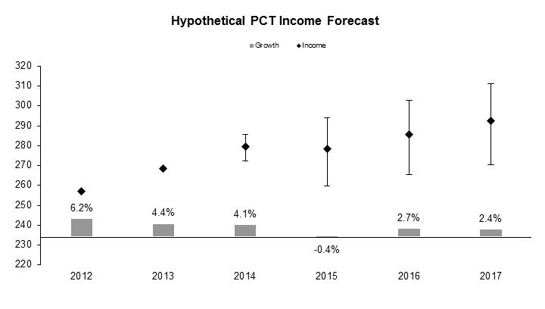

Impact of Payment Delay on PCT Income

- The hypothetical income forecast assumes that fees are paid within the same year of filing. However, WIPO receives payments with a delay ranging from one to six months. Some applicants – especially those who file at the beginning of the year – pay within the same year of filing (usually around 85 per cent), while others pay in the following year (usually around 15 per cent). Therefore, actual PCT income in any given year consists of a portion of payments for filings in the previous year plus a portion of payments for those in the same year. As a result, the money received in a year does not equal to that generated by the filings in the same year. Annual differences between hypothetical and real income do not alter the long-term overall income. Any income shortfall due to payment delays will likely be compensated in the following year. If a large portion of the payment is delayed to next year, this year’s actual income will fall, but next year’s will be higher. On the other hand, if a smaller portion of the payment is shifted to next year, this year’s actual income will rise and next year’s will fall. The adjusted PCT income forecasts until 2017 taking into account the impact of the payment delay is presented below in Chart 5.

Chart 5. Adjusted PCT Income Forecast until 2017

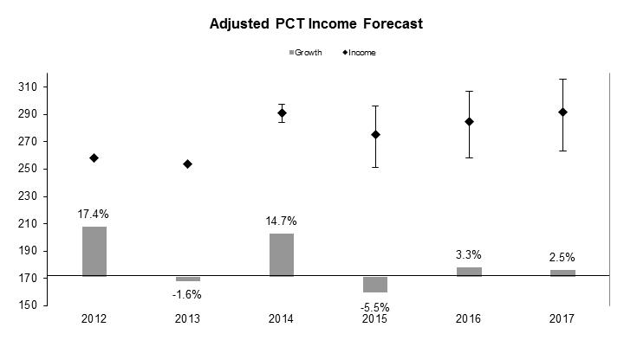

Adjustment by Currency Exchange Rates

- PCT fees are paid in various currencies. For those paid in “freely convertible” currencies, the amount equals to the “equivalent amount” set by the International Bureau; whereas for “not freely convertible” ones, the receiving offices convert them into equivalent amount in Swiss franc, Euro or US dollar (PCT Rule 15). WIPO sets up the equivalent amounts according to the rules prescribed in the Directives of the PCT Assembly: (1) the exchange rates on the first Monday of October is taken as the new WIPO exchange rates for setting the equivalent amounts for the following year; (2) if for more than four consecutive Fridays the exchange rates are changed by 5 per cent, the Director General of WIPO should initiate consultation with offices for setting new equivalent amounts which should be effective after two months from their publication.

- Applicants pay international filing fee according to the equivalent amount on the filing date. However, due to delayed implementation of the equivalent amount, the market exchange rates are likely different from the WIPO rates at the time of payment, resulting in a gain or loss of PCT income. The following graph shows the difference between WIPO exchange rates for setting the “equivalent amount” and the UN operational rates of exchange for the three currencies, namely the US dollar, Euro and Japanese Yen.

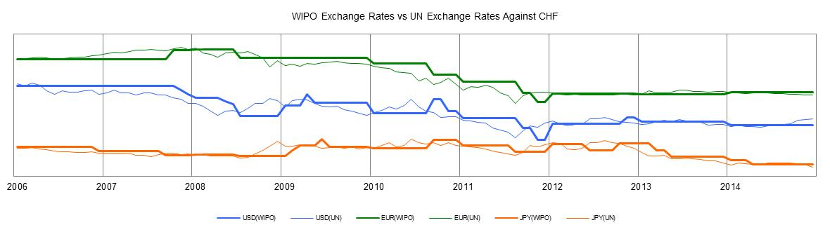

- The difference between the equivalent amount on the filing date and the amount converted to Swiss franc on the date of payment under UN exchange rates constitutes gain or loss of the PCT revenue. The following graph shows the monthly gain/loss of the PCT income.

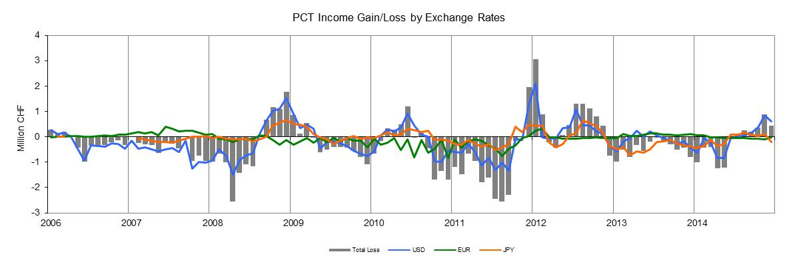

- To the great surprise of market participants, the Swiss National Bank (SNB) announced on January 15, 2015 that it would abandon its exchange rate floor to the euro, triggering a sharp appreciation of the Swiss franc. It is expected that the PCT income will likely loose further 3.1 million Swiss francs as a result.

- The current PCT schedule of fees is reproduced in the tables below.

PCT Fee Schedule  (as of January 1, 2004)  (in Swiss francs) | Revised PCT Fee Schedule  (as of July 1, 2008)  (in Swiss francs)

Madrid

Madrid - Forecast of Demand for International Registration
- Chart 6 shows the forecast for the years 2015 to 2017. The forecast of Madrid registrations is based on multiple models, including autoregressive models, econometric models and transfer models. The autoregressive models are performed on both registrations and applications. The results of applications are then transformed into registration forecast using the average processing delay. The econometric models are based on actual GDP data and GDP forecasts released by the International Monetary Fund (IMF). The results by different models are further combined to control for the uncertainty arising from the correct model specification.

Chart 6. Madrid Demand for International Registration

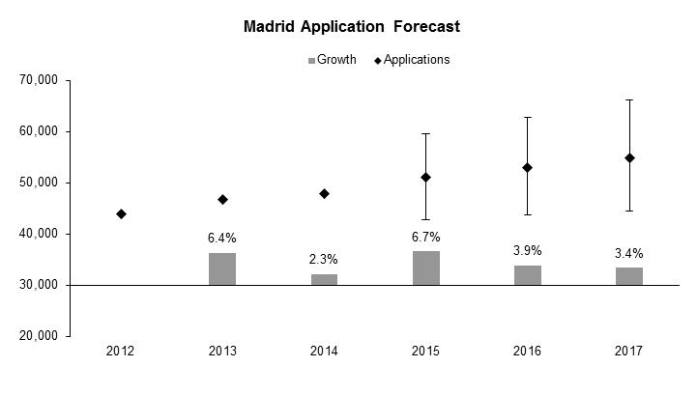

- The above numbers were added to the results from the autoregressive models. The registrations will likely be within a range with certain probabilities. The following graph and table indicate the probabilistic distribution of applications.

Application Probabilistic Distribution
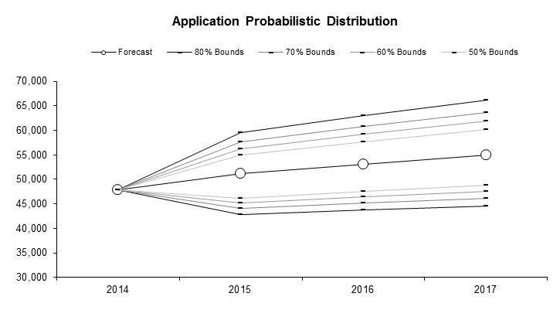

Madrid application Scenarios

Madrid - Forecast of Demand for Renewals

- Chart 7 shows the forecast for the years 2015 to 2017. Renewals are similarly forecasted based on regression models and the transfer model. In addition to the autoregressive models on the renewal time series, we also used a regression model on both renewals and registrations. This regression model assumes that first-time renewals depend on registrations with a ten-year lag, whereas subsequent renewals depend on past renewals with a ten-year lag. The transfer model looks at the potential stock of registrations coming up for renewal, and applies a percentage that is calculated from past years. Results from different models are then combined.

Chart 7. Madrid Renewal Forecast

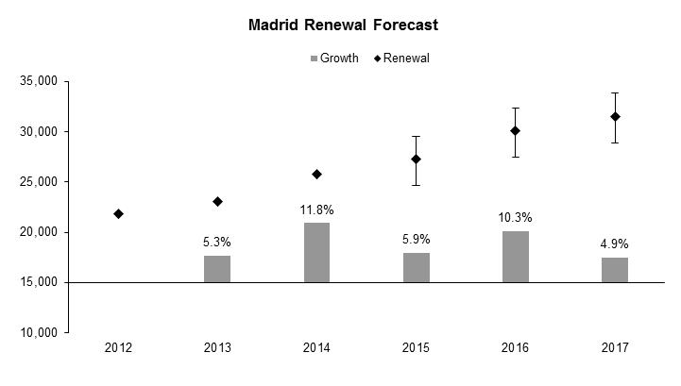

Renewal Probabilistic Distribution
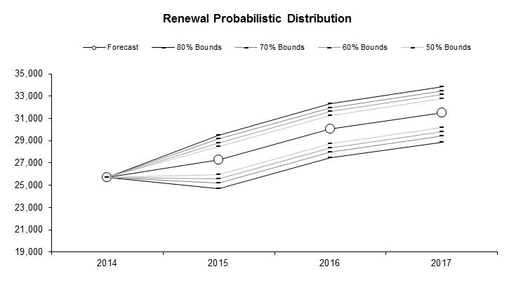
Madrid Renewal Scenarios

Expected Level of Madrid Fee Income
- Madrid fee income derives from three categories of services offered by WIPO under the Madrid System, namely: (a) the recording of international registrations; (b) the recording of renewals; (c) the recording of subsequent designations and (d) other services, including different modifications and the issuance of extracts.

- Chart 8 below shows the estimated figures of Madrid fee income for the period 2015 to 2017, attributable to each of the above-mentioned categories of services. Income estimates are based on the numbers of international registrations and renewals that are expected to get recorded from 2015 to 2017.

Chart 8. Expected Level of Madrid Fee Income, by Source

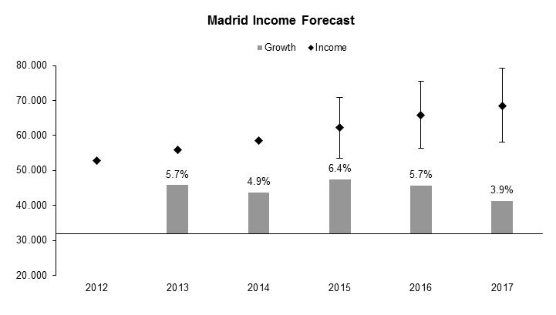
* Forecast figures.

Income Probabilistic Distribution

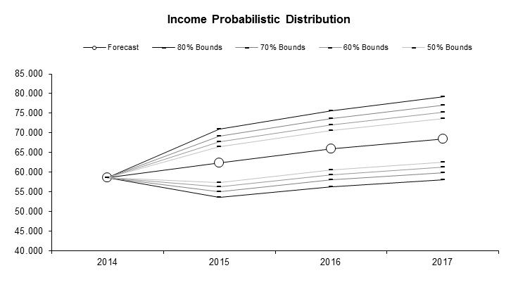

Madrid Income Scenarios

- The table below provides information on the actual and expected numbers of registrations and renewals for the period 2012 to 2017 and on the actual and expected evolution of the average fee during that period. The average fee is calculated as the total Madrid fee income divided by the total number of registrations and renewals in any given year.

Table 16. Madrid Total Fee Income and Average Fee

- A new forecasting model, similar to the one used for the forecasting of PCT activities, was adopted, for the first time, for the 2014/15 biennium for the forecasting of Madrid and the Hague registration activities. The more sophisticated model takes into account, not only earlier Madrid System activity, but also trademark application and registration activities in other offices, as well as economic forecasting data from IMF. As the global economic uncertainty continues and until more experience is gained with the new forecasting model, a slightly lower forecast level for Madrid was felt more prudent by the concerned business area. The lower forecast numbers are reflected in the table below and serve as a basis for the 2016/17 Program and Budget.

Table 17. Madrid Total Fee Income and Average Fee (Basis for PB 2016/17)

Hague

The Hague - Forecast of Demand for International Registration
- Chart 9 shows the forecast for the years 2015 to 2017. The anticipated accession of China, Japan, Republic of Korea, Russian Federation and the United States to the Hague System will have considerable impact from 2015 onwards, resulting in a possible jump in filings and income. The forecast of Hague registrations is based on multiple models, including autoregressive models, econometric models and transfer models. The autoregressive models are performed on registrations. The econometric models are based on actual GDP data and GDP forecasts released by the International Monetary Fund. The results by different models are further combined to control for the uncertainty arising from the correct model specification.

Chart 9. Hague Applications and Renewals
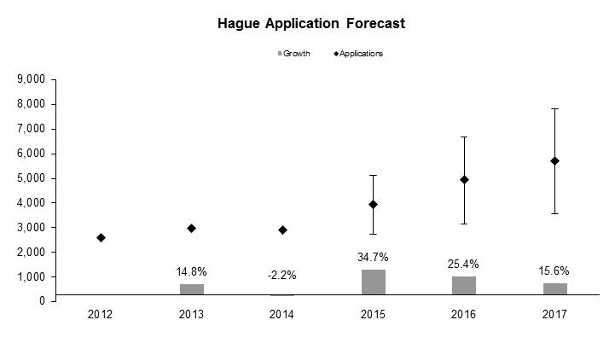

- In light of the anticipated accessions of several new member states from 2014 onwards, a transfer model was used to assess the impact of accession events on registrations. The model employs data on Paris-route “cross filings” between the existing Hague members and the new member states. In particular, transfer rates are estimates to calculate the additional filings from the existing members due to accessions. In addition, the average “transfer rates” of the existing Hague members are used to predict the filing potential from the new members. It is noted that the true “transfer rates” are country-specific. Using average transfer rates for new members is arguably the best approximation possible, but it introduces additional uncertainty to the forecast values. The current estimation is based on the following assumptions of the timing of accessions.

- The above numbers were added to the results from the autoregressive models. The applications will likely be in a range with certain probabilities. The following graph and table indicate the probabilistic distribution of the scenarios.

Application Probabilistic Distribution

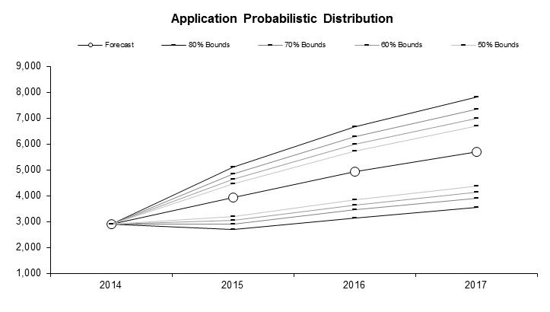

Hague Registration Scenarios

Hague - Forecast of Demand for Renewals
- Different regression models are employed to forecast registration renewals. In addition to autoregressive models, use is made of the relationship between renewals and registrations with five-year lags as well as past renewals with five-year lags, since the registrations and renewals five years ago should contribute to the total renewals in the current year.

Chart 10. Hague Renewal Forecast

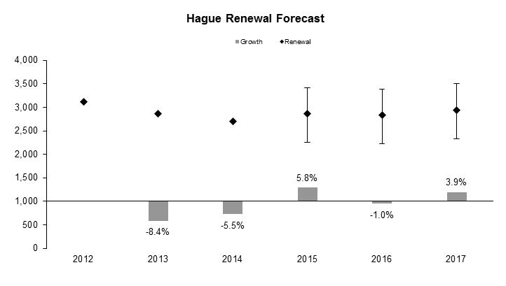

Renewal Probabilistic Distribution
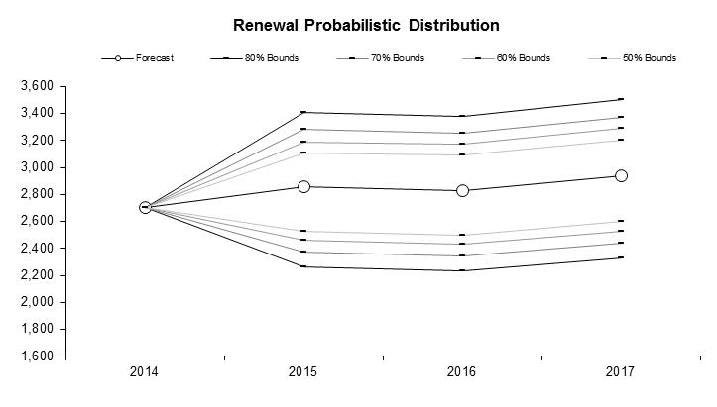

Hague Renewal Scenarios

Expected Level of Hague Income
- The income generated by the Hague System is calculated based on the current fee schedule. The main components of this schedule are the basic fee and renewal fees. These two parts cover about 90 per cent of the income. Other fees are grouped as “Others”.

Chart 11. Expected Level of Hague Fee Income, by Source

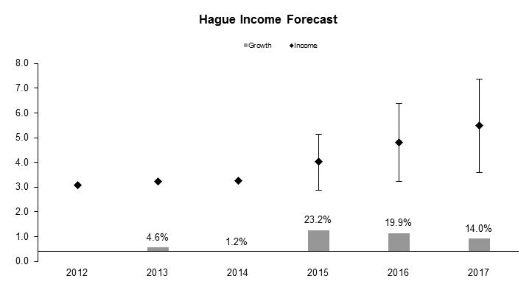

* Forecast figures

Income Probabilistic Distribution

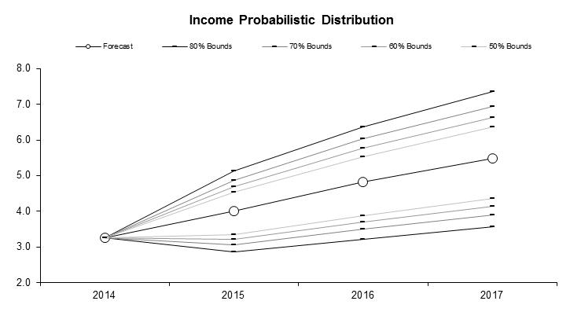

Hague Income Scenarios

- Income estimates for 2015 to 2017 in the table below are based on the expected numbers of international registrations and renewals. It should be noted that the income estimates given below are based on the assumption that no changes to the schedule of fees payable to the International Bureau under the Hague system will take place in the forthcoming years.

Table 18. Hague Total Fee Income and Average Fee

ANNEX V INDICATORS OF PCT OPERATIONS

PERFORMANCE INDICATORS FOR THE EXPECTED RESULT
“IMPROVED PRODUCTIVITY AND SERVICE QUALITY OF PCT OPERATIONS”

General

- As background for the performance indicators for the expected result “improved productivity and service quality of PCT operations”, the evolution of the following factors need to be considered:

- The PCT workloads;
- The language distribution of those workloads;
- The number of staff assigned to process those workloads; and
- The level of automation.

Workloads

- The workloads are tracked on the basis of the yearly number of record copies received by the IB.

Evolution of Record Copies by Medium of Filing
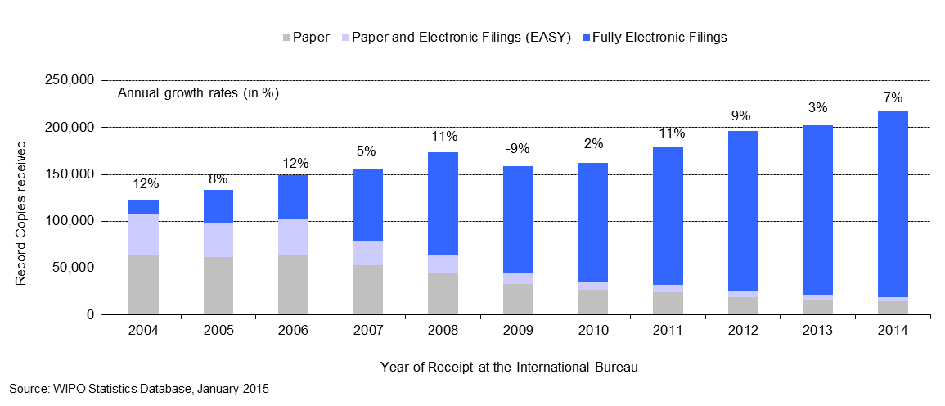

- The IB received approximately 217,700 record copies in 2014, representing an increase of 7 per cent compared to 2013.
- The share of fully electronic filing methods kept increasing in 2014 and now represents 91 per cent of total filings.

Language distribution

- One fundamental development driving change in the IB is the increasing language diversity of filings, resulting, in particular, from continued increased usage of the PCT System in East Asian countries.

Languages of Filing (all languages)
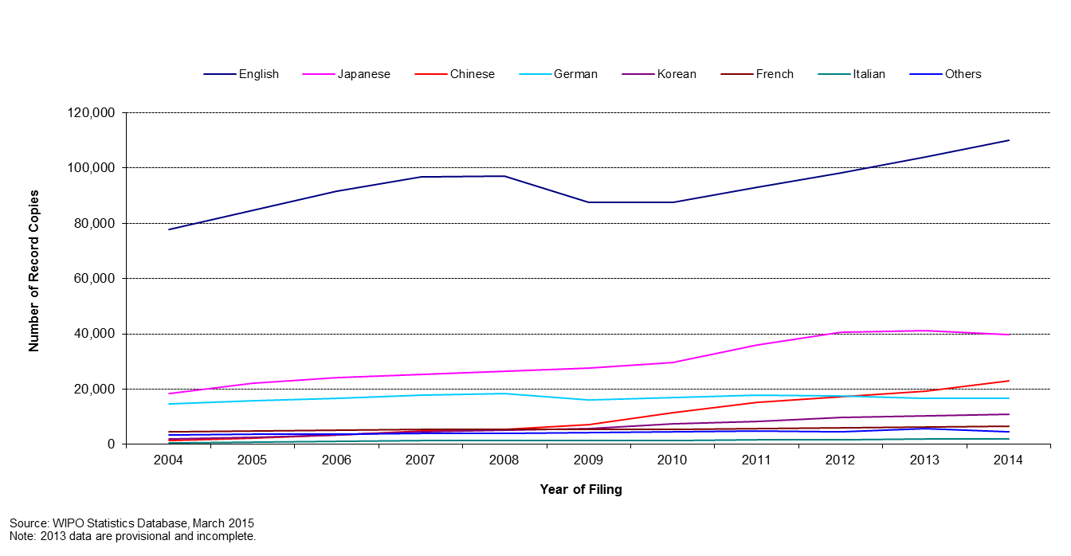
- As can be observed, while English accounts for the majority of filing, with 51.6 per cent of filings in 2014, the shares of Asian languages have increased over the past decade. The combined share of the PCT applications filed in Japanese, Chinese and Korean has increased from 29.5 per cent in 2009 to 34.5 per cent in 2012. This share has remained stable from 2012 to 2014. Zooming in on languages other than English provides the following picture:

Languages of Filing (all languages except English)
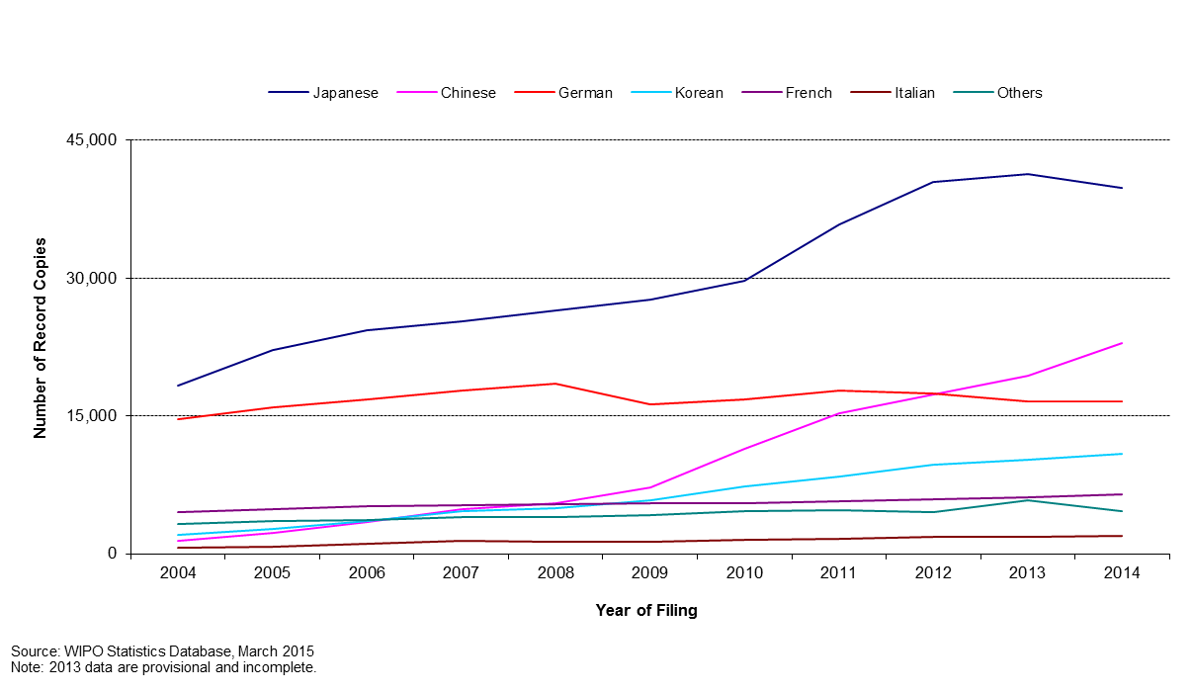
- The sharp increase of applications filed in Asian languages in the last five years put a considerable strain on the IB due to the limited number of staff resources able to work in these languages. Mitigation for this issue is automation of certain tasks and recruitment of staff able to work in these languages.

Staff
- The chart below shows the number of PCT Operations staff since 2001, in Full Time Staff Equivalent (FTSE - total number of full-time staff plus the full-time equivalent of part-time staff).

Number of Personnel in PCT Operations

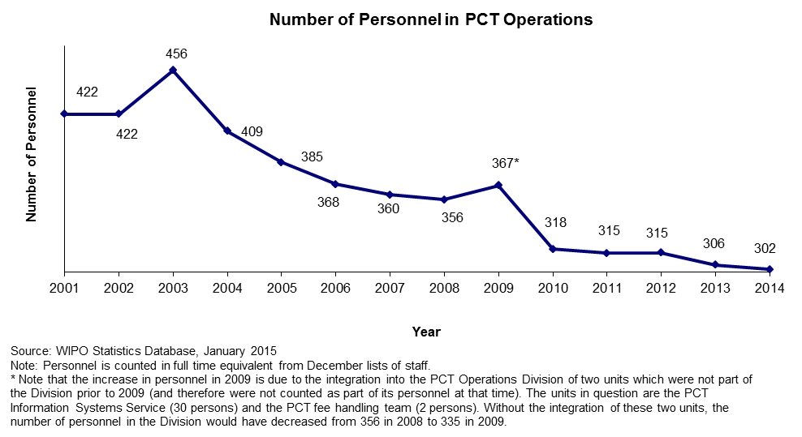

- The PCT Operations Division’s personnel further decreased in 2014.

Unit cost of processing an application

- The IB’s productivity in processing PCT applications can be measured by the unit cost of processing, defined as the average total cost of publishing a PCT application. Average total cost is determined by total direct PCT system expenditure (expenditure incurred by the IB in the administration of the PCT system and related Programs), plus a proportion of indirect expenditure on support and management activities (e.g., buildings and information technology, among others). Indirect costs are weighted to take into account only the share attributable to the PCT system. The unit cost thus includes the cost of all PCT activities, including translation, communication, management and others.

- The methodology to compute the unit cost was revised in 2013 in order to align it with other WIPO unit/union cost calculations and to better capture a fast changing environment. For example, the old method, which was designed in 2007, included a cost of storage (over 30 years) in warehouses, whereas paper filings (including PCT EASY filings) accounted for less than 10 per cent of filings in 2013. The 2012 PCT unit cost has been calculated using both methods. The 2012 unit cost amounted to 680 Swiss francs using the old method and to 712 Swiss francs using the new method. The 32 Swiss francs difference is due to the new method for allocating indirect costs.

- Formally, unit cost is defined as:

- The graphs below depict the evolution of the unit cost of processing from 2004 to 2012 using the old method and from 2012 to 2014 using the new method, including a breakdown of the contribution of direct and indirect costs.

Unit Cost of Processing a Published PCT Application

Old method | New method
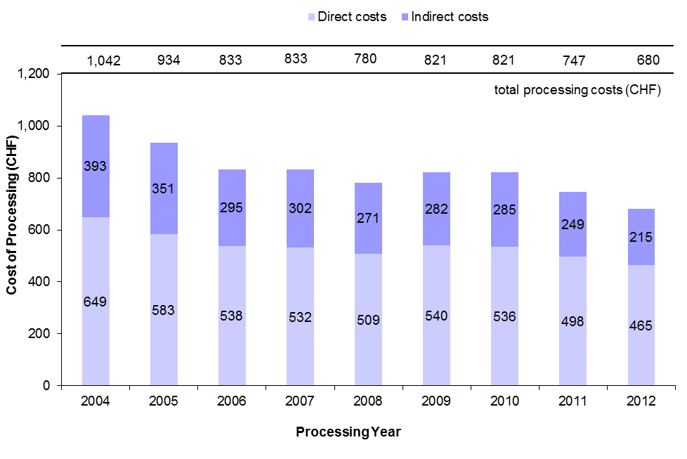 | 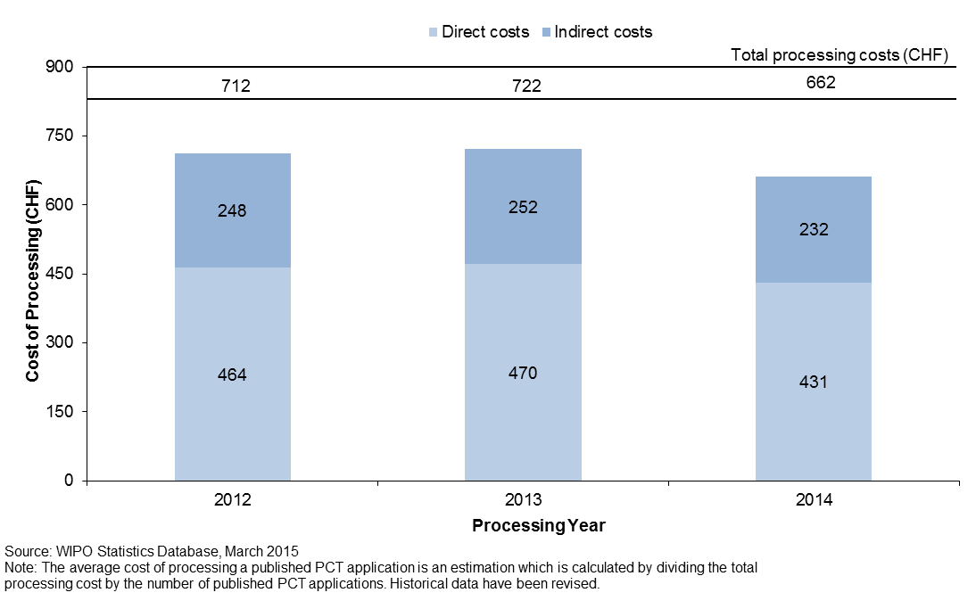

- The average cost of processing a published PCT application was 662 Swiss francs in 2014, representing a decrease of 8.3 per cent compared to 2013. This decrease is due to various efficiency measures including automation.

- The average cost of processing a published PCT application calculated by the old method decreased by an average of 5 per cent per year from 1,042 Swiss francs in 2004 to 680 Swiss francs in 2012.

Productivity of formalities examination

- The definition of staff productivity is output (i.e., the number of PCT publications) divided by the number of staff for formalities examination.

Productivity of Formality Examination
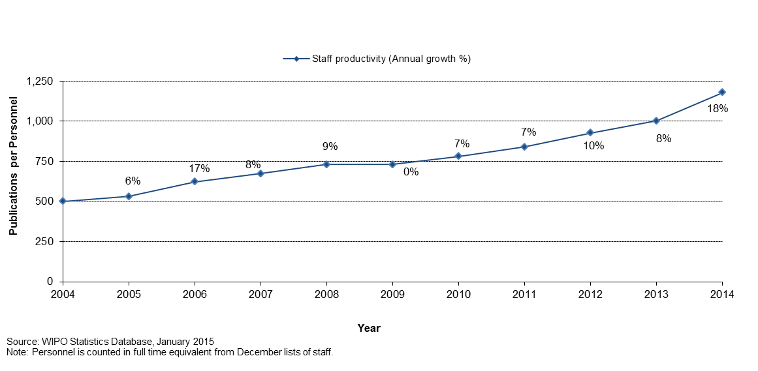
- Historically, productivity of formalities examination has increased, mainly due to automation which has permitted the processing of much larger workloads with less or equal staff.

Aggregate quality of formalities examination

- In order to measure the quality of the work performed by the IB in a simple and comprehensive manner, the IB has developed an aggregate quality index, calculated as the average of four lead quality indicators. Three of these indicators are based on the timeliness of key transactions: acknowledgement of receipt of the PCT application, publication, and republication. The fourth indicator reflects errors made during the processing of PCT applications.

Quality Index of Formalities Examination
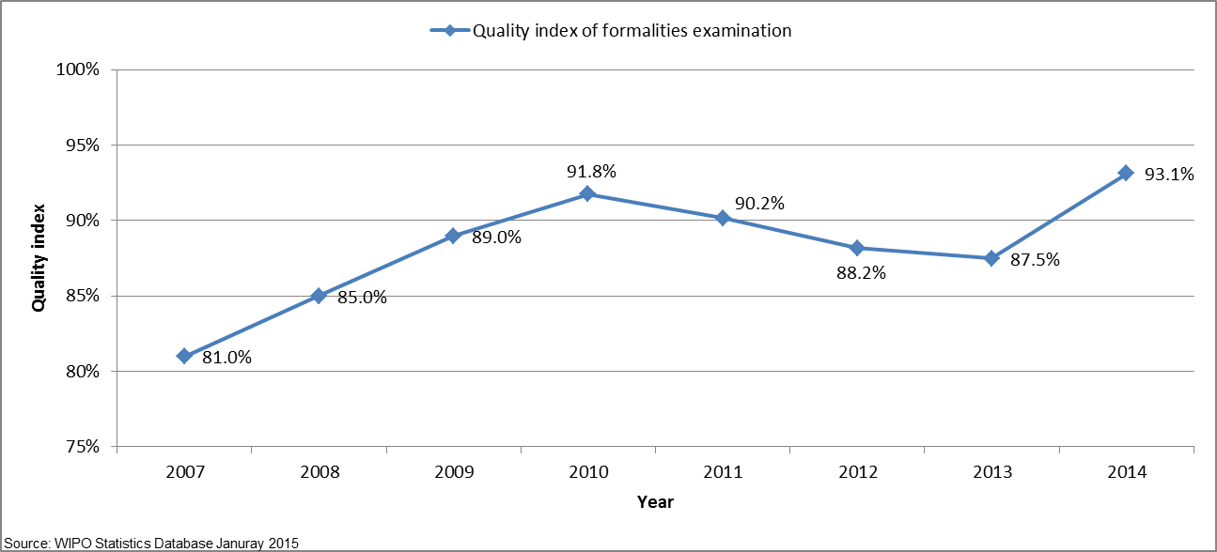
- The overall quality, as measured by the aggregate index, improved markedly from an average of 81 per cent in 2007 to 93.1 per cent in 2014.

- The remarkable increase of the quality index in 2014 is mainly due to improved timeliness in performing formalities examination as well as reduced delays in republishing applications with the ISR. The delay in formalities examination and republication mainly explained the decrease of the quality index observed during the 2010–2013 period.

Timeliness of formalities examination

- This indicator reflects in more detail one of the components of the aggregate quality indicator, namely the time required by the IB to issue Form 301. This form is issued after the formality examination of the application has been completed. Applicants appreciate receiving this Form as soon as possible because it acknowledges receipt of the application at the IB and allows them to know whether their application has any formal defects.

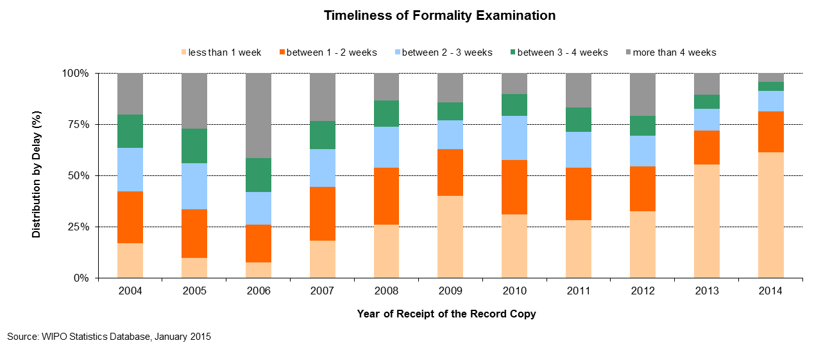
Timeliness of publication

- This indicator reflects in more detail one of the components of the aggregate quality indicator, namely the time required by the IB to publish the application. Article 21 (2) (a) of the PCT states that the “… international publication of the international application shall be effected promptly after the expiration of 18 months from the priority date of that application.”

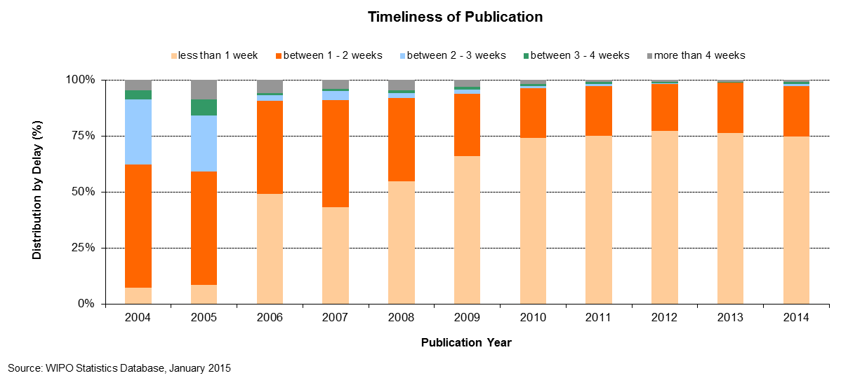
Timeliness of republication

- This indicator reflects in more detail one of the components of the aggregate quality indicator, namely the time required by the IB to republish the application with the ISR. Due to delays in the communication of ISRs by ISAs, a number of international applications are published without the ISR. When the ISR becomes available, the international application needs to be republished with the ISR as soon as possible, so as to complete the international publication.

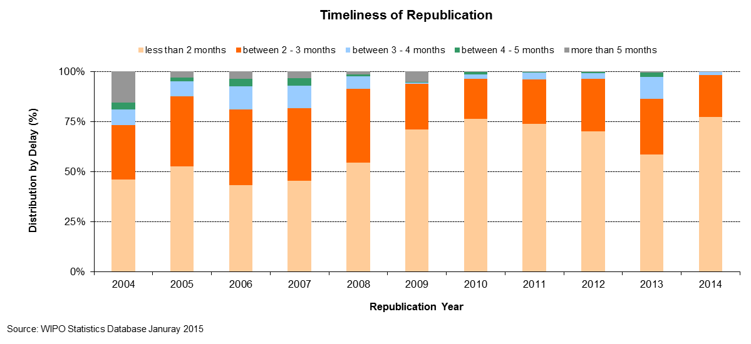

Quality of translation

- Statistically calculated numbers of documents are selected at random from translations of abstracts and patentability reports prepared under the responsibility of the IB for quality control. The evaluation determines whether a translation is “acceptable” or “not acceptable”. This indicator aggregates the results of such quality control performed by the IB across all language combinations and document types. Relationships with any agencies that consistently have less than 80 per cent of their translations deemed “acceptable” are discontinued.

Quality of PCT Translation

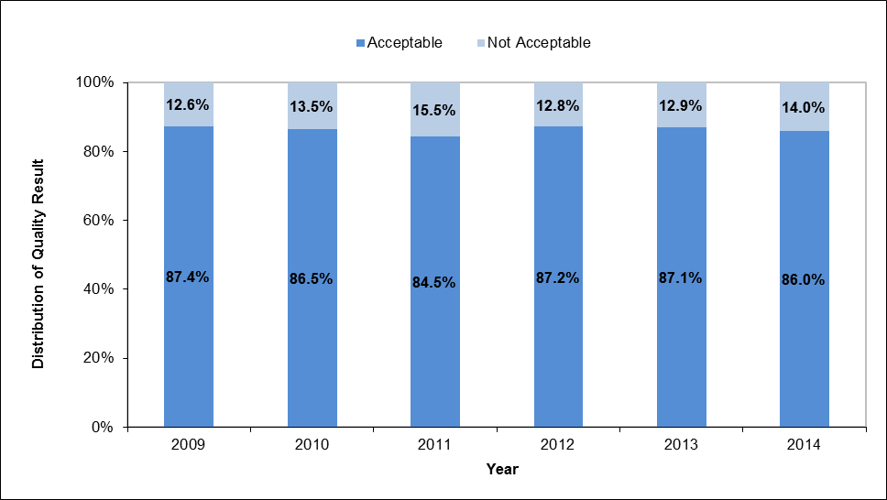

Timeliness of report translation

- This indicator provides information on the timeliness with which patentability report translations are made available by the IB to applicants and Offices. The share of patentability report translations delivered at 30 months from the priority date of the international application has steadily increased since 2010. In 2014, 82.5 per cent of patentability report translations were delivered at 30 months from the priority date.

Timeliness of Report Translation
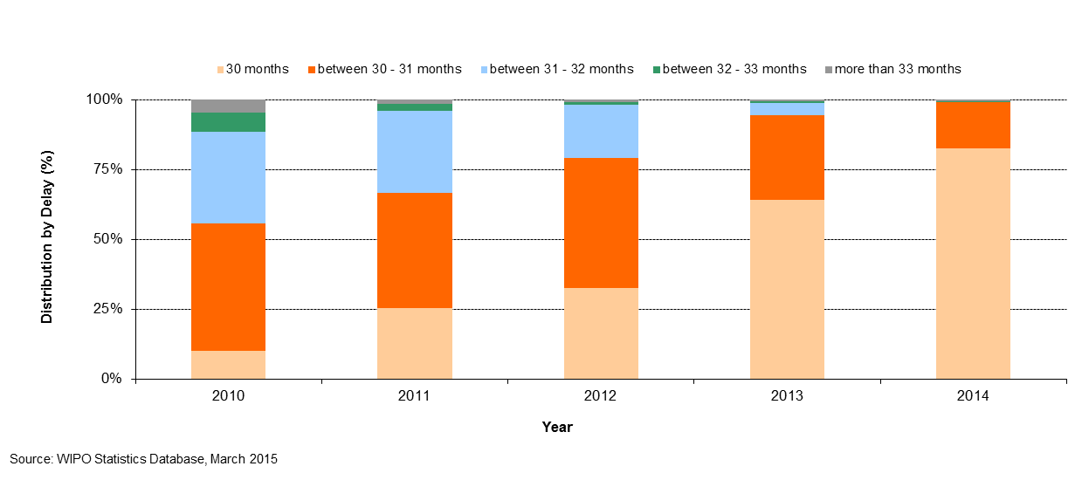

Quality of software development

- The quality of software development (QSD) indicator provides a measure of the quality of major software releases for eDossier and ePCT projects. The QSD reflects the share of the time spent delivering new functionality in the release (i.e. work) out of the total time spent (i.e. work + rework). Rework is the time spent correcting defective work that was detected in the production environment.

- Under this approach, development outputs that contain low levels of rework are deemed high quality as it reflects the extent of value added to the product through the delivery of new features.

- The QSD is defined as:

- In 2014, the quality of major releases, as defined by the QSD, was 94.3 per cent. This share is nearly five percentage points higher than in 2013.

Quality of Software Development
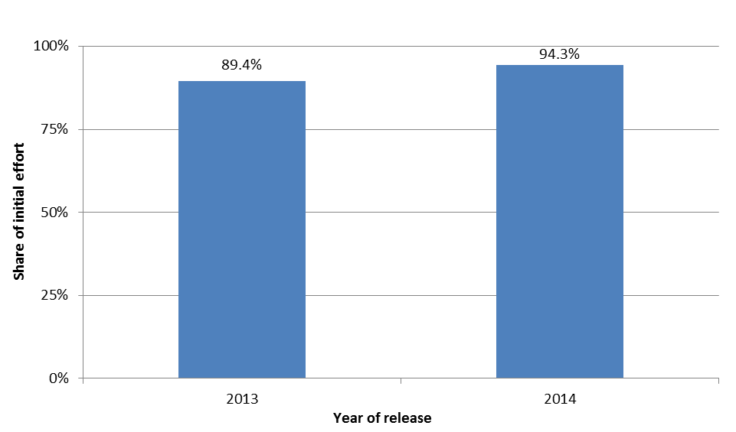

Information systems service levels

- The performance indicator entitled information systems service levels (ISSL) reflects the performance of the service provided by the PCT information systems service to users, based on its ability to meet agreed targets.

- This composite indicator is calculated using the weighted average of five target-based performance indicators. Each indicator is expressed as the percentage of the target actually attained.

- In 2014, overall service level was 95.3 per cent towards meeting the target performance levels.

Information Systems Service Levels

Id | Performance Indicator  Short description | Target | Conditions | 2013 Result | 2014 Result
(1) | Incident resolution time  Working time (7am-7pm on WIPO working days) between a ticket being created and resolved. | Severity 1: 4 hours  Severity 2: 2 days  Severity 3: 5 days  Severity 4: 10 days | Production and Support tickets resolved by the support team | 85.5% | 88.8%
(2) | Document load time  elapsed time between receipt of document at IB and its availability in eDossier | 8 hours | Documents loaded by a semi or fully automated process | 80.0% | 88.2%
(3) | Batch job processing success rate | 100% | Batch jobs to be completed successfully by the close of business on the scheduled date | 99.6% | 99.5%
(4) | eDossier system availability | 99% | 7am-7pm on working days | 100.0% | 100.0%
(5) | ePCT system availability | 99% | 24 hours | 100.0% | 100.0%
 | Information systems service levels (ISSL)  Weighted average of the above indicators: (1): 20% (2): 20% (3) 20% (4) 20% (5) 20%. |  |  | 93.0% | 95.3%

Receiving Office at the International Bureau (RO/IB)

Filings

- This table presents PCT filings by the top ten receiving offices over the past five years to 2014. In principle, a PCT application is filed at the national patent office of the applicant’s home country or at a regional patent office acting for the applicant’s home jurisdiction. The IB is a competent receiving office (RO/IB) for applicants from all PCT contracting states. The evolution of the filings at the RO/IB, its ranking in terms of the number of filings among other receiving offices, as well as its market share can be observed in this table.

- In the Program and Budget 2014/15, the following two performance indicators were added for the RO/IB:

Timeliness of notification of international filing date

- This indicator reflects the time required by the RO/IB to issue Form 105. This form is issued after the international filing date has been accorded. Applicants appreciate receiving this form as soon as possible, because an international application has the effect of a regular national application in each designated State as of the international filing date, which date shall be considered to be the actual filing date in each designated State.

Timeliness of Notification of International Filing Date
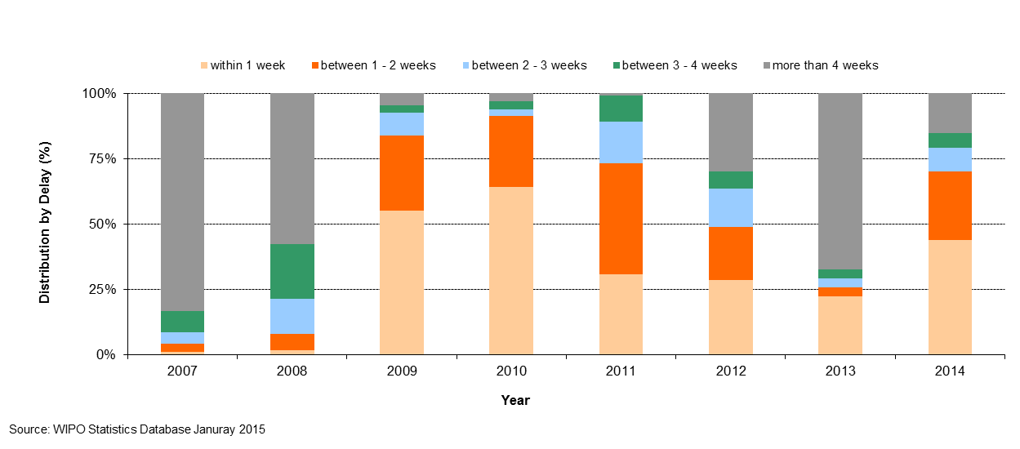

Timeliness of transmittal of search copy

- This indicator reflects the time required by the RO/IB to transmit the search copies to the ISAs. The search copy is to be transmitted promptly after payment of the search fee, so that the ISA can establish the ISR within the deadlines stipulated by the PCT regulatory framework. Delays in paying the fee will delay the transmission of the search copies to the ISAs and therefore negatively impact upon the ability of ISAs to meet these deadlines.

Timeliness of Transmittal of Search Copy
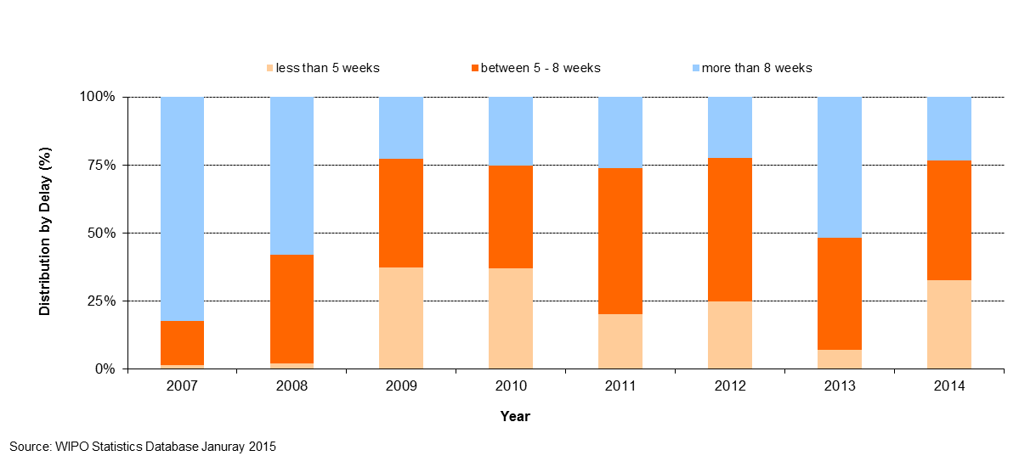

ANNEX VI INDICATORS OF MADRID OPERATIONS

PERFORMANCE INDICATORS FOR THE EXPECTED RESULT
“IMPROVED PRODUCTIVITY AND SERVICE QUALITY OF MADRID OPERATIONS”

- As background for the performance indicators for the expected result “improved productivity and service quality of Madrid operations”, the evolution of the following factors needs to be considered:

- Madrid workloads;
- Composition of those workloads;
- Number of staff assigned to process those workloads;
- Level of automation; and
- Total cost of production.

- Incoming documents

- The International Bureau (IB) receives six different categories of documents, namely international applications, renewals, subsequent designations, modifications, decisions and corrections. The latest trend for each of these documents is presented below. Additional information on applications, such as their average number of classes and average number of words is also provided. For technical reasons, some indicators show data based on processed documents rather than on incoming documents. Backlogs in processing may therefore affect some indicators.

International applications
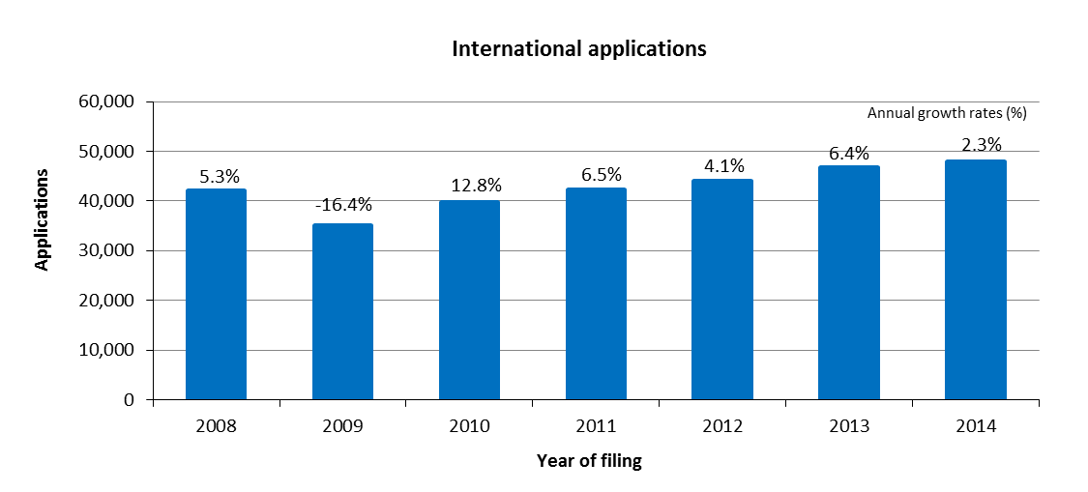

- The IB received 47,885 applications in 2014, representing an increase of 2.3 per cent compared to 2013.
- The numbers of applications received have increased continuously since 2010.

Distribution of applications by language of filing
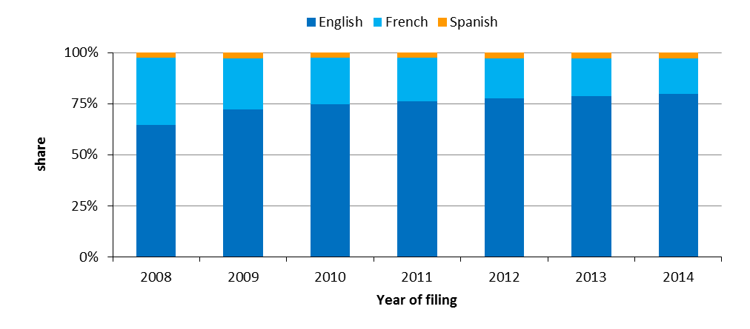
- In 2014, 80 per cent of all applications were filed in English. This share grew by 15 percentage points from 65 per cent in 2008 to 80 per cent in 2014.

Average number of designations per registration
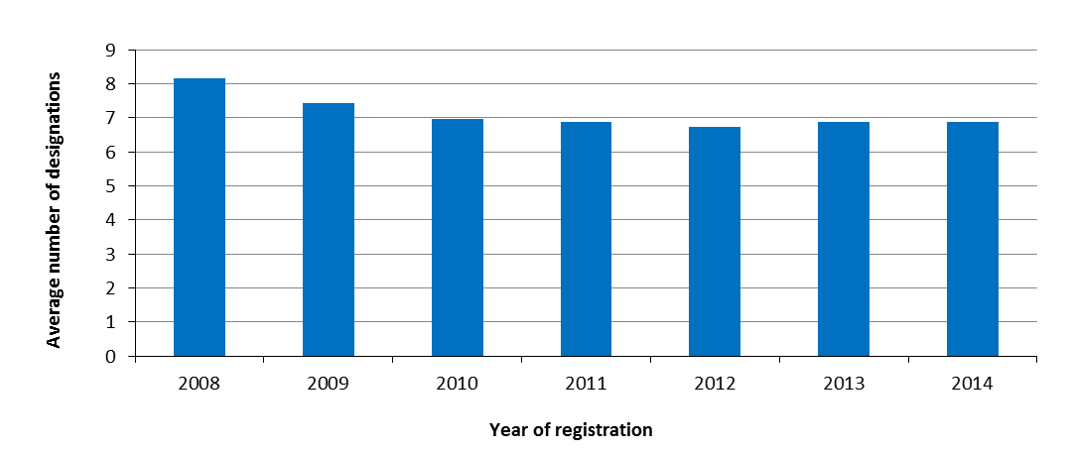
- An average 6.9 designations were made in applications registered in 2014.
- The average number of designations per registration has remained almost unchanged since 2010.

Average number of classes per registration
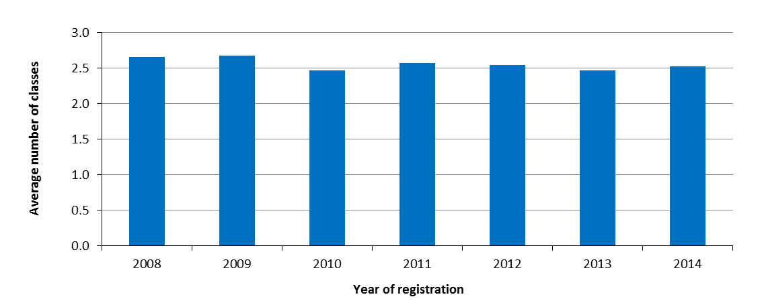
- On average, 2.5 classes were specified in all applications registered in 2014.

Average length of applications

- The length of an application is determined by the total number of words used by applicants to describe their mark, by the basic list of goods and services and by any accompanying limitations. These three elements are translated by the IB into two languages (English, French or Spanish).

- The length of applications has an impact on the workload of examiners, which includes classifying the goods and/or services in the application according to the Nice Classification.

- The average length of an application is determined by the total number of words in basic lists of goods and services, limitations and descriptions divided by the number of applications registered.
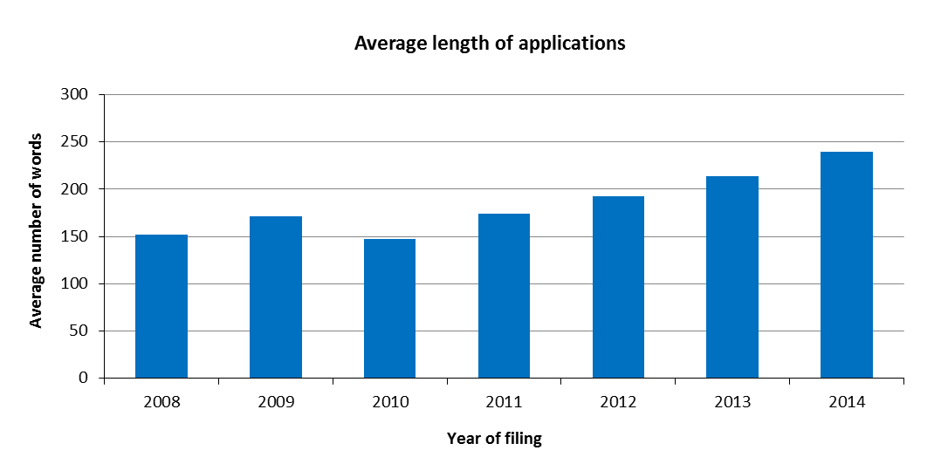

- In 2014, the average length of an application was 239 words. This represents an increase of 12 per cent compared to 2013.
- While certain aspects of the translation and classification work are automated, significant increases in the length of applications has a large impact on the workload of the IB.

Distribution of regular and irregular applications
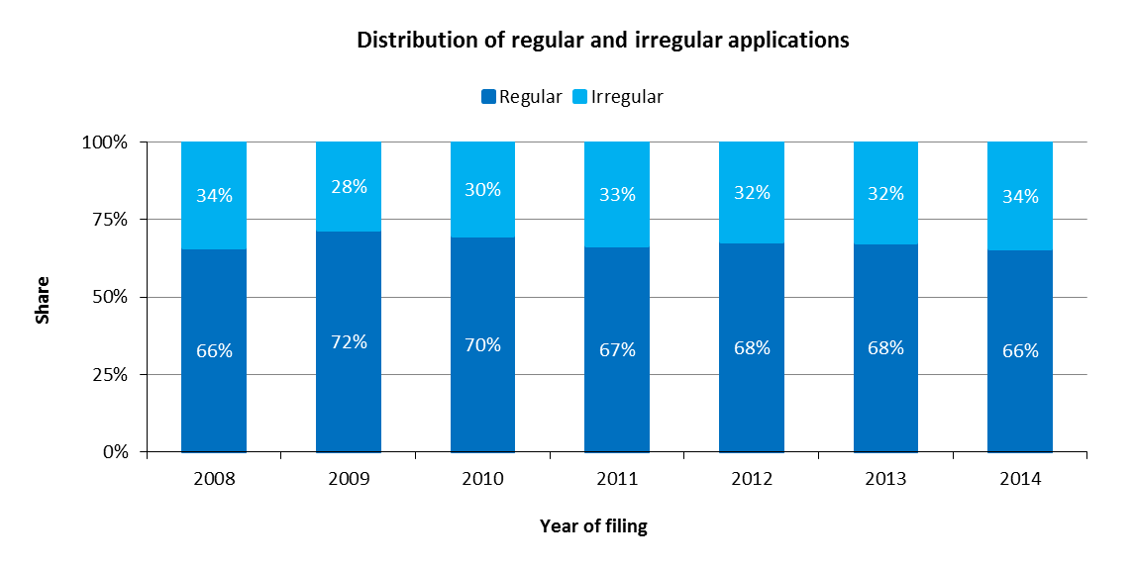
- The share of regular applications has remained more or less the same since 2011.

Renewals
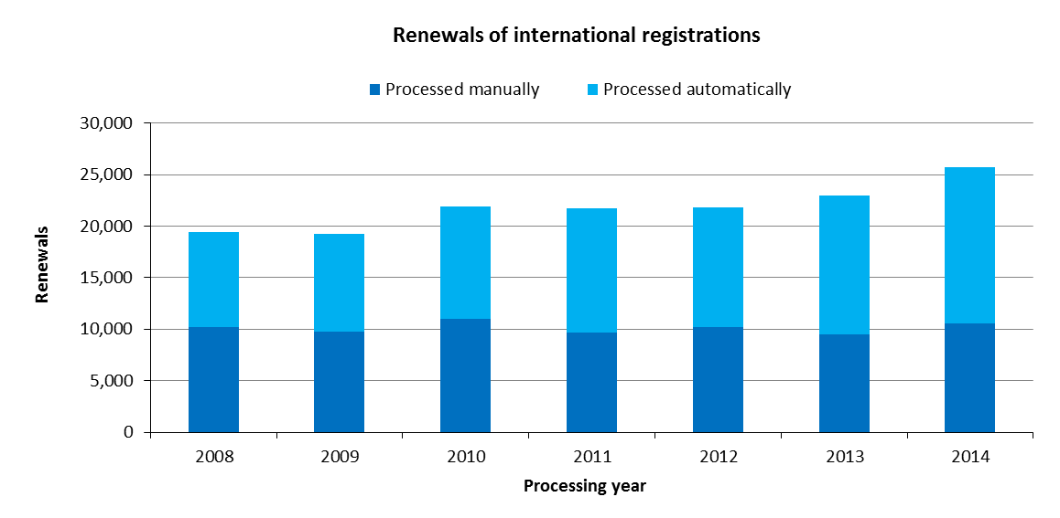
- In 2014, the IB registered 25,729 renewals, up 12 per cent from 2013.
- Despite the increase in renewals between 2009 and 2014, the numbers of renewals processed manually have remained relatively stable. In 2014, 59 per cent of renewals were processed automatically.

Subsequent Designations
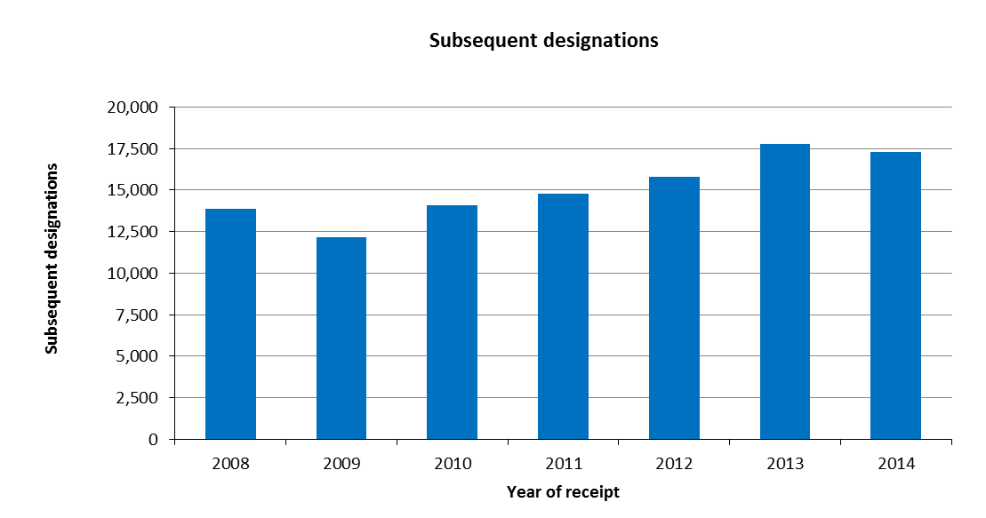

- In 2014, the IB recorded 17,316 subsequent designations, down 2.5 per cent from 2013.
- In 2014, a new web form called E-Subsequent Designation was made available to applicants. This electronic form enabled the IB to process 14 per cent of all subsequent designations automatically.

Modifications
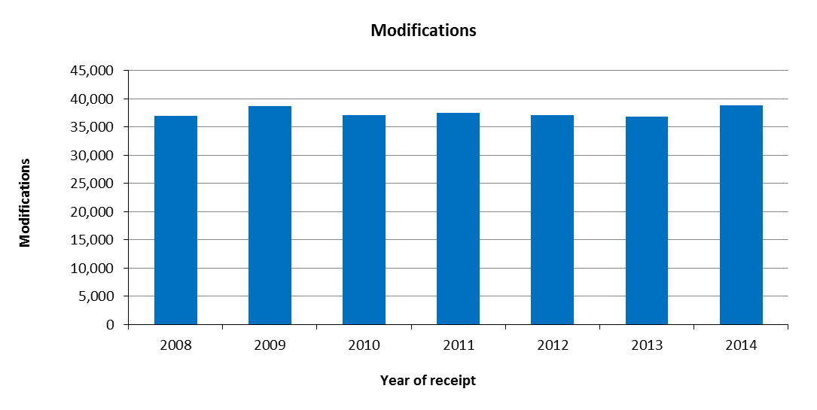
- In 2014, the IB received 38,817 requests for modification, up 5.5 per cent from 2013.

Decisions
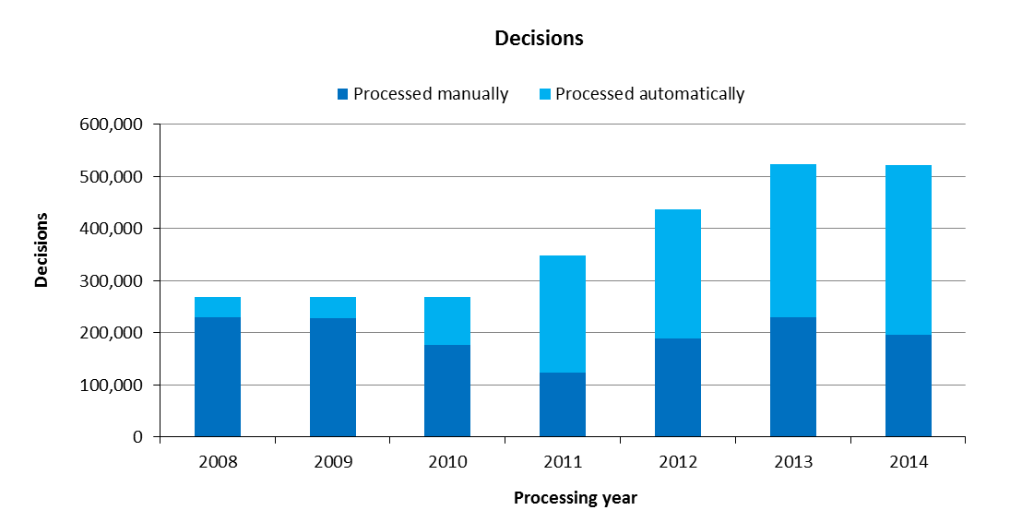
- In 2014, the number of decisions registered decreased by 0.3 per cent compared to 2013, totaling 521,208. The number of decisions processed has rapidly increased since 2010.
- In 2014, 62 per cent of decisions were processed automatically. The majority of decisions have been processed automatically since 2011.

Corrections
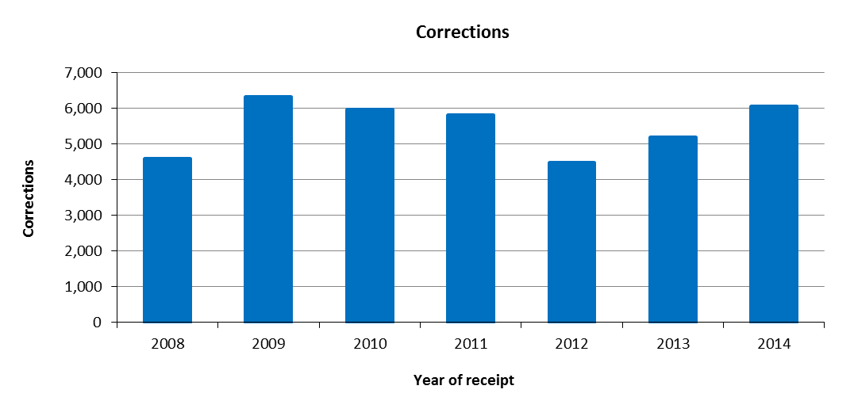
- In 2014, the IB recorded approximately 6,000 corrections. This represents an increase of 17 per cent compared to 2013.
- Total workload

- The total workload represents the weighted total number of documents processed by the IB. All six categories of documents are included (applications, renewals, subsequent designations, modifications, decisions and corrections).

- As processing these types of documents do not require equal resources, they are each weighted differently. According to this weighted system, during the time required to process an international application, an examiner can process 1.6 renewals, 1.8 subsequent designations, 1.8 modifications or 10 decisions. Similarly, during the time required to process an international application, an employee involved in the automation process can be deemed to process 17 documents.

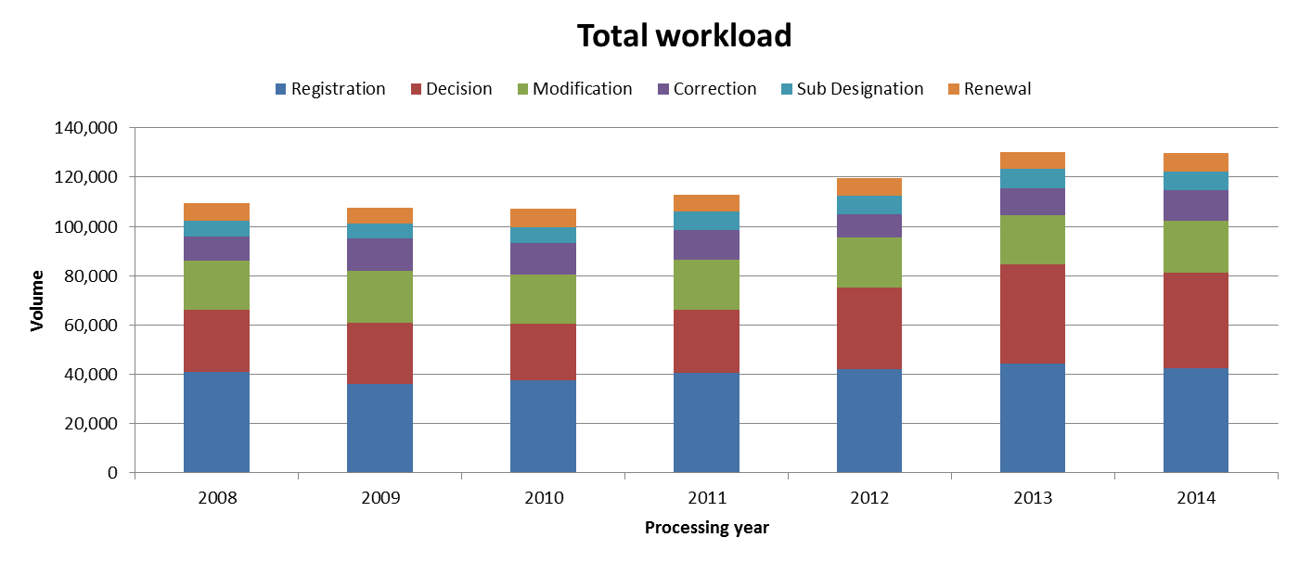
- In 2014, the total workload remained stable compared to 2013. Applications, decisions and modifications represented nearly 80 per cent of the total workload.
- Between 2011 and 2013, the workload increased sharply, mainly due to the increasing number of decisions.

- Medium of Transmission of Incoming Documents

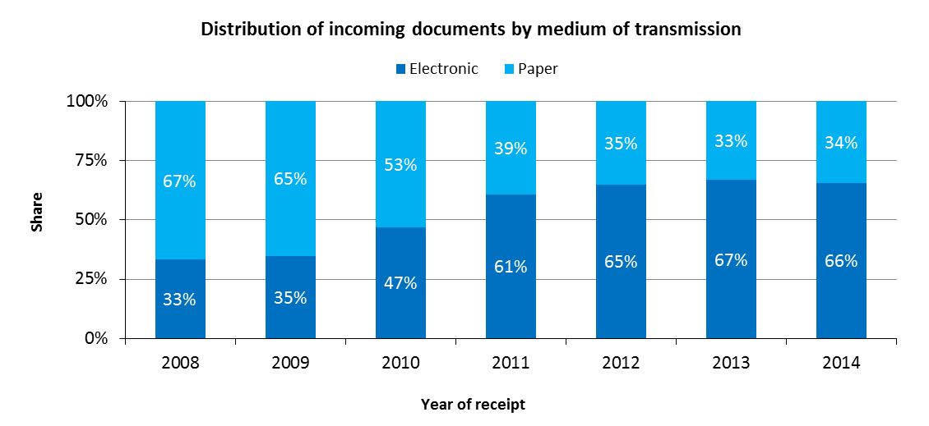
- In 2014, 66 per cent of all incoming documents were transmitted electronically to the IB.
- The share of documents transmitted electronically has been stable since 2012.

- Processing

Total cost of production

- The total cost of production has direct and indirect components. Direct costs reflect expenditure incurred by the IB in administering the Madrid System (such as management, translation and registration). Indirect costs reflect expenditure for supporting activities (such as those associated with buildings and information technology). Indirect costs are weighted to take into account only the share attributable to the Madrid System.
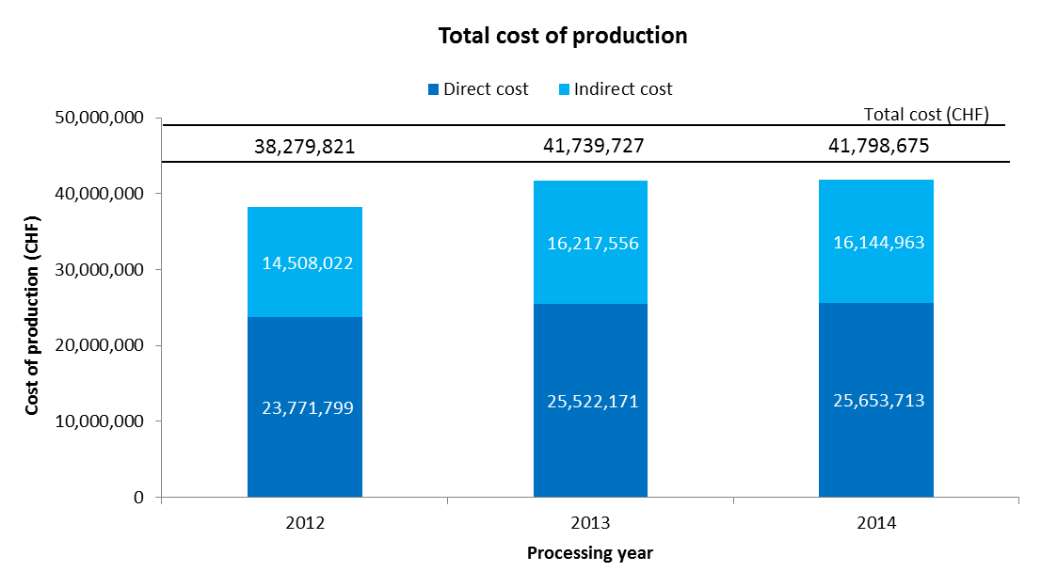
- The total cost of production is estimated at 41.8 million Swiss francs in 2014. This represents a slight increase of 0.1 per cent compared to 2013.

- In 2014, the direct costs accounted for 61 per cent of total costs.

Unit cost

- The IB’s efficiency in processing transactions can be measured by the unit cost, defined as the average cost of producing one unit of output.

- As the IB registers new applications and maintains existing registrations, it is relevant to have a unit of output which includes a set of transactions. Two unit cost indicators are presented below using two different units of output.

- As part of the IB’s efforts to continuously refine the methodology for calculating unit costs, the methodology has been revised in the Program and Budget 2016/17 to reflect more accurately the cost of processing Madrid workloads at the IB:

- The methodology for calculating direct and indirect Madrid costs have been aligned with the methodologies for calculating PCT and the Hague unit costs.

- A weighted system has been introduced to better approximate the actual work required to process the six categories of documents, taking into account that certain of these documents are more labor-intensive than others.

- The first unit cost has been redefined to include only new international registrations and renewals (the unit cost in the Program and Budget 2014/15 also included subsequent designations). The rationale for removing subsequent designations as a component of this unit cost is a sharper focus on the core Madrid outputs, namely the international registration and its renewal. All other Madrid transactions (subsequent designations, modifications, decisions and corrections) can be considered secondary to these two core transactions. Furthermore, there is no real justification for including one of these secondary transactions as a component of unit costs, while not including the others.

- The second unit cost is based on the number of documents inscribed in the register rather than the number of inscriptions due to the different levels of efforts required to process the various documents.

- For ease of comparison, the graphs below depict the evolution of the two unit costs from 2008 to 2014 using the old methodology and from 2012 to 2014 using the new methodology, including a breakdown of the contribution of direct and indirect costs.

Unit cost per new/renewed international registration

- New international registrations consist of applications that are registered within a given year, and renewed international registrations consist of existing registrations that are renewed within a given year. Combined, these two types of transactions reflect the core business of the IB.

- As processing these two types of transactions do not require equal resources, they are each weighted differently. The unit cost is calculated by dividing the total cost of production by the number of new/renewed international registrations.

Old method | New method
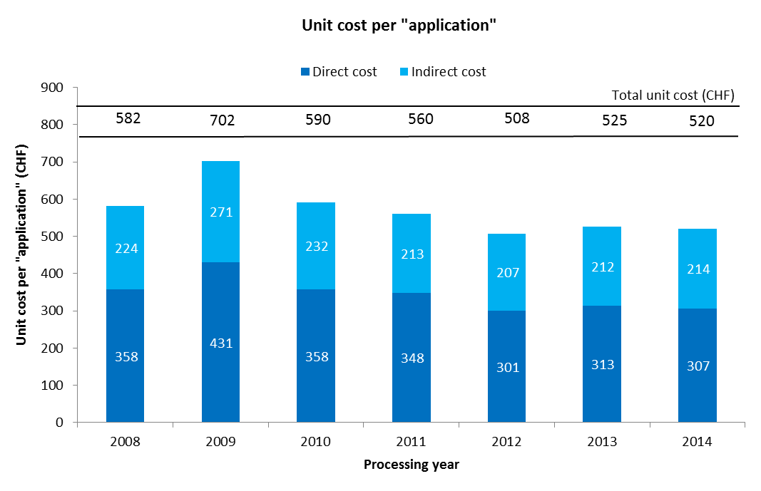 | 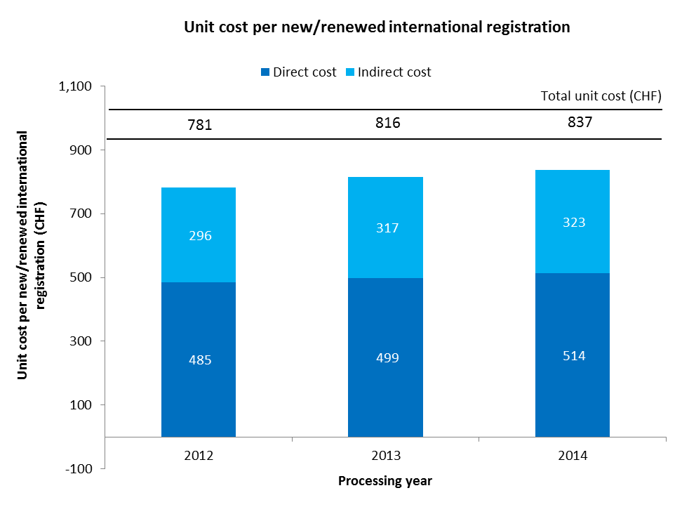

- The average cost of processing a new/renewed international registration was 837 Swiss francs in 2014. This represents an increase of 2.6 per cent compared to 2013. The increase was mainly due to a processing cost that remained relatively stable, combined with a decrease of 4.5 per cent in the number of international applications registered.

Unit cost per document inscribed in the register

- The documents inscribed in the register correspond to the total volume of workload (see “Total volume of workload” above).

Old method | New method
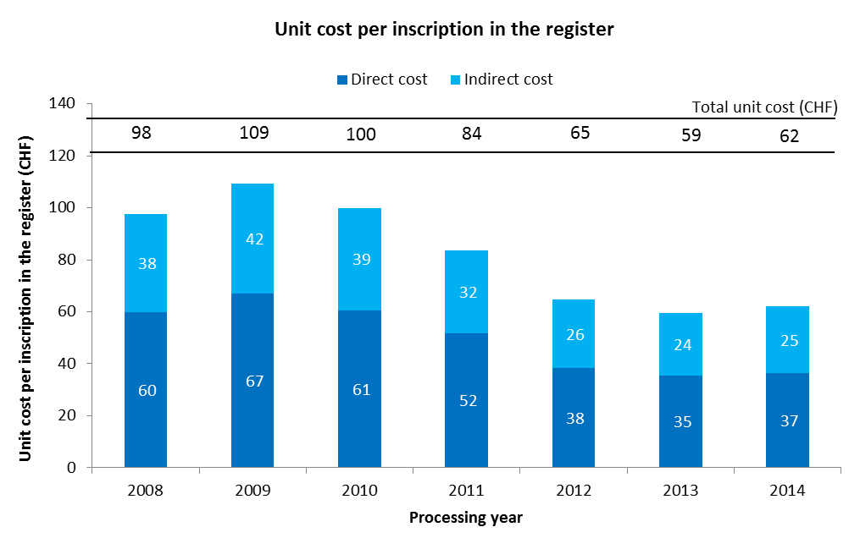 | 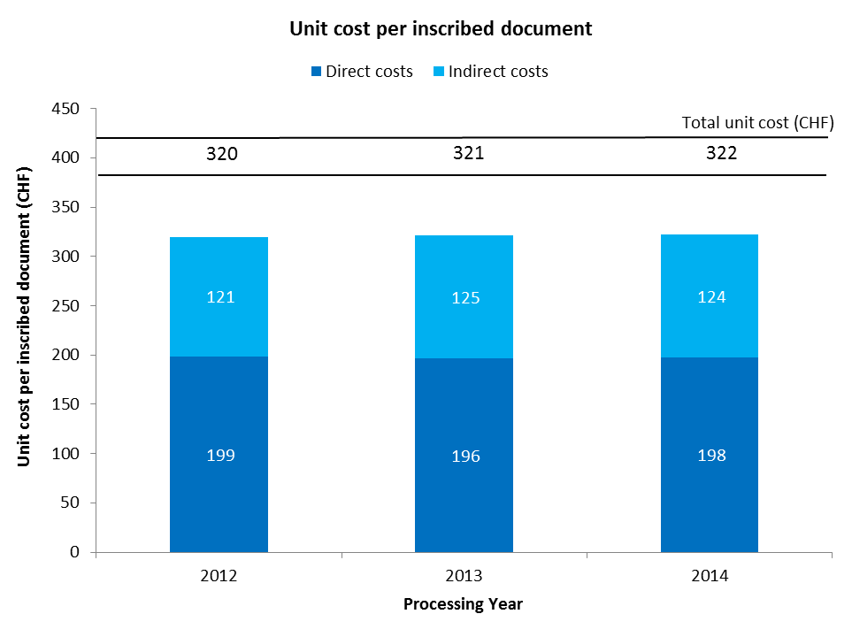

- The average cost of inscribing a document in the register increased slightly from 320 Swiss francs in 2012 to 322 Swiss francs in 2014.

- Productivity of examination

- The definition of examination productivity is the number of new/renewed international registrations processed by examiners divided by the number of personnel involved in examination. The number of personnel includes fellows, interns and external contractors.

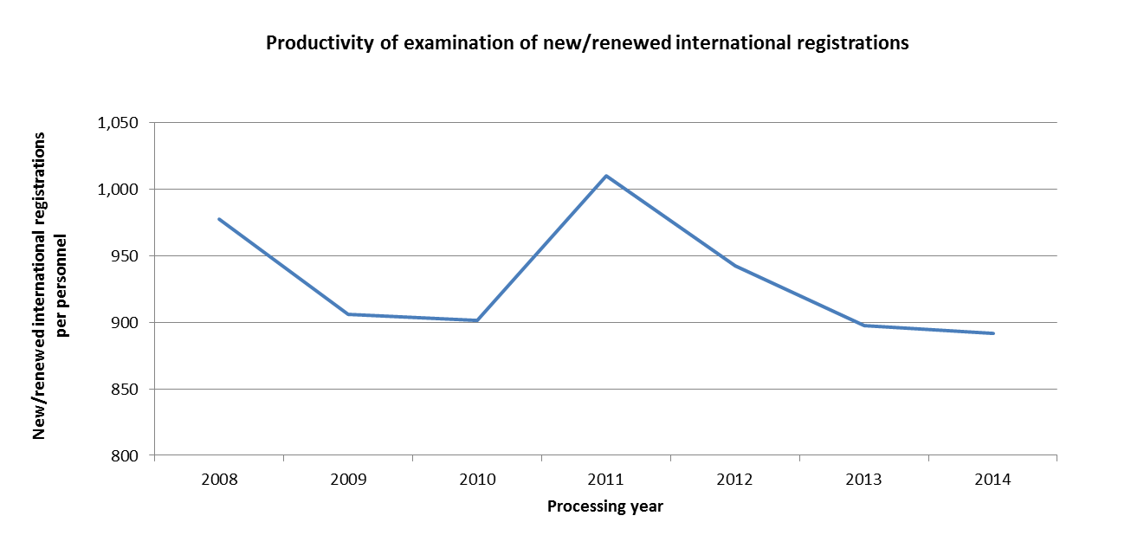

- The productivity of examination remained relatively stable in 2014 compared to 2013.

- Personnel

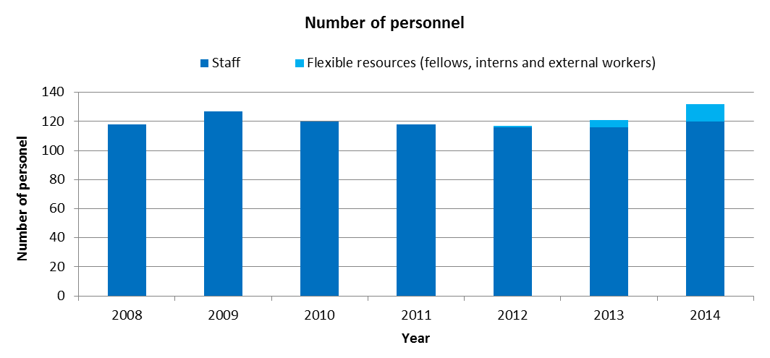
- The number of staff has remained relatively stable since 2010, while the number of flexible resources has increased from 1 in 2012 to 12 in 2014.
- Personnel of outsourcing companies not working on WIPO premises are not included in this indicator.

- Pendency

- The average pendency for each of the six transactions performed by the IB is shown below. The pendency is calculated from the date a document is received to the date it is inscribed.

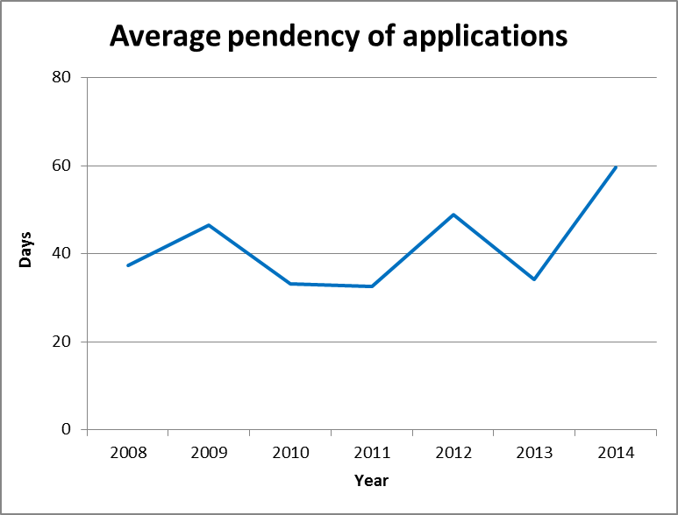 | 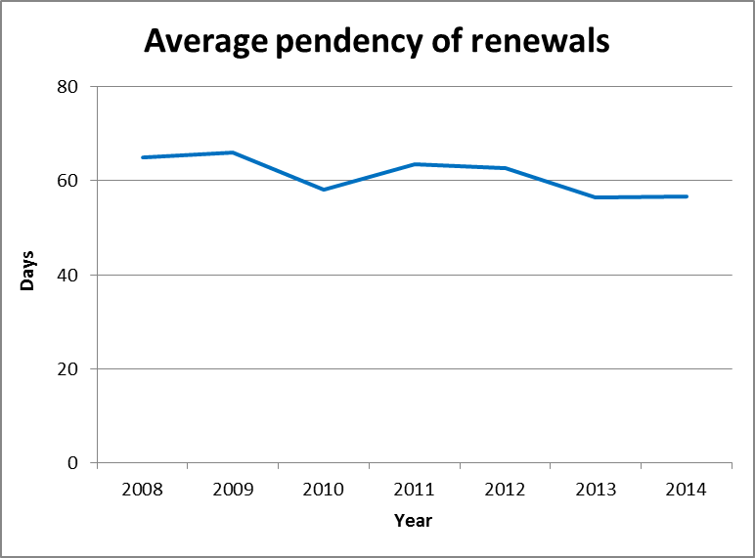
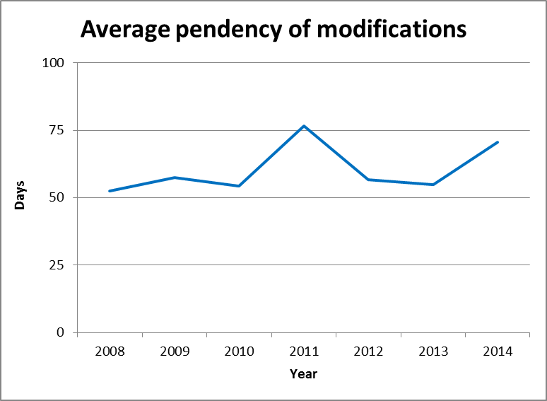 | 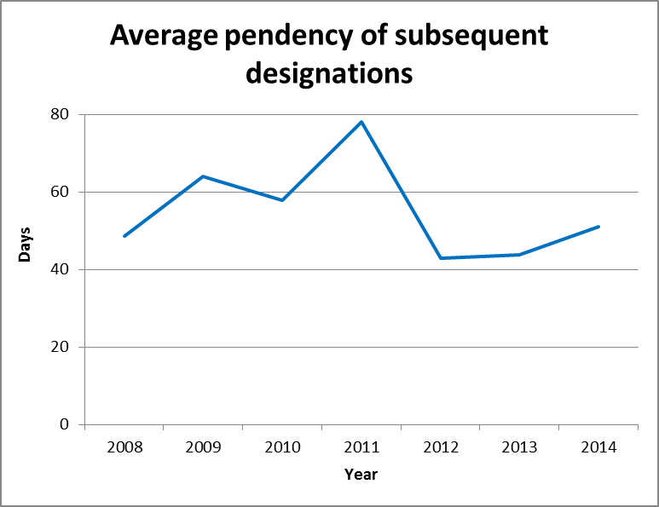
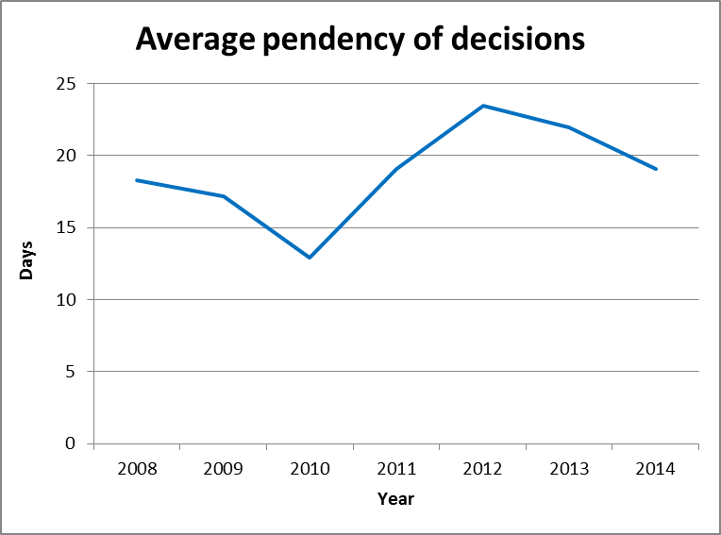 | 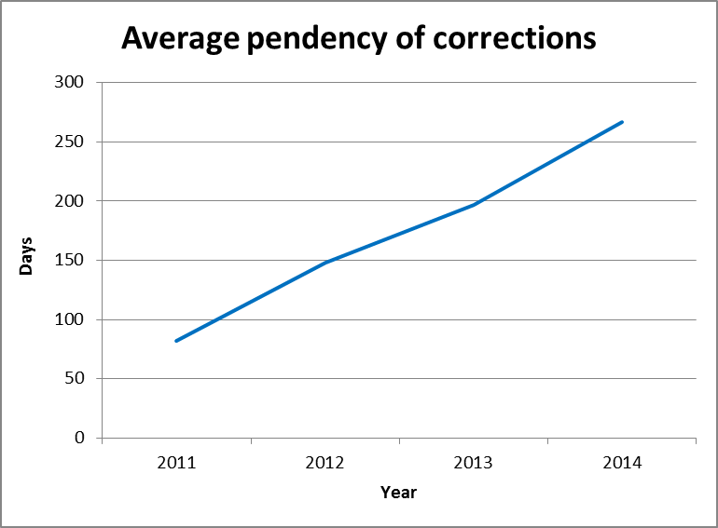

- Compared to 2013, the average pendency in 2014 increased for applications, corrections, modifications and subsequent designations. The average pendency time for renewals remained stable, whereas that for decisions decreased for the second consecutive year.
- Improving and stabilizing pendency across all transactions is a major objective of the IB.

ANNEX VII INDICATORS OF THE HAGUE SYSTEM OPERATIONS

PERFORMANCE INDICATORS FOR THE EXPECTED RESULT
“IMPROVED PRODUCTIVITY AND SERVICE QUALITY OF THE HAGUE OPERATIONS”

- As background for the performance indicators for the expected result “improved productivity and service quality of the Hague operations”, the evolution of the following factors needs to be considered:

- The Hague System workloads;
- The composition of those workloads;
- The level of automation; and
- The resources assigned to cope with the workload.

- The International Bureau (IB) receives four main types of documents, namely international applications, renewals, changes and decisions. The latest trend for each of these documents is presented below. Additional information on the applications received, such as their average number of designs, are also provided. For technical reasons, the indicator on the irregularities issued shows data based on processed documents rather than on incoming documents.

I. Incoming Documents
Applications received
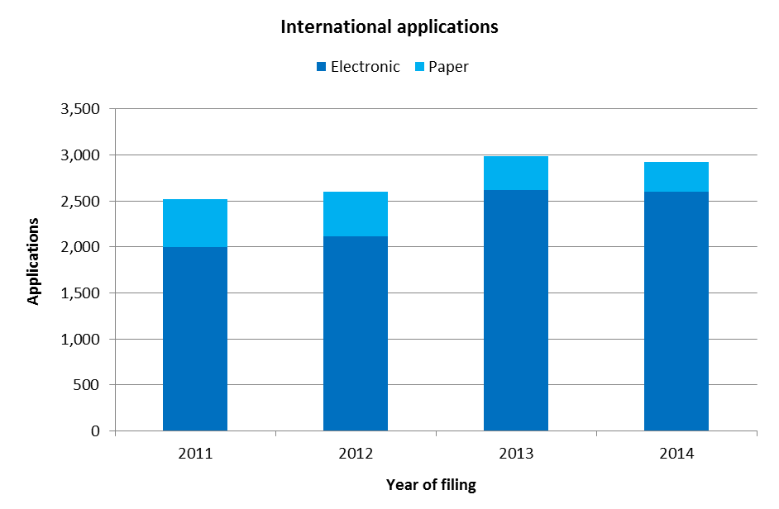
- In 2014, the IB received 2,924 international applications, down 2.2 per cent from 2013. In 2013, applications received sharply grew by 15 per cent.
- In 2014, 89 per cent of applications were filed electronically. The share of electronic filings increased by 10 percentage points from 2011 to 2014, from 79 per cent in 2011 to 89 per cent in 2014.

Average number of designs per application
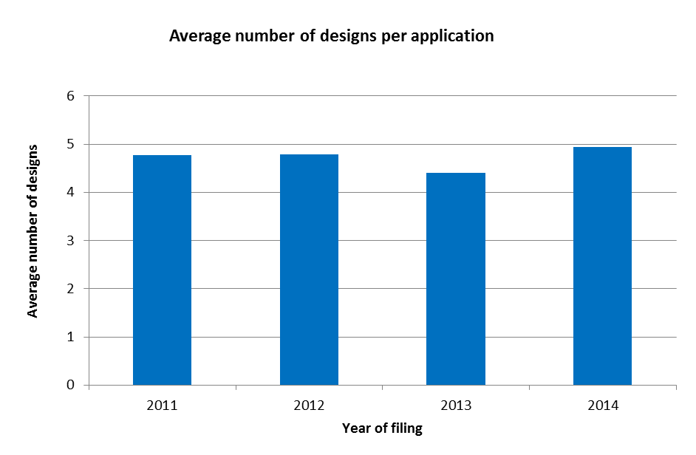
- In 2014, an application contained, on average, nearly five designs. Between 2011 and 2014, the average number of designs per application varied between 4.5 and 5 designs.

Average number of designations per application
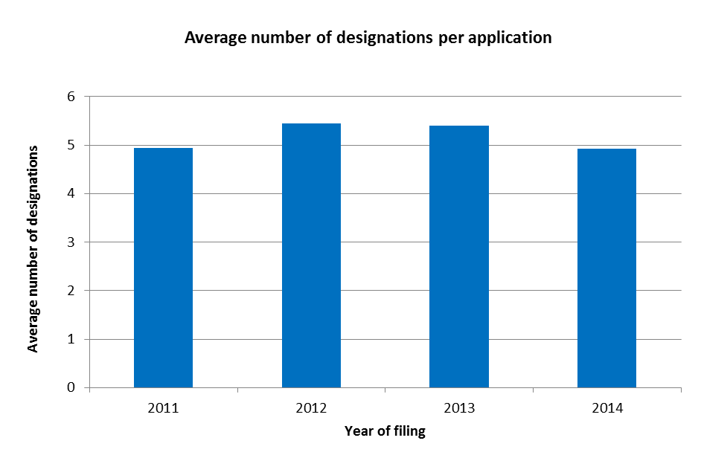
- In 2014, an application contained, on average, nearly five designations.

Trend of irregularities in applications

- Irregularities in applications are grouped among the ten categories shown below.
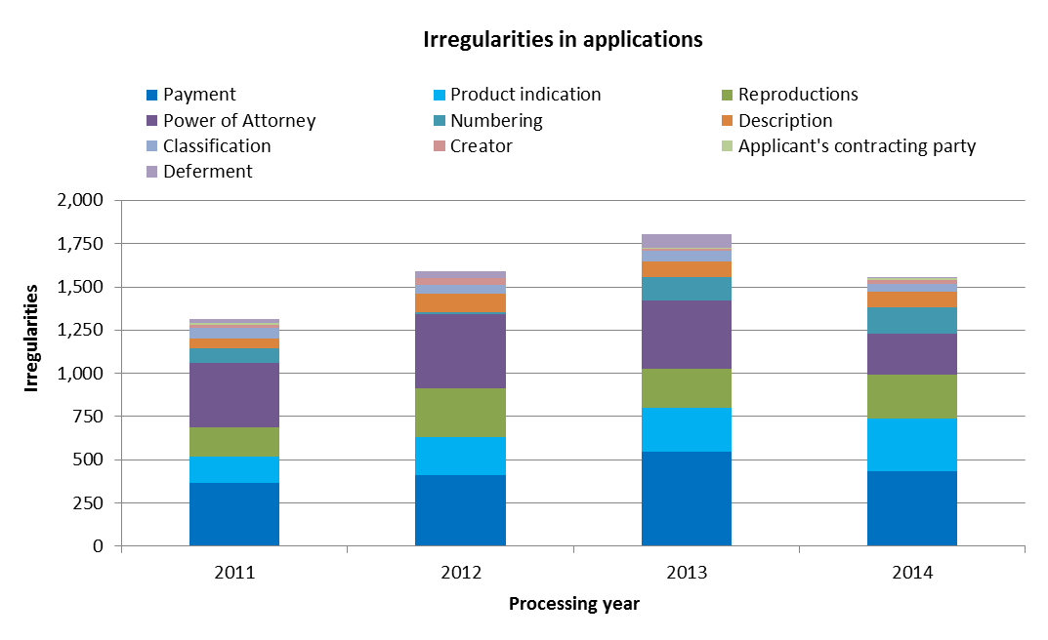
- In 2014, the IB identified 1,557 irregularities in applications, down 14 per cent over 2013.
- Despite this sharp decrease, the irregularities related to product indications increased for the third consecutive year. Together with irregularities of payment, they nearly accounted for half of total irregularities in 2014.

Renewals
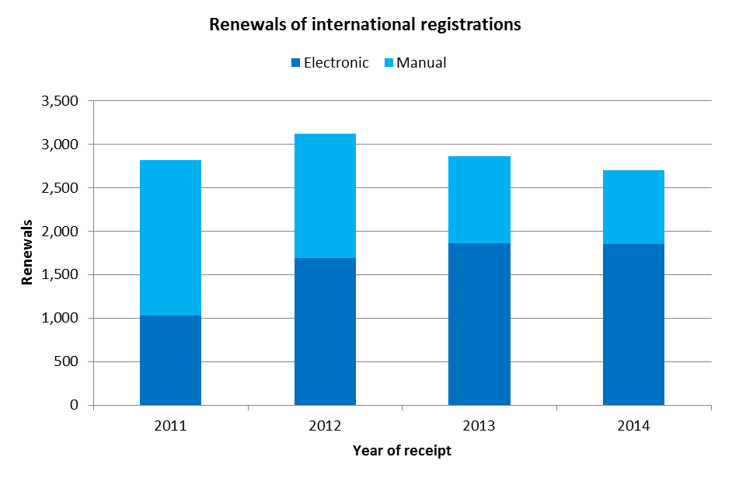
- The number of renewals decreased for the second consecutive year to 2,703 renewals in 2014. This represented a 5 per cent drop on 2013.
- Since 2013, a majority of renewals were processed automatically. They accounted for 60 per cent of total renewals in 2014

Changes
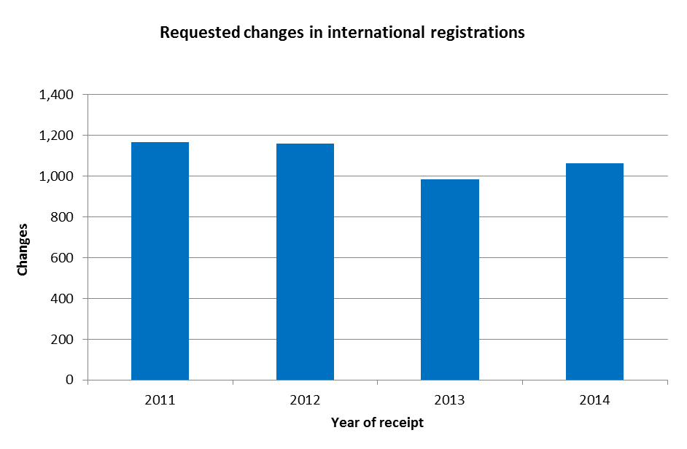
- Applicants requested 1,063 changes in international registrations in 2014, up 8 per cent from 2013.

Decisions
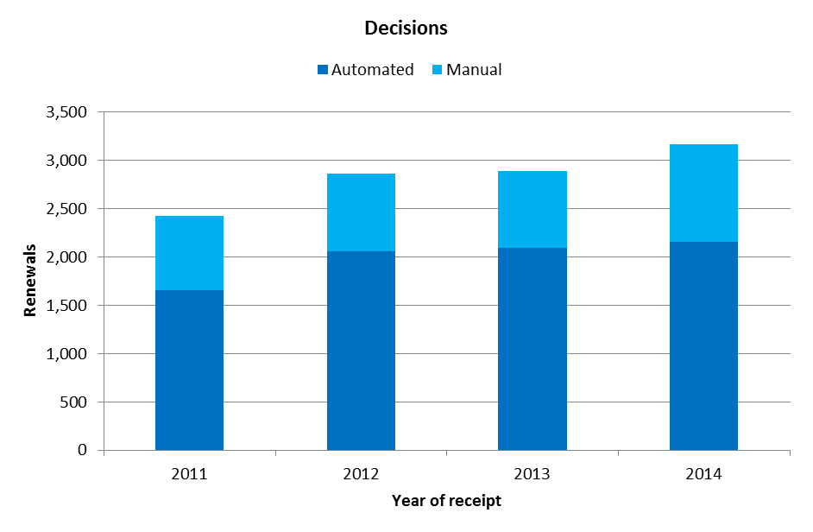
- The number of decisions received in 2014 increased by 10 per cent, to 3,169 decisions.
- Between 68 per cent and 72 per cent of decisions were processed automatically since 2011.

II. Total workload

- The total workload represents the weighted total number of documents received at the IB. All four categories of documents are included (applications, renewals, changes and decisions).

- As processing these types of documents does not require equal resources, they are each weighted differently. According to this weighting, during the time required to process an international application, an examiner can process eight renewals, four changes or four decisions. Similarly, during the time required to process an international application, an employee involved in the automation process can be deemed to process 13 documents.
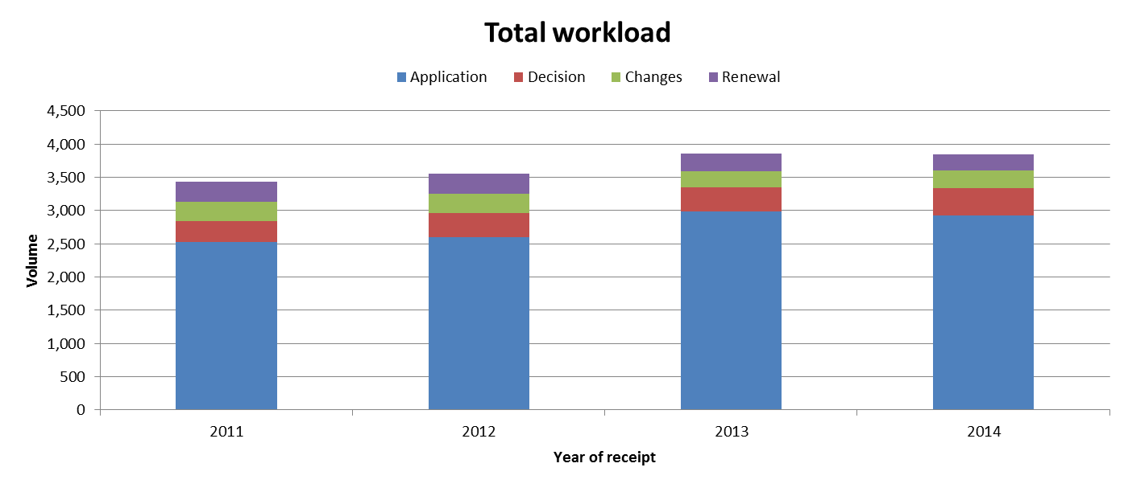
- In 2014, the total workload remained stable compared to 2013. In 2014, applications alone represented 76 per cent of the total workload.
- Between 2011 and 2013, the increase in workload was mainly due to the increase in the number of applications received.

III. Cost of Processing

Total cost of production

- The total cost of production is the total Hague System expenditure, plus a proportion of expenditure on support and management activities. It has direct and indirect components. Direct costs reflect expenditure incurred by the IB in administering the Hague System. Indirect costs reflect expenditure for supporting activities (such as buildings and information technology). Indirect costs are weighted to take into account only the share attributable to the Hague System.

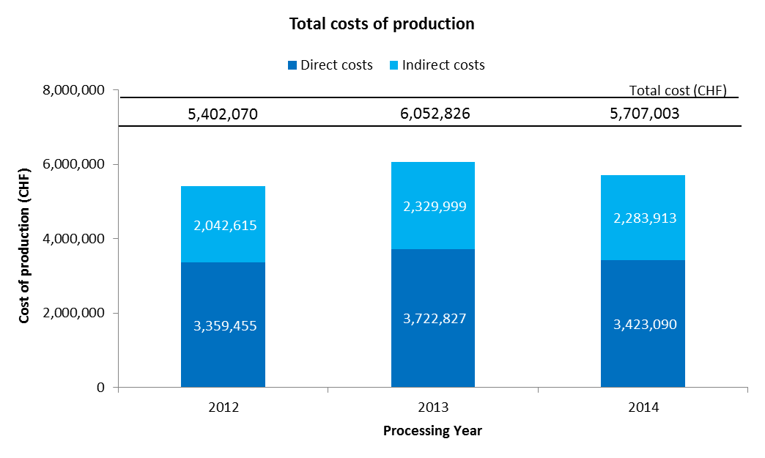
- The total expenditures related to the processing of the Hague System are estimated at 5.7 million Swiss francs in 2014. This represents a decrease of 5.7 per cent on 2013. Direct and indirect costs have decreased, by respectively 8.1 per cent and 2 per cent.
- In 2014, the direct costs accounted for 60 per cent of total expenditures.

Unit cost

- The IB’s efficiency in processing transactions can be measured by the unit cost, defined as the average cost of producing one unit of output.

- As the IB registers new applications and maintains existing registrations, it is relevant to have a unit of output which includes a set of transactions. Two unit cost indicators are presented below using two different units of output.

- As part of the IB’s efforts to continuously refine the methodology for calculating unit costs, the methodology has been revised in the Program and Budget to reflect more accurately the cost of processing Hague workloads at the IB.

- The revisions in question are the following:

- The methodology for calculating direct and indirect costs for the Hague have been aligned with the methodologies for calculating PCT and Madrid unit costs.
- A weighted System has been introduced to better approximate the actual work required to process the four categories of documents, taking into account that certain of these documents are more labor-intensive than others.
- The first unit cost has been redefined to include designs contained in new international registrations and in renewals (the unit cost in the Program and Budget 2014/15 included only designs contained in new international registrations). The rationale for adding designs contained in renewals as a component of this unit cost is a sharper focus on the core Hague outputs, namely the international registration and its renewal.
- The second unit cost is based on the number of documents processed and recorded in the register rather than the number of recordings due to the different levels of efforts required to process the various documents.

- For ease of comparison, the graphs below depict the evolution of the two unit costs from 2008 to 2014 using the old methodology and from 2012 to 2014 using the new methodology, including a breakdown of the contribution of direct and indirect costs.

Unit cost per new/renewed design

- New designs consist of designs in international applications that are registered within a given year, and renewed designs consist of existing designs in international registrations that are renewed within a given year. Combined, designs contained in these two types of transactions reflect the core business of the IB.

- As processing designs contained in these two types of documents do not require equal resources, they are each weighted differently. The unit cost is calculated by dividing the total cost of production by the number of new/renewed designs.

Old method | New method
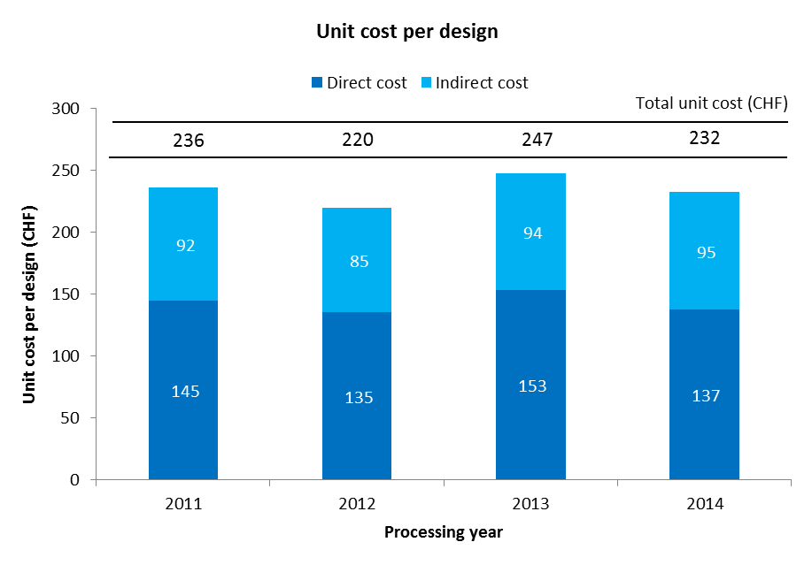 | 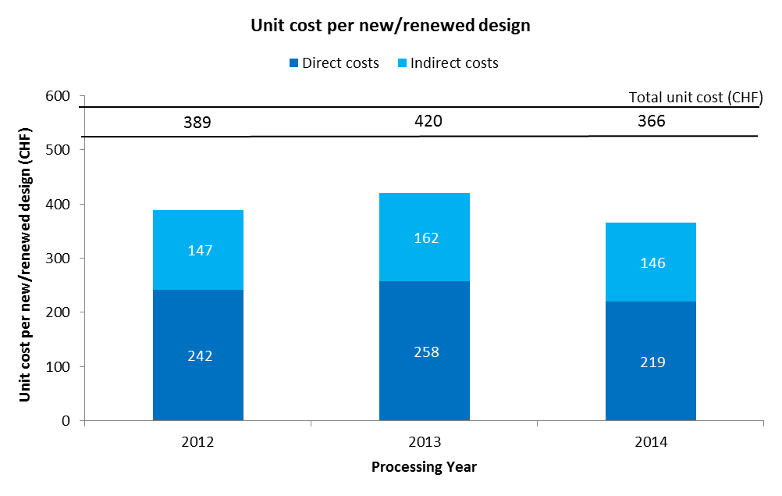

- The average cost of processing a new/renewed design was of 366 Swiss francs in 2014, down 12.8 per cent from 2013. This decrease was mainly due to a decrease of 5.7 per cent of the cost of production combined with an increase of 8.2 per cent of the number of new/renewed designs.

Unit cost per document recorded in the register

- The documents recorded in the register correspond to the total workload (see “Total workload” above).

Old method | New method
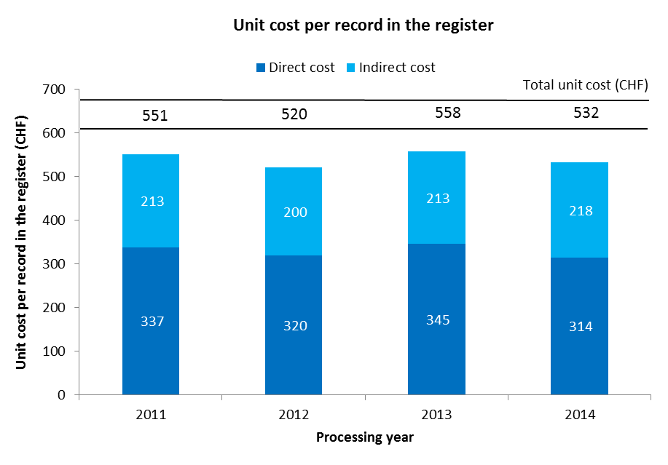 | 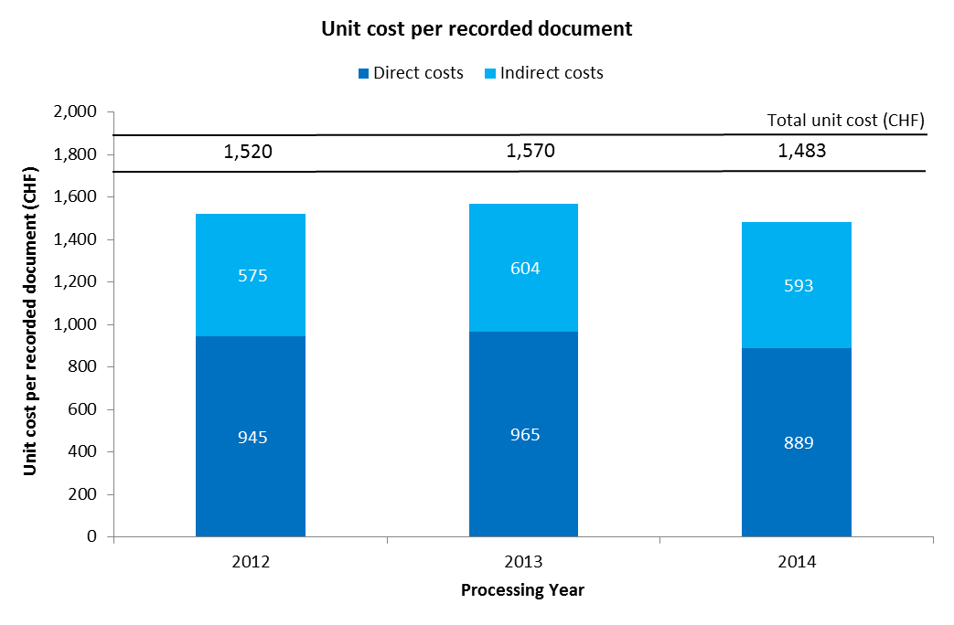

- The average cost of recording a document in the register decreased to 1,483 Swiss francs in 2014. This is due to the decrease of 5.7 per cent of the cost of production.

III. Timeliness to process international applications
- This indicator reflects the time required by the IB to process regular applications. The timeliness is calculated between the time elapsed between the date of receipt of an application and the date it was registered.
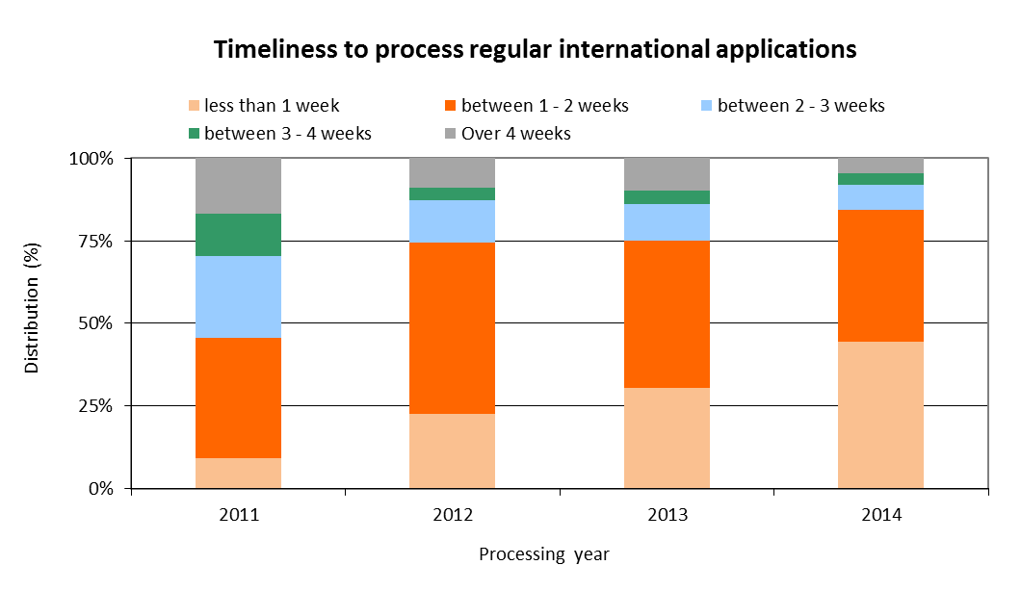
- The share of applications processed within less than one week constantly increased since 2011, to 45 per cent of applications in 2014.
- In 2014, 85 per cent of applications were processed within 2 weeks from the date of receipt at the IB.

ANNEX VIII FUNDS IN TRUST RESOURCES POTENTIALLY AVAILABLE FOR PROGRAMMING

Table 19. Funds in Trust Potentially Available for Programming in 2016/17¹
(in thousands of Swiss francs)

¹The figures do not include interest and exchange rate adjustments. It should also be noted that these funds generally provide for activities spanning a period of time exceeding or overlapping a single biennium, as income is received and expenditure incurred.

²These figures are purely indicative and are based on previous funding patterns. They do not represent Member States' commitments except in those cases where the FIT Agreement includes such a commitment.

³Annual contributions vary and fluctuations have been observed from one year to another.

⁴Republic of Korea (Education) - Expected Balance end 2015 takes into account encumbrances and obligations

.

ANNEX IX ANNUAL BUDGET TABLES FOR IPSAS REPORTING

- At the forty-third session of the Assemblies from September 24 to October 3, 2007, Member States approved the principle of the adoption by WIPO of IPSAS by 2010 (reference documents A/43/5 and A/43/16). This approval was related to the United Nations system-wide initiative endorsed by the General Assembly (A/RES/60/283(IV)I) to replace the existing United Nations Systems Accounting Standards (UNSAS) with IPSAS, which are internationally recognized. Accordingly, WIPO’s financial statements from the year 2010 are prepared in accordance with IPSAS.

- WIPO’s budget continues to be adopted by the Assemblies on a biennial basis. In compliance with IPSAS, the Organization must present financial statements on an annual basis. For this purpose, annual budget figures are provided for both income and expenditure.

- It is recalled that, within the context of the approval of the 2010/11 Program and Budget, the Member States approved the methodology for the annual presentation for WIPO’s biennial approved budget. The table below provides the estimated annual income amounts in accordance with this methodology for the 2016/17 Program and Budget.

Table 20. Annual Income 2006-2017
(in millions of Swiss francs)

*previously, Interest Income (up to the 2014/15 biennium)
Note: Lisbon fee income (2014/15 budgeted estimate: 8,000 Swiss francs; 2016/17: 30,000 Swiss francs)

- In respect of WIPO’s 2016/17 expenditure budget, a 50/50 split has been applied to the biennial non-personnel budget figures in order to establish the annual budget view. The personnel budget has been split on an annual basis based on the calculated costs for the two years respectively. The table below provides the annual expenditure amounts accordingly.

Table 21. Annual Expenditure 2006-2017
(in millions of Swiss francs)

*previously, Travel and Course Fellowships (up to the 2014/15 biennium)

**Contractual Services were restated for years 2004-2009 to include SSAs due to the change introduced in April 2010

***previously, included under Operating Expenses (up to the 2014/15 biennium)

ANNEX X 2016/17 BUDGET BY EXPECTED RESULT AND PROGRAM

ANNEX X (CONT.)

ANNEX XI 2016/17 BUDGET BY EXPECTED RESULT
(in thousands of Swiss francs)

Annex XI cont.

Annex XI cont.

ANNEX XII WIPO ORGANIGRAM

IV. APPENDICES

APPENDIX A
MEMBER STATES’ CONTRIBUTIONS
(in Swiss francs)

States Members of  One or More | Contribution Class | Contribution Units  2016/17 | Contribution¹  2016 | Contribution¹  2017 | Contributions  2016/17

Contribution-Financed Unions
Afghanistan² | Ster | 0.03125 | 1,424 | 1,424 | 2,848
Albania | IX | 0.25 | 11,395 | 11,395 | 22,790
Algeria | IX | 0.25 | 11,395 | 11,395 | 22,790
Andorra | IX | 0.25 | 11,395 | 11,395 | 22,790
Angola | Ster | 0.03125 | 1,424 | 1,424 | 2,848
Antigua and Barbuda | Sbis | 0.0625 | 2,849 | 2,849 | 5,698
Argentina | VIbis | 2 | 91,158 | 91,158 | 182,316
Armenia | IX | 0.25 | 11,395 | 11,395 | 22,790
Australia | III | 15 | 683,685 | 683,685 | 1,367,370
Austria | IVbis | 7.5 | 341,842 | 341,842 | 683,684
Azerbaijan | IX | 0.25 | 11,395 | 11,395 | 22,790
Bahamas | Sbis | 0.0625 | 2,849 | 2,849 | 5,698
Bahrain | S | 0.125 | 5,697 | 5,697 | 11,394
Bangladesh | Ster | 0.03125 | 1,424 | 1,424 | 2,848
Barbados | Sbis | 0.0625 | 2,849 | 2,849 | 5,698
Belarus | IX | 0.25 | 11,395 | 11,395 | 22,790
Belgium | IV | 10 | 455,790 | 455,790 | 911,580
Belize | Sbis | 0.0625 | 2,849 | 2,849 | 5,698
Benin | Ster | 0.03125 | 1,424 | 1,424 | 2,848
Bhutan | Ster | 0.03125 | 1,424 | 1,424 | 2,848
Bolivia (Plurinational State of) | Sbis | 0.0625 | 2,849 | 2,849 | 5,698
Bosnia and Herzegovina | Sbis | 0.0625 | 2,849 | 2,849 | 5,698
Botswana | Sbis | 0.0625 | 2,849 | 2,849 | 5,698
Brazil | VIbis | 2 | 91,158 | 91,158 | 182,316
Brunei Darussalam | S | 0.125 | 5,697 | 5,697 | 11,394
Bulgaria | VIbis | 2 | 91,158 | 91,158 | 182,316
Burkina Faso | Ster | 0.03125 | 1,424 | 1,424 | 2,848
Burundi | Ster | 0.03125 | 1,424 | 1,424 | 2,848
Cabo Verde | Sbis | 0.0625 | 2,849 | 2,849 | 5,698
Cambodia | Ster | 0.03125 | 1,424 | 1,424 | 2,848
Cameroon | Sbis | 0.0625 | 2,849 | 2,849 | 5,698
Canada | IV | 10 | 455,790 | 455,790 | 911,580
Central African Republic | Ster | 0.03125 | 1,424 | 1,424 | 2,848
Chad | Ster | 0.03125 | 1,424 | 1,424 | 2,848
Chile | IX | 0.25 | 11,395 | 11,395 | 22,790
China | IVbis | 7.5 | 341,842 | 341,842 | 683,684
Colombia | IX | 0.25 | 11,395 | 11,395 | 22,790
Comoros | Ster | 0.03125 | 1,424 | 1,424 | 2,848
Congo | Sbis | 0.0625 | 2,849 | 2,849 | 5,698
Costa Rica | S | 0.125 | 5,697 | 5,697 | 11,394
Côte d'Ivoire | Sbis | 0.0625 | 2,849 | 2,849 | 5,698
Croatia | VIII | 0.5 | 22,789 | 22,789 | 45,578
Cuba | S | 0.125 | 5,697 | 5,697 | 11,394
Cyprus | S | 0.125 | 5,697 | 5,697 | 11,394
Czech Republic | VI | 3 | 136,737 | 136,737 | 273,474
Democratic People's Republic of Korea | Sbis | 0.0625 | 2,849 | 2,849 | 5,698
Democratic Republic of the Congo | Ster | 0.03125 | 1,424 | 1,424 | 2,848
Denmark | IV | 10 | 455,790 | 455,790 | 911,580
Djibouti | Ster | 0.03125 | 1,424 | 1,424 | 2,848
Dominica | Sbis | 0.0625 | 2,849 | 2,849 | 5,698
Dominican Republic | S | 0.125 | 5,697 | 5,697 | 11,394
Ecuador | S | 0.125 | 5,697 | 5,697 | 11,394
Egypt | IX | 0.25 | 11,395 | 11,395 | 22,790
El Salvador | Sbis | 0.0625 | 2,849 | 2,849 | 5,698
Equatorial Guinea | Ster | 0.03125 | 1,424 | 1,424 | 2,848
Eritrea ² | Ster | 0.03125 | 1,424 | 1,424 | 2,848
Estonia | IX | 0.25 | 11,395 | 11,395 | 22,790
Ethiopia ² | Ster | 0.03125 | 1,424 | 1,424 | 2,848
Fiji | Sbis | 0.0625 | 2,849 | 2,849 | 5,698
Finland | IV | 10 | 455,790 | 455,790 | 911,580
France | I | 25 | 1,139,475 | 1,139,475 | 2,278,950
Gabon | S | 0.125 | 5,697 | 5,697 | 11,394
Gambia | Ster | 0.03125 | 1,424 | 1,424 | 2,848
Georgia | IX | 0.25 | 11,395 | 11,395 | 22,790
Germany | I | 25 | 1,139,475 | 1,139,475 | 2,278,950
Ghana | Sbis | 0.0625 | 2,849 | 2,849 | 5,698
Greece | VI | 3 | 136,737 | 136,737 | 273,474
Grenada | Sbis | 0.0625 | 2,849 | 2,849 | 5,698
Guatemala | S | 0.125 | 5,697 | 5,697 | 11,394
Guinea | Ster | 0.03125 | 1,424 | 1,424 | 2,848
Guinea-Bissau | Ster | 0.03125 | 1,424 | 1,424 | 2,848
Guyana | Sbis | 0.0625 | 2,849 | 2,849 | 5,698
Haiti | Ster | 0.03125 | 1,424 | 1,424 | 2,848
Holy See | IX | 0.25 | 11,395 | 11,395 | 22,790
Honduras | Sbis | 0.0625 | 2,849 | 2,849 | 5,698
Hungary | VI | 3 | 136,737 | 136,737 | 273,474
Iceland | VIII | 0.5 | 22,789 | 22,789 | 45,578
India | VIbis | 2 | 91,158 | 91,158 | 182,316
Indonesia | VII | 1 | 45,579 | 45,579 | 91,158
Iran (Islamic Republic of) | VII | 1 | 45,579 | 45,579 | 91,158
Iraq | S | 0.125 | 5,697 | 5,697 | 11,394
Ireland | IV | 10 | 455,790 | 455,790 | 911,580
Israel | VIbis | 2 | 91,158 | 91,158 | 182,316
Italy | III | 15 | 683,685 | 683,685 | 1,367,370
Jamaica | Sbis | 0.0625 | 2,849 | 2,849 | 5,698
Japan | I | 25 | 1,139,475 | 1,139,475 | 2,278,950
Jordan | S | 0.125 | 5,697 | 5,697 | 11,394
Kazakhstan | IX | 0.25 | 11,395 | 11,395 | 22,790
Kenya | Sbis | 0.0625 | 2,849 | 2,849 | 5,698
Kiribati² | Ster | 0.03125 | 1,424 | 1,424 | 2,848
Kuwait | IX | 0.25 | 11,395 | 11,395 | 22,790
Kyrgyzstan | IX | 0.25 | 11,395 | 11,395 | 22,790
Lao People's Democratic Republic | Ster | 0.03125 | 1,424 | 1,424 | 2,848
Latvia | IX | 0.25 | 11,395 | 11,395 | 22,790
Lebanon | S | 0.125 | 5,697 | 5,697 | 11,394
Lesotho | Ster | 0.03125 | 1,424 | 1,424 | 2,848
Liberia | Ster | 0.03125 | 1,424 | 1,424 | 2,848
Libya | IX | 0.25 | 11,395 | 11,395 | 22,790
Liechtenstein | VIII | 0.5 | 22,789 | 22,789 | 45,578
Lithuania | IX | 0.25 | 11,395 | 11,395 | 22,790
Luxembourg | VII | 1 | 45,579 | 45,579 | 91,158
Madagascar | Ster | 0.03125 | 1,424 | 1,424 | 2,848
Malawi | Ster | 0.03125 | 1,424 | 1,424 | 2,848
Malaysia | VIII | 0.5 | 22,789 | 22,789 | 45,578
Maldives ² | Sbis | 0.0625 | 2,849 | 2,849 | 5,698
Mali | Ster | 0.03125 | 1,424 | 1,424 | 2,848
Malta | Sbis | 0.0625 | 2,849 | 2,849 | 5,698
Mauritania | Ster | 0.03125 | 1,424 | 1,424 | 2,848
Mauritius | Sbis | 0.0625 | 2,849 | 2,849 | 5,698
Mexico | IVbis | 7.5 | 341,842 | 341,842 | 683,684
Micronesia (Federates States of) | Sbis | 0.0625 | 2,849 | 2,849 | 5,698
Monaco | VII | 1 | 45,579 | 45,579 | 91,158
Mongolia | Sbis | 0.0625 | 2,849 | 2,849 | 5,698
Montenegro | IX | 0.25 | 11,395 | 11,395 | 22,790
Morocco | S | 0.125 | 5,697 | 5,697 | 11,394
Mozambique | Ster | 0.03125 | 1,424 | 1,424 | 2,848
Myanmar ² | Ster | 0.03125 | 1,424 | 1,424 | 2,848
Namibia | Sbis | 0.0625 | 2,849 | 2,849 | 5,698
Nepal | Ster | 0.03125 | 1,424 | 1,424 | 2,848
Netherlands | III | 15 | 683,685 | 683,685 | 1,367,370
New Zealand | VI | 3 | 136,737 | 136,737 | 273,474
Nicaragua | Sbis | 0.0625 | 2,849 | 2,849 | 5,698
Niger | Ster | 0.03125 | 1,424 | 1,424 | 2,848
Nigeria | S | 0.125 | 5,697 | 5,697 | 11,394
Niue² | Sbis | 0.0625 | 2,849 | 2,849 | 5,698
Norway | IV | 10 | 455,790 | 455,790 | 911,580
Oman | IX | 0.25 | 11,395 | 11,395 | 22,790
Pakistan | S | 0.125 | 5,697 | 5,697 | 11,394
Panama | S | 0.125 | 5,697 | 5,697 | 11,394
Papua New Guinea | Sbis | 0.0625 | 2,849 | 2,849 | 5,698
Paraguay | Sbis | 0.0625 | 2,849 | 2,849 | 5,698
Peru | IX | 0.25 | 11,395 | 11,395 | 22,790
Philippines | IX | 0.25 | 11,395 | 11,395 | 22,790
Poland | VI | 3 | 136,737 | 136,737 | 273,474
Portugal | IVbis | 7.5 | 341,842 | 341,842 | 683,684
Qatar | IX | 0.25 | 11,395 | 11,395 | 22,790
Republic of Korea | IVbis | 7.5 | 341,842 | 341,842 | 683,684
Republic of Moldova | IX | 0.25 | 11,395 | 11,395 | 22,790
Romania | VIbis | 2 | 91,158 | 91,158 | 182,316
Russian Federation | IV | 10 | 455,790 | 455,790 | 911,580
Rwanda | Ster | 0.03125 | 1,424 | 1,424 | 2,848
Saint Kitts and Nevis | Sbis | 0.0625 | 2,849 | 2,849 | 5,698
Saint Lucia | Sbis | 0.0625 | 2,849 | 2,849 | 5,698
Saint Vincent and the Grenadines | Sbis | 0.0625 | 2,849 | 2,849 | 5,698
Samoa | Sbis | 0.0625 | 2,849 | 2,849 | 5,698
San Marino | IX | 0.25 | 11,395 | 11,395 | 22,790
Sao Tome and Principe | Ster | 0.03125 | 1,424 | 1,424 | 2,848
Saudi Arabia | VII | 1 | 45,579 | 45,579 | 91,158
Senegal | Ster | 0.03125 | 1,424 | 1,424 | 2,848
Serbia | VIII | 0.5 | 22,789 | 22,789 | 45,578
Seychelles | Sbis | 0.0625 | 2,849 | 2,849 | 5,698
Sierra Leone | Ster | 0.03125 | 1,424 | 1,424 | 2,848
Singapore | IX | 0.25 | 11,395 | 11,395 | 22,790
Slovakia | VI | 3 | 136,737 | 136,737 | 273,474
Slovenia | VII | 1 | 45,579 | 45,579 | 91,158
Somalia ² | Ster | 0.03125 | 1,424 | 1,424 | 2,848
South Africa | IVbis | 7.5 | 341,842 | 341,842 | 683,684
Spain | IV | 10 | 455,790 | 455,790 | 911,580
Sri Lanka | S | 0.125 | 5,697 | 5,697 | 11,394
Sudan | Ster | 0.03125 | 1,424 | 1,424 | 2,848
Suriname | Sbis | 0.0625 | 2,849 | 2,849 | 5,698
Swaziland | Sbis | 0.0625 | 2,849 | 2,849 | 5,698
Sweden | III | 15 | 683,685 | 683,685 | 1,367,370
Switzerland | III | 15 | 683,685 | 683,685 | 1,367,370
Syrian Arab Republic | S | 0.125 | 5,697 | 5,697 | 11,394
Tajikistan | IX | 0.25 | 11,395 | 11,395 | 22,790
Thailand | IX | 0.25 | 11,395 | 11,395 | 22,790
The former Yugoslav Republic of Macedonia | VIII | 0.5 | 22,789 | 22,789 | 45,578
Togo | Ster | 0.03125 | 1,424 | 1,424 | 2,848
Tonga | Sbis | 0.0625 | 2,849 | 2,849 | 5,698
Trinidad and Tobago | S | 0.125 | 5,697 | 5,697 | 11,394
Tunisia | S | 0.125 | 5,697 | 5,697 | 11,394
Turkey | VIbis | 2 | 91,158 | 91,158 | 182,316
Turkmenistan | IX | 0.25 | 11,395 | 11,395 | 22,790
Tuvalu² | Ster | 0.03125 | 1,424 | 1,424 | 2,848
Uganda | Ster | 0.03125 | 1,424 | 1,424 | 2,848
Ukraine | IX | 0.25 | 11,395 | 11,395 | 22,790
United Arab Emirates | IX | 0.25 | 11,395 | 11,395 | 22,790
United Kingdom | I | 25 | 1,139,475 | 1,139,475 | 2,278,950
United Republic of Tanzania | Ster | 0.03125 | 1,424 | 1,424 | 2,848
United States of America | I | 25 | 1,139,475 | 1,139,475 | 2,278,950
Uruguay | S | 0.125 | 5,697 | 5,697 | 11,394
Uzbekistan | IX | 0.25 | 11,395 | 11,395 | 22,790
Vanuatu | Ster | 0.03125 | 1,424 | 1,424 | 2,848
Venezuela (Bolivarian Republic of) | IX | 0.25 | 11,395 | 11,395 | 22,790
Viet Nam | S | 0.125 | 5,697 | 5,697 | 11,394
Yemen | Ster | 0.03125 | 1,424 | 1,424 | 2,848
Zambia | Ster | 0.03125 | 1,424 | 1,424 | 2,848
Zimbabwe | Sbis | 0.0625 | 2,849 | 2,849 | 5,698
Total Contributions |  |  | 17,361,317 | 17,361,317 | 34,722,634

¹ The value of one unit remains unchanged for 2016 and 2017 at 45,579 Swiss francs as compared to 2014 and 2015.

² States members of WIPO which are not members of any of the Unions.

APPENDIX B
DEFINITION OF COST CATEGORIES

SOURCES OF INCOME

Contributions: Contributions of Member States to the Organization under the unitary contribution system.

Fees: Fees for the International Bureau under the PCT, Madrid, Hague and Lisbon Systems, net of related currency adjustments.

Arbitration: Fees for the arbitration of domain names, registration fees for the meetings of the WIPO Arbitration and Mediation Center, net of related currency adjustments

Investment revenue: Revenues earned from investments, including interest on capital deposits.

Publications: Revenues from the sale of publications and from subscriptions to periodicals published by the Secretariat, in paper, CD-ROM or any other format.

Miscellaneous income: registration fees for conferences and training courses, support charges in respect of extra-budgetary activities executed by WIPO and financed by UNDP and trust funds, accounting adjustments (credits) in respect of prior years and currency adjustments, rental of WIPO premises, UPOV’s payments to WIPO for administrative support services.

OBJECTS OF EXPENDITURE

PERSONNEL RESOURCES

Posts: remuneration received by staff members, in particular salaries, post adjustment, dependency allowances, language allowances and overtime, non-resident allowances, assignment grant and representation allowances.

Temporary Staff: remuneration and allowances paid to professional and general service employees on short-term contracts.

Other Staff Costs: provision for professional accident insurance, closed pension fund, litigation costs and Rewards and Recognition Program.

NON-PERSONNEL RESOURCES

Internships and WIPO Fellowships

- Internships: remuneration and allowances paid to interns.

- WIPO Fellowships: expenses related to a training activity that provides a monetary grant to qualified individuals for the purpose of fulfilling special learning objectives.

Travel, Training and Grants

- Staff missions: travel expenses and daily subsistence allowances for all staff on official travel.

- Third party travel: travel expenses and daily subsistence allowances for all third parties, including the travel costs of Government officials, participants and lecturers attending WIPO-sponsored meetings.

- Training and related travel grants: travel expenses, daily subsistence allowances and training and other fees in connection with trainees attending courses, seminars, fellowships.

Contractual Services

- Conferences: remuneration, travel expenses and daily subsistence allowances for interpreters; renting of conference facilities, and interpretation equipment; refreshments and receptions; and the cost of any other service directly linked to the organization of a conference.

- Publishing: outside printing and binding; reviews; paper and printing; other printing: reprints of articles published in reviews; brochures; treaties; collections of texts; manuals; working forms and other miscellaneous printed material; production of CD-ROMs, videos, magnetic tapes and other forms of electronic publishing.

- Individual Contractual Services: remuneration paid in respect of individual contractual services.

- Other Contractual Services: includes all other contractual services with both commercial and non-commercial service providers.

Finance Costs

- Finance costs: Interest on loan; bank charges.

Operating Expenses

- Premises and maintenance: acquiring, renting, improving and maintaining office space and renting or maintaining equipment and furniture, external management consultants related to new construction.

- Communication: communication expenses such as telephone, internet, facsimile and mail, postage and carriage of documents.

- Representation and Other Operating Expenses: official hospitality, WIPO contribution to Staff Association and other operating expenses.

- UN Joint Services: medical assistance, contributions to joint administrative activities within the United Nations system, United Nations cost shared activities, Administrative Tribunal.

Equipment and Supplies

- Furniture and equipment: purchase of office furniture, office machines, computer equipment (desktop, laptops, printers, servers, etc), conference servicing equipment, reproduction equipment and transportation equipment.

- Supplies and materials: stationery and office supplies; internal reproduction supplies (offset, microfilms, etc.); library books and subscriptions to reviews and periodicals; uniforms; computer supplies, software and licenses.

APPENDIX C
COSTING FOR PERSONNEL

- With the launch of EPM (Enterprise Performance Management) system and implementation of ERP (HR Payroll) and as part of further strengthening results-based management, and in particular to reinforce the link between the work performed and the associated resources necessary for implementation, a change in the costing methodology for personnel costs has been applied for 2016/17. The budget for the personnel resources of the Organization has been derived on the basis of actuals based budgeting.

- The actuals based costing is built on the latest available UN salary and pensionable remuneration scales for Professionals and higher categories and General Service staff, historical data of dependencies, and applicable policies and entitlements. The costing methodology applied incorporates several cost elements to derive costs at position level, which is then used to provide an overall costing for personnel resources. The cost elements included in the actuals based costing and the underlying assumptions are summarized below.

Actuals Based Costing and Underlying Assumptions

 | Post  (Professional and higher categories and General Service) | Temporary Staff  (Professional and higher categories and General Service)
Salary | The salary component for an occupied position is calculated at position level applying single or dependent rate scales (ICSC) at projected grade/step. For vacant positions it is at dependent rate at an average step grade. The calculated USD amount is then converted to Swiss francs, with the application of the post adjustment (PA) multiplier, where applicable (for Professionals and higher categories).  The Organization’s share of the pensionable remuneration (UNJSPF) is added to the total amount. | The salary component for an occupied position is calculated at position level applying single or dependent rate scales (ICSC) at projected grade/step. For vacant positions it is at dependent rate at an average step grade. The calculated USD amount is then converted to Swiss francs, with the application of the post adjustment (PA) multiplier, where applicable (for Professionals and higher categories).  The Organization’s share of the pensionable remuneration (UNJSPF) is added to the total amount.
Common Staff Costs (CSC) | The CSC includes all benefits and entitlements other than salary, provided in accordance with the Staff Regulations and Rules (such as dependency allowance, medical contributions, home leave, education grant etc.). The common staff cost is applied at the position level on the basis of a historic pattern of expenditures and projections made.  For vacant positions, an assumption of a spouse and a dependent child is applied to calculate the projected benefits. | The CSC includes all benefits and entitlements other than salary, provided in accordance with the Staff Regulations and Rules (such as dependency allowance, medical contributions etc.). The common staff cost is applied to the position level on the basis of a historic pattern of expenditures and projections made.  For vacant positions, an assumption of a spouse and a dependent child is applied to calculate the projected benefits.
Adjustment | The cost for all positions is adjusted downward to take into account the 3% expected vacancy rate. | No vacancy rate is applied for temporary positions.
Provision for Separation and other related Costs | A 6% provision is applied to the total cost to cover for separation related costs and various after service benefits. | A 2% provision is applied is to the total cost to cover for the separation related costs and various after service benefits.

APPENDIX D
FLEXIBILITY FORMULAS

GENERAL

The flexibility formulas are the mechanism which enables the levels of financial resources allocated to the global protection systems (PCT, Madrid, Hague) to be varied to reflect unbudgeted variations in the total volume of registration activities. The flexibility formulas for the PCT, Madrid and Hague systems were revised and approved by their respective Assemblies, which convened from September 24 to October 3, 2007.

PCT SYSTEM

The revised flexibility formula for the PCT system is described in document PCT/A/36/5, and it was approved by the PCT Assembly as indicated in document PCT/A/36/13. As noted in these documents, the flexibility formula for PCT was revised to reflect a budget variation of 341,870 Swiss francs per 1,000 unbudgeted PCT international applications. The revised formula no longer linked the variations in the number of applications to variations in the number of staff posts as it was done before. Rather, the formula proposed to vary the total resources allocated to programs involved, allowing to use both personnel resources (such as posts, short-term employees, SSAs, etc.) and non-personnel resources (such as outsourcing contracts). The adjustments are allocated to the administration of the PCT system and support services at a 87.5:12.5 ratio.

MADRID SYSTEM

The revised flexibility formula for the Madrid system is described in document MM/A/38/5, and it was approved by the Madrid Assembly as reflected in document MM/A/38/6. The new formula allows for adjustments in the Madrid Union budget by 197,060 Swiss francs for each variation of 500 registrations and/or renewals recorded as compared to the approved initial estimates. The formula no longer links the adjustments to staff posts only, but rather allows for adjustments in overall financial resources allocated to the programs directly involved in the processing of the resulting workload. These resources may be of personnel (posts, short-term employees, etc.) and non-personnel nature (e.g., outsourcing contracts). The adjustments are allocated to the administration of the International Trademark Registry and support services at a 87.5:12.5 ratio.

HAGUE SYSTEM

The revised flexibility formula for the Hague system is described in document H/A/24/3, and it was approved by the Hague Assembly as reflected in document H/A/24/4. The new formula provides for adjustments of the Hague Union budget by an amount of 99,024 Swiss francs for each variation of 300 registrations and/or renewals recorded in the Hague Union Registry as compared to the approved initial estimates. The resources may be of personnel and non-personnel nature, and they are allocated to the administration of the Hague Union Registry and support services at a 87.5:12.5 ratio.

APPENDIX E
ACRONYMS AND ABBREVIATIONS USED IN THE PRESENT DOCUMENT

ABC Accessible Books Consortium
ACE Advisory Committee on Enforcement
ADR Alternative Dispute Resolution
AGICOA Association of International Collective Management of Audiovisual Works
AIMS Administration Information Management System
AIPMS Arab IP Management System
aRDi Access to Research for Development and Innovation
ASEAN Association of South East Asian Nations
ASHI After-Service Health Insurance
ASPI Access to Specialized Patent Information
AUTM Association of University Technology Managers
AWGIPC ASEAN Working Group on Intellectual Property Cooperation
BOIP Benelux Organization for Intellectual Property
CASE Centralized Access to Search and Examination Results
ccTLDs country code Top-Level Domain
CDIP Conference on Development and Intellectual Property
CIS Commonwealth of Independent States
CLIR Cross Lingual Information Retrieval
CMG Crisis Management Group
CMOs collective management organizations
CTCN Climate Technology Center and Network
DA Development Agenda
DAS Digital Access Service for Priority Documents
DGIPR Directorate General of Intellectual Property Rights
DNS Domain Name System

EACIN East Africa Climate Innovation Network
ECDL (test) European Computer Driving Licence (global computer literacy certification)
ECLA patent classification assigned by the European Patent office
ECM Enterprise Content management
EDMS Electronic Document Management System
EEC Eurasian Economic Commission
EGEDA Entidad de Gestión de Derechos de los Productores Audiovisuales
EPO European Patent Office
ERP enterprise resource planning
ETSI European Telecommunication Standards Institute
EU European Union

FAO Food and Agricultural Organization
FI patent classification assigned by the Japanese Patent office
FIT Fund-in-Trust

GNIPA Global Network of IP Academies
GR genetic resources
gTLDs generic Top-Level Domains

HR Human Resources
HRMD Human Resources Management Department

IAOC Independent Advisory and Oversight Committee

ICOM International Council of Museums
IOD Internal Oversight Division
ICANN Internet Corporation for Assigned Names and Numbers
ICE International Cooperation on Examination
ICSEI International Cooperation for the Search and Examination of Inventions
ICPIP Inter-State Council on the Protection of Industrial Property
ICSC International Civil Service Commission
ICT Information and Communication Technology
IGC Intergovernmental Committee on Intellectual Property and Genetic Resources, Traditional Knowledge and Folklore
IGOs inter-governmental organizations
IIA Institute of Internal Auditors
IMPI Mexican Institute of Industrial Property
IMR International Music Registry
INP-BR Brazilian National Institute of Industrial Property
IP Intellectual Property
IPAG Intellectual Property Agreement Guide
IPAS IP Office Administration System
IPACIS Assembly of the CIS Member States
IPC International Patent Classification
IP-DMD Intellectual Property Development Matchmaking Database
IPO Intellectual Property Office
IPoA Istanbul Programme for Action
OPOPHL Intellectual Property Office of the Philippines
IPRs Intellectual Property Rights
IPSAS International Public Sector Accounting Standards
IT Information Technology
IP-TAD Intellectual Property Technical Assistance Database
IP-ROC Intellectual Property Roster of Consultants
ISO International Organization for Standardization
ITIL Information Technology Infrastructure Library
ITPGRFA International Treaty on Plant Genetic Resources for Food and Agriculture
ITU International Telecommunications Union

KOTEC Korea Technology Finance Corporation

LDCs Least Developed Countries

MDGs Millenium Development Goals
MGS Madrid Goods and Services Manager
MTSP Medium Term Strategic Plan

NGOs non-governmental organizations

OHIM Office for Harmonization in the Internal Market (Community Trademarks)
OCR Optical Character Recognition (OCR

PCD Procurement Services Division
PCT Patent Cooperation Treaty
PLR Patent Landscape Reports
PLT Patent Law Treaty
PMSDS Performance Management and Staff Development System
PPR Program Performance Report

RBM Results-based Management
R&D research and development
RFPs Requests for Proposals
RO Receiving Office

SCCR Standing Committee on Copyright and Related Rights
SCP Standing Committee on the Law of Patents
SCT Standing Committee on the Law of Trademarks, Industrial Designs and Geographical Indications
SDG Sustainable Development Goals
SLC Special Labor Contract
SMEs small and medium sized enterprises
SSA Special Service Agreements
SRP Strategic Realignment Program
SRR Staff Regulations and Rules

TA Travel Authorization
TAG Transparency, Accountability and Governance
TCEs Traditional Cultural Expressions/Folklore
TIGAR Trusted Intermediary Global Accessible Resources
TISCs Technology Innovation Support Centers
TK Traditional Knowledge
TTO Technology Transfer Office

UDRP Uniform Domain Name Dispute Resolution Policy
UN United Nations
UNCTAD United Nations Conference on Trade and Development
UN CEB United Nations Chief Executives Board
UN-DESA United Nations Department of Social and Economic Affaires
UNEP United Nations Environmental Programme

UNESCO United Nations Educational, Scientific and Cultural Organization
UNFCCC Framework Convention on Climate Change
UN-H-MOSS UN Headquarters Minimum Operating Security Standards
UNICC UN International Computing Centre
UNIDO United Nations Industrial Development Organization
UNOSSC United Nations Office for South-South Cooperation
UNSAS United Nations System Accounting Standards
UPOV International Union for the Protection of New Varieties of Plants
USCLA US Classifications
USPTO United States Patent and Trademark Office

VIP Visually Impaired Persons and other persons with print disabilities

WBO WIPO Brazil Office
WCC WIPO Copyright Connection
WCO World Customs Organization
WCT WIPO Copyright Treaty
WHO World Health Organization
WIPO CASE Centralized Access to Search and Examination results
WIPOCOS software for collective management of copyright and neighboring rights
WJO WIPO Japan Office
WOC WIPO Office in China
WPPT WIPO Performances and Phonograms Treaty
WRO WIPO Russia Office
WSIS World Summit on the Information Society
WSO WIPO Singapore Office
WTO World Trade Organization

[End of document]

The detailed forecasts are included in Annex IV.
As at April 2015.
For details on Member States’ contributions please refer to Appendix A.
For definitions of sources of income, please refer to Appendix B.
WIPO’s financial statements are prepared in accordance with IPSAS, on a full accrual basis, since 2010.
See Table 6
Review of Budgetary Process Applied to Projects Proposed by the Committee on Development and Intellectual Property (CDIP) for the Implementation of the Development Agenda Recommendations (A/48/5 REV.)
Subject to approval by the Committee on Development and Intellectual Property (CDIP).
See table 7.
Due to the fact that the Program and Budget and the PPR for 2014 are prepared in parallel, any discrepancies between the two documents will be adjusted during the baseline update exercise.
The total non-personnel 2012/13 Approved Budget amounted to 238.8 million Swiss francs
A detailed description of the cost categories is provided in Appendix B.
Posts – this category covers staff on fixed term, continuing or permanent contracts against approved posts in the Professional and General Services categories.
Temporary staff – this category covers staff holding temporary contracts.
Consistent with past practice, countries with economies in transition are included for the purpose of the Program and Budget.
It is understood that possible accreditation of CMOs is not likely to begin before the second half of 2017.
Sustainable national start-up academies are financially and technically self-supporting institutions to which WIPO provides advice on demand.
Sustainable TISCs are financially and technically self-supporting institutions to which WIPO provides advice on demand.
Sustainable national start-up academies are financially and technically self-supporting institutions to which WIPO provides advice on demand.
Sustainable TISCs are financially and technically self-supporting institutions to which WIPO provides advice on demand.
Sustainable TISCs are financially and technically self-supporting institutions to which WIPO provides advice on demand.
Baselines and targets to be established end-2015 once the new web-based statistical tools and methodologies have been tested and confirmed
As regards the 2016/17 Proposed Budget for Program 20, please refer to the explanation in paragraph 20.22.
All statistics are based on the date of filing of PCT applications or Chapter II demands.
A record copy is a PCT application transmitted to the International Bureau (IB) by a receiving Office after its filing at, and its processing by, that Office. Because record copies are only received at the IB after processing at a receiving Office, the figures are strongly influenced by processing times at these Offices. For this reason, trends in the receipt of record copies, while valid indicators of IB workloads, do no exactly match trends in the filing of PCT applications.
Following an independent review of PCTIS performance metrics, its definition slightly changed from the one described in the Program and Budget 2014/15
See “Total workload” above.
See “Total workload” above.
The Madrid System provides support to the Hague System, in particular in translation and IT activities. These costs were disregarded in this method.
See “Total workload” above
See the ratios for applications and renewals in “Total workload”, above.
Salary scale for the Professional and higher categories as of 1 Jan 2015; Pensionable remuneration scale as of February 2013; General Service Category Annual salaries and Allowances as of 1 April 2011

