 |  | E
A/50/10
ORIGINAL: ENGLISH
DATE: august 1, 2012

Assemblies of the Member States of WIPO

Fiftieth Series of Meetings
Geneva, October 1 to 9, 2012

PROGRESS REPORT ON THE IMPLEMENTATION OF A COMPREHENSIVE INTEGRATED ENTERPRISE RESOURCE PLANNING (ERP) SYSTEM

prepared by the Secretariat

- The present document contains a Progress Report on the Implementation of a Comprehensive Integrated Enterprise Resource Planning (ERP) System in WIPO (document WO/PBC/19/14), which is being submitted to the WIPO Program and Budget Committee (PBC) at its nineteenth session (September 10 to 14, 2012).

2. The Assemblies of the Member States of WIPO and of the Unions administered by it, each as far as it is concerned, are invited to take note of the contents of the progress report (document WO/PBC/19/14).

[Document WO/PBC/19/14 follows]
E
WO/PBC/19//14
ORIGINAL: ENGLISH
DATE: JuLY 12, 2012

Program and Budget Committee

Nineteenth Session
Geneva, September 10 to 14, 2012

PROGRESS REPORT ON THE IMPLEMENTATION OF A COMPREHENSIVE INTEGRATED ENTERPRISE RESOURCE PLANNING (ERP) SYSTEM

prepared by the Secretariat

I. INTRODUCTION

- The forty-eighth session of the Assemblies of Member States of WIPO in September 2010, approved the Secretariat’s proposal for the Implementation of a Comprehensive Integrated Enterprise Resource Planning (ERP) System (documents WO/PBC/15/17 and A/48/14).
- The expected benefits from the implementation of the ERP system are: (i) the modernization of WIPO’s core administrative, management and customer-service functions, (ii) improved productivity, and (iii) capability to provide better information to Member States, stakeholders and management.

iI. OBJECTIVES, Scope AND APPROACH - BACKGRound

3. The first objective of the ERP portfolio is to provide WIPO with a comprehensive set of tools to strengthen Human Resource Management (HRM) and Results-Based Management (RBM). HRM will cover all aspects including position management, benefits and entitlements, payroll, recruitment, staff performance and learning and development. RBM will cover biennial planning (preparation of the program and budget) annual work planning, implementation monitoring and assessment and performance reporting.
- The second objective the aims to make information on performance, results, human and financial resources available and easily accessible to Member States, management and staff (Organization-wide Business Intelligence (BI)). To achieve this, WIPO will firstly strengthen the Chart of Accounts (COA), which is the back-bone of the ERP system, to ensure that all dimensions of data needed for reporting are captured in the system. As the HRM and RBM streams progress, more data will become available within WIPO’s ERP system and this will gradually increase the comprehensiveness of the reporting and the BI solution.
- A third important objective of the implementation relates to the enhancement of the existing finance, procurement and travel systems. These enhancements include improvements to business processes and the use of analytical tools (BI) to convert the vast and live data, within the financial, procurement and travel systems, into meaningful management information to support decision making.
- Additionally, the portfolio will lay the foundation for improved Customer Relationship Management (CRM). This will, however, be undertaken in the later part of the implementation timeframe.
- It is imperative that the ERP portfolio is not seen as a set of technical projects, since the true benefits of ERP systems can only be harvested if WIPO (i) takes opportunities to improve the way it works (re-engineering of business processes); (ii) trains staff to take advantage of the new tools; and (iii) to establishes robust enabling policies within a comprehensive regulatory framework.
- WIPO’s approach to the implementation fully recognizes these success factors, and the ERP portfolio of projects has therefore been anchored in the Strategic Realignment Program (SRP), along with other related projects and initiatives, including the revision of Staff Regulations and Staff Rules (SRRs). The implementation is based on a clear blueprint and plan which will help gradually evolve the ERP system over a five-year timeframe in a coherent and measured manner.
- The approach to the ERP Portfolio implementation includes:
(a) A strong portfolio and project governance structure. This includes cross-functional project boards to ensure that organizational and business needs are met;
(b) Learning from and leveraging the experience of other agencies and adopting best practices to make sure that mistakes are not repeated and that processes are actually improved;
(c) Using a judicious mix of internal and external resources to manage costs and quality;
(d) Building a comprehensive solution architecture to create a system which is flexible to perceived future uncertainties and which is efficiently designed;
(e) Strong involvement of the Information and Communication Technology Department (ICTD) to ensure that the capacities and skills to manage and sustain the solutions are developed in the long-run; and
(f) Leveraging existing application hosting arrangements to minimize system and relationship changes and thus mitigate risk.

III. Key Achievements

- The ERP portfolio has thus far proven to be instrumental in improving cross-functional communication throughout the Secretariat. Early stakeholder buy-in has contributed to the success of the initiative to date and to the intensive and thorough preparatory work. The achievements are expressed in the paragraphs to follow in terms of the three portfolio streams that are the focus of the current biennium, namely:
  - HRM; using the PeopleSoft Human Capital Management (HCM) system;
  - RBM, using Enterprise Performance Management (EPM) tools; and
  - Enhancing the existing financial, procurement and travel systems (Administrative Integrated Management System (AIMS) Enhancements).
In addition, the establishment of a robust and enabling governance structure has facilitated timely project decision-making and a high level of understanding of project objectives. Representatives from the business and specialized sectors are directly involved in the governance. This approach is expected to ensure that the ERP system does not evolve purely as an administrative system but as one that provides value to the whole Organization.

Improved Human Resource Management

- The initial project phase, focused on implementing the core of HRM and Payroll processing, has made concrete progress. To date, the emphasis has been on establishing a solid plan and schedule, on selecting an implementation partner through an open international tender, and on identifying improvement and efficiency opportunities. Furthermore, a number of staff members involved in the Human Resources (HR), Payroll and Budget functions have been exposed to the new system and its functions, in preparation for the design phase.
- WIPO has attained a better understanding of the capabilities and prospects of the eventual HR solution in the Organization by implementing a functioning PeopleSoft prototype, based on the working solution of a sister United Nations agency. This prototype has been successfully used to demonstrate functionality within the Secretariat, helping to clarify key requirements, thus providing a solid foundation for WIPO’s own solution.
- The conceptual model that will guide the HR multi-phase implementation is set out below:
- The new HR system is built on a foundation of job profiles, which combine tasks and responsibilities, competencies and experiences, and include requirements such as education levels, degrees, languages, licenses, tests and certifications. A profile is linked to every WIPO regular or temporary position, along with identification of where the position is physically and geographically located, the placement of the position in terms of the hierarchical reporting structure, as well as its budget information. Within the same HR system, a position and its profile details can be used in the recruitment process for internal or external vacancy announcements. Candidate profiles and post profiles may then be matched for suitability within the selection process. Further integration within the PeopleSoft product allows for employee performance to be tracked against their position’s profile requirements. Gaps in performance can then be addressed through courses or other learning methods which target profile requirements, and which are administered within the same PeopleSoft environment.

Results-Based Management (through the implementation of EPM tools)

- WIPO has, for the first time, the ability to analyze work plans in a strategic manner with minimal effort. The 2012 work plans allow for detailed planning of activities and associated resources and can be analyzed across the Organization by dimensions, such as Program, Sector, implementing unit, expected result, timeline and country. This improved functionality has been well received across the Organization, owing to the resulting ability to manage more effectively WIPO Programs with the right information, directly contributing to achieving the Strategic Goals. In addition, the 2012 work plan functionality now also allows the comparison of actual expenditures with the initial budget.
- In 2012-13, WIPO’s first Results-Based Program and Budget included an estimation of resources by expected results and the development share for each result. This was based on a robust bottom-up approach, based on activities planned, as compared to previous biennia. The enhanced AIMS has now been configured to enable reporting of actual expenditure and development share by result.
- WIPO’s work plans are now more consistent and coherent than before and we are moving closer to the objective of a single reliable source of work planning and monitoring information. The identification of country information in the work plans has ensured better visibility across the Organization of country level activities and will lead to better coordination in terms of coherent delivery of our services. This benefit has been made possible by an electronic consolidation of the work plans, which was previously a labor intensive manual process.
- Intensive preparation and planning of work has been carried out both to identify improvements to the biennial planning process based on the lessons learned from the 2012-13 exercise and for the development and deployment of a biennial planning Information Technology (IT) solution. Improvements have been identified to the results and accountability frameworks. The IT solution will help the Secretariat to develop the next biennial Program and Budget with significantly better tools to support the program managers, the Program Management and Performance Section and the Budget Section. A comprehensive project brief has been prepared detailing the work to be carried out.
- A significant challenge is the management of change and ensuring that the tools are more user-friendly. A further challenge is the immovability of the organizational deadlines for the budgeting process, leaving no schedule contingency for delays which may occur due to technical issues. Involvement of program managers, coaching and training and identification of fall-back options have been identified as critical to the success of this project.
- The RBM support tools are expected to significantly increase the efficiency of planning, monitoring end implementation assessment processes, by automating processes which are, to a great extent, manual. Administrative overheads for managers across the Organization, and the central facilitating entities (PMPS and Budget Section) will therefore be greatly reduced (please see chart below for an example of how processes can be streamlined and simplified): 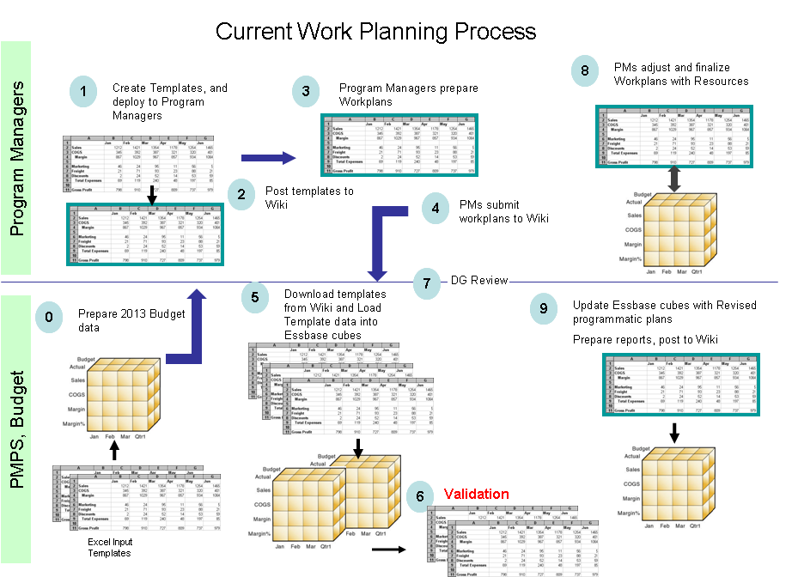 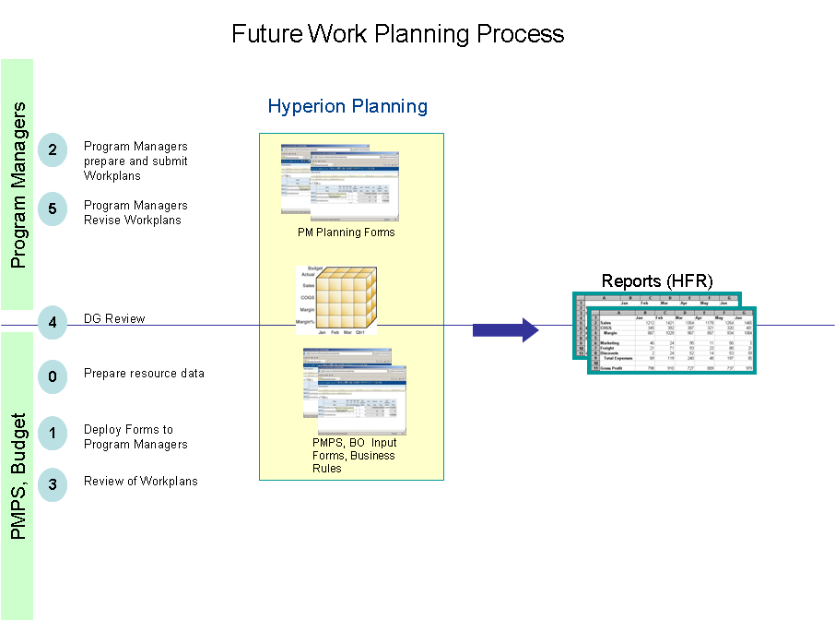

Strengthened Business Processes and Intelligence (Enhancements to the existing AIMS Financial and Procurement system)

- WIPO is starting to benefit from the many functionality improvements that came with the latest version of the PeopleSoft Financial and Procurement software, such as the ability to attach supporting documents to transactions and improved catalog management. Major systems updates take several months in any organization and require meticulous planning to avoid disruption of existing systems and processes. WIPO’s recent AIMS upgrade went particularly smoothly with no unplanned “downtime”, and it provided a solid foundation for integrating the HRM and RBM modules within the same system. The seamless delivery of this solution, ahead of schedule and under the allocated budget, in April 2012, marked an important milestone for the ERP portfolio of projects, and was a result of the proactive technical planning and work carried out by the ICTD, in collaboration with WIPO’s application hosting partner, the United Nations International Computing Center (UNICC) and the external service provider that was awarded the contract for the upgrade on a fixed price basis.
- The project also took advantage of a major opportunity to train nearly 250 users before the upgraded system went live. A major improvement to the training approach was to include a module on business processes, in order to provide users with a better understanding of the overall processes, and to demonstrate how their tasks and functions fit within the scope of these processes. Similar training is being planned for managerial staff to improve their appreciation and use of the ERP system as a tool for their management of results and resources.
- At the center of all ERP systems is the Chart of Accounts (COA). WIPO’s existing COA structure and usage has been reviewed and has resulted in identification of updates needed to provide the Organization with the capability to collect data and report on dimensions of the Organization’s activities that are of interest to stakeholders. Through the review, it was concluded that the COA changes would best be delivered in two phases, those required for integrating HR information into the system in the current biennium, and those required for enhanced stakeholder and performance reporting in the next biennium.

Blueprint and Robust Governance Structure

- Exhaustive and coordinated program planning and communications are central to the success of the ERP portfolio. The vision project, which concluded in early 2012, delivered:
  - Guiding principles, to ensure that the implementation of projects within each area would deliver coherent solutions;
  - A draft blueprint and high-level design, in collaboration with the business functions; and
  - An integrated roadmap which was developed to align the implementation of projects and initiatives with the business priorities and benefits.
- While it is understood to be a “means-to-an-end”, establishing a robust governance structure and process is critical to ensuring ownership and accountability at the right level and to creating an atmosphere that focuses on delivery and benefits.
Figure 1: ERP Portfolio Governance Structure
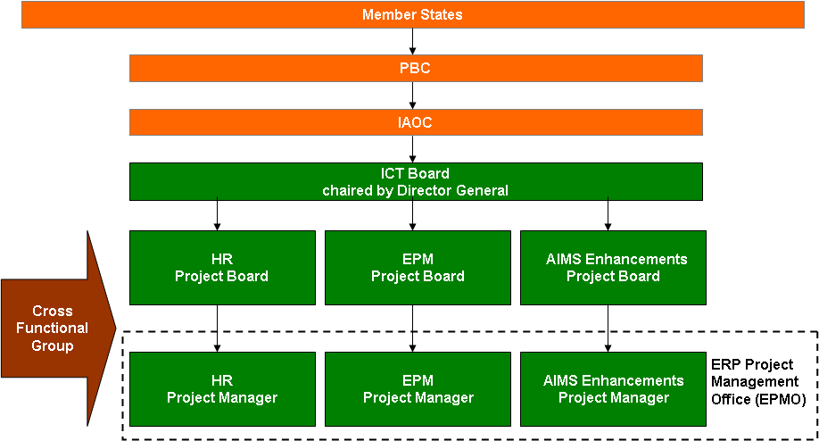
The following elements have been established in this regard:
  - The Information and Communications Technology Board (ICTB) structure was reviewed and assigned the responsibility for the oversight and successful implementation of the ERP portfolio. The Director General now chairs the ICTB;
  - The Cross Functional Group (CFG), composed of staff from across the Organization with sufficient experience and authority, continues to address cross-functional process issues and define reporting needs: While this group serves as a useful discussion forum, more intensive sector-by-sector consultations are being undertaken to identify concrete needs and improvements;
  - A Project Board comprising a single executive (ultimate decision maker), a senior user (customer) and senior supplier (ICTD and/or an external supplier) has been established for each project launched so far, in accordance with the PRINCE2TM project management methodology;
  - The ERP Project Management Office (EPMO) continues to provide common planning, risk management, quality assurance, budget management and reporting processes across the portfolio, as well as the disciplines relating to solution architecture;
  - Ongoing alignment with other WIPO strategic initiatives through regular status updates with the SRP Project Management Office; and
  - Proactive risk management and regular reporting to the WIPO Independent Advisory Oversight Committee (IAOC).
- The Project team continues to engage with staff at all levels through workshops, interviews, meetings and training events. Continued involvement of staff is a critical success factor. A communication leaflet, to explain what the ERP entails and how it will benefit the Organization and staff as a whole, has been prepared and will be issued shortly. Furthermore, the ERP portfolio of projects is currently designing a user-friendly and informative homepage, which will be launched shortly.

Enabling Technology and Cross-Stream Achievements

- WIPO has made progress on some cross-cutting enabling initiatives which will allow the maximum value to be extracted from the ERP system, specifically:
  - Comprehensive solutions architecture which has been developed with a clear view of changes and new components that need to be established. The management of the ERP now requires new and disciplined focus on process and data management as the system expands and begins to be used by more users. The ERP portfolio is collaborating intensively with the ICTD to ensure the necessary change management and control mechanisms are in place.
  - A single sign-on by users to the ERP system to save time and reduce frustration has been successfully piloted confirming the feasibility of the technical solution. An IDentity Management (IDM) solution will be gradually adopted by WIPO, first by providing access to AIMS and then allowing single sign-on access to other solutions, such as the HRM and BI, as these modules are deployed.
  - A comprehensive evaluation resulted in the selection of the best value for money Electronic Document Management System (EDMS). A pilot project to link the EDMS solution to AIMS will commence shortly. Through this project, we will build the capability to store, manage and access documents (input and output) in a more efficient manner.
  - Technical systems infrastructure has been established at the UNICC, where the ERP will be hosted to support the future BI and EPM projects.

IV. ERP Project Budget Utilization

- The overall estimated cost for the implementation of the portfolio of projects is approximately 25 million Swiss francs over a five-year time frame. The estimated costs include application hosting, software acquisition, project personnel, user back-filling resources, external implementation partner fees, training and communication as well as other project-related costs. As these systems are deployed and become operational, the recurring costs of maintenance and system operation would be included in successive Program and Budget proposals as part of the Regular Budget.

- A summary of the budget utilization to date, together with the forecast utilization until the end of 2012 is presented in the following table:

ERP Portfolio of Projects Cost Tracking
(In Swiss francs, as at May 31, 2012)

Cost Element | Project Budget | Actual to Date (Note 1) | Forecast spend by the end of 2012  (Note 2 and 3)
Application Hosting | 1,383,360 | 0 | 728,678
Software Acquisition | 3,989,738 | 1,825,998 | 2,322,468
Project Personnel | 5,564,680 | 1,095,496 | 2,232,148
User back-filling resources | 2,703,800 | 136,979 | 490,763
External Implementation Partner | 9,896,109 | 1,342,661 | 4,472,474
Training | 1,253,780 | 14,218 | 436,908
Communications and other | 550,000 | 13,077 | 303,968
Total | 25,341,467 | 4,428,429 | 10,987,407

Note 1: Actual to date includes expenditures and commitments drawn up to May 31, 2012.
Note 2: Forecast spend by the end of 2012, includes actual to date and expected spend over the rest of 2012, based on the current assumptions for the project budget.
Note 3: At the end of 2012, the original budget indicated an expected spend of over 16 million Swiss francs. The forecast now is significantly lower than the original budget, with the difference expected to be spent in forthcoming project phases.

v. Portfolio schedule

- The ERP portfolio is making steady progress and remains on track to complete the projects within the budget approved by the Member States and broadly within the estimated timeframes. In 2012, the vision project concluded later than initially planned, in part owing to the time needed to establish a qualified and experienced team and to allow for extensive user engagement and ownership of the deliverables. However, the EPM early value work planning was fast-tracked to deliver ahead of schedule in early 2012, since it was analyzed to be on the critical path to support the 2012 work planning process and has contributed to keeping the overall implementation on track.
- The HRM stream and, in particular, the core HR and payroll project, have made considerable progress in accordance with the plan. The core HR and Payroll system is expected to be deployed in the second quarter of 2013. This progress has been made possible through the establishment of a skilled and experienced team, the effective functioning of the project board and the high-level of involvement of HR staff. Some concern, related to a change-over of the Payroll system during a biennium, has been signaled by key users and will be examined more thoroughly before finalizing a precise date for the deployment of the new system.

- A summary diagram illustrating the key deliverables for the remainder of 2012 and for 2013 is shown in figure 2.
Figure 2: Key deliverables of the ERP Portfolio in 2012-13:

vI. Risks

- The table below depicts the main high-level risks that have been identified for the ERP portfolio. The EPMO and ICT Board will continuously review and monitor these risks to develop and refine mitigation strategies as well as to identify new risks as the portfolio progresses:
Risk Category | Description | Risk Mitigation
Strategy
Maximum value is not obtained from the ERP Portfolio | Inability to extract maximum value from ERP Portfolio at multiple levels: SMT, operational level, staff in general | Well defined ERP Portfolio governance structure with participation from the business areas. Project is driven as an organization-wide project, not just an administration and management one, and not a technology project
User expectations are not met | User expectations may exceed what was initially scoped for the portfolio and this could impact the ability for the portfolio to conclude successfully | Prioritize portfolio activities based on business requirements. Manage the portfolio scope carefully. Communicate regularly and clearly
Change is not well managed | Staff do not use the system as planned, they do not respond well to the change | Change Management efforts; ownership and involvement of users and business process owners at multiple levels
Operations
Skills Deficiency | Insufficient resource capacity in key areas that are highly involved (Budget, PMPS, HRMD, Procurement, Finance, AIMS Support) | Adequate recruitment and backfilling as well as training on the new work processes
Changes to existing Systems | Changes to the existing systems in anticipation of the ERP portfolio requirements poses a risk of disruption to the existing systems | Full involvement of ICTD AIMS upgrade and enhancements are integrated with ERP portfolio.  The project board reviews and approves all key changes to the system  Master data and process management disciplines are established
Resources
High dependence on a small core team of staff | The projects within the portfolio are cross-functional by nature and typically rely on the same resources availability of which is limited, especially during holidays and busy work periods | Prepare a long term business involvement plan. Avoid busy periods, plan realistically and work closely with business. Try and use resources different from those used by the core team to reduce reliance on groups already heavily relied upon
Finance
Cost Overruns | Project cost overruns and ongoing cost of ERP solutions too high for organization to absorb | Manage carefully the mix of direct hire staff versus commercially contracted staff. Use of solid project management practices  Consider-going maintenance and support cost of new systems at the time of designing the solutions

vII. LESSONS LEARNED

- The following lessons have been learnt, and will be incorporated into future projects:
  - The time period needed for new staff members to get up to speed must not be underestimated;
  - User engagement and ownership are vital to progress. Projects need to continuously look for creative ways to involve business users at all stages;
  - To ensure that projects deliver small, regular benefits to the customer(s). Project management should be as agile as possible;
  - To make certain that communication is simple and targeted to the right audience, give fewer key messages, ensure consistency, cascade communication, cross-link / build-on other initiatives and generate supportive communication from outside the project team;
  - Selection of the right implementation service provider is key to the success of each project within the portfolio;
  - Projects have to be aligned to, and planned to work within, the business cycle of the Organization;
  - Business continuity must be a driving consideration; and
  - Training and communication must take a holistic view, especially in relation to integration across all functions.
- The Program and Budget Committee is invited to recommend to the Assemblies of the Member States of WIPO to take note of the contents of the present document

[End of document]

