WIPO |  | E  A/35/11  ORIGINAL: English  DATE: September 22, 2000
WORLD INTELLECTUAL PROPERTY ORGANIZATION
GENEVA

assemblies of the member states of wipo
Thirty-Fifth Series of Meetings
Geneva, September 25 to October 3, 2000
REVISED PLAN AND BUDGET FOR THE RENOVATION,
MODERNIZATION AND EXTENSION OF THE
EX-WORLD METEOROLOGICAL ORGANIZATION (WMO) BUILDING
Memorandum of the Director General
1. The Program and Budget Committee, at its second session from September 20 to 22, 2000, discussed the proposals on the Revised Plan and Budget for the Renovation, Modernization and Extension of the ex-World Meteorological Organization (WMO) Building. (document WO/PBC/2/4) which is annexed to this document. The views of the Member States on these proposals, are contained in its report (document WO/PBC/2/6*).

2. The Chairman of the Committee thanked the Secretariat and the delegations for their comments. He indicated that, in light of the support expressed for the proposed revised plan and budget for the renovation of the ex-WMO building, and while noting the comments made and the concerns expressed, the Member States represented at the Committee recommended that:

3. The General Assembly of WIPO take the decisions proposed in paragraph 29 of document WO/PBC/2/4.

[Attachment follows]
A/35/11
ATTACHMENT

I. INTRODUCTION

1 This document presents a proposed revised plan and budget for work related to the ex-WMO building. The proposed revised budget amounts to 59,000,000 Swiss francs, reflecting an increase of 28,600,000 Swiss francs, as compared to the initial budget of 30,400,000 Swiss francs approved by the General Assembly in March 1998. The proposed revised budget includes 16,000,000 Swiss francs for activities which have been completed or are underway and 43,000,000 Swiss francs for the work which remains to be done. The additional amount of 28,600,000 Swiss francs is required to cover cost increases due to higher construction costs in Geneva (5,300,000 Swiss francs), changes in building regulations (3,000,000 Swiss francs) and unforeseen modifications in project specifications, such as adapting the building for use by the PCT operations (3,900,000 Swiss francs), adding work areas (800,000 Swiss francs) and other changes (3,400,000 Swiss francs). Finally, it is now apparent that the initial budget, prepared on the basis of preliminary assessments in late 1997/early 1998, was underestimated by 12,200,000 Swiss francs. On the basis of additional studies conducted in the second half of 1999 and the evaluation of bids received in July 2000 under the tendering process to select the general contractor for the renovation work, the proposed revised plan and budget are now realistic. The total project cost is to be covered under the Special Reserve Fund for Additional Premises and Computerization. It is to be recalled that the purchase of the building by WIPO from WMO was authorized by the General Assembly in 1991. The total cost of the purchase amounted to 34,290,000 Swiss francs.

II. BACKGROUND AND PROJECT IMPLEMENTATION SO FAR

2 In March 1998, the General Assembly approved the renovation, modernization and extension of the ex-WMO building at a cost of 30,400,000 Swiss francs (see paragraph 9(c) of document WO/GA/22/2) as proposed in paragraphs 32 to 35 and 52 to 54 of document WO/GA/22/1. The facility was planned to provide some 430 working places, a cafeteria for 250 people and 180 parking spaces. This included the renovation of the existing building with 300 working places, the existing cafeteria of 250 places and existing 80 parking spaces as well as the construction of underground and aerial passageways from the ex-WMO building to G. Bodenhausen I and A. Bogsch buildings at a total estimated cost of about 16,400,000 Swiss francs. In addition, the approved project was to include an extension of the existing facilities at an estimated cost of about 14,000,000 Swiss francs, including an additional tower with 80 working places, an additional floor with 50 working places and 100 additional parking spaces. It was then estimated that the work would start in early 1999 and would be completed in mid-2001 after 30 months, assuming that WMO would vacate the building by the end of 1998. The work was to be implemented in a two-stage approach. It was foreseen that following an early renovation of the existing tower, about 100 working places would be made available already in the latter half of 1999. This would be then followed by the main renovation and modernization work.

3 As it turned out, some delays were experienced during the early stages of the project, and the approved project specifications underwent substantial changes. WMO vacated the building in June 1999 rather than in late 1998 as had been expected. Moreover, following further studies, it became apparent that the two-step renovation approach contained additional risks and costs. The Program and Budget Committee was therefore informed in April 1999 (paragraph 63 of document A/34/5) that the work would be implemented in a one-time full renovation without interval as the most cost-effective solution.

4 Annex A provides a detailed list of activities to be covered under the proposed revised plan and budget for the ex-WMO building project in the amount of 59,000,000 Swiss francs. This includes activities implemented or committed so far in the amount of 16,000,000 Swiss francs as well as activities planned up to the end of the project completion in the amount of 43,000,000 Swiss francs. The main cost factors and milestones in project implementation so far are listed below.

5 From July 1998 to January 1999, Frei & Stefani SA, a Geneva-based architectural company, and several engineering companies were entrusted with studies for the preparation of renovation plans and requests for building permits. The total cost of these studies amounted to 1,645,930 Swiss francs. Frei & Stefani SA and the engineering companies analyzed major tasks and issues, researched essential elements of the overall project, prepared draft project proposals and elaborated initial cost estimates. This work was followed by a further elaboration of project plans, construction details and cost estimates before a request for building permits could be filed with the Geneva authorities. The studies were followed by the submission of the request for building permits. As a result, the Geneva authorities could only provide the required building permits for the renovation, modernization and extension of the ex-WMO building in September 1999, rather than in November 1998 as initially anticipated.

6 In July 1999, FG Pool (Favre & Guth, a Geneva-based architectural company, and a pool of engineering companies) was engaged to provide detailed studies on the execution of plans, further elaborate project plans, cost estimates and construction details, prepare relevant documents for the tendering process of selecting a general contractor, evaluate and analyze the received bids, develop final project plans and provide architectural guidance and supervision during the entire building work. The contract, amounting to a total of 3,478,000 Swiss francs, was awarded in a tendering process involving 15 local architectural companies.

7 Following the analyses of the detailed studies by FG Pool and the Secretariat, it became apparent that the initial budget had been underestimated. This also resulted in a decision to change the project management approach. Initially, it had been foreseen to rely mainly on in-house capacity, supported by an advisory firm of architects. Whereas this approach requires the establishment of an adequate in-house capacity, it also carries a number of problems associated with the need for the Secretariat to coordinate and control a large number of sub-contractors. As a result, it was decided to entrust an external general contractor with full responsibility for project implementation. This approach provides additional assurance that the project will be completed on time, within budget and fulfilling all technical and legal requirements. In addition, a number of project modifications were introduced to conform to the latest building standards adopted by the Geneva authorities. Moreover, it was decided to utilize the building for the PCT operations which resulted in a number of modifications, including extra provisions for all vital security systems which are essential to the PCT operations dealing with unpublished information. This decision was justified by the considerable growth in the PCT operations and the urgent need to provide for additional space with adequate security. The security concerns can best be realized by confining the PCT operations within an integrated building complex.

8 Following the decisions on project modifications, the building plan and budget needed to be updated and supplementary building permits needed to be secured from the Geneva authorities. FG Pool was contracted to carry out relevant studies on project options at a cost of 400,000 Swiss francs from November to December 1999. FG Pool was also required to prepare an adaptation of the project plan in order to obtain the supplementary building permits required from the Geneva authorities, at a cost of 950,000 Swiss francs, from March to April 2000. The Geneva authorities granted the supplementary building permits in July 2000.

9 Work on the building site had already started in late 1999. Seydoux-DMB SA, a company based in Geneva, was contracted from November 1999 to March 2000 to dismantle and clear old technical installations of the vacated building. The contract amounted to 1,285,000 Swiss francs and was awarded following a tendering process involving 11 companies. The selection of the general contractor was initiated in January 2000 with the dissemination of a request for expressions of interest internationally, to which 18 companies from eight countries replied. In May 2000, a call for tenders was sent out to 12 companies in three different countries. The call for tenders was based on the approved project plan, which included the main building components, the renovation of the existing building, an extension of the building through an additional tower and an additional floor, underground parking facilities as well as underground and aerial passageways. Furthermore, the call for tenders reflected the latest building standards and a number of other project modifications such as the use of the building solely for the PCT operations, the additional basement, the additional office space, the printing plant, the mail room and modern technical installations as described in Part C below.

10 Bids amounting up to 64,100,000 Swiss francs were received in July 2000 from nine companies. Negotiations were conducted with four companies during August 2000, to arrive at the most cost-effective solution at an estimated cost of 51,000,000 Swiss francs. Beric, Perret and Seydoux-DMB (BPS), a consortium of three companies based in Geneva, was engaged as the general contractor in the second half of August 2000.

11 The contractual arrangement with BPS ensures that work will commence within the approved budget ceiling of 30,400,000 Swiss francs, while allowing flexibility regarding the decision of the General Assembly on the proposed revised project budget. Towards this end, the contractual arrangement with BPS provides that only the first of two distinct phases is carried out initially. Phase 1 covers the period from September 2000 to March 2001 and is limited to work which has to be carried out in any case, including the preparation of general site facilities and installations, the scaffolding, the preparatory concrete and stone work and the adaptation to the existing building to allow for subsequent main renovation, construction and extension work. The total cost of Phase 1 amounts to 8,000,000 Swiss francs. As a result, the activities completed or underway amount to 16,000,000 Swiss francs as indicated in Annex A.

12 Following the approval of the proposed revised plan and budget by the General Assembly, BPS would only then commence with Phase 2 covering the main renovation, construction and extension work, including the structural work (steel construction, metal work, stonework and roofing), the installation work (fitting of electrical, heating, ventilation, air conditioning and sanitary facilities), internal and external surface treatment and finishing work. The cost of Phase 2 is estimated at up to 43,000,000 Swiss francs which results in a combined contract value of 51,000,000 Swiss francs for Phases 1 and 2. With the completion of Phase 2 by September 2002, it is anticipated that the renovated complex would be fully occupied by early 2003.

13 Should the General Assembly decide to make major changes to the proposed revised project plan and budget, including changes in the main building components, this might require a decision not to embark on Phase 2. This is foreseen as an option in the arrangement with the general contractor and no binding obligation would exist after Phase 1. A decision not to embark on Phase 2 might require the preparation of a new project plan and the implementation of a new tendering process for the selection of a general contractor. In this event, the work already performed under Phase 1 could be utilized.

14 As noted, it is anticipated that the renovated complex would be fully occupied by early 2003. When compared to the initial plan, this represents a delay of approximately 15 months as illustrated in Annex B. A delay was due to the fact that WIPO took over the building in June 1999, almost six months later than originally expected. Other delays resulted from the introduction of project modifications, including studies to be done following the decision to adapt the building for use by the PCT operations. This, in turn, required the granting of supplementary building permits by the Geneva authorities.

III. UPDATE OF PROJECT SPECIFICATIONS FOR EX-WMO BUILDING

15 The approved project plan includes as main building components the renovation of the existing building, an extension of the building through an additional tower and an additional floor, underground parking facilities as well as underground and aerial passageways. Whereas this remains unchanged, a number of project specifications have been adjusted to arrive at the most appropriate and cost-effective technical solution.
Table 1
Comparison between initial and revised plans for ex-WMO building

Summary of project specifications

Project Elements |  | Initial Plan | Revised Plan
Working places |  | 430 | 450
Underground parking spaces |  | 160 | 144
Cafeteria seats |  | 250 | 300
Extra working area for auxiliary equipment |  | - | 640 square meters
Printing plant |  | - | Yes, for PCT
Mail room |  | - | Yes, mainly for PCT
Electrical installations and cabling |  | In line with old standard | PCT–adapted and in line with latest standards
Office floor |  | Standard | Double floor for PCT cabling
Security |  | In line with old standards | PCT–adapted and in line with latest standards
Air conditioning, heating, ventilation |  | In line with old regulations and standards | PCT–adapted and in line with latest regulations and latest standards
Two elevators for underground passage |  | Access to ground floor of G. Bodenhausen I | Access to all floors of  G. Bodenhausen I
Kitchen equipment |  | - | Yes

16 The total building space amounts to 18,670 square meters and would remain as initially approved. Changes in project specifications are indicated in Table 1 which would include an increase in the number of working places from 430 to 450 and of cafeteria places from 250 to 300, whereas the modification would result in a reduction of indoor parking spaces from 160 to 144. Moreover, an extra working area of 640 square meters would be created to accommodate the needs for auxiliary equipment, such as printers and copy machines. Other features include a printing plant for the PCT operations and a mail room mainly for use by the PCT operations. The electrical installations and cabling will be in line with latest standards and adapted for the use by the PCT operations. In order to accommodate the cabling requirements, the building would include a double floor, instead of standard configuration. The building would provide the high level of security required by PCT operations. All technical installations, including ventilation, heating and air-conditioning systems, would be in compliance with the latest local regulations and standards and the requirements of the PCT automation, the printing plant and the mail room. The two elevators connecting the underground passage with the ground floor of the G. Bodenhausen I building would be extended to connect with all floors of that building to ensure the efficient workflow of the PCT operations. Finally, the proposed project plan makes provision for the required installation of kitchen equipment which had not been included in the approved plan. The work would utilize standard office building material, excluding material that could be considered excessive.

IV. BUDGET ANALYSIS

17 The proposed revised project budget is estimated at 59,000,000 Swiss francs as indicated in Annex A. This amount includes 16,000,000 Swiss francs already spent or committed for studies, securing the necessary building permits, undertaking the demolition of old technical installations and Phase 1 of the general contractor’s work, and 43,000,000 Swiss francs for the work which remains to be done. The revised project budget of 59,000,000 Swiss francs reflects an increase of 28,600,000 Swiss francs as compared to the initial project budget of 30,400,000 Swiss francs. The budget analysis of this increase is presented below.

18 Project reviews and the outcome of the bidding process for the selection of the general contractor have confirmed the proposed revised project plan as the most appropriate solution. Whereas budget reductions could be realized through major changes in the project plan, including the main building components, they are advised against. The use of the building for the PCT operations constitutes an optimal solution to solve urgent space requirements. No alternative facilities could be identified by the Secretariat with adequate size and security and at comparable costs. Other alternatives, such as the deletion of the approved additional tower and additional floor, for example, would result in a reduction of the overall project cost. The associated loss in working space, however, would more than offset such savings and could increase the average cost of the reduced working space. Most important, such modification would also reduce the availability of urgently required working space for the expanding PCT operations. Finally, significantly reducing the parking facilities or eliminating passageways would limit and hamper access to the building.

19 In accordance with the presentation of the approved budget, the ex-WMO building project can be divided into four main building components: (i) renovation, modernization and connection; (ii) additional floor, (iii) extended underground parking and (iv) additional tower. The budget analysis is presented in accordance with the four main building components. For each of those, two groups of cost factors can be identified which result in a proposed budget revision. Cost factors (Group A) include those outside the control of WIPO, such as recent cost increases in construction work for Geneva, changes in building regulations and an underestimation of costs as compared to the approved budget estimate. New cost factors (Group B) include modifications in project specifications introduced by WIPO. Adjusting the initial budget in accordance with new cost factors (Group B) would adapt the building for the use by the PCT operations and increase the usefulness and cost-effectiveness of the new facility. Table 2 (see page 7) provides a summary of budget changes by main building components and by cost factors.

20 As shown in Table 2, cost factors (Group A) account for a budget increase of 20,500,000 Swiss francs, from 30,400,000 to 50,900,000 Swiss francs. Cost factors (Group B) account for an additional budget increase of 8,100,000 Swiss francs. Detailed explanations by cost factors are provided under the six headings below.

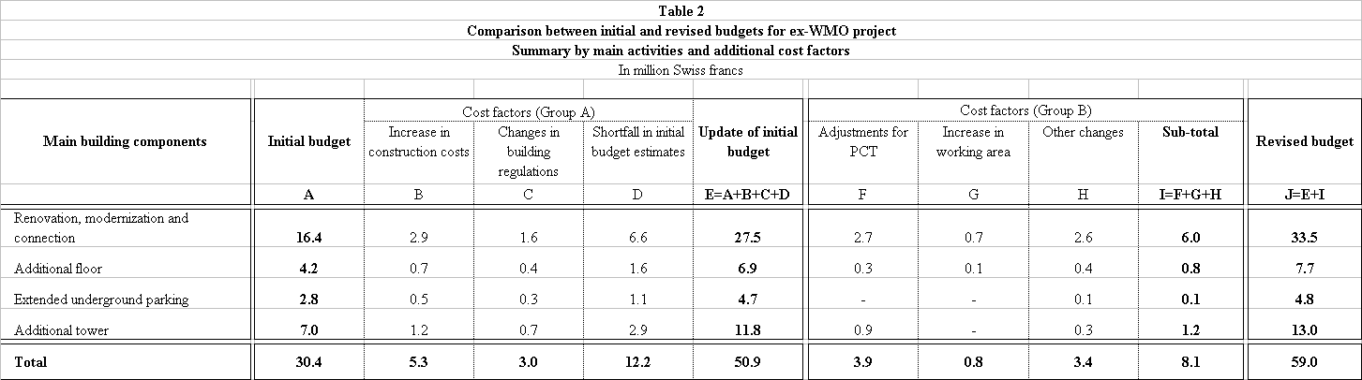
A/35/11
Attachment, page 7

A. Increases in construction costs for Geneva

21 In 1998, the annual increase in construction costs for Geneva amounted to 0.1 per cent and no provision for cost increases was included in the initial budget estimate. Whereas increases in consumer prices for Switzerland remain very low, construction costs have increased considerably in Geneva over the last two years and, as of May 2000, are estimated at an average annual rate of 5.9 per cent according to the Office cantonal de la statistique. Applying this increase rate for construction costs to the initially approved budget of 30,400,000 Swiss francs, project costs are estimated to increase by 5,300,000 Swiss francs, taking into account the phasing of expenditures over the project duration of four years. In Table 2, this increase is allocated to the main building components in accordance with the distribution of the approved initial budget.

B. Changes in building regulations

22 Since the initial building plan was approved in 1998, changes of the law on construction works (Loi sur les constructions et les installations diverses) and the law on energy (Loi sur l’énergie) in June 1999 required substantial adjustments in project specifications. This includes, for example, new regulations assuring a better human safety in emergency situation (additional ventilation system to allow for stronger air pressure to neutralize hazardous smoke) and requiring the development of overall security concepts for buildings. Other changes include stricter regulations on the maximum level of energy that can be lost and stricter sorting and classification of materials from the demolition work by type and characteristics. Implementation of project modifications resulting from such changes in building regulations concerning human safety, energy savings and environmental issues are estimated to amount to 3,000,000 Swiss francs.

C. Shortfall in initial approved budget estimates

23 The initial project budget of 30,400,000 Swiss francs, approved by the General Assembly in March 1998, had been prepared on the basis of a preliminary study of requirements prepared in late 1997/early 1998. Subsequently, and based on further detailed studies, it became apparent that the initial budget was considerably underestimated. This was confirmed by the results of the tendering process. As compared to the initial estimates of the approved budget, a budget shortfall of 12,200,000 Swiss francs is identified. This amount is not linked to specific changes in the project. However, it is reasonable to assume that the budgetary implications of changes in project specifications, additional preparatory time required, changes in the project management approach, supplementary studies have not been fully captured in the analysis and may well account for part of the budget shortfall. As shown in Table 2, the shortfall of 12,200,000 Swiss francs is attributed to the main building components in accordance with initial distribution of the approved budget.

D. Adaptation of building for PCT use

24 Using the building for the PCT operations requires a number of significant changes for at a total cost of 3,900,000 Swiss francs, including 2,700,000 Swiss francs for the existing building, 300,000 Swiss francs for the additional floor and 900,000 Swiss francs for the additional tower. As noted, due to the considerable growth in PCT operations, additional space with adequate security is being required urgently. These security concerns can only be addressed by confining the PCT operations within an integrated building complex. The specific changes are detailed below:

- Additional installations for security arrangements required by the PCT operations, including features such as video surveillance equipment, access control installations, additional security doors, fire alarm and sprinkler systems and pre-cabling in each office for the access control, at a cost of 1,300,000 Swiss francs.

- Additional cabling for the computer equipment utilized by the PCT operations, at a cost of 800,000 Swiss francs.

- Additional installations for ventilation, air conditioning, electrical installations and cabling required by the automation of the PCT operations (IMPACT project), the PCT printing plant and the main mail office are estimated at a cost of 700,000 Swiss francs.

- Additional office floor layer to facilitate the installation of cabling required by the PCT operations and frequent modifications of office configuration, at a cost of 600,000 Swiss francs.

- Preparation of space for accommodating the heavy PCT compactus, at a cost of 500,000 Swiss francs.

E. Increase in working area

25 The proposed revised project specification provides for an extension of the working area. This includes 20 additional workplaces, or 570 square meters of office space, to be obtained as a result of changing the position of elevators from the facades to the center of the building and an additional space of 640 square meters by extending a portion of the long part of the building to accommodate auxiliary equipment. The changes require an additional amount of 800,000 Swiss francs and provide a cost-effective solution for working area requirements.

F. Other changes

26 A number of changes in other project specifications are proposed at a total additional cost of 3,400,000 Swiss francs, including 2,600,000 Swiss francs for the existing building, 400,000 Swiss francs for the additional floor, 100,000 Swiss francs for the extended underground parking and 300,000 Swiss francs for the additional tower as detailed below:

- Additional electrical installations, including the control mechanism to provide for the self-regulation of office lighting, and additional cabling and electrical equipment for improved office lighting in accordance with current standards, at a cost of 1,100,000 Swiss francs.

- Equipment for kitchen, at a cost of 1,000,000 Swiss francs. Whereas the kitchen was foreseen in the approved initial project plan, no budgetary provision was provided for the equipment.

- Additional installation of a central control system for the regulation of heating, ventilation and air conditioning systems to cope with the increased thermal load from the higher level of office automation, at a cost of 800,000 Swiss francs.

- Extension of two elevators to connect the underground passage with all floors of the G. Bodenhausen I building, not only with the ground floor as initially envisaged, at a cost of 500,000 Swiss francs.

V. FUNDING: SPECIAL RESERVE FUND FOR ADDITIONAL
PREMISES AND COMPUTERIZATION

27 The Special Reserve Fund for Additional Premises and Computerization covered the purchase of 34,290,000 Swiss francs and the initial approved budget for renovation, modernization and extension of 30,400,000 Swiss francs. The proposed revised budget for the renovation, modernization and extension amounts to 59,000,000 Swiss francs. It is proposed to fund the increase of 28,600,000 Swiss francs in the proposed revised budget also from the Special Reserve Fund for Additional Premises and Computerization. A detailed presentation of the evolution and status of the Special Reserve Fund for Additional Premises and Computerization is presented in document WO/PBC/2/2. As of January 1, 2000, total uncommitted resources amount to 62,184,000 Swiss francs.

28 The Program and Budget Committee is invited to express its views on the proposed revised plan and budget for the renovation, modernization and extension of the ex-WMO building.

29 The WIPO General Assembly is invited:

(i) to approve the revised plan and budget for the renovation, modernization, connection and extension of the ex-WMO building, including an increase of 28,600,000 Swiss francs in the budget, from 30,400,000 Swiss francs to 59,000,000 Swiss francs;

(ii) to approve the funding of the budget increase of 28,600,000 Swiss francs from the Special Reserve Fund for Additional Premises and Computerization.

[Annexes follow]

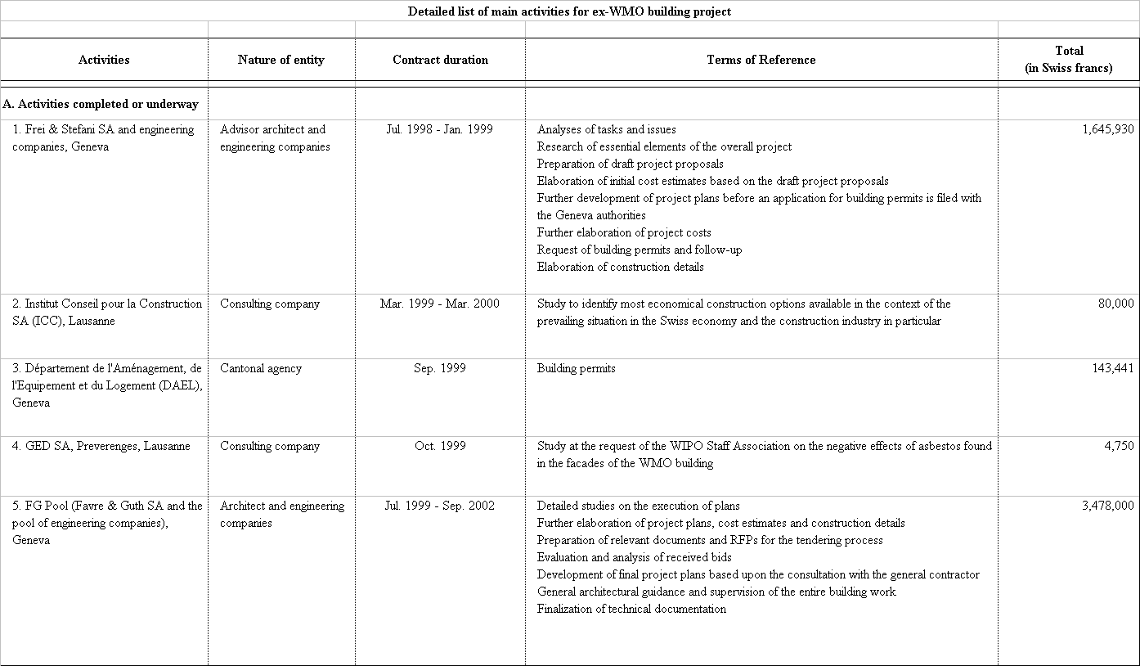
A/35/11
ANNEX A

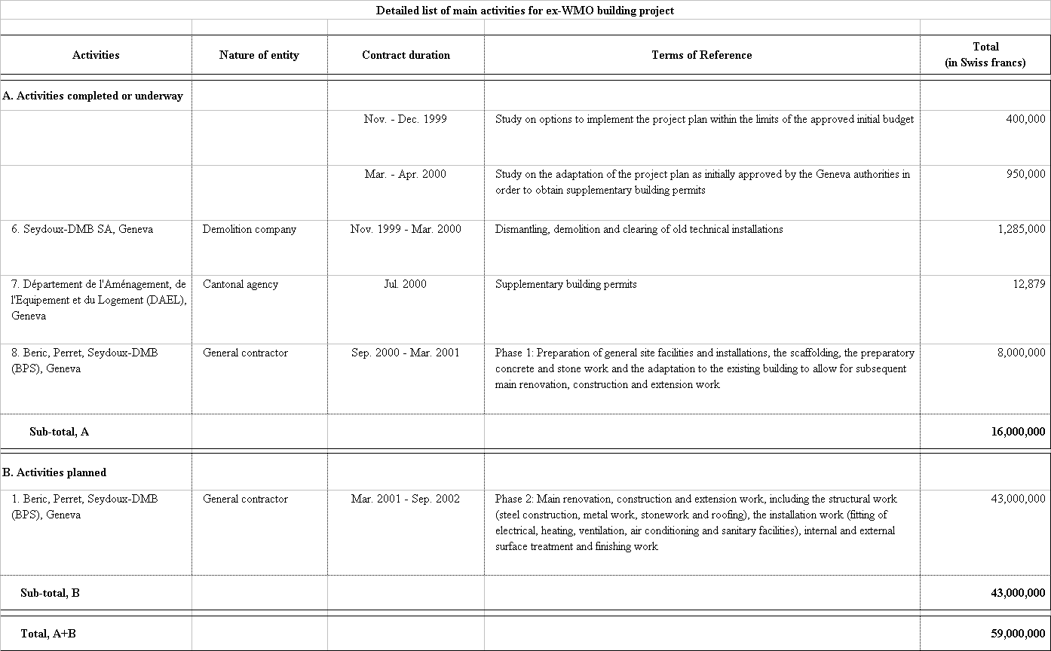
A/35/11
Annex A, page 2
[Annex B follows]
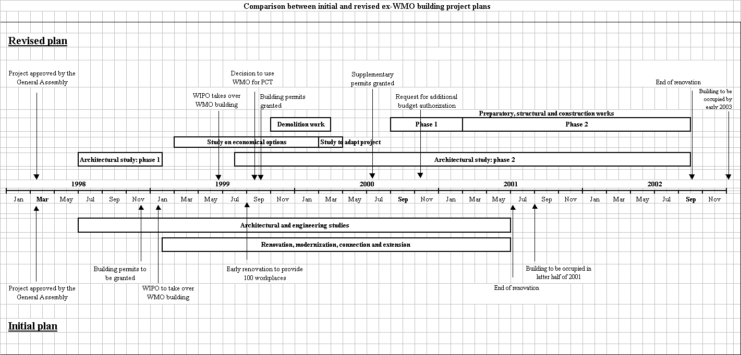
A/35/11

ANNEX B
[End of Annex B and of document]
[Annex B follows]

* document WO/PBC/2/6 is available for reference

