|  |  |  |
| --- | --- | --- |
|  | WIPO-E | **E** |
| WIPO/IP/ai/GE/19/iNF 3 | | |
| ORIGINAL: English | | |
| DATE: sEPTEMBER 26, 2019 | | |

**WIPO CONVERSATION ON INTELLECTUAL PROPERTY (IP)** **AND ARTIFICIAL INTELLIGENCE (AI)**

Organized by

the World Intellectual Property Organization (WIPO)

**Geneva, September 27, 2019**

MODERATORS AND PANELISTS’ PROFILES

*Prepared by the Secretariat*

**OPENING PANEL**

**Moderator**

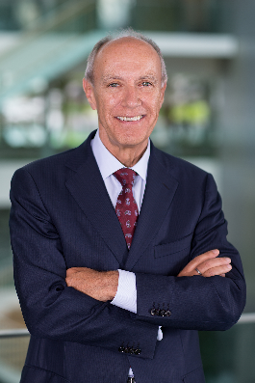  
**Mr. Francis Gurry**Director Generalof the World Intellectual Property Organization (WIPO)

Francis Gurry is an Australian lawyer who has served as Director General of the World Intellectual Property Organization (WIPO) since October 1, 2008.

He holds law degrees from the University of Melbourne, a Ph.D from the University of Cambridge and is an honorary professor of, and holds honorary doctorates from, universities in a wide range of countries.

He is the author of a number of publications, on of which has become a standard legal text in the UK and is published by Oxford University Press as *Gurry on Breach of Confidence.*

Francis Gurry speaks English and French.

**Co-Panelists**

**  
Mr. Andrei Iancu**   
Under Secretary of Commerce for Intellectual Property and Director of the United States Patent and Trademark Office (USPTO)

In his role as the Under Secretary of Commerce for Intellectual Property and Director of the USPTO.

Andrei Iancu provides leadership and oversight to one of the largest intellectual property offices in the world, with more than 12,000 employees and an annual budget of over $3 billion. He also serves as the principal advisor to the President, through the Secretary of Commerce, on domestic and international intellectual property policy matters.   
  
Prior to joining the USPTO, Mr. Iancu was the Managing Partner at Irell & Manella LLP, where his practice focused on intellectual property litigation. Mr. Iancu appeared in a variety of high-profile matters in front of the USPTO, U.S. district courts, the Court of Appeals for the Federal Circuit, and the U.S. International Trade Commission. He has represented clients across the technical and scientific spectra, including those associated with medical devices, genetic testing, therapeutics, the Internet, telephony, TV broadcasting, video game systems and computer peripherals.   
Mr. Iancu has also taught patent law at the UCLA School of Law, and has written and spoken publicly on a variety of intellectual property issues. Prior to his legal career, Mr. Iancu was an engineer at Hughes Aircraft Company. Throughout his career, many organizations have recognized Mr. Iancu for his work. Among his legal community accolades, the Daily Journal, California Lawyer magazine, Los Angeles Business Journal, Chambers USA, Best Lawyers in America, and many others have acknowledged his expertise in commercial litigation and intellectual property law. Mr. Iancu has also been the recipient of the Patent and Trademark Office Society 36th Annual Rossman Award, the Hughes Aircraft Malcolm R. Currie Innovation Award, and the Melville B. Nimmer Copyright Award. Mr. Iancu holds a J.D. from the UCLA School of Law. He also has a M.S. in Mechanical Engineering and a B.S. in Aerospace Engineering, both from UCLA.  Mr. Iancu was born in Bucharest, Romania. He has lived in the United States since the age of 12. He and his wife Dr. Luiza C. Iancu have two children, Ariella and Robert.

**  
Ms. Nuria Oliver**   
Chief Data Scientist in Data-Pop Alliance, Chief Scientific Advisor to the Vodafone Institute  
  
With a PhD from MIT, she is an expert in Artificial Intelligence, ubiquitous computing and the use of Big Data for Social Good. She was the first female Scientific Director at Telefonica (2007-2016) and first Director of Research in Data Science at Vodafone (2017-2019). She is an advisor to six European Universities, the Spanish and Valencian Governments, the European Commission and the World Economic Forum. She is the only Spanish scientist to have been elected at the same time a Fellow of the Association for Computing Machinery (ACM), a Fellow of the Institute of Electrical and Electronic Engineers (IEEE) and a Fellow of the European Association of Artificial Intelligence. She is a member of CHI Academy and the Academia Europaea. Dr. Oliver has authored more than 180 scientific articles and filed 41 patents. Her work has been recognized internationally with many awards, including the MIT TR35 Young Innovator Award, the European Digital Woman of the Year Award, the Spanish National Computer Science Award and the Medal to Business and Social Merit by the Valencian Government. She is an advocate of diversity in the technology field and has contributed with her research for over two decades to the development of technology with positive impact on society.

 **Ms. Karin Mayer Rubinstein**Chief Executive Officer and President, Israel Advanced Technology Industries (IATI)Karin Mayer Rubinstein is the CEO & President of IATI, Israel’s Umbrella Organization of the High-tech, Life Science and other advanced technology industries, with hundreds of paying members from every level and aspect of the ecosystem, including Venture Capital Funds, Israeli R&D Centers of Multinational Companies, Start-Ups, Incubators & Accelerators, leading global Stock Exchanges, Tech Transfer Organization, Academic Institutions, Innovation Centers, Hospitals, Municipalities, service Providers and more. Through this broad range of members, IATI connects Israel’s tech ecosystem, provides solutions and support at all levels, and integrates the various sectors of the industry with strategic and ongoing governmental goals.

Prior to her current position, Karin served as a senior partner and managing director of business development in leading commercial law firms.

Karin is a member of steering committees and a keynote speaker of many leading global events and conferences around the world. She is a member of the board of Governance of   
Tel Aviv University; a Director in the Israel-America Chamber of Commerce; a Co-Founder and Co-Manager of Israel 2048 Council, a union of civil and business organizations which act to create a whole vision for the State of Israel; a member of the 5x2 initiative’s Steering Committee; a Council for the Advancement of Women in Science and Technology of the Ministry of Science and Technology; an Honorary Ambassador of GISEP; and more.

Karin is a keynote speaker at many leading global conferences. She regularly sits as a jury member in leading technology competitions and awards worldwide.

Karin holds a BA in Economics, an LLB and an MBA from Tel-Aviv University. Karin was named, twice in a row, as one of the Top 100 Influential Young Business Persons in Israel by Forbes Magazine, as well as one of the Marker’s Top 40 Leading Young Business Persons.

**Mr. Zeng Zhihua**Director General of China National Intellectual Property Administration (CNIPA), Automation Department

He has more than 24 years’ experience in the Intellectual Property field. Following completion of his master degree in the major of vehicle engineering, Mr. Zeng worked four years as a lecture in Beijing Institute of Technology. He joined CNIPA from 1995 as an examiner in Machinery Patent Examination Department, and served in Patent Examination Cooperation Center as a Director during 2001-2005 and Deputy Director General from 2005 to 2006. Then he worked as Deputy Director General in Automation Department for three years and after that as Director General in Patent Documentation Department for six years. He served as Director General in Patent Examination Cooperation Guang Dong Center of CNIPA from 2015, and has been in charge of the overall work of both Automation Department and Patent Examination Cooperation Guang Dong Center as the Director General since 2019. Mr. Zeng has rich experience in patent examination, management of IT and documentation-related issues, as well as the general management. He is familiar with the current situation and the future development direction of the IT systems, as well as the examination and documentation status of CNIPA.

**PATENT** **PANEL**

**Moderator**

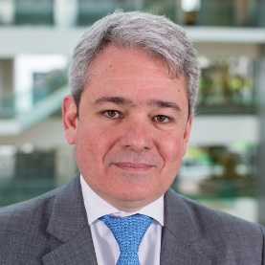 **Mr. Marco Aleman**Director, Patent Law Division, WIPO

Marco M. Alemán, studied law at the Javeriana University (J.D., 1991) where he also obtained a Corporate Law Certificate (L.L.M., 1996). He then obtained a Diploma in Advanced Studies (DEA) in Research at the Alcala University (Spain, 2006), and a Ph.D. in Law (2011,   
Cum Laude).

Mr. Alemán practiced as an IP Attorney from 1991 to 1995. He was then appointed Head of the Colombian Industrial Property Office, from 1995 to 1998, and was invited as a Fellow Visiting Researcher at the Max Planck Institute in Munich, Germany in 1998. He joined the World Intellectual Property Organization (WIPO) in Geneva, Switzerland, in 1999 as Senior Program Officer, Office of Cooperation for Development for Latin America and the Caribbean (from 1999 to 2006). He was then appointed Deputy Director in the Division for Public Policy and Development (from 2006 to 2009) and went on to be Deputy Director of the Patent Law Division (from 2009 to 2013). He currently holds the position of Director of the Patent Law Division.

Mr. Alemán is the author of The Andean Legal Framework on Trademarks (Bogota, 1994) and co-author of several books, the most recent ones being: Studies in Homage to Mariano Uzcátegui Urdaneta (Caracas, 2011), Bilateral Trade Agreements and Intellectual Property (Heidelberg, 2014), Intellectual Property Study in contemporary issues (Mexico, 2015) and Technology Transactions (Genève/ Zurich 2018, Schulthess Éditions Romandes).

Languages: Spanish, English and French.

**Co-Panelists**

**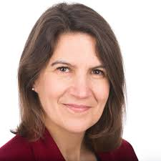  
Ms. Belinda Gascoyne**Senior IP Law Counsel, IBM-Europe, Middle East & Africa

She heads up the EMEA IP Law team, providing all aspects of IP Law support for IBM in Europe, the Middle East and Africa. Belinda is a Chartered and European Patent Attorney with a background in Physics and has wide practical experience in drafting, filing and prosecuting patent applications as well as in IP strategy, patent management and copyright issues. Before joining IBM in 2004, Belinda worked in private practice in London. Belinda is also actively involved in policy matters and is currently President of the IP Federation, having been an IP Federation Council member since 2011, and is a Director of the ORoPO Foundation (Open Register of Patent Ownership).

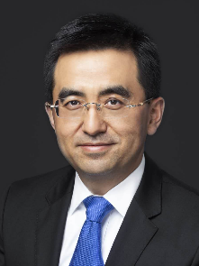  
**Mr. Zhixiang LIANG**

Vice President & General Counsel, Baidu

Mr. Liang joined Baidu in June 2005 and was promoted to Vice President in June 2011, holding the General Counsel position.

Mr. Liang graduated from Yale Law School in the United States. He worked in the Legal Department of the State Council of China. He also has working experience at the Davis Polk & Wardwell LLP New York Headquarters in Davis, USA. Mr. Liang provided powerful policy, legal support and guarantee for Baidu in various new business and exploration of the new models. He has also been directly involved in Baidu's 2005 NASDAQ IPO process in the United States, supporting many years of Baidu's mergers and acquisitions, domestic and foreign business cooperation projects among the policy and legal area.

**Mr. Toshimoto Mitomo**

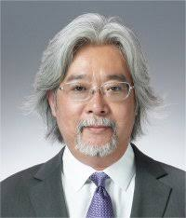Corporate Executive, Executive Vice President, Sony Corporation

Has been responsible for Intellectual Property, Business Incubation Platform, and he serves as Sony Global China Representative. In these roles, Mr. Mitomo is responsible for Sony’s global IP rights and its alliances and partnerships with other companies in the areas of new technologies and patents, strategizing global technology standard-setting activities as well as Sony’s global business strategy for the future growth of Sony Corporation.

In addition, Mr. Mitomo manages the Sony Innovation Fund, which was formed in 2016 as Sony Corporation’s $100 million corporate venture fund. Sony Innovation Fund has been actively making investments in technology start ups world wide, including its strategic investment in start up focused on next generation technologies, including AI and robotics.

As part of his public services, Mr. Mitomo serves as a Director of Japan Institute of Invention and Innovation, Public Interest Incorporated Association, – which promotes innovation and invention in Japan. Mr. Mitomo is also a member of the Ministry of Economy, Trade and Industry Industrial Structure Council. He has delivered speeches and lectures to numerous Japanese government bodies and industry associations to revitalize the Japanese industry by maximizing the value of intellectual property and technologies, including speaking before the Liberal Democratic Party in Japan in 2016.

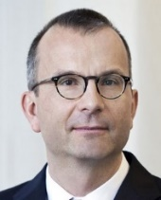 **Mr. Beat Weibel**Chief IP Counsel, Siemens AG

He was born in 1966. He studied Electrical Engineering at the ETH in Zurich and was Trainee Patent Attorney with ABB from 1991 until 1995. In 1995 he qualified as European Patent Attorney. He was head of Corporate IP of Georg Fischer AG from 1998 until 2000, head of the IP Department of ABB Switzerland from 2000 until 2007, and Chief IP Counsel of ABB Ltd.

From 2007 until 2012. Since 2013 he is the head of the Corporate Intellectual Property Department of Siemens AG. He was lecturer on patent law at ETH Zurich and the University of Applied Science Zurich for many years. Beat Weibel teaches in preparation courses for the Swiss patent attorney qualifying examination, he regularly publishes and speaks on actual topics in the intellectual property law.

**GOVERNANCE AND DEVELOPMENT PANEL**

**Moderator**

**Mr. Tim Moss**

Chief Executive Officer and Comptroller General, Intellectual Property Office

Tim took up post as Chief Executive Officer and Comptroller General of the UK’s Intellectual Property Office (IPO) on 1 May 2017.

As CEO of the IPO Tim is responsible for advising Ministers on all IP policy matters and for the operation of the Office, which grants some 6325 patents, 63312 national trade marks and 20137 Designs each year.

Tim came to the IPO from Companies House where he was the Registrar of Companies for England and Wales and Chief Executive (March 2012- April 2017). He worked at Companies House from 2002 where he held many senior positions within the organization. His extensive work portfolio included leading on the digital agenda, operational delivery, business strategy and corporate policy. Tim also held the position of president of the Corporate Registers Forum (an association of over 60 registries worldwide) from 2013 to 2017.

Tim’s career also includes 12 years in senior operational roles in the manufacturing industry; he has a Natural Sciences degree from Cambridge University, an MBA from Swansea University and lives on a farm in South Wales and is married with two children. He was awarded a CBE in the 2016 Queen’s Birthday Honours list for services to the economy and the people of Swansea.

**Co-Panelists**

 **Mr. Tom Peter Migun OGADA**Executive Director, African Center for Technology Studies

2003 – 2005 - MBA - Strategic Management - Moi University, Kenya

1990 – 2005 - PhD - Chemical Engineering - Hamburg-Harburg, Germany  
1981 – 1987 - MSc - Mechanical Engineering - BPI, Minsk, USSR

Since 10/07/2018

Executive Director at the African Centre for Technology Studies

Since 06/12/2017

Chairperson at the Board, National Commission for Science, Technology and Innovation, Kenya

2013 - 2017

Executive Committee Member (Minister)

Trade, Industrialization, Investment and Cooperatives, Homa Bay County

2011 – 2013

Managing Director

T&P Innovation and Technology, Management Services

  
**Ms. Nuria Oliver**Chief Data Scientist in Data-Pop Alliance, Chief Scientific Advisor to the Vodafone Institute

**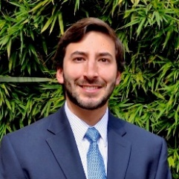  
Mr. Santiago Wills**

Ambassador to the World Trade Organization (WTO)

Mr. Santiago Wills is the Ambassador and Permanent Representative of Colombia to WTO and Deputy Permanent Representative to the World Intellectual Property Organization (WIPO) since August 2019.

Mr. Wills has extensive knowledge on international trade, particularly on the multilateral trade regulation, the mechanisms and procedures on dispute settlement – multilateral and bilateral – and on international trade policy making.

Before joining the Permanent Mission of Colombia to the WTO, he served as Director of International Trade and Investment Protection at the Law Firm Lewin & Wills (Bogota, Colombia). In addition to his previous experience in the private sector and in International Organizations, such as the WTO, he has held different public sector positions. Mr. Wills has served for the Colombian Ministry of Foreign Relations as Counselor of Foreign Relations posted in the Colombian Embassy before Canada, and for the Ministry of Trade, Industry and Tourism of Colombia, as Adviser to the Deputy Minister of Trade.

Over the past 10 years, Mr. Wills has been lecturer on WTO Law, International Trade, and International Dispute Settlement Mechanisms at Los Andes University (Colombia), and has published several academic articles on such topics, as well as numerous media articles. Santiago is currently a Member of the Academic Board of the *John H. Jackson Moot Court Competition on WTO Law*, and has judged said competition for over 10 years.

Mr. Wills holds a Law degree from Los Andes University (Bogota, Colombia) and two Masters Degrees on International Economic Law from the University of Barcelona (*LL.M on International Economic Law and Policy – IELPO – and Masters on Advanced Legal Studies with emphasis on International Economic Law*).

**  
Ms. Sharmaine WU**

Director of Registries of Patents, Designs and Plant Verities, Intellectual Property Office of Singapore

Over a span of almost two decades at the Intellectual Property Office of Singapore (IPOS), Sharmaine has held numerous portfolios involving patent policy and operations, designing and implementing patent acceleration programs like the ASEAN Patent Examination Cooperation (ASPEC), setting up of the patent examination unit in IPOS, and implementing programs for IP monetization and IP skills development. She has also represented Singapore and IPOS in international meetings. Presently, she heads the Registries of Patents, Designs & Plant Varieties.

Sharmaine received her Bachelor of Arts degree majoring in Economics and History from the National University of Singapore and her Master of Intellectual Property Law degree from the University of Melbourne in Australia.

**COPYRIGHT PANEL**

**Moderator**

[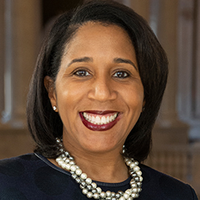](https://www.copyright.gov/about/leadership/images/karyn-full.jpg) **Ms. Karyn Temple**Register of Copyrights and Director, United States Copyright Office   
  
On March 27, 2019, Librarian of Congress Dr. Carla Hayden appointed Karyn A. Temple Register of Copyright and the Director of the U.S. Copyright Office. From October 21, 2016, to March 26, 2019, Temple served as Acting Register of Copyrights. As Acting Register, Temple led the implementation of an office-wide modernization plan. Prior to that, Temple had served as Associate Register of Copyrights and director of policy and international affairs for the United States Copyright Office since january 30, 2013. Prior to that, she served as senior counsel in the Office of Policy and International Affairs.

As Associate Register, she assisted the Register of Copyrights with critical policy functions of the Copyright Office, including domestic and international policy analyses, legislative support, and trade negotiations. She directed the Office of Policy and International Affairs, which represents the Copyright Office at meetings of government officials concerned with the international aspects of intellectual property protection, and she provided regular support to Congress and its committees on statutory amendments and construction.

Prior to joining the Copyright Office, Temple served as senior counsel fo the deputy attorney general of the United States, assisting with the furmulation of U.S. Department of Justice policy on sensitive legal issues and helping to manage the department’s Task Force on Intellectual Property. She also spent several years in private practice at the Recording Industry Association of America and at the law firm Williams & Connolly, LLP. She began her legal career as a trial attorney for the U.S. Department of Justice’s Civil Division through its Honors Program and also served as a law clerk to the Hon. Nathaniel R. Jones of the U.S. Court of Appeals for the Sixth Circuit.

Temple earned her JD from the Columbia University Law School, where she was senior editor of the Columbia Law Review and Harlan Fiske Stone Scholar. She earned her BA in English from the University of Michigan.

**Co-Panelists**

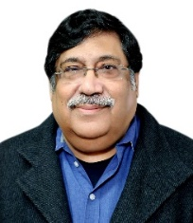**Mr. Pravin Anand**Managing Partner,Anand and Anand

Practice area/industry focus: Intellectual Property, Litigation and Dispute Resolution

Career highlights: Pravin Anand, Managing Partner of Anand and Anand, completed his law studies in New Delhi in 1979 and has practiced as an IP lawyer since then.

He has been a counsel in several landmark IP cases, including those involving the first Anton Piller order (HMV); First Mareva injunction order (Philips); India's first SEP litigation in a DVD player technology matter (Philips), Pre suit mediation Litigation involving Nokia, First Norwich Pharmacal order (Hollywood Cigarettes) Moral rights of artists (Amarnath Sehgal) First order under the Hague Convention (Astra Zeneca) and several significant cases for pharmaceutical clients such as Monsanto, Merck, Novartis, Pfizer and Roche; apart from many others. He has received the National Innovation Foundation Award from the Indian government in recognition of pro bono work for rural innovators at the grassroots.

His innovative and creative approach towards IP is reflected across the pioneering initiatives the firm has taken to develop unique IP Concepts and products including an 'IP Board Game', India's First IP themed Play 'Brainchild', IP Comic- Adventures of Mr. IP, Compilation of legendary IP Matters in the form of a coffee table book “IPONOMICS” and others.

He is a regular speaker at various prestigious forums, including the World Intellectual Property Organization (WIPO), World Intellectual Property Forum, MIP- International Patent Forum, Global IP Convention(GIPC), International Association for the Protection of Intellectual Property (AIPPI), International Trademark Association, Licensing Executives Society, International Bar Association; to name a few.

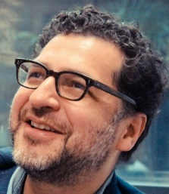**Mr. Andres Guadamuz**

Senior Lecturer in intellectual property law, the University of Sussex

He is a Senior Lecturer in Intellectual Property Law at the University of Sussex and the Editor in Chief of the Journal of World Intellectual Property. His main research areas are on digital copyright, AI, open licensing, cryptocurrencies, blockchain, and complexity. Andres has published two books, the most recent one of which is "Networks, Complexity and Internet Regulation", and he regularly blogs at Technollama.co.uk.  He has various consulting and advocacy interests.

**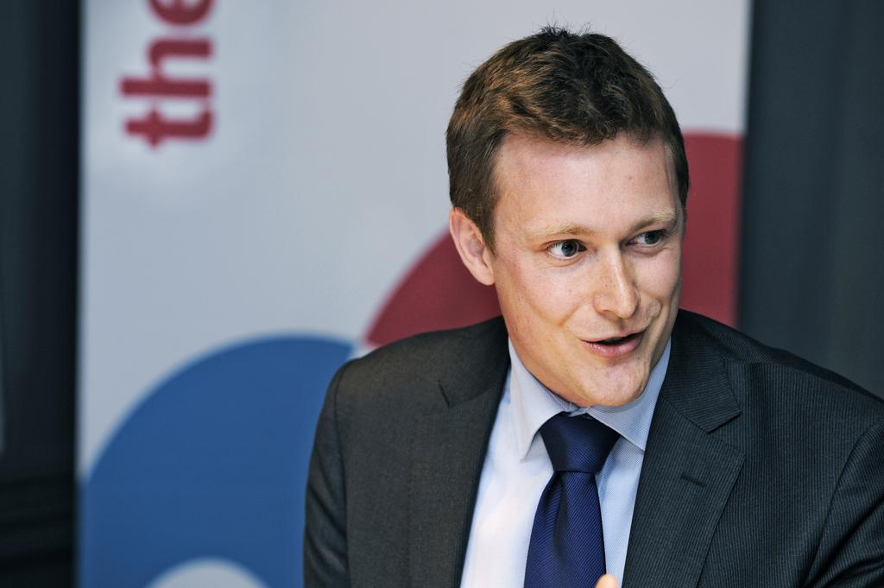  
Tobias Mckenney**Associate Copyright Counsel, Google

Tobias Mckenney graduated in law from Poitiers University in France and Cambridge in the UK, before researching copyright issues at the European University Institute in Florence.

Tobias trained in law firms in Paris before working in the European Commission on intellectual property issues. He joined Google in 2012 as European Intellectual Property Manager.

**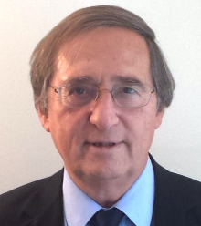  
Mr. Pierre Sirinelli**

Professeur à l'Université Paris-1 (Panthéon – Sorbonne) et doyen honoraire de la Faculté Jean Monnet

Il est directeur du Master 2 « *Droit de la création et du numérique* » et du Master 2 *« Droit, économie et gestion de l’audiovisuel* ».

Il est, depuis 2000, membre du Conseil Supérieur de la Propriété Littéraire et artistique organe consultatif du Ministère de la Culture français - et, à ce titre, auteur de différents rapports dont certains ont eu des suites normatives.

Il a également présidé, à la demande du Ministère de l’Industrie et du ministère à l’économie numérique, des commissions qui ont abouti à l’élaboration et la signature de Codes de bonne conduite en matière de Cyber contrefaçon.

Il a été médiateur lors de travaux de réforme du Code de la propriété intellectuelle français et a, à ce titre, rédigé la nouvelle loi française relative au contrat d’édition.

Ses publications portent essentiellement sur le thème des propriétés intellectuelles et celui des nouvelles techniques. Il dirige le *Lamy Droit des Médias et de la communication*, est l’auteur d’un *Mémento Dalloz* relatif à la Propriété littéraire et artistique, coauteur d’un *Dictionnaire de droit comparé* (Editions du CNRS) et du *Code Dalloz de la Propriété intellectuelle*. Il tient une chronique trimestrielle à la Revue Internationale de droit d’auteur et annuelle au Recueil Dalloz. Il est également directeur scientifique de la Revue Dalloz IP/IT.

Il est président de l’Association française pour la protection internationale du droit d’auteur et vice-président de l’association littéraire artistique et internationale (ALAI).

**DATA PANEL**

**Moderator**

 **Mr. Ryan Abbott**Professor of Law and Health Sciences at the University of Surrey School of Law

MD, JD, MTOM, Professor of Law and Health Sciences at the University of Surrey School of Law, Adjunct Assistant Professor of Medicine at the David Geffen School of Medicine at UCLA, and a mediator and arbitrator with JAMS.   
He has published widely on issues associated with law and technology, health law and intellectual property in leading legal, medical, and scientific journals. Professor Abbott has worked as partner at a litigation firm, general counsel of a biotechnology company, and of counsel at law firms specialized in transactional matters and intellectual property litigation for biopharmaceutical and medical device companies. He is a licensed and board-certified physician and patent attorney in the United States, and a solicitor (non-practicing) in England and Wales.

**Co-Panelists**

**Mr. Erich Andersen** Corporate Vice President and Chief IP Counsel, Microsoft

He joined Microsoft in 1995 and, in addition to his work on IP and data rights issues, has worked very closely with Microsoft business groups over the years on legal, regulatory, technical and policy issues, handling many of the company’s strategic relations with partners. Andersen was based in Paris, France from 2006 – 2009, where he led the EMEA legal and government affairs team and he previously held the positions of Vice President & Deputy General Counsel for the company’s Office and Windows product divisions. Andersen graduated from the University of California, Los Angeles (UCLA) in 1986 and from the UCLA School of Law in 1989, where he served as Chief Managing Editor of the law review.

 **Ms. Virginie Fossoul**Legal and Policy Officer, European Commission, Directorate-General for Internal Market, Industry, Entrepreneurship and SMEs

Ms. Fossoul is a policy and legal officer in the EC Intellectual Property and Fight against Counterfeiting Unit (DG GROW). Before joining DG GROW, Virginie worked at the EC Copyright unit (DG CONNECT) where she took part in the work on the Directive on Copyright in the Digital Single Market. Previously, Virginie worked as an IP lawyer in a Brussels-based law firm and as a researcher at the Brussels University (ULB).

**Mr. Jonathan P. Osha**

Reporter General of Association Internationale pour la Protection de la Propriété Intellectuelle (AIPPI)

Mr. Osha is a United States patent attorney and attorney at law. He holds an electrical engineering degree from Cornell University and a Juris Doctor degree for George Mason University School of Law. Now in his 30th year of practice, Mr. Osha has a wide range of experience throughout the intellectual property field including both litigation and prosecution. His focus includes counseling, licensing, and providing strategic advice on complex international IP portfolios. He is the founding partner of Osha Liang LLP, a U.S.- based IP boutique with four offices in the United States as well as offices in Paris, Tokyo, and Hangzhou (China). He is also the founder and president of Comp-U-Dopt, a non-profit organization that provides free computers and computer education to children in need.

Mr. Osha currently serves as Reporter General of AIPPI (based in Zurich, Switzerland) and as a member of the Board of Directors of AIPLA. He speaks English, French, Spanish, and Japanese, and has five grown children and one grand-daughter.

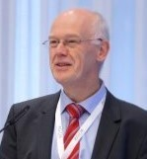 **Mr. Andreas Wiebe**Chair for Civil Law, Intellectual Property Law, Media Law and Information and Communications Technology Law, University of Göttingen

Prof. Dr. Wiebe obtained law degrees at the University of Hannover 1987 and at the University of Virginia (U.S.A.) in 1988. Having obtained the doctoral degree in 1991 with a comparative work on the protection of computer programs in the U.S. and Germany he completed his habilitation on electronic contracting in 2001. From 2002 to 2009 he was the head of the Department of Information Law and Intellectual Property Law at Vienna University of Economics and Business Administration. Besides several guest professorships, he was a Visiting Professor at Stanford Law School from January to June 2008, and at the University of Nanjing, China, in 2012. Since May 2009 he is a Professor of competition law, intellectual property law and ICT law at the University of Göttingen, Germany. Since 2017 he is the Director of the LL.M. Programme on European and Transnational IP and ICT Law in Göttingen.

Main areas of research are information and communication technology law, copyright and intellectual property law, and unfair competition law. He participated in several nationally and EU funded research projects and is co-director of the Institute of German-Chinese law in Göttingen. He is also the organizer of the Austrian ICT Law Day and the Competition Law Forum, both annual events in Vienna, and of the International Research Forum on ICT and IP Law in Göttingen, providing an annual forum for young researchers from all over Europe.

Prof. Wiebe is an author of several German and English legal articles and books and co-editor of handbooks. He was Vice President of the German computer law association (DGRI) from 2005 to 2011. He is also an active member of the German Society of intellectual property law (GRUR), the German society for comparative law and the Austrian chapter of the ALAI.

**IPO ADMINISTRATION** **PANEL**

**Moderator**

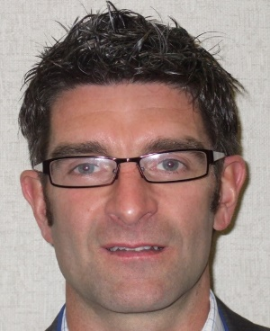  
**Mr. Andy Bartlett**

Divisional Director, Intellectual Property Office

Andy Bartlett leads the IPO’s Programme to transform the way it delivers services for its customers including the deployment of exponential technologies like AI. He has had a longstanding role in initiatives to improve the international patent system including on substantive patent law harmonisation, improving the PCT, collaboration with other offices and work sharing initiatives like the Patent Prosecution Highway.

He joined the UK Intellectual Property Office as a patent examiner in 1990 after graduating in Physics from the University of Birmingham.

He has also acted as Policy Advisor to the IPO Chief Executive and was IPO practice lead on the eligibility of software and business method patents from 2001 until 2015 when this issue was regularly considered in the UK courts.

**Co-Panelists**

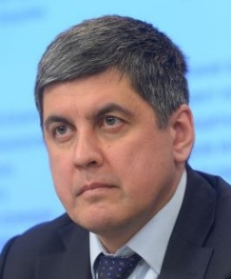**Mr. Alexander Gorbunov**Deputy General Director, Federal Institute of Industrial Property of the Russian Federation

Alexander is responsible for all informatization including the application of artificial intelligence in patent examination processing in order to effectively automate the intellectual property workflow processes and manage large quantities of data. Management of IT departments, operation, design and development of applied information systems. Management of work within the framework of the Institute's participation in the ‘Digital Economy’ Federal Project with the budget of 1 billion rubles.

Omsk Regional Government, Omsk Russia — Minister of Industrial Policy, Transport & Communications of Omsk Region

The Ministry is the state authority of the Omsk Region, who is in charge of the development of the industrial potential of the region, the development of transport, power plants, communications and information technologies. The number of budgetary institutions of the region (metro construction directorate, levee construction directorate, Omsk-Fedorovka airport construction directorate) are directly subordinated to the ministry. The heads of the ministry are members of the boards of directors of Omsk Airport, Omsk-Suburb, and Tevrizneftegaz. The budget of the ministry is more than 2.5 billion rubles a year, the number of employees, taking into account budgetary institutions, is more than 1200 people.

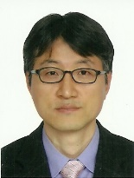 **Mr. Gyudong HAN**   
Director of the Information Management Division, Korean Intellectual Property Office (KIPO)

Current : Information Management Division

Former : Information & Customer Policy Division

Computer System Examination Division

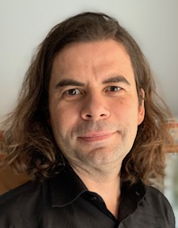  
**Mr. Miguel Ortega**Advisor to Director of Department, Digital Transformation Department, European Union Intellectual Property Office (EUIPO)

Miguel Ortega is currently Advisor to the Director of the Digital Transformation Department of the EUIPO (European Union Intellectual Property Office).

He is graduated in Business Computing and in Computer Science for the University Autonoma of Barcelona. Before joining EUIPO, Miguel worked in several UK Universities in different research positions, among these University College London and City University.

He moved from Academy to IT Consultancy and then joined EUIPO as Project Manager in 2003. Mr. Ortega has worked in different roles along his career always linked to the Information Technology domain and recently to the Digital Transformation of business processes. As Programme/Portfolio manager, he has led big teams to implement key IP projects to transform the digital landscape at EUIPO.

Strong information technology professional, skilled in management, budgeting, procurement, software development methodologies and familiar with emerging technologies, Mr. Ortega participates in the definition of the EUIPO’S Digital Strategy focusing on an open, friendly and problem-solving approach.

 **Ms. Frances Roden**Deputy Director General, IP Rights Division of IP Australia

Her responsibilities include the statutory roles of Commissioner of Patents, Registrar of Trade Marks, Designs and Plant Breeder’s Rights.

Fran moved from academia to join the Australian Public Service as a patent examiner in 1996. She has held a number of policy and governance roles, which include, three years in the Department of Industry, Innovation and Science, a secondment to the Australian Public Service Commission to work on IP Australia’s Capability Review in 2013, establishing IP Australia’s new Governance Secretariat team, and Director of IP Australia’s domestic policy section. She has also spent 18 months working with a former Parliamentary Secretary as the Department’s Liaison Officer. More recently, Fran was General Manager of IP Australia’s Policy and Governance Group where she was responsible for implementing legislative changes, international IP policy and trade agreements, attorney registration and economic research.

Fran has a Bachelor of Science (Hons) and PhD in organic chemistry, from Bristol University, England.

[End of document]