E
WIPO/GEO/LIS/08/INF/1
ORIGINAL: English
DATE: September 3, 2008


NATIONAL INSTITUTE OF INDUSTRIAL PROPERTY | WORLD INTELLECTUAL PROPERTY ORGANIZATION
FORUM on geographical indications
and appellations of origin
jointly organized by
the World Intellectual Property Organization (WIPO)
and
the National Institute of Industrial Property (INPI), Portugal
Lisbon, October 30 and 31, 2008

GENERAL INFORMATION
prepared by the International Bureau of WIPO
I. ORGANIZATION OF THE FORUM

Organizers

The Forum on Geographical Indications and Appellations of Origin is being organized jointly by the World Intellectual Property Organization (WIPO) and the National Institute of Industrial Property (INPI), Portugal.

Venue and Dates

The Forum will be held in Lisbon, on Thursday, October 30, 2008, from 4 p.m. to Friday, October 31, 2008, until 3 p.m., at the following address:

FIL Meeting Centre
Auditorium I
FIL - Feira Internacional de Lisboa
Rua do Bojador, Parque das Nações
1998-010 Lisboa
Telephone: +351 21 892 1725
Facsimile: +351 21 892 1722
E-mail: lisboacc@aip.pt
Internet: www.lisboacc.pt

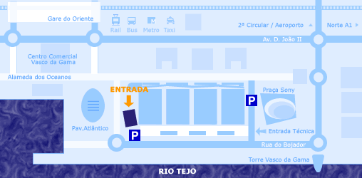
Entrance
FIL
Meeting Centre

Commemoration Ceremony

The Forum will be followed by a Commemoration Ceremony to celebrate the 50th Anniversary of the Adoption of the Lisbon Agreement for the Protection of Appellations of Origin and their International Registration. This Ceremony will take place at 4 p.m. in the same venue.

Registration

Registration for the Forum should be done by means of the Registration Form annexed to this document.

On-site registration will take place on Thursday, October 30, 2008, from 3 p.m. to 4 p.m. at the Registration/Information Counter, which is located at the entrance to the FIL Meeting Centre.

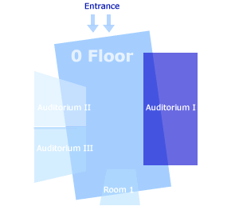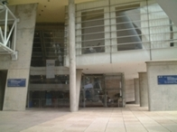

Working Languages and Documentation

The working languages of the Forum are English, French, Portuguese and Spanish with simultaneous interpretation.

All documents will be published on the WIPO website at the following address: http://www.wipo.int/meetings/en/.
II. INFORMATION CONCERNING HOTEL AND IMMIGRATION FORMALITIES

Entry Visa

In order to obtain a visa in time for their travel, foreign participants who need a Portuguese entry visa, are strongly recommended to contact the Embassy or Consulate of Portugal in their respective countries as soon as possible. They should be in possession of a valid entry visa before commencing their travel.

Any participant or speaker having difficulty in obtaining a Portuguese entry visa may request assistance from INPI (see details of the contact person, below).

Hotel Accommodation

Room reservations have been made by INPI, for participants, at preferential room rates at the following hotels:

Tivoli Oriente****

Avenida D. João II, Parque das Nações
Lisbon 1990 – 083
Tel.: +351 21 891 5335
Contact: Ms. Luísa Lello – e-mail address: luisa.lello@tivolihotels.com
Booking guarantee: till September 15, 2008
Booking reference: 92463
Single room: 95 euros
Double room: 105 euros

Olissippo****

Avenida D. João II, Parque das Nações
Lisbon 1990 – 083
Tel. +351 21 318 2794
Contact: Ms. Gabriela Almeida – e-mail address: grupos@olissippohotels.com
Booking guarantee: till September 29, 2008
Booking reference: INPI – Comemoração dos 50 anos do Acordo de Lisboa 2008
Single room: 97 euros
Double room: 108 euros

Tryp Oriente****

Avenida D. João II, Parque das Nações
Lisbon 1990 – 083
Tel. +351 21 893 0099
Contact: Ms. Filipa Mendes – e-mail address: tryp.oriente@solmeliaportugal.com
Booking guarantee: till September 15, 2008
Booking reference: Ref/0190/DRIPI/2008
Single room: 87 euros
Double room: 99 euros

Further information on hotels in Lisbon for room reservation may be obtained at the following website address: http://www.channels.nl/hotel_index_pt_lisbon-pt.html.

All participants should make their room reservation directly with the hotel of their choice. All bills are to be settled directly with the hotel. All major credit cards are accepted.

III. INPI AND WIPO CONTACT DETAILS

Reports of any difficulty in obtaining a Portuguese entry visa, should be sent to the following INPI official:

Mrs. Maria de Jesus Augusto
Telephone: +351 21 881 8209
Facsimile: +351 21 887 8508
E-mail: maria.augusto@inpi.pt

For further assistance and inquiries from WIPO, the following person may be contacted:

Mrs. Marie-Pierre Doré
Telephone: + 41 22 338 9621
Facsimile: + 41 22 338 8160
E-mail: mariepierre.dore@wipo.int

[Annex follows]

National Institute of World Intellectual
Industrial Property Property Organization

REGISTRATION FORM

FORUM ON GEOGRAPHICAL INDICATIONS
AND APPELLATIONS OF ORIGIN

Lisbon – October 30 and 31, 2008

TO BE RETURNED TO:

WIPO

FACSIMILE: +41 22 338 8160
E-MAIL: mariepierre.dore@wipo.int

Mr./Mrs./Ms.: ______________________________________________________________

First Name: ________________________________________________________________

Family Name: ______________________________________________________________

Country - Organization: _______________________________________________________

Title: ______________________________________________________________________

Address: ___________________________________________________________________

City: ____________________________________State: _____________________________

Country: ___________________________________________________________________

Telephone: ________________________________________Fax: _____________________

E–mail: ____________________________________________________________________

[End of Annex and of document]

