E
WIPO/GEO/BEI/07/2
ORIGINAL: English
DATE: June 6, 2007
 | 
STATE ADMINISTRATION FOR INDUSTRY AND COMMERCE | WORLD INTELLECTUAL PROPERTY ORGANIZATION
INTERNATIONAL SYMPOSIUM ON GEOGRAPHICAL INDICATIONS
jointly organized by
the World Intellectual Property Organization (WIPO)
and
the State Administration for Industry and Commerce (SAIC)
of the People’s Republic of China
Beijing, June 26 to 28, 2007
geographical indications and trademarks:
combined efforts for a stronger product identity
cricova case
Presentation by Mrs. Jalba Violeta
Head, International Trademarks Section,
State Agency for Intellectual Property (AGEPI), Kishinev

INTRODUCTION (General overview on the protection of GIs and AOs in Moldova)

Moldova is a small country situated in the Eastern part of Europe, between Romania (West) and Ukraine (East), with a tumultuous history that left its marks on the present society and on the economic situation of the country. Moldova has a favorable climate and fertile soil. The agricultural sector holds the maximum share in economy: the main Moldovan products are fruits, vegetables, wine and tobacco. The country has an overall area of 33,843 km² and a population of 4,431,570 inhabitants. Being a former Soviet Republic, its law system was developed on the vestiges of the soviet legislation, being strongly influenced by the continental system. Currently, bringing the legislation of the RM in line with the one of the European Union is one of the most important commitments our country undertook by signing the Partnership and Cooperation Agreement between the Member States of the European Community on the one hand, and Moldova, on the other hand, on November 28, 1994 that came into force on July 1, 1998.

The current protection system of Geographic Indications in Moldova is a bit different from the internationally recognized systems. The provisions of the Law No. 588 of the RM on Trademarks and Appellations of Origin include the concepts of geographical indication and appellation of origin, cumulating the already known positions of WTO and EU, specifying that the appellation of origin is protected by registration with the State Agency on Intellectual Property (AGEPI), as well as by the existence of a protection system and a register of appellations of origin. Geographical indications are protected indirectly. Appellations of origins shall be refused and protection shall not be granted if they do not comply with the conditions specified in the Law. Foreign appellations of origin are refused if they are not protected in the country of origin. Symbols constituting exclusively from a geographical indication and trademarks containing a geographical indication for products that do not have their origin in the given zone are not protected and cannot be registered. But still, the concept of geographical indication is not developed and producers tend to protect their products in different ways that in certain cases prove to be successful in their fight with the competitors as well.

The use of GIs in the RM is not limited only to agricultural or food products. GI can also emphasize the specific qualities of a product the specificity being due to the human factor, such as specific production skills and traditional knowledge. If we are to make a research of the internationally registered AOs to see the variety of the products covered by AOs, we could say that Moldova has quite a significant potential. Many products that are manufactured in Moldova could be protected by means of appellations of origin, for instance handicraft articles, glass jewelleries, ceramics, musical instruments, musical toys, wooden handicraft articles, cloth, manually worked laces, lace tablecloth, cheese, sausage, oil, butter, yoghurt, vegetable salads, honey, grapes, nuts, fruit, mineral water, wines, tobacco, tobacco products.

Though the difference between a geographical indication and a mark is obvious as the mark is the sign used by an enterprise to distinguish its products and services from those of other enterprises and the holder has the exclusive right to use the mark, while the geographical indication tells the consumer that the product is manufactured in a certain place and has certain characteristics that are due to the place of production and can be used by all producers who manufacture specific products in the specific place denominated by a geographical indication and whose products have common qualities, local producers tend to combine these two elements. Moreover, they fight fiercely to obtain rights on the geographical indication, similar to the exclusive right on the mark and, as a result, to deprive other competitive producers in the zone of the right to mark their products with the same geographical indication.

Thus, the national GI and AO protection system is not uniform and contains different protection elements: there is the possibility to protect AOs by registration at the national office, AGEPI (for ex., Romanesti, Ciumai), by registration of collective, certification or guarantee marks and there are laws and Government decisions which recognize certain GIs (for ex., Milestii Mici, Cricova).

If to make a retrospective of the national protection system of geographical indications and appellations of origin in Moldova, we could divide the past in 2 stages:

- The 1st stage covers the period of 07.26.1993- 02.08.96 - 02.08.96 (from the publication of the Government Decision of Moldova on the Protection of Industrial Property in Moldova No. 456 of 07.26.93, that contained temporary provisions related to AOs, which, in certain points, even contravened the international provisions, until the publication of the Law No. 588/1995 on Trademarks and Appellations of Origin that laid the basis of the current system.

- The 2nd stage covers the period from 02.08.96 (Publication of the Law No 588/1995) until 05.04.2001, when Moldova signed the Lisbon Agreement for the Protection of Appellations of Origin and their International Registration of 1958. This period is characterized by the first registrations of AOs in Moldova. Height AO applications were submitted altogether, one in 1997 and seven in 1998. Only two of them were submitted by national applicants and namely: AO ROMANESTI, the holder of the right of use “Romanesti” SA for the product – red wine, it was recently submitted for registration according to the Lisbon Agreement and AO CIUMAI, the holder of the right of use “Ciumai” SA Joint Venture for such products as red sweet dessert wine and natural red dry wine. For both appellations of origin the holders were the only producers in the area. Six AO applications were submitted by foreign applicants from the Czech Republic, namely: BUD, BUDWEISER BIER, BUDWEISER BIER – BUDVAR, BUDWEISER BUDVAR, BUDWEIS BEER, all for beer products and KARLSBADER BITTER for alcoholic drinks. Seven AOs were registered on the whole, the only rejected application was the 0002 BUD application, because it did not correspond to the definition of AO according to the national legislation (it is a derivative from the denomination of the Budweiser locality, thus, it is not a geographical name).

The next stage covers the period from 05.04.2001, since the signing of the Lisbon Agreement until the present day, characterized by the development of AO and GI institutions. Still, the system is not integrated and there is a lack of cooperation and information between the ministries and competent institutions. Along with the accession to the Lisbon Agreement Moldova committed itself to protect the appellations of origin submitted for registration through the Lisbon system. Over eight hundred of AOs were submitted through this system, out of which six were rejected on the ground that the geographical indications were not precise and they could be attributed to more countries, KASKAVAL BALKAN, DUNAVSKA SALATA, KARPATSKE BRANDY, KARPATSKA PERLA. The AO BUD was rejected from the same reason as the national application.
As we already have a general vision on the peculiarities of GI and AO protection in Moldova, I would like to pass to a specific example of GI use by a producer in the wine-making branch. This producer is considered to be one of the local leaders in wine production, its products being identified by a famous GI in Moldova.

CRICOVA case

- The history of the enterprise (its establishment, operation, basements, production area, focus on the elements, which made the enterprise renowned)

The Integrated Wine Producing Establishment “Cricova” JSC, famous for its unique underground labyrinths and especially for its excellent wines, was founded in 1952. Namely in this year the old limestone mines located in an immediate proximity to the small town of Cricova, were turned into vast wine cellars.

The greatest part of “Cricova’s” production facilities is placed under the ground, at a depth of 60-80 m representing, indeed, a huge Underground City of Wine, the numerous galleries of which spread at a length of more than 60 km. These labyrinths have a truly unique, exclusively favourable original microclimate: the whole year round the naturally constant temperature here is about +12°-+14°C and the humidity – about 97-98%, which are the most propitious conditions one can imagine for the birth, development and aging of exquisite fine wines. Namely this humid, chilly environment contributes the most to the formation of the unrepeatable, authentic character of “Cricova” wine products.

The Integrated Wine Producing Establishment “Cricova” is by all means an extraordinary underground complex with a huge production capacity. That is why several years it has been declared a “object of national cultural patrimony” and granted the supreme state award – “The Order of the Republic”, as a sign of acknowledgement of its remarkable contribution to the development of the Moldavian economy and its special accomplishments in the field of the wine-making.

The second half of the 20th century is considered by right to be one of the most important periods in the development of wine-making in Moldova. At the beginning of the 1950s, after a pertinent decline that followed the World War II, there started the construction of numerous primary grape processing facilities with huge production capacities, on a modern technological and scientific basis.

This upsurge of the Moldavian wine-making was preceded by the opening in 1945 of the Chisinau branch of the Magaraci Institute (one of the most prominent soviet agriculture research institutions) and, in 1950, by the establishment of the Institute of Scientific Research in the field of Wine-making, affiliated by the Moldavian branch of the Academy of Science of the U.S.S.R.

Nevertheless, at the first stage the development of the wine-making industry faced considerable difficulties. Thus, despite the spectacular growth of the primary grape processing capacities, a rational organization of the technological process as well as its continuity were hampered by a stringent lack of properly equipped wine storage, processing and aging facilities. An essential part of the wine materials was kept in the open areas, which had an utmost negative impact on the wine quality and generated huge losses.

The solution of this problem was found: why do not use as wine storehouses some abandoned stone mines?

During several months a team of professional geologists, constructors and cavers, visited and thoroughly examined tens of mines all over the country. Their choice turned to be the vast underground galleries in the city of Cricova, situated at a distance of about 16 km from Moldova’s capital, Chisinau. These wide stone labyrinths were so spacious that millions of decilitres of wine could easily fit in, while their cool and damp microclimate was truly unmatchable: a year round naturally constant temperature and humidity required no additional capital investments. After a thorough examination of this innovative suggestion, the Government of the Republic allowed Cricova galleries to be adjusted “with the purpose of storing and aging wines and brandy”. Afterwards, many other mines in Moldova had been adapted, given the wide acceptance of technical and economic advantages of using the underground locations provided.

However, with all the initial general enthusiasm, the first flow of substantial capital investments was directed to “Cricova” only at the end of 1954, destined to both the adjustment of mines and the acquisition of the necessary technical equipment. The same year was marked by another important event: the foundation of the great National Wine Collection at “Cricova”, the first exhibits of which included such precious bottles as those from the famous Göring collection. A year later, in 1955 the first vintage of selected high-quality wines (harvests of 1953 and 1954) was deposited for aging, which signified the actual birth of Cricova Cellars. This was an important debut not only for “Cricova” but also for the whole country of Moldova, given that the general level of a national wine-making industry development is heavily influenced by the share of high-quality vintage wines in the whole wine output. Or, till then Moldova had been producing only regular table wines.

Another breaking point in “Cricova’s” history was the year of 1957, when the first vintage of classical sparkling wines was “accommodated” in the Cellars. At the end of 1960s, being the lucky owner of a rich basis of agricultural raw materials, Moldova became one of the biggest wine suppliers in U.S.S.R. In 1968 there is built up a complex experimental wine producing facility at “Cricova”, being an integral part of the huge Agro-Industrial Association “Cricova”, which had at its disposition vast and ever-expanding vineyards. Among supplementary activities performed within the Association there were encountered the animal breeding and fruit and vegetable cultivation. On July 30, 1980, about 30 years after the first endeavour was made, the activity of the classical sparkling wine production was successfully launched in one of the most remote sections of “Cricova’s” underground galleries. The success of the project was ensured by the rich experience and great potential accumulated by an entire generation of notorious specialists in the field of sparkling wine production.

The really “hard times”, however, came with the collapse of the U.S.S.R. in 1991, which led to a sudden break down of the traditional and decades-long production and commercial relationships “Cricova” had with the enterprises from all over Soviet Union. This resulted into a tremendous cut in the quantities produced and marketed, the crisis being amplified by an unprecedented deficit of energy resources and auxiliary materials. But even then, despite the general distortion of the economy, “Cricova’s” team was constantly looking for feasible outrunning measures. These by right titanic efforts were not lost in vain. The continuous amelioration of the underground wine tasting site in the Cellars and set up of a chain of specialized wine stores, the foundation in 1998 of the Business & Tourism Center “Cricova-Vin” LLC focused on complex marketing activities, the unceasing endeavours to establish “Cricova” name on new markets and at the same time preserve the traditional ones – all these undoubtedly contributed to what the I.W.P.E. “Cricova” JSC is now.

Cricova Cellars could easily pretend to be included among the most fascinating wonders of the world. Why not? Being placed under the town of Cricova, they make up a true underground wine city with avenues, streets and broadways, each with its own name: Cabernet, Chardonnay, Pinot Noir, Riesling, Aligote, Sauvignon…, which corresponds to the wine variety preserved right there, in the adjacent stone niches.

Having appeared as the result of the traditional stone extraction activities in this region, Cricova Cellars are in fact a former limestone mine. Many buildings in Cricova, Chisinau, Balti and other Moldavian cities were built namely of the limestone extracted here. The limestone is still being extracted in some of the numerous galleries, which leads to the continuous expansion of the underground city.

The Integrated Wine Producing Establishment “Cricova” JSC was initially conceived as a top-quality vintage wines producer, oriented toward classical European grape varieties and technologies. The fundamental premises for the production of faultless and expressive vintage wines consist of minimal variations in environment’s temperature and also relatively high air humidity. Besides, the higher is the air humidity the lower is the wine loss. In Cricova Cellars wine product losses are ten times lower comparing to the on-the-ground storage facilities and, which is amazing and crucial cost-wise, there is no need in special conditioning or airing devices. The nature has already arranged everything by itself!

Another attribute of the Cricova Cellars is the remarkable collection of wines – the Oenotec, comprising nowadays on the whole about 1.3 million bottles. Here, as into an authentic internal conceiving, a lot of historic wines are collected, wines with identity, which make up an eminent data base, having a scientific and a perceptual significance, ready to be tested, unravelled and relished by experts. The pride of the Oenotec are, first of all, the wines bearing the name “Cricova”, that is why “Cricova’s” collection of national and international tasting awards consists, at the moment, of more than 80 Grand-Prix, gold and silver medals.

(b) GI registration (special laws) (The Law on Declaring “Cricova” SA Wine Complex a National Cultural Heritage of Moldova No. 322-XV of 07.18.2003).

Now that we have found out that the wines with the geographical indication “Cricova” have become famous due to the underground town, let’s see how the producer of these famous wines have protected their business. Since, as we have already mentioned geographical indications cannot be protected as such, in Moldova, but only by means of a trade mark or appellation of origin, it is obvious that all the producers of the region can use the name “Cricova” to mark all the wine produced in this region. According to the national legislation, the denomination “Cricova” did not meet all the criteria to be registered as an appellation of origin, and thus it was possible to register it just as a trademark bearing other distinctive elements. As this geographical indication was very famous, several manufacturers established wine-making enterprises in the region, marking their products with “Cricova”. In order to stop the use of this geographical indication by other enterprises that did not have access and neither owned the famous underground cellars of Cricova, the Moldovan Parliament adopted a new Law on Declaring “Cricova” SA Wine Complex National Cultural Heritage of Moldova No. 322-XV of 07.18.2003.

The Law refers to “Cricova” SA Wine Complex, which is recognized as a unique cultural and landscape complex, proof of the spiritual, economic and social development of the country, bearer of the information about the origin and settlement of wine-making traditions, being declared an object of the national and cultural heritage of Moldova. The same status was assigned to the galleries of Cricova stone quarries, underground structures (including the tasting hall), the land construction complex and adjacent land and geographical landscape, the unique collection of wines from all the wine-producing regions and micro zones of Moldova and other countries, which all have a historical and cultural value and reflect the national and international wine-making traditions.

To that day, there were 42 trademarks registered in Moldova containing the word “Cricova”, which belonged to several enterprises.

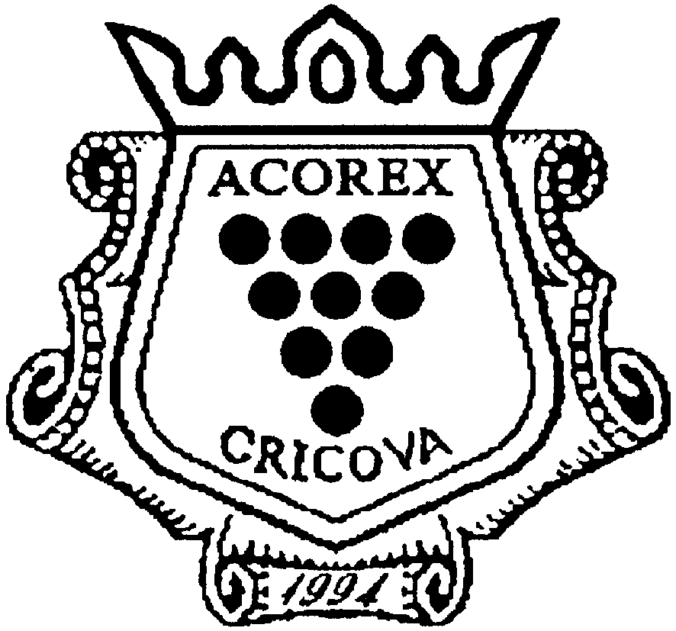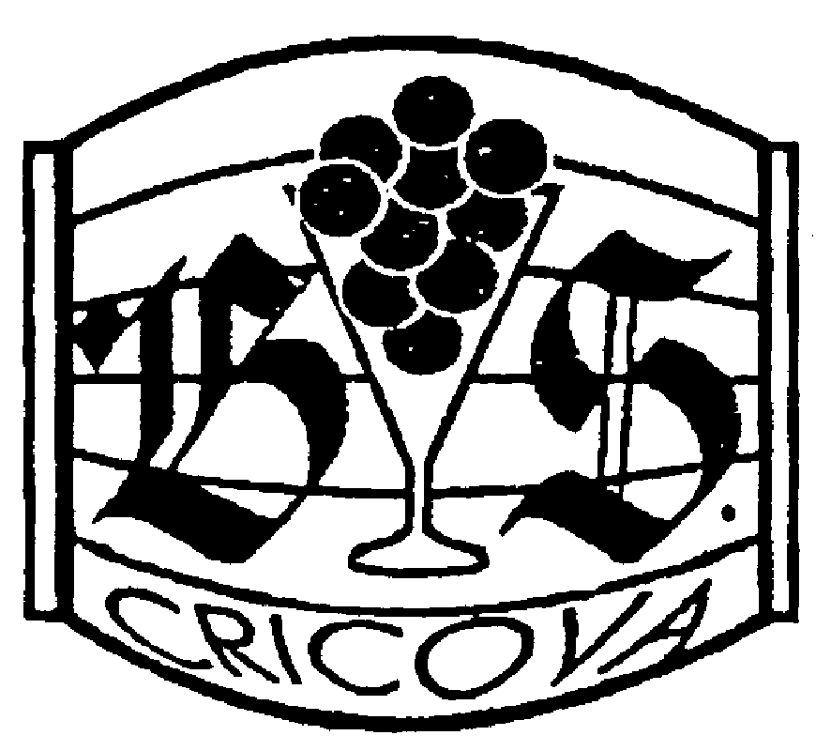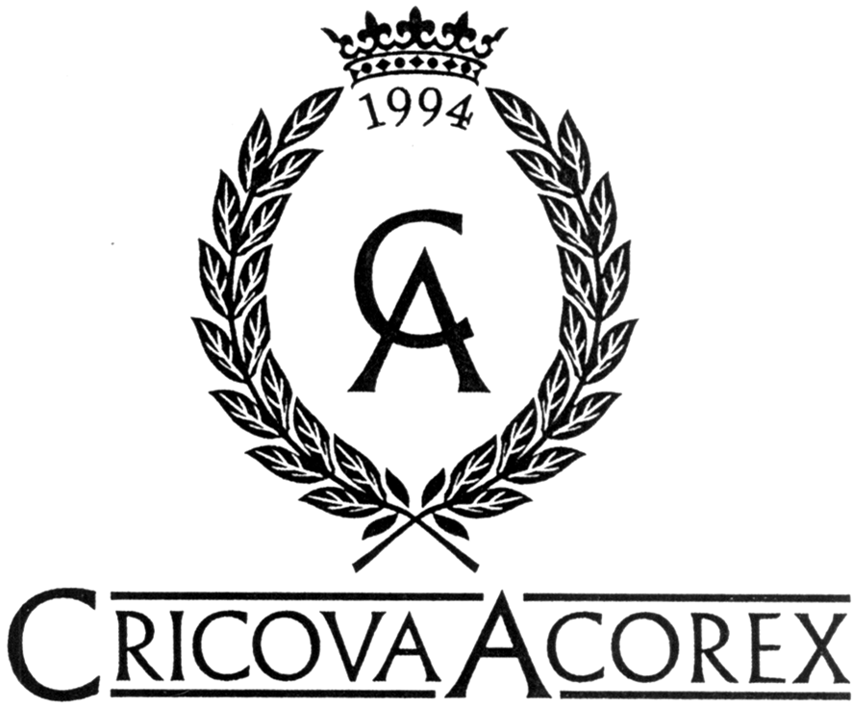

An entire chapter of this Law was dedicated to the particularities of exercising the right of ownership of “Cricova” SA Wine Complex. It was declared state property, thus the state was granted the preferential right to use the geographical indication “Cricova” in the commercial name of the company, trademarks and other industrial property objects. It was prohibited to use identical or similar appellations containing the geographical indication “Cricova” for commercial purposes or in any other fields of activity, if this would result in confusions or would suggest a relation to “Cricova” Complex, thus causing a prejudice to its interests or misleading the public opinion. Any individual or legal entity with the official residence or premises in Cricova geographical area, owner of an operating industrial or commercial enterprise, has the right to use the geographical indication “Cricova” for identification of the manufactured products (performed works, provided services) only with the authorization of the Parliament. If there is no such authorization or it has been rejected, the holders of trademarks, company names or other industrial property containing the geographical indication “Cricova”, regardless of the goods or services, for the identification of which this mark or appellation is used, have to exclude the geographical indication “Cricova” from the corresponding names within five years. In this way, “Cricova” SA Wine Complex has become the only legal holder with the right to use the geographical indication “Cricova” and the problem of competitors in terms of using the geographical indication Cricova was solved.

(c) Trademark Registration (Portfolio). Registration Problems in Other Countries

The “Cricova” SA Wine Complex has a considerable portfolio compared to other companies in the field, and regardless of the fact that it is a young company, in 2007 it will celebrate its 55th anniversary. The first registration dates back to 1993 (Moldova became independent in 1991 and the Office for Inventions and Trademarks was established in 1992).

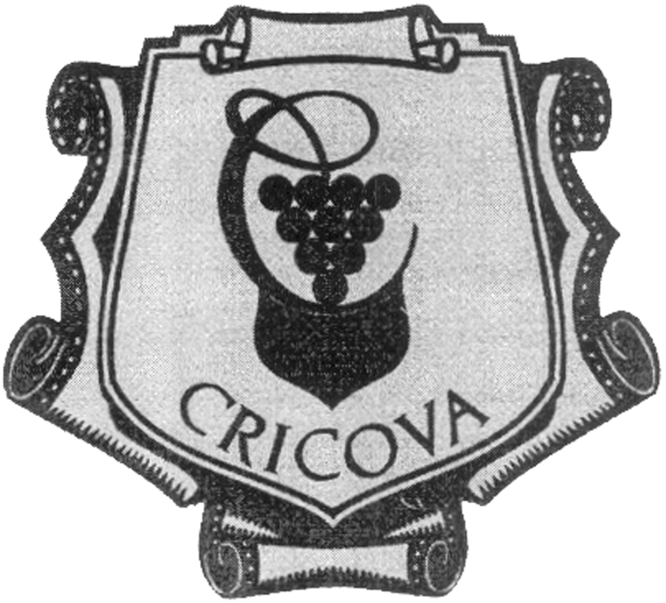 | The biggest part of those 45 registered marks contains the GI “Cricova”, and its main trademark has become so famous that it began being registered abroad by third persons – traders or other economic entities without authorization of its true holder in Moldova. Unfortunately, this fact was revealed only on 05.12.2002 when the CRICOVA S.A. Wine Complex submitted an application for the international registration of the mark according to the Madrid System for

the products of class 33 – alcoholic drinks (except for beer), covering 32 countries. The mark turned out to be registered as such in several countries, even under names of certain individuals. At present, the company is involved in negotiations and legal proceedings in several countries. The search in Romarin Database provided that there were three international registrations containing the word Cricova. The first of them, a verbal trademark, based on a national registration in Netherlands, the holder is a natural person and it was designated for France and Germany, was registered for wines and sparkling wines. The second trademark was registered by another Moldavian company, but at this moment it could not use the trademark due to the earlier mentioned Law, and the third trademark belongs to Cricova S.A.

 | 743787 | Jacob Hofstra |  | Cricova |  | 33
 | 792179 | ACOREX WINE HOLDING S.A., întreprindere mixta |  |  |  | 33
 | 794492 | CRICOVA S.A., Combinat de vinuri |  | 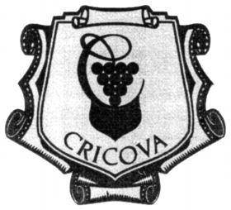 |  | 33
The search in the United Kingdom Trademark Database revealed that since 1994 the trademark Cricova is registered for one British company for the same products - wine and spirits. Consequently, the Moldavian trademark was refused on prior rights. The same situation is in United States of America, Turkey and some CIS countries.
TM Number Mark Text Type Date Status Classes
1564151 CRICOVA WO 04.03.1994 Registered 33
M794492 CRICOVA C DW 05.12.2002 Refused 33

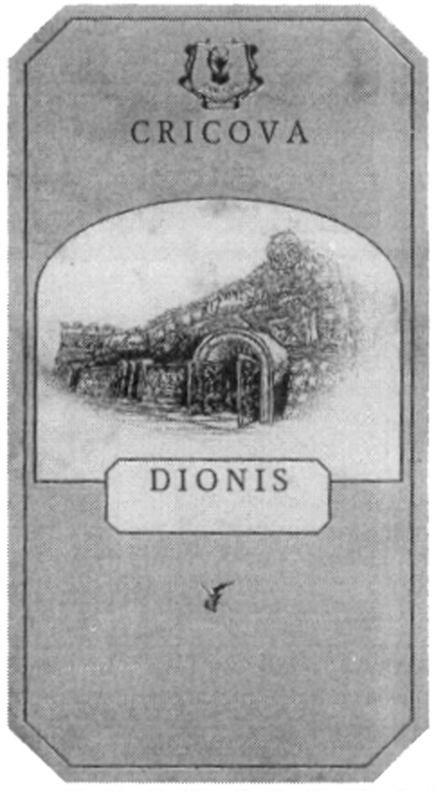 |  |  | The company is registering the name of GI as a part of its trademarks, for example DIONIS with pictures of the entrance into the underground cellars, as well as ORASUL SUBTERAN (UNDERGROUND TOWN), REGELE GUSTULUI (KING OF THE TASTE), TEZAURUL SOARELUI (TREASURE OF THE SUN), NOMEN EST OMEN, CODRU, SERENADA, ELEGANTA (ELEGANCE) etc. |  | 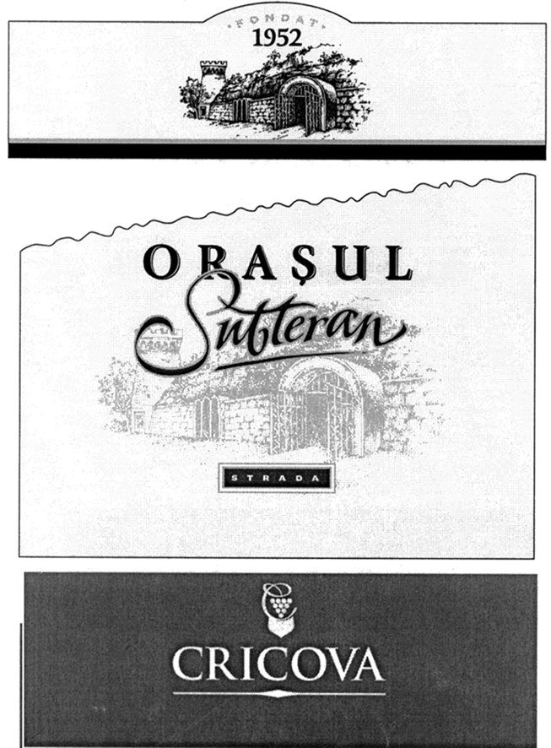

d) Product marketing by means of GI, Mark, Design (methods, export etc.)

Good economic results cannot be achieved without having a cohesive vision on all the components of the marketing mix (product policy, price policy, distribution policy, promotion policy), which was established by the company.

The present market represents an ongoing fight between products, economic entities, trademarks and advertising image with the view of drawing consumer’s attention and winning his/her sympathy. This reality determines national producers to start the application of the so popular branding concept in developed countries on the Moldovan market.

It is obvious that the profits depend on the sales volume made by the entrepreneur, which in its turn depends on the demand for the product. In order to succeed in business it is very important to have loyal customers, which can be achieved in time by means of maintaining the quality of products of certain trademark, but in order to gain customers’ loyalty one has to draw the attention to the product first. Thus, modern technologies offer a big number of opportunities starting with launching of certain advertising spots in different media and ending with the provision of certain additional services or discounts to loyal customers. But in order for the product not to get lost in the multitude of products on the market it has to be individualized, in this context the mark and design play a primary role. Recently, the company has launched a slogan – Nomen est omen (The name is a sign), that is the name speaks for itself – which emphasized company’s reputation even more and determined consumers to test the new production.

As for the design, I will refer especially to the package, which at the moment is one of the most common objects of design. Decorative packages for bottles are inspired by the traditions of Moldovan people, have a historical note and remind of our ancestors’ values.

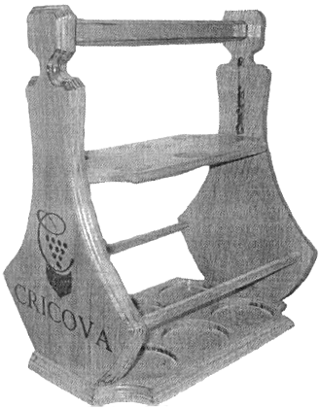 | 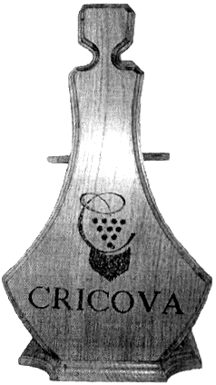 | 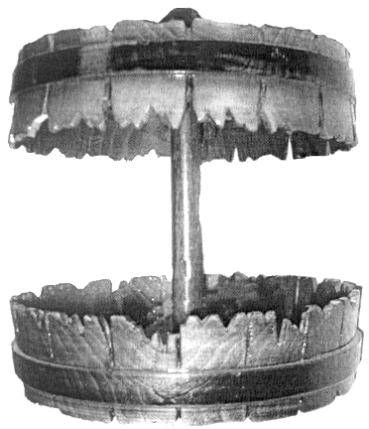 | 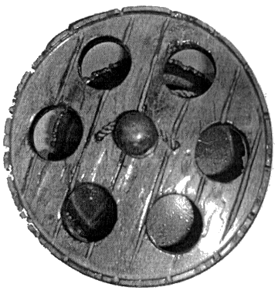

In the case of Cricova S.A Company, the transition point towards the success namely in its production marketing both within the country and abroad was the fact that they convinced the Parliament of Moldova to adopt a law on declaring the complex a national and cultural heritage and as a result prohibiting the use of GI “Cricova”. This fact is really a new method of promoting the products of this company.

Another individual method of marketing is the fact that Cricova Company was granted the title of tourism objective of Moldova. A visit to the Complex Cricova can be by right compared to the legendary journey of the Argonauts. The latter were dreaming of the Golden Fleece while those who cross the threshold of the Underground Empire of Wine are aspiring for at least in the same measure spectacular things and … are not at all disappointed. The history, the geology and literally the unrepeatable savour that wraps you on the instant do not leave indifferent even the most unreceptive imagination. Nowadays, Cricova is the object of “the sweetest” pilgrimage: delegates from more than 100 countries of the world have already passed inspired under the prodigious vaults of the galleries which, just like some large tempting veins, lead you towards the very heart of the Earth. Among the well-known guests of The Great Cellar of Moldova there were, every at his/her time, the presidents of many states. Cricova’s cellars were honoured also with the presence of the most talented and the worthiest people of art and science. It is well-known the funny case (or maybe just a legend?) about the long-lasting visit of Iurii Gagarin, the first cosmonaut, who was under such a great impression of this grandeur that lost himself in the hospitable galleries. The Visit Book of Cricova was fulfilled with the signatures of many-many great men and women of the world. Nowadays the impetuous wooden doors of Cricova are open for everyone. You have the unique chance to penetrate into the essence of the mysterious process of wine-making, to feel yourself a medieval alchemist looking for the philosopher’s stone…

Also, it should be mentioned that the Company successfully participates in many exhibitions and auctions, invests in new processes and equipment, and strongly promotes products on the local market and foreign one. The data of the marketing survey of 2006 show that the enterprise spent 500 000 lei for direct advertising on TV, Radio, outdoor media, Press, 150 000 lei on new product development, 635 000 lei on participation in wine exhibitions and festivals in Moldova, Ukraine, Poland, Romania, presentations in China and Austria, 150 000 lei on corporate ware (corkscrews, glasses for wine and sparkling wine, cans), 275 00 lei on corporate materials (catalogues, agendas, calendars, bags, badges etc.), 450 000 lei for wine products. The total costs for 2006 made up to 2 160 000 lei (550 000 lei more than in 2005). The enterprise also invests in modernization and reequipping of buildings, wine-making machines and equipment, including reception, storage, processing, bottling and marketing of wine; invests in the improvement of product quality and hygiene for handling, recycling and elimination of residual products and harmful wastes, invests in the improvement of the system of monitoring and control of the chain of reception, storage, processing and marketing of products in terms of quantity and quality; invests in the improvement of the internal control of the quality of raw material, semi-manufactured articles, products and subproducts obtained at processing and marketing units (building and modernization of areas for analysis laboratories and purchase of laboratory equipment).

Cricova collection and vintage wines constituting the national fame of Moldova, winning more than 70 high prizes at the most prestigious contests and tasting in Bordeaux, Barcelona, Rome. First medals were won in 1958 in Liubleana and Budapest, where the wines Aligote and Feteasca won silver medals. According to the results of the III international wine contest that took place in 1988 in Mukovele –Czecoslovakia, seven samples of wine and sparkling wines were awarded with three gold medals (Cabernet, Codru and sparkling Codrinscoe), one silver medal (sparkling white dry) and three diplomas of II level (Risling, Aligote, white selective Moldavian wine). A year later, in Bratislava they won other two gold medals, five silver medals and seven diplomas. Cricova winery of sparkling wines and vintage wines was afforded the honor of being invited and becoming the member of International Club of Quality Leaders, a fact that is yearly marked with prizes in the cities of Barcelona and Paris.

Company’s brand name and trademarks, are now among the most valuable assets of the enterprise. The most interesting fact is that all trademarks were proposed by the company’s staff with the exception of one, the most original “The Underground town” which was acquired after long negotiations. The Company has registered its domain name and is involved now in some law-suits regarding the trademarks.

The Cricova case was so successful that another big producer of vintage wines obtained the same status as Cricova S.A. On 28.07.2005 a new Law on granting the status of national and cultural heritage of Moldova to the property of the State Enterprise Quality Wines Industrial Complex “Milestii Mici” was passed. One more GI and practically an identical case with the example of Cricova – the same underground cellars, the same status of the enterprise, one more collection of unique wines, the difference being made by the fact that this company went even further, its wine collection being included in the Guinness Book.

In conclusion it has to be mentioned that the future of GI and AO in Moldova will be determined by the draft law on the protection of GI and AO developed currently. The draft law was developed with the technical assistance provided to AGEPI by the European Union within EU TACIS Assistance Program 2004. Assistance included especially the compliance analysis of the national legislation to the legislative framework for the protection of geographical indications and appellations of origin of products within the European Community and the best international practices. Taking into account the multitude of amendments, which were supposed to be made to the Law on Trademarks and Appellation of Origin No.588/1995, it was decided to develop a draft law separately for GIs and AOs. As a result, the draft law fully complies with the legal framework for the protection of geographical indications and appellations of origin of products of the European Community in force at the moment when the draft law was developed, as well as with International conventions in the field of geographical indications and appellations of origin to which Moldova is party. The legal system shall protect the appellation of origin of products, geographical indication and traditionally guaranteed products although the latter ones are not included as objects of intellectual property.

[End of document]

Official exchange rate for date 05/31/2007 EUR 1 = 16.6779 Mold Lei

