OMPI  WIPO | 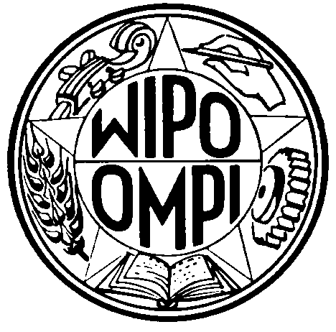 | F - E  WIPO/ACE/4/INF/2  ORIGINAL : français/English  DATE : 20 Octobre /October 20, 2007
ORGANISATION MONDIALE DE LA PROPRIÉTÉ INTELLECTUELLE
WORLD INTELLECTUAL PROPERTY ORGANIZATION
GENÈVE / GENEVA

comité consultatif sur l’application DES DROITS
Quatrième session
Genève, 1 – 2 novembre 2007

Advisory Committee on Enforcement

Fourth Session
Geneva, November 1 and 2, 2007

LISTE DES CONFÉRENCIERS/
LIST OF SPEAKERS
établie par le Secrétariat/
prepared by the Secretariat

CONFÉRENCIERS/SPEAKERS
(dans l’ordre alphabétique des noms)
(in the alphabetical order of names)

John ANDERSON, Chairman Global Anti-Counterfeiting Group, GACG Network Co-ordination Office, London, United Kingdom

Bobby BEDI, Bollywood Film and Music Industry, New Delhi, India

Jason GULL, Senior Counsel, Computer Crime & Intellectual Property Section, U.S. Department of Justice, Washington D.C., United States of America

Justice Louis HARMS, Judge of Appeal, Supreme Court of Appeal of South Africa, Bloemfontein, South Africa

Charles LEACOCK QC, Director of Public Prosecutions, St Michael, Barbados

John NEWTON, IPR Project Manager, Financial and High-Tech Crime Sub-Directorate, ICPO-INTERPOL, Lyon, France

Justice Abdul Karim M. PHARAON, Supreme Court of Justice, Amman, Jordan

Galo PICO MANTILLA (Dr.), Director General, Centro de Estudios de la Integración, Comunidad Andida, Quito, Ecuador

Valerio REGGI (Dr.), Coordinator, Medicines Regulatory Support, Department of Technical Cooperation for Essential Drugs and Traditional Medicine, World Health Organization, Geneva

Piotr P. SERKOV, Deputy Chairman, Supreme Court of the Russian Federation, Moscow

Christian TOURNIÉ, Policy Officer, Intellectual Property Rights, Sector Financial Crime, DG Justice, Freedom and Security, European Commission, Brussels, Belgium

[Fin du document/
End of document]

