E
CWS/5/2
ORIGINAL: English
DATE: April 11, 2017

Committee on WIPO Standards (CWS)

Fifth Session
Geneva, May 29 to June 2, 2017

Report on the Survey on the use of WIPO Standards

Document prepared by the Secretariat

INTRODUCTION
- The Committee on WIPO Standards (CWS) at its reconvened fourth session held in March 2016, approved the questionnaire on the use of WIPO Standards and requested the International Bureau to carry out the following actions:
(a) prepare and issue a circular inviting industrial property (IP) offices to complete the questionnaire;
(b) prepare a survey report; and
(c) present the results of the survey for consideration by the CWS at its following (fifth) session in order to approve its publication in Part 7 of the WIPO Handbook on Industrial Property Information and Documentation (WIPO Handbook) and take the other relevant actions, if necessary.
(See paragraphs 92 and 93 of document CWS/4BIS/16.)
- The CWS also requested the Secretariat to emphasize, in the cover letter accompanying the questionnaire, the importance of highlighting any problems with the implementation of WIPO Standards and reasons for the problems (see paragraph 23 of document CWS/4BIS/16).

- As a follow-up to these decisions of the CWS, the Secretariat issued Circular C.CWS 74 of August 11, 2016 to IP Offices of CWS members, where appropriate, through their Permanent Missions in Geneva, and created a Wiki space to provide a platform for sharing practices regarding the use of WIPO Standards, with a view to inviting CWS members to submit their response to the questionnaire via this Wiki space. In addition to that, the Secretariat encouraged Member States to respond to the survey through various channels including an informal reminder to regional groups in September and formal reminder made during the Secretariat’s report of CWS at the General Assembly held in October 2016, with extending the deadline for responses. As a result of that, responses were collected across the globe including some developing countries (see paragraph 6 below).
- The responses to the survey are publically available in “CWS Survey on the Use of WIPO Standards” Wiki at https://www3.wipo.int/confluence/x/OADDB; the survey results can be browsed by Standard and by IP Office. The overview of the implementation status is available in a table form on the page “WIPO Standards Implementation Overview” at https://www3.wipo.int/confluence/x/OALDB.
- IP Offices who did not respond to the survey, or would like to amend the information submitted, are invited to contact the International Bureau at cws.surveys@wipo.int and follow the instructions available at https://www3.wipo.int/confluence/x/MALDB.

SUMMARY OF THE SURVEY RESULTS
- The following 30 IP Offices took part in the survey:
AU  BA  BD  CA  CN  CO  CZ  DE  HN  HR  HU  IT  JP  KG  KR | Australia  Bosnia and Herzegovina  Bangladesh  Canada  China  Colombia  Czechia  Germany  Honduras  Croatia  Hungary  Italy  Japan  Kyrgyzstan  Republic of Korea | LT  MD  MX  OM  RU  SA  SE  SK  SV  TN  TT  UA  UG  US  ZA | Lithuania  Republic of Moldova  Mexico  Oman  Russian Federation  Saudi Arabia  Sweden  Slovakia  El Salvador  Tunisia  Trinidad and Tobago  Ukraine  Uganda  United States of America  South Africa
- The graph below shows the status of implementation of WIPO Standards in the IP Offices who participated in the survey (see Figure 1). It is noted that many respondents indicated that they were willing to implement WIPO Standards, or parts thereof, in the future.
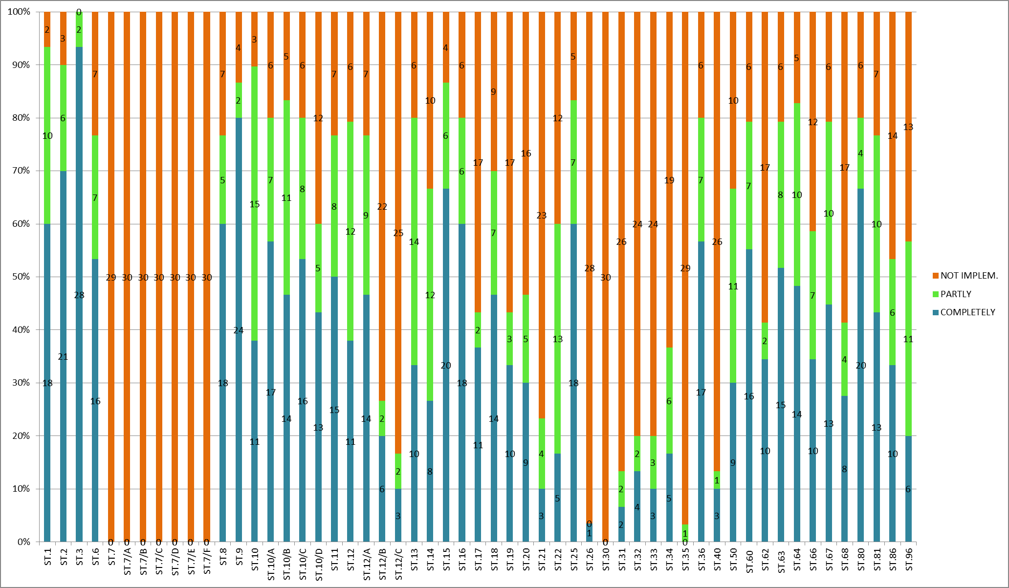
Figure 1
- The following main obstacles for the implementation of WIPO Standards in IP Offices’ practices and reasons for their non-implementation were indicated in the responses.
  - Standards related to outdated technologies
    - Recommended technologies were outdated, for example, microforms (ST.7 to ST.7/F), magnetic tape (ST.30) and mixed-mode format (ST.35).
    - Recommendations were relevant to the paper publication and were no longer applicable to the electronic publication, for example, recommendations related to indexes of patent documents (ST.19), name indexes (ST.20) and reduction of volume of priority documents (ST.21).
    - For certain recommendations, some IP Offices used more recent WIPO Standards covering the same subject matter, for example, ST.13 instead of ST.34 and ST.96 instead of ST.66 and ST.86.
  - Administrative constraints
    - More time was needed to implement recently adopted WIPO Standards (ST.26 and ST.68) in IP Offices’ practices.
    - Some IP Offices did not have a business case for the implementation of a given WIPO Standard. It was the case, for example, when another national authority carried out the relevant functions, such as publication of IP documents or trademark registration.
    - Implementation of some WIPO Standards (for example, ST.80) was pending the accession to corresponding International Systems of IP protection, for example, the Hague Agreement.
    - National legislation did not contain provisions necessary for the implementation of certain WIPO Standards, for example, protection of sound marks (ST.68); some IP Offices reported that they were considering including the corresponding provisions in their national legislation.
    - Already existing national (regional) practices did not follow (completely or partially) the recommendations of a given WIPO Standard. There was resistance, in particular, from the third parties to the change of the used technology.
    - One IP Office reported that they needed to develop sufficient capacity to carry out certain functions, for example, substantive examination or official publication, to which the implementation of WIPO Standards was relevant.
  - Awareness and technical assistance required
    - One IP Office reported that they were not aware of the existence of certain WIPO Standards.
    - Some IP Offices required guidelines on the implementation of WIPO Standards in their practices or needed certain clarifications from the International Bureau of WIPO.
    - One IP Office reported that they needed to receive technical assistance in the implementation of certain Standards such as ST.96.
- The graph below shows the number of IP Offices, which reported obstacles listed in paragraph 8 above (see Figure 2).
Figure 2

FOLLOW-UP
- Regarding difficulties listed in sub-paragraph 8 (a) above, all IP Offices participated in the survey reported that they were not using WIPO Standards ST.7 to ST.7/F and ST.30. Therefore, it is proposed to remove these WIPO Standards from the WIPO Handbook and move them to the Archive, which is also available on WIPO website.
- The following WIPO Standards were considered outdated by a large number of respondents, but at the same time, there were IP Offices, which had implemented these WIPO Standards completely:
- WIPO Standards relevant for paper publication: ST.10/D, ST.12/C, ST.18, ST.19, ST.20 and ST.21; and
- WIPO Standards related to technologies, which are outdated: ST.31 (character sets), ST.32 (SGML), ST.33 (facsimile), ST.34 (recording of application numbers), ST.35 (mixed-mode) and ST.40 (facsimile on CD-ROM).
- The CWS is invited to consider whether WIPO Standards listed in paragraph 10 above should remain in WIPO Handbook or be moved to the Archive, i.e. whether it is still advisable that IP Offices who have not implemented these WIPO Standards implement them in the future.
- Difficulties listed in sub-paragraph 8 (b) above are caused by reasons which cannot be addressed within the framework of the CWS.
- With respect to the difficulties listed in sub-paragraph 8 (c) above, the International Bureau will continue its effort to provide technical advice and assistance for capacity building to IP Offices, in particular, upon request from the interested IP Offices, it will follow-up on the issues indicated in the responses to the survey.
- As it was reported that in some cases the implementation of WIPO Standards was achieved via WIPO software solutions for IP offices, for example, WIPO Standards ST.9, ST.36, ST.60 and ST.80 can be automatically implemented through the use of by the Industrial Property Automation System (IPAS). The International Bureau will continue to support the implementation of WIPO Standards through WIPO software solutions for IP Offices.
- The International Bureau made efforts to raise awareness on WIPO Standards, for example, it provided training for IP offices, updated the WIPO Standards area of the WIPO web site and published a brochure on WIPO Standards
(see http://www.wipo.int/export/sites/www/standards/en/pdf/standards-brochure-web.pdf). The International Bureau will continue its efforts to raise awareness about WIPO Standards.
- Furthermore, in order to facilitate the implementation of WIPO Standards by IP Offices, recent and new WIPO Standards contain guidance document as their integral part.

CONCLUSIONS
- The survey was useful to ascertain the status of implementation of WIPO Standards in IP offices; to identify problems with the implementation of WIPO Standards and reasons for them; raise awareness of WIPO Standards; identify needs of IP offices for future development of standardization on IP information and for technical assistance in this field.
- The survey shows that, despite the existing differences in the implementation by IP offices, WIPO Standards remain a powerful tool of the international exchange of IP information and documentation.
- The responses submitted by IP offices – especially the information whether WIPO Standards were implemented in their practices or not – could help IP information users analyze IP documents; for other IP offices they constituted a valuable source of learning existing practices in the field of IP information and documentation.
- The CWS is invited to
(a) note the content of the present document;
(b) consider and decide on the publication of the survey results as Part 7.12 of the WIPO Handbook, as referred to in paragraph 1(c) above;
(c) encourage IP Offices who did not submit their responses to do so, as referred to in paragraph 5 above;
(d) consider and decide on moving WIPO Standards ST.7 to ST.7/F and ST.30 from the WIPO Handbook to the Archive, as referred to in paragraph 9 above;
(e) provide guidance with respect to WIPO Standards listed in paragraphs 10 and 11 above; and
(f) request the International Bureau to follow-up on the cases referred to in paragraph 8 (c) above and other cases in the future which would require awareness building and technical assistance, to provide assistance as appropriate, and to include the result in “report by the International Bureau on the provision of technical advice and assistance for capacity building to industrial property offices” to the CWS.

[End of document]

