PROPOSAL TO CHANGE WIPO STANDARD ST.96 TO INCORPORATE COPYRIGHT ORPHAN WORKS

Document prepared by the UKIPO
- The UKIPO will soon be registering intellectual property protected under Copyright. As such, we seek to include Copyright Orphan Works within the scope of the Committee on WIPO Standards (CWS).
- “EU Directive 2012/28/EU sets out common rules on the digitisation and online display of so-called orphan works. Orphan works are works like books, newspaper and magazine articles and films that are still protected by copyright but whose authors or other rights holders are not known or cannot be located or contacted to obtain copyright permissions. Orphan works are part of the collections held by European libraries that might remain untouched without common rules to make their digitisation and online display legally possible”. Taken from the EU Commission website.
- The intention of the UK Government is to provide a related but enhanced service, whereby UK residents and organisations are able to make commercial use of orphan works legally.
- As the above results in Copyright partly becoming a registered right, there will be a need to start exchanging and storing data. As WIPO Standard ST.96 is the accepted data format for the registered rights of patents, industrial designs and trademarks, we propose that ST.96 is extended to include Copyright.
- The UKIPO proposes the following for consideration and approval by the CWS:
  - the data dictionary and XML (eXtensible Markup Language) schemas be extended to include all registered rights; and
  - the definition of associated XML schema components which would initially be restricted to Copyright Orphan Works.
- The UKIPO also proposes the CWS to:
  - note the EU and UK legislation and refer to the draft licence as outlined in Appendix 1;
  - acknowledge the need to extend the scope of registered rights to include Copyright;
  - consider and agree to extend the scope of the XML4IP Task Force to include all registered rights;
  - consider and agree to the inclusion of Copyright data within WIPO Standard ST.96; and
  - consider the proposed schema provided in Appendix 3 within the XML4IP Task Force.
[Appendix 1 follows]

APPENDIX 1: UK ORPHAN WORKS LICENCE SCHEME

CONTEXT
At present, if a museum wants to exhibit a copy of a work or an author wants to publish a copy of a work in a book but they cannot find the rights holder, under UK law they cannot do so without risking infringing copyright.
The Government has passed primary legislation to introduce a domestic scheme for licensing orphan works in the UK. This scheme allows for the commercial and non-commercial use of any type of orphan work, by any applicant, subject to the applicant undertaking a diligent search for missing rights holders and paying a licence fee. This is separate but complementary to the UK’s implementation of the EU Directive on certain permitted uses of orphan works. The Directive allows publicly accessible archives to digitise certain works to display on their websites, for access across the EU. It must be implemented as an exception to copyright law.

DOMESTIC ORPHAN WORKS LICENSING IN THE UK
The regulations for the domestic scheme for licensing orphan works have been developed following written consultation, extensive discussions with organisations and individuals, research on orphan works schemes abroad and after nine meetings of a stakeholder working group.
Certain principles for how the scheme will work have already been set out either in the legislation amending the CDPA or announced as government policy in “Modernising Copyright”. Further details about how the scheme will work are set out below.
As stated above, the domestic scheme can only license use within the UK because other countries may wish to treat orphan works differently. Although the Government recognises that this may impair the attractiveness of the scheme for some potential, in the longer term, there may be opportunities to make reciprocal agreements with other countries that have or introduce compatible schemes, particularly English- speaking countries. Such agreements could allow orphan works licensed in one country for a certain purpose to also be licensed for use in the other countries party to the agreement without requiring separate applications in each territory. However, we are not consulting on this issue as it is not clear when such opportunities will arise, or the terms on which they might be offered.

THE AUTHORISING BODY
The scheme will operate through an authorising body, appointed by the Secretary of State, to license the use of orphan works. Anyone wishing to use an orphan work will need to apply to the authorising body. It was announced during the passage of the Enterprise and Regulatory Reform Act that the authorising body would be a public body and likely to be an existing one. Following an assessment of the potential candidates, it has been decided that the Intellectual Property Office (IPO) will be the authorising body.

DILIGENT SEARCH
These regulations require an applicant to undertake a diligent search on a suspected orphan work. When an individual wants to use any copyright work lawfully they have to find out who the relevant rights holders are and approach them for permission. At present, if they cannot find the rights-holder, they cannot use the work lawfully and the resource used in searching for the rights-holder has, effectively, been wasted. This process of looking for rights holders, which many people carry out already, is known by some as a diligent search or due diligence.
Anyone who wishes to apply for a licence to copy an orphan work will have to provide the authorising body with the details of the diligent search. Where there are multiple rights holders, a diligent search is needed for each rights holder where the right is relevant to the proposed use.
Applicants will need to obtain the permission of any relevant known rights holder in the work, as with any other copyright work. An applicant can show copies of the orphan work to the authorising body as part of their application. Depending on the type of work, this may provide evidence to help the authorising body assess the likelihood of the missing rights holder(s) considering the proposed use derogatory. It will not be a pre-condition for an orphan works licence that the consent of all known rights holders should be obtained, which would unnecessarily slow the licensing of the work.
If a rights holder is located but chooses not to respond, the work would not qualify as an orphan work. Canada has a well-established orphan works scheme and this is the approach it has taken for non-responsive rights holders, which has proven to be effective.
The regulations set out three general requirements of the diligent search:
- it should be appropriate to the orphan work or orphan right;
- it should relate to the rights in the work or the right that the licensee proposes to use; and
- it shall comprise a reasonable search to identify the rights holder of the work or right.
Guidance will be produced on diligent search once the regulations have been agreed. The regulations will not contain this level of detail on the basis that guidance can be updated more easily than legislation in line with market or other developments. As the exact sources to be checked will vary according to the type of work and from one sector to another, the IPO is developing sector-specific good practice guidance with sector practitioners to sit alongside the regulations. There is no provision in the regulations to stop an applicant using an old diligent search in support of an application. Instead it is proposed that the guidance to applicants will contain advice that the expectation is for diligent searches to have been conducted within a reasonable period before any application on which it relies.
It is also proposed that a diligent search conducted for the purposes of the EU Directive can be relied upon for the purposes of an application under the UK licensing scheme, if the search was for the relevant rights holder. For example, the Directive search would have been for digitisation rights which are often retained by authors, while a publisher may hold the right to publish in print. In any case, the search would be subject to the authorising body’s procedures for satisfying itself as to the quality of any diligent searches supporting an application.
The Directive lists a number of sources that should be searched as a minimum. Although this list of sources only covers the types of works covered by the Directive it is a useful reference point for some diligent searches for the UK licensing scheme too. Therefore, the draft regulations implementing the UK licensing scheme refer to the list from the Directive, which is duly transcribed into the regulations implementing the Directive.

THE ORPHAN WORKS REGISTRY
An orphan works register will be created and maintained by the IPO as the authorising body and will list details of works which have been subject to diligent search, those licensed as orphans, works where a licence has been refused and where an absent rights holder has come forward subsequently. The register will help with diligent searches by providing an additional source to search, as well as provide a record of orphan works applications. It will also provide a source of information which may help reunite some works with the relevant rights holders.

LICENSING TERMS
The authorising body has the power to grant an orphan work licence if satisfied that a diligent search has been carried out. Licences granted under the orphan works scheme will be non-exclusive and only apply within the UK. Sub-licensing will not be permitted under the regulations. This does not mean that the licence cannot cover a range of uses, providing the licensee pays for all the rights at the appropriate rates. If a licensee subsequently wants to use the work for a purpose not covered by the licence they can apply to extend their licence, providing, again, they pay the relevant licence fee. This would be the same as with a known rights holder where the rights obtained were not in perpetuity and had not been assigned. Further detailed work on developing orphan works licences will be taken forward through sector-specific working groups.
Licences for non-orphans are not generally transferable. As drafted, the regulations, similarly, do not allow for a licence to be transferred. This consultation seeks views on whether an orphan works licence should be treated differently and allow for transfer.
To make the scheme attractive to prospective licensees, who may be investing in making a new product or service containing the orphan work (such as a book or web service), it will be necessary to offer business certainty that they can continue selling the product even in the unlikely event of a rights holder reappearing, at least for a reasonable amount of time. On the other side of the argument, some returning rights holders may not be happy that their work had been licensed and might want to stop use of the work as soon as possible.
Consultation responses from museums, libraries and archives show that when they use orphan works on a risk basis at the moment, it is rare for a rights holder to reappear and that it is even rarer for the rights holder to want to stop the use or to claim remuneration. It is anticipated that this is likely to be the case with non-commercial use under the orphan works scheme, particularly if a proper diligent search has been performed.
The IPO as authorising body will take account of the relevant industry norms for licensing terms. Where the licence for a non-orphan work used in a book was licensed for a print run, rather than a specific period of time, that would be mirrored in the licence term for an equivalent orphan use. The longest any licence should run (regardless of the metric used) is seven years, which accords with the longest standard period we found other than a licence in perpetuity.
The scheme can also incorporate notice periods where these are the norm for equivalent non-orphans, such as maximum periods of time within which something has to be withdrawn from circulation. The IPO is working with industry practitioners in the various sectors to develop guidance on the duration of licences and any notice periods.
It is also proposed that there should be a simple process to allow for the renewal of an orphan works licence without the need for a full application. However, a new diligent search will be required (Regulation 8).

MORAL RIGHTS
It will be assumed that the creator of the orphan work has asserted their moral rights and therefore credits of names (where known) will need to be given when the work is reproduced, together with the details of the authorising body. This makes it clear that the use is lawful and also increases the chances of reuniting the work with its owner. This could be done by web links. As it would not always be known whether one of the statutory exceptions to providing credits applied, it will be assumed that a credit is necessary for all orphan works where the name is known.
The assumption is that the moral rights regime in the CDPA applies, covers derogatory treatment, and creators will also retain the right to claim derogatory treatment. The Government also proposes that the authorising body should have the right to refuse to grant a licence on the grounds that it believes the proposed treatment of the orphan work could be derogatory. The authorising body will also retain a general discretion to refuse a licence if they consider it is not in the public interest, which could cover instances where the proposed use might be inappropriate.

RIGHTS OF IDENTIFIED OWNER
If a rights holder reappears after an orphan works licence has been issued they will be able to claim the remuneration set aside for them for the relevant right. A rights holder will need to satisfy the authorising body of their ownership. It is anticipated that this will be to the civil proof, that is, on the balance of probabilities.
Once an owner has been identified, their work will no longer be listed as an orphan work. The existing, non-exclusive, orphan works licence will continue for the remainder of its term, subject to any notice period set out in the original licence, but the rights holder will take over the licence from the authorising body. Future uses of the work will, of course, be up to the rights holder.

APPEALS
As a public body, the authorising body would be subject to public law and therefore, it would be subject to judicial review, the Freedom of Information Act and other relevant legislation. Beyond that it is proposed that there should be one or two specific appeal routes.
The strongest claim to a right to appeal is likely to be that of a rights holder whose work has been licensed as an orphan when it manifestly should not have been or at a rate that was obviously not appropriate. Therefore, the Government proposes that returning rights holders should have a right of appeal; the potential grounds for this type of appeal are part of this consultation.
The likely route for appeals would be the First-tier Tribunal (FtT); this is part of the tribunals system of the United Kingdom and was created via the Tribunals Courts and Enforcement Act 2007. The FtT is empowered to deal with a wide range of issues which might form the substance of appeals. Appeals under Regulation 14 would likely use the Tribunal Procedure (First-tier Tribunal) (General Regulatory Rules) 2009 which provide flexibility for dealing with individual cases. In the event that an appeal by a rights holder resulted in an increase in the amount payable for the use of the orphan work, the liability for this would rest with the authorising body and not the licensee. Any party to a case has a right to appeal to the Upper Tribunal on points of law arising from a decision of the First-tier Tribunal. The right may only be exercised with the permission of either the First-tier or Upper Tribunal.
There is also a possible need for applicants wishing to obtain orphan works licences to have a right of appeal to the Copyright Tribunal in relation to the licence fee set by the authorising body. This mirrors the existing right of licensees and prospective licensees to refer such disputes to the Copyright Tribunal.

ORPHAN WORKS EXCEPTION IN THE EU
This part of the consultation relates to the details of the implementation of Directive 2012/28/EU on certain permitted uses of orphan works. The Directive came into force on 25 October 2012 and requires Member States to implement its provisions by 29 October 2014. It permits cultural and heritage organisations with a legal certainty to digitally reproduce (digitise) works within their collections and make them available to the public (online/on demand) after a diligent search, for non-commercial use. The uses of reproducing and making available to the public are covered under Articles 2 and 3 of Directive 2001/29/EC on the harmonisation of certain aspects of copyright and related rights in the information society.
The types of orphan works are restricted to books, journals, newspapers, magazines or other writings, cinematic or audiovisual works and phonograms. The scope does not include the use of artistic works such as standalone photographs, illustrations and paintings, but embedded artistic works within works are permitted. The relevant bodies able to use the works are restricted to publically accessible cultural and heritage organisations with a public-interest mission:
- libraries;
- educational establishments;
- museums;
- archives;
- film or audio heritage organisations; and
- public-service broadcasting organisations.
Relevant bodies have to search for rights holders, as a minimum, in the appropriate sources set out in the Directive to find rights holders, which include those set out in the Annex to the Directive. The Directive provides that the diligent search is to be carried out in the Member State of first publication or broadcast. If there is evidence to suggest that relevant information on rights holders is found in other countries, sources of information available in those other countries should also be consulted. Member States are allowed to add to the appropriate sources but are not able to remove any of them. The responsibility for the diligence of the search will lie with the relevant body making use of the works. If rights holders emerge after the diligent search they are entitled to fair compensation for the use of their work.
Following a diligent search relevant bodies are required to submit the following information to the UK:
- national competent authority;
- the results of the search;
- the use the organisation will make of the work;
- any change to the status of the work; and
- relevant contact details.
The UK national competent authority will forward this information to the Office for Harmonisation in the Internal Market (OHIM) which will maintain a publicly accessible database of orphan works being used. This will all be completed through the orphan works database application created by OHIM. The UK national competent authority is likely to be the same public body as the authorising body for the UK’s domestic orphan works licensing scheme, that is, the IPO.
The Directive allows for mutual recognition across the EU, so a diligent search completed in one member state will be valid across the whole EU. This would avoid duplicate searches where a relevant body has a physical copy of an orphan work within their collection that has had a diligent search already completed by another relevant body.

[Appendix 2 follows]

APPENDIX 2: DRAFT ORPHAN WORKS LICENCE

NON-EXCLUSIVE LICENCE ISSUED TO THE [ ] FOR THE USE, REPRODUCTION AND PUBLIC PERFORMANCE OF FILM FOOTAGE [DESCRIPTION OF WORK]

Licensee: [name and details of licensee]
Pursuant to the provisions of Regulation 6 of the Copyright (Licensing of Orphan Works) Regulations 2014 the [Authorising Body] grants a licence to [ ] as follows:
The Licence authorises the use of a film footage of [description of footage including any known details such as creator/publisher, year produced etc.] in the documentary entitled [ ] produced by [ ].
The Licence also authorises the reproduction of the footage on DVD, its public performance or communication to the public by telecommunication as part of the exploitation of the documentary.

Terms & Conditions
(1) The Licence is for a period of 7 years and expires on [ ]. A Licence may be renewed in accordance with the provisions set out [reference to regulation].
(2) The Licence is non-exclusive.
(3) The Licence is valid only in the United Kingdom. For other territories, it is the law of that country that applies.
(4) The Licensee cannot sub-license the Licensed Material identified in this Licence.
(5) The issuance of the Licence does not release the Licensee from the obligation to obtain permission for any other use not covered by this Licence.
(6) The issuance of the Licence does not release the Licensee from the obligation to obtain permission from any other rights holder in the work.
(7) The coming into force of this Licence is conditional on the Licensee complying with the conditions set out in paragraphs (5) and (6) above.
(8) The Licensee will pay the sum of [ ] to the Authorising Body.
(9) The use of the Licensed Material must be accompanied by a credit identifying the creator of the work where known, or [the web address of the Authorising Body] where the creator of the work is not known.
(10) No ownership or copyright in any Licensed Material shall pass to the Licensee by the issue of this Licence.
(11) Provided the Licensed Material is only used in accordance with the Terms and Conditions set out in this Licence, the Licensee shall not be held responsible for any damages, liabilities and expenses arising out of any action by a third party for infringement of copyright.
(12) The [Authorising Body] shall not be held responsible for any damages, liabilities and expenses arising out of any claim by a third party where the Licensee has acted outside the Terms and Conditions set out in this licence, or where the claim by the third party is not on the basis of an infringement of copyright.
(13) Any use of the Licensed Material in a manner not expressly authorised by the Licence may result in the termination without refund of the Licence by the Authorising Body.

Definitions
“Licensee” means the person or body identified as such in this Licence.
“Licensed Material” means the material identified in paragraph (1) above.
“Licence” refers to this agreement, including the Terms and Conditions stipulated within it.

[Appendix 3 follows]

APPENDIX 3: ORPHAN WORKS DRAFT SCHEMA

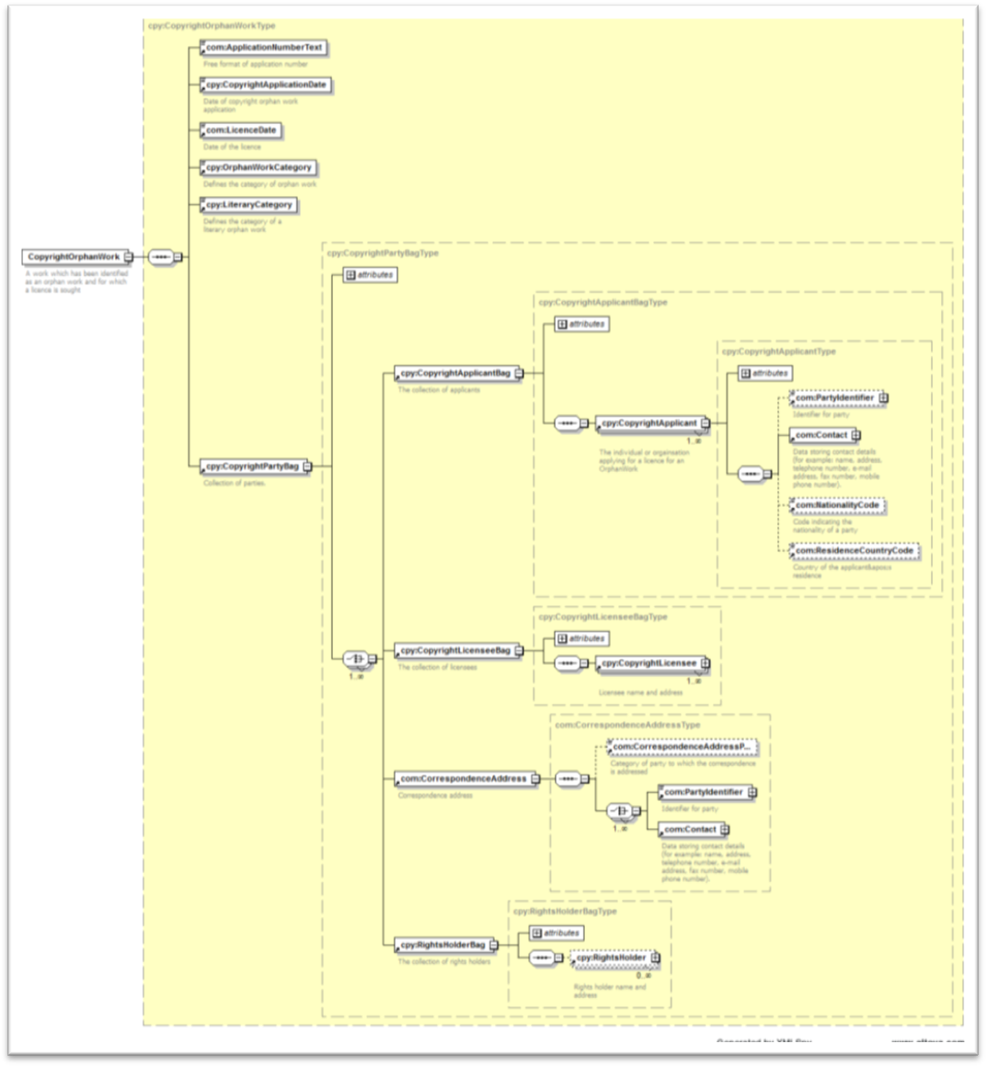
[End of Annex and of document]

http://www.legislation.gov.uk/ukpga/2013/24/contents

