PROPOSAL FOR ESTABLISHING AN INTERNATIONAL DATABASE TO STANDARDIZE APPLICANT NAMES
Document prepared by Saudi Authority for Intellectual Property (SAIP)

Proposal Brief
The Committee on WIPO Standards (CWS) is currently developing a WIPO standard to unify the format in which applicant names are stored in an effort to improve the quality of Intellectual Property (IP) information of Member States.
Therefore, the Saudi Authority of Intellectual Property (SAIP) is submitting a proposal to create a unified international database through which IP offices’ (IPOs) data will be stored in a unified format to generate a useful source of data that can enhance the efficiency and effectiveness of IP information search, analysis and utilization.

Current Situation
Currently, applicants can file directly at multiple IPOs. This might result in variation or differences in the applicant name used in each application form at their selected IPO depending on the applicant or agent used to file. Search difficulties and challenges might also occur as a result; affecting the credibility and accuracy of the results.
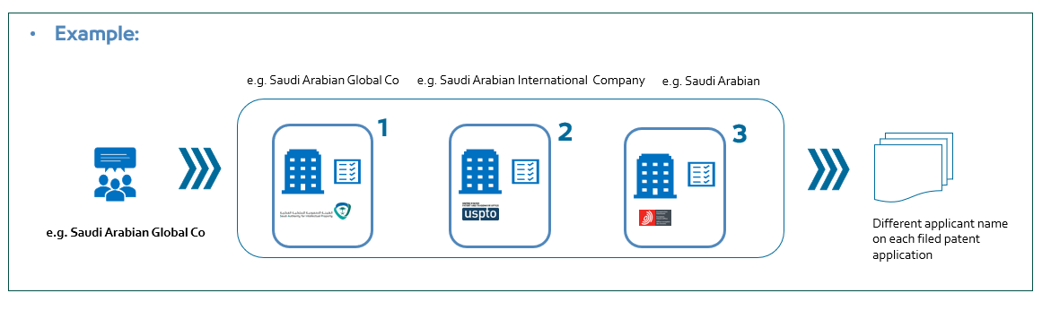

Proposed Situation
The proposed solution suggests that when filing an application for the first time, a unique identifier (ID) for the applicant will be created to ensure a globally standardized name without sharing application information to maintain and sustain application confidentiality. Any subsequent filing across different IPOs, at any time, for any application would allow applicants information to be retrieved from the global database.
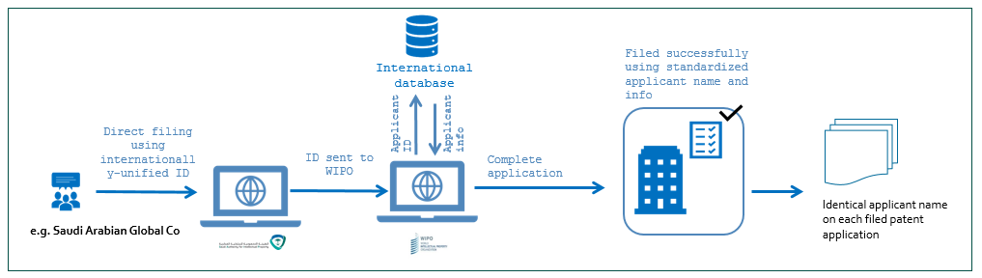

Applicants’ Journey

Execution Steps:
- Applicants file an application at any IPO;
- Applicants add their information to the filing form;
- Applicants information is stored in WIPO international database and an ID is generated; and
- In any future filing, at any IPO, applicants can enter their ID and their information will be retrieved automatically.
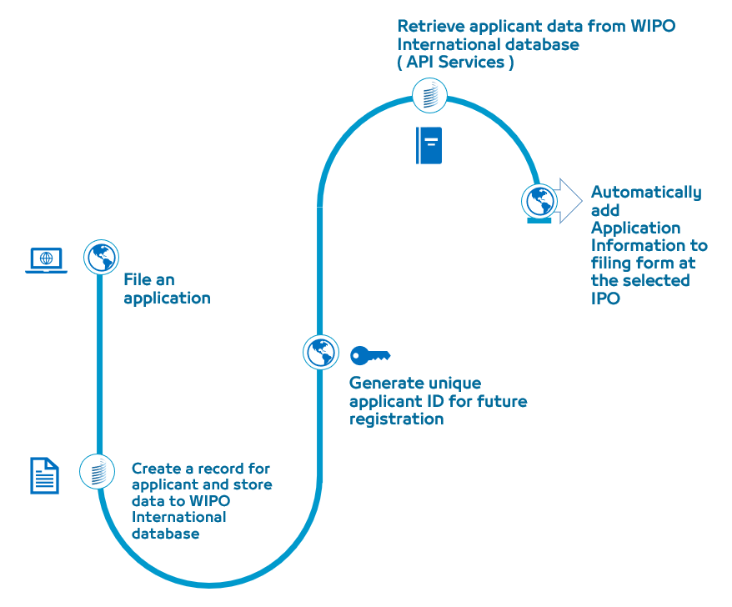

Value and Benefits
- Standardize applicant names across all IPOs;
- Effective and accurate utilization of IP information for studies, analytics and reporting;
- Enhance and speed up the registration process; and
- Improved IP information quality.

Similar Practice

ORCID:
The Open Researcher and Contributor ID (ORCID) is a global non-profit organization which aims at providing a unique, persistent identifier for individuals to use as they engage in research, scholarship, and innovation activities.

ORCID Features:
- A unique, persistent identifier free of charge to researchers;
- An ORCID record connected to the ORCID; and
- A set of Application Programming Interfaces (APIs), as well as the services and support of communities of practice that enable interoperability between an ORCID record and member organizations.
[End of Annex and of document]

