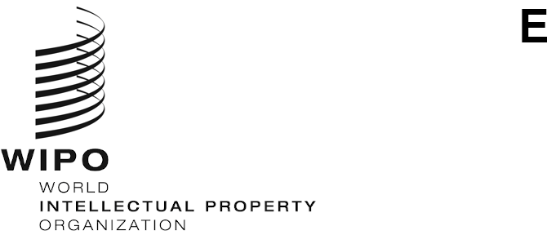
WIPO/CR/COVID-19/GE/22/1
ORIGINAL: EN
DATE: April 25, 2022

Information Session on the Impact of the Covid-19 Pandemic on the Copyright Ecosystem

Geneva, May 9, 2022

Program
prepared by the Secretariat

11.30 – 11.35 Opening of the Information Session

11.35 – 11.55 Overview on the Impact of the Covid-19 Pandemic on the Creative Industries

Speaker: Ms. Marilena Vecco, Professor in Entrepreneurship, Burgundy School of Business, France and Associated Professor, Carmelle and Rémi Marcoux Chair in Arts Management, HEC Montréal, Canada

11.55 – 12.30 Round Table Discussion

Moderator: Secretariat

Speakers:

Ms. Violeta Mansilla, Artist and Director, UV Estudios, Argentina

Mr. Dino D’Santiago, Musical Artist, Cabo Verde and Portugal

Mr. Dariusz Grzywaczewski, Junior Business Development Manager, CD Projekt Red, Poland

Ms. Sarah Migwi, Co-founder and Managing Director, Protel Studios, Nairobi, Kenya

Mr. Pranav Gupta, Managing Director, Prints Publications Pvt Ltd, India

12.30 – 13.00 Interactive Discussion

13.00 – 14.30 Lunch Break

14.30 – 14.50 Overview on Copyright-Related Impacts of the Covid-19 Pandemic on Educational, Research and Cultural Heritage Institutions and the People They Serve

Speakers:

Mr. Paul Vroonhof, Econometrician and Project Manager, Panteia, Netherlands

Mr. Martin Clarke, Researcher, Panteia, Netherlands

14.50 – 15.25 Round Table Discussion

Moderator: Secretariat

Speakers:

Ms. Inkyung Chang, Founding Director, Iron Museum, Republic of Korea

Ms. Nompumelelo Mohohlwane, Education Researcher and Deputy Director in the Research Coordination, Monitoring and Evaluation Directorate, National Department of Basic Education, South Africa

Mr. Ruel Ellis, Coordinator of the MSc. Project Management Program, West Indies University, Trinidad and Tobago

Mr. Hamad Al Mutairi, Director of Archives Department, National Archives, United Arab Emirates

Ms. Liisa Savolainen, Deputy Director, National Library, Finland

15.25 – 15.55 Interactive Discussion

15.55 – 16.00 Closing

Speaker: Ms. Sylvie Forbin, Deputy Director General, Copyright and Creative Industries Sector

[End of document]

