E
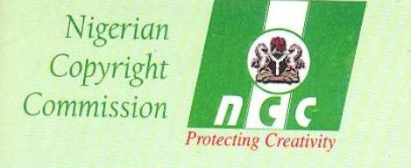
nigeriAN COPYRIGHT COMMISSION (NCC)
Federal Ministry of justice
GOVERNMENT OF NIGERIA

regional seminar
wipo/ap/cr/abu/10/1 Prov
OriGINAL: English
DATE: July 29, 2010
WIPO Regional Seminar for African Countries
on the Protection of Audiovisual Performances
Organized by
the World Intellectual Property Organization (WIPO) and
the Nigerian Copyright Commission (NCC),
Federal Ministry of Justice,
Government of Nigeria
Abuja, October 19 and 20, 2010
Provisional Program
Document prepared by the International Bureau of WIPO

Tuesday, October 19, 2010

13.30 – 14.30 Topic 1: Legal and Policy Considerations for the Protection of
Audiovisual Performances in Africa
Speaker:
14.30 – 17.00 Topic 2: Contracts, Collective Management and Social
Infrastructures: Improving the Protection of
Audiovisual Performers in Africa
Moderators:
Speakers:
17.00 – 17.30 Questions and Answers

Wednesday, October 20, 2010
Consultations Among Governments and Stakeholders
17.00 Closing Ceremony

[End of document]

