
SCCR/49/INF/1
ORIGINAL: English
DATE: October 15, 2026
Standing Committee on Copyright and Related Rights
Forty-Ninth Session
Geneva, November 30 to December 4, 2026
Roadmap for the implementation of Artist’s Resale Right in Africa
prepared by the Delegation of Morocco

E
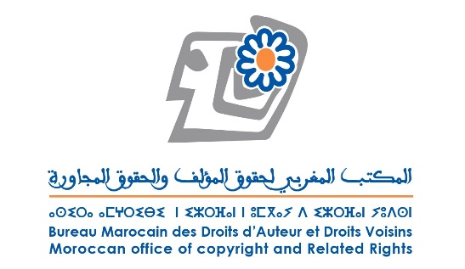 | 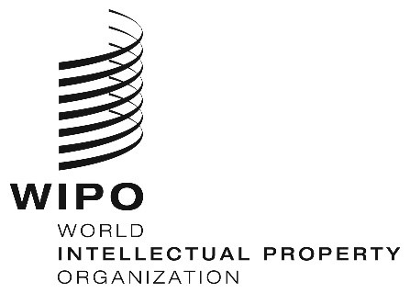

African Regional Conference on Artist's Resale Right

Rabat, Morocco, October 14 – 16, 2025

Roadmap for the implementation of Artist’s Resale Right in African Countries

Africa's cultural and creative landscape is at a decisive turning point in its history. Driven by a young and dynamic population, unparalleled cultural wealth and rapid digitization, the continent is experiencing an explosion of creative content in music, film, literature and the visual arts included in this roadmap. This dynamism represents a major economic opportunity, a powerful tool for employment, social cohesion and the assertion of a strong African voice on the world stage.

However, a persistent paradox threatens this momentum: the vast majority of African creators and right holders are unable to obtain fair and transparent remuneration for the exploitation of their works. The basic reason for this is the absence or fragility of the infrastructures needed to effectively administer, monitor and monetize copyright at national and international levels.

This roadmap is a response to this need for justice, transparency and economic development. The establishment of a robust, modern, and compatible infrastructure for rights management is no longer an option, but a prerequisite to:

- Ensure the traceability of works and the clear identification of right holders.
- Automate the collection and distribution of royalties efficiently and transparently.
- Give creators the means to make a living from their art and invest in new projects.
- Position Africa as a reliable and vital partner in the world's creative economy.

Artwork is a special asset.

It is hard to define what constitutes an artwork and it is even more difficult to appraise when it emerges from the artist's studio. Its price bears no relation to the cost of its creation.

Works of art are destined to be circulated. Their monetary value is determined when they first appear on the market, but this value will evolve over time and, for some of them, their price will increase from their first resale and subsequent resales, through art market professionals such as galleries and auction houses.

An artist's reputation begins to take root after their very first resale.

The resale right is an artist's right to remuneration for the resale of their creation on the market. In order to be enforced, an infrastructure that identifies the work, the artist, the transaction, and the professionals involved in the resale is required. The digital age, which has contributed to the dematerialization of the art market, makes the traceability of works essential. The implementation of resale rights contributes to this traceability.

It is with this in mind that Morocco, alongside WIPO, decided to organize a regional conference to promote the exchange of information and best practices with a view to effectively implement resale rights in Africa. The dynamism of African artists and their growing appeal worldwide means that the continent must equip itself with the means to enable artists to reap the rewards of their success.

During conference discussions, four stakeholder groups were identified as key players in the implementation of resale rights by African countries: (1) policymakers and regulators; (2) collective management organizations (CMOs); (3) art market professionals, galleries and auction houses (AMPs); and (4) artists.

The following roadmap summarizes the immediate steps that need to be taken by each stakeholder group. It is based on the findings of the WIPO Toolkit on Artist’s Resale Right, which was distributed to participants at the conference.

Steps to be taken by policymakers and regulators

- Ensure that laws and regulations properly address the following issues:

- Eligible works/excluded works.
- Eligible resales.
- Rights and obligations of AMPs to ensure a transparent art market.
- Accreditation and governance of CMOs: establish clear criteria for the designation, regulation and supervision of CMOs that manage resale rights.
- Supervision of CMO governance mechanisms by supervisory authorities.
- Specific authority for CMOs to request information on resales from AMPs.

- Create incentives to encourage AMPs to comply with resale right obligations.

- Participate in and support regional resale right initiatives.

Steps to be taken by Collective Management Organizations (CMOs):

- If necessary, amend the statutes of existing CMOs to include the graphic arts or, where appropriate, establish a dedicated CMO for such creations.

- Ensure the representation of visual artists in CMO governance bodies in accordance with the statutes of each CMO.

- Promote dialogue between all stakeholders within advisory committees.

- Enter into bilateral or multilateral representation agreements with sister societies at regional and international levels.

- Actively engage in the specialized working groups of the International Confederation of Societies of Authors and Composers (CISAC) and International Council of Creators of Graphic, Plastic and Photographic Arts (CIAGP) network to share best practices and leverage the experience of sister societies that manage resale rights.

- Adopt technological solutions that promote effective management of resale rights (WIPO Connect, already adopted by a number of African CMOs, is currently developing a solution dedicated to the management of resale rights).

- Adopt robust strategies and business plans for resale right management to overcome the obstacle of the initial costs associated with introducing this right into the CMO's activities. One option to consider could be to focus initially on the larger AMPs and then gradually cover the other AMPs as the CMO gains expertise.

- Establish transparent rules for the collection and distribution of resale right royalties.

- Provide ongoing training to their staff to keep pace with developments in the art market.

- Raise awareness among their members about their rights and how they are managed.

- Foster the exchange of information and mutual understanding with AMPs on the legal framework and purpose of resale rights in order to encourage their involvement in this process.

- Capacity building: support training initiatives on resale rights for law enforcement agencies, CMO staff, and AMPs. Regional and international partners (WIPO, CISAC, and, where applicable, ARIPO, OAPI) can provide support.

- Outreach efforts to raise awareness among artists and AMPs on the importance of resale rights.

Steps to be taken by Art Market Professionals (AMPs) :

- Comply with legal obligations concerning resale right payments.

- Maintain precise records of sales and transactions and provide timely reports to the responsible CMOs.

- Work in good faith with CMOs.

- If possible, find or set up umbrella organizations/professional associations to develop procedures that simplify the reporting of resales to CMOs.

- Keep records of exhibited artists and works and encourage their digitalization.

- Formalize transactions through written contracts and proper documentation.

- Adopt technological solutions that further the traceability of artwork.

- Encourage long-term partnerships with artists.

- Establish a code of ethics for the profession to ensure a relationship of trust between artists, collectors and AMPs.

- Use mediation and arbitration systems to settle any disputes.

- Promote the creation of AMP associations to pool their experiences to help develop this sector.

Steps to be taken by artists

- Ensure that their works are signed, numbered if part of a series, and properly documented.

- Implement methods of authenticating artwork in accordance with modern art market practices.

- Promote and develop the creation of artists' associations, as well as their umbrella groups or confederations, and encourage artists to join them in order to ensure better representation and protection of their rights.
All the steps outlined in this roadmap will help to establish a new virtuous ecosystem that encourages all stakeholders to work together, in accordance with international and regional treaties, applicable national law and internationally recognized best practices.
These recommendations and guidelines constitute an evolving and adaptable platform for action.

[End of document]

