
SCCR/47/INF/3
ORIGINAL: English
DATE: December 3, 2025
Standing Committee on Copyright and Related Rights
Forty-Seventh Session
Geneva, December 1 to 5, 2025
Information Session on Copyright and Generative Artificial Intelligence – Speaker Profiles
prepared by the Secretariat

Panel 1: Visibility and Transparency

Mr. Daniel Gervais, Milton R. Underwood Chair in Law, Vanderbilt University, Nashville


Daniel J. Gervais, PhD, is the Milton R. Underwood Chair in Law at Vanderbilt University Law School, where he serves as Director of the Vanderbilt Intellectual Property Program. He is also appointed as part-time Senior Associate Professor at the Vrije Universiteit Amsterdam. In 2022, he held the Distinguished Fulbright Chair at Carleton University in Ottawa. He is a Past President of the International Association for the Advancement of Teaching and Research in Intellectual Property (ATRIP). Prior to joining Vanderbilt, he was the Acting Dean of the Faculty of Law (Common Law Section) of the University of Ottawa. He has been visiting professor at several major universities in Europe and Asia. He is the author of a leading treatise on the WTO TRIPS Agreement (Sweet & Maxwell, 5th edition 2023), and a “sci-fi legal trilogy” titled the Coexistence Trilogy. The first volume Forever, was published in 2023. He also published books published by Cambridge University Press and Oxford University Press, among others. His research has been published in many of the world's leading law reviews, and other publications, including Science.

MS. ANNA VUOPALA, SENIOR MINISTERIAL ADVISER, MINISTRY OF EDUCATION AND CULTURE, HELSINKI

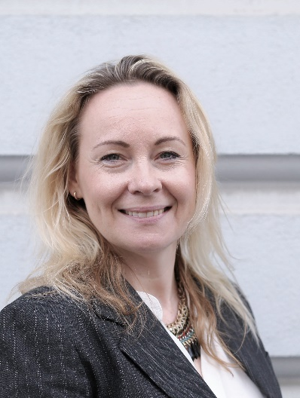
Anna Vuopala is a Senior Ministerial Adviser and vice Head of Unit in the Art and Cultural Policy Department of the Ministry of Education and Culture in Finland. Ms. Vuopala has a Master of Laws degree from the University of Helsinki and trained on the bench in 2000.
She has nearly 25 years of experience in developing and amending national, EU and international IP legislation, in particular copyright law and the EU AI Act and the big data legislations. She promotes the modernisation of the copyright infrastructure on EU level and leads the AI & copyright use cases of the Copyright Infrastructure Task Force (CITF).

MS. YUNYUN DIAO, VICE PRESIDENT, LEGAL DEPARTMENT, TENCENT BEIJING BRANCH, BEIJING

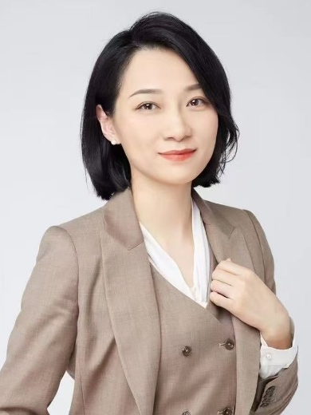
Diao Yunyun, Vice President of Legal at Tencent Group, holds a Doctor of Laws degree and serves as Vice Chairman of the China Copyright Association, Deputy Director-General of the Cyber and Information Law Research Society of the China Law Society, and Practical Supervisor for Juris Master students at Peking University Law School. She is also an Adjunct Supervisor at the Juris Master College of China University of Political Science and Law, a Researcher at the Intellectual Property Innovation and Competition Research Center of China University of Political Science and Law, and a Researcher at the Zhongguancun Intellectual Property Strategy Institute. Additionally, she chairs the Internet Platform Professional Committee of the Beijing Intellectual Property Judicial Protection Research Society and serves as Deputy Director of the Performance and Brokerage Law Professional Committee of the Beijing Film, Television and Entertainment Law Society. She is an arbitrator at the Hainan International Arbitration Court. With nearly two decades of professional experience in IP law practice, she previously served in the IP divisions of the Haidian District Court and the IP Tribunal of Beijing First Intermediate Court. She has published multiple academic articles in journals such as Law Science Magazine, China Publishing Journal, and Intellectual Property.

MS. JEWEL GREENE, AUTHOR AND CEO, CARIBBEAN BOOK MARKETING HUB, TOBAGO

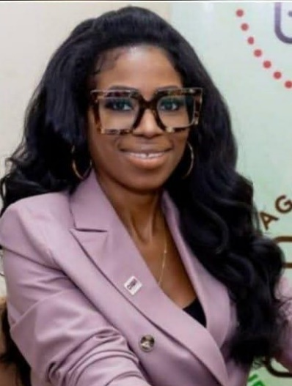
Jewel R. Greene is a reporter, published writer, strategic communications professional, gender equity advocate, and certified digital marketing specialist with over a decade of leadership in civic engagement, media, publishing, and public policy. Holding a Bachelor of Science in Psychology with Management, Digital Marketing Specialist and Certified Co-Op Professional accreditation, Jewel brings a rare combination of data-driven insight and community-centered vision to her work.
As Chair of the Caribbean Women in Leadership (CIWiL) Trinidad and Tobago Chapter, Jewel launched and hosted Meet the Candidates: Women Voters Matter, in the lead-up to Trinidad and Tobago’s 2025 general elections, a powerful platform that boosted voter awareness ahead of national polls and influenced political discourse on women’s leadership. Jewel has twice represented women in policy at the Tobago House of Assembly’s International Women’s Day Mock Plenary (2024, 2025), where she contributed to forward-looking legislative debates. She is recognized across the Tobago and beyond for championing inclusive participatory governance and for her commitment to building spaces that encourage women and youth to step into leadership roles.
As President of the Trinidad and Tobago Writers Guild, Jewel leads initiatives such as the upcoming Keeping Literary Traditions Alive series of writing workshops during the Tobago Heritage Festival, that empower creatives within the post-COVID Orange Economy, and broader economic recovery promoting literary and cultural entrepreneurship as a core national and regional component.
As She-E-O of Caribbean Book Marketing Hub TT, Jewel has launched initiatives such as Book Club Corner TT (television interview program for literary creatives) and Book Marketing for AuthorPreneurs Workshop that educates and empowers literary creatives and members of the publishing and book industry. Jewel’s advocacy and leadership continue to make a lasting impact in political education, digital media strategy, the literary arts and women’s empowerment throughout the Caribbean.

MS. XENIA MANNING, DIRECTOR, GLOBAL MUSIC POLICY, SPOTIFY, WASHINGTON


Xenia Manning serves as Director of Global Music Policy at Spotify, responsible for setting the company’s position on legislative and policy proposals involving copyright, AI, culture and media regulation across the 184 markets where the service is currently available. Based in Washington D.C., she also represents Spotify on the board of DIMA, the Digital Media Association.
Prior to joining Spotify, Xenia worked on various IP and international trade matters for the recorded music industry (IFPI), brand owners (INTA), and as a lawyer at Covington LLP. She holds law degrees from Oxford and Harvard, and works in English, Spanish, Polish and French.

MR. GEOFF TAYLOR, EXECUTIVE VICE-PRESIDENT FOR ARTIFICIAL INTELLIGENCE, SONY MUSIC ENTERTAINMENT, LONDON


In June 2023, Geoff Taylor was appointed the Executive Vice President for Artificial Intelligence at Sony Music Entertainment with responsibility for aligning and helping coordinate the work of every part of the global business that touches AI.
Taylor brings decades of music industry experience to the business. From 2007 to 2022, he was the Chief Executive Officer of the BPI, the UK Trade Body for recorded music, where he advocated for the strategic value of the music industry, highlighting the importance of recorded music to jobs, investment and maintaining the UK’s global competitiveness as well as led the fight against music piracy and fraud. During his
tenure, he also expanded the reach, size and influence of the BRIT Awards. Prior to joining the BPI, Taylor was General Counsel and Executive Vice-President at global recorded music trade body, the IFPI from 2005-2007.

MR. ADAM BRIGGS, ARTIST, Victoria

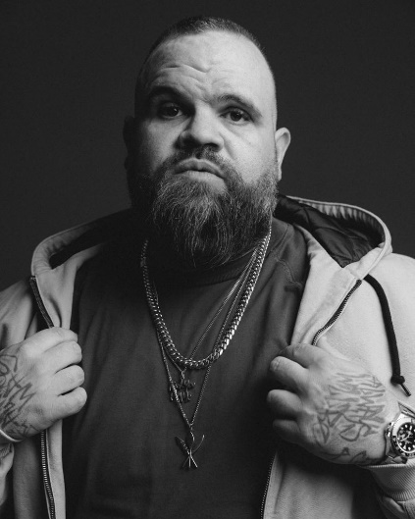
Briggs is a proud Yorta Yorta man and one of Australia’s most dynamic creative figures — a rapper, lyricist, hip-hop artist, writer, presenter, author, and actor.
He first rose to prominence as a solo rapper before co-founding the acclaimed hip-hop duo A.B. Original in 2016. On stage, Briggs has supported international icons such as 50 Cent, Ice Cube, Ice-T, and KRS-One, and collaborated with Australian legends including Hilltop Hoods, Midnight Oil, Paul Kelly, and Henry Rollins. A.B. Original’s debut album Reclaim Australia earned widespread critical acclaim, winning the 2017 ARIA Awards for Best Independent Release and Best Urban Album, as well as Triple J’s J Award for Album of the Year. In 2018,
the duo was named APRA Songwriters of the Year. After a four-year hiatus, they returned in 2022 with the powerful single ‘King Billy Cokebottle’, touring nationally with Hilltop Hoods.

Briggs has also carved out a prolific career beyond music. He was a writer on the Netflix animated series Disenchantment (from the creators of The Simpsons and Futurama) and wrote and performed in all three seasons of the hit sketch comedy Black Comedy. His acting credits include roles in Cleverman, The Other Guy, Get Krack!n, and recurring appearances on The Weekly and The Yearly with Charlie Pickering. More recently, he voiced Adam in season 7 of Netflix’s Big Mouth, starred as Alex Bermuda in Boy Swallows Universe, and played Chief in the film adaptation of How To Make Gravy.

A passionate advocate for First Nations representation, Briggs is the founder and chair of the Adam Briggs Foundation — a First Nations-led charity dedicated to developing skills and increasing visibility for Indigenous Australians in the creative industries.
In 2020, Briggs released his debut children’s book Our Home, Our Heartbeat, a celebration of culture, identity, and resilience. Earlier, in 2017, he was named GQ Agenda Setter of the Year, recognising his influence across culture and community.

Panel 2: Licensing and Remuneration

Ms. Birgitta Sander Hjortsø, Chief Legal Advisor, Legal and Copyright, Ministry of Culture of Denmark, Copenhagen

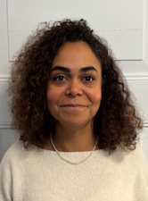
Ms. Birgitta Sander Hjortsø serves as a Senior Legal Adviser at the Danish Ministry of Culture. In this role, she oversees legislative quality assurance to ensure alignment with national and EU legal standards across the Ministry. She is responsible for the Ministry’s policy coordination on copyright and intellectual property in WIPO. She holds a Bachelor and Master of Laws from the University of Copenhagen.
Previously, she served in various senior advisory roles in the Ministry of Industry, Business and Financial Affairs in the areas of EU and international affairs. She has coordinated Denmark’s policy positions across the EU Single Market, the digital economy, intellectual property, maritime affairs, and trade
She has also contributed to multilateral work on industrial property, sustainability, and responsible business conduct. Ms. Sander Hjortsø has extensive experience negotiating in EU, OECD, UN, IMO, and WIPO settings. She directed several EU Presidencies (2012–2013) in the area of export credits, delivering coherent and impactful policy outcomes.

Mr. Caue Oliveira Fanha, Director for Regulation on Copyright, Secretariat for Copyright and Intellectual Property Rights, Ministry of Culture, Brasilia

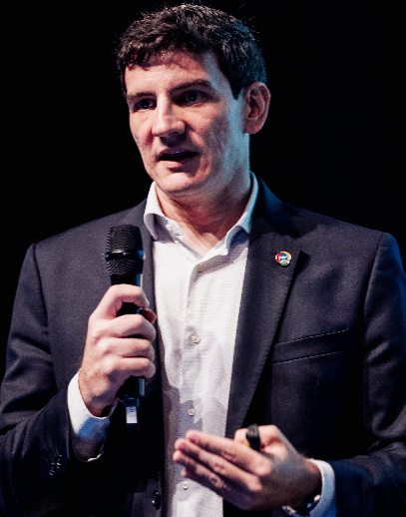
Is the Director of Copyright Regulation at the Ministry of Culture. He served as a Delegate for intellectual property at the Mission of Brazil to the WTO, in Geneva, and was previously deputy head of the Intellectual Property Division at the Ministry of Foreign Affairs. Joined the diplomatic career in 2009.

Ms. Carmen Paez, Undersecretary for Culture, Ministry of Culture of Spain, Madrid


Carmen Páez (Madrid, 1983) holds a degree in Law and Business Administration and Management (E3 Program) from the Pontifical University of Comillas (ICADE) and has been a member of the Senior Corps of Civil Administrators of the State since 2012. She began her professional career in the public sector at the Ministry of Education, Culture, and Sport, where she was Deputy Assistant Director of Intellectual Property and Advisory Member in the field of intellectual property rights management entities. In 2016, she took up the position of Deputy Assistant Director of International Relations and Immigration at the Ministry of the Interior, later becoming Head of the Support Unit of the Directorate General for International
Relations in the same department. In 2019, she returned to the Ministry of Culture and Sport, where she held the positions of Deputy Director General for International Cooperation and Promotion of Culture and Deputy Director General for the Promotion of Cultural Industries. From October 2022, she served as Secretary General of the EOI Foundation of the Ministry of Industry, Trade, and Tourism until her appointment as Director General of Cultural Industries, Intellectual Property, and Cooperation on April 18, 2023.
She has taught various courses and given lectures on intellectual property, international relations, and administrative law at various institutions, including the National Institute of Public Administration. She was awarded the White Cross of the Order of Police Merit in 2018. On February 27, 2024, she was appointed Undersecretary of Culture.

Ms. Do-young Kim, Director, Cultural Trade and Cooperation Division, Ministry of Culture and Tourism, Sejong, Seoul


Ms. Do Young KIM is Director of Cultural Trade and Cooperation Division, Copyright Bureau of the Ministry of Culture, Sports and Tourism (MCST). In this role, she supervises and coordinates MCST’s international affairs concerning copyright as well as overall cross-border trade issues under the authority of the Ministry.
Ms. Kim joined the Civil Service in 2000 as an Audit and Inspection Officer of the Board of Audit and Inspection (BAI). In 2006, she joined MCST as Assistant Director for Cultural Technology and Human Resource Development Division and has spent nearly two decades in government roles in culture,
arts, media and tourism policy including as Director for Publication Industry Division and Director for Urban & Metropolitan Policy Division. Prior to being appointed to her current position in January 2025, Ms. Kim served as Director for Arts Policy for two years. She is the recipient of the Prime Minister’s Award for Distinguished Civilian Service of 2015.
Ms. Kim received her B.A. in Political Science from Korea University, Seoul, Korea and received her Master of Science Degree in Tourism Administration from the University of Guelph, Canada. She is native in Korean and professional in English.

Mr. Dan Neely, CEO, Vermillio, Chicago


Dan Neely is the Co-Founder and CEO of Vermillio, an AI licensing and protection platform with the mission to empower humanity to thrive in the era of Generative AI, and one of TIME’s 100 Most Influential Companies for 2025. Providing cutting-edge protection and control, Vermillio’s TraceID, enables studios, record labels and creators to take advantage of the benefits of Generative AI in a safe and secure environment while attributing where their valuable data is being used. In 2024, Dan and Vermillio announced a first-of-its-kind partnership with talent agency WME to protect clients from IP theft and give them the opportunity to monetize their image and likeness by securely licensing their data. Dan was also recently
named one of TIME's 100 Most Influential People in AI and one of Observer's 100 Leaders Shaping the Future of AI.

A serial entrepreneur and investor, Dan has been building Artificial Intelligence software platforms for the last two decades. He previously founded and served as CEO of Networked Insights, a machine learning software company that was backed by Goldman Sachs. Dan has spent the better part of the last two decades building companies that use technology to disrupt the status quo. Additionally, Dan is on a number of technology company boards and is a member of the board of the non-profit After School Matters. Dan and his family are based in Chicago.

Ms. Isabella Splendore, Head, Legal and International Affairs, Italian Federation of Newspaper Publishers, Rome

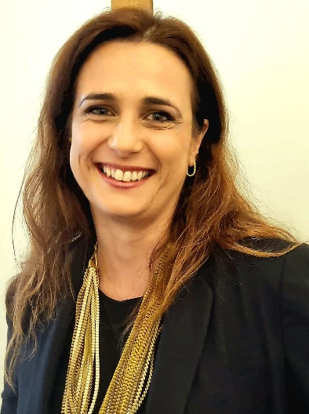
A Lawyer, specialized in Information and Technology Law, Isabella Splendore is the legal adviser to the FIEG management and to the Italian press publishing companies. She coordinates publishing policies at the national and international levels, and represents Italian publishers before European Institutions and International Associations. She also manages the activities of the Repertorio Promopress, for the collection of copyright in press reviews and for the actions against online copyright infringement and digital piracy phenomena. In following, in particular, national and European trends in the regulation of the activities of the so-called Over The Top, she has managed the relationships between them
and the FIEG companies by signing collaboration agreements - the first of their kind - aimed at promoting an innovative approach for the Italian press in the digital age.
In 2011 she was selected as the Italian representative to the Eisenhower Fellowships Multi Nation Program: an exclusive seven-week program for professional development and leadership, funded by the Eisenhower Fellowships (EF), a non-profit, non-partisan organization based in Philadelphia.

Mr. Robbert Baruch, SVP Public Affairs, Universal Music Group, Amsterdam


Robbert Baruch is Senior Vice President Public Affairs – Europe and Multilateral Relations at Universal Music Group. He leads UMG’s government relations across Europe, including the European Union, and oversees the company’s engagement with major global organizations such as the UN, G7/G20, WEF, UNESCO and WIPO. He directs UMG’s policy strategy on competition, copyright, artificial intelligence, cultural diversity, and the role of the creative economy in sustainable development, representing the company at the highest political levels in Brussels, across European capitals, and internationally at UN institutions and global multilateral forums. Before joining UMG, Robbert held senior public-affairs roles at Buma/Stemra
and the National Association of Insurers and previously served as Deputy Mayor of the Rotterdam borough of Feijenoord. He holds degrees in Political Science, also studied Public Administration and Religious Studies. He is based in The Hague. In his spare time, he travels Europe on his BMW R1200 GSA LQ.

[End of document]

