|  |  |  |  |
| --- | --- | --- | --- |
|  | WIPO-E | **E** | |
| **SCCR/43/6 PROV** | | |
| **ORIGINAL: English** | | |
| **DATE: March 14, 2023** | | |

**Standing Committee on Copyright and Related Rights**

**Forty-Third Session**

Information Session ON THE MUSIC STREAMING MARKET

Geneva, March 16, 2023

SPEAKER PROFILES (PROVISIONAL)

*prepared by the Secretariat*

**Speaker Profiles**

**Opening**

**Speakers:**

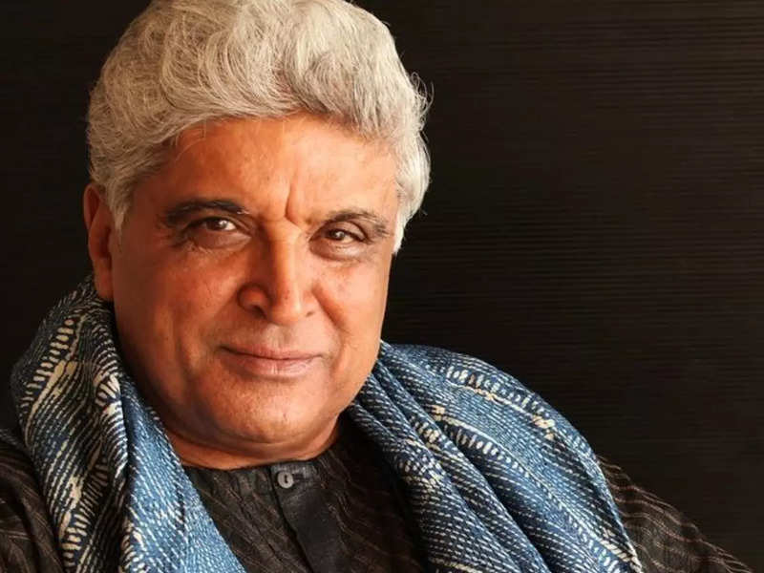

**Javed Akhtar**

**Script Writer, Lyricist, Poet and Activist, India**

Son of well-known Urdu poet and film lyricist Jan Nisar Akhtar and Safia Akhtar, who was a professor of English Literature and a writer, Javed Akhtar belongs to a family lineage that can be traced back to seven generations of writers.

Javed Akhtar was nominated to Rajya Sabha (Upper House) as a Member of Parliament by the President of India in 2010. He is the architect of the Copyright Amendment Bill passed by both Houses of Indian Parliament after a long struggle in 2012. It has given copyright royalties to lyricists and music composers. Javed Akhtar has been the Chairman of IPRS, the government recognized Copyright Society of India, since 2017.

He was also the Vice–President of the International Confederation of Societies of Authors and Composers (CISAC), and the first Asian to be on the Governing Board of CISAC.

It is another proof of his communication skills that Javed Akhtar has presented many extremely successful solo programs on TV in which he speaks directly to the camera for almost 45 minutes. Tata Sky has dedicated a channel exclusively to him on which his pre-recorded talks are telecast explaining traditional dohas and modern poetry. This program has been telecast 24/7 for the last seven years.



**Rosana Arbelo**

**Artist, Spain**

Talented and award-winning Spanish singer/songwriter Rosana Arbelo got involved in music after getting her first guitar at the age of five and composing her first song three years later. The artist's passion for music grew in her student years at a local Catholic school, and she later moved to Madrid to study music. Before going out on her own, Arbelo composed songs for local celebrities such as Joaquín Sabina, Miguel Rios, and María Dolores Pradera. She released her solo debut album, Lunas Rotas, in 1996, using only her first name. The album produced the singles "El Talisman" and "Sin Miedo," which climbed the Spanish charts. That same year, Rosana achieved two Onda Awards for Best Album and Revelation of the Year. In addition, "El Talisman" and "Lunas Rotas" were chosen by director Quentin Tarantino for the soundtrack to his movie Curled. In 1998, Rosana's Luna Nueva was released. The next three years saw her writing material for other artists, but in 2001 she returned with her much-anticipated eponymous third outing, which utilized the complex rhythms of her Canary Islands birthplace as its foundation. Marca Registrada, a double-disc LP consisting of 12 of her greatest hits, ten brand new songs, and a pair of videos, were released in 2003. With her fourth studio long-player, Magia, Rosana introducing a more muscular, pop/rock-oriented sound, a style she continued to explore on 2011's 8 Lunas. In 2016, Rosana released the deeply personal En la Memoria de la Pel, which coincided with her 20th anniversary as a recording artist.



**Yvonne Chaka Chaka**

**Artist and Vice-President, CISAC, South Africa**

Yvonne Chaka Chaka has been at the forefront of South African popular music since 1985, becoming known as the “Princess of Africa”. Having shared the stage with creators including Angélique Kidjo, Annie Lennox, Bono, Queen, Miriam Makeba and Youssou N’Dour, Yvonne Chaka Chaka has also performed for Queen Elizabeth II, US President Bill Clinton, South African President Thabo Mbeki and a host of other world leaders.

She has become a champion for the Global Fund to Fight AIDS, TB and Malaria, the United Nations MDG Envoy for Africa, and the Goodwill Ambassador for the Roll Back Malaria Partnership. Nelson Mandela chose her as the first ambassador for his children’s fund. She has also established her own charity, the Princess of Africa Foundation.



**Pierre-Yves Dermagne**

**Minister of Economy and Employment, Belgium**

Pierre-Yves Dermagne holds a Law degree from the Catholic University of Louvain and has been Deputy Prime Minister and Minister of the Economy and Labor since October 1, 2020 and Mayor of Rochefort since December 3, 2018 (in title since September 13, 2019).



**Françoise Remarck**

**Minister of Culture and Francophonie, Côte d’Ivoire**

Françoise Remarck is a graduate of the Abidjan Business School (ESCA) and of the Executive MBA and HEC Paris, she has more than 35 years of experience both on a continental and international level, having held management positions in prestigious groups operating in the media and distribution sectors. Françoise Remarck began her professional career in 1986 in Paris with Ernst & Young. A few years later in 1992, she decided to return to her country and contributed to the creation of the Canal+ subsidiary in Côte d'Ivoire. In eighteen years, she climbed all the ranks from Finance Director to Chairman and CEO of the company.

In 2010, she was appointed Director of Communications and Institutional Relations within the Canal+ Africa Group in France. She participates in the implementation of its strategic development plan on the Continent. Françoise Remarck joins the Franco-Japanese Group CFAO (Corporation For Africa & Overseas) as Vice President in charge of Institutional Relations and Communication, for which she would manage, among other things, the implementation of major projects in Africa.

Françoise Remarck chose to return to Côte d'Ivoire and was appointed Chairman of the Board of Directors of two subsidiaries of the Canal+ Group.

She has been a member of several Boards of Directors in the banking, insurance, and services sectors as well as a member of the Investment Committee of a fund dedicated to SMEs.

Françoise Remarck was Vice President of the Ivorian Patronat.

She also puts her experience to the benefit of young people by relying on her national and international network for quality accompaniment around various projects, with a strong societal impact on the Continent.

Françoise Remarck is Commander of the National Order of Côte d'Ivoire, Commander of the Order of Communication of Côte d'Ivoire, and Commander of the Order of the Cultural Merit.

In view of her career, her various commitments, and her leadership, Françoise Remarck, has been for some years, very often cited among the most influential personalities in Côte d'Ivoire and in Africa. On January 8, she was named one of the 100 inspiring women of the continent, in the 21st century.

**Konrad von Löhneysen**

**Founder and CEO, Embassy of Music, Germany**

Embassy of Music GmbH is an independent music label based in Berlin that has been in existence since 2001. Originally operating under the name "Ministry of Sound Germany GmbH", the company changed its name in 2008 following a management buyout. Founded and managed by Konrad von Löhneysen (formerly COO Logic Records in the U.S., U.K. and Germany, MD Jive Germany, MD Universal Records), Embassy manages both a German and international roster of artists, including Calvin Harris, David Guetta, Passenger, Bob Sinclar, Kid Cudi, Eric Prydz, Oceana, CrazyFrog , Carla Bruni, Simply Red, Mousse T, Moby, Robyn, Asgeir, Madness, Simple Minds and Nena, as well as local artists such as Leslie Clio, Madeline Juno, Kay One and Ali As.

**Panel 1 – Licensing Practices for Music Streaming Services**

**Speakers:**

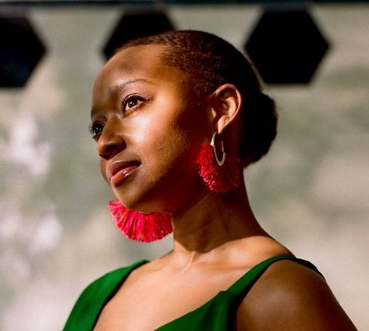

**Reni Adadevoh**

**Senior Vice-President Legal and Business Affairs, Warner Music International, United States of America**

Reni Adadevoh is Senior Vice President, Legal and Business Affairs at Warner Music International, based in London. She began her career in the music industry in 2011 when she joined Warner Music Group (WMG) in New York, following several years of practice as a derivatives lawyer at Shearman & Sterling LLP.

During Adadevoh’s time in New York, she took the leading legal role in working with the Strategy and Business Development team to structure and negotiate WMG’s global digital content licensing deals with partners such as Spotify and Tidal. In 2015, she moved to London and joined WMG’s international legal team. In addition to her work on global deals, she now focuses on digital content licensing in emerging markets, collaborating with regional business development teams to create new strategies informed by local laws and practices.

Since 2020, Adadevoh has served as the co-lead of The Link ­— WMG’s employee resource group for people of colour in the U.K. She also has served on the company’s UK Diversity Council, which is tasked with ensuring that Warner Music UK meets its diversity, equity, and inclusion goals.

In 2022, Adadevoh joined the board of Music Minds Matter, a charity set up and sustained by Help Musicians (also known as the Musicians Benevolent Fund), to support the mental health of individuals working in the UK music industry.

Adadevoh holds a Juris Doctor from Harvard Law School and Bachelor of Arts from Yale University.

Having spent a significant portion of her childhood playing the violin and the piano, her main engagement with music now is through dance.



**Antony Bebawi**

**President, Global Digital, Sony Music Publishing, United Kingdom/Egypt**

Antony Bebawi is President, Global Digital at Sony Music Publishing and is based in London. He started his career in music publishing when he joined EMI Music Publishing in September 2005 to head up its UK legal and business affairs team having previously been a partner at leading London media and entertainment law firm, Harbottle and Lewis LLP. During his time at EMI, he was responsible for implementing a restructuring of the music publisher’s digital rights to help launch the first successful publisher-led, Pan-European digital licensing initiative outside of the traditional collection society network. The model became and remains the industry solution for licensing digital music services in Europe. Bebawi was European General Counsel when EMI Music Publishing was acquired in 2007 by Sony Music Publishing which he joined as EVP, Digital and Society Relations, International and UK to continue his focus on the rapidly developing digital market. He was promoted to his current role in 2020 and he now leads Sony Music Publishing’s dedicated digital licensing team based in the US and the UK as well as working closely with Sony Music Publishing’s national and regional business units to help develop local and regional digital licensing solutions.

Bebawi is a member of the Members’ Council and Board of the UK performing rights organisation, PRS for Music.

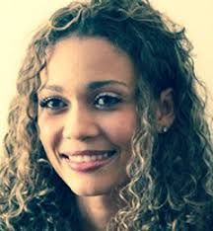

**Solange Cesarovna**

**Artist and President, Sociedade Cabo-Verdiana de Música (SCM), Cabo Verde**

Solange Cesarovna, President of the Cabo Verdean Music Society (SCM) is a singer and songwriter considered by critics as the Queen of Morna of the 21st Century. A humanitarian woman as well as an ambassador of peace and copyright in the world with a unique and unusual voice, Solange has been able to take her country’s culture to the world.

In June 2013, Solange participated in the creation of SCM along with several Cabo Verdean authors, composers, musicians, interpreters, editors, producers and musicologists. SCM is the collective management organisation that defends authors’ rights and related rights. It was created with the goal of giving back to the country and represents all those in the music sector through collection and distribution of royalties owed for the use of works and musical recordings in Cabo Verde.

Solange was elected in 2013 and re-elected in 2018 as SCM President. She has facilitated significant changes within the Cabo Verdean copyright landscape. Under her presidency, SCM joined the International Confederation of Societies of Authors and Composers (CISAC) in 2017.

In January 2019, Solange was elected as a Permanent Observer of CIAM’s Executive Committee.



**Bill McGoey**

**Global Music Strategy & Business Development, TikTok / ByteDance, United Kingdom**

Bill McGoey is a member of TikTok's Global Music Strategy & Business Development team, based in London. He joined the company in August 2021, working across TikTok's global music products and initiatives, with a particular focus on strategic planning efforts, recorded music and publishing content acquisition and partnerships, market/industry research and investments.

Prior to TikTok, Bill spent just under 5 years at Warner Music Group as a Director on the Digital Strategy & Business Development team in New York City, and previously spent time at ESPN and Credit Suisse, where he started his career in investment banking. He earned his BS degree from Georgetown University in Washington, DC, where he studied Finance, Economics and Government.



**Annie Morin**

**Executive Director, Artisti, Canada**

Annie Morin started her career as a lawyer. In 1998, she joined the *Union des artistes*(UDA), first as legal counsel and then, as Head of Legal Affairs. In 2006, she joined Artisti, a Canadian collective management organization for performers, where she holds the position of Executive Director.

Since 2006, Annie Morin has been on the Board of Directors of *ReSound* where she also served as Chair of the Board from 2013 to 2015. She also held that position with the *Canadian Private Copying Collective* (CPCC) from 2007 to 2011. She has been on the Board of *Les Cahiers de propriété intellectuelle* since 2012. Having been its President from 2016 to 2021, she has also been on the Board of Directors of the Canadian section of the *Association littéraire et artistique internationale* (*ALAI*) since 2016. At the same time, she has been a member of the Executive Committee of this international association since 2016.

In 2020, she was named to the Board of MetaMusic and elected to the Board of *SCAPR*, a global organization that represents collective management organizations administering performers’ rights.



**Guillermo Ocampo**

**Director General, Sociedad Argentina de Autores y Compositores de Música (SADAIC), Argentina**

Guillermo Ocampo has been practicing law since 1975. He has held several positions in the Argentinian government such as: Cabinet Advisor to the Legal and Technical Secretariat of the Presidency of the Argentine Nation, Chief of Staff of the Minister of Justice, President of the Legal and Technical Secretariat, Minister of Justice.

He is the Director General of the Sociedad Argentina de Autores y Compositores de Música (SADAIC), as well as the President of Latinautor, a federation of Spanish and Latin American collective management organizations, which has its headquarters in the city of Montevideo.

Ocampo is a member of the Board of Directors of the International Confederation of Societies of Authors and Composers (CISAC).



**Regan Smith**

**Head of Public Policy, Government Affairs, Spotify, United States of America**

Regan Smith is Head of Public Policy in Spotify’s government affairs group, where she engages on global policy development and advocacy related to intellectual property, music, artificial intelligence, broadcasting, algorithmic regulation, cultural policies, and related issues. She is also a Professorial Lecturer in Law at the George Washington University Law School.

Previously, Ms. Smith was General Counsel and Associate Register of Copyrights at the U.S. Copyright Office. As general counsel during a particularly active period, she oversaw an extensive portfolio of regulatory, litigation, legislative, and policy matters, including spearheading the agency’s multi-year leadership on the Music Modernization Act to effectuate the most significant update to U.S. copyright law in four decades. During her tenure, she also helped formulate the government's views in every copyright litigation to reach the Supreme Court and multiple circuits, updated rules governing the administration of copyright formalities, and overhauled the agency’s policy approach to digital rights management regulation.

Ms. Smith received her JD from Harvard Law School, and a BA from the University of Michigan. Prior to attending law school, Ms. Smith was an executive at an entertainment company that produced feature film, live theatrical, and related properties.



**Qihu Yang**

**General Counsel and Head of Music Institute, Tencent, China**

Mr. Qihu Yang is Vice President (General Counsel) of Tencent Music Entertainment Group (TME), which is the music branch of Tencent Group of China; Vice Chairman of the Digital Music Working Committee of the China Audiovisual and Digital Publishing Association, Vice Chairman of the China Digital Copyright Industry Alliance, Tutor in the Intellectual Property Law (Copyright) Seminar of the China University of Political Science and Law, and Master of Law of Peking University.

Mr. Yang joined Tencent Group in 2011 and served as the director of the litigation center of the Group's Legal Department. He set up the Tencent Group Rights Protection Center as the director, responsible for IPR protection of all content products of Tencent Group, including video, games, music, literature, news, etc.

Mr. Yang joined Tencent Music Entertainment Group in 2017. Currently he is responsible for general legal affairs, antitrust and government affairs of the Group.

**Panel 2 – Licensing Practices for Music Streaming Services**

**Speakers:**



**Kwee Tiang Ang**

**Senior Vice President of Asia Public Policy, Universal Music Group, Hong Kong**

KT Ang is the Senior Vice President of Asia Public Policy for Universal Music Group. In this role, KT is tasked to lead the conversation to help create and sustain a robust and effective copyright framework for a sustainable ecosystem for artists, creators and industry across all markets throughout the region.

With over 30 years of copyright industry experience throughout Asia, KT has been intimately involved in the development of copyright public policy, including the enactments of copyright laws, their enforcement, anti-piracy efforts and the establishment of more than a dozen copyright collection societies for creators, publishers and producers in the region.

Prior to his Universal Music appointment in January 2019, KT was the Asia Pacific Regional Director for IFPI, where he coordinated IFPI’s priorities across the region, leading legal policy, government affairs and anti-piracy actions.

Before that, he had served as the Asia Pacific Regional Director of CISAC for over 2 decades, where he had helped to create, revitalize and/or develop most of the authors/publishers copyright collective management organizations in the region. During this time, he also worked with IFRRO and developed the work plan that led to the creation of CLASS Ltd.

KT Ang has a first degree in law from the National University of Singapore, a Master of Laws and a Postgraduate Diploma in UK, US and EU Copyright Laws from King’s College, University of London.

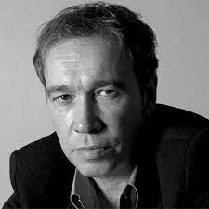

**Nacho García Vega**

**Artist, Performer and President, International Artist Organisation (IAO), Spain**

Nacho García Vega is a musician, composer, producer and founder member of the pop band Nacha Pop, among other groups. He has recorded and produced over twenty albums and participated in numerous projects related to the Spanish music scene.

He is currently a member of the Board of AIE, and General Coordinator of CoArtis.

In February 2017 Nacho was elected President of the International Artist Organisation (IAO) based in Paris.



**Daniel Johansson**

**Researcher and Senior Lecturer, Inland Norway University of Applied Science, Sweden**

Daniel Johansson has a background in computer science and economics. He started out as an artist in the 1990s. From 2002 - 2007 he was a part of running the largest music festival in Sweden, the Hultsfred festival. During 2005 - 2010 he did his PhD studies in computer science, with a focus on how digital distribution of music was changing information models in the music industry. Since 2008 he has been writing analyses and news for the Swedish music industry at www.musikindustrin.se, the official news agency financed by IFPI and The Music Publishers Association. For many years he did research on the music industry at the Linnaeus University, and at the moment he is a researcher and senior lecturer at The Inland Norway University of Applied Science, as well as being a frequent consultancy collaborator with labels, PROs, publishers, performers, and other stakeholders in the music industry.

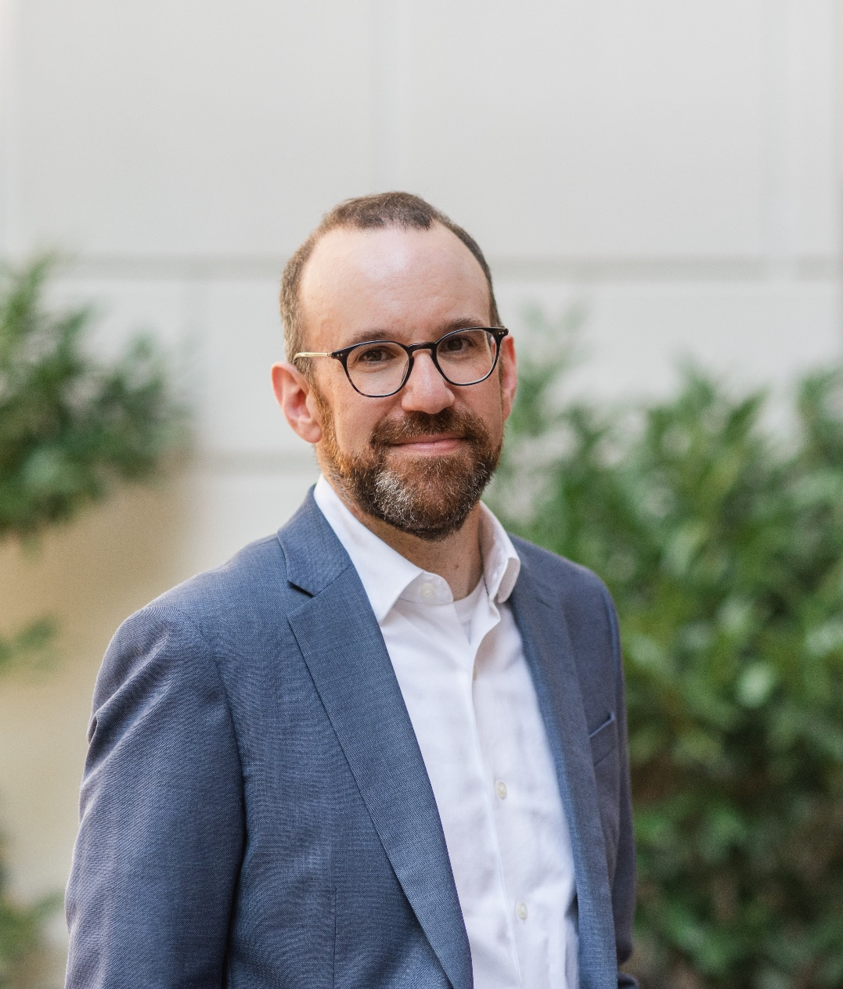

**Garrett Levin**

**President and Chief Executive Officer, Digital Media Association (DiMA), United States of America**

Garrett Levin is the President and Chief Executive Officer of the Digital Media Association (DiMA) - the leading organization advocating for the digital music innovations that have revolutionized the way music fans and artists connect.

Garrett’s deep experience at the center of music licensing issues, pragmatic political savvy and commitment to consensus building has earned him a reputation as one of the most trusted policy voices in the music industry today. As part of his work at DiMA, Garrett serves as the representative of the digital music services on the Board of the Mechanical Licensing Collective and as a member of the Advisory Board to WIPO for Creators. He also sits on the National Recording Preservation Board at the Library of Congress.

Prior to DiMA, Garrett was Senior Vice President and Deputy General Counsel at the National Association of Broadcasters (NAB), where he led on all copyright-related issues. He previously served as senior counsel to Senate Judiciary Committee Ranking Member Patrick Leahy, as a copyright policy attorney at the U.S. Patent & Trademark Office, and as a litigator specializing in digital copyright issues. Before law school, Garrett edited award-winning documentaries, including The Three Pickers and the Peabody Award-winning The Rise and Fall of Jim Crow.

Garrett graduated with a B.F.A. in Film and Television Production from New York University. He holds a J.D., magna cum laude, from Duke University School of Law, and an M.A. in Cultural Anthropology from Duke.



**Helienne Lindvall**

**President, European Composer and Songwriter Alliance (ECSA), Sweden**

Helienne Lindvall is an award-winning professional songwriter, musician, and columnist. She's the former Chair of the Songwriter Committee and Ivor Novello Awards & Board Director of the Ivors Academy, as well as Trustee of the Ivors Academy Trust. She’s also the writer behind the Guardian music industry columns - '*Behind the Music'* and '*Plugged In',*and the former Head of Business & Songwriter relations for song data management platform Auddly/Sessions, backed by hitmakers Max Martin and Abba’s Björn Ulvaeus.

Hailing from Sweden, she worked as a session singer, recording artist, and performer in Stockholm and NYC before settling in London, where she signed a publishing deal with BMG Scandinavia and, later, Universal Music Publishing Scandinavia. Since then she’s been working with recording artists on both sides of the Atlantic.

Helienne Lindvall was elected to the position of ECSA President in February 2022.



**Will Page**

**Author of *Pivot*, Fellow of London School of Economics, United Kingdom**

Will Page is the author of the critically acclaimed book *Tarzan Economics*, now translated into five languages and released in paperback as *Pivot* in January 2023. As the former Chief Economist of Spotify and PRS for Music, he pioneered Rockonomics. At PRS he published work on Radiohead’s *In Rainbows* and saved BBC 6Music. At Spotify he uncovered the anatomy of a hit and articulated the global value of music copyright. A passionate communicator, Will is a regular contributor to the *Financial Times*, *Billboard* and *The Economist*. Will's first break into music was penning articles for *Straight no Chaser* magazine, and his DJ sets continue to top the global charts on MixCloud. He co-presents the Bubble Trouble podcast and is a fellow at the London School of Economics, Edinburgh Futures Institute and the Royal Society of the Arts.



**Enrique Zayas**

**Artist member of the group Paiko and Secretary of the Board of Directors, Entidad de Artistas Intérpretes y Ejecutantes of Paraguay (AIE Paraguay), Paraguay**

Enrique Zayas Urbieta is one of the four founders of the legendary Paraguayan Latin Rock group, Paiko. After the release of their first album in 2000, they toured more than 50 cities, taking their energetic and modern show, which combines Latin American tradition and rock and rolls style, around the world, including USA, Germany, Spain, Brazil, Argentina, Mexico, and Russia. Undoubtedly, Paiko, with their nine albums, two DVDs, and a series of singles, has been a powerful influencer of the Paraguayan scene from 2000 until today and is considered one of the most representative iconic bands of Paraguay.

In 2004, together with other important artists of long trajectory, he participated in the foundation of the collective management organization Entidad de Artistas, Intérpretes y Ejecutantes (AIE-Paraguay). He was also involved in innumerable campaigns in defense of copyright and related rights throughout the country and the region. Currently he has been re-elected as the Secretary of the Board of Directors for the period 2021 – 2025.