E
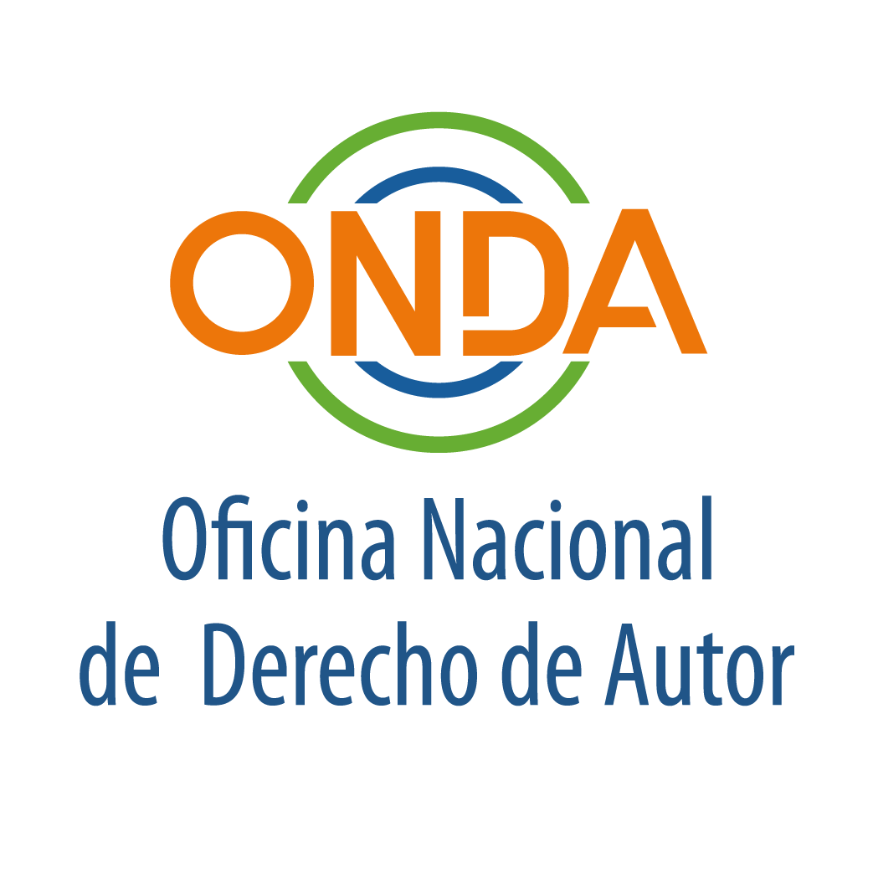
regional seminar
OMPI/DA/SDO/19/INF 1 PROV.
ORIGINAL: sPANISH
date: July 3, 2019

REGIONAL SEMINAR FOR THE LATIN AMERICAN AND CARIBBEAN GROUP ON LIBRARIES, ARCHIVES, MUSEUMS, AND EDUCATIONAL AND RESEARCH INSTITUTIONS IN THE FIELD OF COPYRIGHT

organized by
the World Intellectual Property Organization (WIPO)

and
the Oficina Nacional de Derecho de Autor (ONDA)

Santo Domingo, July 4 and 5, 2019

PROVISIONAL PROGRAM

prepared by the International Bureau of WIPO

Thursday, July 4, 2019

OPENING CEREMONY

08.30 – 09.00 Registration

09.00 – 09.30 Welcome addresses by:

Ms. Sylvie Forbin, Deputy Director General, WIPO Copyright and Creative Industries Sector

Mr. Trajano Santana, Director, National Copyright Office (ONDA)

09.30 – 10.00 Coffee Break

PLENARY

10.00 – 12.00 Setting the Scene

In this part of the program, facilitators/speakers that have prepared the various WIPO studies and typologies on limitations and exceptions will introduce the background of the Seminar based on their findings and focused on the specificities of the Member States of the Latin America and Caribbean Group.

Moderator: Ms. Sylvie Forbin

Facilitators/
Speakers: Mr. Kenneth Crews
Mr. David Sutton
Mr. Yaniv Benhamou
Ms. Raquel Xalabarder

12.00 – 12.30 Group photo

12.30 – 14.00 Lunch Break

FOUR PARALLEL WORKING GROUPS

13.30 – 15.30 Challenges and Opportunities

In this part of the program, participants will be divided in four groups so as to hold discussions and identify the challenges and opportunities in their region regarding the various limitations and exceptions at stake.

Each group will have its own Chair and Rapporteur.

Facilitators/speakers will assist participants in their group discussions.

Observers (Member States from other regions as well as IGOs and NGOs, through their representatives with relevant experience on libraries, archives, museums, or educational and research institutions) will be able to take part in the discussions.

15.30 – 16.00 Coffee Break

16.00 – 18.00 Challenges and Opportunities (cont’d)

Participants will continue their discussions.

20.00 Reception offered by WIPO

Friday, July 5, 2019

FOUR PARALLEL WORKING GROUPS (cont’d)

09.00 – 10.00 Challenges and Opportunities (cont’d)

Participants will continue their discussions.

10.00 – 10.30 Coffee Break

10.30 – 12.00 Wrap-up and Preparation of Reports

In this final exercise of the working groups, participants will prepare their findings, observations and proposals through their Chairs and Rapporteurs.

12.00 – 14.00 Lunch Break

PLENARY

14.00 – 16.00 Presentation of Reports and Proposals by Groups

- Participants will be invited to present in thematic order their findings, observations and proposals as the outcome of their respective group discussions.

Moderator: Ms. Sylvie Forbin

Spokespersons: Chairs and Rapporteurs, together with Member States from the
Latin America and Caribbean Group

- General discussions with all Member States and observers. Facilitators/speakers will provide their views and advice.

Moderator: Ms. Sylvie Forbin

Facilitators/
Speakers: Mr. Kenneth Crews
Mr. David Sutton
Mr. Yaniv Benhamou
Ms. Raquel Xalabarder

16.00 – 17.30 Coffee Break

17.30 – 18.00 WAY FORWARD: Final Remarks

Ms. Sylvie Forbin

Mr. Trajano Santana

18.30 Social event organized by ONDA

[End of document]

