Japan Patent Office

1. Design Classification under Japanese Design Registration System
Our country’s design registration system adopts Japanese own “Japanese Design Classification (hereinafter, referred to as JDC)” as a major design classification. However, with regard to emphasizing international cooperation, the International Classification for Industrial Designs under Locarno Agreement (hereinafter, referred to as Locarno International Classification) has been described in the Design Gazette as reference information along with the JDC since April 1998. In addition, a comparison table for the Locarno International Classification 8th edition and the JDC is published on Japan Patent Office’s homepage to provide to users.
The Locarno International Classification enables design information such as the Design Gazette to be shared internationally, which may be considered quite useful. Nonetheless we use the “JDC” because the Locarno International Classification has limited classification options and a large number of documents cannot be sorted, which is not better suited for a search tool for examination such as novelty’s. Therefore, we created our own design classification based on trends toward fields of design registration applied to our country.
For example, we receive about forty thousand applications for design registration every year and examine all of these applications for novelty and the like. In the prior design search which examiners conduct before examinations, those examiners search as many as about 7 million documents stored in the database (foreign design gazettes, and designs collected through magazines, catalogues and internet, in addition to the Design Gazette). In order to execute examination processes swiftly and accurately as our nation’s users require for the design system while searching a large number of documents like these, the number of documents to be searched needs to be sorted by using detailed design classifications.
Also, in Japan, there are many cases that applicant himself/herself conducts a prior design search before he/she applies design registration. By assigning detailed classifications in those applications, documents to be searched can be stringently selected.

2. Items Concerned Necessary for Examination such as Novelty’s
Characteristics of the design classification which are concerned as necessary for examination such as Novelty’s in Japan are explained by taking the JDC as an example. The characteristics mean making a plurality of assignments possible, having tree-structured classification, and defining all classifications.

2.1 A plurality of assignments
If a subclass is newly set up for design according to shape/form/configuration or pattern, we suggest that one design could have multiple classifications, because designs having the same characteristics can be efficiently extracted.
The JDC consists of “classification” and “D-term”. By assigning both the “classification” based on functions and the “D-term” based on forms at the same time, designs having the same functions can be efficiently extracted.
Specific configurations of the “classification” and the “D-term” are as follows;
The “classification” is basically configured based on functions. One “classification” is assigned to one application for design registration or one publicly-known design document. In contrast, the D-term is developed based on forms under several “classifications” having characteristics in forms. The D-term is always assigned in parallel with the classification, and there is no case that only the D-term is assigned to one application for design registration. The number of D-terms that can be assigned in parallel with the classification is not limited to one. Up to seven D-terms may be assigned.

[Example of a Plurality of Assignments]
Extraction can be done based on a common point of having armrests

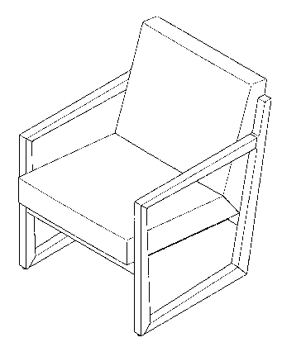
D7-22 Chairs
D7-22DA Frame Leg Type
D7-22H with Armrests

（D1333867）

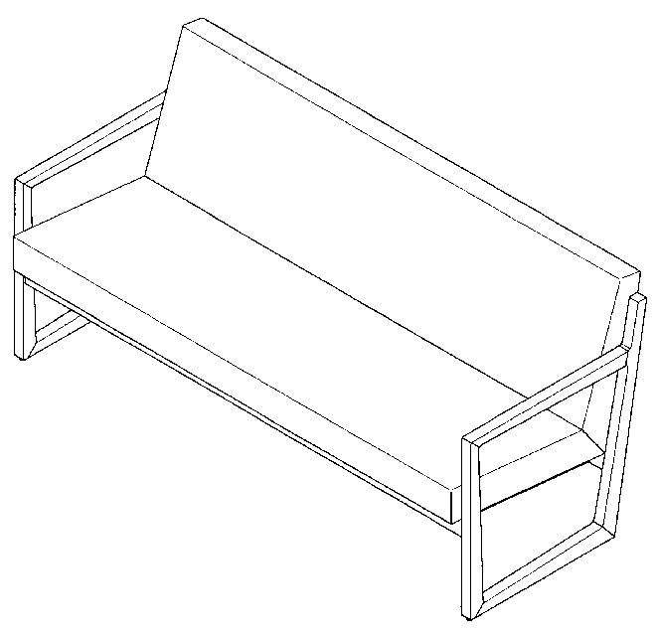
D7-24 Sofa
D7-24CD Cushion Seat Type
D7-24EB Rectangular/Non-Separated Seats Type
D7-24H with Armrests

（D1334436）

In addition, the “classification” has 3,193 options. Of those, 527 options have the D-terms. A total of 1,843 options of D-terms exist, and 527 “classifications” having the D-terms have 3.5 D-term options in average.

[Comparison between the JDC and the Locarno International Classification]
Japan Design Classification |  |  | Locarno International Classification (8th edition)
Item |  | Number | Item | Number
Classification | Group | 13 | Class | 32
Classification | Main Class | 77 | Class | 32
Classification | Minor Class | 3,193 | Subclass | 223
D-term |  | 1,843 | － | －
Name of articles placed  on the JDC list |  | 8,829 | Display of Articles | 6,831

2.2 Tree Structure
“Tree structure” enables wider deployment based on functions and forms of articles.
In order to fulfill detailed deployment, the “classification” of the JDC has a “tree structure” consisting of groups, main classes and minor classes (5-digits).
The D-term is deployed under several “classifications” having characteristics in forms and expressed by up to three digits of alphabet letters at the last in the minor class.
D 7 - 22
Group Major Minor
Class Class

[Example of tree structure]
GROUP D Housing Equipment

D0 Various Housing Equipment which do not belong to D3 to D9
D3 Flashing and Lighting Equipment
D4 Heating and Cooling Equipment, Air Conditioners and Ventilators .
D5 Kitchen Equipment and Sanitation
D6 Put-In-Order Furniture and Equipment
D7 Furniture

D7－10 Tables, Desks, Counters or the like

D7－200 Seats, Chairs or the like
D7－201 Legless Chairs
D7－202 Chairs for Sitting Straight
D7－203 Seats used as Fences
D7－204 Set of Chairs
D7－21 Chairs, Footstools
D7－22 Chairs
D7－23 Bench
D7－24 Sofa
D7－250 Seats for Special Use
D7－251 Child Seats or the like
D7－252 Barber and Hairdressing Chairs and Seats, Medical Chairs and Seats
D7－253 Vehicle Seats, Vehicle Chairs or the like
D7－254 Bathroom Seats, Bathroom Chairs
D7－290 Parts and Accessories for Seat and Chair

D7－300 Beds or the like
D7－40 Screens and Paper Screens or the like
D7－50 Mirrors, Dressers

2.3 Definition of Classification
Definition of Locarno International Classification should be unified in all countries adopting the definition. There will be no point in adopting the same classification symbols if its definition varies in each country.

In the JDC, all “classifications” and D-terms of 5,036 options are defined. Those definitions are described in documents called “Document card of Classification Definition.” The document cards of classification definition are created by using Microsoft Corporation’s Microsoft Word for each “classification” and “D-term.” A design examiner can rewrite anything other than nature of definitions anytime, as required.

The document cards of classification definition include additional information such as designs included in other classifications, in addition to its definition, because rich additional information helps to assign classification efficiently.
For example, a definition card for B7-42 (Hand mirrors) shows the definition of “A small mirror with handle for make-up and the like by directly having the mirror in one’s hand”, along with addition information of “A mirror having a stand for always mounting the mirror on a desktop is classified to D7-50.”

The document cards of classification definition which are converted to PDF are placed on the Japan Patent Office homepage in order to share information with applicants. The document cards of classification definition in Microsoft Word file are updated as needed by examiners, while the document cards of classification definition in PDF published on the homepage are updated only once a year. Updating several times a year by switching from PDF to any other format in the near future has been under consideration.

(Sample) | JDC Symbol |  |  | JDC Title
B7-42 |  |  | Hand Mirror

 | Referential Classification/Referential Article
Classification Symbol |  |  |  | Title of Classification or Title of Article
D7-50C |  |  |  | Dressers or the like/Table Mirrors Type
 | Article(s) included in this classification
Hand Mirrors
 |  |  | Definition
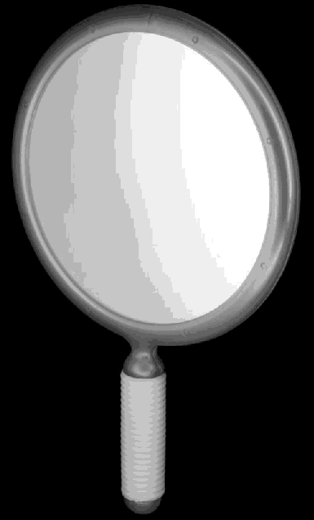
A small mirror with handle for make-up and the like by directly having the mirror in one’s hand
B7-42
Registration
1113953
Hand Mirror
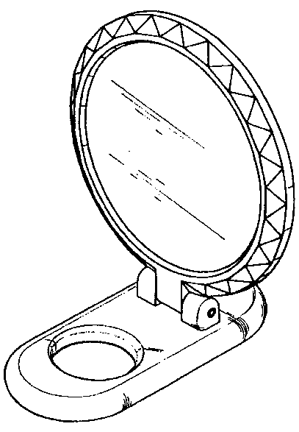
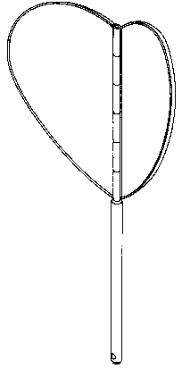
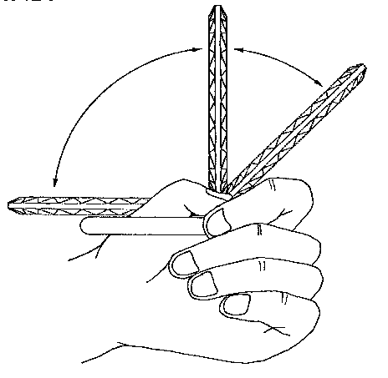
B7-42
Registration 11175534
Hand Mirror
B7-42
Registration1112654
Hand Mirror
Relations with other design classification (Excluded Articles and Designs)
A mirror having a stand for always mounting the mirror on a desktop is classified to D7-50 (Dressers or the like/Table Mirrors Type).
 |  | Memorandum for classification assignment processes (Assignment priority related matters and the like)
 | Titles of articles which were classified in the past

