ANNEX 1

All examples in LOC class 6

Chair
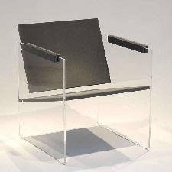

WA, XA, YB, YE

Chair
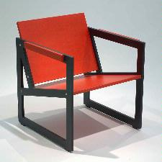

WA, XA, YC

Carpet
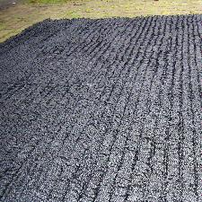

WA, XB, YB

Umbrella stands
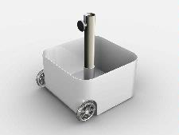 WA, XA, YB,

Shape & Ornamentation in the same category ?

Towels
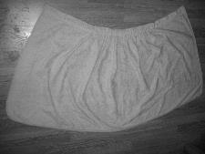

WA, XF, YA-YB

Towels
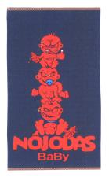

WA, XF, YC + WE, WI (?)

Towels

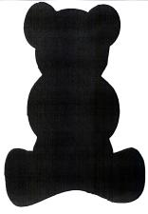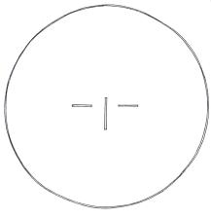

What happens if the animal/plant/human etc form is the shape of the design and what when it is just the ornamentation of the design?

Cabinet
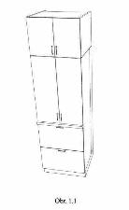

WA, XA, YA-YB -- better B/W instead of not specified colour ?

Shelves
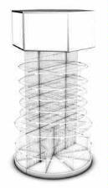WB, XA, YE

Table linen
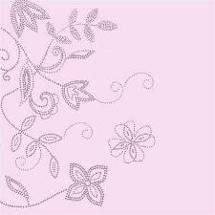

WA, WC, XF, YC

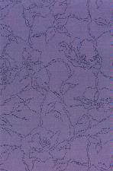

WC, XF, YB

Cupboards
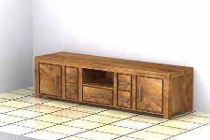

WA, XA, YB

Blankets
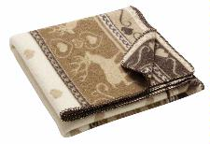

WA, WD, XF, YD

Seat
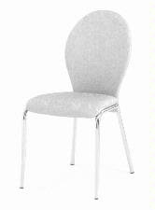

WB, XA, YA, YB

Cupboard

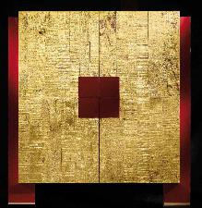

WA, Surface: wooden, YC

Bar stool

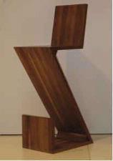
WA, XA, Wooden, YB

Bench seat

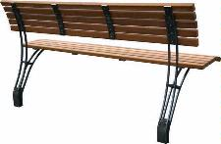

WA, XC, YC

Shaped to the body

Baby’s chair
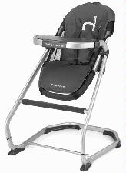
WB, XA, XE

Seat
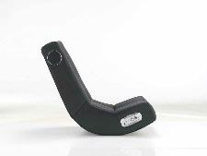
WB, XE, YA, YB

Part of furniture
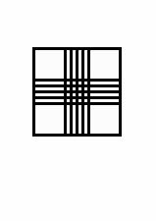
WA, XA, YA

Racks
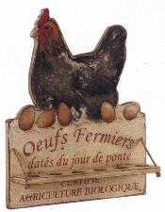

WA, WD, WI, YD

Photo frame
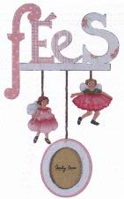

WE, WI, XC, YD
Armchair, sofa
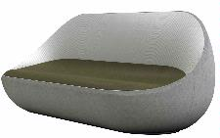

WB, XA, XF, YC

Clothes racks
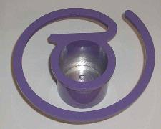

WB, XC, YB, YE

Sofas

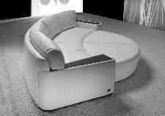
WB, XF, YB

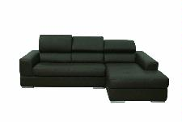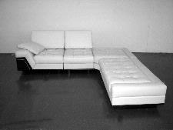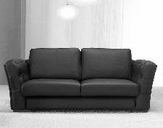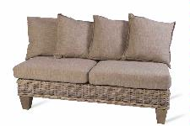
WA, XF, YB

Armchair
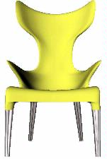

WB, XA, XE, YC

Commodes
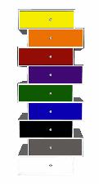 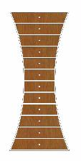WB, XD, YB
WA, XD, YD

