COMMON CATEGORIES

SHAPE AND/OR ORNAMENTATION

SURFACE

COLOUR

W THE CATEGORY OF SHAPE AND/OR ORNAMENTATION

The categories should apply solely to shape, solely to ornamentation or both. The option is selected by ticking the proper window or windows

□ applied to shape
□ applied to ornamentation

WA Rectilinear (2D and 3D geometric shapes - triangle, square, rectangle, cuboid, spire, cube, shapes composed of straight lines and symmetrical at least about one central-line)

WB Curvilinear (2D and 3D geometric shapes - circle, ellipse, semicircle, sector of circle, drop or heart shape, cylinder, cone, ball/sphere, their segments, and other round symmetrical shapes at least about one central-line)

WC Plants and plant like forms (including parts of plants)

WD Animals and animal like forms

WE Humans and human like forms / Non-humanoid beings

WF Heads / Faces (including individual parts of heads/faces, both human & animal)

WG Limbs (both human & animal)

WH Other body parts (both human & animal)

WI Letters / Numbers / Typographic symbols

WJ Celestial bodies / Natural phenomena / Landscapes

WK Heraldry / Coins / Emblems
X THE CATEGORY OF SURFACE

XA Smooth

XB Textured

XC Nets / Holes / Grille / Perforation / Windowed

XD Buttons / Switches / Knobs / Keys / Illuminating indicators

XE Shaped to the body (in sense of ergonomics or harmonization of
the design with the needs of human body)

XF Textile / Leather / Hair / Unwoven

Y THE CATEGORY OF COLOUR

YA Not specified

YB 1 colour

YC 2 colours

YD More than 2 colours

YE Transparent

YF Spots / Blots / Stripes / Chequered

NOTE: all designs represented by black and white drawings or photographs should be classified YA – colour not specified. Where, however, black and white photographs or drawings show clearly that a design comprises two or more colours (though not specified), it should be classified both in YA and in the relevant category YC or YD.

NOTE: The examples of designs may apply to more than one category.
The scheme is not finite and it may be further modified or new categories may be created.
COMMON CATEGORIES WITH EXAMPLE DESIGNS

W THE CATEGORY OF SHAPE AND/OR ORNAMENTATION

WA Rectilinear (2D and 3D geometric shapes - triangle, square, rectangle, cuboid, spire, cube, shapes composed of straight lines and symmetrical at least about one central-line)
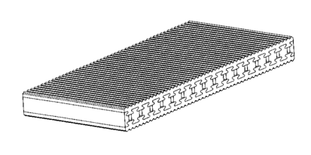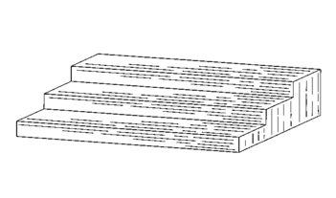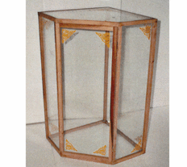

WB Curvilinear (2D and 3D geometric shapes - circle, ellipse, semicircle, sector of circle, drop or heart shape, cylinder, cone, ball/sphere, their segments, and other round symmetrical shapes at least about one central-line)
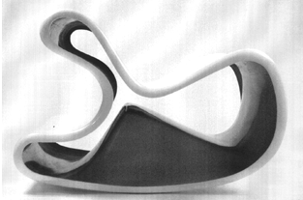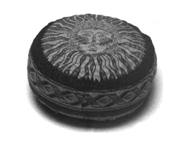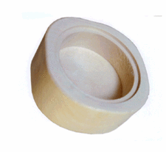

WC Plants and plant like forms (including parts of plants)
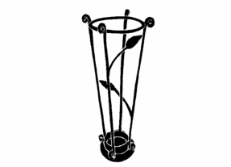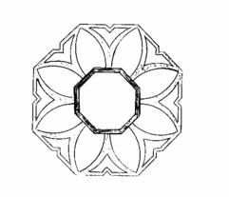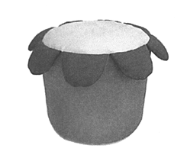

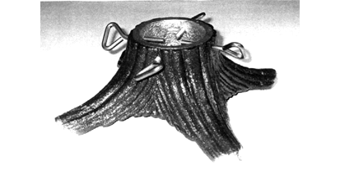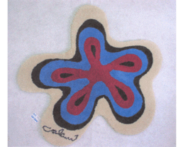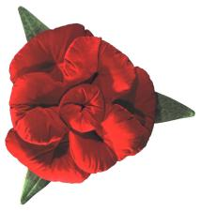

WD Animals and animal like forms

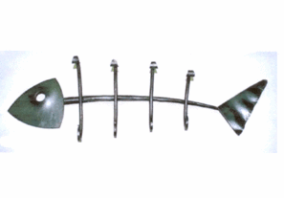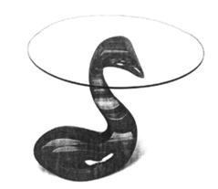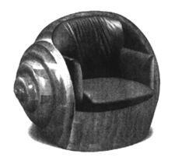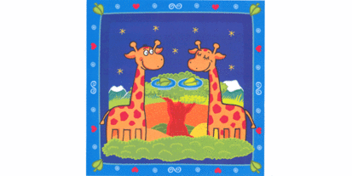

WE Humans and human like forms / Non-humanoid beings

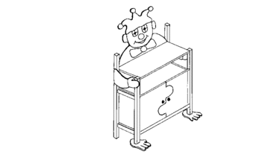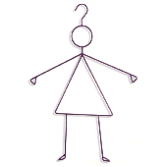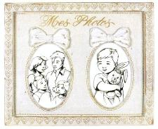

WF Heads / Faces (including individual parts of heads/faces, both human & animal)
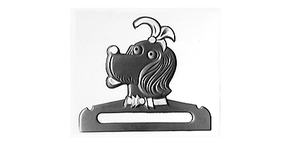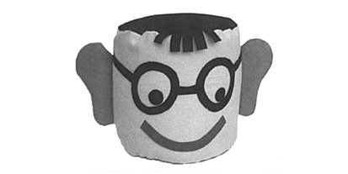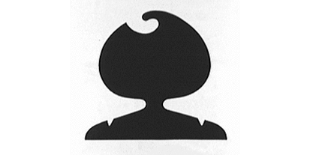
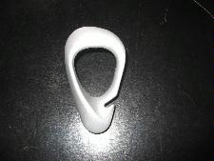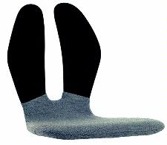

WG Limbs (both human & animal)

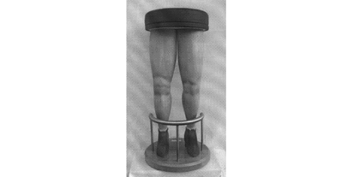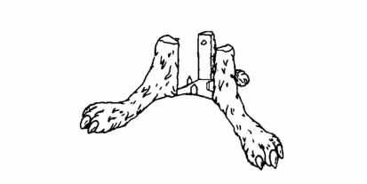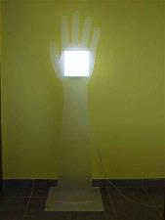

WH Other body parts (both human & animal)

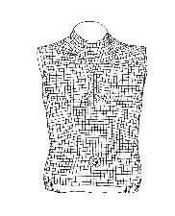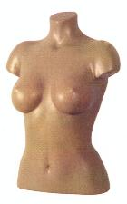

WI Letters / Numbers / Typographic symbols

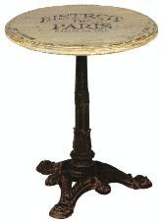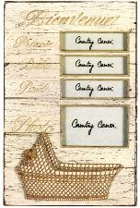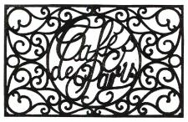

WJ Celestial bodies / Natural phenomena / Landscapes

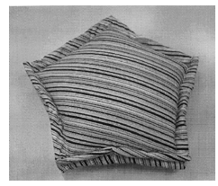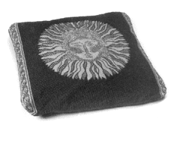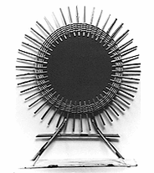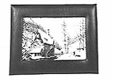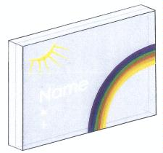

WK Heraldry / Coins / Emblems

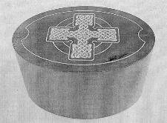

The categories should apply solely to shape, solely to ornamentation or both. The option is selected by ticking the proper window or windows

□ applied to shape
□ applied to ornamentation

X THE CATEGORY OF SURFACE

XA Smooth

XB Textured

XC Nets / Holes / Grille / Perforation / Windowed

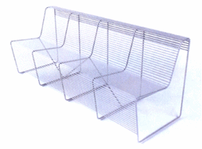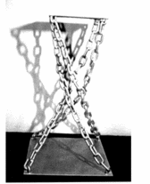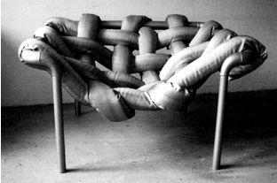

XD Buttons / Switches / Knobs / Keys / Illuminating indicators



XE Shaped to the body (in sense of ergonomics or harmonization of
the design with the needs of human body)

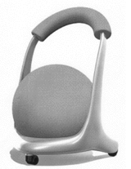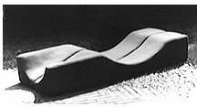

XF Textile / Leather / Hair / Unwoven

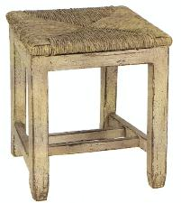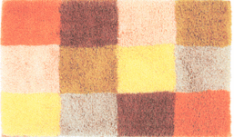

Y THE CATEGORY OF COLOUR

YA Not specified

NOTE: all designs represented by black and white drawings or photographs should be classified YA – colour not specified. Where, however, black and white photographs or drawings show clearly that a design comprises two or more colours (though not specified), it should be classified both in YA and in the relevant category YC or YD.
Example: YA and YC)

YB 1 colour

YC 2 colours

YD > 2 colours

YE Transparent

YF Spots / Blots / Stripes / Chequered

NOTE: The examples of designs may apply to more than one category.
The scheme is not finite and it may be further modified or new categories may
be created.

