Proposed ST.27 - ANNEX V
GUIDELINE DOCUMENT
Draft proposal presented for consideration at the CWS/6

TABLE OF CONTENTS

ANNEX V 1
TABLE OF CONTENTS 1
INTRODUCTION 2
STRUCTURE OF EXAMPLES 2
EXAMPLES 3
Category A: Application filing 3
Category B: Application discontinuation 6
Category C: Application revival 9
Category D: Search and examination 10
Category E: Pre-grant review requested 12
Category F: IP right grant 15
Category G: Protection beyond IP right term 17
Category H: IP Right Cessation 22
Category K: IP right revival 27
Category L: IP right review requested 29
Category M: IP right maintenance 32
Category N: Termination 34
Category P: Document modification 36
Category Q: Document publication 38
Category R: Party data change 42
Category S: Licensing information 45
Category T: Administrative procedure adjustment 50
Category U: Payment 52
Category V: Appeal 53
Category W: Other 61
Category Y: Correction and deletion of event information 63

INTRODUCTION
WIPO Standard ST.27 is aimed to provide a standardized model which describes national, regional or international legal status events of a patent or supplementary protection certificate (SPC) in a global manner that is understandable to a user who lacks an in-depth understanding of the specific laws and/or prosecution practices of the prosecuting intellectual property office (IPO). The events of Standard ST.27 consist of Categories, Key events and Detailed events.
It is recommended that IPOs map their national/regional events to the events defined in Standard ST.27, so that a user can understand the legal status of an application or IP right without in-depth knowledge of the specific national or regional prosecution practices. IPOs should attempt to map their national/regional event to a Detailed event(s) and/or a Key event(s). If it is not possible for an IPO to map their national/regional event to either a Key event or a Detailed event, the IPO should map it to a Category.
The IPO should map their national or regional events to the standardized events and/or categories on the basis of their titles and descriptions, the examples provided in this Standard, the Overall Patent/SPC Prosecution Model, and the scenarios included in this Guidance Document. The list of events provided in the descriptions of the categories and key events are examples only and do not limit the scope of the category or key event.
This Guidance Document is intended to help IPOs on how to map their national/regional events to the Key events, Detailed events, and Categories defined in Standard ST.27. It provides examples of possible event histories that can be used to describe a particular scenario. The Guidance Document includes event histories for actual patents or SPCs as well as for theoretical situations, which can be specific to an IPO or unspecific, in which case no national/regional events or dates will be included.

STRUCTURE OF EXAMPLES
This Guidance Document provides examples according to the 21 Categories defined in Standard ST.27 on the basis of the practices reported by IPOs. Each example under the Categories is composed of the title of the example, the scenario, the ST.3 two-letter code of the IPO event history being described, the IPO’s name, basic information, illustration of the events in the Overall Patent/SPC Prosecution Model, national event history, Key event history, Detailed event history, Category history and Mapping summary.
It should be noted that the examples are for event histories that describe various real and theoretical situations that may occur during the prosecution of an IP right. The situations, for which the event histories are provided may be generic and not specific to the national/regional practices of any individual IPO or they may be specific to the practices of a few individual IPOs or a single IPO.
The event history provided for a scenario is an example only and does not represent the only possible event history that may describe that scenario. The event history used to describe a scenario may vary based on national and regional practices; however, the example event history provides one possible set of events that can be used to describe the scenario.
The event history provided for each example may be partial event history only and may not necessarily include all events that could have occurred. The event history focuses on the events most important to the scenario described and are listed in chronological order. Note that while the event history is listed in chronological order in the Guidance Document for ease of understanding, the Standard requires legal status information to be exchanged with event histories in reverse chronological order. Status event codes are presented alongside the event history.
The examples in this document are based on the data that IPOs provided. When no date information was provided for an event, a theoretical date is used for guidance in this document.

EXAMPLES

Category A: Application filing

Example 1: PCT application enters national phase and is then divided
Scenario: A PCT application was filed and then entered into the national phase. The applicant then made a request to divide the national application. The request was accepted by the IPO.
CA Example

Basic Information:
- File Creation date: N/A
- Application number: N/A
- Type of IP right: National patent

Overall Patent/SPC Prosecution Model:
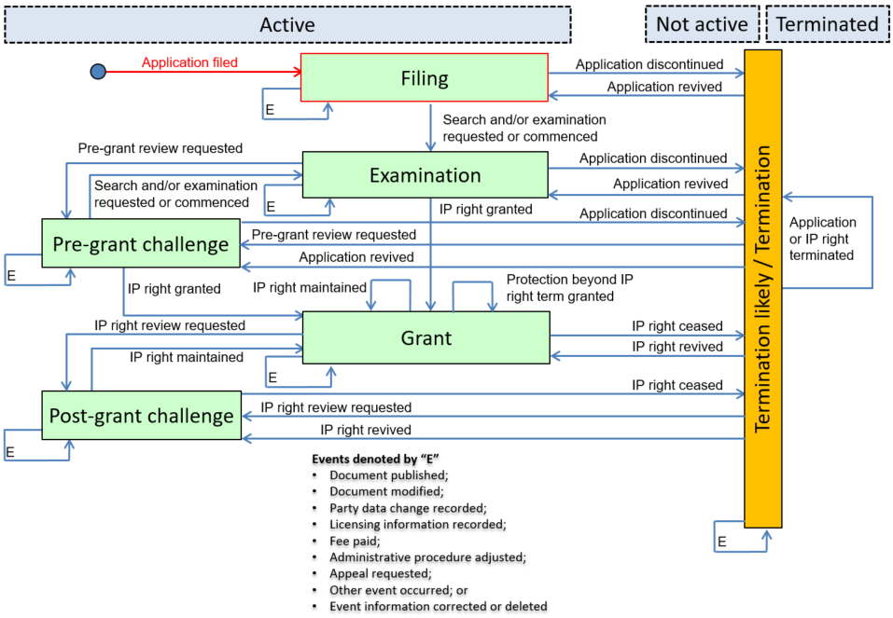
National Event History:
- 2008-04-02: X000: International filing into Interap system
- 2009-01-02: X000: PCT national entry applications
- 2009-08-20: X000: Divisional request filed
- 2009-12-23: X000: Divisional request granted

Key Event History:
- 2008-04-02: A10: Application filed
- 2009-01-02: A10: Application filed
- 2009-08-20: A10: Application filed

Detailed Event History:
- 2008-04-02: A13: PCT application filed
- 2009-01-02: A15: PCT application entered into the national or regional phase
- 2009-08-20: A16: Divisional, continuation or continuation in part application filed
- 2009-12-23: A18: Application divided or continuation or continuation in part accepted
Category History:
- 2008-04-02: A: Application filed
- 2009-01-02: A: Application filed
- 2009-08-20: A: Application filed
- 2009-12-23: A: Application filed

Mapping Summary:
Event Date | Nat. Code | National Text | Cat. | Key. | Det. | Status Event Code | Remark
2008-04-02 | X000 | International filing into Interap system | A | A10 | A13 | A-0-1-A10-A13-X000
2009-01-02 | X000 | PCT national entry applications | A | A10 | A15 | A-1-1-A10-A15-X000
2009-08-20 | X000 | Divisional request filed | A | A10 | A16 | A-1-1-A10-A16-X000
2009-12-23 | X000 | Divisional request granted | A | - | A18 | A-1-1-A00-A18-X000

JP Example

Basic Information:
- File Creation date: N/A
- Application number: N/A
- Type of IP right: National patent
Overall Patent/SPC Prosecution Model:
National Event History:
- 2006-02-03: X000: PCT application filed
- 2006-07-15: X000: PCT application entered into the national phase
- 2006-11-29: X000: Divisional application filed
- 2007-01-29: X000: Application divided

Key Event History:
- 2006-02-03: A10: Application filed
- 2006-07-15: A10: Application filed
- 2006-11-29: A10: Application filed

Detailed Event History:
- 2006-02-03: A13: PCT application filed
- 2006-07-15: A15: PCT application entered into the national or regional phase
- 2006-11-29: A16: Divisional, continuation or continuation in part application filed
- 2007-01-29: A18: Application divided or continuation or continuation in part accepted

Category History:
- 2006-02-03: A: Application filed
- 2006-07-15: A: Application filed
- 2006-11-29: A: Application filed
- 2007-01-29: A: Application filed

Mapping Summary:
Event Date | Nat. Code | National Text | Cat. | Key. | Det. | Status Event Code | Remark
2006-02-03 | X000 | PCT application filed | A | A10 | A13 | A-0-1-A10-A13-X000
2006-07-15 | X000 | PCT application entered into the national phase | A | A10 | A15 | A-1-1-A10-A15-X000
2006-11-29 | X000 | Divisional application filed | A | A10 | A16 | A-1-1-A10-A16-X000
2007-01-29 | X000 | Application divided | A | - | A18 | A-1-1-A00-A18-X000

Category B: Application discontinuation

Example 1: Application discontinued after substantive examination
Scenario: Examination was requested at the point of filing. The application was rejected after substantial examination and the application was discontinued.
DE Example

Basic Information:
- File Creation date: 2017-07-14
- Application number: 10 2012 001 472.4
- Type of IP right: National patent

Link to national Patent register: https://register.dpma.de/DPMAregister/pat/register?AKZ=1020152029573
Overall Patent/SPC Prosecution Model:
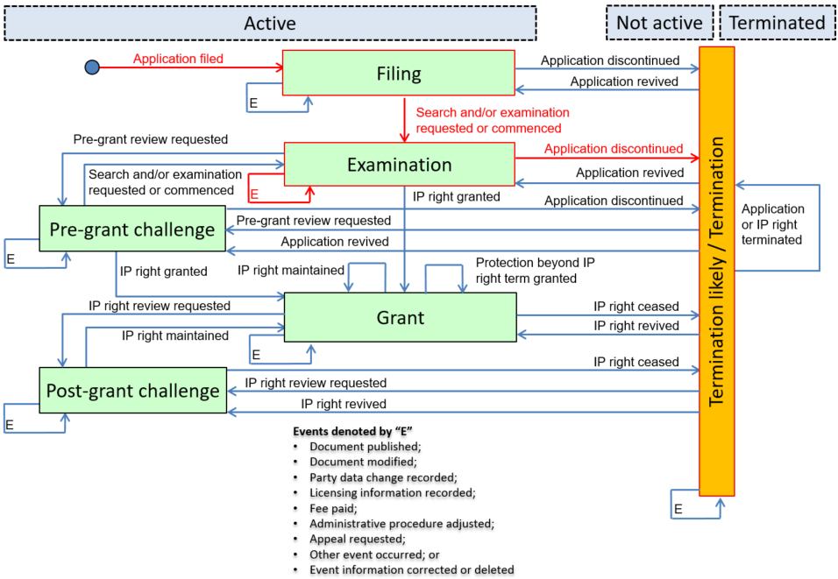
National Event History:
- 2015-02-18: R000: The application is under preliminary examination
- 2015-02-18: R012: Request for examination effectively filed
- 2015-02-18: R004: Pre-registration procedure has been concluded
- 2015-07-28: R015: Official communication on examination
- 2015-11-25: R016: Reply to official communication
- 2016-01-07: R200: Publication of application (Offenlegungsschrift)
- 2016-01-07: R230: Request for early publication of application (Offenlegung)
- 2016-01-12: R002: Decision to reject in examination/protection certificate/registration procedure
- 2016-02-16: R003: Decision to reject has become final

Key Event History:
- 2015-02-18: A10: Application filing
- 2015-02-18: D10: Search and/or examination requested or commenced
- 2016-01-07: Q10: Document published
- 2016-02-06: B10: Application discontinued

Detailed Event History:
- 2015-02-18: D11: Substantive examination requested
- 2015-07-28: D15: Examination report issued
- 2016-01-07: Q12: Application published
- 2016-02-16: B15: Application refused following examination
Category History:
- 2015-02-18: A: Application filing
- 2015-02-18: D: Search and examination
- 2015-03-27: A: Application filing
- 2015-07-28: D: Search and examination
- 2015-11-25: P: Document modification
- 2016-01-07: Q: Document publication
- 2016-01-07: Q: Document publication
- 2016-01-12: B: Application discontinuation
- 2016-02-16: B: Application discontinuation

Mapping Summary:
Event Date | Nat. Code | National Text | Cat. | Key. | Det. | Status Event Code |  | Remark
2015-02-18 | R000 | The application is under preliminary examination | A | A10 | - | A-1-2-A10-A00-R000
2015-02.18 | R012 | Request for examination effectively filed | D | D10 | D11 | A-2-2-D10-D11-R012
2015-03-27 | R004 | Pre-registration procedure has been concluded | A | - | - | A-0-0-A00-A00-R004
2015-07-28 | R015 | Official communication on examination | D | - | D15 | A-2-2-D00-D15-R015 |  | "Issue" is limited to communication between the IPO and the applicant/owner as opposed to the public.
2015-11-25 | R016 | Reply to official communication | P | - | - | A-2-2-P00-P00-R016
2016-01-07 | R200 | Publication of application (Offenlegungsschrift) | Q | Q10 | Q12 | A-2-2-Q10-Q12-R200
2016-01-07 | R230 | Request for early publication of application (Offenlegung) | Q | - | - | A-2-2-Q00-Q00-R230
2016-01-12 | R002 | Decision to reject in examination/protection certificate/registration procedure | B | - | - | A-2-2-B00-B00-R002
2016-02-16 | R003 | Decision to reject has become final | B | B10 | B15 | N-2-6-B10-B15-R003

Category C: Application revival

Example 1: Application revived after lapse
Scenario: An application is withdrawn. The lapsed application is then revived. Following a formality examination, the IP right is granted and the IP right document is published.
EA Example

Basic Information:
- File Creation date: N/A
- Application number: N/A
- Type of IP right: National patent

Overall Patent/SPC Prosecution Model:
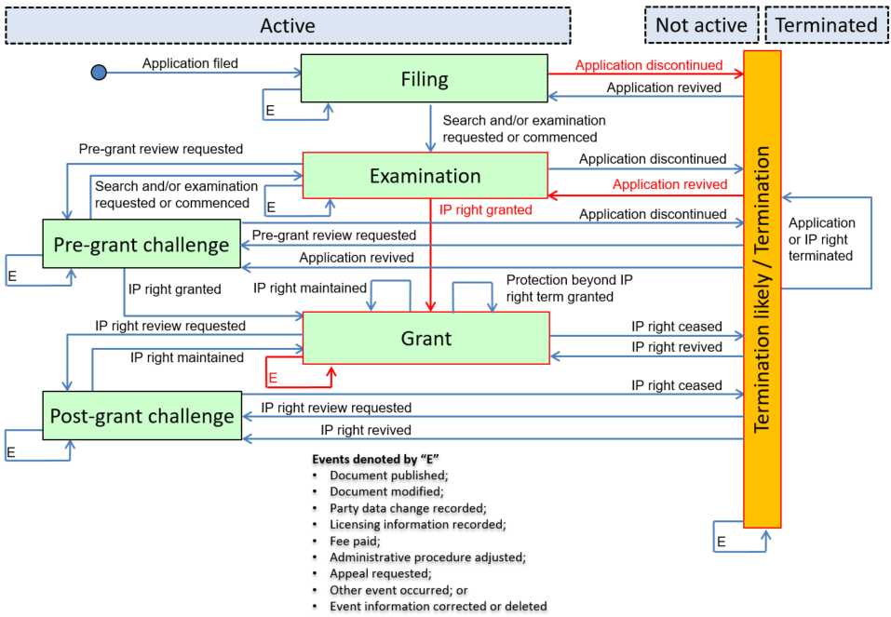
National Event History:
- 1998-03-24: FA9A: Withdrawal of a Eurasian application
- 1998-06-13: NF9A: Restoration of lapsed application to a Eurasian patent application
- 1999-01-14: FG4A: Eurasian patent for invention (B1 publication)

Key Event History:
- 1998-03-24: B10: Application discontinued
- 1998-06-13: C10: Application revived
- 1999-01-14: F10: IP right granted
- 1999-01-14: Q10: Document published

Detailed Event History:
- 1998-06-13: C13: Application revived following an application revival request
- 1999-01-14: F12: IP right granted following formality examination
- 1999-01-14: Q13: IP right document published
Category History:
- 1998-03-24: B: Application discontinuation
- 1998-06-13: C: Application revival
- 1999-01-14: F: IP right grant
- 1999-01-14: Q: Document publication

Mapping Summary:
Event Date | Nat. Code | National Text | Cat. | Key. | Det. | Status Event Code | Remark
1998-03-24 | FA9A | Withdrawal of a Eurasian application | B | B10 | - | N-1-6-B10-B00-FA9A
1998-06-13 | NF9A | Restoration of lapsed application to a Eurasian patent application | C | C10 | C13 | A-6-2-C10-C13-NF9A
1999-01-14 | FG4A | Eurasian patent for invention (B1 publication) | F | F10 | F12 | A-2-4-F10-F12-FG4A
1999-01-14 | FG4A | Eurasian patent for invention (B1 publication) | Q | Q10 | Q13 | A-4-4-Q10-Q13-FG4A | The regional event, FG4A simultaneously maps to two key/detailed events.

Category D: Search and examination

Example 1: Fast track examination requested and granted
Scenario: An application for a national patent was filed. The applicant requested an accelerated examination which was granted. The IP right was granted after a substantive examination.
US Example

Basic Information:
- File Creation date: N/A
- Application number: N/A
- Type of IP right: National patent

Overall Patent/SPC Prosecution Model:
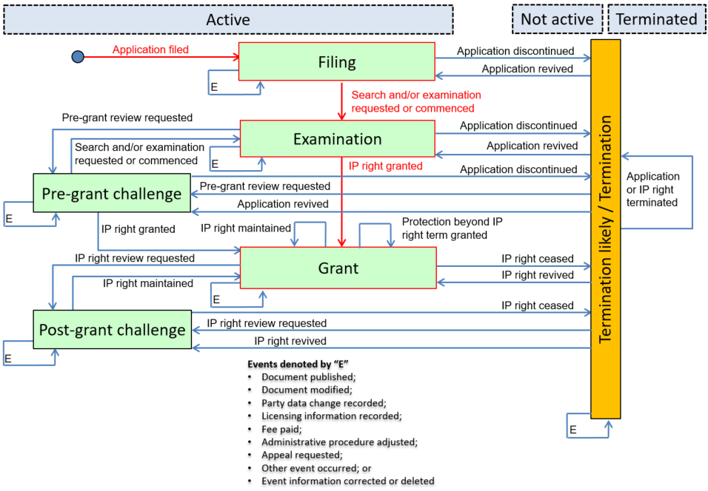
National Event History:
- 2011-02-27: APC Application Filing Date: Filing Date- Date Application Filed
- 2011-03-29: DOCK: Application docketed to an examiner for examination
- 2011-06-20: 289: All petitions and requests to make special are entered; Track 1 and Rocket Docket requests entered
- 2011-12-03: 289: All petitions and requests to make special are entered; Track 1 and Rocket Docket requests granted
- 2012-02-05: Patent Issue Date: Patent Issue Date

Key Event History:
- 2011-02-27: A10: Application filed
- 2011-03-29: D10: Search and/or examination requested or commenced
- 2011-06-20: D10: Search and/or examination requested or commenced
- 2012-02-05: F10: IP right granted

Detailed Event History:
- 2011-06-20: D16: Fast track examination requested
- 2011-12-03: D17: Fast track examination accepted

Category History:
- 2011-02-27: A: Application filed
- 2011-03-29: D: Search and examination
- 2011-06-20: D: Search and examination
- 2011-12-03: D: Search and examination
- 2012-02-05: F: IP right grant

Mapping Summary:
Event Date | Nat. Code | National Text | Cat. | Key. | Det. | Status Event Code | Remark
2011-02-27 | APC | Filing Date- Date Application Filed | A | A10 | - | A-0-1-A10-A00- APC Application Filing Date | Application Filing Date
2011-03-29 | DOCK | Application docketed to an examiner for examination | D | D10 | - | A-1-2-D10-D00- DOCK
2011-06-20 | 289 | All petitions and requests to make special are entered; Track 1 and Rocket Docket requests entered | D | D10 | D16 | A-2-2-D10-D16-289
2011-12-03 | 289 | All petitions and requests to make special are entered; Track 1 and Rocket Docket requests granted | D | - | D17 | A-2-2-D00-D17-289
2012-02-05 | Patent Issue Date | Patent Issue Date | F | F10 | - | A-2-4-F10-F00- Patent Issue Date

Category E: Pre-grant review requested

Example 1: Pre-grant review and granted in part
Scenario: Immediately with filing, the examination was requested and the patent was intended to be granted. After publication of the patent an opposition was filed and the patent was maintained in amended form. The patent is still in force.
Remark: This scenario describes a sequence of events with a patent scope adjustment before granting. It is a basic scenario, which should happen at least several times a year in each IP office. The pre-grant review might be an opposition or any other proceedings used to adjust the scope of a patent before grant.
DE Example

Basic Information:
- File Creation date: 2017-07-14
- Application number: 10 2011 051 254.3
- Type of IP right: National patent

Link to national Patent register: https://register.dpma.de/DPMAregister/pat/register?AKZ=1020110512543

Overall Patent/SPC Prosecution Model:
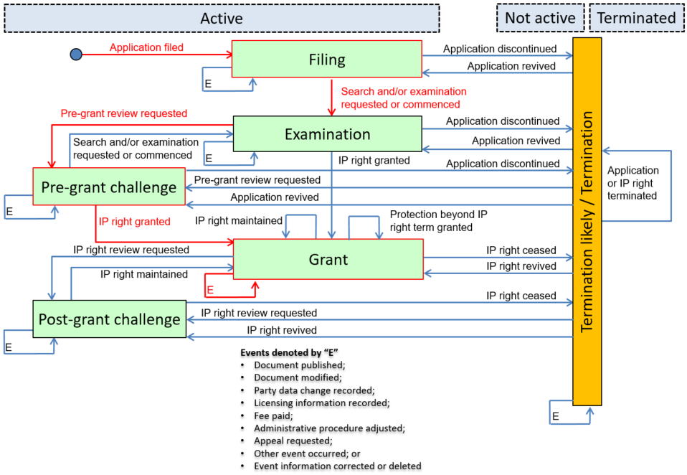

National Event History:
- 2011-06-22: R000: The application is under preliminary examination
- 2011-06-22: R012: Request for examination effectively filed
- 2011-08-03: R004: Pre-registration procedure has been concluded
- 2012-02-24: R015: Official communication on examination
- 2012-06-21: R016: Reply to official communication
- 2012-10-10: R018: Decision to grant patent by Examining Section/Patent Division
- 2012-12-27: R200: Publication of application (Offenlegungsschrift)
- 2013-02-21: R110: Patent specification
- 2013-05-16: R026: Opposition to patent filed
- 2016-03-25: R032: Patent maintained with limitations by decision of Patent Division
- 2016-03-25: R034: Decision to maintain patent with limitations by Patent Division / Federal Patent Court has become final
- 2016-06-16: R206: Amended patent specification

Key Event History:
- 2011-06-22: A10: Application filing
- 2011-06-22: D10: Search and/or examination requested or commenced
- 2012-12-27: Q10: Document published
- 2013-05-16: E10: Pre-grant review requested
- 2016-03-25: F10: IP right granted
- 2016-06-16: P10: Document modified

Detailed Event History:
- 2011-06-22: D11: Substantive examination requested
- 2012-02-24: D15: Examination report issued
- 2012-10-10: D22: Grant of IP right intended
- 2012-12-27: Q12: Application published
- 2013-02-21: Q13: IP right document published
- 2013-05-16: E11: Pre-grant opposition filed
- 2016-03-25: F14: IP right granted in amended form following pre-grant review
- 2016-06-16: P16: IP right document amended

Category History:
- 2011-06-22: A: Application filing
- 2011-06-22: D: Search and examination
- 2011-08-03: A: Application filing
- 2012-02-24: D: Search and examination
- 2012-06-21: P: Document modification
- 2012-10-10: D: Search and examination
- 2012-12-27: Q: Document publication
- 2013-02-21: W: Other
- 2013-05-16: E: Pre-grant review request
- 2016-03-25: E: Pre-grant review request
- 2016-03-25: F: IP right grant
- 2016-06-16: P: Document modification

Mapping Summary:

Event Date | Nat. Code | National Text | Cat. | Key. | Det. | Status event code | Remark
2011-06-22 | R000 | The application is under preliminary examination | A | A10 | - | A-1-2-A10-A00-R000
2011-06-22 | R012 | Request for examination effectively filed | D | D10 | D11 | A-2-2-D10-D11-R012
2011-08-03 | R004 | Pre-registration procedure has been concluded | A | - | - | A-0-0-A00-A00-R004
2012-02-04 | R015 | Official communication on examination | D | - | D15 | A-2-2-D00-D15-R015 | "Issue" is limited to communication between the IPO and the applicant/owner as opposed to the public.
2012-06-21 | R016 | Reply to official communication | P |  |  | A-2-2-P00-P00-R016
2012-10-10 | R018 | Decision to grant patent by Examining Section/Patent Division | D | - | D22 | A-2-2-D00-D22-R018
2012-12-27 | R200 | Publication of application (Offenlegungsschrift) | Q | Q10 | Q12 | A-2-2-Q10-Q12-R200
2013-02-21 | R110 | Patent specification | W | - | - | A-2-2-W00-W00-R110
2013-05-16 | R026 | Opposition to patent filed | E | E10 | E11 | A-2-3-E10-E11-R026
2016-03-25 | R032 | Patent maintained with limitations by decision of Patent Division | E | - | - | A-3-3-E00-E00-R032
2016-03-25 | R034 | Decision to maintain patent with limitations by Patent Division / Federal Patent Court has become final | F | F10 | F14 | A-3-4-F10-F14-R034
2016-06-16 | R206 | Amended patent specification | P | P10 | P16 | A-4-4-P10-P16-R206

Category F: IP right grant

Example 1: IP right granted for utility model
Scenario: An IP right granted for a utility model.
UA Example

Basic Information:
- File Creation date: N/A
- Application number: N/A
- Type of IP right: Utility model

Overall Patent/SPC Prosecution Model:
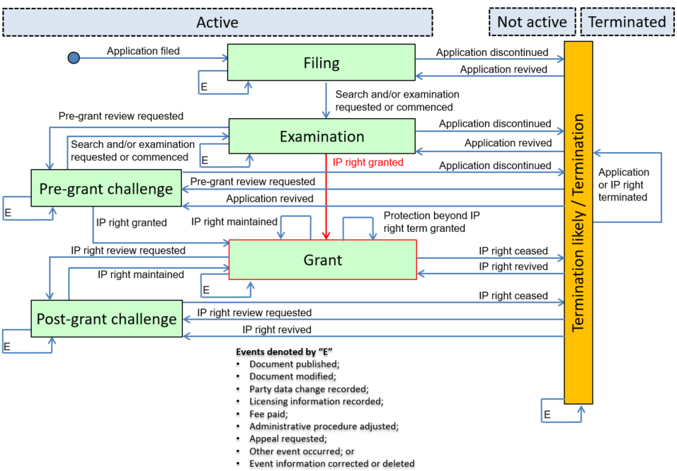
National Event History:
- 2014-06-23: X000: Grant of a patent for a utility model

Key Event History:
- 2014-06-23: F10: IP right granted

Detailed Event History:
- 2014-06-23: F12: IP right granted following formality examination

Category History:
- 2014-06-23: F: IP right grant

Mapping Summary:
Event Date | Nat. Code | National Text | Cat. | Key. | Det. | Status Event Code | Remark
2014-06-23 | X000 | Grant of a patent for a utility model | F | F10 | F12 | A-0-4-F10-F12- X000 | UA does not report events before the grant of an IP right.

Category G: Protection beyond IP right term

Example 1: Patent Term Adjustment granted after grant of patent
Scenario: Due to a delay in the prosecution of the patent application caused by the IPO an adjustment to the patent term is granted to extend the patent term beyond the initial 20 years. The adjustment is granted after the patent was granted.
US Example

Basic Information:
- File Creation date: N/A
- Application number: N/A
- Type of IP right: National patent

Overall Patent/SPC Prosecution Model:
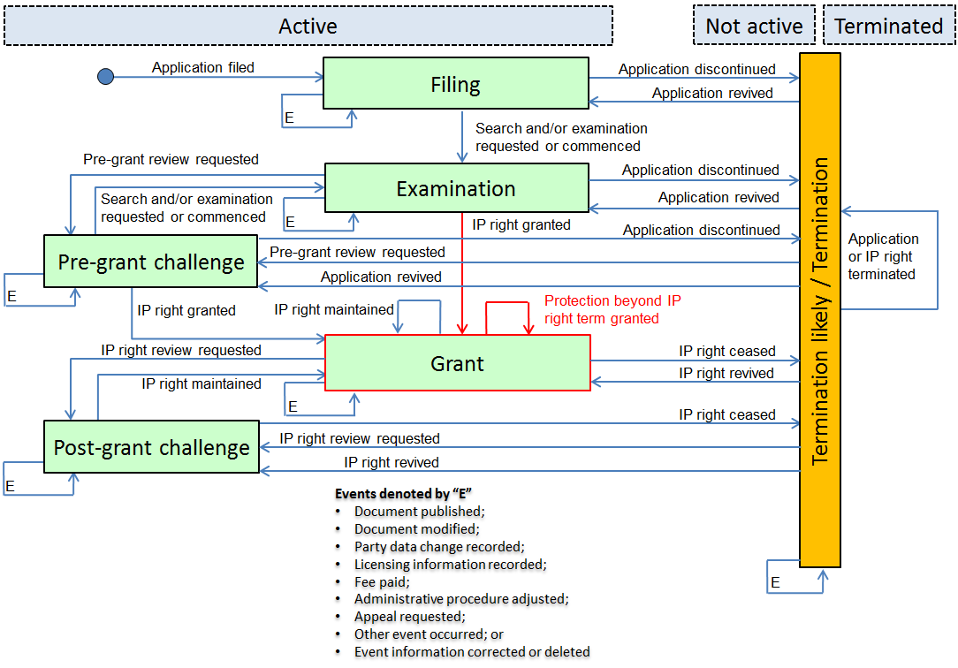
National Event History:
- 2016-04-28: Patent Issue Date: Patent Issue Date
- 2016-08-21: Petition 551 filed: Patent Term Adjustment petition entered
- 2017-01-14: Petition 551 granted: Patent Term Adjustment petition granted
Key Event History:
- 2016-04-28: F10: IP right granted
- 2017-01-14: G10: Protection beyond IP right term granted

Detailed Event History:
- 2016-08-21: G15: PTA requested
- 2017-01-14: G17: PTA granted

Category History:
- 2016-04-28: F: IP right grant
- 2016-08-21: G: Protection beyond IP right term
- 2017-01-14: G: Protection beyond IP right term

Mapping Summary:
Event Date | Nat. Code | National Text | Cat. | Key. | Det. | Status Event Code | Remark
2016-04-28 | Patent Issue Date | Patent Issue Date | F | F10 | - | A-0-4-F10-F00-Patent Issue Date
2016-08-21 | Petition 551 filed | Patent Term Adjustment petition entered | G | - | G15 | A-4-4-G00-G15-Petition 551 filed
2017-01-14 | Petition 551 granted | Patent Term Adjustment petition granted | G | G10 | G17 | A-4-4-G10-G17-Petition 551 granted

KR Example

Basic Information:
- File Creation date: N/A
- Application number: N/A
- Type of IP right: National patent

Overall Patent/SPC Prosecution Model:
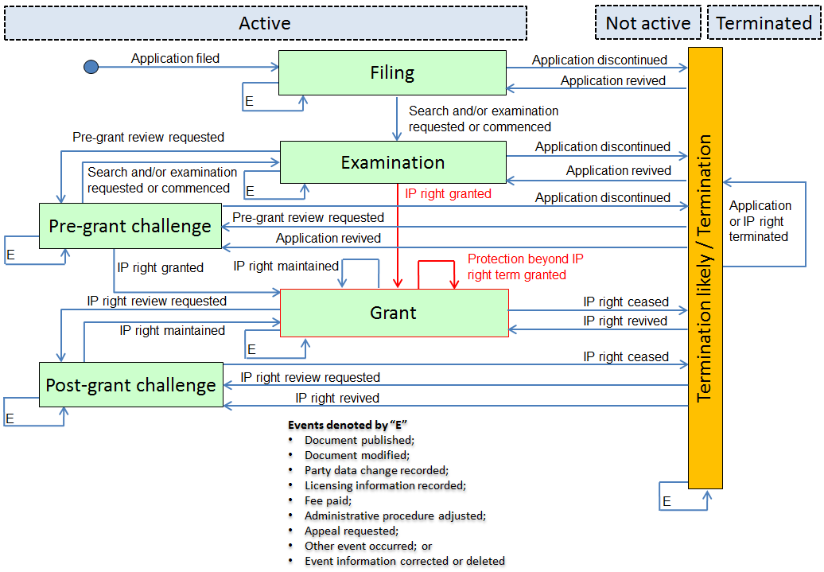
National Event History:
- 2009-10-16: PR0702: Registration of Establishment of National Patent
- 2010-02-25: PA0102: Application to Register Extension of Term of Patent Right Following Delayed Registration
- 2010-04-15: PE0703: Decision to Register Extension of Term of Patent Right Following Delayed Registration
- 2010-04-30: PR1102: Extension of Term of Patent Right Following Delayed Registration

Key Event History:
- 2009-10-16: F10: IP right granted
- 2010-04-30: G10: Protection beyond IP right term granted

Detailed Event History:
- 2010-02-25: G15: PTA requested
- 2010-04-30: G17: PTA granted

Category History:
- 2009-10-16: F: IP right grant
- 2010-02-25: G: Protection beyond IP right term
- 2010-04-15: G: Protection beyond IP right term
- 2010-04-30: G: Protection beyond IP right term

Mapping Summary:
Event Date | Nat. Code | National Text | Cat. | Key. | Det. | Status Event Code | Remark
2009-10-16 | PR0702 | Registration of Establishment of National Patent | F | F10 | - | A-0-4-F10-F00- PR0702
2010-02-25 | PA0102 | Application to Register Extension of Term of Patent Right Following Delayed Registration | G | - | G15 | A-4-4-G00-G15- PA0102
2010-04-15 | PE0703 | Decision to Register Extension of Term of Patent Right Following Delayed Registration | G | - | - | A-4-4-G00-G15- PE0703
2010-04-30 | PR1102 | Extension of Term of Patent Right Following Delayed Registration | G | G10 | G17 | A-4-4-G10-G17- PR1102

Example 2: Extension of Supplementary Protection Certificate granted
Scenario: An extension of a Supplementary Protection Certificate was granted.
GB Example

Basic Information:
- File Creation date: N/A
- Application number: N/A
- Type of IP right: Supplementary Protection Certificate

Overall Patent/SPC Prosecution Model:
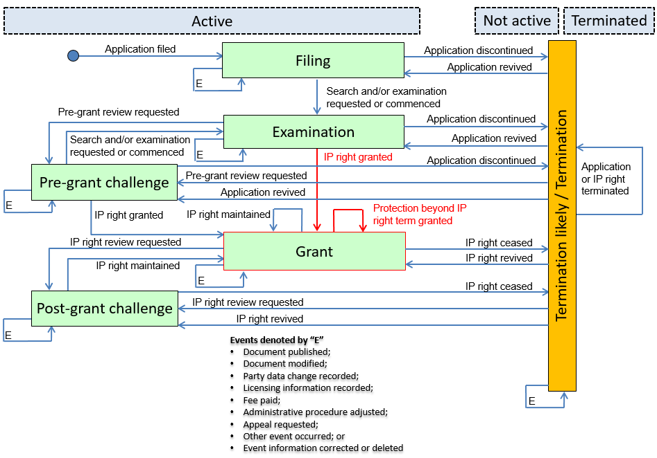
National Event History:
- 2007-06-23: X000: Application SPC/GB##/### for a Supplementary Protection Certificate in respect of “…” was granted on ##/##/#### with a maximum expiry date of ##/##/####
- 2015-07-28: X000: Application SPC/GB##/### for a (Paediatric) Extension of a supplementary protection certificate in respect of “…” was filed on ##/##/#### (+ variations)
- 2016-01-02: X000: Application SPC/GB##/### for a Paediatric Extension of a Supplementary Protection Certificate in respect of “…” was granted on ##/##/#### with a maximum period expiring on ##/##/####

Key Event History:
- 2007-06-23: F10: IP right granted
- 2016-01-02: G10: Protection beyond IP right term granted

Detailed Event History:
- 2007-06-23: F12: IP right granted following formality examination
- 2015-07-28: G11: Extension of SPC term requested
- 2016-01-02: G13: Extension of SPC term granted

Category History:
- 2007-06-23: F: IP right grant
- 2015-07-28: G: Protection beyond IP right term
- 2016-01-02: G: Protection beyond IP right term

Mapping Summary:
Event Date | Nat. Code | National Text | Cat. | Key. | Det. | Status Event Code | Remark
2007-06-23 | X000 | Application SPC/GB##/### for a Supplementary Protection Certificate in respect of “…” was granted on ##/##/#### with a maximum expiry date of ##/##/#### | F | F10 | F12 | A-0-4-F10-F12- X000
2015-07-28 | X000 | Application SPC/GB##/### for a (Paediatric) Extension of a supplementary protection certificate in respect of “…” was filed on ##/##/#### (+ variations) | G | - | G11 | A-4-4-G00-G11- X000
2016-01-02 | X000 | Application SPC/GB##/### for a Paediatric Extension of a Supplementary Protection Certificate in respect of “…” was granted on ##/##/#### with a maximum period expiring on ##/##/#### | G | G10 | G13 | A-4-4-G10-G13- X000

Category H: IP Right Cessation

Example 1: Patent granted and surrendered
Scenario: Examination was requested at the point of filing. The application was published and after communication between applicant and IP office the patent was granted. Patent was surrendered after one or two years.
Remark: This scenario describes an ordinary sequence of events during the live cycle of a patent. It is a basic scenario, which should happen several times a year in each IP office.
DE Example

Basic Information:
- File Creation date: 2017-07-14
- Application number: 10 2012 001 472.4
- Type of IP right: National patent

Link to national Patent register: https://register.dpma.de/DPMAregister/pat/register?lang=en&AKZ=1020120014724&CURSOR=0

Overall Patent/SPC Prosecution Model:
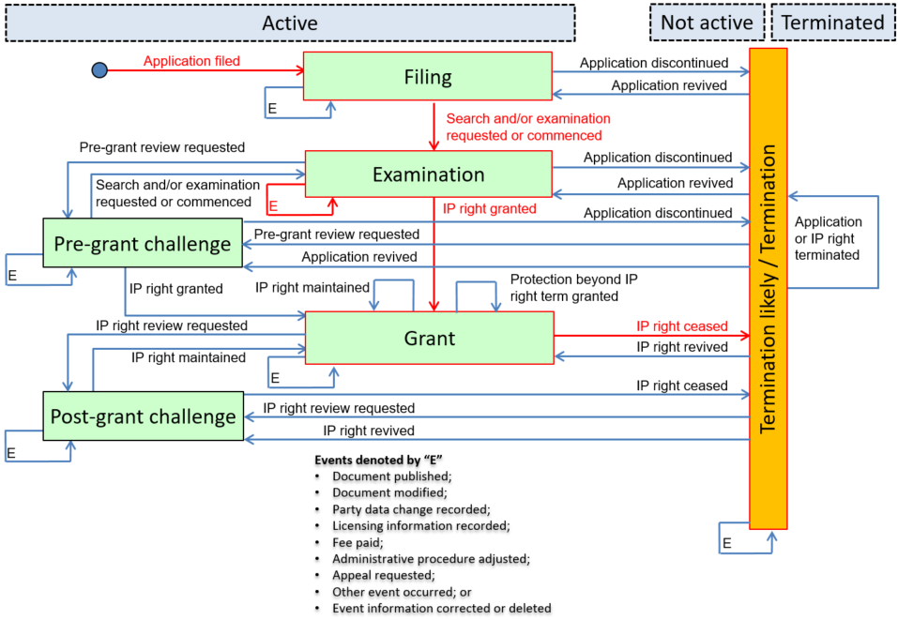
National Event History:
- 2012-01-26: R000: The application is under preliminary examination
- 2012-01-26: R012: Request for examination effectively filed
- 2012-02-06: R004: Pre-registration procedure has been concluded
- 2012-07-11: R015: Official communication on examination
- 2012-10-12: R016: Reply to official communication
- 2013-01-08: R200: Publication of application (Offenlegungsschrift)
- 2015-02-12: R015: Official communication on examination
- 2015-03-13: R016: Reply to official communication
- 2015-04-01: R018: Decision to grant patent by Examining Section/Patent Division
- 2015-07-16: R110: Patent specification
- 2016-04-19: R020: Grant of patent has become final
- 2017-03-11: R120: Application withdrawn/ IP right surrendered

Key Event History:
- 2012-01-26: A10: Application filing
- 2012-01-26: D10: Search and/or examination requested or commenced
- 2013-08-01: Q10: Document published
- 2016-04-19: F10: IP right granted
- 2017-03-11: H10: IP right ceased

Detailed Event History:
- 2012-01-26: D11: Substantive examination requested
- 2012-07-11: D15: Examination report issued
- 2013.08.01: Q12: Application published
- 2015-02-12: D15: Examination report issued
- 2015-04-01: D22: Grant of IP right intended
- 2017-03-11: H15: IP right surrendered

Category History:
- 2011-01-26: A: Application filing
- 2012-01-26: D: Search and examination
- 2012-02-06: A: Application filing
- 2012-07-11: D: Search and examination
- 2012-10-12: P: Document modification
- 2013-08-01: Q: Document publication
- 2015-02-12: D: Search and examination
- 2015-03-13: P: Document modification
- 2015-04-01: D: Search and examination
- 2015-07-16: W: Other
- 2016-04-19: F: IP right grant
- 2017-03-11: H: IP right cessation

Mapping Summary:
Event Date | Nat. Code | National Text | Cat. | Key. | Det. | Status Event Code | Remark
2012-01-26 | R000 | The application is under preliminary examination | A | A10 | - | A-1-2-A10-A00-R000
2012-01-26 | R012 | Request for examination effectively filed | D | D10 | D11 | A-2-2-D10-D11-R012
2012-02-06 | R004 | Pre-registration procedure has been concluded | A | - | - | A-0-0-A00-A00-R004
2012-07-11 | R015 | Official communication on examination | D | - | D15 | A-2-2-D00-D15-R015 | "Issue" is limited to communication between the IPO and the applicant/owner as opposed to the public.
2012-10-12 | R016 | Reply to official communication | P | - | - | A-2-2-P00-P00-R016
2013-08-01 | R200 | Publication of application (Offenlegungsschrift) | Q | Q10 | Q12 | A-2-2-Q10-Q12-R200
2015-02-12 | R015 | Official communication on examination | D | - | D15 | A-2-2-D00-D15-R015 | "Issue" is limited to communication between the IPO and the applicant/owner as opposed to the public.
2015-03-13 | R016 | Reply to official communication | P | - | - | A-2-2-P00-P00-R016
2015-04-01 | R018 | Decision to grant patent by Examining Section/Patent Division | D | - | D22 | A-2-2-D00-D22-R018
2015-07-16 | R110 | Patent specification | W | - | - | A-2-2-W00-W00-R110
2016-04-19 | R020 | Grant of patent has become final | F | F10 | - | A-2-4-F10-F00-R020
2017-03-11 | R120 | Application withdrawn/ IP right surrendered | H | H10 | H15 | A-4-6-H10-H15-R120

EA Example

Basic Information:
- File Creation date: N/A
- Application number: N/A
- Type of IP right: Regional patent

Overall Patent/SPC Prosecution Model:
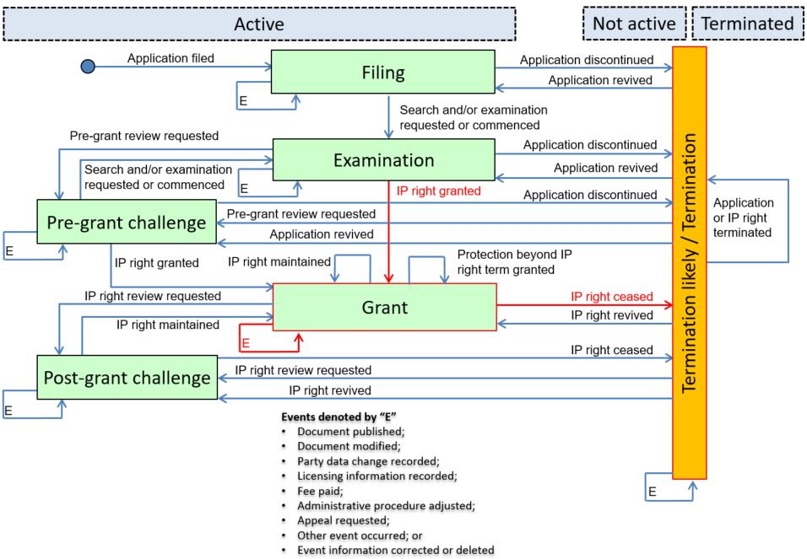
National Event History:
- 2007-02-03: FG4A: Eurasian patent for invention (B1 publication)
- 2007-02-03: FG4A: Eurasian patent for invention (B1 publication)
- 2013-09-11: MA4A: Revocation of a Eurasian patent at the proprietor’s request filed with EAPO

Key Event History:
- 2007-02-03: F10: IP right granted
- 2007-02-03: Q10: Document published
- 2013-09-11: H10: IP right ceased

Detailed Event History:
- 2007-02-03: F12: IP right granted following formality examination
- 2007-02-03: Q13: IP right document published
- 2013-09-11: H15: IP right surrendered

Category History:
- 2007-02-03: F: IP right grant
- 2007-02-03: Q: Document publication
- 2013-09-11: H: IP right cessation

Mapping Summary:
Event Date | Nat. Code | National Text | Cat. | Key. | Det. | Status Event Code | Remark
2007-02-03 | FG4A | Eurasian patent for invention (B1 publication) | F | F10 | F12 | A-2-4-F10-F12-FG4A | The regional event, FG4A simultaneously maps to two key/detailed events.
2007-02-03 | FG4A | Eurasian patent for invention (B1 publication) | Q | Q10 | Q13 | A-4-4-Q10-Q13-NG4A
2013-09-11 | MA4A | Revocation of a Eurasian patent at the proprietor’s request filed with EAPO | H | H10 | H15 | N-4-6-H10-H15-MA4A

Category K: IP right revival

Example 1: Lapsed patent is revived
Scenario: A patent lapses due to non-payment of maintenance fees. The patent owner pays the maintenance fee and requests the revival of the lapsed patent. The IPO revives the patent.
CA Example

Basic Information:
- File Creation date: N/A
- Application number: N/A
- Type of IP right: National patent

Overall Patent/SPC Prosecution Model:
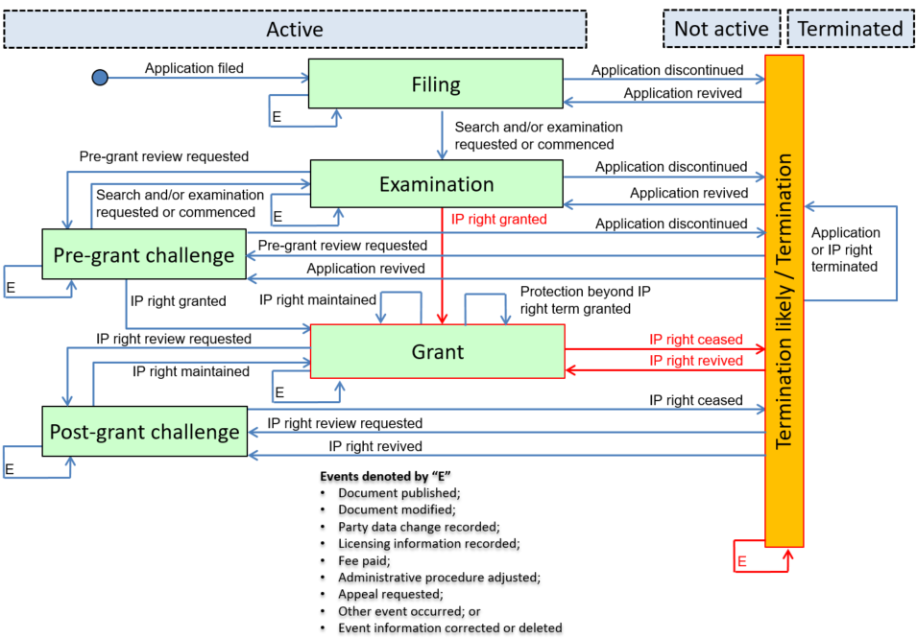
National Event History:
- 2010-01-18: X000: Grant
- 2011-07-18: X000: Lapsed date/log, Appl maint dead - fee not paid
- 2011-07-18: X000: Lapsed (not dead)
- 2011-08-02: X000: Maintenance fees
- 2011-08-02: X000: Request for reversal of lapsed
- 2011-08-14: X000: Lapsed Reversal

Key Event History:
- 2010-01-18: F10: IP right granted
- 2011-07-18: H10: IP right ceased
- 2011-08-02: U10: Fee paid
- 2011-08-14: K10: IP right revived

Detailed Event History:
- 2010-01-18: F11: IP right granted following substantive examination
- 2011-07-18: U13: Renewal or maintenance fee not paid
- 2011-07-18: H13: IP right lapsed
- 2011-08-02: U11: Renewal or maintenance fee paid
- 2011-08-02: K11: IP right revival requested
- 2011-08-14: K13: IP right revived in full

Category History:
- 2010-01-18: F: IP right grant
- 2011-07-18: U: Payment
- 2011-07-18: H: IP right cessation
- 2011-08-02: U: Payment
- 2011-08-02: K: IP right revival
- 2011-08-14: K: IP right revival

Mapping Summary:
Event Date | Nat. Code | National Text | Cat. | Key. | Det. | Status Event Code | Remark
2010-01-18 | X000 | Grant | F | F10 | F11 | A-0-4-F10-F11- X000
2011-07-18 | X000 | Lapsed date/log, Appl maint dead - fee not paid | U | - | U13 | A-4-4-U00-U13- X000
2011-07-18 | X000 | Lapsed (not dead) | H | H10 | H13 | N-4-6-H10-H13- X000
2011-08-02 | X000 | Maintenance fees | U | U10 | U11 | N-6-6-U10-U11- X000
2011-08-02 | X000 | Request for reversal of lapsed | K | - | K11 | N-6-6-K00-K11- X000
2011-08-14 | X000 | Lapsed Reversal | K | K10 | K13 | A-6-4-K10-K13- X000

Category L: IP right review requested

Example 1: Post-Grant challenge and patent revoked
Scenario: One month after filing of a patent, the examination was requested. The patent was granted without any objection. 4 years after the grant of the patent has become final, a post-grant challenge was initiated by a third party. The case was discussed at the associated authority and it was decided to revoke the patent completely.
DE Example

Basic Information:
- File Creation date: 2017-07-14
- Application number: 10 2005 011 790.2
- Type of IP right: National patent

Link to national Patent register: https://register.dpma.de/DPMAregister/pat/register?AKZ=1020050117902

Overall Patent/SPC Prosecution Model:
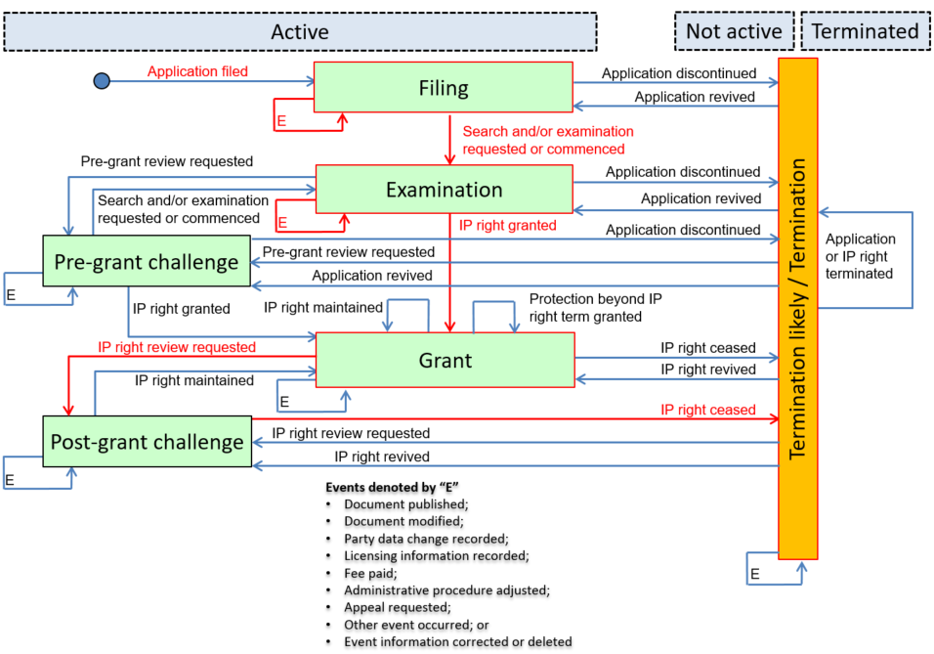
National Event History:
- 2005-03-11: R000: The application is under preliminary examination
- 2005-04-08: R012: Request for examination effectively filed
- 2005-05-12: R004: Pre-registration procedure has been concluded
- 2005-10-17: R079: Change of IPC main class
- 2006-03-20: R015: Official communication on examination
- 2006-07-26: R018: Decision to grant patent by Examining Section/Patent Division
- 2006-11-23: R110: Patent specification
- 2007-02-23: R020: Grant of patent has become final
- 2011-07-19: R039: Action brought for declaration of nullity
- 2011-07-19: R008: Case file pending with Federal Patent Court
- 2015-08-11: R042: Final declaration of nullity of patent in full
- 2015-12-24: R078: Other <with further information such as lien, etc>

Key Event History:
- 2005-03-11: A10: Application filing
- 2005-04-08: D10: Search and/or examination requested or commenced
- 2005-10-17: P10: Document modified
- 2007-02-23: F10: IP right granted
- 2011-07-19: L10: IP right review request
- 2015-08-11: H10: IP right ceased
- 2015-12-24: W10: Other event occurred

Detailed Event History:
- 2005-04-08: D11: Substantive examination requested
- 2005-10-17: P22: Classification modified
- 2006-03-20: D15: Examination report issued
- 2006—7-26: D22: Grant of IP right intended
- 2011-07-19: L15: Invalidation requested
- 2015-08-11: H12: IP right ceased following an IP right review

Category History:
- 2005-03-11: A: Application filing
- 2005-04-08: D: Search and examination
- 2005-05-12: A: Application filing
- 2005-10-17: P: Document modification
- 2006-03-20: D: Search and examination
- 2006-07-26: D: Search and examination
- 2006-11-23: W: Other
- 2007-02-23: F: IP right grant
- 2011-07-19: L: IP right review requested
- 2011-07-19: V: Other
- 2015-08-11: H: IP right cessation
- 2015-12-24: W: Other

Mapping Summary:
Event Date | Nat. Code | National Text | Cat. | Key. | Det. | Status Event Code | Remark
2005-03-11 | R000 | The application is under preliminary examination | A | A10 | - | A-1-2-A10-A00-R000
2005-04-08 | R012 | Request for examination effectively filed | D | D10 | D11 | A-2-2-D10-D11-R012
2005-05-12 | R004 | Pre-registration procedure has been concluded | A | - | - | A-0-0-A00-A00-R004
2005-10-17 | R079 | Change of IPC main class | P | P10 | P22 | A-2-2-P10-P22-R079
2006-03-20 | R015 | Official communication on examination | D | - | D15 | A-2-2-D00-D15-R015 | "Issue" is limited to communication between the IPO and the applicant/owner as opposed to the public.

2006-07-26 | R018 | Decision to grant patent by Examining Section/Patent Division | D | - | D22 | A-2-2-D00-D22-R018
2006-11-23 | R110 | Patent specification | W | - | - | A-2-2-W00-W00-R110
2007-02-23 | R020 | Grant of patent has become final | F | F10 | - | A-2-4-F10-F00-R020
2011-07-19 | R039 | Action brought for declaration of nullity | L | L10 | L15 | A-4-5-L10-L15-R039
2011-07-19 | R008 | Case file pending with Federal Patent Court | V | - | - | A-5-5-V00-V00-R008
2015-08-11 | R042 | Final declaration of nullity of patent in full | H | H10 | H12 | A-5-6-H10-H12-R042
2015-12-24 | R078 | Other <with further information such as lien, etc> | W | W10 | - | A-0-0-W10-W00-R078

Category M: IP right maintenance

Example 1: IP right maintained following administrative decision resulting in partial revocation
Scenario: Following the grant of an IP right, a third party requested an IP right review. Following the IP right review, the IP right was maintained in part and the amended IP document was published.
EA Example

Basic Information:
- File Creation date: N/A
- Application number: N/A
- Type of IP right: Regional patent

Overall Patent/SPC Prosecution Model:
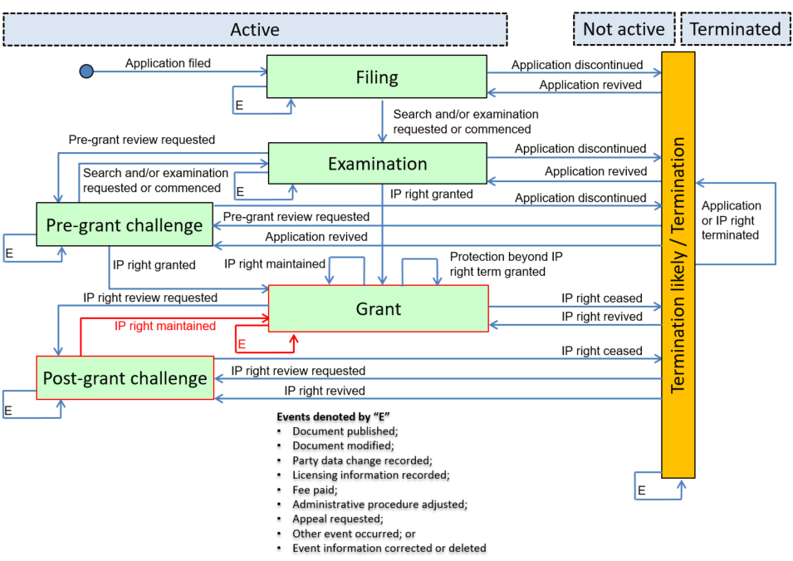
National Event History:
- 2009-10-11: LC4A: Eurasian patent for invention for which administrative decision of partial revocation was made (+ B2 publication)

Key Event History:
- 2009-10-11: M10: IP right maintained
- 2009-10-11: Q10: Document published

Detailed Event History:
- 2009-10-11: M12: IP right maintained in amended form following an IP right review or an appeal
- 2009-10-11: Q17: Amended document published

Category History:
- 2009-10-11: M: IP right maintenance
- 2009-10-11: Q: Document publication

Mapping Summary:
Event Date | Nat. Code | National Text | Cat. | Key. | Det. | Status Event Code | Remark
2009-10-11 | LC4A: | Eurasian patent for invention for which administrative decision of partial revocation was made (+ B2 publication) | M | M10 | M12 | A-5-4-M10-M12-LC4A | Regional event, LC4A, simultaneously maps to two key/detailed events.
2009-10-11 | LC4A: | Eurasian patent for invention for which administrative decision of partial revocation was made (+ B2 publication) | Q | Q10 | Q17 | A-4-4-Q10-Q17-LC4A | Q17: Amended document published is more appropriate than Q13: IP right document published, because the focus of regional event LC4A to document publication, is the amendment of a published document.

Remark: The administrative procedure, LC4A, affects all EAPO member states.

Category N: Termination

Example 1: Lapsed patent is terminated with no possibility of revival
Scenario: A patent lapses due to non-payment of maintenance fees. The patent owner does not pay the maintenance fee or request revival in the allowable grace period. The IPO terminates the IP right with no possibility of revival.
CA Example

Basic Information:
- File Creation date: N/A
- Application number: N/A
- Type of IP right: National patent

Overall Patent/SPC Prosecution Model:
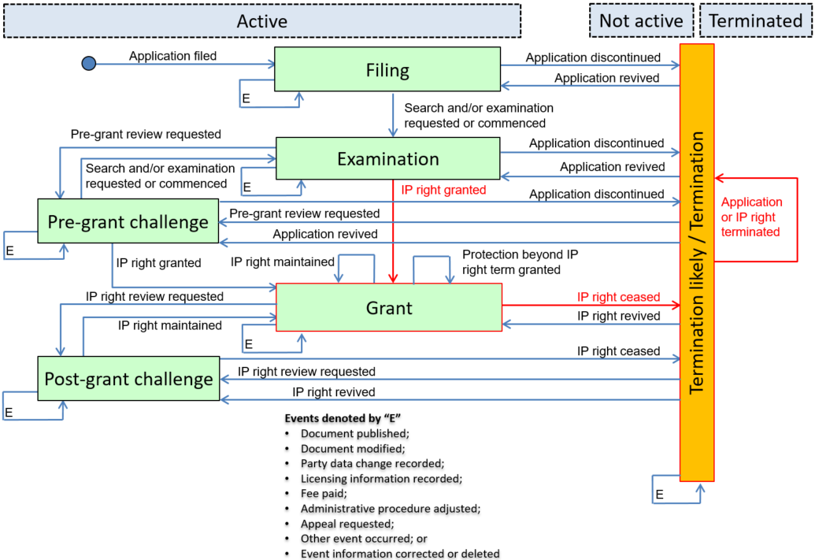
National Event History:
- 2002-04-11: X000: Grant
- 2010-04-11: X000: Lapsed date/log, Appl maint dead - fee not paid
- 2010-10-11: X000: Lapsed (not dead)
- 2011-04-11: X000: Lapsed, and expired

Key Event History:
- F10: IP right granted
- 2010-10-11: H10: IP right ceased
- 2011-04-11: N10: Application or IP right terminated

Detailed Event History:
- 2002-04-11: F11: IP right granted following substantive examination
- 2010-04-11: U13: Renewal or maintenance fee not paid
- 2010-10-11: H13: IP right lapsed
- 2011-04-11: N12: IP right terminated

Category History:
- 2002-04-11: F: IP right grant
- 2010-04-11: U: Payment
- 2010-10-11: H: IP right cessation
- 2011-04-11: N: Termination

Mapping Summary:
Event Date | Nat. Code | National Text | Cat. | Key. | Det. | Status Event Code | Remark
2002-04-11 | X000 | Grant | F | F10 | F11 | A-0-4-F10-F11- X000
2010-04-11 | X000 | Lapsed date/log, Appl maint dead - fee not paid | U | - | U13 | A-4-4-U00-U13- X000
2010-10-11 | X000 | Lapsed (not dead) | H | H10 | H13 | N-4-6-H10-H13- X000 | The IP right can still be revived if the missed maintenance fee is paid and the reinstatement is requested by the patent owner.
2011-04-11 | X000 | Lapsed, and expired | N | N10 | N12 | T-6-6-N10-N12-X000

Category P: Document modification

Example 1: Errors in application are corrected and re-published
Scenario: Errors made by an IPO during the publication of the application are corrected and the application is re-published.
EA Example

Basic Information:
- File Creation date: N/A
- Application number: N/A
- Type of IP right: Regional patent

Overall Patent/SPC Prosecution Model:
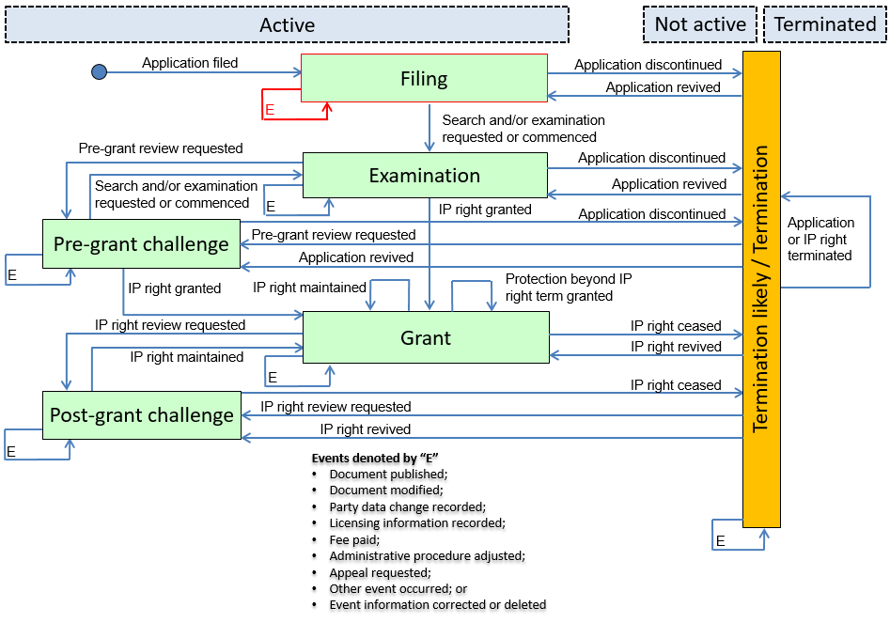
National Event History:
- 2015-05-06: HH9A: Reprint of the description of invention in a Eurasian patent application (list of corrections applied, A9 publication)
- 2015-05-06: HH9A: Reprint of the description of invention in a Eurasian patent application (list of corrections applied, A9 publication)

Key Event History:
- 2015-05-06: P10: Document modified
- 2015-05-06: Q10: Document published

Detailed Event History:
- 2015-05-06: P21: Errors in published documents corrected
- 2015-05-06: Q17: Modified document published

Category History:
- 2015-05-06: P: Document modification
- 2015-05-06: Q: Document publication

Mapping Summary:
Event Date | Nat. Code | National Text | Cat. | Key. | Det. | Status Event Code | Remark
2015-05-06 | HH9A | Reprint of the description of invention in a Eurasian patent application (list of corrections applied, A9 publication) | P | P10 | R14 | A-1-1-P10-P21-HH9A | This event covers both document modification (errors and correction) and republication; therefore it simultaneously maps to two key/detailed events.  It includes correction of both applicants’ errors and errors introduced by the EAPO at the publication stage.
2015-05-06 | HH9A | Reprint of the description of invention in a Eurasian patent application (list of corrections applied, A9 publication) | Q | Q10 | Q17 | A-1-1-Q10-Q17-HH9A

Category Q: Document publication

Example 1: Amended application published
Scenario: Subsequent to the issuance of the first examination report the application is republished with corrections.
EP Example

Basic Information:
- File Creation date: N/A
- Application number: N/A
- Type of IP right: Regional patent application

Overall Patent/SPC Prosecution Model:
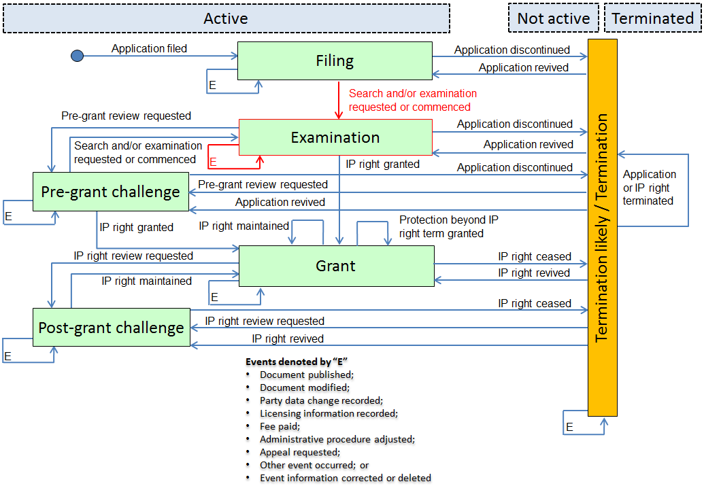
National Event History:
- 2009-10-14: 17P: Request for examination filed
- 2010-03-18: 17Q: First examination report
- 2010-07-15: K1C3: Correction of patent application (complete reprint) published

Key Event History:
- 2009-10-14: D10: Search and/or examination requested or commenced
- 2010-07-15: Q10: Document published

Detailed Event History:
- 2009-10-14: D11: Substantive examination requested
- 2010-03-18: D15: Examination report issued
- 2010-07-15: Q17: Modified document published

Category History:
- 2009-10-14: D: Search and examination
- 2010-03-18: D: Search and examination
- 2010-07-15: Q: Document publication

Mapping Summary:
Event Date | Nat. Code | National Text | Cat. | Key. | Det. | Status Event Code | Remark
2009-10-14 | 17P | Request for examination filed | D | D10 | D11 | A-0-2-D10-D11-17P
2010-03-18 | 17Q | First examination report | D | - | D15 | A-2-2-D00-D15-17Q | "Issue" is limited to communication between the IPO and the applicant/owner as opposed to the public.
2010-07-15 | K1C3 | Correction of patent application (complete reprint) published | Q | Q10 | Q17 | A-1-1-Q10-F11-K1C3 | Regional event, K1C3 corresponds to the republication of a modified document, but does not cover the actual modification and is therefore only mapped to category Q.

Example 2: Application laid open for public inspection
Scenario: An application was laid open for public inspection after the expiration of an eighteen-month confidentiality period starting on the filing date.
CA Example

Basic Information:
- File Creation date: N/A
- Application number: N/A
- Type of IP right: National patent

Overall Patent/SPC Prosecution Model:
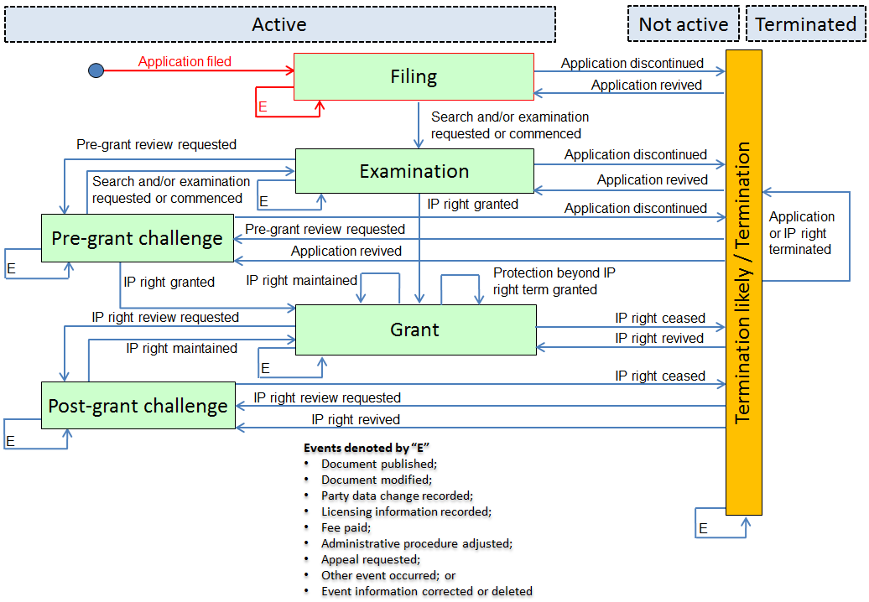
National Event History:
- 2007-04-03: X000: International filing into Interap system
- 2007-08-11: X000: PCT national entry applications
- 2007-09-23: X000: Open to Public Inspection (OPI)

Key Event History:
- 2007-04-03: A10: Application filed
- 2007-08-11: A10: Application filed
- 2007-09-23: Q10: Document published

Detailed Event History:
- 2007-04-03: A13: PCT application filed
- 2007-08-11: A15: PCT application entered into the national or regional phase
- 2007-09-23: Q12: Application published

Category History:
- 2007-04-03: A: Application filed
- 2007-08-11: A: Application filed
- 2007-09-23: Q: Document publication

Mapping Summary:
Event Date | Nat. Code | National Text | Cat. | Key. | Det. | Status Event Code | Remark
2007-04-03 | X000 | International filing into Interap system | A | A10 | A13 | A-0-1-A10-A13-X000
2007-08-11 | X000 | PCT national entry applications | A | A10 | A15 | A-1-1-A10-A15-X000
2007-09-23 | X000 | Open to Public Inspection (OPI) | Q | Q10 | Q12 | A-1-1-Q10-Q12-X000 | Laying open an application is a form of publication as it is made available to the public. The action of laying open the application itself does not trigger a pre-grant review and should therefore be mapped to category Q and not category E.

Category R: Party data change

Example 1: Ownership of a granted patent is transferred
Scenario: The owner of a granted patent assigns complete ownership of the IP right to another party.
CA Example

Basic Information:
- File Creation date: N/A
- Application number: N/A
- Type of IP right: National patent

Overall Patent/SPC Prosecution Model:
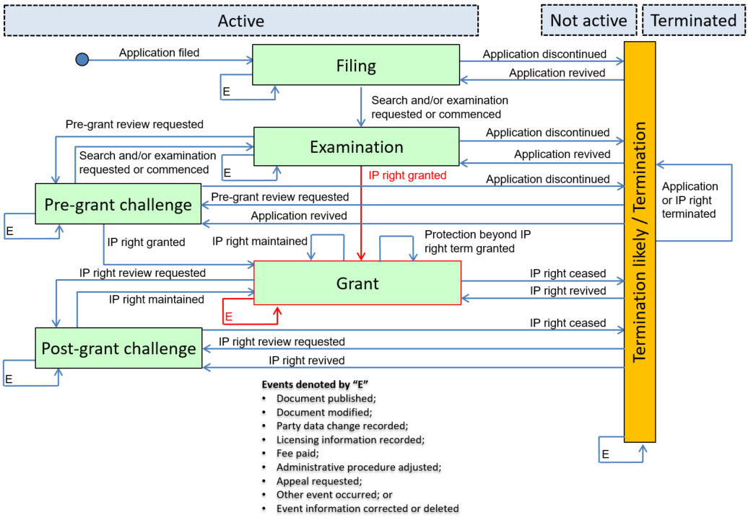
National Event History:
- 2016-05-12: X000: Grant
- 2018-02-04: X000: Assignment

Key Event History:
- 2016-05-12: F10: IP right granted
- 2018-02-04: R10: Party data change recorded

Detailed Event History:
- 2016-05-12: F11: IP right granted following substantive examination
- 2018-02-04: R14: Transfer of ownership recorded

Category History:
- 2016-05-12: F: IP right grant
- 2018-02-04: R: Party data change

Mapping Summary:
Event Date | Nat. Code | National Text | Cat. | Key. | Det. | Status Event Code | Remark
2016-05-12 | X000 | Grant | F | F10 | F11 | A-0-4-F10-F11-X000
2018-02-04 | X000 | Assignment | R | R10 | R14 | A-4-4-R10-R14-X000

US Example Basic Information:
- File Creation date: N/A
- Application number: N/A
- Type of IP right: National patent

Overall Patent/SPC Prosecution Model:
National Event History:
- 2008-09-14: Patent Issue Date: Patent Issue Date
- 2012-05-30: Pre Exam: Ownership change

Key Event History:
- 2008-09-14: F10: IP right granted
- 2012-05-30: R10: Party data change recorded

Detailed Event History:
- 2012-05-30: R12: Change to the name of applicant or owner or transfer of ownership recorded

Category History:
- 2008-09-14: F: IP right grant
- 2012-05-30: R: Party data change

Mapping Summary:
Event Date | Nat. Code | National Text | Cat. | Key. | Det. | Status Event Code | Remark
2008-09-14 | Patent Issue Date | Patent Issue Date | F | F10 | - | A-0-4-F10-F00-Patent Issue Date
2012-05-30 | Pre Exam | Ownership change | R | R10 | R12 | A-4-4-R10-R12-Pre Exam | The US cannot distinguish between a change in owners due to an assignment/transfer of ownership versus a change in the name/composition of owners, therefore this national event is mapped to R12.

Category S: Licensing information

Example 1: The owner of a granted patent licenses it to another party, license amended, and then subsequently cancelled.
Scenario: The owner of a granted patent licenses use of the IP right to another party. The terms of the license are amended and then subsequently the license is cancelled on agreement of the parties.
CA Example

Basic Information:
- File Creation date: N/A
- Application number: N/A
- Type of IP right: National patent

Overall Patent/SPC Prosecution Model:
National Event History:
- 1999-05-19: X000: Grant
- 2001-08-28: X000: License agreement recorded
- 2005-08-23: X000: License agreement termination

Key Event History:
- 1999-05-19: F10: IP right granted
- 2001-08-28: S10: Licensing information recorded
- 2005-08-23: S10: Licensing information recorded

Detailed Event History:
- 1999-05-19: F11: IP right granted following substantive examination
- 2001-08-28: S11: Voluntary license recorded
- 2005-08-23: S13: Recordation of voluntary license cancelled

Category History:
- 1999-05-19: F: IP right grant
- 2001-08-28: S: Licensing information
- 2005-08-23: S: Licensing information

Mapping Summary:
Event Date | Nat. Code | National Text | Cat. | Key. | Det. | Status Event Code | Remark
1999-05-19 | X000 | Grant | F | F10 | F11 | A-0-4-F10-F11-X000
2001-08-28 | X000 | License agreement recorded | S | S10 | R11 | A-4-4-S10-S11-X000 | CA does not have a national event corresponding to the amendment of a license agreement
2005-08-23 | X000 | License agreement termination | S | S10 | S13 | A-4-4-S10-S13-X000

CN Example

Basic Information:
- File Creation date: N/A
- Application number: N/A
- Type of IP right: National patent

Overall Patent/SPC Prosecution Model:
National Event History:
- GR01: The grant of patent right
- EE01: Taking effect of the recordation of contract for exploitation of patent
- EM01: Change of the recordation of contract for exploitation of patent
- EC01: Cancellation of the recordation of contract for exploitation of patent
Key Event History:
- F10: IP right granted
- S10: Licensing information recorded
- S10: Licensing information recorded
- S10: Licensing information recorded

Detailed Event History:
- F11: IP right granted following substantive examination
- S11: Voluntary license recorded
- S12: Recordation of voluntary license amended
- S13: Recordation of voluntary license cancelled

Category History:
- F: IP right grant
- S: Licensing information
- S: Licensing information
- S: Licensing information

Mapping Summary:
Event Date | Nat. Code | National Text | Cat. | Key. | Det. | Status Event Code | Remark
N/A | X000 | The grant of patent right | F | F10 | F11 | A-0-4-F10-F11-GR01
N/A | X000 | Taking effect of the recordation of contract for exploitation of patent | S | S10 | S11 | A-4-4-S10-S11-EE01
N/A | X000 | Change of the recordation of contract for exploitation of patent | S | S10 | S12 | A-4-4-S10-S12- EM01
N/A | X000 | Cancellation of the recordation of contract for exploitation of patent | S | S10 | S13 | A-4-4-S10-S13- EC01

UA Example

Basic Information:
- File Creation date: N/A
- Application number: N/A
- Type of IP right: National patent

Overall Patent/SPC Prosecution Model:
National Event History:
- 2007-11-07: X000: Grant of a patent for an invention
- 2009-10-21: X000: Grant of a license to use
- 2013-04-06: X000: Amendments to the recorded information on the grant of a license to use
- 2015-08-11: X000: Early termination of a license agreement by mutual consent of the parties

Key Event History:
- 2007-11-07: F10: IP right granted
- 2009-10-21: S10: Licensing information recorded
- 2013-04-06: S10: Licensing information recorded
- 2015-08-11: S10: Licensing information recorded

Detailed Event History:
- 2007-11-07: F11: IP right granted following substantive examination
- 2009-10-21: S11: Voluntary license recorded
- 2013-04-06: S12: Recordation of voluntary license amended
- 2015-08-11: S13: Recordation of voluntary license cancelled

Category History:
- 2007-11-07: F: IP right grant
- 2009-10-21: S: Licensing information
- 2013-04-06: S: Licensing information
- 2015-08-11: S: Licensing information

Mapping Summary:
Event Date | Nat. Code | National Text | Cat. | Key. | Det. | Status Event Code | Remark
2007-11-07 | X000 | Grant of a patent for an invention | F | F10 | F11 | A-0-4-F10-F11-X000
2009-10-21 | X000 | Grant of a license to use | S | S10 | S11 | A-4-4-S10-S11-X000
2013-04-06 | X000 | Amendments to the recorded information on the grant of a license to use | S | S10 | S12 | A-4-4-S10-S12-X000
2015-08-11 | X000 | Early termination of a license agreement by mutual consent of the parties | S | S10 | S13 | A-4-4-S10-S13-X000

Category T: Administrative procedure adjustment

Example 1: Prosecution of application interrupted and resumed
Scenario: During the prosecution of the application of a regional patent, the applicant company enters into receivership and the prosecution is interrupted. Once the receivership ends, the prosecution of the application resumes.
EP Patent Office

Basic Information:
- File Creation date: N/A
- Application number: N/A
- Type of IP right: Regional patent application

Overall Patent/SPC Prosecution Model:
National Event History:
- 2006-05-12: 17P: Request for examination filed
- 2007-01-03: 19U: Interruption of proceedings before grant
- 2007-06-28: 19W: Resumption of proceedings before grant (after interruption of proceedings)

Key Event History:
- 2006-05-12: D10: Search and/or examination requested or commenced
- 2007-01-03: T10: Administrative procedure adjusted
- 2007-06-28: T10: Administrative procedure adjusted

Detailed Event History:
- 2006-05-12: D11: Substantive examination requested
- 2007-01-03: T15: Administrative procedure interrupted
- 2007-06-28: T16: Administrative procedure resumed

Category History:
- 2006-05-12: D: Search and examination
- 2007-01-03: T: Administrative procedure adjustment
- 2007-06-28: T: Administrative procedure adjustment

Mapping Summary:
Event Date | Nat. Code | National Text | Cat. | Key. | Det. | Status Event Code | Remark
2006-05-12 | 17P | Request for examination filed | D | D10 | D11 | A-0-2-D10-D11-17P
2007-01-03 | 19U | Interruption of proceedings before grant | T | T10 | T15 | A-2-2-T10-T15-19U
2007-06-28 | 19W | Resumption of proceedings before grant (after interruption of proceedings) | T | T10 | T16 | A-2-2-T10-T16-19W

Category U: Payment

Example 1: Registration and renewal fee paid
Scenario: The applicant paid the necessary fee to have the patent granted. On the first anniversary of the grant of the patent the applicant paid the annual fee to maintain the patent.
KR Example

Basic Information:
- File Creation date: N/A
- Application number: N/A
- Type of IP right: National patent

Overall Patent/SPC Prosecution Model:
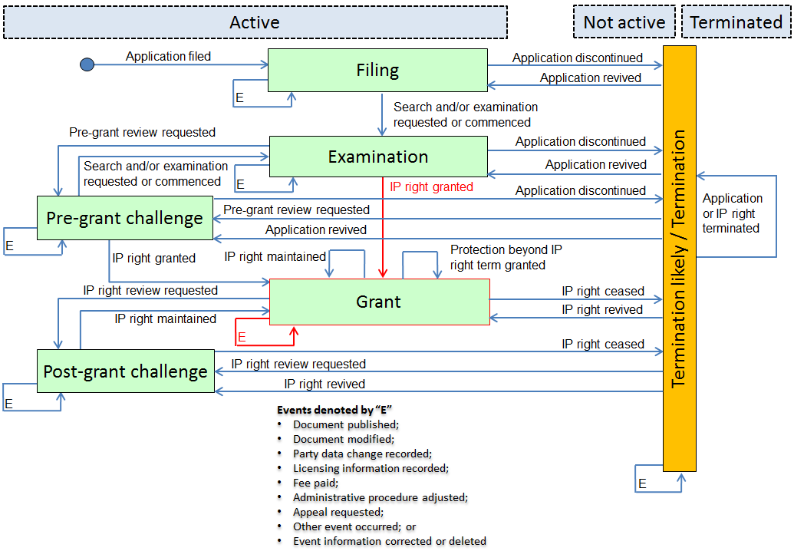

National Event History:
- 2012-12-14: PR1002: Payment of Registration Fee
- 2012-12-14: PR0702: Registration of Establishment of National Patent
- 2013-12-14: PR1001: Payment of Annual Fee

Key Event History:
- 2012-12-14: U10: Fee paid
- 2012-12-14: F10: IP right granted
- 2013-12-14: U10: Fee paid

Detailed Event History:
- 2013-12-14: U11: Renewal or maintenance fee paid

Category History:

- 2012-12-14: U: Payment
- 2012-12-14: F: IP right grant
- 2013-12-14: U: Payment

Mapping Summary:
Event Date | Nat. Code | National Text | Cat. | Key. | Det. | Status Event Code | Remark
2012-12-14 | PR1002 | Payment of Registration Fee | U | U10 | - | A-0-0-U10-U00-PR1002
2012-12-14 | PR0702 | Registration of Establishment of National Patent | F | F10 | - | A-0-4-F10-F00- PR0702
2013-12-14 | PR1001 | Payment of Annual Fee | U | U10 | U11 | A-0-0-U10-U00-PR1001

Category V: Appeal

Example 1: Appeal regarding request to change inventors
Scenario: Following the grant of an IP right, a third party requested the IPO to make a change to the inventors listed on the IP right document. The IPO agreed to the request and changed the inventors listed on the IP right document. The IP right owner appealed the decision of the IPO to change the inventors listed on the IP right document and the appeal was unsuccessful.
Remark: The IPO cannot distinguish between an appeal made to an administrative body or a court.
IPO Example

Basic Information:
- File Creation date:
- Application number:
- Type of IP right: National patent

Overall Patent/SPC Prosecution Model:
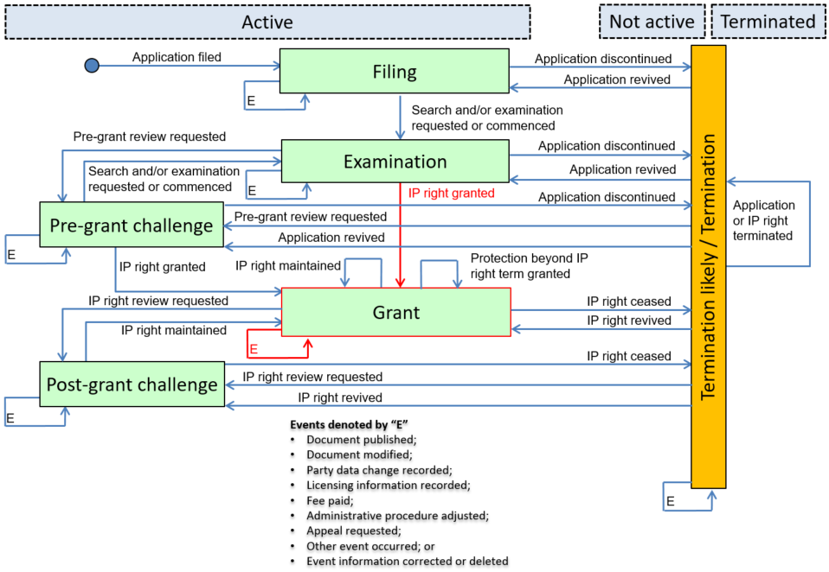
Key Event History:
- 2010-05-17: F10: IP right granted
- 2012-12-22: R10: Party data change recorded
- 2013-04-11: V10: Appeal requested

Detailed Event History:
- 2012-08-09: R15: Change to inventor requested
- 2012-12-22: R16: Change to inventor recorded
- 2014-01-10: V13: Appeal inadmissible, rejected or withdrawn

Category History:
- 2010-05-17: F: IP right grant
- 2012-08-09: R: Party data change
- 2012-12-22: R: Party data change
- 2013-04-11: V: Appeal
- 2014-01-10: V: Appeal

Mapping Summary:
Event Date | Nat. Code | National Text | Cat. | Key. | Det. | Status Event Code | Remark
2010-05-17 | X000 | N/A | F | F10 | - | A-2-4-F10-F00-X000
2012-08-09 | X000 | N/A | R | - | R15 | A-4-4-R00-R15-X000
2012-12-22 | X000 | N/A | R | R10 | R16 | A-4-4-R10-R16-X000
2013-04-11 | X000 | N/A | V | V10 | - | A-4-4-V10-V00-X000 | The IPO cannot distinguish between an appeal made to an administrative body or a court.
2014-01-10 | X000 | N/A | V | - | V13 | A-4-4-V00-V13-X000

Example 2: Appeal regarding unpaid fee
Scenario: Following the grant of an IP right, the IPO recorded that the IP right owner failed to pay a maintenance fee and consequently the IP right lapsed. The IP right owner appealed the IPO’s decision that the patent lapsed due to non-payment of a maintenance fee. The appeal board/court substituted its own decision after finding that the maintenance fee was actually paid and consequently revives the IP right.
Remark: The IPO cannot distinguish between an appeal made to an administrative body or a court.
IPO Example

Basic Information:
- File Creation date:
- Application number:
- Type of IP right: National patent

Overall Patent/SPC Prosecution Model:
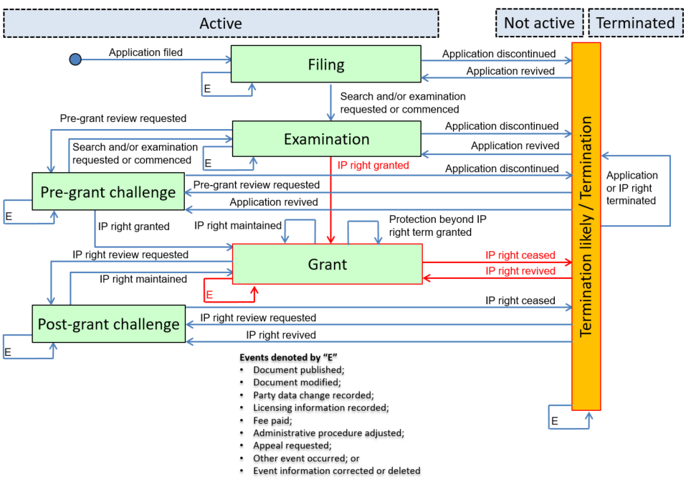
Key Event History:
- 2007-11-14: F10: IP right granted
- 2009-05-14: H10: IP right ceased
- 2009-08-23: V10: Appeal requested
- 2009-12-13: U10: Fee paid
- 2009-12-13: K10: IP right revived

Detailed Event History:
- 2008-11-14: U13: Renewal or maintenance fee not paid
- 2009-05-14: H13: IP right lapsed
- 2009-12-13: V15: Decision substituted
- 2009-12-13: U11: Renewal or maintenance fee paid
- 2009-12-13: K13: IP right revived in full

Category History:
- 2007-11-14: F: IP right grant
- 2008-11-14: U: Payment
- 2009-05-14: H: IP right cessation
- 2009-08-23: V: Appeal
- 2009-12-13: V: Appeal
- 2009-12-13: U: Payment
- 2009-12-13: K: IP right revival

Mapping Summary:
Event Date | Nat. Code | National Text | Cat. | Key. | Det. | Status Event Code | Remark
2007-11-14 | X000 | N/A | F | F10 | - | A-2-4-F10-F00-X000
2008-11-14 | X000 | N/A | U | - | U13 | A-4-4-U00-U13-X000
2009-05-14 | X000 | N/A | H | H10 | H13 | N-4-6-H10-H13-X000
2009-08-23 | X000 | N/A | V | V10 | - | N-6-6-V10-V00-X000 | The IPO cannot distinguish between an appeal made to an administrative body or a court.
2009-12-13 | X000 | N/A | V | - | V15 | N-0-0-V00-V15-X000
2009-12-13 | X000 | N/A | U | U10 | U11 | N-0-0-U10-U11-X000 | The effective date for the payment of the maintenance fee would be retroactive in this example.
2009-12-13 | X000 | N/A | K | K10 | K13 | A-0-4-K10-K13-X000

Example 3: Appeal regarding pre-grant opposition
Scenario: Following an unsuccessful pre-grant opposition an IP right was granted in full. The third party that filed the opposition appeals the decision of the IPO to grant the IP right in full. The appeal board/court remanded the decision back to the IPO for reconsideration. The IPO reviewed the opposition and changed their decision and granted the IP right in amended form.
Remark: The IPO cannot distinguish between an appeal made to an administrative body or a court.
IPO Example

Basic Information:
- File Creation date:
- Application number:
- Type of IP right: National patent

Overall Patent/SPC Prosecution Model:
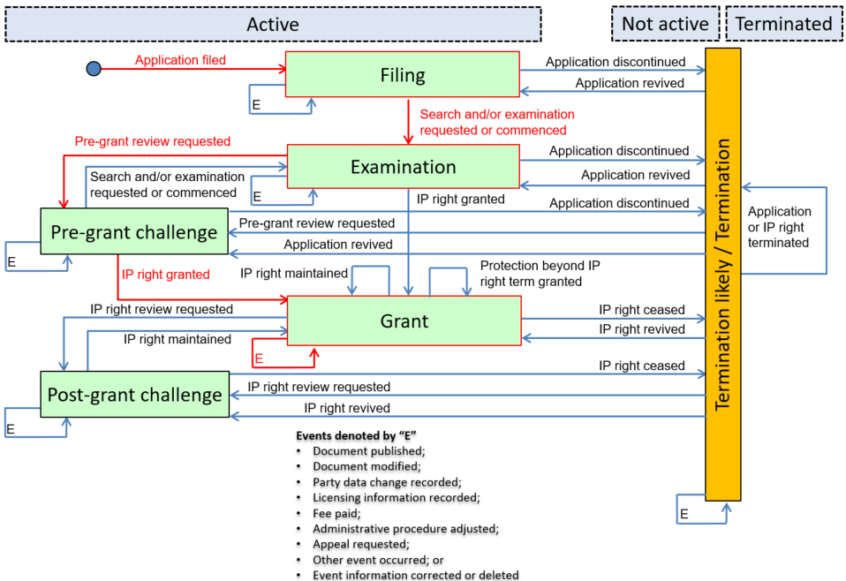
Key Event History:
- 2005-03-12: A10: Application filed
- 2005-06-01: D10: Search and/or examination requested or commenced
- 2005-09-12: E10: Pre-grant review requested
- 2006-07-13: F10: IP right granted
- 2006-11-21: V10: Appeal requested
- 2007-05-18: F10: IP right granted

Detailed Event History:
- 2005-06-01: D11: Substantive examination requested
- 2005-09-12: E11: Pre-grant opposition filed
- 2006-07-13: F13: IP right granted in full following pre-grant review
- 2007-02-11: V14: Decision remanded
- 2007-05-18: F14: IP right granted in full following pre-grant review

Category History:
- 2005-03-12: A: Application filing
- 2005-06-01: D: Search and examination
- 2005-09-12: E: Pre-grant review request
- 2006-07-13: F: IP right grant
- 2006-11-21: V: Appeal
- 2007-02-11: V: Appeal
- 2007-05-18: F: IP right grant

Mapping Summary:
Event Date | Nat ode | National Text | Cat. | Key. | Det. | Status Event Code | Remark
2005-03-12 | X000 | N/A | A | A10 | - | A-0-1-A10-A00-X000
2005-06-01 | X000 | N/A | D | D10 | D11 | A-1-2-D10-D11-X000
2005-09-12 | X000 | N/A | E | E10 | E11 | A-2-3-E10-E11-X000
2006-07-13 | X000 | N/A | F | F10 | F13 | A-3-4-F10-F13-X000
2006-11-21 | X000 | N/A | V | V10 | - | A-4-4-V10-V00-X000 | The IPO cannot distinguish between an appeal made to an administrative body or a court.
2007-02-11 | X000 | N/A | V | - | V14 | A-0-0-V00-V14-X000
2007-05-18 | X000 | N/A | F | F10 | F14 | A-0-4-F10-F14-X000

Example 4: Appeal regarding intention to reject application
Scenario: Following a substantive examination, the IPO intended to reject the application. The applicant amended the application and requested a re-examination. The IPO still intended to reject application. The applicant appealed the IPO’s second decision to intend to reject the application. The appeal was unsuccessful and the application was discontinued.
Remark: The IPO cannot distinguish between an appeal made to an administrative body or a court.
IPO Example

Basic Information:
- File Creation date:
- Application number:
- Type of IP right: National patent

Overall Patent/SPC Prosecution Model:
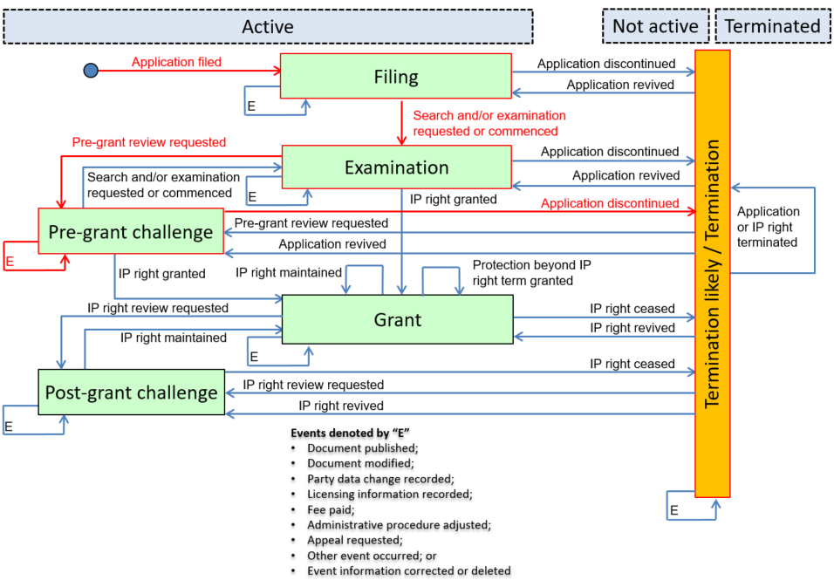
Key Event History:
- 2002-03-19: A10: Application filed
- 2002-05-29: D10: Search and/or examination requested or commenced
- 2002-12-11: P10: Document modified
- 2002-12-11: E10: Pre-grant review requested
- 2003-06-11: V10: Appeal requested
- 2003-08-14: B10: Application discontinued

Detailed Event History:
- 2002-05-29: D11: Substantive examination requested
- 2002-09-21: D21: Rejection of application intended
- 2002-12-11: P13: Application amended
- 2002-12-11: E12: Pre-grant re-examination requested
- 2003-03-19: D21: Rejection of application intended
- 2003-08-14: V13: Appeal inadmissible, rejected or withdrawn
- 2003-08-14: B15: Application refused following examination

Category History:
- 2002-03-19: A: Application filing
- 2002-05-29: D: Search and examination
- 2002-09-21: D: Search and examination
- 2002-12-11: P: Document modification
- 2002-12-11: E: Pre-grant review request
- 2003-03-19: D: Search and examination
- 2003-06-11: V: Appeal
- 2003-08-14: V: Appeal
- 2003-08-14: B: Application discontinuation

Mapping Summary:
Event Date | Nat. Code | National Text | Cat. | Key. | Det. | Status Event Code | Remark
2002-03-19 | X000 | N/A | A | A10 | - | A-0-1-A10-A00-X000
2002-05-29 | X000 | N/A | D | D10 | D11 | A-1-2-D10-D11-X000
2002-09-21 | X000 | N/A | D | - | D21 | A-2-2-D00-D21-X000
2002-12-11 | X000 | N/A | P | P10 | P13 | A-2-2-P10-P13-X000
2002-12-11 | X000 | N/A | E | E10 | E12 | A-2-3-E10-E12-X000
2003-03-19 | X000 | N/A | D | - | D21 | A-3-3-D00-D21-X000
2003-06-11 | X000 | N/A | V | V10 | - | A-0-0-V10-V00-X000 | The IPO cannot distinguish between an appeal made to an administrative body or a court.
2003-08-14 | X000 | N/A | V | - | V13 | A-0-0-V00-V13-X000
2003-08-14 | X000 | N/A | B | B10 | B15 | N-0-6-B10-B00-X000

Category W: Other

Example 1: Patent application validated in third-party country
Scenario: A European patent application is validated in a third-party country (e.g., Morocco).
EP Example

Basic Information:
- File Creation date: N/A
- Application number: N/A
- Type of IP right: Regional patent application

Overall Patent/SPC Prosecution Model:
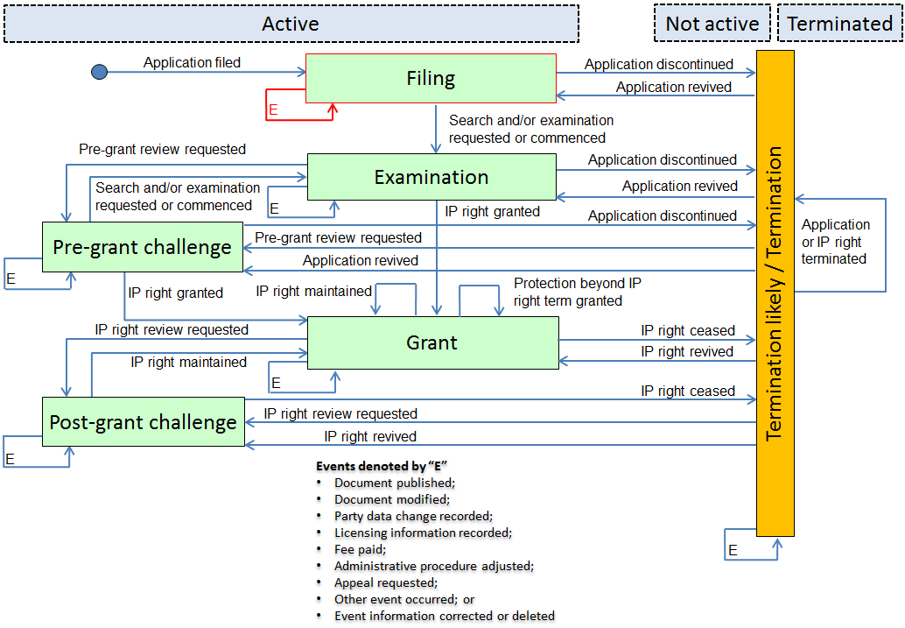
National Event History:
- 2012-11-16: AV: Request for validation of the European patent in

Key Event History:
- 2012-11-16: W10: Other event occurred

Detailed Event History:
- N/A

Category History:
- 2012-11-16: W: Other

Mapping Summary:
Event Date | Nat. Code | National Text | Cat. | Key. | Det. | Status Event Code | Remark
2012-11-16 | AV | Request for validation of the European patent in | W | W10 | - | A-0-1-W10-W00-AV | The European Patent Office does not have a regional event corresponding to the filing of a regional application. However, a European patent application is automatically deemed to be a request to validate the effects of the application to all states with which there is a validation agreement in force on the date on which the application is filed. This regional event does not correspond to any other category.

Category Y: Correction and deletion of event information

Example 1: Incorrectly recorded resumption of proceedings is corrected
Scenario: During the prosecution of the application of a regional patent, the applicant company enters into receivership and the prosecution is interrupted. The IPO is incorrectly notified that the receivership ended; the prosecution of the application resumes and the error is then corrected.
EP Example

Basic Information:
- File Creation date: N/A
- Application number: N/A
- Type of IP right: Regional patent application

Overall Patent/SPC Prosecution Model:
National Event History:
- 2013-11-27: 17P: Request for examination filed
- 2014-02-19: 19U: Interruption of proceedings before grant
- 2014-07-21: 19W: Resumption of proceedings before grant (after interruption of proceedings)
- 2014-08-11: D19F: Previously announced "resumption after interruption of proceedings" was erroneous

Key Event History:
- 2013-11-27: D10: Search and/or examination requested or commenced
- 2014-02-19: T10: Administrative procedure adjusted
- 2014-07-21: T10: Administrative procedure adjusted
- 2014-08-11: Y10: Event information corrected or deleted

Detailed Event History:
- 2013-11-27: D11: Substantive examination requested
- 2014-02-19: T15: Administrative procedure interrupted
- 2014-07-21: T16: Administrative procedure resumed

Category History:
- 2013-11-27: D: Search and examination
- 2014-02-19: T: Administrative procedure adjustment
- 2014-07-21: T: Administrative procedure adjustment
- 2014-08-11: Y: Correction and deletion of event information

Mapping Summary:
Event Date | Nat. Code | National Text | Cat. | Key. | Det. | Status Event Code | Remark
2013-11-27 | 17P | Request for examination filed | D | D10 | D11 | A-0-2-D10-D11-17P
2014-02-19 | 19U | Interruption of proceedings before grant | T | T10 | T15 | A-2-2-T10-T15-19U
2014-07-21 | 19W | Resumption of proceedings before grant (after interruption of proceedings) | T | T10 | T16 | A-2-2-T10-T16-19W
2014-08-11 | D19F | Previously announced "resumption after interruption of proceedings" was erroneous | Y | Y10 | - | A-2-2-Y10-Y00-D19F | The effective date of this event would be retroactive.

[End of Annex II and of document]

According to WIPO Standard ST.27, the code “X000” is given to the national events to which the IPO has not assigned any national or regional event code.

