A/R/W | Prop. No./nº | Cl. | Basic No. or Place/  Nº de base ou endroit | EN/FR | M/S | Action | Existing entry/  Entrée existante | New or modified entry/  Nouvelle entrée ou entrée modifiée | New Cl./  Nlle cl. | Remarks/  Remarques | Comments from Offices/  Commentaires des Offices | Responses to comments/  Réponses aux commentaires | T
 | US-28-1 | 6 | New ind. in  NCL12-2022 | EN |  | -- | queue ticket dispensers of metal |  |  | This term will be added to the Alphabetical List as part of Nice 12-2022, effective January 1, 2022.  *No proposed change*
 | US-28-1 | 6 | Nouvelle ind.  dans  NCL12-2022 | FR |  | -- | distributeurs métalliques de tickets pour la gestion de files d’attente
 | US-28-2 | 20 | New ind. in  NCL12-2022 | EN |  | -- | queue ticket dispensers, not of metal |  |  | This term will be added to the Alphabetical List as part of Nice 12-2022, effective January 1, 2022.  *No proposed change*
 | US-28-2 | 20 | Nouvelle ind.  dans  NCL12-2022 | FR |  | -- | distributeurs non métalliques de tickets pour la gestion de files d’attente
 | US-28-3 | 7 | New ind. in  NCL12-2022 | EN |  | -- | ticket vending machines |  |  | “Ticket vending machines” will be added to the Alphabetical List in Class 7 as part of Nice 12-2022, effective January 1, 2022.  *No proposed change* | IB: The CE approved the addition of this term to the Alphabetical List as part of Nice 12-2022, effective January 1, 2022.  IB: Concerning the addition of the synonym “ticket dispensing machines” to this term, the IB is of the opinion that the proposed synonym does not contain the concept of “selling/vending”, which was the main reason for accepting the term in Cl. 7. | USPTO withdraws the proposal to add the alternate wording “ticket dispensing machines.” USPTO also proposes to delete “automatic machines, distribution” (Basic No. 070537), which was the basis for the initial proposal. See also WO-13-43.
 | US-28-3 | 7 | Nouvelle ind.  dans  NCL12-2022 | FR |  | -- | distributeurs automatiques de billets ou de tickets
W | US-28-4 | 7 | 070537 | EN |  | -- | vending machines |  |  |  |  | See the IB’s proposals WO-13-43 to delete “distribution machines, automatic,” and change “distributeurs automatiques” to “distributeurs automatiques de vente”
W | US-28-4 | 7 | 070537 | EN |  | Delete | distribution machines, automatic
W | US-28-4 | 7 | 070537 | FR |  | changer | distributeurs automatiques | distributeurs automatiques de vente
A | US-28-5 | 7 |  | EN |  | Add |  | fluid dispensing machines for industrial use |  |  |  | USPTO proposes this new term as an example of the type of “dispensing machine” that is properly classified in Class 7. 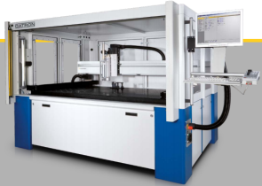  The DATRON PRXL series of portal dispensing machines is ideally designed for large-format workpieces and nesting. Dispensing speeds of up to 20 m/min (333 mm/s) are achievable, providing shortest possible cycle times. DATRON PRXL dispensing machines are available with different operating ranges possible cycle times. http://marketing.datrondynamics.com/acton/attachment/6438/f-009b/1/-/-/-/-/DATRON%20Dispensing%20Systems.pdf | T
A | US-28-5 | 7 |  | FR |  | ajouter |  | distributeurs de fluides à usage industriel |  |  |  |  | T
 | US-28-6 | 9 | 090086 changed in  NCL12-2022 | EN |  | -- | ticket dispensing terminals, electronic |  |  | As part of Nice 12-2022, effective January 1, 2022, the existing term “ticket dispensers” (Basic No. 090086) will be changed to “ticket dispensing terminals, electronic.”  *No proposed change*
 | US-28-6 | 9 | 090086 changé dans  NCL12-2022 | FR |  | -- | terminaux électroniques de distribution de tickets
A | US-28-7 | 6 | 060452 | EN |  | Change | dispensers for dog waste bags, fixed, of metal | dispensers of metal for dog waste bags |  | 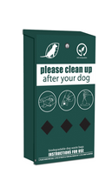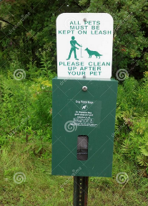 | IB: change to “dispensers of metal for dog waste bags” | USPTO adopts with the IB’s suggestion and modifies the proposal from “dispensers for dog waste bags, of metal, other than for household” to the current wording. | T
A | US-28-7 | 6 | 060452 | FR |  | changer | distributeurs métalliques fixes de sacs pour déjections canines | distributeurs métalliques de sacs pour déjections canines |  |  |  |  | T
A | US-28-8 | 20 | 200295 | EN |  | Change | dispensers for dog waste bags, fixed, not of metal | dispensers, not of metal, for dog waste bags |  |  | IB: change to “dispensers, not of metal, for dog waste bags” | 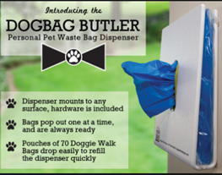  USPTO adopts the IB’s suggestion and modifies the proposal from “dispensers for dog waste bags, not of metal, other than for household” to the current wording. | T
A | US-28-8 | 20 | 200295 | FR |  | changer | distributeurs non métalliques fixes de sacs pour déjections canines | distributeurs non métalliques de sacs pour déjections canines |  |  |  |  | T
A | US-28-9 | 18 |  | EN |  | Add |  | dog waste bag dispensers adapted for use with leashes |  | 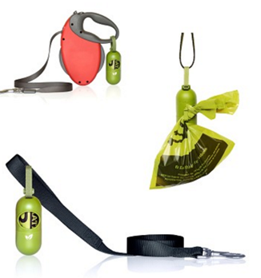  whitedogbone | IB: “dog waste bag dispensers adapted for use with animal leashes”  Since this indication refers to dog waste bag dispensers, is the term “animal” necessary?  These dispensers do not seem to be “adapted”. They rather fit in any kind of leashes, so we prefer “for use with”. Even if not really adapted to dog leashes, these dispensers would still be acceptable in Cl. 18 because it is the class of collars, leashes, clothing and other articles for animals. | USPTO modifies the proposal from “dog waste bag dispensers adapted for use with animal leashes” to the current wording.  The IB suggested alternative wording “dog waste dispensers for use with leashes.” USPTO prefers to retain the term “adapted.” The “dog waste bag dispensers adapted for use with leashes” are very different from the dog waste bag dispensers classified in Class 6 and Class 20, see Proposal Nos. 7 and 8. While all of the goods are containers, these particular containers are adapted for use with leashes in that they are smaller, portable, without sharp edges, and feature a loop or fastener. | T
A | US-28-9 | 18 |  | FR |  | ajouter |  | distributeurs de sacs pour déjections canines conçus pour s’adapter à une laisse |  |  |  |  | T
A | US-28-10 | 6 | 060358 | EN |  | Change | towel dispensers, fixed, of metal | towel dispensers of metal |  | 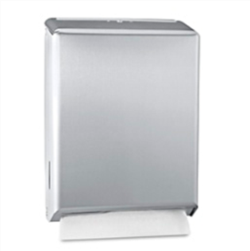 | IB: Includes automatic and non-automatic dispensers.  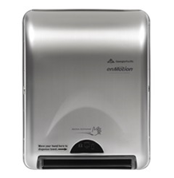  change to “towel dispensers of metal” | USPTO adopts the IB’s suggestion and modifies the proposal from “towel dispensers of metal, other than for household use” to the current wording. | T
A | US-28-10 | 6 | 060358 | FR |  | changer | distributeurs fixes de serviettes métalliques | distributeurs métalliques de serviettes |  |  |  |  | T
A | US-28-11 | 20 | 200084 | EN |  | Change | towel dispensers, fixed, not of metal | towel dispensers, not of metal |  | 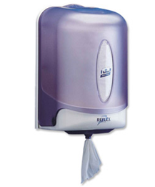 | IB: automatic and non-automatic  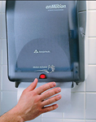  change to “towel dispensers, not of metal” | USPTO adopts the IB’s suggestion and modifies the proposal from “towel dispensers, not of metal, other than for household use” to the current wording. | T
A | US-28-11 | 20 | 200084 | EN |  | Delete | towel dispensers, not of metal, fixed |  |  |  |  |  | T
A | US-28-11 | 20 | 200084 | FR |  | changer | distributeurs fixes de serviettes non métalliques | distributeurs non métalliques de serviettes |  |  |  |  | T
A | US-28-12 | 21 | 210036 | EN |  | Change & Transfer | boxes for dispensing paper towels | boxes of metal for dispensing paper towels | 6 | 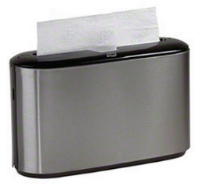 | IB: Change to “boxes of metal for dispensing paper towels” & transfer to 6  Or delete entry, as it is covered by “towel dispensers of metal”? | USPTO adopts the IB’s suggestion and modifies the proposal from “boxes, for household use, for dispensing paper towels” to the current proposal to change and transfer Basic No. 210036 to Class 6.  USPTO prefers to change and transfer the existing term (instead of deleting it) to illustrate that generally both “dispensers” and “containers for dispensing” are classified in Class 6 when comprised of metal and Class 20 when comprised of non-metal. | T
A | US-28-12 | 21 | 210036 | FR |  | changer & transférer | boîtes pour la distribution de serviettes en papier | boîtes métalliques pour la distribution de serviettes en papier | 6 |  |  |  | T
A | US-28-13 | 20 |  | EN |  | Add |  | boxes, not of metal, for dispensing paper towels |  | See Proposal No. 14 above. | IB: Add “boxes, not of metal, for dispensing paper towels” in cl. 20  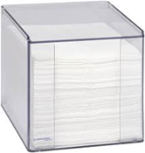  Or not necessary as it is covered by “towel dispensers, not of metal”?  IB: Add “covers for paper tissue boxes” in cl. 21. Regardless of material  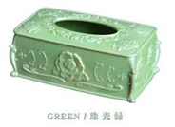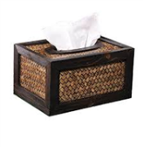 | USPTO adopts the IB’s suggestion and proposes to add to “boxes, not of metal, for dispensing paper towels” as a corollary to Proposal No. 12. | T
A | US-28-13 | 20 |  | FR |  | ajouter |  | boîtes non métalliques pour la distribution de serviettes en papier |  |  |  |  | T
A | US-28-14 | 21 |  | EN |  | Add |  | covers for tissue boxes |  |  |  | USPTO adopts the IB’s suggestion and proposes “covers for paper tissue boxes” in Class 21.  USPTO currently classifies these goods in various classes based on material composition. However, classifying them based on their function as household containers simplifies the classification practice. | T
A | US-28-14 | 21 |  | FR |  | ajouter |  | couvre-boîtes de mouchoirs |  |  |  |  | T
A | US-28-15 | 21 | 210116 | EN |  | Change & Transfer | toilet paper dispensers | toilet paper dispensers of metal | 6 |  | IB: Change to “toilet paper dispensers of metal” & transfer to Cl. 6  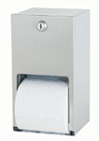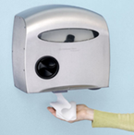  Automatic and non-automatic | USPTO adopts the IB’s suggestion and modifies the proposal from “toilet paper dispensers for household use” to the current proposal to change and transfer Basic No. 210116 to Class 6. | T
A | US-28-15 | 21 | 210116 | FR |  | changer & transférer | distributeurs de papier hygiénique | distributeurs métalliques de papier hygiénique | 6 |  |  |  | T
A | US-28-16 | 20 |  | EN |  | Add |  | toilet paper dispensers, not of metal |  | 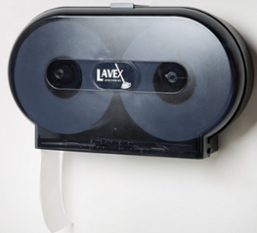 | IB: Add “toilet paper dispensers, not of metal”  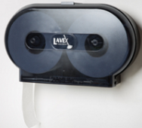  Automatic and non-automatic | USPTO adopts the IB’s suggestion and proposes to add to “toilet paper dispensers, not of metal” as a corollary to Proposal No. 15. | T
A | US-28-16 | 20 |  | FR |  | ajouter |  | distributeurs non métalliques de papier hygiénique |  |  |  |  | T
W | US-28-17 | 21 | 210335 | EN |  | Change & Transfer | toilet paper holders | toilet paper holders of metal | 6 | 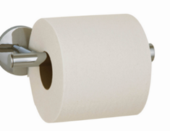 | IB: unchanged  Preferably in Cl. 21 as it is a holder, not a dispenser. However, if considered as dispensers, toilet paper holders could also be classified in classes 6 and 20, of metal/not of metal. | USPTO modifies the proposal from “toilet paper dispensers for household use” to the current proposal to change and transfer Basic No. 210335 to Class 6.  The IB prefers to classify the term “toilet paper holders” in Class 21 because, the IB says, “it is a holder.” However, the justification for classifying the goods in Class 21 is not clear. Holders are classified in various classes depending on the nature of the goods, or in the same class as the goods for which the holder is intended. See, for example, “blade holder [parts of machines]” Basic No. 070220), “saw holders” (Basic No 080186), “pencil holders” (Basic No. 160113), among others.  USPTO prefers classification based on material composition, in Class 6 when metal or Class 20 when not of metal, because the function of the goods does not appear to be covered by the Nice Classification. See General Remarks, Goods (a).
W | US-28-17 | 21 | 210335 | FR |  | changer & transférer | porte-rouleaux pour papier hygiénique | porte-rouleaux métalliques pour papier hygiénique | 6
W | US-28-18 | 20 |  | EN |  | Add |  | toilet paper holders, not of metal |  |  |  | USPTO proposes this term as a corrollary to Proposal No. 17.
W | US-28-18 | 20 |  | FR |  | ajouter |  | porte-rouleaux non métalliques pour papier hygiénique
W | US-28-19 | 16 | 160003 | EN |  | Change | adhesive tape dispensers [office requisites] | adhesive tape dispensers [office requisites], other than machines |  | 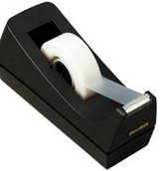 | The IB prefers not to change this entry to “adhesive tape dispensers for office use, non-electric” because the proposed wording makes unclear the classification of tape dispensers that are not for office use and tape dispensers that are electric and for office use.  The current situation is clearer: all adhesive tape dispensers are in Cl. 16 on grounds that they are considered to be office requisites, with the exception of tape dispensers that are considered to be machines (cl. 7). | USPTO modifies the proposal from “adhesive tape dispensers for office use, non-electric“ to “adhesive tape dispensers [office requisites], other than machines.”  USPTO’s proposal makes clear the IB’s interpretation of Basic No 160003 (all adhesive tape dispensers are in Cl. 16 on grounds that they are considered to be office requisites, with the exception of tape dispensers that are considered to be machines (cl. 7)), which may be implicit in the current wording, but should be incorporated into the ID to provide guidance to Nice Classification users.
W | US-28-19 | 16 | 160003 | FR |  | changer | distributeurs de ruban adhésif [articles de papeterie] | distributeurs de ruban adhésif [articles de bureau] autres que machines
A | US-28-20 | 7 | 070004 | EN |  | Change | adhesive tape dispensers [machines] | tape dispensing machines for industrial use |  |  |  | USPTO modifies its proposal from “adhesive tape dispensing machines” to “industrial tape dispensing machines.”  USPTO’s modified proposal is a specific example of the type of “dispensing machine” classified in Class 7 consistent with Proposal No. 5.  The START International ZCM1000 (The Original M1000) electric tape dispenser automatically cuts and advances predefined tape lengths and is suitable for medium to high production of repetitive taping in industrial applications.  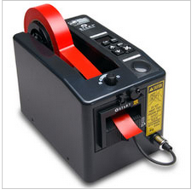  start | T
A | US-28-20 | 7 | 070004 | FR |  | changer | distributeurs de ruban adhésif [machines] | distributeurs industriels de ruban |  |  |  | IB : does « industrial » refer to « machine » or to « tape » ? Tape dispensing machines for industrial use?  Adhesive tape? see US-28-43, last proposal in this document | T
 | US-28-21 | 7 | 070542 | EN |  | -- | fuel dispensing pumps for service stations |  |  | *No proposed change*
 | US-28-21 | 7 | 070542 | FR |  | -- | distributeurs de carburants pour stations-service
A | US-28-22 | 7 |  | EN |  | Add |  | petrol pumps for service stations |  |  |  |  | T
A | US-28-22 | 7 |  | EN |  | Add |  | gas pumps for service stations |  |  | IB: The term “fuel” (“carburant” in FR) is broader in meaning than “gas” or “gasoline” (“petrol” in British EN, “essence” in FR). The IB would therefore prefer to add this indication as a separate entry. | 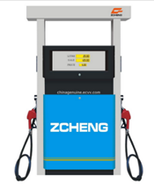  USPTO adopts the IB’s suggestion and proposes adding this new term in Class 7. The IB indicates that the term “fuel” (“caburant”) is more broad than “gas” or “gasoline” or “petrol” (“essence”). | T
A | US-28-22 | 7 |  | FR |  | ajouter |  | pompes à essence pour stations-services |  |  |  |  | T
A | US-28-23 | 9 | 090565 | EN |  | Delete | dosage dispensers |  |  | Dosage dispensers and dosimeters are different goods and should be assigned different Basic Nos.  Dosimeters are devices for measuring radiation doses. These goods are classified in Class 9 based on “measuring instruments” (Basic No. 090347). Dictionary | The IB agrees with the separation of these terms | USPTO maintains this proposal as worded and classified and thanks the IB for its support. | T
A | US-28-23 | 9 | 090565 | EN |  | -- | dosimeters |  |  |  |  |  | T
A | US-28-23 | 9 | 090565 | FR |  | -- | doseurs |  |  |  |  |  | T
A | US-28-23 | 9 | 090565 | FR |  | supprimer | appareils de dosage |  |  |  |  |  | T
A | US-28-24 | 9 |  | EN |  | Add |  | dosage dispensers, not for medical use [measuring apparatus] |  |  | IB: “dosage dispensers, electric, not for medical use” Electric or non-electric, dosage dispensers that are not for medical purposes would be in Cl. 9 as a kind of measuring apparatus. | 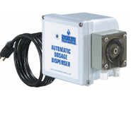  USPTO modifies the proposal from “dosage dispensers, electric, not for medical use” to “dosage dispensers, not for medical use [measuring apparatus]” based on comments from the IB. USPTO thanks the IB for supporting the proposal to separate the terms. The bracketed wording indicates the class justification and the reason that the goods are considered an exception to the general rule for classifying dispensers.  The proposal to insert the bracketed wording to indicate the class justification for specialized dispensers is consistent with the existing “adhesive tape dispensers [office requisites]” (Basic No. 160003) and Proposal No. 29 “disinfectant dispensers for toilets [sanitary apparatus]” in Class 11, among others. | T
A | US-28-24 | 9 |  | FR |  | ajouter |  | distributeurs-doseurs non à usage médical [appareils de mesure] |  |  |  |  | T
A | US-28-25 | 10 |  | EN |  | Add |  | dosage dispensers for medical use |  | 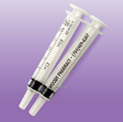 |  | USPTO maintains this proposal as worded and classified and thanks the IB for its support | T
A | US-28-25 | 10 |  | FR |  | ajouter |  | distributeurs-doseurs à usage médical |  |  |  |  | T
A | US-28-26 | 10 | 100160 | EN |  | Delete | aerosol dispensers for medical purposes |  |  | The English version of the indication is unclear. It is not a common commercial name for medical apparatus in the U.S. market. An internet search for the French version, appareils destinés à la projection d'aérosols à usage médical retrieves the images depicted below  The common commercial name for these goods in the U.S. marketplace is “nebulizers.” Just nebulizers | IB: Delete? “aerosol dispensers for medical purposes” :  This product may consist of a dispenser that contains a medicated aerosol. A typical example would be an asthma inhaler.  The IB prefers to add “nebulizers for medical purposes“ as a new entry, independently of keeping or deleting 100160. | USPTO adopts the IB’s suggestion to delete this term (instead of changing it to “nebulizers for medical purposes”) because, as previously indicated by USPTO, the English version of the term is unclear as to the nature of the goods. In addition, the term is overbroad and may include pre-filled inhalers for treating asthma in Class 5, for example. | T
A | US-28-26 | 10 | 100160 | FR |  | supprimer | appareils destinés à la projection d'aérosols à usage médical |  |  |  |  |  | T
A | US-28-27 | 10 |  | EN |  | Add |  | nebulisers for medical purposes |  |  |  |  | T
A | US-28-27 | 10 |  | EN |  | Add |  | nebulizers for medical purposes |  |  |  | 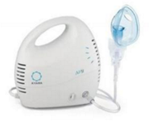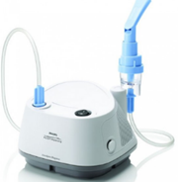  USPTO adopts the IB’s suggestion to delete Basic No. 100160 and add “nebulizers for medical purposes” as a new term. USPTO thanks the IB for its support and suggestions. | T
A | US-28-27 | 10 |  | FR |  | ajouter |  | nébuliseurs à usage médical |  |  |  |  | T
R | US-28-28 | 21 | 210233 | EN |  | Delete | aerosol dispensers, not for medical purposes |  |  | The nature of the goods covered by this indication, both the English version and French version, is unclear. Is this term intended to cover the goods depicted below, sold empty?  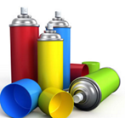 | The IB supports this deletion. | USPTO maintains the proposal to delete this term. USPTO thanks the IB for its support
R | US-28-28 | 21 | 210233 | FR |  | supprimer | appareils destinés à la projection d'aérosols non à usage médical
R | US-28-29 | 11 | 110114 | EN |  | Change | disinfectant dispensers for toilets | disinfectant dispensers for toilets [sanitary apparatus] |  |  | IB: Change to “disinfectant dispensers for toilets [sanitary apparatus]” and delete “disinfectant distributors for toilets”. The IB prefers to add “sanitary apparatus” in brackets as it is really an additional clarification that does not modify the scope of the indication. These dispensers would be in Cl. 11, regardless of material or mode of operation.  However, one can pose the question whether goods such as aerosol dispensers for hand sanitizers and disinfectant dispensers for toilets can be considered as “sanitary apparatus”. If the answer is negative, such dispensers could follow the general principle for dispensers as suggested in this paper and be classified according to the material of which they are made: of metal Cl. 6, not of metal Cl. 20, whether automatic or non-automatic. | USPTO adopts the IB’s suggestion and modifies the proposal from “disinfectant dispensers being sanitary apparatus for toilets” to “disinfectant dispensers for toilets [sanitary apparatus].  ALTERNATIVE - As indicated by the IB, if the Committee is not in favor of maintaining the current practice of classifying these goods in Class 11 as sanitary apparatus, the Committee may vote to classify disinfectant dispensers for toilets in Class 6 when metal and Class 20 when not of metal.  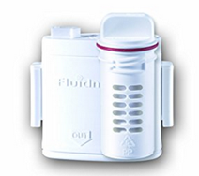
R | US-28-29 | 11 | 110114 | EN |  | Delete | disinfectant distributors for toilets
R | US-28-29 | 11 | 110114 | FR |  | changer | distributeurs de désinfectants pour toilettes | distributeurs de désinfectant pour toilettes [appareils sanitaires]
R | US-28-30 | 11 |  | EN |  | Add |  | aerosol dispensers for hand sanitizers [sanitary apparatus] |  | USPTO requests feedback on whether the proposed term, which is consistent with the current practice, is overbroad and includes goods in Class 7 and Class 11?  ALTERNATIVES  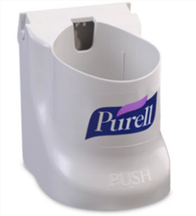  aerosol dispensers for hand sanitizers being sanitary apparatus in Class 11  AND  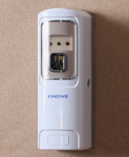  aerosol dispensing machines, automatic, other than for sanitary use in Class 7 | IB: Add “aerosol dispensers for hand sanitizers [sanitary apparatus]” in Cl. 11.  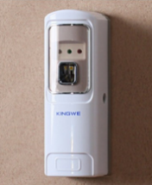  Again, if these dispensers were not considered as sanitary apparatus, they could be classified according to material.  IB: Add “air deodorizing aerosol dispensers” in Cl. 11.  We have added this proposal in order to clarify that aerosol dispensers used for deodorizing the air are in Cl. 11 by analogy with 110009 air deodorizing apparatus, regardless of material or mode of operation.  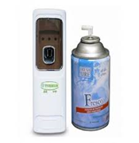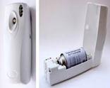  IB: Add “air freshening aerosol dispensers” in Cl. 11.  We have added this proposal in order to clarify that aerosol dispensers that are used for freshening or perfuming the air are in Cl. 11 by analogy with 110009 air deodorizing apparatus, regardless of material and mode of operation. | USPTO adopts the IB’s suggestion and modifies the proposal from “aerosol dispensers for hand sanitizers being sanitary apparatus” to “aerosol dispensers for hand sanitizers [sanitary apparatus].”  ALTERNATIVE - As indicated by the IB, if the Committee is not in favor of classifying these goods in Class 11 as sanitary apparatus by analogy with the disinfectant dispensers for toilets (Basic No. 110114), then the Committee may vote to classify them in Class 6 when metal and Class 20 when not of metal.
R | US-28-30 | 11 |  | FR |  | ajouter |  | appareils destinés à la projection d’aérosols pour la désinfection des mains [appareils sanitaires]  OU  distributeurs d’aérosols pour la désinfection des mains [appareils sanitaires]
R | US-28-33 | 21 | 210117 | EN |  | Change & Transfer | soap dispensers | soap dispensers [sanitary apparatus], other than soap dispensing bottles | 11 |  | IB: change to “soap dispensers [sanitary apparatus], other than soap dispensing bottles” & transfer to Cl. 11  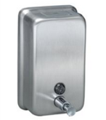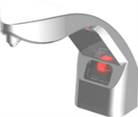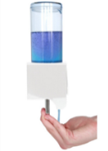  Cl. 11 regardless of material and mode of operation.  In the case that “soap dispensers, other than soap dispensing bottles” were not to be considered as sanitary apparatus, they could be classified like the other dispensing containers in Classes 6 and 20 (of metal/not of metal), whether automatic or not.  IB: Add “soap dispensing bottles”  Regardless of material.  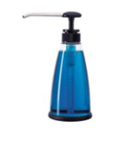 | USPTO adopts the IB’s suggestion and proposes to change and transfer Basic No. 210117 to Class 11.  ALTERNATIVE - As indicated by the IB, if the Committee is not in favor of classifying these goods in Class 11 as sanitary apparatus, the Committee may vote to classify soap dispensers, other than soap dispensing bottles, in Class 6 when metal and Class 20 when not of metal.
R | US-28-33 | 21 | 210117 | FR |  | changer & transférer | distributeurs de savon | distributeurs de savon [appareils sanitaires] autres que flacons distributeurs de savon | 11
R | US-28-34 | 21 |  | EN |  | Add |  | soap dispensing bottles |  |  |  | USPTO adopts the IB’s proposal and thanks the IB for its suggestion.
R | US-28-34 | 21 |  | FR |  | ajouter |  | flacons distributeurs de savon
W | US-28-35 | 6 | Explanatory Note | EN |  | Add |  | This Class includes, in particular:  …  - certain dispensing containers of metal, automatic or non-automatic, for example, towel dispensers, boxes for dispensing paper towels, toilet paper dispensers, queue ticket dispensers, dispensers for dog waste bags;  … |  |  | IB: Inclusion Note : Add “certain dispensing containers of metal, automatic or non-automatic, for example, towel dispensers, boxes for dispensing paper towels, toilet paper dispensers, queue ticket dispensers, dispensers for dog waste bags;”
W | US-28-35 | 6 | Note explicative | FR |  | ajouter |  | Cette classe comprend notamment :  …  - certains contenants distributeurs en métal, automatiques ou non automatiques, par exemple, les distributeurs de serviettes, les boîtes pour la distribution de serviettes en papier, les distributeurs de papier hygiénique, les distributeurs de tickets pour la gestion de files d’attente, les distributeurs de sacs pour déjections canines;  …
W | US-28-36 | 6 | Explanatory Note | EN |  | Add |  | This Class does not include, in particular:  …  - certain dispensing machines, for example, fluid dispensing machines for industrial use, industrial tape dispensing machines (Cl. 7), certain sanitary apparatus, for example, disinfectant dispensers for toilets, soap dispensers, aerosol dispensers for hand sanitizers (Cl. 11), adhesive tape dispensers, other than machines (Cl. 16), soap dispensing bottles, covers for paper tissue boxes (Cl. 21);  … |  |  | IB: Exclusion Note : Add “disinfectant dispensers for toilets, soap dispensers, air deodorizing aerosol dispensers (Cl. 11), soap dispensing bottles, toilet paper holders, covers for paper tissue boxes (Cl. 21);”
W | US-28-36 | 6 | Note explicative | FR |  | ajouter |  | Cette classe ne comprend pas notamment :  …  - certains distributeurs, par exemple, les distributeurs de fluides à usage industriel, les distributeurs industriels de ruban (cl. 7), certains appareils sanitaires, par exemple, les distributeurs de désinfectant pour toilettes, les distributeurs de savon, les appareils destinés à la projection d’aérosols pour la désinfection des mains (cl. 11), les distributeurs de ruban adhésif autres que machines (cl. 16), les flacons distributeurs de savon, les couvre-boîtes de mouchoirs en papier (cl. 21);  …
W | US-28-37 | 20 | Explanatory Note | EN |  | Add |  | This Class includes, in particular:  …  - certain dispensing containers, not of metal, automatic or non-automatic, for example, towel dispensers, boxes for dispensing paper towels, toilet paper dispensers, queue ticket dispensers, dispensers for dog waste bags;  … |  | containers, not of metal [storage, transport] (Basic No. 200068) | IB: Inclusion Note : Add “certain dispensing containers, not of metal, automatic or non-automatic, for example, towel dispensers, boxes for dispensing paper towels, toilet paper dispensers, queue ticket dispensers, dispensers for dog waste bags;”
W | US-28-37 | 20 | Note explicative | FR |  | ajouter |  | Cette classe comprend notamment :  …  - certains contenants distributeurs, non métalliques, automatiques ou non automatiques, par exemple, les distributeurs de serviettes, les boîtes pour la distribution de serviettes en papier, les distributeurs de papier hygiénique, les distributeurs de tickets pour la gestion de files d’attente, les distributeurs de sacs pour déjections canines;  …
W | US-28-38 | 20 | Explanatory Note | EN |  | Add |  | This Class does not include, in particular:  …  - certain dispensing machines, for example, fluid dispensing machines for industrial use, industrial tape dispensing machines (Cl. 7), certain sanitary apparatus, for example, disinfectant dispensers for toilets, soap dispensers, aerosol dispensers for hand sanitizers (Cl. 11), adhesive tape dispensers, other than machines (Cl. 16), soap dispensing bottles, covers for paper tissue boxes (Cl. 21);  … |  |  | IB: Exclusion Note : Add “disinfectant dispensers for toilets, soap dispensers, air deodorizing aerosol dispensers (Cl. 11), soap dispensing bottles, toilet paper holders, covers for paper tissue boxes (Cl. 21);”
W | US-28-38 | 20 | Note explicative | FR |  | ajouter |  | Cette classe ne comprend pas notamment :  …  - certains distributeurs, par exemple, les distributeurs de fluides à usage industriel, les distributeurs industriels de ruban (cl. 7), certains appareils sanitaires, par exemple, les distributeurs de désinfectant pour toilettes, les distributeurs de savon, les appareils destinés à la projection d’aérosols pour la désinfection des mains (cl. 11), les distributeurs de ruban adhésif autres que machines (cl. 16), les flacons distributeurs de savon, les couvre-boîtes de mouchoirs en papier (cl. 21);  …
W | US-28-39 | 7 | Explanatory Note | EN |  | Add |  | This Class includes, in particular:  …  - certain dispensing machines, for example, fluid dispensing machine for industrial use, industrial adhesive tape dispensing machines, fuel dispensing pumps for service stations;  …
W | US-28-39 | 7 | Note explicative | FR |  | ajouter |  | Cette classe comprend notamment :  …  - certains distributeurs, par exemple, les distributeurs de fluides à usage industriel, les distributeurs industriels de ruban adhésif, les distributeurs de carburants pour stations-services;  …
W | US-28-40 | 7 | Explanatory Note | EN |  | Add |  | This Class does not include, in particular:  …  - certain automatic dispensing containers, for example, towel dispensers, toilet paper dispensers and queue ticket dispensers, of metal (Cl. 6), and not of metal (Cl. 20), disinfectant dispensers for toilets, soap dispensers, aerosol dispensers for hand sanitizers (Cl. 11), as well as dosage dispensers for medical use (Cl. 10) and non-medical use (Cl. 9), adhesive tape dispensers (Cl. 16);  …
W | US-28-40 | 7 | Note explicative | FR |  | ajouter |  | Cette classe ne comprend pas notamment :  …  - certains contenants distributeurs, par exemple, les distributeurs de serviettes, distributeurs de papier hygiénique et distributeurs de tickets pour la gestion de files d’attente, métalliques (cl. 6), et non métalliques (cl. 20), les distributeurs de désinfectant pour toilettes, les distributeurs de savon, les appareils destinés à la projection d’aérosols pour la désinfection des mains (cl. 11), ainsi que les distributeurs-doseurs à usage médical (cl. 10) et non à usage médical (cl. 9), les distributeurs de ruban adhésif (cl. 16);  …
W | US-28-41 | 11 | Explanatory Note | EN |  | Add |  | This Class includes, in particular:  …  - certain dispensing containers, automatic or non-automatic, that are considered as sanitary apparatus, for example, disinfectant dispensers for toilets, aerosol dispensers for hand sanitizer, soap dispensers;  …
W | US-28-41 | 11 | Note explicative | FR |  | ajouter |  | Cette classe comprend notamment :  …  - certains contenants distributeurs, automatiques ou non automatiques, considérés comme des appareils sanitaires, par exemple, les distributeurs de désinfectant pour toilettes, les appareils destinés à la projection d’aérosols pour la désinfection des mains et les distributeurs de savon;  …
W | US-28-42 | 16 | Explanatory Note | EN |  | Add |  | This Class includes, in particular:  …  - adhesive tape dispensers, other than machines, automatic or non-automatic;  …
W | US-28-42 | 20 | Note explicative | FR |  | ajouter |  | Cette classe comprend notamment :  …  - les distributeurs de ruban adhésif autres que machines, automatiques ou non automatiques;  …
W | US-28-43 | 16 | Explanatory Note | EN |  | Add |  | This Class does not include, in particular:  …  - industrial adhesive tape dispensing machines;  …
W | US-28-43 | 16 | Note explicative | FR |  | ajouter |  | Cette classe ne comprend pas notamment :  …  - les distributeurs industriels de ruban adhésif;  …

GENERAL COMMENTS FROM OFFICES

CH: The Swiss office likes to thank you for the submitted proposals. In our view, this proposal does not make it easier to classify the dispensers. In particular, we are against a differentiation between household and non-household use.

IL: we agree to the basic proposal being to separate dispensers as per their function as a storage container vs household and kitchen items, as well specialized and general machines, we would also like to thank the USPTO on this very comprehensive list, the main problem being that the term dispenser isn't classifiable as a single item and can encompass many functions.
The distinctions between metal and non metal, as well as machine vs non machine dispensers are clear enough, the problem arises when we try to distinguish "household" vs "sanitary " purposes, I can't see the justification to classify soap dispensers being sanitary apparatus, other than for household in Class 11, are soap dispensers for household purposes not considered a sanitary apparatus??? Class 11 does not distinguish between a household vs non household designation when classifying sanitary installations. So on this point the preferred approach would be to separate between soap dispensers for household purposes (whether metal or non metal) in class 21 and soap dispenser for non household purposes being non household soap containers classified according to their metal and non metal material in classes 6 and 20 accordingly.
We would also remark further need to discuss the exclusion of a vending function when classifying dispensing machines in classes other than class 7.

IB: The IB thanks the USPTO for the efforts put into the preparation of such extensive proposal.
In general, the IB is of the opinion that classifying dispensing containers according to their use (for household use/other than for household use) and, at the same time, according to material (of metal/not of metal) does not make their classification clearer. It is difficult to establish the line that separates “household use” from “other than household use”.
Instead, an analogy could be established with the entries approved by the CE for “queue ticket dispensers”, which will enter into force in 2022, namely, all queue ticket dispensers, automatic or non-automatic, were classified according to material composition: queue ticket dispensers of metal in Cl. 6 and queue ticket dispensers, not of metal, in Cl. 20.
It should be noted here that “ticket vending machines” were accepted by the CE in Cl. 7 not because they are automatic machines but because of their selling or vending function, thus, by analogy with 070537 “vending machines”.
As for the change of 090086 “ticket dispensers” to “ticket dispensing terminals, electronic”, it was approved by the CE because such terminals are like computers and by analogy with 090766 “interactive touch screen terminals”.
Taking the above into consideration and as an alternative to the proposal presented by the USPTO, our sugestion is to classify, with a few exceptions, most dispensing containers, automatic or non-automatic, according to the material of which they are made, in Classes 6 and 20 (of metal/not of metal), as follows:

[End of document/Fin du document]

A: Approved/Approuvé; R: Rejected/Rejeté; W: Withdrawn/Retiré
EN/FR: English/French // Anglais/Français
T: Transfer. The CE has considered that the proposals marked with a T (in blue) entail an amendment in the sense of Article 3(7)(b) of the Nice Agreement. Adopted amendments will enter into force with the 12th edition of the Classification at a date to be fixed by the Committee./Transfert. Le comité d’experts a considéré que les propositions marquées d’un T (en bleu) entraînaient une modification en vertu de l’article 3.7)b) de l’Arrangement de Nice. Les modifications adoptées entreront en vigueur avec la 12ème édition de la classification à une date qui sera fixée par le comité.
The USPTO proposed to add “ticket dispensing machines” as a synonym of “ticket vending machines”. The IB is of the opinion that the proposed synonym does not contain the concept of “selling/vending”, which was the main reason why this product was accepted in Cl. 7. The current synonym of 070537 “vending machines” is “distribution machines, automatic”, which could eventually be deleted (see proposals WO-13-43 for deleting “distribution machines, automatic, and changing “distributeurs automatiques” to “distributeurs automatiques de vente”.

