Conference on Technology Scouting and Deployment for Sustainable Development
Technology scouting and deployment can constitute precious allies towards the achievement of the Sustainable Development Goals (SDGs), in particular in the context of the Covid-19 crisis, and post-crisis.
In those uncertain times, because more urgent priorities are competing for public and private finances, while at the same time, the demands for technological solutions to help fight the pandemic or help business stay afloat are increasing, the question of harnessing technology and deploying it is particularly timely.
The WIPO Regional Bureau for Asia and Pacific (RBAP), in cooperation with the Global Solutions Summit (GSS), and the Association of Southeast Asian Nations (ASEAN) Committee on Science, Technology and Innovation, are organizing two 90-minute panel discussions. It is free of charge and will be held in English.
Panel Discussion on Technology Scouting
Most of the R&D related to development objectives have been conducted and patented by scientists in some other country in Asia and elsewhere.
Furthermore, many of the technologies that countries in the Asia and Pacific Region need to meet development challenges, such as off-grid electricity, advanced manufacturing and smart factories, potable water, and low-cost, high-quality health care, are already in widespread use in various countries around the world.
Technology scouting provides the capacity to select from the vast array of research results and available development solutions and lean how to harness them to meet national development priorities.
The panel will focus on the quest for appropriate solutions to concrete problems geared to the concerns of policy-makers and related stakeholders. Speakers will share their experience, their success, and less successful endeavors, and explain how Asian countries can incorporate those experience lessons into their own national innovation programs.
When: Tuesday November 10, 2020
Welcome: Andrew Michael ONG, Director, World Intellectual Property Organization Regional Bureau for Asia and the Pacific
Moderator: Alfred Watkins, Chairman, Global Solutions Summit
Panelists:
- Dr. Theresa Kotanchek, CEO, Evolved Analytics and current Chair of the National Materials, and Manufacturing Board (NMMB) of the US National Academies of Science, Engineering and Medicine. She is an expert in sustainable technologies and innovation sourcing.
- Leena Thomas, CEO, Global Business Inroads (GBI). Based in India, GBI is helping European Union companies market their technology in India and South Asia. Ms. Thomas has two decades of experience in the field of International Business, Climate Change Mitigation, Energy, Environment, Transport, Biotech and ICT sectors.
- Dr. Cung Vu, Independent Consultant, formerly with the United States Office of Naval Research Global in Singapore, is an expert of technology scouting in the Asia-Pacific region.

Register for the 10 November Panel Discussion here: https://attendee.gotowebinar.com/register/7950211649472635918

Moderator
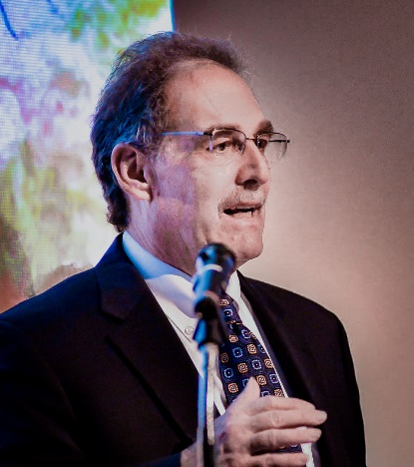  Alfred Watkins | Alfred Watkins is currently Chairman of the Global Solutions Summit and a member of the Governing Council of the UN Technology Bank for the Least Developed Countries.  Prior to assuming these positions, he worked for more than 23 years in various positions at the World Bank and served for more than six years as the World Bank’s Science and Technology Program Coordinator and head of the World Bank’s Science, Technology and Innovation Global Expert Team.

Speakers
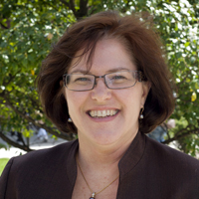  Dr. Theresa Kotanchek | Dr. Theresa Kotanchek is CEO of Evolved Analytics and the current chair of the National Materials and Manufacturing Board (NMMB) of the US National Academics of Science, Engineering and Medicine.  Previously, she was Chief Technology Officer of Dow Asia Pacific and in 2011-2012 she served as the industrial lead and working group co-chair of President Obama’s Advanced Manufacturing Partnership Initiative which provided input into the creation of the Manufacturing Innovation Institute Network.
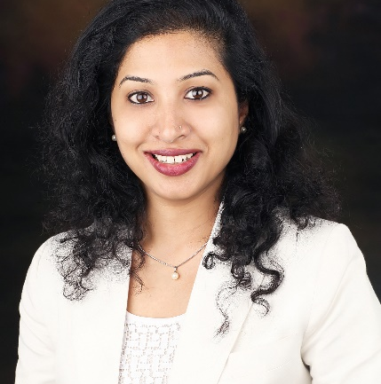  Leena Thomas | Leena Thomas is CEO of Global Business Inroads (GBI), based in India.  She has two decades of experience in the field of International Business, Technology and Project Management in the Climate Change Mitigation, Energy, Environment, Transport, Biotech and ICT sectors working with numerous leading US, European and Indian organizations.  Leena established (GBI) in September 2009 to assist and serve Governments, NGOs, Financial Institutions, and Private Sector organizations with their technology, sustainable energy, environmental project development, market access and international business needs.
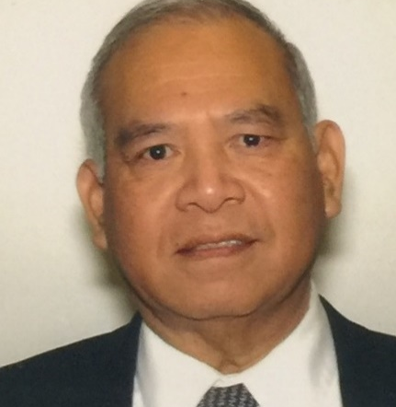  Dr. Cung Vu | Dr. Cung Vu is an independent consultant, focusing in Science and Technology (S&T) in National Security, S&T in Maritime Security, Cyber Security, Emerging Technologies, Renewable Energy for Rural Community, Waste to Energy, Water and Energy Nexus, and Renewable Energy in the Asia-Pacific region.  He was formerly with the US Office of Naval Research Global in Singapore, where he led the technology scouting effort in the Asia-Pacific region.  Dr. Vu spent more than 20 years in the private sector, working in the chemical and material industries.

Conference on Technology Scouting and Deployment for Sustainable Development

Panel Discussion on Technology Scouting
Scouting for innovative solutions is not the same as getting those solutions to the residents of tens of thousands urban and rural communities and factories across the Asia and Pacific region.
Harnessing innovative solutions to achieve the SDGs entails building an effective and efficient deployment ecosystem, and embedding these innovative solutions in businesses and government institutions with the capacity to adapt, adopt, and deploy them at scale on a financially and operationally sustainable basis.
A series of broken circuits, however, hinders the deployment process.
The panel will discuss some of the issues involved in repairing those broken circuits, and creating an effective, efficient deployment ecosystem. The conversation will be practical and focus on the quest for appropriate solutions to concrete problems geared to the concerns of policy-makers and related stakeholders. Speakers will share their experience, their success, and less successful endeavors, and explain how Asian countries can incorporate those experience lessons into their own national technology deployment program.
When: Thursday November 12, 2020
Welcome: Andrew Michael ONG, Director, World Intellectual Property Organization Regional Bureau for Asia and the Pacific
Moderator: Alfred Watkins, Chairman, Global Solutions Summit
Panelists:
- Alfred Watkins is currently Chairman of the Global Solutions Summit and a member of the Governing Council of the UN Technology Bank for the Least Developed Countries.
- Christopher Tan has extensive experience helping governments in Malaysia, Tanzania, India, South Africa, Saudi Arabia, Oman, Russia, and Nepal strengthen their implementation capacity.
- Randy Welsch, former CEO, Founder and Advisory Board Member, Jibu. Mr. Welsch has led several impactful organizations spanning multiple industries.

Register for the 12 November Panel Discussion here: https://attendee.gotowebinar.com/register/2726109749001942542

Moderator/Speaker:
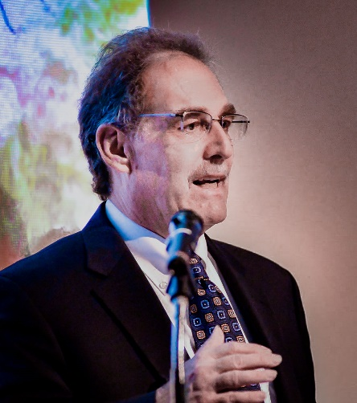  Alfred Watkins | Alfred Watkins is currently Chairman of the Global Solutions Summit and a member of the Governing Council of the UN Technology Bank for the Least Developed Countries.  Prior to assuming these positions, he worked for more than 23 years in various positions at the World Bank and served for more than six years as the World Bank’s Science and Technology Program Coordinator and head of the World Bank’s Science, Technology and Innovation Global Expert Team.

Speakers:
: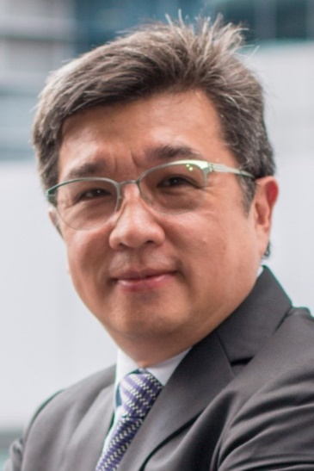  Christopher Tan | Christopher Tan Chris Tan has extensive experience helping governments in Malaysia, Tanzania, India, South Africa, Saudi Arabia, Oman, Russia, and Nepal strengthen their implementation capacity.
Randy Welsch | Randy Welsch, former CEO, Founder and Advisory Board Member, Jibu. Jibu capitalizes and equips emerging market entrepreneurs to create affordable access to drinking water and other necessities.  Mr. Welsch is also President of Courage, Inc. and Rockwise LLC, which are multi-faceted enterprises that make private investments in promising early stage companies and provides various business support services. The companies have particular expertise in blended capital, international business coaching, and social enterprises.

