E
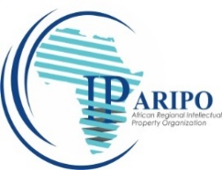 | 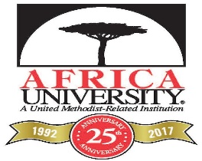 | 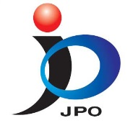
AFRICAN REGIONAL  INTELLECTUAL PROPERTY  ORGANIZATION | AFRICA UNIVERSITY | JAPAN PATENT OFFICE
Webinar
WIPO/WEBINAR/RBA/2021/2/1
ORIGINAL: Eng
DATE: MAY 26, 2021

Annual Sub Regional Workshop – MIP Program, Africa University

From University Research to IP Commercialization and Entrepreneurship

Organized by
The World Intellectual Property Organization (WIPO)

In collaboration with
The African Regional Intellectual Property Organization (ARIPO)

With financial support from
The Japanese Patent Office (JPO)

Virtual, June 3 & 4, 2021

Prepared by the International Bureau of WIPO

PROGRAM

Thursday June 3, 2021

10.30 – 10.35 Introduction and Welcome

10.35 – 11.00 Opening Ceremony

Welcome addresses by:

Mr. Bemanya Twebaze, Director General, African Regional Intellectual Property Organization (ARIPO), Harare, Zimbabwe

Mr. Futoshi Yasuda, Director-General, Patent Examination Department, JPO, Tokyo, Japan

Professor Peter Mageto, Acting Vice Chancellor, Africa University,
Mutare, Zimbabwe

Mr. Marc Sery Kore, Director, Africa Division, Regional and National Development Sector, World Intellectual Property Organization (WIPO), Geneva, Switzerland

11.00 – 12.00 PART ONE: From University Research to IP Commercialization and Entrepreneurship

- Acquisition of IPRs for University- Led Innovation : Issues Arising

- IPR Commercialization : The Process, Challenges and Opportunities

- From Research to Entrepreneurship : Practical Examples

Moderator: Dr. Rapuleng Outule, Head, ARIPO Academy,
Harare, Zimbabwe

Speakers: Dr. McLean Sibanda, Managing Director,
Bigen Global Limited,
Pretoria, South Africa

Professor Caroline Ncube,
University of Cape Town,
Cape Town, South Africa

Ms. Rose Mboya, International Consultant and IP Expert, Kenya Industrial Research and Development Institute, Nairobi, Kenya

Professor Keo Motaung, Founder,
Global Health Biotech (Pty) Ltd,
Pretoria, South Africa

12.00 – 12.30 Discussions, Q&A

12.30 Wrap Up and close of Day 1
Friday, June 4, 2021

10.30 – 11.45 PART TWO: SHARING OF EXPERIENCES AND GOOD PRACTICES

- The MIP Program – Fostering Innovation and Entrepreneurship;

- Breaking Barriers - From Alumni to Entrepreneur

Moderator: Ms. Loretta Asiedu, Senior Counsellor,
WIPO Division for Africa,
Geneva, Switzerland

Speakers: Mr. George Mandewo, MIP Program Coordinator
Africa University,
Mutare, Zimbabwe

Ms. Eunice Adu Boahen, IP Administrator
Kwame Nkrumah University of Science and Technology
Kumasi, Ghana

Ms. Sarah Anku, Alumni, MIP Africa University;
Senior Partner,
ANKU. ANKU AT- LAW
Accra, Ghana

Mr. Kumamoto Daiki, Growth Manager
Real Tech Fund,
Tokyo, Japan

Professor Jameson Mbale, Alumni, MIP Africa University,
Inaugural Director: Directorate of Research,
Innovation and Consultancy (DRIC),
Copperbelt University,
Copperbelt, Zambia

11.45 – 12. 30 Discussions, Q & A

12.30 Wrap Up and Closing Remarks by Mr. Bemanya Twebaze

[End of document]

