E
WIPO/IP/MCT/04/INF.1
ORIGINAL: English
DATE: February 2004
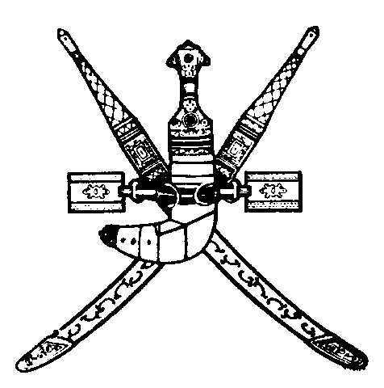 | 
SULTANATE OF OMAN | WORLD INTELLECTUAL  PROPERTY ORGANIZATION
wipo national SEMINAR ON INTELLECTUAL PROPERTY
FOR THE MEMBERS OF THE SHU’RA COUNCIL
organized by
the World Intellectual Property Organization (WIPO)
in cooperation with
the Ministry of Commerce and Industry
and
the Shu’ra Council
Muscat, March 23 and 24, 2004
PROGRAM
prepared by the International Bureau of WIPO

Tuesday, March 23, 2004

8.30 – 9.00 OPENING CEREMONY

Welcome addresses by:

Representative of the Government of the Sultanate of Oman

Representative of the Director General of the World Intellectual Property Organization (WIPO), Geneva, Switzerland

9.00 – 9.30 Coffee Break

9.30 – 10.00 WIPO: Mandate, Program and Constitutional Structure

Speaker: Ms. Ola Zahran, Counsellor, Economic Development Bureau for Arab Countries, WIPO

10.00 – 11.00 Defining Intellectual Property Rights

Speakers: Dr. Hossam Eldin Al-Saghir, Head, Commercial Law Department, Faculty of Law, University of Monufeya, Cairo

Dr. Bassam Talhouni, Assistant Professor of Law, Faculty
of Law, University of Jordan, Amman

11.00 – 11.45 Overview of the International Intellectual Property Protection System

Speaker: Ms. Ola Zahran

11.45 – 12.30 Integrating Intellectual Property in Policies of Development

Speaker: Mr. Sherif Saadallah, Executive Director, Economic Development Bureau for Arab Countries, WIPO

12.30 – 13.00 Coffee Break

13.00 – 13.45 The Internet and Digital Rights Management

Speaker: Dr. Bassam Talhouni
13.45 – 14.30 Enforcement Provisions under the Agreement on Trade-Related Aspects of Intellectual Property Rights (TRIPS Agreement)

Speaker: Dr. Hossam Eldin Al-Saghir

Wednesday, March 24, 2004

8.30 – 9.15 Contribution of Copyright Industries to Economic Development

Speaker: Mr. Sherif Saadallah

9.15 – 10.00 The Patent System and Access to Medicine

Speaker: Ms. Ola Zahran

10.00 – 10.30 Coffee Break

10.30 – 11.15 Intellectual Property Licensing and Transfer of Technology

Speaker: Dr. Hossam Eldin Al-Saghir

11.15 – 12.00 The State of Negotiations of Intellectual Property Rights in Multilateral Fora

Speaker: Ms. Ola Zahran

12.00 – 12.30 Coffee Break

12.30 – 13.15 Intellectual Property Protection in Oman: Legislation and Enforcement

Speaker: Local Speaker

13.15 – 13.45 Promoting the Protection of Intellectual Property in Oman: Challenges and Opportunities

Speaker: Mr. Sherif Saadallah

13.45 – 14.00 Closing Ceremony

[End of document]

