E
WIPO/IP/JOURN/MCT/04/INF.1
ORIGINAL: English
DATE: February 2004
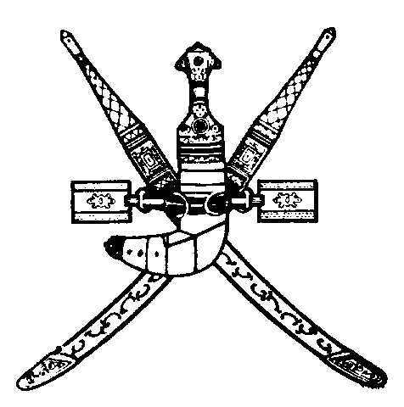 | 
SULTANATE OF OMAN | WORLD INTELLECTUAL  PROPERTY ORGANIZATION
wipo national SEMINAR ON INTELLECTUAL
PROPERTY FOR JOURNALISTS
organized by
the World Intellectual Property Organization (WIPO)
in cooperation with
the Ministry of Commerce and Industry
and
the Ministry of Information
Muscat, March 22, 2004
PROGRAM
prepared by the International Bureau of WIPO

Monday, March 22, 2004

8.30 – 9.00 OPENING CEREMONY

Welcome addresses by:

Representative of the Government of the Sultanate of Oman

Representative of the Director General of the World Intellectual Property Organization (WIPO), Geneva, Switzerland

9.00 – 9.30 Coffee Break

9.30 – 10.00 The Intellectual Property System: A Historical Background

Speaker: Ms. Ola Zahran, Counsellor, Economic Development Bureau for Arab Countries, WIPO

10.00 – 10.45 Intellectual Property and Economic Development

Speaker: Mr. Sherif Saadallah, Executive Director, Economic Development Bureau for Arab Countries, WIPO

10.45 – 11.45 Intellectual Property Rights: What are the Issues?

Speakers: Dr. Hossam Eldin Al-Saghir, Head, Commercial Law Department, Faculty of Law, University of Monufeya, Cairo

Dr. Bassam Talhouni, Assistant Professor of Law, Faculty
of Law, University of Jordan, Amman

11.45 – 12.30 The Patent System and Access to Medecine

Speaker: Ms. Ola Zahran

12.30 – 12.45 Coffee Break

12.45 – 13.30 Challenges for Copyright Protection on the Internet: Managing and Enforcing Digital Rights

Speaker: Dr. Bassam Talhouni

13.30 – 14.15 International Standards for the Enforcement of Intellectual Property Rights

Speaker: Dr. Hossam Eldin Al-Saghir

14.15 – 14.30 Closing Ceremony

[End of document]

