E
WIPO/INN/MCT/04/INF.1
ORIGINAL: English
DATE: April 2004
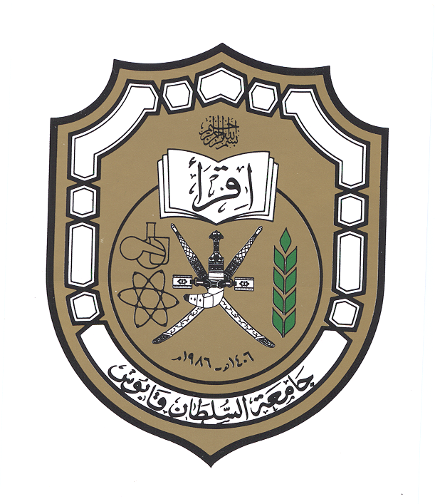   |  | 
SULTANATE OF OMAN | SULTAN QABOOS UNIVERSITY | WORLD INTELLECTUAL  PROPERTY ORGANIZATION
wipo national workshop on INNOVATION SUPPORT
SERVICES AND THEIR MANAGEMENT
organized by
the World Intellectual Property Organization (WIPO)
in cooperation with
the Ministry of Commerce and Industry
and
the Sultan Qaboos University (SQU)
Muscat, April 20, 2004
PROGRAM
prepared by the International Bureau of WIPO

Tuesday, April 20, 2004

8.00 – 8.15 OPENING CEREMONY

Welcome addresses by:

Representative of the Sultan Qaboos University (SQU), Sultanate of Oman

Representative of the Director General of the World Intellectual Property Organization (WIPO), Geneva, Switzerland

8.15 – 9.00 Intellectual Property and its Impact on Research and Development

Speaker: Mr. Prabuddha Ganguli, Advisor, Vision-IPR, Mumbai, India

9.00 – 9.45 Scientific Research and Development in the Arab Region

Speaker: Mr. Sherif Saadallah, Executive Director, Economic Development Bureau for Arab Countries, WIPO

9.45 – 10.15 Coffee Break

10.15 – 11.00 Development of an Innovation Center

Speaker: Mr. Vladimir Yossifov, Director, Division for Infrastructure Services and Innovation Promotion, WIPO

11.00 – 11.45 Patent Documents, a Source of Technological Information and a Tool for Research and Development Strategy

Speaker: Ms. Ola Zahran, Counsellor, Economic Development Bureau for Arab Countries, WIPO

11.45 – 12.30 Promotion of Commercial Exploitation of Research Results and Inventions at Universities

Speaker: Mr. Vladimir Yossifov

12.30 – 13.00 Coffee Break

13.00 – 13.45 Strategy for Protecting Intellectual Property Rights (IPRs) Related to Inventions and Research Results

Speaker: Mr. Prabuddha Ganguli

13.45 – 14.30 Relationship between Employed Inventors and Employers; Legal, Contractual and Financial Questions

Speaker: Mr. Vladimir Yossifov

14.30 – 14.45 Closing Ceremony

[End of document]

