E
WIPO-LAS/IP/MCT/03/INF.2
ORIGINAL: English
DATE: September 10, 2003
 | 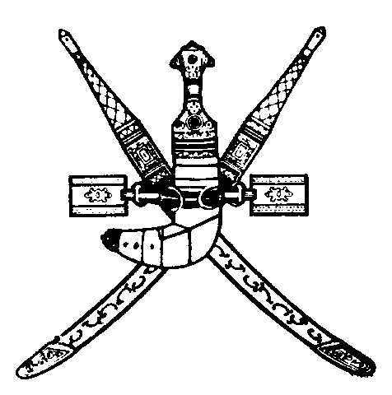 | 
LEAGUE OF ARAB STATES (LAS) | SULTANATE OF OMAN | WORLD INTELLECTUAL  PROPERTY ORGANIZATION
WIPO/LAS ARAB REGIONAL COORDINATION MEETING FOR
HEADS OF INDUSTRIAL PROPERTY AND COPYRIGHT OFFICES
organized by
the World Intellectual Property Organization (WIPO)
and
the League of Arab States (LAS)
in cooperation with
the Ministry of Commerce and Industry
Muscat, September 15 to 17, 2003
LIST OF PARTICIPANTS
prepared by the International Bureau of WIPO

I. INVITED PARTICIPANTS

ALGERIA/ALGÉRIE

Amor BOUHNIK, Directeur général, Institut national algérien de la propriété industrielle (INAPI), Alger

Hakim TAOUSAR, Directeur général, Office national du droit d’auteur et des droits voisins (ONDA), Alger

BAHRAIN/BAHREÏN

Mohammed Dhirar AL SHA’ER, Director of Industrial Property, Directorate of Industrial Property, Ministry of Commerce, Manama

Jamal Dawood SALMAN, Director, Directorate of Publications, Ministry of Information, Manama

Abdelaziz Ali AL-JABIRI, Legal Researcher, Ministry of Information, Manama

DJIBOUTI

Abdourahman Youssouf ABOUBAKER, Chef de service adjoint, Unité de propriété industrielle, Ministère du commerce, de l’industrie et de l’artisanat, Djibouti

EGYPT/EGYPTE

Mohamed Nour FARAHAT, Director, Permanent Office for the Protection of Copyright, Supreme Council of Culture, Ministry of Culture, Cairo

Nadia Ibrahim ABDALLAH (Mrs), Director, Patent Office, Academy of Scientific Research and Technology (ASRT), Cairo

JORDAN/JORDANIE

Mamoun Th. TALHOUNI, Director General, Department of the National Library, Ministry of Culture, Amman

Khaled ARABIAT, Acting Director, Directorate of Trade Registration and Industrial Property Protection, Ministry of Industry and Trade, Amman

KUWAIT/KOWEÏT

Nasser AL-MUBARAK, Controller of Trademarks and Patents, Ministry of Commerce and Industry, Safat

Manal AL-BAGHDADI (Mrs.), Acting Director, Intellectual Property Department, Ministry of Information, Safat

Kanas Hamad AL-EDWANI, Director, Artistic Works Department, Ministry of Information, Safat

LEBANON/LIBAN

Rita ALALAM (Ms.), Head, Industrial Property Department, Intellectual Property Protection Office, General Directorate of Economy and Trade, Ministry of Economy and Trade, Beirut

Randa SERHAL (Ms.), Information Technology Professional, Intellectual Property Protection Office, General Directorate of Economy and Trade, Ministry of Economy and Trade, Beirut

LIBYAN ARAB JAMAHIRIYA/JAMAHIRIYA ARAB LIBYENNE

Abdallah AL-KAMOUSHI, Official, National Board for Scientific Research, Tripoli

Milad El-Hariri MILAD, Official, Patents and Industrial Designs Section, National Board for Scientific Research, Tripoli

Mohamed Saleh NEGM, Director, National Registry for Books, National Board for Scientific Research, Tripoli

MAURITANIA/MAURITANIE

Seyidna Oumar Ould HADRAMI, Chef de division de la propriété industrielle, Direction de l’industrie, Ministère des mines et de l’industrie

MOROCCO/MAROC

Brahim SETTAR, fonctionnaire, Bureau marocain du droit d’auteur (BMDA), Rabat

Abderrahim JALLAOUI, Chef du département noms commerciaux et marques, Office marocain de la propriété industrielle et commerciale, Casablanca

PALESTINIAN NATIONAL AUTHORITY

Mohammed Khaled BATRAWI, Director General, Cultural Development and Copyright, Ministry of Culture, Ramallah

QATAR

Abdallah QAYED, Director, Copyright Office, Ministry of Economy and Commerce, Doha

Abdel Razak AL-KAWARI, Head, Patent Office, Ministry of Economy and Commerce, Doha

SAUDI ARABIA/ARABIE SAOUDITE

Shayea Ali AL SHAYEA, Director General for Patents, King Abdulaziz City for Science and Technology (KACST), Riyadh

Ali Abdulaziz AL BESHI, Official, General Administration of Copyright, Ministry of Information, Riyadh

SUDAN/SOUDAN

Eltigani Elhag MOSSA, Secretary General, Federal Council for Literary and Artistic Works, Ministry of Culture and Tourism, Khartoum

Muzzammil Abdullah MOHAMMED, General Registrar of Intellectual Property Office, Ministry of Justice, Khartoum

SYRIAN ARAB REPUBLIC/RÉPUBLIQUE ARABE SYRIENNE

Rabie KHASHANEH, Director, Copyright and Related Rights Office, Ministry of Culture, Damascus

Bachir HAZAA, Director, Directorate of Commercial and Industrial Property Protection, Ministry of Supply and Internal Trade Damascus

TUNISIA/TUNISIE

Chiheb MOKNI, Secrétaire général, Organisme tunisien de protection des droits d’auteur (OTPDA), Tunis

Mokhtar HAMDI, Responsable du Département de la propriété industrielle, Institut national de la normalisation et de la propriété industrielle (INORPI), Ministère de l’industrie et de l’énergie, Tunis

UNITED ARAB EMIRATES/ÉMIRATS ARABES UNIS

Fawzi Abdel Aziz AL-JABIRY, Senior Manager, Copyright Section, Ministry of Information and Culture, Abu Dhabi

Ali SALEH, Senior Economist Researcher, Ministry of Economy and Commerce, Abu Dhabi

YEMEN

Fadhel Mokbul MANSOUR, Director General, General Administration for Intellectual Property Protection, Ministry of Industry and Trade, Sana’a

II. LEAGUE OF ARAB STATES (LAS)

Maha BAKHEET (Mrs), Intellectual Property Unit, LAS, Cairo

III. WORLD INTELLECTUAL PROPERTY ORGANIZATION (WIPO)

Sherif SAADALLAH, Director, Cooperation for Development Bureau for Arab Countries

Nuno PIRES DE CARVALHO, Head, Industrial Property Law Section, Cooperation for Development (Intellectual Property Law) Department

Ola ZAHRAN, Counsellor, Cooperation for Development Bureau for Arab Countries

Dimiter GANTCHEV, Consultant, Copyright and Related Rights Sector

Hisham AL-FAYED, Information Technology Consultant, WIPO, Cairo

[End of document]

