E
WIPO/IP/MCT/03/INF.1
ORIGINAL: English
DATE: November 10, 2003
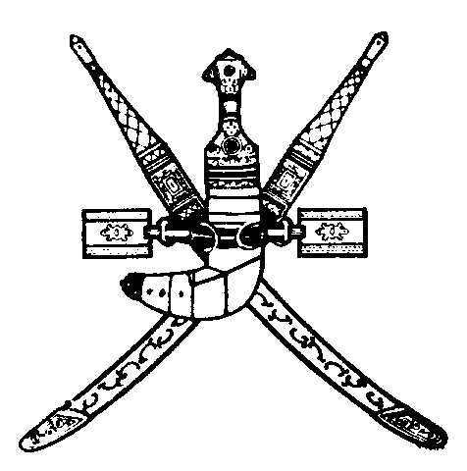 | 
SULTANATE OF OMAN | WORLD INTELLECTUAL  PROPERTY ORGANIZATION
wipo national seminar on INTELLECTUAL PROPERTY FOR THE OMANI PHARMACEUTICAL INDUSTRY
organized by
the World Intellectual Property Organization (WIPO)
in cooperation with
the Ministry of Commerce and Industry
Muscat, December 6, 2003
PROGRAM
prepared by the International Bureau of WIPO

Saturday, December 6, 2003

8.30 - 9.00 OPENING CEREMONY

9.00 – 9.30 Overview of the Relationship between Intellectual Property and Pharmaceuticals; the Different Areas of Intellectual Property Related to Pharmaceuticals: Copyright, Trademarks, Patents, Undisclosed Information and Unfair Competition

Speaker: Mr. Nuno Pires de Carvalho, Head, Industrial Property Law Section, Cooperation for Development (Intellectual Property Law) Department, WIPO, Geneva

9.30 – 10.00 General Provisions and Basic Principles: Implementation; National Treatment and Most Favored Nation (MFN) Treatment Principles; Exhaustion; Measures Necessary to Protect and Promote the Public Interest; Measures Necessary to Prevent and/or Repress Abuses of Rights; the TRIPS Agreement and Health; the Doha Declaration and its Practical Impact

Speaker: Mr. Nuno Pires de Carvalho

10.00 – 10.30 Patents and Public Health

Speaker: Ms. Ola Zahran, Counsellor, Cooperation for Development Bureau for Arab Countries, WIPO

10.30 - 11.00 Coffee Break

11.00 – 12.00 Patentable Subject Matter; Discrimination as to the Field of Technology, the Place of Invention and the Place of Exploitation; Exceptions to Rights Conferred; Compulsory Licenses: Limitations and Conditions; Protection of Test Data

Speaker: Mr. Nuno Pires de Carvalho

12.00 – 13.00 The Pharmaceutical Industry: Challenges and Opportunities

(i) in the Sultanate of Oman

Speaker: A Local Representative of a Pharmaceutical Company

(ii) in Developing Countries

Speaker: Mr. Sherif Saadallah, Director, Cooperation for Development Bureau for Arab Countries, WIPO

13.00 – 13.45 Dispute Settlement Mechanism (DSM); Violation and Non-Violation Complaints; Lessons Learned (so far) from the WTO DSM

Speaker: Mr. Nuno Pires de Carvalho

13.45 – 14.00 CLOSING CEREMONY

[End of document]

