E
WIPO/IPTK/MCT/02/INF.1
ORIGINAL: English
DATE: December 2001
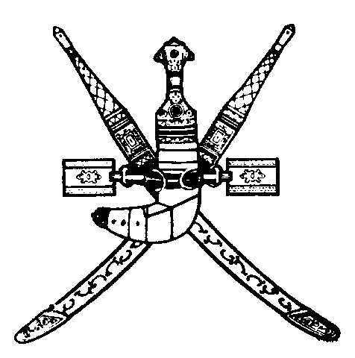 | 
SULTANATE OF OMAN | WORLD INTELLECTUAL  PROPERTY ORGANIZATION
UNDER THE PATRONAGE OF
HIS HIGHNESS SAYyiD FAISAL BIN ALI AL SAID
wipo international forum on “intellectual property
and traditional knowledge: our identity, our future”
organized by
the World Intellectual Property Organization (WIPO)
in cooperation with
the Government of the Sultanate of Oman
Muscat, January 21 and 22, 2002
PROGRAM
prepared by the International Bureau of WIPO

Monday, January 21, 2002

9.00 – 9.30 OPENING CEREMONY

Welcome addresses by:

His Excellency Mr. Maqbool Bin Ali Bin Sultan, Minister for Commerce and Industry, Sultanate of Oman

Dr. Kamil Idris, Director General, World Intellectual Property Organization (WIPO), Geneva

9.30 – 10.00 Theme One: The Relevance of Applying the Intellectual Property System for the Protection of Traditional Knowledge

Speaker: WIPO official

10.00 – 12.30 Theme Two: Traditional Knowledge; A Bridge Between Civilizations and Cultures

Dialogue Among Civilizations

Speaker: His Royal Highness Prince El Hassan bin Talal, Hashemite Kingdom of Jordan

Globalization and Cultural Identities

Speaker: His Excellency Dr. Boutros Boutros-Ghali, Secretary General, International Organisation of the Francophonie, Paris

Intellectual Property and the Preservation of Cultural Identity

Speaker: His Excellency Mr. Jorge Alberto Lozoya, Secretary, Secretariat of Ibero-American Cooperation, Madrid

12.30 – 13.00 Coffee Break

Monday, January 21, 2002 (cont’d)

13.00 – 15.00 Theme Three: Traditional Knowledge; A Source of Wealth Creation

The Renaissance of African Culture

Speaker: His Excellency Dr. Salim Ahmed Salim,
former Prime Minister of the United Republic of Tanzania

The Role of Arab Women in Preserving Traditional Knowledge, Identity and Building the Future

Speaker: Her Excellency Mrs. Bahia El Hariri, Chairperson, Committee on Education, Parliament of the Republic of Lebanon, Beirut

Tuesday, January 22, 2002

9.00 – 11.00 Theme Four: The Economic Value of Traditional Knowledge

The Traditional Cultures of the Americas: Relevance in a Globalized World

Speaker: His Excellency Mr. Ernesto Samper Pizano, former President of the Republic of Colombia

Economic and Cultural Dimensions of Preserving and Protecting Arab Traditional Knowledge

Speaker: His Excellency Mr. Amre Moussa, Secretary General, League of Arab States, Cairo

11.00 – 11.30 Coffee Break

Tuesday, January 22, 2002 (cont’d)

11.30 – 13.30 Theme Five: The Future; What Lies Ahead

Empowerment of People; A Quest for Economic Growth, Cultural Identity and National Solidarity

Speaker: His Excellency Mr. Fidel V. Ramos, former President of the Republic of the Philippines

African Traditional Knowledge; A Vehicle of African Unity

Speaker: His Excellency Mr. Amara Essy, Secretary General, Organization of African Unity, Addis Ababa

Possibilities of SAARC Cooperation on Intellectual Property, Particularly in the area of Traditional Knowledge

Speaker: His Excellency Mr. D.E. Nihal Rodrigo, Secretary General, South Asian Association for Regional Cooperation (SAARC), Kathmandu

The Protection of National Heritage and Traditional Knowledge in the Sultanate of Oman

Speaker: Representative from the Sultanate of Oman

13.30 – 14.00 CLOSING CEREMONY

[End of document]

