E
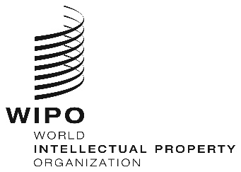
WEBINARS
ORIGINAL: eNGLISH
DATE: June 26, 2020

REGIONAL BUREAU FOR AFRICA CAPACITY BUILDING FOR R&D INSTITUTIONS AND UNIVERSITIES, JULY 2020

organized by
the World Intellectual Property Organization (WIPO)

PROVISIONAL PROGRAM

prepared by the International Bureau of WIPO

Tuesday, July 28, 2020
10.00 – 12.00 | Topic 1 | Basics of Intellectual Property (IP)  - IP Concepts  - IP Types  - Importance of IP for R&D institutions
Speaker: Prof. Barthelemy Nyasse
International Consultant &IP Expert;
Cameroon

 |  | Discussions
 |  | [End of Webinar]

